Slide 1 - Field Examination Documentation
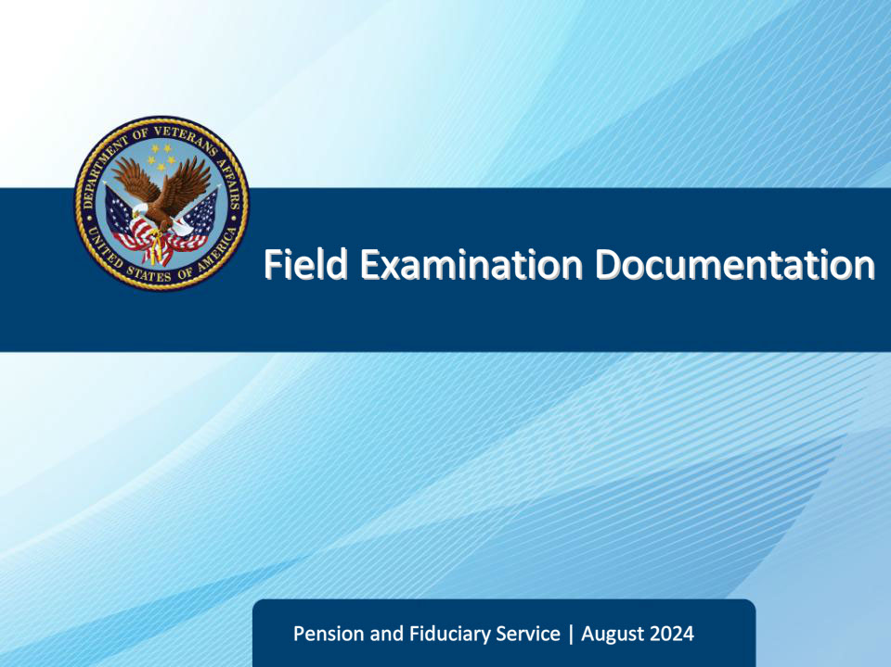
Slide notes

Course Description:

The purpose of this lesson is to provide learners information on completing field examinations and the related documentation requirements.

Slide 2 - Objectives
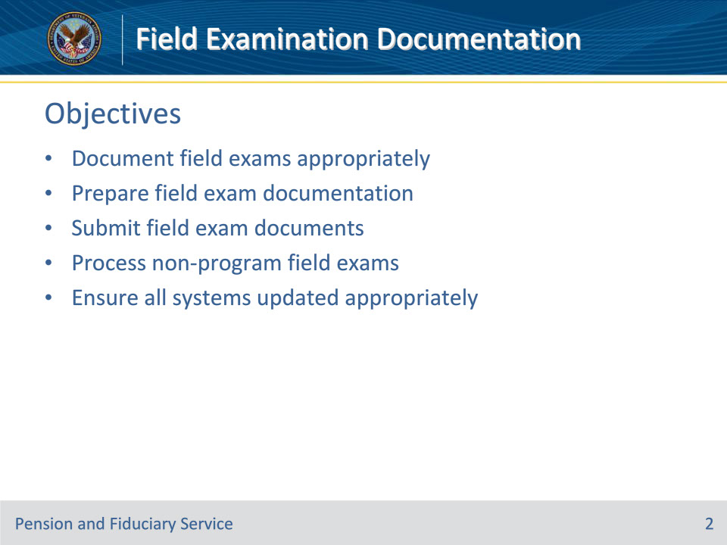
Slide notes

Instructor Notes:

At the end of this lesson, given the training and references, the learner will be able to do the following:

• Document field exams appropriately

• Prepare field exam documentation

• Submit field exam documents

• Process non-program field exams

• Ensure all systems updated appropriately

Slide 3 - References
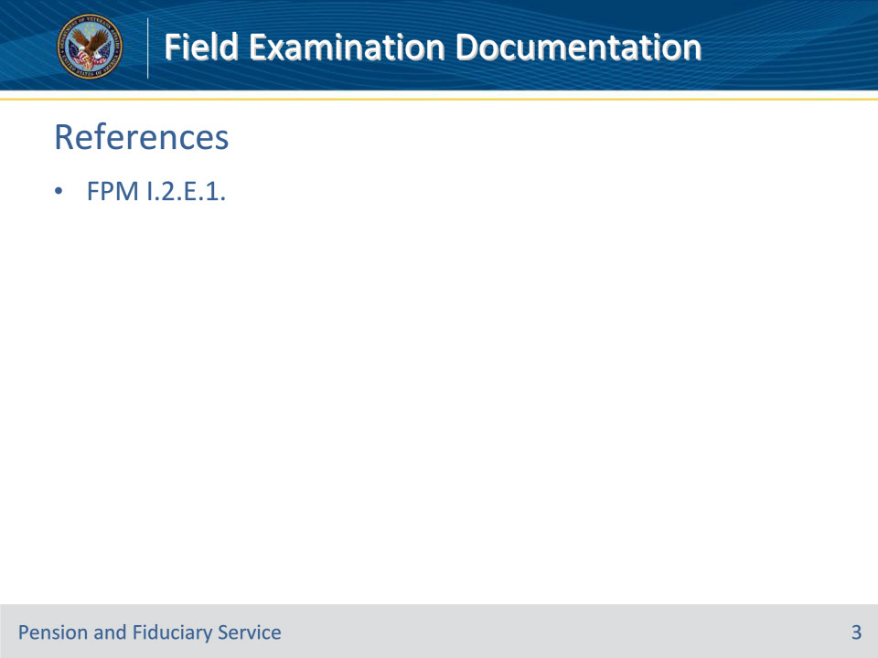
Slide notes

Instructor Notes:

These are the relevant references pertaining to this course:

• FPM I.2.E.1. Required Field Examination Documentation and Supporting Evidence

Slide 4 - Documenting
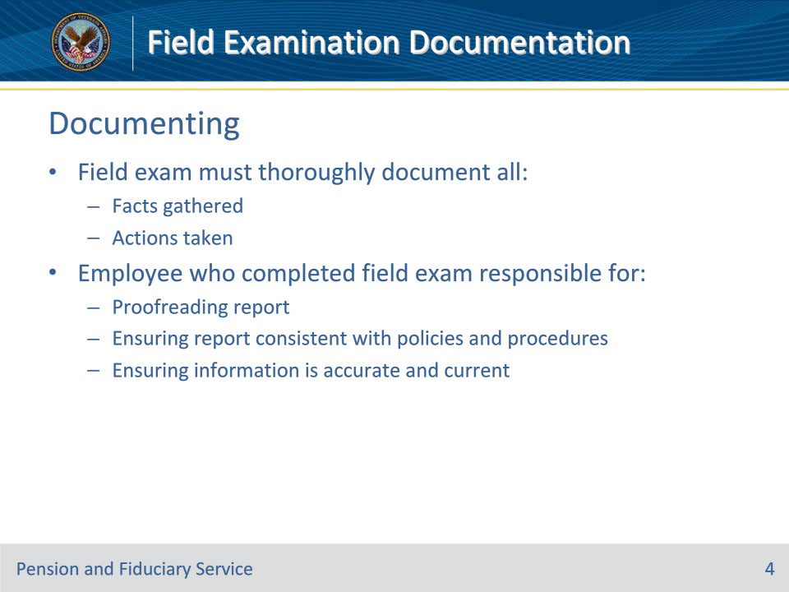
Slide notes

Policy Reference(s): FPM I.2.E.1.a.

Instructor Notes:The field examination must thoroughly document all facts gathered and actions taken during the field examination process.

The fiduciary hub (hub) employee who completed the field examination is responsible for proofreading the report, ensuring the report is consistent with policies and procedures, and the information is both accurate and current.

Slide 5 - Personal Opinions
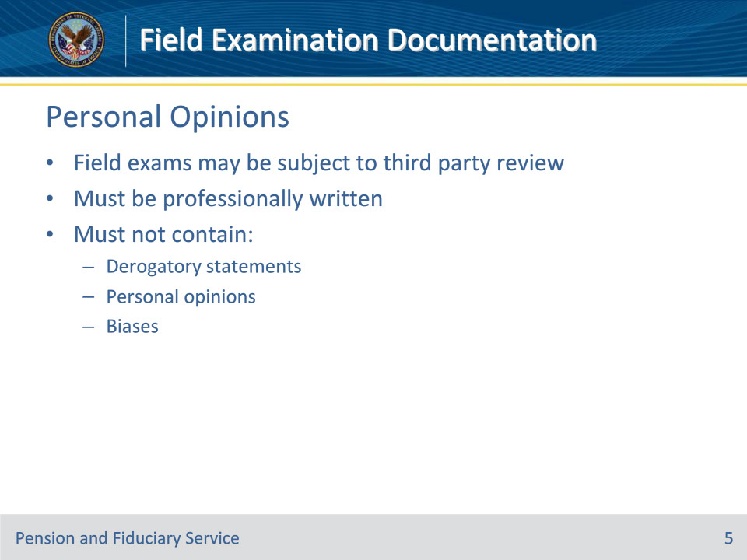
Slide notes

Policy Reference(s): FPM I.2.E.1.b.

Instructor Notes:Field examinations may be subject to third party review. Field examinations must be professionally written and must not contain derogatory statements reflecting the hub employee’s personal opinions and/or biases.

Slide 6 - Preparing Documentation
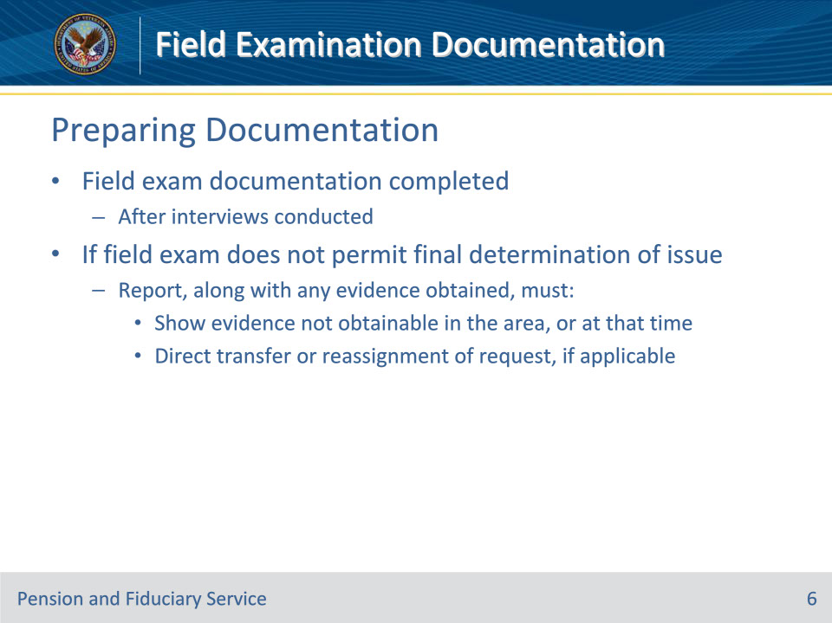
Slide notes

Policy Reference(s): FPM I.2.E.1.c.

Instructor Notes:Field examination documentation is completed after interviews are conducted.

If the field examination does not permit a final determination of an issue, the report, along with any evidence obtained, must

• show that conclusive evidence is not obtainable in the area, or at that time, and

• direct the transfer or reassignment of the request, if the evidence is available elsewhere, or at a later date.

Slide 7 - Preparing Documentation
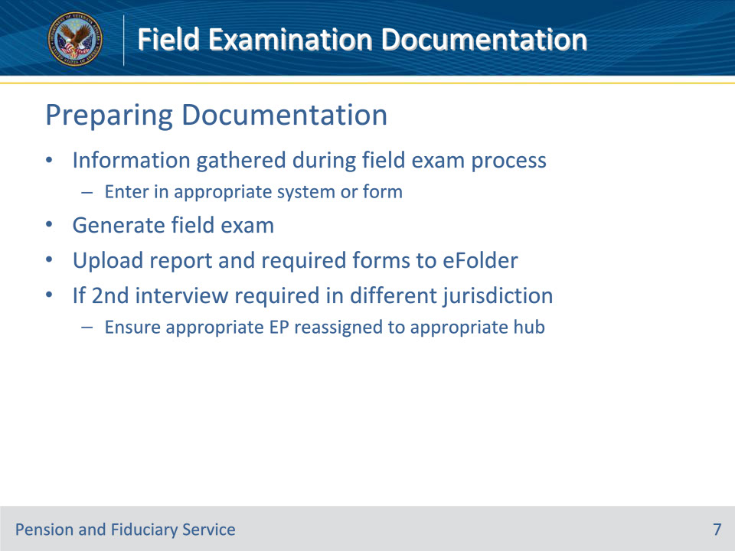
Slide notes

Policy Reference(s): FPM I.2.E.1.d.

Instructor Notes:Hub personnel must enter the information gathered during the field examination process in the appropriate system or on the appropriate form. Hub personnel must also generate the applicable field examination and upload the report and required form(s) to the electronic claims folder (eFolder).

If a partial field examination is completed and a second interview must be conducted in a different jurisdiction, hub personnel must ensure the appropriate end product (EP) is reassigned to the appropriate hub.

Slide 8 - Preparing Documentation
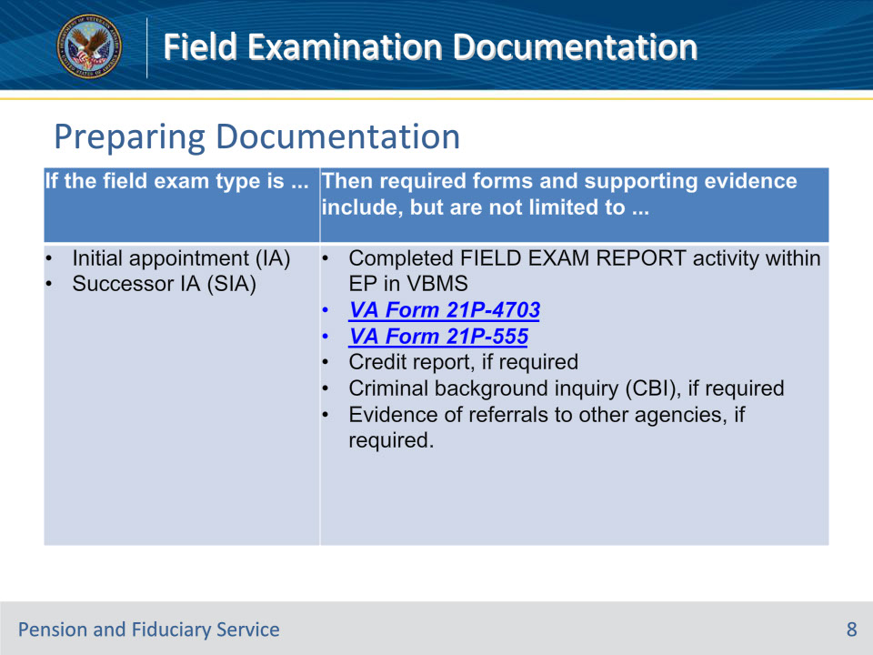
Slide notes

Policy Reference(s): FPM I.2.E.1.d.

Instructor Notes:Use this table to determine the required Department of Veterans Affairs (VA) forms and supporting evidence based on the type of field examination.

Notes:

• VA Form 21P-4703 is not required when the beneficiary is approved for supervised direct pay (SDP).

• VA Form 21P-555 is required to certify all fiduciary appointment types to include SDP and temporary fiduciary appointments.

Slide 9 - Preparing Documentation
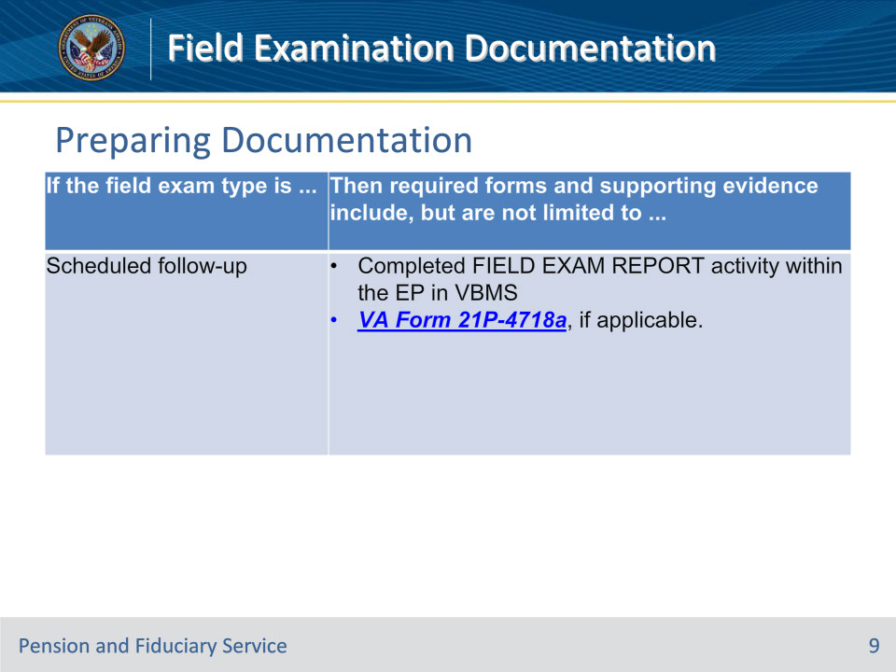
Slide notes

Policy Reference(s): FPM I.2.E.1.d.

Instructor Notes:Use this table to determine the required Department of Veterans Affairs (VA) forms and supporting evidence based on the type of field examination.

Slide 10 - Preparing Documentation
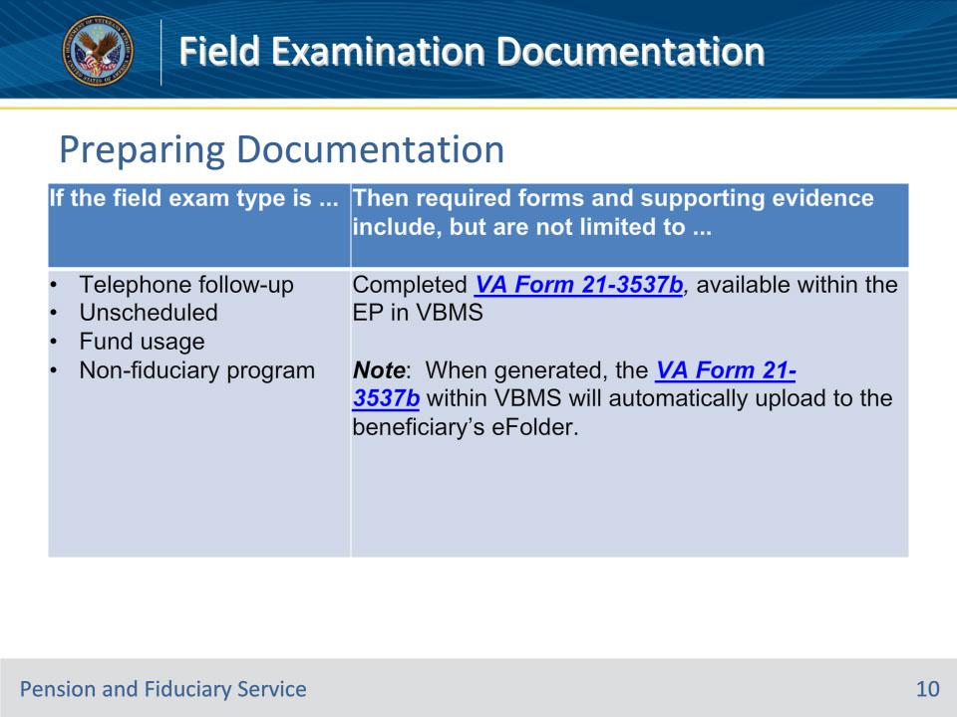
Slide notes

Policy Reference(s): FPM I.2.E.1.d.

Instructor Notes:Use this table to determine the required Department of Veterans Affairs (VA) forms and supporting evidence based on the type of field examination.

Slide 11 - Submission
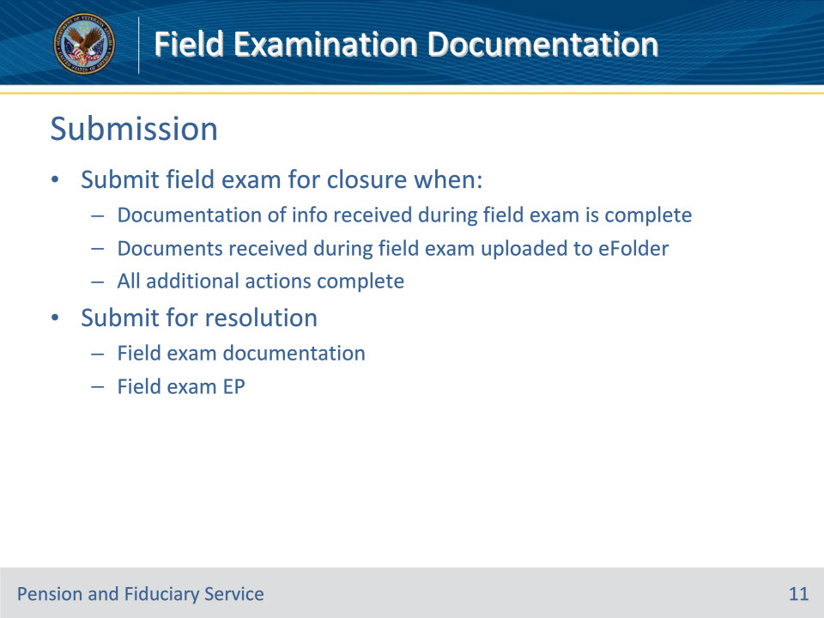
Slide notes

Policy Reference(s): FPM I.2.E.1.e.

Instructor Notes:Hub personnel must submit the field examination for closure when

• documentation of the information received during the field examination is complete

• all documents received during the field examination, to include the required forms and supporting evidence, are uploaded to the eFolder, and

• all additional actions such as diary updates, referrals, and task establishment are complete.

Both the field examination documentation and the field examination EP must be submitted for resolution.

Slide 12 - Uploading
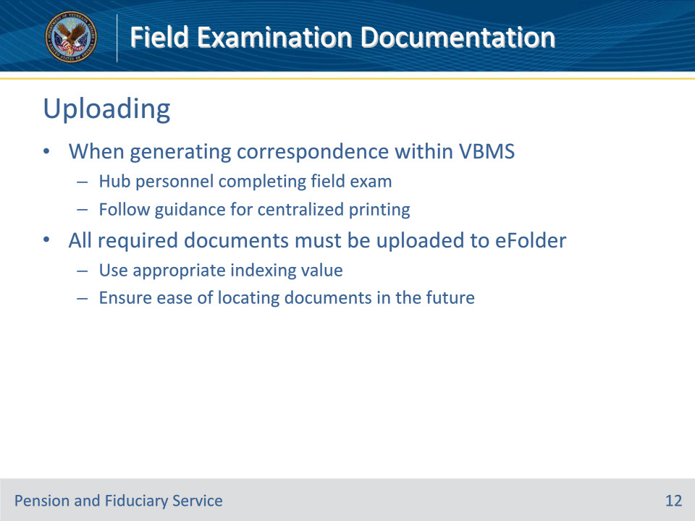
Slide notes

Policy Reference(s): FPM I.2.E.1.f.

Instructor Notes:When generating correspondence within VBMS, hub personnel completing the field examination must follow the guidance for centralized printing.

All required documents must be uploaded to the Veteran’s eFolder. Use the appropriate indexing value to ensure ease of locating documents in the future.

Slide 13 - Non-Program Exams
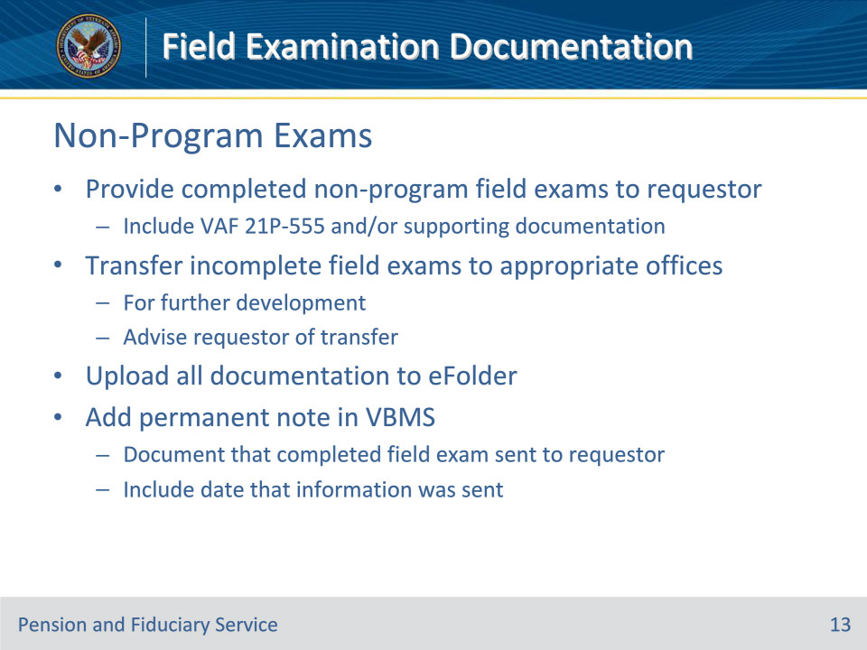
Slide notes

Policy Reference(s): FPM I.2.E.1.g.

Instructor Notes:Hub personnel must provide completed non-fiduciary program field examinations, to include the VA Form 21P-555 and/or any supporting documentation, to the requestor.

Where necessary, incomplete field examinations are transferred to other appropriate offices for further development and the requestor is advised of the transfer. All documentation prepared or gathered must be uploaded to the beneficiary’s eFolder by the hub personnel completing the field examination.

Add a permanent note in VBMS documenting that the completed field examination was sent to the requesting agency or department, to include the date that the information was sent.

Slide 14 - Updating Profiles
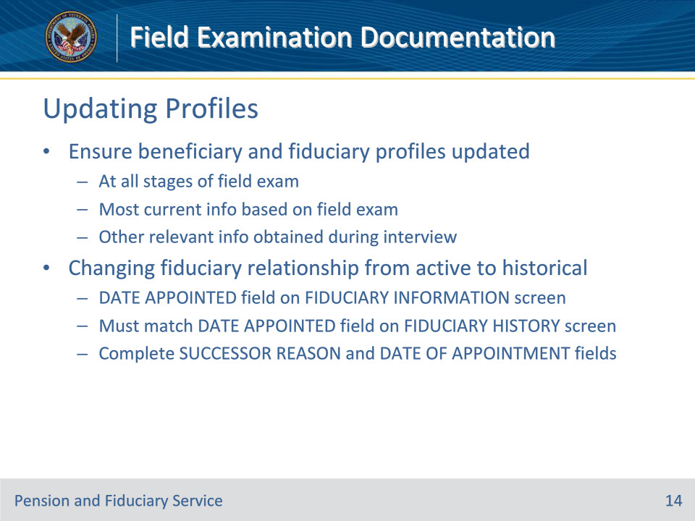
Slide notes

Policy Reference(s): FPM I.2.E.1.h.

Instructor Notes:At all stages of the field examination, hub personnel must ensure fields in the beneficiary’s and fiduciary’s profiles are updated to reflect the most current information based on the documentation requirements for the particular field examination and other relevant information obtained during the interview.

When changing a fiduciary relationship from active to historical, the DATE APPOINTED field on the FIDUCIARY INFORMATION screen must match the DATE APPOINTED field on the FIDUCIARY HISTORY screen. Additionally, hub personnel must complete the SUCCESSOR REASON and DATE OF APPOINTMENT fields on the FIDUCIARY HISTORY screen.

Slide 15 - Controls
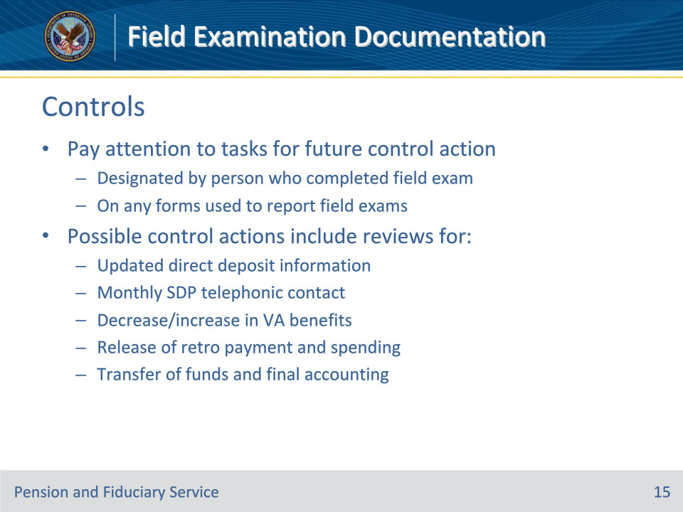
Slide notes

Policy Reference(s): FPM I.2.E.1.i.

Instructor Notes:Hub personnel must pay particular attention to any tasks for future control action designated by the person who completed the field examination on any of the various forms used to report field examinations.

Possible control actions include reviews for

• updated direct deposit information

• monthly SDP telephonic contact

• decrease/increase in VA benefits

• release of retroactive payment and spending, or

• transfer of funds and final accounting pertaining to the appointment of a successor fiduciary.

Slide 16 - Requesting Forms
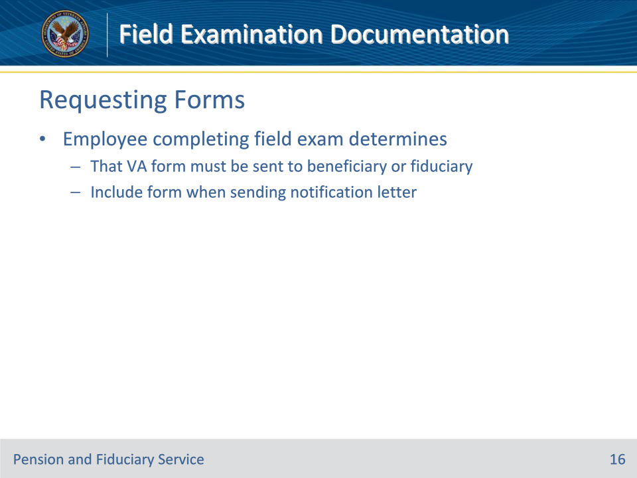
Slide notes

Policy Reference(s): FPM I.2.E.1.j.

Instructor Notes:When the hub employee completing the field examination determines that a VA form must be sent to the beneficiary or fiduciary, include the form when sending the notification letter.

Slide 17 - Completion
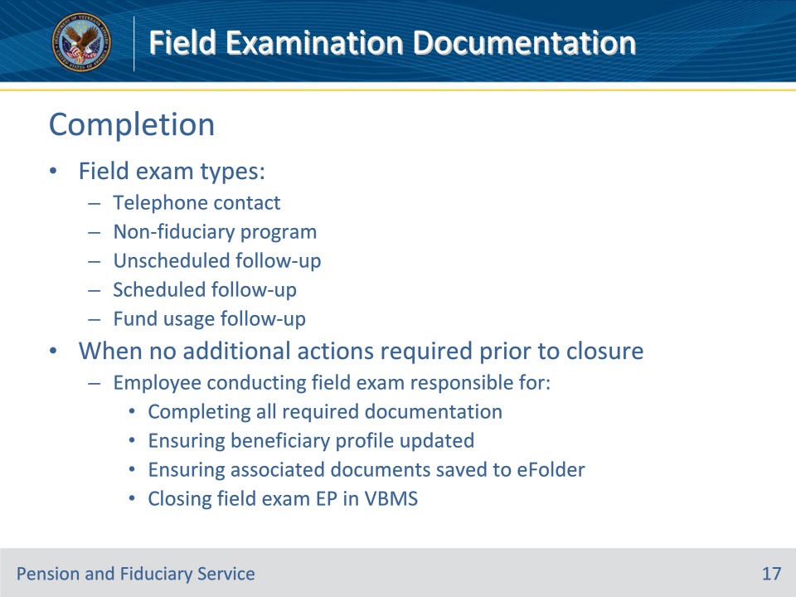
Slide notes

Policy Reference(s): FPM I.2.E.1.k.

Instructor Notes:When telephone contact, non-fiduciary program, unscheduled follow-up, scheduled follow-up, and fund usage follow-up field examinations are completed and no additional actions are required prior to closure, the hub employee conducting the field examination is responsible for

• completing all required documentation

• ensuring

• the beneficiary profile is properly updated, and

• any associated documents are properly saved to the beneficiary’s eFolder, and

• closing the field examination EP in VBMS.

Slide 18 - Questions?
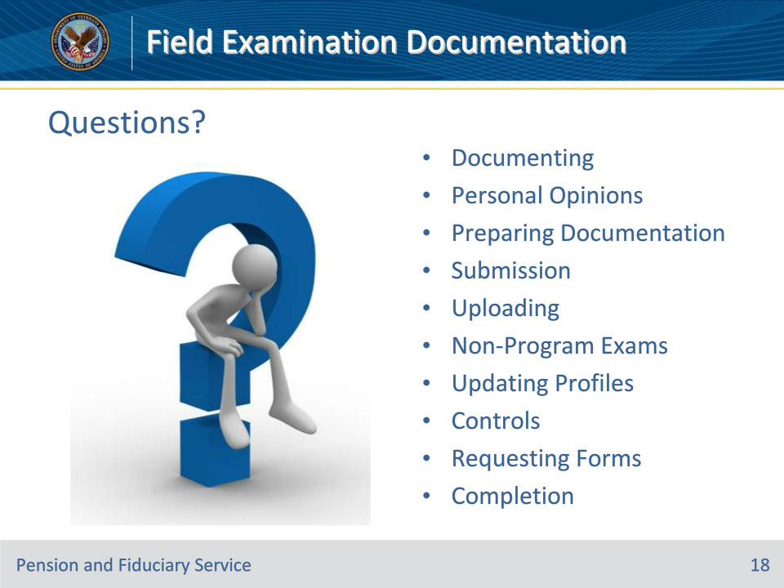
Slide notes

Instructor Notes:

(Recall) These are our learning objectives as stated from the beginning of the training:

• Document field exams appropriately

• Prepare field exam documentation

• Submit field exam documents

• Process non-program field exams

• Ensure all systems updated appropriately

(Recap) We discussed each of these learning objectives through the following topics in each slide today:

• Documenting

• Personal Opinions

• Preparing Documentation

• Submission

• Uploading

• Non-Program Exams

• Updating Profiles

• Controls

• Requesting Forms

• Completion

Are there any additional questions?

Questions should be filtered through your QRT team. They will submit your questions to the Field Inquiry Tool (FIT) on your behalf.

Slide 19 - TMS Survey/Assessment
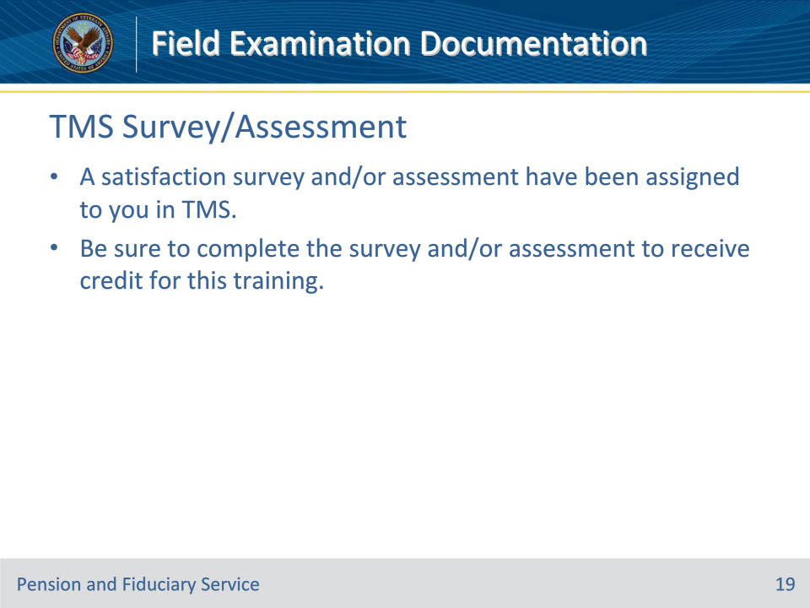
Slide notes

Instructor Notes

A satisfaction survey and/or assessment have been assigned to you in TMS.

Be sure to complete the survey and/or assessment to receive credit for this training.

