Slide 1 - Changes to Entitlement
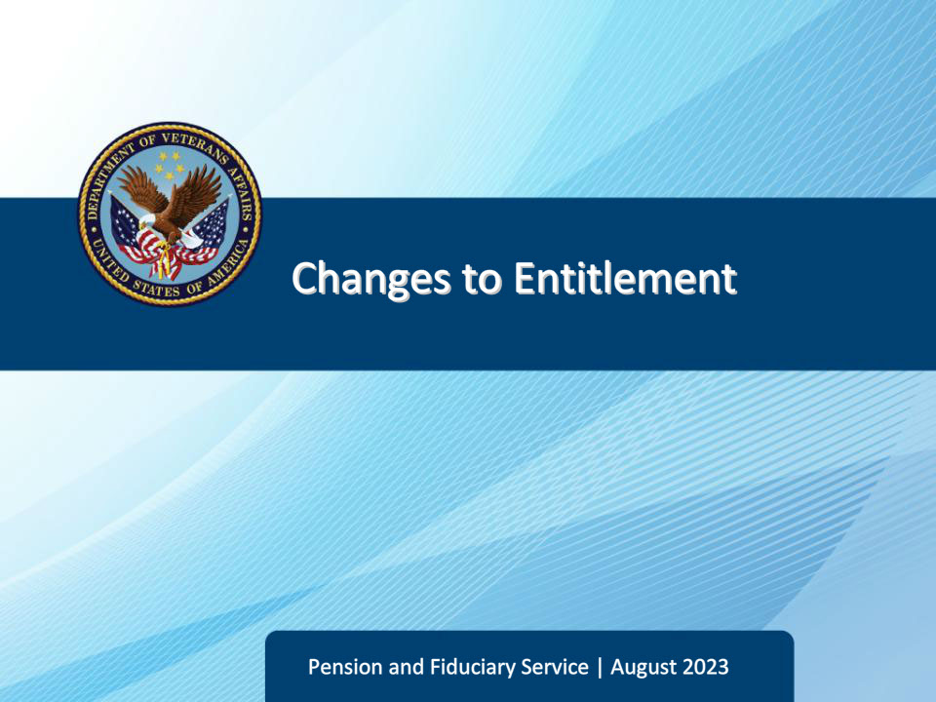
Slide notes

Course Description:

The purpose of this lesson is to provide learners with guidance regarding information that the FE must gather and document during IA and SIA field examinations for adult beneficiaries, specifically changes to benefit entitlement and handling claims and intent to file.

Slide 2 - Navigation
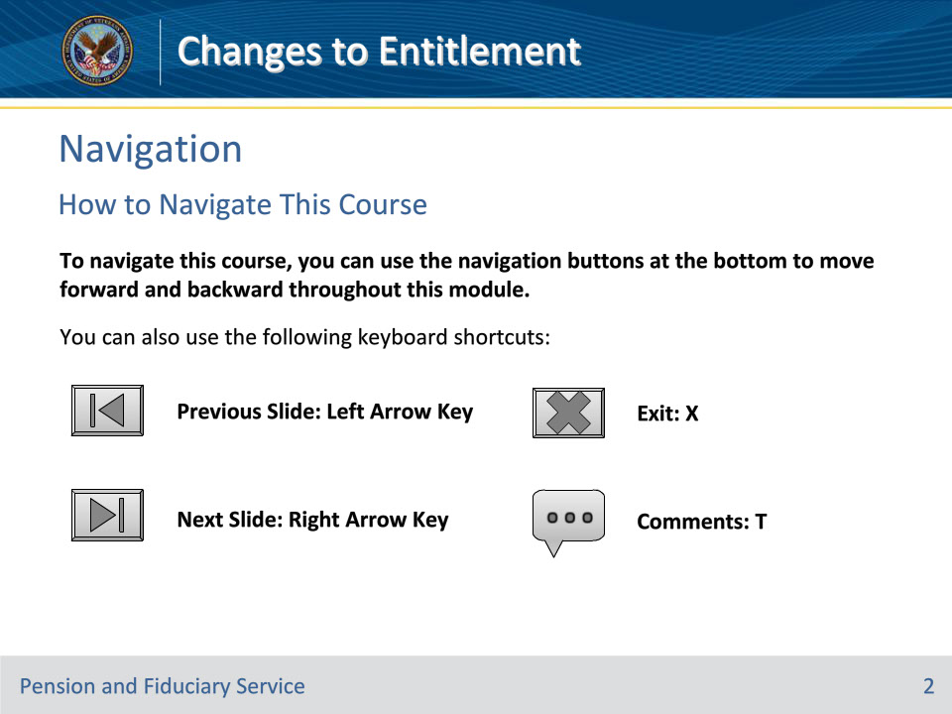
Slide notes

To navigate this course, you can use the navigation buttons at the bottom to move forward and backward throughout this module.

You can also use the following keyboard shortcuts:

• Previous Slide: Left Arrow Key

• Next Slide: Right Arrow Key

• Exit: X

• Comments: T

Slide 3 - Objectives
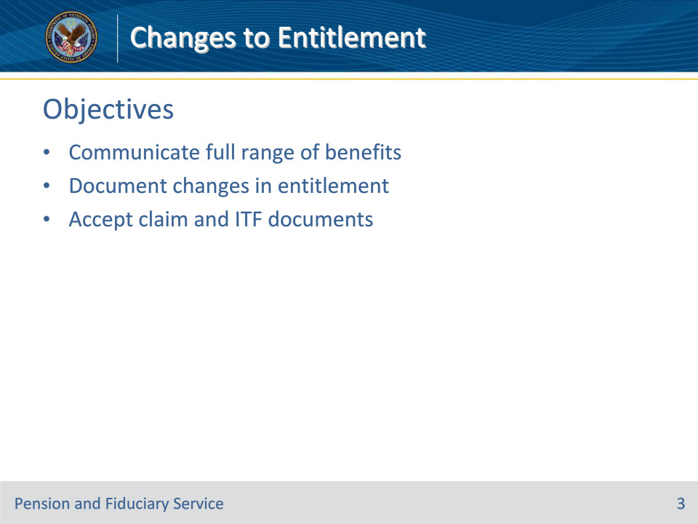
Slide notes

Instructor Notes:

At the end of this lesson, given the training and references, the learner will be able to do the following:

• Communicate full range of benefits

• Document changes in entitlement

• Accept claim and ITF documents

Slide 4 - Reference
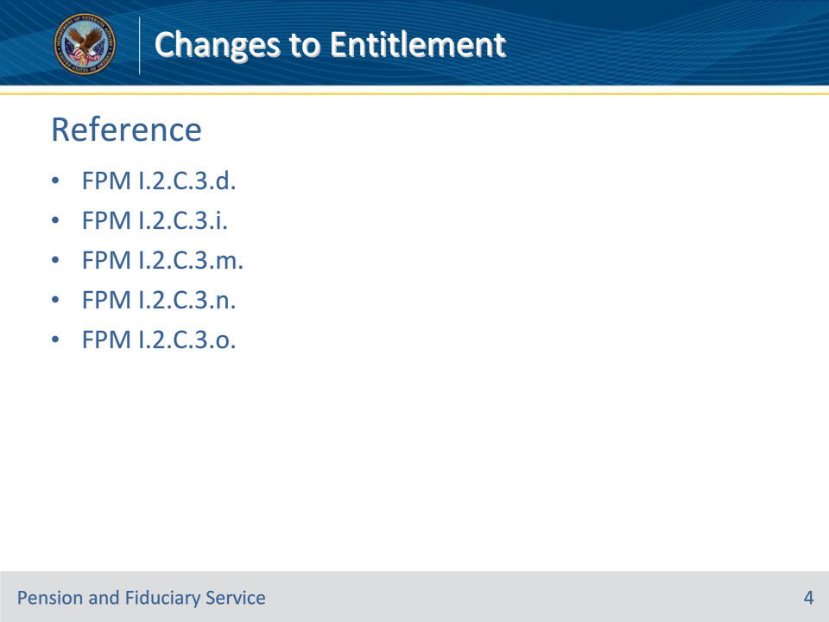
Slide notes

Instructor Notes:

These are the relevant references pertaining to this course:

• FPM I.2.C.3.d. Possible Changes to Benefit Entitlement

• FPM I.2.C.3.i. Documenting Changes to Benefit Entitlement

• FPM I.2.C.3.m. Handling Claims for Benefits

• FPM I.2.C.3.n. Accepting an ITF

• FPM I.2.C.3.o. Accepting a Claim Other Than an ITF

Slide 5 - Benefits Available
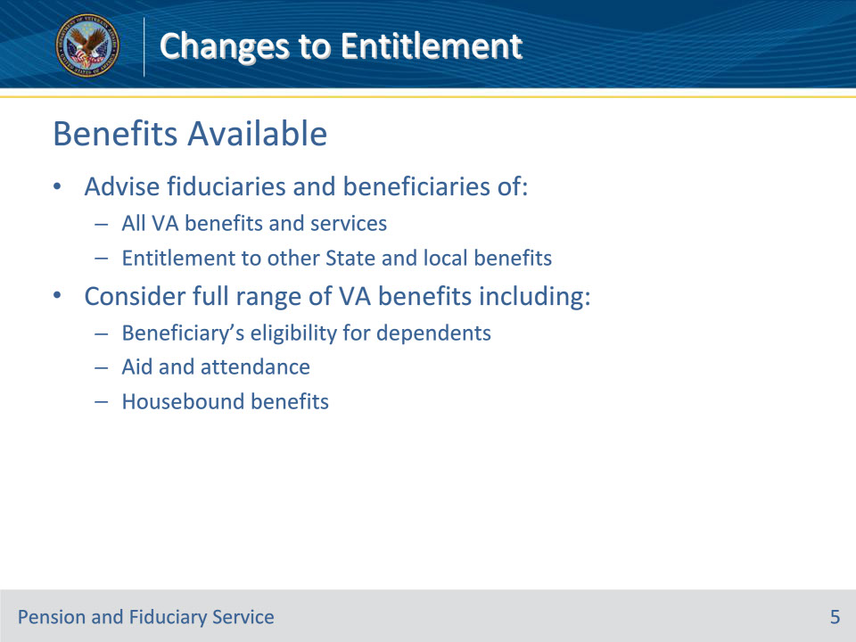
Slide notes

Policy Reference(s): FPM I.2.C.3.d.

Instructor Notes:

FEs must advise fiduciaries and beneficiaries of all VA benefits and services to ensure that the beneficiary receives accurate payment of benefits. The FE should also explain entitlement to other State and local benefits.

FEs should consider the full range of VA benefits including the beneficiary’s eligibility for dependents, aid and attendance and housebound benefits.

Slide 6 - Benefits Available
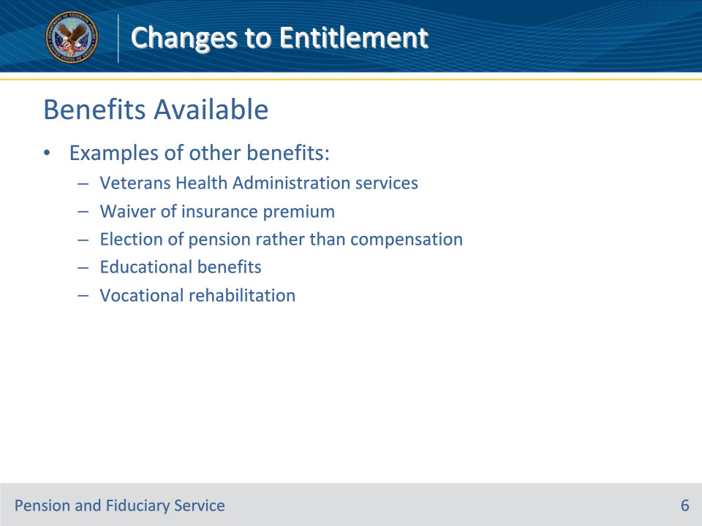
Slide notes

Policy Reference(s): FPM I.2.C.3.d.

Instructor Notes:

Examples of other benefits include the following:

• services available through Veterans Health Administration facilities

• a waiver of the premium on insurance

• the election of pension rather than compensation, when advantageous

• educational benefits, and

• vocational rehabilitation.

If there are changes in entitlement to VA benefits that may result in a decrease or increase in VA benefits payments, follow the guidance in the next slide.

Slide 7 - Documentation
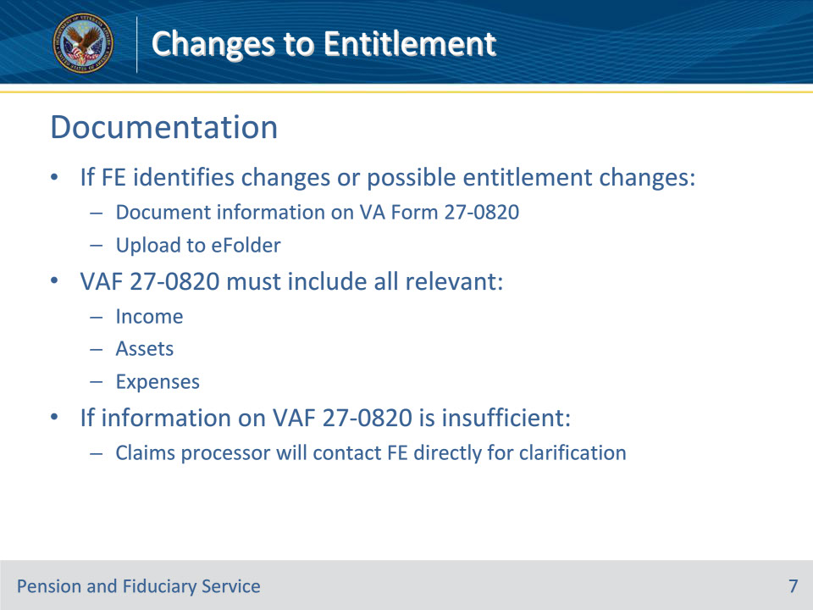
Slide notes

Policy Reference(s): FPM I.2.C.3.i.

Instructor Notes:

If the FE identifies changes or possible changes in benefit entitlement, the FE must document the information on a VA Form 27-0820 and upload it into the eFolder.

When there is a potential change to benefit entitlement, the FE must incorporate all relevant income, asset, and expense details from the field examination to the VA Form 27-0820. If the information provided by the FE on the VA Form 27-0820 is insufficient for action by the claims processor who is acting on the EP, the claims processor will contact the FE directly for clarification, if necessary.

Slide 8 - Changes to Entitlement
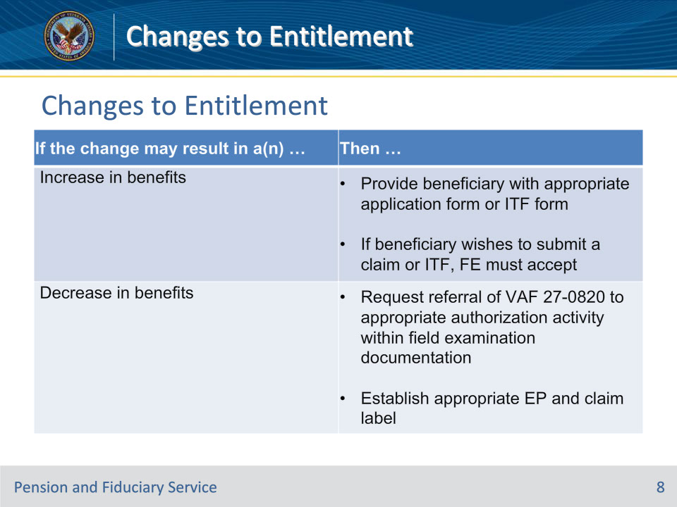
Slide notes

Policy Reference(s): FPM I.2.C.3.i.

Instructor Notes:

Use this table to determine additional actions when a possible change in benefit entitlement is identified.

• If the employee who identifies a possible decrease in benefits is unable to establish the EP, submit a request for the appropriate hub employee to complete the action.

Slide 9 - Claims for Benefits
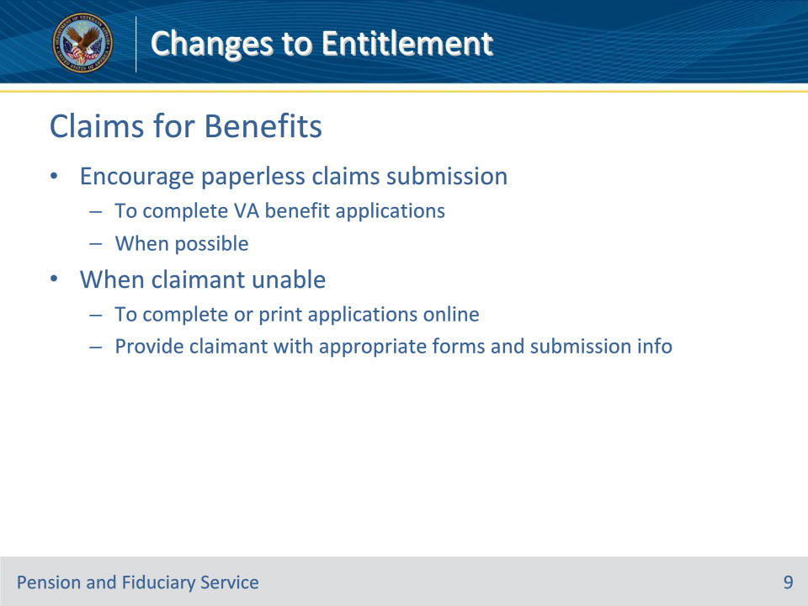
Slide notes

Policy Reference(s): FPM I.2.C.3.m.

Instructor Notes:

FEs should encourage claimants to utilize VA paperless claims submission tools, when possible, to complete VA benefit applications.

To meet the requirements of 38 CFR 3.150, in situations when the claimant does not have the ability to complete or print applications online, the FE must provide the claimant with the appropriate form(s) and submission information.

Slide 10 - Claims for Benefits
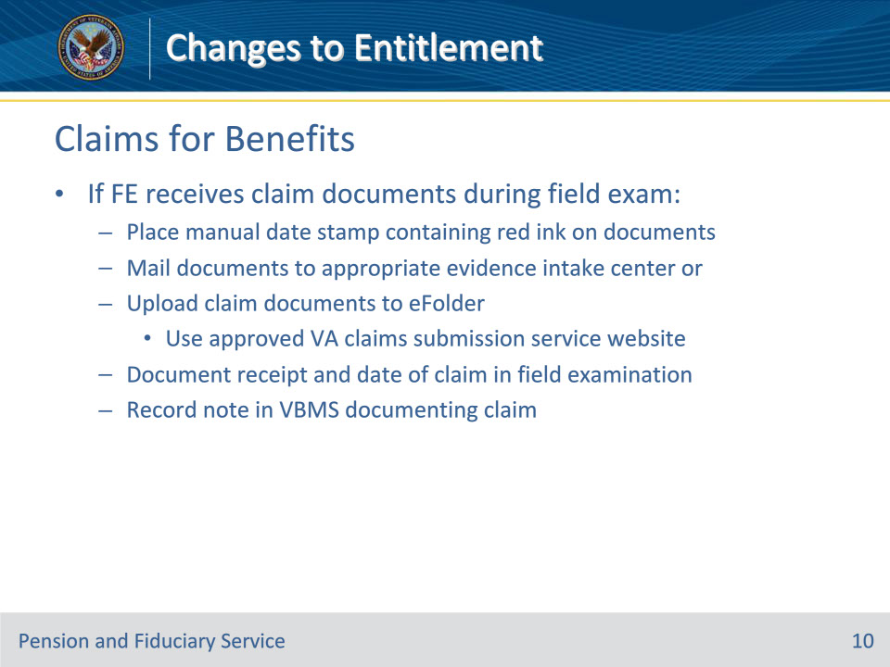
Slide notes

Policy Reference(s): FPM I.2.C.3.m.

Instructor Notes:

If the FE receives claim document(s) during the field examination, the FE must

• place a manual date stamp containing red ink documenting the date of receipt on the document

• mail the claim document(s) to the appropriate evidence intake center or upload the claim document(s) to the eFolder using an approved VA claims submission service website such as Direct Upload

• document the receipt and date of the claim in the field examination, and

• record a note in VBMS documenting the claim.

Slide 11 - Accepting an ITF
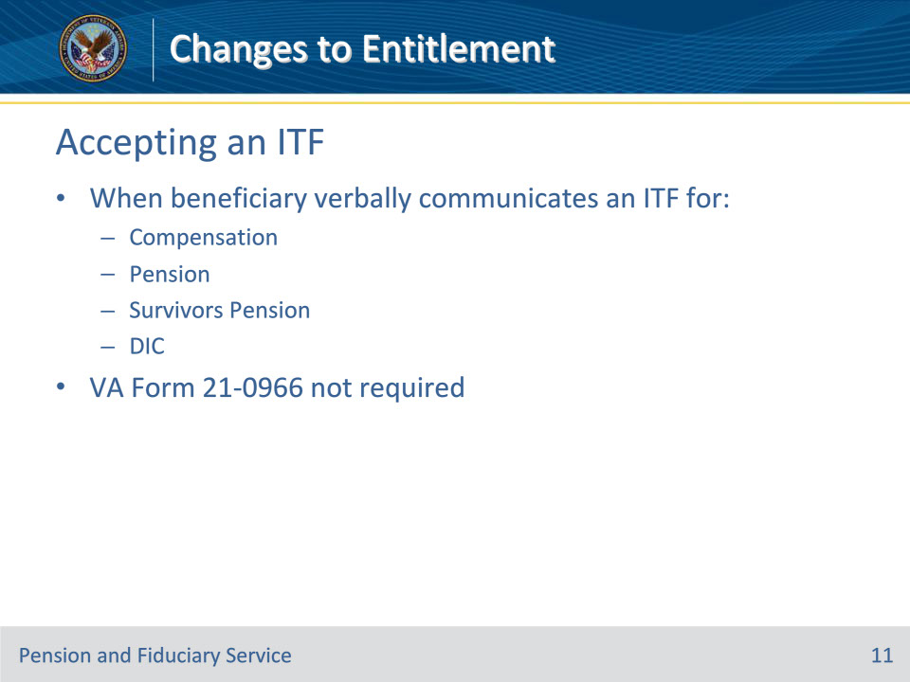
Slide notes

Policy Reference(s): FPM I.2.C.3.n.

Instructor Notes:

When a beneficiary verbally communicates to a VA employee an ITF a claim for compensation, pension, Survivors Pension or Dependency and Indemnity Compensation (DIC), the beneficiary does not need to complete a VA Form 21-0966, Intent to File a Claim for Compensation and/or Pension, or Survivors Pension and/or DIC.

Slide 12 - Accepting an ITF
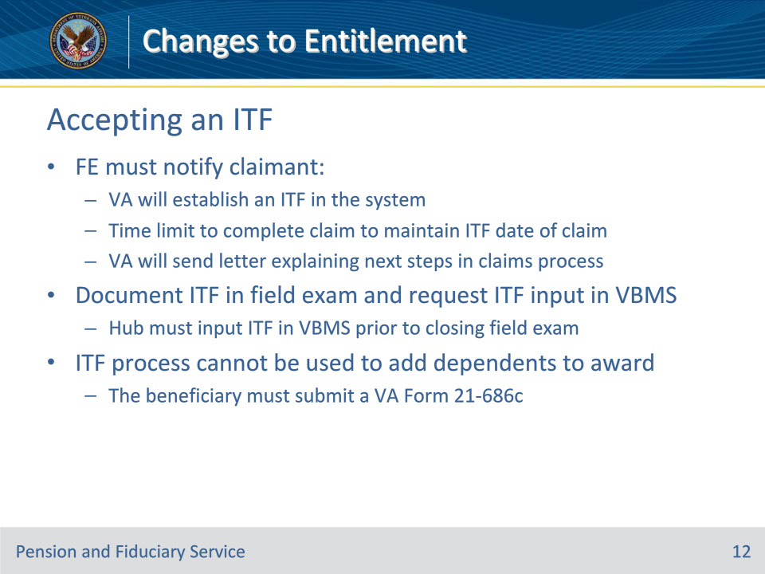
Slide notes

Policy Reference(s): FPM I.2.C.3.n.

Instructor Notes:

The FE must notify the claimant

• that VA will establish an ITF in the system

• of the time limit to complete the claim to maintain the ITF date of claim, and

• that VA will send a letter explaining the next steps in the claims process.

The FE must document the ITF in the field examination and request input of the ITF in VBMS.

The hub personnel must input the ITF in VBMS prior to closing the field examination.

The ITF process cannot be used in conjunction with a request to add dependents to a compensation award. The beneficiary must submit a VA Form 21-686c, Application Request to Add and/or Remove Dependents.

Slide 13 - Accepting Other Claims
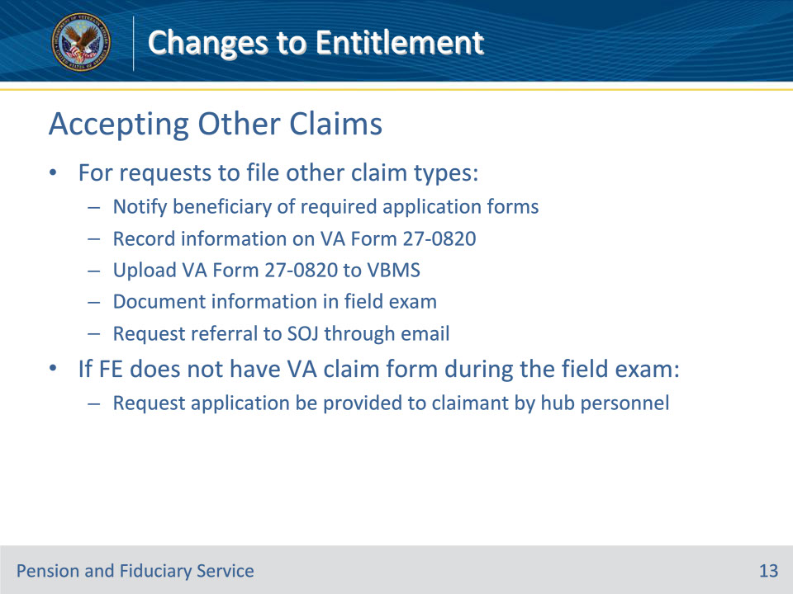
Slide notes

Policy Reference(s): FPM I.2.C.3.o.

Instructor Notes:

For requests to file a claim for benefits other than compensation, pension, or DIC, the FE will

• notify the beneficiary of the required application form(s)

• record the information on VA Form 27-0820

• upload the VA Form 27-0820 to VBMS, and

• document the information in the field examination and request hub personnel referral to the station of jurisdiction through email notification.

If the FE does not have the appropriate VA claim form available during the field examination, the FE must request the application be provided to the claimant by hub personnel.

Slide 14 - Questions?
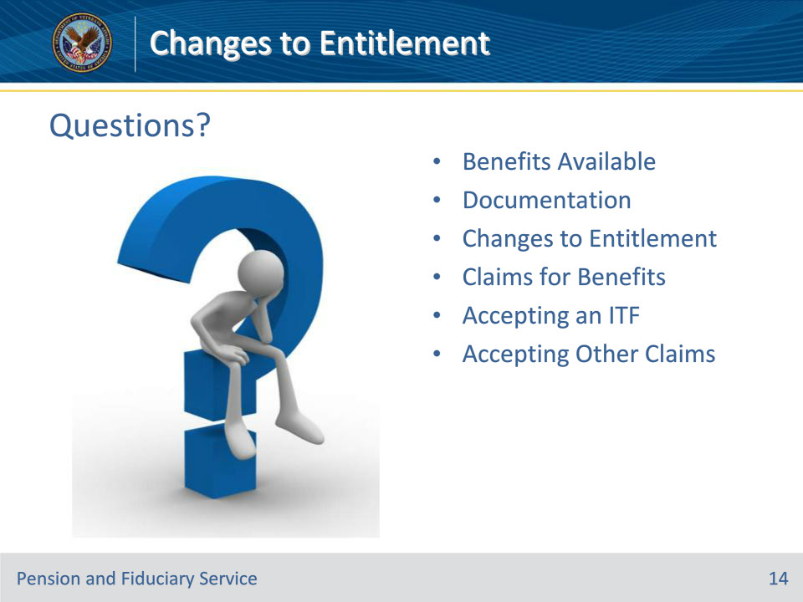
Slide notes

Instructor Notes:

(Recall) These are our learning objectives as stated from the beginning of the training:

• Communicate full range of benefits

• Document changes in entitlement

• Accept claim and ITF document

(Recap) We discussed each of these learning objectives through the following topics in each slide today:

• Benefits Available

• Documentation

• Changes to Entitlement

• Claims for Benefits
• Accepting an ITF

• Accepting Other Claims

Are there any additional questions?

Slide 15 - TMS Survey
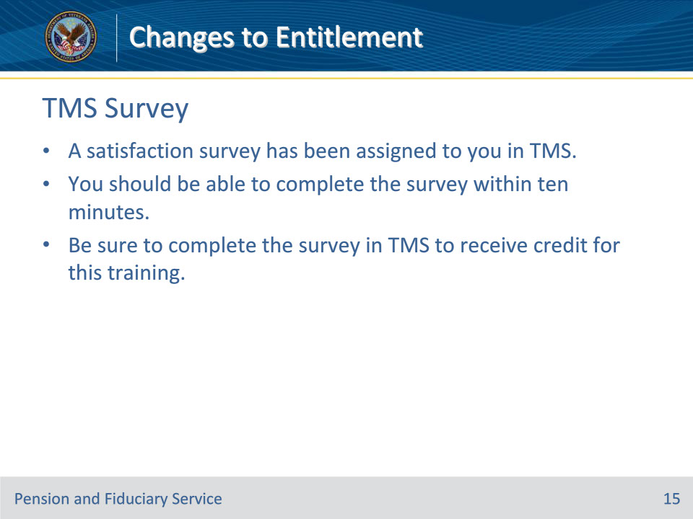
Slide notes

Instructor Notes:

A satisfaction survey has been assigned to you in TMS. You should be able to complete the survey within ten minutes. Completing the survey will allow you to receive credit for this training.

