Slide 1 - Beneficiary Financial Information
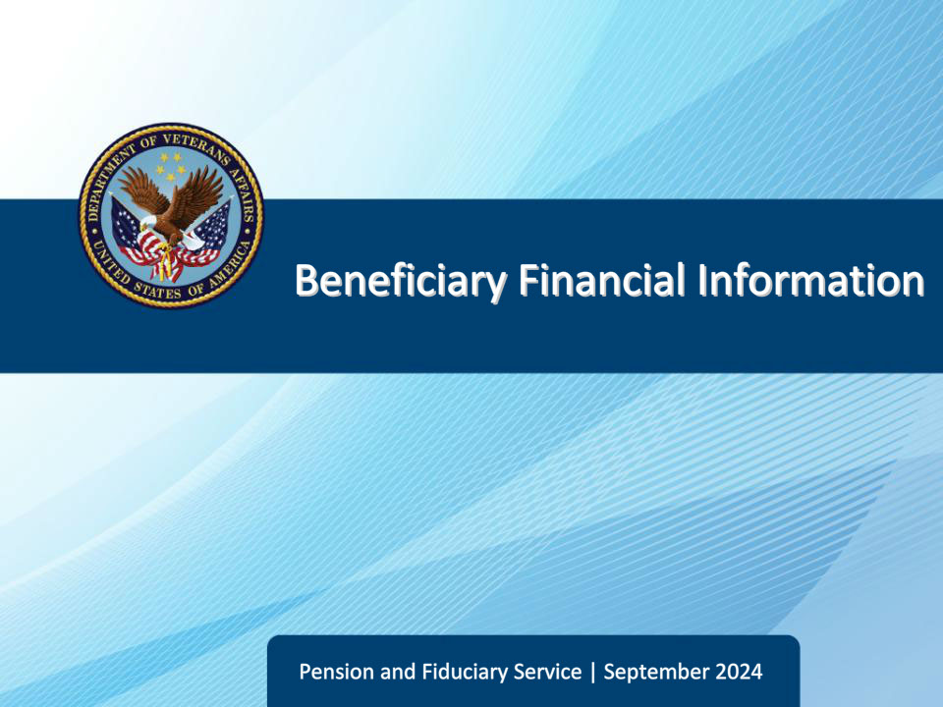
Slide notes

Course Description:

The purpose of this lesson is to provide learners with guidance regarding financial information that the field examiner must gather and document during IA and SIA field examinations.

Slide 2 - Objectives
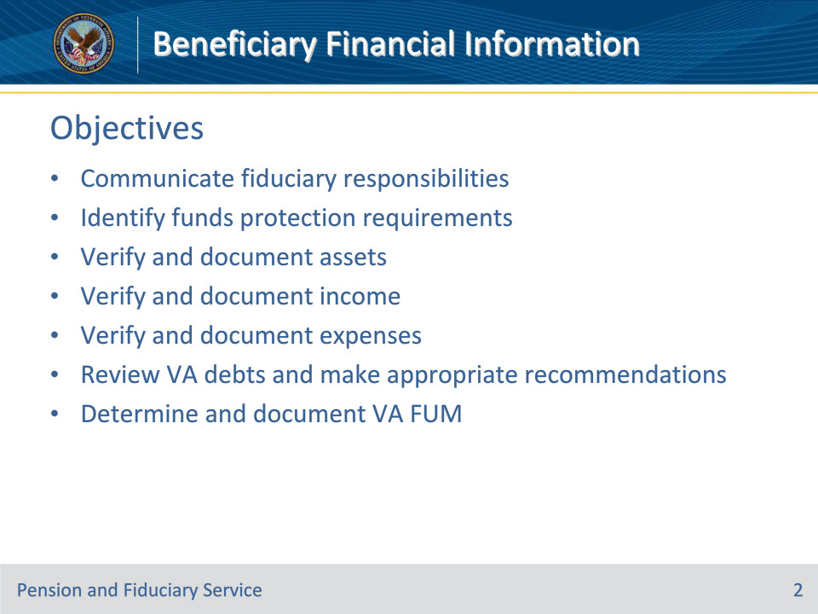
Slide notes

Instructor Notes:

At the end of this lesson, given the training and references, the learner will be able to do the following:

• Communicate fiduciary responsibilities

• Identify funds protection requirements

• Verify and document assets

• Verify and document income

• Verify and document expenses

• Review VA debts and make appropriate recommendations

• Determine and document VA FUM

Slide 3 - Reference
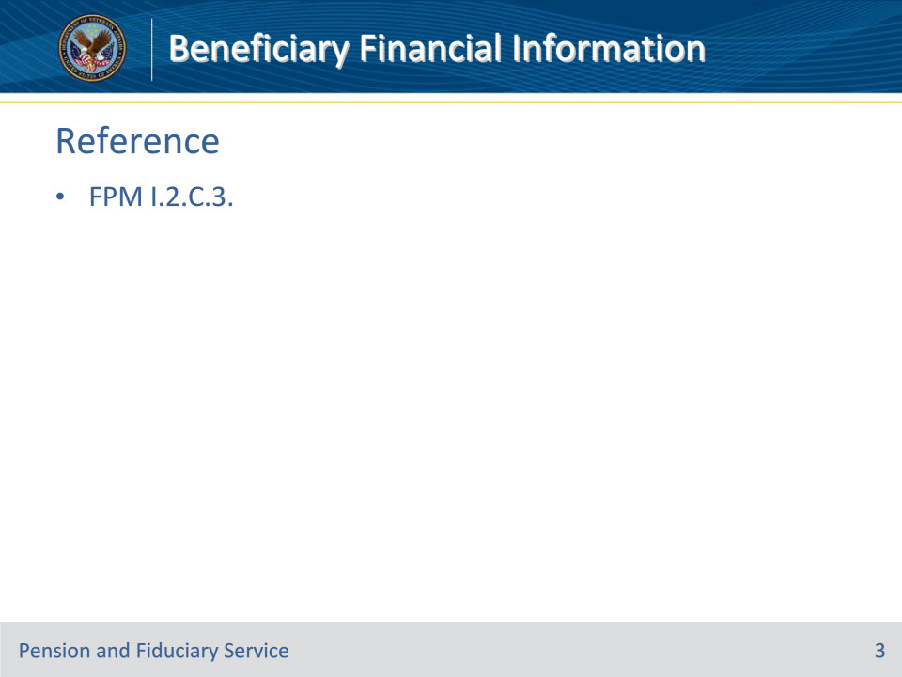
Slide notes

Instructor Notes:

These are the relevant references pertaining to this course:

• FPM I.2.C.3. Financial Information of the Beneficiary

Slide 4 - Fiduciary Responsibilities
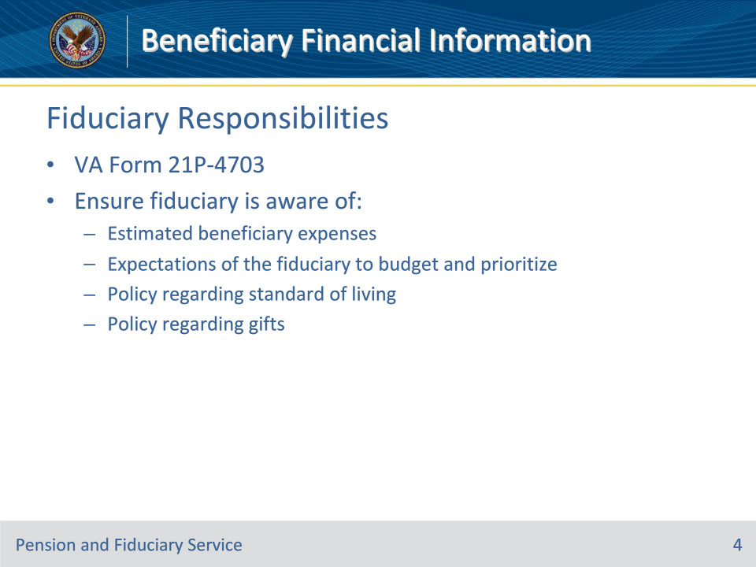
Slide notes

Policy Reference(s): FPM I.2.C.3.a.

Instructor Notes:

During each adult and minor beneficiary IA field examination, the FE must discuss with the proposed fiduciary the responsibilities and information outlined on the VA Form 21P-4703.

In addition to those responsibilities outlined in the VA Form 21P-4703, for adult beneficiaries the FE must ensure that the fiduciary is aware of the following:

• estimated beneficiary expenses, regardless of the benefit amount

• expectations of the fiduciary to

• budget the expenses considering the beneficiary’s and their dependent’s needs, and

• prioritize payment of expenses according to the best interests of the beneficiary and the beneficiary’s dependents

• to the extent possible, allowances should enable the beneficiary and their dependents to enjoy a standard of living consistent with those similarly situated, and

• that should the beneficiary request the fiduciary give a gift to a family member, close friend or charitable institution, the fiduciary must carefully evaluate the request and maintain sufficient documentation to support the approval or denial of the request.

Slide 5 - Refusal to Disclose
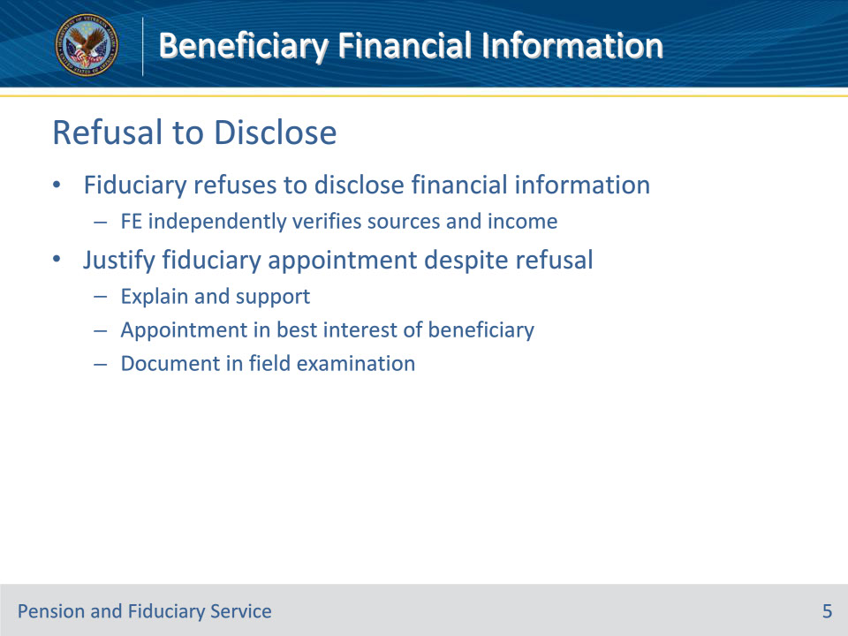
Slide notes

Policy Reference(s): FPM I.2.C.3.b.

Instructor Notes:

If the fiduciary has knowledge of the beneficiary’s income or other financial information but refuses to disclose such information, the FE must independently verify, to the greatest extent possible, the sources and amounts of income.

The FE must fully justify why an individual should be appointed or remain as the VA-appointed fiduciary despite the refusal to disclose sources of income or other financial information. Full justification must explain and support why the appointment or continued appointment of the fiduciary is in the best interest of the beneficiary in the field examination.

Slide 6 - Retro Payments
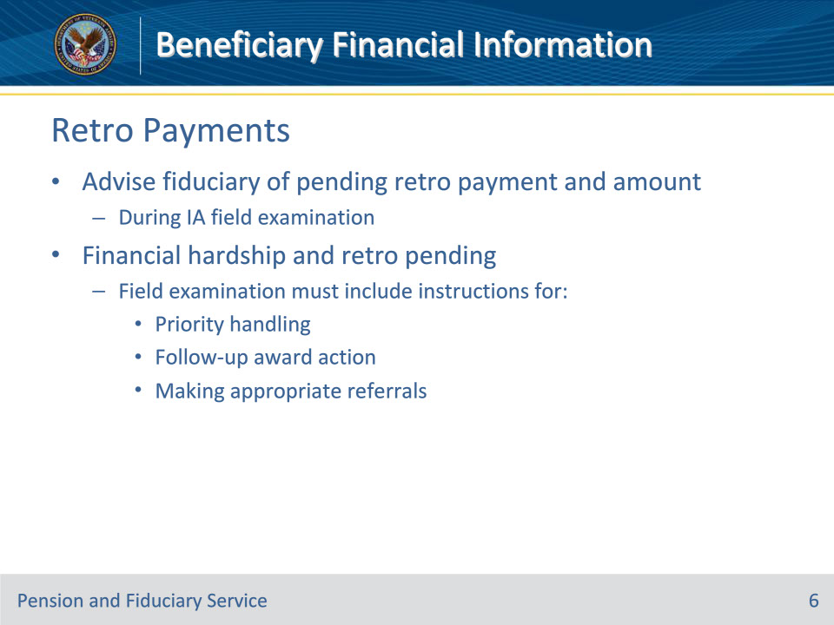
Slide notes

Policy Reference(s): FPM I.2.C.3.c.

Instructor Notes:

Information regarding a retroactive VA benefits payment is available in VA systems. During each adult and minor IA field examination, the FE must advise the fiduciary of any pending retroactive payment and the approximate amount.

When the FE determines a financial hardship exists and VA funds have not been released, the field examination must include instructions for

• priority handling

• follow-up award action, and

• making appropriate referrals.

Slide 7 - Retro Payments
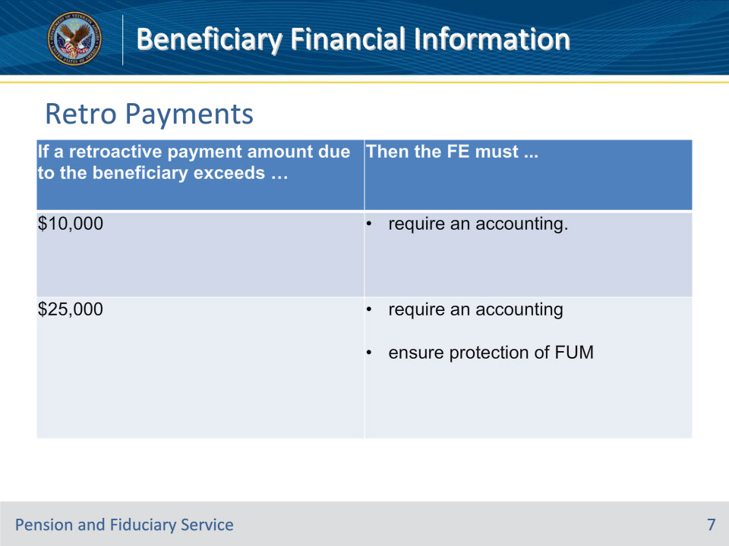
Slide notes

Policy Reference(s): FPM I.2.C.3.c.

Instructor Notes:

Use this table for guidance when the retroactive payment amount due to the adult or minor beneficiary exceeds certain limits.

Slide 8 - Liquid Assets
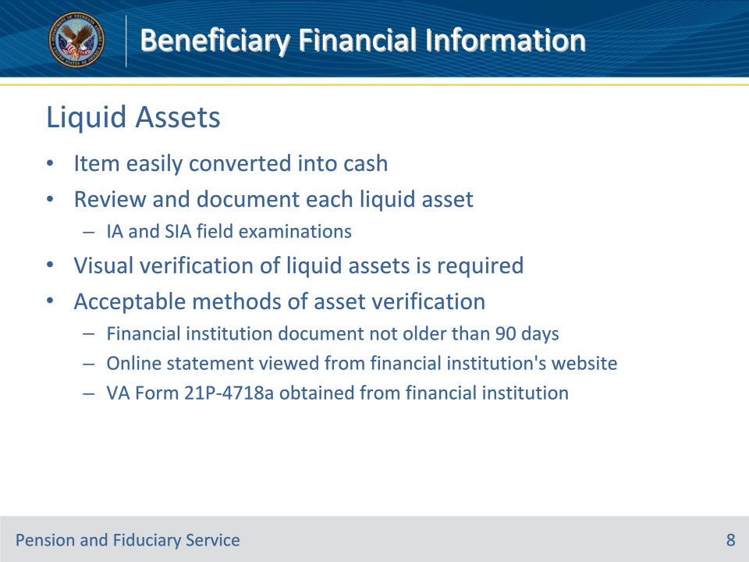
Slide notes

Policy Reference(s): FPM I.2.C.3.e.

Instructor Notes:The FE must review and document each liquid asset identified during all IA and SIA field examinations. A liquid asset is an item that may easily be converted into cash.

Visual verification of liquid assets is necessary. Acceptable methods of asset verification include viewing one of the following items:

• an original, photocopied, or computer-generated financial institution document which does not exhibit any signs of alteration, not older than 90 days from the date of the field examination

• an online statement viewed from the financial institution’s website, or

• a VA Form 21P-4718a, Certificate of Balance on Deposit and Authorization to Disclose Financial Records, obtained from the financial institutions.

Slide 9 - Liquid Assets
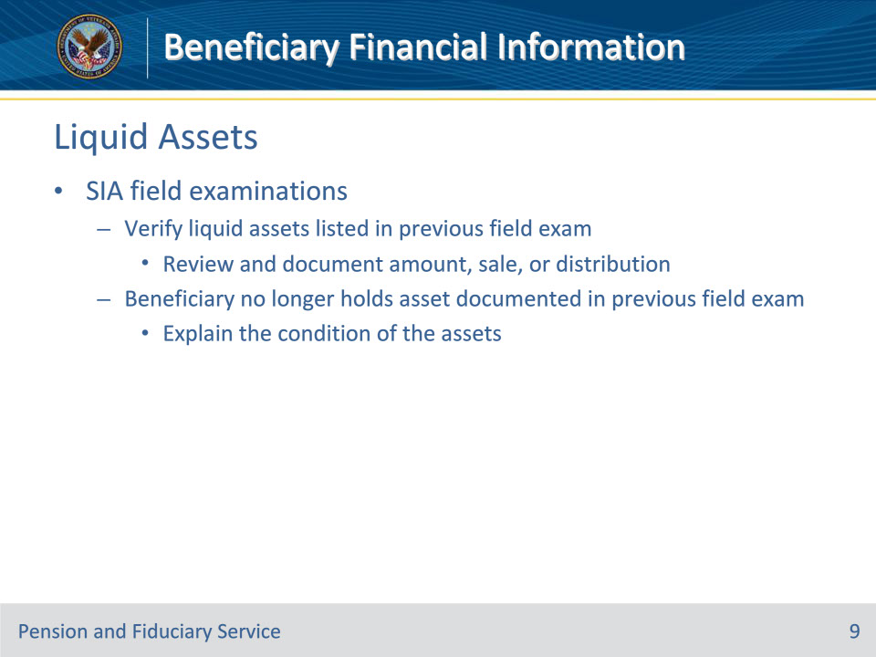
Slide notes

Policy Reference(s): FPM I.2.C.3.e.

Instructor Notes:During SIA field examinations, the FE must verify liquid assets listed in the previous field examination by reviewing and documenting the amount, sale, or distribution of assets identified in the previous field examination. If the beneficiary no longer holds an asset (for example, sold property or closed an account) or has exhausted an asset that was documented in the previous field examination, the FE must explain the condition of the assets.

Slide 10 - Liquid Assets
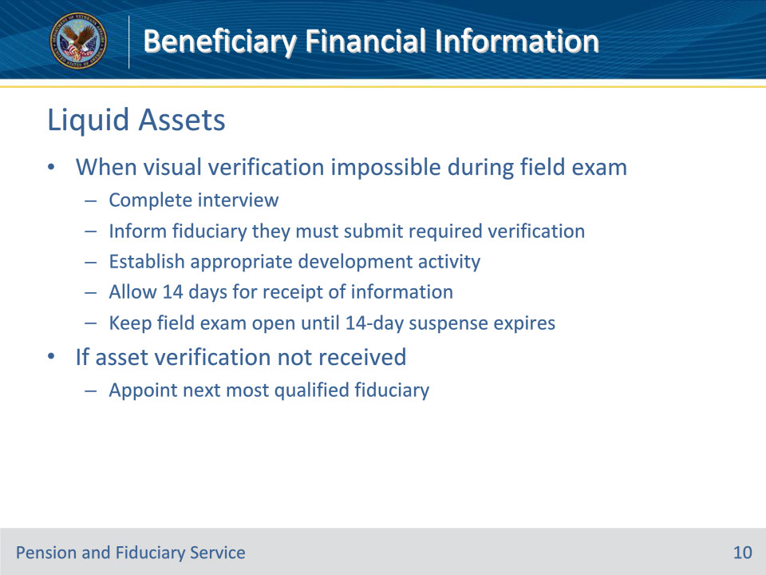
Slide notes

Policy Reference(s): FPM I.2.C.3.e.

Instructor Notes:

If the FE cannot visually verify liquid assets during the field examination

• complete the interview

• inform the fiduciary that they must submit the required verification to the hub using a secure communication method (for example, fax, mail)

• establish the appropriate development activity

• allow 14 days for receipt of the information, and

• keep the field examination open until the 14-day suspense expires.

If the proposed fiduciary does not submit the asset verification within the requested timeframe, the FE must proceed with appointing the next most qualified fiduciary.

Slide 11 - Liquid Assets
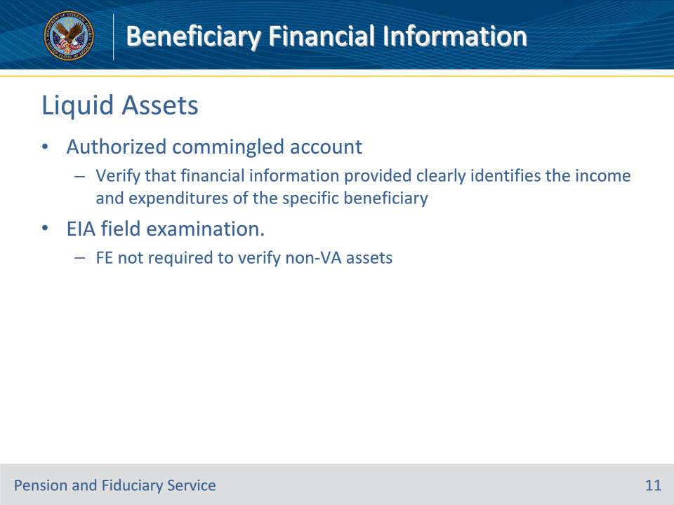
Slide notes

Policy Reference(s): FPM I.2.C.3.e.

Instructor Notes:

If the fiduciary has an authorized commingled financial account, the FE must verify that the financial information provided clearly identifies the income and expenditures of the specific beneficiary.

The FE is not required to verify non-VA assets during an EIA field examination.

Slide 12 - Liquid Assets
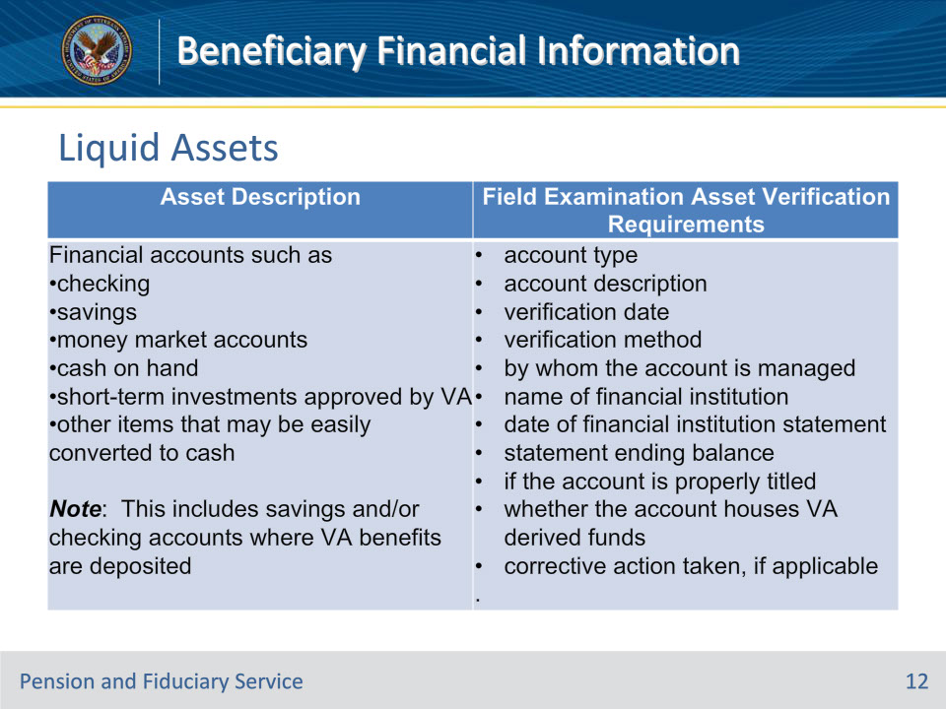
Slide notes

Policy Reference(s): FPM I.2.C.3.e.

Instructor Notes:This table provides information on the types of liquid assets and the verification requirements.

Important: When adding an asset, enter the information in the appropriate fields. Use the DESCRIPTION field to document any required information for which there is not a designated field

Slide 13 - Recurring Income
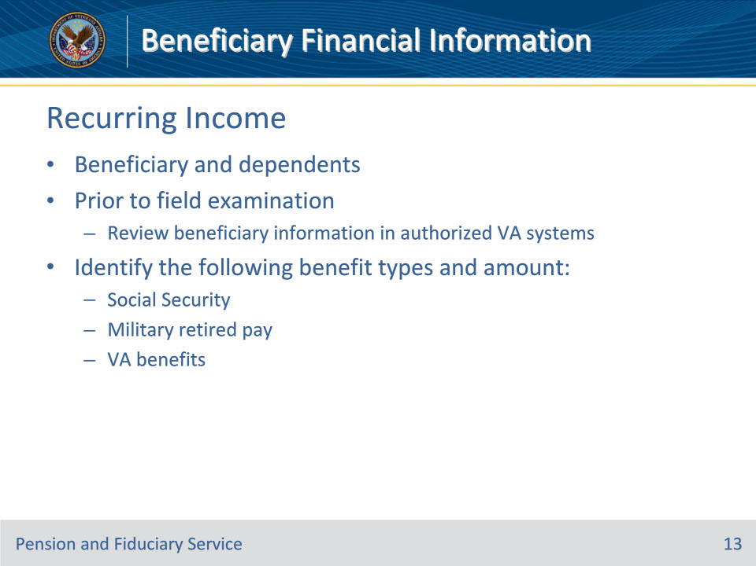
Slide notes

Policy Reference(s): FPM I.2.C.3.f.

Instructor Notes:Prior to the field examination, the FE must review beneficiary information in authorized VA systems. During this review, the FE must identify if the beneficiary and their dependents are recipients of the following benefit types and the amount of the payment:

• Social Security

• military retired pay, and/or

• VA benefits (for example, education, compensation, pension, or vocational rehabilitation).

Slide 14 - Recurring Income
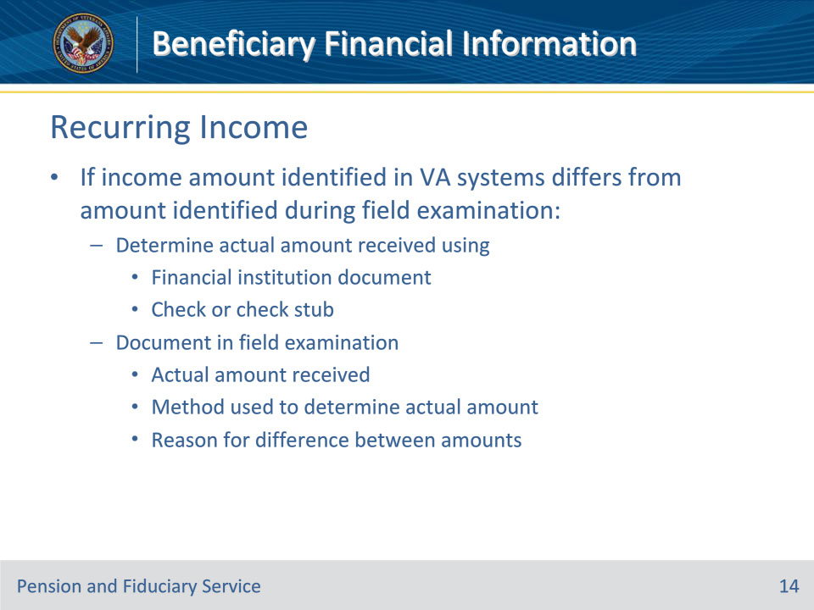
Slide notes

Policy Reference(s): FPM I.2.C.3.f.

Instructor Notes:If the amount of income identified in authorized VA systems from the three benefits listed on the previous slide differs from the amount identified during the field examination, the FE must

• determine the actual amount received by viewing

• an original, photocopied, or computer-generated financial institution document, which does not show any signs of alteration, or

• the check or check stub, and

• document in the field examination the

• actual amount received

• method used to determine the actual amount received, and

• reason for the difference between the amount shown in authorized VA systems and in the field examination.

Slide 15 - Recurring Income
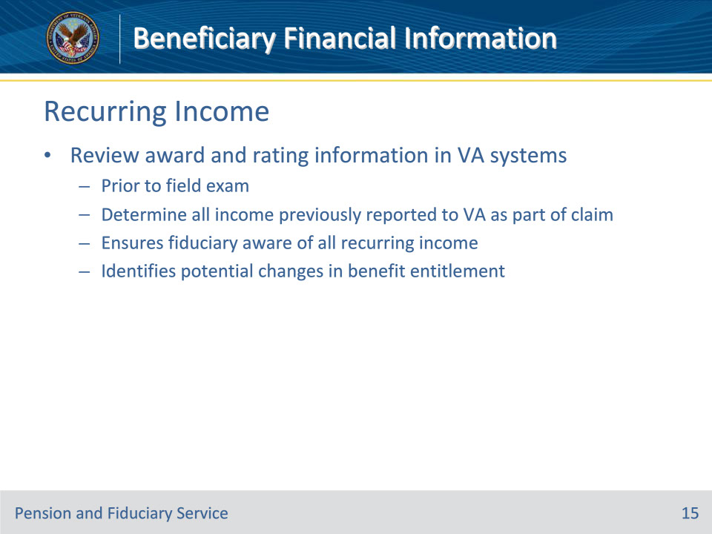
Slide notes

Policy Reference(s): FPM I.2.C.3.f.

Instructor Notes:The FE must also review the award and rating information in VA systems prior to the field examination to determine all income that was previously reported to VA as part of a claim for benefits. This will assist the FE in ensuring that the fiduciary is aware of all recurring income and identifying any potential changes in benefit entitlement

Slide 16 - Recurring Income
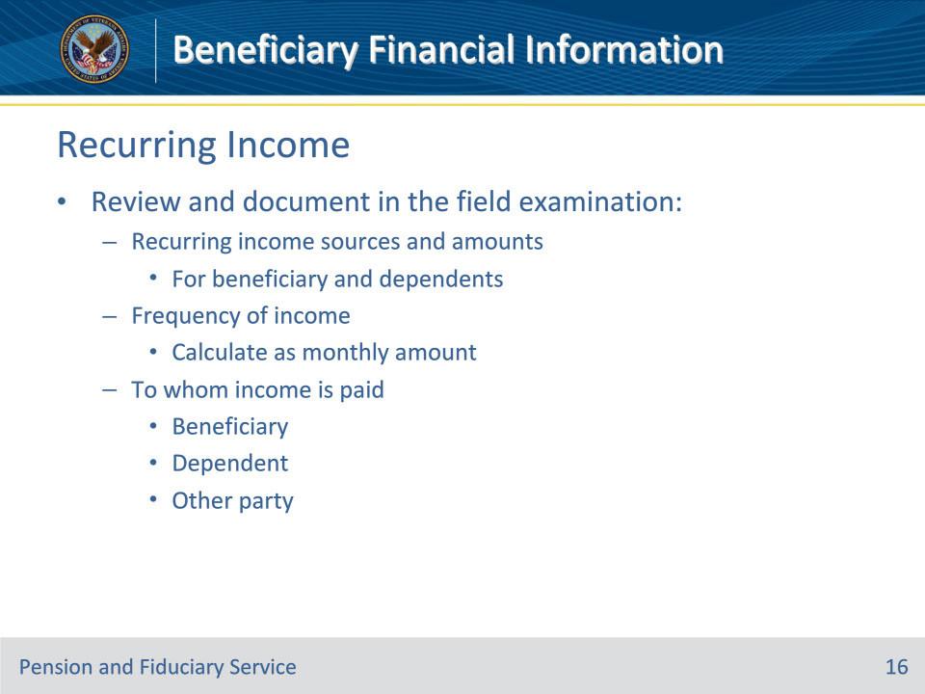
Slide notes

Policy Reference(s): FPM I.2.C.3.f.

Instructor Notes:During the field examination, the FE must request all beneficiary and dependent recurring income sources and amounts.

The FE must review and document the following in the field examination:

• all recurring income sources and amounts for the beneficiary and their dependents

• the frequency of income (the FE must calculate and document as a monthly amount of recurring income amount), and

• to whom that income is paid (beneficiary, dependent or the name and relationship of any other party, if known).

Slide 17 - Recurring Income
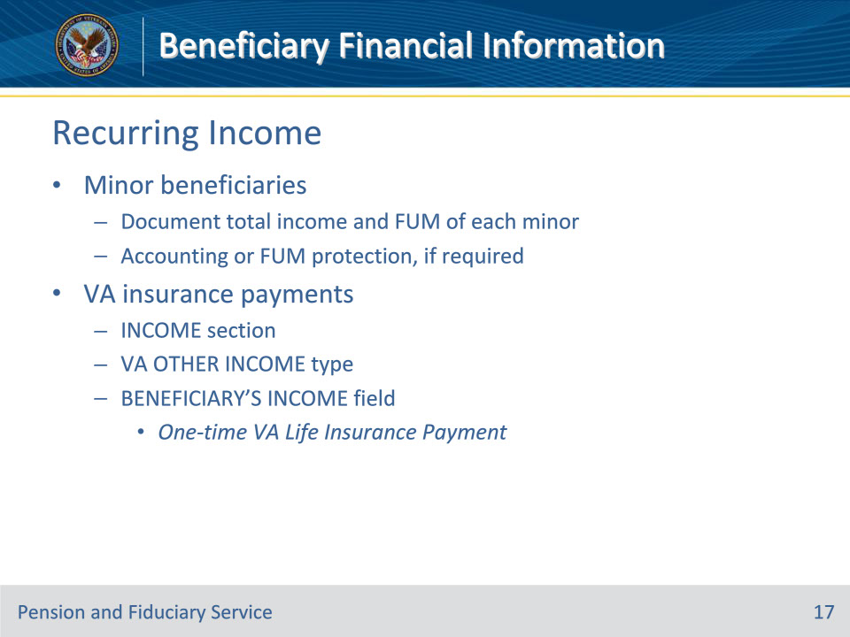
Slide notes

Policy Reference(s): FPM I.2.C.3.f.

Instructor Notes:For minor beneficiaries, the field examination must document the total income and FUM of each minor. The FE must also document the need for an annual accounting or protection of the FUM, if required.

The INCOME section is intended for recording recurring income, except for VA insurance payments. Within the INCOME section, utilize the VA OTHER INCOME type and enter the following within the BENEFICIARY’S INCOME field: One-time VA Life Insurance Payment.

Slide 18 - Non-Liquid Assets
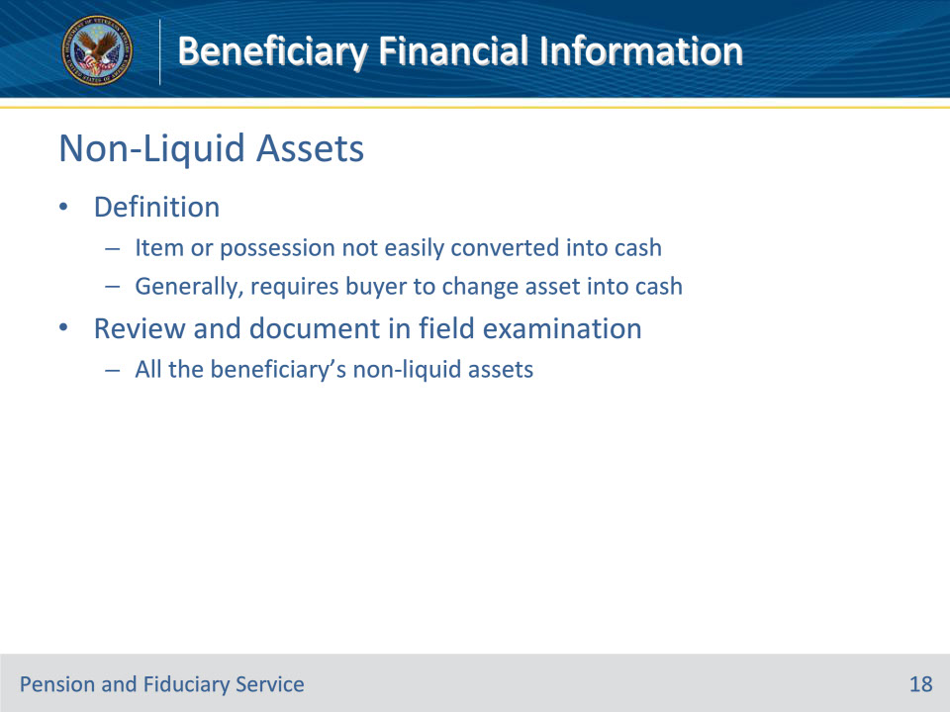
Slide notes

Policy Reference(s): FPM I.2.C.3.g.

Instructor Notes:The FE must review and document in the field examination all the beneficiary’s non-liquid assets. A non-liquid asset is an item or possession not easily converted into cash and generally requires the buyer to change the asset into cash.

Slide 19 - Non-Liquid Assets
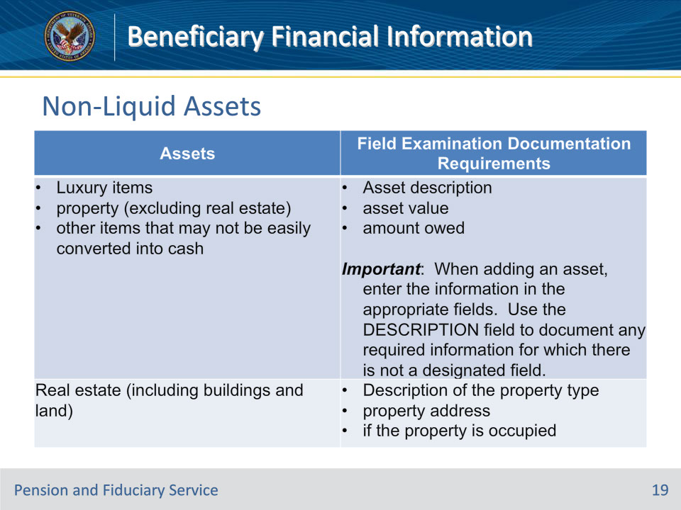
Slide notes

Policy Reference(s): FPM I.2.C.3.g.

Instructor Notes:

This table provides information on non-liquid assets and documentation requirements.

Slide 20 - Expenses
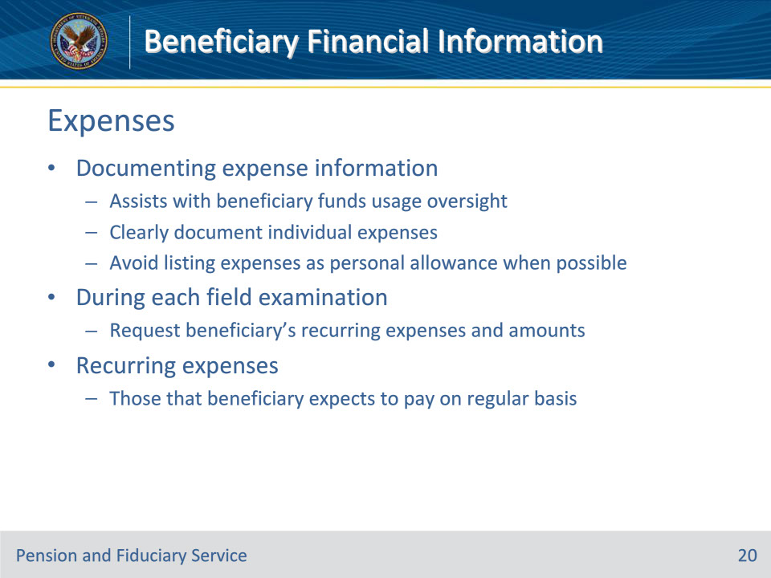
Slide notes

Policy Reference(s): FPM I.2.C.3.h.

Instructor Notes:Documenting expense information during the IA or SIA assists with oversight of the use of beneficiary funds during follow-up field examinations, accounting and fund usage reviews, and other VA fiduciary oversight activities. Therefore, FEs must make efforts to clearly document individual expenses and avoid listing expenses as personal allowance when individual expense types are known.

During each field examination, the FE must request the beneficiary’s recurring expenses and the amounts of those expenses. Recurring expenses are those that the beneficiary can expect to pay on a regular basis (for example, monthly, quarterly, or annually).

Slide 21 - Expenses
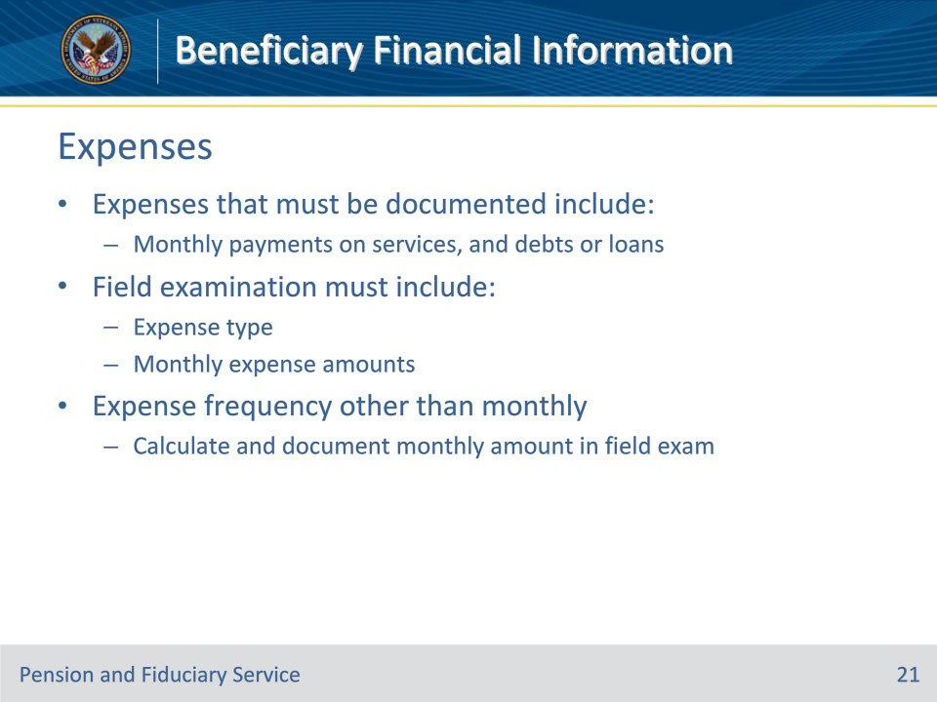
Slide notes

Policy Reference(s): FPM I.2.C.3.h.

Instructor Notes:Expenses that must be documented include, but are not limited to monthly payments on services, and debts or loans. The field examination must include

• expense type (for example, mortgage, including a mortgage backed by VA Home Loan, groceries, vehicle, electric, water, insurance, etc., using the company name, when available), and

• the monthly expense amounts.

If the frequency of the expense payment is other than monthly (for example, quarterly, or annually), the FE must calculate and document the monthly amount in the field examination.

Slide 22 - Expenses
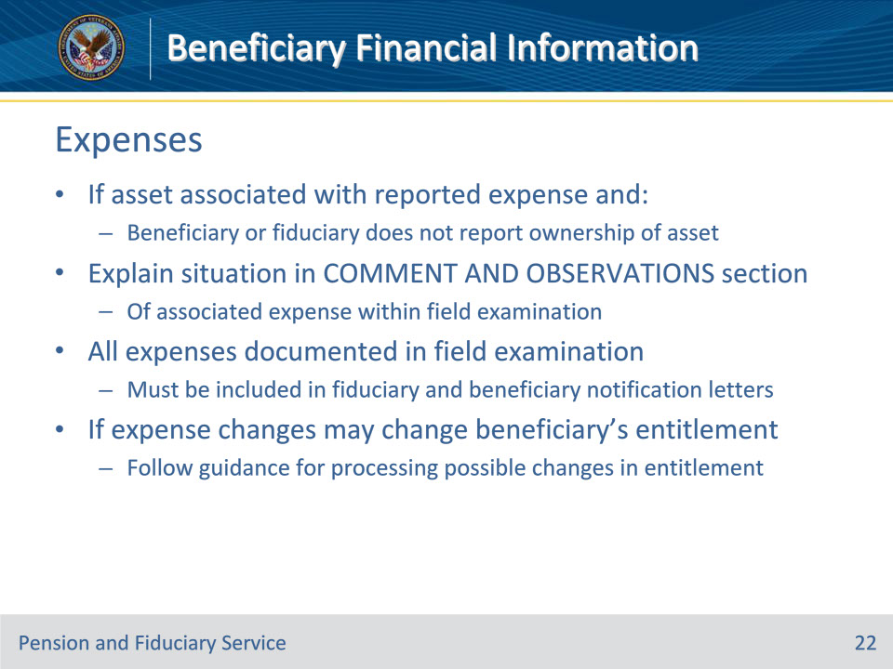
Slide notes

Policy Reference(s): FPM I.2.C.3.h.

Instructor Notes:

If the beneficiary or fiduciary reports expenses but does not report ownership of the asset associated with expenses reported, the FE must explain the situation in the COMMENT AND OBSERVATIONS section of the associated expense within the field examination.

All expenses documented in the field examination must be included in the fiduciary and beneficiary notification letters.

If there are changes in expenses, such as unreimbursed medical expenses, that may change the beneficiary’s entitlement to VA benefits, follow the guidance for possible changes in entitlement.

Slide 23 - Expenses
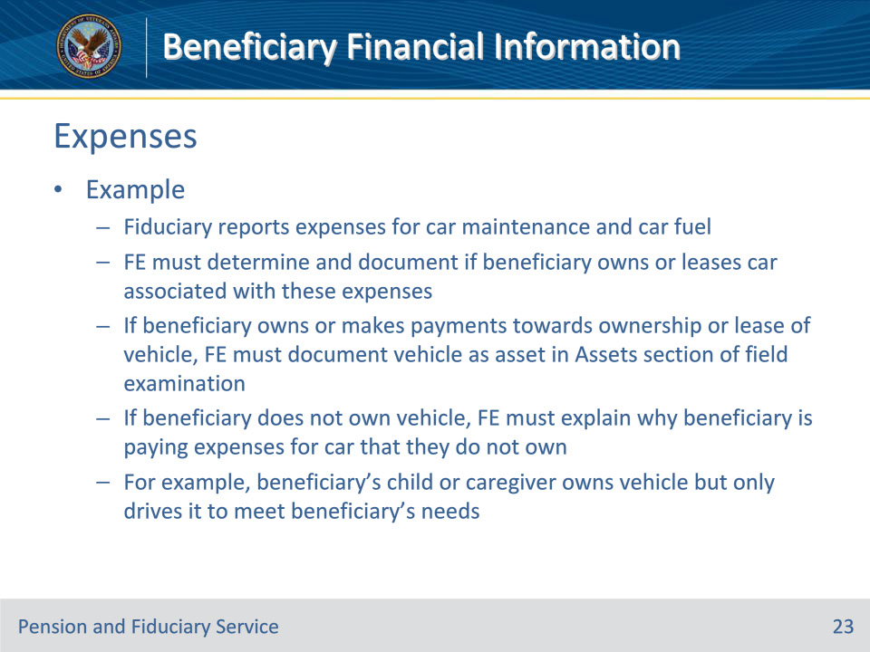
Slide notes

Policy Reference(s): FPM I.2.C.3.h.

Instructor Notes:Example: The fiduciary reports expenses for car maintenance and car fuel. The FE must determine and document if the beneficiary owns or leases a car associated with the car and fuel expenses.

• If the beneficiary owns, or makes payments towards ownership or the lease of the vehicle, the FE must document the vehicle as an asset in the Assets section of the field examination.

• If the beneficiary does not own the vehicle, the FE must explain why the beneficiary is paying expenses for the car that the beneficiary does not own or is not shown to make regular payments for their use/benefit (for example, the beneficiary’s child or caregiver owns the vehicle but only drives it to meet beneficiary’s needs).

Slide 24 - Expenses for Minors
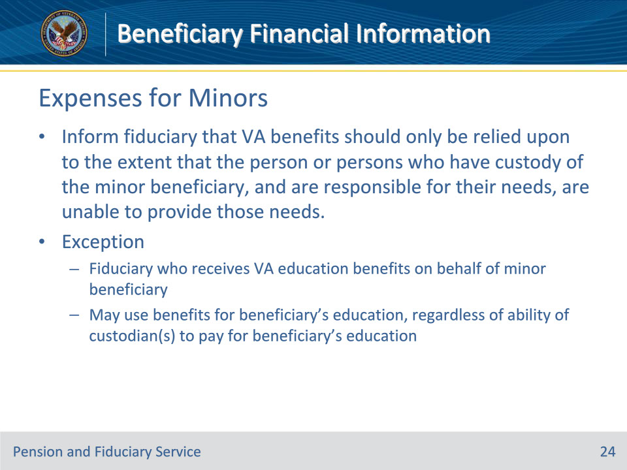
Slide notes

Policy Reference(s): FPM I.2.C.3.i.

Instructor Notes:In accordance with 38 CFR 13.240, the FE must inform the fiduciary that VA benefits should only be relied upon to the extent that the person or persons who have custody of the minor beneficiary, and are responsible for their needs, are unable to provide those needs.

Exception: A fiduciary who receives VA education benefits on behalf of a beneficiary who is less than the age of majority may use the benefits for the beneficiary’s education, regardless of the ability of the custodian(s) to pay for the beneficiary’s education.

Note: There is no requirement for the FE to document this discussion within the field examination.

Slide 25 - Expenses for Minors
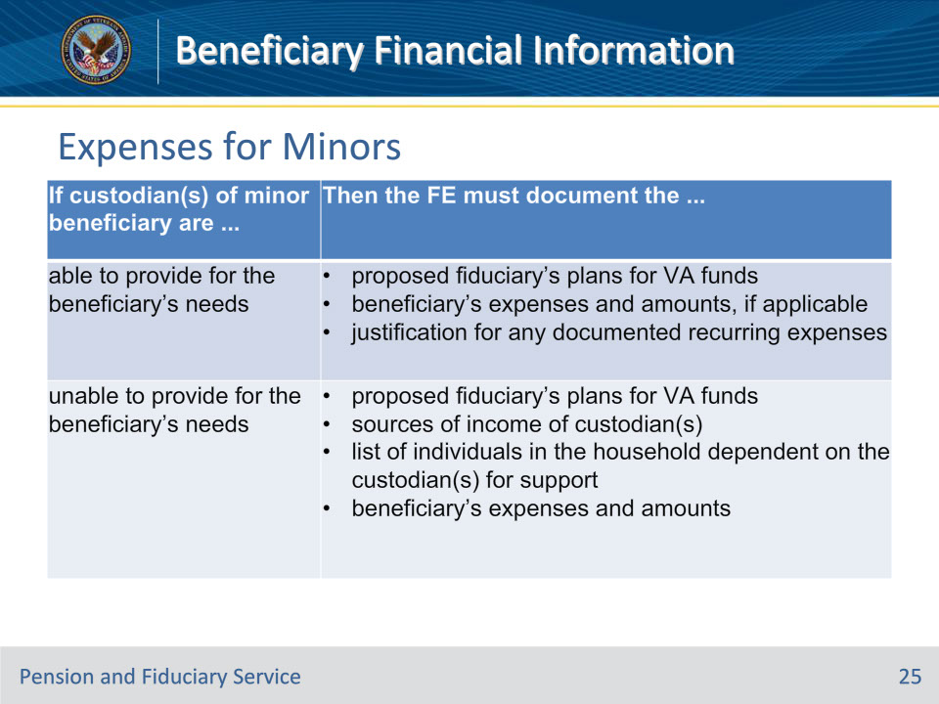
Slide notes

Policy Reference(s): FPM I.2.C.3.i.

Instructor Notes:

Use this table to determine the expense information that must be documented in the field examination for a minor beneficiary.

Slide 26 - Expenses for Minors
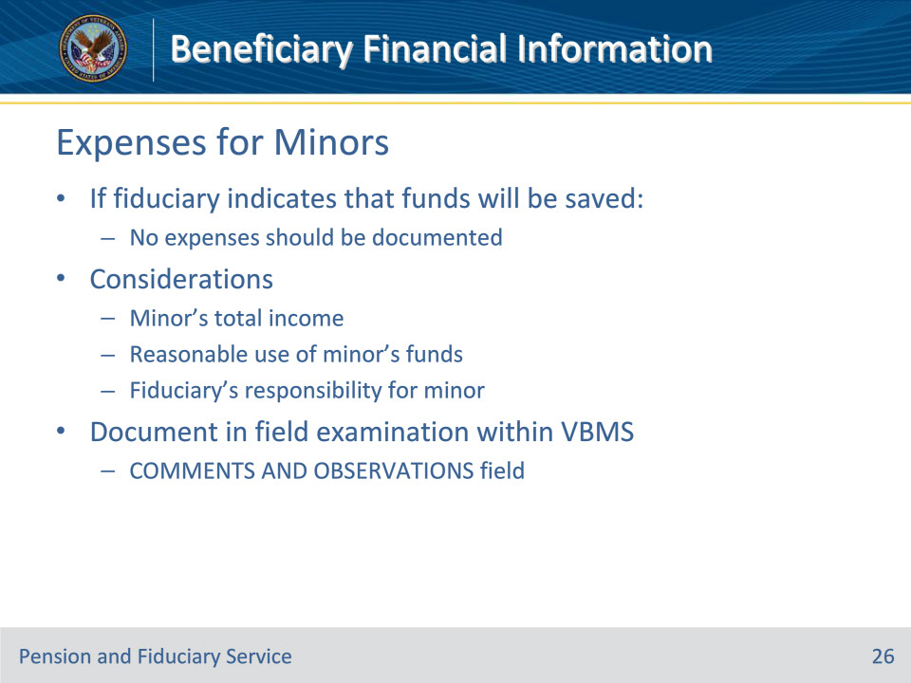
Slide notes

Policy Reference(s): FPM I.2.C.3.i.

Instructor Notes:

• If the fiduciary indicates that funds will be saved, no expenses should be documented.

• When documenting expenses for a minor beneficiary, matters for consideration include, but are not limited to, the minor’s total income, reasonable use of the minor’s funds, and the fiduciary’s responsibility for the minor.

• All documentation requirements must be reflected in the field examination within VBMS. FEs may utilize the COMMENTS AND OBSERVATIONS field within the field examination.

Slide 27 - VA Debts
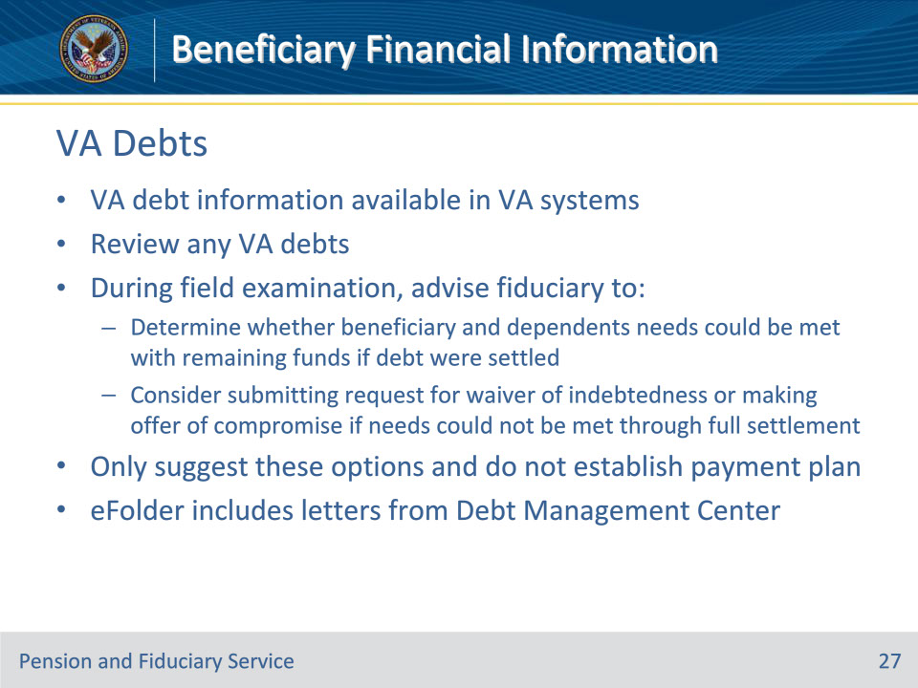
Slide notes

Policy Reference(s): FPM I.2.C.3.k.

Instructor Notes:

VA debt information is available in VA systems. The FE must review any VA debts and during the field examination advise the fiduciary to

• determine whether the needs of the beneficiary and dependents could be met with the remaining funds if the debt were settled, and/or

• consider submitting a request for a waiver of the indebtedness or making an offer of compromise if the needs could not be met through full settlement of the debt.

The FE may only suggest these as options and should not establish a payment plan.

Note: The eFolder includes notification letters from the Debt Management Center.

Slide 28 - VA FUM
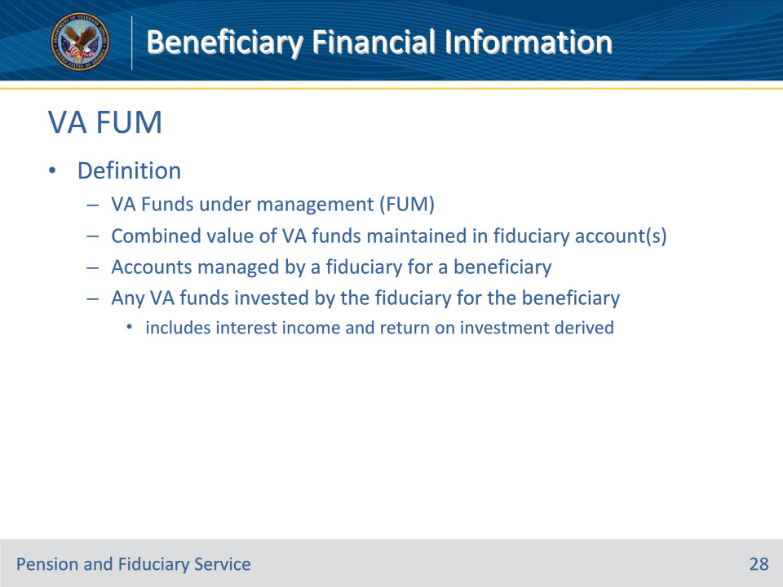
Slide notes

Policy Reference(s): FPM I.2.C.3.l.

Instructor Notes:FUM means the combined value of the VA funds maintained in a fiduciary account or accounts managed by a fiduciary for a beneficiary and any VA funds invested by the fiduciary for the beneficiary, to include any interest income and return on investment derived from any account

Slide 29 - IA/EIA FUM
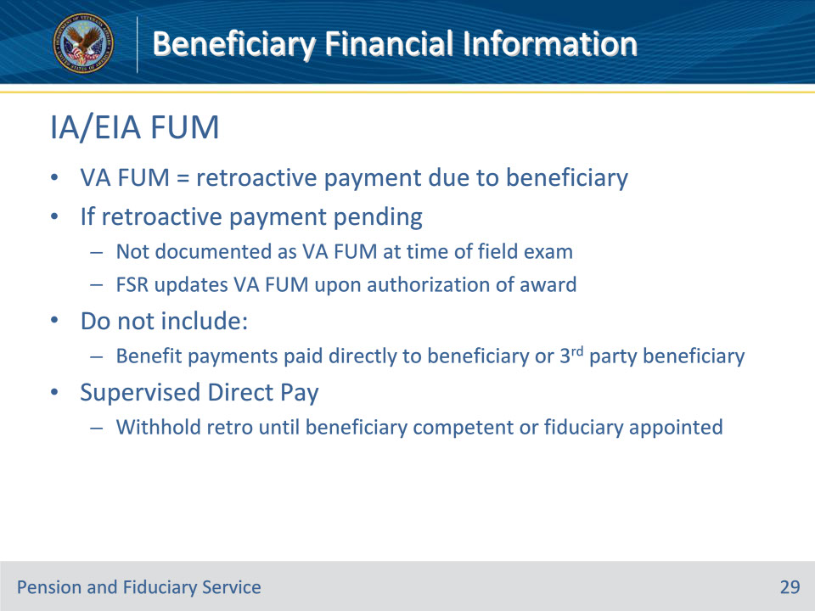
Slide notes

Policy Reference(s): FPM I.2.C.3.l.

Instructor Notes:

If the field examination type is an IA/EIA, then the VA FUM is the retroactive payment due to the beneficiary, if any, upon release to the fiduciary. If a retroactive payment is pending, the retroactive payment is not documented as VA FUM at the time of the field examination conducted by the FE. The Fiduciary Service Representative will update VA FUM within the beneficiary profile to reflect the amount of the retroactive payment released to the fiduciary immediately upon authorization of the award.

Determining VA FUM during an IA/EIA shall not include any regular or irregular benefit payments which are paid directly to a beneficiary or to a third-party beneficiary other than the potential fiduciary. This includes all non-VA benefits, as well as VA benefits which are structured to provide payments for specific expenses (for example, clothing expenses, education benefit, specially adapted housing/special home adaptation grants, automobile grants, etc.) which are not paid directly to the fiduciary. Any determination of VA FUM following an IA/EIA shall include any VA benefits deposited within a properly titled account managed by an existing or previous fiduciary.

When VA appoints a beneficiary under SDP, retroactive funds are withheld until the beneficiary is rated competent or a fiduciary is appointed. As a result, retroactive funds are not considered FUM upon authorization of an SDP award.

Slide 30 - SIA FUM
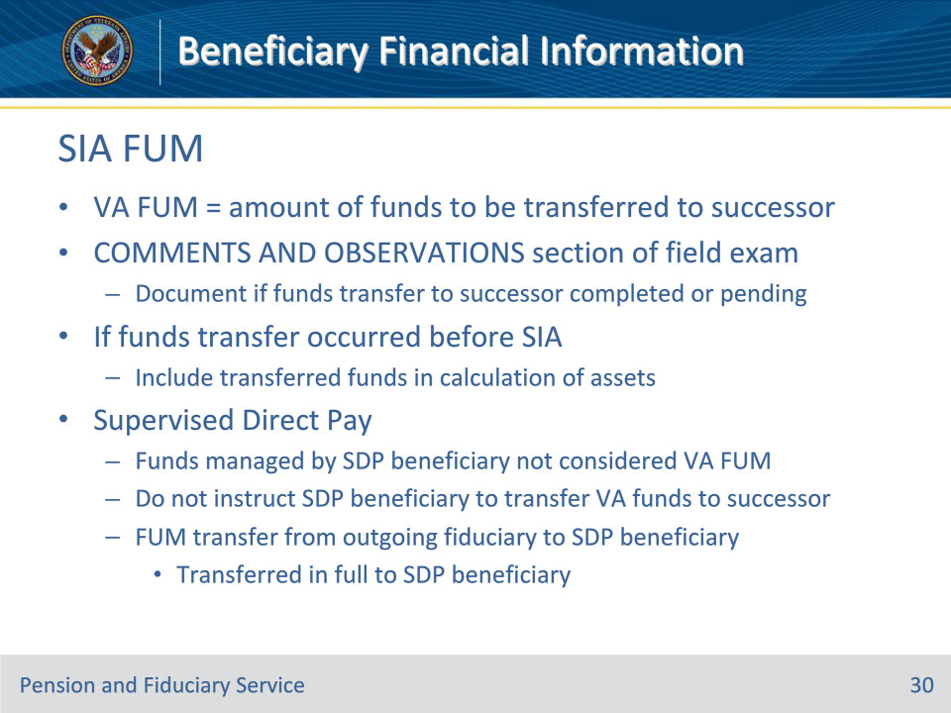
Slide notes

Policy Reference(s): FPM I.2.C.3.l.

Instructor Notes:

If the field examination type is an SIA, then the VA FUM is the amount of funds to be transferred to the appointed successor fiduciary or beneficiary with an SDP appointment.

The field examination must also document in the COMMENTS AND OBSERVATIONS section of the report if the funds transfer to the successor fiduciary has been completed or is pending. If the funds transfer has occurred before the SIA, include the transferred funds in the calculation of assets. The field examination may not be submitted for closure without documenting the status of the funds transfer.

Funds managed directly by a beneficiary under an SDP appointment are not considered VA FUM. Therefore, the hub should not instruct the beneficiary under an SDP appointment to transfer VA funds when VA appoints a fiduciary because SDP is no longer appropriate.

The hub must not consider FUM that is being transferred from an outgoing fiduciary appointed by VA to the beneficiary with an SDP appointment as a retroactive or one-time payment subject to withholding. The outgoing fiduciary must transfer all FUM to the beneficiary when the beneficiary receives an SDP appointment.

Slide 31 - FUM protection
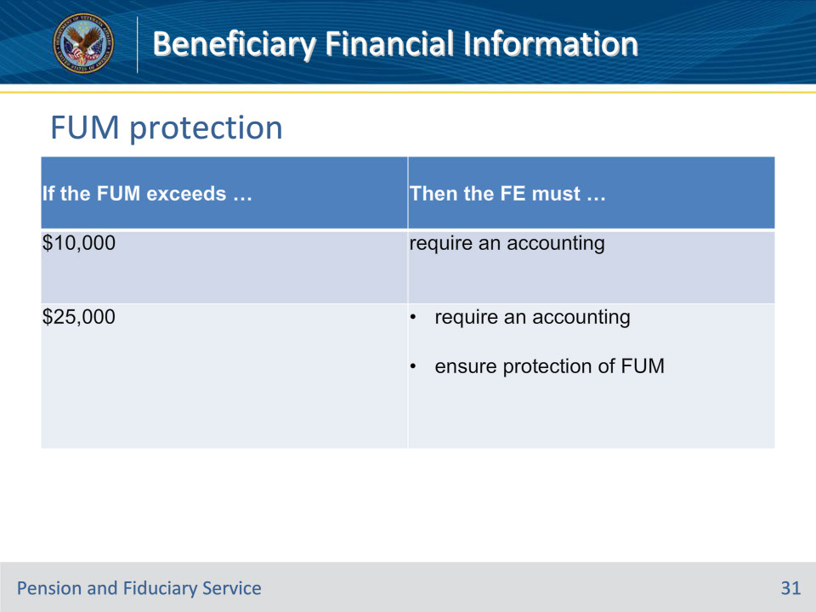
Slide notes

Policy Reference(s): FPM I.2.C.3.m.

Instructor Notes:Use this table to determine the appropriate actions if the FUM exceeds the limits for accounting and protection of FUM limits.

Slide 32 - Guidelines for Minors
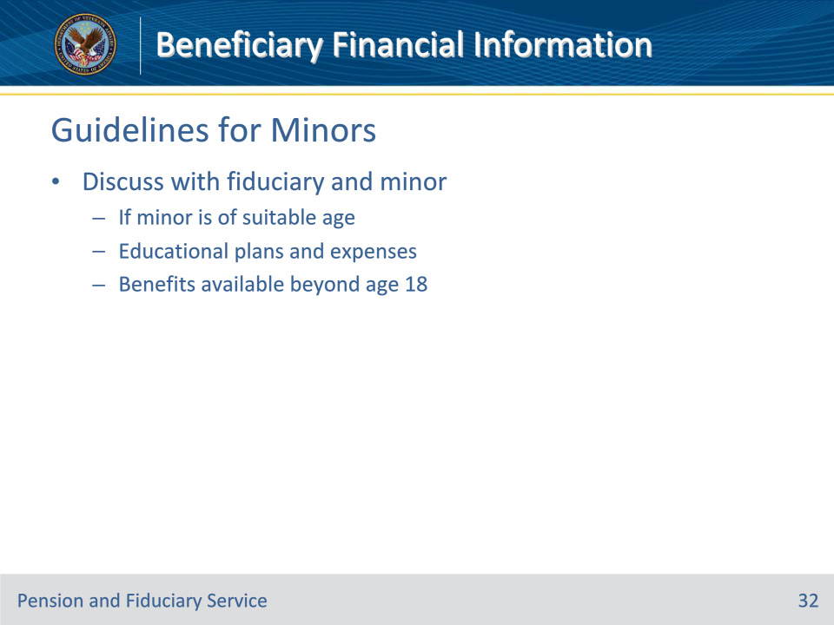
Slide notes

Policy Reference(s): FPM I.2.C.3.q.

Instructor Notes:

The FE must discuss with the fiduciary and minor, if the minor is of a suitable age, information regarding

• educational plans and expenses, and

• benefits available beyond age 18 based upon school attendance, including Dependents’ Educational Assistance, VA pension, and benefits from other State and/or Federal agencies.

There is no requirement to document this discussion within the field examination.

Slide 33 - Questions?
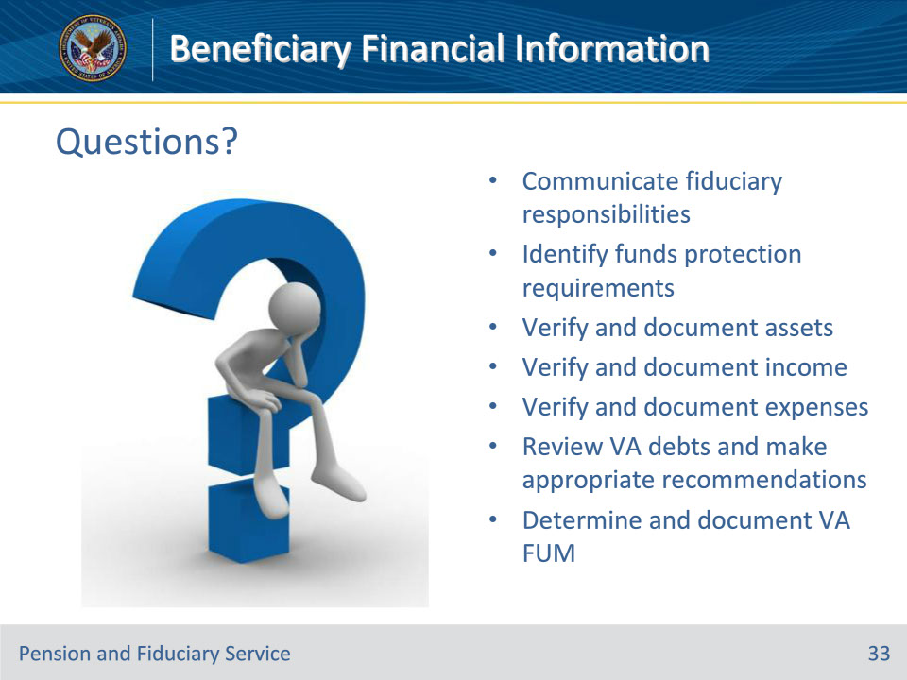
Slide notes

Instructor Notes:

(Recall) These are our learning objectives as stated from the beginning of the training:

• Communicate fiduciary responsibilities

• Identify funds protection requirements

• Verify and document assets

• Verify and document income

• Verify and document expenses

• Review VA debts and make appropriate recommendations

• Determine and document VA FUM

Are there any additional questions?

Questions should be filtered through your QRT team. They will submit your questions to the Field Inquiry Tool (FIT) on your behalf.

Slide 34 - TMS Survey/Assessment
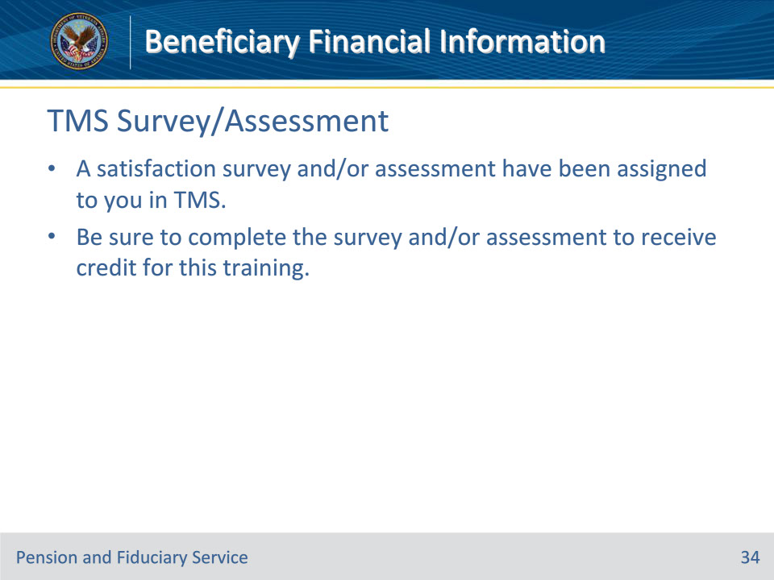
Slide notes

Instructor Notes:

A satisfaction survey and/or assessment have been assigned to you in TMS.

Be sure to complete the survey and/or assessment to receive credit for this training.

