Slide 1 - Overview of Quality Review Team (QRT) Individual Quality Reviews (IQRs)
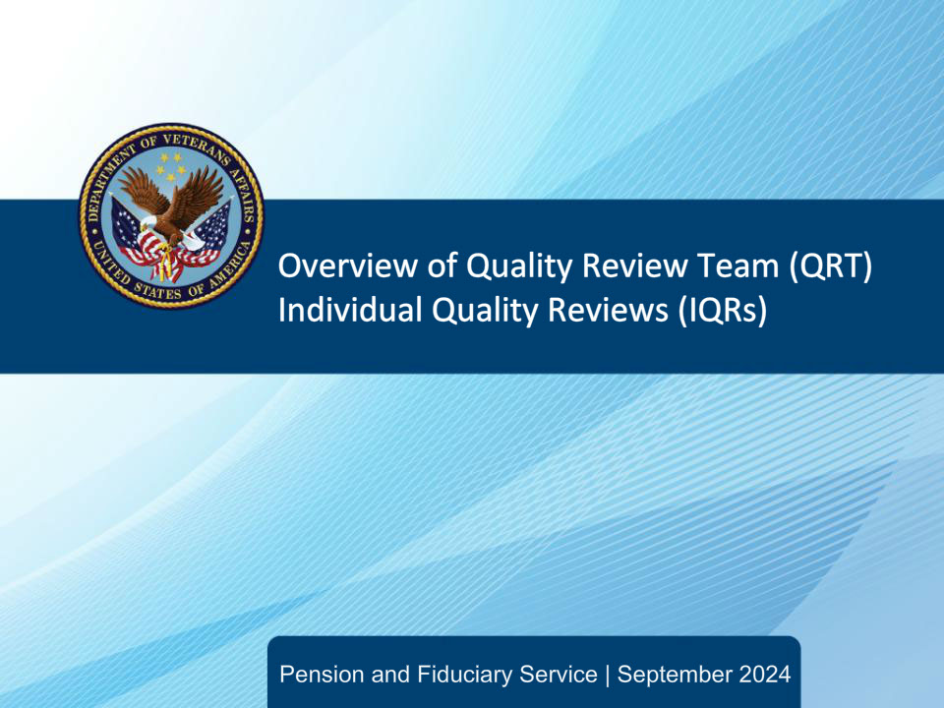
Slide notes

The purpose of this lesson is to provide learners with guidance on the Quality Review Team Individual Quality Reviews process.

Slide 2 - Objectives
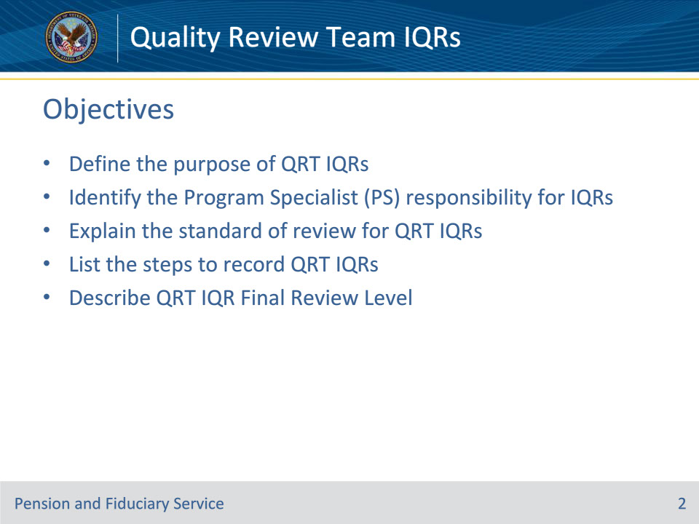
Slide notes

Instructor Notes:

By the end of this lesson, given the training and reference, the student will be able to do the following:

• Define the purpose of the QRT IQRs

• Identify the Program Specialist responsibility for IQRs

• Explain the standard review for QRT IQRs

• List the steps to record QRT IQRs

• Describe QRT IQR Final Review Level

Slide 3 - References
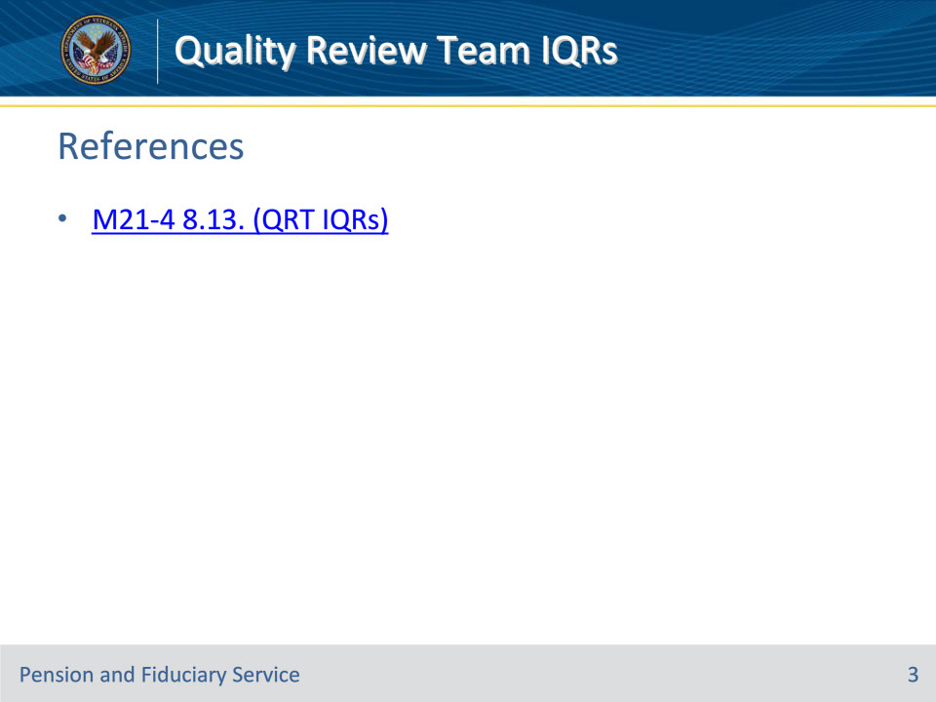
Slide notes

Instructor Notes:

These are the relevant references pertaining to this training:

M21-4, 8.13.a-e.

Slide 4 - Purpose of QRT IQRs
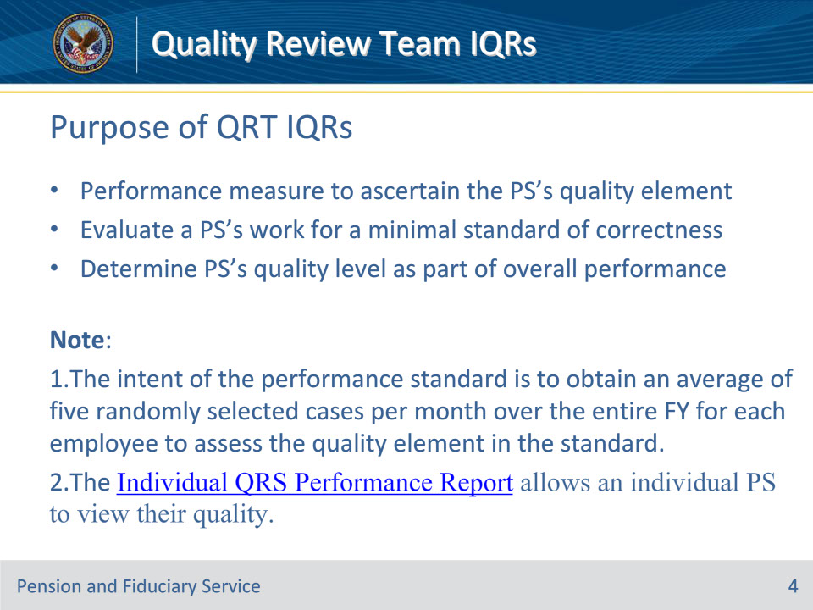
Slide notes

Policy Reference: M21-4, 8.13.a.

Instructor Notes:

A review of the individual’s work is intended as a performance measure to ascertain the quality element in that individual’s performance standard.

A QRT IQR is intended to provide an evaluation of an individual PS’s work product to determine if the minimal standard for correctness has been met.

QRT IQRs are the review of five randomly-selected cases per month (on average) for the Program Specialist. This review determines the employee’s individual quality level as part of his or her overall performance evaluation.

Note that:

The intent of the performance standard is to obtain an average of five per month over the entire FY for each employee to assess the quality element in the standard.

The Individual QRS Performance Report allows an individual PS to view their quality.

Slide 5 - PS IQRs Responsibilities
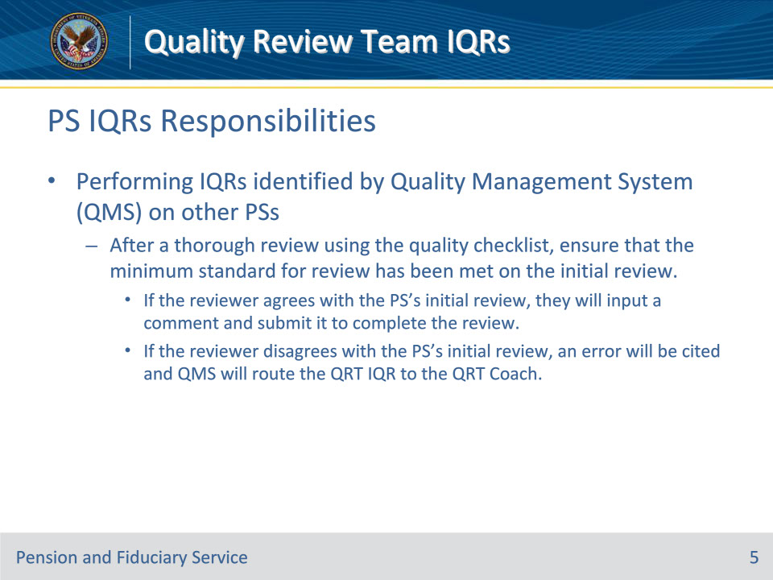
Slide notes

Policy Reference: M21-4, 8.13.b-d.

Instructor Notes:

PSs are responsible for performing IQRs identified by the Quality Management System (QMS) on other PSs. After a thorough review using the quality checklist, ensure that the minimum standard for review has been met on the initial review. If the reviewer agrees with the PS’s initial review, they will input a comment and submit it to complete the review. If the reviewer disagrees with the PS’s initial review, an error will be cited and QMS will route the QRT IQR to the QRT Coach.

Slide 6 - Review Criteria for IQRs
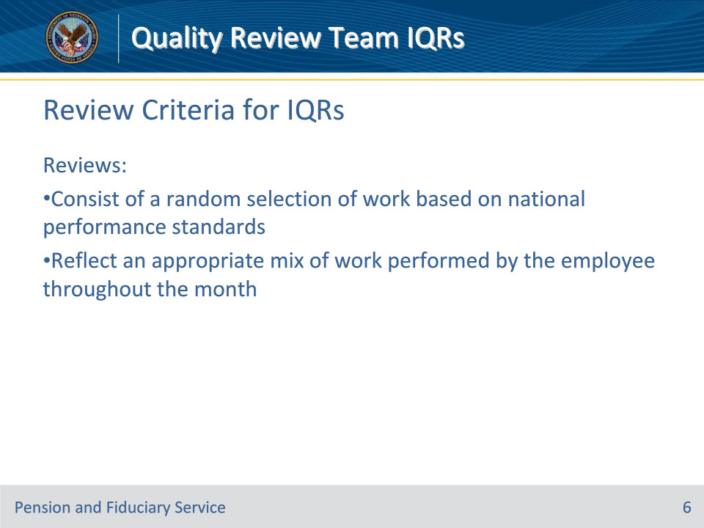
Slide notes

Policy Reference: M21-4, 8.13.c.

Instructor Notes:

These reviews will consist of a random selection of work, based on the amount set forth in the national performance standards. The selection of actions, while random, will reflect an appropriate mix of work performed by the employee throughout the month (i.e., not from a single day or single week).

Slide 7 - Standard of review for QRT IQRs
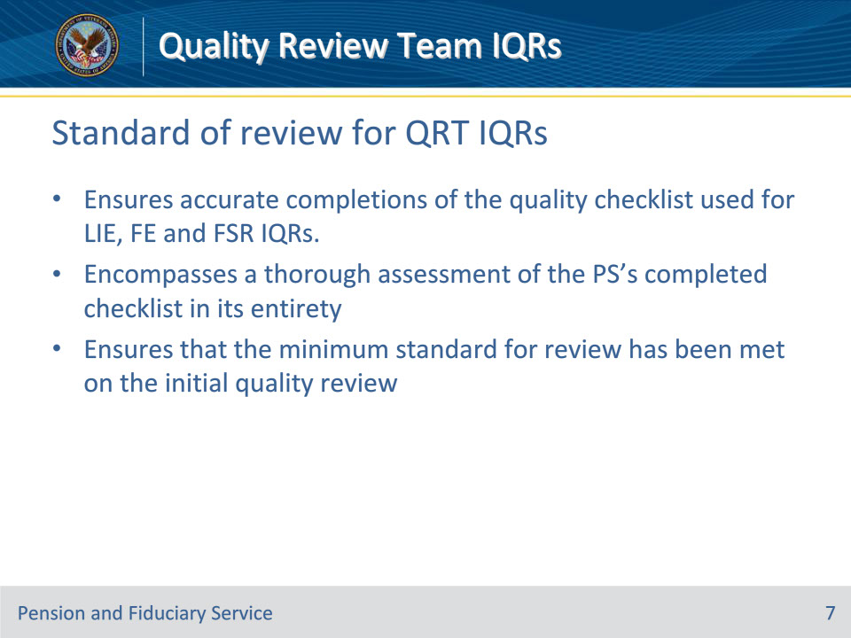
Slide notes

Policy Reference: M21-4, 8.13.c.

Instructor Notes:

The standard of review for QRT IQRs is to ensure accurate completions of the quality checklist used for LIE, FE and FSR IQRs. The QRT IQR will encompass a thorough assessment of the PS’s completed checklist in its entirety to ensure that the minimum standard for review has been met on the initial quality review which includes proper selection of yes, no, or N/A on the checklist task questions.

Slide 8 - Standard of review for QRT IQRs
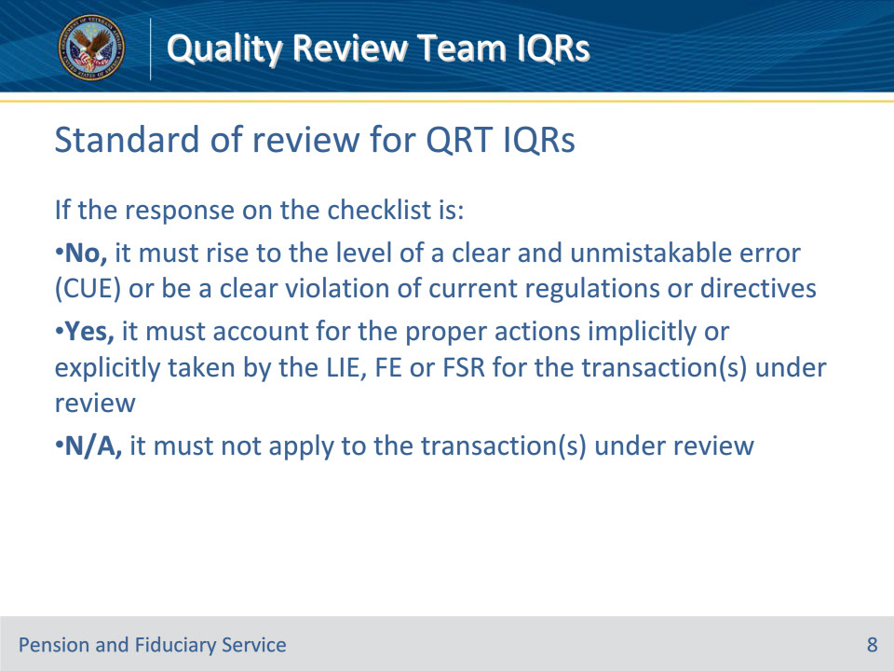
Slide notes

Policy Reference: M21-4, 8.13.c.

Instructor Notes:

If the response on the checklist is

• No it must rise to the level of a CUE(a clear and unmistakable error) or be a clear violation of current regulations or directives

• Yes it must account for the proper actions implicitly or explicitly taken by the LIE, FE or FSR for the transaction(s) under review

• N/A it must not apply to the transaction(s) under review

Selecting the proper checklist responses to reflect the appropriate answer for each task is important to ensure the LIE, FE or FSR receives credit for work completed correctly or ensuring the employee does not receive undue credit for work not applicable to the transaction under review.

Slide 9 - Standard of review for QRT IQRs
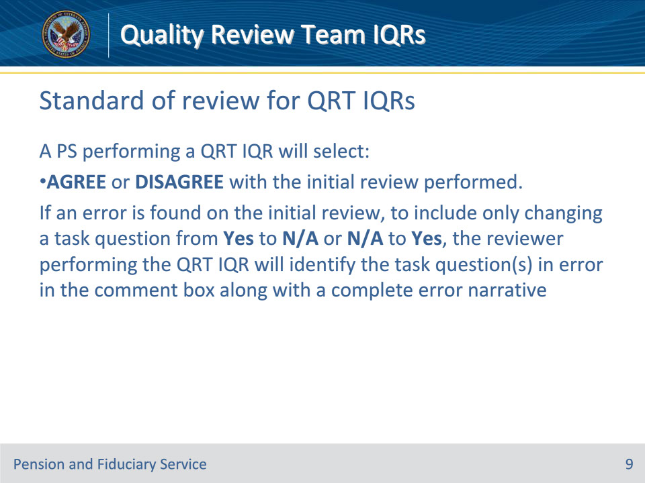
Slide notes

Policy Reference: M21-4, 8.13.c.

Instructor Notes:

A PS performing a QRT IQR will select either AGREE or DISAGREE with the initial review performed. If an error is found on the initial review, to include only changing a task question from yes to N/A or N/A to yes, the reviewer performing the QRT IQR will identify the task question(s) in error in the comment box along with a complete error narrative.

Slide 10 - Standard of review for QRT IQRs
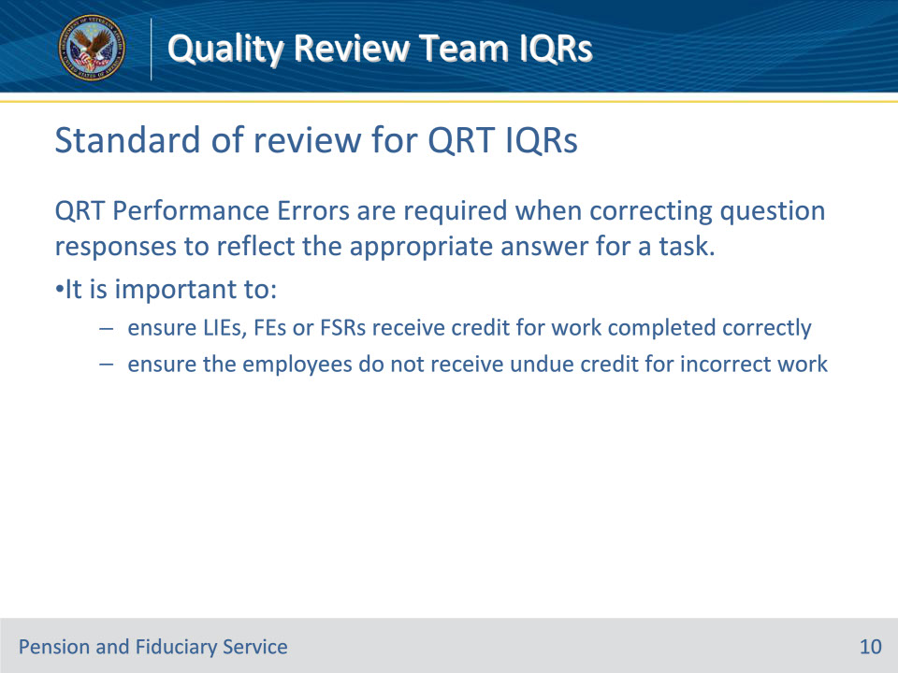
Slide notes

Policy Reference: M21-4, 8.13.c.

Instructor Notes:

QRT Performance Errors are required when correcting question responses to reflect the appropriate answer for a task because it is important to ensure LIEs, FEs or FSRs receive credit for work completed correctly or to ensure the employees do not receive undue credit for work not applicable to the transaction(s) under review.

Slide 11 - Example 1:
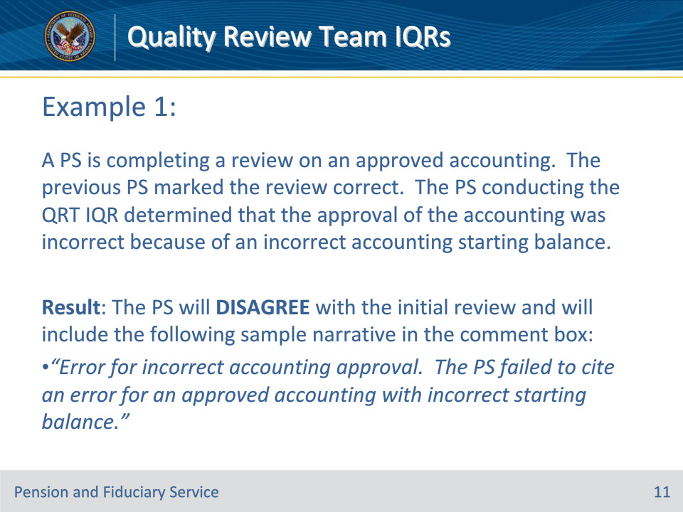
Slide notes

Policy Reference: M21-4, 8.13.c.

Instructor Notes:

Lets look at some examples.

Example 1: A PS is completing a review on an approved accounting. The previous PS marked the review correct. The PS conducting the QRT IQR determined that the approval of the accounting was incorrect because of an incorrect accounting starting balance. The PS will DISAGREE with the initial review and will include the following sample narrative in the comment box: Error for incorrect accounting approval. The PS failed to cite an error for an approved accounting with incorrect starting balance.

Slide 12 - Example 2:
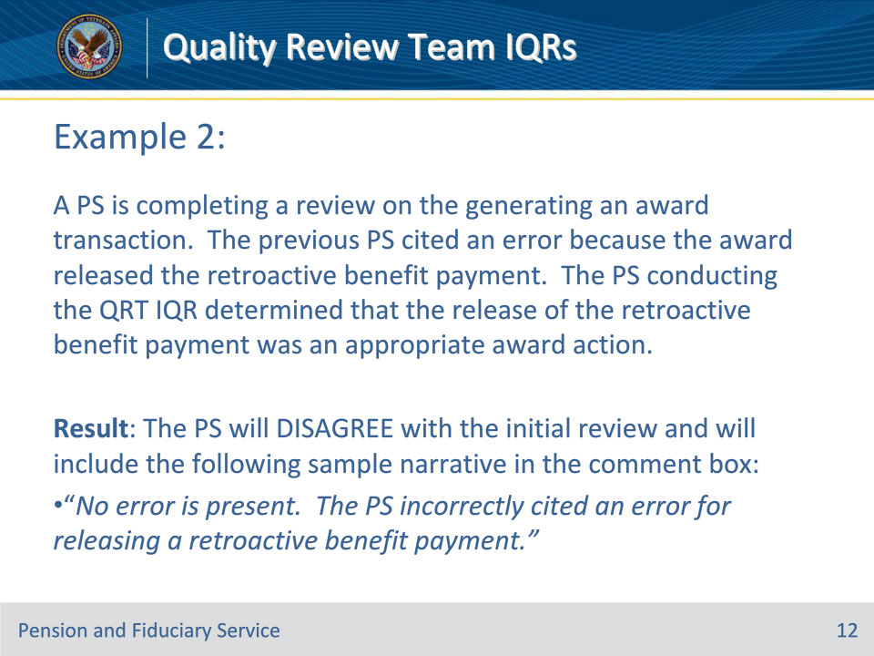
Slide notes

Policy Reference: M21-4, 8.13.c.

Instructor Notes:

Example 2: A PS is completing a review on the generating an award transaction. The previous PS cited an error because the award released the retroactive benefit payment. The PS conducting the QRT IQR determined that the release of the retroactive benefit payment was an appropriate award action. The PS will DISAGREE with the initial review and will include the following sample narrative in the comment box: No error is present. The PS incorrectly cited an error for releasing a retroactive benefit payment.

Slide 13 - Recording QRT IQRs
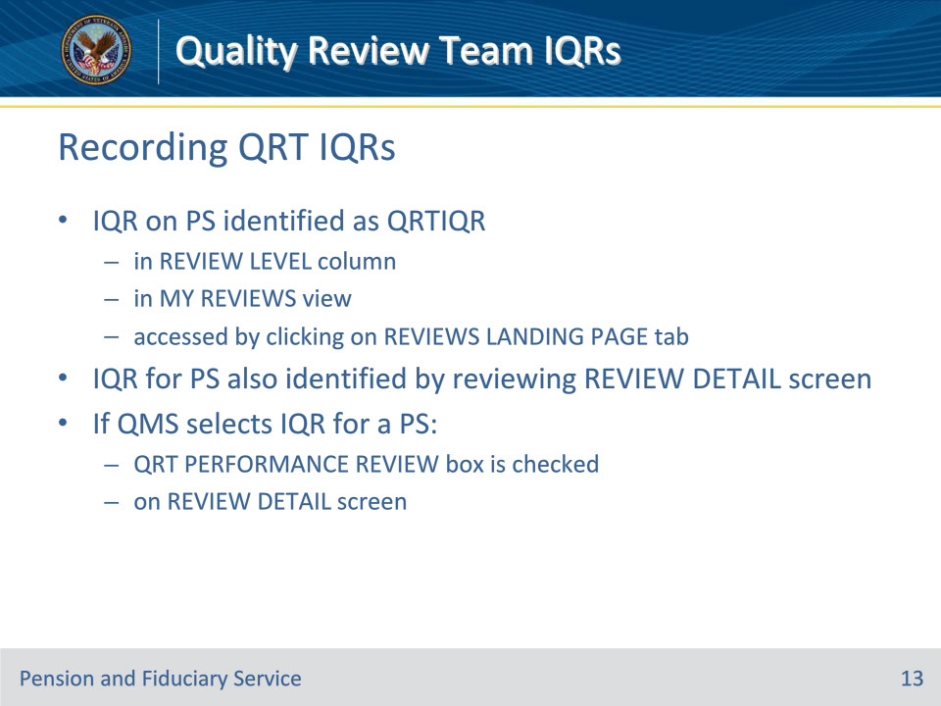
Slide notes

Policy Reference: M21-4, 8.13.d.

Instructor Notes:

An IQR on a PS is identified as QRTIQR in the REVIEW LEVEL column in the MY REVIEWS view, which can be accessed by clicking on the REVIEWS LANDING PAGE tab.

The IQR for a PS can also be identified by reviewing the REVIEW DETAIL screen.

If QMS selects an IQR for a PS, the QRT PERFORMANCE REVIEW box is checked on the REVIEW DETAIL screen.

Slide 14 - Recording QRT IQRs
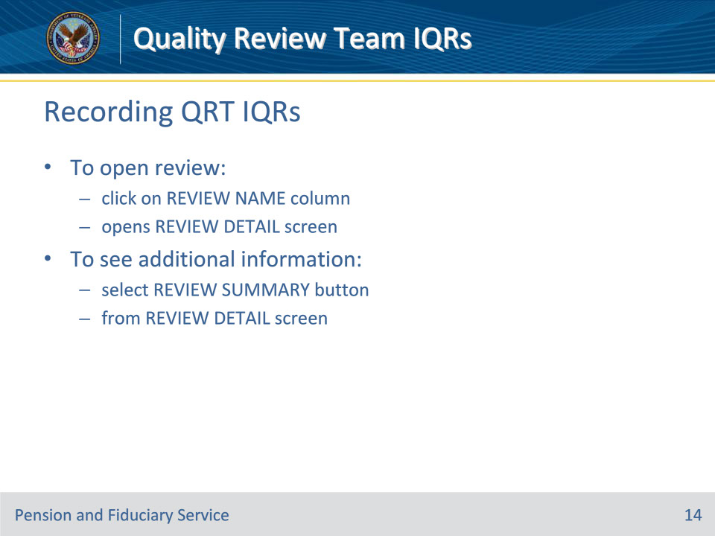
Slide notes

Policy Reference: M21-4, 8.13.d.

Instructor Notes:

To open the review, click on the REVIEW NAME column, which will open the REVIEW DETAIL screen. To see additional information, select the REVIEW SUMMARY button from the REVIEW DETAIL screen.

Slide 15 - Recording QRT IQRs
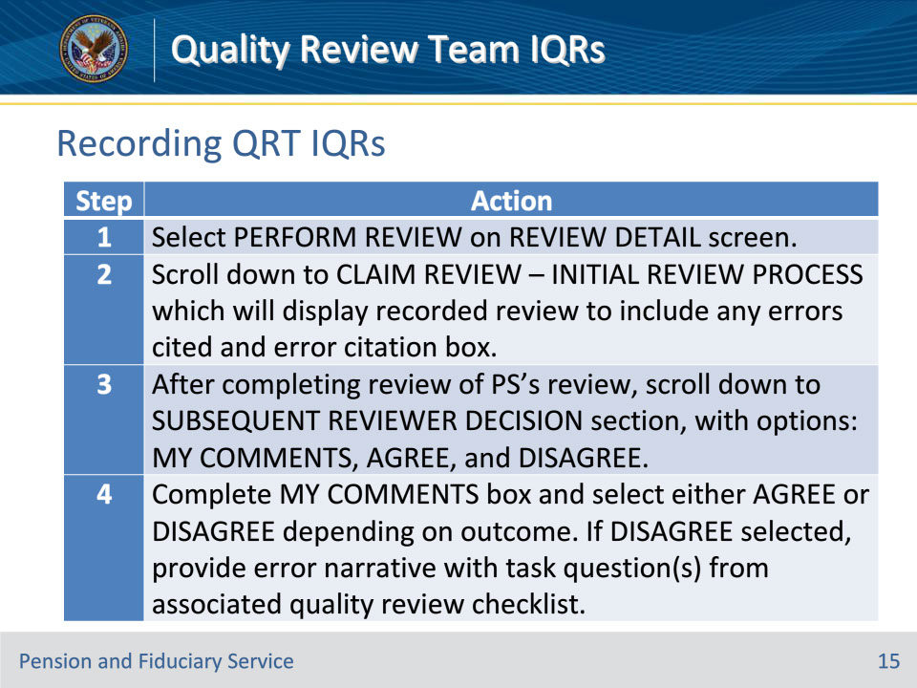
Slide notes

Policy Reference: M21-4, 8.13.d.

Instructor Notes:

Follow the steps in this table below to record a QRT IQRs.

Slide 16 - Recording QRT IQRs
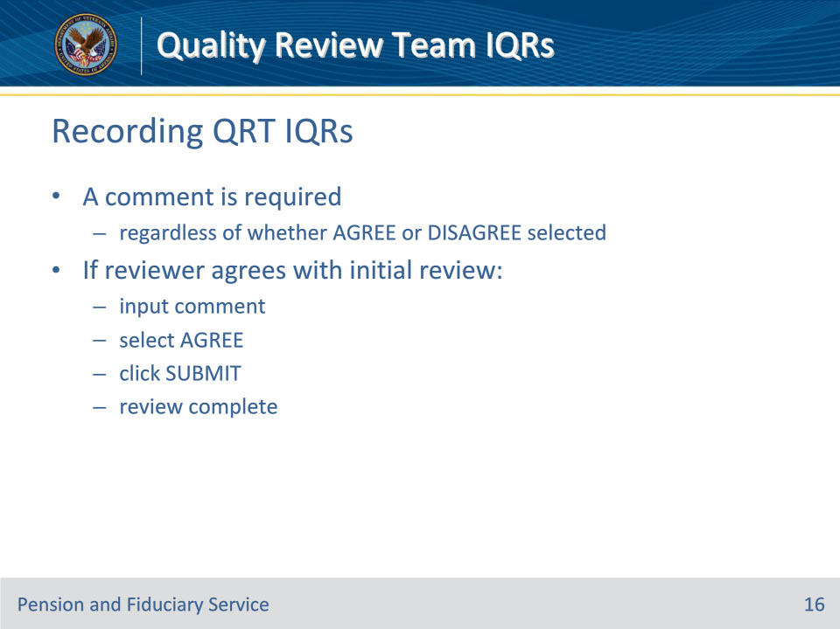
Slide notes

Policy Reference: M21-4, 8.13.d.

Instructor Notes:

A comment is required regardless of whether the AGREE or DISAGREE button is selected.

If the reviewer agrees with the PS’s initial review, they will input a comment, select the AGREE button, and click SUBMIT. Once the PS selects SUBMIT, the review is complete.

Slide 17 - Recording QRT IQRs
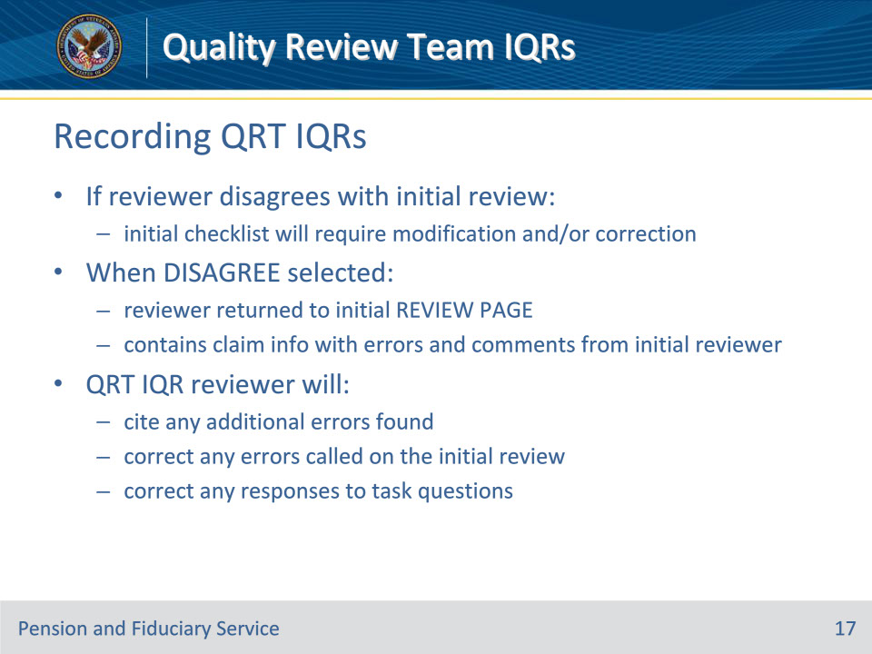
Slide notes

Policy Reference: M21-4, 8.13.d.

Instructor Notes:

If the reviewer disagrees with the PS’s initial review, the checklist completed during the initial review will require modification and/or correction. When the DISAGREE button is selected, the reviewer is returned to the initial REVIEW PAGE that contains the claim information with the error citations and comments provided by the initial reviewer. The QRT IQR reviewer will cite any additional errors found, correct any of the errors called on the initial review, and/or correct any responses to the task question(s).

Slide 18 - Recording QRT IQRs
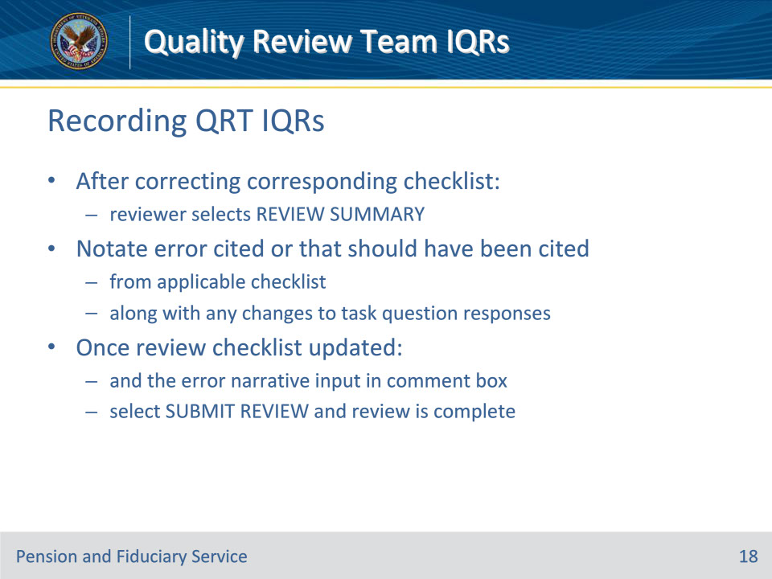
Slide notes

Policy Reference: M21-4, 8.13.d.

Instructor Notes:

After correcting the corresponding checklist, the reviewer selects the REVIEW SUMMARY button. The reviewer will also annotate the error that was cited or that should have been cited from the applicable checklist, along with any changes to task question responses. Once the review checklist is updated and the error narrative is input in the comment box, the reviewer will select SUBMIT REVIEW button and the review is complete.

For more information on QRT IQR routing rules and procedures, see the QMS User Guide in the QRT SharePoint site.

Slide 19 - QRT IQR Final Review Level
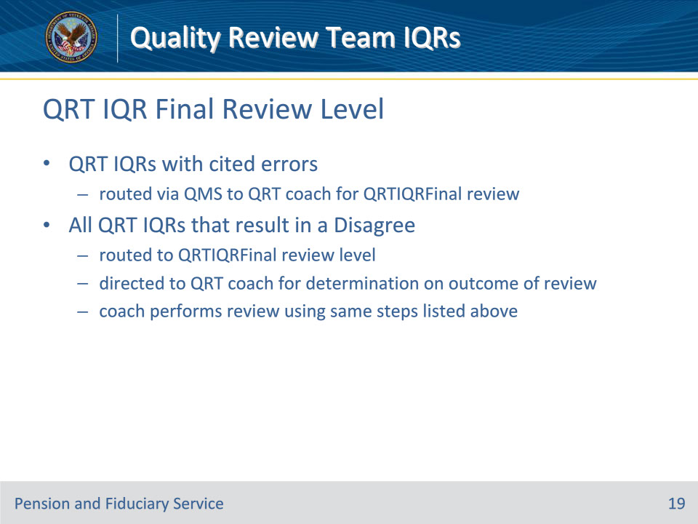
Slide notes

Policy Reference: M21-4, 8.13.e.

Instructor Notes:

QRT IQRs with cited errors will be routed via QMS to a QRT coach for QRTIQRFinal review.

All QRT IQRs that result in a Disagree are routed to the QRTIQRFinal review level. This level is directed to a QRT coach for their determination on the outcome of the review. The coach performs the review using the same steps listed above.

Important: If the coach is agreeing with the changes to the review made by the last individual that reviewed the case, this indicates the QRTIQRFinal individual is approving the changes and the disagreement indicated by the QRTIQR reviewer. A disagreement at the QRTIQRFinal level is used if the coach does not agree with the subsequent reviewer’s determination.

Note: QRTIQR reviews are a subsequent review of an initial review completed by a quality review specialist. If during the subsequent review, the reviewer disagrees with the initial review the review is routed to the QRT Coach as a QRTIQRFINAL for a final decision. Once the QRT Coach makes the decision to agree or disagree with the subsequent review, the review is then routed to the initial reviewer and allows them to agree or disagree with the QRTIQRFINAL decision. If the initial reviewer disagrees, the review is then returned to the QRT Coach and the QRT Coach will need to make a decision again. This cycle will continue until the QRT Coach and initial reviewer come to an agreement.

Slide 20 - Questions?
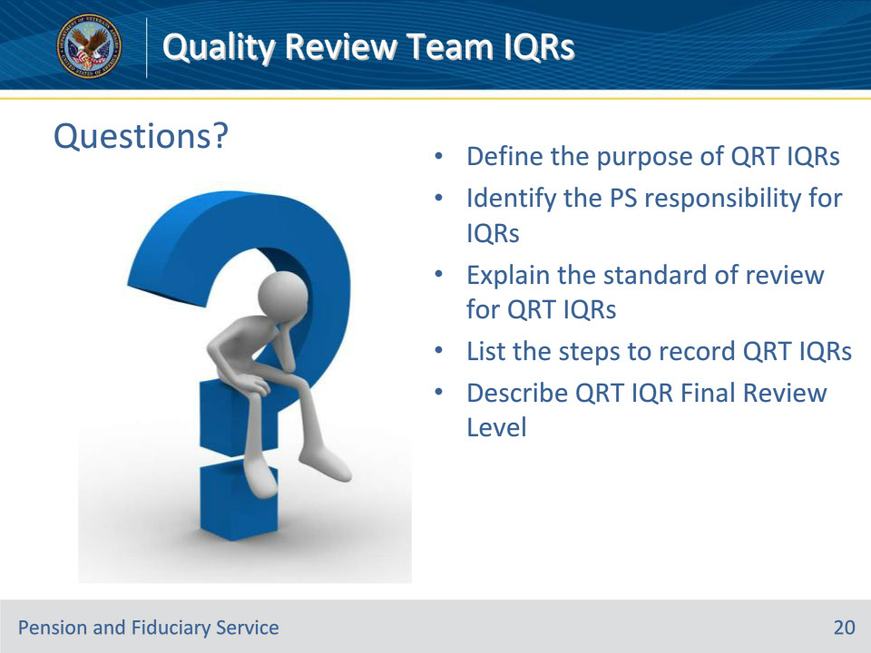
Slide notes

Instructor Notes:

(Recall) These are our learning objectives as stated from the beginning of the training:

• Define the purpose of QRT IQRs

• Identify the Program Specialist (PS) responsibility for IQRs

• Explain the standard of review for QRT IQRs

• List the steps to record QRT IQRs

• Describe QRT IQR Final Review Level

Are there any additional questions?

Questions should be filtered through your QRT team. They will submit your questions to the Field Inquiry Tool (FIT) on your behalf.

Slide 21 - TMS Survey/Assessment
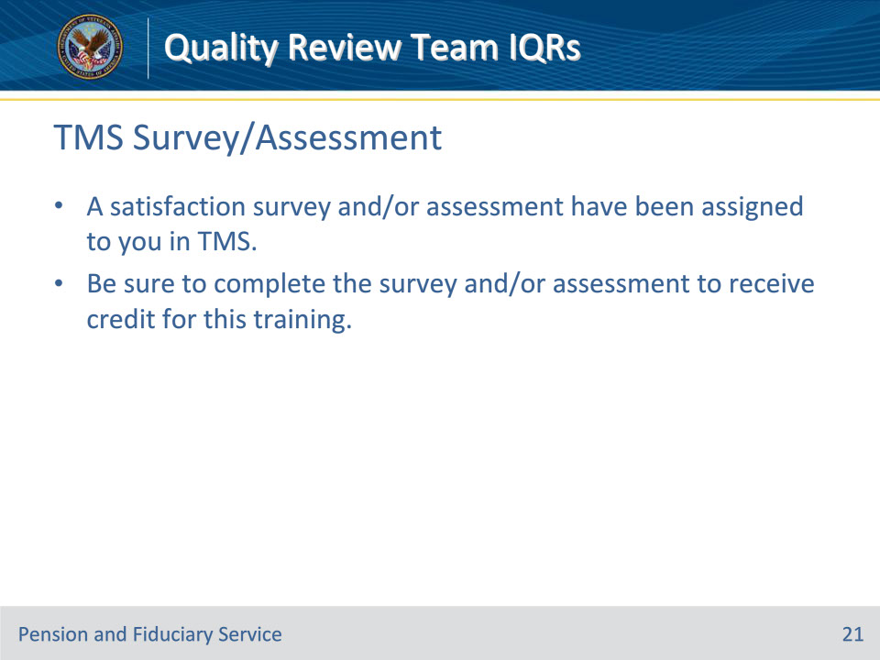
Slide notes

Instructor Notes:

A satisfaction survey and/or assessment have been assigned to you in TMS.

Be sure to complete the survey and/or assessment to receive credit for this training.

