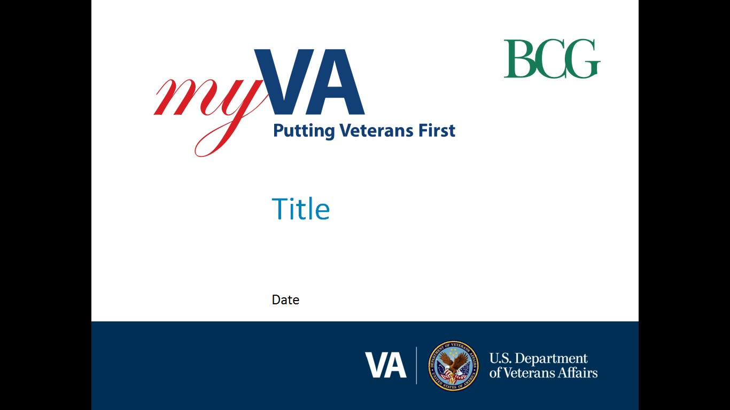

**Pension and Fiduciary (P&F) Service**

|  |  |
| --- | --- |
| Fiduciary Quality Call | Date: February 28, 2023TMS: # VA 4640155 |

|  |  |
| --- | --- |
| AGENDA TOPICS ITEM 1: Fiduciary Quality Error Trend Analysis  ITEM 2: Update on Step-by-Step Quality Review Guidelines  ITEM 3: Quality Coalition Group Update  ITEM 4: VA Form 21-555 Form Certification to Receive and Disburse Benefits and Fee Authorization  ITEM 5: Special Focus Review on Field Examination Compliance  Q&A  ITEM 6: Interactive Discussion on Annual Written Contact  Closing & Next Quality Call |  |

# AGENDA ITEMS

|  |  |  |  |
| --- | --- | --- | --- |
| Agenda item: | Fiduciary Quality Error Trend Analysis | Presenter: | Alvin Hill, Analyst |

#### Target Audience:

#### Quality Review Team (QRT) Program Specialists and Coaches/Assistant Coaches

#### Discussion:

**Accounting**

During the review period of December 2022 through January 2023, a total of 47 errors were found resulting in 18 being critical in 13 unique cases that impact individual hub and overall national quality. The remaining 29 errors were non-critical and do not impact national quality. There were three consistently reoccurring questions that were the primary Financial Review errors found during the quarter.

The three most cited errors are outlined in the following chart:

|  |  |
| --- | --- |
| **Error Title** | **Error Description** |
| NFAQR1a | The beginning and/or ending date of the next accounting period was not correct. |
| NFAQR13a | The accounting was approved without receipt of a complete VA Form 21P-4706b, 21P-4706c and/or financial statements for the entire accounting period. |
| NFAQR13b | A credit report has not been obtained and reviewed, if applicable. |

**Field Examinations**

There was a total of four field examination errors cited with no critical errors impacting national fiduciary quality.

The four non-critical field examination errors are as follows:

|  |  |
| --- | --- |
| **Error Title** | **Error Description** |
| NFFEQR17d | The Hub did not establish proper future oversight. (1 occurrence) |
| NFFEQR17e | All documentation was not complete and uploaded to the eFolder. (3 occurrences) |

**Conclusion**

The results of this analysis demonstrate that mistakes in completing financial review actions continue to be the most prevalent types of STAR errors. However, this has not prevented national fiduciary accuracy from improving overall in the last four months to 95.08 percent to exceed the outstanding national target of 94 percent.

| References/Contacts |  |  |
| --- | --- | --- |
| [FPM II.1.C.4.e - Fund Usage Report Past Due Notification Requirement](https://vaww.vrm.km.va.gov/system/templates/selfservice/va_kanew/help/agent/locale/en-US/portal/554400000001030/content/554400000153966/FPM-Part-II-Chapter-1-Section-C-Issues-Regarding-Beneficiarys-Funds#4)  [FPM, II.1.C.4.p - Elements of a Complete Fund Usage Report Submission](https://vaww.vrm.km.va.gov/system/templates/selfservice/va_kanew/help/agent/locale/en-US/portal/554400000001030/content/554400000153966/FPM-Part-II-Chapter-1-Section-C-Issues-Regarding-Beneficiarys-Funds#4)  [FPM II.1.C.4.s - Fund Usage Review Completion Activities](https://vaww.vrm.km.va.gov/system/templates/selfservice/va_kanew/help/agent/locale/en-US/portal/554400000001030/content/554400000153966/FPM-Part-II-Chapter-1-Section-C-Issues-Regarding-Beneficiarys-Funds#4) |  |  |

|  |  |  |  |
| --- | --- | --- | --- |
| Agenda item: | Update on Step-by-Step Quality Review Guidelines | Presenter: | Gary Hodge, Lead Analyst |

#### Target Audience:

#### Quality Review Team (QRT) Program Specialists and Coaches/Assistant Coaches

#### Discussion:

During the summer of 2022, P&F Service with the assistance of the hubs developed three Step-by-Step Quality Review Guides to assist quality reviewers when completing an individual quality review of a completed transaction. P&F Service decided not to publish these guides. There are concerns with controlling the accuracy of the guides over time since they rely heavily on the FPM which changes often. Any FPM change would require a change to the guides. This information was shared with the Fiduciary Advisory Committee. However, P&F Service is in the process of creating QRT IQR using the unpublished guides as a reference. We also anticipate publishing changes to M21-4 Chapter 8 to include QRT IQR procedures by March 3, 2023.

|  |  |  |  |
| --- | --- | --- | --- |
| Agenda item: | Quality Coalition Update | Presenter: | Gary Hodge, Lead Analyst |

#### Target Audience:

#### Quality Review Team (QRT) Program Specialists and Coaches/Assistant Coaches

#### Discussion:

P&F Service started the Quality Coalition in December 2022. We have already met with each of the three hubs participating in the program for coaching and mentoring sessions. We appreciate the cooperation and candid conversation from each hub. P&F Service continues to monitor quality results to determine if any changes are needed in the hubs that are participating.

|  |  |  |  |
| --- | --- | --- | --- |
| Agenda item: | VA Form 21-555 Form Certification to Receive and Disburse Benefits and Fee Authorization | Presenter: | David Gunnell, Analyst |

#### Target Audience:

#### Quality Review Team (QRT) Program Specialists and Coaches/Assistant Coaches

#### Discussion:

P&F Service is continuing to find VAF 21P-555s with legacy fiduciary types. The fiduciary type in the VBMS-beneficiary profile must match the fiduciary type of the most recent VAF 21P-555. If the form does not match the fiduciary type, is not of record due to applied procedures at the time or requires an SIA field examination, due to changes in the qualification or oversight of the fiduciary. An updated 21P-555 is required.

| References/Contacts |  |
| --- | --- |
| * [FPM, II.1.C.4.o, Assessing Fund Usage Reports](https://vaww.vrm.km.va.gov/system/templates/selfservice/va_kanew/help/agent/locale/en-US/portal/554400000001030/content/554400000153966/FPM-Part-II-Chapter-1-Section-C-Issues-Regarding-Beneficiarys-Funds#4) * [FPM, I.1.B.3.d, Certifying Appointment (21P-555 not of record at the time)](https://vaww.vrm.km.va.gov/system/templates/selfservice/va_kanew/help/agent/locale/en-US/portal/554400000001030/content/554400000153946/FPM-Part-I-Chapter-1-Section-B-General-Information-on-the-Fiduciary-Program#3d) * [FPM, I.2.C.5.a, General Policy on Appointment and Fiduciary Types](https://vaww.vrm.km.va.gov/system/templates/selfservice/va_kanew/help/agent/locale/en-US/portal/554400000001030/content/554400000153950/FPM-Part-I-Chapter-2-Section-C-Initial-Appointments-IAs-and-Successor-IAs-SIAs#5a) * [FPM, I.1.B.6.d Additional Benefit Responsibilities (LIE)](https://vaww.vrm.km.va.gov/system/templates/selfservice/va_kanew/help/agent/locale/en-US/portal/554400000001030/content/554400000153946/FPM-Part-I-Chapter-1-Section-B-General-Information-on-the-Fiduciary-Program#6)  |  |  |  |  | | --- | --- | --- | --- | | Agenda item: | Special Focus Review of Field Examination Compliance | Presenter: | Glenda Russell, Analyst |  Target Audience:Quality Review Team (QRT) Program Specialists and Coaches/Assistant CoachesDiscussion: P&F Service amended the Updated Temporary Field Examination Protocol memorandum to resume face-to-face field interviews. A review of the field examinations was conducted to verify compliance. The review showed that the field examiners complied with the memorandum 100% of the time. |  |

# Q&A

**Question 1**:  We have an aged accounting that was disapproved for funds exceeding $250,000 at one banking institution and the FPM says those funds must be split.  Although the FPM is not explicit on follow-up actions, the LIE is holding the case in a disapproved status until we receive proof the funds have been split.  We are requesting clarification on FPM II.2.A.2.c, Requirements for Ensuring Security of Investments, when an account is close to or exceeds the FDIC limit, fiduciaries must be **advised and are required** to split funds into two or more financial institutions.  Since fiduciaries are now required to split the funds, how are the hubs supposed to track the actual splitting of the funds?  FPM II.2.A.2.c does not mention disapproving the accounting until we receive evidence the funds have been split, nor does it mention opening an administrative task.  FPM I.3.D.1.a, Approval Requirements, does not mention this scenario, either.

**P&F Service Response 1**: Per [FPM, Part I, 3.C.5.a](https://vaww.vrm.km.va.gov/system/templates/selfservice/va_kanew/help/agent/locale/en-US/portal/554400000001030/content/554400000153957/FPM-Part-I-Chapter-3-Section-C-Audits#5), if indications of improper accounts or investments are discovered during the accounting audit, the LIE must act to correct the deficiencies found and disapprove the accounting. FPM, [Part I, 3.C.5.b](https://vaww.vrm.km.va.gov/system/templates/selfservice/va_kanew/help/agent/locale/en-US/portal/554400000001030/content/554400000153957/FPM-Part-I-Chapter-3-Section-C-Audits#5) lists the requirements for VA and other funds under management (FUM) by the fiduciary, to include the requirement for the account to be Federally insured and not exceed current insured limits of protection. When VA FUM is not properly invested in accordance with [FPM, Part I, 3.C.5.b](https://vaww.vrm.km.va.gov/system/templates/selfservice/va_kanew/help/agent/locale/en-US/portal/554400000001030/content/554400000153957/FPM-Part-I-Chapter-3-Section-C-Audits#5), the fiduciary hub (hub) must track corrections through disapproval of the accounting in accordance with [FPM, Part I, 3.D.2](https://vaww.vrm.km.va.gov/system/templates/selfservice/va_kanew/help/agent/locale/en-US/portal/554400000001030/content/554400000153959/FPM-Part-I-Chapter-3-Section-D-Accounting-Disposition#2).

**Question 2**:  Expedited Initial Appointments (EIA); can a spouse (not on the award) be appointed as a VA appointed Fiduciary under the EIA process? It does not say that the spouse has to be appointed a spouse fiduciary, BUT does the spouse have to be on the award or recognized as a dependent to use the EIA protocol if the spouse will be appointed a VA-appointed fiduciary?  There is some confusion whether the spouse has to be verified on the award as a dependent to use the EIA protocol.

**P&F Service Response 2**: Per [FPM, Part I, 2.C.5.a](https://vaww.vrm.km.va.gov/system/templates/selfservice/va_kanew/help/agent/locale/en-US/portal/554400000001030/content/554400000153950/FPM-Part-I-Chapter-2-Section-C-Initial-Appointments-IAs-and-Successor-IAs-SIAs#5), determining a spouse for VA purposes is an adjudication decision and hubs will not make this determination, except as outlined under [FPM, Part I, 2.E.3.k](https://vaww.vrm.km.va.gov/system/templates/selfservice/va_kanew/help/agent/locale/en-US/portal/554400000001030/content/554400000153953/FPM,-Part-I,-Chapter-2,-Section-E---Field-Examination-Documentation). Hubs must follow the guidance in [FPM, Part I, 2.C.5.a](https://vaww.vrm.km.va.gov/system/templates/selfservice/va_kanew/help/agent/locale/en-US/portal/554400000001030/content/554400000153950/FPM-Part-I-Chapter-2-Section-C-Initial-Appointments-IAs-and-Successor-IAs-SIAs#5) (including the noted exception) to determine whether a fiduciary is considered a spouse for the purposes of conducting an expedited initial appointment (EIA). If the proposed fiduciary cannot be considered a spouse under FPM, Part I, 2.C.5.a, an EIA is not appropriate.

***Notes***:

* Hubs may consider the spouse as valid for appointment as a spouse fiduciary, and by extension, the EIA process, when the spouse has been verified on the award as a dependent spouse within the last eight years and since that time was not removed due to death, divorce, or the beneficiary’s request. If the spouse is qualified to be a spouse fiduciary, the spouse must be appointed as such vs. being appointed as a VA-appointed fiduciary.
* P&F Service is actively reviewing [FPM, Part I, 2.C.7.a](https://vaww.vrm.km.va.gov/system/templates/selfservice/va_kanew/help/agent/locale/en-US/portal/554400000001030/content/554400000153950/FPM-Part-I-Chapter-2-Section-C-Initial-Appointments-IAs-and-Successor-IAs-SIAs) to determine if clarity should be added regarding a spouse for EIA purposes. If a manual change is implemented, you will be notified via the Compensation Service Calendar email blast. To subscribe to this email blast, please visit the [Calendar Subscriptions](http://vbacoweb03.dva.va.gov/bl/21/Calendar/cal_Subscribe.asp) website.

**Question 3:** When should an LIE pull a credit report? I.3.A.3.o. indicates that the LIE must obtain the credit report during the accounting audit (unless they qualify for an exception). If an LIE should disapprove an accounting for other reasons, are they required to pull the credit report prior to disapproving the accounting? Or is the credit report something that just needs to be of record prior to approving the accounting? If the credit report is pulled when the accounting is disapproved, is it required to be pulled again if the accounting is being approved more than 30 days after the first credit report was pulled?

**P&F Service Response 3:** The LIE must pull a credit report when performing an accounting audit, per  [FPM, Part I, 3.A.3.o](https://www.knowva.ebenefits.va.gov/system/templates/selfservice/va_ssnew/help/customer/locale/en-US/portal/554400000001018/content/554400000153954/FPM-Part-I-Chapter-3-Section-A-Accounting-Process-and-Requirements#3). The credit report must be pulled and uploaded to the eFolder regardless of whether the accounting is approved or disapproved. The credit report is an oversight tool separate from the accounting and the results of the credit report do not affect whether an accounting is approvable. There is no requirement to pull another credit report when approving a previously disapproved accounting for the same accounting period.

|  |  |  |  |
| --- | --- | --- | --- |
| Agenda item: | Interactive Discussion - Annual Written  Contact | Presenter: | Nicole Weatherall |

#### Target Audience:

#### Quality Review Team (QRT) Program Specialists and Coaches/Assistant Coaches

#### Discussion:

In an effort to engage the hubs in determining some best practices while performing local quality reviews, P&F Service will host and facilitate an Interactive Discussion at the end of each quality call.

| References/Contacts |  |  |
| --- | --- | --- |
| * [FPM II.2.D Annual Written Contact](https://vaww.vrm.km.va.gov/system/templates/selfservice/va_kanew/help/agent/locale/en-US/portal/554400000001030/content/554400000154889/FPM-Part-II-Chapter-2-Section-D-Annual-Contact) |  |  |

# Closing Comments

#### P&F Quality Mailbox:

We will solicit for agenda topic(s) for each future Quality Call. If you have a specific topic suggestion, please feel free to email it to the Pension and Fiduciary (P&F) Quality mailbox at [PFTNGQUALOVRST.VBACO@va.gov](mailto:PFTNGQUALOVRST.VBACO@va.gov)

#### Quality Call Bulletins

Quality Call Bulletins can be found in the following locations: <https://vbaw.vba.va.gov/PENSIONANDFIDUCIARY/Quality_Call_Bulletins.asp>. The next Quality Call is tentatively scheduled for April 2023.

**TMS Courses**

All P&F Service Quality Calls and bulletins will be available in TMS. Once the monthly bulletin is finalized, information will be sent to the PMCs and Fiduciary Hubs, which will include the TMS #.