Slide 1 - Recoupment and Reissuance Procedures
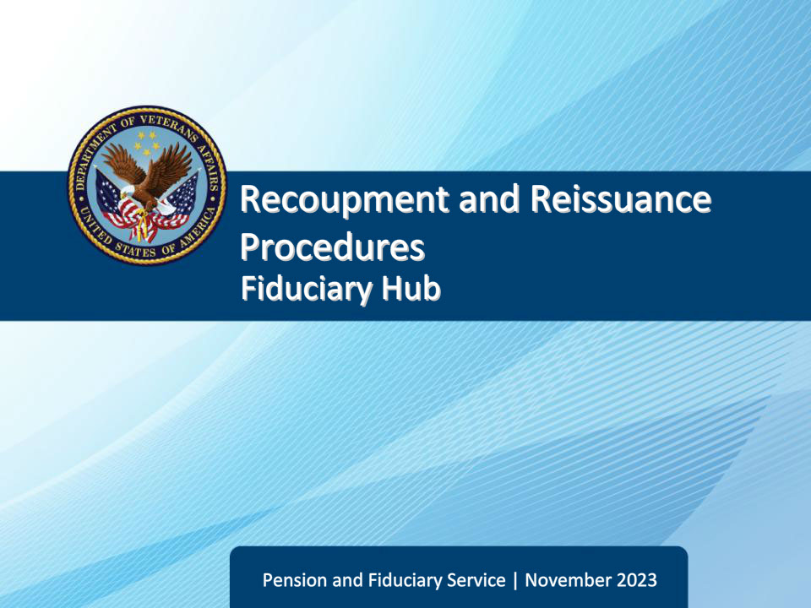
Slide notes

Course Description:

This course teaches learners about reissuance of funds based on repayment of misuse debt and recovery of reissued funds.

Slide 2 - Objectives
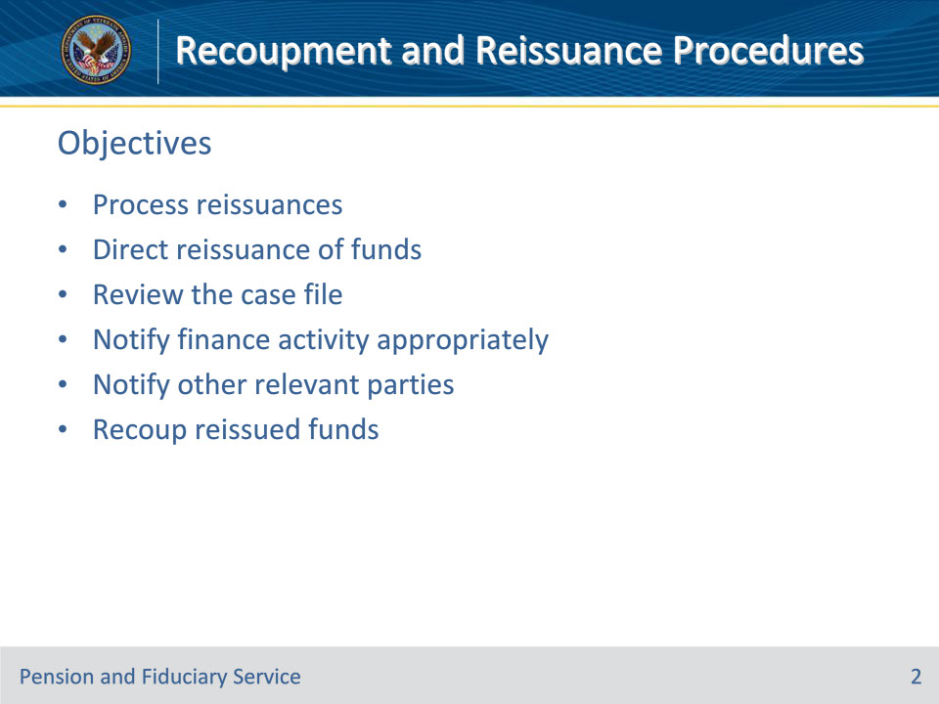
Slide notes

Instructor Notes:

At the end of this lesson, given the training and references, the learner will be able to do the following:

• Process reissuances

• Direct reissuance of funds

• Review the case file

• Notify finance activity appropriately

• Notify other relevant parties

• Recoup reissued funds

Slide 3 - References
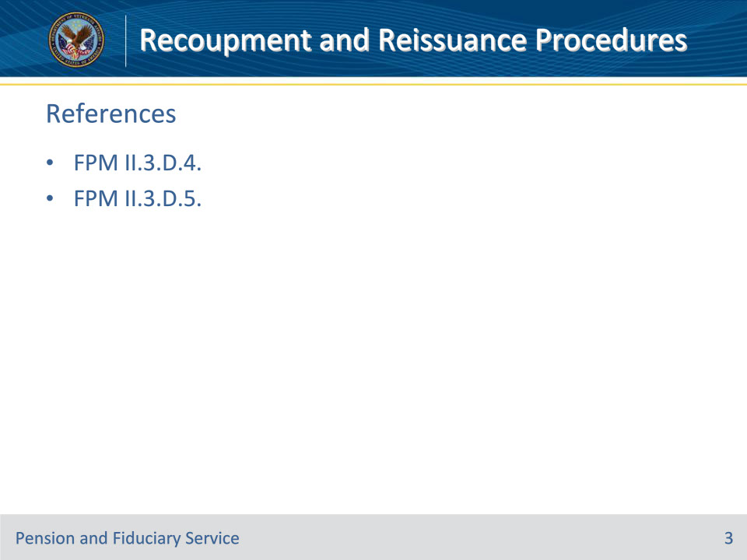
Slide notes

Instructor Notes:

These are the relevant references pertaining to this course:

• FPM II.3.D.4. Recoupment of Reissued Funds

• FPM II.3.D.5. Reissuance of Recouped Misused Benefits From a Misuse Debt

Slide 4 - Reissuance
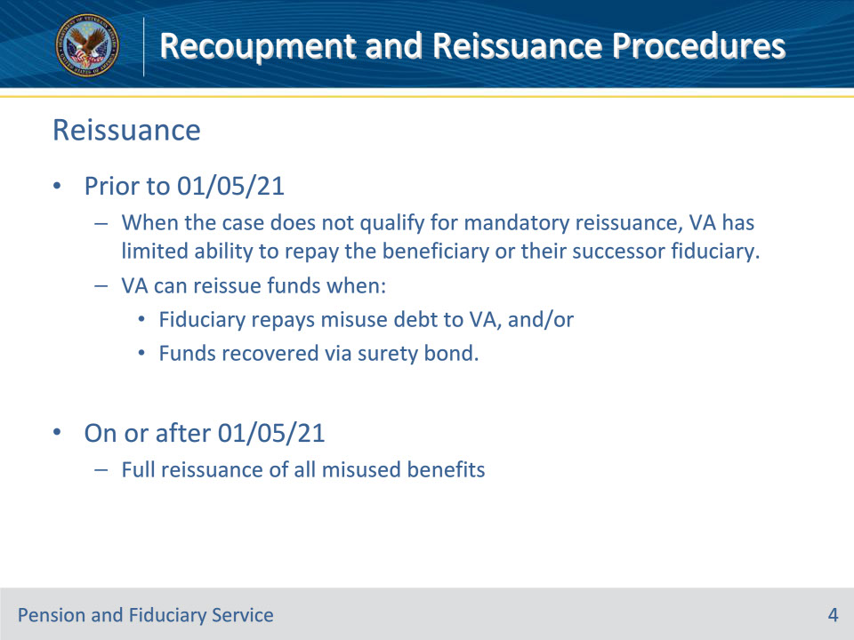
Slide notes

Policy Reference(s): FPM II.3.D.5.a.

Instructor Notes:

When a misuse case completed prior to January 5, 2021 (with no reconsideration or corrected determination completed on or after January 5, 2021), does not qualify for the mandatory reissuance of misused funds, VA has limited ability to repay the beneficiary or their successor fiduciary. In this situation, VA’s only recourse to reissue misused funds occurs when

• the fiduciary repays portions, or all, of the misuse debt to VA, and/or

• any misused benefits are recovered from the surety company, if a surety bond is in place.

For all misuse cases completed on or after January 5, 2021 (to include reconsiderations and corrected determinations completed on or after January 5, 2021), 38 CFR provides for reissuance of all misused benefits equal to the amount of benefits that were so misused. As a result, reissuance of repaid funds resulting from a misuse debt to the beneficiary or his or her successor fiduciary will not occur since the beneficiary receives the full amount of misused benefits regardless of debt collection efforts. Any recouped misused benefits are offset against the debt incurred by the fiduciary unless an exception applies.

Slide 5 - Direction of Repaid Funds
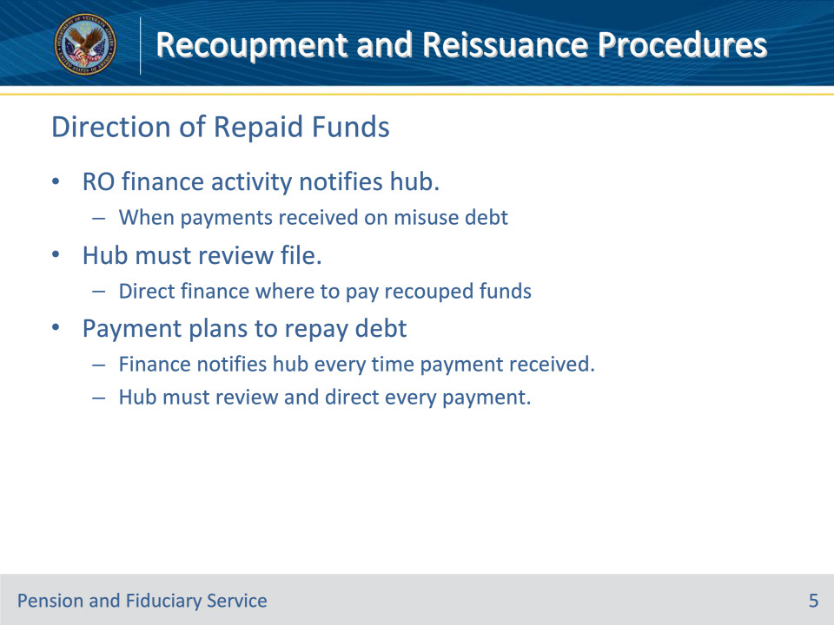
Slide notes

Policy Reference(s): FPM II.3.D.5.b.

Instructor Notes:

The RO finance activity will notify the hub when payments are received on a fiduciary misuse debt. The hub must review the file to direct the RO finance activity where the recouped funds must be paid.

Fiduciaries who have misused VA funds may establish payment plans to repay the debt, therefore every time a payment is received from a fiduciary, the RO finance activity will notify the hub. The hub must review the file and direct the reissuance of repaid funds in response to every notification from the RO finance activity.

Slide 6 - Reissuance Timeframe
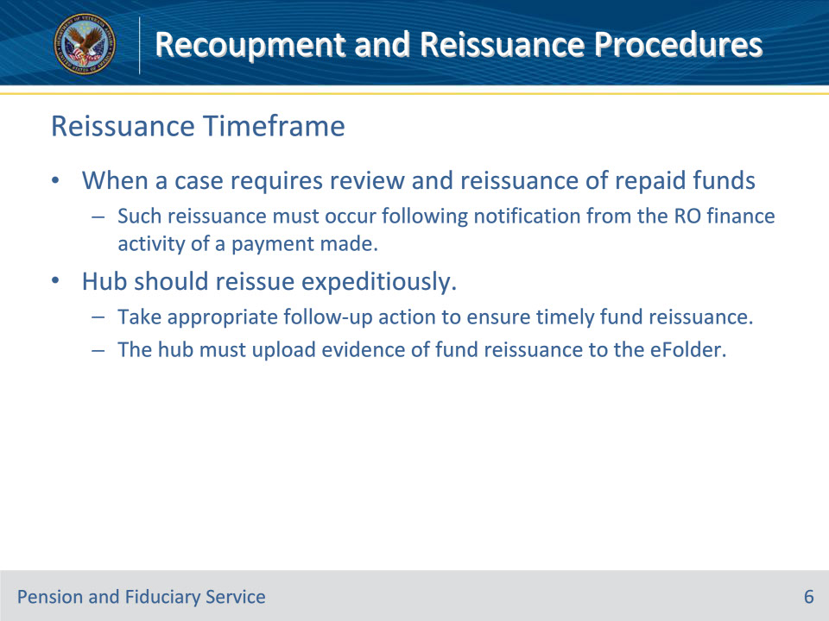
Slide notes

Policy Reference(s): FPM II.3.D.5.c.

Instructor Notes:

When a case requires review and reissuance of repaid funds to a beneficiary or his or her successor fiduciary, such reissuance must occur following notification from the RO finance activity of a payment made.

The hub should reissue misused funds expeditiously and take appropriate follow-up action to ensure timely fund reissuance. The hub must upload evidence of fund reissuance to the eFolder.

Slide 7 - Reviewing the File
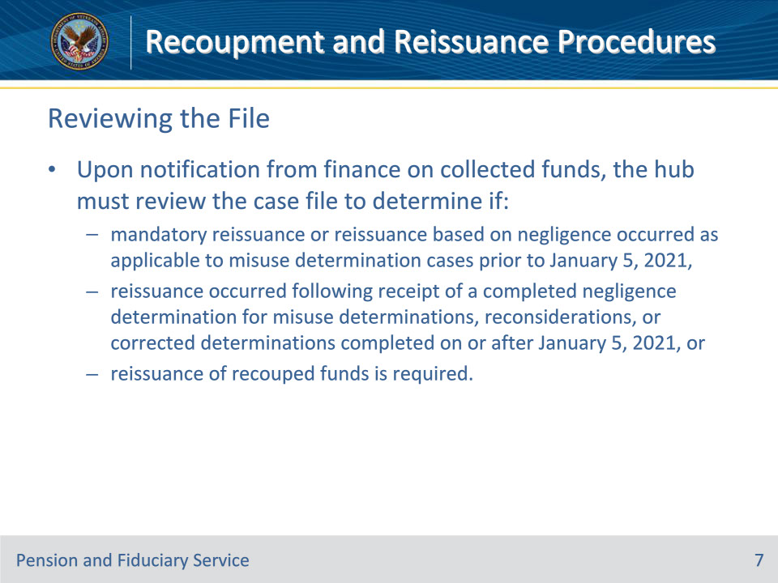
Slide notes

Policy Reference(s): FPM II.3.D.5.d.

Instructor Notes:

Upon notification from RO finance activity on collected funds, the hub must review the case file to determine if

• mandatory reissuance or reissuance based on negligence occurred as applicable to misuse determination cases prior to January 5, 2021

• reissuance occurred following receipt of a completed negligence determination for misuse determinations, reconsiderations, or corrected determinations completed on or after January 5, 2021, or

• reissuance of recouped funds is required.

Slide 8 - Reviewing the File (Cont.)
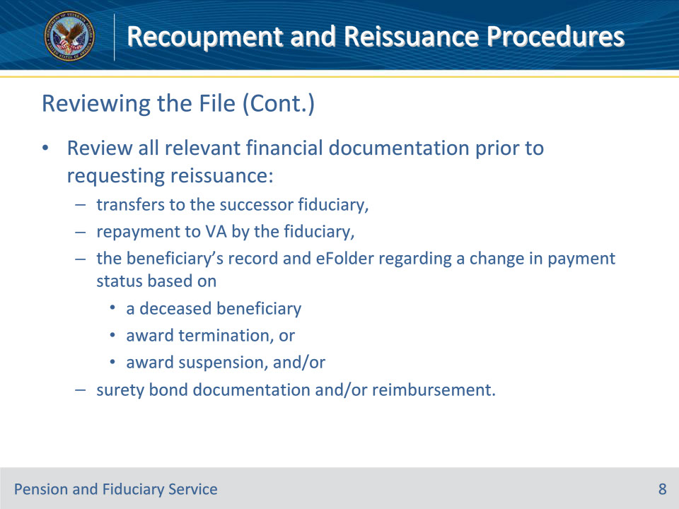
Slide notes

Policy Reference(s): FPM II.3.D.5.d.

Instructor Notes:

Hubs are responsible for conducting a review of all relevant financial documentation prior to requesting reissuance of recouped funds by the RO finance activity. This includes a review of

• transfers to the successor fiduciary

• repayment to VA by the fiduciary

• the beneficiary’s record and eFolder regarding a change in payment status based on

• a deceased beneficiary

• award termination, or

• award suspension, and/or

• surety bond documentation and/or reimbursement.

The hub review must be thorough as reissuance in inappropriate instances can create an overpayment to the beneficiary that must be repaid.

Slide 9 - Notifying RO Finance (1 of 4)
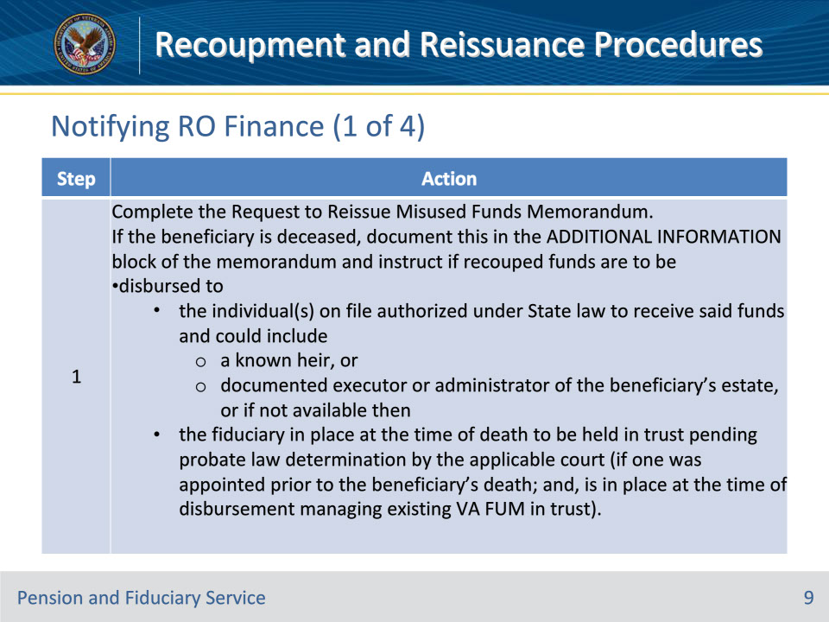
Slide notes

Policy Reference(s): FPM II.3.D.5.e.

Instructor Notes:

After the hub determines reissuance of recouped misused benefits is appropriate, follow the steps in the table above for the reissuance of benefits.

Slide 10 - Notifying RO Finance (2 of 4)
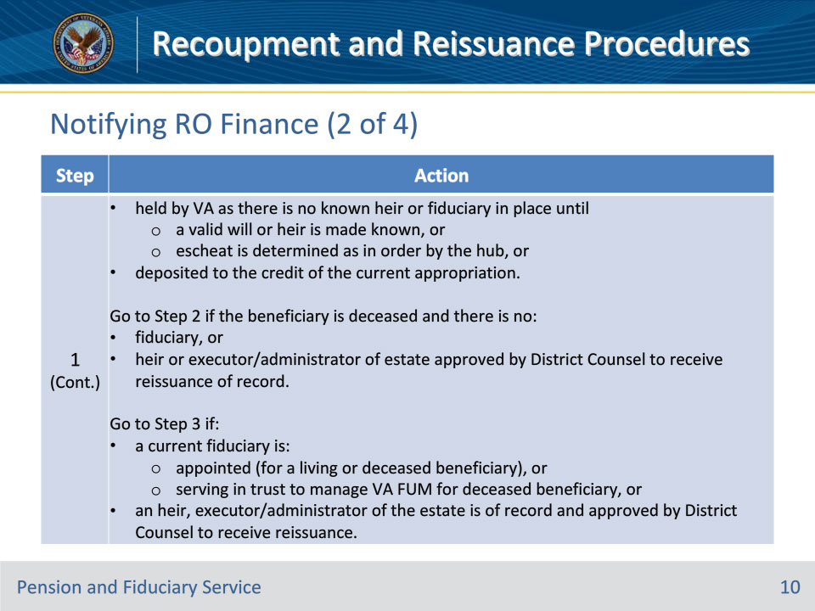
Slide notes

Policy Reference(s): FPM II.3.D.5.e.

Instructor Notes:

After the hub determines reissuance of recouped misused benefits is appropriate, follow the steps in the table above for the reissuance of benefits.

Important: If a fiduciary was not appointed prior to the beneficiary’s death and/or a fiduciary is no longer appointed or serving to hold VA FUM in trust, VA must hold the misused funds to be reissued until the inheritance laws are determined by the applicable court of jurisdiction for non-escheatable funds.

Slide 11 - Notifying RO Finance (3 of 4)
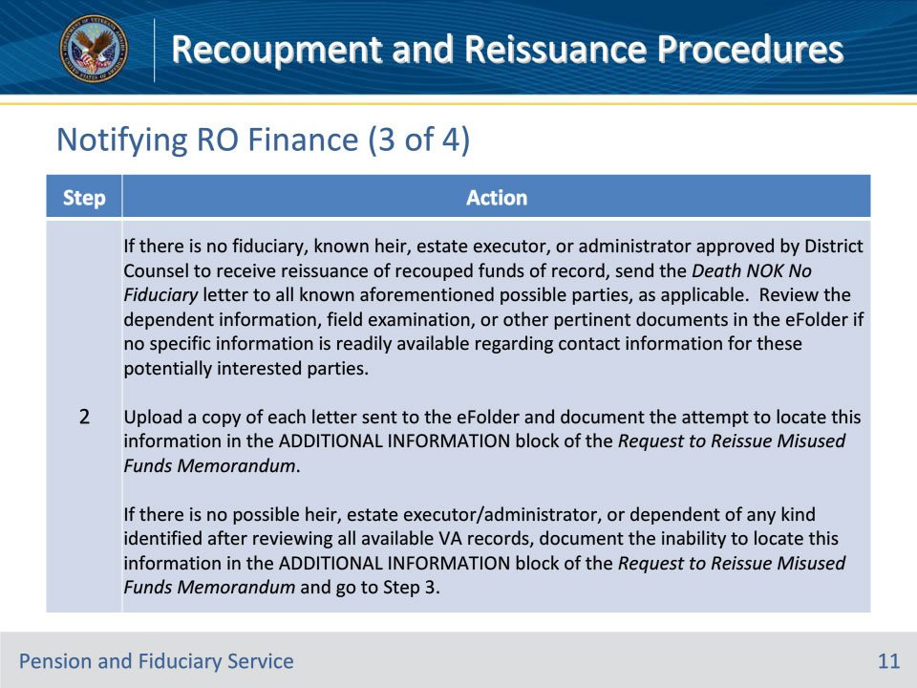
Slide notes

Policy Reference(s): FPM II.3.D.5.e.

Instructor Notes:

After the hub determines reissuance of recouped misused benefits is appropriate, follow the steps in the table above for the reissuance of benefits.

• The hub must provide the finance activity with the name and address of the valid individual (or entity such as a court or law firm) the funds are to be reissued to.

• The hub is responsible for making reasonable attempts to identify the individual or entity entitled to or administering the affairs of the beneficiary’s estate if there is no fiduciary in place managing VA FUM in trust at the time of the beneficiary’s death. Hubs do not need to take further action to locate a possible heir if all research into VA records contained in VA systems have been exhausted and the Death - NOK No Fiduciary letter has been sent.

• After sending the Death - NOK No Fiduciary letter to all applicable parties, hubs do not need to create a task or diary to track responses. Hubs only need to act if a response is received. Follow the guidance for actions to take upon receipt of a response to the memorandum.

Slide 12 - Notifying RO Finance (4 of 4)
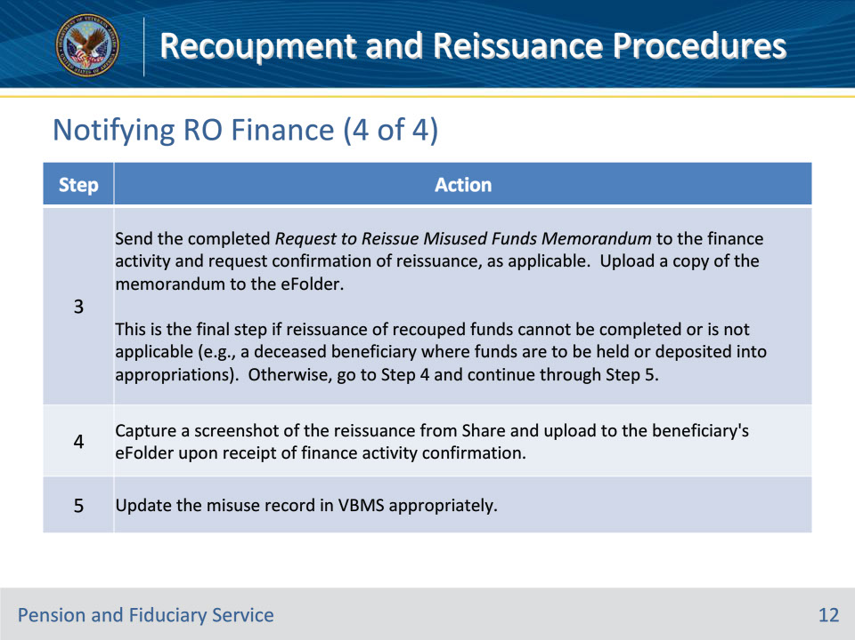
Slide notes

Policy Reference(s): FPM II.3.D.5.e.

Instructor Notes:

After the hub determines reissuance of recouped misused benefits is appropriate, follow the steps in the table above for the reissuance of benefits.

Slide 13 - Notification of Reissuance
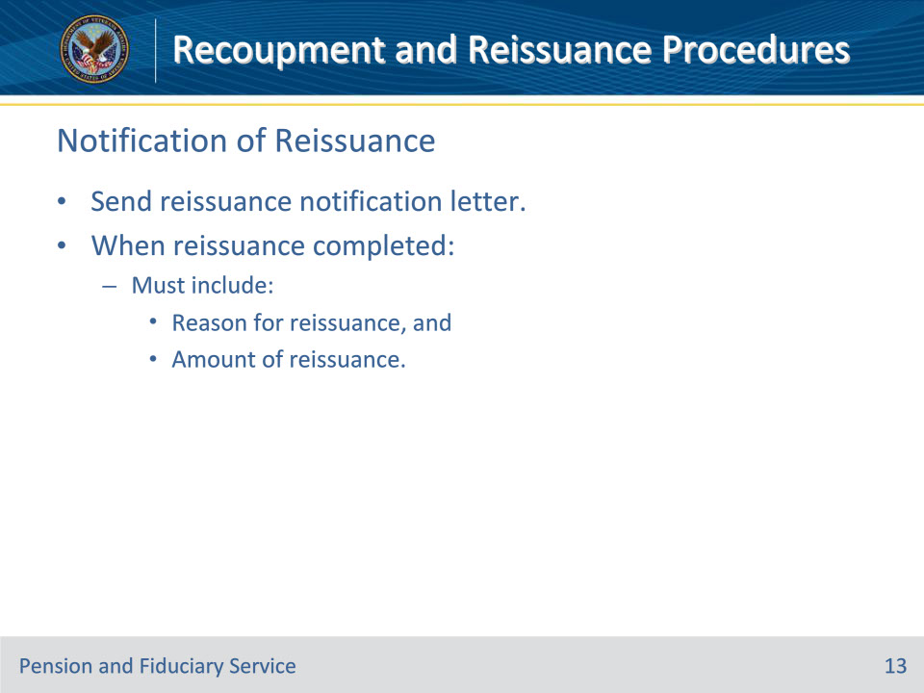
Slide notes

Policy Reference(s): FPM II.3.D.5.f.

Instructor Notes:

Since reissuance based on repaid misuse debt can be sporadic and long term, send the appropriate reissuance notification letter to ensure the beneficiary or fiduciary understands the reason for the additional payment.

When reissuance is completed, notification must be provided to the beneficiary, his/her legal guardian (if applicable), and the beneficiary’s successor fiduciary, if one was appointed.

If the beneficiary is deceased, determine reissuance and notification procedures.

The notification must include the following elements:

• a statement of the reason why funds were reissued, and

• amount of reissuance, if applicable.

Slide 14 - Recoupment of Reissued Funds
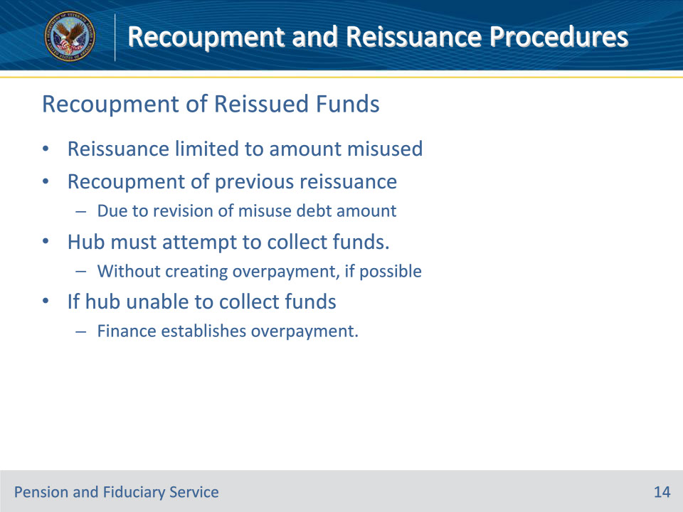
Slide notes

Policy Reference(s): FPM II.3.D.4.a.

Instructor Notes:

VA’s benefit reissuance amount is limited to the total benefit amount misused by the fiduciary. In some instances, recoupment of previously reissued funds may be required due to a revision of misuse debt amount. The hub must attempt to collect the funds without creating an overpayment, if possible.

If the hub is unable to collect the funds, then a benefit overpayment must be established by the RO finance activity co-located with the hub.

Slide 15 - Notification
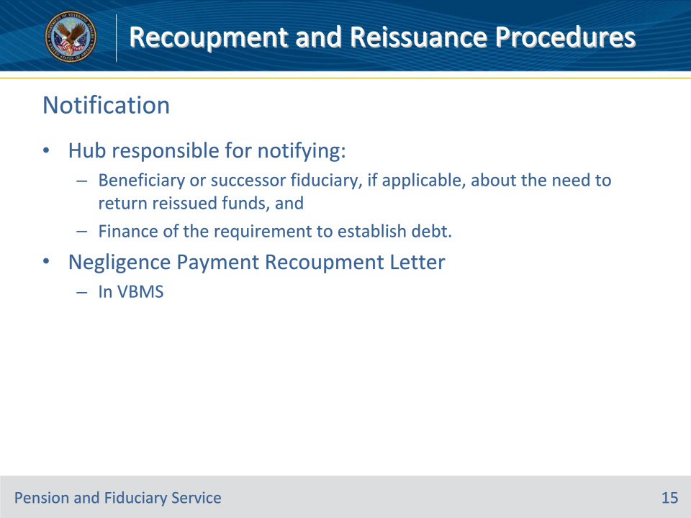
Slide notes

Policy Reference(s): FPM II.3.D.4.b.

Instructor Notes:

The hub is responsible for notifying

• the beneficiary or successor fiduciary, if applicable, about the need to return the reissued funds, and/or

• finance activity of the requirement to establish the debt to the beneficiary.

Note: The Negligence Payment Recoupment Letter in VBMS satisfies this notification.

Slide 16 - Procedures
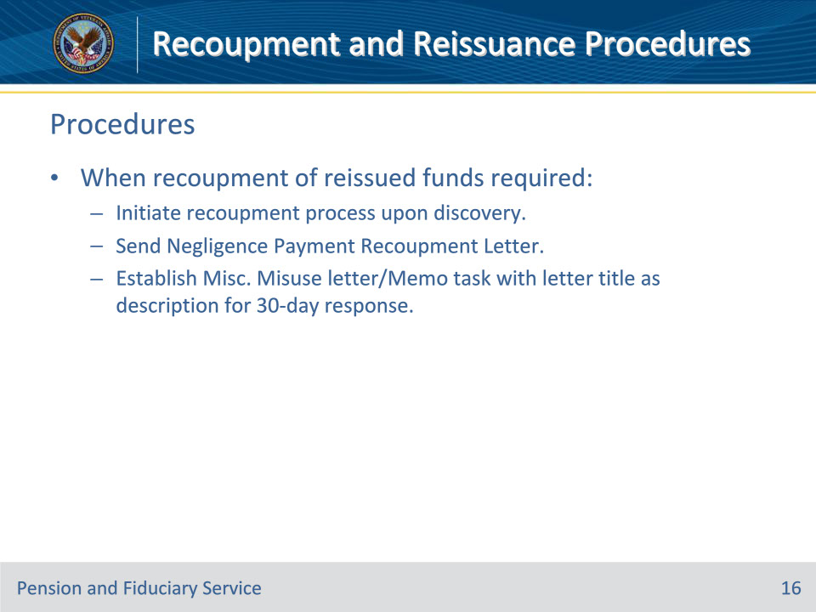
Slide notes

Policy Reference(s): FPM II.3.D.4.c.; d.

Instructor Notes:

When a case requires the recoupment of reissued funds, hub personnel must initiate the process of recoupment upon discovery.

The hub is responsible for recoupment of reissued benefits due to a revision of misuse debt amount. If recoupment of reissued funds is required

• issue a Negligence Payment Recoupment Letter to the beneficiary or successor fiduciary to return funds upon the discovery of the need to recoup reissued funds, and

• establish a Misc. Misuse letter/Memo task with the description as the title of the letter for 30 days for a response from the beneficiary or successor fiduciary.

Slide 17 - Procedures (Cont.)
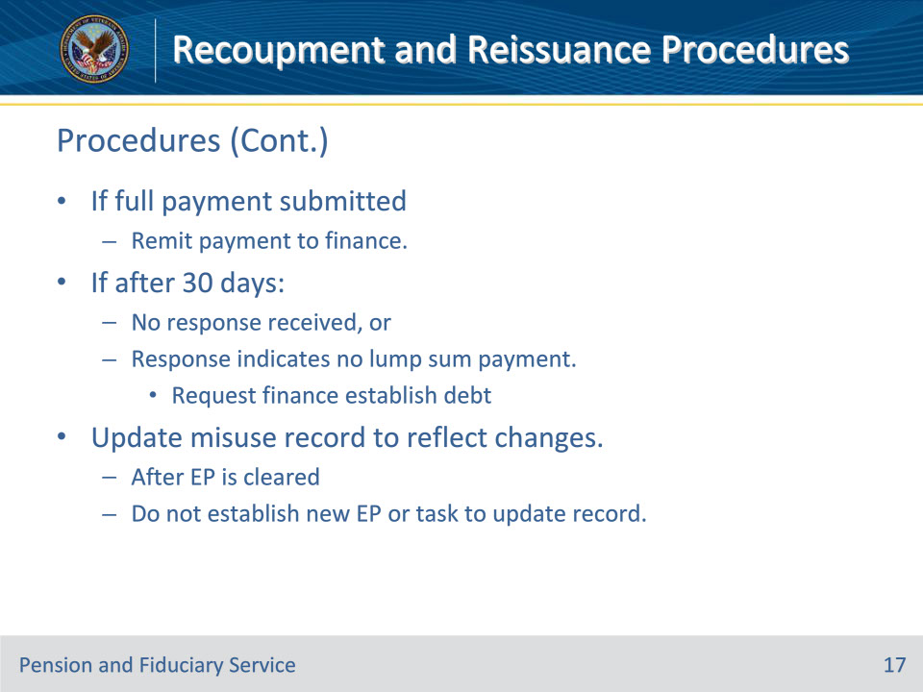
Slide notes

Policy Reference(s): FPM II.3.D.4.d.

Instructor Notes:

If the beneficiary or fiduciary submits full payment in response to the request to Negligence Payment Recoupment Letter, the hub will remit the payment to the finance activity.

At the expiration of the 30 days, if no response is received from the beneficiary or successor fiduciary, or the response received indicates they cannot return the funds in a lump sum payment, hub personnel will send a request to the finance activity to establish a debt to the beneficiary to recoup the reissued funds.

The appropriate misuse record must be updated to reflect the changes based on recoupment of previously reissued funds after the EP is cleared. Do not establish a new EP or task to update the misuse record when documenting the recoupment of funds.

Slide 18 - Summary
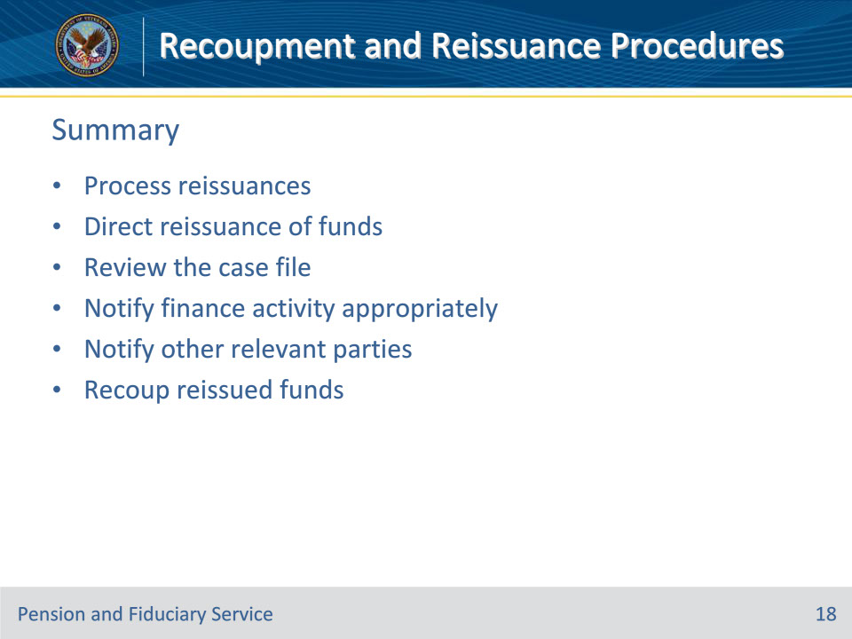
Slide notes

Instructor Notes:

(Recall) These are our learning objectives as stated from the beginning of the training:

• Reissuance

• Direction of Repaid Funds

• Reissuance Timeframe

• Reviewing the File

• Notifying RO Finance

• Notification of Reissuance

• Recoupment of Reissued Funds

• Notification

• Procedures

(Recap) We discussed each of these learning objectives through the following topics in each slide today:

• Process reissuances

• Direct reissuance of funds

• Review the case file

• Notify finance activity appropriately

• Notify other relevant parties

• Recoup reissued funds

Are there any additional questions?

Slide 19 - TMS Survey
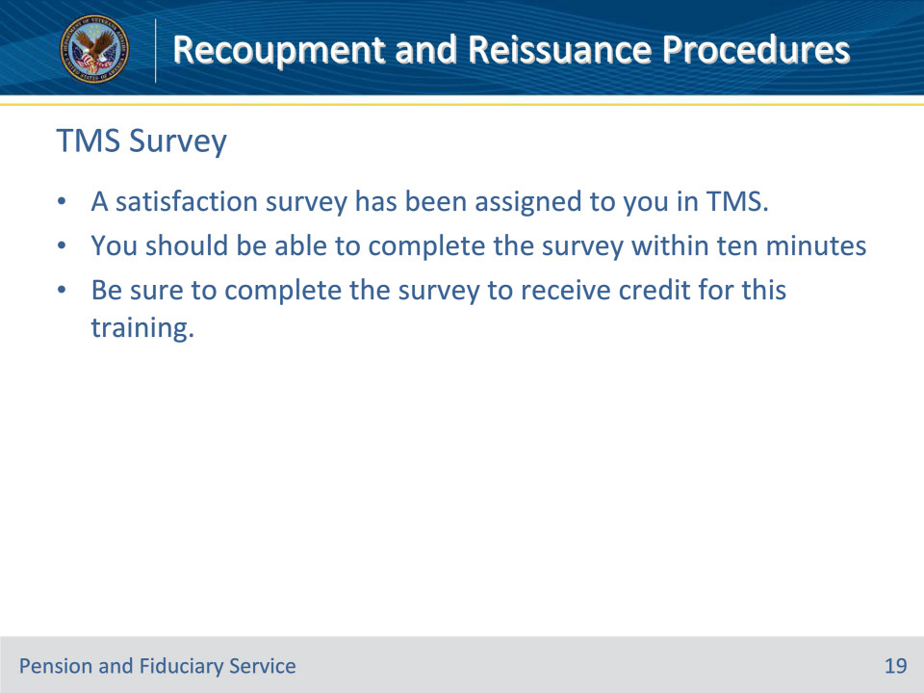
Slide notes

Instructor Notes:

A satisfaction survey has been assigned to you in TMS. You should be able to complete it within ten minutes.

Completing it will allow you to receive credit for this training.

