Slide 1 - Negligence Determinations
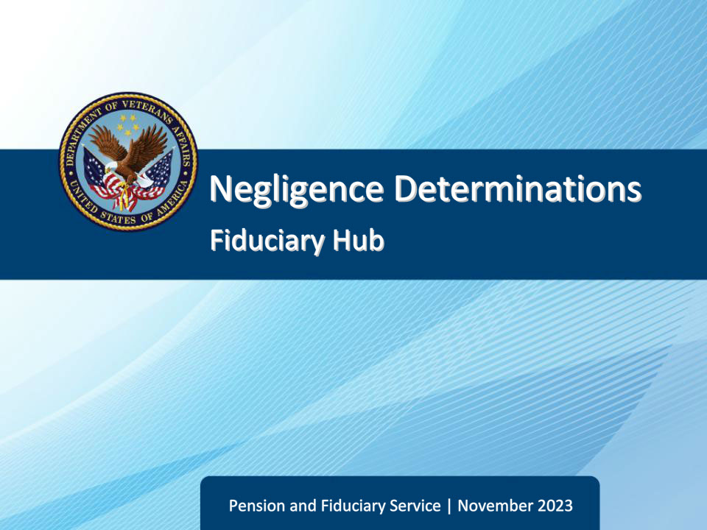
Slide notes

Course Description:

This course teaches learners about negligence determinations and reissuance following a completed negligence determination.

Slide 2 - Objectives
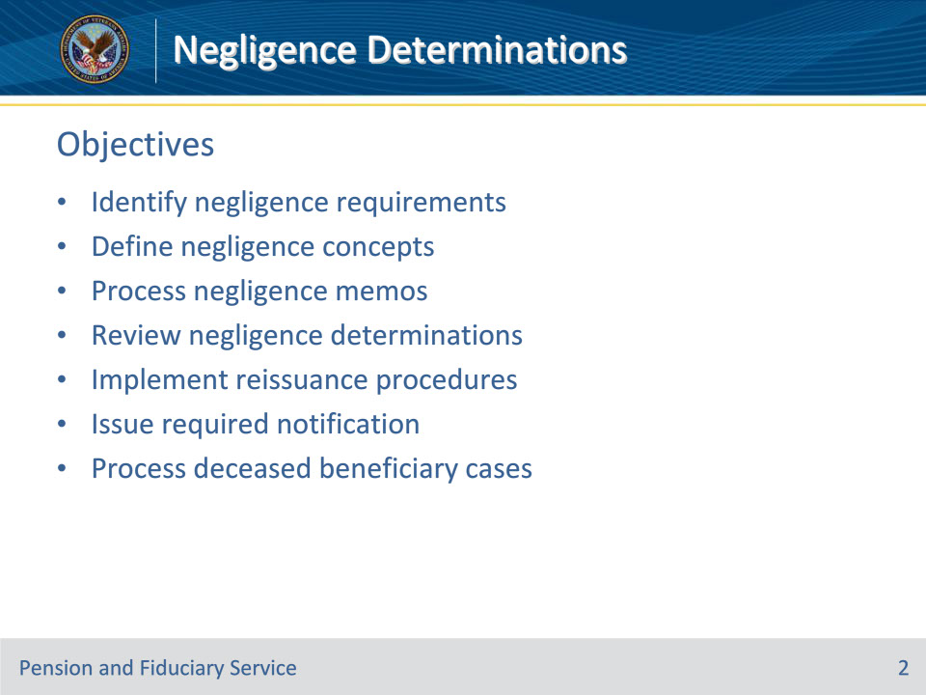
Slide notes

Instructor Notes:

At the end of this lesson, given the training and references, the learner will be able to do the following:

• Identify negligence requirements

• Define negligence concepts

• Process negligence memos

• Review negligence determinations

• Implement reissuance procedures

• Issue required notification

• Process deceased beneficiary cases

Slide 3 - References
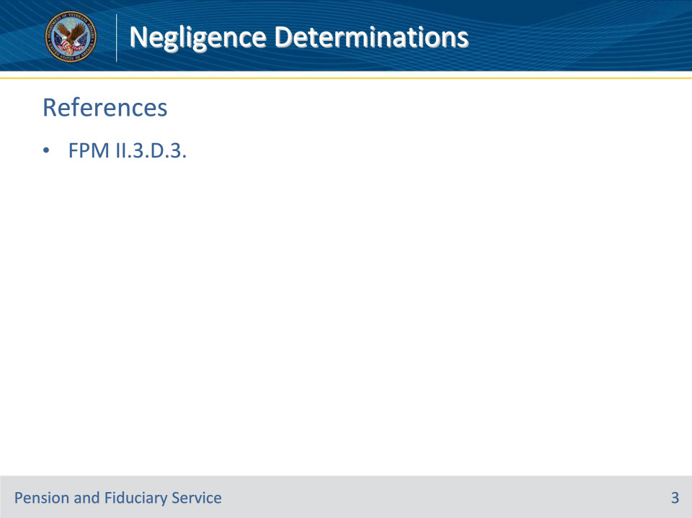
Slide notes

Instructor Notes:

These are the relevant references pertaining to this course:

• FPM II.3.D.3. Negligence Determinations and Reissuance

Slide 4 - Requirements
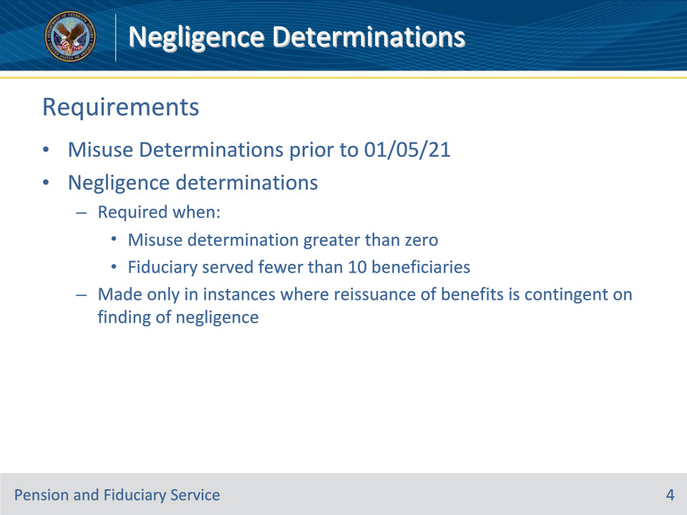
Slide notes

Policy Reference(s): FPM II.3.D.3.a.

Instructor Notes:

For misuse determinations, reconsiderations, and corrected misuse determinations completed prior to January 5, 2021, a negligence determination was required in each case where

• a determination of misuse has been made with a dollar amount greater than zero, and

• the fiduciary is an individual who served fewer than 10 beneficiaries during the period when the misuse occurred.

Negligence determinations will be made only in instances where the reissuance of benefits is contingent on a finding of negligence.

If at the time of completion of the misuse determination, the number of beneficiaries served by the fiduciary is unknown due to limited historical data, the hub will use the number of beneficiaries being served at the time of the misuse determination. In such cases, if 10 or more beneficiaries are served at the time of the misuse determination, then the negligence determination will not be required.
Slide 5 - Requirements
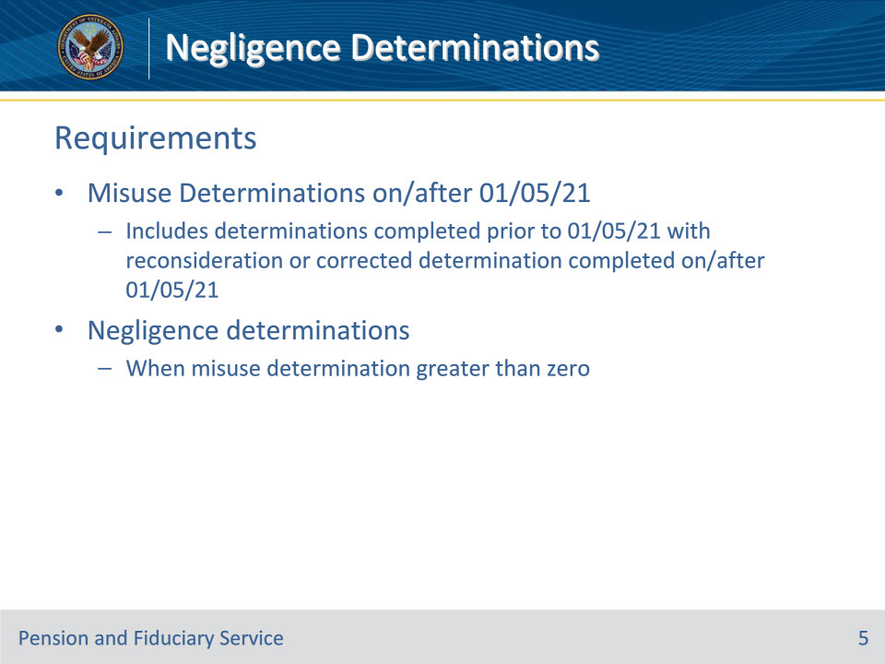
Slide notes

Policy Reference(s): FPM II.3.D.3.b.

Instructor Notes:

For misuse determinations completed on or after January 5, 2021, negligence determinations will be completed in all cases where a determination of misuse has been made with a dollar amount greater than zero. This includes misuse determinations completed prior to January 5, 2021, with a reconsideration or corrected determination resulting in a positive dollar amount completed on or after January 5, 2021.

Slide 6 - Findings of Negligence
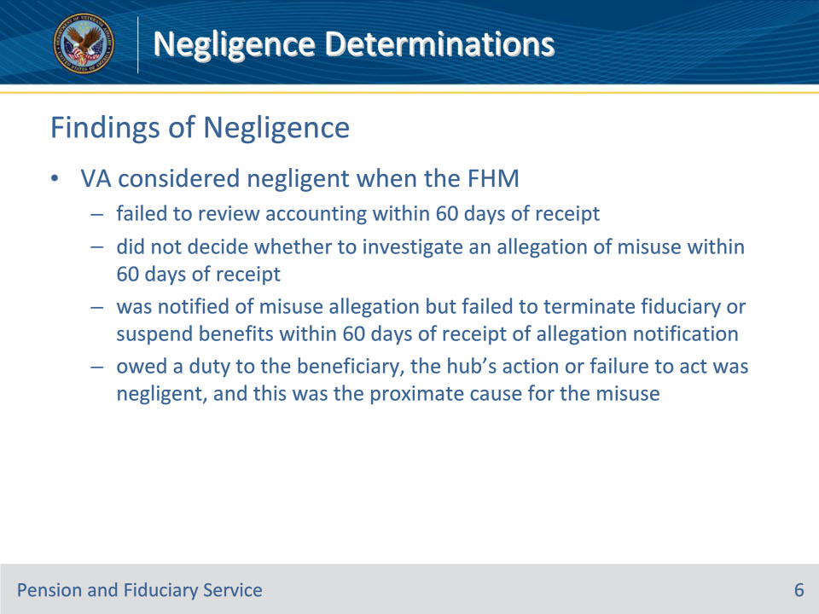
Slide notes

Policy Reference(s): FPM II.3.D.3.c.

Instructor Notes:

VA is considered to have been negligent when the FHM

• failed to review the fiduciary’s accounting within 60 days of the date the hub receives the accounting

• did not decide whether to investigate an allegation of misuse within 60 days of receipt of the allegation

• was notified of an allegation of misuse but failed to terminate the fiduciary or suspend the beneficiary’s VA benefit award within 60 days of receiving the allegation notification, or

• owed a duty to the beneficiary, the hub’s action or failure to act under this duty was negligent, and the negligence which occurred from this action or failure to act was the proximate cause for the misuse.

Slide 7 - Negligent Failure
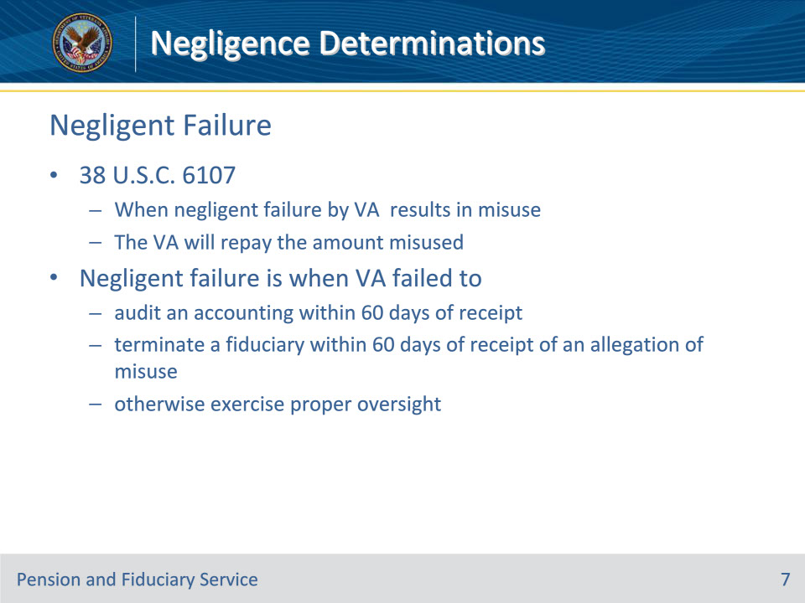
Slide notes

Policy Reference(s): FPM II.3.D.3.d.

Instructor Notes:

Based on 38 U.S.C. 6107, any case in which the negligent failure of the Secretary to investigate or monitor a fiduciary results in misuse of benefits by the fiduciary, the Secretary shall pay to the beneficiary or the beneficiary’s successor fiduciary an amount equal to the amount of benefits that were so misused.

Negligent failure is any case in which VA failed to

• audit an accounting within 60 days of receipt

• terminate a fiduciary within 60 days of receipt of an allegation of misuse, or

• otherwise exercise proper oversight.

Slide 8 - Proximate Cause
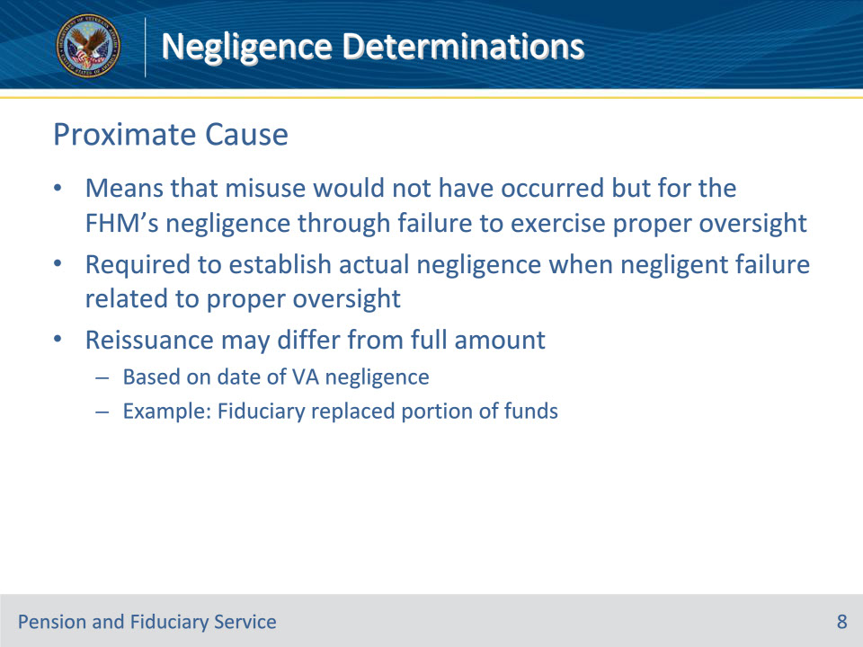
Slide notes

Policy Reference(s): FPM II.3.D.3.d.

Instructor Notes:

Proximate cause means that the misuse would not have occurred but for the FHM’s negligence through failure to exercise proper oversight.

A finding of proximate cause will be required to establish actual negligence only where negligent failure is related to the exercise of proper oversight.

Based on the date of VA negligence, reissuance of misused benefits by a negligence determination may differ from the full amount of misuse, such as when a fiduciary has replaced a portion of the misused funds since the initial finding of misuse.

Slide 9 - Proximate Cause Examples
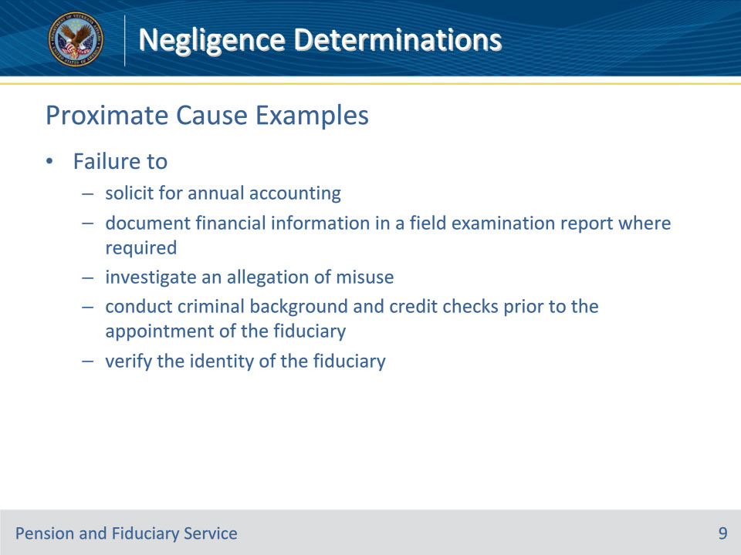
Slide notes

Policy Reference(s): FPM II.3.D.3.d.

Instructor Notes:

Examples of whether a negligent act would have proximately caused the misuse of funds include, but are not limited to, failure to

• solicit for the annual accounting

• document financial information in a field examination report as required, including verification of liquid assets

• investigate an allegation of misuse

• conduct criminal background and credit checks prior to the appointment of the fiduciary, and

• verify the identity of the fiduciary.

Slide 10 - Actual Negligence
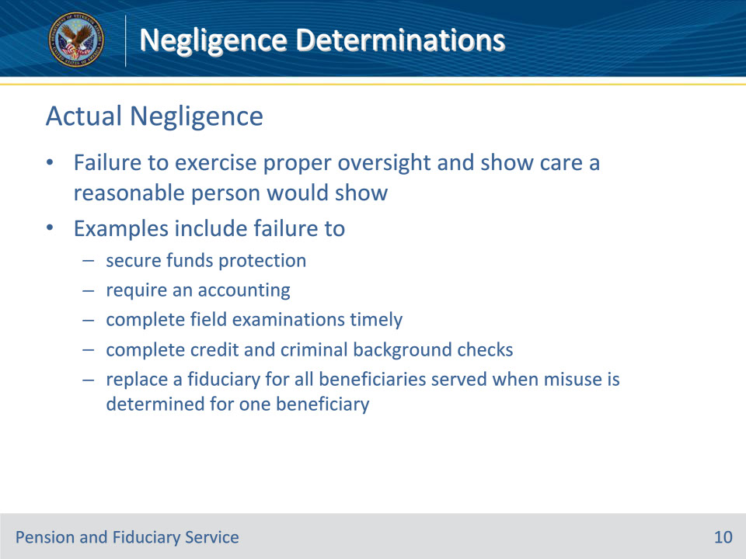
Slide notes

Policy Reference(s): FPM II.3.D.3.e.

Instructor Notes:

VA is negligent when it fails to exercise proper oversight and show care a reasonable person would show in similar circumstances. Examples of actual negligence include failure to

• secure protection for funds under management (FUM)

• require an accounting, as appropriate

• complete field examinations timely

• complete credit and criminal background checks appropriately, or

• replace a fiduciary for all beneficiaries served when misuse is determined for one beneficiary.

Slide 11 - Additional Action Memo
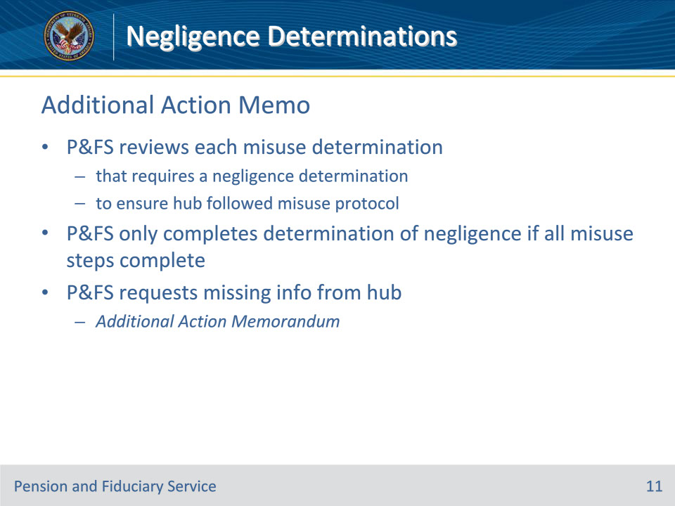
Slide notes

Policy Reference(s): FPM II.3.D.3.f.

Instructor Notes:

P&F Service reviews each misuse determination that requires a negligence determination to ensure the misuse protocol was appropriately followed by the hub. P&F Service may only complete a determination of negligence if all steps of the misuse process are complete.

If during review of the misuse case, P&F Service determines information is missing, inconsistent with policy, or inaccurate, it will request the missing information from the hub through an Additional Action Memorandum.

Slide 12 - Negligence Determination Memo
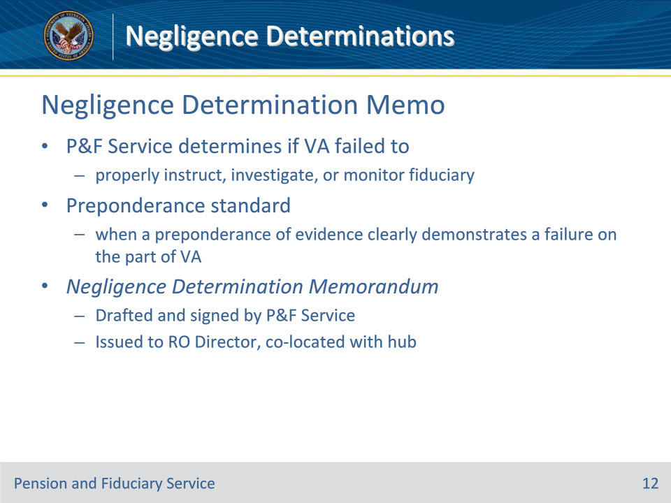
Slide notes

Policy Reference(s): FPM II.3.D.3.g.

Instructor Notes:

P&F Service will thoroughly review all available evidence to determine if VA failed to properly instruct, investigate, or monitor a fiduciary.

P&F Service will determine negligence using a preponderance standard. A negligence determination will result when a preponderance of evidence clearly demonstrates a failure on the part of VA to properly instruct, investigate, or monitor a fiduciary.

Based on the critical review and analysis, P&F Service will draft a Negligence Determination Memorandum for approval and signature by the Executive Director of P&F Service, or designee. Once signed, the Negligence Determination Memorandum will be issued to the RO Director, co-located with the hub, with a copy to the District Director, to complete the requirements of the decision, including notification of completion to the P&F Service Training, Quality and Oversight mailbox at VAVBAWAS/CO/P&F TNG QUAL OVRST.

Slide 13 - Review
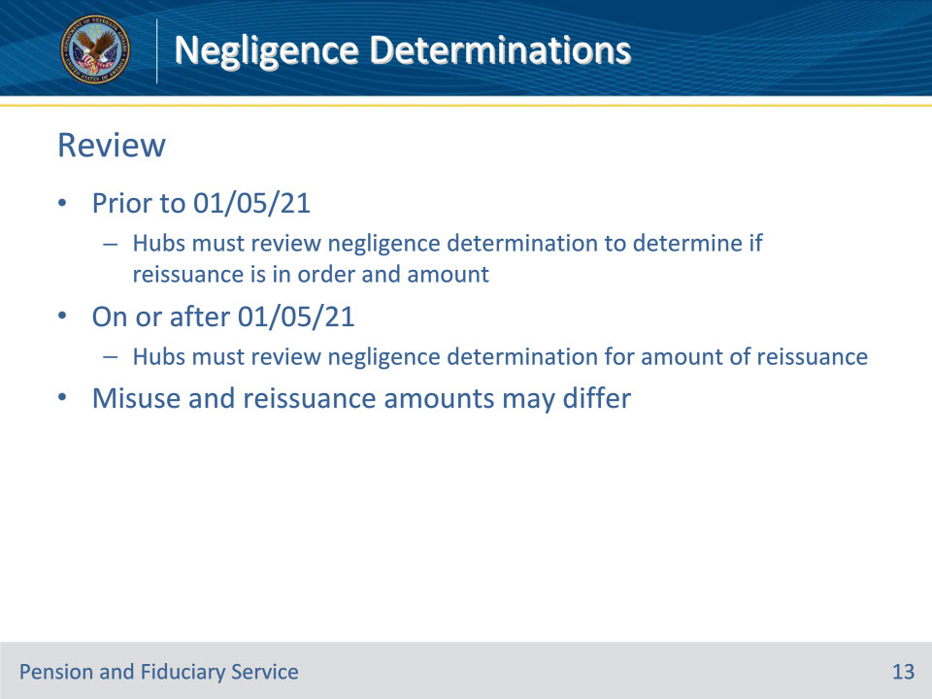
Slide notes

Policy Reference(s): FPM II.3.D.3.h.

Instructor Notes:

If the misuse determination was completed prior to January 5, 2021, and there was no reconsideration or corrected determination on or after January 5, 2021, hubs must review the negligence determination received from P&F Service to determine if reissuance is in order and the amount of reissuance.

If the misuse determination was completed on or after January 5, 2021 (or a reconsideration or corrected determination was completed on or after January 5, 2021), hubs must review the negligence determination for the amount of reissuance.

Hubs must be mindful that the misuse amount and the amount determined as eligible for reissuance may differ. Based on the date of VA negligence, reissuance of misused benefits by a negligence determination may differ from the full amount of misuse, such as when a fiduciary has replaced a portion of the misused funds since the initial finding of misuse.

Slide 14 - Review
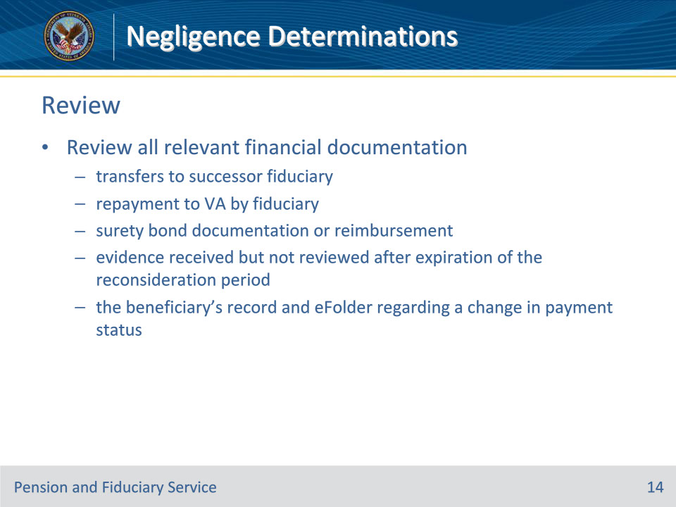
Slide notes

Policy Reference(s): FPM II.3.D.3.h.

Instructor Notes:

Hubs are responsible for conducting a review of all relevant financial documentation prior to requesting reissuance by the RO finance activity co-located with the hub. This includes a review of

• transfers to the successor fiduciary

• repayment to VA by the fiduciary

• surety bond documentation and/or reimbursement

• evidence received but not reviewed after expiration of the reconsideration period, if applicable, and

• the beneficiary’s record and eFolder regarding a change in payment status based on

• a deceased beneficiary

• award termination

• award suspension, or

• outstanding receivable (e.g., debt due to overpayment).

Slide 15 - Reissuance Procedure
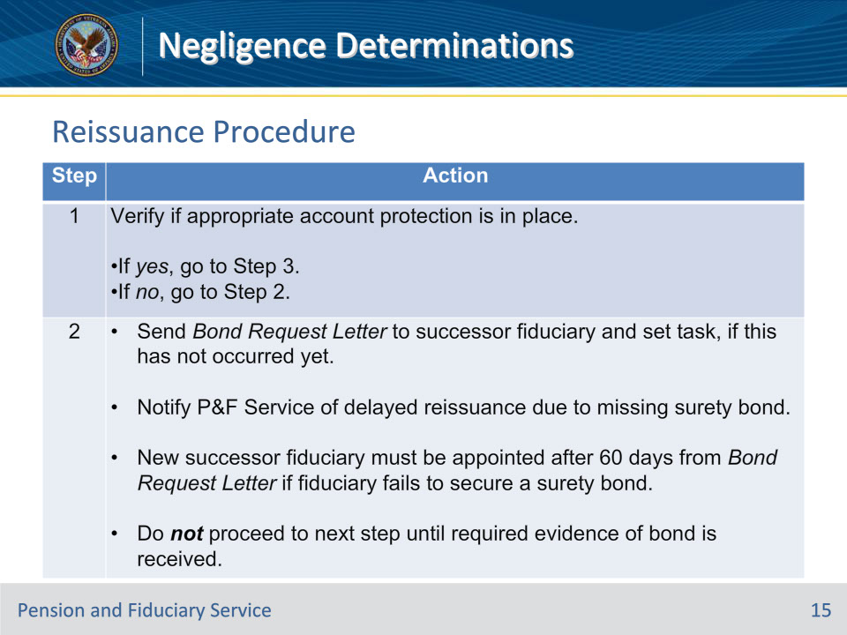
Slide notes

Policy Reference(s): FPM II.3.D.3.i.

Instructor Notes:

The hub is responsible for reviewing the Negligence Determination Memorandum for required actions and validating the amount of reissuance.

Follow the steps in this table for the reissuance of benefits after the amount of reissuance is validated.

Exception: This does not apply to the estates of deceased beneficiaries. Go to Step 3 in all deceased beneficiary matters.

Slide 16 - Reissuance Procedure
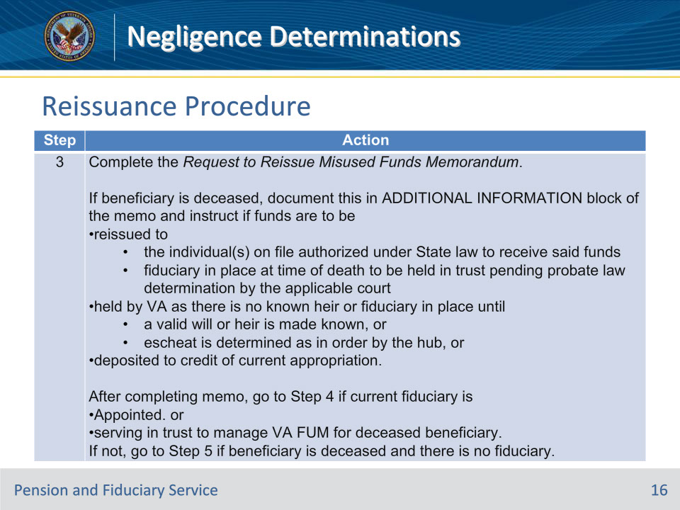
Slide notes

Policy Reference(s): FPM II.3.D.3.i.

Instructor Notes:

The hub is responsible for reviewing the Negligence Determination Memorandum for required actions and validating the amount of reissuance.

Follow the steps above for the reissuance of benefits after the amount of reissuance is validated.

Slide 17 - Reissuance Procedure
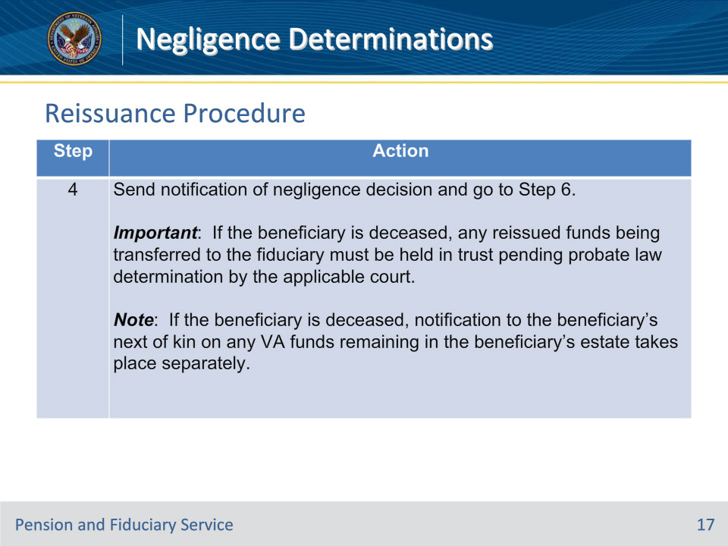
Slide notes

Policy Reference(s): FPM II.3.D.3.i.

Instructor Notes:

The hub is responsible for reviewing the Negligence Determination Memorandum for required actions and validating the amount of reissuance.

Follow the steps above for the reissuance of benefits after the amount of reissuance is validated.

Slide 18 - Reissuance Procedure
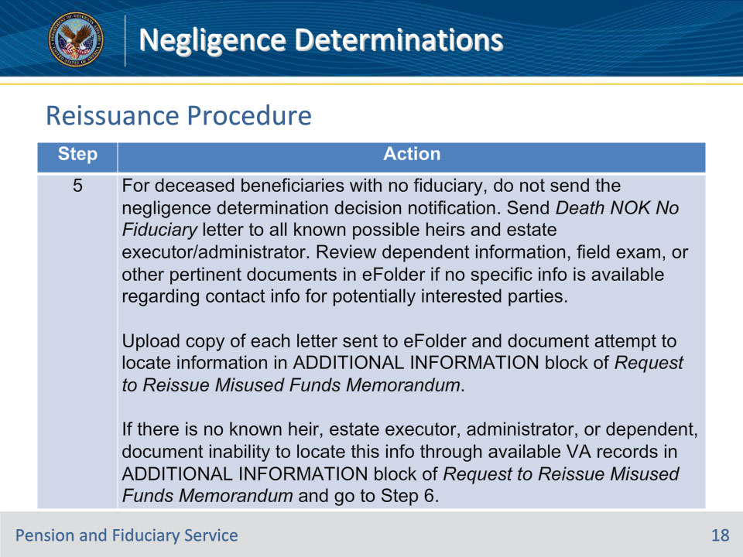
Slide notes

Policy Reference(s): FPM II.3.D.3.i.

Instructor Notes:

The hub is responsible for reviewing the Negligence Determination Memorandum for required actions and validating the amount of reissuance.

Follow the steps above for the reissuance of benefits after the amount of reissuance is validated.

Slide 19 - Reissuance Procedure
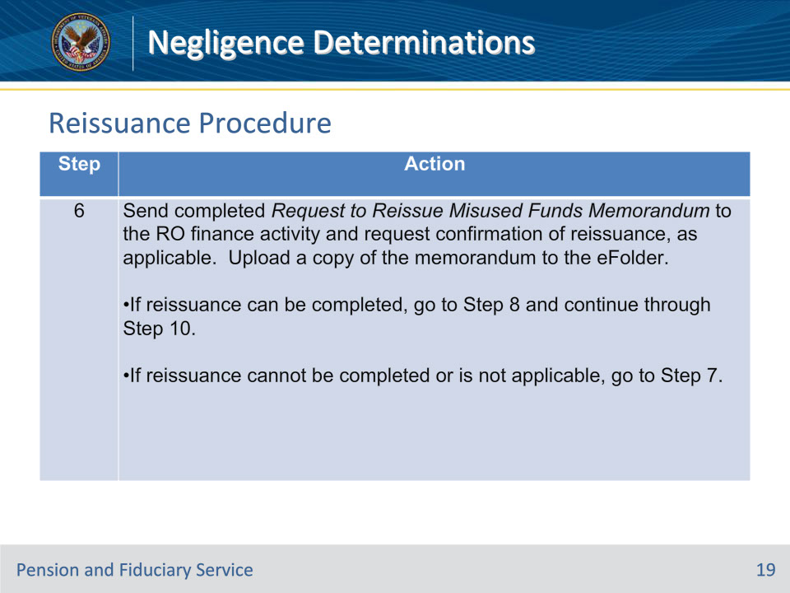
Slide notes

Policy Reference(s): FPM II.3.D.3.i.

Instructor Notes:

The hub is responsible for reviewing the Negligence Determination Memorandum for required actions and validating the amount of reissuance.

Follow the steps above for the reissuance of benefits after the amount of reissuance is validated.

Slide 20 - Step 7
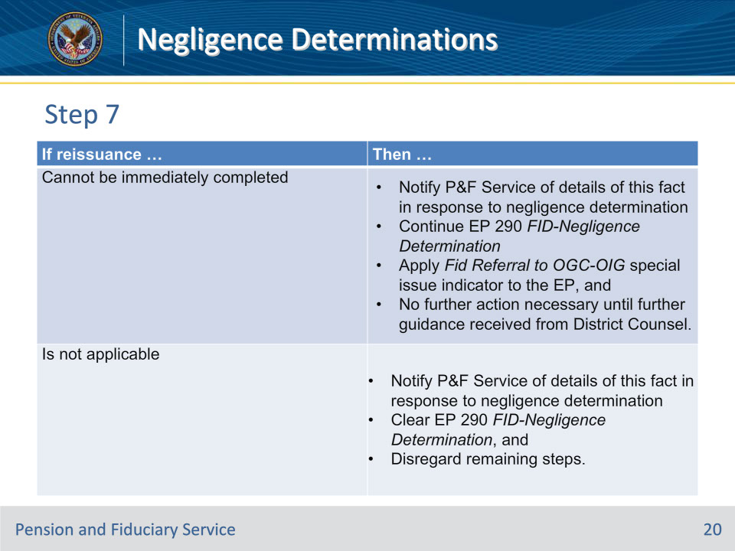
Slide notes

Policy Reference(s): FPM II.3.D.3.i.

Instructor Notes:

Step 7:

Use the table on this slide to determine the appropriate actions to take if reissuance cannot be completed or is not applicable.

Notes:

• When applying the special issue indicator to the EP, use free text in the CONTENTION field to insert an appropriately descriptive contention name and select Administrative Issue in the CLASSIFICATION field.

• Upon receiving confirmation that District Counsel has completed the action(s) requested by the claim referral, remove the Fid Referral to OGC-OIG special issue indicator from the EP.

Slide 21 - Reissuance Procedure
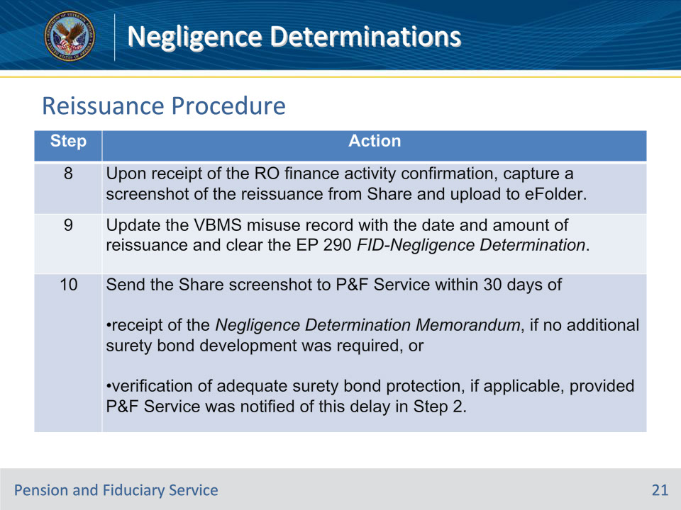
Slide notes

Policy Reference(s): FPM II.3.D.3.i.

Instructor Notes:

The hub is responsible for reviewing the Negligence Determination Memorandum for required actions and validating the amount of reissuance.

Follow the steps above for the reissuance of benefits after the amount of reissuance is validated.

Slide 22 - Reissuance Notes
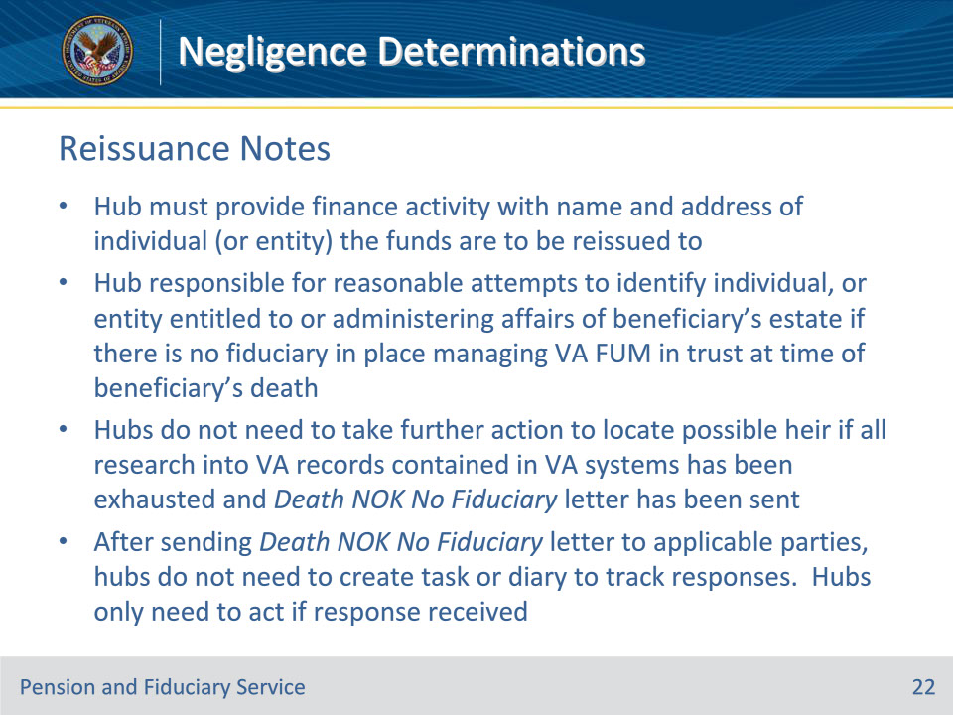
Slide notes

Policy Reference(s): FPM II.3.D.3.i.

Instructor Notes:

• The hub must provide the finance activity with the name and address of the valid individual (or entity such as a court or attorney) the funds are to be reissued to.

• The hub is responsible for making reasonable attempts to identify the individual or entity entitled to or administering the affairs of the beneficiary’s estate if there is no fiduciary in place managing VA FUM in trust at the time of the beneficiary’s death. Hubs do not need to take further action to locate a possible heir if all research into VA records contained in VA systems have been exhausted and the Death NOK No Fiduciary letter has been sent.

• After sending the Death NOK No Fiduciary letter to all applicable parties, hubs do not need to create a task or diary to track responses. Hubs only need to take action if a response is received. Follow the guidance for actions to take upon receipt of a response to the letter.

Slide 23 - Notification
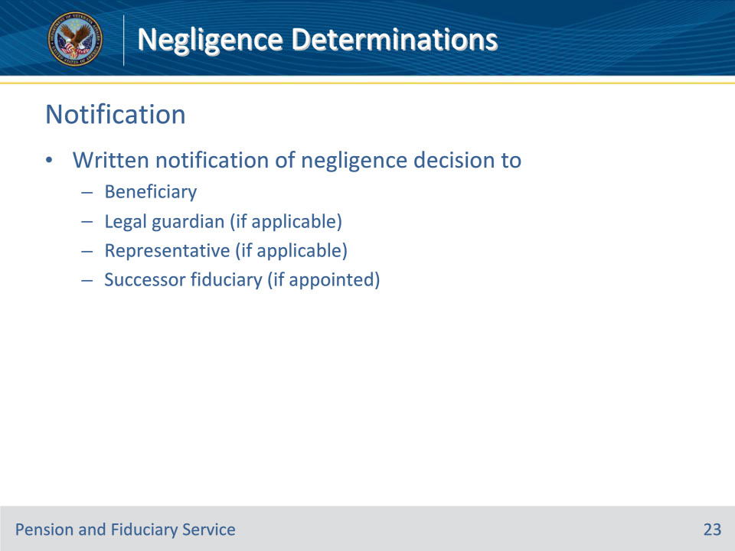
Slide notes

Policy Reference(s): FPM II.3.D.3.j.

Instructor Notes:

After completing a negligence determination, prepare written notification of the decision and send notice to the beneficiary and, as applicable, to the beneficiary’s

• legal guardian

• accredited representative (Veterans service organization representatives, attorneys, and agents), and

• successor fiduciary, if one was appointed.

Slide 24 - Notification
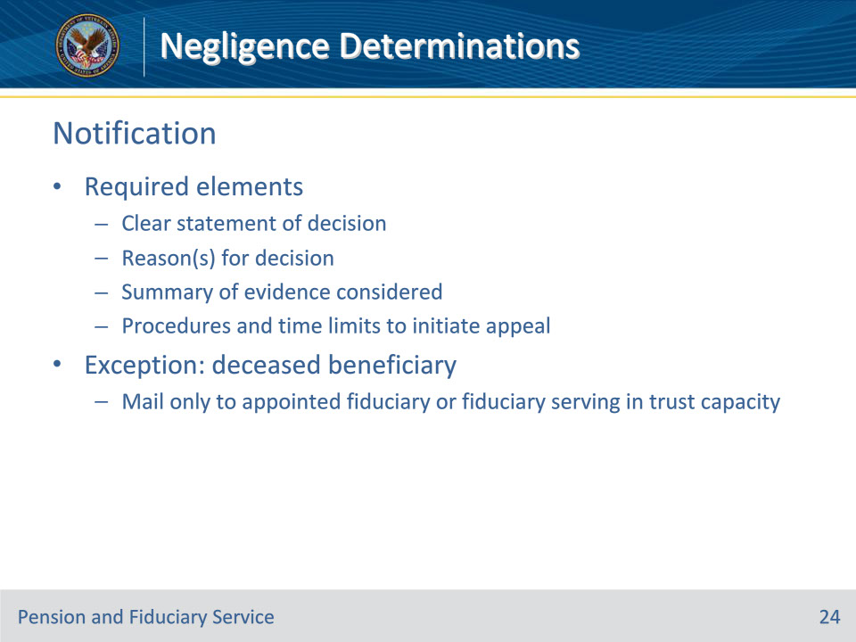
Slide notes

Policy Reference(s): FPM II.3.D.3.j.

Instructor Notes:

The decision notice must include the following elements:

• a clear statement of the decision made

• the reason(s) for the decision

• a summary of the evidence considered in reaching the decisions, and

• the necessary procedures and time limits to initiate an appeal of the decision.

Exception: If the beneficiary is deceased, mail the notification only to the appointed fiduciary (or fiduciary currently serving in a trust capacity for administration of remaining VA FUM).

Slide 25 - Deceased Beneficiaries
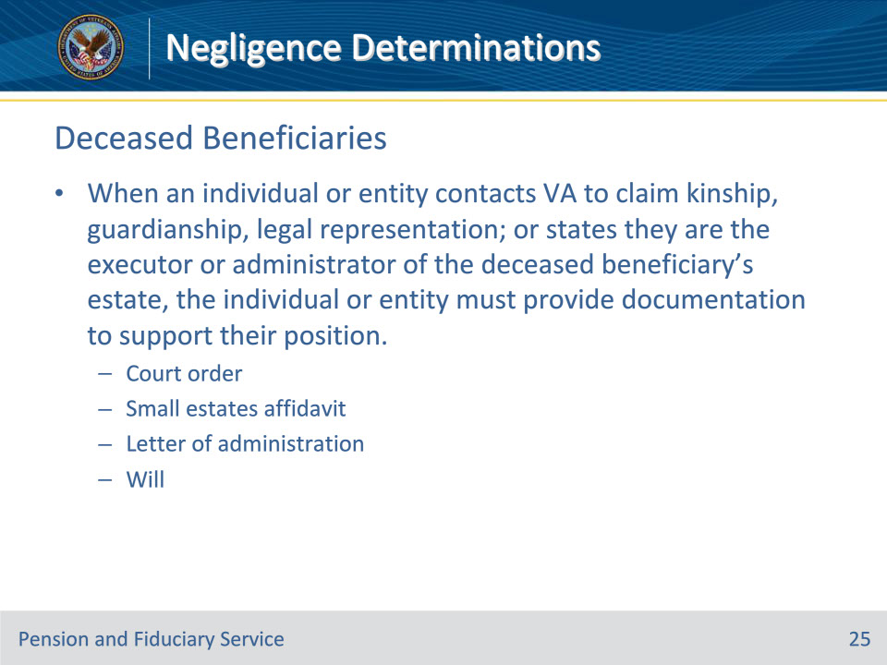
Slide notes

Policy Reference(s): FPM II.3.D.3.k.

Instructor Notes:

When an individual or entity contacts VA to claim kinship, guardianship, legal representation; or, states they are the executor or administrator of the deceased beneficiary’s estate, the individual or entity must provide documentation to support their position. The document could be a (not an all-inclusive list):

• court order

• small estates affidavit

• letter of administration, or

• will

Slide 26 - Deceased Beneficiaries
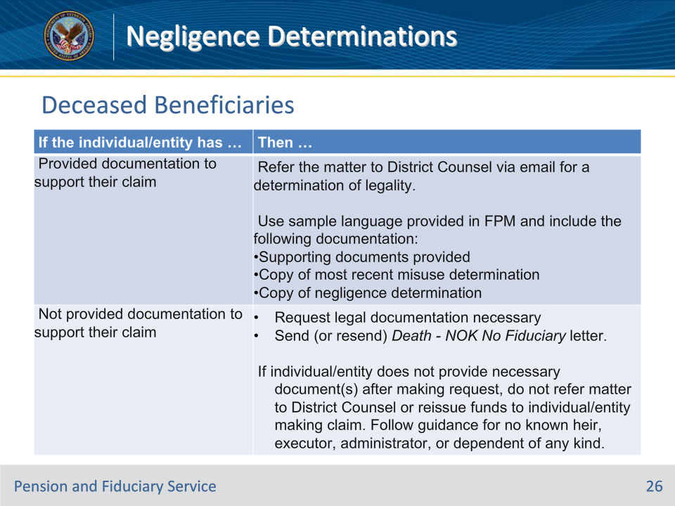
Slide notes

Policy Reference(s): FPM II.3.D.3.k.

Instructor Notes:

Use the table on this slide to determine the action necessary prior to reissuing funds when an individual/entity contacts VA claiming kinship, guardianship, legal representation; or states they are the executor or administrator of the deceased beneficiary’s estate.

Slide 27 - District Counsel
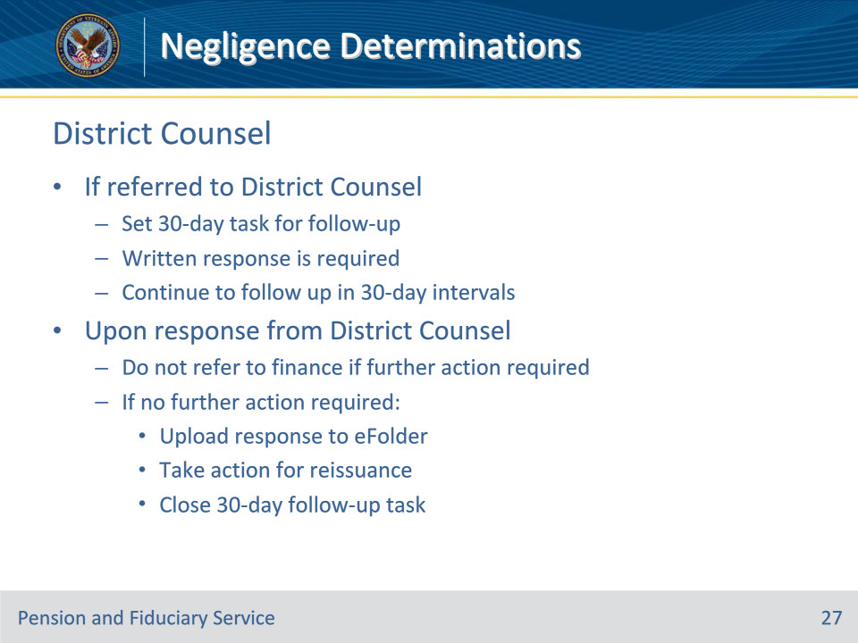
Slide notes

Policy Reference(s): FPM II.3.D.3.k.

Instructor Notes:

If referred to District Counsel, set a 30-day task for follow-up. A written response is required and must, at a minimum, acknowledge the referral. If a response is not received after 30 days, continue to follow up in 30-day intervals until a response is received.

Upon response by District Counsel, follow the guidance provided to include any necessary completion and referral to the finance activity for reissuance. Do not refer to the finance activity if District Counsel requires further action, such as additional documentation or information. If no further action is required:

• upload the response to the beneficiary’s eFolder

• take appropriate action for reissuance, and

• close the 30-day task for follow-up.

Important: It is not the responsibility of the hub to determine the legality of the documentation received; that is reserved for District Counsel.

Reference: For more information on contact information for the Offices of Chief Counsel in the Districts, see the District Office SharePoint site.

Slide 28 - Questions?
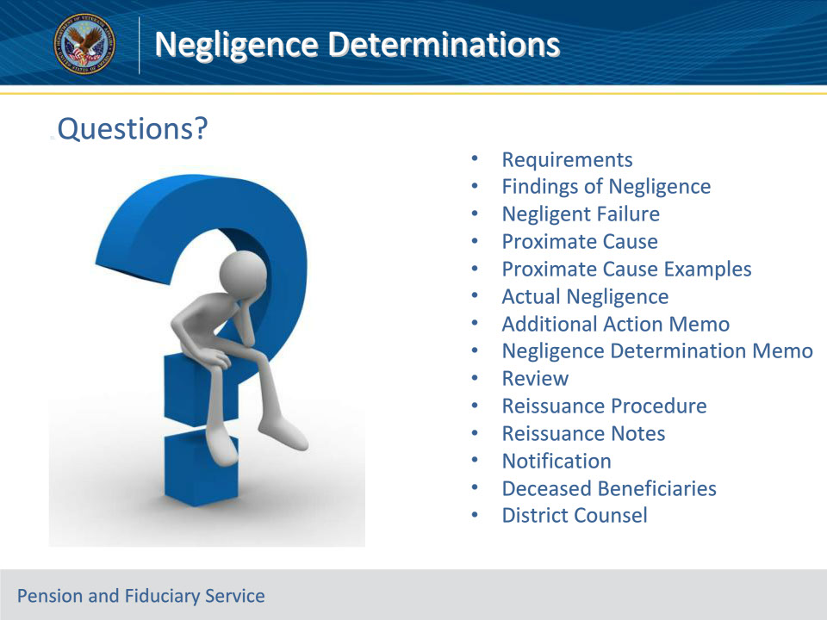
Slide notes

Instructor Notes:

These are our learning objectives as stated from the beginning of the training:

• Identify negligence requirements

• Define negligence concepts

• Process negligence memos

• Review negligence determinations

• Implement reissuance procedures

• Issue required notification

• Process deceased beneficiary cases
We discussed each of these learning objectives through the following topics in each slide today:

• Requirements

• Findings of Negligence

• Negligent Failure

• Proximate Cause

• Proximate Cause Examples

• Actual Negligence

• Additional Action Memo

• Negligence Determination Memo

• Review

• Reissuance Procedure

• Reissuance Notes

• Notification

• Deceased Beneficiaries

• District Counsel

Are there any additional questions?

Slide 29 - TMS Survey
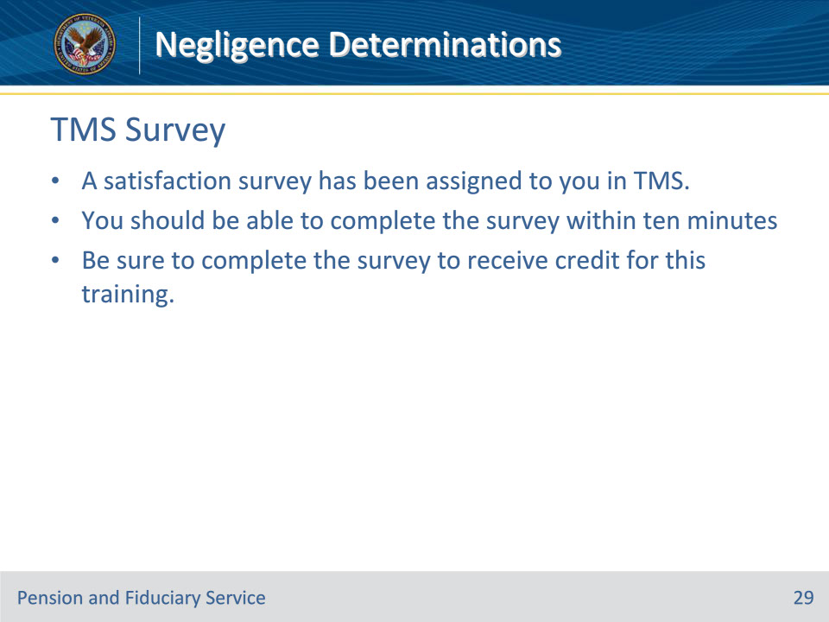
Slide notes

Instructor Notes:

A satisfaction survey has been assigned to you in TMS. You should be able to complete it within ten minutes.

Completing it will allow you to receive credit for this training.

