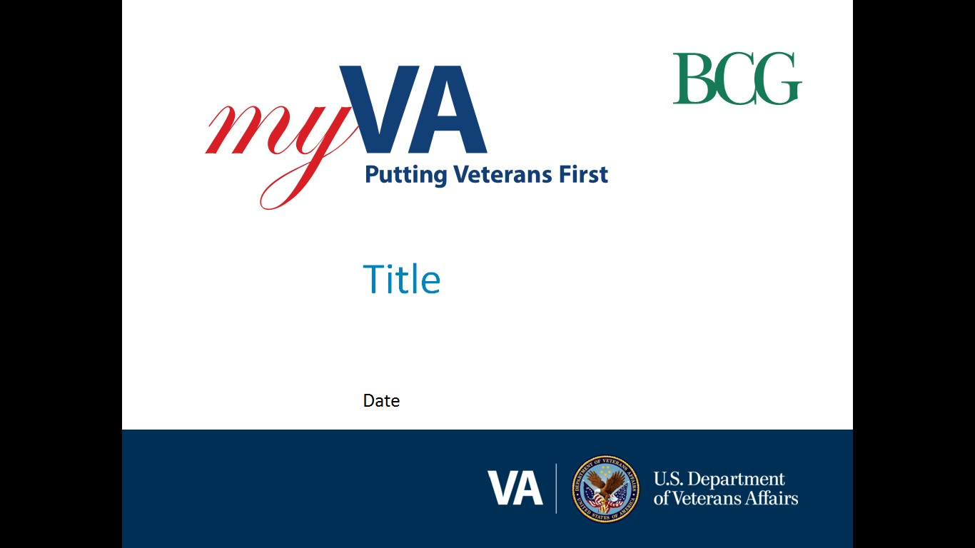

**Pension and Fiduciary (P&F) Service**

|  |  |
| --- | --- |
| Fiduciary Quality Call | Date: December 20, 2022TMS: # VA 4637732 |

|  |  |
| --- | --- |
| AGENDA TOPICS ITEM 1: Quality Error Analysis and Case Study  ITEM 2: SOAR Changes  ITEM 3: Accounting Reminders  ITEM 4: Interactive Discussions Customer Service/Phones & FUR  ITEM 5: VBMS Beneficiary Record Maintenance Training  Closing, Questions, Next Quality Call |  |

# AGENDA ITEMS

|  |  |  |  |
| --- | --- | --- | --- |
| Agenda item: | Quality Error Analysis | Presenter: | Alvin Hill, Analyst |

#### Target Audience:

Quality Review Team (QRT) Program Specialists and Coaches/Assistant Coaches

#### Discussion:

A total of 87 Financial Review errors were found during the 4th quarter resulting in 60 (69%) being noncritical errors and 27 (31%) being critical errors. Of the 27 critical errors, 19 were Accounting and 8 were Fund Usage Reviews (FUR).

There were three consistently reoccurring questions that were the primary Financial Review errors found during the quarter.  Two of the questions (13A and 13B) were accounting related and one (21A) was related to FUR.

|  |  |  |  |
| --- | --- | --- | --- |
| **Error** | **Instances** | **Type** | **Root Cause** |
| 13a | 5 | ACCT | The accounting was approved without receipt of a complete VA Form 21P-4706b, 21P-4706c and/or financial statements for the entire accounting period. |
| 13b | 5 | ACCT | A credit report has not been obtained and reviewed, if applicable. |
| 21a | 6 | FUR | The Hub did not receive all financial institution statements for the previous three-month FUR period. |

Accounting and FUR continue to be the primary area of concern for national quality accuracy. A review of the error narratives associated with each error does not identify a systemic nor procedural root cause. However, the review does present a commonality of the lack of attention to detail when reviewing financial statements and accounts during accounting audits and FUR reviews.

The hubs continue to demonstrate proficiency in field examinations resulting in no current concerns.

**References/Contacts**

[FPM II.1.C.4.e - Fund Usage Report Past Due Notification Requirement](https://vaww.vrm.km.va.gov/system/templates/selfservice/va_kanew/help/agent/locale/en-US/portal/554400000001030/content/554400000153966/FPM-Part-II-Chapter-1-Section-C-Issues-Regarding-Beneficiarys-Funds#4)

[FPM, II.1.C.4.p - Elements of a Complete Fund Usage Report Submission](https://vaww.vrm.km.va.gov/system/templates/selfservice/va_kanew/help/agent/locale/en-US/portal/554400000001030/content/554400000153966/FPM-Part-II-Chapter-1-Section-C-Issues-Regarding-Beneficiarys-Funds#4)

[FPM II.1.C.4.s - Fund Usage Review Completion Activities](https://vaww.vrm.km.va.gov/system/templates/selfservice/va_kanew/help/agent/locale/en-US/portal/554400000001030/content/554400000153966/FPM-Part-II-Chapter-1-Section-C-Issues-Regarding-Beneficiarys-Funds#4)

|  |  |  |  |
| --- | --- | --- | --- |
| Agenda item: | SOAR Changes | Presenter: | Alvin Hill, Analyst |

#### Target Audience:

Quality Review Team (QRT) Program Specialists and Coaches/Assistant Coaches

#### Discussion:

P&F Service updated the Fiduciary Hub Strategic Oversight and Analysis Review (SOAR) topic requirements in the [M21-4, Chapter 5.7.a](https://gcc02.safelinks.protection.outlook.com/?url=https%3A%2F%2Fvaww.vrm.km.va.gov%2Fsystem%2Ftemplates%2Fselfservice%2Fva_kanew%2Fhelp%2Fagent%2Flocale%2Fen-US%2Fportal%2F554400000001034%2Fcontent%2F554400000011657%2FChapter%25205.%2520Strategic%2520Oversight%2520and%2520Analysis%2520Review%2520(SOAR)%232c&data=05%7C01%7C%7C858de4753e4246df5ec608dad4a4ee53%7Ce95f1b23abaf45ee821db7ab251ab3bf%7C0%7C0%7C638056102087187984%7CUnknown%7CTWFpbGZsb3d8eyJWIjoiMC4wLjAwMDAiLCJQIjoiV2luMzIiLCJBTiI6Ik1haWwiLCJXVCI6Mn0%3D%7C3000%7C%7C%7C&sdata=kHzMzTNHa4mk%2FTnf364C3%2BBptCQpNZyeDIKJFWS%2BQcA%3D&reserved=0). The updates were published to the M21-4 on December 9, 2022. Along with updating the topic requirements, the fiscal year (FY) 2023 submission window is being adjusted to January 2023 to March 2023 to accommodate the recent updates. After the initial submissions in FY23, the frequency outlined in [M21-4 Chapter 5.2.c](https://gcc02.safelinks.protection.outlook.com/?url=https%3A%2F%2Fvaww.vrm.km.va.gov%2Fsystem%2Ftemplates%2Fselfservice%2Fva_kanew%2Fhelp%2Fagent%2Flocale%2Fen-US%2Fportal%2F554400000001034%2Fcontent%2F554400000011657%2FChapter%25205.%2520Strategic%2520Oversight%2520and%2520Analysis%2520Review%2520(SOAR)%232c&data=05%7C01%7C%7C858de4753e4246df5ec608dad4a4ee53%7Ce95f1b23abaf45ee821db7ab251ab3bf%7C0%7C0%7C638056102087187984%7CUnknown%7CTWFpbGZsb3d8eyJWIjoiMC4wLjAwMDAiLCJQIjoiV2luMzIiLCJBTiI6Ik1haWwiLCJXVCI6Mn0%3D%7C3000%7C%7C%7C&sdata=kHzMzTNHa4mk%2FTnf364C3%2BBptCQpNZyeDIKJFWS%2BQcA%3D&reserved=0) should be followed for future submissions.

For example, the FY23 two annual SOAR windows are:

* January to March (modified to accommodate updates), and
* June to August

**Key Updates:**

* Reduction in reporting topics
* Reduction in reporting frequency
* Strategic performance reporting alignment

|  |  |  |  |
| --- | --- | --- | --- |
| Agenda item: | Accounting Reminders | Presenter: | Nicole Weatherall, Analyst |

#### Target Audience:

Quality Review Team (QRT) Program Specialists and Coaches/Assistant Coaches

#### Discussion:

#### In reviewing the Unscheduled, Scheduled Field Exams, and Accountings, it is critical to remember to:

* Review the most recent budget letter to notice changes in expenses
* Review the most recent field examination report to ensure that the any changes noted by the Field Examiner in relation to the needs of the beneficiary and/or their lifestyle
* Review the most recent accounting to determine if there are any duplicate purchases being made
* Review any correspondence and/or phone calls from the fiduciary and/or beneficiary since the last accounting review to determine if anything changed that needs further review
* Review the eFolder and question any expenses that do not seem to benefit the beneficiary and any dependents and/or seem excessive

**Question 1 Salt Lake City Fiduciary Hub:** In reference to the court appointment fiduciary fee. When you say fiduciary fee, do you mean a fiduciary fee that the VA has authorized on a 21-555 or something beyond the normal fee?

**P&F Service Response:** The fiduciary fee is listed on the VA Form 21-555. It should be 4 percent. It is not supposed to exceed 4% unless it's for extraordinary services which goes beyond normal service to the beneficiary.

**Question 2 Salt Lake City Fiduciary Hub:** Is there a difference between guardian and conservator based on each state?

**P&F Service Response:** Conservator oversees the estate and Guardian oversees the person. Claims processors should review the state regulations and the court documents in the eFolder.

**Question 3 Salt Lake Fiduciary Hub**: Many times, the budget letters are two to three years old. What is your advice on what we should be looking for in the budget letter for an accounting that we are reviewing for the current year?

**P&F Service Response:** If the initial budget letter indicated (e.g., personal expenses, personal spending, allowance room and board, clothing, groceries, etc...) we should look down the list for fluctuations in expenses. Please be aware, there will more than likely be an increase over the years due to inflation or cost of living. The claims processor should be looking for general expenses that continue from the budget letter to the accounting. Please note, there can be some different items such as repairs.

For instance, if a caregiver is being paid, but this was not in the initial budget letter, then this shows that the beneficiary has additional needs for care. You should then determine if the beneficiary is receiving A&A. If not, then determine if a claim for A&A should be submitted. Perhaps the beneficiary is already paying the caregiver. Who are we paying? Are we set up on a on a strict budget or are we just taking the caregiver's word for it?

**Question 4 Louisville Fiduciary Hub:** Do you have any suggestions for QRT, if we fight an error based off of the information that was just discussed? If it's returned by High-Level Review (HLR) because the High-Level Review process doesn't agree with the error that was called by QRT; do you suggest that QRT document the eFolder or do we document it in our quality review that we have requested that this information be questioned to the fiduciary?

**P&F Service Response:** QRT specialist must document it in their quality reviews, as these are internal documents.

| References/Contacts |  |  |
| --- | --- | --- |
| * [FPM, Part I, Chapter 3, Section A - Accounting Process and Requirements](https://vaww.vrm.km.va.gov/system/templates/selfservice/va_kanew/help/agent/locale/en-US/portal/554400000001030/content/554400000153954/FPM-Part-I-Chapter-3-Section-A-Accounting-Process-and-Requirements) |  |  |

|  |  |  |  |
| --- | --- | --- | --- |
| Agenda item: | Interactive Discussions Customer Service/Phones and FUR | Presenter: | Sandy Lundquist, Analyst |

#### Target Audience:

Quality Review Team (QRT) Program Specialists and Coaches/Assistant Coaches

#### Discussion:

In an effort to engage the hubs in determining some best practices while performing local quality reviews, P&F Service did host and facilitated an Interactive Discussion during the call. The Interactive Discussion focused on reviews of Customer Service while on the phones and IQR on Fund Usage Reviews. The discussion ended with the hubs sharing their best practices for reviewing Customer Service on the phones and IQR for Fund Usage Reviews.

|  |  |  |  |
| --- | --- | --- | --- |
| Agenda item: | VBMS Beneficiary Record Maintenance Training | Presenter: | David Gunnell, Analyst |

#### Target Audience:

Quality Review Team (QRT) Program Specialists and Coaches/Assistant Coaches

#### Discussion:

VBMS beneficiary profile maintenance training. Understanding the beneficiary life cycle in the fiduciary program and utilizing a high-level overview (Big Picture) of the beneficiary profile during record maintenance, and the effect of failed oversight resulting in cascading errors.

**Question Salt Lake City:** In the training you discussed the “Big Picture” or the “Life Cycle of the Beneficiary record and maintaining the record from the creation of the record to closing the record”. In terms of the big picture, is that a principle (life cycle) that we can apply to IQRs?

**P&F Service Response:** That would be something you could discuss with your leadership team.

The training is included in the call recording.

**References/Contacts**

[38 C.F.R. 13.280 – Accountings](https://www.ecfr.gov/current/title-38/chapter-I/part-13/section-13.280)

[M21, 4.8. 3.e – Cascade Effect](https://vaww.vrm.km.va.gov/system/templates/selfservice/va_kanew/help/agent/locale/en-US/portal/554400000001030/content/554400000127439/Chapter%208.%20%20Fiduciary%20Hub%20(Hub)%20National%20Quality%20Reviews%20and%20Quality%20Review%20Teams%20(QRT)#3)

[FPM, I.1.B.3.d – Certifying Appointment of Fiduciary](https://vaww.vrm.km.va.gov/system/templates/selfservice/va_kanew/help/agent/locale/en-US/portal/554400000001030/content/554400000153946/FPM-Part-I-Chapter-1-Section-B-General-Information-on-the-Fiduciary-Program#3)

[FPM, I.1.B.3.u – Control of Missed Oversight Actions](https://vaww.vrm.km.va.gov/system/templates/selfservice/va_kanew/help/agent/locale/en-US/portal/554400000001030/content/554400000153946/FPM-Part-I-Chapter-1-Section-B-General-Information-on-the-Fiduciary-Program#3t)

[FPM, I.1.B.6.d – LIE Responsibilities FPM, I.2.C.5.a – Appointment and Fiduciary Types](https://vaww.vrm.km.va.gov/system/templates/selfservice/va_kanew/help/agent/locale/en-US/portal/554400000001030/content/554400000153946/FPM-Part-I-Chapter-1-Section-B-General-Information-on-the-Fiduciary-Program#6)

[FPM, I.3.A.2.a – VA Appointed Fiduciaries Accounting Req](https://vaww.vrm.km.va.gov/system/templates/selfservice/va_kanew/help/agent/locale/en-US/portal/554400000001030/content/554400000153954/FPM-Part-I-Chapter-3-Section-A-Accounting-Process-and-Requirements#2).

[FPM, I.3.A.2.c – Exceptions To the Accounting Requirement](https://vaww.vrm.km.va.gov/system/templates/selfservice/va_kanew/help/agent/locale/en-US/portal/554400000001030/content/554400000153954/FPM-Part-I-Chapter-3-Section-A-Accounting-Process-and-Requirements#2)

[FPM, I.3.D.1.g – Updating the Beneficiary and Fiduciary Profile](https://vaww.vrm.km.va.gov/system/templates/selfservice/va_kanew/help/agent/locale/en-US/portal/554400000001030/content/554400000153959/FPM-Part-I-Chapter-3-Section-D-Accounting-Disposition#1)

[FPM, II.1.C.4.o – Assessing Fund Usage Reports](https://vaww.vrm.km.va.gov/system/templates/selfservice/va_kanew/help/agent/locale/en-US/portal/554400000001030/content/554400000153966/FPM-Part-II-Chapter-1-Section-C-Issues-Regarding-Beneficiarys-Funds#4)

[FPM, II.1.C.4.s – Fund Usage Review Completion Activities](https://vaww.vrm.km.va.gov/system/templates/selfservice/va_kanew/help/agent/locale/en-US/portal/554400000001030/content/554400000153966/FPM-Part-II-Chapter-1-Section-C-Issues-Regarding-Beneficiarys-Funds#4)

# Closing Comments

#### P&F Service Quality Mailbox:

#### We will solicit for agenda topic(s) for each future Quality Call. If you have a specific topic suggestion, please feel free to email it to the P&F Service Training, Quality, and Oversight mailbox at [PFTNGQUALOVRST.VBACO@va.gov](mailto:PFTNGQUALOVRST.VBACO@va.gov). For specific policy and procedures related topics, please email to the Policy and Procedures mailbox at [PFPOLPROC.VBACO@va.gov](mailto:PFPOLPROC.VBACO@va.gov).

#### Quality Call Bulletins

Quality Call Bulletins can be found in the following location: <https://vbaw.vba.va.gov/PENSIONANDFIDUCIARY/Quality_Call_Bulletins.asp>. The next Quality Call is tentatively scheduled for February 2023.

#### TMS Courses

All P&F Service Quality Calls and bulletins will be available in TMS. Once the monthly bulletin is finalized, information will be sent to the PMCs and Fiduciary Hubs, which will include the TMS #.

# Post-Call Follow Up

**Quality Call Recording:**

A recording of the December 2022 Fiduciary Quality Call can be found [here](https://web.microsoftstream.com/video/ed62b659-f709-4149-97d1-1d9daa86c93f) (open in Chrome):

**TMS Course:**

Available content from the Quality Call (bulletin, recording, etc.) will be available in TMS. The TMS # for the December 2022 Pension and Fiduciary Quality Call is VA 4637732 (Pension and Fiduciary Service Quality Call – Fiduciary December 2022)



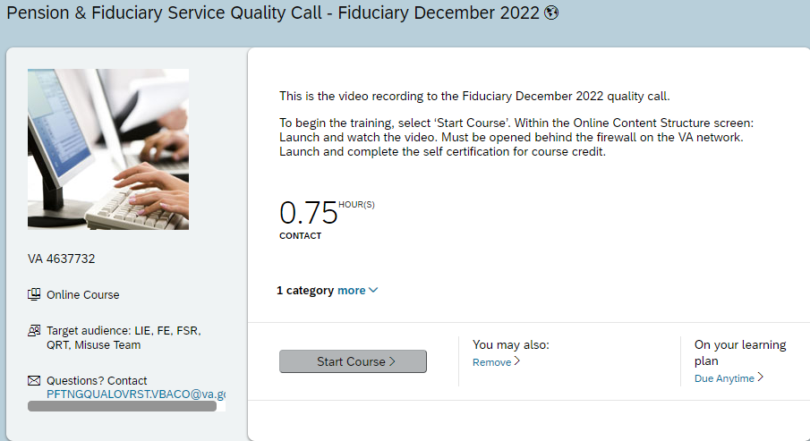

**Q&A:**

**Question Indianapolis Fiduciary Hub:** Please clarify if there is a need to create a bond exoneration task to track proof a bond was exonerated, and any unused premiums are refunded. FPM II.2.B.1.h is has been referenced by P&F in the past stating a task is needed to adjust the bond. We are interpreting the exoneration itself is not a bond adjustment, but rather a removal of a bond.

**P&F Service Response:** A bond exoneration task is ***not required*** to track proof a bond was exonerated and any unused premiums are refunded.

The procedures listed in [FPM, Part II, 2.B.1.h](https://vaww.vrm.km.va.gov/system/templates/selfservice/va_kanew/help/agent/locale/en-US/portal/554400000001030/content/554400000153970/FPM-Part-II-Chapter-2-Section-B-Bonds-Withdrawal-Agreements-and-Liability-Insurance#1h), are concerning adjusting a bond amount to account for a significant change in VA funds under management. The procedures outlined within this block allow timely oversight of the required actions of the fiduciary to ensure appropriate benefit funds protection are in place for the beneficiary.

P&F Service is researching existing procedures to determine if clarification is needed within the FPM.  Please note, if a manual change is implemented, you will be notified via the Compensation Service Calendar email blast. To subscribe to this email blast, please visit the [Calendar Subscriptions](http://vbacoweb03.dva.va.gov/bl/21/Calendar/cal_Subscribe.asp) website.