Slide 1 - FAST Special Considerations

Slide notes

Course Description:

This course teaches learners about actions required when reviewing FAST accounting submissions, including assigning a reviewer in FAST, managing multiple submissions, other acceptable submission modes, and incorrect report types.

Slide 2 - Objectives
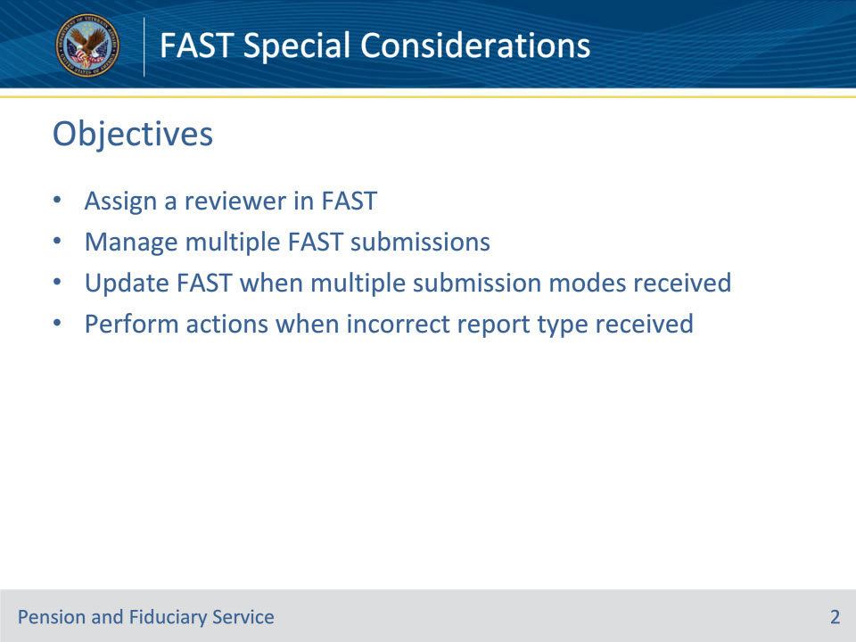
Slide notes

Instructor Notes:

At the end of this lesson, given the training and references, the learner will be able to do the following:

• Assign a reviewer in FAST

• Manage multiple FAST submissions

• Update FAST when multiple submission modes received

• Perform actions when incorrect report type received

Slide 3 - References
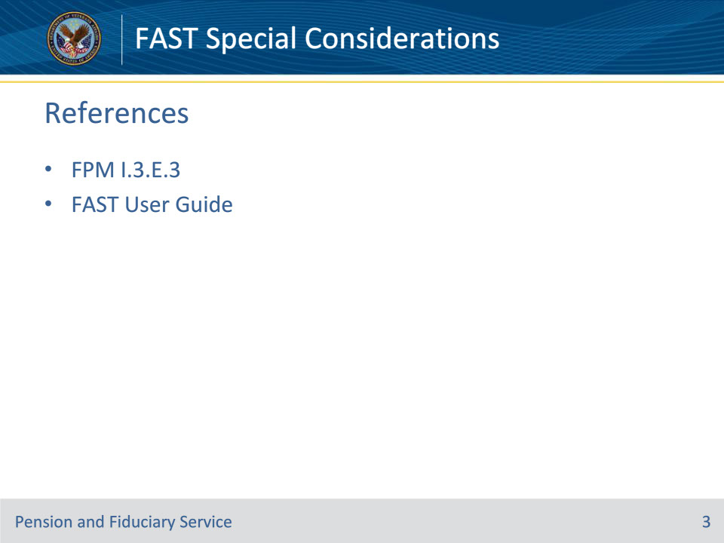
Slide notes

Instructor Notes:

These are the relevant references pertaining to this course:

• FPM I.3.E.3 Special Considerations When Reviewing FAST Submissions

• FAST User Guide

• how to assign reviewer and deactivate an accounting(s). Please see link https://vbaw.vba.va.gov/PENSIONANDFIDUCIARY/fiduciary/docs/FAST_User_Guide.pdf

Slide 4 - Assigning Reviewer
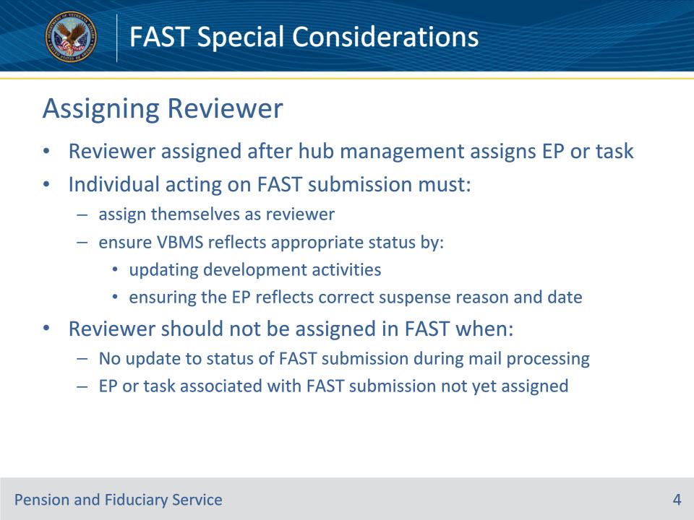
Slide notes

Policy Reference(s): FPM I.3.E.3.a.

Instructor Notes:

Generally, a reviewer in FAST is assigned after hub management assigns the EP or administrative task to the appropriate hub employee in the Veterans Benefits Management System (VBMS).

The individual acting on a FAST submission must

• assign themselves as the reviewer, and

• ensure VBMS reflects the appropriate status by

• updating development activities, and

• ensuring the EP reflects the correct suspense reason and date.

A reviewer should not be assigned in FAST when

• no action will be taken to update the status of the FAST submission during mail processing and/or

• the EP or administrative task associated with the FAST submission has not yet been assigned.

Slide 5 - Managing Submissions
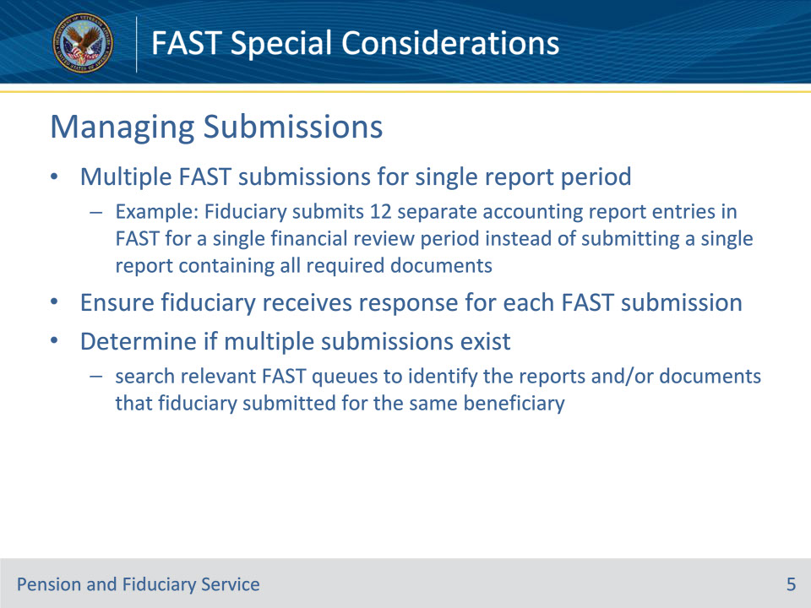
Slide notes

Policy Reference(s): FPM I.3.E.3.b.

Instructor Notes:

Ideally, when a fiduciary provides documents in response to VA’s request for an accounting, the fiduciary will provide the report as a single submission.

However, on occasion, a fiduciary may make multiple submissions for VA’s review in FAST for a single financial report period. For example, a fiduciary may submit 12 separate accounting report entries in FAST for a single financial review period instead of submitting a single report containing all required documents.

When the fiduciary provides multiple submissions for a single financial review period, the individual completing the EP or administrative task must ensure the fiduciary receives a response for each fiduciary FAST submission. Determine if multiple submissions exist by searching relevant FAST queues to identify the reports and/or documents that the fiduciary submitted for the same beneficiary.

Slide 6 - Managing Submissions
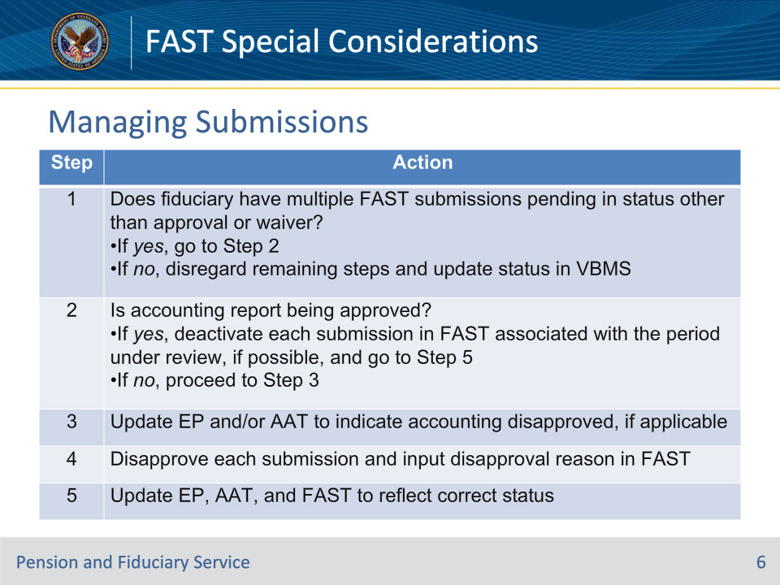
Slide notes

Policy Reference(s): FPM I.3.E.3.b.

Instructor Notes:

Follow the steps in this table to ensure FAST is updated appropriately when the hub receives multiple submissions for the same period under review.

Note for step 2: Ensure that the VBMS and FAST disposition updates are consistent.

Note for step 4: When providing a disapproval reason, only provide a disapproval reason for the impacted submission when the fiduciary has provided multiple reports in FAST.

Slide 7 - Multiple Submission Modes
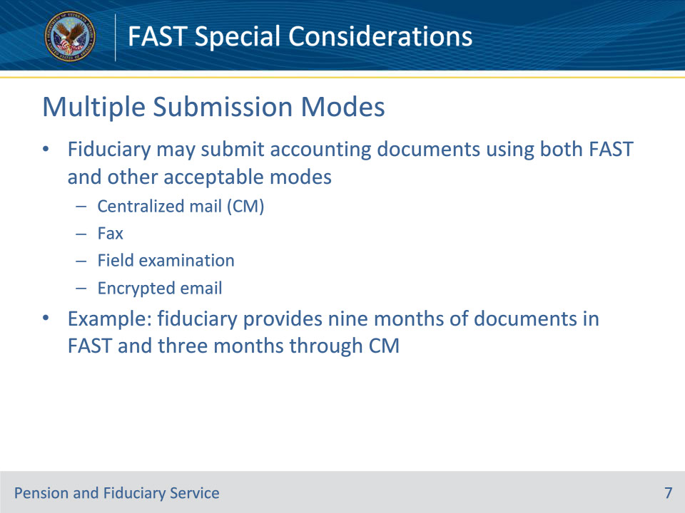
Slide notes

Policy Reference(s): FPM I.3.E.3.c.

Instructor Notes:

A fiduciary may submit their accounting documents using both FAST and other acceptable modes (for example, FAST, CM (centralized mail), fax, field examination, or encrypted email) for the same period under review. For example, the fiduciary responds to VA’s request for accounting information by providing nine months in FAST and three months through CM.

Slide 8 - Multiple Submission Modes
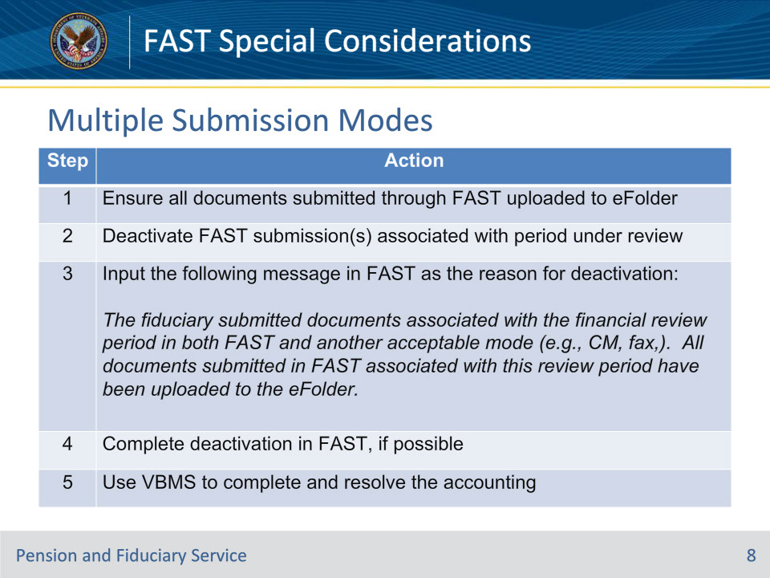
Slide notes

Policy Reference(s): FPM I.3.E.3.c.

Instructor Notes:

Follow the steps in this table to update the systems and notify the fiduciary when multiple modes were used to submit accounting information associated with the same financial review period.

Slide 9 - Incorrect Report Type
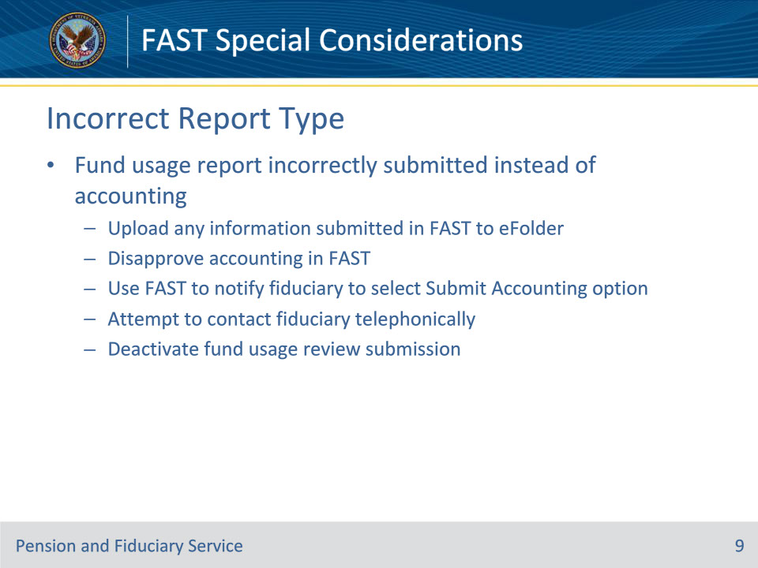
Slide notes

Policy Reference(s): FPM I.3.E.3.d.

Instructor Notes:

In order to comply with VA’s request for information relating to management of VA beneficiary funds, the fiduciary may inadvertently submit the incorrect type of report in FAST.

The requirements for an accounting report are generally more comprehensive than the fund usage report. Therefore, the hub must immediately

• upload any information submitted in FAST to the beneficiary’s eFolder

• disapprove the accounting in FAST and use FAST to notify the fiduciary that they must select the Submit Accounting option

• attempt to contact the fiduciary telephonically, and

• deactivate the fund usage review submission so that the fiduciary is unable to add any additional documents to the fund usage review submission in FAST.

Important: Document successful and unsuccessful telephone contact attempts on VA Form 27-0820 and detail on the form that the FAST submission has been deactivated and is no longer available for review because the fiduciary submitted the incorrect report type.

Slide 10 - Questions?
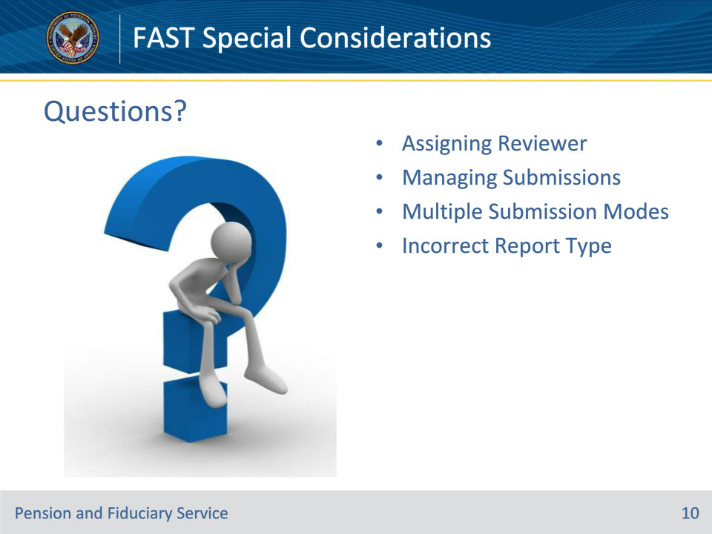
Slide notes

Instructor Notes:

(Recall) These are our learning objectives as stated from the beginning of the training:

• Assign a reviewer in FAST

• Manage multiple FAST submissions

• Update FAST when multiple submission modes received

• Perform actions when incorrect report type received

(Recap) We discussed each of these learning objectives through the following topics in each slide today:

• Assigning Reviewer

• Managing Submissions

• Multiple Submission Modes

• Incorrect Report Type

Are there any additional questions?

Questions should be filtered through your QRT team. They will submit your questions to the Field Inquiry Tool (FIT) on your behalf.

Slide 11 - TMS Survey/Assessment
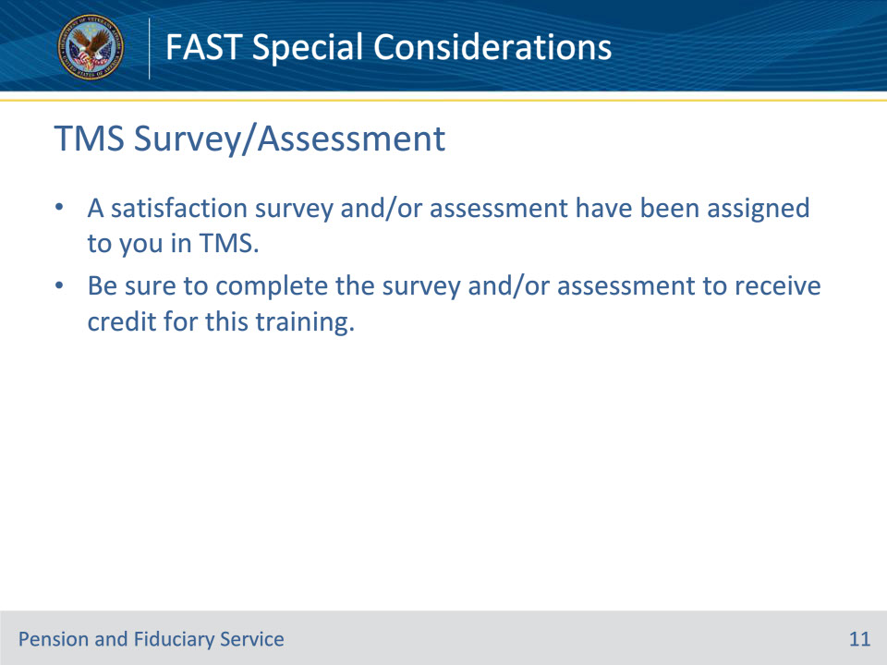
Slide notes

Instructor Notes:

A satisfaction survey and/or assessment have been assigned to you in TMS.

Be sure to complete the survey and/or assessment to receive credit for this training.

