Slide 1 - Final Accountings

Slide notes

Course Description:

This course teaches learners information on final accountings, including when they are required, notification requirements, benefit overpayment procedures, and required actions.

Slide 2 - Objectives
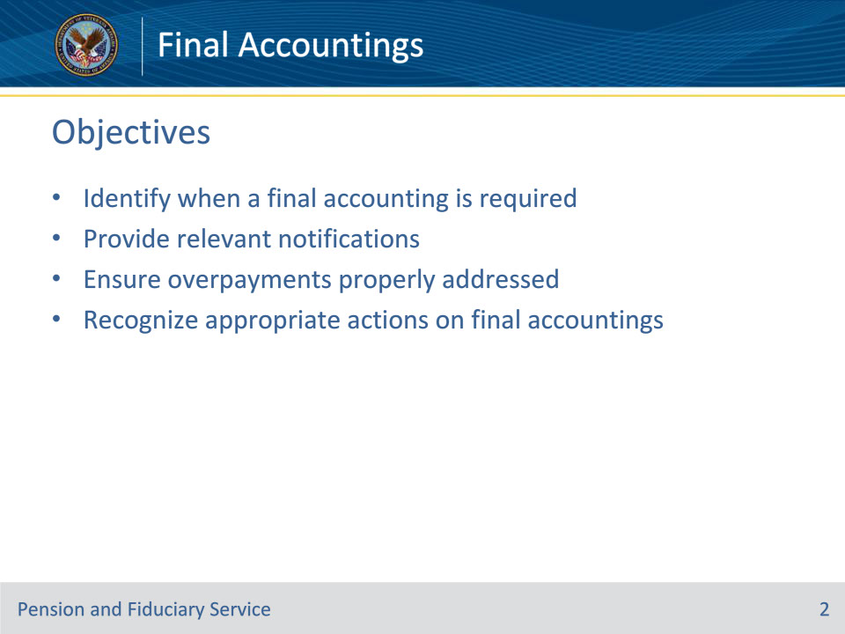
Slide notes

Instructor Notes:

At the end of this lesson, given the training and references, the learner will be able to do the following:

• Identify when a final accounting is required

• Provide relevant notifications

• Ensure overpayments properly addressed

• Recognize appropriate actions on final accountings

Slide 3 - References
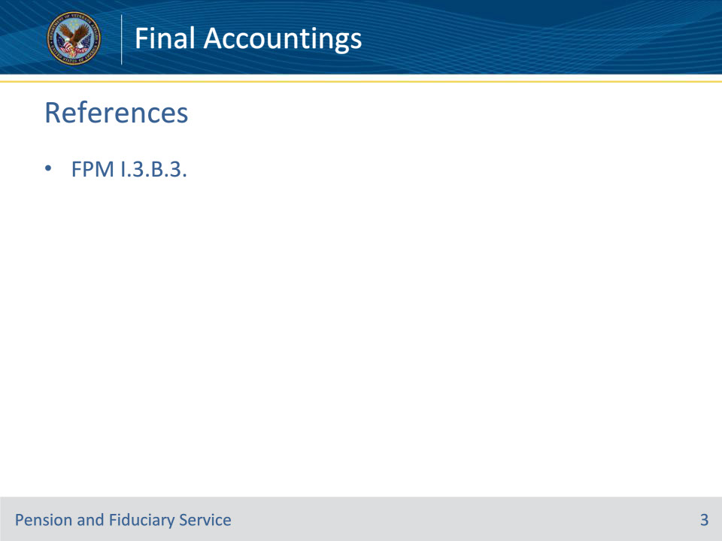
Slide notes

Instructor Notes:

These are the relevant references pertaining to this course:

• FPM I.3.B.3. Final Accountings

Slide 4 - Requirements
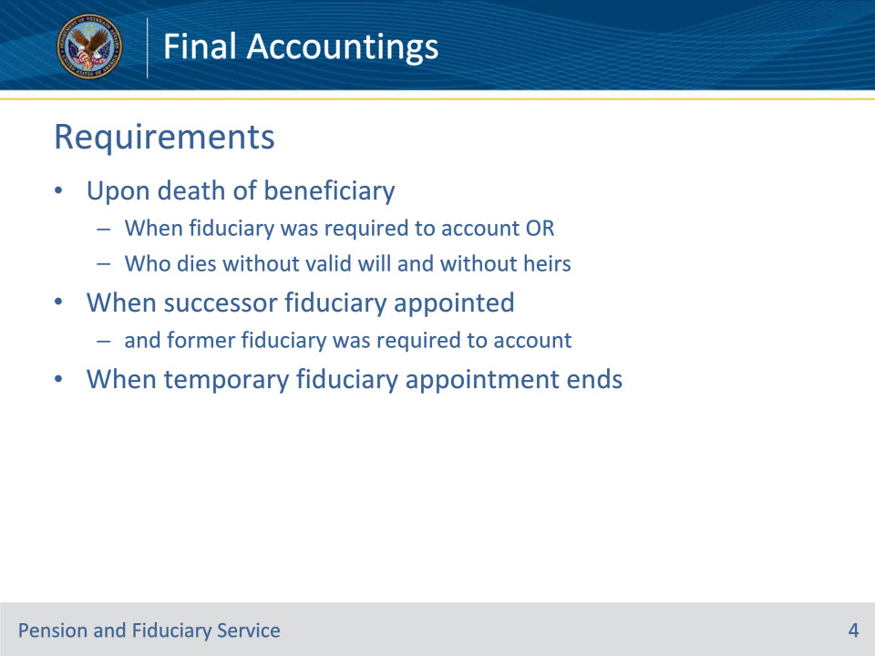
Slide notes

Policy Reference(s): FPM I.3.B.3.a.

Instructor Notes:

In accordance with 38 CFR 13.250(b) and 38 CFR 13.280, VA requires a final accounting from a VA-appointed fiduciary any time an accounting requirement is met.

Hub personnel must make an immediate request for final accountings

• upon the death of a beneficiary

• when the fiduciary was required to account, or

• who dies without a valid will and without heirs, whose VA FUM would be forfeited to a State and must be returned to VA through the escheat statute

• when a successor fiduciary is appointed and the former fiduciary was required to account, or

• when a temporary fiduciary appointment ends.

Slide 5 - Due Dates
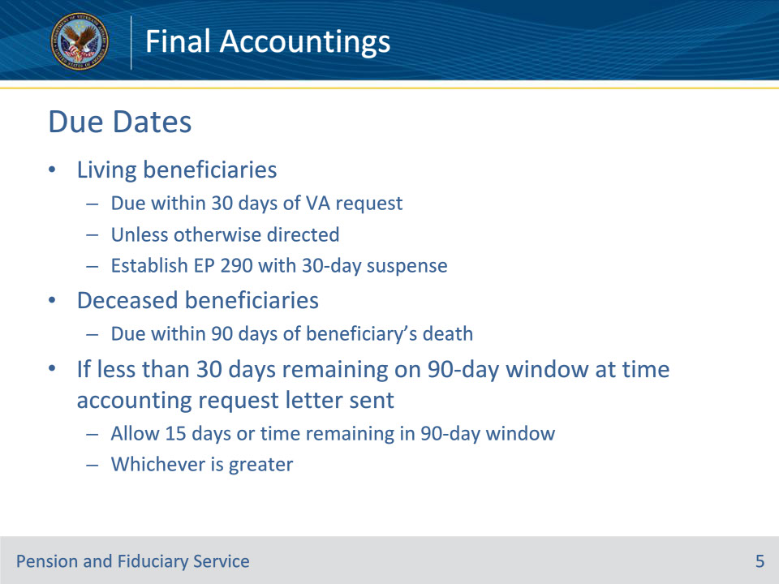
Slide notes

Policy Reference(s): FPM I.3.B.3.a.

Instructor Notes:

Final accountings for living beneficiaries are due within 30 days of the VA request unless otherwise directed. Establish an EP 290 with a 30-day suspense date to track for receipt of these final accountings.

Final accountings for deceased beneficiaries are due to VA within 90 days of the beneficiary’s death. If there are less than 30 days remaining on the 90-day window at the time the accounting request letter is sent, the fiduciary has 15 days to submit the final accounting, or the time remaining in the 90-day window, whichever is greater.

Slide 6 - FUM Transfer
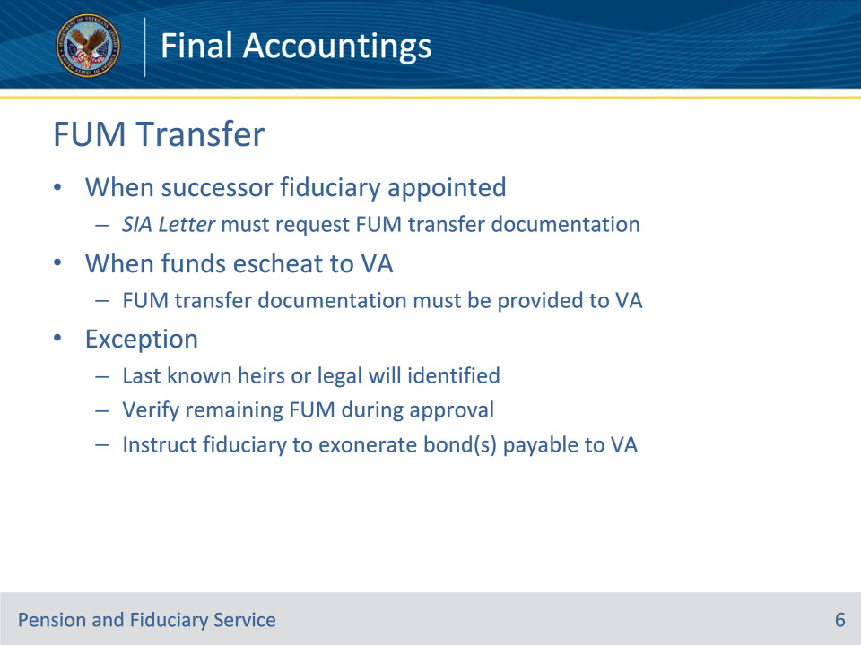
Slide notes

Policy Reference(s): FPM I.3.B.3.a.

Instructor Notes:

When a successor fiduciary is appointed, the SIA Letter must request documentation concerning the FUM transfer. This documentation must also be provided to VA if FUM is to be transferred to the VA when escheat applies.

Exception: A request for FUM transfer documentation is not required when a final accounting for a deceased beneficiary is needed and last known heirs or a legal will has been identified. Approval of the final accounting verifies the remaining FUM and the fiduciary can be instructed to exonerate the active surety bond(s) payable to the VA in the accounting approval letter.

Slide 7 - Actions
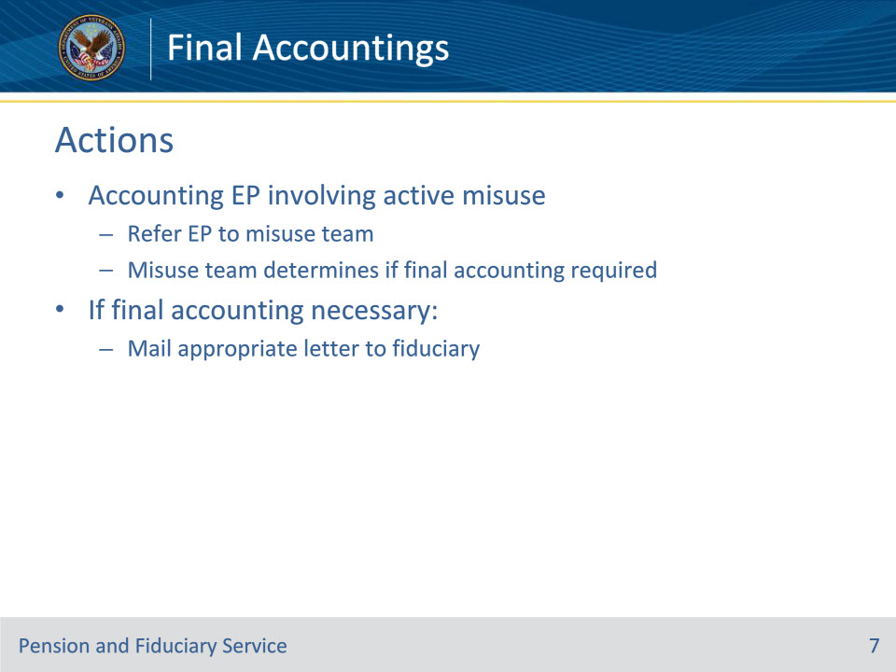
Slide notes

Policy Reference(s): FPM I.3.B.3.a.

Instructor Notes:

• Refer any accounting EP involving an active misuse EP to the misuse team to determine if a final accounting is required.

• Mail the appropriate letter to the fiduciary if a final accounting is necessary

Slide 8 - Approval
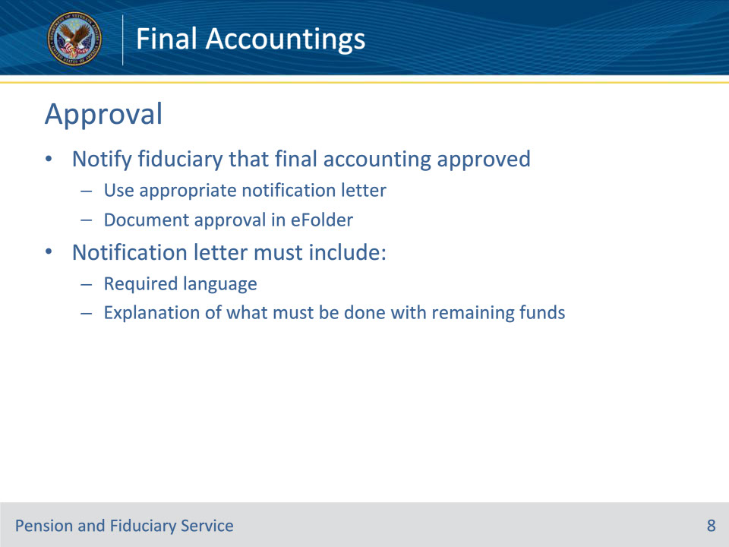
Slide notes

Policy Reference(s): FPM I.3.B.3.b.

Instructor Notes:

Hubs must notify the fiduciary that the final accounting was approved, using the appropriate notification letter, and document the approval in the eFolder. The notification letter must include

• the required language, and

• an explanation of what must be done with the beneficiary’s remaining funds.

Slide 9 - Approval
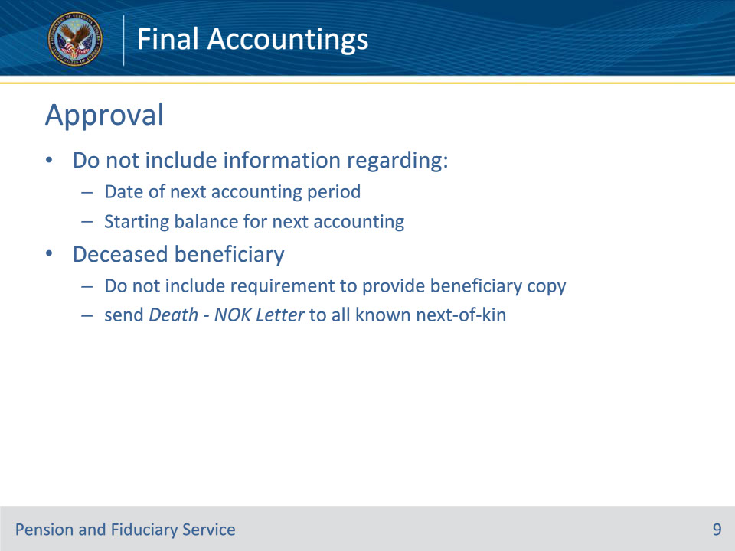
Slide notes

Policy Reference(s): FPM I.3.B.3.b.

Instructor Notes:

Exception: Do not include information regarding the

• date of the next accounting period

• starting balance for the next accounting, or

• requirement to provide the beneficiary with a copy of the approval notification letter and VA accounting form, when the beneficiary is deceased.

When the accounting of a deceased beneficiary is resolved, send the Death - NOK Letter to all the known beneficiary’s next-of-kin, that includes the fiduciary’s contact information.

Slide 10 - Approval
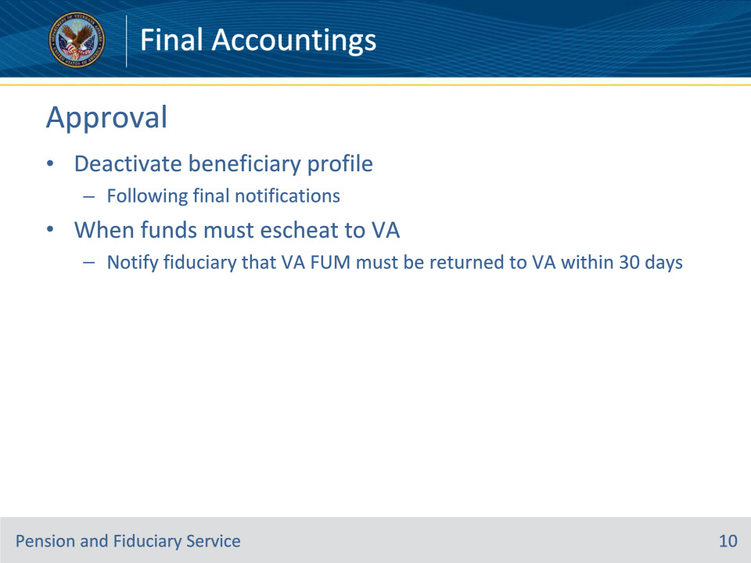
Slide notes

Policy Reference(s): FPM I.3.B.3.b.

Instructor Notes:

• Deactivate the beneficiary profile following final notifications.

• When funds must escheat to VA, the Legal Instruments Examiner (LIE) must notify the fiduciary that the VA FUM must be returned to VA within 30 days.

Slide 11 - Benefit Overpayment
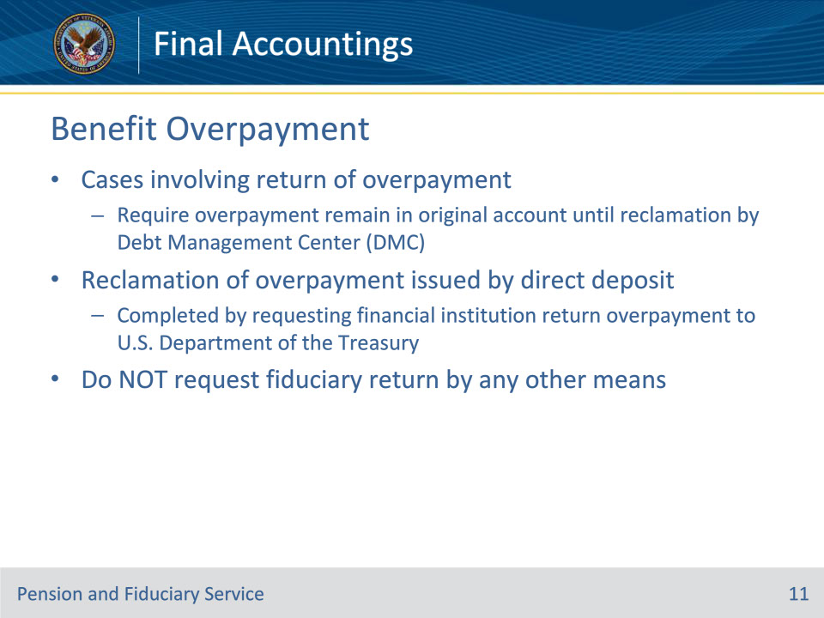
Slide notes

Policy Reference(s): FPM I.3.B.3.c.

Instructor Notes:

Cases involving return of an overpayment, require the overpayment to remain in the original financial institution account until reclamation by the Debt Management Center. Reclamation of an overpayment issued by direct deposit may be completed by requesting the financial institution to return the overpayment to the U.S. Department of the Treasury. Do not request the fiduciary to return the overpayment by any other means.

Slide 12 - Additional Considerations
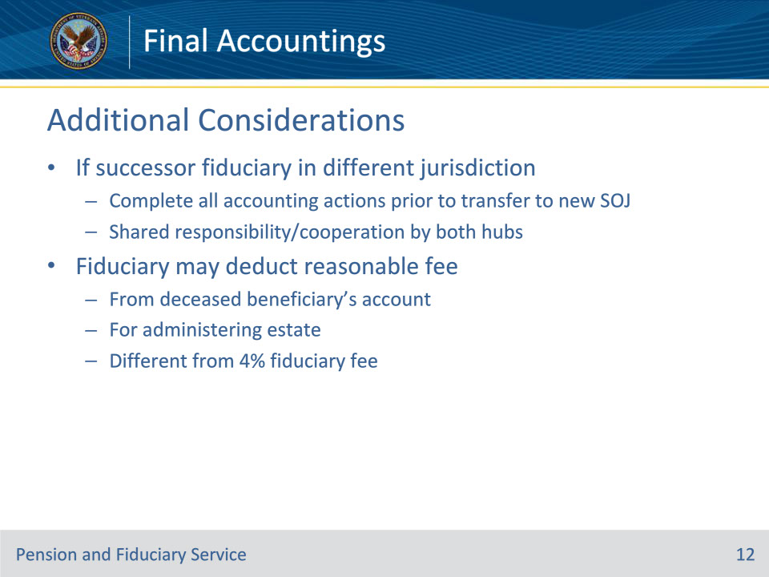
Slide notes

Policy Reference(s): FPM I.3.B.3.d.

Instructor Notes:

If the successor fiduciary is in a different hub of jurisdiction, the hub must complete all accounting actions prior to transfer to the new station of jurisdiction. Shared responsibility by both hubs must be utilized with a spirit of cooperation.

VA funds must be returned to VA upon the death of a beneficiary who dies without a valid will or heirs, and whose VA FUM would be forfeited to a State. The fiduciary may deduct a reasonable fee from the deceased beneficiary’s account for purposes of determining whether the FUM would escheat to a State under State law or the beneficiary has a valid will or heirs.

The reasonable fee is not the 4-percent fiduciary fee authorized by the Fiduciary Hub Manager, but a fee for administering the deceased beneficiary’s estate.

Slide 13 - Questions?
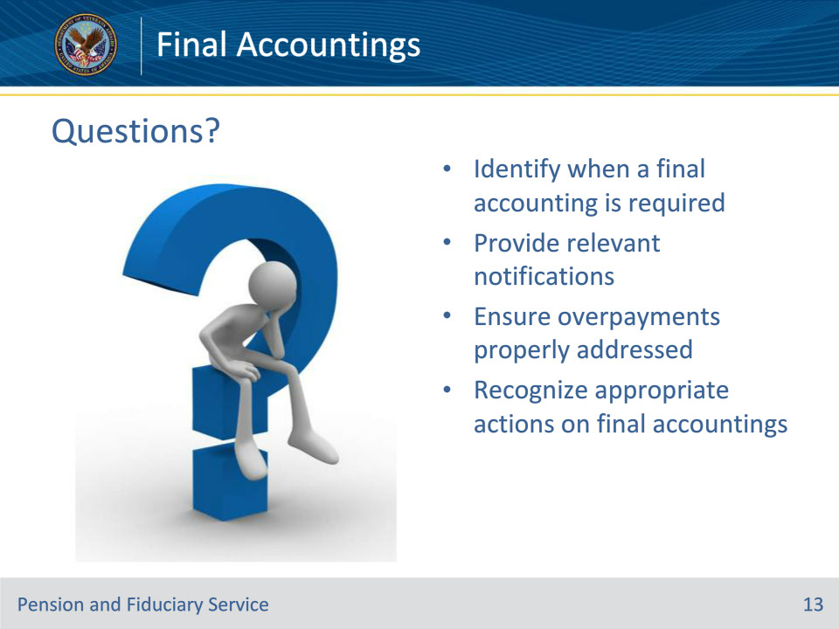
Slide notes

Instructor Notes:

(Recall) These are our learning objectives as stated from the beginning of the training:

• Identify when a final accounting is required

• Provide relevant notifications

• Ensure overpayments properly addressed

• Recognize appropriate actions on final accountings

Are there any additional questions?

Questions should be filtered through your QRT team. They will submit your questions to the Field Inquiry Tool (FIT) on your behalf.

Slide 14 - TMS Survey/Assessment
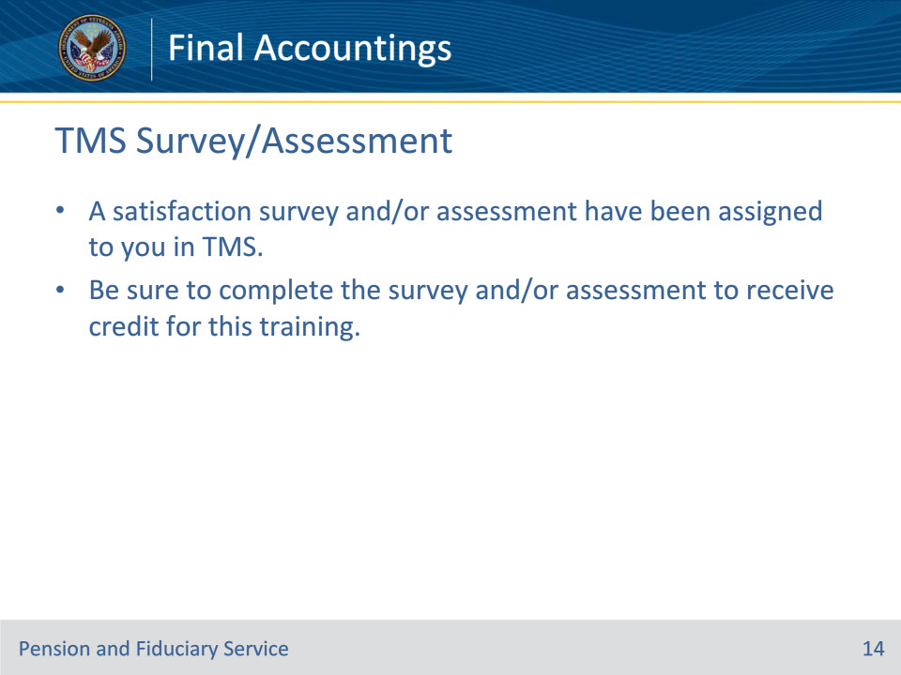
Slide notes

Instructor Notes:

A satisfaction survey and/or assessment have been assigned to you in TMS.

Be sure to complete the survey and/or assessment to receive credit for this training.

