Slide 1 - Accounting Issues
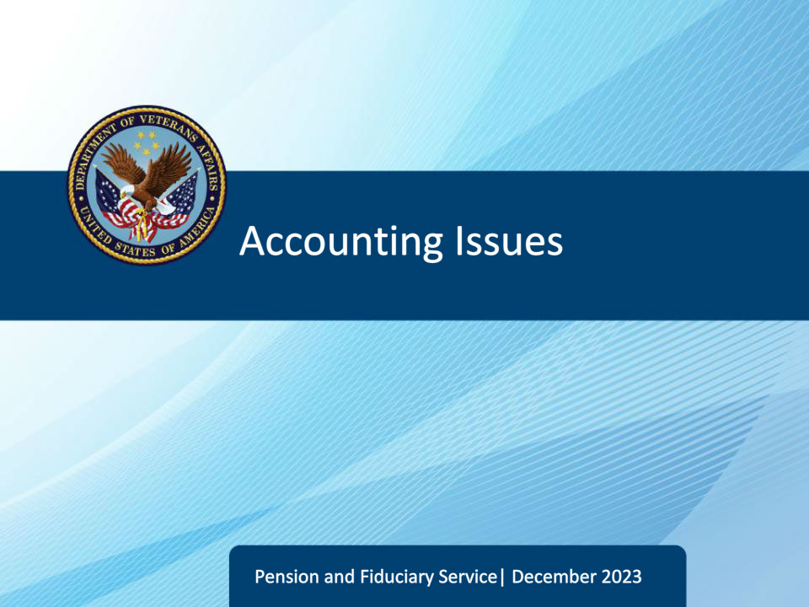
Slide notes

Course Description:

This course teaches learners actions to take when an accounting cannot be approved and guidance regarding accountings following a fund usage follow-up field examination.

Slide 2 - Objectives
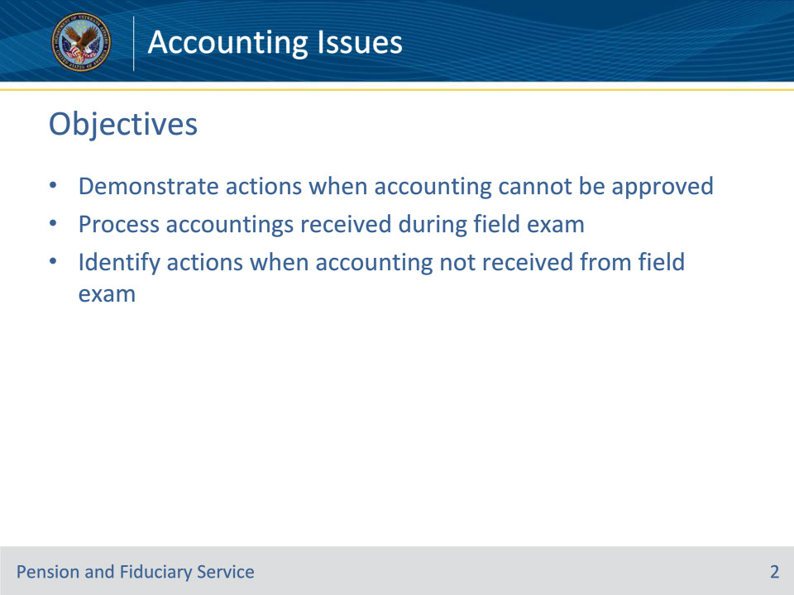
Slide notes

Instructor Notes:

At the end of this lesson, given the training and references, the learner will be able to do the following:

• Demonstrate actions when accounting cannot be approved

• Process accountings received during field exam

• Identify actions when accounting not received from field exam

Slide 3 - References
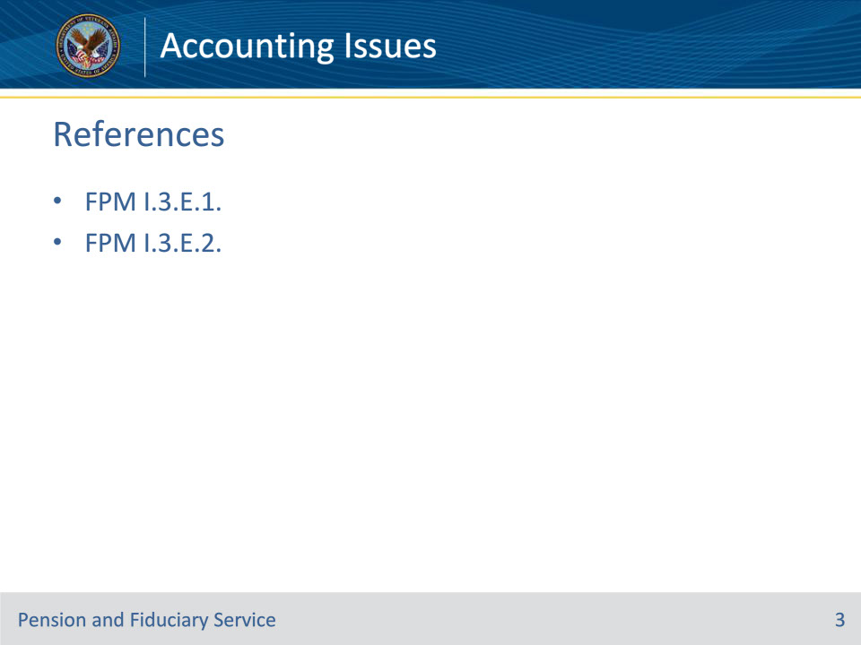
Slide notes

Instructor Notes:

These are the relevant references pertaining to this course:

• FPM I.3.E.1. Procedures When Approving an Accounting Is Not Possible

• FPM I.3.E.2. Handling Accountings Following a Fund Usage Follow-Up Field Examination

Slide 4 - Willful Neglect
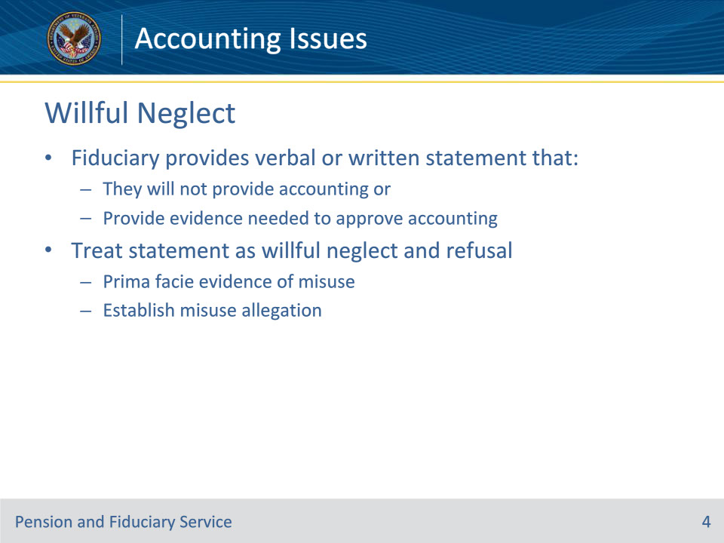
Slide notes

Policy Reference(s): FPM I.3.E.1.a

Instructor Notes:

When a fiduciary provides a verbal or written statement that they will not provide an accounting or provide evidence needed to approve an accounting, the Department of Veterans Affairs (VA) will treat this statement as willful neglect and refusal. VA will treat the fiduciary’s refusal to file proper accountings as prima facie evidence of misuse and will establish an allegation.

Slide 5 - Willful Neglect
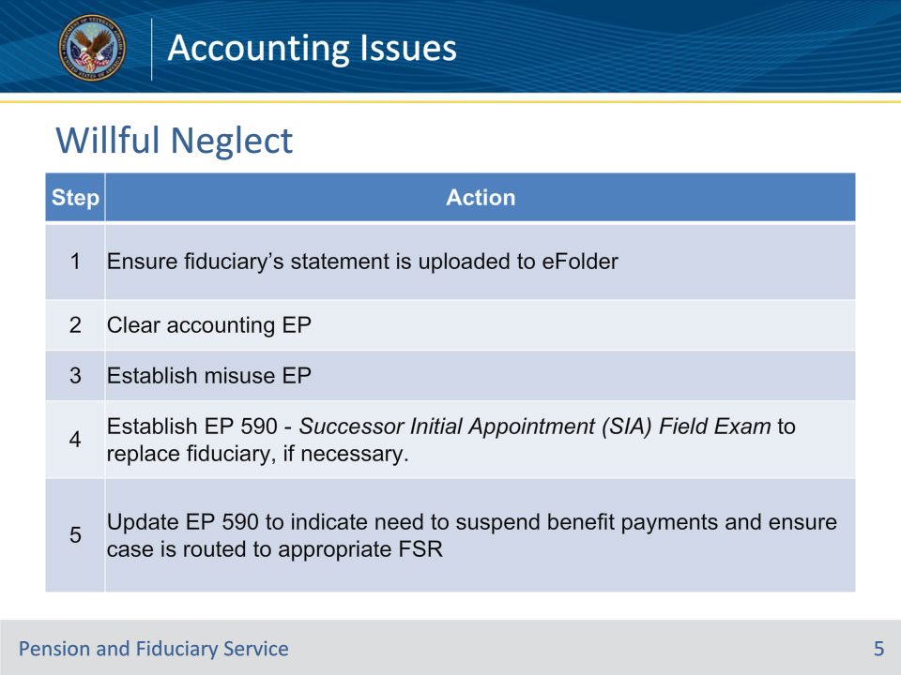
Slide notes

Policy Reference(s): FPM I.3.E.1.a

Instructor Notes:

Follow the steps in this table upon receipt of the fiduciary’s statement.

Note for step 1: If the statement is made verbally, document the fiduciary’s refusal on a VA Form 27-0820, Report of General Information, for inclusion in the eFolder.

Note for step 4: The DATE OF CLAIM value is the date VA received the fiduciary’s statement.

Slide 6 - Incomplete Accounting
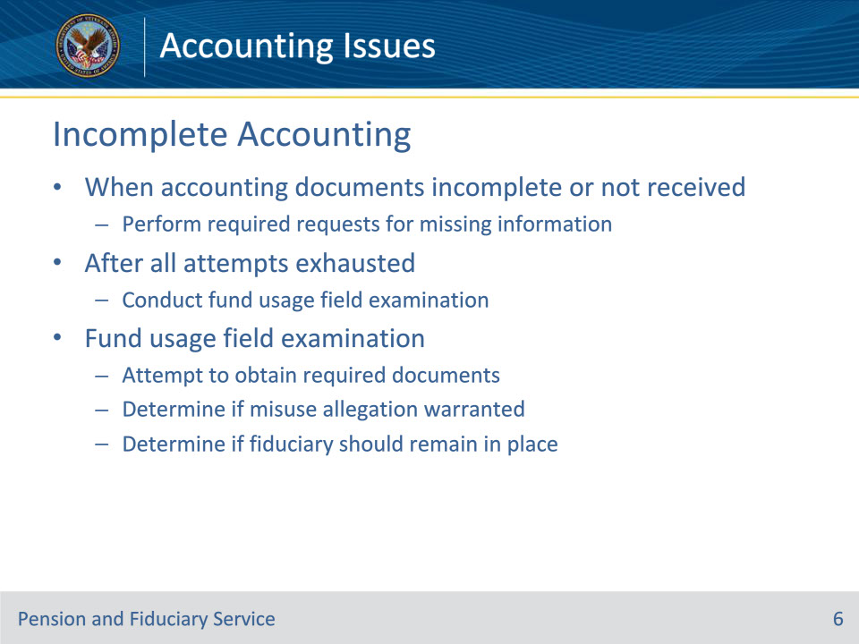
Slide notes

Policy Reference(s): FPM I.3.E.1.b

Instructor Notes:

When accounting documents are incomplete or not received, follow required requests for the missing information per FPM, Part I, 3.B.4 and FPM, Part I, 3.D.2, respectively.

Slide 7 - Incomplete Accounting
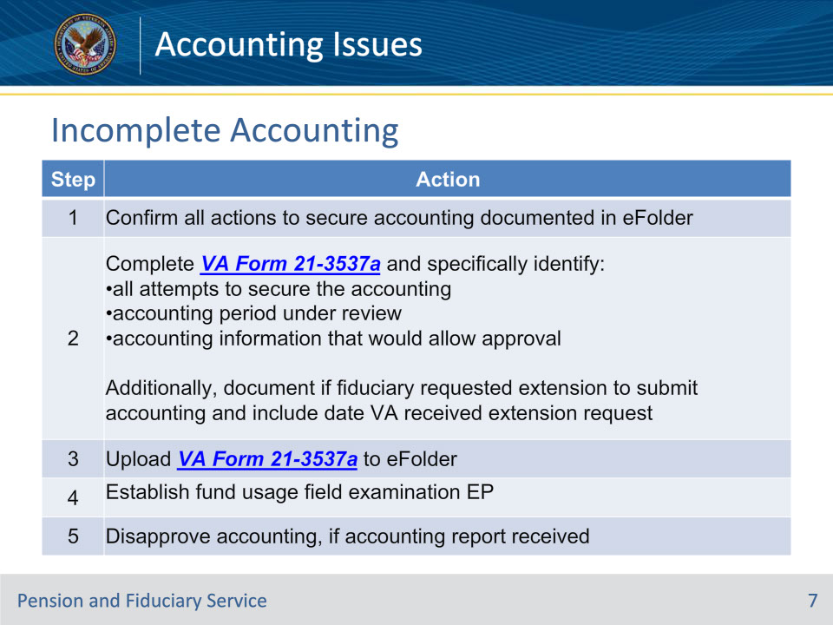
Slide notes

Policy Reference(s): FPM I.3.E.1.b

Instructor Notes:

Follow the steps in this table upon determination that the accounting is not approvable.

Note for step 4: The DATE OF CLAIM value is the date the Legal Instruments Examiner (LIE) determines the accounting is not approvable. This is generally the date of the completion of the VA Form 21-3537a.

Note for step 5: Do not cancel or clear the accounting EP. Add the appropriate development activity and update the suspense to follow up on the field examination request in 14 days.

Slide 8 - Incomplete Accounting
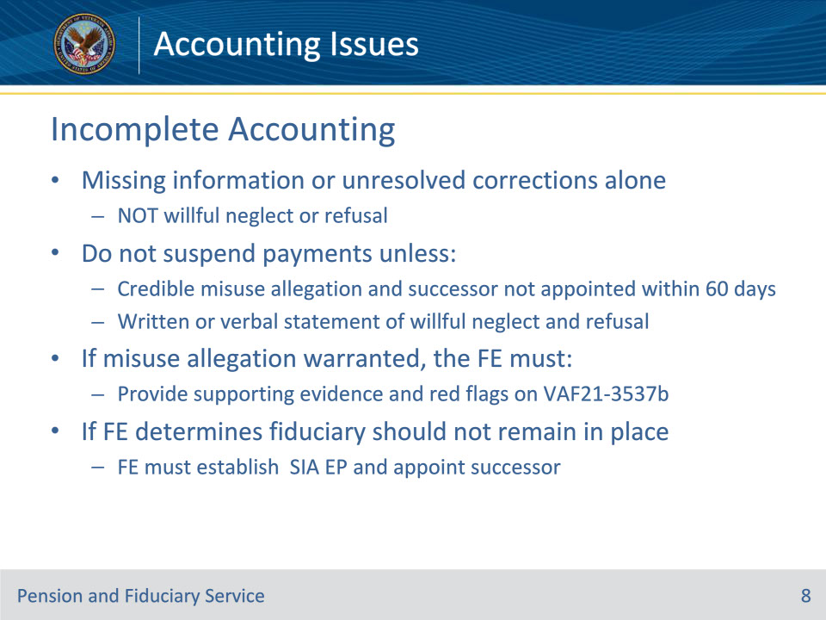
Slide notes

Policy Reference(s): FPM I.3.E.1.b

Instructor Notes:

VA will not treat missing information or unresolved corrections alone as willful neglect or refusal requiring a misuse allegation. Do not suspend payments unless there is a

• credible allegation of misuse and a successor fiduciary will not be appointed within 60 days of the allegation, or

• written or verbal statement from the fiduciary which indicates they do not intend to submit the requested documents.

If a misuse allegation is warranted, the Field Examiner (FE) must provide evidence to support the decision and document the red flag indicators that warrant a referral to misuse on VA Form 21-3537b, Report of Field Examination. If such evidence is not found, then a referral of misuse is not appropriate.

If the FE determines that the fiduciary should not remain in place, the FE must immediately establish an SIA EP and appoint a successor fiduciary.

Slide 9 - Assistance Needed
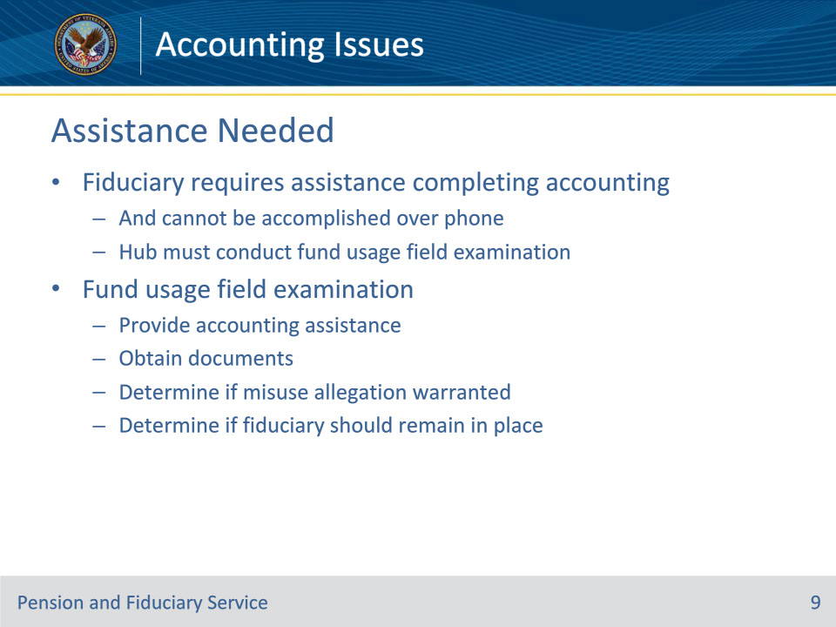
Slide notes

Policy Reference(s): FPM I.3.E.1.c

Instructor Notes:

When a fiduciary indicates that they require assistance completing the accounting and the assistance cannot be accomplished over the phone, the hub must conduct a fund usage field examination. The field examination is conducted to

• provide accounting assistance to the fiduciary

• attempt to obtain the required documents, and

• determine if

• an allegation of misuse is warranted, and

• the fiduciary should remain in place.

Slide 10 - Assistance Needed
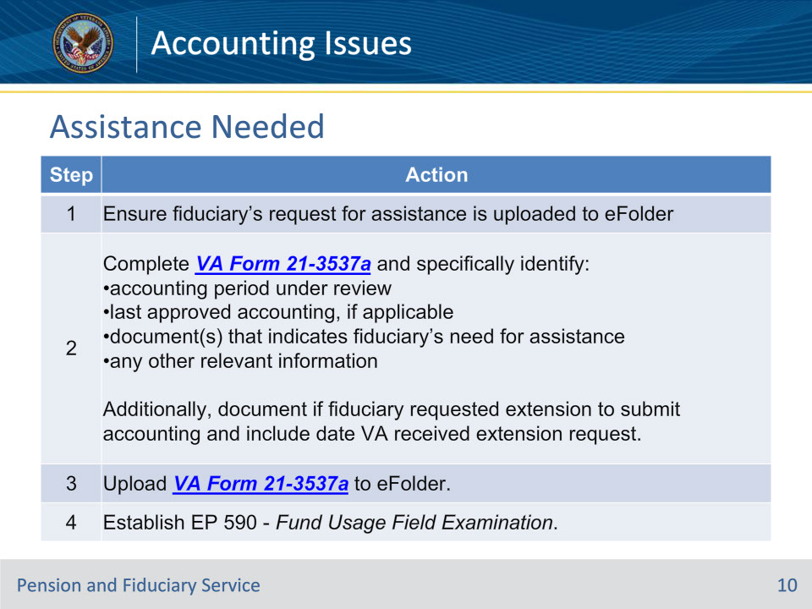
Slide notes

Policy Reference(s): FPM I.3.E.1.c

Instructor Notes:

Follow the steps in this table upon determination that the fiduciary requires face-to-face accounting assistance.

Note for step 1: If the request is made verbally, document the fiduciary’s request on a VA Form 27-0820 for inclusion in the eFolder.

Notes for step 4: The DATE OF CLAIM value is the date of the completion of the VA Form 21-3537a. Do not cancel or clear the accounting EP.

Slide 11 - Assistance Needed
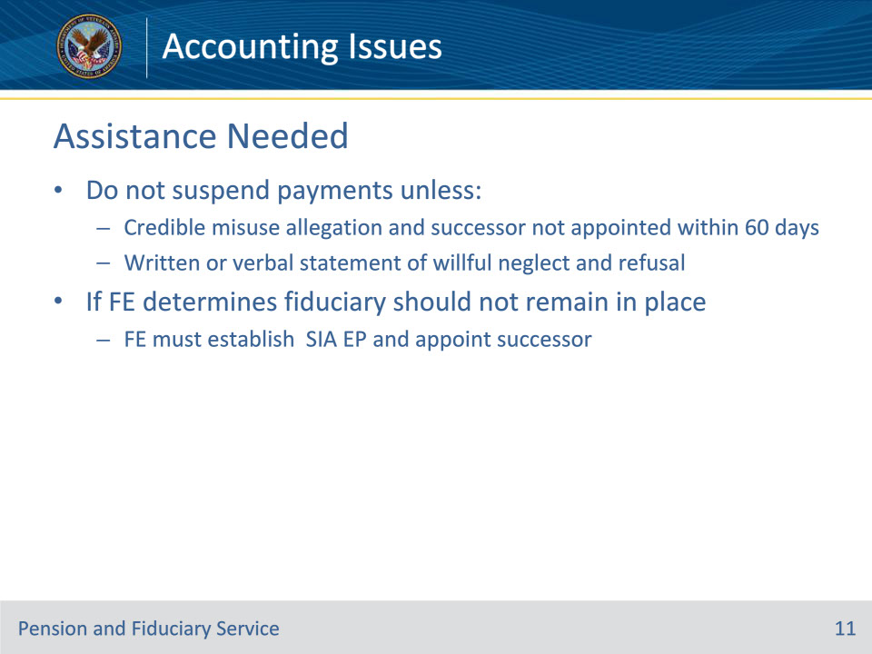
Slide notes

Policy Reference(s): FPM I.3.E.1.c

Instructor Notes:

Do not suspend payments unless there is a

• credible allegation of misuse and a successor fiduciary will not be appointed within 60 days of the allegation, or

• written or verbal statement from the fiduciary which indicates they do not intend to submit the requested documents.

If the FE determines that the fiduciary should not remain in place, the FE must immediately establish an SIA EP and appoint a successor fiduciary.

Slide 12 - Accounting Received
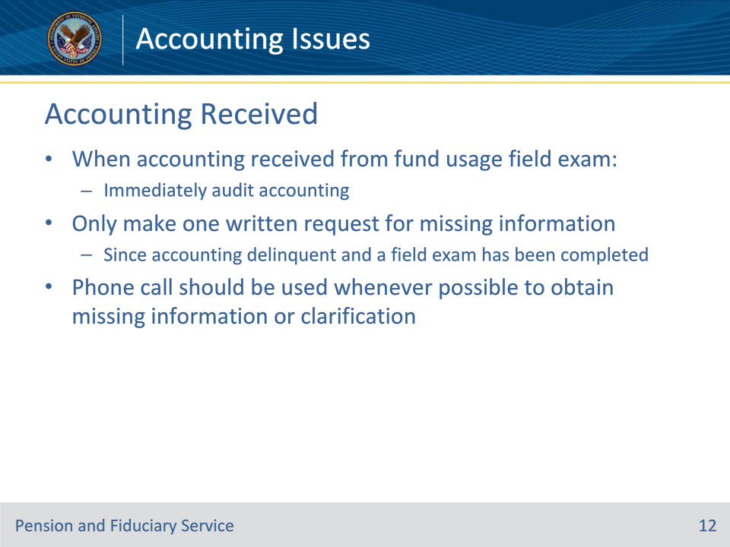
Slide notes

Policy Reference(s): FPM I.3.E.2.a

Instructor Notes:

The LIE must immediately audit the accounting report when the hub receives the report following a fund usage field examination.

Audit and process the accounting.

• Generally, two attempts are made for additional information. However, because the accounting is delinquent and a field examination to obtain the accounting has been completed, the LIE will only make one written request for missing information.

• A phone call should be used whenever possible to obtain missing information or clarification and documented.

Slide 13 - Accounting Received
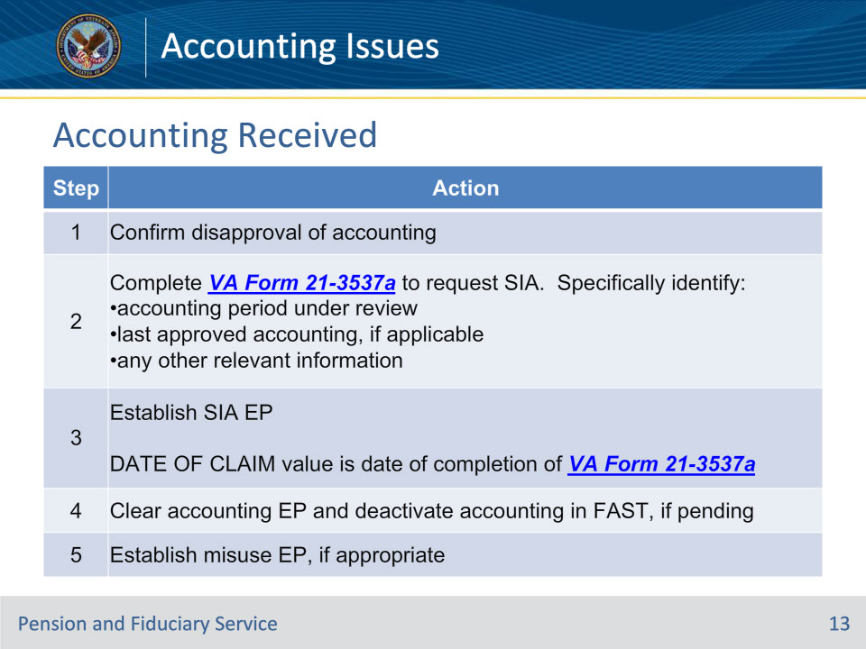
Slide notes

Policy Reference(s): FPM I.3.E.2.a

Instructor Notes:

If the accounting is not approvable, disapprove the accounting. Then follow the steps in this table.

Note: The FE is responsible for requesting the creation of the misuse allegation and/or the suspension of benefits if the evidence supports that the fiduciary has misused the beneficiary’s funds.

Slide 14 - Accounting Not Received
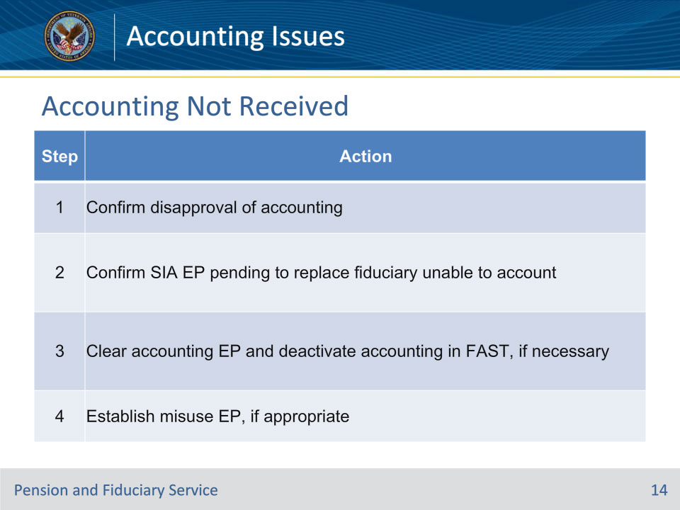
Slide notes

Policy Reference(s): FPM I.3.E.2.b

Instructor Notes:

During the closure of the fund usage field examination the LIE may discover that the FE was not able to obtain an accounting report from the fiduciary.

Note: The FE is responsible for requesting creation of a misuse allegation if the evidence supports that the fiduciary has misused the beneficiary’s funds and suspension of benefit payments.

Disapprove the accounting and follow the steps in this table when the fiduciary does not provide the FE with an accounting during the fund usage follow-up field examination.

Slide 15 - Questions?
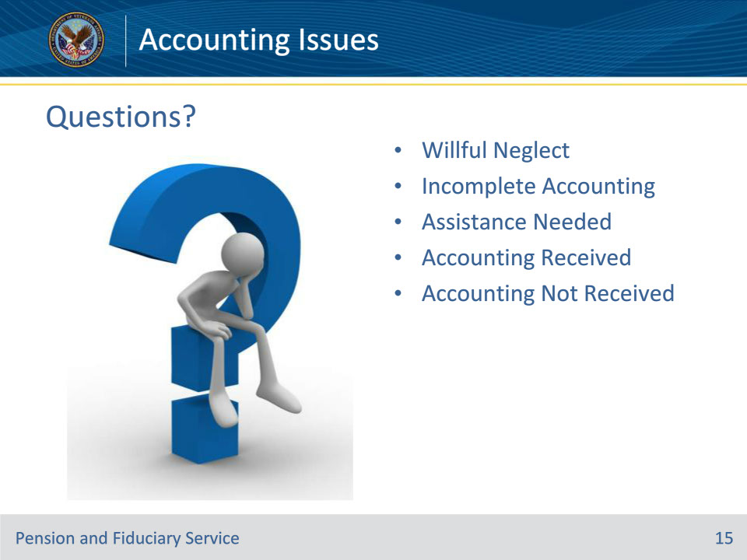
Slide notes

Instructor Notes:

(Recall) These are our learning objectives as stated from the beginning of the training:

• Demonstrate actions when accounting cannot be approved

• Process accountings received during field exam

• Identify actions when accounting not received from field exam

(Recap) We discussed each of these learning objectives through the following topics in each slide today:

• Willful Neglect

• Incomplete Accounting

• Assistance Needed

• Accounting Received

• Accounting Not Received

Are there any additional questions?

Slide 16 - TMS Survey
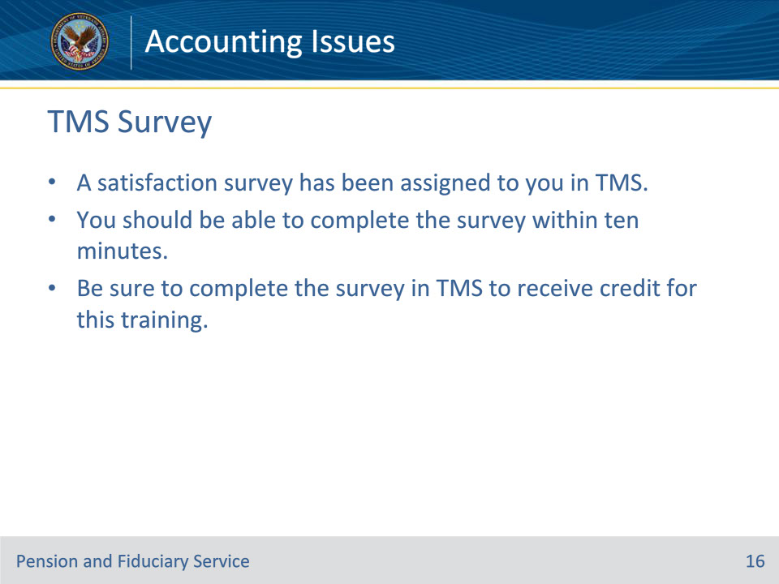
Slide notes

Instructor Notes:

A satisfaction survey has been assigned to you in TMS. You should be able to complete the survey within ten minutes. Completing the survey will allow you to receive credit for this training.

