Slide 1 - Elements of Accounting Audit
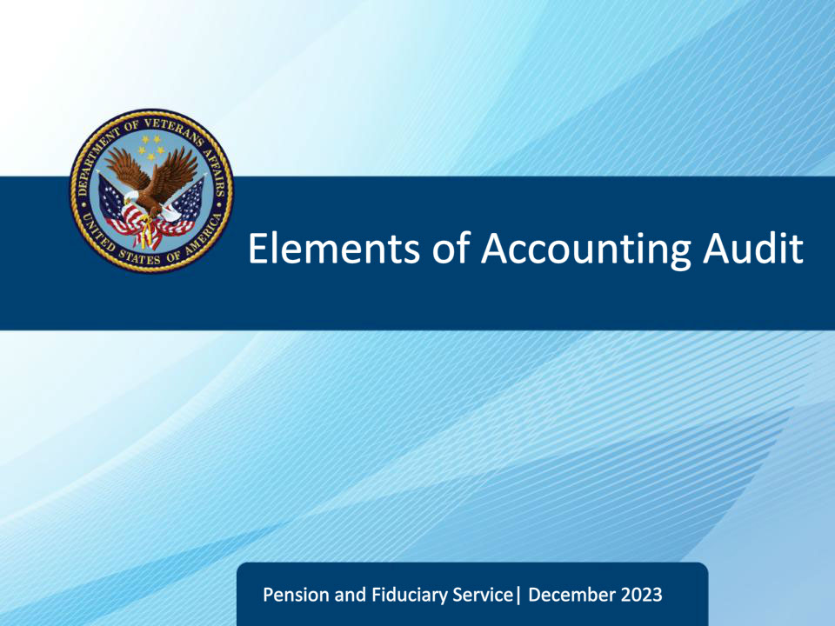
Slide notes

Course Description:

This course teaches learners information on the elements of the accounting audit process, including processing the accounting upon receipt, negligence of accounting analysis, computing timeliness, and more.

Slide 2 - Objectives
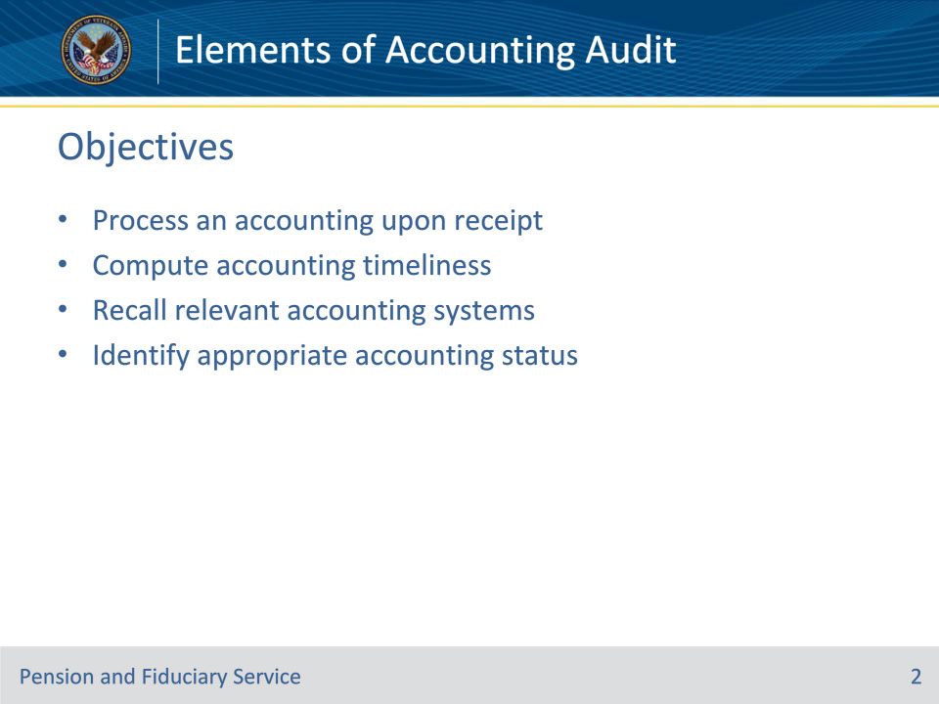
Slide notes

Instructor Notes:

At the end of this lesson, given the training and references, the learner will be able to do the following:

• Process an accounting upon receipt

• Compute accounting timeliness

• Recall relevant accounting systems

• Identify appropriate accounting status

Slide 3 - References
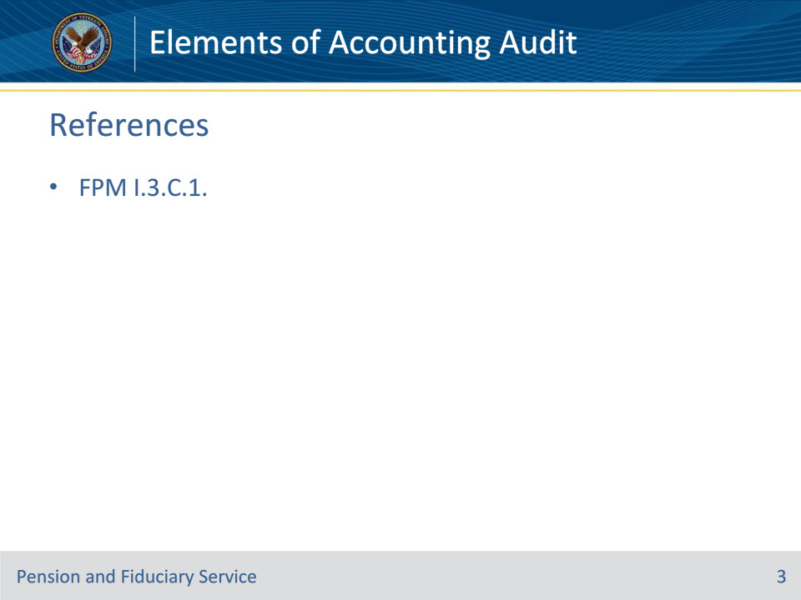
Slide notes

Instructor Notes:

These are the relevant references pertaining to this course:

• FPM I.3.C.1. Elements of the Accounting Audit Process

Slide 4 - Process Upon Receipt
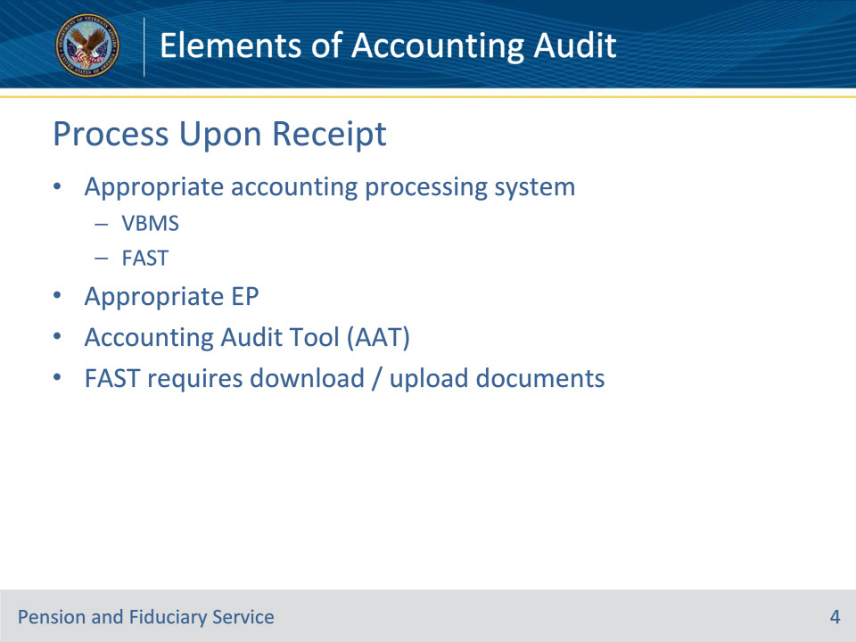
Slide notes

Policy Reference(s): FPM I.3.C.1.a

Instructor Notes:

To process an accounting, fiduciary hubs (hubs) must utilize the

• appropriate accounting processing system, to include the

• Veterans Benefits Management System (VBMS), and

• Fiduciary Accountings Submission Tool (FAST)

• appropriate accounting end product (EP), and

• the Accounting Audit Tool.

When action is taken based on receipt of documents in FAST, such as to approve, disapprove, or provide an extension on the accounting, the hub employee will download all associated accounting documents from FAST and upload them into the corresponding VBMS electronic claims folder (eFolder). For example, if an accounting is approved, all relevant documents within FAST, such as the VA Form 21P-4706b, VA Fiduciary’s Account, and corresponding bank statements, must be uploaded to the eFolder.

Exception: If a credible misuse allegation has been received prior to the completion of the accounting audit, the accounting must be worked as part of the misuse process.

Important: Do not waive or remove the accounting requirement for a one-time or less than annual accounting. The fiduciary must complete the accounting and the Department of Veterans Affairs (VA) must conduct a full audit.

Slide 5 - Timeliness
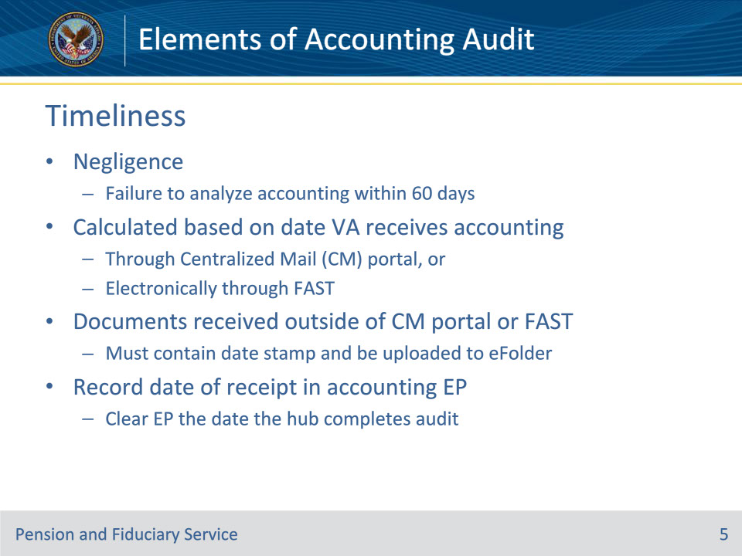
Slide notes

Policy Reference(s): FPM I.3.C.1.b; c

Instructor Notes:

VA’s failure to timely analyze a fiduciary’s accounting within 60 days of the date scheduled for review is cause for a finding of VA negligence in review of a fiduciary misuse determination.

Accounting timeliness is calculated based on the date VA receives the accounting through the Centralized Mail (CM) portal or electronically through FAST. Documents received outside of the CM portal or FAST must contain a date stamp and be uploaded to the eFolder. Hub personnel must record the date VA received the accounting in the appropriate accounting EP in VBMS. Clear the accounting EP the date the Legal Instruments Examiner (LIE) completes the accounting audit.

Slide 6 - Accounting Audit Tool
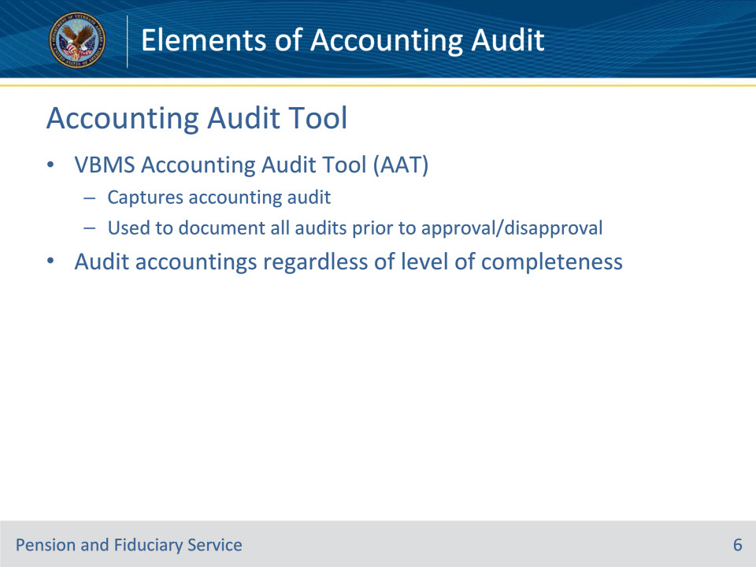
Slide notes

Policy Reference(s): FPM I.3.C.1.d

Instructor Notes:

The VBMS Accounting Audit Tool captures the auditing LIE’s audit of the accounting. The hub must use the VBMS Accounting Audit Tool to document all accounting audits prior to the approval or disapproval of an accounting.

Audit accountings when the fiduciary provides an accounting report, regardless of the level of completeness of the fiduciary’s submission.

Slide 7 - Accounting EPs
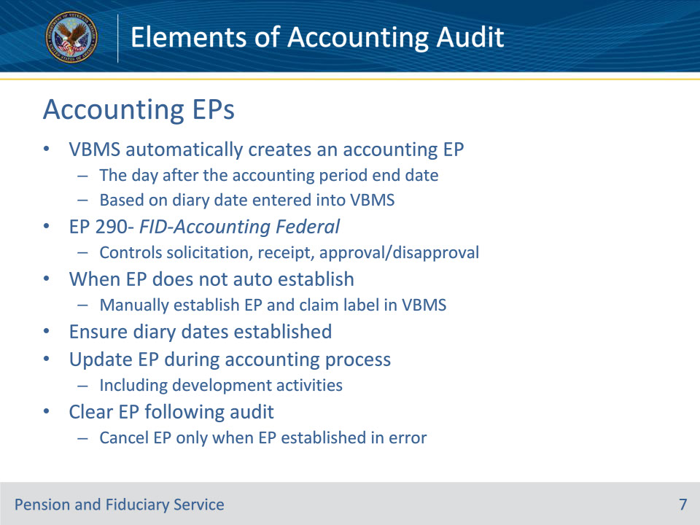
Slide notes

Policy Reference(s): FPM I.3.C.1.e

Instructor Notes:

VBMS automatically creates an accounting EP the day after the accounting period end date based on the diary date entered into VBMS.

The EP 290 – FID-Accounting Federal controls the solicitation, receipt, and approval or disapproval of accounting reports. If the hub determines the need for an accounting review and the system does not have an accounting EP established, the hub must manually establish the appropriate EP and claim label in VBMS. Hubs must ensure diary dates are appropriately established while completing an accounting review.

Hubs must update the accounting EPs, to include adding the appropriate development activities, when necessary, throughout the accounting process.

Generally, accounting EPs will be cleared following the audit. The audit does not need to result in an approvable accounting for the LIE to clear the EP. Cancel accounting EPs only when the establishment of the EP was in error

Slide 8 - Systems Review
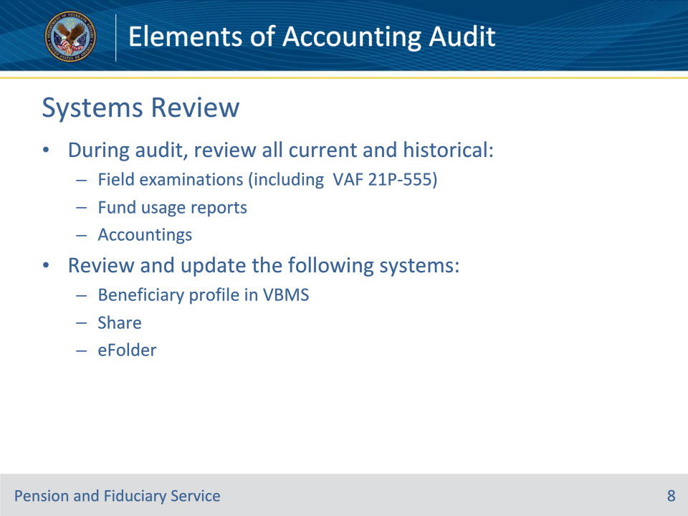
Slide notes

Policy Reference(s): FPM I.3.C.1.f

Instructor Notes:

Hub personnel must review all current and historical field examinations, fund usage reports, and accountings to obtain supporting information during the accounting audit. Hub personnel must also review and update the following systems:

• the beneficiary profile in VBMS

• Share, and

• the eFolder.

Review of all current and historical field examinations includes a review of the VA Form 21P-555, Certificate of Legal Capacity to Receive and Disburse Benefits and Fee Authorization.

Slide 9 - Accounting Statuses
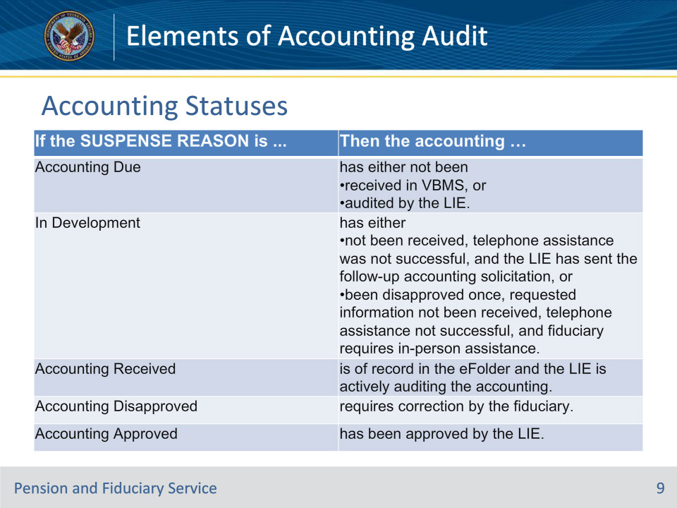
Slide notes

Policy Reference(s): FPM I.3.C.1.g

Instructor Notes:

Use this table for a description of the SUSPENSE REASON fields within the accounting EP in VBMS.

Slide 10 - When Audit Not Required
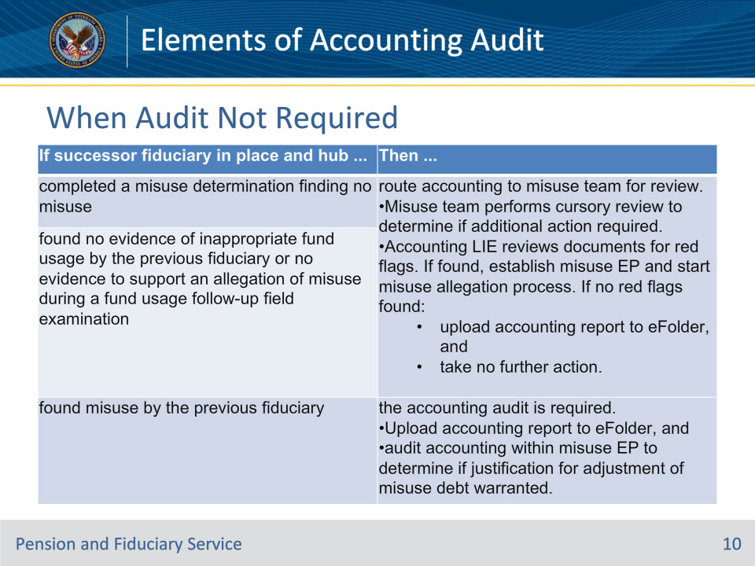
Slide notes

Policy Reference(s): FPM I.3.C.1.g

Instructor Notes:

Occasionally, hubs may receive accounting reports from previous fiduciaries after a successor fiduciary is in place and a misuse determination has been completed or an accounting has been disapproved.

Use this table to determine whether an accounting audit is required.

Exception: If no debt adjustment is warranted, an accounting audit is not necessary.

Slide 11 - Questions?
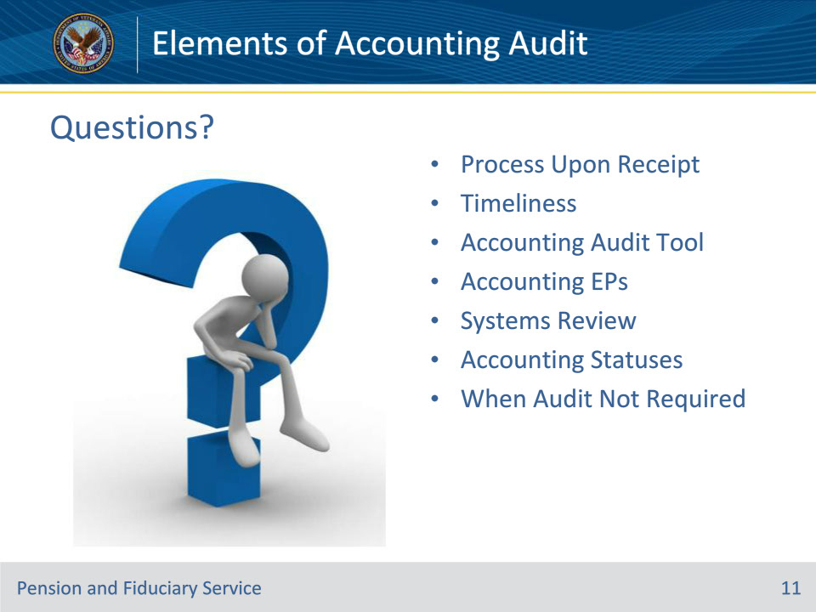
Slide notes

Instructor Notes:

(Recall) These are our learning objectives as stated from the beginning of the training:

• Process an accounting upon receipt

• Compute accounting timeliness

• Recall relevant accounting systems

• Identify appropriate accounting status

(Recap) We discussed each of these learning objectives through the following topics in each slide today:

• Process Upon Receipt

• Timeliness

• Accounting Audit Tool

• Accounting EPs

• Systems Review

• Accounting Statuses

• When Audit Not Required

Are there any additional questions?

Slide 12 - TMS Survey
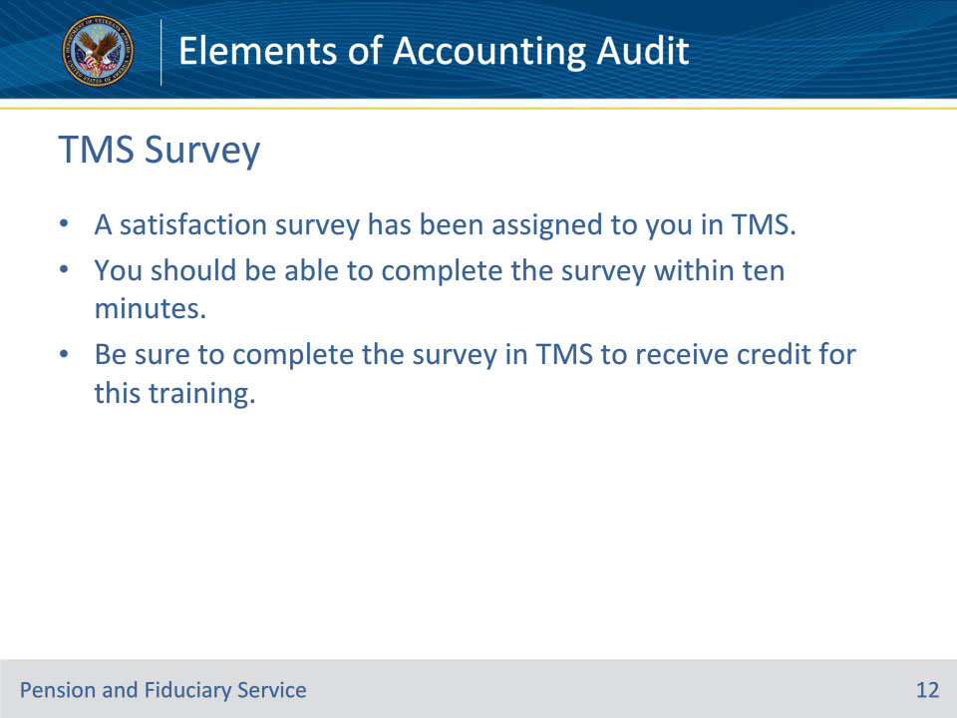
Slide notes

Instructor Notes:

A satisfaction survey has been assigned to you in TMS. You should be able to complete the survey within ten minutes. Completing the survey will allow you to receive credit for this training.

