Slide 1 - P&FS Video Conferencing
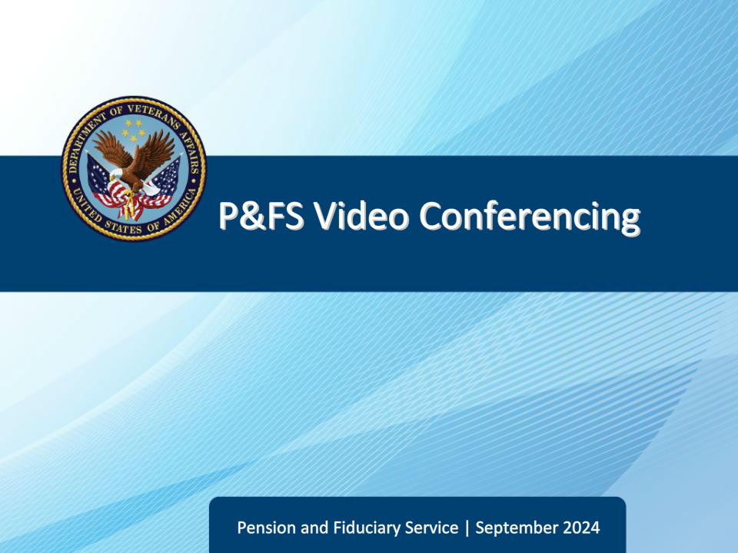
Slide notes

Course Description:

This lesson provides an overview of the Pension & Fiduciary Service Video Conferencing system.

Slide 2 - Objectives
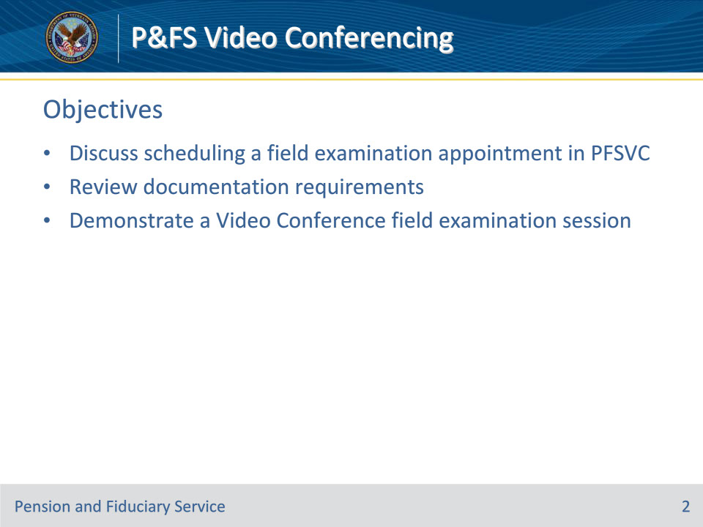
Slide notes

Instructor Notes:

At the end of this lesson, given the training and references, the learner will be able to do the following:

• Discuss scheduling a field examination appointment in PFSVC

• Review documentation requirements

• Demonstrate a Video Conference field examination session

Slide 3 - Equipment Requirements
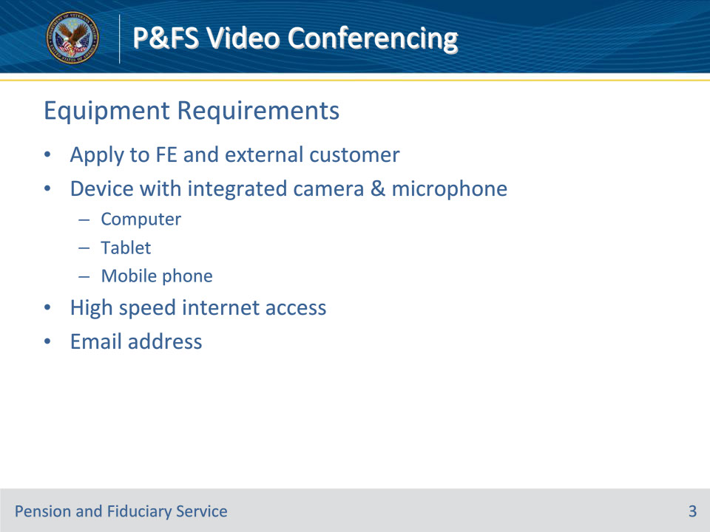
Slide notes

Instructor Notes:

These are the equipment requirements for both field examiners and external customers:

• Device with integrated camera & microphone

• Computer

• Tablet

• Mobile phone

• High speed internet access

• Email address

Slide 4 - Acceptable Browsers
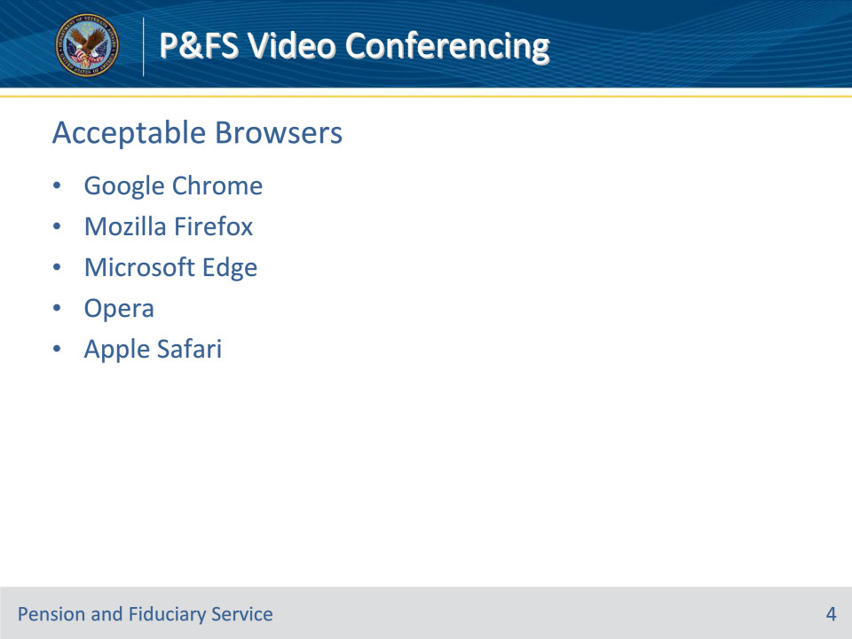
Slide notes

Instructor Notes:

These are the acceptable browsers for running the video conferencing system:

• Google Chrome

• Mozilla Firefox

• Microsoft Edge

• Opera

• Apple Safari

Slide 5 - Scheduling Appointment
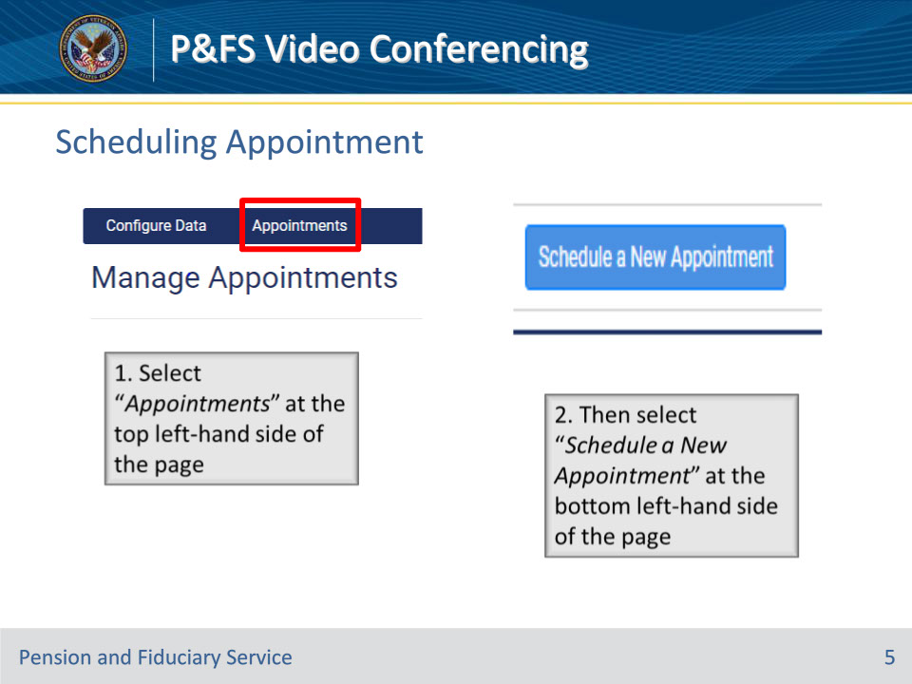
Slide notes

Instructor Notes:

This slide demonstrates the steps for scheduling a video conferencing appointment

Slide 6 - Scheduling Appointment
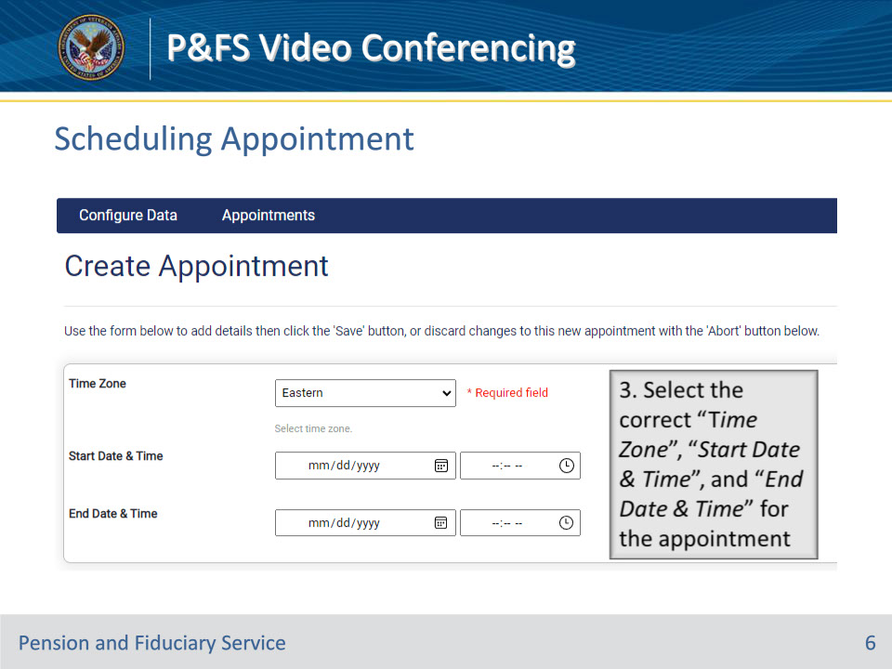
Slide notes

Instructor Notes:

This slide demonstrates the steps for scheduling a video conferencing appointment

Slide 7 - Scheduling Appointment
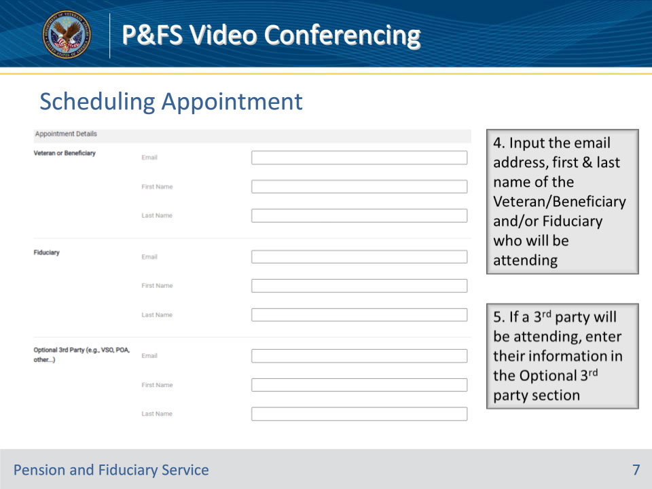
Slide notes

Instructor Notes:

This slide demonstrates the steps for scheduling a video conferencing appointment

Slide 8 - Scheduling Appointment
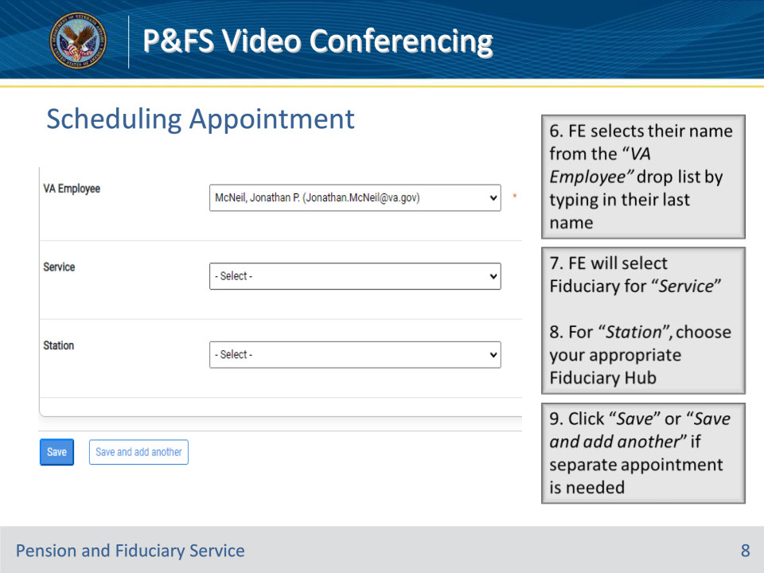
Slide notes

Instructor Notes:

This slide demonstrates the steps for scheduling a video conferencing appointment

Slide 9 - Scheduling Appointment
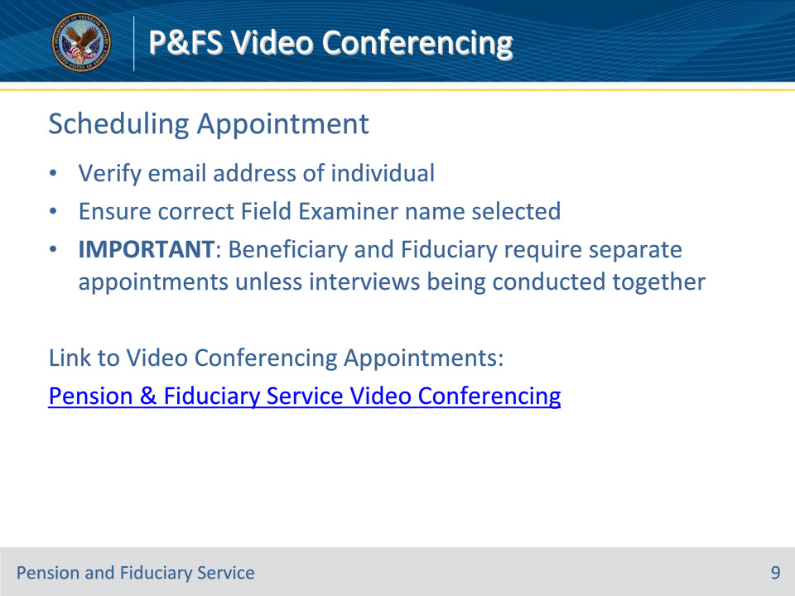
Slide notes

Instructor Notes:

Important reminders for scheduling appointments:

• Verify email address of individual

• Ensure correct Field Examiner name selected

• Beneficiary and Fiduciary require separate appointments unless interviews being conducted together

Slide 10 - Appointment Notice
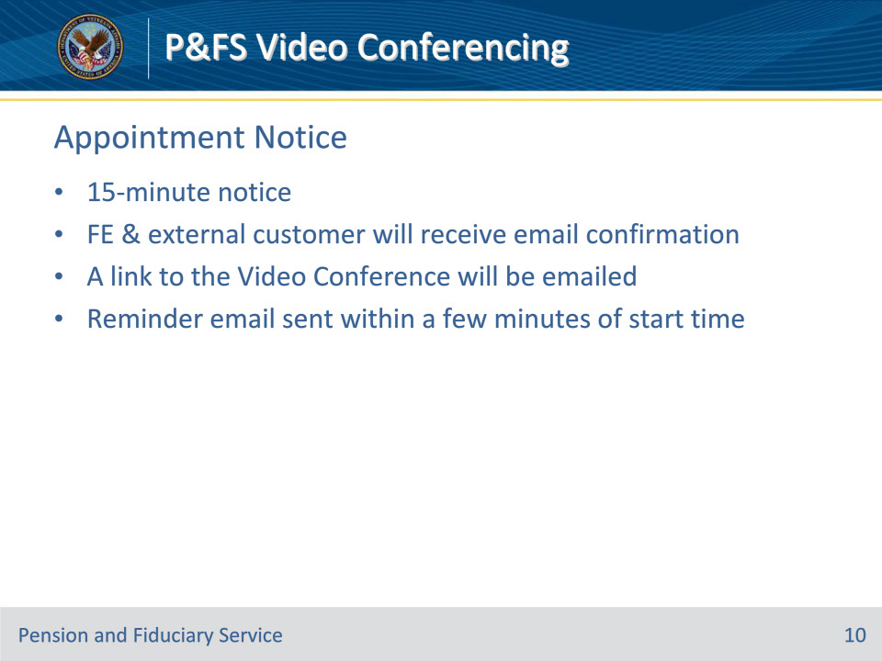
Slide notes

Instructor Notes:

Appointment Notice:

• 15-minute notice

• FE & external customer will receive email confirmation

• A link to the Video Conference will be emailed

• Reminder email sent within a few minutes of start time

Slide 11 - Adding to Calendar
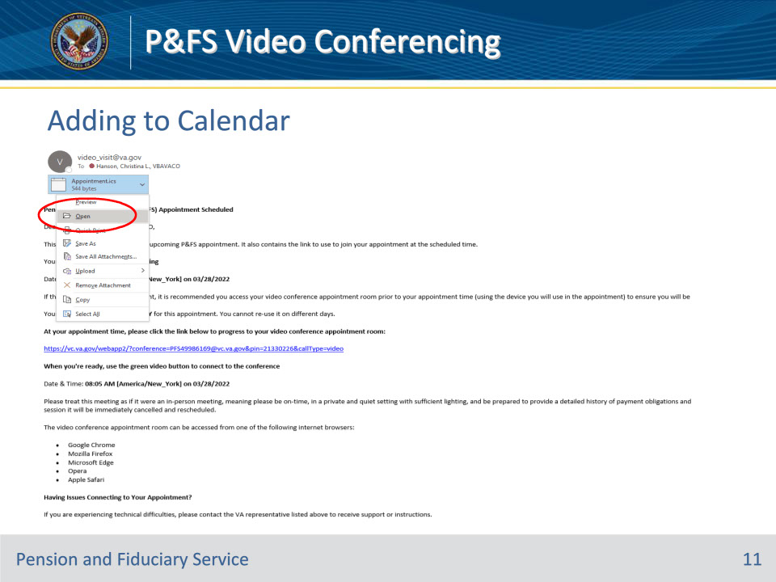
Slide notes

Instructor Notes:

This slide demonstrates the steps for adding a video conferencing appointment to your calendar

Slide 12 - Canceling Appointment
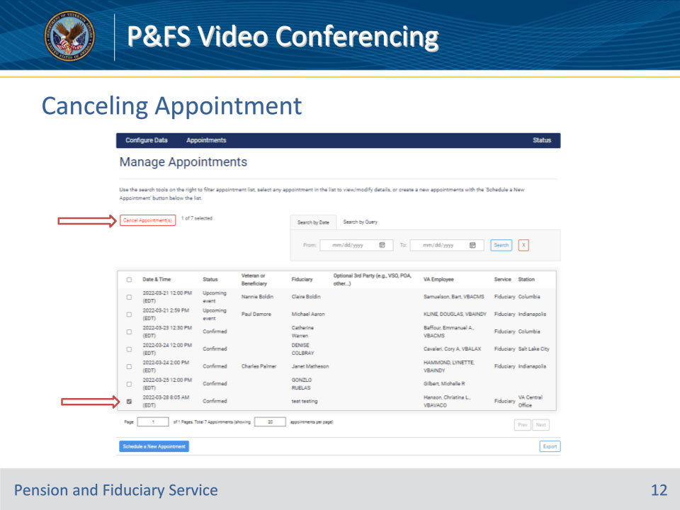
Slide notes

Instructor Notes:

This slide demonstrates the steps for canceling an appointment

Slide 13 - No-Shows & Cancellations
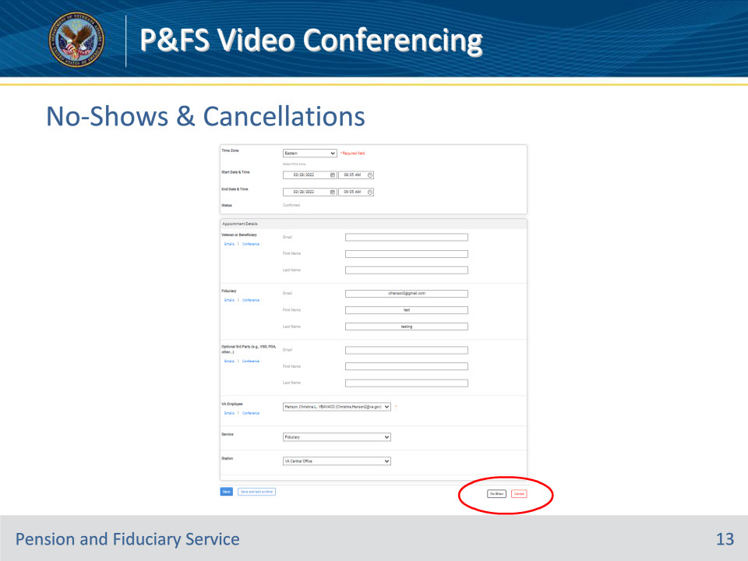
Slide notes

Instructor Notes:

This slide demonstrates the steps for no-shows and cancellations.

Slide 14 - Connecting to Windows Session
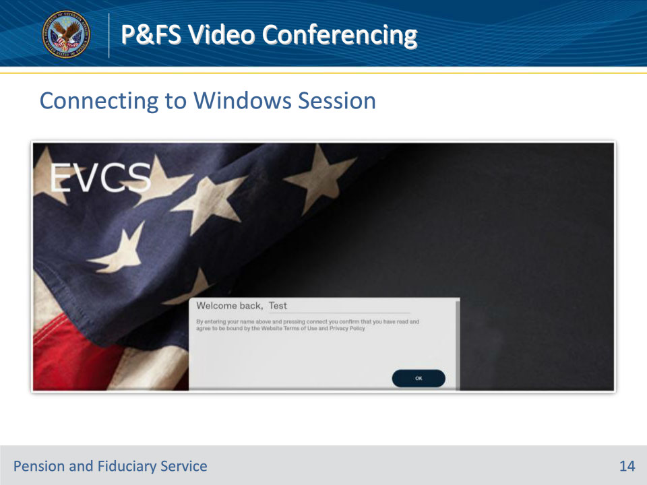
Slide notes

Instructor Notes:

This slide demonstrates what the user will see when connecting to a Windows session

Slide 15 - Connecting to Windows Session
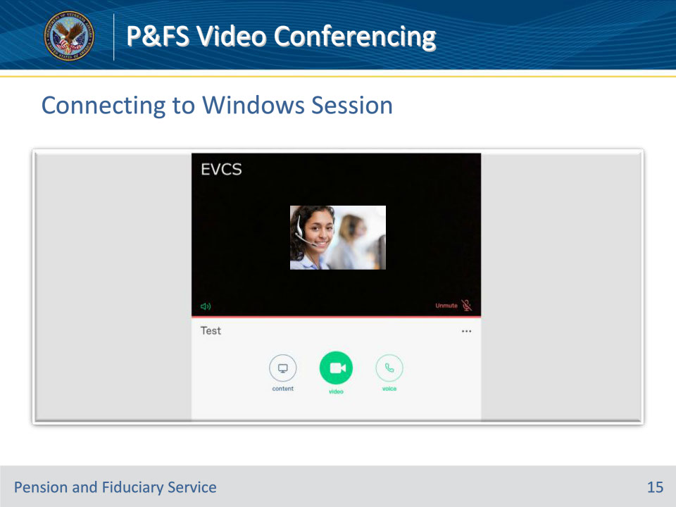
Slide notes

Instructor Notes:

This slide demonstrates what the user will see when connecting to a Windows session

Slide 16 - Troubleshooting
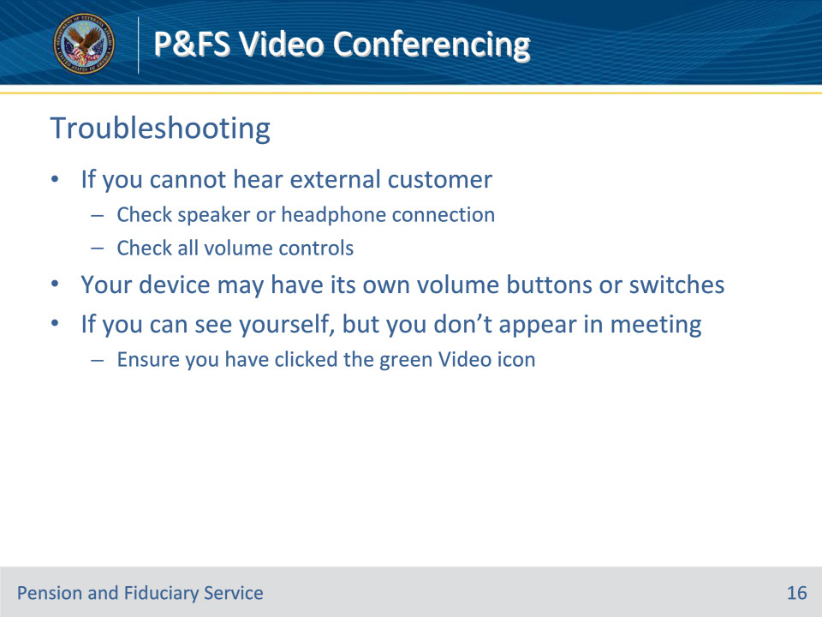
Slide notes

Instructor Notes:

Troubleshooting tips:

• If you cannot hear external customer

• Check speaker or headphone connection

• Check all volume controls

• Your device may have its own volume buttons or switches

• If you can see yourself, but you don’t appear in meeting

• Ensure you have clicked the green Video icon

Slide 17 - Technical Support
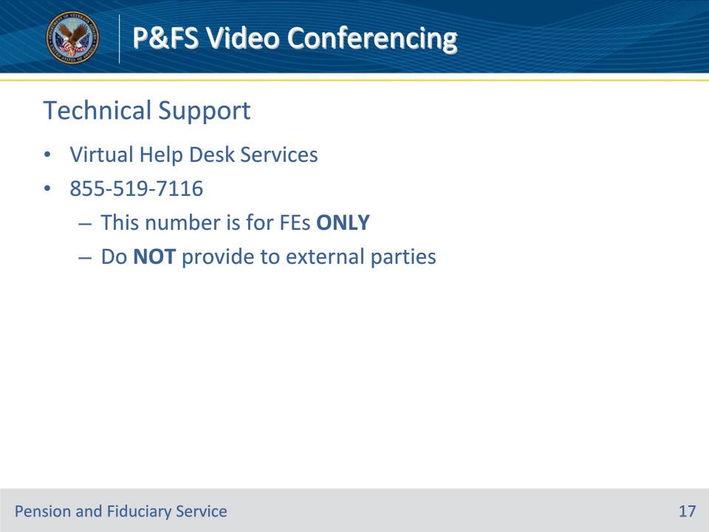
Slide notes

Instructor Notes:

Technical Support contact information:

• Virtual Help Desk Services

• 855-519-7116

• This number is for Field Examiners ONLY

• Do NOT provide to external parties

Slide 18 - Questions?
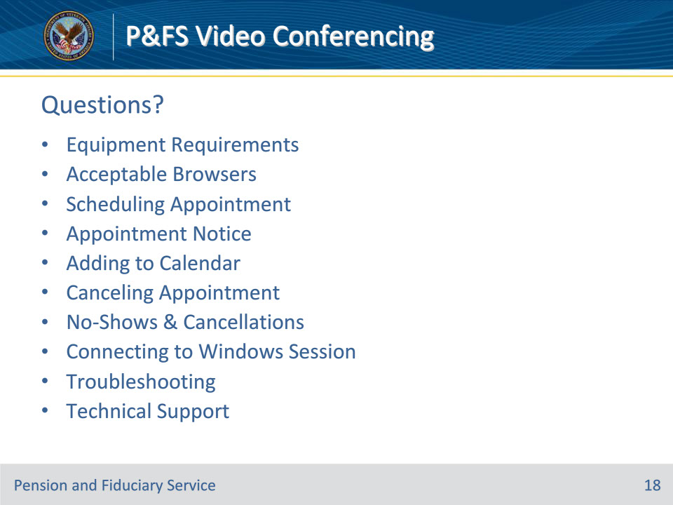
Slide notes

Instructor Notes:

(Recall) These are our learning objectives as stated from the beginning of the training:

• Discuss scheduling a field examination appointment in PFSVC

• Review documentation requirements

• Demonstrate a Video Conference field examination session

(Recap) We discussed each of these learning objectives through the following topics in each slide today:

• Equipment Requirements

• Acceptable Browsers

• Scheduling Appointment

• Appointment Notice

• Adding to Calendar

• Canceling Appointment

• No-Shows & Cancellations

• Connecting to Windows Session

• Troubleshooting

• Technical Support

Are there any additional questions?

Questions should be filtered through your QRT team. They will submit your questions to the Field Inquiry Tool (FIT) on your behalf.

Slide 19 - TMS Survey/Assessment
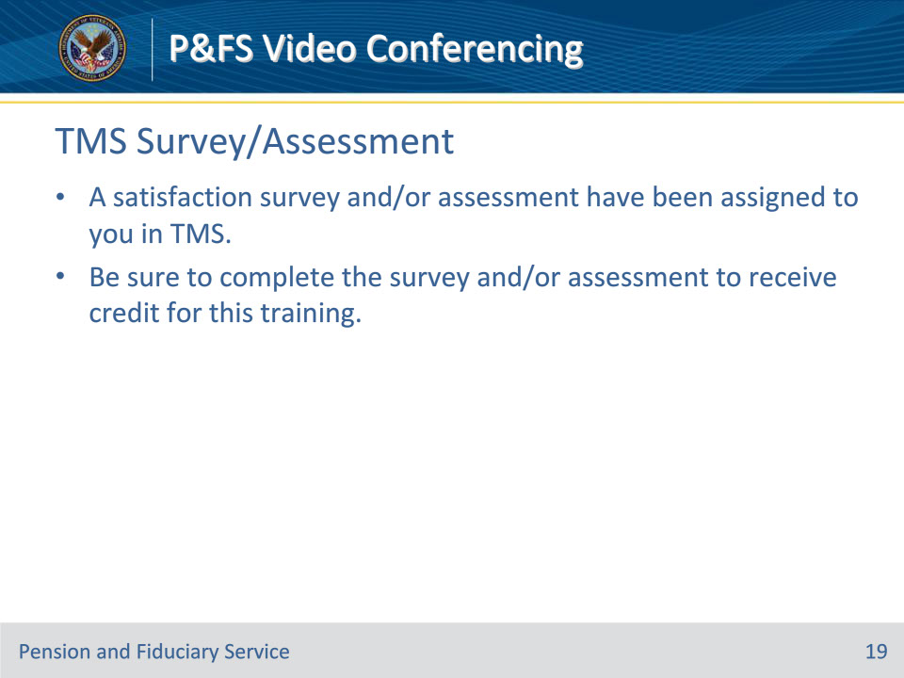
Slide notes

Instructor Notes:

A satisfaction survey and/or assessment have been assigned to you in TMS.

Be sure to complete the survey and/or assessment to receive credit for this training.

