Slide 1 - Overview of Reissuance and Recoupment
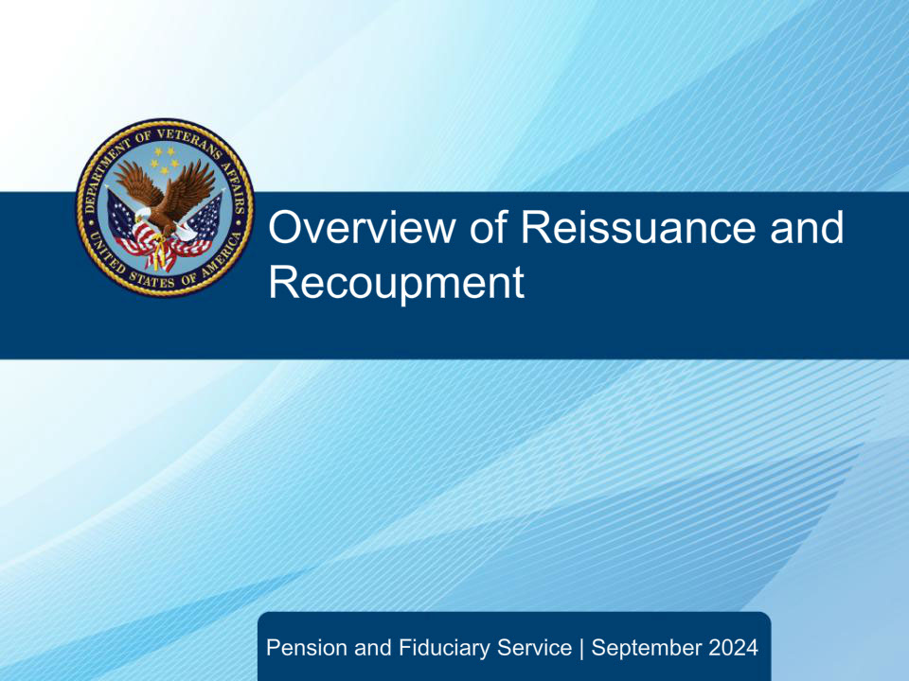
Slide notes

Course Description:

This course teaches learners a general overview of requirements for reissuance of benefits when a determination of misuse has been made.

Slide 2 - Objectives
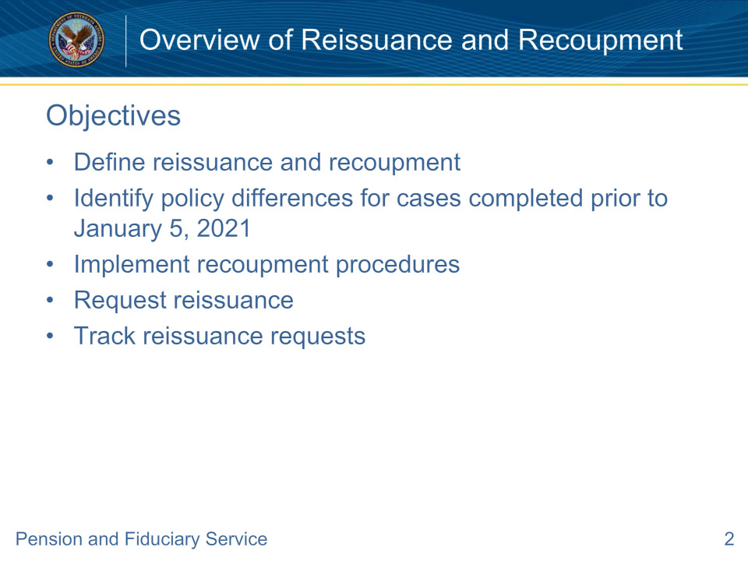
Slide notes

Instructor Notes:

At the end of this lesson, given the training and references, the learner will be able to do the following:

• Define reissuance and recoupment

• Identify policy differences for cases completed prior to January 5, 2021

• Implement recoupment procedures

• Request reissuance

• Track reissuance requests

Slide 3 - References
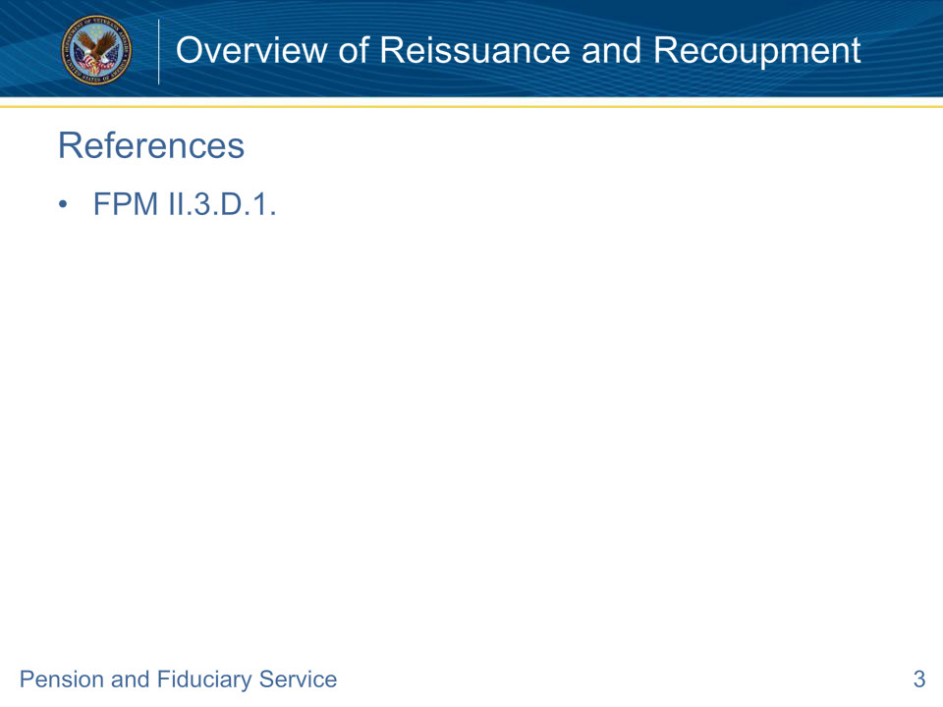
Slide notes

Instructor Notes:

These are the relevant references pertaining to this course:

• FPM II.3.D.1. General Overview of Reissuance and Recoupment

Slide 4 - Reissuance
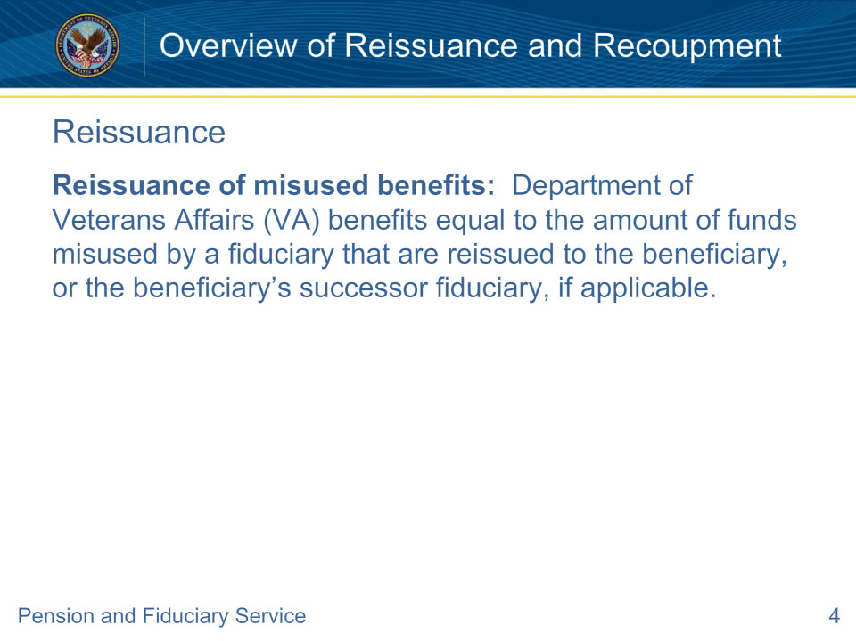
Slide notes

Policy Reference(s): FPM II.3.D.1.a.

Instructor Notes:

Reissuance of misused benefits: Department of Veterans Affairs (VA) benefits equal to the amount of funds misused by a fiduciary that are reissued to the beneficiary, or the beneficiary’s successor fiduciary, if applicable.

Slide 5 - Payment of Recouped Benefits
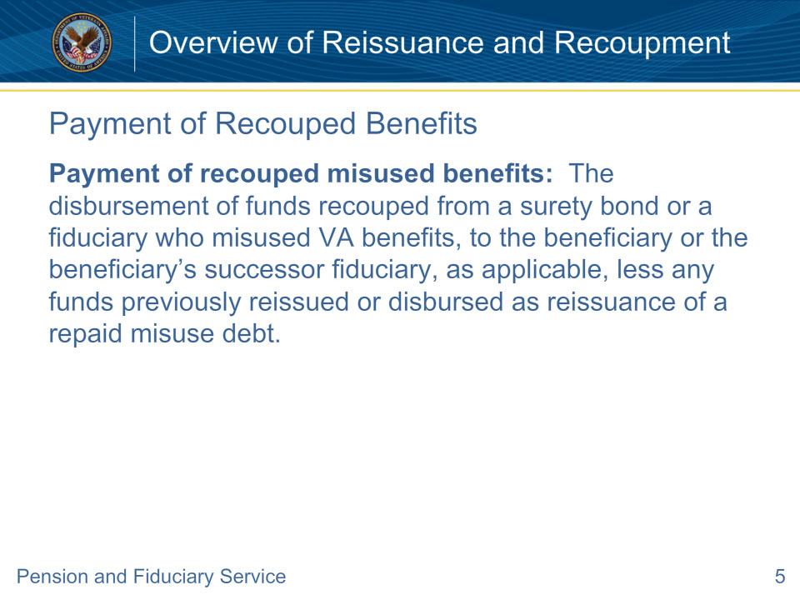
Slide notes

Policy Reference(s): FPM II.3.D.1.a.

Instructor Notes:

Payment of recouped misused benefits: The disbursement of funds recouped from a surety bond or a fiduciary who misused VA benefits, to the beneficiary or the beneficiary’s successor fiduciary, as applicable, less any funds previously reissued or disbursed as reissuance of a repaid misuse debt.

Slide 6 - Policy Change
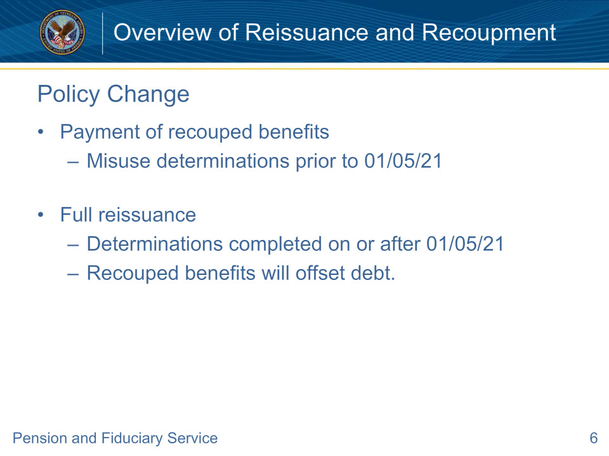
Slide notes

Policy Reference(s): FPM II.3.D.1.a.

Instructor Notes:

Payment of recouped misused benefits to beneficiaries applies to misuse determinations completed prior to January 5, 2021 (without a reconsideration or corrected determination completed on or after January 5, 2021). For misuse determinations, reconsiderations, and/or corrected determinations completed on or after January 5, 2021, the beneficiary will receive the full amount of misused benefits through reissuance based on 38 U.S.C. 6107, as amended by Public Law (PL) 116-315. Any recouped misused benefits will be applied to offset the debt established by VA.

Slide 7 - Reissuance Types
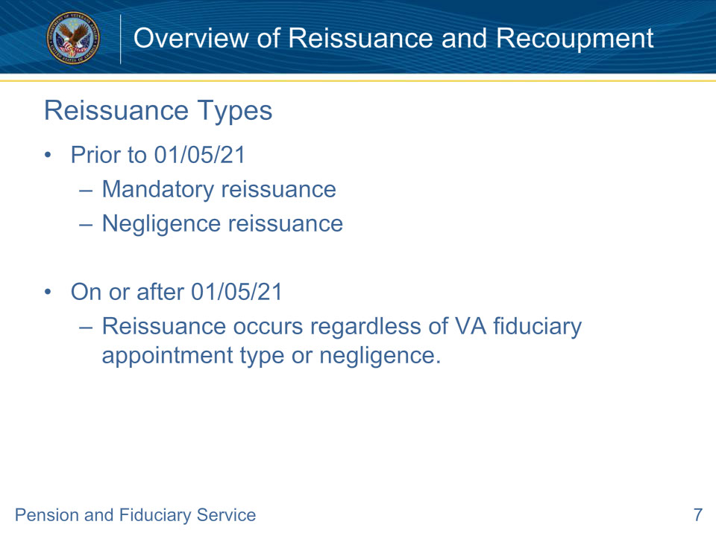
Slide notes

Policy Reference(s): FPM II.3.D.1.b.

Instructor Notes:

For misuse cases prior to January 5, 2021 (without reconsiderations or corrected determinations on or after January 5, 2021), there are two primary types of reissuance following a determination of misuse; the mandatory reissuance of misused benefits based on 38 CFR 13.410(a) and reissuance based on VA negligence. The determination for which type of reissuance is appropriate is based on

• the type of fiduciary

• the number of beneficiaries the fiduciary serves, or

• whether negligence was found.

On or after January 5, 2021, reissuance occurs regardless of VA fiduciary appointment type and is not contingent upon a determination of negligence. Based on 38 U.S.C. 6107, as amended by PL 116-315 on January 5, 2021, misused benefits shall be paid to the beneficiary or the beneficiary’s successor fiduciary upon negligent failure by VA; or, in any other case where negligence was not found.

Slide 8 - Good Faith Standard
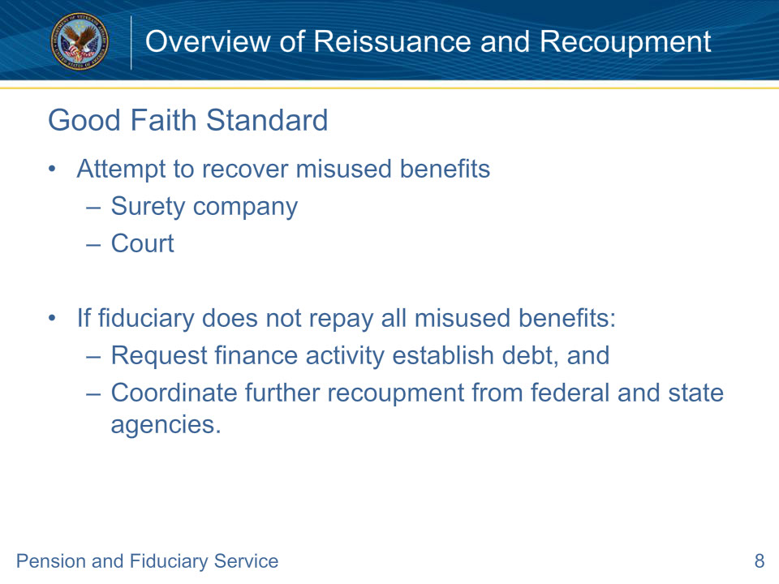
Slide notes

Policy Reference(s): FPM II.3.D.1.c.

Instructor Notes:

VA will make a good faith effort to recoup the total amount of misused benefits from the misusing fiduciary. The good faith standard is met by attempting to complete the following actions below.

• Recover any misused benefits from the surety company, if a surety bond is in place. If the surety bond is held by the court of jurisdiction for a court-appointed fiduciary, recover those funds from the court.

• If the misusing fiduciary does not repay all misused benefits within the time limit prescribed by the Fiduciary Hub Manager (FHM)

• request the creation of a debt by notifying the finance activity, and

• coordinate further recoupment from any Federal and State agencies.

Slide 9 - Recoupment
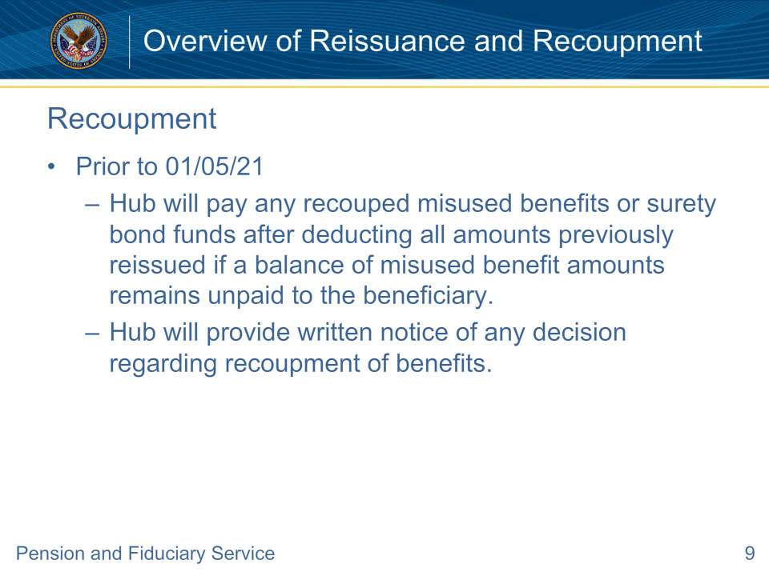
Slide notes

Policy Reference(s): FPM II.3.D.1.c.

Instructor Notes:

Where a misuse determination was completed before January 5, 2021 (without a reconsideration or corrected determination completed on or after January 5, 2021), the fiduciary hub (hub) will pay any recouped misused benefits or surety bond funds to the beneficiary or the beneficiary’s successor fiduciary (as applicable) after deducting all amounts previously reissued if a balance of misused benefit amounts remains unpaid to the beneficiary.

For misuse determinations, reconsiderations, and/or corrected determinations completed before January 5, 2021, the hub will provide written notice of any decision regarding recoupment of benefits to the

• beneficiary or the beneficiary’s legal guardian, and

• beneficiary’s accredited representative, attorney, or claims agent.

Slide 10 - Recoupment (Cont.)
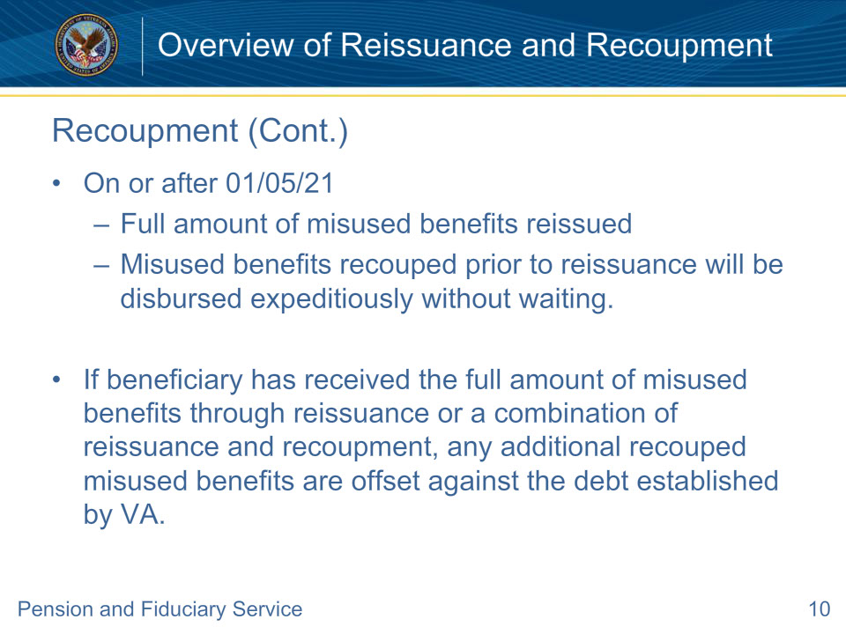
Slide notes

Policy Reference(s): FPM II.3.D.1.c.; a.

Instructor Notes:

For misuse determinations, reconsiderations, and/or corrected determinations completed on or after January 5, 2021, the beneficiary will receive the full amount of misused benefits through reissuance.

In some cases, misused benefits may be recouped from the fiduciary or through surety bond collection prior to VA action to reissue. For these cases, the recouped amount will be disbursed to the beneficiary or the beneficiary’s successor fiduciary, less the portion of those funds that may have already been reissued by VA, if applicable. Recouped funds will be disbursed expeditiously without waiting for the outcome of a negligence determination. However, if through the negligence determination process a higher amount of misused benefits is calculated than what was recouped and disbursed, the difference in the amounts will be reissued by VA to the beneficiary and a debt for the difference will be established against the fiduciary.

If the beneficiary has received the full amount of misused benefits through reissuance or a combination of reissuance and recoupment, any additional recouped misused benefits are offset against the debt established by VA.

Slide 11 - Responsibility
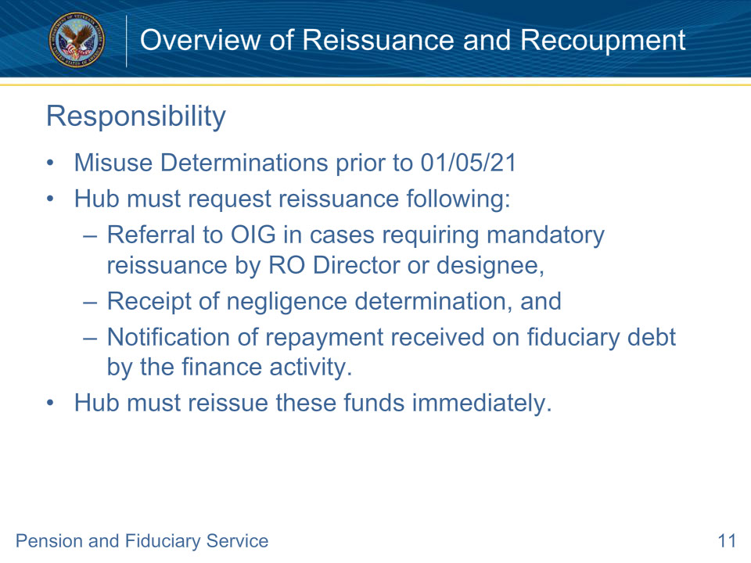
Slide notes

Policy Reference(s): FPM II.3.D.1.d

Instructor Notes:

The hub of jurisdiction is responsible for directing the finance activity co-located with the hub on reissuance of payments regarding any fiduciary matter.

For misuse determinations prior to January 5, 2021 (without reconsiderations or corrected determinations on or after January 5, 2021), the hub must request reissuance following the

• referral to VA Office of Inspector General, in cases requiring mandatory reissuance by the Regional Office (RO) Director or designee based on 38 CFR 13.410(a)

• receipt of a negligence determination, or

• notification of repayment received on fiduciary debt by the finance activity (recoupment of misused benefit amounts).

Important: Prior to requesting the finance activity to reissue misused funds, hubs must ensure appropriate account protections are in place for the new fiduciary.

The hub must not wait when one of the situations above has occurred. In these instances, the hub must reissue funds immediately.

Slide 12 - Responsibility (Cont.)
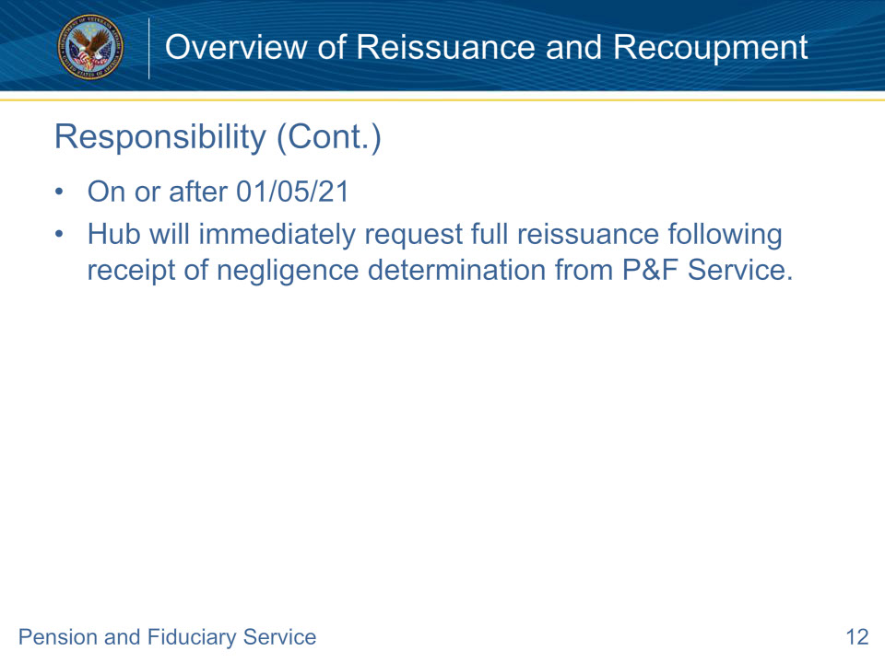
Slide notes

Policy Reference(s): FPM II.3.D.1.d.

Instructor Notes:

For misuse determinations on or after January 5, 2021 (to include misuse determinations completed prior to January 5, 2021, with a reconsideration or corrected misuse determination completed on or after January 5, 2021), the hub will immediately request the appropriate reissuance amount following the receipt of a negligence determination issued by the Director or designee of Pension and Fiduciary (P&F) Service.

Slide 13 - Reissuance Request
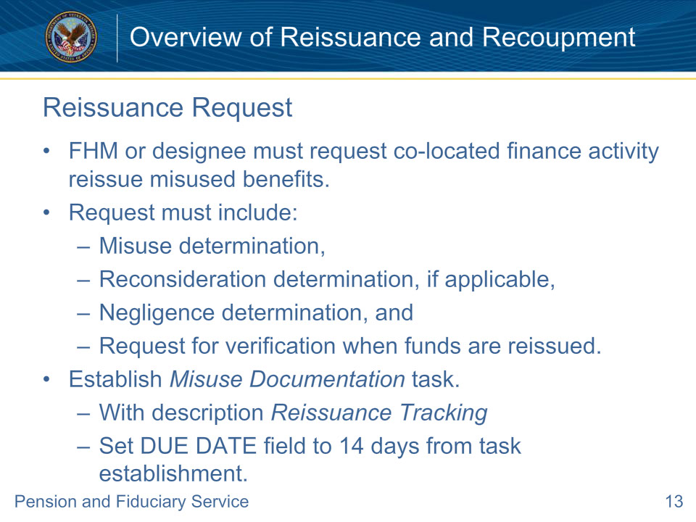
Slide notes

Policy Reference(s): FPM II.3.D.1.e.

Instructor Notes:

The FHM (or appropriate designee) must request the finance activity co-located with the hub to reissue misused benefits when required. The request must include a

• misuse determination

• reconsideration determination, if applicable

• negligence determination, and

• request for verification when funds are reissued.

At the time the request for reissuance is sent to the finance activity, the hub must establish a Misuse Documentation task with the description listed as Reissuance Tracking. The DUE DATE field must be set for 14 days from the date of task establishment.

Slide 14 - Tracking Requests
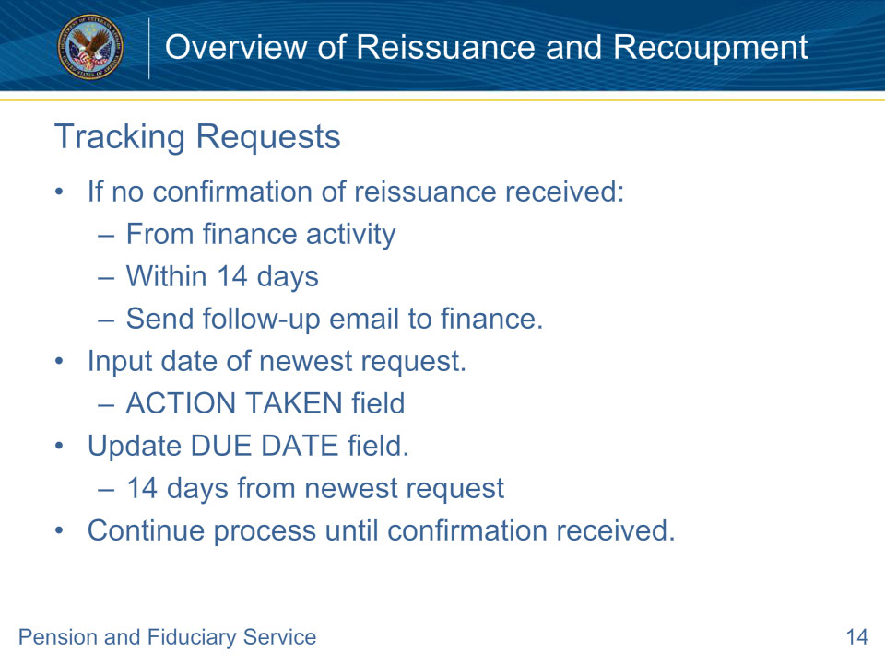
Slide notes

Policy Reference(s): FPM II.3.D.1.e.

Instructor Notes:

If no confirmation of reissuance is received from the finance activity within 14 days, the hub must send a follow-up email to the finance activity. Input the date of the newest request in the ACTION TAKEN field and update the DUE DATE field to 14 days from the newest request. Continue this process until confirmation of reissuance is received from the finance activity.

Slide 15 - Deceased Beneficiaries
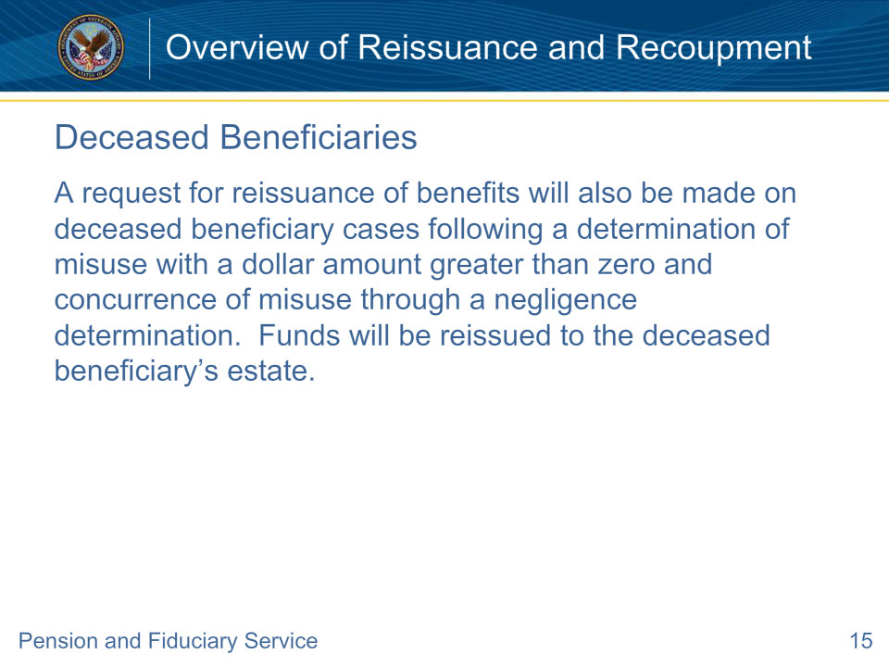
Slide notes

Policy Reference(s): FPM II.3.D.1.e.

Instructor Notes:

A request for reissuance of benefits will also be made on deceased beneficiary cases following a determination of misuse with a dollar amount greater than zero and concurrence of misuse through a negligence determination. Funds will be reissued to the deceased beneficiary’s estate.

If the beneficiary received the full amount of misused benefits prior to death, all recouped funds are to either be applied to VA appropriations or offset against the debt established by VA, as applicable.

Slide 16 - Processing in VBMS
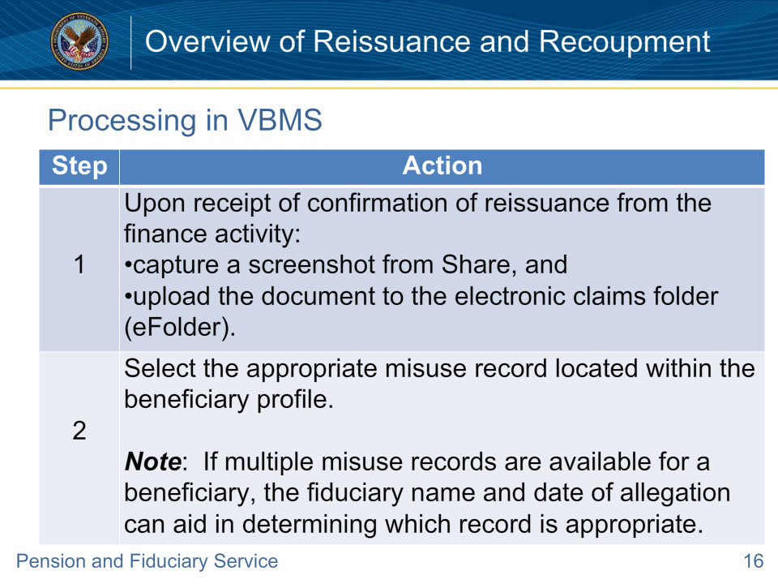
Slide notes

Policy Reference(s): FPM II.3.D.1.f.

Instructor Notes:

The hub must update the Veterans Benefits Management System (VBMS) misuse record to reflect any reissuance. Follow the steps in the table above to process a reissuance in VBMS.

Slide 17 - Processing in VBMS (Cont.)
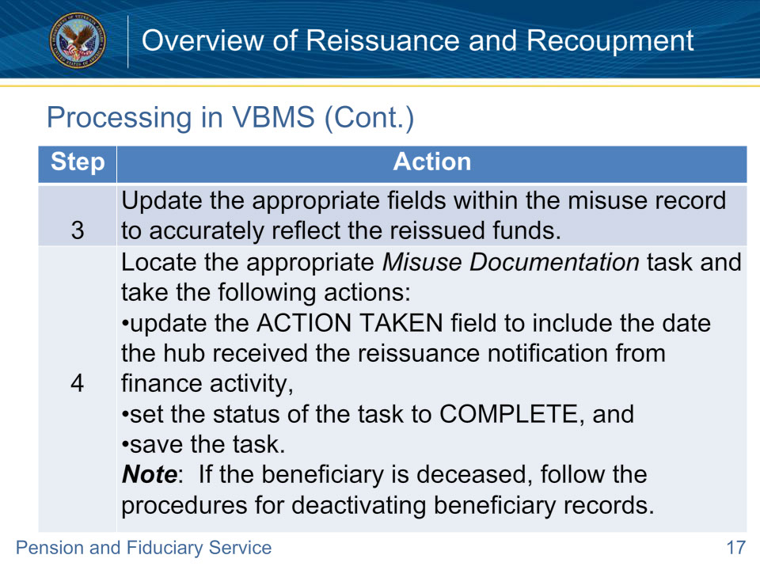
Slide notes

Policy Reference(s): FPM II.3.D.1.f.

Instructor Notes:

The hub must update the Veterans Benefits Management System (VBMS) misuse record to reflect any reissuance. Follow the steps in the table above to process a reissuance in VBMS.

Slide 18 - Questions?
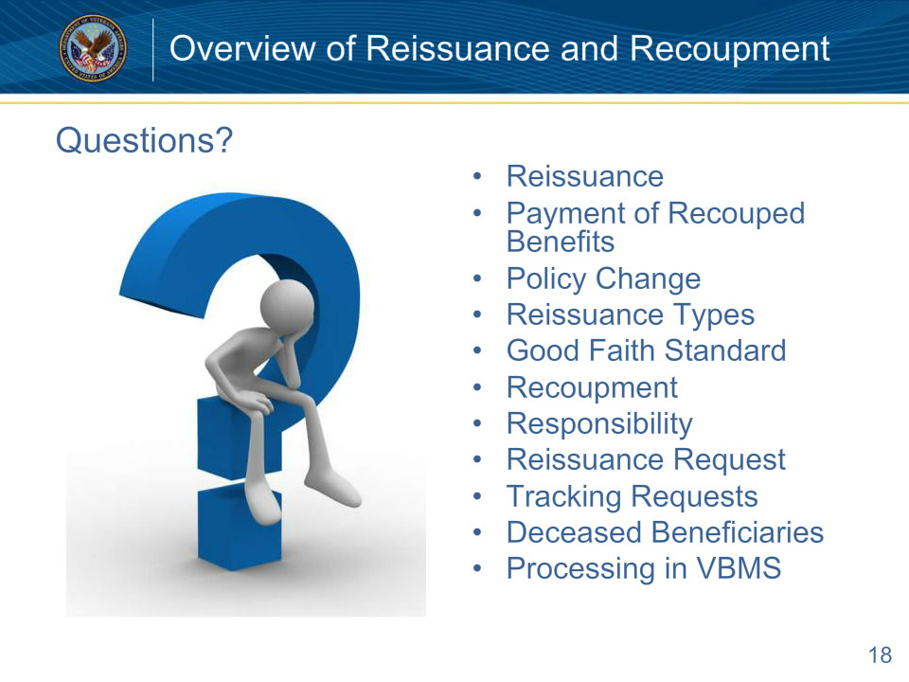
Slide notes

Instructor Notes:

(Recall) These are our learning objectives as stated from the beginning of the training:

• Define reissuance and recoupment

• Identify policy differences for cases completed prior to January 5, 2021

• Implement recoupment procedures

• Request reissuance

• Track reissuance requests

(Recap) We discussed each of these learning objectives through the following topics in each slide today:

• Reissuance

• Payment of Recouped Benefits

• Policy Change

• Reissuance Types

• Good Faith Standard

• Recoupment

• Responsibility

• Reissuance Request

• Tracking Requests

• Deceased Beneficiaries

• Processing in VBMS

Are there any additional questions?

Questions should be filtered through your QRT team. They will submit your questions to the Field Inquiry Tool (FIT) on your behalf.

Slide 19 - TMS Survey/Assessment
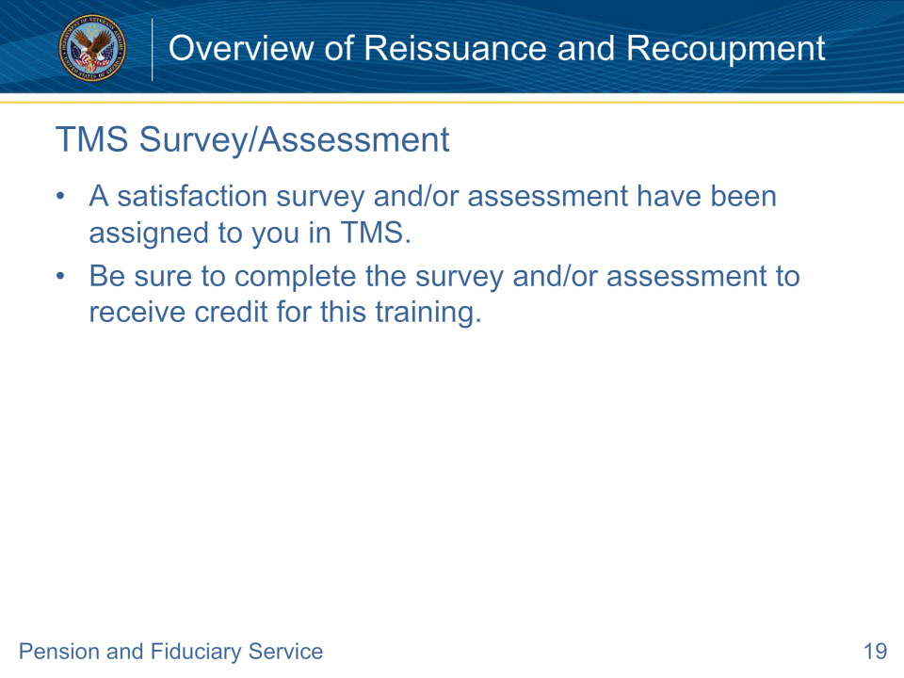
Slide notes

Instructor Notes:

A satisfaction survey and/or assessment have been assigned to you in TMS.

Be sure to complete the survey and/or assessment to receive credit for this training.

