Slide 1 - Misuse Allegations
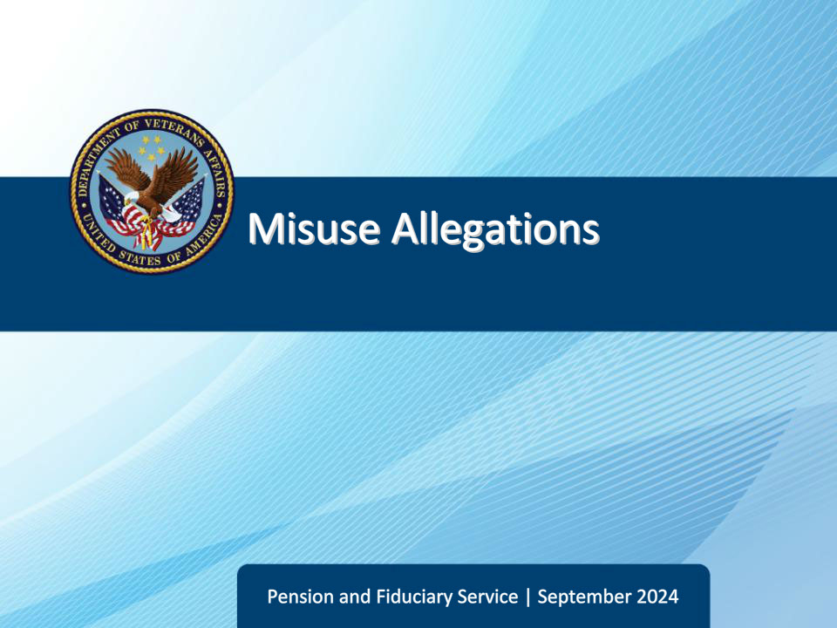
Slide notes

Course Description:

This course teaches learners information on the types, control, and disposition of misuse allegations.

Slide 2 - Objectives
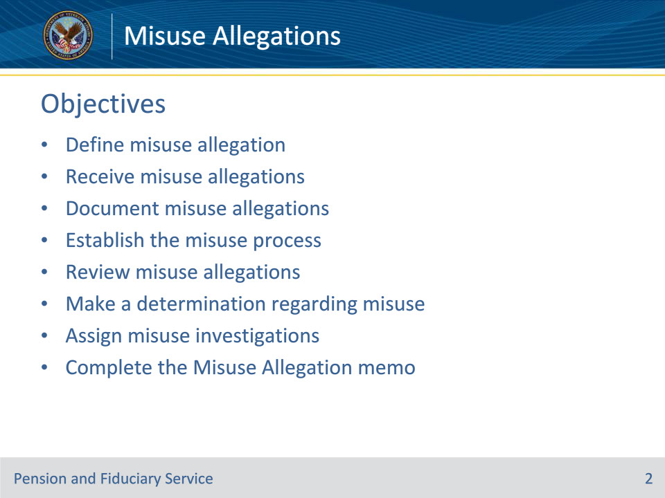
Slide notes

Instructor Notes:

At the end of this lesson, given the training and references, the learner will be able to do the following:

• Define misuse allegation

• Receive misuse allegations

• Document misuse allegations

• Establish the misuse process

• Review misuse allegations

• Make a determination regarding misuse

• Assign misuse investigations

• Complete the Misuse Allegation memo

Slide 3 - References
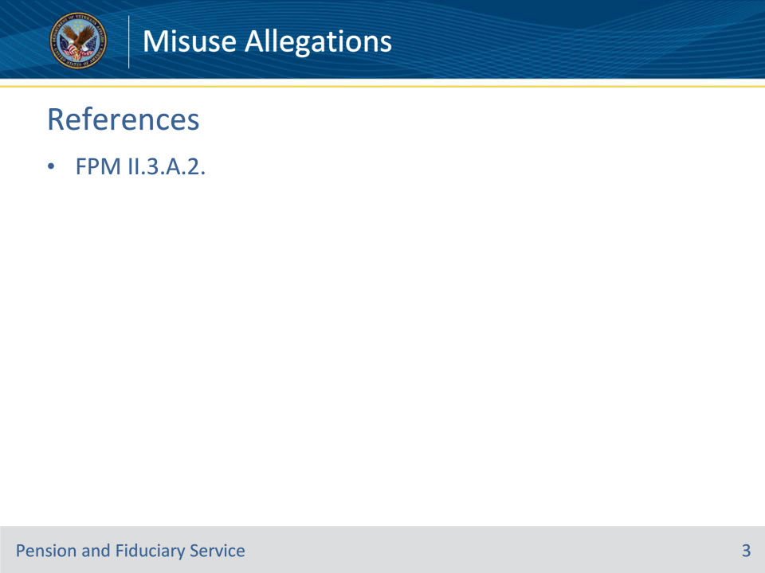
Slide notes

Instructor Notes:

These are the relevant references pertaining to this course:

• FPM II.3.A.2. Misuse Allegations

Slide 4 - Definition
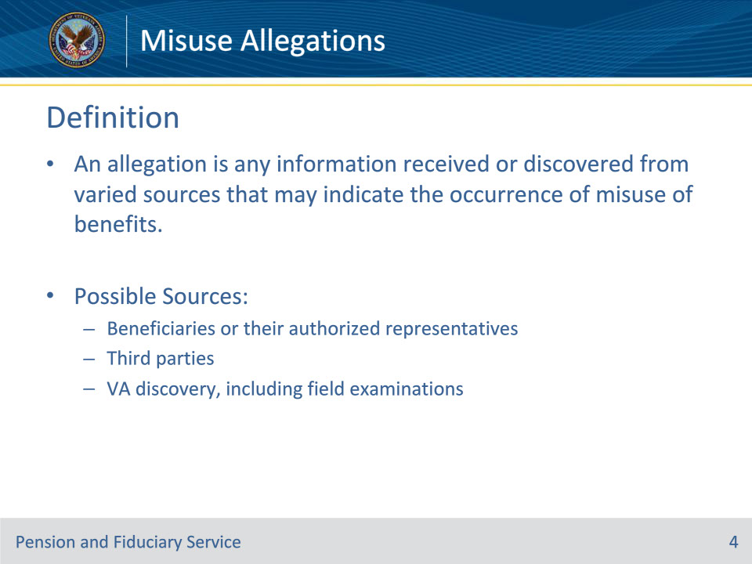
Slide notes

Policy Reference(s): FPM II.3.A.2.a.

Instructor Notes:

An allegation is any information received or discovered from varied sources that may indicate the occurrence of misuse of benefits. Sources of misuse allegations may include

• beneficiaries or their authorized representatives

• third parties, and/or

• VA discovery, to include issues discovered during a field examination.

Slide 5 - SDP Beneficiary
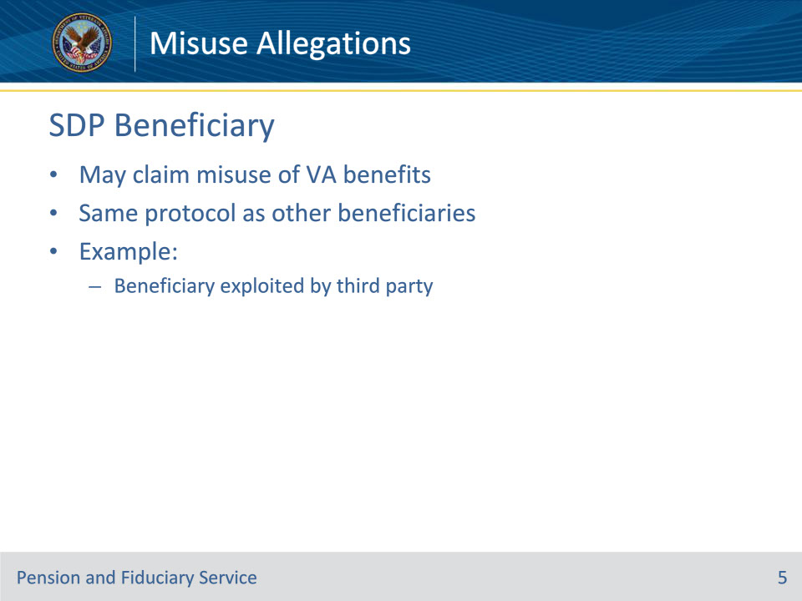
Slide notes

Policy Reference(s): FPM II.3.A.2.b.

Instructor Notes:

A beneficiary appointed under supervised direct pay (SDP) as well as his/her friend, relative, interested third party, or a successor fiduciary, may claim misuse of VA benefits. The misuse protocol for these beneficiaries is the same as that required for all other beneficiaries.

An example of SDP misuse of VA benefits could include a beneficiary who is the victim of financial exploitation at the hands of a third party.

Slide 6 - VA Discovery
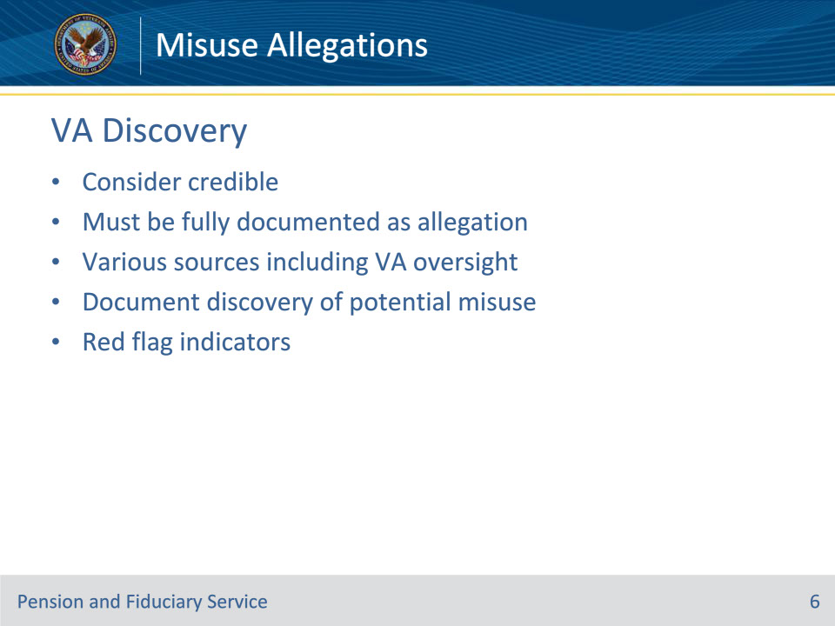
Slide notes

Policy Reference(s): FPM II.3.A.2.c.

Instructor Notes:

Any situation that indicates the possibility of misuse must be fully documented as an allegation of misuse. An allegation of misuse may come from various sources. Potential misuse may also be identified by VA during routine scheduled and unscheduled oversight of beneficiaries and fiduciaries.

Hubs must consider all allegations of misuse discovered by VA as credible regardless of whether an investigation will be required.

Instances of potential fiduciary misuse identified through routine supervision and oversight are identified as red flag indicators.

Slide 7 - Receiving Allegations
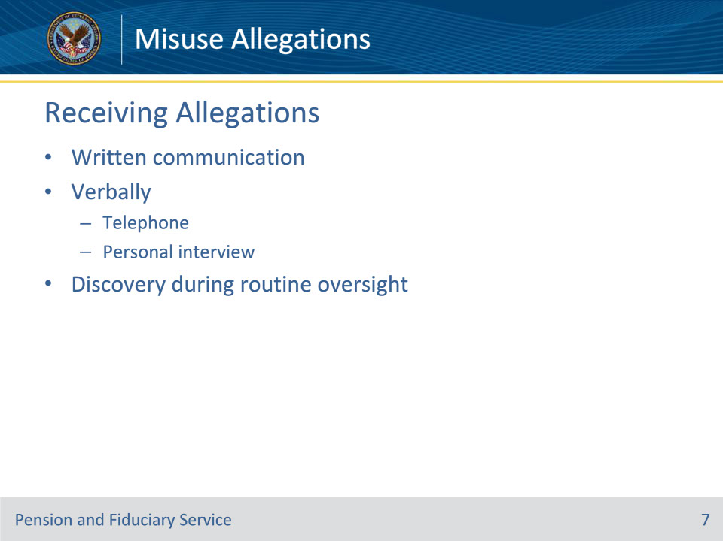
Slide notes

Policy Reference(s): FPM II.3.A.2.d.

Instructor Notes:

Allegations of misuse may come in the form of

• written communication

• Verbal communication by telephone or personal interview, or

• discovery during routine oversight.

Slide 8 - Documenting Allegations
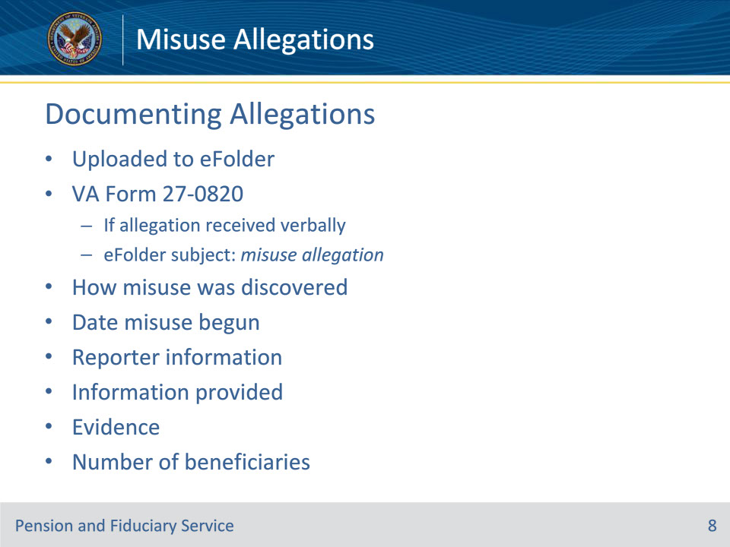
Slide notes

Policy Reference(s): FPM II.3.A.2.d.

Instructor Notes:

All misuse allegation documentation must be uploaded to the beneficiary’s eFolder. If an allegation is received verbally, the information must be documented on a VA Form 27-0820, Report of General Information, and uploaded to the beneficiary’s eFolder with the subject of the document listed as misuse allegation. The documentation must provide:

• complete details of the allegation to include

• how the misuse was discovered

• the date misuse may have begun, if known, and

• the name and contact information of reporter or a statement that the reporter refuses to provide his/her identity

• an accurate record of the information provided during the contact

• evidence that supports the allegation, and

• if the fiduciary serves more than one beneficiary.

The VA Form 27-0820 must be signed by the individual documenting the allegation.

Slide 9 - Establishing Misuse Process
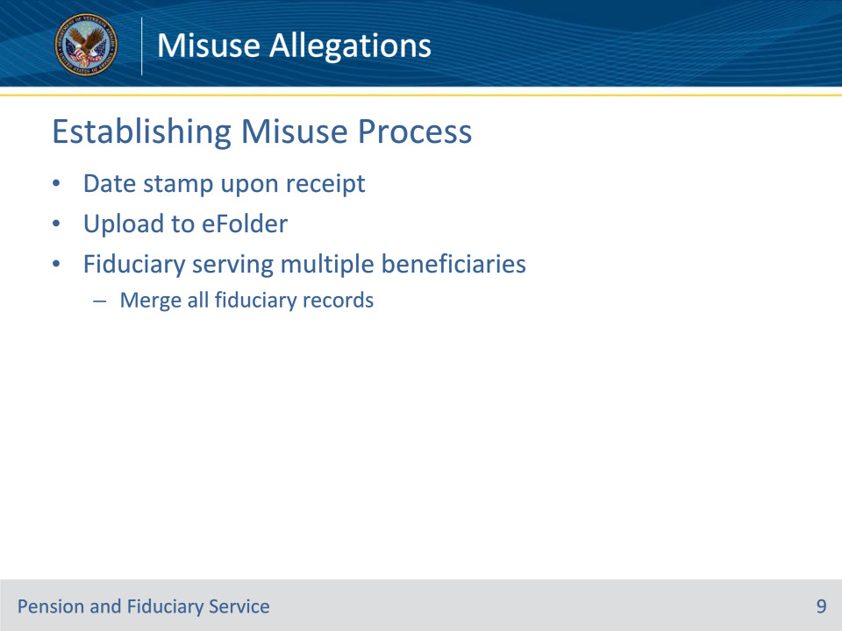
Slide notes

Policy Reference(s): FPM II.3.A.2.e.

Instructor Notes:

To ensure timely processing of misuse allegations, upon receipt the hub must immediately

• date stamp written allegations of misuse

• upload the documentation to the eFolder, and

• follow the guidance to properly control the misuse allegation (on next slide)

Additionally, if an allegation is received concerning a fiduciary that serves multiple beneficiaries, the hub must immediately merge all fiduciary records pertaining to the fiduciary.

Slide 10 - Control
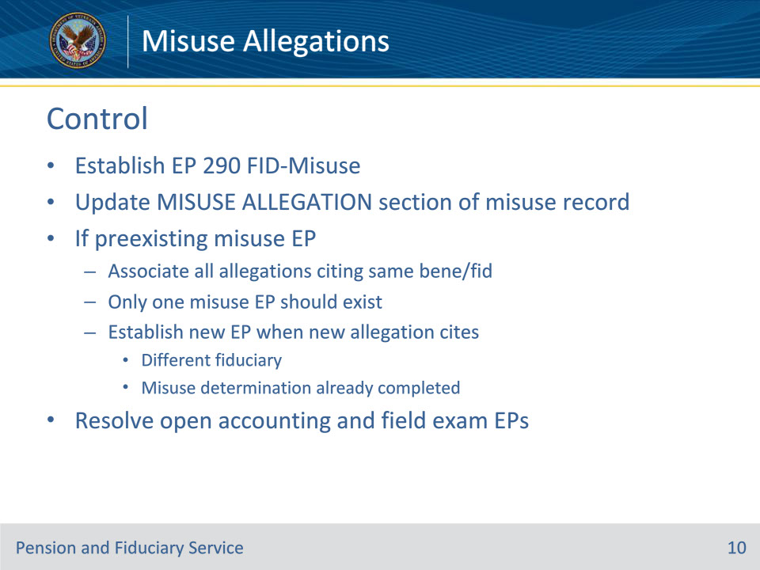
Slide notes

Policy Reference(s): FPM II.3.A.2.f.

Instructor Notes:

Establish an EP 290 with claim label FID-Misuse when VA receives a credible allegation of misuse. After establishing the EP 290, update all fields of the MISUSE ALLEGATION section of the misuse record by selecting and entering the appropriate details of the misuse allegation. The ALLEGATION STATEMENT field must contain the information described for that element.

If an open misuse EP exists, associate all misuse allegations citing the same fiduciary and beneficiary under the same misuse EP and update the MISUSE ALLEGATION section as described above. Only one misuse EP should exist when the same beneficiary and fiduciary are cited in the misuse allegation regardless of the number of allegations VA receives.

A new misuse EP is established only when VA receives a new misuse allegation citing

• a different fiduciary, or

• the same fiduciary and beneficiary, and

• a misuse determination was already completed.

Example: If the hub receives multiple misuse allegations regarding a beneficiary’s funds prior to the completion of the misuse determination (for example, an FE referral with credible evidence following a follow-up field examination and a third party’s report of possible misuse), incorporate the new allegation as evidence and do not establish a new EP.

After establishing an EP 290 with claim label FID-Misuse, resolve any pending accounting, fund usage review, and/or field examination EPs that relate to oversight of the fiduciary who is the subject of a misuse allegation.

If the subject fiduciary of the misuse allegation submits an accounting or fund usage report after the EP is resolved, establish the appropriate financial review EP to complete the assessment. The date of claim value is the date the report was received.

Slide 11 - EP Claim Date
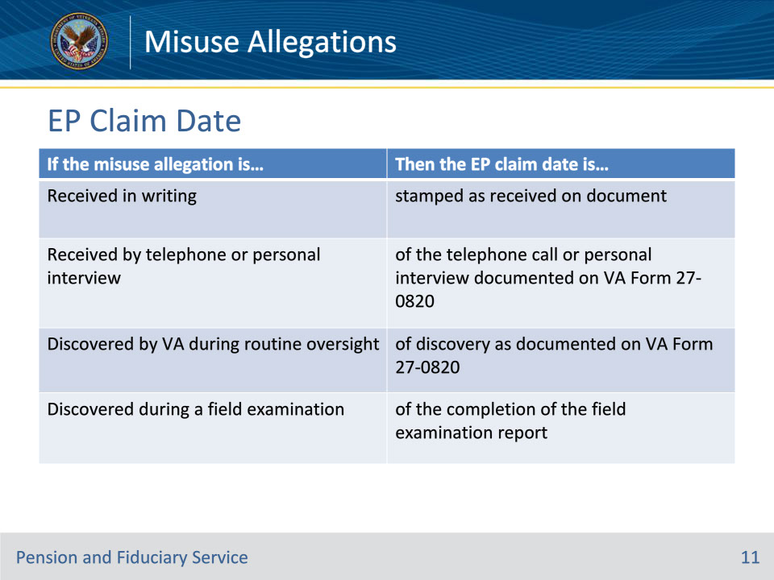
Slide notes

Policy Reference(s): FPM II.3.A.2.f.

Instructor Notes:

Use the table on this slide to determine the received date when establishing the misuse EP.

Slide 12 - Review of Allegation
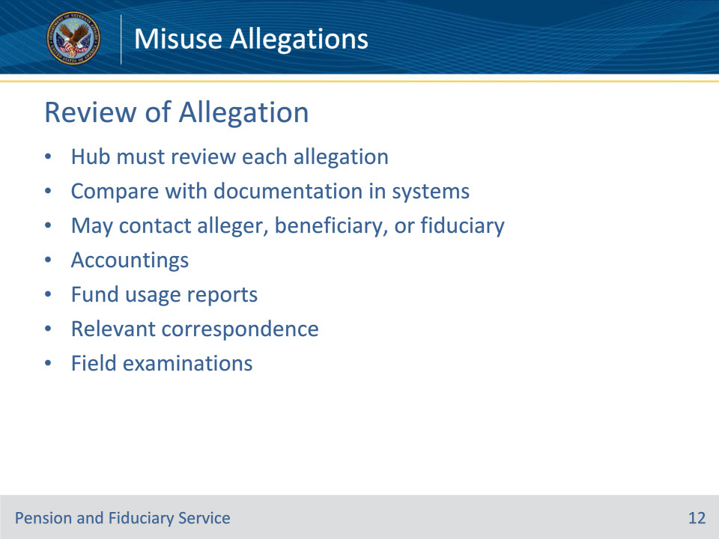
Slide notes

Policy Reference(s): FPM II.3.A.2.g.

Instructor Notes:

The hub must review each allegation of misuse and decide if a misuse investigation is warranted. The review should compare the allegation with documentation contained in the eFolder and systems such as, but not limited to, VBMS and Share. In addition, VA may contact the alleger, beneficiary, or fiduciary to make the decision as to whether a misuse determination is warranted. The hub must investigate each allegation unless there is clear evidence that the allegation has no basis in fact.

When reviewing the misuse allegation, consider evidence the of record relating to accountings, fund usage reports, relevant correspondence, and field examinations to assist in making the appropriate decision.

Slide 13 - Prior Accountings & Fund Usage
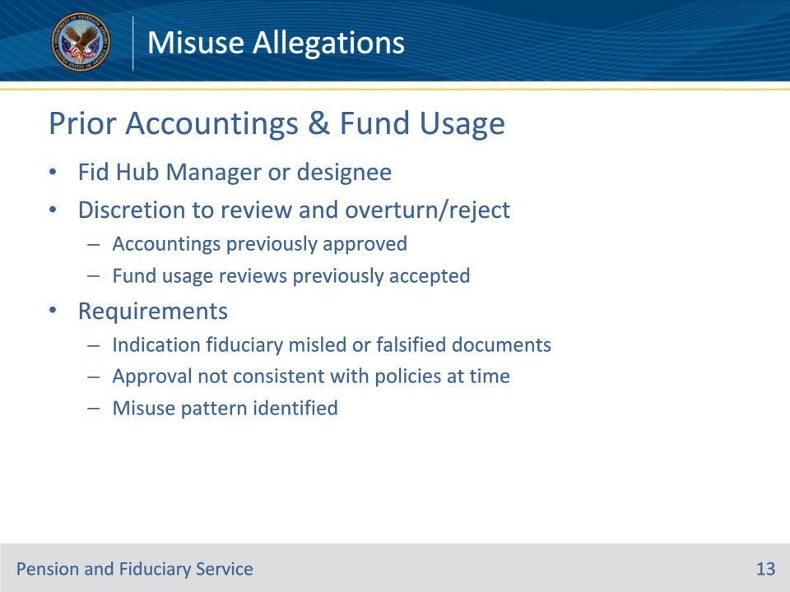
Slide notes

Policy Reference(s): FPM II.3.A.2.g.

Instructor Notes:

The FHM or designee may review previously approved accountings or accepted fund usage reports and reverse the prior finding, if

• the fiduciary appears to have intentionally misled or falsified financial reports or documents submitted to VA

• the approval or acceptance was not consistent with policies or procedures in place at the time, or

• a pattern of misuse has been identified in previously approved accountings or accepted fund usage reports.

Slide 14 - Actions
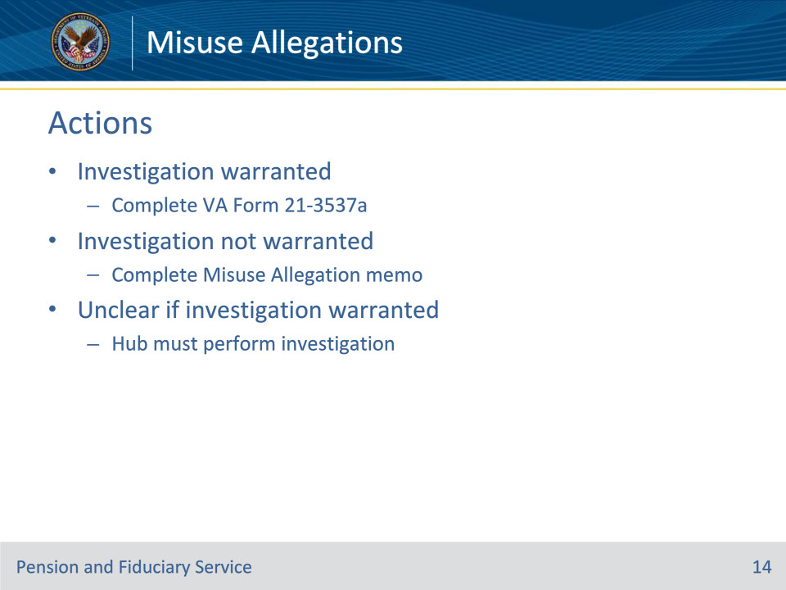
Slide notes

Policy Reference(s): FPM II.3.A.2.h.

Instructor Notes:

If the hub determines an investigation is warranted, then complete a VA Form 21-3537a. A Misuse Allegation memorandum is not required in this case.

If the hub determines an investigation is not warranted, complete a Misuse Allegation memorandum for each allegation the hub receives.

If it is not clear whether an allegation warrants an investigation, the hub must perform the investigation.

Slide 15 - Multiple Beneficiaries
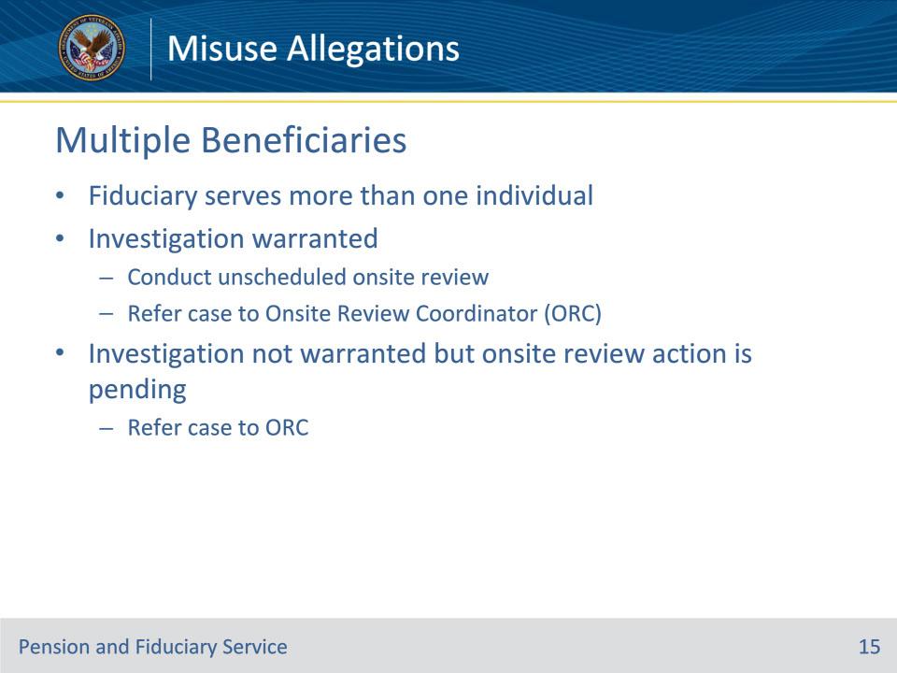
Slide notes

Policy Reference(s): FPM II.3.A.2.h.

Instructor Notes:

• When an investigation is warranted and the fiduciary serves more than one individual, the hub must

• conduct an unscheduled onsite review, and

• refer the case to the Onsite Review Coordinator (ORC) for tracking and action.

• When an investigation is not warranted but an onsite review action is pending, the hub must refer the case to the ORC for the establishment of an onsite review activity.

Slide 16 - Reasons not to Investigate
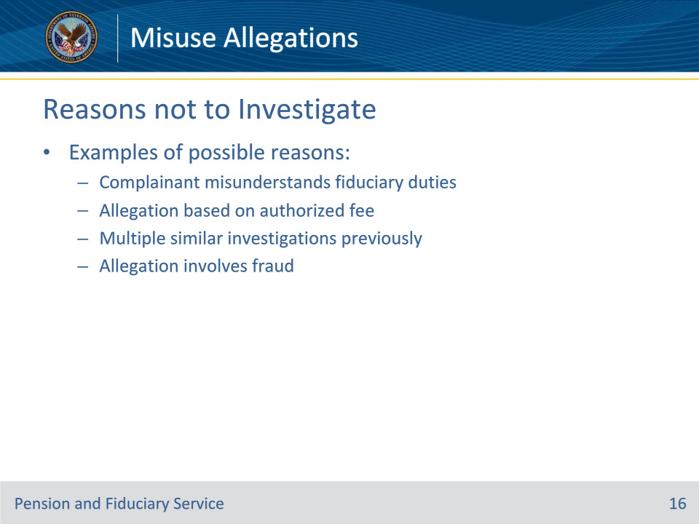
Slide notes

Policy Reference(s): FPM II.3.A.2.i.

Instructor Notes:

The following are examples of possible reasons not to investigate an allegation of misuse:

• the nature of the allegation clearly indicates the alleger misunderstands the fiduciary’s duties and authority

• the allegation reports the fiduciary is misusing a beneficiary’s funds by charging a fee for serving as fiduciary when VA or a court of jurisdiction has authorized or statutorily allowed a fee

• multiple but similar allegations are received that were previously reviewed or investigated, or

• the allegation involves fraud.

Slide 17 - No Misuse Determination
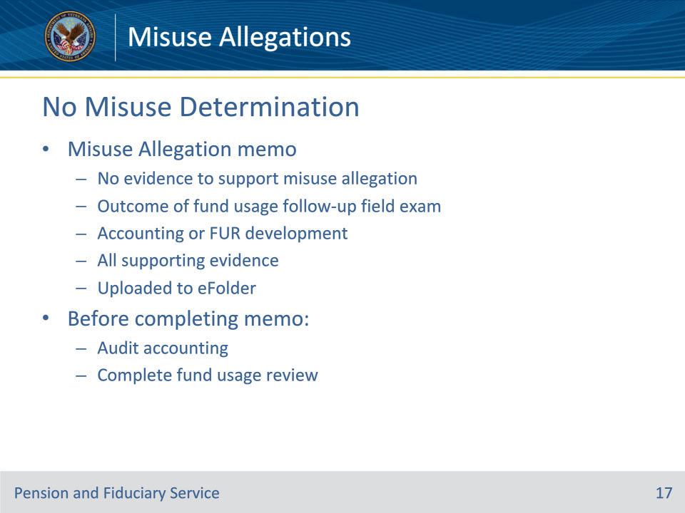
Slide notes

Policy Reference(s): FPM II.3.A.2.j.

Instructor Notes:

The hub must document the outcome of the fund usage follow-up field examination and accounting or fund usage report development, if applicable, on a Misuse Allegation memorandum.

The Misuse Allegation memorandum must clearly indicate there is no evidence to support the allegation of misuse and support the decision with sufficient evidence to confirm the conclusion not to complete a misuse determination. The hub must upload the completed and approved Misuse Allegation memorandum to the eFolder.

Before completing the misuse allegation memorandum, if received, the hub must:

• audit the accounting, and/or

• fund usage review

The Misuse Allegation memorandum approver cannot be the same person as the preparer.

Slide 18 - No Misuse Determination
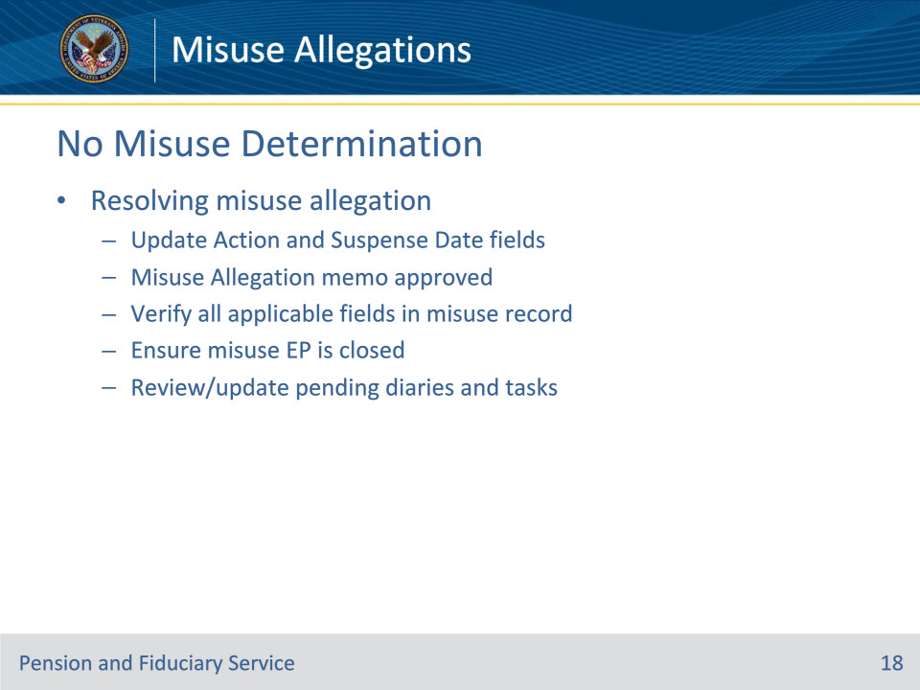
Slide notes

Policy Reference(s): FPM II.3.A.2.k.

Instructor Notes:Once the appropriate hub employee determines a misuse determination is not warranted, update the ACTION and SUSPENSE DATE fields in the misuse EP.

After the Misuse Allegation memorandum is approved, verify that all fields in the misuse record applicable to the misuse case are updated and ensure that the misuse EP is closed. Review all pending diaries and tasks for accuracy and update any incorrect diaries and tasks as necessary to ensure appropriate future oversight.

Slide 19 - Misuse Determination
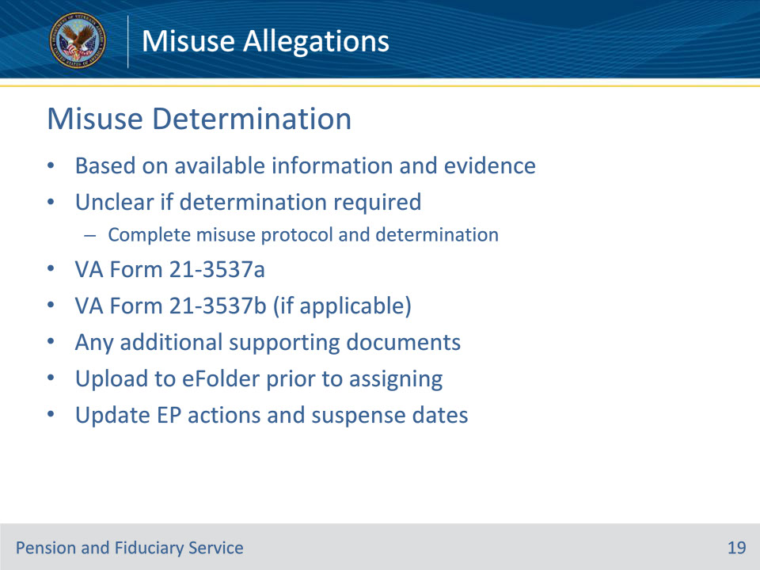
Slide notes

Policy Reference(s): FPM II.3.A.2.l.

Instructor Notes:

The hub must base the decision to complete a misuse determination on available information and evidence supporting the decision. If it is not clear whether an allegation requires a misuse determination complete the misuse protocol and a misuse determination.

Documentation of the need to complete a misuse determination includes:

• VA Form 21-3537a

• VA Form 21-3537b, for the fund usage follow-up field examination, if applicable, and

• any additional documents which support the need to complete a misuse determination.

The hub must upload all supporting documentation into the beneficiary’s eFolder prior to assigning the case for investigation. Update the EP actions and suspense dates to ensure a correct EP status and timely processing.

Slide 20 - Assigning Investigation
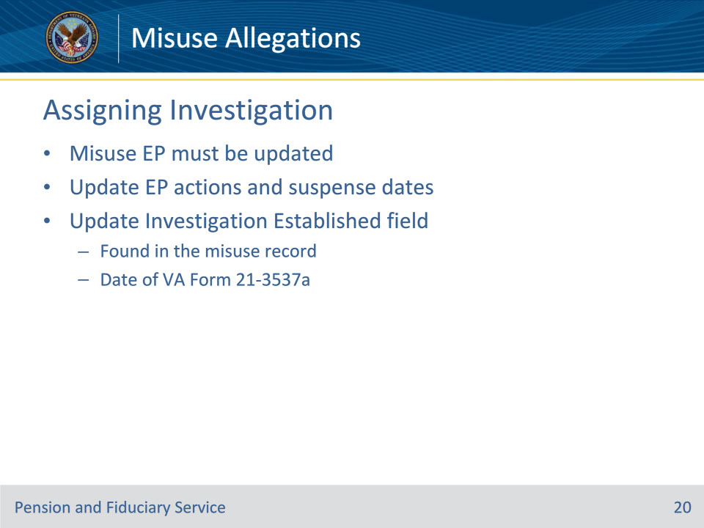
Slide notes

Policy Reference(s): FPM II.3.A.2.m.

Instructor Notes:

The EP in VBMS must be updated accordingly in order to assign the investigation to the appropriate hub employee.

Update the EP actions and suspense dates to ensure timely processing and that the EP status is correct.

Additionally, update the INVESTIGATION ESTABLISHED field on the corresponding misuse record with the date of the VA Form 21-3537a requesting the investigation.

Slide 21 - Misuse Allegation Memo
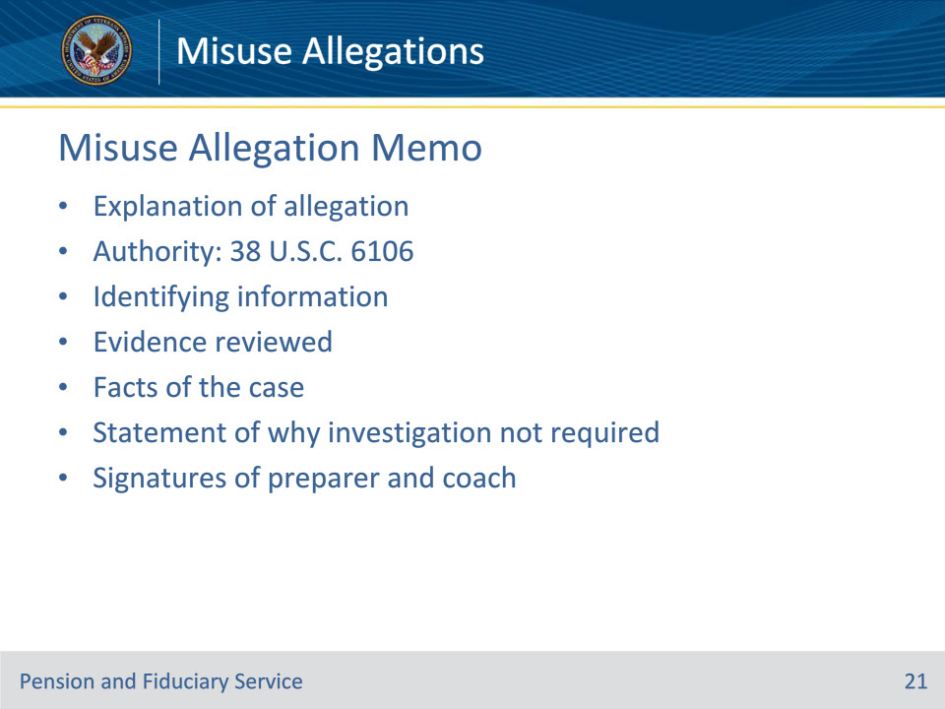
Slide notes

Policy Reference(s): FPM II.3.A.2.n.; o.

Instructor Notes:

The Misuse Allegation memorandum must include the following elements:

• explanation of the specific allegation

• authority: 38 U.S.C. 6106

• identifying information, including

• Veteran name

• Veteran claim number

• beneficiary name

• fiduciary name

• fiduciary Social Security number or tax identification number

• fiduciary category (individual or entity)

• number of beneficiaries served, and

• if the fiduciary is court appointed

• evidence reviewed

• facts of the case

• definitive statement indicating why an investigation is not required, and

• signature of

• hub employee who prepared the document, and

• coach providing concurrence or non-concurrence on the decision.

A detailed table explaining all required elements of the misuse allegation memo can be found at FPM II.3.A.2.n. and a sample misuse allegation memo can be found at FPM II.3.A.2.o.

Slide 22 - Questions?
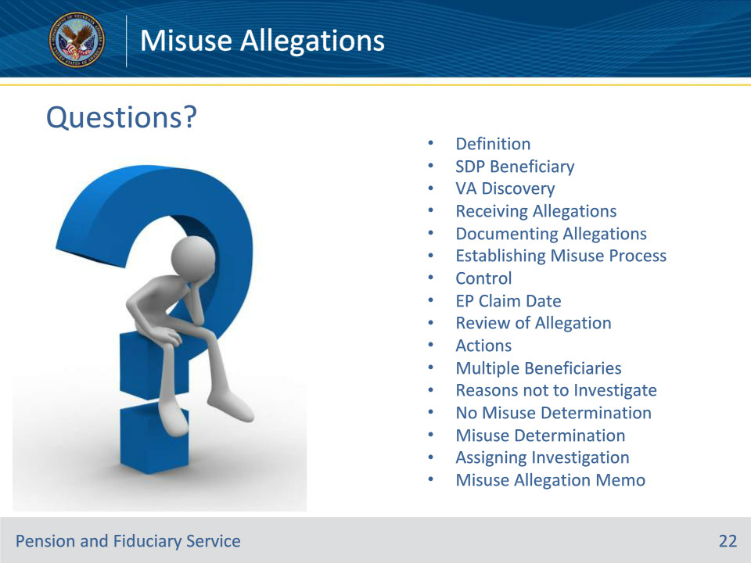
Slide notes

Instructor Notes:

(Recall) These are our learning objectives as stated from the beginning of the training:

• Define misuse allegation

• Receive misuse allegations

• Document misuse allegations

• Establish the misuse process

• Review misuse allegations

• Make a determination regarding misuse

• Assign misuse investigations

• Complete the Misuse Allegation memo

(Recap) We discussed each of these learning objectives through the following topics in each slide today:

• Definition

• SDP Beneficiary

• VA Discovery

• Receiving Allegations

• Documenting Allegations

• Establishing Misuse Process

• Control

• EP Claim Date

• Review of Allegation

• Actions

• Multiple Beneficiaries

• Reasons not to Investigate

• No Misuse Determination

• Misuse Determination

• Assigning Investigation

• Misuse Allegation Memo

Are there any additional questions?

Questions should be filtered through your QRT team. They will submit your questions to the Field Inquiry Tool (FIT) on your behalf.

Slide 23 - TMS Survey/Assessment
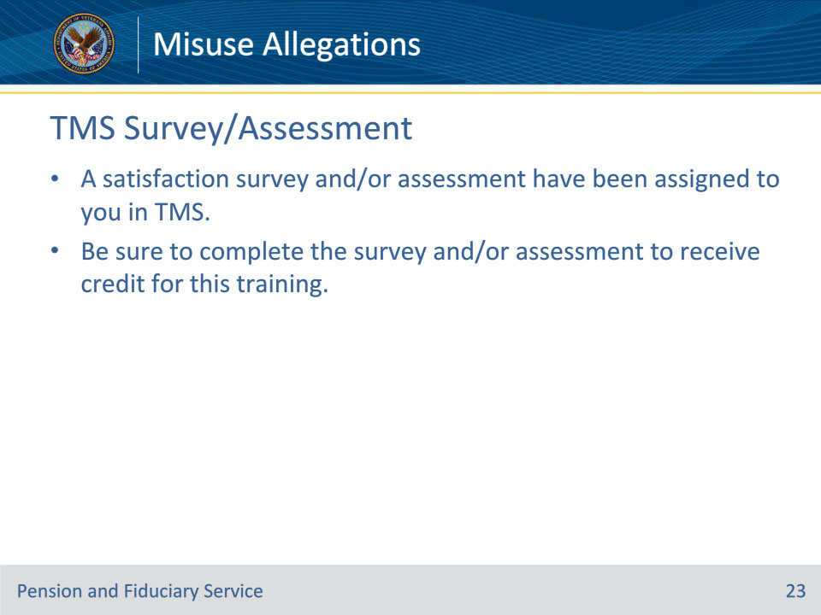
Slide notes

Instructor Notes:

A satisfaction survey and/or assessment have been assigned to you in TMS.

Be sure to complete the survey and/or assessment to receive credit for this training.

