Slide 1 - Collection of Surety Bond
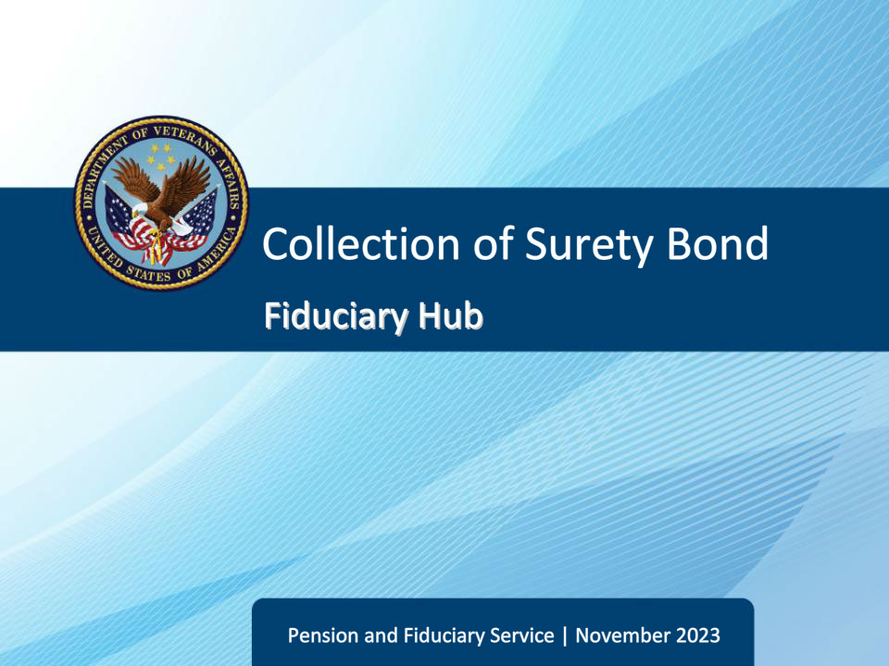
Slide notes

Course Description:

This course teaches learners about the collection of surety bonds, including responsibility, assistance, procedures, and receipt.

Slide 2 - Objectives
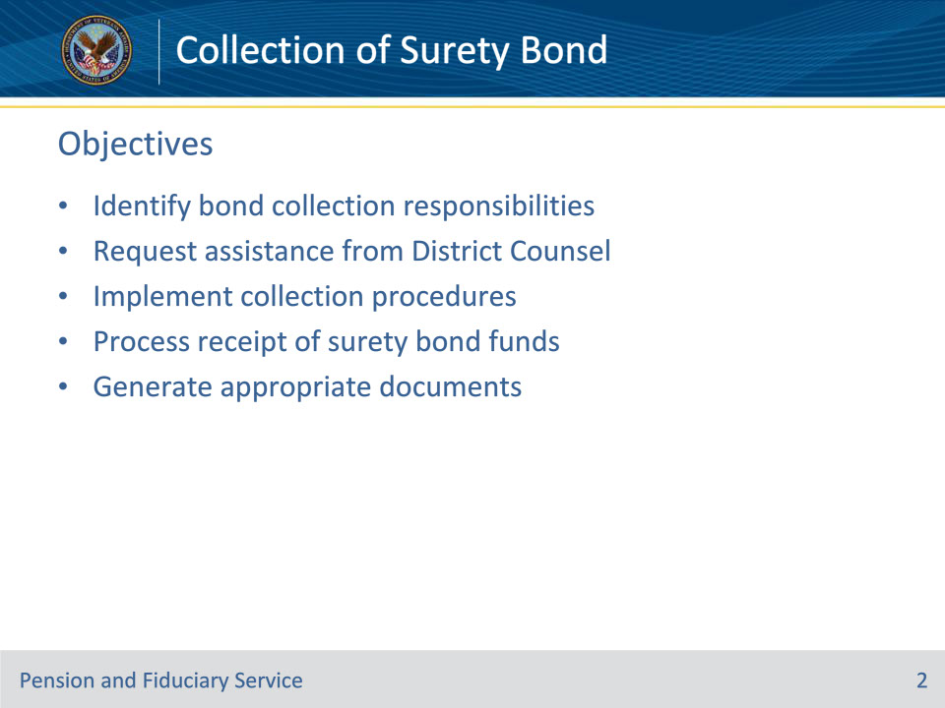
Slide notes

Instructor Notes:

At the end of this lesson, given the training and references, the learner will be able to do the following:

• Understand bond collection responsibilities

• Request assistance from District Counsel

• Implement collection procedures

• Process receipt of surety bond funds

• Generate appropriate documents

Slide 3 - References
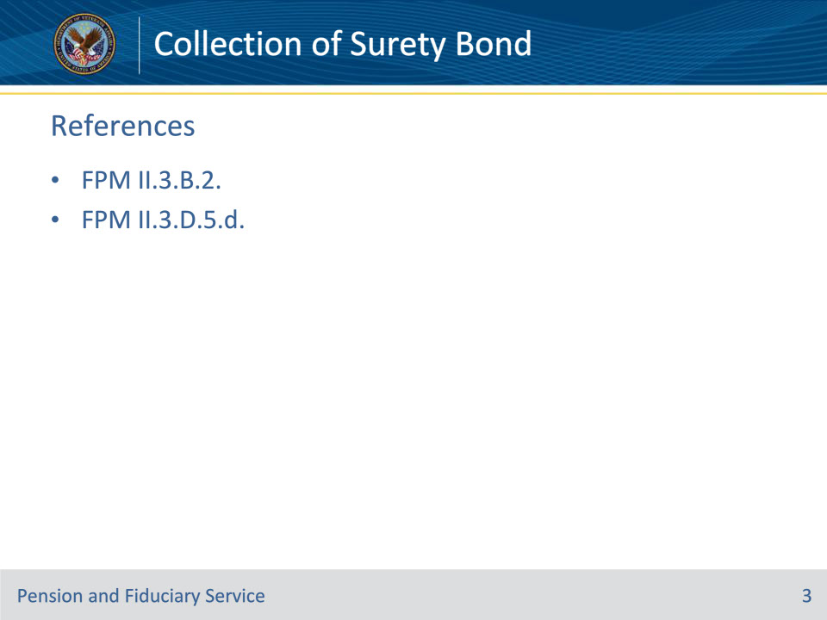
Slide notes

Instructor Notes:

These are the relevant references pertaining to this course:

• FPM II.3.B.2. Collection of Surety Bond

• FPM II.3.D.5.d. Actions for Determining Direction of Funds

Slide 4 - Responsibility
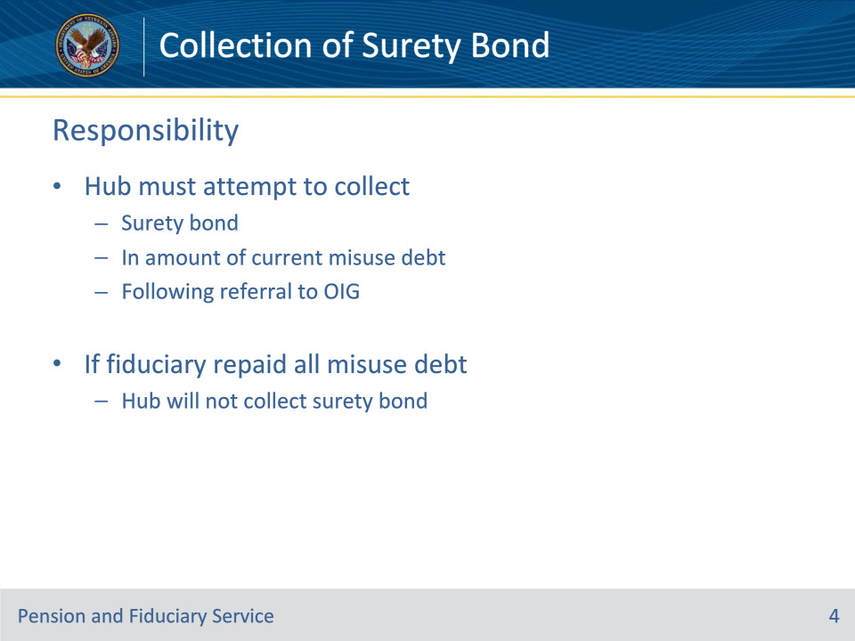
Slide notes

Policy Reference(s): FPM II.3.B.2.a.

Instructor Notes:

The hub must attempt to collect any surety bond protecting the beneficiary’s VA funds in the amount of the current misuse debt. The hub must follow the procedures immediately following referral to OIG.

If the evidence of record confirms the fiduciary has repaid all of the misuse debt amount to VA, the successor fiduciary, or the beneficiary, the hub will not attempt to collect the surety bond.

Slide 5 - Procedures (1 of 4)
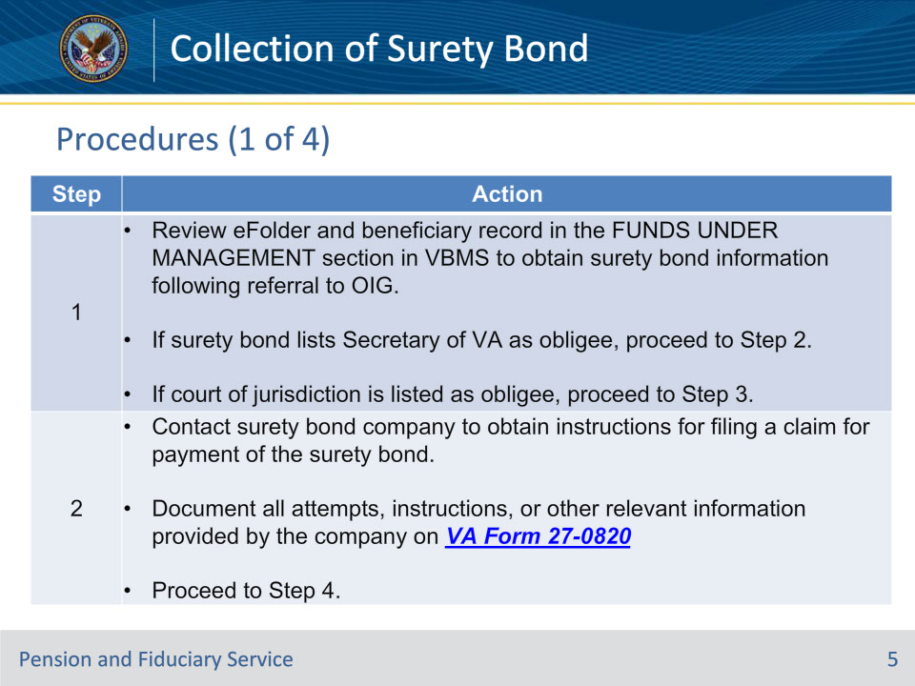
Slide notes

Policy Reference(s): FPM II.3.B.2.b.

Instructor Notes:

Follow the steps in the table above to collect the surety bond.

Slide 6 - Procedures (2 of 4)
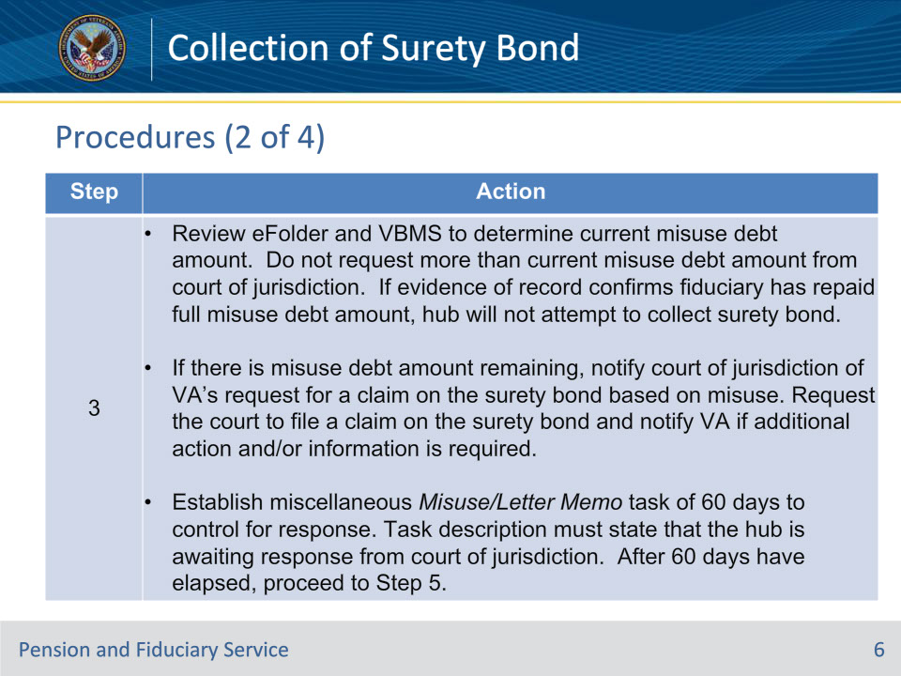
Slide notes

Policy Reference(s): FPM II.3.B.2.b.

Instructor Notes:

Follow the steps in the table above to collect the surety bond.

Slide 7 - Procedures (3 of 4)
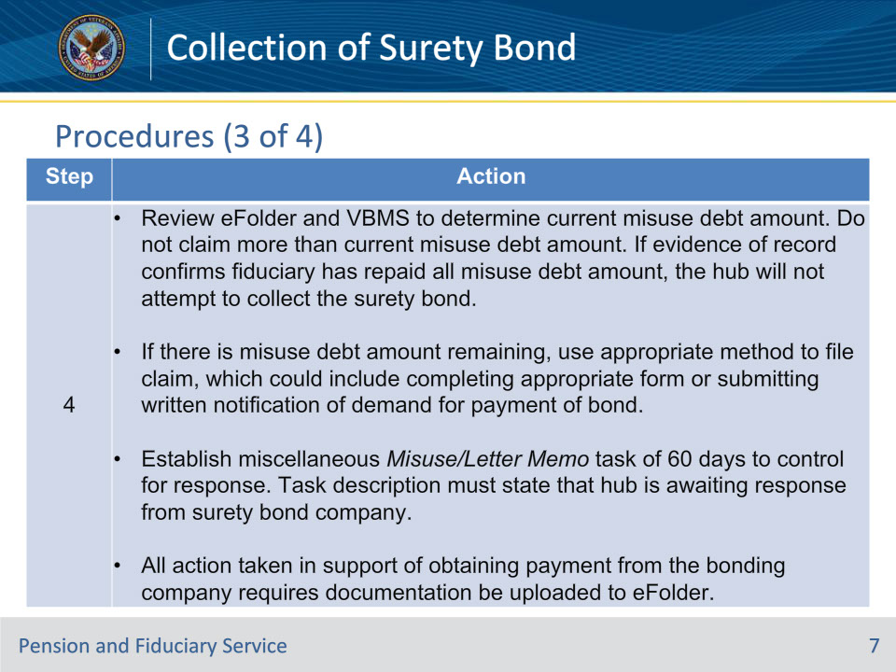
Slide notes

Policy Reference(s): FPM II.3.B.2.b.

Instructor Notes:

Follow the steps in the table above to collect the surety bond.

Slide 8 - Procedures (4 of 4)
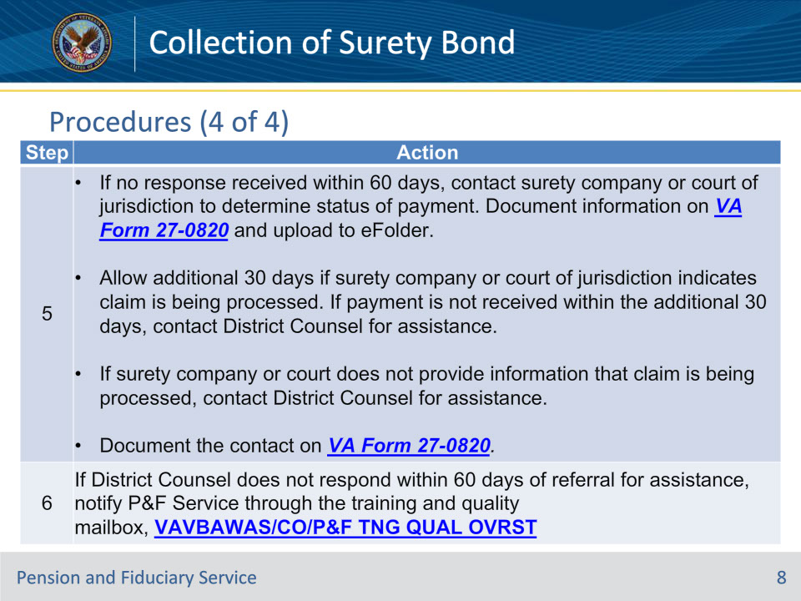
Slide notes

Policy Reference(s): FPM II.3.B.2.b.

Instructor Notes:

Follow the steps in the table above to collect the surety bond.

Slide 9 - Receipt of Funds
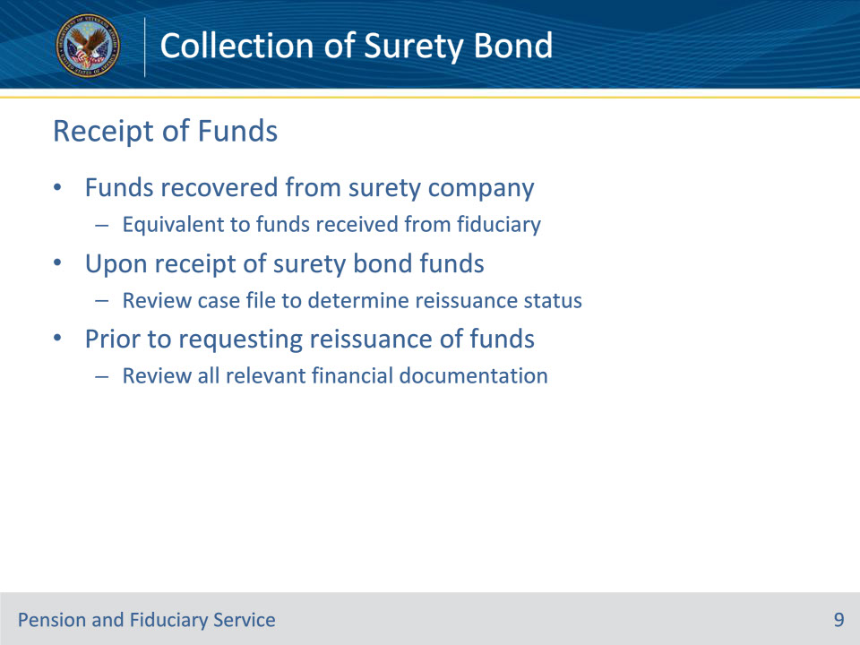
Slide notes

Policy Reference(s): FPM II.3.B.2.c. ; II.3.D.5.d.

Instructor Notes:

The requirement for surety bonds is to ensure adequate protection of a beneficiary’s VA FUM in the event of misuse. Any funds recovered from the surety bond company are equivalent to funds received from the misusing fiduciary.

Upon notification of the receipt of surety bond funds from finance activity, hubs must review the case file to determine if:

• mandatory reissuance or reissuance based on negligence occurred as applicable to misuse determination cases prior to January 5, 2021

• reissuance occurred following receipt of a completed negligence determination for misuse determinations, reconsiderations, or corrected determinations completed on or after January 5, 2021, or

• reissuance of recouped funds is required.

Hubs are responsible for conducting a review of all relevant financial documentation prior to requesting reissuance of recouped funds by the RO finance activity. This includes a review of:

• transfers to the successor fiduciary

• repayment to VA by the fiduciary

• the beneficiary’s record and eFolder regarding a change in payment status based on

• a deceased beneficiary

• award termination, or

• award suspension, and/or

• surety bond documentation and/or reimbursement.

The hub review must be thorough as reissuance in inappropriate instances can create an overpayment to the beneficiary that must be repaid.

Slide 10 - Collection Documents
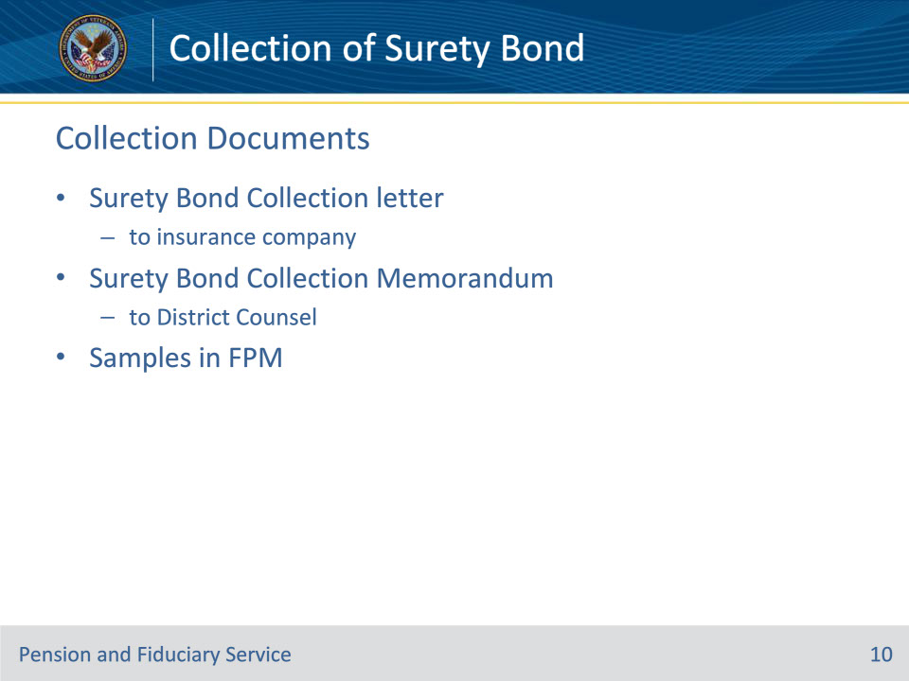
Slide notes

Policy Reference(s): FPM II.3.B.2.d.; e.

Instructor Notes:

Surety Bond collection documents consist of the Surety Bond Collection letter to an insurance company and the Surety Bond Collection Memorandum to District Counsel. Samples of both documents can be found in the fiduciary program manual.

Slide 11 - Summary
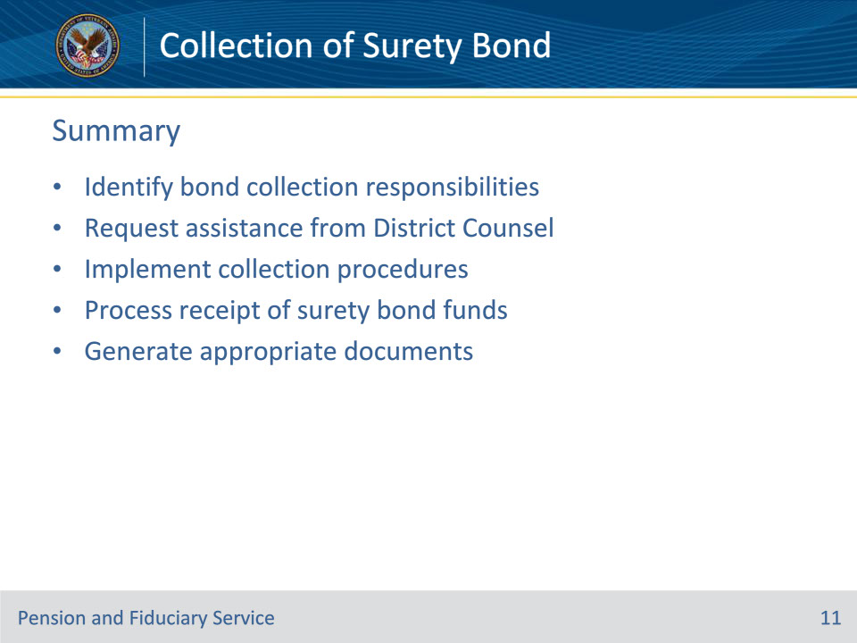
Slide notes

Instructor Notes:

(Recall) These are our learning objectives as stated from the beginning of the training:

• Identify bond collection responsibilities

• Request assistance from District Counsel

• Implement collection procedures

• Process receipt of surety bond funds

• Generate appropriate documents

(Recap) We discussed each of these learning objectives through the following topics in each slide today:

• Responsibility

• Procedures
• Receipt of Funds

• Collection Documents

Are there any additional questions?

Slide 12 - TMS Survey
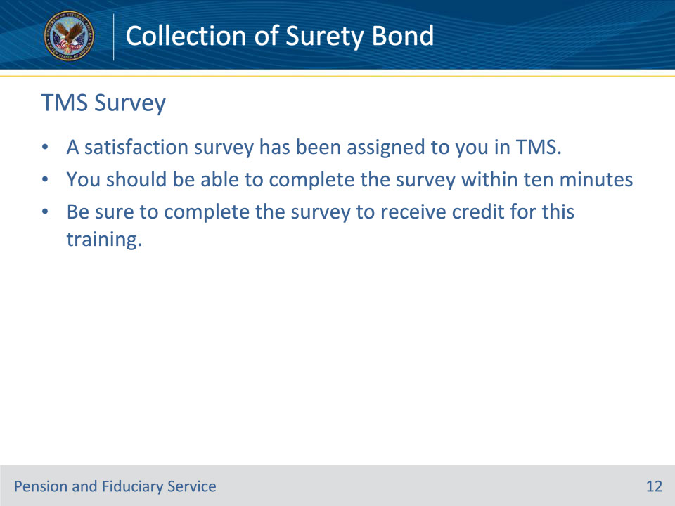
Slide notes

Instructor Notes:

A satisfaction survey has been assigned to you in TMS. You should be able to complete it within ten minutes.

Completing it will allow you to receive credit for this training.

