Slide 1 - OIG Referrals

Slide notes

Course Description:

The purpose of this lesson is to communicate the policies and requirements for referral of fiduciary misuse determinations to the VA Office of Inspector General (OIG).

Slide 2 - Objectives
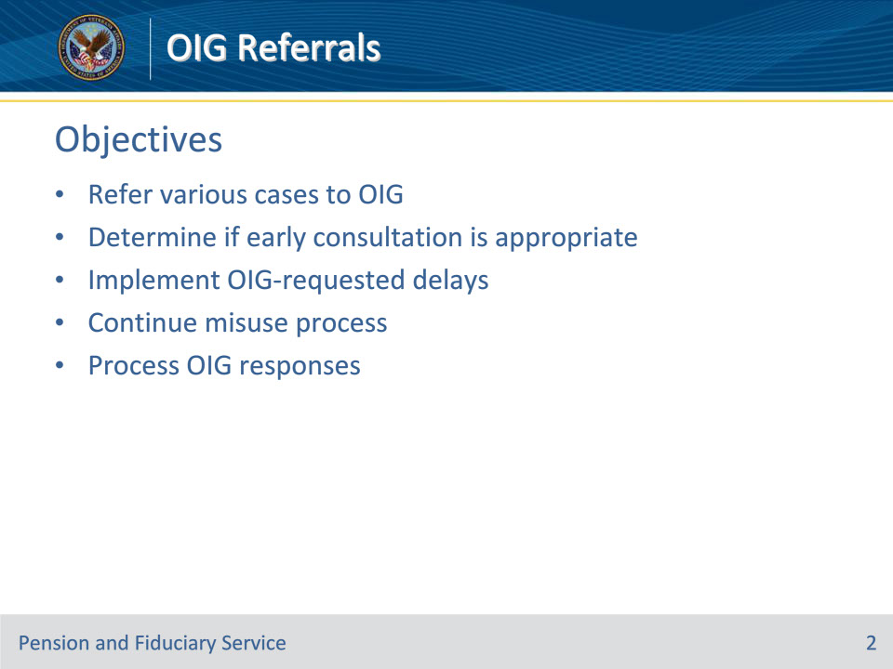
Slide notes

Instructor Notes:

By the end of this lesson, given the training and references, learners will be able to do the following:

• Refer various cases to OIG

• Determine if early consultation is appropriate

• Implement OIG-requested delays

• Continue misuse process

• Process OIG responses

Slide 3 - References
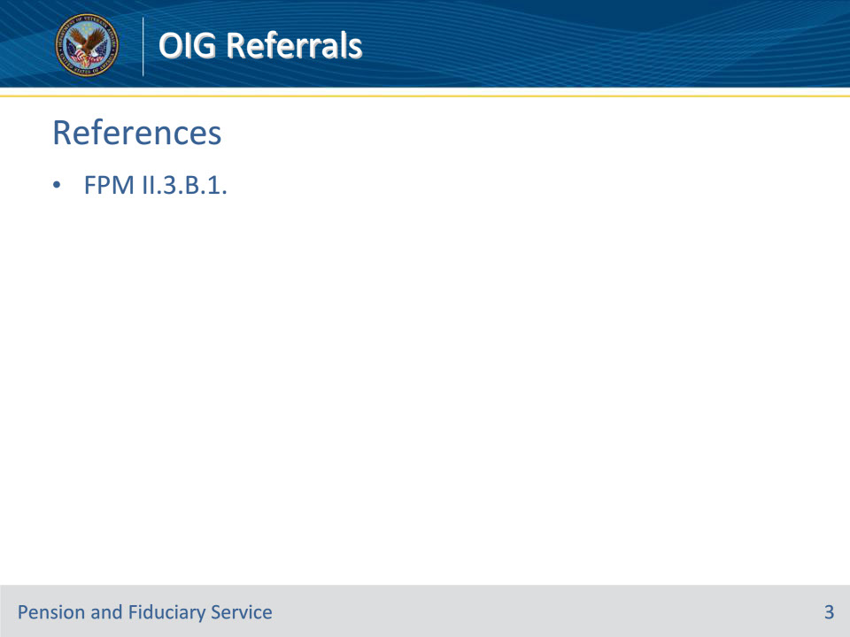
Slide notes

Instructor Notes:

These are the applicable references for today’s trainings:

• FPM II.3.B.1. Department of Veterans Affairs (VA) OIG Referrals

Slide 4 - Policy
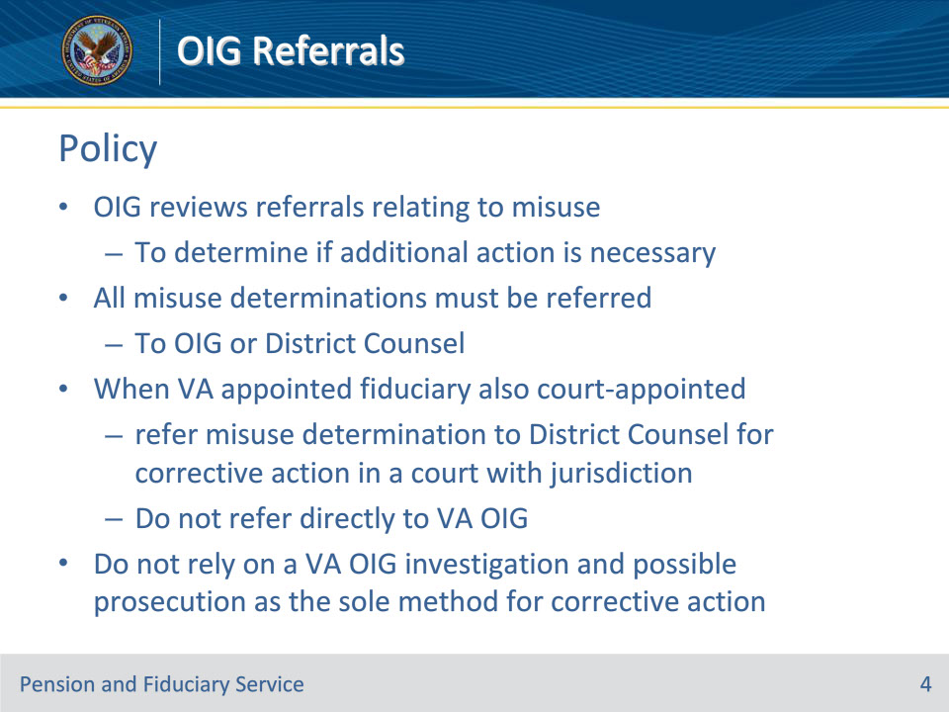
Slide notes

Policy Reference(s): FPM II.3.B.1.a.

Instructor Notes:

Misuse cases may involve fraud, embezzlement, and other criminal conduct by fiduciaries appointed by VA. VA Office of Inspector General (OIG) reviews referrals relating to the misuse of beneficiary VA funds to determine if additional action is necessary.

All misuse determinations that do not involve a court-appointed guardian or fiduciary must be referred to OIG or District Counsel and contain required information.

When the fiduciary appointed by VA also serves as a court-appointed guardian or fiduciary, refer the misuse determination to District Counsel for corrective action in a court with jurisdiction.

Do not refer court-appointed cases directly to VA OIG. Court-appointed fiduciary cases are referred to OIG by District Counsel.

Fiduciary hubs will not rely on a VA OIG investigation and possible prosecution as the sole method for corrective action.

Slide 5 - When to Refer
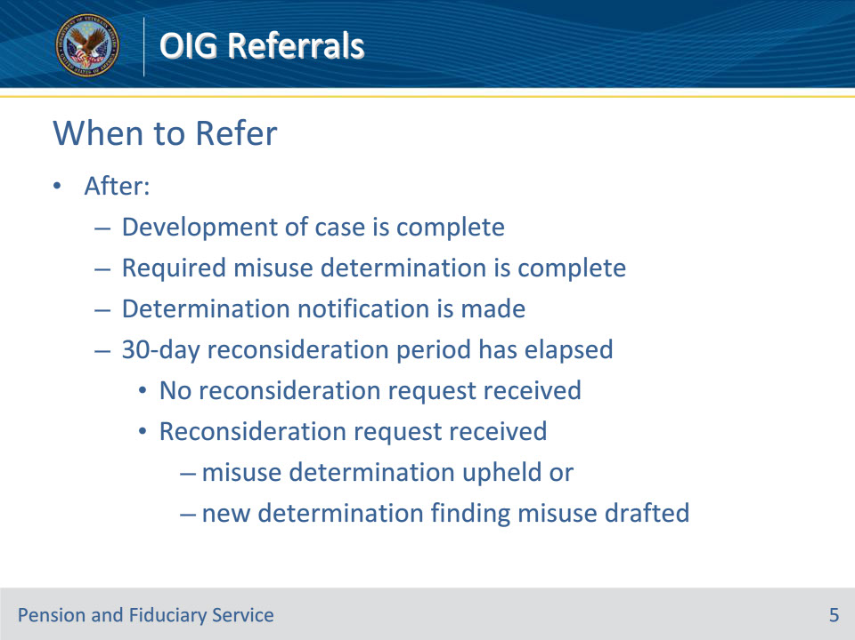
Slide notes

Policy Reference(s): FPM II.3.B.1.b.

Instructor Notes:

Hubs must refer all misuse determinations to VA OIG only after the following has taken place

• development of the case is complete

• the required misuse determination is complete

• notification of the determination is made, and

• the 30-day reconsideration period has elapsed with

• no request for reconsideration received, or

• a request for reconsideration received and the misuse determination is upheld or a new determination finding misuse is drafted.

Slide 6 - Early Consultation
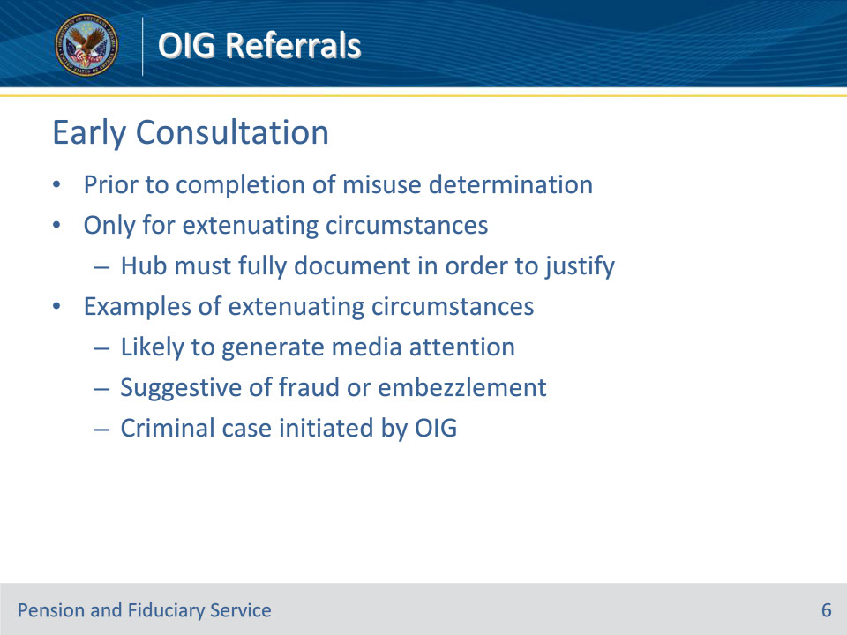
Slide notes

Policy Reference(s): FPM II.3.B.1.c.

Instructor Notes:

VA OIG early consultation is a referral to OIG that occurs prior to the completion of a misuse determination.

Hubs may complete a VA OIG early consultation only for cases with extenuating circumstances. The hub must fully document the extenuating circumstances in order to justify early consultation and include required information.

Extenuating circumstances requiring consideration of an early consultation may include cases that are

• highly sensitive, such as if it involves a VA employee or is likely to generate significant public scrutiny or media attention

• suggestive of fraud or embezzlement, or

• initiated through an allegation received from OIG resulting from an ongoing criminal investigation (for example, a criminal case initiated by OIG that is subsequently used for a misuse allegation).

Slide 7 - OIG Requests Delay
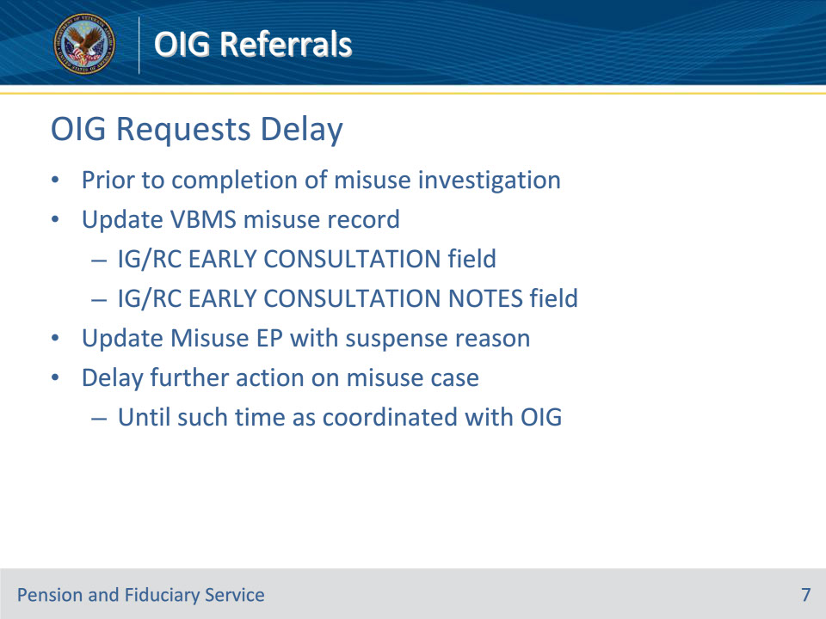
Slide notes

Policy Reference(s): FPM II.3.B.1.c.

Instructor Notes:

The hub will continue the misuse protocol as required following the early consultation unless OIG requests the hub delay further action. If a delay is requested and is made prior to the completion of the misuse investigation, the hub will

• update the misuse record by

• entering the date of the early consultation request in the IG/RC EARLY CONSULTATION field in VBMS, and

• providing the reason for the delayed action in the IG/RC EARLY CONSULTATION NOTES field

• update the misuse end product with the appropriate suspense reason, and

• delay any further action with regard to completing the misuse investigation or decision until such time as coordinated with OIG.

Use of the IG/RC EARLY CONSULTATION field in VBMS is applicable only if the consultation is made prior to completing the misuse investigation and OIG requests a delay in further action. If the misuse investigation has already been completed or a delay is not requested, do not enter a date in the IG/RC EARLY CONSULTATION field.

If an early consultation does not meet the requirements necessary to use the IG/RC EARLY CONSULTATION field in VBMS, it is of special importance that the details of this development are included in the documentation that is uploaded to justify the extenuating circumstances of the early consultation.

Slide 8 - Required Information
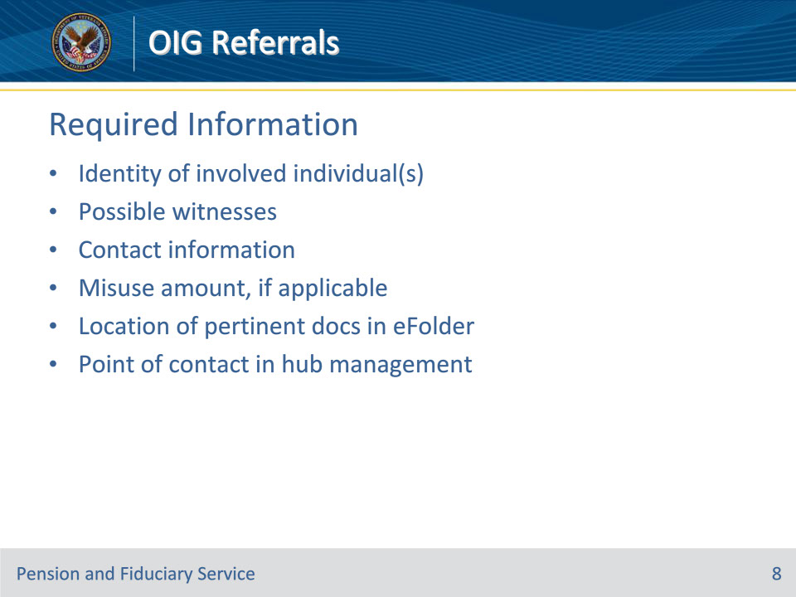
Slide notes

Policy Reference(s): FPM II.3.B.1.d.

Instructor Notes:

Each referral will contain the following information when applicable and/or available:

• identity of individuals involved

• possible witnesses

• contact information for individuals involved

• misuse amount, if applicable,

• location of pertinent documentation in the eFolder, and

• a primary point of contact who is a part of hub management

Slide 9 - Required Information
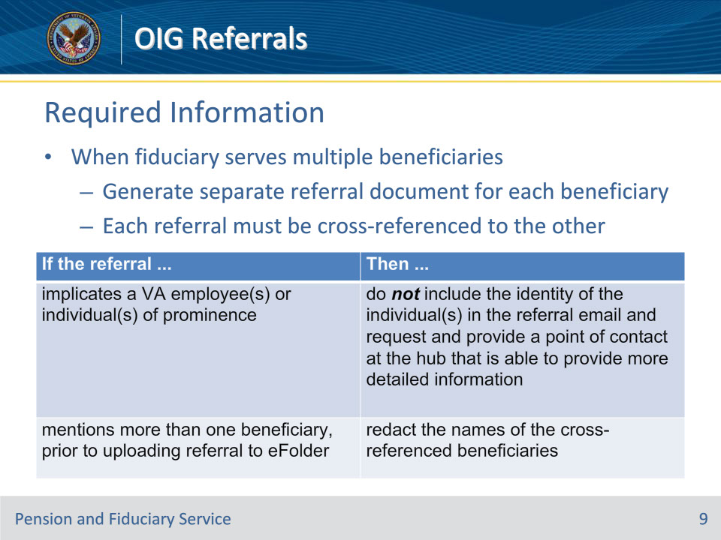
Slide notes

Policy Reference(s): FPM II.3.B.1.d.

Instructor Notes:

When a fiduciary serves multiple beneficiaries, a separate referral document must be generated for each beneficiary. Each referral must be cross-referenced to the other.

Use this table to determine what information should be modified in the referral email when special circumstances exist prior to uploading the email to the eFolder.

If the referral implicates a VA employee or individual of prominence, then do not include the identity of the individual in the referral email and request and provide a point of contact at the hub that is able to provide more detailed information.

If the referral mentions more than one beneficiary, prior to uploading referral to eFolder, then redact the names of the cross-referenced beneficiaries.

Slide 10 - Knowledge Check
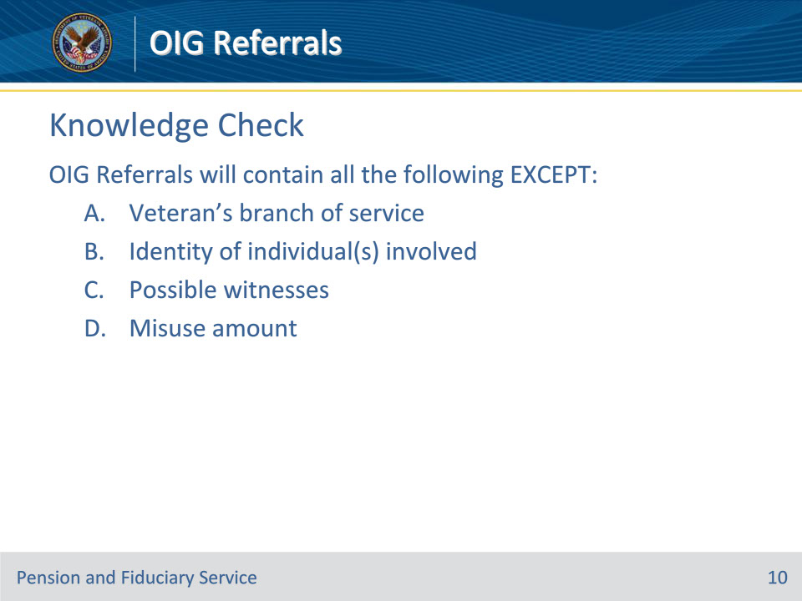
Slide notes

Policy Reference(s): FPM II.3.B.1.d.

Instructor Notes:

OIG Referrals will contain all the following EXCEPT:

A. Veteran’s branch of service

B. Identity of individual(s) involved

C. Possible witnesses

D. Misuse amount

Answer on next slide.

Slide 11 - Answer
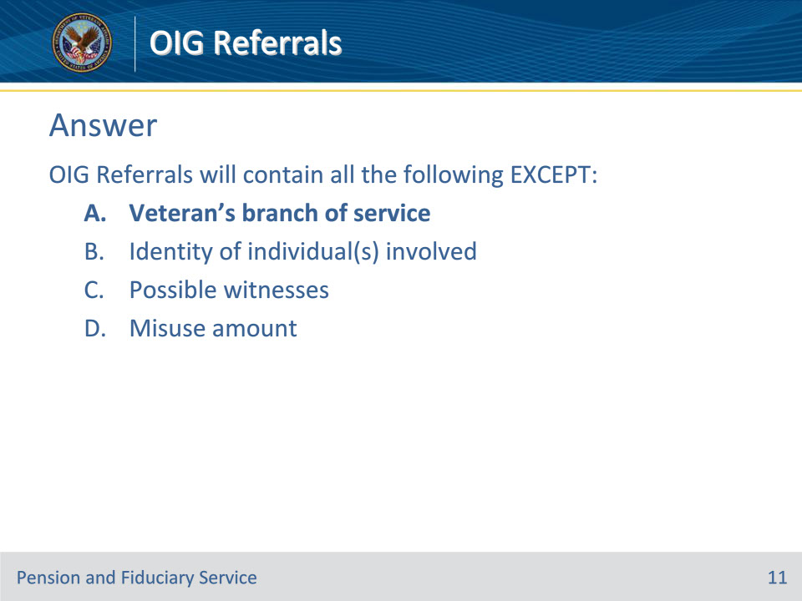
Slide notes

Policy Reference(s): FPM II.3.B.1.d.

Instructor Notes:

OIG Referrals will contain all the following EXCEPT:

A. Veteran’s branch of service (correct answer)

B. Identity of individual(s) involved

C. Possible witnesses

D. Misuse amount

Slide 12 - Sending Referrals
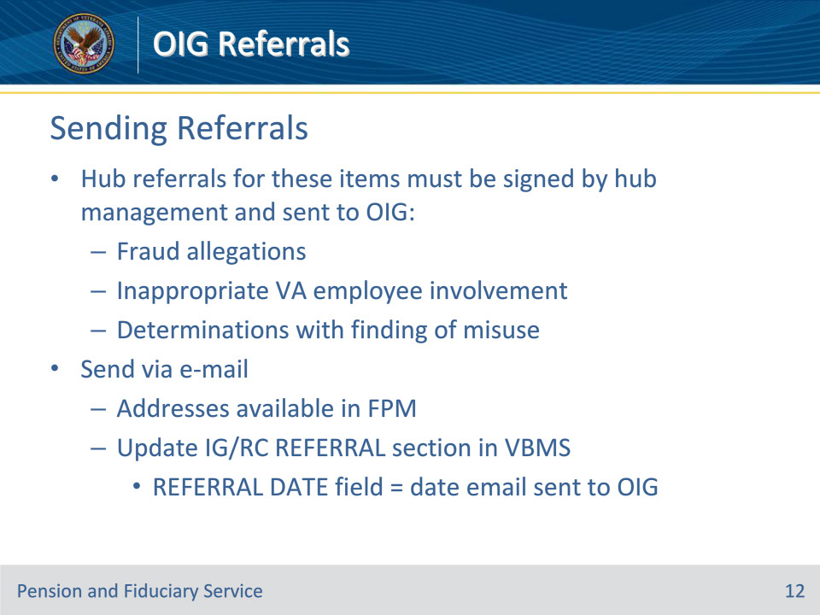
Slide notes

Policy Reference(s): FPM II.3.B.1.e.

Instructor Notes:

Hub referrals for the following items must be signed by hub management and sent to OIG:

• allegations of fraud

• inappropriate involvement of a VA employee, and

• determinations which report a finding of misuse.

All OIG referrals must be sent via e-mail to the Assistant Special Agent in Charge and include a Carbon Copy to the required parties and be uploaded to the eFolder. All relevant email addresses can be found in the fiduciary program manual.

After sending the email to OIG, update the IG/RC REFERRAL section REFERRAL DATE field in VBMS to reflect the date that the referral email was sent to OIG.

Slide 13 - Timeliness
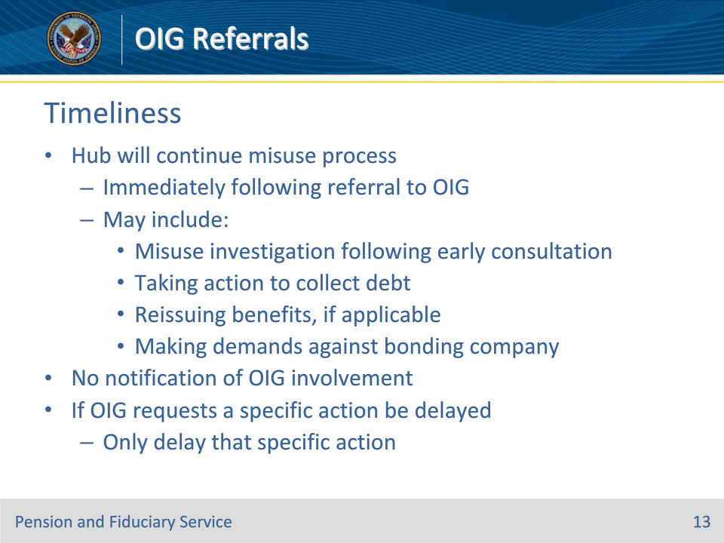
Slide notes

Policy Reference(s): FPM II.3.B.1.f.

Instructor Notes:

The hub will continue the misuse process immediately following the referral to OIG, which may include:

• the misuse investigation following an early consultation

• taking action to collect any debt

• reissuing benefits, if applicable, and

• making demands against the bonding company, if appropriate.

At no time during the process will hub personnel notify the parties involved in the case of potential or actual OIG involvement. Information regarding all referrals will be strictly limited to those having a need to know.

If OIG requests that a specific action should not be taken pending their investigation, then only that action should be delayed. All other actions should proceed. The misuse record will be properly updated and the reason for any delayed action will be provided in the notes.

Slide 14 - OIG Responses
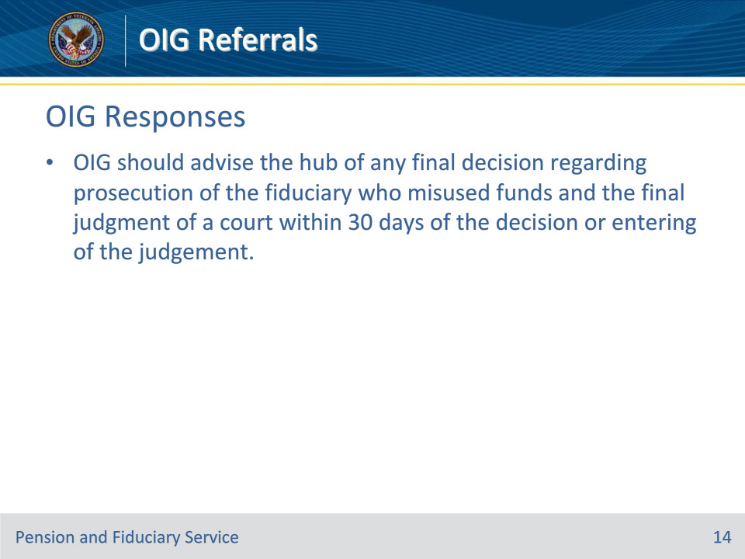
Slide notes

Policy Reference(s): FPM II.3.B.1.g.

Instructor Notes:

OIG should advise the hub of any final decision regarding prosecution of the fiduciary who misused funds and the final judgment of a court within 30 days of the decision or entering of the judgement.

Slide 15 - Documenting Responses
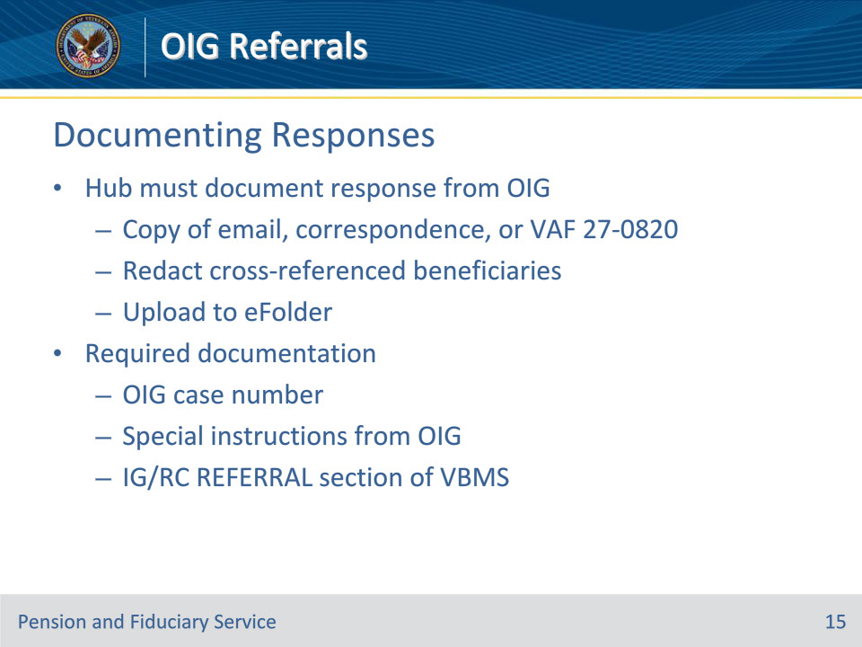
Slide notes

Policy Reference(s): FPM II.3.B.1.g.

Instructor Notes:

The hub must document any information received.

Documentation of a response from OIG must be uploaded to the eFolder. Documentation includes a copy of an email, correspondence from OIG, or VA Form 27-0820. If necessary, redact the information of cross-referenced beneficiaries prior to upload.

The hub must document the OIG case number and any special instructions received from OIG in the IG/RC REFERRAL section of VBMS.

Slide 16 - Negative Responses
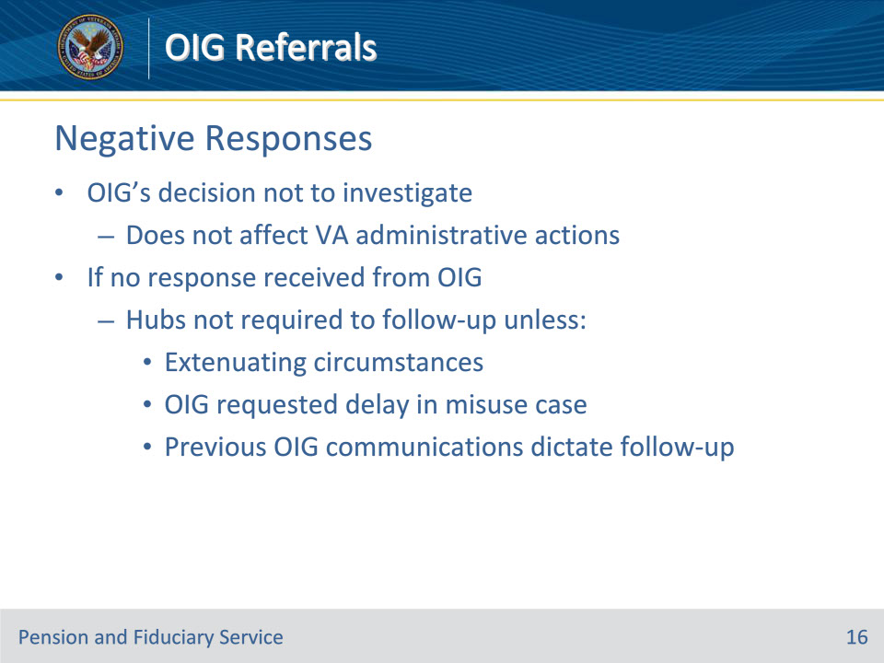
Slide notes

Policy Reference(s): FPM II.3.B.1.h.

Instructor Notes:

OIG’s decision not to investigate a misuse case does not affect VA administrative actions otherwise applicable.

If no response is received from OIG, hubs are not required to follow-up with OIG unless

• extenuating circumstances exist

• delay in processing of the misuse case was requested by OIG, or

• previous communications with OIG dictates follow-up communication.

Slide 17 - Questions?
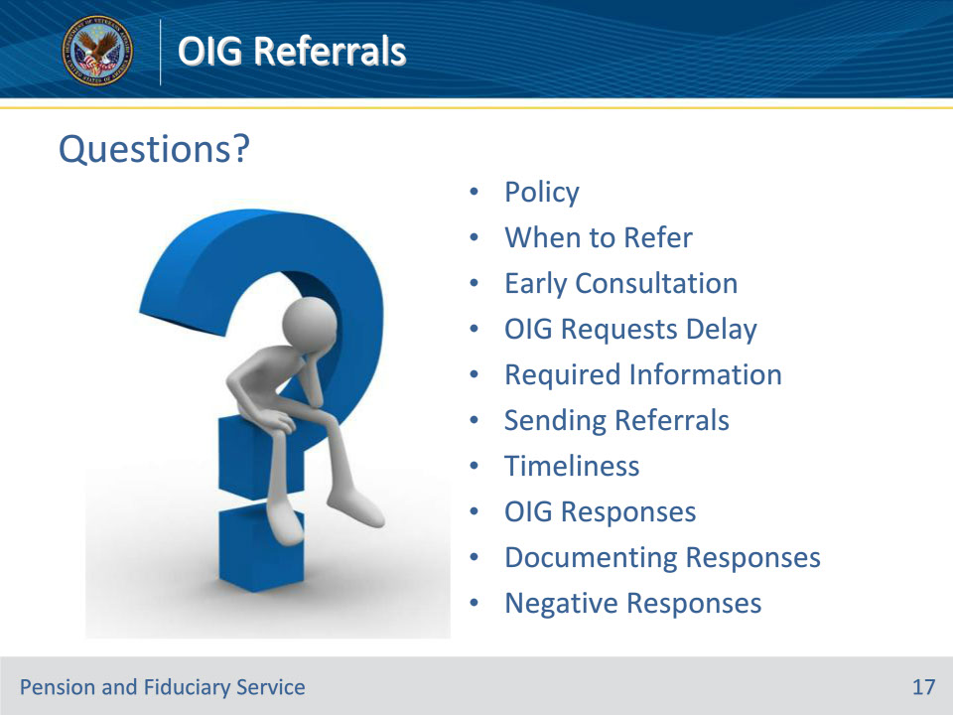
Slide notes

(Recall) These are our learning objectives as stated from the beginning of the training:

• Refer various cases to OIG

• Determine if early consultation is appropriate

• Implement OIG-requested delays

• Continue misuse process

• Process OIG responses

(Recap) We discussed each of these learning objectives through the following topics in each slide today:

• Policy on OIG Referrals

• When to Refer to OIG

• OIG Early Consultation

• OIG Requests Delay

• Required Information

• Sending Referrals

• Timeliness

• OIG Responses

• Documenting Responses

• Negative Responses

Are there any additional questions?

Questions should be filtered through your QRT team. They will submit your questions to the Field Inquiry Tool (FIT) on your behalf.

Slide 18 - TMS Survey/Assessment
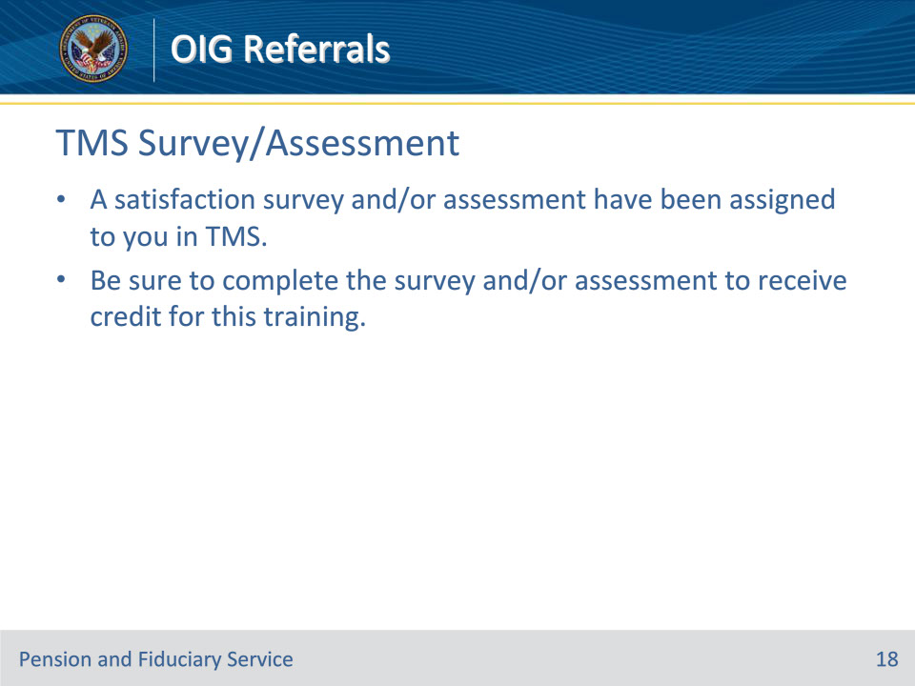
Slide notes

Instructor Notes:

A satisfaction survey and/or assessment have been assigned to you in TMS.

Be sure to complete the survey and/or assessment to receive credit for this training.

