Slide 1 - Misuse Reconsiderations
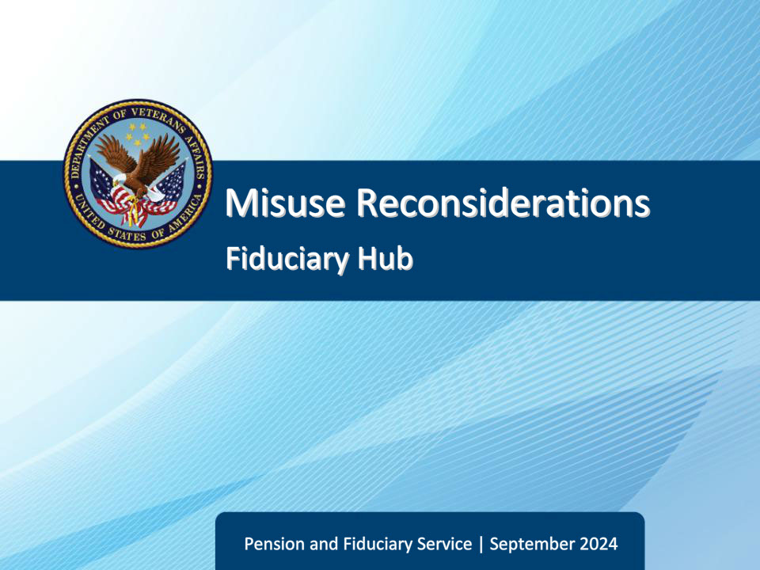
Slide notes

Course Description:

Hello and welcome to Misuse Reconsiderations training. This course teaches learners the procedures for reconsideration requests.

Slide 2 - Objectives
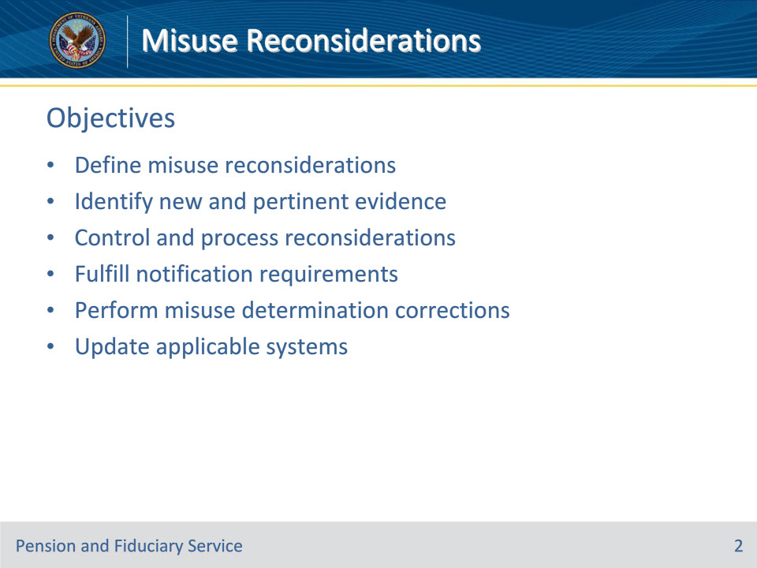
Slide notes

Instructor Notes:

Here are the objectives for this course. At the end of this lesson, given the training and references, the learner will be able to do the following:

• Define misuse reconsiderations

• Identify new and pertinent evidence

• Control and process reconsiderations

• Fulfill notification requirements

• Perform misuse determination corrections

• Update applicable systems

Slide 3 - References
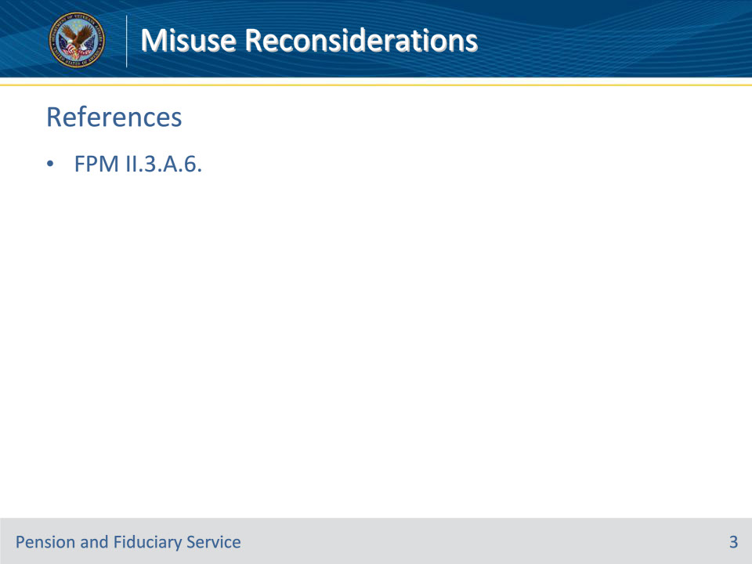
Slide notes

Instructor Notes:

These are the relevant references pertaining to this course:

• FPM II.3.A.6. Misuse Reconsiderations

Slide 4 - Definition
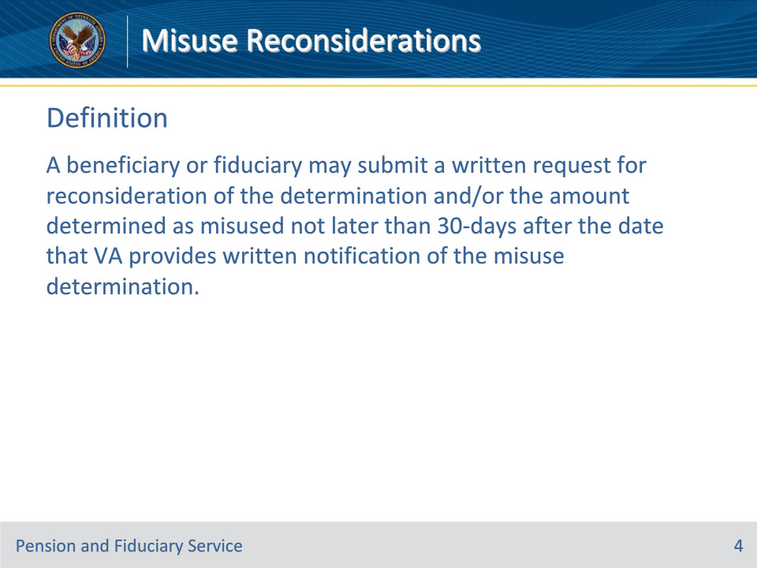
Slide notes

Policy Reference(s): FPM II.3.A.6.a.

Instructor Notes:

A beneficiary or fiduciary may submit a written request for reconsideration of the determination and/or the amount determined as misused not later than 30-days after the date that VA provides written notification of the misuse determination.

Slide 5 - Control
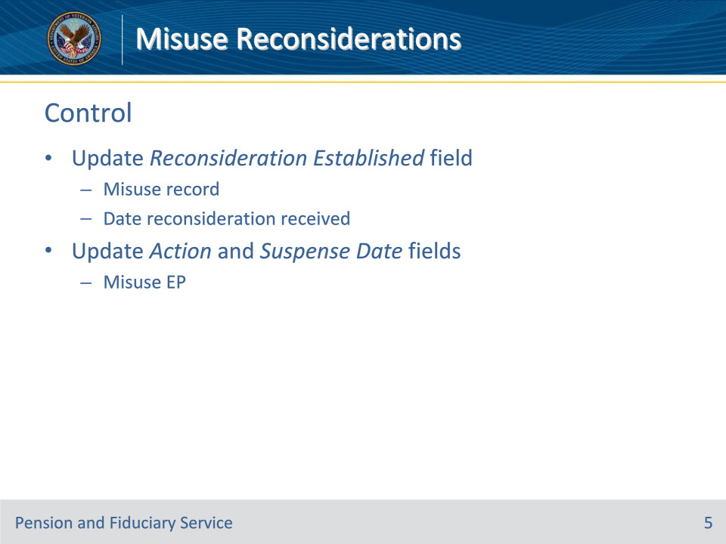
Slide notes

Policy Reference(s): FPM II.3.A.6.b.

Instructor Notes:

If the hub receives pertinent information and a reconsideration request from the beneficiary or fiduciary within 30 days of notification of the misuse determination, update the RECONSIDERATION ESTABLISHED date field on the misuse record to reflect the date of receipt. Update the ACTION and SUSPENSE DATE fields in the misuse EP to reflect the appropriate action required.

Upon the expiration of the 30-day time limit to submit a timely misuse reconsideration request, complete the misuse determination reconsideration.

Slide 6 - Personal Hearings
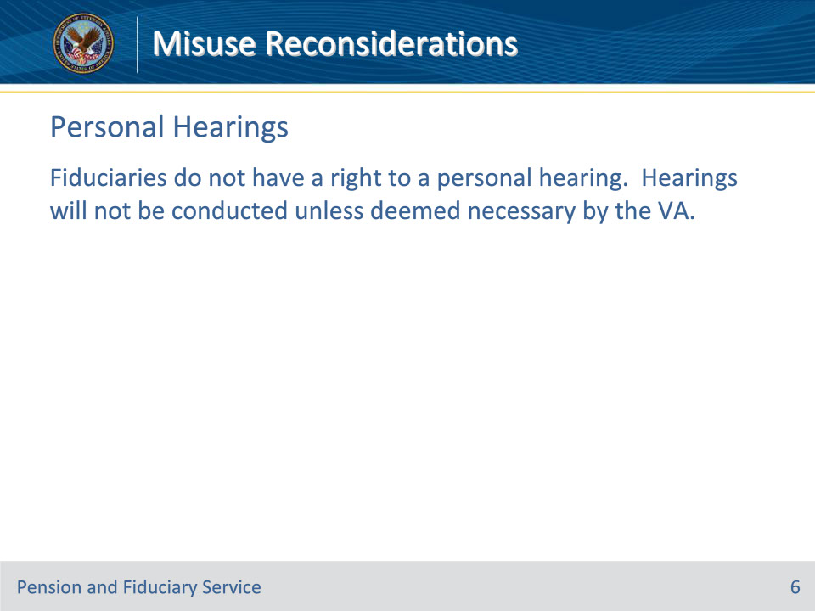
Slide notes

Policy Reference(s): FPM II.3.A.6.c.

Instructor Notes:

Fiduciaries do not have a right to a personal hearing. Hearings will not be conducted unless deemed necessary by the VA.

Slide 7 - New & Pertinent Evidence
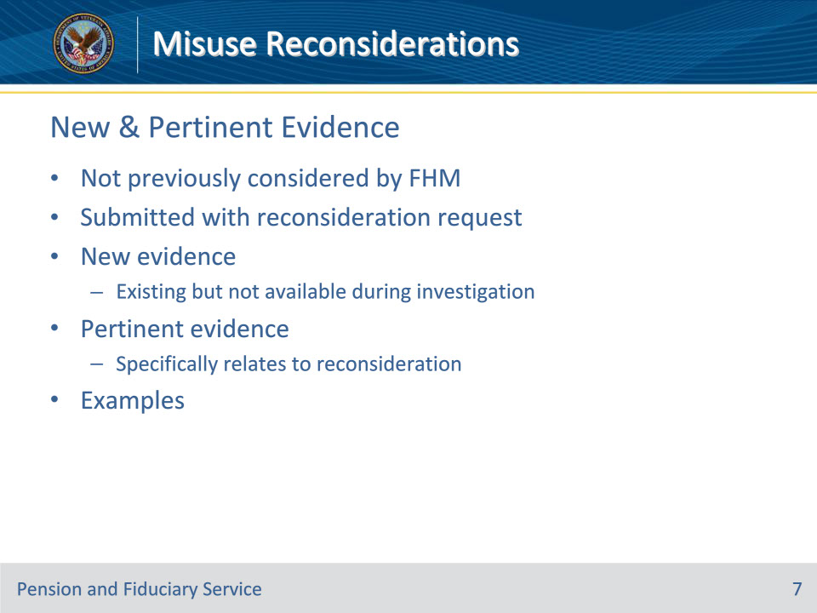
Slide notes

Policy Reference(s): FPM II.3.A.6.d.

Instructor Notes:

The fiduciary or the beneficiary may submit new evidence or information pertinent for reconsideration of the misuse determination if it

• was not previously considered by the FHM, and

• is submitted with the written reconsideration request.

New evidence means existing evidence not previously submitted or available to hub personnel at the time of the misuse investigation and determination. Pertinent evidence means evidence that specifically relates to reconsideration of the misuse determination.

Examples of new and pertinent evidence include:

• a statement from the beneficiary indicating how the funds were used and their approval of the use of funds

• annual accounting(s) or fund usage report(s) not previously submitted, or

• evidence of funds transferred to the successor fiduciary.

Slide 8 - Validation
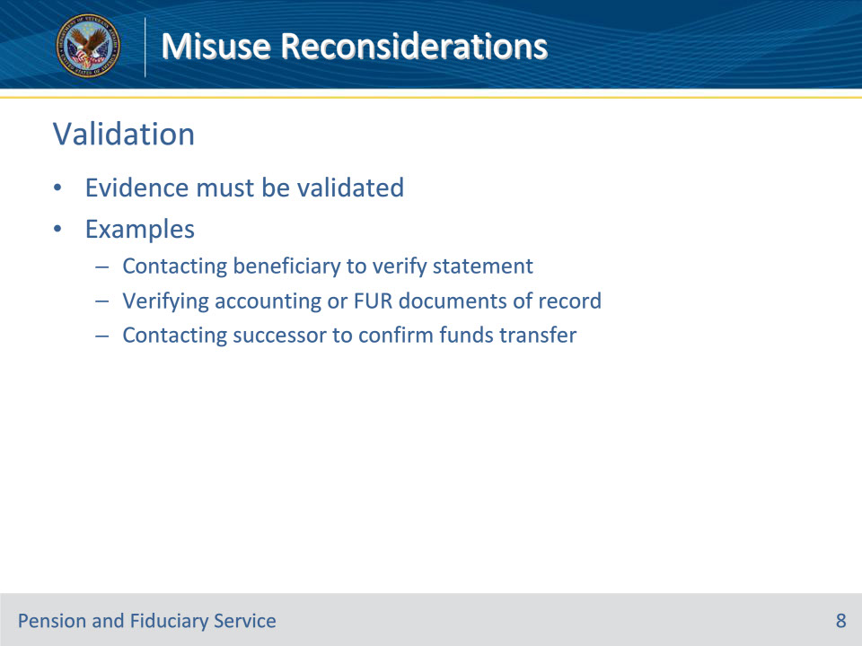
Slide notes

Policy Reference(s): FPM II.3.A.6.e.

Instructor Notes:

New and pertinent evidence must be validated before a change to a misuse determination is warranted. Examples include:

• contacting the beneficiary to verify his/her statement regarding the funds and how they were used

• verifying that all documentation required for a complete and correct accounting or fund usage report is of record, or

• contacting the successor fiduciary to verify he/she received the funds transferred, if applicable.

Slide 9 - Decision
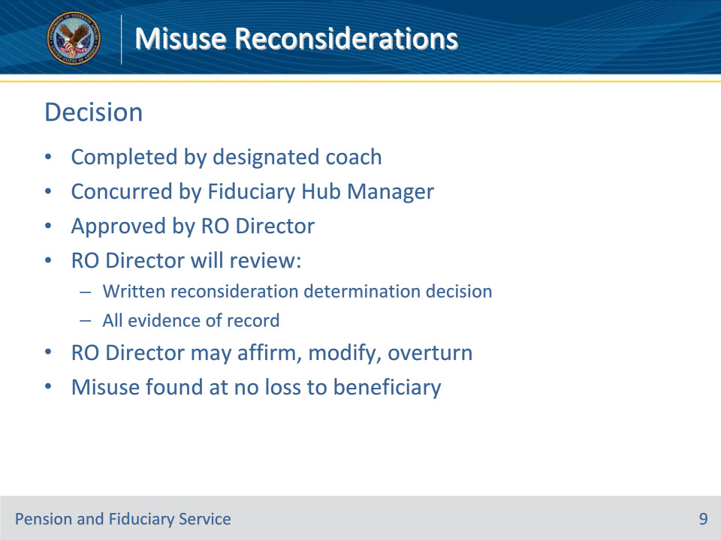
Slide notes

Policy Reference(s): FPM II.3.A.6.f.; g.

Instructor Notes:

The reconsideration must be completed by the designated coach within the misuse record in VBMS and must contain concurrence by the FHM and approval of the RO Director.

The RO Director will review the written reconsideration determination decision and all evidence of record to include any new evidence received from the fiduciary with the reconsideration request. The RO Director may affirm, modify or overturn the FHM’s decision.

Example: During the reconsideration period, the fiduciary provides the hub with information showing the funds previously found to be misused were either accounted for or repaid to the beneficiary. The RO Director may choose to modify the hub’s decision as misuse found at no loss to the beneficiary.

Slide 10 - Required Elements
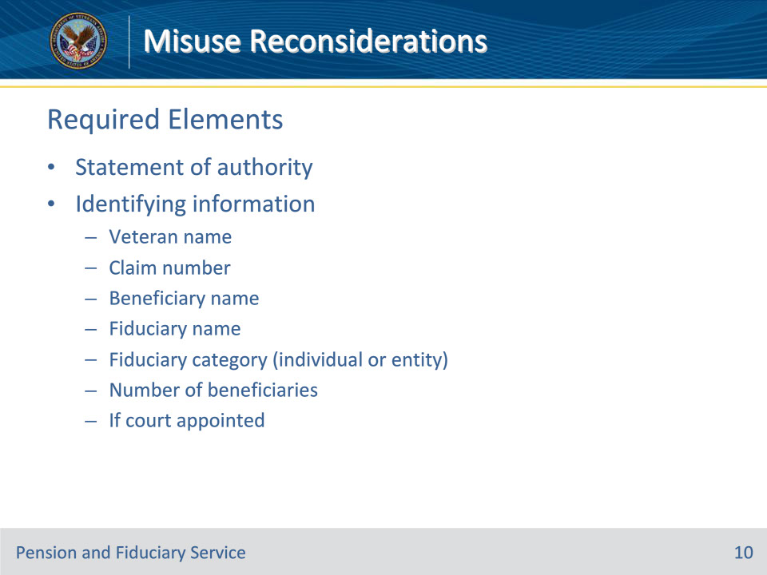
Slide notes

Policy Reference(s): FPM II.3.A.6.g.

Instructor Notes:

The misuse reconsideration determination must include all the elements listed below:

• statement of authority per 38 U.S.C. 6106

• identifying information, including

• Veteran name

• claim number

• beneficiary name

• fiduciary name

• fiduciary category (individual or entity)

• greatest number of beneficiaries served by the fiduciary during the suspected period of misuse, and

• if the fiduciary is also court appointed

Slide 11 - Required Elements (Cont.)
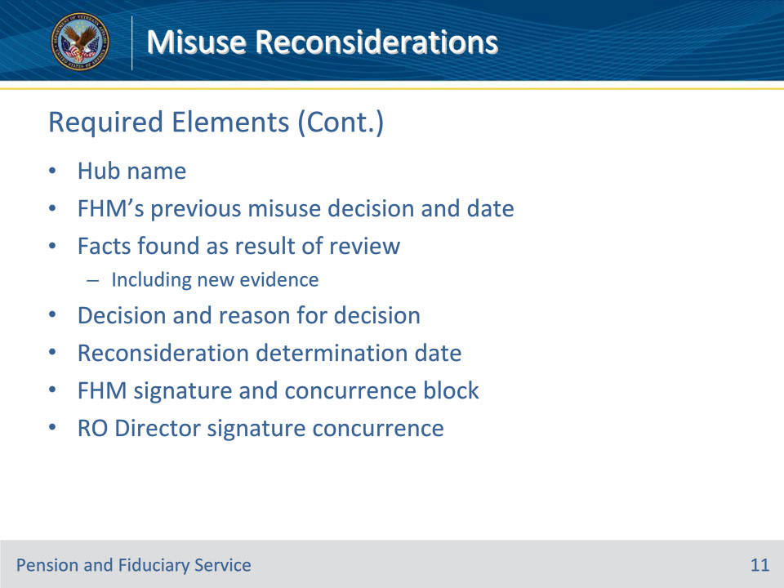
Slide notes

Policy Reference(s): FPM II.3.A.6.g.

Instructor Notes:

• Hub name

• FHM’s previous decision regarding misuse, including the date of the previous decision

• facts found as a result of the review, to include all new evidence

• decision and reason for the decision

• reconsideration determination date

• FHM’s signature and concurrence block, and

• RO Director’s signature of concurrence.

Slide 12 - Late Evidence
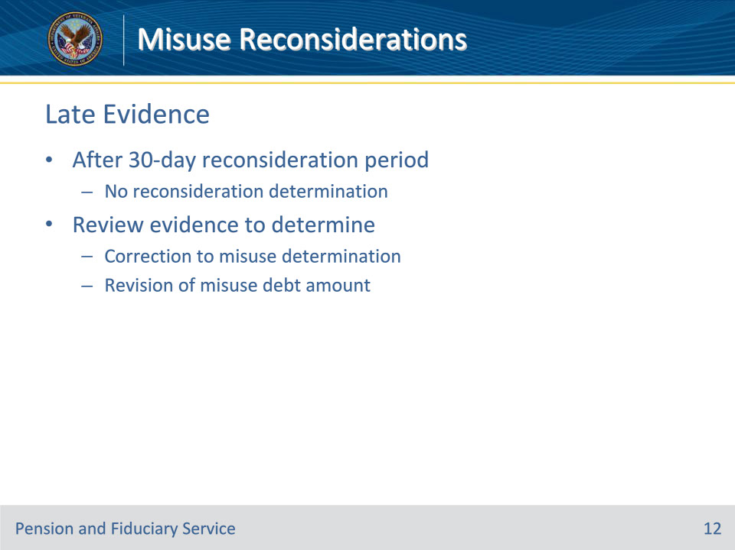
Slide notes

Policy Reference(s): FPM II.3.A.6.h.

Instructor Notes:

Reconsideration requests received by the hub after the 30-day reconsideration period will not receive a reconsideration determination. However, the hub must review the evidence received after the expiration of the reconsideration period to determine if the evidence supports a:

• correction to the misuse determination, or

• revision to the amount of misuse debt.

Slide 13 - Late Evidence (Cont.)
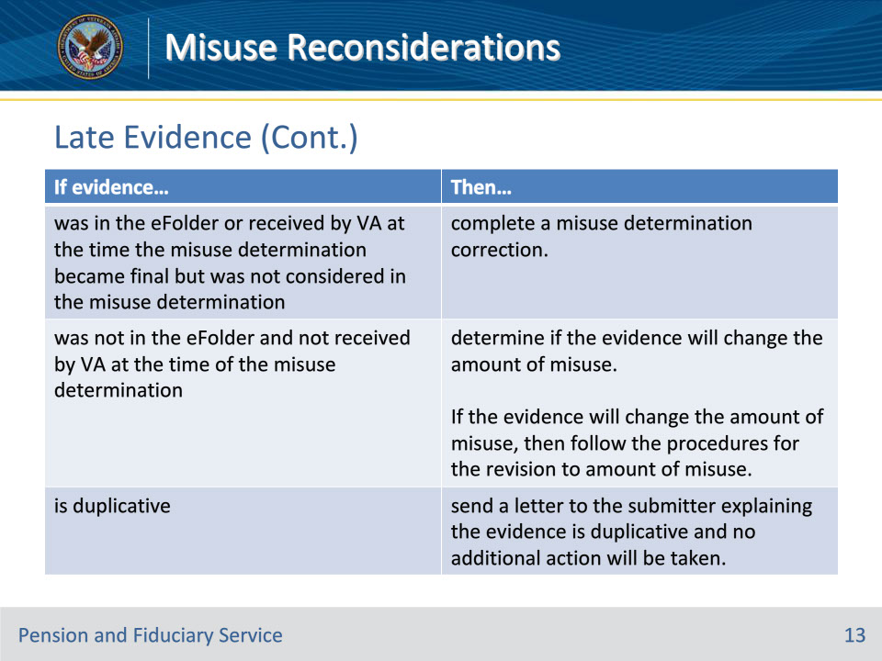
Slide notes

Policy Reference(s): FPM II.3.A.6.h.

Instructor Notes:

Use the table on this slide to determine the actions to take when reviewing evidence after the misuse determination becomes final.

If evidence was in the eFolder or received by VA at the time the misuse determination became final but was not considered in the misuse determination, then complete a misuse determination correction.

If evidence was not in the eFolder and not received by VA at the time of the misuse determination, then determine if the evidence will change the amount of misuse.

If the evidence will change the amount of misuse, then follow procedures for revision to amount of misuse. The misuse determination is final and cannot be changed.

If evidence is duplicative, then send a letter to the submitter of the evidence explaining the evidence is duplicative and no additional action will be taken.

Slide 14 - Fiduciary Notification
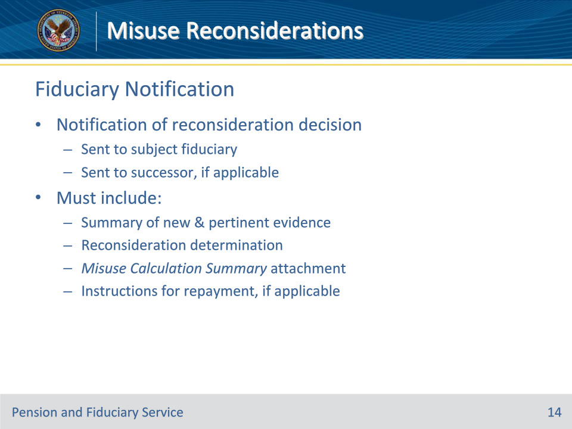
Slide notes

Policy Reference(s): FPM II.3.A.6.i.

Instructor Notes:

Notification of the reconsideration decision must be sent to the fiduciary that was subject to the misuse investigation and the successor fiduciary, if appointed.

This notification must include:

• a summary of the new and pertinent evidence considered

• the reconsideration determination to include the Misuse Calculation Summary attachment, and

• instructions for repayment, if applicable.

Slide 15 - Fiduciary Notification (Cont.)
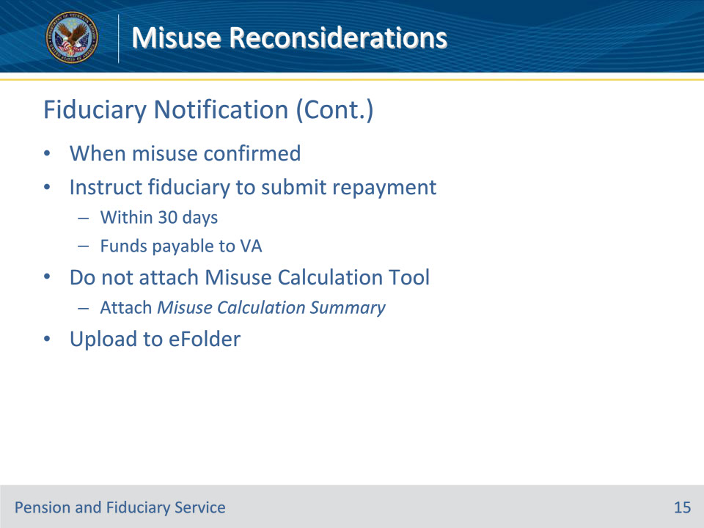
Slide notes

Policy Reference(s): FPM II.3.A.6.i.

Instructor Notes:

When misuse is confirmed, notification will instruct the previous fiduciary to submit repayment to the hub within 30 days, with funds payable to VA.

Hub personnel must not attach a copy of the Misuse Calculation tool as an enclosure to the misuse determination notification. The Misuse Calculation Summary is the proper enclosure to accompany the notification.

The hub will upload all documentation related to the reconsideration to the eFolder.

Slide 16 - Beneficiary Notification
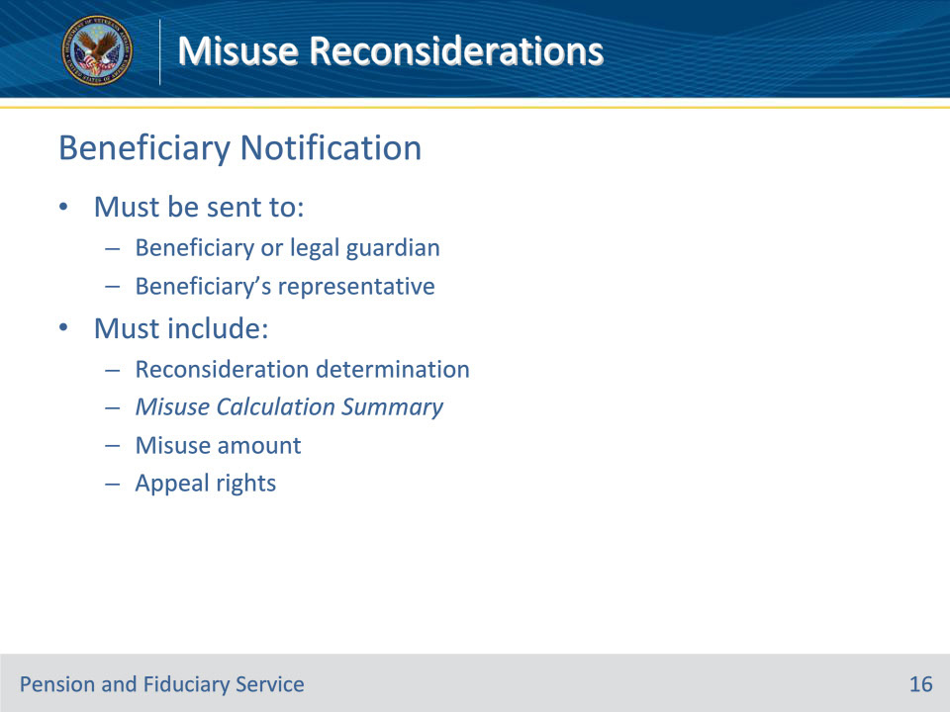
Slide notes

Policy Reference(s): FPM II.3.A.6.j.

Instructor Notes:

Any beneficiary whose fiduciary misused funds, and a reconsideration is completed, must receive notification. The notification must be sent to the beneficiary or the beneficiary’s legal guardian, and the beneficiary’s accredited representative, attorney or claims agent. The notice must include:

• a copy of the reconsideration determination to include the Misuse Calculation Summary attachment

• amount of misuse found, if applicable, and

• details of the appeal rights.

Do not include a copy of the misuse calculation tool.

Slide 17 - Court Notification
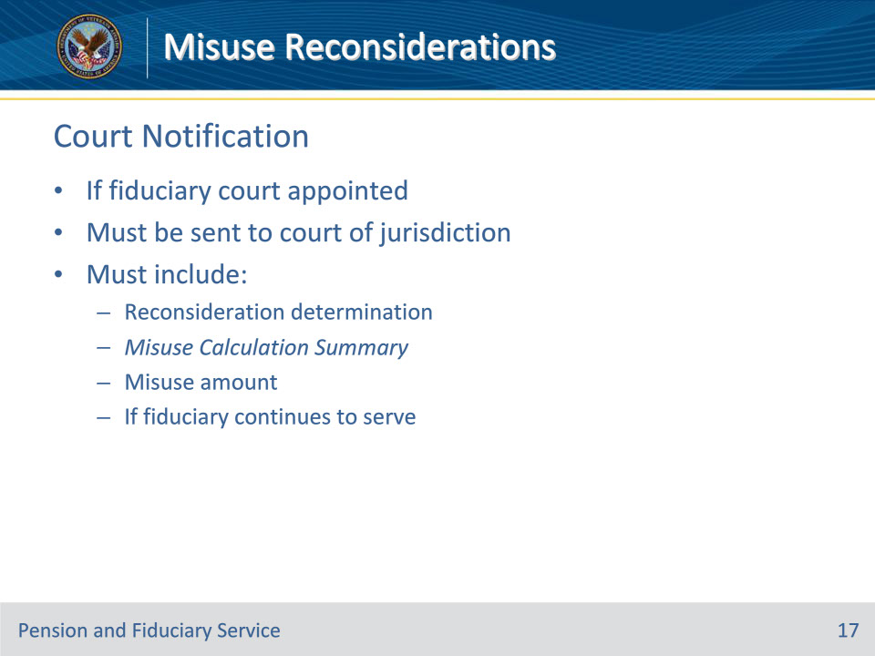
Slide notes

Policy Reference(s): FPM II.3.A.6.k.

Instructor Notes:

If the fiduciary who is the subject of the misuse investigation also serves as a court appointed fiduciary, notification must be sent to the court of jurisdiction for reconsideration regarding misuse. The notification must include:

• a copy of the reconsideration determination to include the Misuse Calculation Summary attachment

• amount of misuse found, if applicable, and

• information about whether the fiduciary continues to serve

Do not include a copy of the misuse calculation tool.

Slide 18 - Funds Recovered
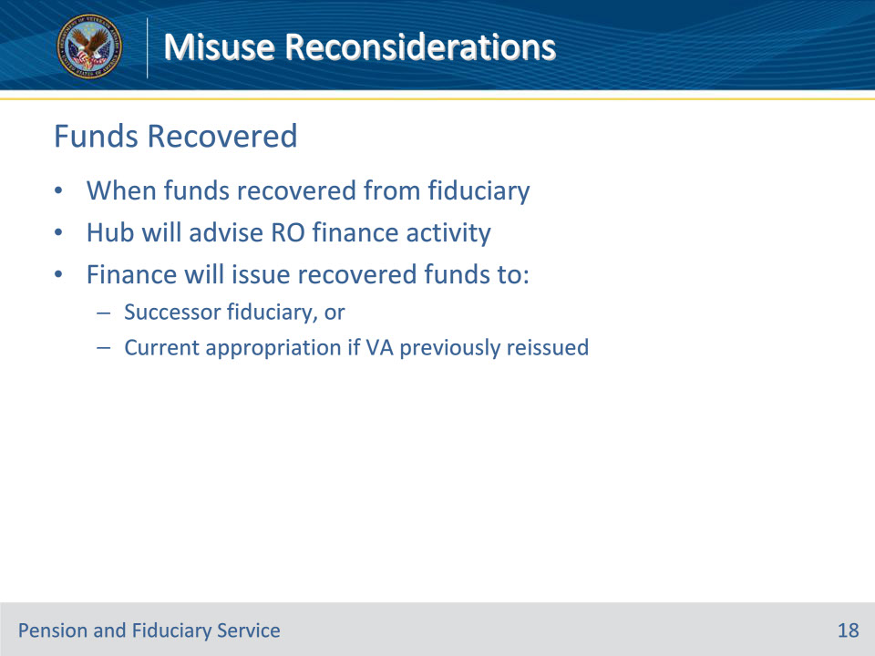
Slide notes

Policy Reference(s): FPM II.3.A.6.l.

Instructor Notes:

When funds are recovered from a former fiduciary as a result of a misuse determination, hub personnel will advise the RO finance activity.

The finance activity will issue the disposition of the recovered funds by:

• remitting recouped funds to the successor fiduciary, or

• returning recouped funds to the current appropriation if VA previously reissued benefits.

Slide 19 - Determination Correction
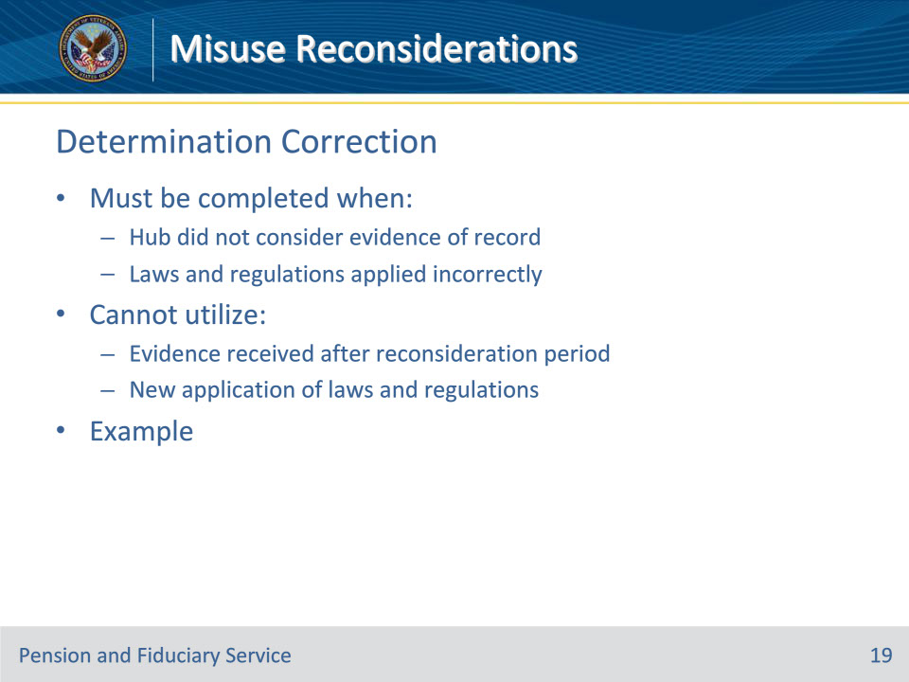
Slide notes

Policy Reference(s): FPM II.3.A.6.m.

Instructor Notes:

A corrected misuse determination must be completed when it is determined that the:

• hub did not consider evidence that was in the eFolder or received by VA at the time the misuse determination became final, or

• laws and regulations were applied incorrectly during the misuse determination.

A corrected misuse determination cannot utilize evidence received after the expiration of the misuse reconsideration period or new application of laws and regulations regarding the misuse finding.

Example: The hub determined misuse based on overprotection of VA FUM. Pursuant to 38 CFR 13.230(g)(1), the fiduciary may deduct the expenses of the bond from the beneficiary’s monthly payments. Further 38 CFR 13.400(a), defines misuse as when a fiduciary fails to utilize benefit payments for the use and benefit of the beneficiary. The fiduciary’s use of the beneficiary’s funds followed the regulations in that the payment was allowed out of beneficiary funds and the use was for the benefit of the beneficiary. Over protection of VA FUM does not meet the definition of misuse so the hub must complete a corrected misuse determination.

Slide 20 - Determination Correction (Cont.)
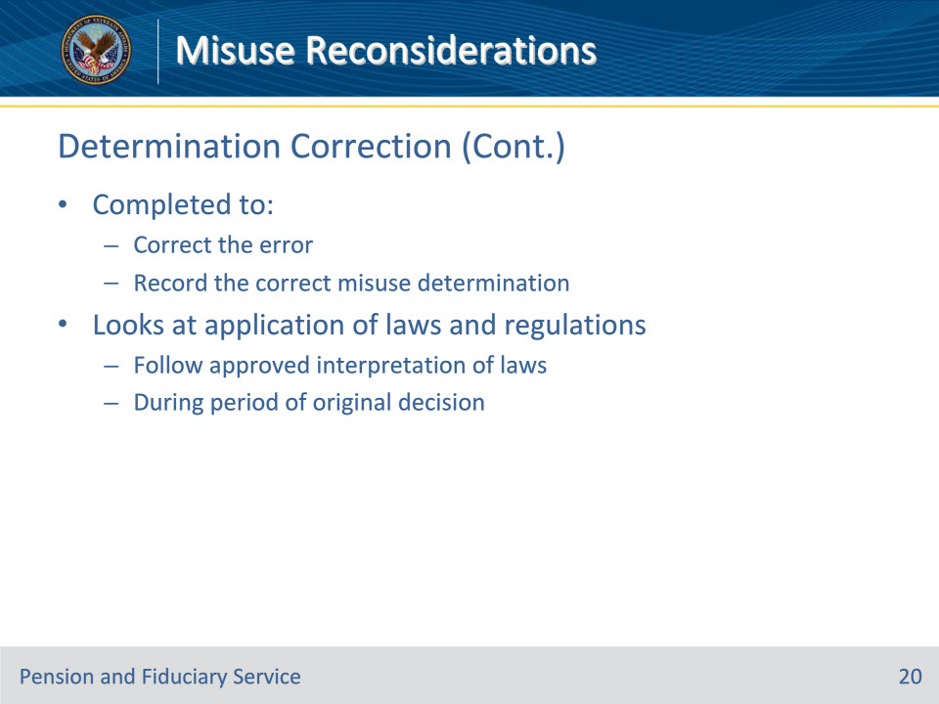
Slide notes

Policy Reference(s): FPM II.3.A.6.n.

Instructor Notes:

When hub staff review a misuse determination in which the laws and regulations were applied incorrectly or evidence was not properly reviewed, a corrected misuse determination must be completed within the misuse record in VBMS to:

• correct the error, and

• record the correct misuse determination.

The corrected misuse determination will specifically look at the application of laws and regulations following the approved interpretation of said laws during the period of the original decision.

Slide 21 - Determination Correction (Cont.)
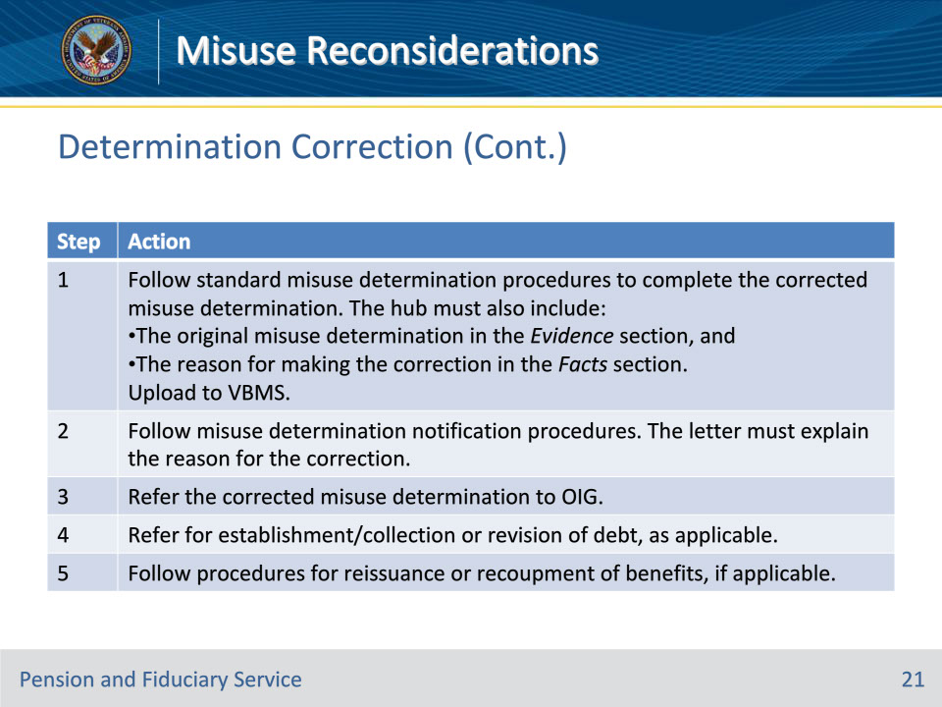
Slide notes

Policy Reference(s): FPM II.3.A.6.n.

Instructor Notes:

Follow the steps in the table on this slide when a corrected misuse determination is made.

Step 1:

Follow the procedures to complete the corrected misuse determination. In addition to the required elements, the hub must include

the original misuse determination in the EVIDENCE section, and

the reason for making the corrected misuse determination in the FACTS section.

Ensure the corrected misuse determination is uploaded to the eFolder in VBMS.

Step 2:

Follow the procedures to provide notification to the fiduciary, beneficiary, and court of jurisdiction. Explain in the notification letter the reason for making the corrected misuse determination.

Step 3:

Follow the procedures to refer the corrected misuse determination to the OIG.

Step 4:

Follow the procedures for referrals for establishment and collection of debt, if applicable. If the corrected misuse determination requires a revision to a previously established misuse debt, the hub must submit a Request for Revision of the Misuse Debt Amount memorandum to the co-located RO finance activity.

Do not prepare a Justification for Revision of the Misuse Debt Amount memorandum as P&F Service concurrence is not required for a corrected misuse determination.

Step 5:

Follow procedures for reissuance or recoupment of benefits, if applicable.

Slide 22 - Controlling Corrections
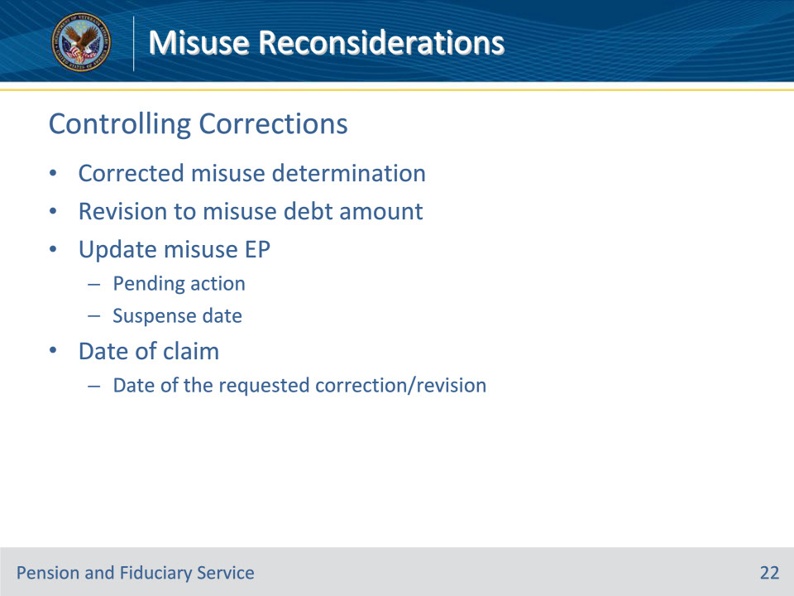
Slide notes

Policy Reference(s): FPM II.3.A.6.o.

Instructor Notes:

When it is determined that a corrected misuse determination or revision to the amount of misuse debt is required, the misuse EP will be updated to reflect the appropriate pending action and suspense date.

The date of claim value for control of the corrected misuse determination or revision to amount of misuse debt is the date of the requested correction or misuse revision.

Slide 23 - Correction to No Misuse
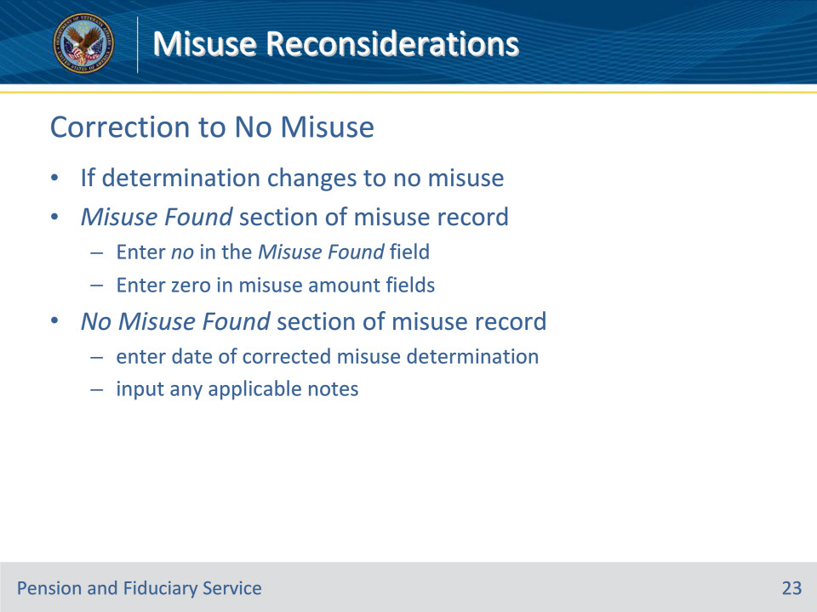
Slide notes

Policy Reference(s): FPM II.3.A.6.o.

Instructor Notes:

If the determination changes to no misuse:

• MISUSE FOUND section of the misuse record enter

• No in the MISUSE FOUND field, and

• 0 (zero) in the applicable field(s) relating to the amount of misuse, and

• NO MISUSE FOUND section of the misuse record

• enter the date of the corrected misuse determination, and

• input any applicable notes.

Slide 24 - Correction to Misuse
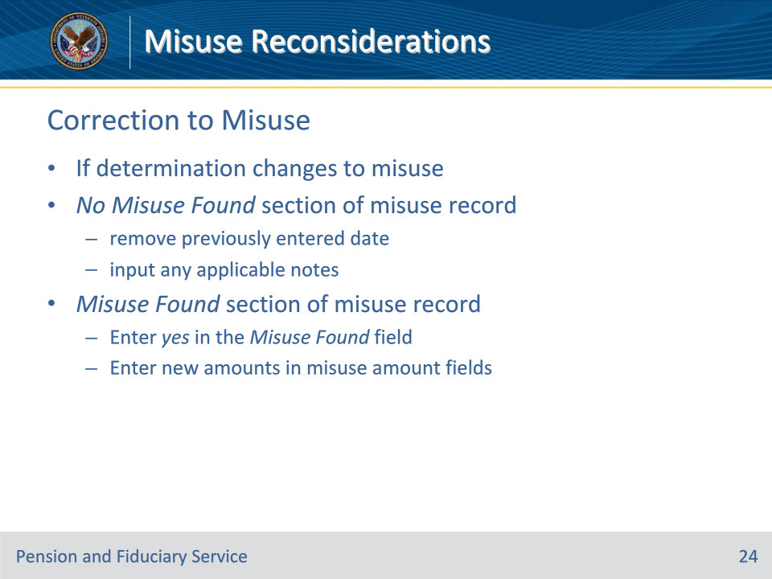
Slide notes

Policy Reference(s): FPM II.3.A.6.o.

Instructor Notes:

If the determination changes to misuse:

• NO MISUSE FOUND section of the misuse record,

• remove the previously entered date, and

• input any applicable notes, and

• MISUSE FOUND section of the misuse record enter

• Yes in the MISUSE FOUND field, and

• the appropriate amounts in the fields relating to the amount of misuse.

Slide 25 - Correction to Amount
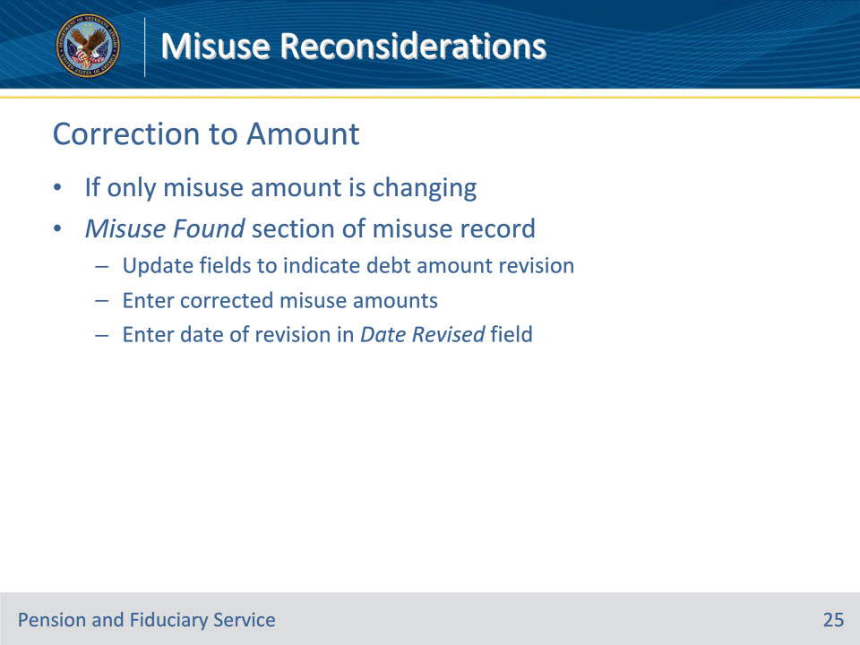
Slide notes

Policy Reference(s): FPM II.3.A.6.o.

Instructor Notes:

If only the misuse amount is changing:

MISUSE FOUND section of the misuse record,

• update the applicable field(s) to indicate the debt amount has been revised, and

• enter the

• corrected misuse amount(s) in the applicable field(s) relating to the amount of misuse, and

• date of revision in the DATE REVISED field, even if the misuse amount is 0 (zero).

Slide 26 - Questions?
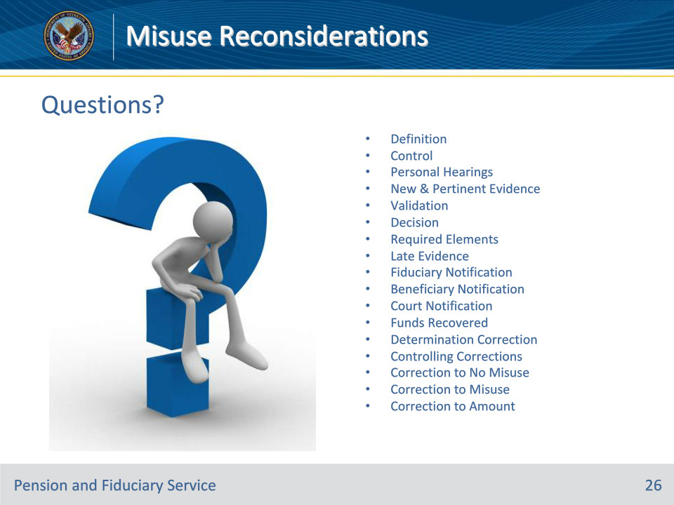
Slide notes

Instructor Notes:

These are our learning objectives as stated from the beginning of the training:

• Define misuse reconsiderations

• Identify new and pertinent evidence

• Control and process reconsiderations

• Fulfill notification requirements

• Perform misuse determination corrections

• Update applicable systems

We discussed each of these learning objectives through the following topics in each slide today:

• Definition

• Control

• Personal Hearings

• New & Pertinent Evidence

• Validation

• Decision

• Required Elements

• Late Evidence

• Fiduciary Notification

• Beneficiary Notification

• Court Notification

• Funds Recovered

• Determination Correction

• Controlling Corrections

• Correction to No Misuse

• Correction to Misuse

• Correction to Amount

Are there any additional questions?

Questions should be filtered through your QRT team. They will submit your questions to the Field Inquiry Tool (FIT) on your behalf.

Slide 27 - TMS Survey/Assessment
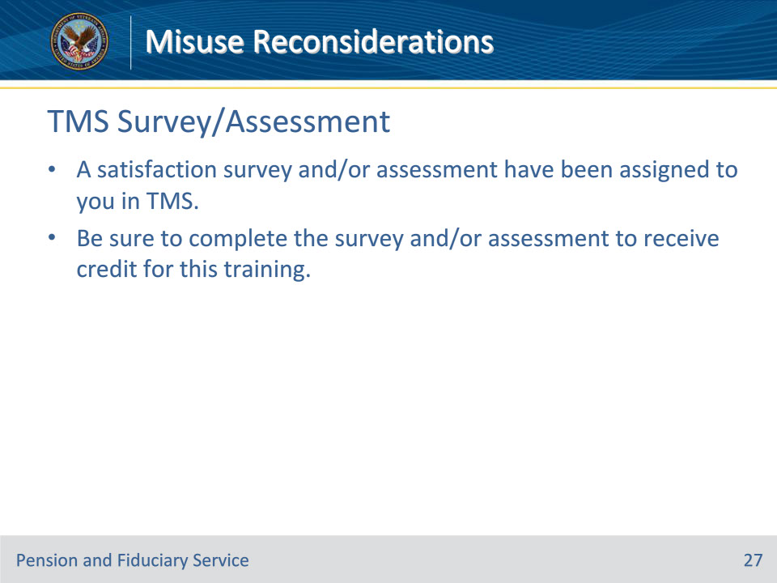
Slide notes

Instructor Notes:

A satisfaction survey and/or assessment have been assigned to you in TMS.

Be sure to complete the survey and/or assessment to receive credit for this training.

