Slide 1 - Misuse Investigations
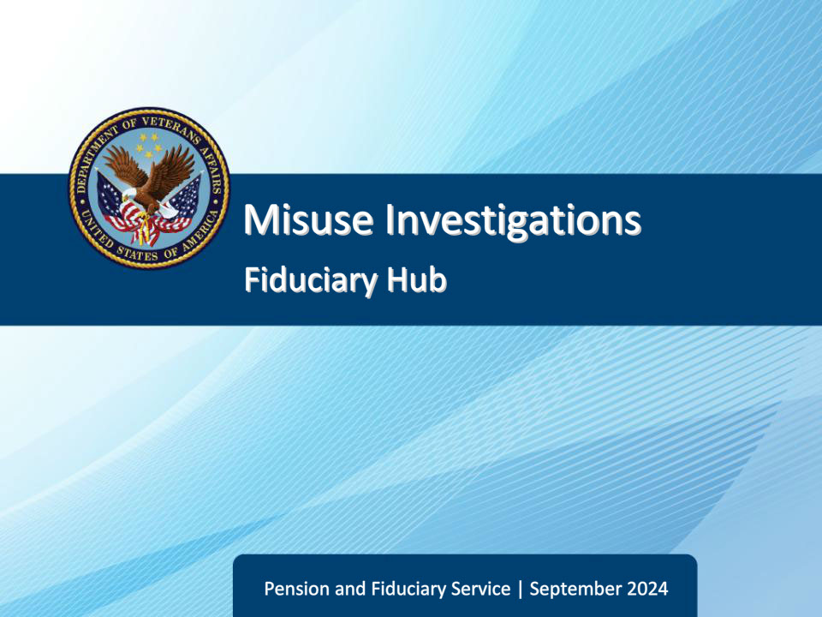
Slide notes

Course Description:

This course teaches learners the criteria for a misuse investigation.

Slide 2 - Objectives
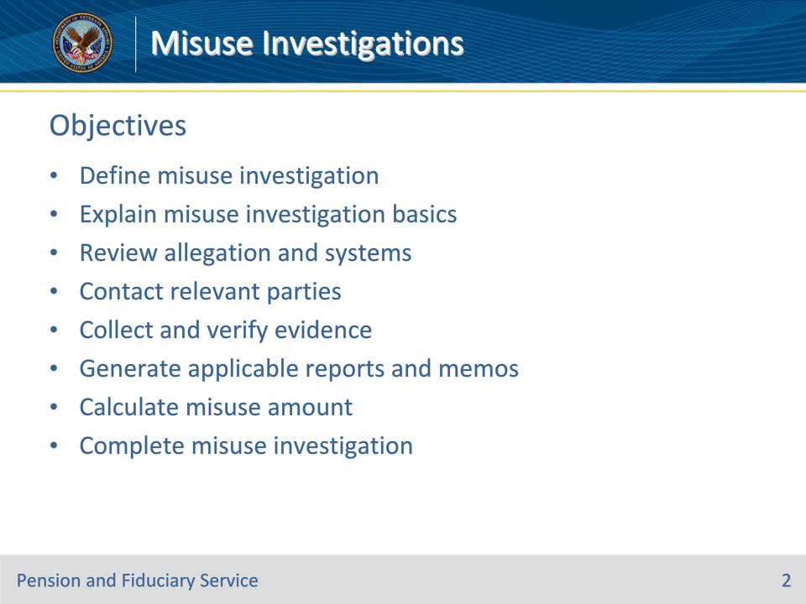
Slide notes

Instructor Notes:

At the end of this lesson, given the training and references, the learner will be able to do the following:

• Define misuse investigation

• Explain misuse investigation basics

• Review allegation and systems

• Contact relevant parties

• Collect and verify evidence

• Generate applicable reports and memos

• Calculate misuse amount

• Complete misuse investigation

Slide 3 - References
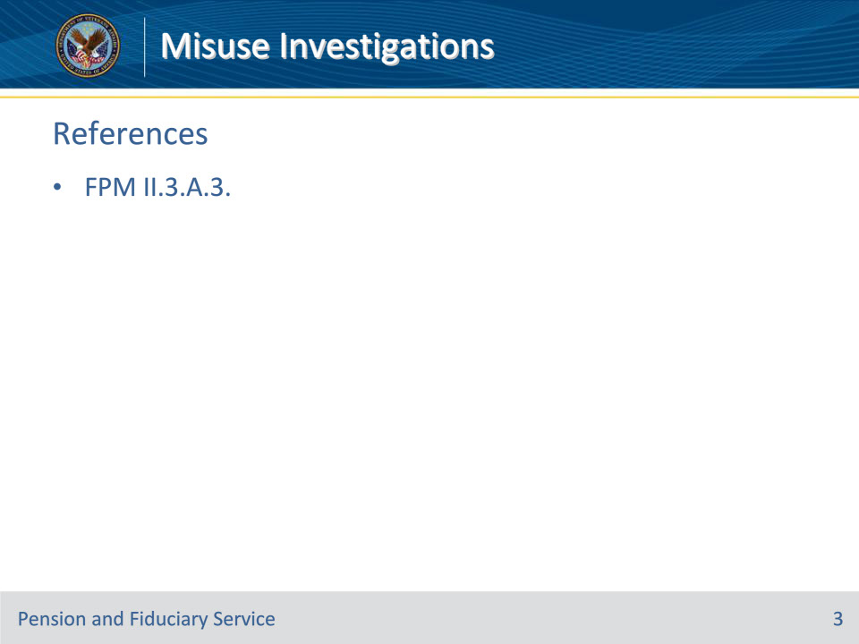
Slide notes

Instructor Notes:

These are the relevant references pertaining to this course:

• FPM II.3.A.3 Misuse Investigations

Slide 4 - Definition
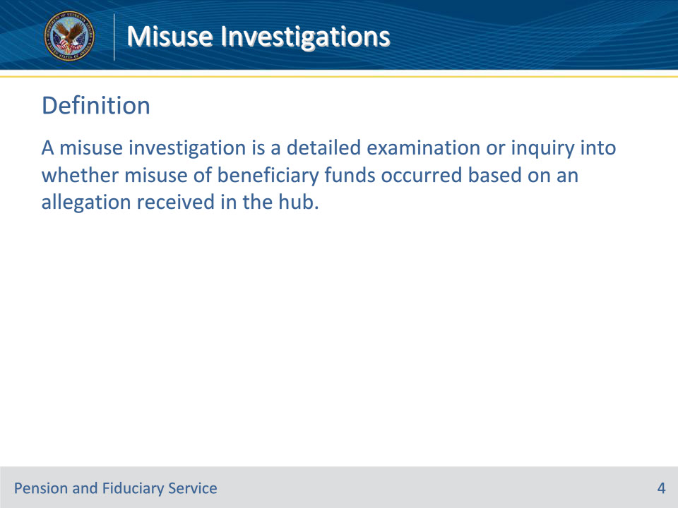
Slide notes

Policy Reference(s): FPM II.3.A.3.a.

Instructor Notes:

A misuse investigation is a detailed examination or inquiry into whether misuse of beneficiary funds occurred based on an allegation received in the hub.

Slide 5 - Basics
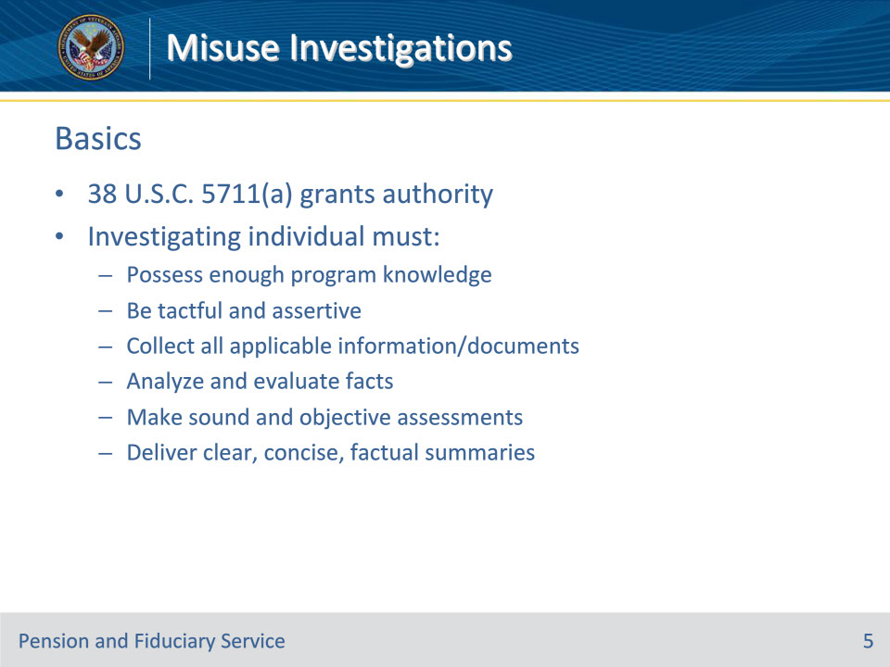
Slide notes

Policy Reference(s): FPM II.3.A.3.a.

Instructor Notes:

Pursuant to 38 U.S.C. 5711(a), staff working under the delegated authority of the Secretary may

• require the production of books, papers, documents, and other evidence

• take affidavits and administer oaths and affirmations, and

• make investigations and examine witnesses upon any matter within the jurisdiction of the VA.

In every instance, the investigation must be made by an individual with enough program knowledge to enable a thorough investigation to include the ability to

• be tactful and assertive in discussing the allegation to relevant parties and obtain information

• collect all applicable financial information and/or documentation

• analyze and evaluate facts

• make sound and objective assessments, and

• deliver clear, concise, and factual summaries of the investigation.

Slide 6 - Purpose and Intent
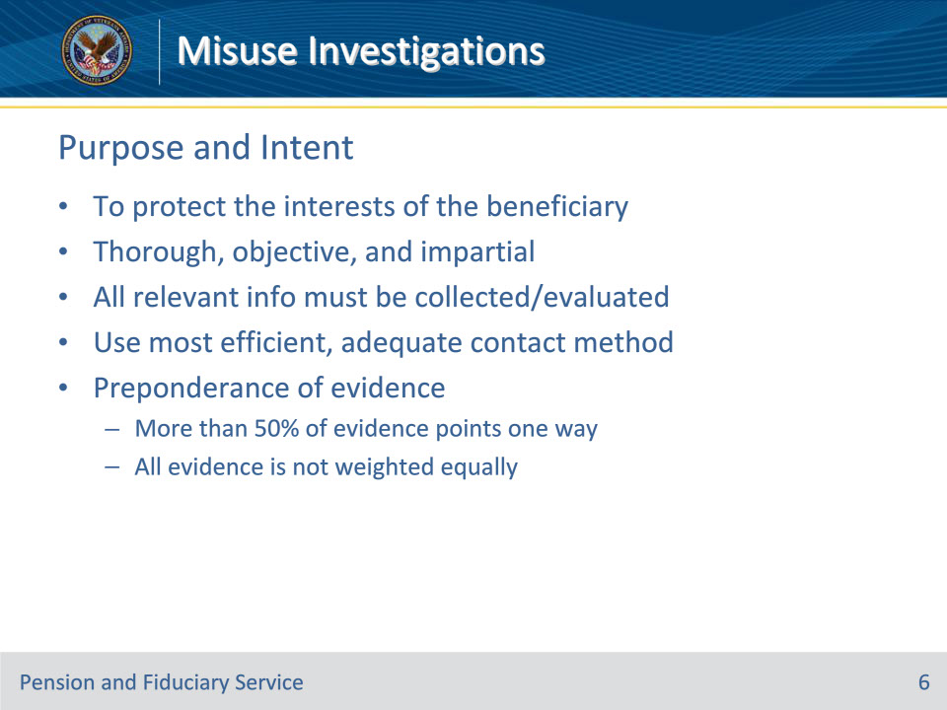
Slide notes

Policy Reference(s): FPM II.3.A.3.b.

Instructor Notes:

The purpose of a misuse investigation is to protect the interests of the beneficiary in receipt of VA benefits. The investigation must be thorough, objective, and impartial in order to ensure a conclusive determination of misuse.

The investigation should ensure all relevant information is collected and evaluated while avoiding unnecessary delay and/or expense. The most efficient contact method should be used in all cases. Face-to-face visits should only be used if simpler methods, such as telephone or video teleconference contact are not adequate.

Evidence collection and development must continue until there is a preponderance of evidence to support a conclusion. Preponderance of evidence refers to the principle that more than 50 percent of the evidence points in a single direction.

When evaluating for preponderance, not all pieces of evidence should be weighted equally.

Examples:

• A list of expenditures prepared by the fiduciary would carry less weight than a detailed list of transactions received from a financial institution.

• Evidence the beneficiary was hospitalized while VA benefits were used to pay for a vacation would have more weight than the fiduciary’s statement that the trip was used for the benefit of the beneficiary.

Slide 7 - Timeliness
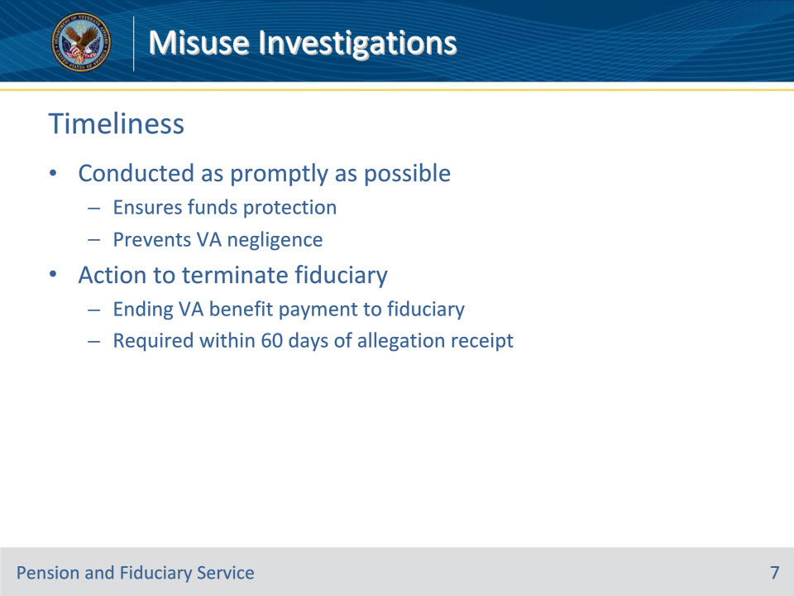
Slide notes

Policy Reference(s): FPM II.3.A.3.c.

Instructor Notes:

The misuse investigation must be conducted as promptly as possible to ensure protections of beneficiary funds and to prevent VA negligence. 38 U.S.C. 6107(a) requires VA to take action to terminate the fiduciary within 60 days of the misuse allegation. Failure to take action within 60 days of an allegation of misuse constitutes VA negligence.

Termination of the fiduciary means to end the payment of VA benefits to the fiduciary when VA receives a credible allegation of misuse from any party. A credible allegation is reasonable grounds for the allegation to be believable, convincing and/or plausible. Ending payment of benefits to the fiduciary for whom a credible allegation of misuse has been received must occur within 60 days of receipt of the allegation of misuse.

Slide 8 - Action to Terminate
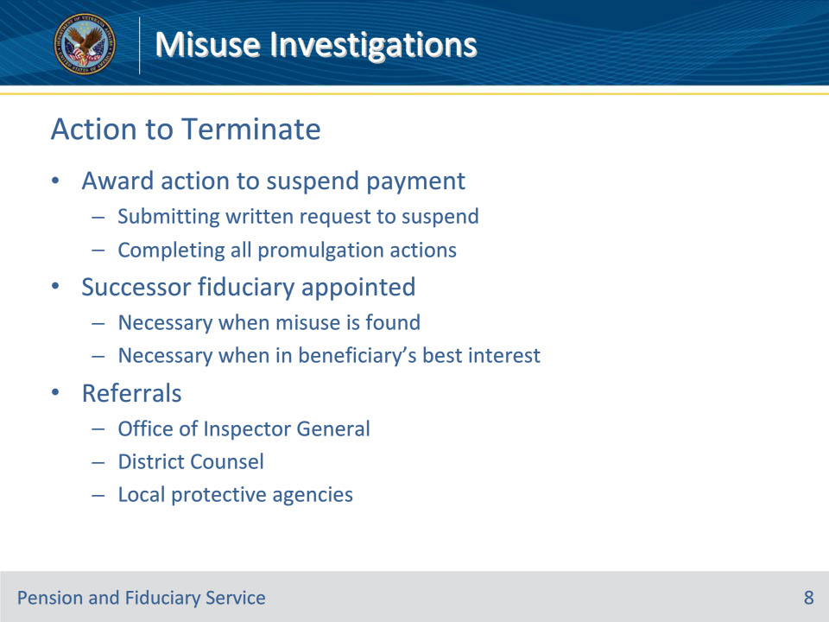
Slide notes

Policy Reference(s): FPM II.3.A.3.c.

Instructor Notes:

For the purposes of VA negligence, termination of the fiduciary occurs when the hub completes either of the following:

• an award action to suspend VA benefit payments, including

• submitting the written request to suspend benefits, and

• completing all required promulgation actions to suspend VA benefits, or

• action to remove the fiduciary with appointment of a successor fiduciary.

Replacement of the fiduciary is necessary when misuse is found or when evidence discovered during the investigation indicates it would be in the beneficiary’s best interest to replace the fiduciary.

Termination of the fiduciary does not preclude the hub from taking other actions, to include referrals to the

• OIG

• District Counsel, and

• local protective agencies, such as Adult Protective Services or police.

Slide 9 - Due Diligence
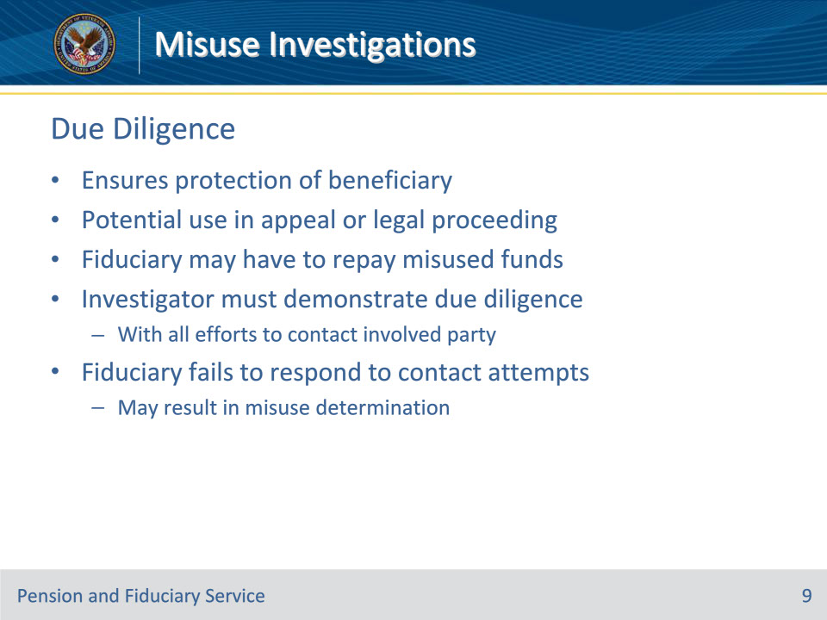
Slide notes

Policy Reference(s): FPM II.3.A.3.d.

Instructor Notes:

Hub personnel must exercise due diligence in a misuse investigation to ensure protection of the beneficiary, understanding the investigation may be used in an appeal or legal proceeding. In addition, a fiduciary may be obligated to repay the VA benefits found to have been misused.

The individual completing the investigation must adequately demonstrate due diligence is performed with all efforts to contact the party involved documented in the final investigative report.

Misuse may be determined based on a fiduciary’s failure to respond to the required attempts at contact made by hub personnel to execute due diligence.

Slide 10 - Reviewing the Allegation
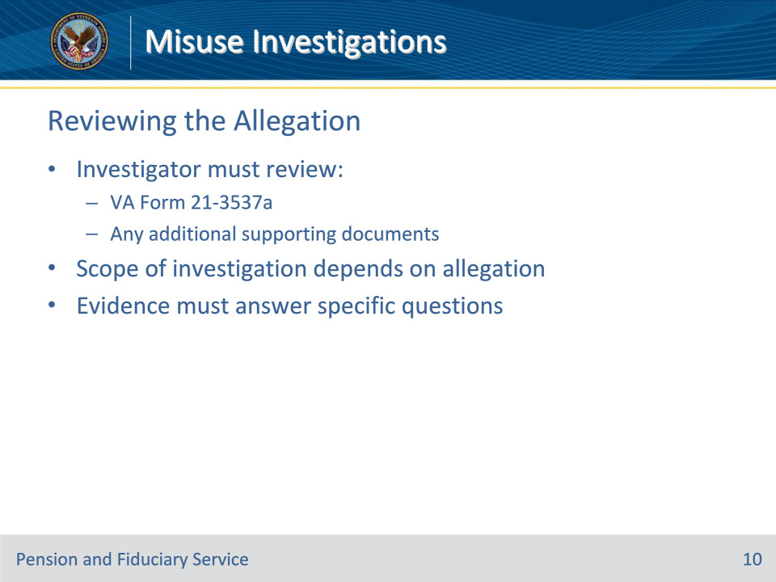
Slide notes

Policy Reference(s): FPM II.3.A.3.e.

Instructor Notes:

The hub personnel responsible for conducting the misuse investigations must review the VA Form 21-3537a, and any additional documents supporting the need to investigate the allegation. The scope of the investigation will depend on the nature of the allegation. The evidence collected during the investigation must be able to answer specific questions regarding potential misuse.

Slide 11 - Reviewing Systems
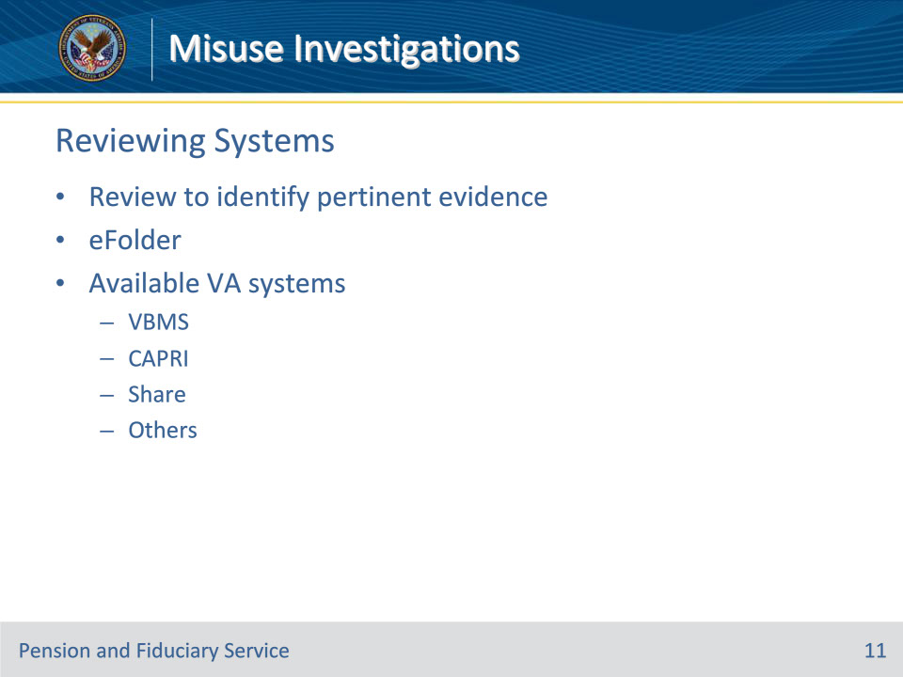
Slide notes

Policy Reference(s): FPM II.3.A.3.f.

Instructor Notes:

The eFolder and available VA systems must be reviewed to identify the evidence of record that is pertinent to the misuse allegation.

Hub personnel conducting the investigation must review the documentation contained in the eFolder and systems such as, but not limited to VBMS, CAPRI, and Share.

Slide 12 - Minimum Documentation
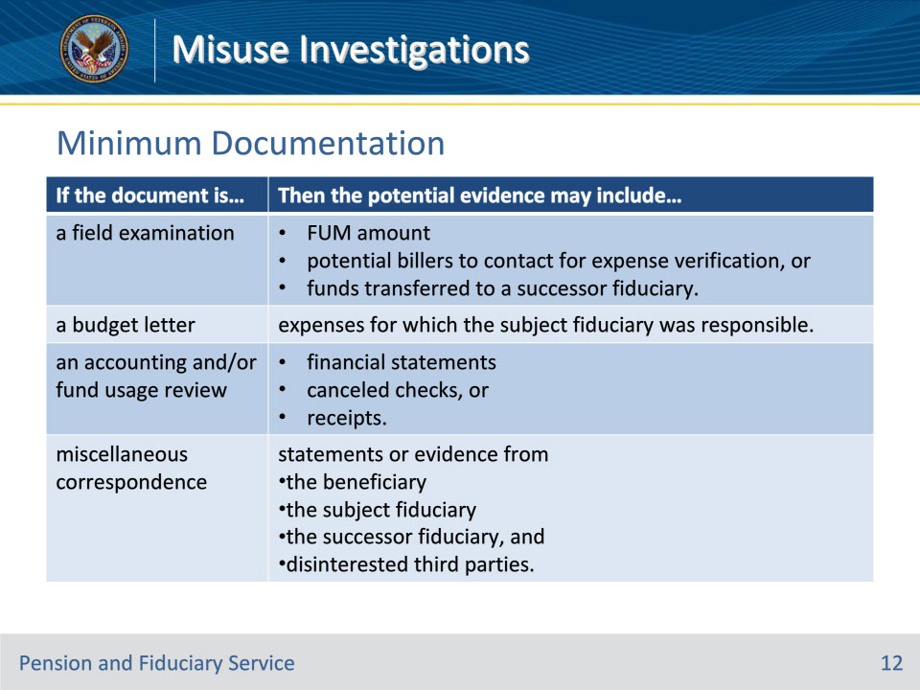
Slide notes

Policy Reference(s): FPM II.3.A.3.f.

Instructor Notes:

Use the table on this slide to determine the minimum documentation to review in the eFolder and the potential evidence that may be used in the investigation.

The hub should review previously approved accountings and/or fund usage reviews if

• the allegation contains credible information that the fiduciary may have:

• intentionally misled VA in the submission or completion of required accountings or fund usage reports or documents, or

• a pattern of misuse has been identified in previous reports

The documents and potential evidence in this table are not all inclusive. Additional documentation or personal questioning may be needed.

Slide 13 - Contacting the Beneficiary
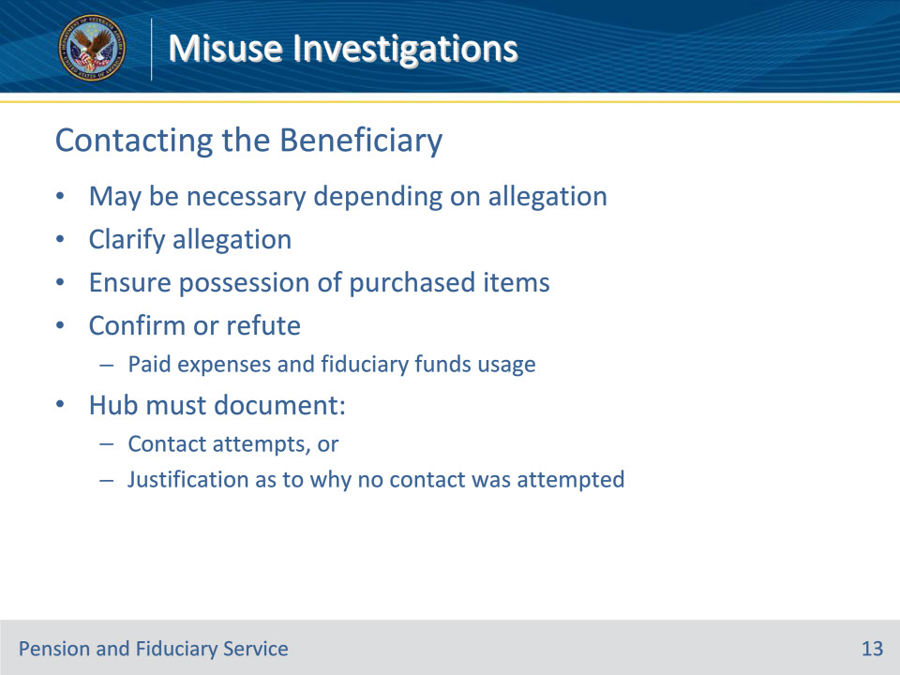
Slide notes

Policy Reference(s): FPM II.3.A.3.g.

Instructor Notes:

Depending on the nature of the allegation, the beneficiary may need to be interviewed. Contact with the beneficiary may be necessary to

• clarify the allegation

• ensure possession of items shown to be purchased for the beneficiary, and

• confirm or refute

• the beneficiary’s expenses were paid, and

• a fiduciary’s claims regarding use of the VA funds.

If contact is necessary, hub personnel must document attempts or justification as to why this was not performed, as applicable.

Slide 14 - Contacting the Fiduciary
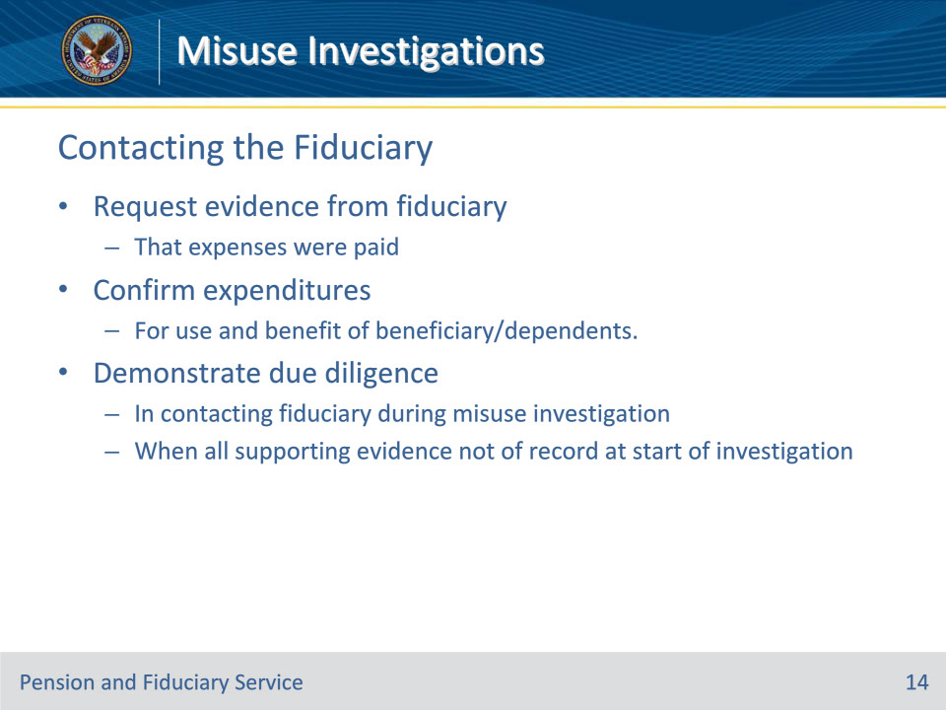
Slide notes

Policy Reference(s): FPM II.3.A.3.h.

Instructor Notes:

The hub must request evidence from the subject fiduciary that expenses were paid and confirm that expenditures were for the use and benefit of the beneficiary and/or their dependents.

The hub must demonstrate due diligence in contacting the subject fiduciary during the misuse investigation in cases where all supporting evidence for a determination of misuse is not of record at the beginning of the investigation.

Slide 15 - Fiduciary Contact Steps
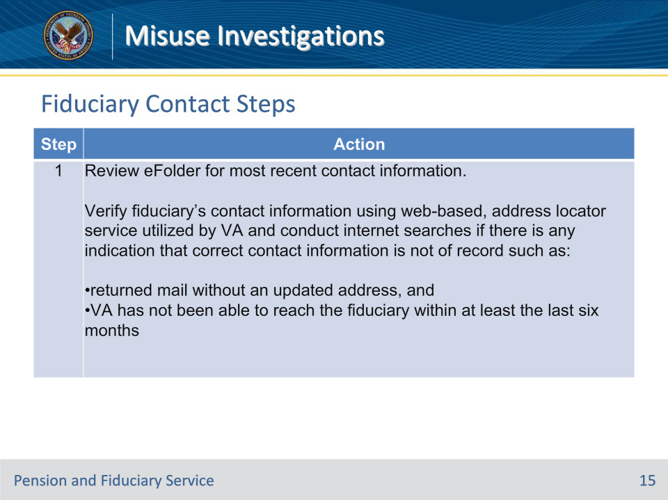
Slide notes

Policy Reference(s): FPM II.3.A.3.h.

Instructor Notes:

Follow the steps in this table to show due diligence in contacting the subject fiduciary.

Step 1: Review eFolder for most recent contact information.

Verify fiduciary’s contact information using web-based, address locator service utilized by VA and conduct internet searches if there is any indication that correct contact information is not of record such as:

returned mail without an updated address, and

VA has not been able to reach the fiduciary within at least the last six months

Slide 16 - Steps Continued
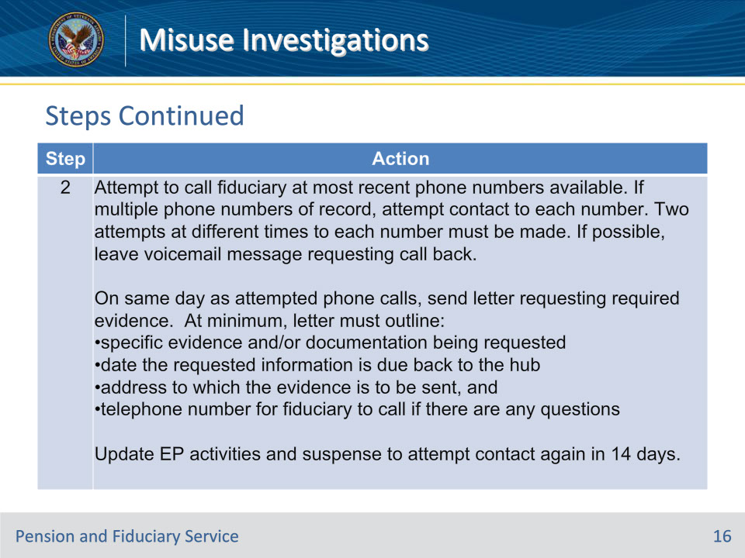
Slide notes

Policy Reference(s): FPM II.3.A.3.h.

Instructor Notes:

Step 2:

Attempt to call the fiduciary at the most recent telephone number(s) available. If multiple telephone numbers are of record, attempt contact to each number. Two attempts at different times to each number must be made. If possible, leave a voicemail message requesting a call back.

Important: Do not include personally identifiable information in the voicemail.

On the same day as the attempted telephone calls, send a letter requesting the required evidence. At a minimum, the letter must outline the

• specific evidence and/or documentation being requested

• date the requested information is due back to the hub

• address to which the evidence is to be sent, and

• telephone number for the fiduciary to call if there are any questions.

Update the EP activities and suspense date to attempt contact again in 14 days.

Note: Hubs should not use the whereabouts unknown development activity in this step.

Slide 17 - Steps Continued
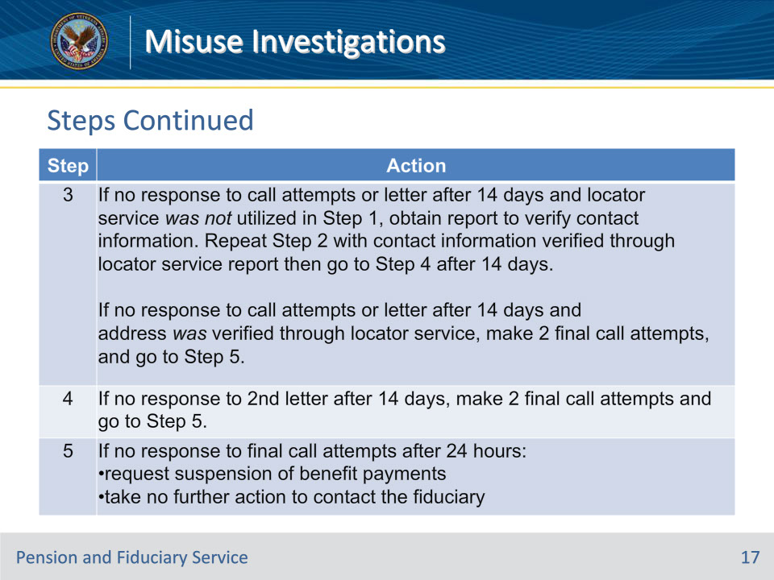
Slide notes

Policy Reference(s): FPM II.3.A.3.h.

Instructor Notes:

Step 3: If no response to call attempts or letter after 14 days and locator service was not utilized in Step 1, obtain report to verify contact information. Repeat Step 2 with contact information verified through locator service report then go to Step 4 after 14 days.

If no response to call attempts or letter after 14 days and address was verified through locator service, make 2 final call attempts, and go to Step 5.

Step 4: If no response to 2nd letter after 14 days, make 2 final call attempts and go to Step 5.

Step 5: If no response to final call attempts after 24 hours:

• request suspension of benefit payments

• take no further action to contact the fiduciary

Slide 18 - Steps Continued
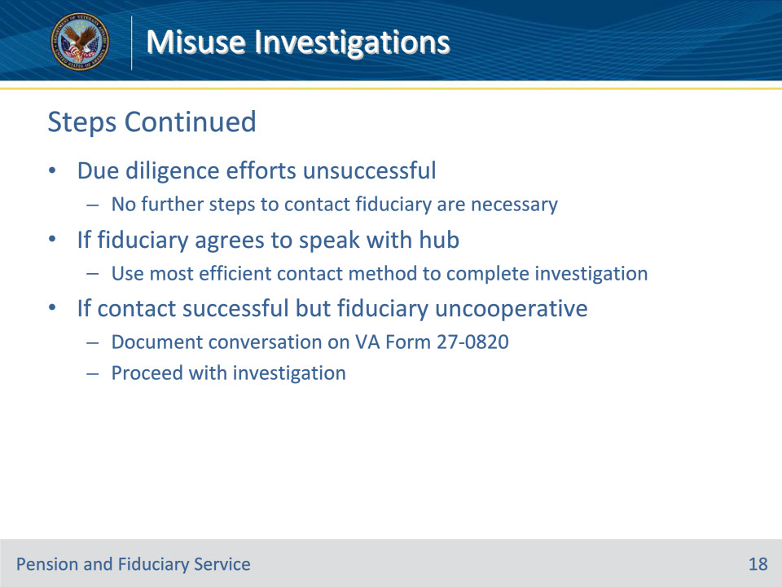
Slide notes

Policy Reference(s): FPM II.3.A.3.h.

Instructor Notes:

When due diligence efforts are successful no further steps to contact the subject fiduciary are necessary. If the subject fiduciary agrees to speak with the hub regarding the use of the beneficiary’s funds, use the most efficient contact method to complete the investigation. If contact is successful, but the fiduciary is not cooperative in scheduling a meeting or providing the requested information, document the conversation on a VA Form 27-0820 and proceed with the investigation.

Slide 19 - Face-to-Face Exceptions
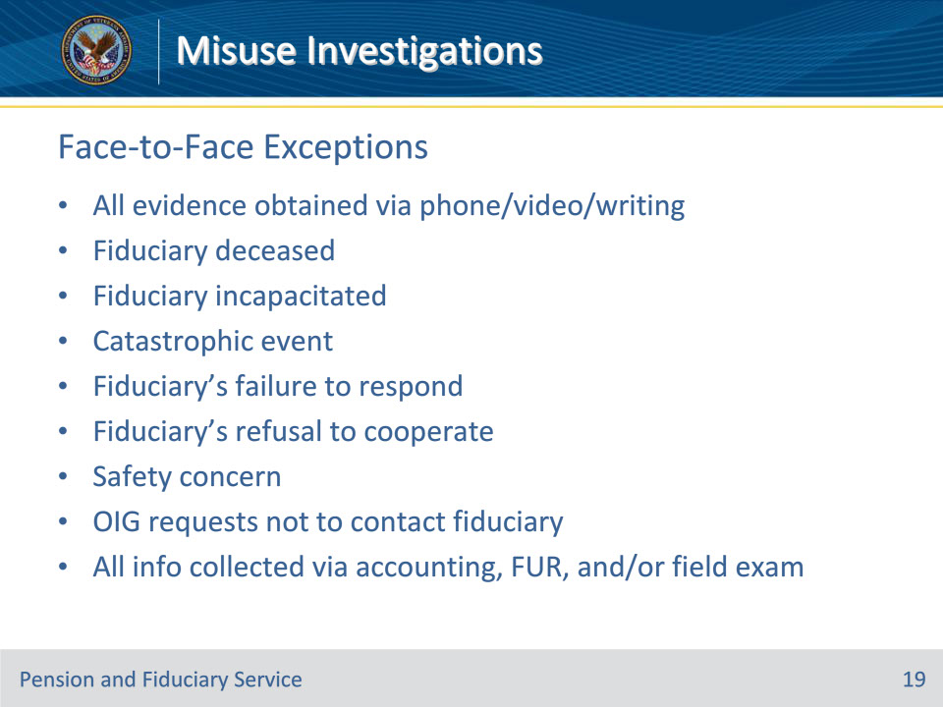
Slide notes

Policy Reference(s): FPM II.3.A.3.h.

Instructor Notes:

Face-to-face contact with a fiduciary is not appropriate when

• all evidence can be obtained telephonically, via secure video teleconferencing, and/or in writing

• the fiduciary

• is deceased

• is incapacitated (for example, extreme illness)

• has been impacted by a catastrophic event

• fails to respond to VA’s contact attempts, or

• provided a documented response to VA that they will not cooperate

• personal contact with the fiduciary presents a safety concern

• OIG request not to contact the fiduciary, or

• hub staff collected all pertinent information during the development phase of the accounting or fund usage review and subsequent field examination to decide misuse and continued development is not expected to yield new and pertinent information.

Slide 20 - Contacting Successor
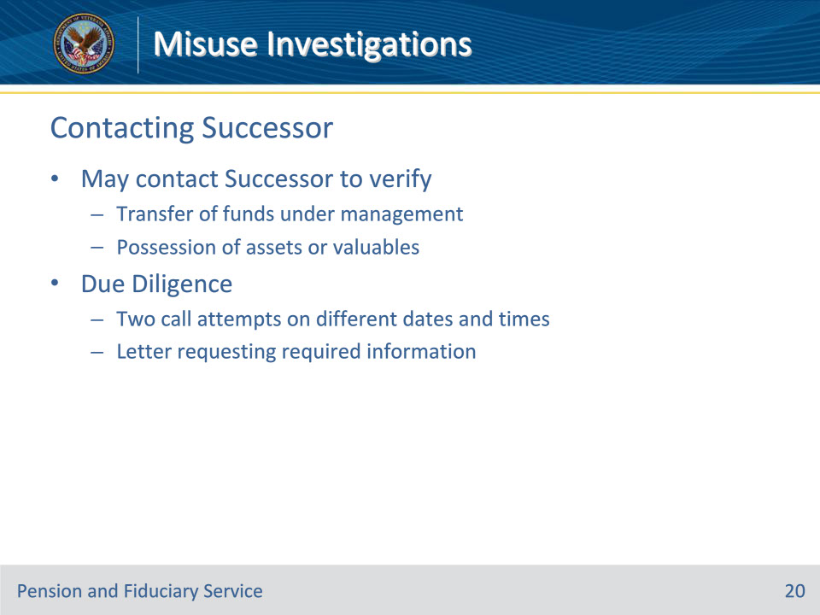
Slide notes

Policy Reference(s): FPM II.3.A.3.i.

Instructor Notes:

If a successor initial appointment (SIA) has been completed, the successor fiduciary may need to be contacted to verify

• transfer of FUM, and

• possession of assets or valuables.

To ensure due diligence in contacting the successor fiduciary during a misuse investigation, hub personnel will at minimum:

• attempt and document two telephone contacts on different dates and at different times, and

• send one letter requesting the required information.

Slide 21 - Contacting Third Parties
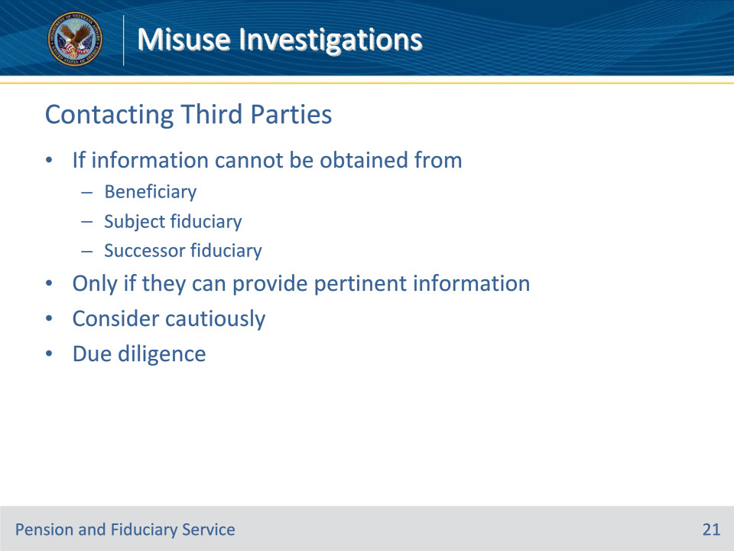
Slide notes

Policy Reference(s): FPM II.3.A.3.j.

Instructor Notes:

Disinterested third parties who may have pertinent information regarding the allegation should also be contacted if the information cannot be obtained from the beneficiary, subject fiduciary, or successor fiduciary.

Only contact disinterested third parties when there is an indication that individual may be able to provide information pertinent to the allegation.

Information from individuals with a close association to the subject fiduciary should be considered cautiously.

Due diligence is shown by contacting these individuals/entities through telephone on two different days at different times during the day.

Slide 22 - Third Party Examples
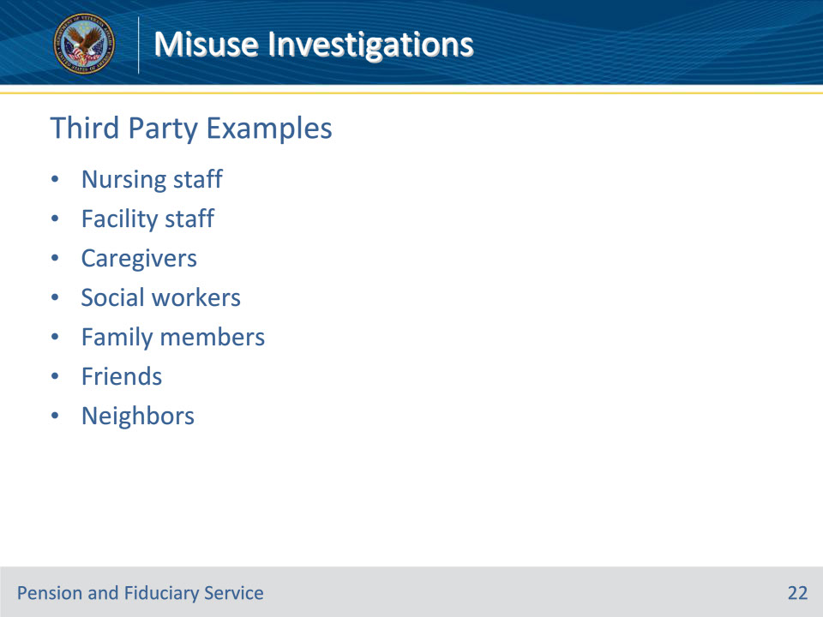
Slide notes

Policy Reference(s): FPM II.3.A.3.j.

Instructor Notes:

Disinterested third parties may include:

• nursing staff assigned to the beneficiary

• facility business and administrative staff

• caregivers

• VA and non-VA social workers

• family members

• friends, and

• neighbors.

Slide 23 - Collecting Evidence
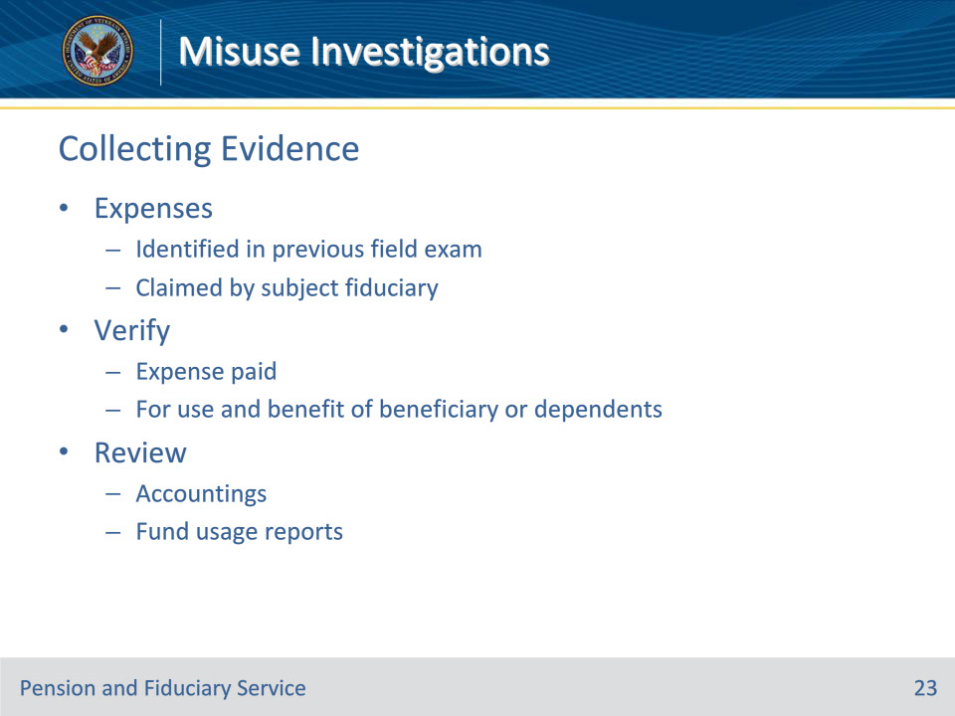
Slide notes

Policy Reference(s): FPM II.3.A.3.k.

Instructor Notes:

For each expense identified in the previous field examination and/or each expense claimed by the subject fiduciary, the hub must verify the expense was paid and was for the use and benefit of the beneficiary or beneficiary’s dependents.

The hub must also review previously submitted accountings and/or fund usage reports when attempting to identify the beneficiary’s expenses.

Slide 24 - Types of Evidence
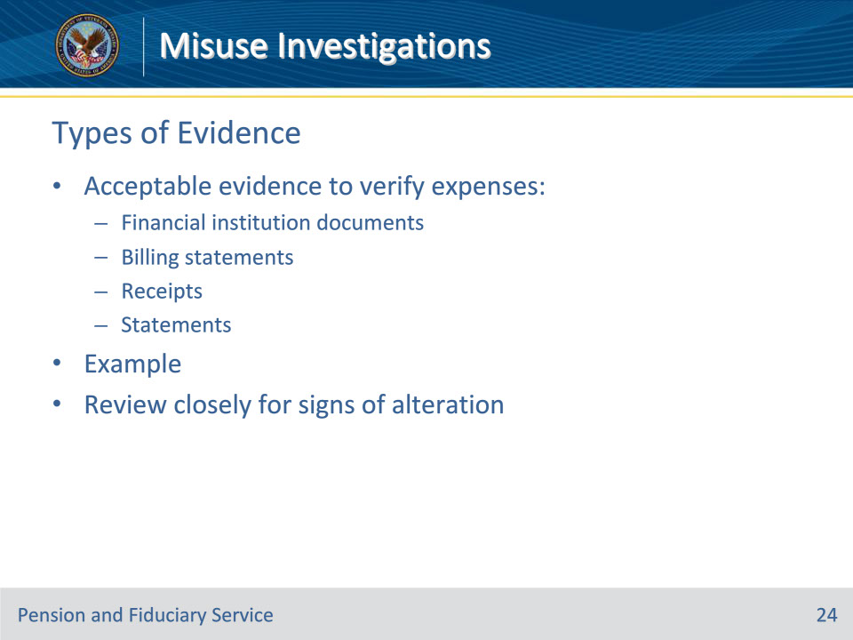
Slide notes

Policy Reference(s): FPM II.3.A.3.k.

Instructor Notes:

Acceptable forms of evidence to verify expenses include the following:

• original, photocopied, or computer-generated financial institution documents

• billing statements

• receipts, and

• statements from the beneficiary, successor fiduciary, or disinterested third parties.

Example: The beneficiary living at a personal residence indicates that the electricity remained on for the duration of the misuse period. Accept the beneficiary’s statement as evidence that the electrical bill was paid. Use the amount identified in the previous field examination, accounting, or fund usage report as the amount to be subtracted from the misuse amount, unless more accurate information is available.

Review evidence closely to ensure the documentation does not exhibit any signs of alteration.

Slide 25 - Verification
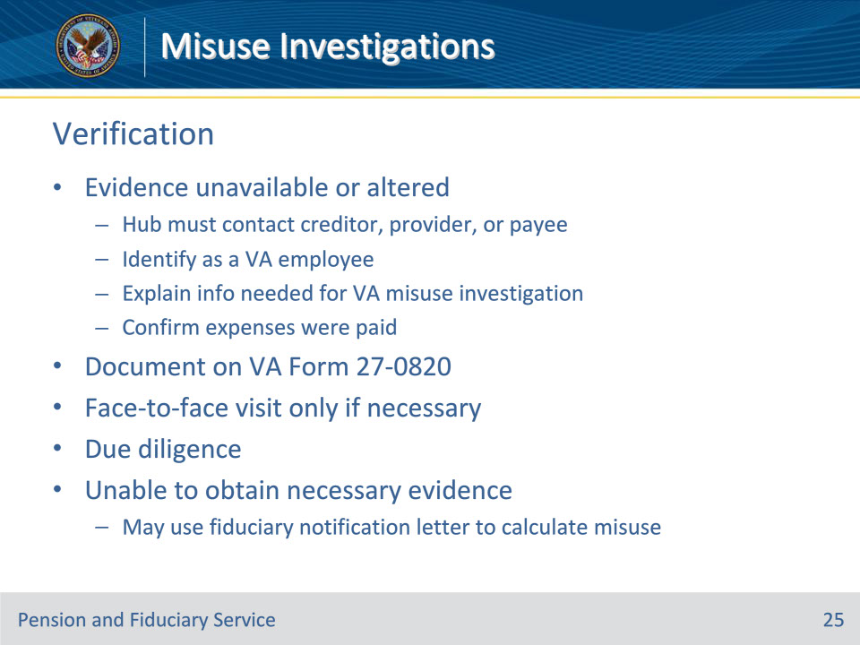
Slide notes

Policy Reference(s): FPM II.3.A.3.k.

Instructor Notes:

When evidence to verify expenses cannot be gathered from the document sources listed on the previous slide, or the documentation exhibits signs of alteration, the hub must contact the creditor, service provider, or payee of the expense and

• identify as a VA employee

• explain that the information is needed for a VA misuse investigation, and

• request to confirm that the expense was paid.

Document all conversations or attempts to contact creditors, service providers, and payees of expenses on a VA Form 27-0820. If the creditor, service provider, or payee of the expense refuses to provide the information, document the conversation.

Face-to-face contact with a creditor, service provider, or payee of the expense is not required unless the entity indicates that they cannot provide the information over the phone or require in-person identification.

Hub personnel conducting the investigation must demonstrate due diligence when attempting to contact the other parties, documenting attempts or justification as to why this was not performed, as applicable. Due diligence is shown by contacting these entities through telephone on two different days at different times during the day.

In the absence of evidence to verify expenses paid and determine misuse, hub personnel may use the fiduciary notification letter as a tool to assist in calculating the misuse amount. However, due diligence in attempting to obtain the required evidentiary material must be documented.

Slide 26 - Additional Beneficiaries
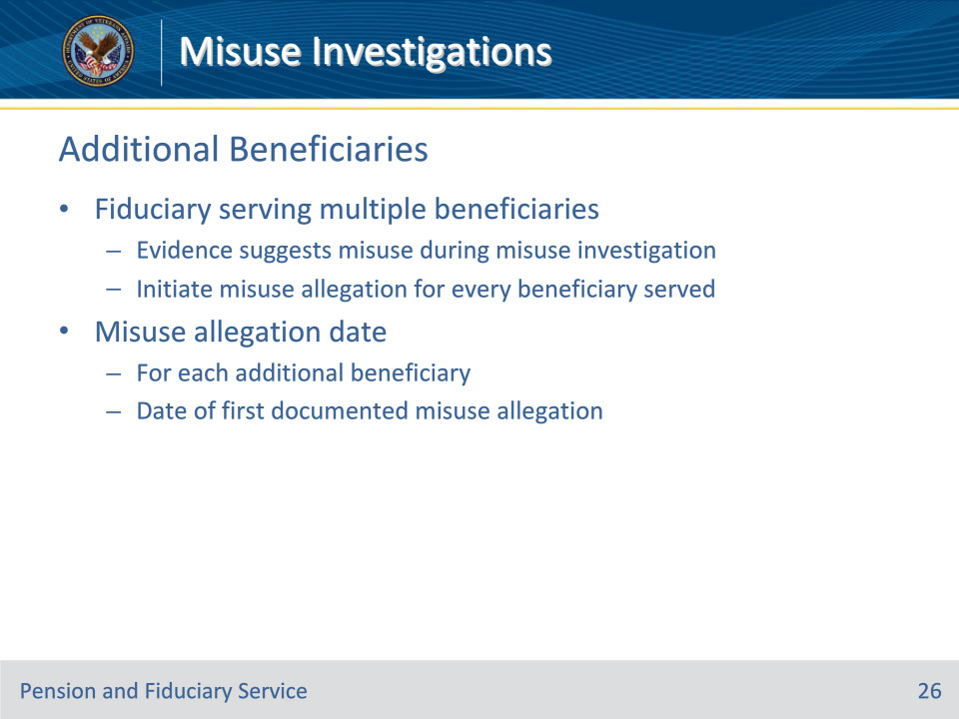
Slide notes

Policy Reference(s): FPM II.3.A.3.l.

Instructor Notes:

When evidence gathered suggests misuse during the misuse investigation of a fiduciary serving more than one beneficiary, the hub must initiate a misuse allegation for every beneficiary served by that fiduciary.

The misuse allegation date for each additional beneficiary is the date of the first documented misuse allegation for a fiduciary serving multiple beneficiaries.

Slide 27 - Accounting & FUR Considerations
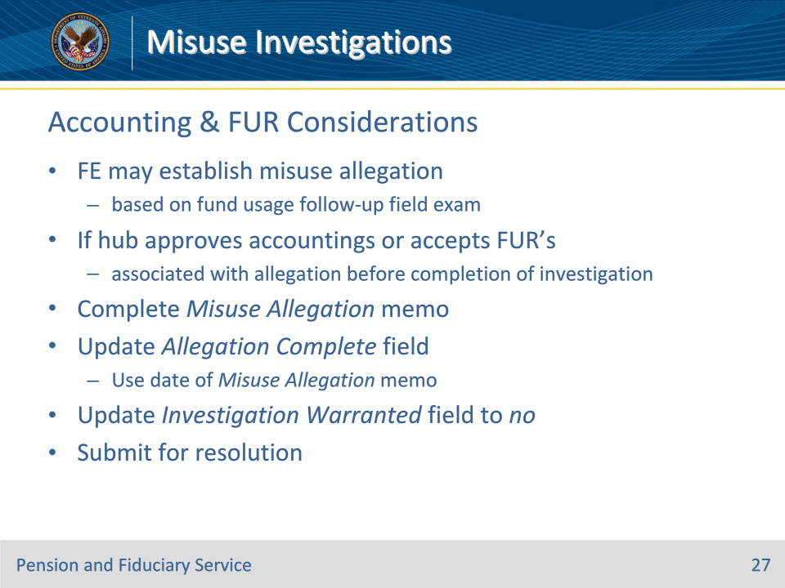
Slide notes

Policy Reference(s): FPM II.3.A.3.m.

Instructor Notes:

FE’s may establish a misuse allegation based on credible evidence obtained following the completion of a fund usage follow-up field examination.

If the hub approves past due accounting(s) or accepts fund usage review(s) associated with the pending misuse allegation before the completion of a misuse investigation

• complete a Misuse Allegation memorandum

• update the ALLEGATION COMPLETE field with the completion date of the Misuse Allegation memorandum

• update the INVESTIGATION WARRANTED field to no, and

• submit the misuse activity for resolution.

A misuse allegation memorandum is not appropriate when the past due accounting or fund usage review does not apply to the period of alleged misuse.

Slide 28 - Misuse Allegation Memo
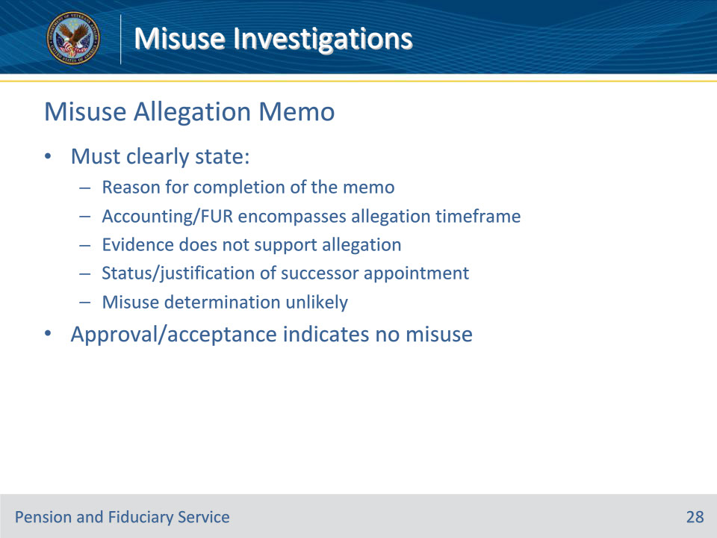
Slide notes

Policy Reference(s): FPM II.3.A.3.m.

Instructor Notes:

The Misuse Allegation memorandum must clearly state the following:

• the reason for the completion of the Misuse Allegation memorandum

• the approved accounting or accepted fund usage report encompasses the misuse allegation timeframe, and the evidence does not support the allegation of misuse

• if the fiduciary was replaced, if not why, or a SIA fiduciary is pending, and

• a decision that additional investigation into the allegation of misuse is not likely to result in a determination of misuse of VA funds by the fiduciary.

The hub’s approval of the delinquent accounting(s) or acceptance of a fund usage review may be considered evidence that the fiduciary has not misused the beneficiary’s funds and there were no red flags of misuse at the time of the review. Completion of the elements of the misuse investigation and misuse determination are not required.

Slide 29 - Report formats
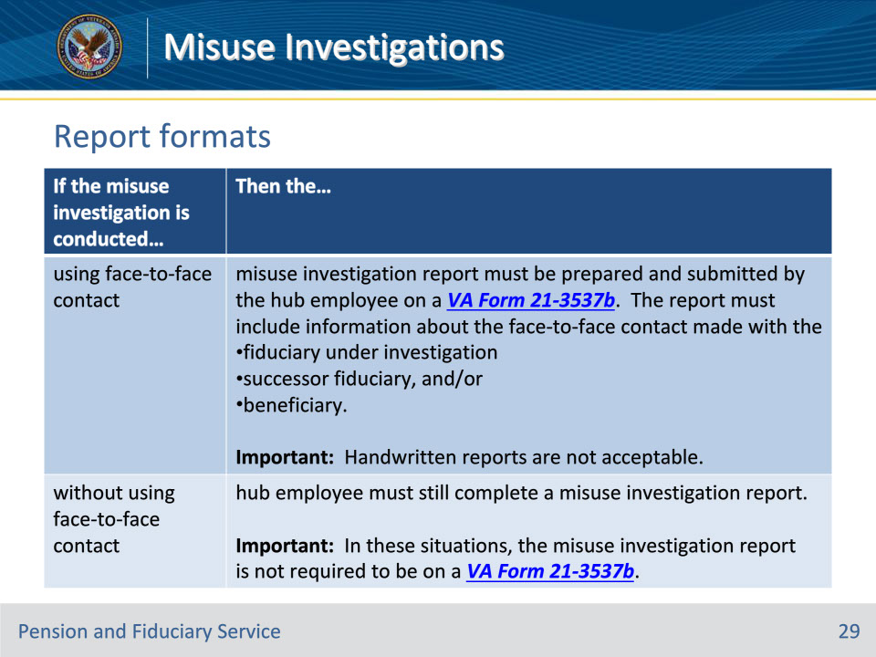
Slide notes

Policy Reference(s): FPM II.3.A.3.n.

Instructor Notes:

Use this table to determine the appropriate format for the misuse investigation report.

If the misuse investigation is conducted using face-to-face contact, then the misuse investigation report must be prepared and submitted by the hub employee on a VA Form 21-3537b. The report must include information about the face-to-face contact made with the

• fiduciary under investigation

• successor fiduciary, and/or

• beneficiary.

Handwritten reports are not acceptable.

If the misuse investigation is conducted without using face-to-face contact, then the hub employee must still complete a misuse investigation report.

In these situations, the misuse investigation report is not required to be on a VA Form 21-3537b.

Notes:

• Upon completion of a misuse investigation report using any method of contact, upload to the beneficiary’s eFolder.

• Regardless of the method of contact, all required elements must be included within the misuse investigation report.

Slide 30 - Required Elements
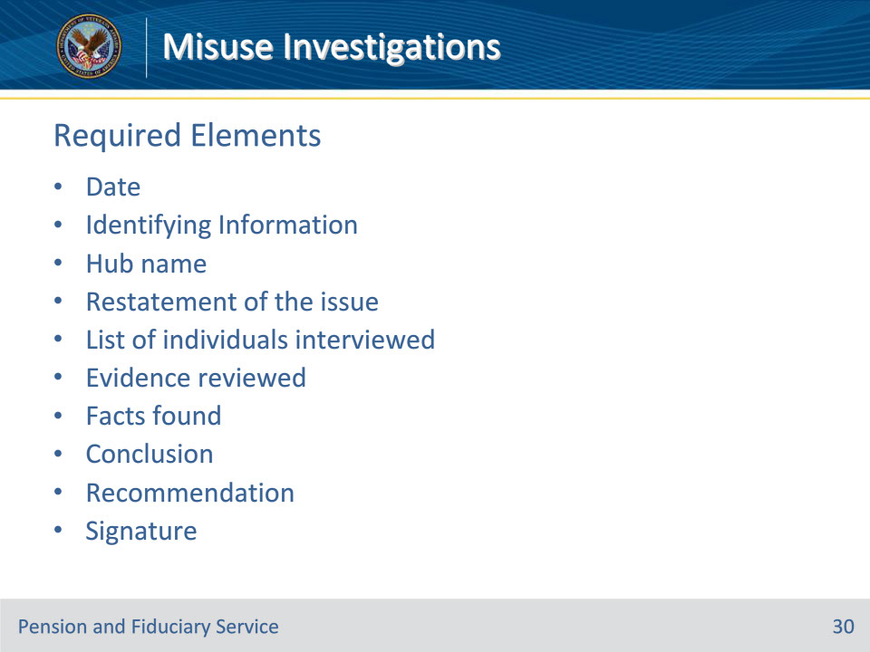
Slide notes

Policy Reference(s): FPM II.3.A.3.o.

Instructor Notes:

Each misuse investigation report must contain several elements in order to be complete.

The required elements are:

• Date: Date of the report

• Identifying Information

• Hub name: Name of the hub of jurisdiction

• Restatement of the issue

• List of individuals interviewed

• Evidence reviewed

• Facts found

• Conclusion

• Recommendation

• Signature: Name, title, signature of employee who conducted investigation

The misuse investigation report must be a stand-alone document. A reasonable person must be able to come to the same conclusion the investigating employee reached based on review of the report and the specific evidence listed within the report. The evidence must support the findings of the report.

We will go into more detail on the required elements in the following slides.

Slide 31 - Identifying Information
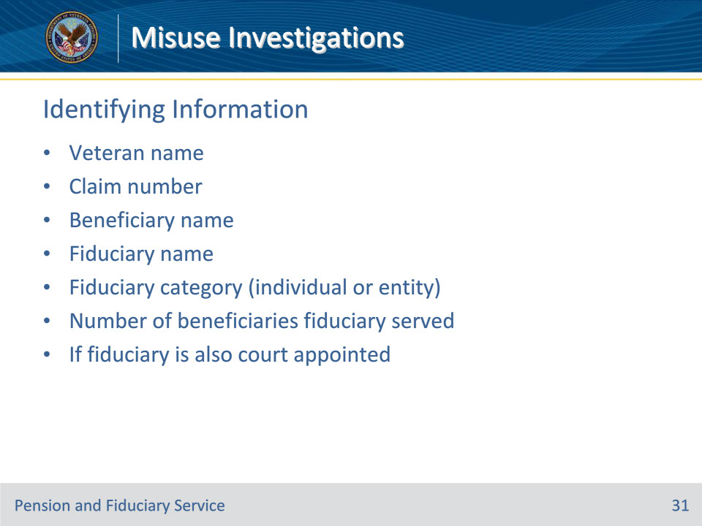
Slide notes

Policy Reference(s): FPM II.3.A.3.o.

Instructor Notes:

Identifying information:

List relevant information associated with the misuse investigation. This includes the

• Veteran’s name

• claim number

• beneficiary’s name

• fiduciary’s name

• fiduciary category (individual or entity)

• greatest number of beneficiaries the fiduciary served during the suspected period of misuse, and

• if the fiduciary is also court appointed.

Slide 32 - Restatement of the Issue
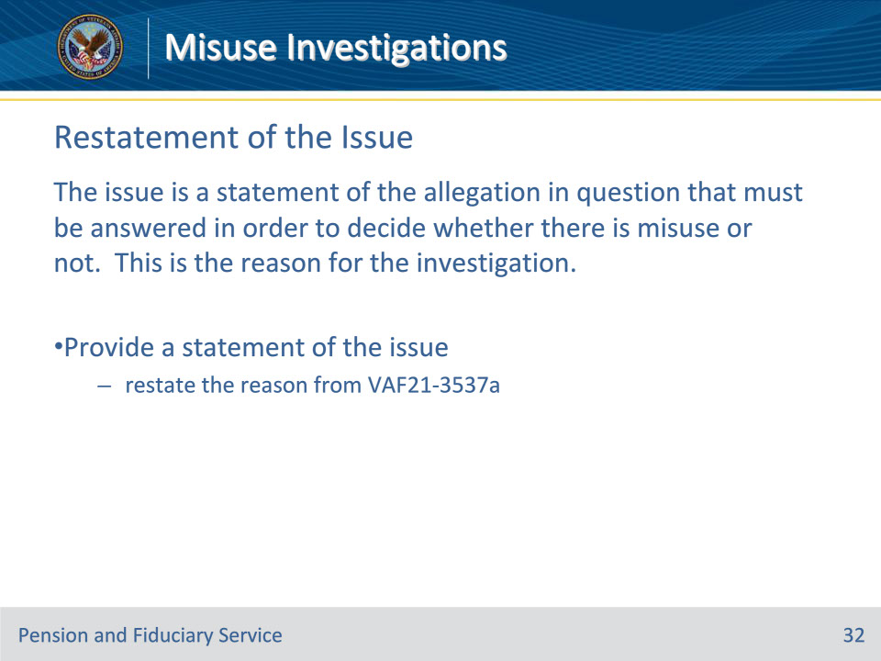
Slide notes

Policy Reference(s): FPM II.3.A.3.o.

Instructor Notes:

The issue is a statement of the allegation in question that must be answered in order to decide whether there is misuse or not. This is the reason for the investigation.

Provide a statement of the issue (e.g., restate the reason for the request for a misuse investigation as provided on the corresponding VA Form 21-3537a).

Slide 33 - Individuals Interviewed
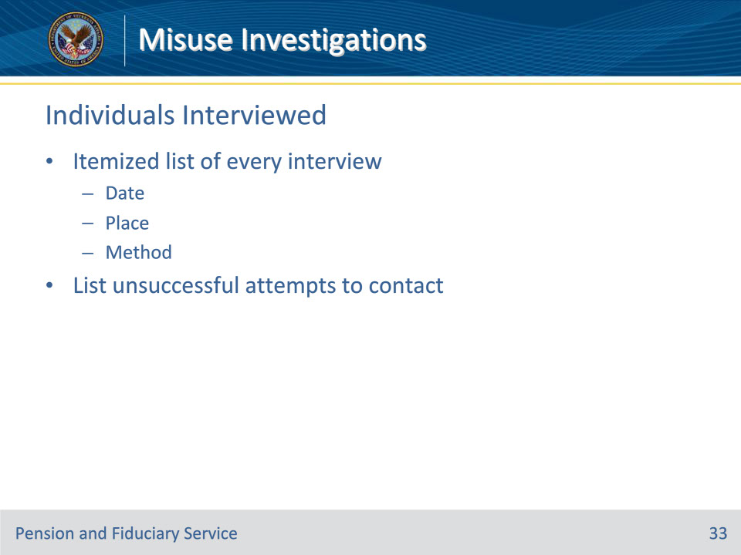
Slide notes

Policy Reference(s): FPM II.3.A.3.o.

Instructor Notes:

Itemized list of every interview that occurred to include

• date

• place, and

• methods of interview for each.

Unsuccessful attempts to contact individuals involved are also listed.

Slide 34 - Evidence Reviewed
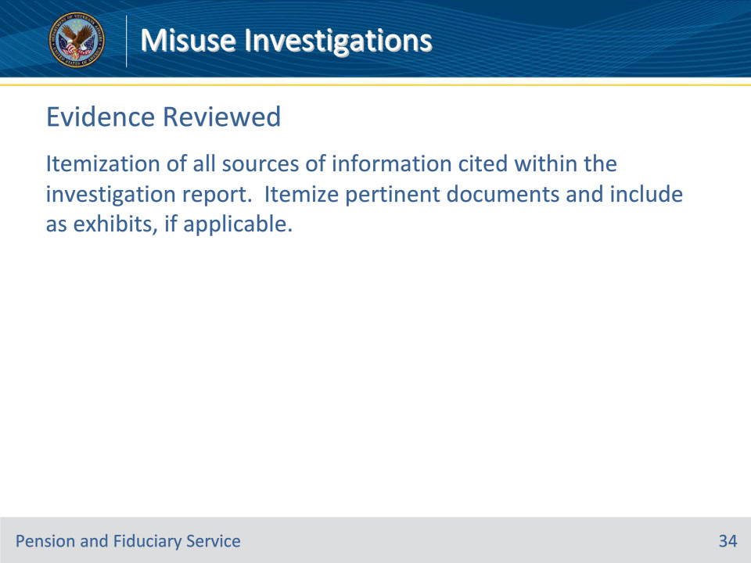
Slide notes

Policy Reference(s): FPM II.3.A.3.o.

Instructor Notes:

Itemization of all sources of information cited within the investigation report. Itemize pertinent documents and include as exhibits, if applicable.

Slide 35 - Facts Found
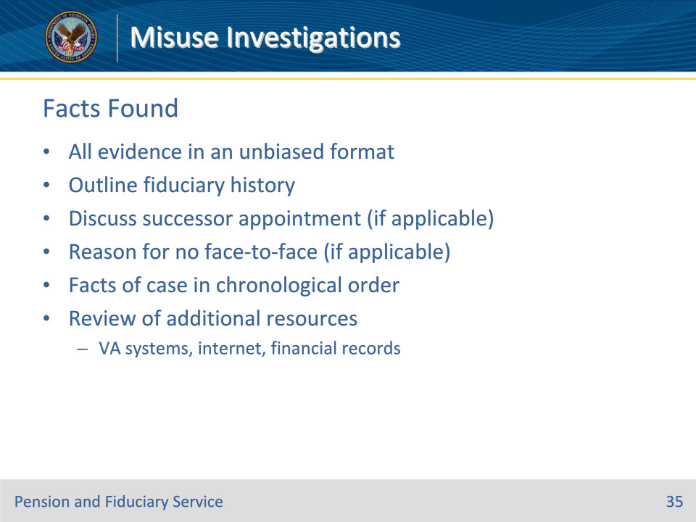
Slide notes

Policy Reference(s): FPM II.3.A.3.o.

Instructor Notes:

Account of all evidence gathered and organized in an unbiased format.

Outline the history of the fiduciary appointment leading to the misuse allegation.

If applicable, discuss the appointment of a successor fiduciary.

If applicable, indicate the reason the face-to-face visit with the fiduciary did not occur.

The section will enumerate the facts of the case in chronological order based on interview findings and other evidence.

A review of additional resources should be documented in this section to support the misuse findings. Examples could include, but are not limited to

• a review of documentation contained in the eFolder and systems such as, but not limited to VBMS, CAPRI, and Share

• internet research (attempts to locate the fiduciary, comparison of available service companies, calls to utility companies, mortgage companies, and property management companies), and

• a detailed review of financial records.

Slide 36 - Conclusion
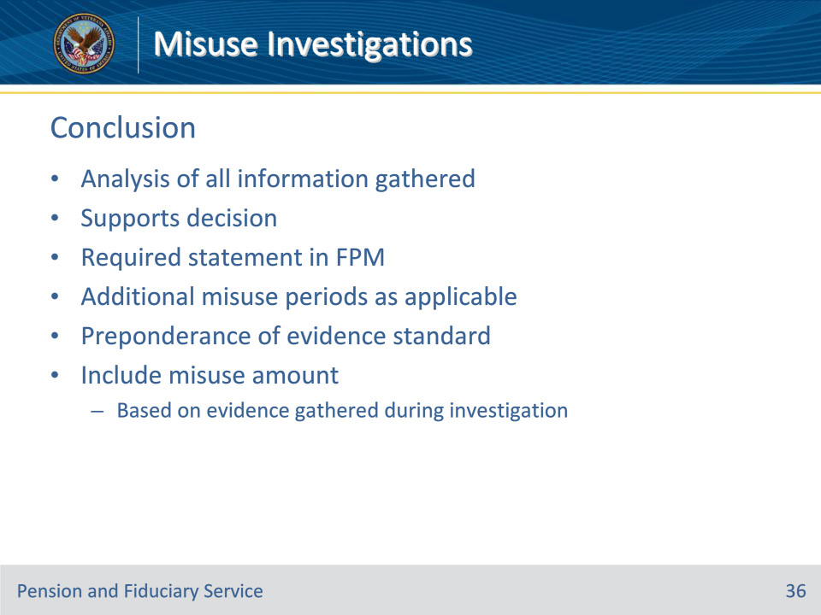
Slide notes

Policy Reference(s): FPM II.3.A.3.o.

Instructor Notes:

Analysis of all information gathered to make and support the decision. The following statement must be provided to outline the conclusion of the misuse investigation:

Based on the review of the eFolder and evidence available at the conclusion of the misuse investigation, a misuse determination is necessary to determine if the fiduciary misused the beneficiary’s benefits during the period of <MONTH/DAY/YEAR> through <MONTH/DAY/YEAR>.

Add additional misuse periods as applicable.

Care should be taken to meet the preponderance of evidence standard.

If misuse is found, the hub employee must include the misuse amount. Conclusion regarding the misuse amount must be shown to be made based on evidence gathered during the investigative process.

Slide 37 - Recommendation
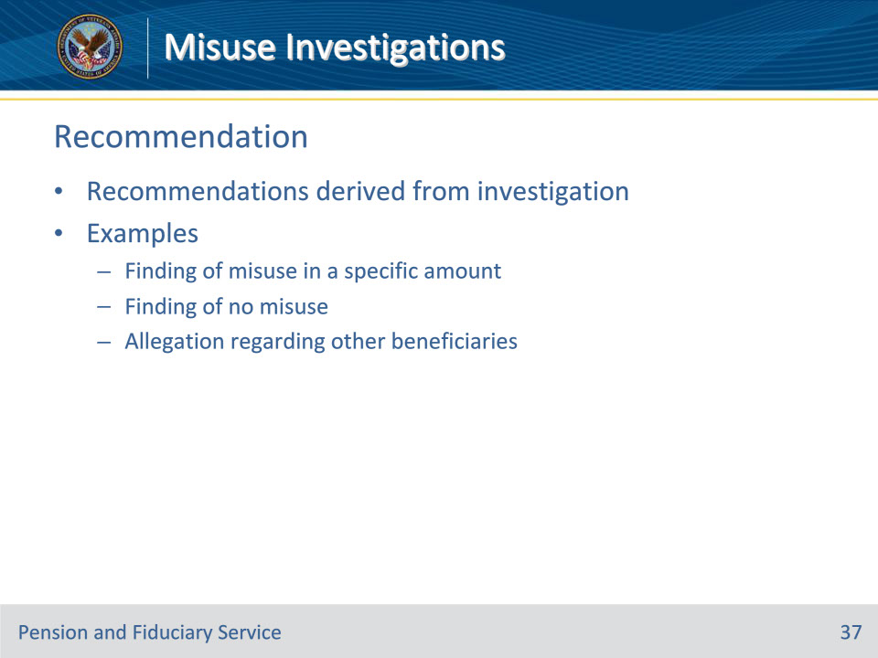
Slide notes

Policy Reference(s): FPM II.3.A.3.o.

Instructor Notes:

Include recommendations derived from the investigation, as appropriate. Examples include the recommendation

• of a finding of misuse in a specified amount or a finding of no misuse, and/or

• to make an allegation of misuse against the fiduciary with regard to other beneficiaries served which are not presently part of the current investigation.

Slide 38 - Misuse Amount
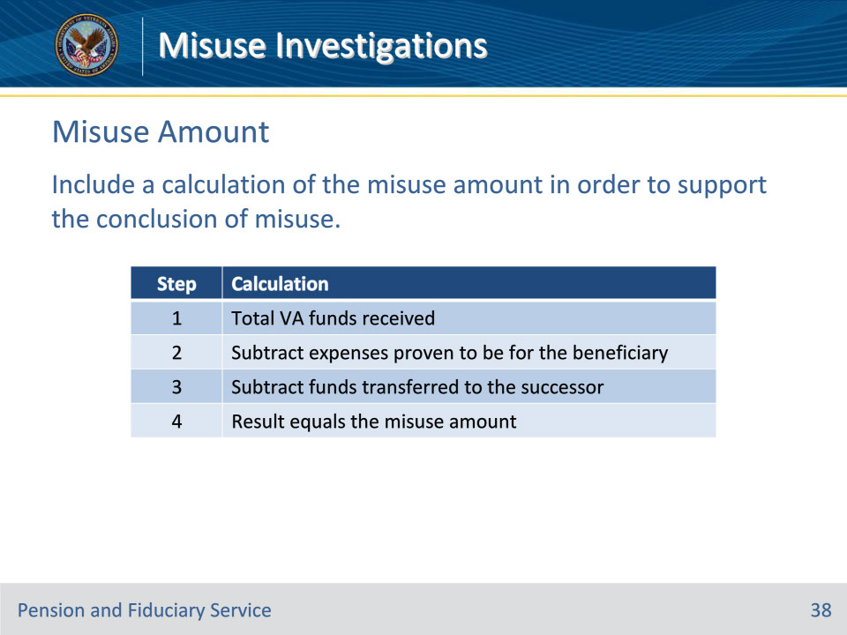
Slide notes

Policy Reference(s): FPM II.3.A.3.p.

Instructor Notes:

The employee completing the misuse investigation must include a calculation of the misuse amount in order to objectively support the conclusion of misuse.

Follow the steps in this table to determine the misuse amount as part of the conclusion of the investigation.

Slide 39 - Misuse Amount
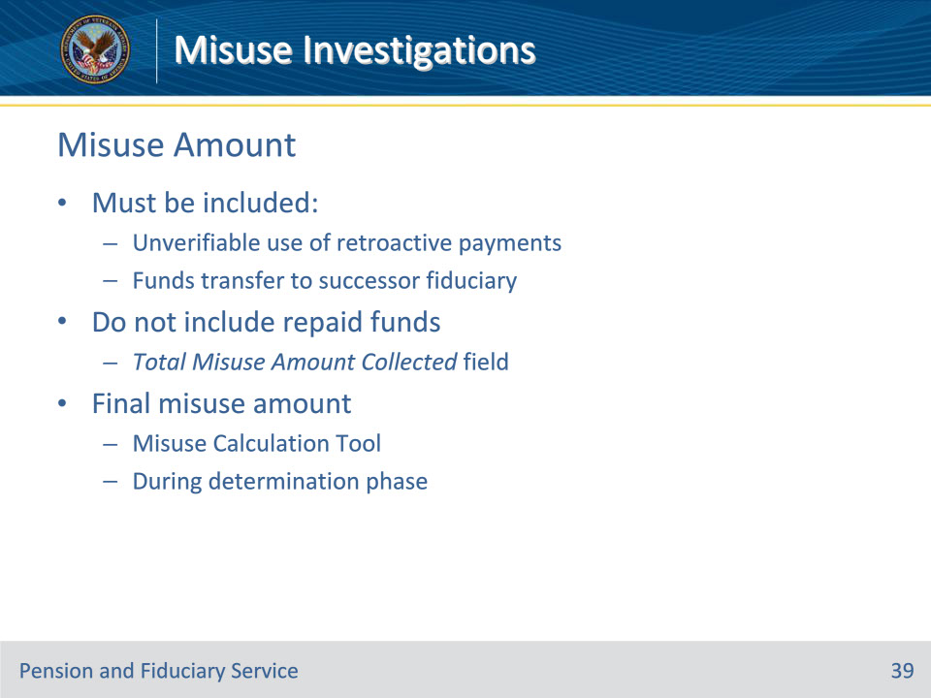
Slide notes

Policy Reference(s): FPM II.3.A.3.p.

Instructor Notes:

• The following must be included when calculating a misuse amount:

• If the fiduciary received a retroactive payment, review the prior field examinations for the agreement regarding the use of the funds. If the FE or LIE cannot verify the use of the retroactive payments, consider misuse and add any unverified use of the retroactive benefit to the total misuse amount.

• If a successor fiduciary is already in place, and there is evidence the previous fiduciary transferred funds, credit the amount of expenses proven to be for the beneficiary.

• Do not include funds repaid by the fiduciary in the calculation for the misuse amount. If any funds were repaid by the fiduciary, this amount is documented in the TOTAL MISUSE AMOUNT COLLECTED field in the misuse record in VBMS.

• The final misuse amount must be determined by using the Misuse Calculation tool currently authorized by P&F Service during the determination phase of the misuse case.

Slide 40 - Completion
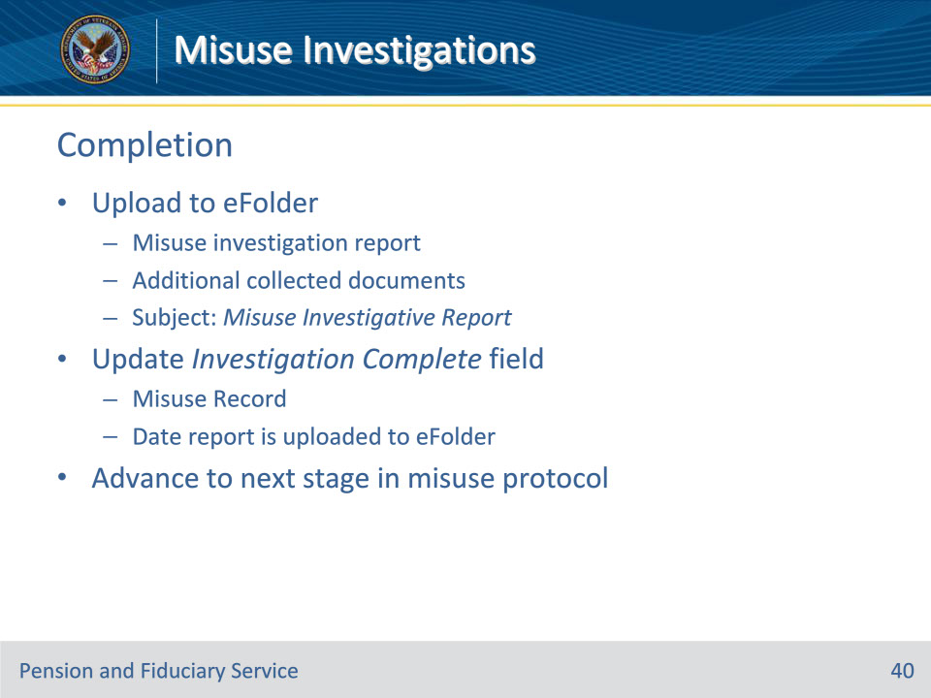
Slide notes

Policy Reference(s): FPM II.3.A.3.q.

Instructor Notes:

Upon completion of the misuse investigation, hub personnel must

• upload the misuse investigation report and additional collected documents to the beneficiary’s eFolder

• update the INVESTIGATION COMPLETE field on the misuse record with the date the investigation report is uploaded to the eFolder, and

• advance the misuse record to the next stage of the misuse protocol.

When uploading the misuse investigation report into the eFolder, the hub employee must enter Misuse Investigative Report in the SUBJECT field in VBMS, regardless of the method of contact used.

Slide 41 - Questions?
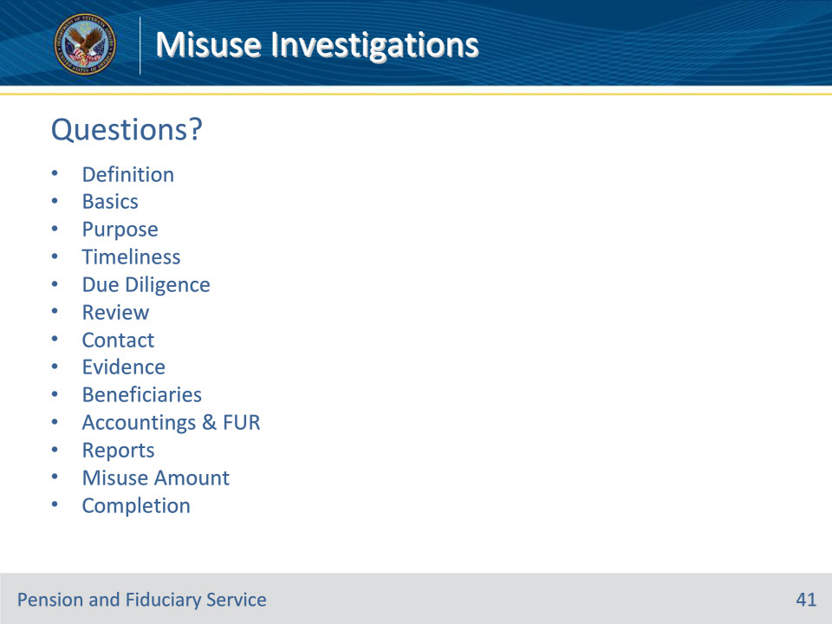
Slide notes

Instructor Notes:

(Recall) These are our learning objectives as stated from the beginning of the training:

• Define misuse investigation

• Explain misuse investigation basics

• Review allegation and systems

• Contact relevant parties

• Collect and verify evidence

• Generate applicable reports and memos

• Calculate misuse amount

• Complete misuse investigation

(Recap) We discussed each of these learning objectives through the following topics in each slide today:

• Definition

• Basics

• Purpose

• Timeliness

• Due Diligence

• Review

• Contact

• Evidence

• Beneficiaries

• Accountings & FUR

• Reports

• Misuse Amount

• Completion

Are there any additional questions?

Questions should be filtered through your QRT team. They will submit your questions to the Field Inquiry Tool (FIT) on your behalf.

Slide 42 - TMS Survey/Assessment
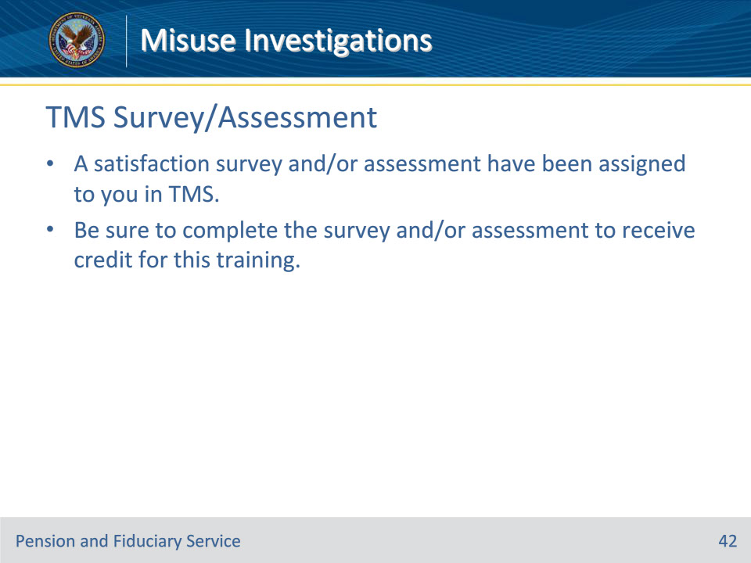
Slide notes

Instructor Notes:

A satisfaction survey and/or assessment have been assigned to you in TMS.

Be sure to complete the survey and/or assessment to receive credit for this training.

