Slide 1 - Misuse Determinations
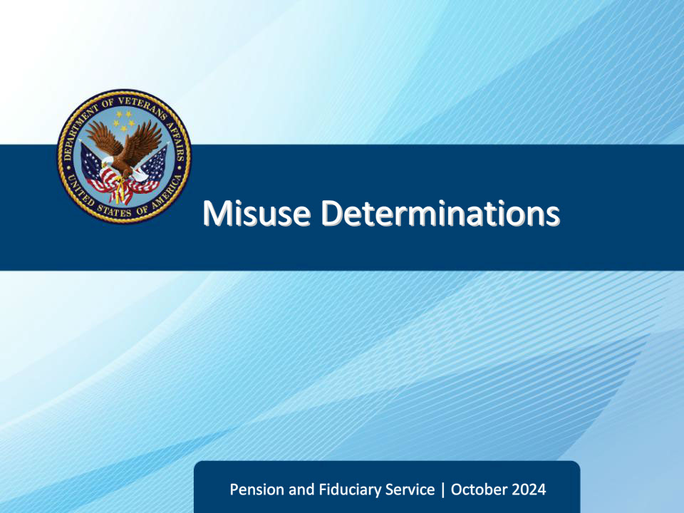
Slide notes

Course Description:

This course teaches learners information on misuse determination content and format.

Slide 2 - Objectives
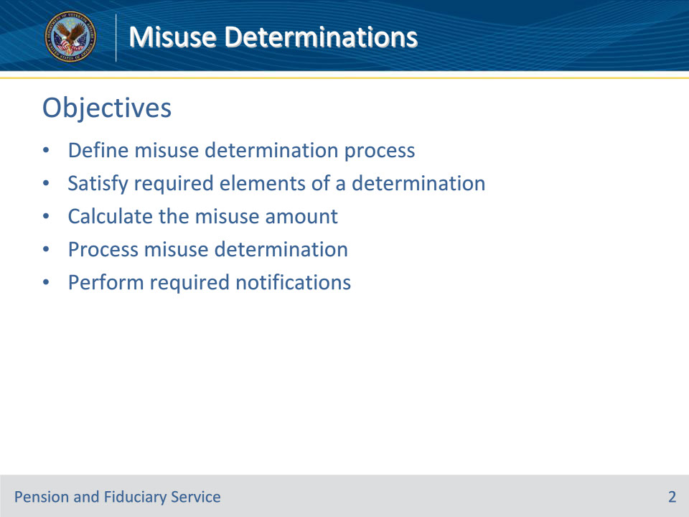
Slide notes

Instructor Notes:

At the end of this lesson, given the training and references, the learner will be able to do the following:

• Define misuse determination process

• Satisfy required elements of a determination

• Calculate the misuse amount

• Process misuse determination

• Perform required notifications

Slide 3 - References
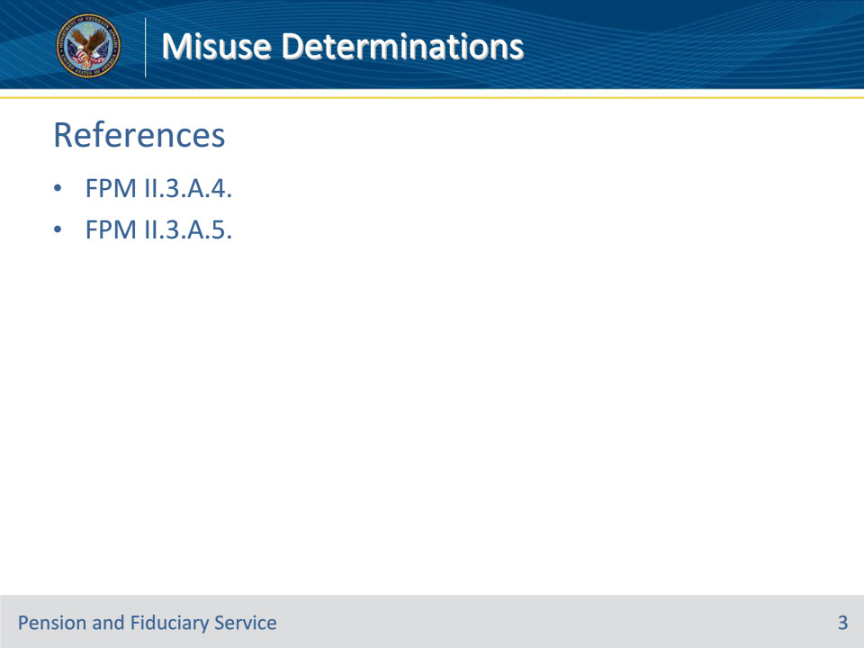
Slide notes

Instructor Notes:

These are the relevant references pertaining to this course:

• FPM II.3.A.4. Misuse Determinations

• FPM II.3.A.5. Notification of Misuse Determination

Slide 4 - Definition
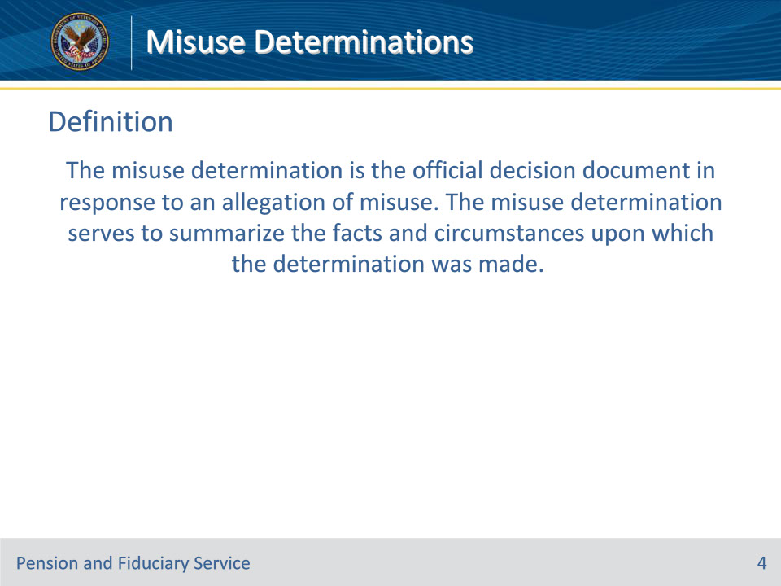
Slide notes

Policy Reference(s): FPM II.3.A.4.a.

Instructor Notes:

The misuse determination is the official decision document in response to an allegation of misuse. The misuse determination serves to summarize the facts and circumstances upon which the determination was made.

Slide 5 - Process
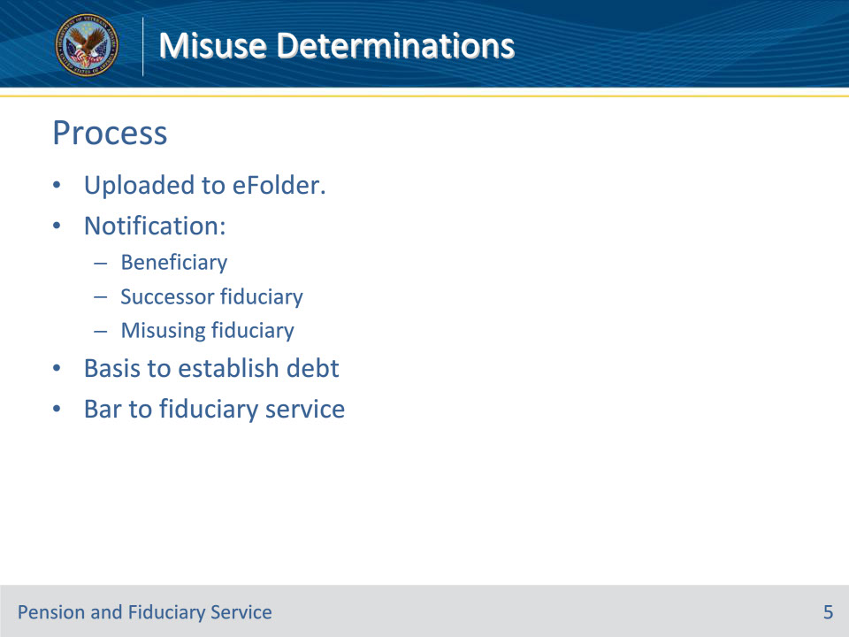
Slide notes

Policy Reference(s): FPM II.3.A.4.a.

Instructor Notes:

After completion, a copy of this document is uploaded to the beneficiary’s eFolder and provided with notification of the determination to the:

• beneficiary

• successor fiduciary, if appointed, and

• misusing fiduciary.

If misuse is found, the misuse determination serves as the basis to establish a debt for the VA and represents a bar to continued or future service as a fiduciary for any VA beneficiary.

Slide 6 - Complete Review
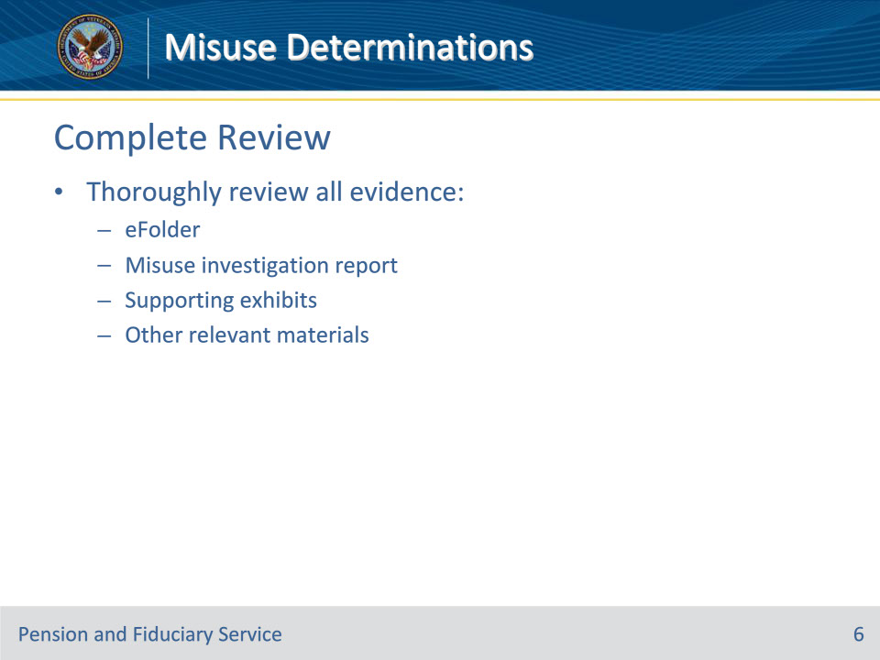
Slide notes

Policy Reference(s): FPM II.3.A.4.b.

Instructor Notes:

The seriousness of the misuse allegation and implications of a finding of factual misuse require that the decision maker thoroughly review all available evidence prior to making a final determination. This review should include a review of the eFolder, the misuse investigation report with supporting exhibits, and any other relevant material.

Slide 7 - Required Elements
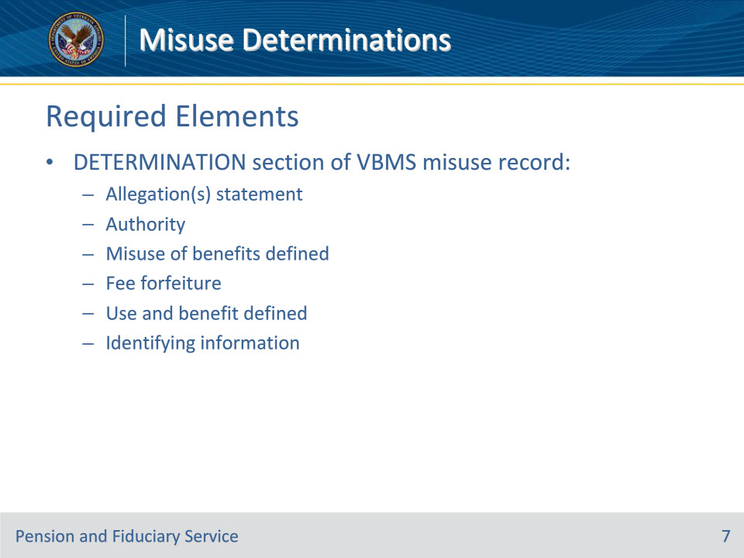
Slide notes

Policy Reference(s): FPM II.3.A.4.c.

Instructor Notes:

Each field in the DETERMINATION section of the VBMS misuse record must be completed regardless of the finding. After updating all required fields in the misuse record, generate the misuse determination in VBMS.

This list provides the required elements along with a detailed description of each:

Allegation(s) statement

List all the allegations, including sources and receipt dates, in relation to the misuse.

Authority

Outlines relevant misuse statutes and regulations.

Misuse of benefits defined

Definition of misuse.

Fee forfeiture

Outlines statutes related to fee entitlement when misuse is found.

Use and benefit defined

Details relevant use and benefit regulations.

Identifying information

List relevant information associated with the misuse determination. This includes the

• Veteran’s name

• claim number

• beneficiary’s name

• fiduciary’s name

• fiduciary category (individual or entity)

• greatest number of beneficiaries the fiduciary served during the suspected period of misuse, and

• State, if the fiduciary is also court appointed.

Slide 8 - Required Elements (Cont.)
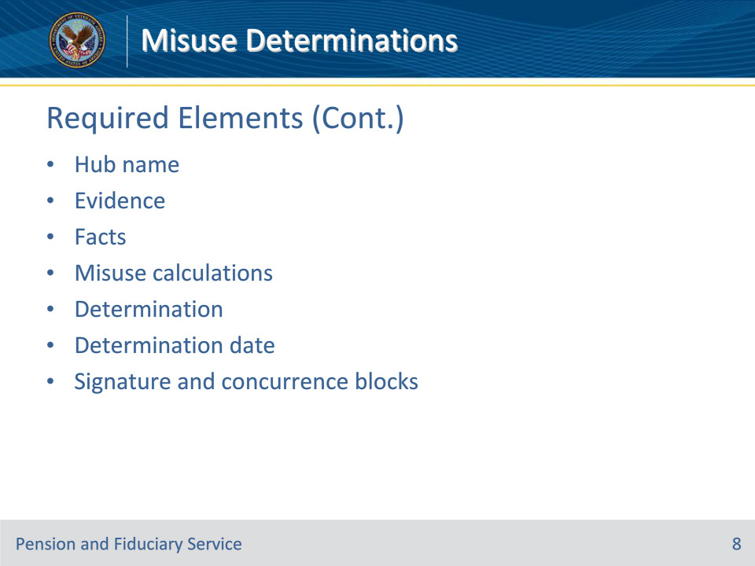
Slide notes

Policy Reference(s): FPM II.3.A.4.c.

Instructor Notes:

Hub name

Name of the hub with jurisdiction over the misuse determination.

Evidence

At a minimum, hubs must document any information referenced in the FACTS section.

Facts

In general, the facts should describe how the determination was reached that the fiduciary did or did not use the beneficiary’s funds for the use and benefit of the beneficiary and their dependents. The facts must be relevant to the misuse determination.

To accomplish this, the facts must

• clearly explain why the evidence is found to be persuasive or unpersuasive

• outline specific dates, periods, or instances relevant to the decision

• clearly define the repayment of any funds where misuse occurred but the fiduciary corrected the issue prior to the determination of misuse, if applicable, and

• identify any funds transferred to the successor fiduciary, if applicable.

• The facts of the misuse determination must not be a restatement of the investigation report nor be a narrative of every detail. They should be focused on the pertinent facts that support the decision.

• Avoid discussing details that are not relevant to the misuse determination. Do not include information such as

• the appointment date of the successor fiduciary when only the fund transfer is applicable to the determination of the misuse amount, and/or

• details outlining every telephone call attempt made in contacting the fiduciary.

Misuse calculations

Statement indicating that detailed misuse calculations are attached.

Determination

Specify the decision regarding the misuse finding and include the following information if misuse is found:

• the specific time period of misuse

• the amount of misuse

• the date misuse was found, and

• how the misuse amount was determined.

Utilize the Misuse Calculation tool provided by P&F Service to determine the final misuse amount when misuse is found. The calculation will consider

• VA FUM

• VA benefits received

• expenditures proven to have benefited the beneficiary, and

• the transfer of any funds to the successor fiduciary.

Determination date

Date of the misuse determination.

Signature and concurrence blocks

Include all required signatures to complete the misuse determination.

Slide 9 - Required Elements (Cont. 2)
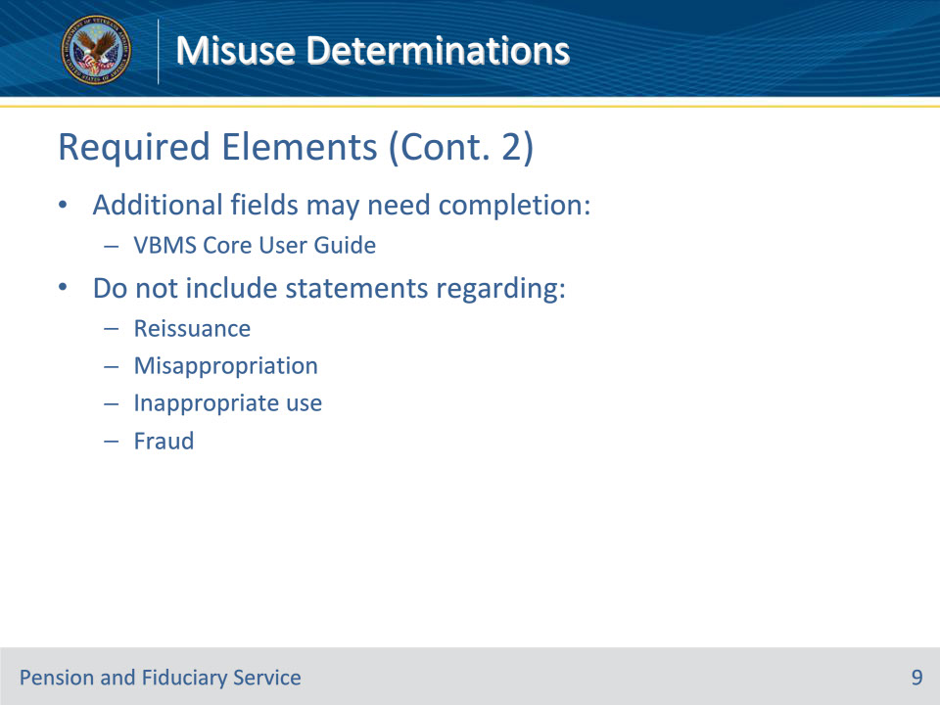
Slide notes

Policy Reference(s): FPM II.3.A.4.c.

Instructor Notes:

• While the items provided in the previous slides are required, this is not an exhaustive list. Additional fields as described in the VBMS Core User Guide may need to be completed depending on the case.

• Statements regarding reissuance, misappropriation, inappropriate use, or fraud should not be used in the misuse determination.

Slide 10 - Supplemental Document
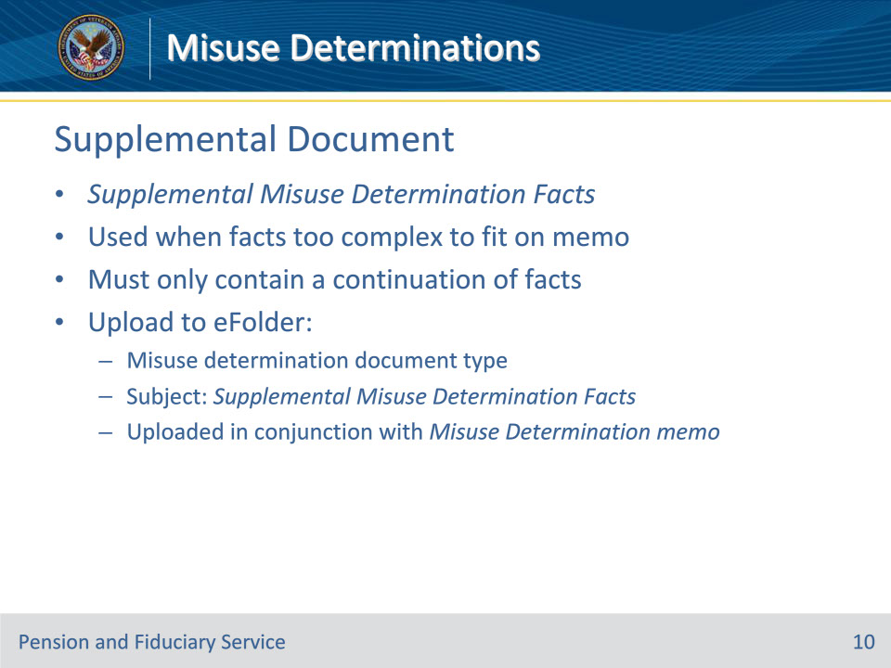
Slide notes

Policy Reference(s): FPM II.3.A.4.c.

Instructor Notes:

• The facts in the Misuse Determination memorandum should be focused on the pertinent facts that support the determination being made. If the case is complex and pertinent facts cannot be adequately stated within the authorized Misuse Determination memorandum, a supplemental document can be created to accommodate the need for additional language. The document must be structured as follows:

• The top of the document will indicate Supplemental Misuse Determination Facts and must only contain a continuation of the facts that do not fit within the FACTS section of the authorized memorandum.

• Upon completion, the document must be uploaded to the eFolder as a misuse determination document type with the subject Supplemental Misuse Determination Facts. This supplemental document must be uploaded in conjunction with completion of the Misuse Determination memorandum.

Slide 11 - Calculating Misuse Amount
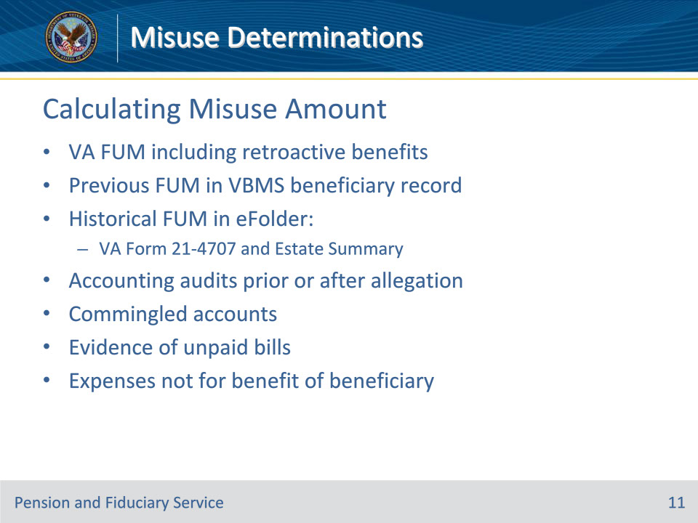
Slide notes

Policy Reference(s): FPM II.3.A.4.d.

Instructor Notes:

The final misuse amount must consider all the following items:

• VA FUM to include any retroactive benefits received

• previous FUM in the VBMS beneficiary record

• historical FUM in the eFolder on the VA Form 21-4707, Estate Summary

• accounting audits prior to or after the misuse allegation

• commingled accounts

• evidence of unpaid bills

• expenses not for the benefit of the beneficiary; fees, including legal fees and court costs are typically considered for the benefit of the beneficiary

Slide 12 - Calculating Misuse Amount
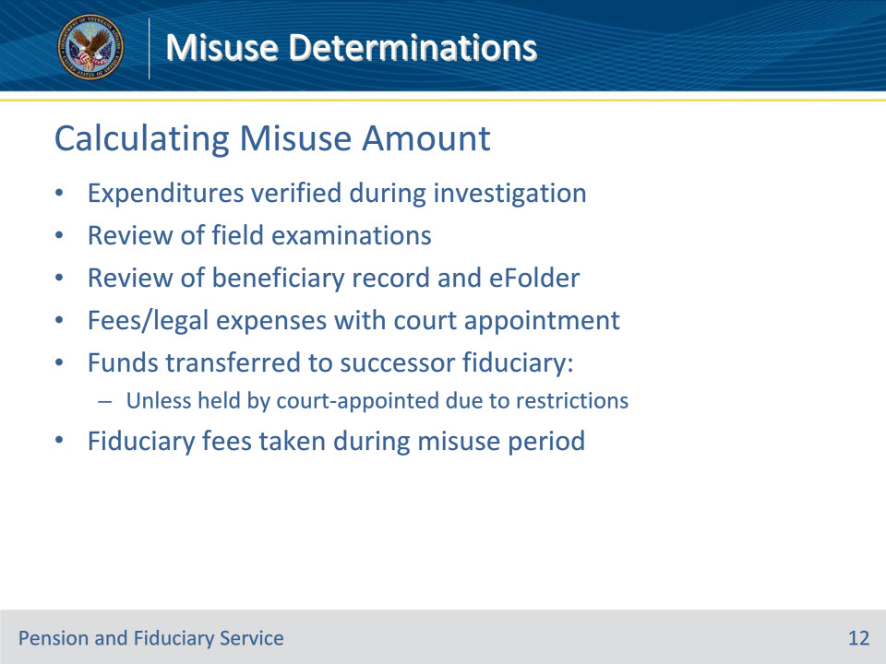
Slide notes

Policy Reference(s): FPM II.3.A.4.d.

Instructor Notes:

• expenditures verified by the FE during the misuse investigation as paid by the fiduciary

• review of field examinations prior to, during, and following removal of misusing fiduciary

• review of the beneficiary record and eFolder

• fees and legal expenses associated with a court appointment

• funds previously issued to the fiduciary that were transferred to a successor fiduciary, unless the funds are held by a court-appointed fiduciary and have not been transferred due to court restrictions, and

• fiduciary fees taken during a period of misuse.

Slide 13 - Calculating Misuse Amount (Cont.)
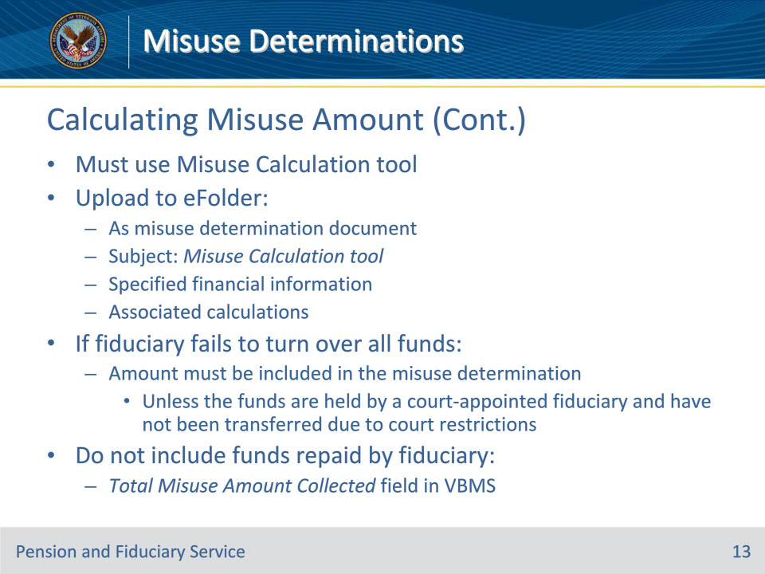
Slide notes

Policy Reference(s): FPM II.3.A.4.d.

Instructor Notes:

• The final misuse amount must be determined by using the Misuse Calculation tool currently authorized by P&F Service. This tool is used to calculate VA and other misuse amounts to include both the remaining FUM and the misuse amount. This calculation tool must be uploaded to the eFolder as a misuse determination document with the subject Misuse Calculation tool.

• Specified financial information and associated calculations from the Misuse Calculation tool must be uploaded to the beneficiary’s eFolder.

• If the fiduciary fails to turn over all VA funds, the amount must be included in the misuse determination, unless the funds are held by a court-appointed fiduciary as described in this block.

• Do not include funds repaid by the fiduciary in the calculation for the misuse amount. If any funds were repaid by the fiduciary, this amount is documented in the TOTAL MISUSE AMOUNT COLLECTED field in the misuse record in VBMS.

• Once the final misuse amount is determined using the Misuse Calculation tool, follow the guidance in FPM, Part II, 3.A.4.e to create a summary of the calculation. This summary will be the attachment to the misuse determination.

Slide 14 - Calculation Summary
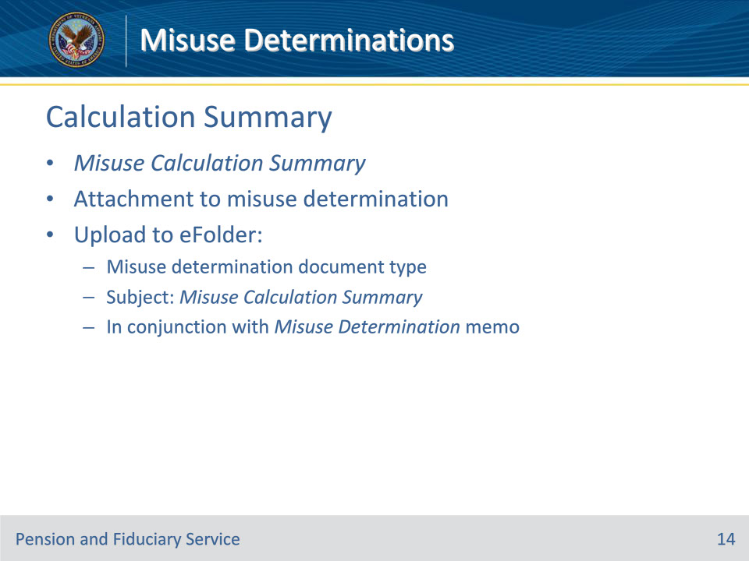
Slide notes

Policy Reference(s): FPM II.3.A.4.e.

Instructor Notes:

After determining the final misuse amount using the Misuse Calculation tool, a summary of the calculations must be created that will accompany the misuse determination as an attachment. The top of the document will indicate Misuse Calculation Summary and must be uploaded to the eFolder as a misuse determination document type with the subject Misuse Calculation Summary. This summary document must be uploaded in conjunction with completion of the Misuse Determination memorandum.

Slide 15 - Calculation Summary
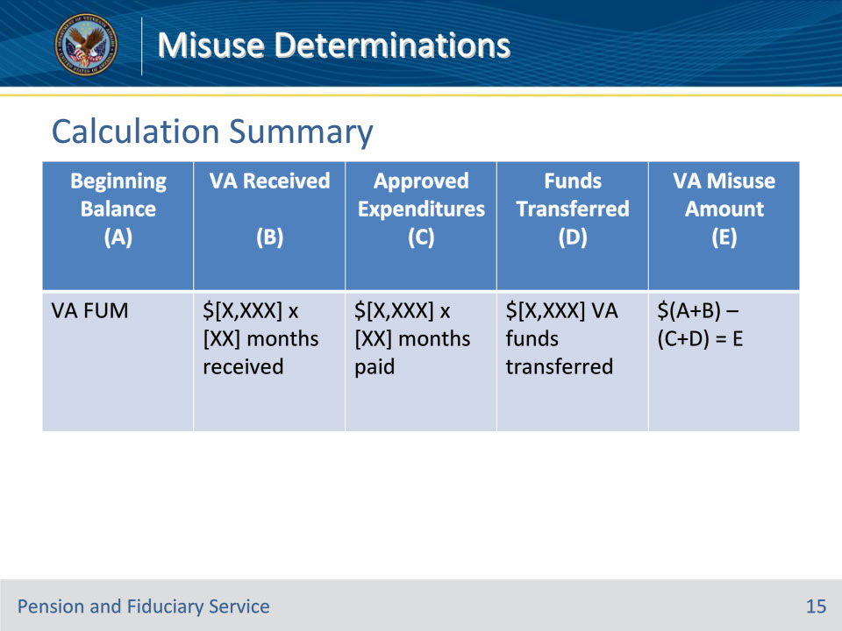
Slide notes

Policy Reference(s): FPM II.3.A.4.e.

Instructor Notes:

The template above should be used for the Misuse Calculation Summary. The template shows the basic formula of (A+B)-(C+D)=E. When completing the template, replace the formulas provided with the appropriate numerical values.

If no misuse is found, the total VA misuse amount should be shown as N/A with the remainder of the fields blank.

Slide 16 - No Face-to-Face Visit
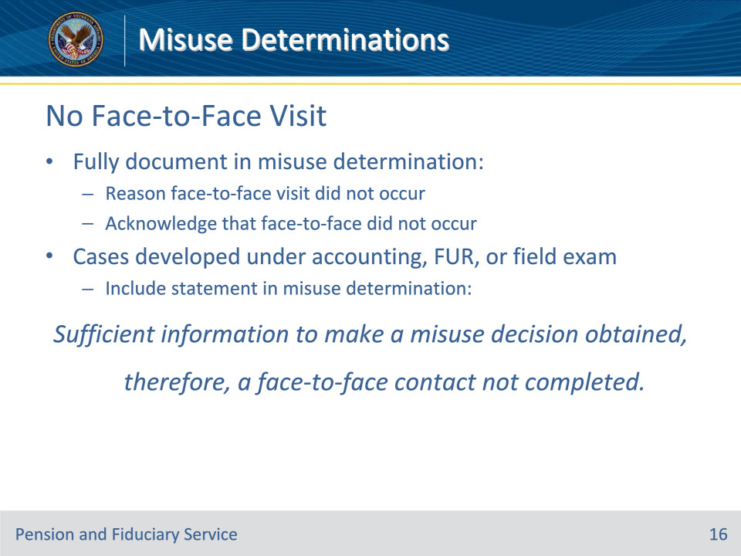
Slide notes

Policy Reference(s): FPM II.3.A.4.f.

Instructor Notes:

In cases where a face-to-face visit with the fiduciary cannot be accomplished, or was not necessary, document

• the reason a face-to-face visit did not occur, and

• acknowledgement that a face-to-face visit did not occur.

For cases developed under an accounting, fund usage review, or field examination include a statement in the discussion of the misuse determination facts similar to:

Sufficient information to make a misuse decision obtained, therefore, a face-to-face contact not completed.

Slide 17 - Processing Determination
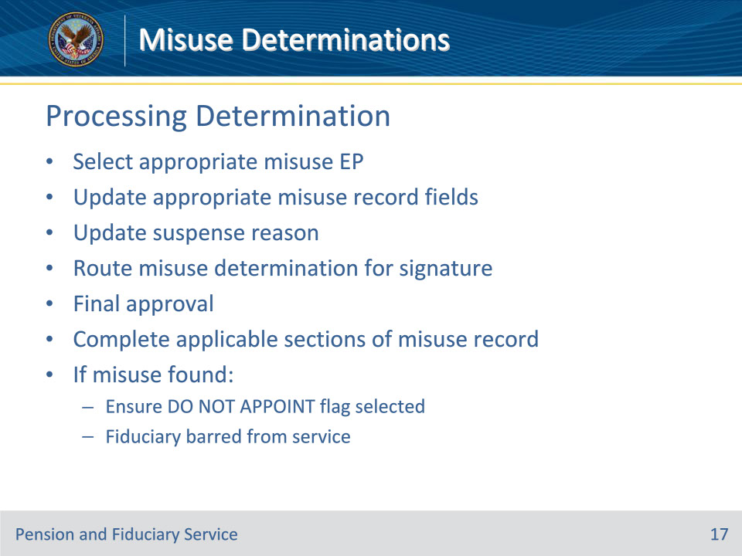
Slide notes

Policy Reference(s): FPM II.3.A.4.g.

Instructor Notes:

Select the appropriate misuse EP and navigate to the misuse record to update all fields as appropriate to support the generation of the misuse determination memo and to track the misuse findings.

Once the appropriate hub employee concludes the misuse determination and VBMS entries are accurate and complete, the suspense reason for the EP is updated accordingly and the misuse determination is routed to the next level of signature authority. After final approval of the misuse determination, hub personnel must complete all applicable sections of the MISUSE RECORD.

Important: Upon completion of the misuse determination, if misuse is found, the hub employee must ensure the DO NOT APPOINT flag is selected on the fiduciary profile as the fiduciary is barred from service.

Slide 18 - Copies of Determination
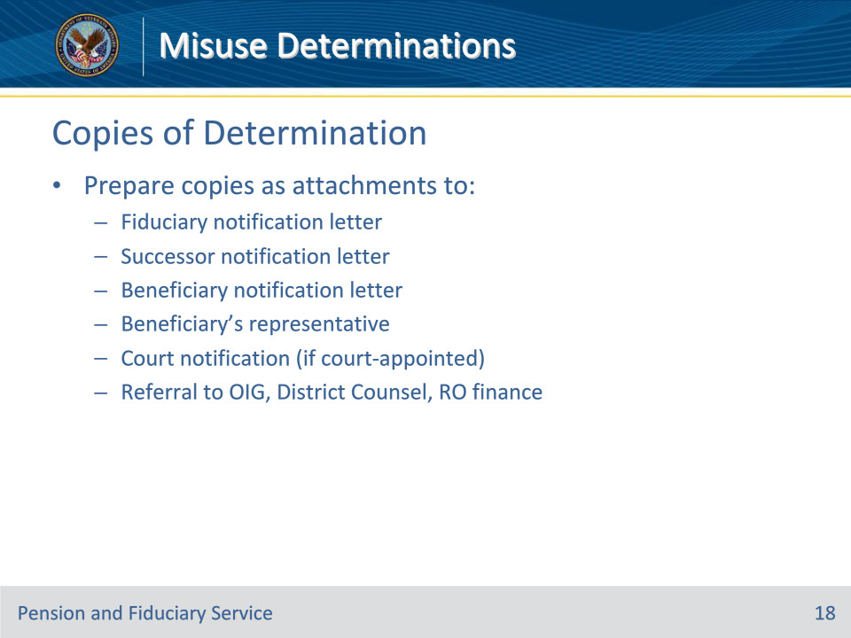
Slide notes

Policy Reference(s): FPM II.3.A.4.h.

Instructor Notes:

Hub personnel must upload the misuse determination to the eFolder and prepare copies as an attachment to the

• notification letter sent to the fiduciary

• copy of the notification letter sent to the successor fiduciary, if one is appointed

• notification letter to the beneficiary or the beneficiary’s legal guardian, and the beneficiary’s accredited representative, attorney, or claims agents

• notification to the court of jurisdiction, if the subject of the misuse investigations is a court appointed fiduciary, and

• referral to

• VA OIG, as appropriate

• District Counsel, if appropriate, and

• RO finance activity co-located with the hub when establishment of debt and/or reissuance of benefits is required.

Slide 19 - Finality
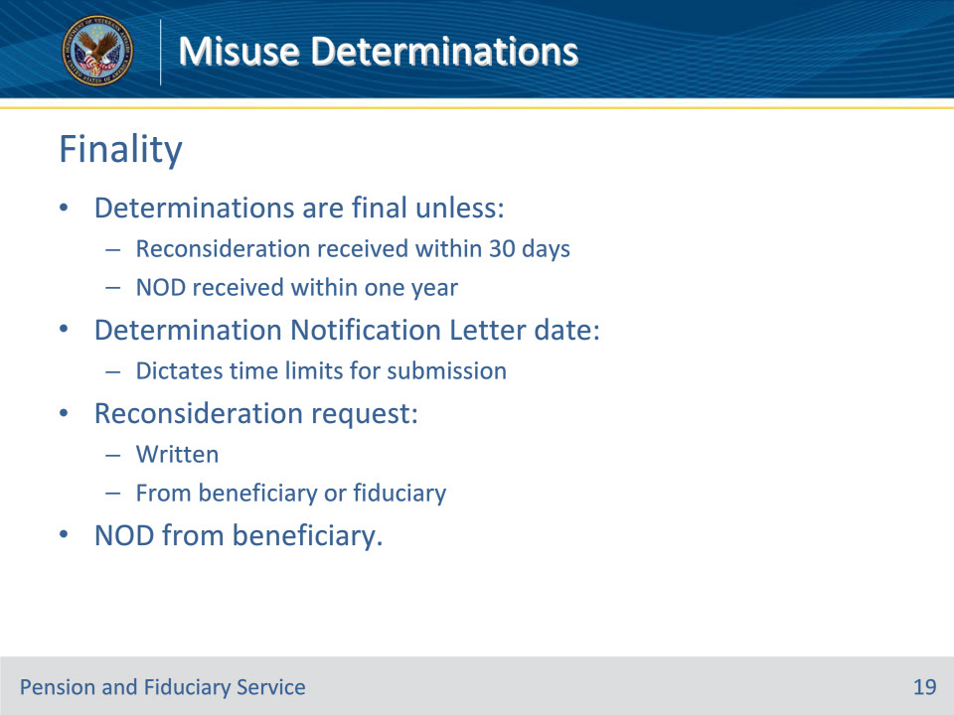
Slide notes

Policy Reference(s): FPM II.3.A.4.i.

Instructor Notes:

Misuse determinations are final unless the hub receives a

• written request for reconsideration from the beneficiary or fiduciary not later than 30 days after the date of the determination notification letter, or

• notice of disagreement (NOD) from the beneficiary not later than one year after the date of the determination notification letter.

Requests for reconsideration or appeal received later than the prescribed time period will not be considered.

Slide 20 - Recovered Funds
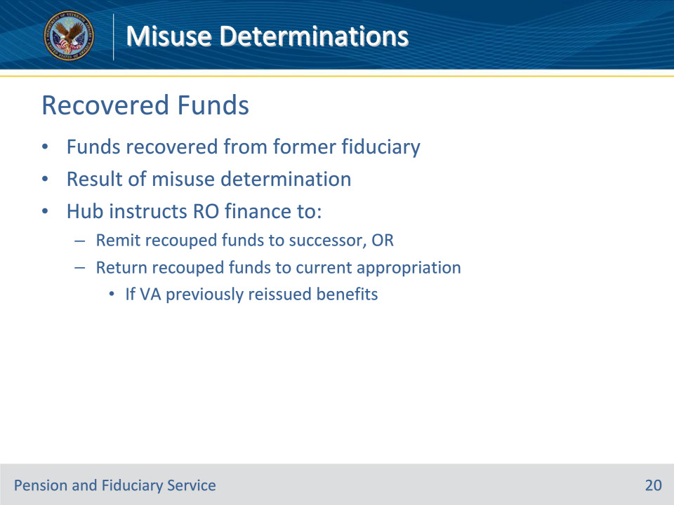
Slide notes

Policy Reference(s): FPM II.3.A.4.j.

Instructor Notes:

When funds are recovered from a former fiduciary as a result of a misuse determination, the hub will instruct RO finance activity whether to

• remit recouped funds to the successor fiduciary, or

• return recouped funds to the current appropriation if VA previously reissued benefits.

Slide 21 - Fiduciary Notification
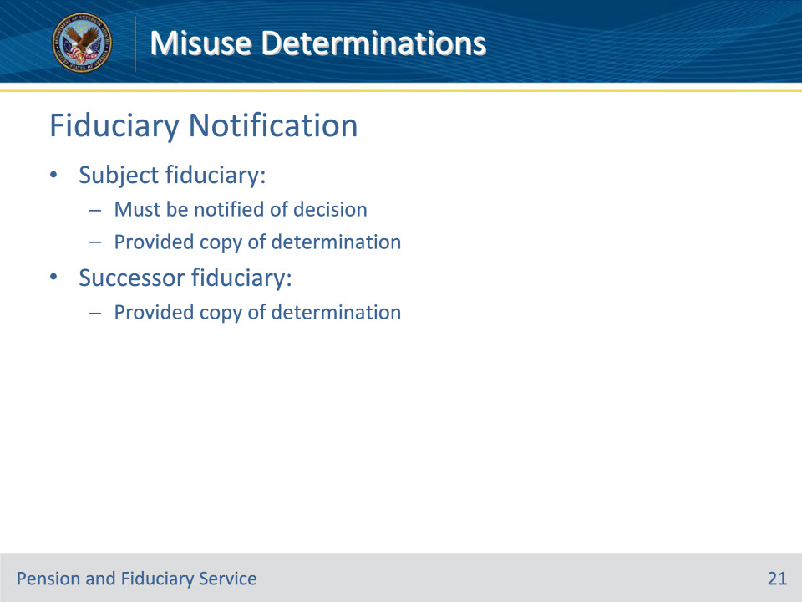
Slide notes

Policy Reference(s): FPM II.3.A.5.a.

Instructor Notes:

Any fiduciary who is the subject of a misuse investigation must be notified of the decision and provided a copy of the misuse determination. When generating correspondence, the hub must follow the guidance for dating and uploading the letter into the eFolder to be centrally printed.

A copy of the misuse determination must be sent to the successor fiduciary if one is appointed.

Slide 22 - Decision Letter
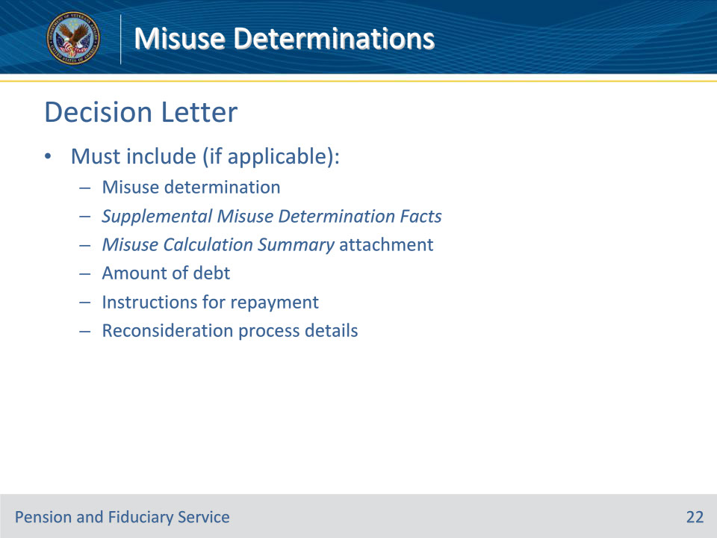
Slide notes

Policy Reference(s): FPM II.3.A.5.a.

Instructor Notes:

The decision letter must include

• a copy of the

• misuse determination

• Supplemental Misuse Determination Facts, if applicable, and

• Misuse Calculation Summary attachment

• amount of debt, if applicable

• instructions for repayment, if applicable, and

• details on the reconsideration process.

Slide 23 - Returned Mail
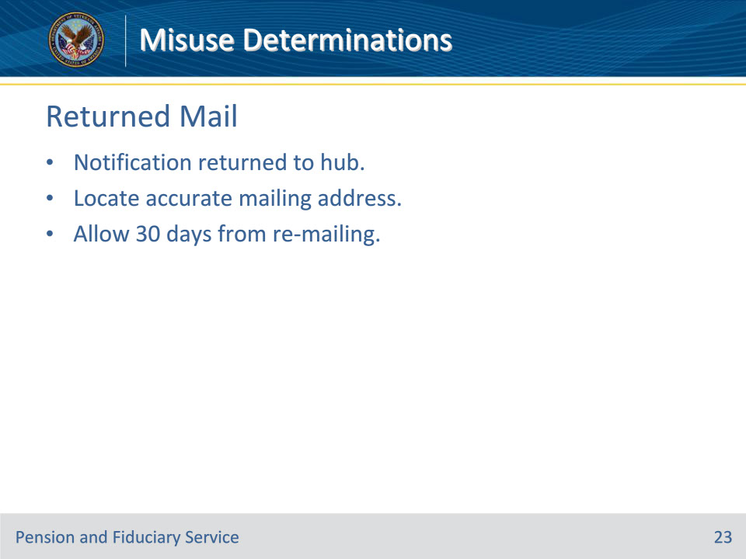
Slide notes

Policy Reference(s): FPM II.3.A.5.a.

Instructor Notes:

In instances where the misuse determination notification is returned to the hub, employees must make every effort to locate an accurate mailing address for the fiduciary. The hub must allow the 30-day time period when the notification is re-mailed due to unsuccessful attempts.

Slide 24 - Beneficiary Notification
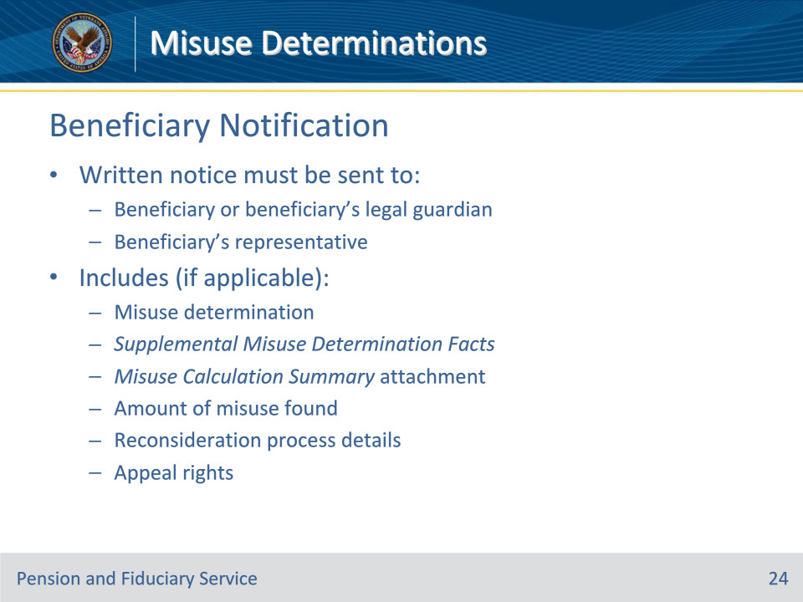
Slide notes

Policy Reference(s): FPM II.3.A.5.b.

Instructor Notes:

Any beneficiary who has had a misuse determination completed, must be provided the right to appeal that determination and also the right to request a reconsideration. The beneficiary or the beneficiary’s legal guardian, and the beneficiary’s accredited representative, attorney or claims agent must be sent written notice that includes:

• a copy of the

• misuse determination

• Supplemental Misuse Determination Facts, if applicable, and

• Misuse Calculation Summary attachment

• amount of misuse found, if applicable

• details on the reconsideration process, and

• details of the appeal rights.

When generating correspondence, the hubs must follow the guidance for dating and uploading the letter into the eFolder to be centrally printed.

Slide 25 - Court Notification
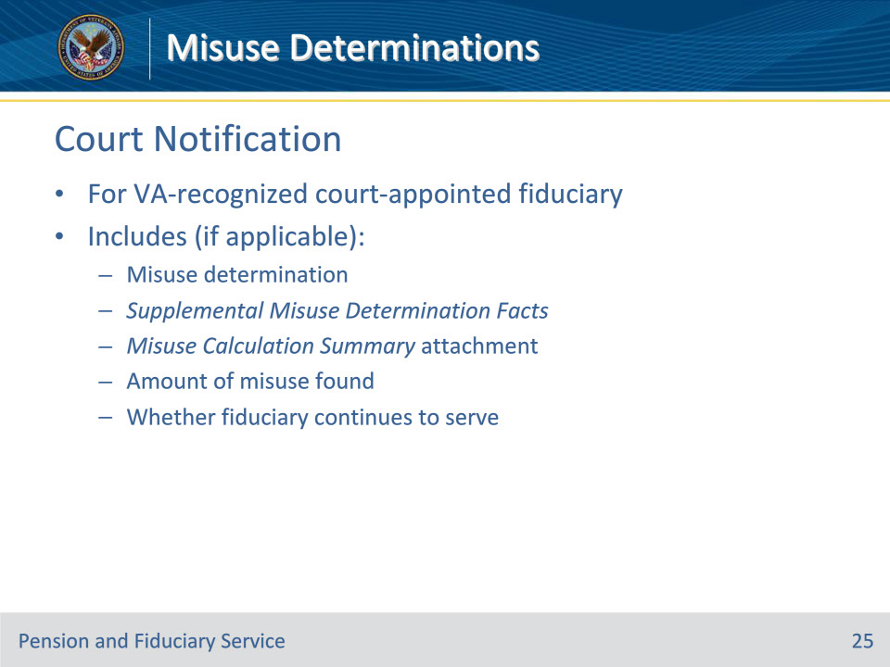
Slide notes

Policy Reference(s): FPM II.3.A.5.c.

Instructor Notes:

If the fiduciary who is the subject of the misuse investigation also serves as a court appointed (VA-recognized) fiduciary, notification must be sent to the court of jurisdiction for any determination regarding misuse. The notification must include

• a copy of the

• misuse determination

• Supplemental Misuse Determination Facts, if applicable, and

• Misuse Calculation Summary attachment

• amount of misuse found, if applicable, and

• information about whether the fiduciary continues to serve.

When generating correspondence, hub personnel must follow the guidance for dating and uploading the letter into the eFolder to be centrally printed

Slide 26 - Misuse Calculation
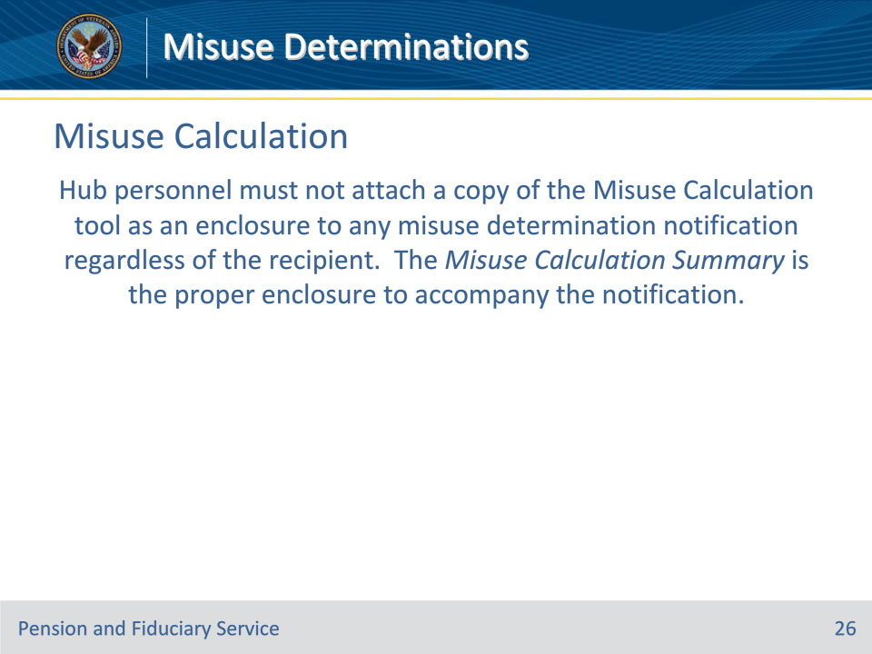
Slide notes

Policy Reference(s): FPM II.3.A.5.a.-c.

Instructor Notes:

Hub personnel must not attach a copy of the Misuse Calculation tool as an enclosure to any misuse determination notification regardless of the recipient. The Misuse Calculation Summary is the proper enclosure to accompany the notification.

Slide 27 - Notification Control
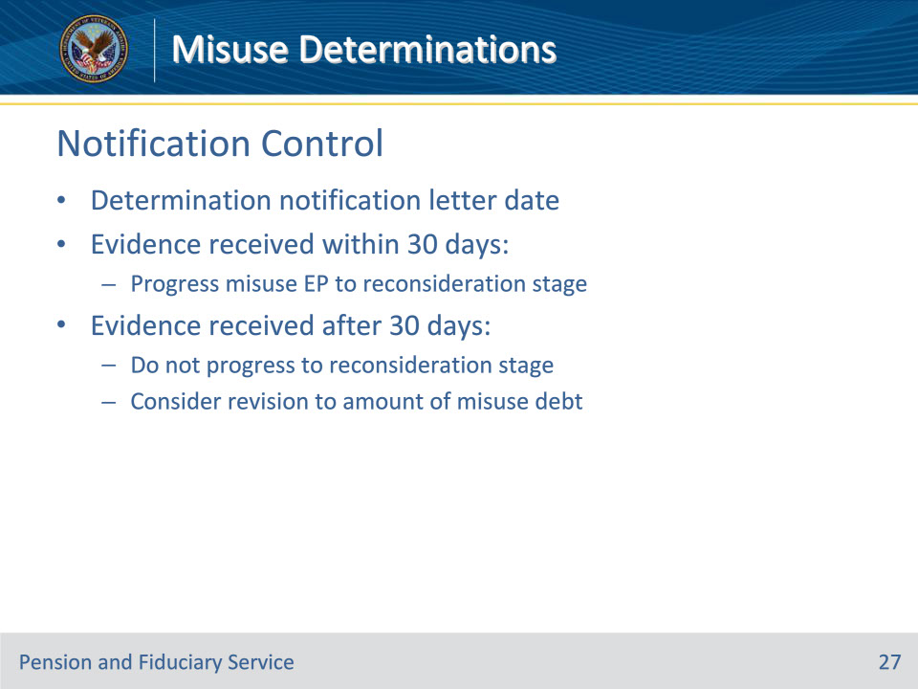
Slide notes

Policy Reference(s): FPM II.3.A.5.d.

Instructor Notes:

If evidence is received from the fiduciary or beneficiary not later than 30 days after the date of the determination notification letter, hub personnel should progress the misuse EP to reconsideration stage.

If evidence is received from the fiduciary or beneficiary later than 30 days after the date on the notification letter, a reconsideration determination must not be completed. However, the hub may consider the information received for revision to the amount of misuse debt.

Slide 28 - 31. Questions?
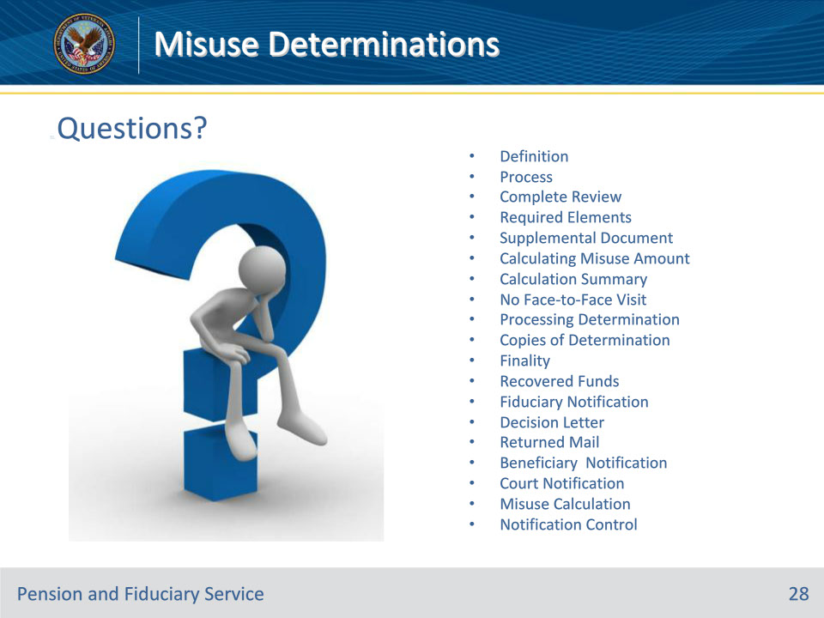
Slide notes

Instructor Notes:

(Recall) These are our learning objectives as stated from the beginning of the training:

• Define misuse determination process

• Satisfy required elements of a determination

• Calculate the misuse amount

• Process misuse determination

• Perform required notifications

(Recap) We discussed each of these learning objectives through the following topics in each slide today:

• Definition

• Process

• Complete Review

• Required Elements

• Supplemental Document

• Calculating Misuse Amount

• Calculation Summary

• No Face-to-Face Visit

• Processing Determination

• Copies of Determination

• Finality

• Recovered Funds

• Fiduciary Notification

• Decision Letter

• Returned Mail

• Beneficiary Notification

• Court Notification

• Misuse Calculation

• Notification Control

Are there any additional questions?

Questions should be filtered through your QRT team. They will submit your questions to the Field Inquiry Tool (FIT) on your behalf.

Slide 29 - TMS Survey/Assessment
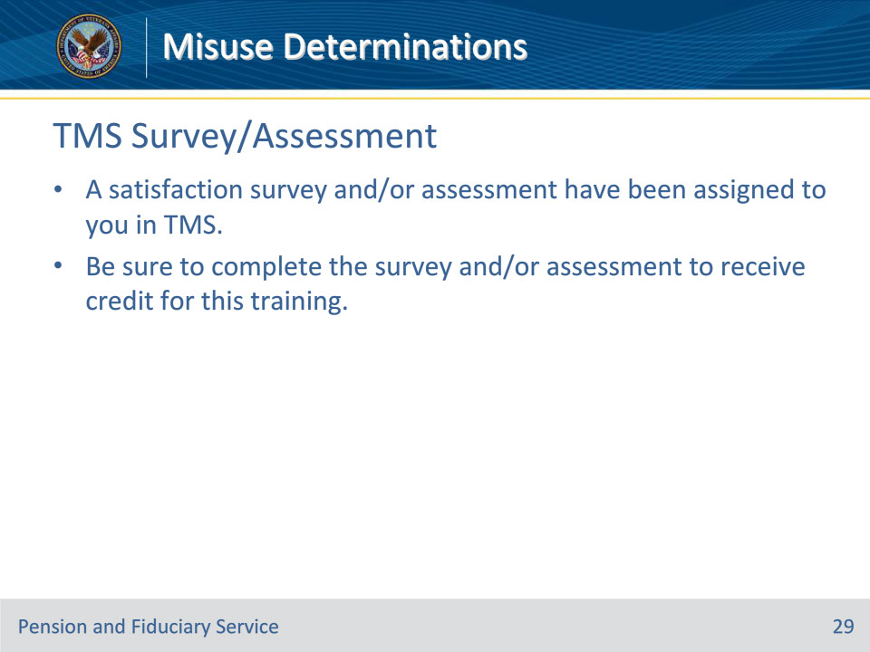
Slide notes

Instructor Notes:

A satisfaction survey and/or assessment have been assigned to you in TMS.

Be sure to complete the survey and/or assessment to receive credit for this training.

