Slide 1 - Fiduciary Appeals Overview
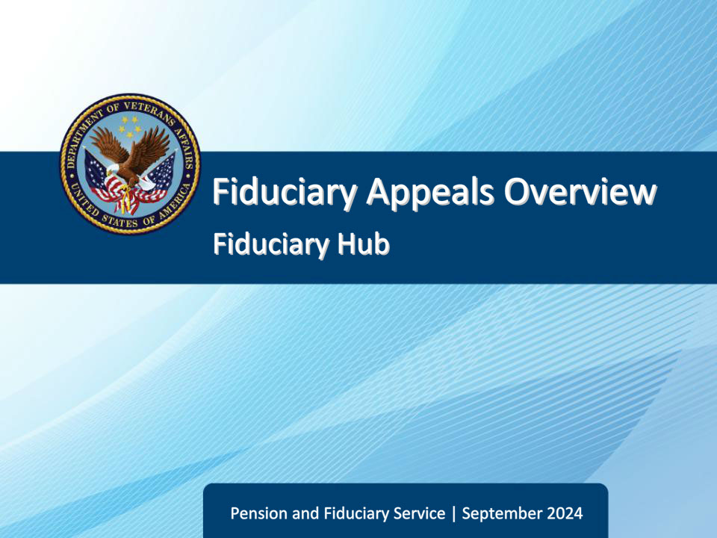
Slide notes

Course Description:

This course teaches learners the authority of appealable fiduciary decisions and common fiduciary appeals terminology and definitions.

Slide 2 - Objectives
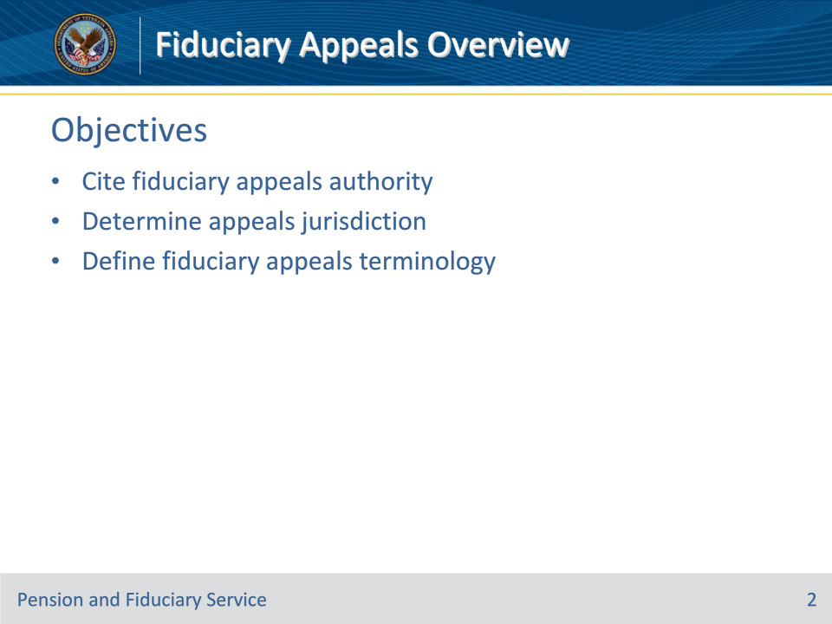
Slide notes

Instructor Notes:

At the end of this lesson, given the training and references, the learner will be able to do the following:

• Cite fiduciary appeals authority

• Determine appeals jurisdiction

• Define fiduciary appeals terminology

Slide 3 - References
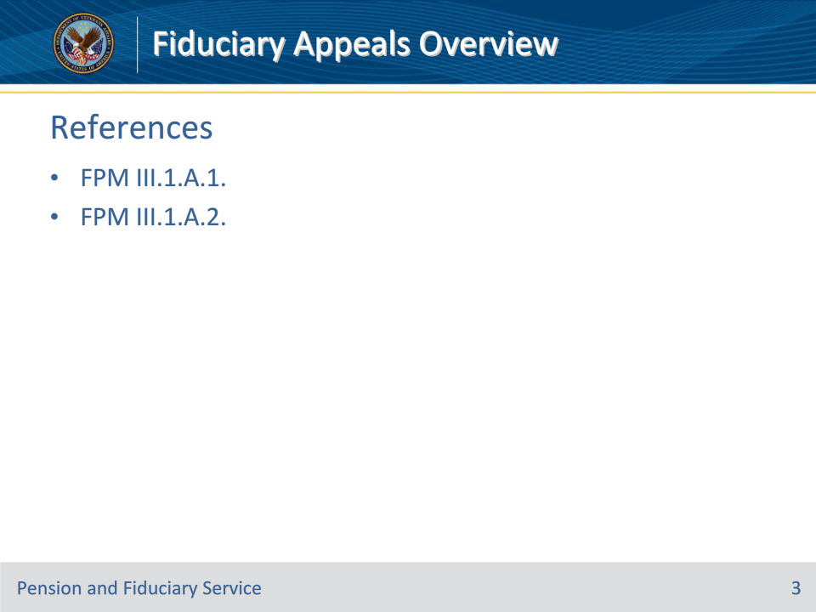
Slide notes

Instructor Notes:

These are the relevant references pertaining to this course:

• FPM III.1.A.1. Fiduciary Appeals Authority

• FPM III.1.A.2. Common Appeals Terminology

Slide 4 - Appeals Authority
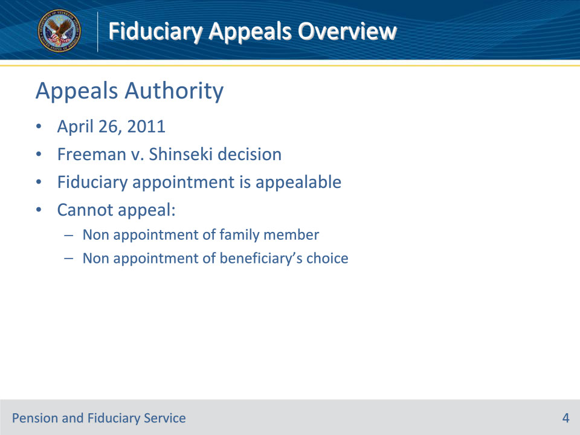
Slide notes

Policy Reference(s): FPM III.1.A.1.a.

Instructor Notes:

Generally, Department of Veterans Affairs (VA) decisions regarding fiduciary matters are committed to the Secretary of VAs’ discretion by law and cannot be appealed to the Board of Veterans’ Appeals (BVA) or any court.

On April 26, 2011, the Court of Appeals for Veterans Claims (CAVC) decided Freeman v. Shinseki, 24 Vet.App. 404 (2011) holding that VA’s appointment of a fiduciary is subject to appeal by the beneficiary to BVA and thereafter to the CAVC.

Although VA fiduciary appointments are appealable, the beneficiary cannot appeal the fact that VA did not appoint his/her family member or choice of fiduciary.

Slide 5 - Appealable Decisions
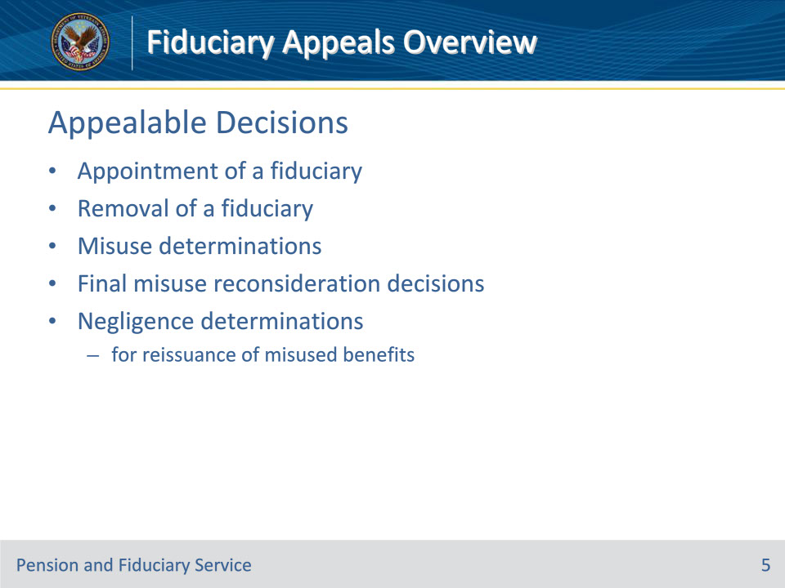
Slide notes

Policy Reference(s): FPM III.1.A.1.a.

Instructor Notes:

The Fiduciary Program has extended the holding in Freeman v. Shinseki, 24 Vet.App. 404 (2011) allowing a beneficiary to appeal to BVA the following decisions:

• the appointment of a fiduciary

• the removal of a fiduciary

• misuse determinations

• final decisions upon reconsideration of a misuse determination, and

• negligence determinations for the purposes of reissuance of misused benefits.

Slide 6 - Appealable Decisions (Cont.)
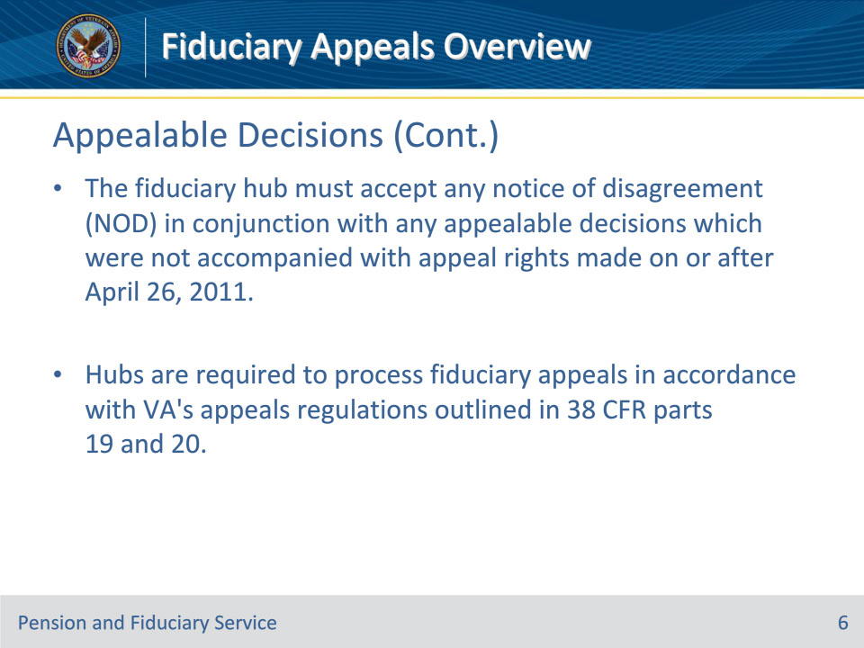
Slide notes

Policy Reference(s): FPM III.1.A.1.a.

Instructor Notes:

The fiduciary hub (hub) must accept any notice of disagreement (NOD) in conjunction with any appealable decisions which were not accompanied with appeal rights made on or after April 26, 2011, date of the Freeman v. Shinseki, 24 Vet.App. 404 (2011) decision, because 38 CFR 13.600 extended the holding in Freeman v. Shinseki, 24 Vet.App. 404 (2011) decision to any fiduciary decision that is made under a law that affects the provision of benefits to Veterans or to the dependents or survivors of Veterans.

Hubs are required to process fiduciary appeals in accordance with VA’s appeals regulations outlined in 38 CFR parts 19 and 20.

Slide 7 - Appeals Jurisdiction
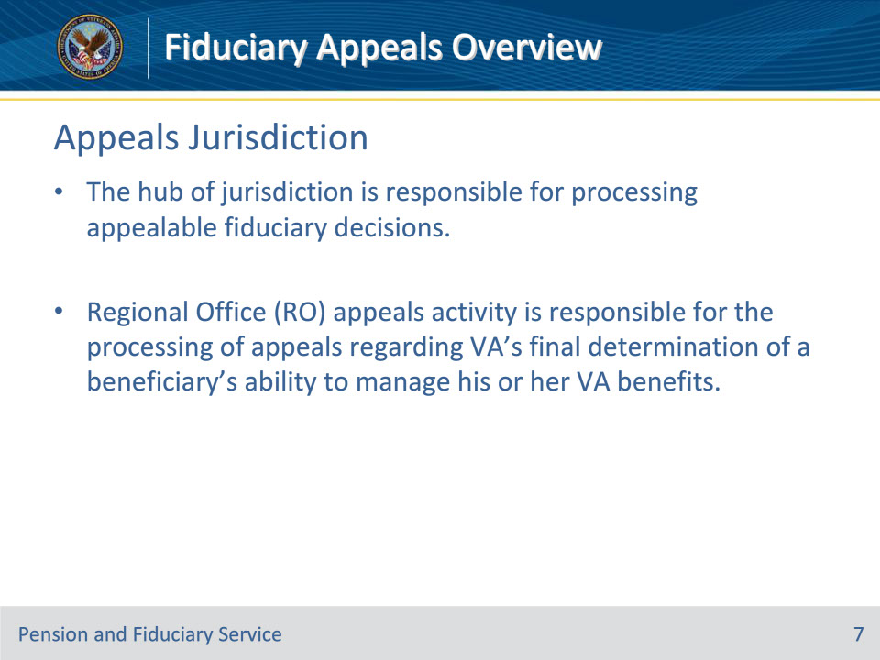
Slide notes

Policy Reference(s): FPM III.1.A.1.b.

Instructor Notes:

The hub of jurisdiction is responsible for processing appealable fiduciary decisions.

Regional Office (RO) appeals activity is responsible for the processing of appeals regarding VA’s final determination of a beneficiary’s ability to manage his or her VA benefits.

Slide 8 - Appellant
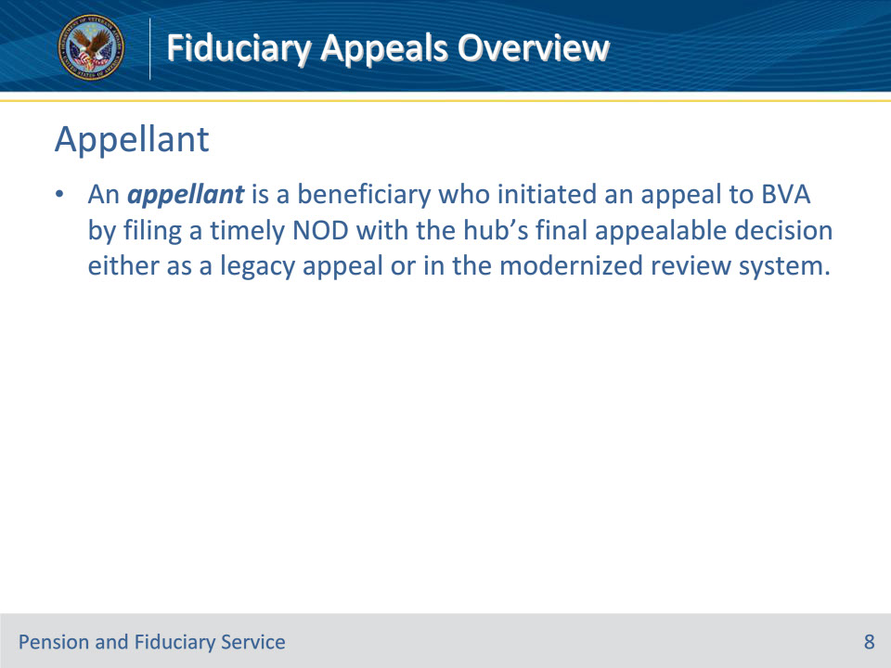
Slide notes

Policy Reference(s): FPM III.1.A.2.a.

Instructor Notes:

An appellant is a beneficiary who initiated an appeal to BVA by filing a timely NOD with the hub’s final appealable decision either as a legacy appeal or in the modernized review system.

Slide 9 - Authorized Representative
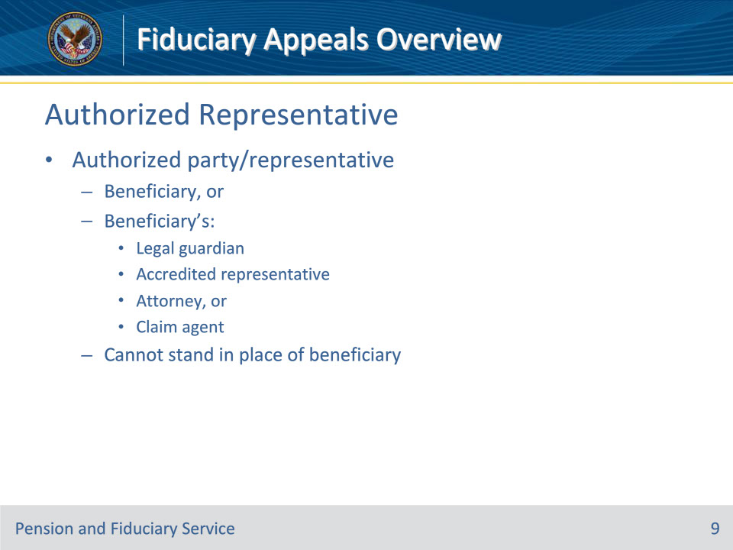
Slide notes

Policy Reference(s): FPM III.1.A.2.b.

Instructor Notes:

An authorized party/representative for purposes of submitting a fiduciary related appeal is one of the following:

• the beneficiary, or

• the beneficiary’s legal guardian, or accredited representative, attorney, or claim agent.

Representatives cannot stand in the place of the beneficiary. The representatives may be present at the hearing and may assist the beneficiary at the hearing, however; the beneficiary must be present at the hearing. Only VA-accredited attorneys, claims agents, and accredited representatives of VA-recognized Veterans service organizations who have complied with the power-of-attorney requirements in 38 CFR 14.631 may represent beneficiaries before VA in fiduciary matters.

Slide 10 - Appeals Designee
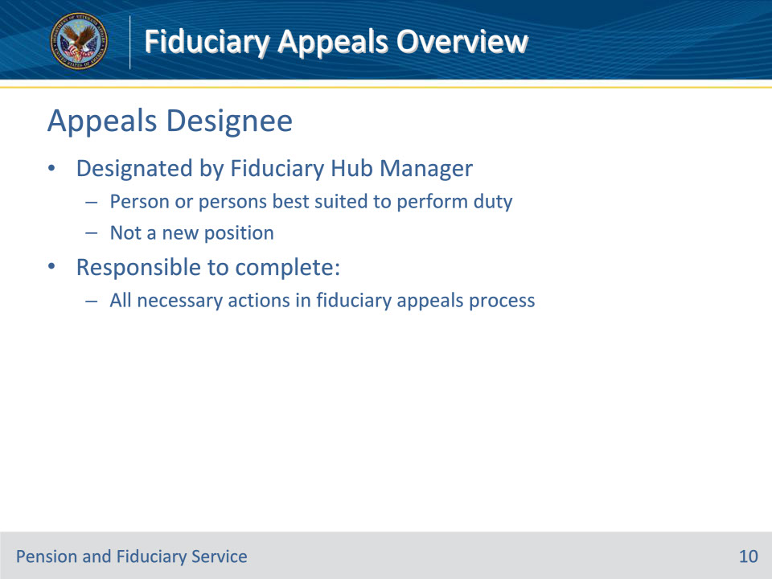
Slide notes

Policy Reference(s): FPM III.1.A.2.c.

Instructor Notes:

The appeals designee is designated by the Fiduciary Hub Manager (FHM) and is responsible to complete all necessary actions in the fiduciary appeal process. The FHM will appoint the person or persons considered best suited to perform this duty. The development of this duty and/or assignment is not meant to create a new position.

Slide 11 - Appeals Activity
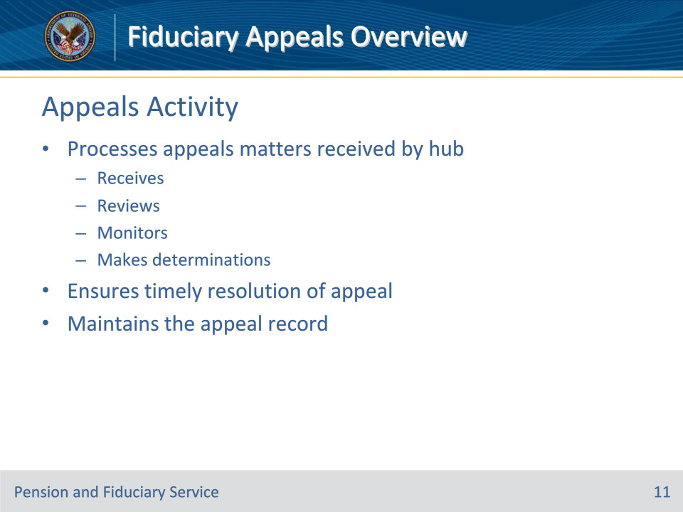
Slide notes

Policy Reference(s): FPM III.1.A.2.d.

Instructor Notes:

Appeals activity receives, reviews, monitors, and makes determinations regarding appeals matters received by the hub. The appeals activity ensures a speedy and timely resolution of the appeal and maintains and preserves the appeal record.

Slide 12 - Notice of Disagreement
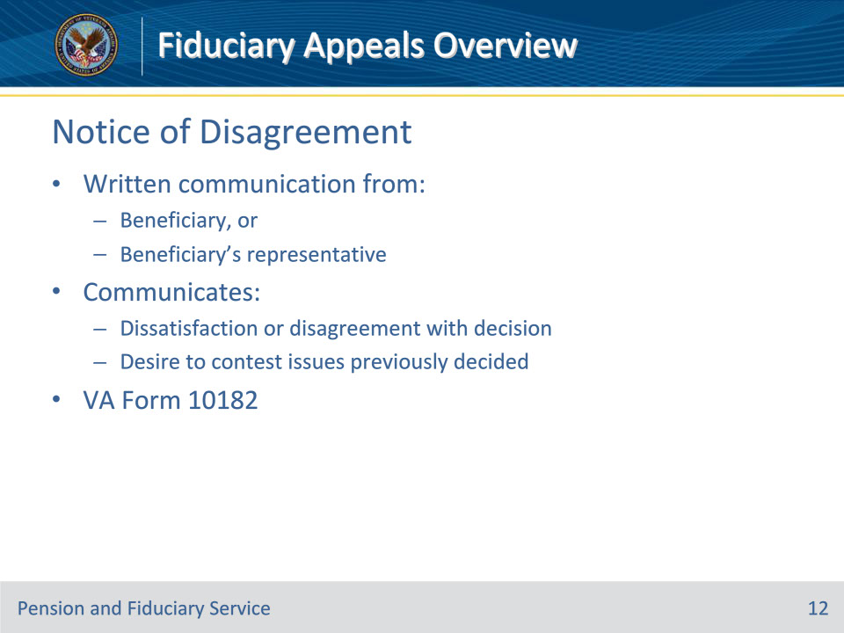
Slide notes

Policy Reference(s): FPM III.1.A.2.e.

Instructor Notes:

A notice of disagreement is a written communication from a beneficiary or his/her representative expressing

• dissatisfaction or disagreement with a decision, and

• a desire to contest issues previously decided.

For NODs regarding an appealable fiduciary decision, VA will accept the NOD on VA Form 10182, Decision Review Request: Board Appeal (Notice of Disagreement), for any benefit decision made on or after February 19, 2019, which the claimant would like reviewed directly by BVA.

Slide 13 - Post-Decision Review
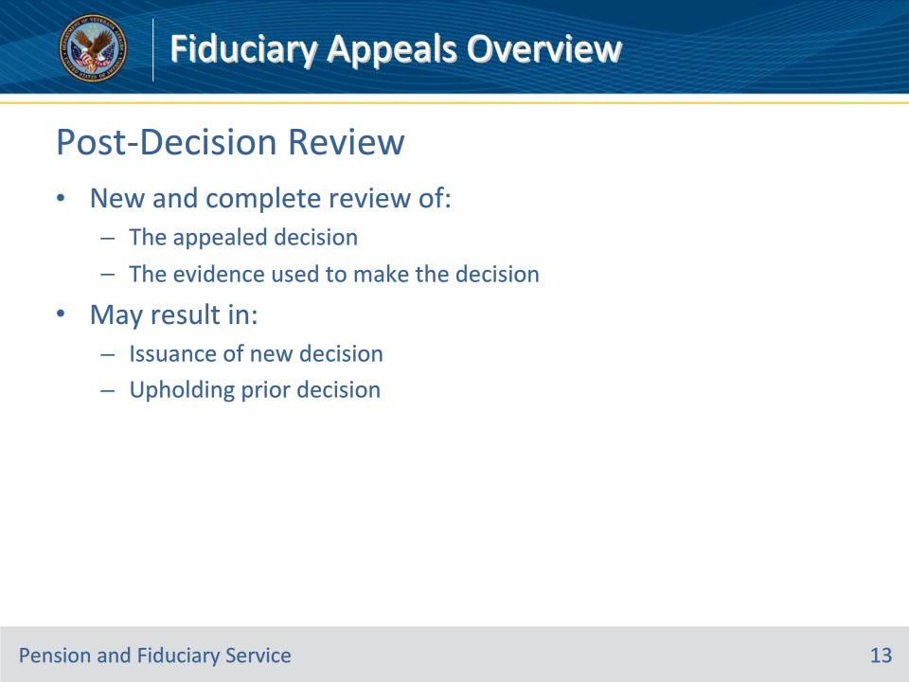
Slide notes

Policy Reference(s): FPM III.1.A.2.f.

Instructor Notes:

A post-decision review is a new and complete review of the appealed decision and the evidence used to make the prior decision. This review could result in the issuance of a new decision or uphold the prior decision.

Slide 14 - New Decision on Appeal
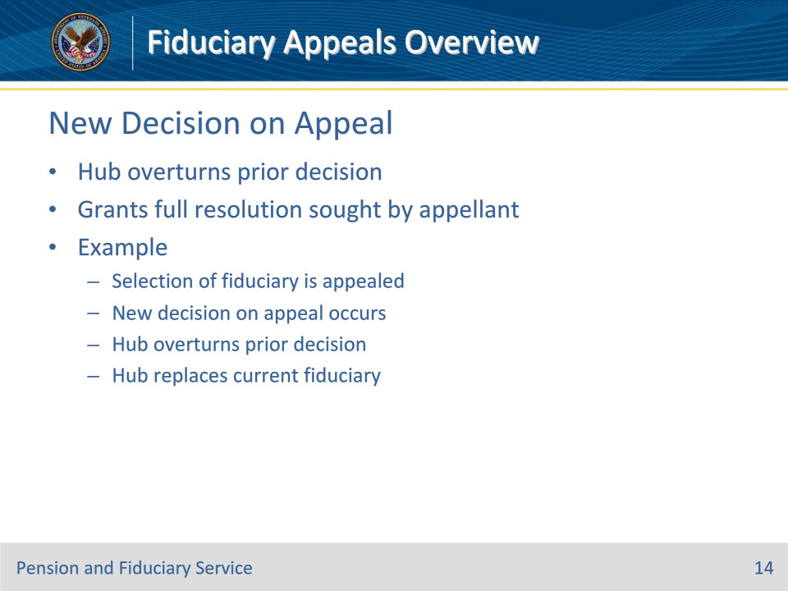
Slide notes

Policy Reference(s): FPM III.1.A.2.g.

Instructor Notes:

A new decision on appeal occurs when the hub overturns the prior decision and grants full resolution sought by an appellant.

Example: For appeals on the selection of a fiduciary, a new decision on appeal occurs when the hub overturns the prior decision and replaces the current fiduciary.

Slide 15 - Informal Conference
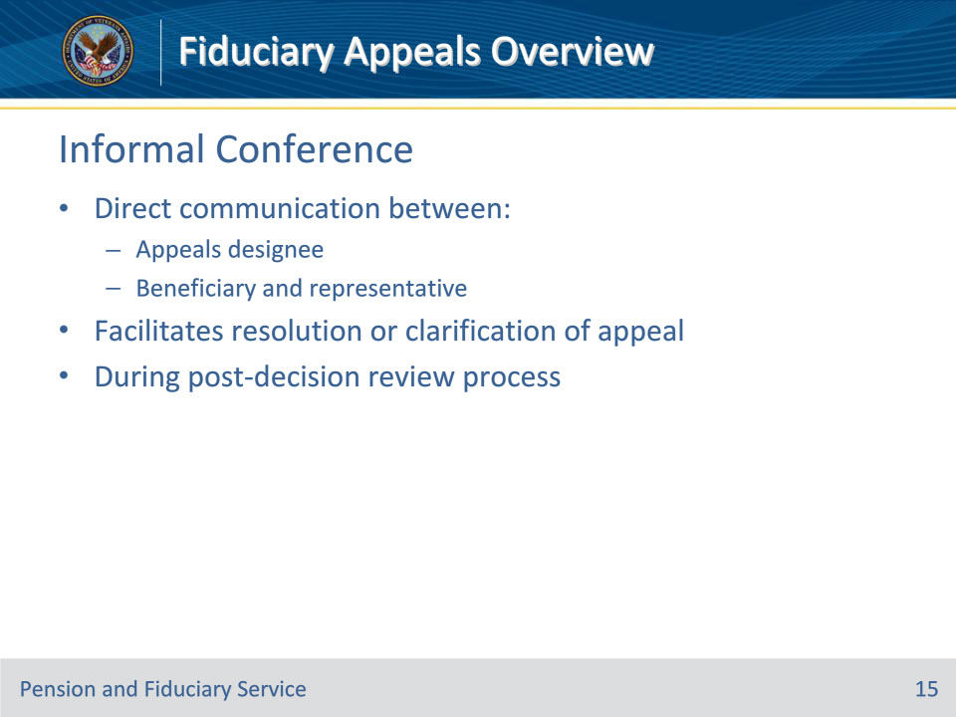
Slide notes

Policy Reference(s): FPM III.1.A.2.h.

Instructor Notes:

An informal conference is a tool available to the hub or RO personnel during the post-decision review process to ensure all parties understand the issue pending review.

An informal conference is a direct communication between the appeals designee and the beneficiary and his/her representative to facilitate resolution or clarification of the appeal.

Slide 16 - SOC and SSOC
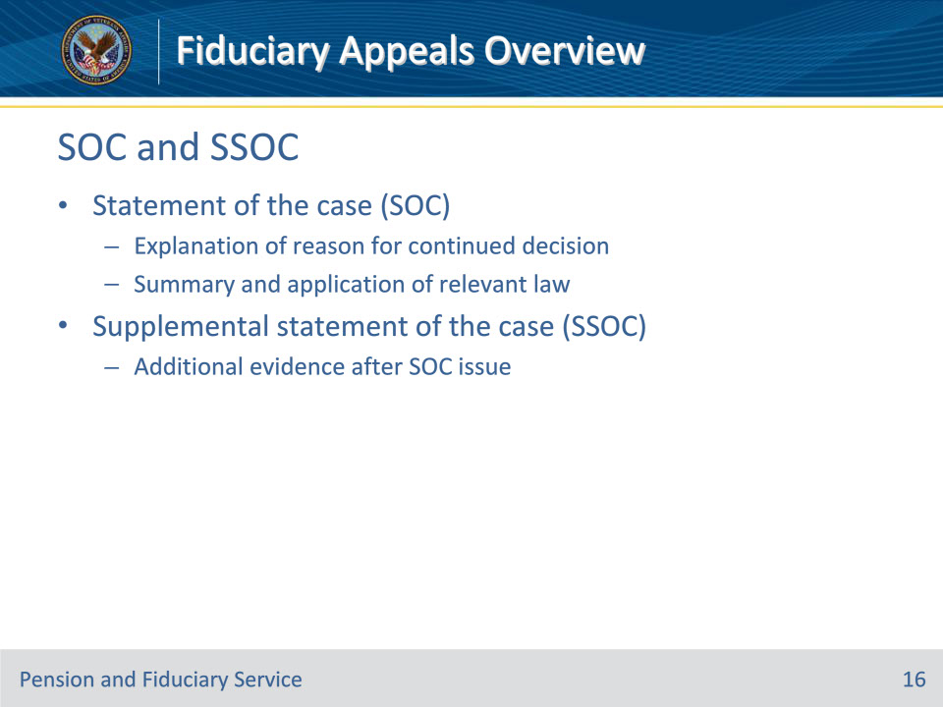
Slide notes

Policy Reference(s): FPM III.1.A.2.i.; j.

Instructor Notes:

A statement of the case (SOC) is an explanation of the reason for the continued decision with a summary of the relevant law and how it was applied to the evidence before the hub.

A supplemental statement of the case (SSOC) is furnished when additional pertinent evidence is received after an SOC or the most recent SSOC has been issued before or after receipt of a substantive appeal, or after a remand.

Slide 17 - Remanded Appeal
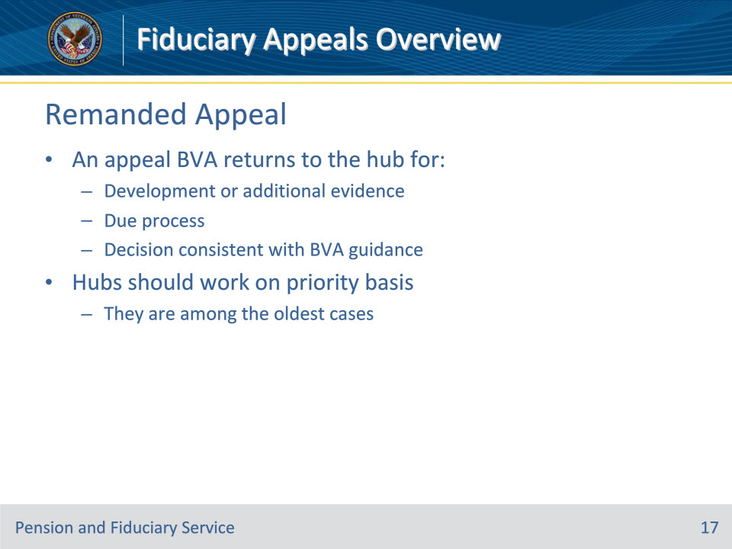
Slide notes

Policy Reference(s): FPM III.1.A.2.k.

Instructor Notes:

A remanded appeal is an appeal that BVA returns to the hub for

• development of additional evidence

• due process, or

• for a decision consistent with the guidance provided by the BVA.

Hubs should work remanded appeals on a priority bases as they are among the oldest cases.

Slide 18 - Testimony
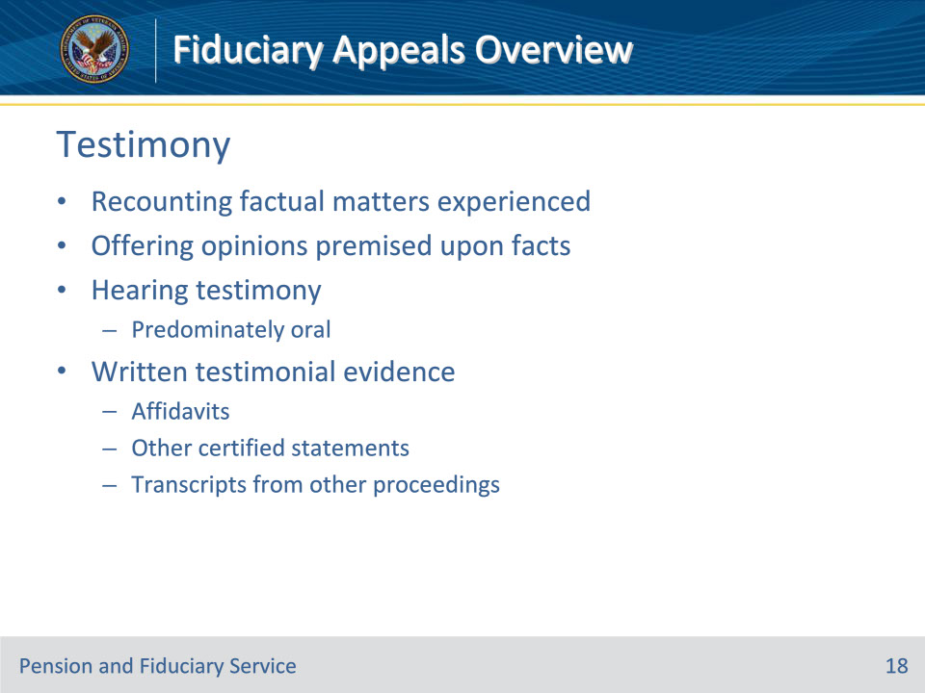
Slide notes

Policy Reference(s): FPM III.1.A.2.l.

Instructor Notes:

Testimony refers to a person recounting factual matters he/she experienced and/or offering opinions premised upon other facts.

Hearing testimony is predominately oral. Written testimonial evidence includes affidavits or other certified statements, or transcripts from another proceeding.

Slide 19 - Argument
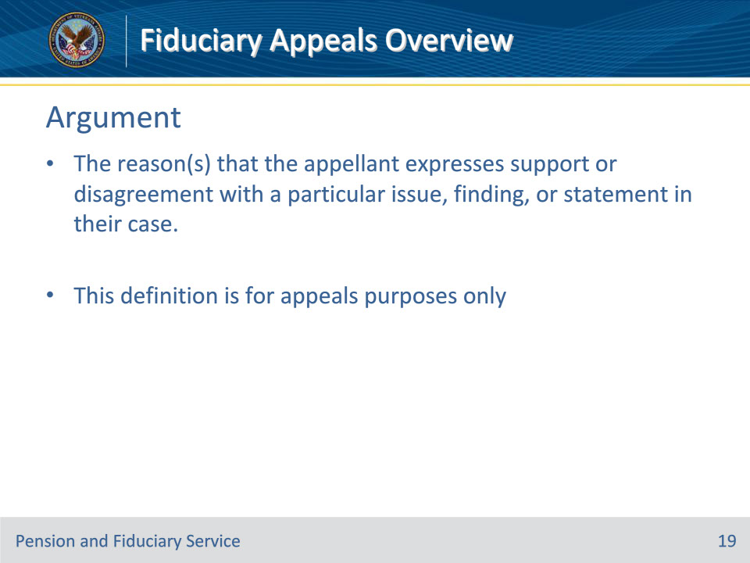
Slide notes

Policy Reference(s): FPM III.1.A.2.m.

Instructor Notes:

For the purposes of this appeals section only, an argument is the reason(s) that the appellant expresses support or disagreement with a particular issue, finding, or statement in his or her case.

Slide 20 - Agency of Original Jurisdiction
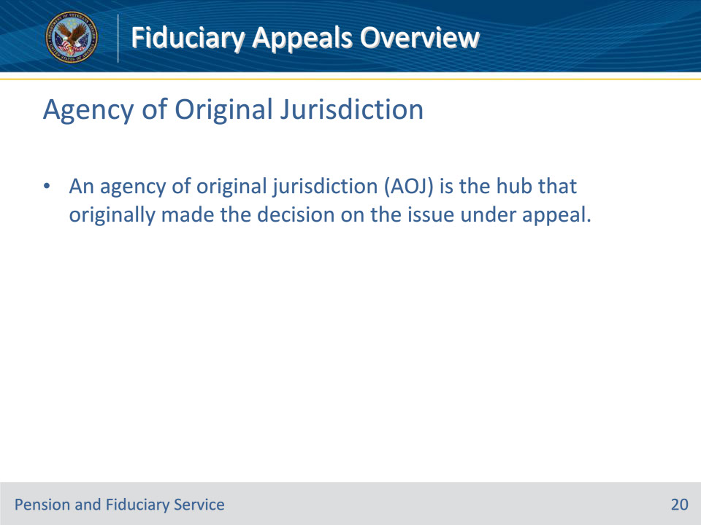
Slide notes

Policy Reference(s): FPM III.1.A.2.n.

Instructor Notes:

An agency of original jurisdiction (AOJ) is the hub that originally made the decision on the issue under appeal.

Slide 21 - Substantive Appeal
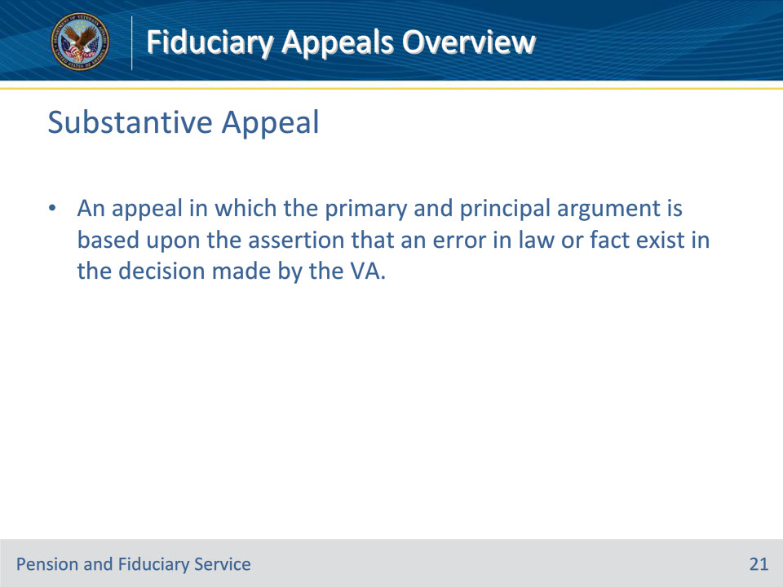
Slide notes

Policy Reference(s): FPM III.1.A.2.o.

Instructor Notes:

A substantive appeal is an appeal in which the primary and principal argument is based upon the assertion that an error in law or fact exist in the decision made by the VA.

Slide 22 - Hearing
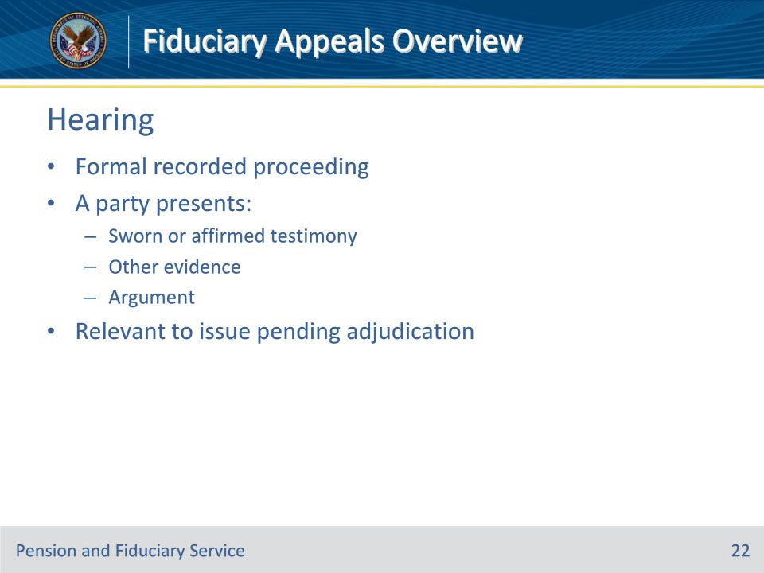
Slide notes

Policy Reference(s): FPM III.1.A.2.p.

Instructor Notes:

A hearing is a formal recorded proceeding wherein a party presents sworn or affirmed testimony, other evidence and/or argument relevant to an issue pending adjudication before the decision maker.

Slide 23 - Clear and Unmistakable Error
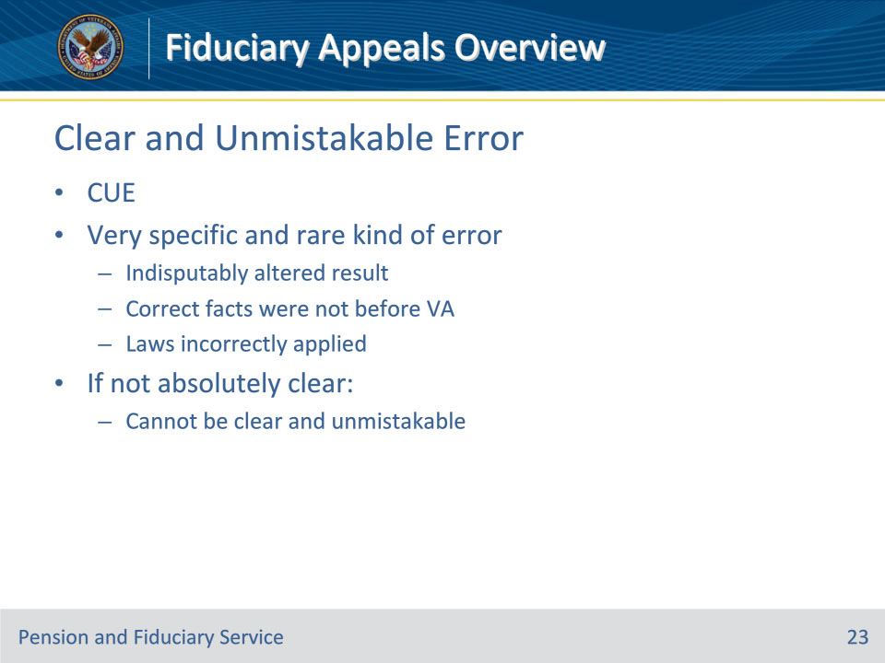
Slide notes

Policy Reference(s): FPM III.1.A.2.q.

Instructor Notes:

A clear and unmistakable error is a very specific and rare kind of error. It is the kind of error, of fact or of law, that when called to the attention of later reviewers compels the conclusion, to which reasonable minds could not differ, that the result would have been manifestly different but for the error.

If it is not absolutely clear that a different result would have ensued, the error complained of cannot be clear and unmistakable. Generally, either the correct facts, as they were known at the time, were not before VA, or the statutory and regulatory provisions existent at the time were incorrectly applied.

Slide 24 - De Novo Review
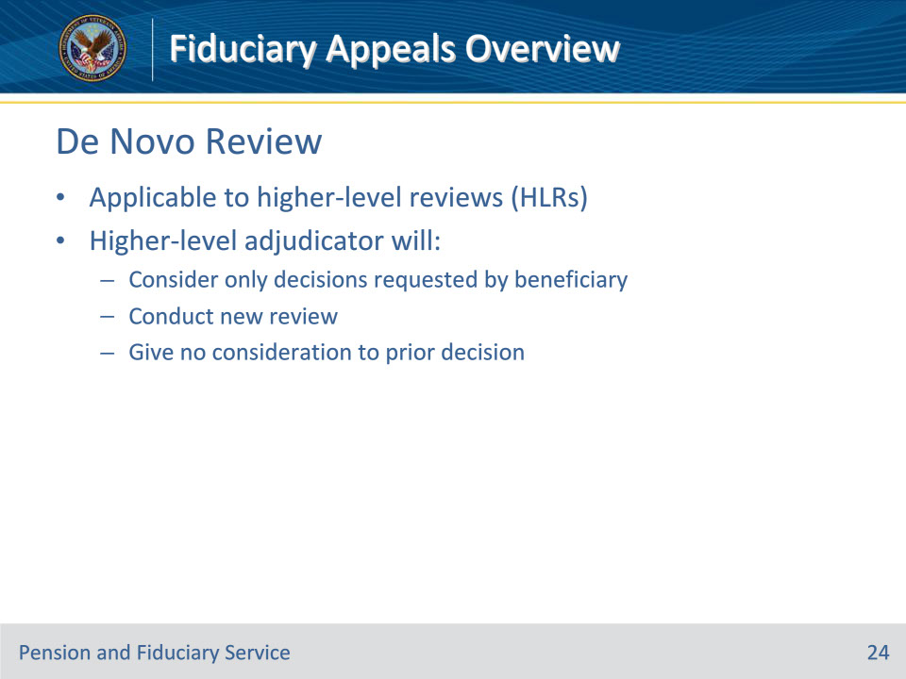
Slide notes

Policy Reference(s): FPM III.1.A.2.r.

Instructor Notes:

A de novo review is applicable to higher-level reviews (HLRs). The higher-level adjudicator will consider only those decisions which the beneficiary has requested a HLR, and will conduct a new review, giving no consideration to the prior decision.

Slide 25 - Favorable Finding
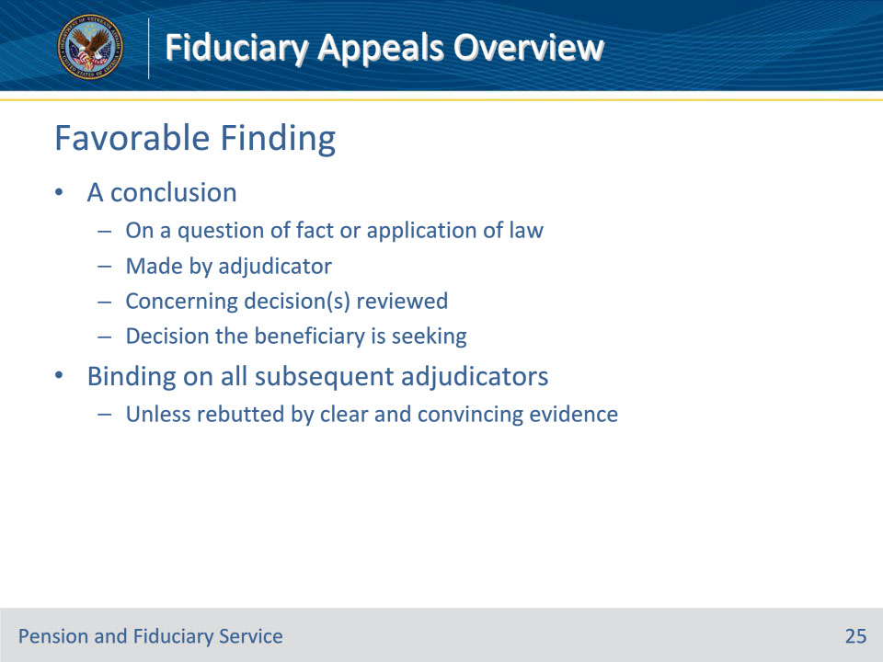
Slide notes

Policy Reference(s): FPM III.1.A.2.s.

Instructor Notes:

For purposes of this section, a favorable finding means a conclusion either on a question of fact or on an application of law to facts made by an adjudicator concerning the decision(s) reviewed, and is the decision the beneficiary is seeking. A favorable finding is binding on all subsequent VA and BVA adjudicators, unless rebutted by clear and convincing evidence to the contrary.

Slide 26 - Finally Adjudicated Decision
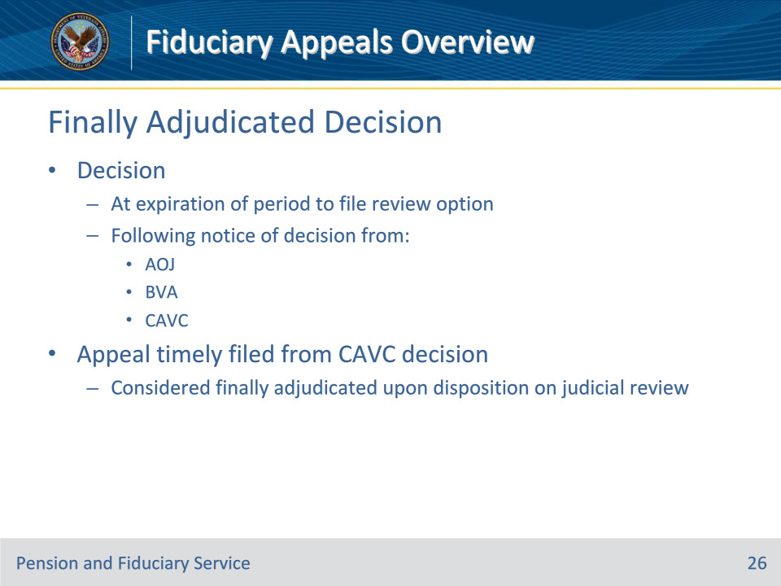
Slide notes

Policy Reference(s): FPM III.1.A.2.t.

Instructor Notes:

A decision is considered a finally adjudicated decision at the expiration of the period to file a review option following notice of a decision by the AOJ, BVA, or CAVC. If an appeal is timely filed from a decision of the CAVC, a claim is finally adjudicated upon its disposition on judicial review.

Slide 27 - Legacy Decision
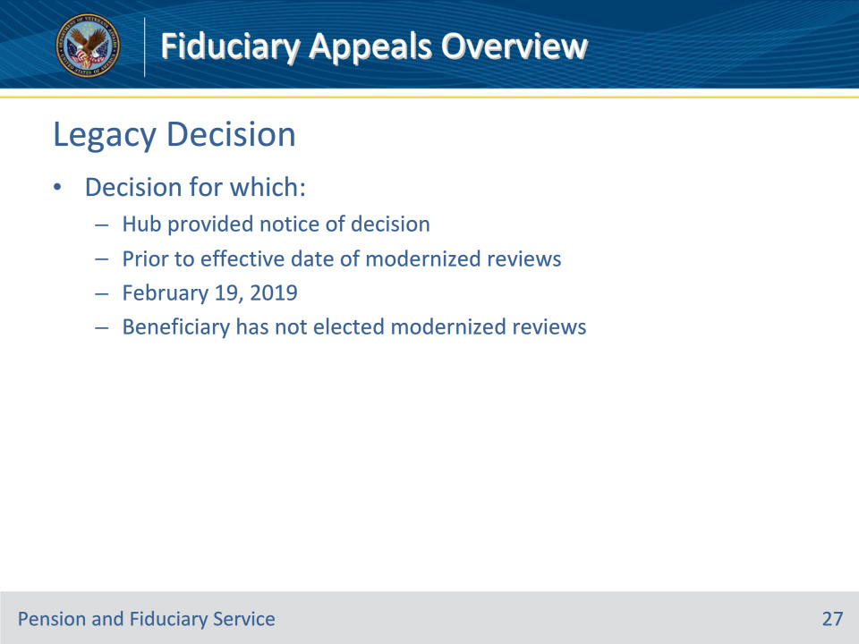
Slide notes

Policy Reference(s): FPM III.1.A.2.u.

Instructor Notes:

A legacy decision is a decision for which the hub provided notice of the decision prior to the effective date of the modernized review system on February 19, 2019, and the beneficiary has not elected to participate in the modernized review system.

Slide 28 - New and Relevant Evidence
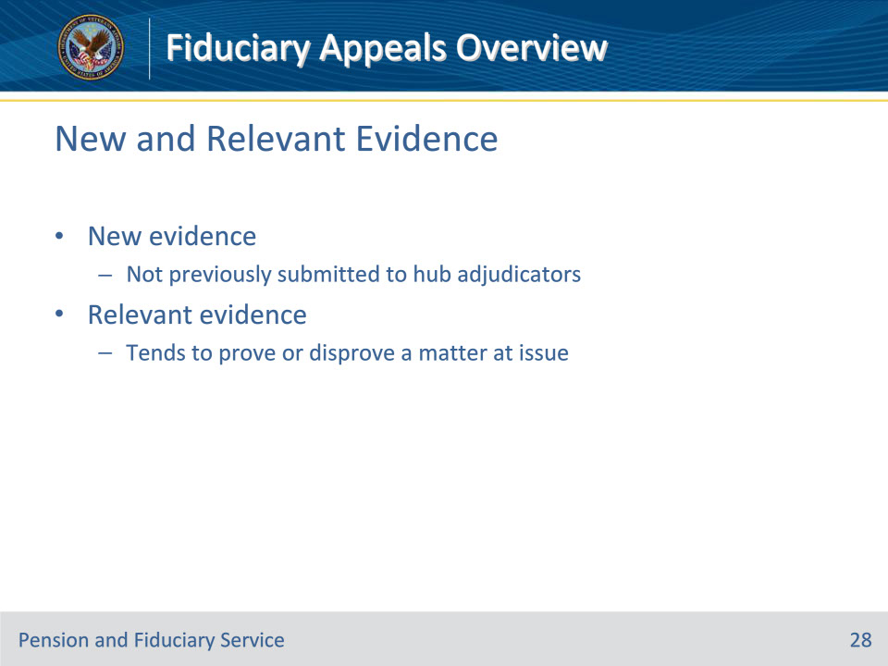
Slide notes

Policy Reference(s): FPM III.1.A.2.v.

Instructor Notes:

New evidence is evidence not previously submitted to hub adjudicators.

Relevant evidence is information that tends to prove or disprove a matter at issue.

Slide 29 - Questions?
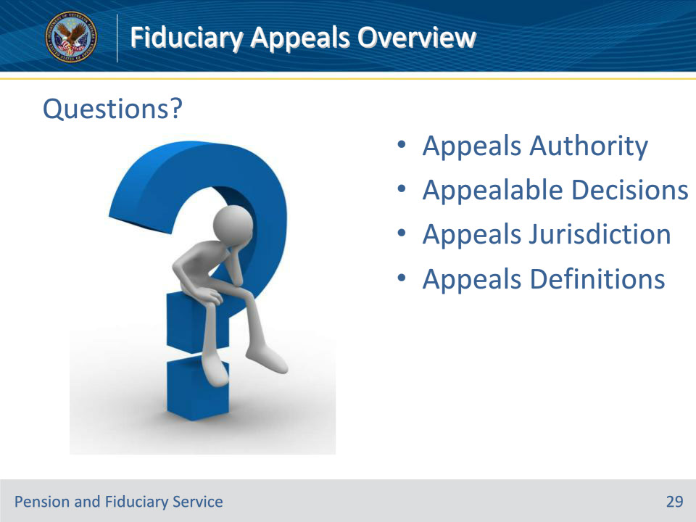
Slide notes

Instructor Notes:

(Recall) These are our learning objectives as stated from the beginning of the training:

• Cite fiduciary appeals authority

• Determine appeals jurisdiction

• Define fiduciary appeals terminology

(Recap) We discussed each of these learning objectives through the following topics in each slide today:

• Appeals Authority

• Appealable Decisions

• Appeals Jurisdiction

• Appeals Definitions

Are there any additional questions?

Questions should be filtered through your QRT team. They will submit your questions to the Field Inquiry Tool (FIT) on your behalf.

Slide 30 - TMS Survey/Assessment
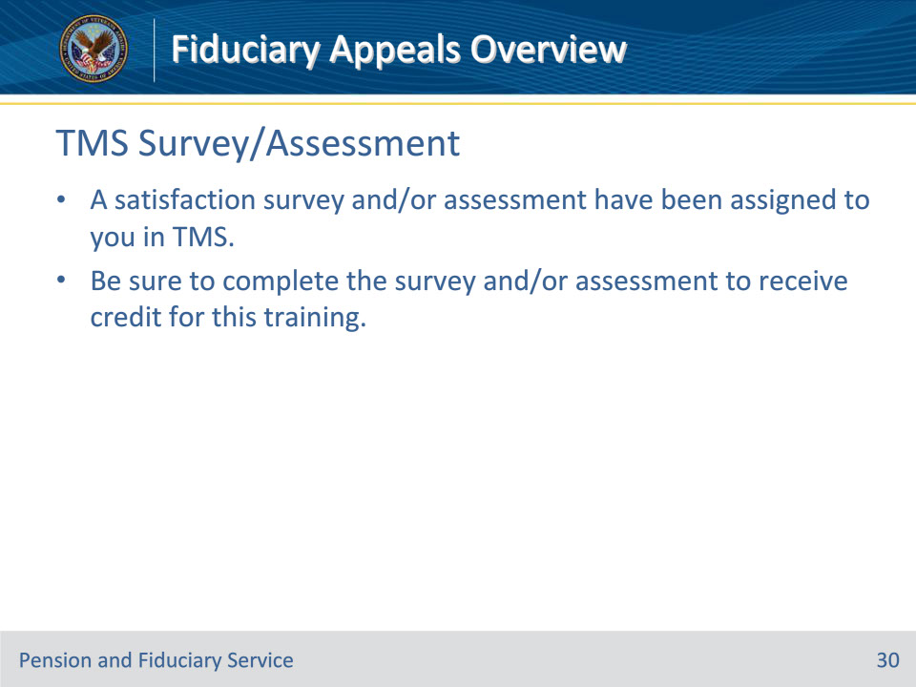
Slide notes

Instructor Notes:

A satisfaction survey and/or assessment have been assigned to you in TMS.

Be sure to complete the survey and/or assessment to receive credit for this training.

