Slide 1 - Higher-Level Review Requests
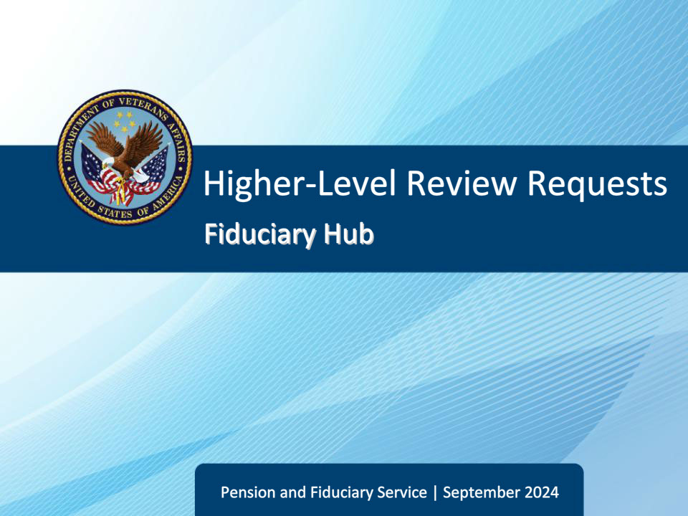
Slide notes

Course Description:

This course teaches learners information about reviewing and controlling higher-level review (HLRs).

Slide 2 - Objectives
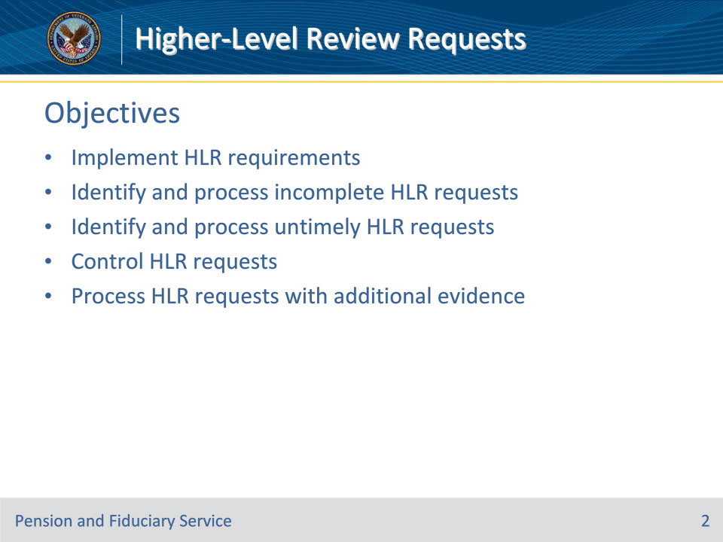
Slide notes

Instructor Notes:

At the end of this lesson, given the training and references, the learner will be able to do the following:

• Implement HLR requirements

• Identify and process incomplete HLR requests

• Identify and process untimely HLR requests

• Control HLR requests

• Process HLR requests with additional evidence

Slide 3 - References
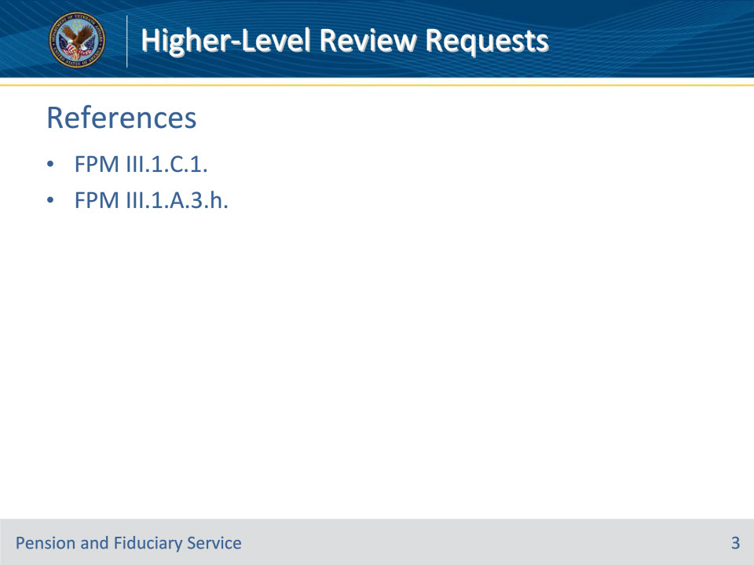
Slide notes

Instructor Notes:

These are the relevant references pertaining to this course:

• FPM III.1.C.1. HLR Requests

• FPM III.1.A.3.h. Placing Review Elections Under Control

Slide 4 - Requirements
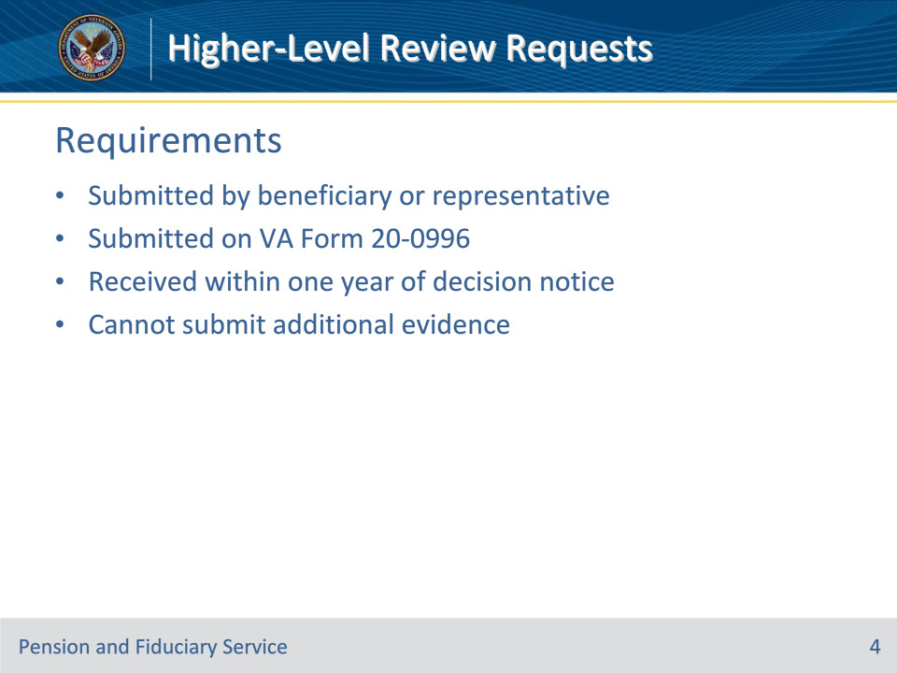
Slide notes

Policy Reference(s): FPM III.1.C.1.a.

Instructor Notes:

A beneficiary or his/her representative who is dissatisfied with an appealable fiduciary decision may file a request for a higher-level review (HLR). The request must be

• submitted on a VA Form 20-0996, Decision Review Request: Higher-Level Review, and

• received within one year of the date of the Department of Veterans Affairs (VAs) issuance of the notice of the decision.

In electing an HLR, the beneficiary cannot submit additional evidence for fiduciary hubs (hub) to consider. Hubs must review the previously decided decision based on the evidence of the record at the time of the prior decision.

Slide 5 - Incomplete Requests
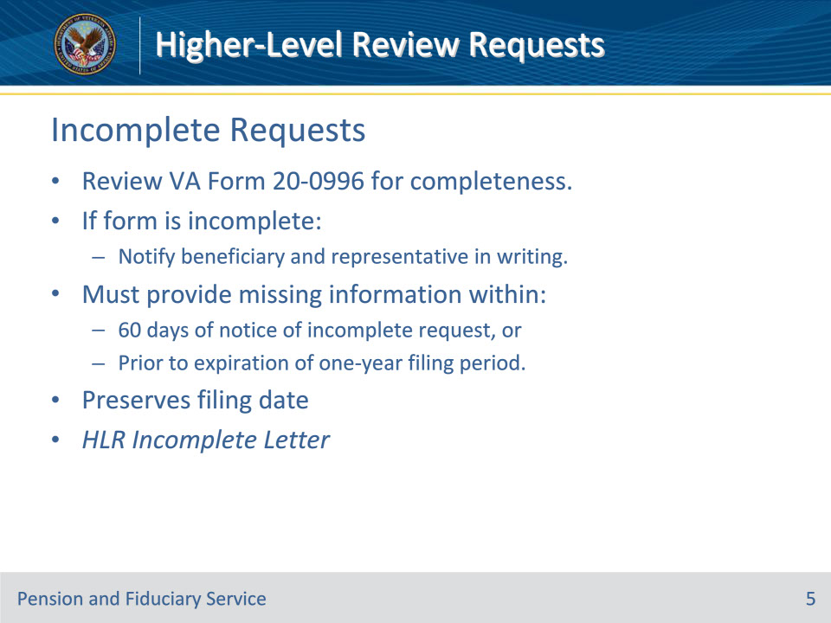
Slide notes

Policy Reference(s): FPM III.1.C.1.b.

Instructor Notes:

Hubs must review the VA Form 20-0996 for completeness. If the beneficiary submits an incomplete request form, the hub must notify the beneficiary and his/her representative, if any, in writing that he/she has 60 days to submit the information necessary to complete the VA Form 20-0996.

If the information is submitted within 60 days of the notice of the incomplete request, or prior to the expiration of the one-year filing period, the date filed for the HLR request is the date VA received the incomplete application.

The lack of a checkmark, on VA Form 20-0996, in the box listed below does not constitute an incomplete request:

IF YOU WOULD LIKE THE SAME OFFICE THAT ISSUED YOUR PRIOR DECISION TO CONDUCT THE REVIEW, YOU CAN MAKE THAT REQUEST BY CHECKING THE BOX BELOW. IF YOU DO NOT CHECK THE BOX, VA WILL TAKE THAT AS A REQUEST TO HAVE A DIFFERENT OFFICE CONDUCT THE REVIEW.

If an incomplete request is received, utilize the HLR Incomplete Letter to meet the written notification requirement.

Slide 6 - Untimely Requests
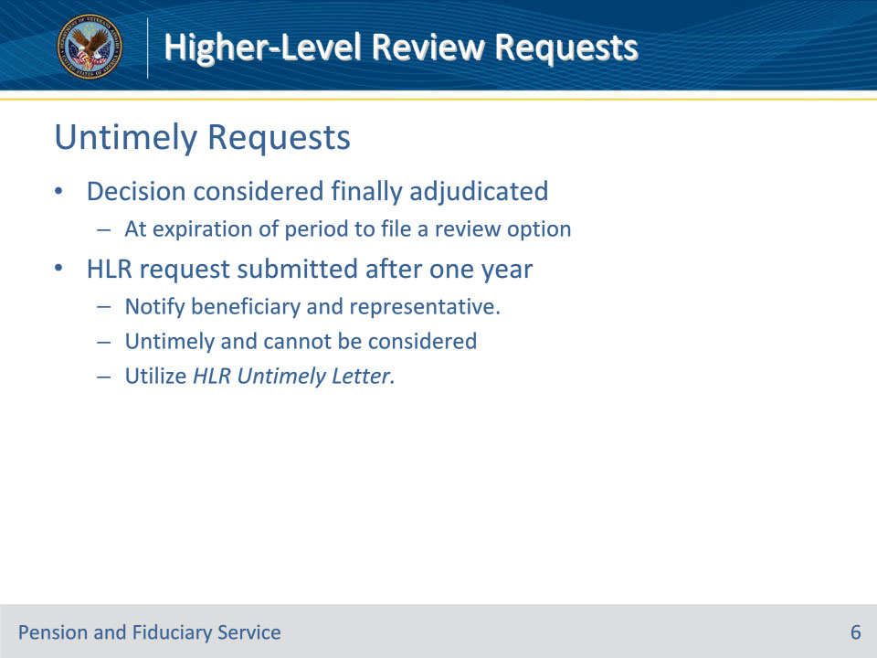
Slide notes

Policy Reference(s): FPM III.1.C.1.c.

Instructor Notes:

A decision is considered finally adjudicated at the expiration of the period to file a review option following notice of a decision by the agency of original jurisdiction (AOJ). If the beneficiary submits a request for an HLR after the expiration of the one-year period following the date VA issued the notice of the decision, hubs must notify the beneficiary and his/her representative, if any, in writing that his/her request was untimely and cannot be considered.

Utilize the HLR Untimely Letter to meet the written notification requirement.

Slide 7 - Controlling HLR Requests
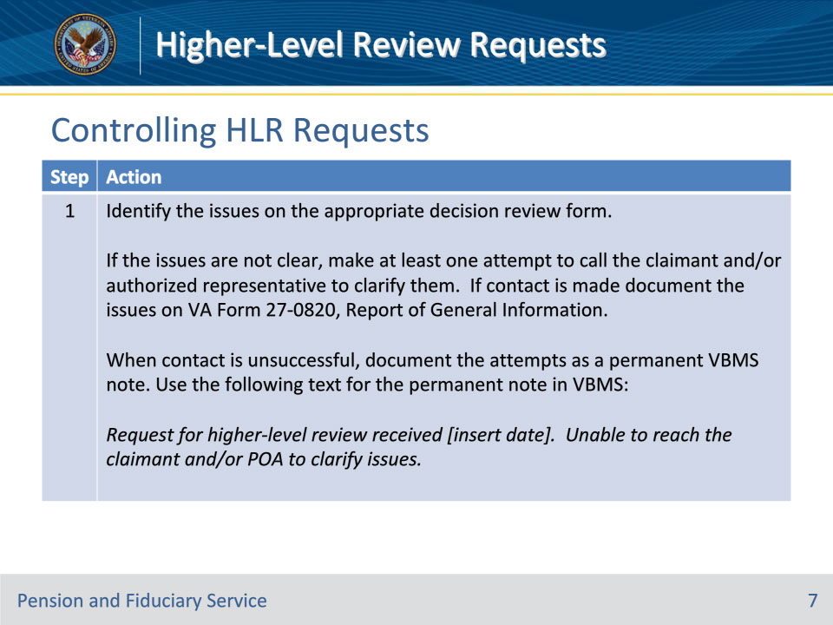
Slide notes

Policy Reference(s): FPM III.1.A.3.h.

Instructor Notes:

Follow the steps in the table above to place the HLR election under control.

Slide 8 - Controlling HLR Requests
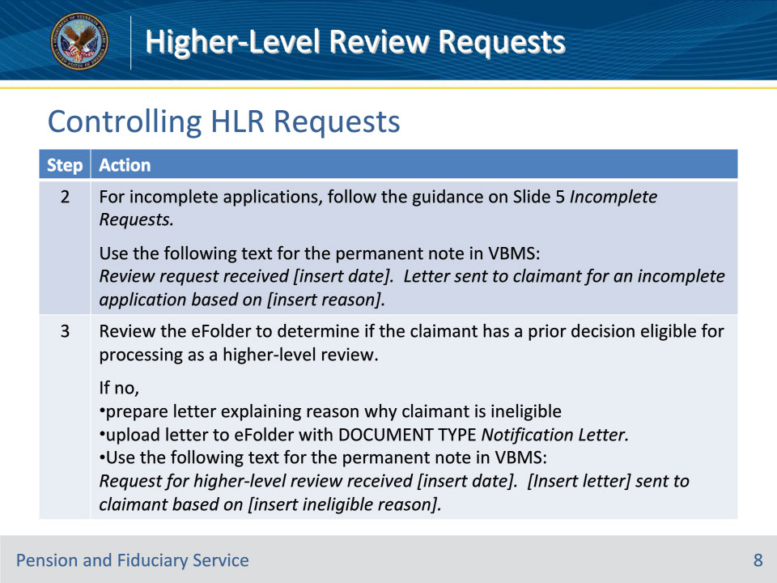
Slide notes

Policy Reference(s): FPM III.1.A.3.h.

Instructor Notes:

Follow the steps in the table above to place the HLR election under control.

Slide 9 - Controlling HLR Requests
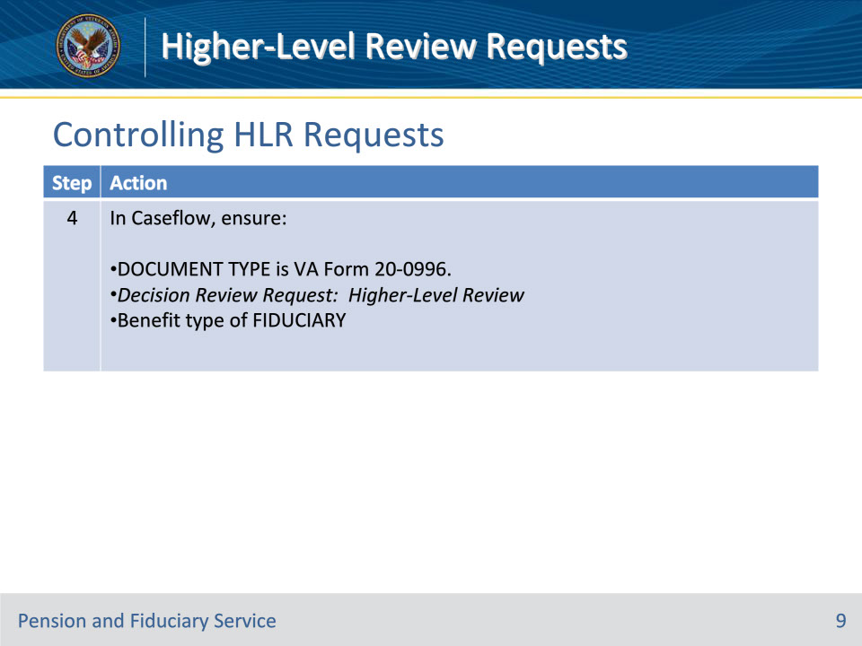
Slide notes

Policy Reference(s): FPM III.1.A.3.h.

Instructor Notes:

Follow the steps in the table above to place the HLR election under control.

Slide 10 - Controlling HLR Requests
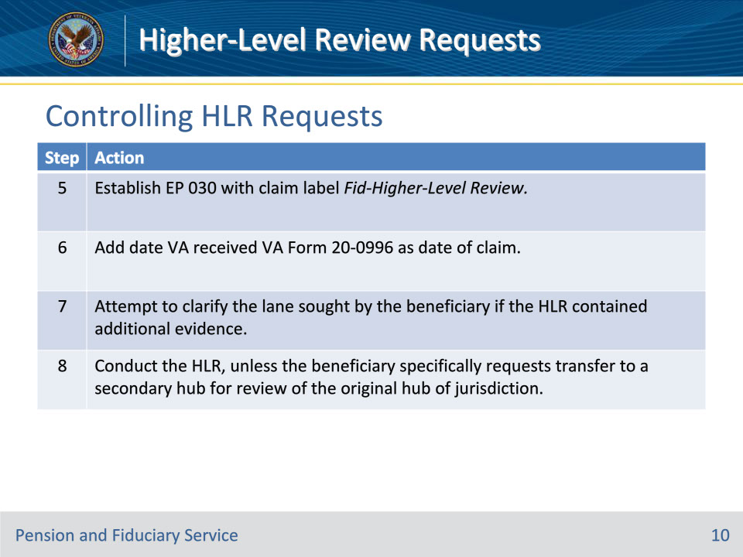
Slide notes

Policy Reference(s): FPM III.1.A.3.h.; FPM III.1.C.1.d.

Instructor Notes:

Follow the steps in the table above to place the HLR election under control.

Slide 11 - Secondary Hub for HLRs
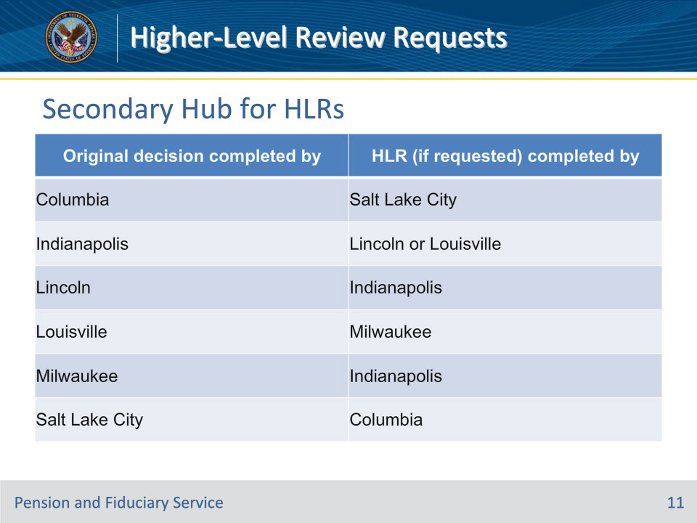
Slide notes

Policy Reference(s): FPM III.1.C.1.e.

Instructor Notes:

Use the table above to determine which secondary hub is responsible for completing the HLR (if requested).

The Louisville Hub is the secondary hub for original decisions concerning beneficiaries residing in foreign countries.

Slide 12 - Evidence Received
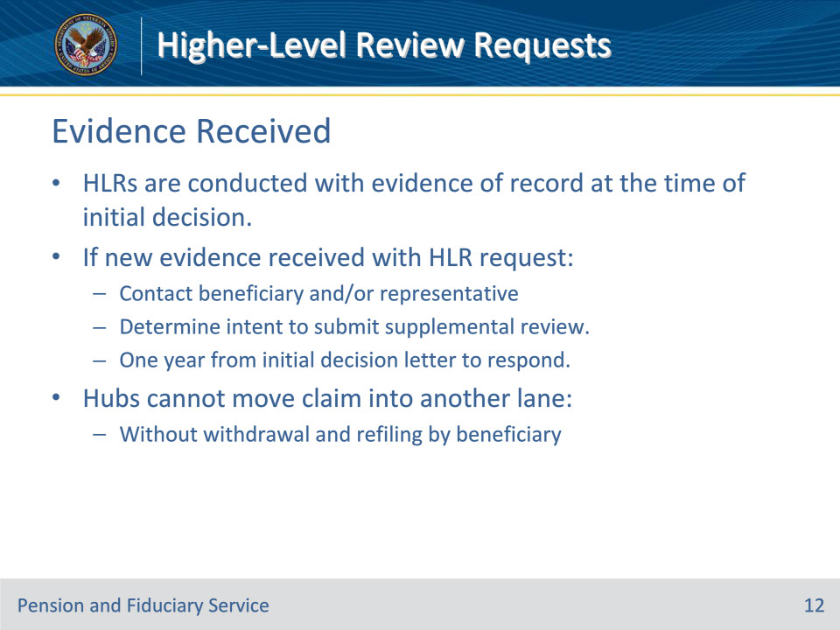
Slide notes

Policy Reference(s): FPM III.1.C.1.f.

Instructor Notes:

Hubs must conduct an HLR with the evidence of record at the time of the initial decision. If new evidence is received with the HLR request, hubs must make reasonable efforts to contact the beneficiary and/or the authorized representative to determine if the beneficiary intends to submit a supplemental review instead of an HLR.

Notes:

• To be considered timely, the response must be received within one year from the date of the initial decision letter.

• Hubs cannot move the claim into another lane without the express withdrawal and refiling by the beneficiary.

Slide 13 - Reasonable Contact Efforts
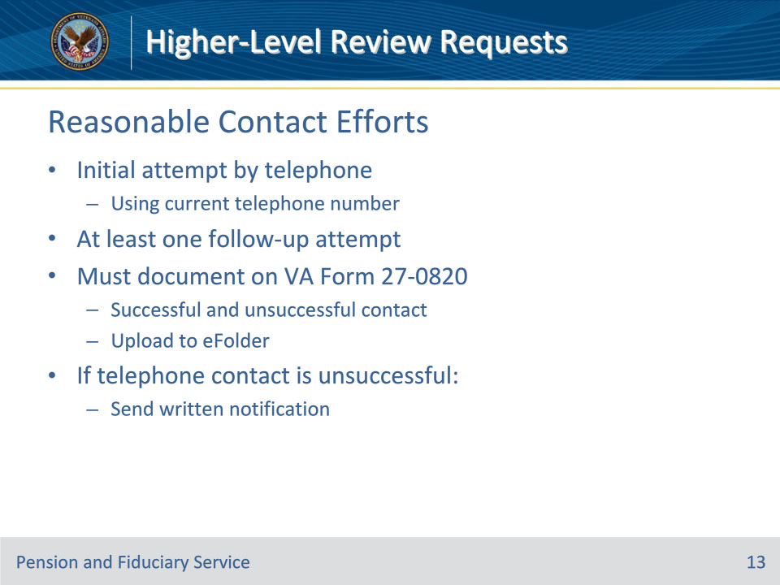
Slide notes

Policy Reference(s): FPM III.1.C.1.f.

Instructor Notes:

Reasonable efforts generally consist of

• an initial attempt to contact the beneficiary by telephone, using his/her current telephone number, and

• at least one follow-up attempt if the initial attempt is unsuccessful.

Hubs must document successful or unsuccessful contact on a VA Form 27-0820, Report of General Information, and upload to the electronic claims folder (eFolder). If such reasonable efforts are not successful, hubs must notify the beneficiary and his/her representative, if any, in writing that the HLR process does not allow for the submission of additional evidence.

Slide 14 - Summary
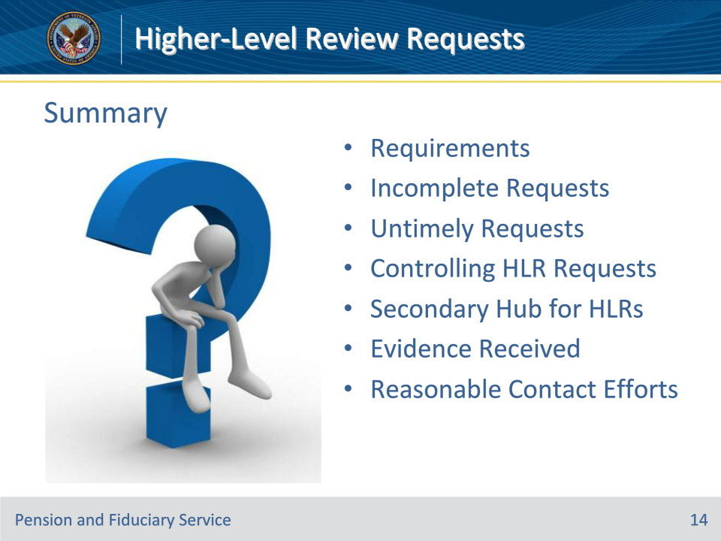
Slide notes

Instructor Notes:

(Recall) These are our learning objectives as stated from the beginning of the training:

• Implement HLR requirements

• Identify and process incomplete HLR requests

• Identify and process untimely HLR requests

• Control HLR requests

• Process HLR requests with additional evidence

(Recap) We discussed each of these learning objectives through the following topics in each slide today:

• Requirements

• Incomplete Requests

• Untimely Requests

• Controlling HLR Requests

• Secondary Hub for HLRs

• Evidence Received

• Reasonable Contact Efforts

Are there any additional questions?

Questions should be filtered through your QRT team. They will submit your questions to the Field Inquiry Tool (FIT) on your behalf.

Slide 15 - TMS Survey/Assessment
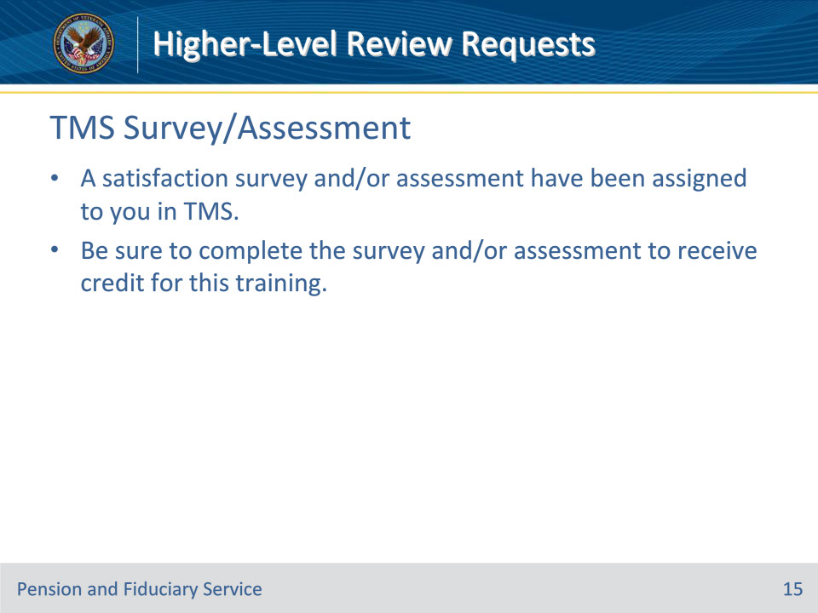
Slide notes

Instructor Notes:

A satisfaction survey and/or assessment have been assigned to you in TMS.

Be sure to complete the survey and/or assessment to receive credit for this training.

