Slide 1 - Issuing a Statement of the Case
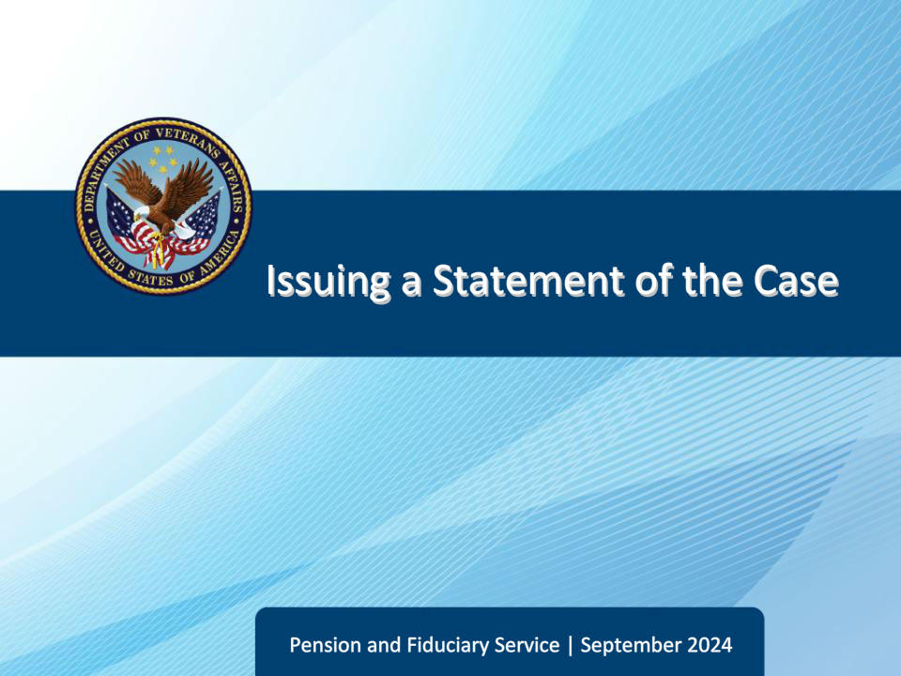
Slide notes

Course Description:

This course teaches learners about preparing and issuing a statement of the case (SOC).

Slide 2 - Objectives
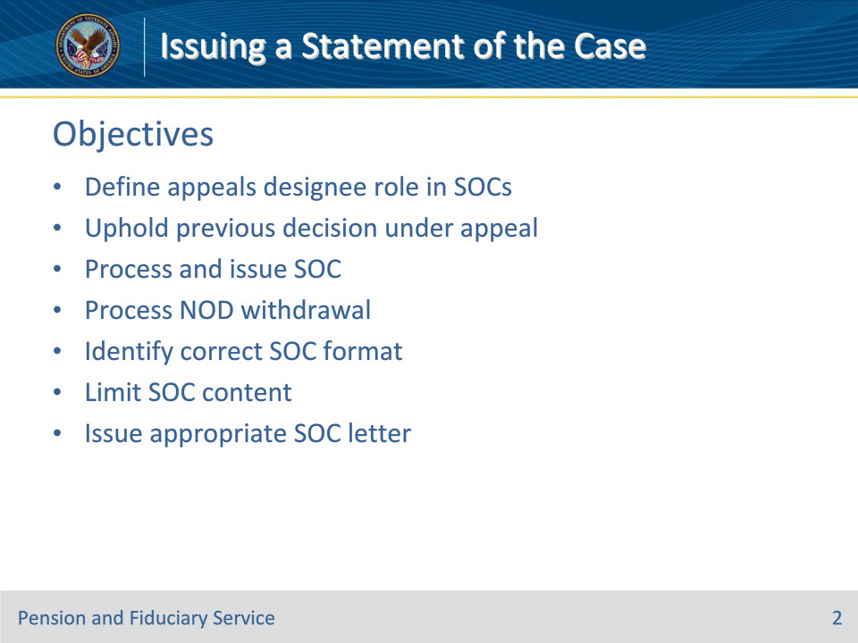
Slide notes

Instructor Notes:

At the end of this lesson, given the training and references, the learner will be able to do the following:

• Define appeals designee role in SOCs

• Uphold previous decision under appeal

• Process and issue SOC

• Process NOD withdrawal

• Identify correct SOC format

• Limit SOC content

• Issue appropriate SOC letter

Slide 3 - References
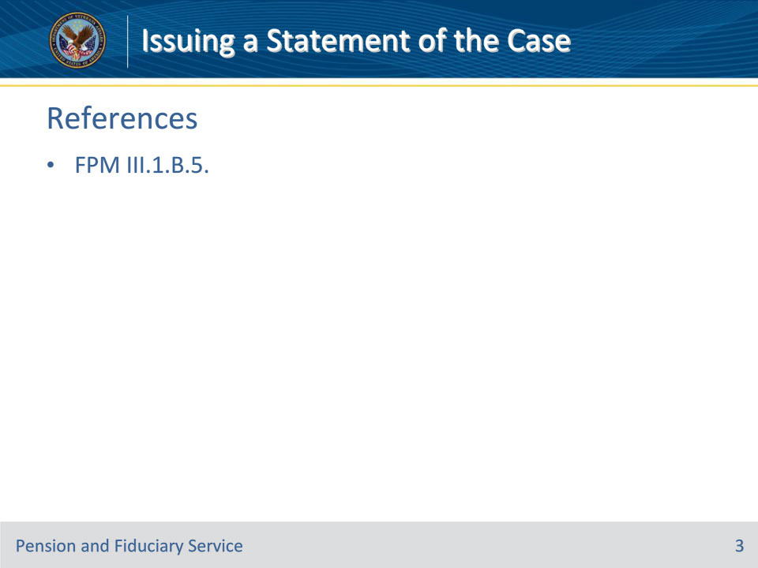
Slide notes

Instructor Notes:

These are the relevant references pertaining to this course:

• FPM III.1.B.5. Preparing and Issuing an SOC

Slide 4 - Appeals Designee
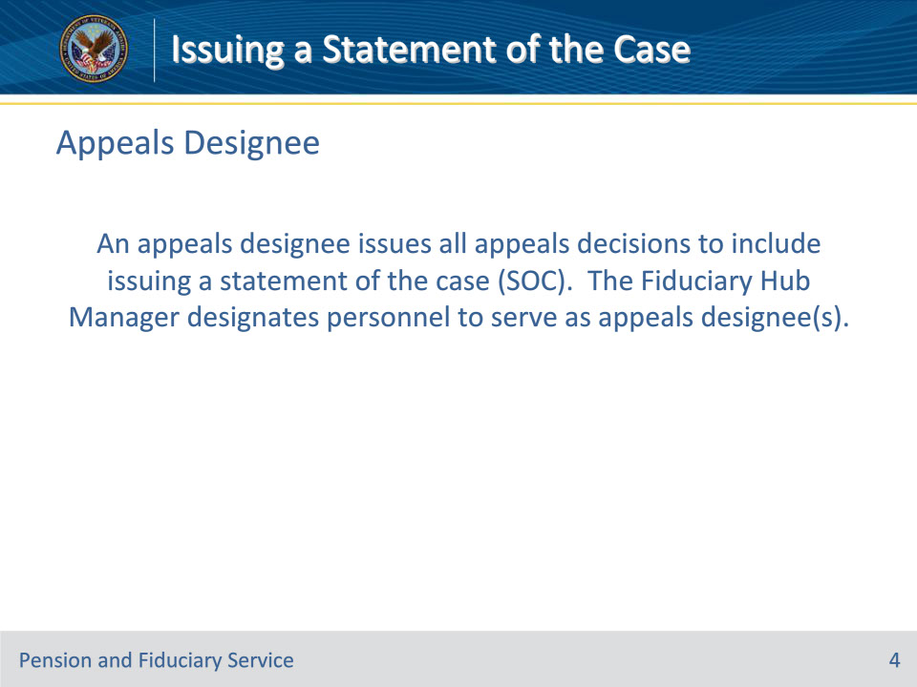
Slide notes

Policy Reference(s): FPM III.1.B.5.a.

Instructor Notes:

An appeals designee issues all appeals decisions to include issuing a statement of the case (SOC). The FHM designates personnel to serve as appeals designee(s).

Slide 5 - Decision to Uphold
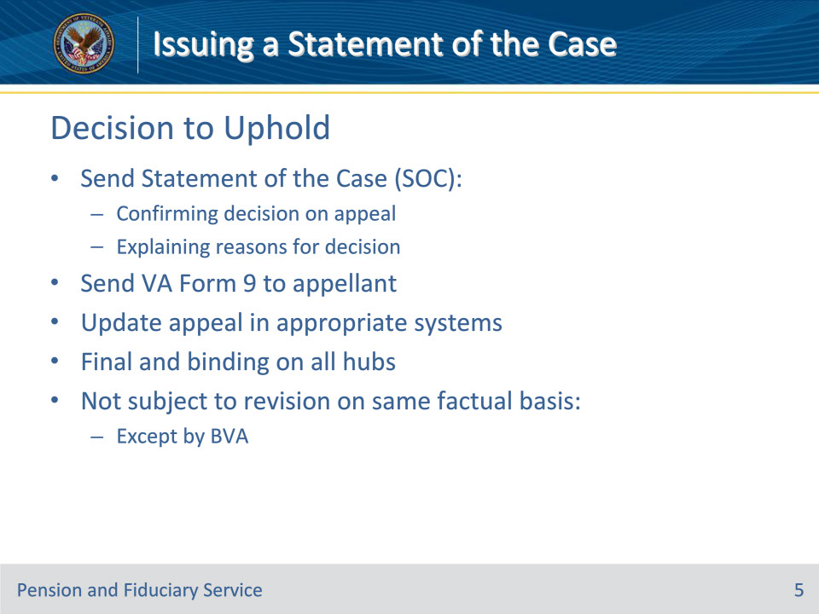
Slide notes

Policy Reference(s): FPM III.1.B.5.b.

Instructor Notes:

The appeals designee reviews the evidence used in the prior decision and may agree with the previously issued decision. If the appeals designee upholds the previous decision under appeal, they send the appellant a/an

• SOC

• confirming the decision on appeal, and

• explaining the reasons and basis for the VA decision, and

• VA Form 9.

The appeals designee updates the appeal in proper work systems, accordingly.

An appeals decision is final and binding on all hubs and is not subject to revision on the same factual basis, except by BVA.

Slide 6 - When to Issue SOC
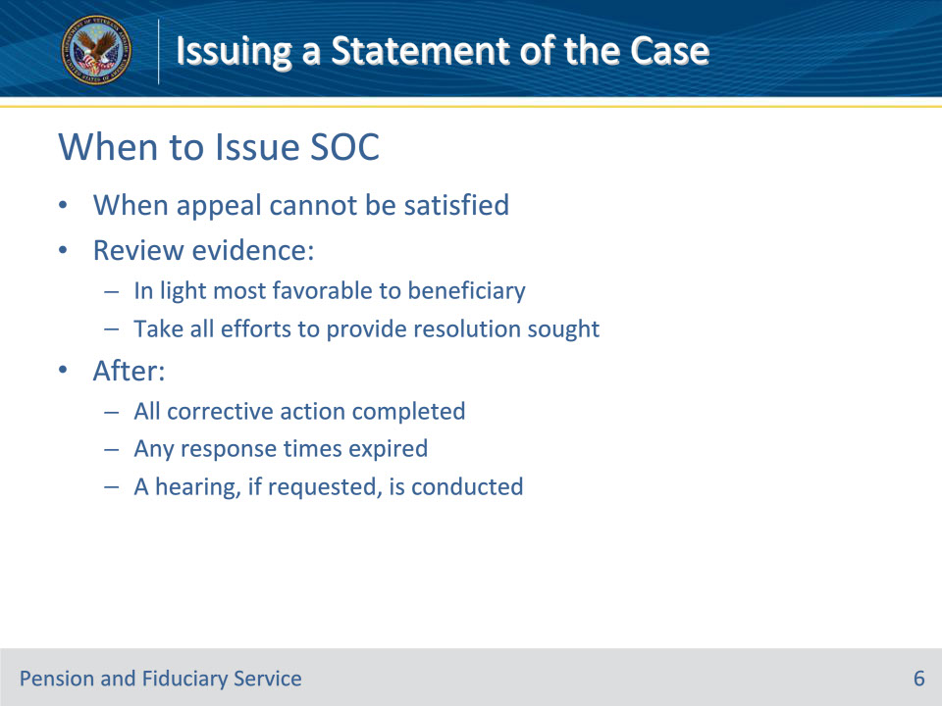
Slide notes

Policy Reference(s): FPM III.1.B.5.c.

Instructor Notes:

Complete an SOC only when the appeal cannot be satisfied. Evidence should be reviewed in a light that is most favorable to the beneficiary and all efforts to provide the beneficiary with the resolution sought should be taken.

Do not issue an SOC until after

• all corrective action(s) is completed

• any response times have expired, and

• a hearing, if requested, is conducted.

Slide 7 - NOD Withdrawal
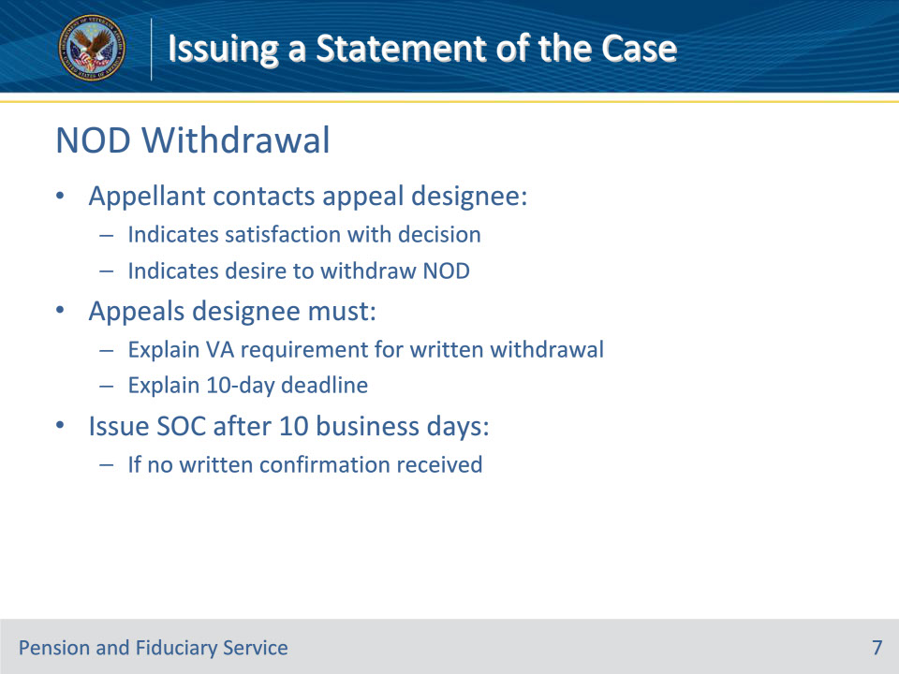
Slide notes

Policy Reference(s): FPM III.1.B.5.d.

Instructor Notes:

If an appellant contacts the appeals designee to indicate satisfaction with the decision and a desire to withdraw the legacy NOD, the appeals designee must

• explain VA’s need to obtain written confirmation of the withdrawal, and

• inform the appellant that VA will send an SOC or supplemental SOC (SSOC) if written confirmation is not received in 10 business days from the date of the notification letter.

If the appeals designee does not receive written confirmation within 10 business days, they issue an SOC.

An appellant and/or their authorized representative may withdraw an appeal at any time, subject to the restrictions of 38 CFR 20.204.

Slide 8 - SOC Format
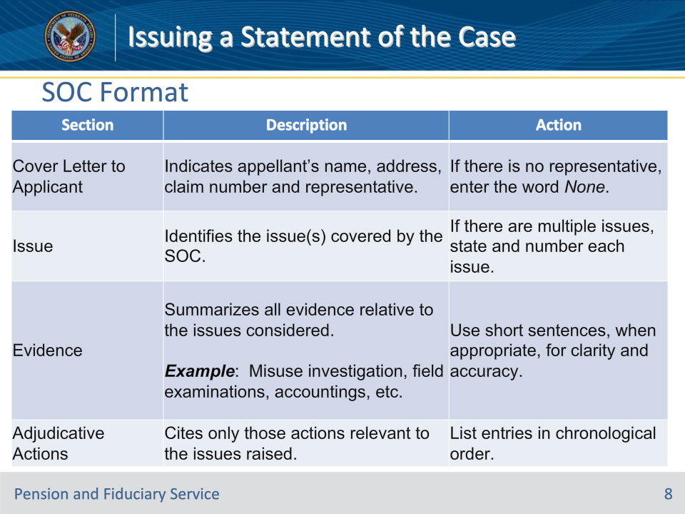
Slide notes

Policy Reference(s): FPM III.1.B.5.e.

Instructor Notes:

The table above describes the sections of an SOC and the actions required when completing each section.

Slide 9 - SOC Format (Cont.)
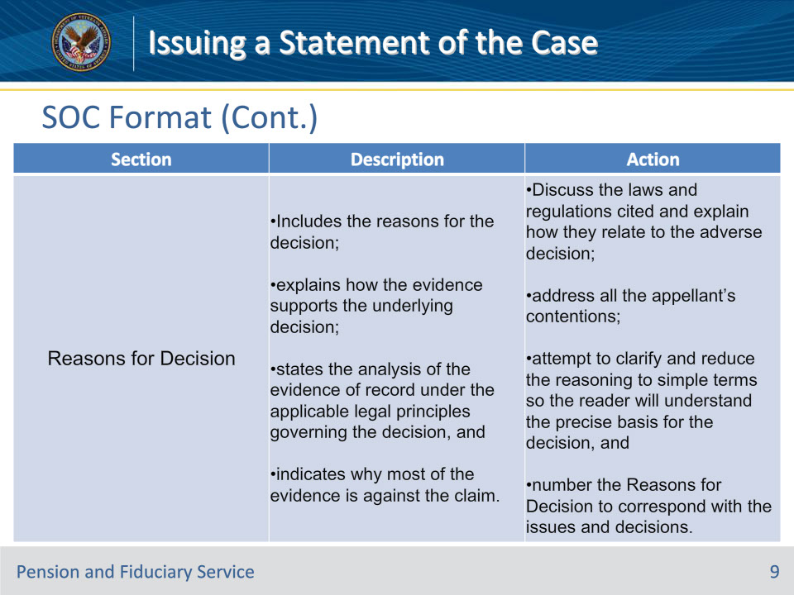
Slide notes

Policy Reference(s): FPM III.1.B.5.e.

Instructor Notes:

The table above describes the sections of an SOC and the actions required when completing each section.

Slide 10 - SOC Format (Cont. 2)
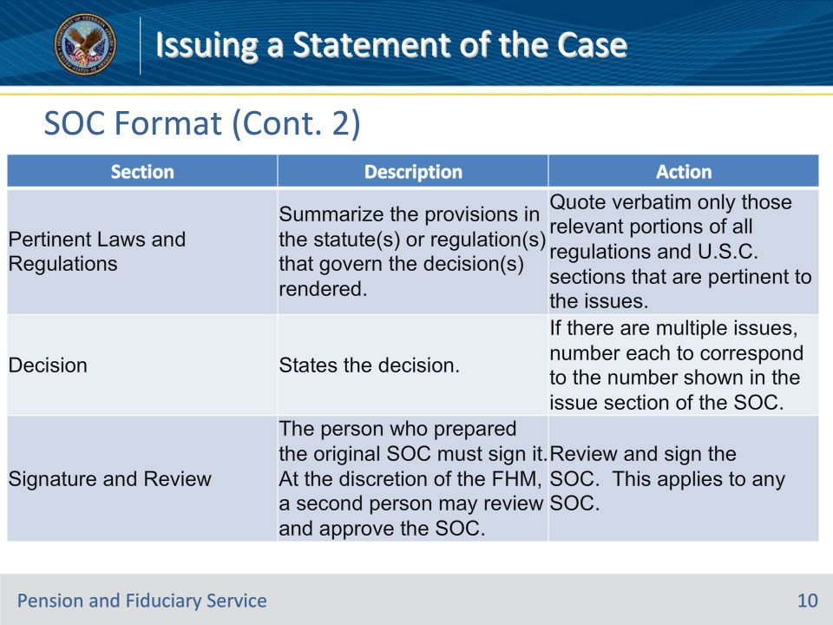
Slide notes

Policy Reference(s): FPM III.1.B.5.e.

Instructor Notes:

The table above describes the sections of an SOC and the actions required when completing each section.

Slide 11 - Limiting SOC Content
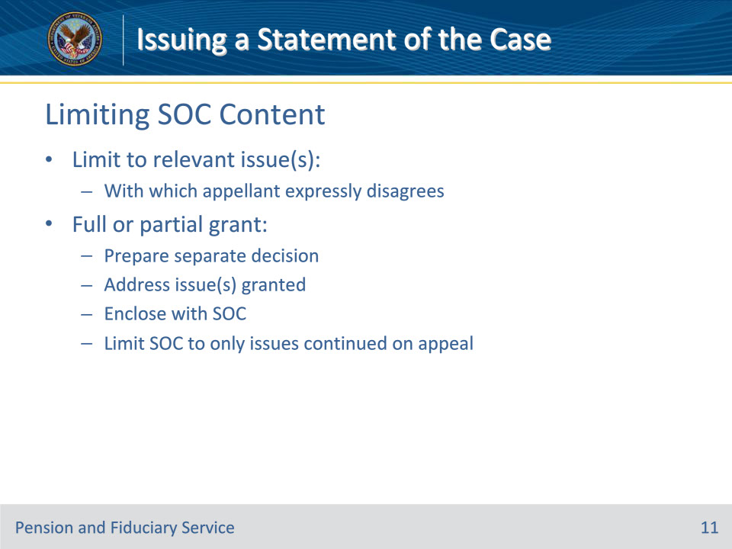
Slide notes

Policy Reference(s): FPM III.1.B.5.f.

Instructor Notes:

Limit an SOC to content relevant to the issue(s) with which the appellant expressly disagrees. If a decision is a full or partial grant of an issue under appeal, prepare a separate decision that addresses the issue(s) granted and enclose it with the SOC. Limit the content of the SOC to only the issue(s) continued on appeal because they remain denied or only partially granted.

Slide 12 - SOC Not Required
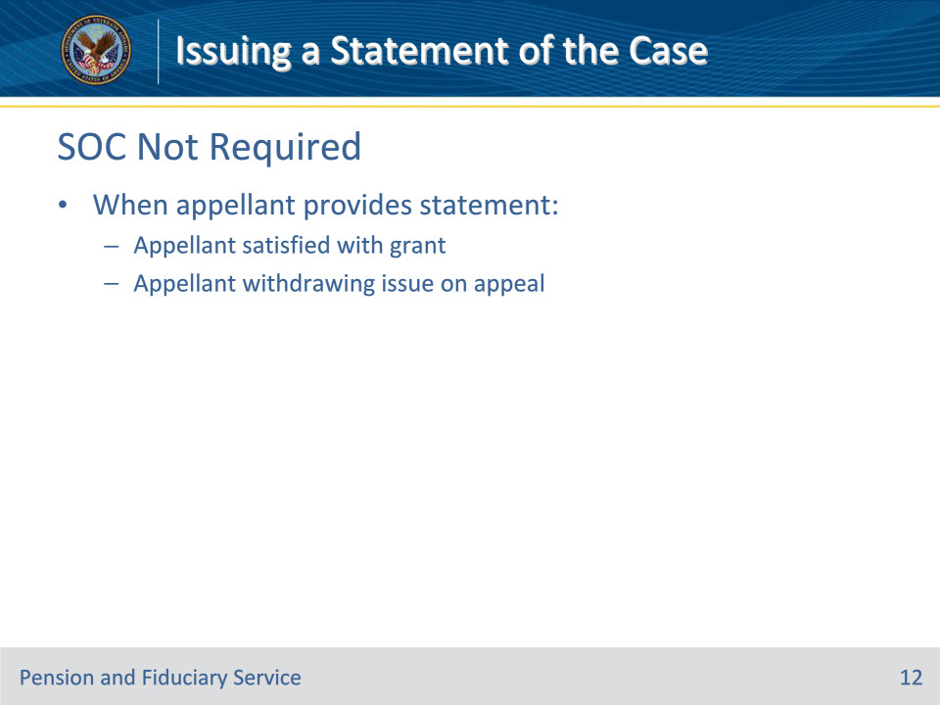
Slide notes

Policy Reference(s): FPM III.1.B.5.f.

Instructor Notes:

An SOC is not required on an issue if the appellant provides a statement that they are

• satisfied with the grant, or

• withdrawing the issue on appeal.

Slide 13 - Disclosing Evidence
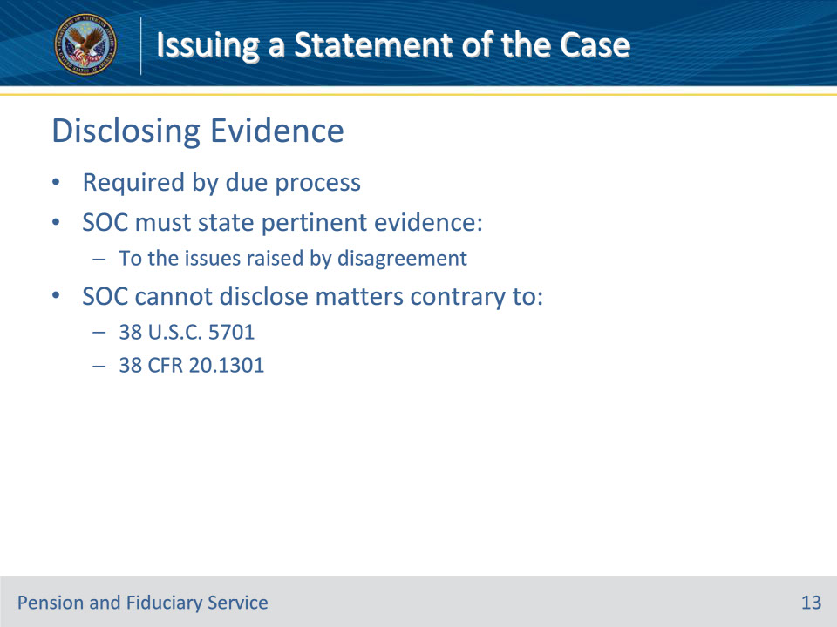
Slide notes

Policy Reference(s): FPM III.1.B.5.g.

Instructor Notes:

Due process requires that an SOC state the evidence pertinent to the issues raised by the disagreement; however, an SOC cannot disclose matters contrary to 38 U.S.C. 5701 or 38 CFR 20.1301. These matters will be discussed in more detail in the following slide.

Slide 14 - Not Disclosed
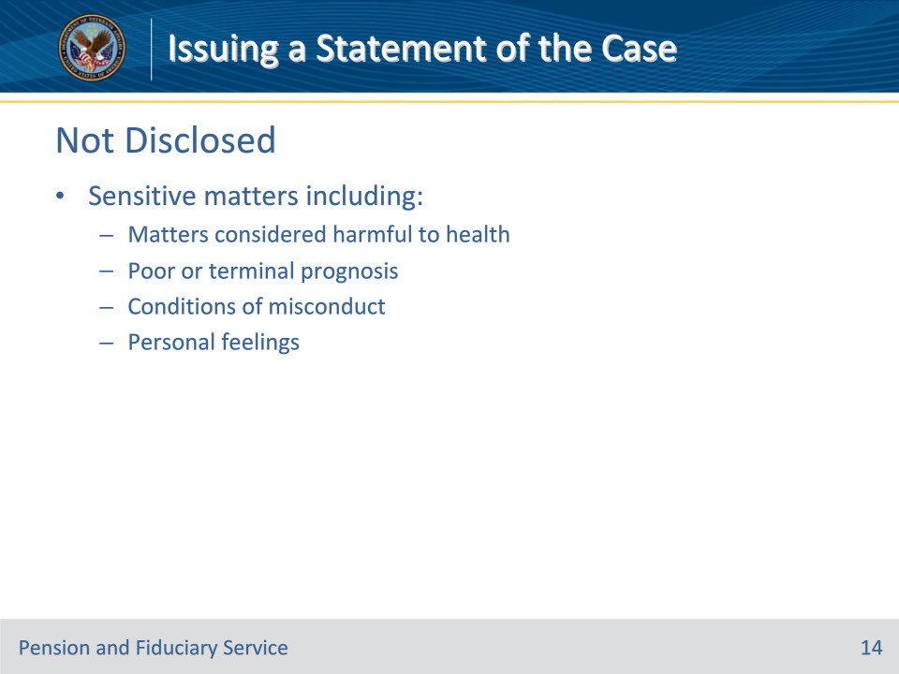
Slide notes

Policy Reference(s): FPM III.1.B.5.h.

Instructor Notes:

Do not include matters in an SOC of a sensitive nature that would be harmful to the physical or mental health of the appellant, including

• matters considered by responsible medical authority to be harmful to the appellant’s health

• references to

• a poor or terminal prognosis, or

• conditions of misconduct, unless the specific misconduct is relevant to the issue, or

• discussions of evidence in a manner that reveal one’s personal feelings.

Slide 15 - Disclose to Representative
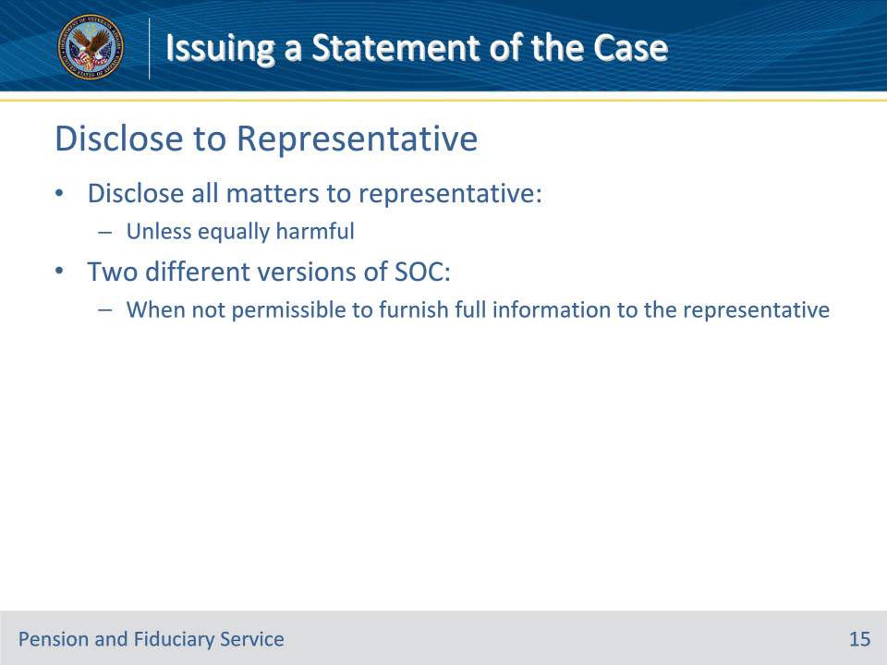
Slide notes

Policy Reference(s): FPM III.1.B.5.i.

Instructor Notes:

Disclose all matters to an appellant’s authorized representative unless disclosure to the representative would be as harmful as if made to the appellant. Therefore, in some cases, two different versions of the SOC may be prepared when it is not permissible to furnish full information to the representative.

Slide 16 - Disclose to Representative (Cont.)
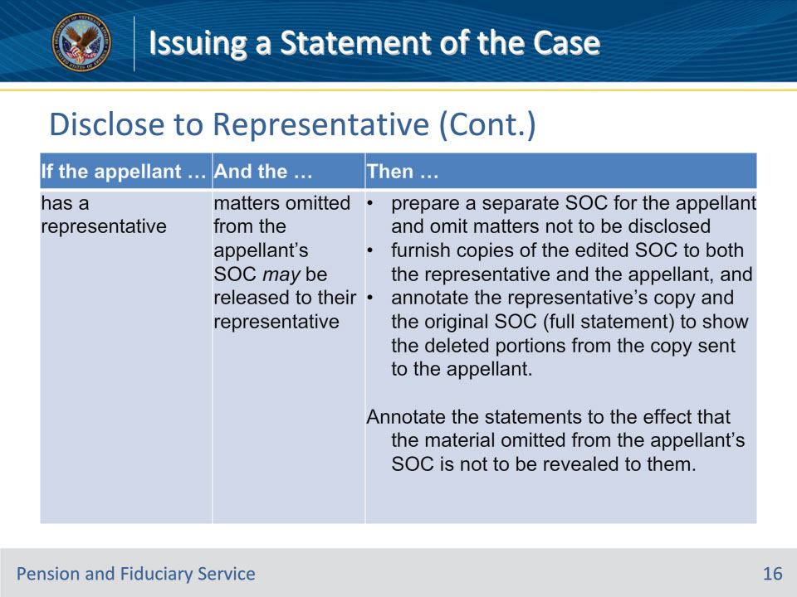
Slide notes

Policy Reference(s): FPM III.1.B.5.i.

Instructor Notes:

Use this table when disclosing information to the appellant’s representative.

Slide 17 - Disclose to Representative (Cont.)
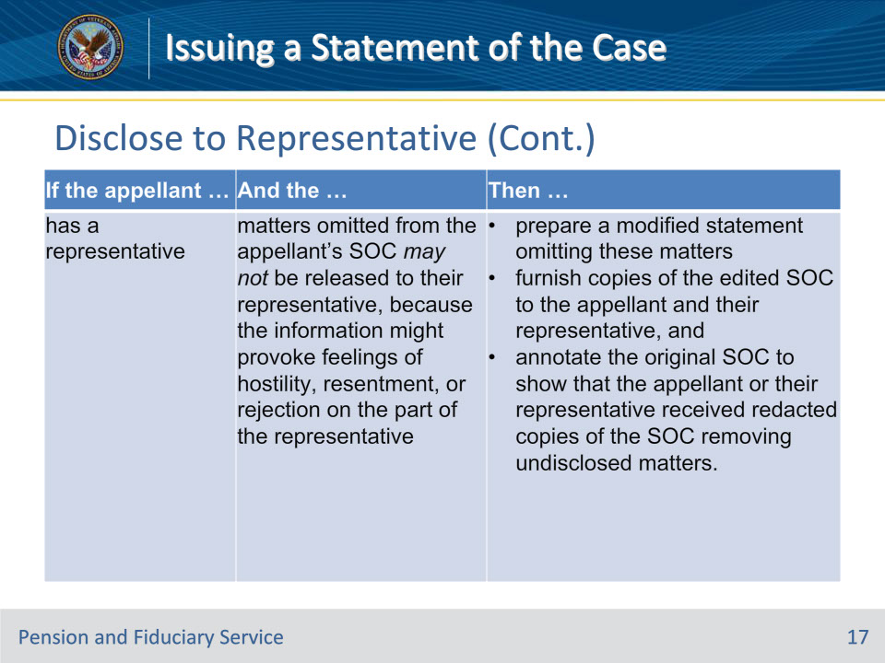
Slide notes

Policy Reference(s): FPM III.1.B.5.i.

Instructor Notes:

Use this table when disclosing information to the appellant’s representative.

Slide 18 - Disclose to Representative (Cont.)
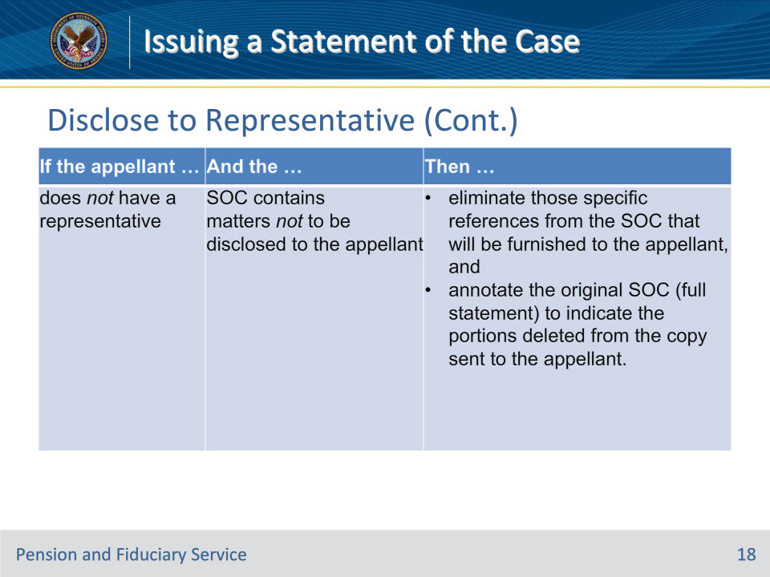
Slide notes

Policy Reference(s): FPM III.1.B.5.i.

Instructor Notes:

Use this table when disclosing information to the appellant’s representative.

Slide 19 - Letter Requirements
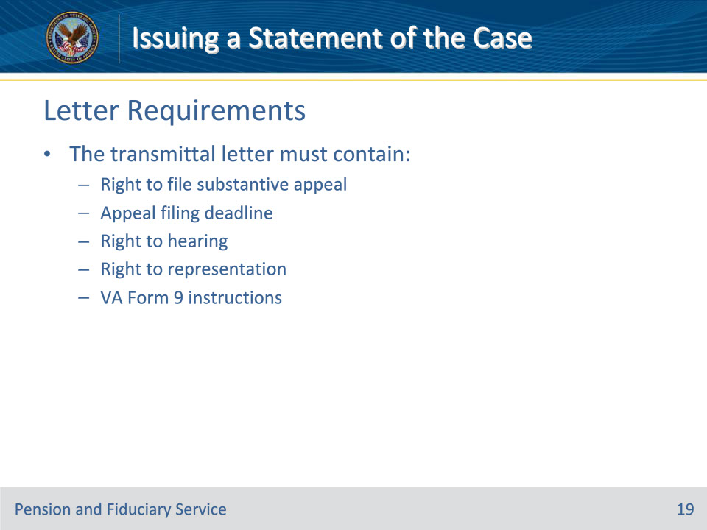
Slide notes

Policy Reference(s): FPM III.1.B.5.j.

Instructor Notes:

The transmittal letter must contain

• a notice of the right to file a substantive appeal

• the time within which the appeal must be filed

• information regarding the right to a hearing and the right to representation, and

• instructions to the appellant that if appellate review by the BVA is still desired after reading the SOC, they should state on a VA Form 9, which fact or law cited they believe to be in error and for what issue.

The various SOC letter templates can be found in FPM III.1.B.5.k.-p

Slide 20 - 31. Questions?
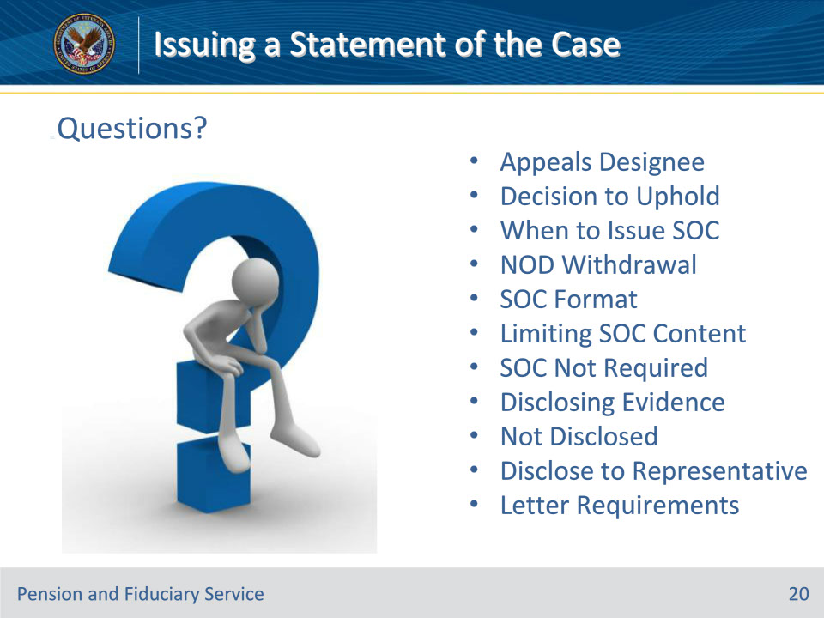
Slide notes

Instructor Notes:

(Recall) These are our learning objectives as stated from the beginning of the training:

• Define appeals designee role in SOCs

• Uphold previous decision under appeal

• Process and issue SOC

• Process NOD withdrawal

• Identify correct SOC format

• Limit SOC content

• Issue appropriate SOC letter

(Recap) We discussed each of these learning objectives through the following topics in each slide today:

• Appeals Designee

• Decision to Uphold

• When to Issue SOC

• NOD Withdrawal

• SOC Format

• Limiting SOC Content

• SOC Not Required

• Disclosing Evidence

• Not Disclosed

• Disclose to Representative

• Letter Requirements

Are there any additional questions?

Questions should be filtered through your QRT team. They will submit your questions to the Field Inquiry Tool (FIT) on your behalf.

Slide 21 - TMS Survey/Assessment
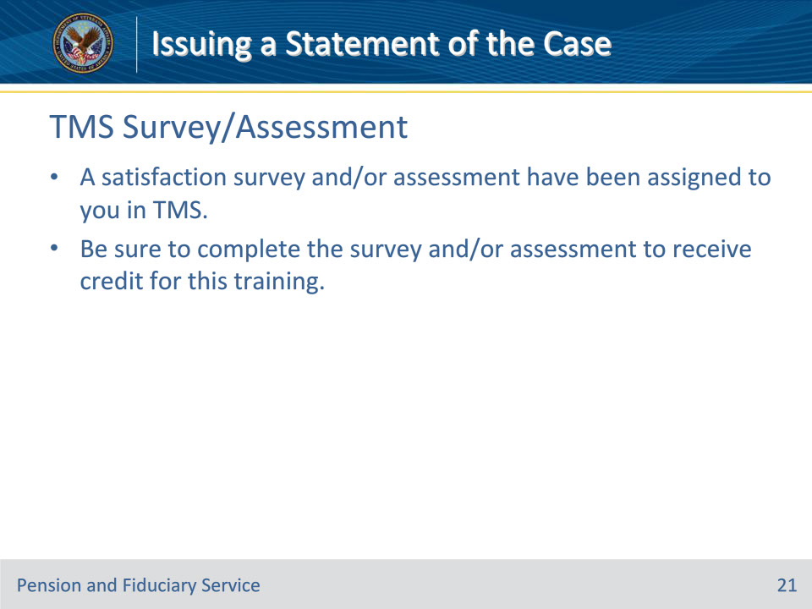
Slide notes

Instructor Notes:

A satisfaction survey and/or assessment have been assigned to you in TMS.

Be sure to complete the survey and/or assessment to receive credit for this training.

