Slide 1 - Issuing a Supplemental Statement of the Case
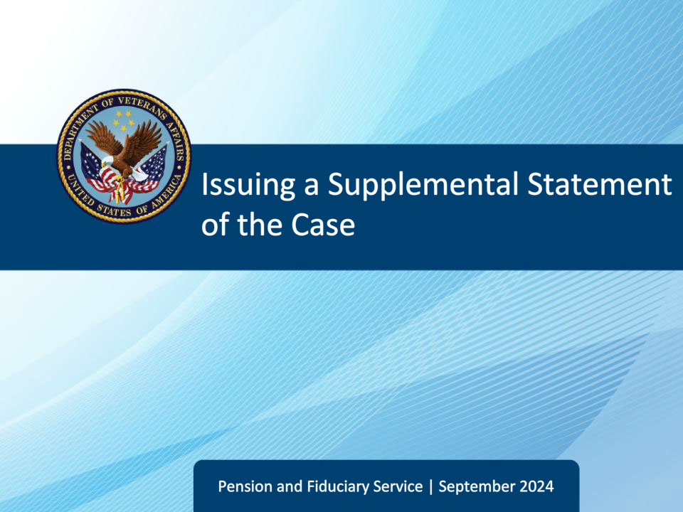
Slide notes

Course Description:

This course teaches learners an overview of a supplemental statement of the case.

Slide 2 - Objectives
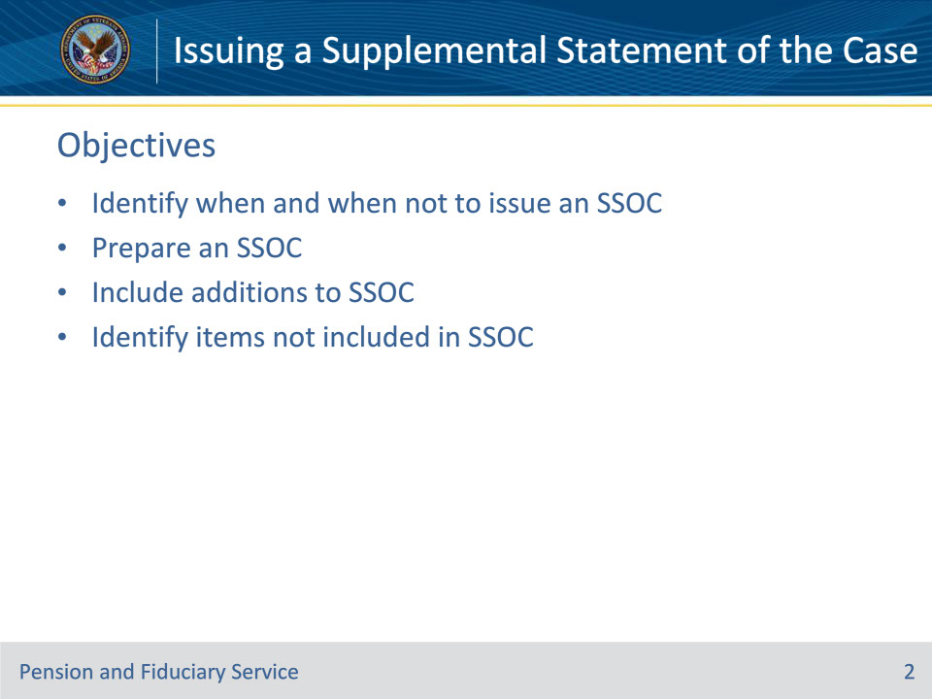
Slide notes

Instructor Notes:

At the end of this lesson, given the training and references, the learner will be able to do the following:

• Identify when and when not to issue an SSOC

• Prepare an SSOC

• Include additions to SSOC

• Identify items not included in SSOC

Slide 3 - References
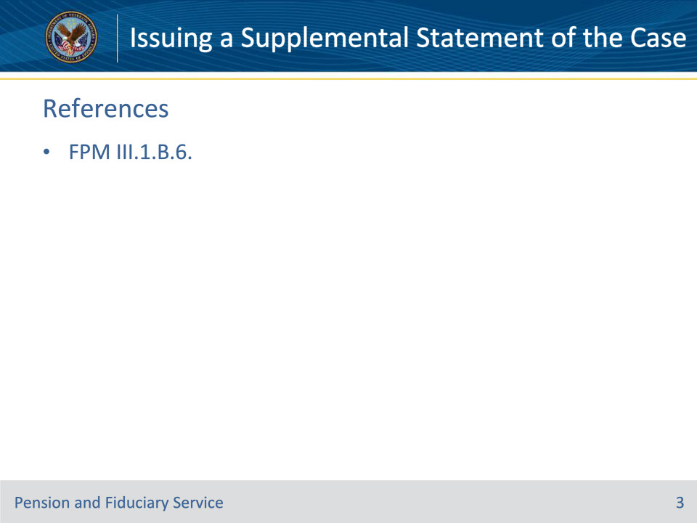
Slide notes

Instructor Notes:

These are the relevant references pertaining to this course:

• FPM III.1.B.6. Preparing and Issuing an SSOC

Slide 4 - When to Issue SSOC
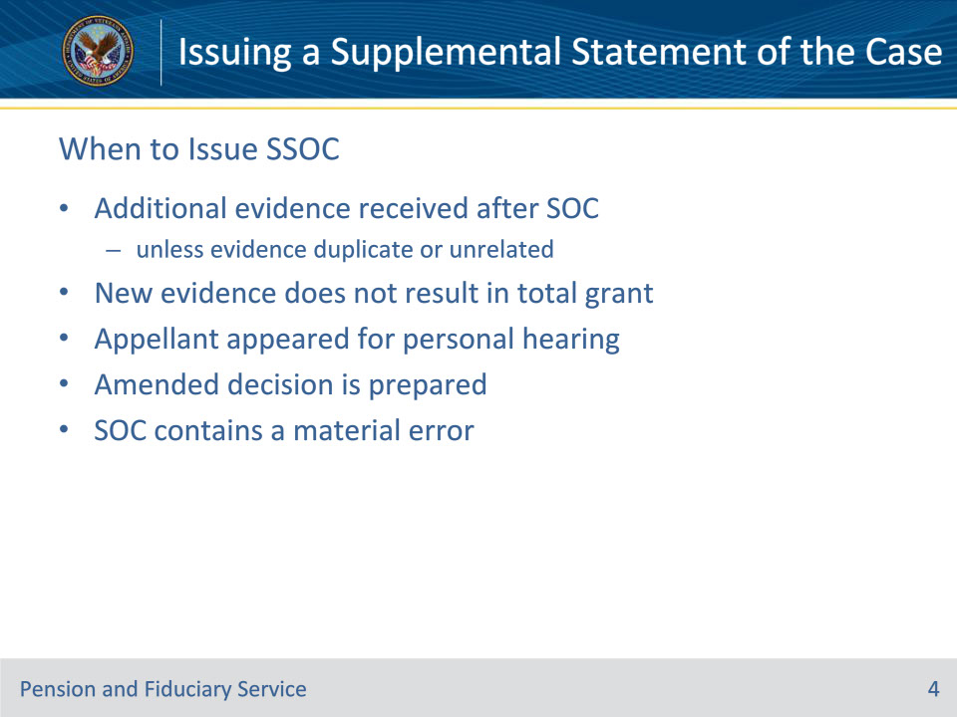
Slide notes

Policy Reference(s): FPM III.1.B.6.a.

Instructor Notes:

Issue a SSOC to the appellant and their representative when

• the SOC or SSOC was prepared before receipt of additional evidence unless the evidence is duplicate or unrelated to the issue under appeal

• the new evidence does not result in a total grant of the issue under appeal

• the appellant appeared for a personal hearing

• an amended decision is prepared, or

• the SOC contains a material error.

This also applies if BVA remands the legacy appeal based on instructions from the Court of Appeals for Veterans Claims (CAVC).

Slide 5 - When Not to Issue SSOC
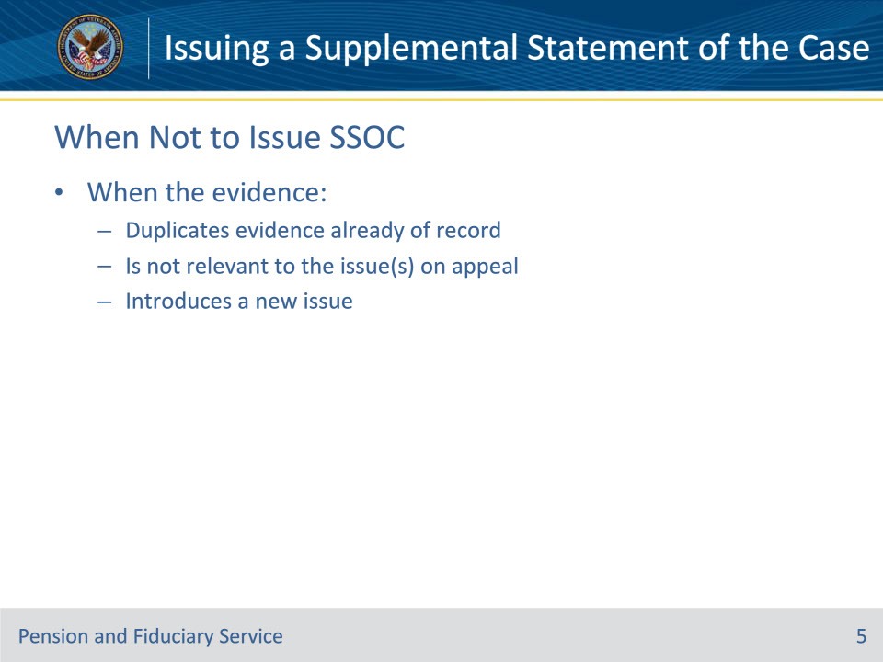
Slide notes

Policy Reference(s): FPM III.1.B.6.b.

Instructor Notes:

Do not issue an SSOC if the evidence

• duplicates evidence already of record

• is not relevant to the issue(s) on appeal, or

• introduces a new issue into the appellate process.

Slide 6 - Preparing SSOC
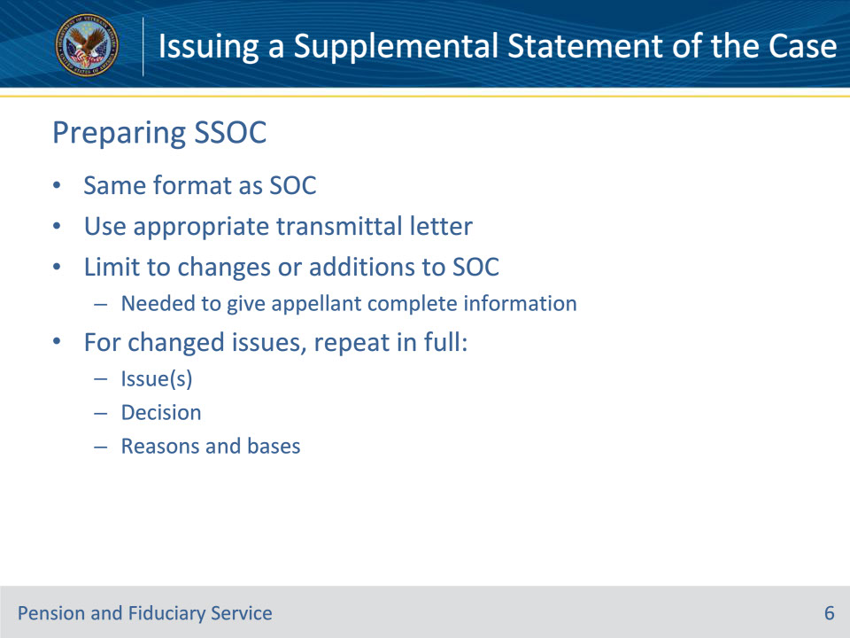
Slide notes

Policy Reference(s): FPM III.1.B.6.c.

Instructor Notes:

Prepare an SSOC in the same format as an SOC and use the appropriate transmittal letter.

Limit the SSOC to those changes or additions to the SOC needed to give complete information to the appellant. For those issues that have undergone a change, repeat in full the

• issue(s)

• decision, and

• reasons and bases.

Include the required language regarding evidence liberally interpreted in favor of the Veteran as provided in M21-5, Chapter 7, Section D.1.d.

Slide 7 - Additions to SSOC
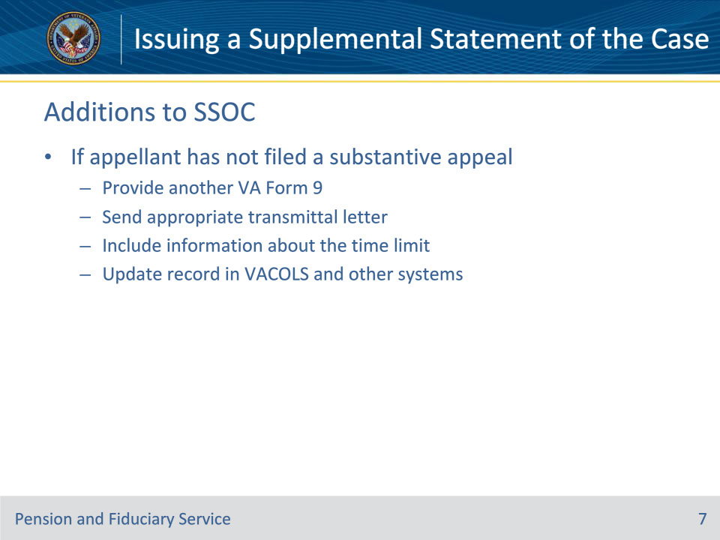
Slide notes

Policy Reference(s): FPM III.1.B.6.d.

Instructor Notes:

If the appellant has not filed a substantive appeal at the time the SSOC is released

• provide another VA Form 9 with the appropriate transmittal letter

• include information about the time limit for submitting a substantive appeal, and

• update the appeals record in VACOLS and other work systems.

Slide 8 - Additions to SSOC
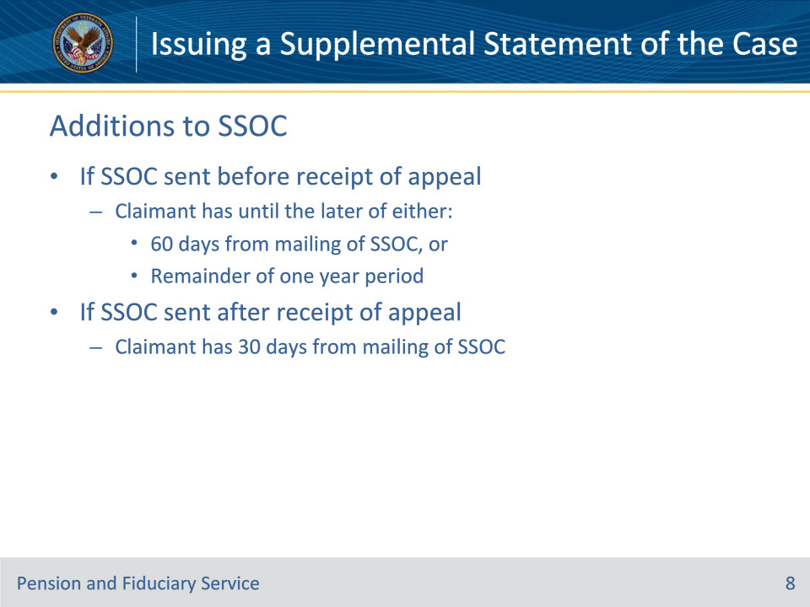
Slide notes

Policy Reference(s): FPM III.1.B.6.d.

Instructor Notes:

If an SSOC is sent before the receipt of the substantive appeal, then the claimant has until the later of either 60 days from the mailing of the SSOC, or the remainder of the one-year period from the date of the original notification to perfect the appeal with a VA Form 9 or substantive appeal.

If an SSOC is sent after the receipt of the substantive appeal, then the claimant has 30 days from the mailing of the SSOC to respond before VA certifies the appeal to BVA.

Slide 9 - Not Included in SSOC
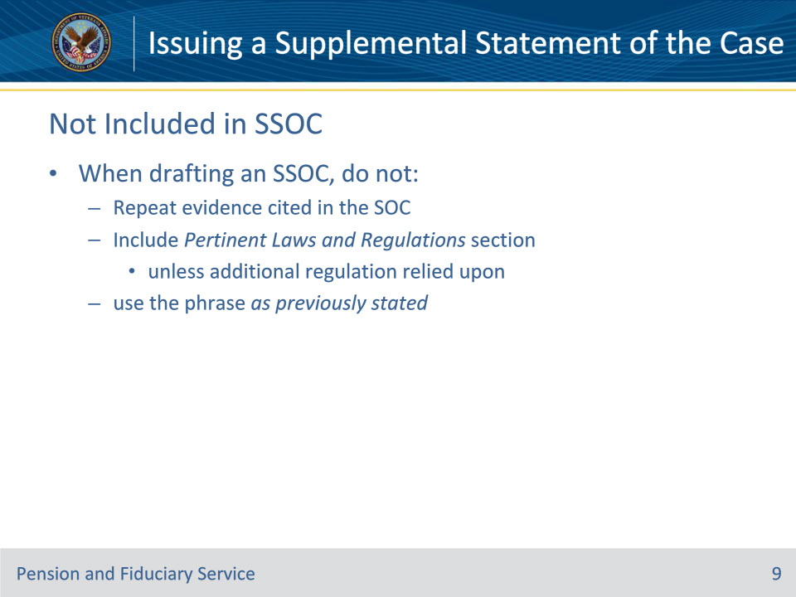
Slide notes

Policy Reference(s): FPM III.1.B.6.e.

Instructor Notes:

When drafting an SSOC, do not

• repeat evidence cited in the SOC

• include the Pertinent Laws and Regulations section unless an additional statute or regulation is relied upon, or

• use the phrase as previously stated in any of the sections.

Slide 10 - Questions?
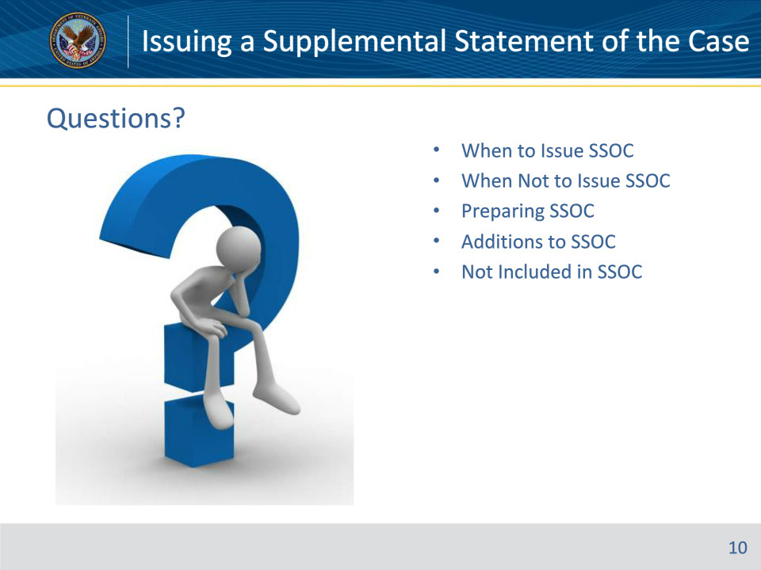
Slide notes

Instructor Notes:

(Recall) These are our learning objectives as stated from the beginning of the training:

• Identify when and when not to issue an SSOC

• Prepare an SSOC

• Include additions to SSOC

• Identify items not included in SSOC

(Recap) We discussed each of these learning objectives through the following topics in each slide today:

• When to Issue SSOC

• When Not to Issue SSOC

• Preparing SSOC

• Additions to SSOC

• Not Included in SSOC

Are there any additional questions?

Questions should be filtered through your QRT team. They will submit your questions to the Field Inquiry Tool (FIT) on your behalf.

Slide 11 - TMS Survey/Assessment
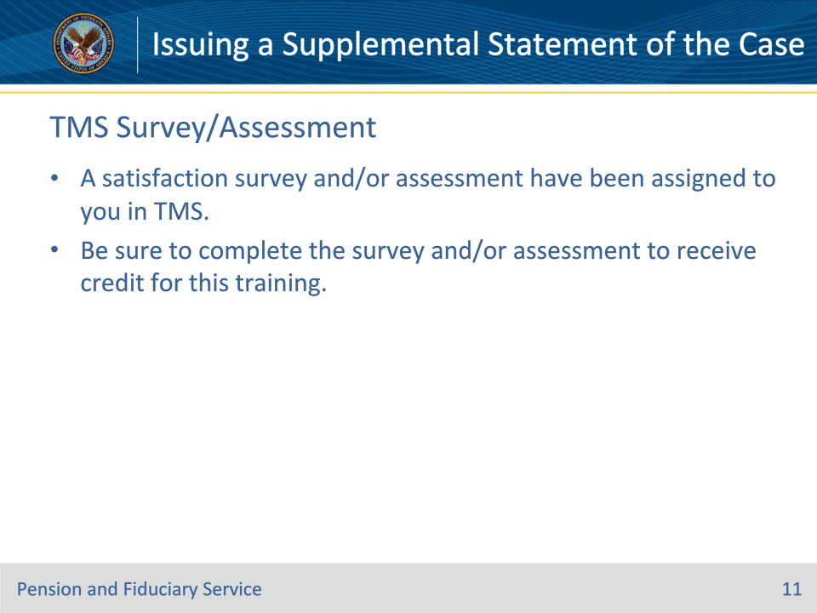
Slide notes

Instructor Notes:

A satisfaction survey and/or assessment have been assigned to you in TMS.

Be sure to complete the survey and/or assessment to receive credit for this training.

