Slide 1 - Legacy Appeal Decisions
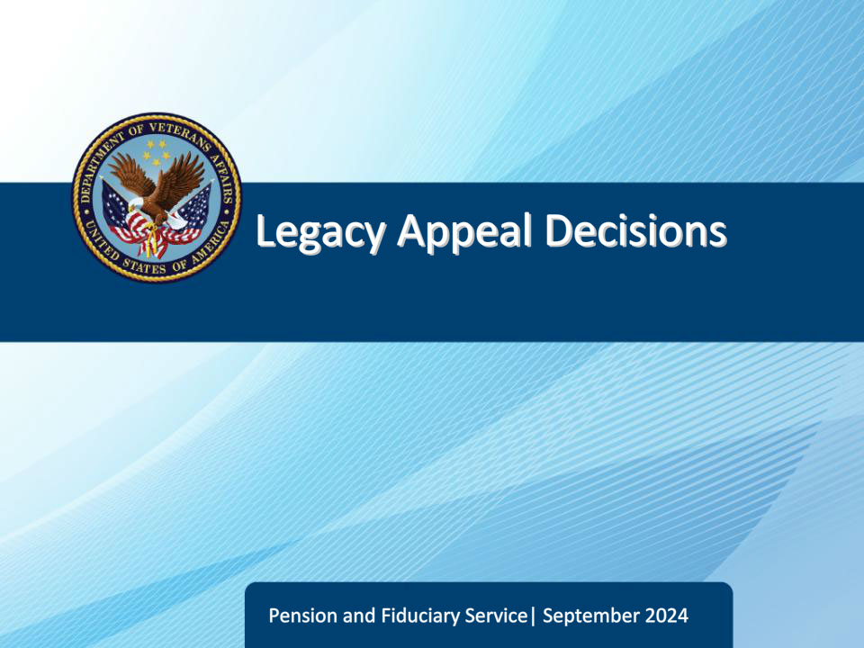
Slide notes

Course Description:

This course teaches learners general information related to legacy appeals decisions.

Slide 2 - Objectives
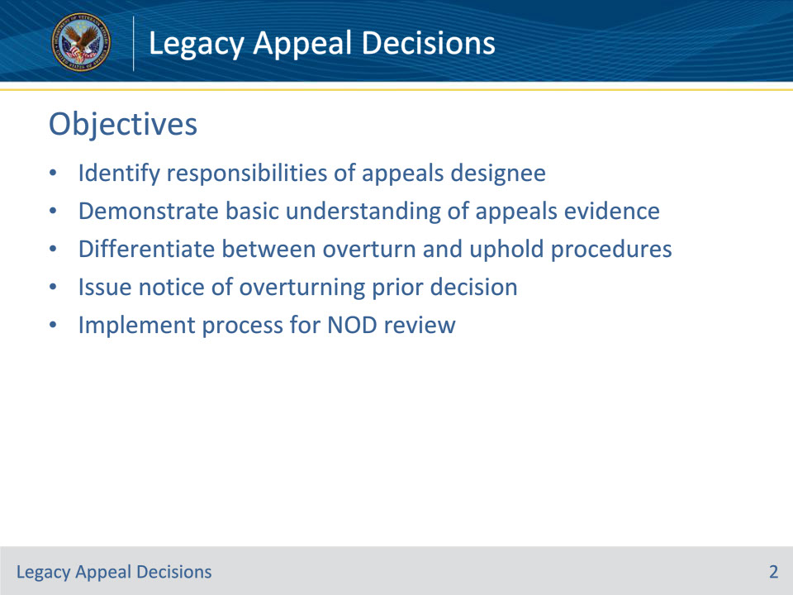
Slide notes

Instructor Notes:

At the end of this lesson, given the training and references, the learner will be able to do the following:

• Identify responsibilities of appeals designee

• Demonstrate basic understanding of appeals evidence

• Differentiate between overturn and uphold procedures

• Issue notice of overturning prior decision

• Implement process for NOD review

Slide 3 - References
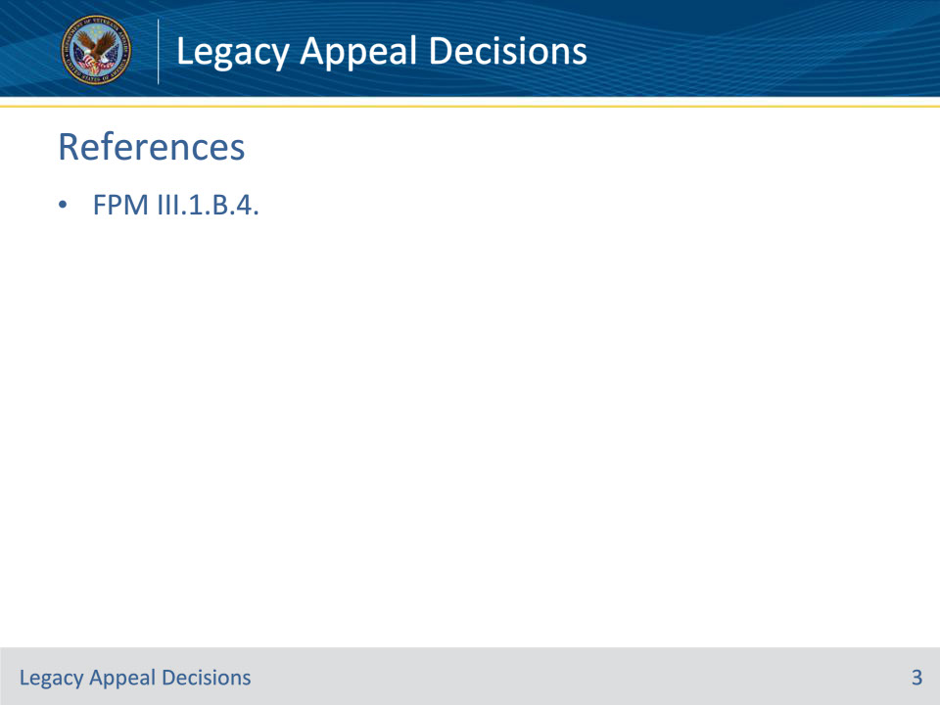
Slide notes

Instructor Notes:

These are the relevant references pertaining to this course:

• FPM III.1.B.4. General Information on Appeals Decisions

Slide 4 - Fiduciary Hub Manager
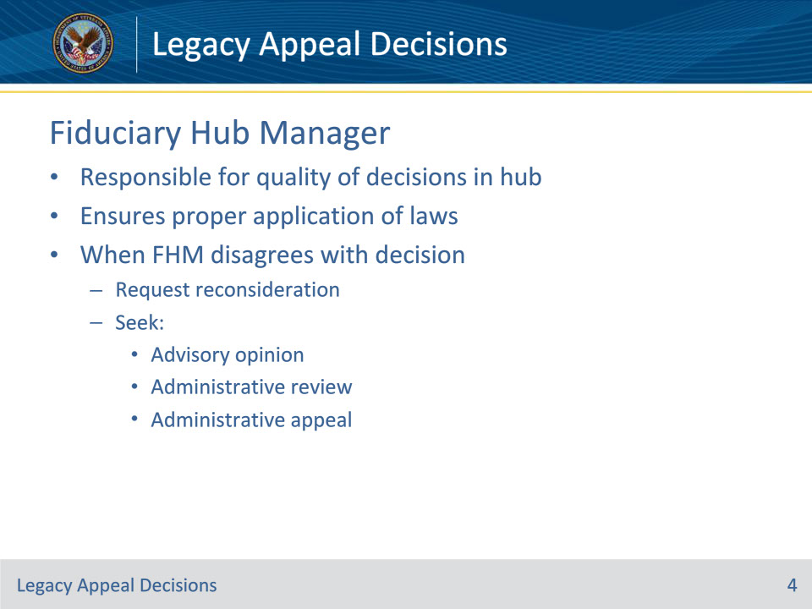
Slide notes

Policy Reference(s): FPM III.1.B.4.a.

Instructor Notes:

The FHM is responsible for the quality of decisions in the hub. This responsibility extends to ensuring that appeals designees properly apply all laws, regulations, and instructions to decisions rendered.

In some cases, where the FHM disagrees with the substantive decision of an appeals designee, the FHM may

• request reconsideration in the decision, or

• seek an advisory opinion, administrative review, or administrative appeal.

Slide 5 - Appeals Designee
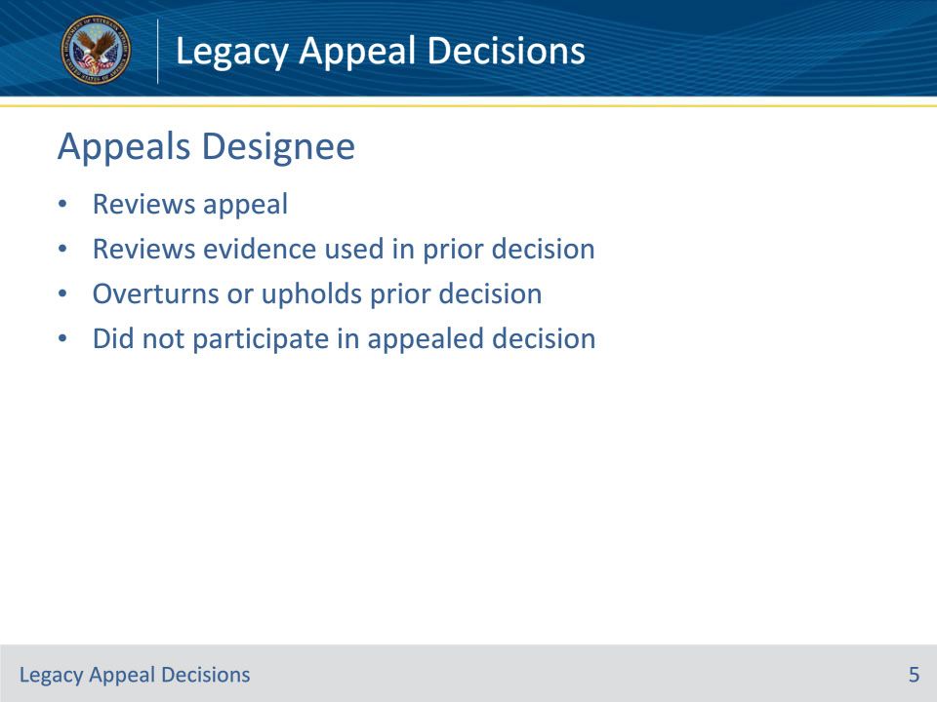
Slide notes

Policy Reference(s): FPM III.1.B.4.b.

Instructor Notes:

Upon receipt of an adequate NOD, the appeals designee has sole authority to review the appeal and the evidence used in making the prior decision. Upon review of the evidence, the appeals designee can overturn the prior decision or uphold it.

Only an individual who did not participate in the appealed decision may conduct the post-decision review.

Slide 6 - Considering Evidence
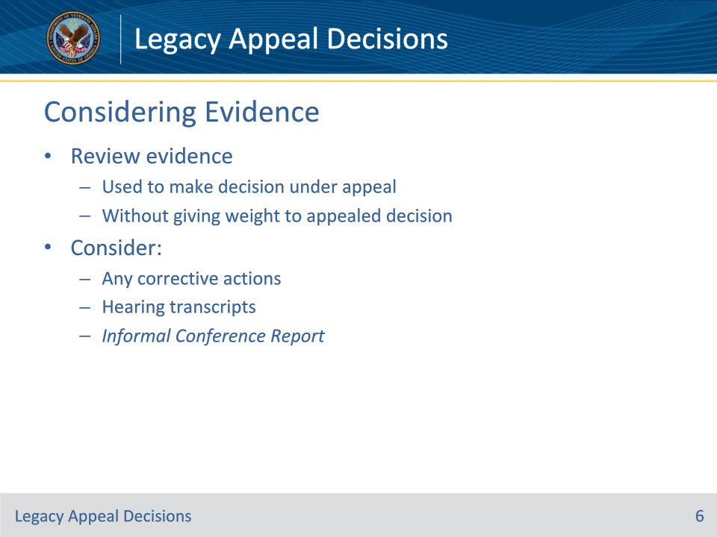
Slide notes

Policy Reference(s): FPM III.1.B.4.c.

Instructor Notes:

The appeals designee only reviews the evidence, used to make the decision under appeal, without giving weight to the prior appealed decision.

Consider any corrective actions in addition to information recorded in hearing transcripts and/or the Informal Conference Report, if conducted, when making a new decision.

Slide 7 - Overturning a Fiduciary
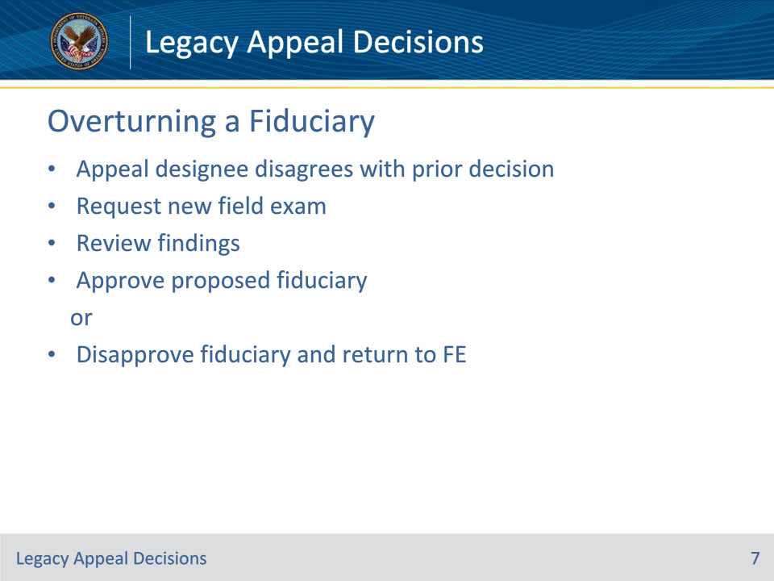
Slide notes

Policy Reference(s): FPM III.1.B.4.d.

Instructor Notes:

The appeals designee is responsible for reviewing the evidence used in the prior decision and requesting any corrective action.

If the appeals designee disagrees with the prior decision, the appeals designee must take immediate action to remedy the prior decision. by requesting the Field Examiner (FE) conduct a new field examination and subsequently reviewing the findings to determine whether to:

• approve the certification of the proposed fiduciary, or

• disapprove the recommendations and return to the FE to qualify a new proposed fiduciary.

Slide 8 - Notification
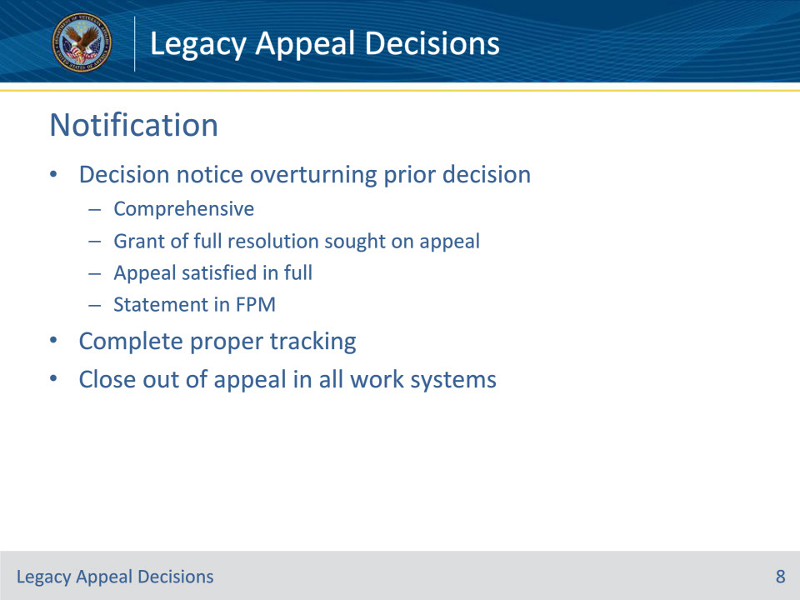
Slide notes

Policy Reference(s): FPM III.1.B.4.e.

Instructor Notes:

The decision notice overturning a prior decision must be comprehensive and include a statement that the decision is a grant of full resolution sought on appeal and the appeal is satisfied in full.

Include the following language in all new decision notices providing full resolution of the appeal:

The following decision is in response to the notice of disagreement received regarding VA decision dated [Month, Day, and Year]. This is a full grant of the resolution sought and satisfies your appeal on this issue.

Complete proper tracking and closing out of the appeal in all work systems.

Slide 9 - Decision to Uphold
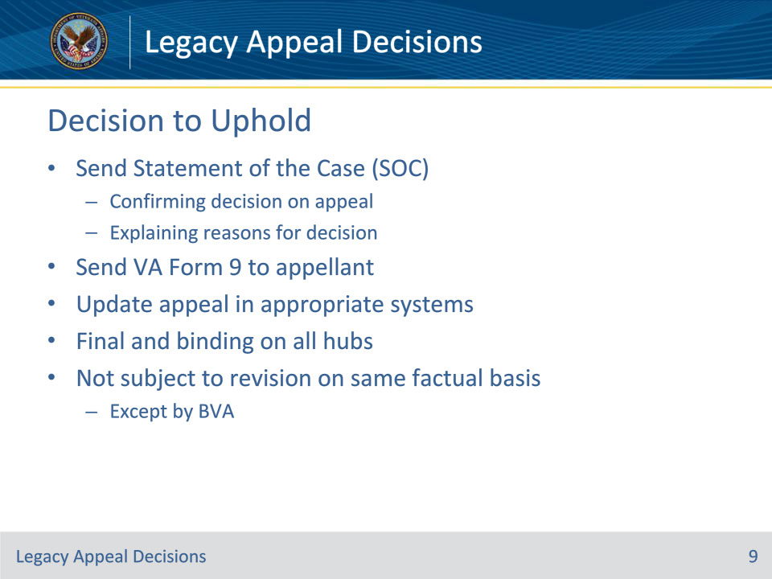
Slide notes

Policy Reference(s): FPM III.1.B.4.f.

Instructor Notes:

If the appeals designee upholds the previous decision under appeal, they send a

• SOC

• confirming the decision on appeal, and

• explaining the reasons and basis for the VA decision, and

• VA Form 9, to the appellant.

The appeals designee updates the appeal in the appropriate systems.

An appeals decision is final and binding on all hubs and is not subject to revision on the same factual basis, except by BVA.

Slide 10 - Reviewing an NOD
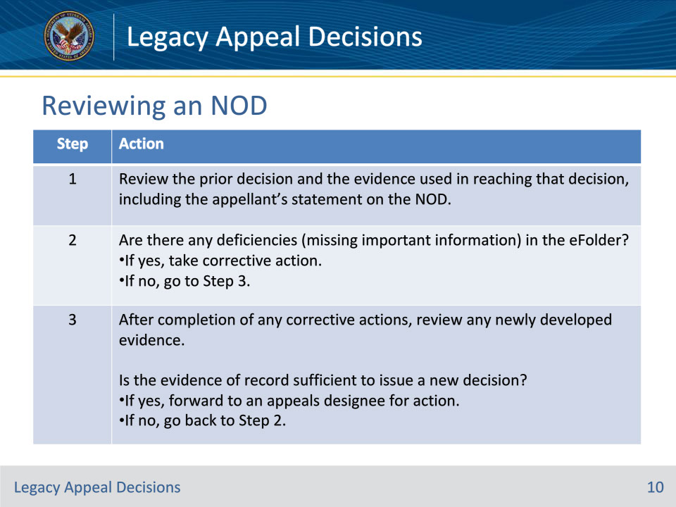
Slide notes

Policy Reference(s): FPM III.1.B.4.g.

Instructor Notes:

Follow the steps in the table above to review an NOD.

Slide 11 - Questions?
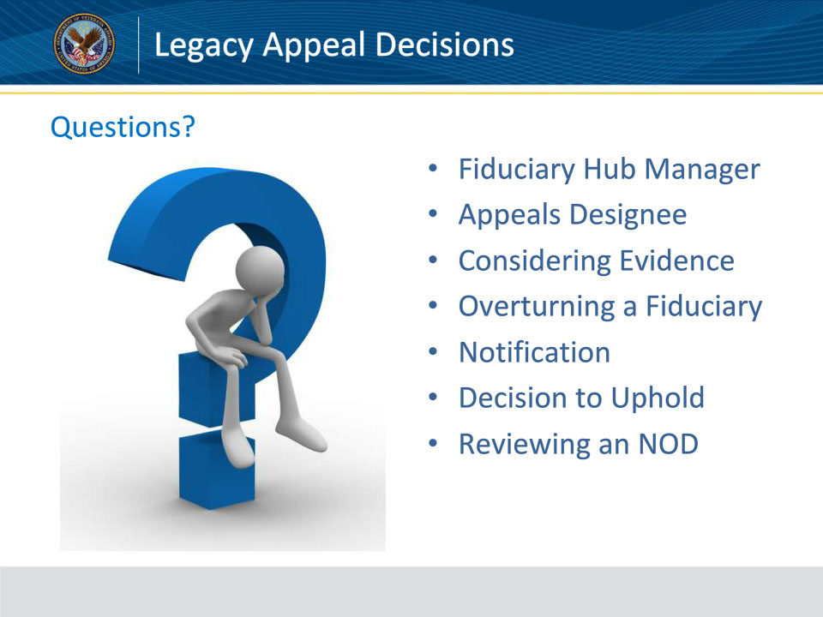
Slide notes

Instructor Notes:

(Recall) These are our learning objectives as stated from the beginning of the training:

• Identify responsibilities of appeals designee

• Demonstrate basic understanding of appeals evidence

• Differentiate between overturn and uphold procedures

• Issue notice of overturning prior decision

• Implement process for NOD review

(Recap) We discussed each of these learning objectives through the following topics in each slide today:

• Fiduciary Hub Manager

• Appeals Designee

• Considering Evidence

• Overturning a Fiduciary

• Notification

• Decision to Uphold

• Reviewing an NOD

Are there any additional questions?

Questions should be filtered through your QRT team. They will submit your questions to the Field Inquiry Tool (FIT) on your behalf.

Slide 12 - TMS Survey/Assessment
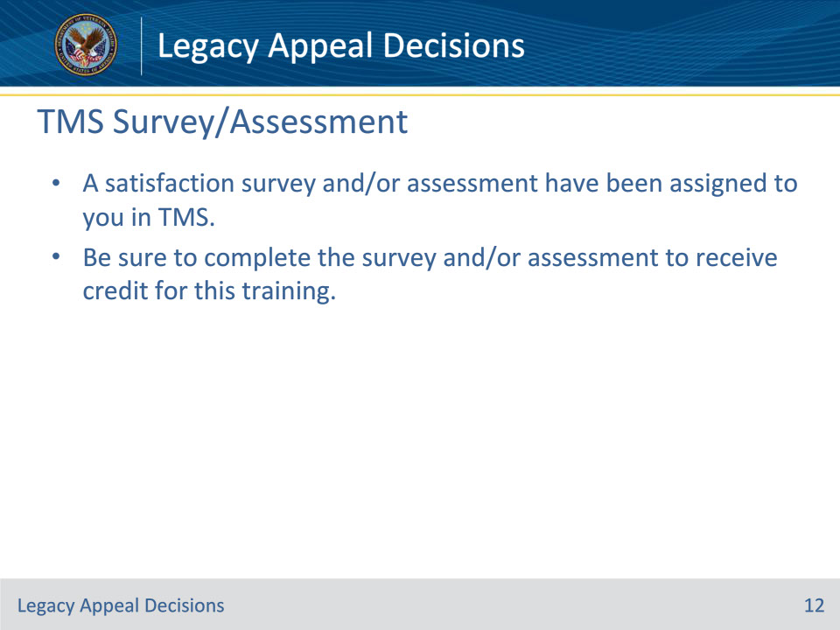
Slide notes

Instructor Notes:

A satisfaction survey and/or assessment have been assigned to you in TMS.

Be sure to complete the survey and/or assessment to receive credit for this training.

