Slide 1 - Legacy Notice of Disagreement
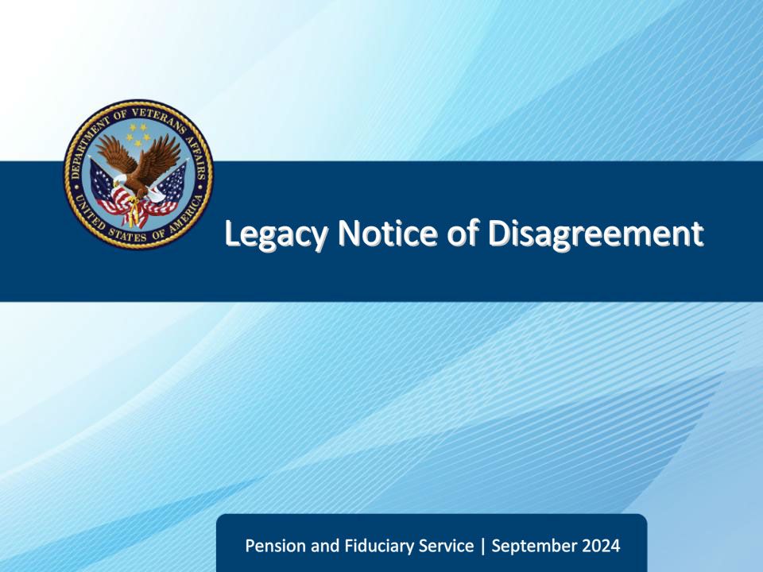
Slide notes

Course Description:

This course teaches learners general information regarding Legacy Notice of Disagreements (NODs)

Slide 2 - Objectives
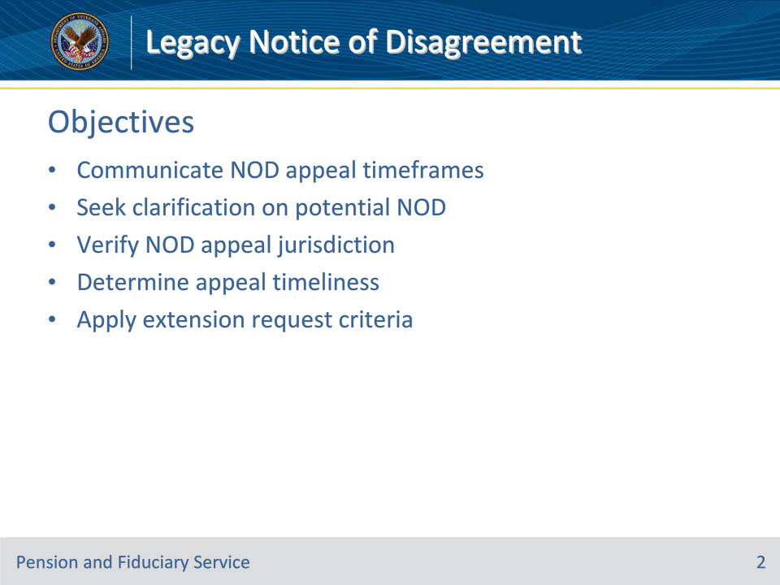
Slide notes

Instructor Notes:

At the end of this lesson, given the training and references, the learner will be able to do the following:

• Communicate NOD appeal timeframes

• Seek clarification on potential NOD

• Verify NOD appeal jurisdiction

• Determine appeal timeliness

• Apply extension request criteria

Slide 3 - References
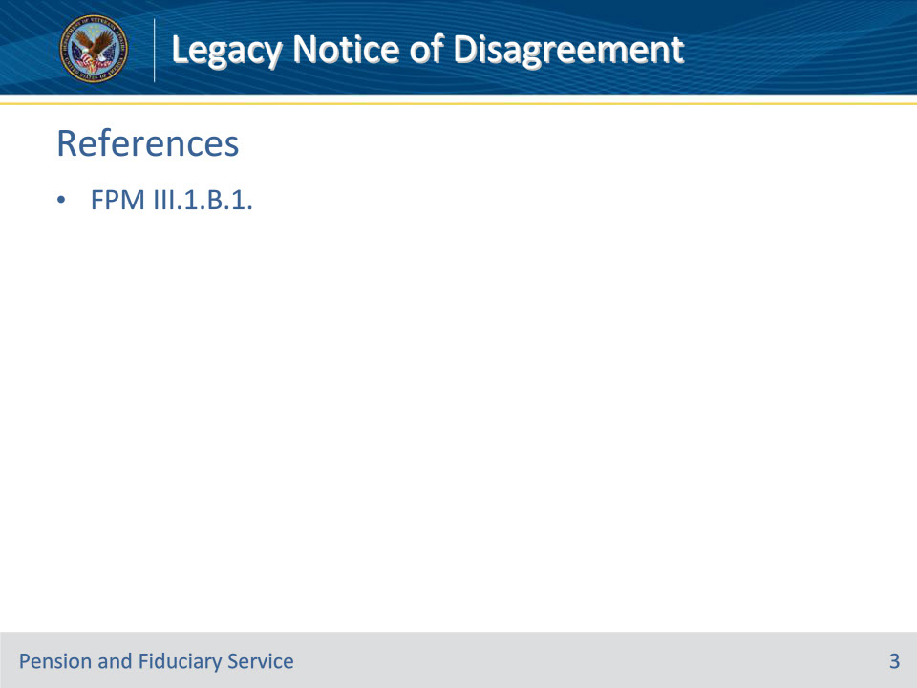
Slide notes

Instructor Notes:

These are the relevant references pertaining to this course:

• FPM III.1.B.1. General Information on Legacy NODs

Slide 4 - Time Frames
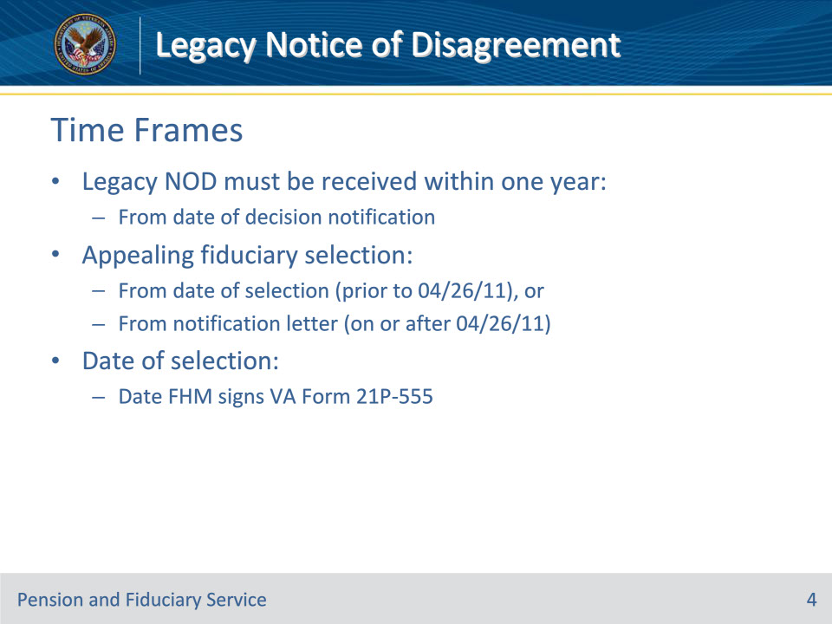
Slide notes

Policy Reference(s): FPM III.1.B.1.a.

Instructor Notes:

A legacy notice of disagreement (NOD) must be received within one year from the notification date for that specific Department of Veterans Affairs (VA) decision. If no NOD is received within one year of notification, the decision becomes final.

Exception: For NODs disagreeing with a fiduciary selection, an appeal is timely if the NOD is received within one year of the date of

• selection (for selections made prior to April 26, 2011), or

• the notification letter (for selections made on or after April 26, 2011).

The date of selection is the date the Fiduciary Hub Manager (FHM) or designee signs VA Form 21P-555, Certificate of Legal Capacity to Receive or Disburse Benefits and Fee Authorization.

Effective August 13, 2018, appeal rights must accompany all appealable decisions.

Slide 5 - Clarification
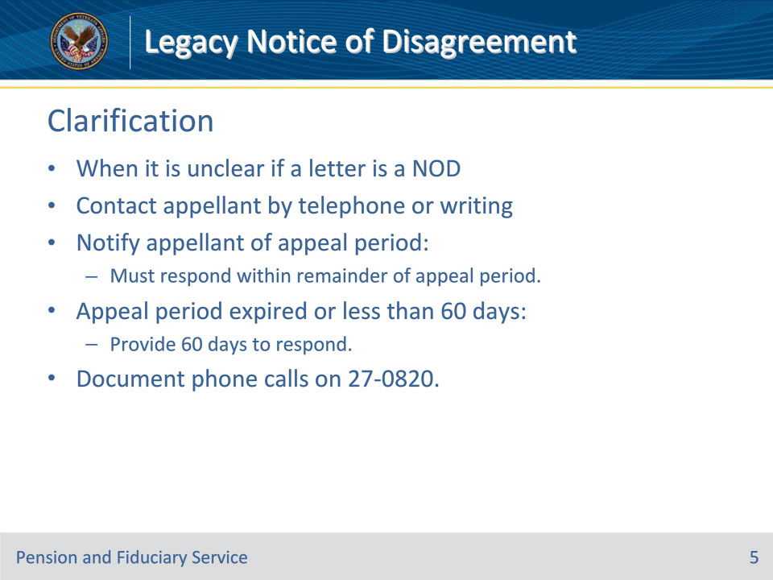
Slide notes

Policy Reference(s): FPM III.1.B.1.b.

Instructor Notes:

If it is unclear, whether a letter from a beneficiary or their legal guardian, accredited representative, attorney, or claim agent is an NOD, request clarification by contacting the appellant by telephone or in writing.

• Notify the appellant that failures to respond within the remainder of the appeal period will result in VA not considering the earlier, unclear communication an NOD.

• If the appeal period is expired, or has less than 60 days remaining, provide the appellant 60 days to respond to the request for clarification to keep the appeal viable. Explain this 60-day time limit in your oral or written contact with the appellant.

• Document any telephone conversation with the appellant on VA Form 27-0820, Report of General Information.

Slide 6 - Clarification (Cont.)
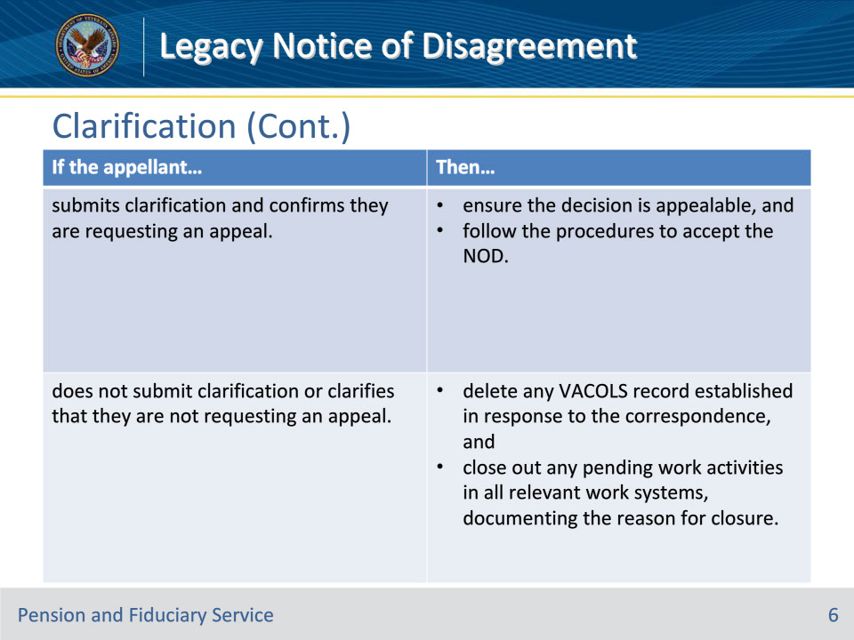
Slide notes

Policy Reference(s): FPM III.1.B.1.b.

Instructor Notes:

Upon expiration of the 60-day timeframe or notice of receipt of additional evidence, review the electronic claims folder (eFolder) for a response. Use the table on this slide to determine appropriate actions to take based on evidence identified in the eFolder.

For all clarified issues taken as an NOD, the date of the NOD is the date of receipt of the initial written communication, not the date of clarification.

Slide 7 - Review
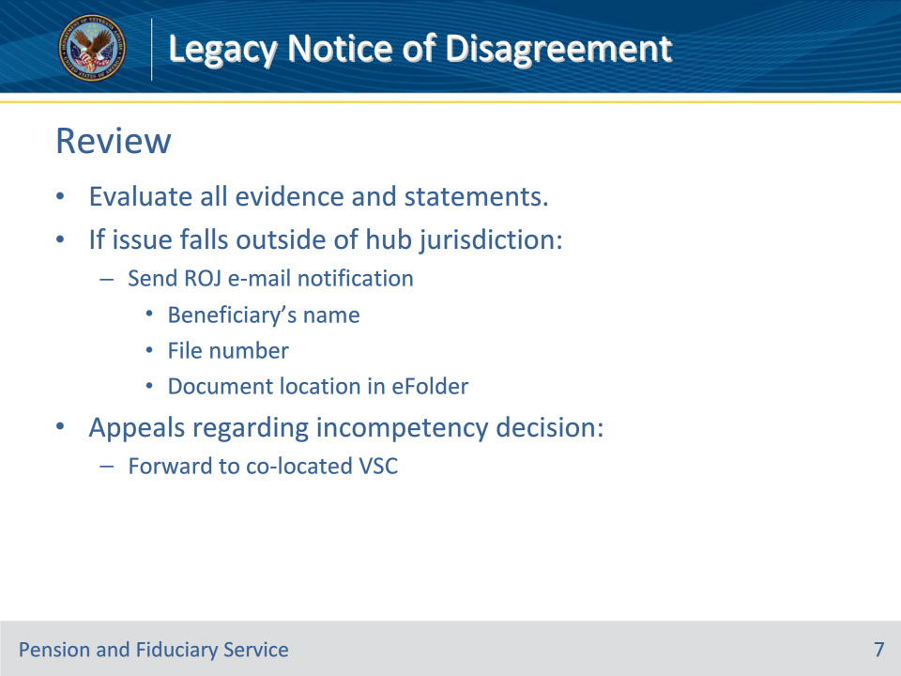
Slide notes

Policy Reference(s): FPM III.1.B.1.c.

Instructor Notes:

VA employees should liberally evaluate all evidence and statements from an appellant to address all appealed decisions. If an NOD contains an issue that falls outside of the fiduciary hub’s (hub) jurisdiction, send the regional office (RO) of jurisdiction e-mail notification including the:

• beneficiary’s name

• file number, and

• location of the document in the eFolder.

Forward all appeals regarding decisions to rate the beneficiary unable to manage VA benefits completed by a hub to the co-located Veterans Service Center.

Slide 8 - Untimely
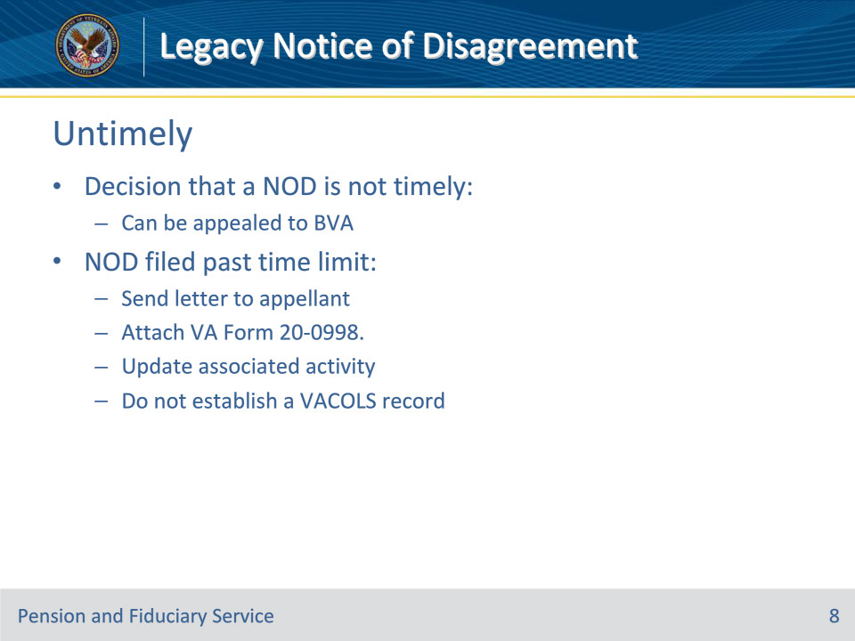
Slide notes

Policy Reference(s): FPM III.1.B.1.d.

Instructor Notes:

An appellant may appeal VA’s decision that a legacy NOD is not timely to the Board of Veterans’ Appeals (BVA).

If an appellant files an NOD past the time limit

• send a letter informing the appellant that the NOD is not timely

• attach VA Form 20-0998, Your Right to Seek Review of Our Decision, and

• update the associated activity in proper work systems.

Do not establish a record in VACOLS.

Slide 9 - Extension Request
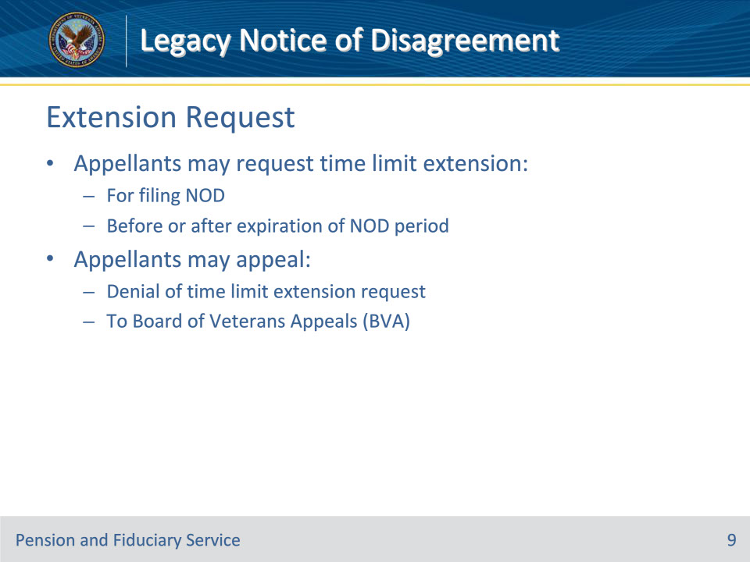
Slide notes

Policy Reference(s): FPM III.1.B.1.e.

Instructor Notes:

An appellant may

• request an extension of the time limit for filing an NOD before or after the expiration of the NOD period, and

• appeal a denial of a request for a time limit extension to BVA.

Slide 10 - Extension Request (Cont.)
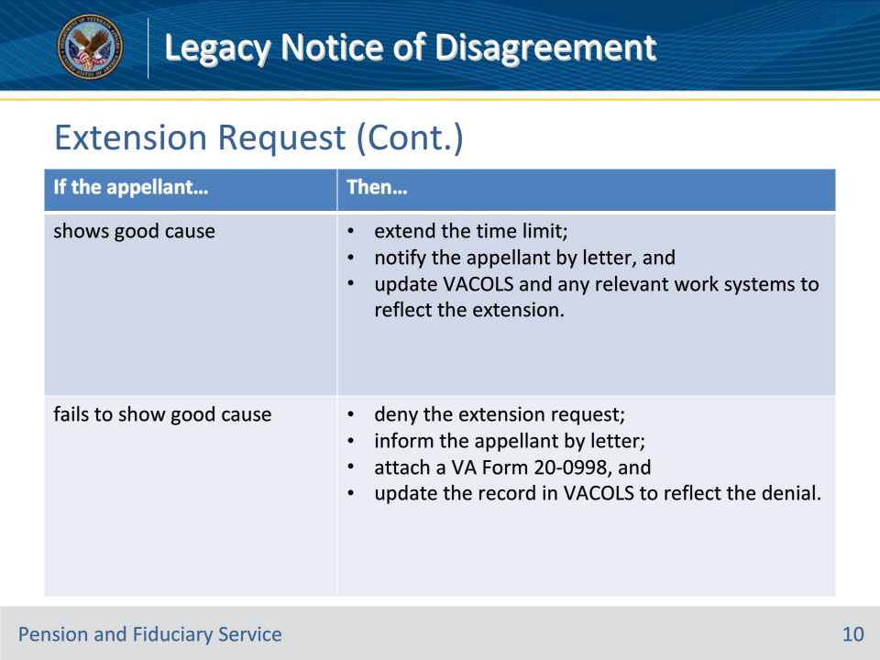
Slide notes

Policy Reference(s): FPM III.1.B.1.e.

Instructor Notes:

Follow the steps in the table on this slide when the hub receives a request to extend the time limit.

Reference: For more information on good cause, see 38 CFR 3.109(b).

Slide 11 - 31. Questions?
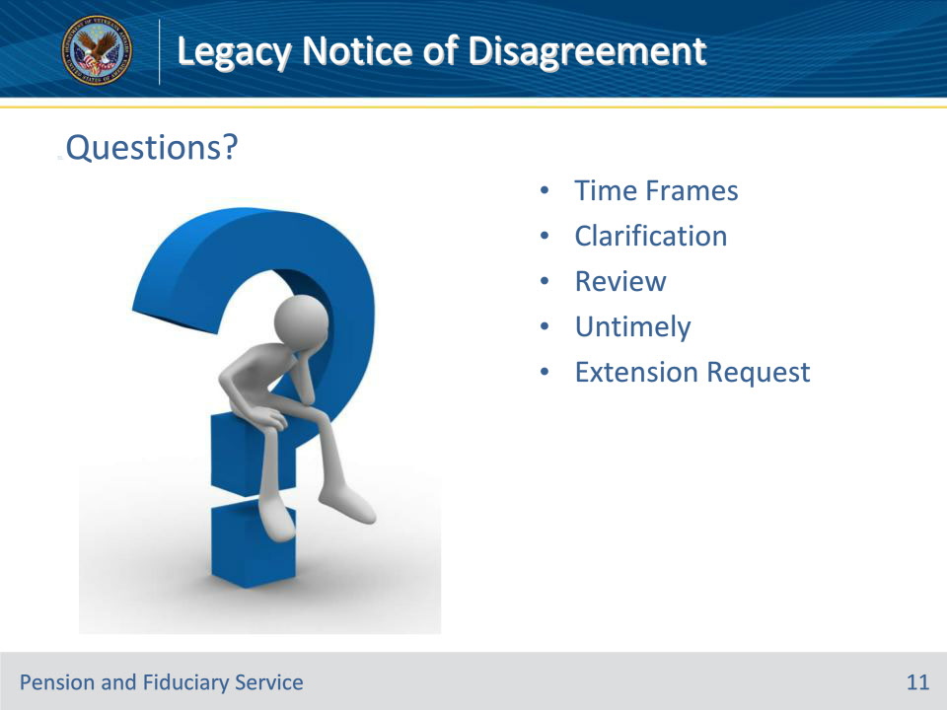
Slide notes

Instructor Notes:

(Recall) These are our learning objectives as stated from the beginning of the training:

• Communicate NOD appeal timeframes

• Seek clarification on potential NOD

• Verify NOD appeal jurisdiction

• Determine appeal timeliness

• Apply extension request criteria

(Recap) We discussed each of these learning objectives through the following topics in each slide today:

• Time Frames

• Clarification

• Review

• Untimely

• Extension Request

Are there any additional questions?

Questions should be filtered through your QRT team. They will submit your questions to the Field Inquiry Tool (FIT) on your behalf.

Slide 12 - TMS Survey/Assessment
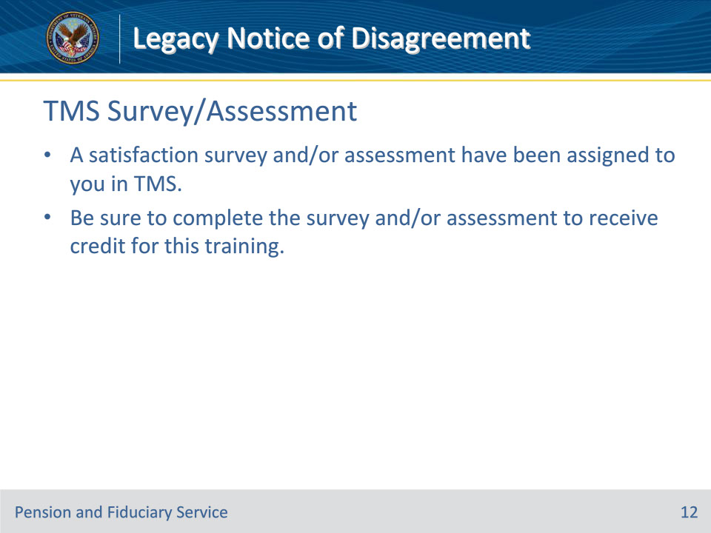
Slide notes

Instructor Notes:

A satisfaction survey and/or assessment have been assigned to you in TMS.

Be sure to complete the survey and/or assessment to receive credit for this training.

