Slide 1 - Receipt and Withdrawal of NOD
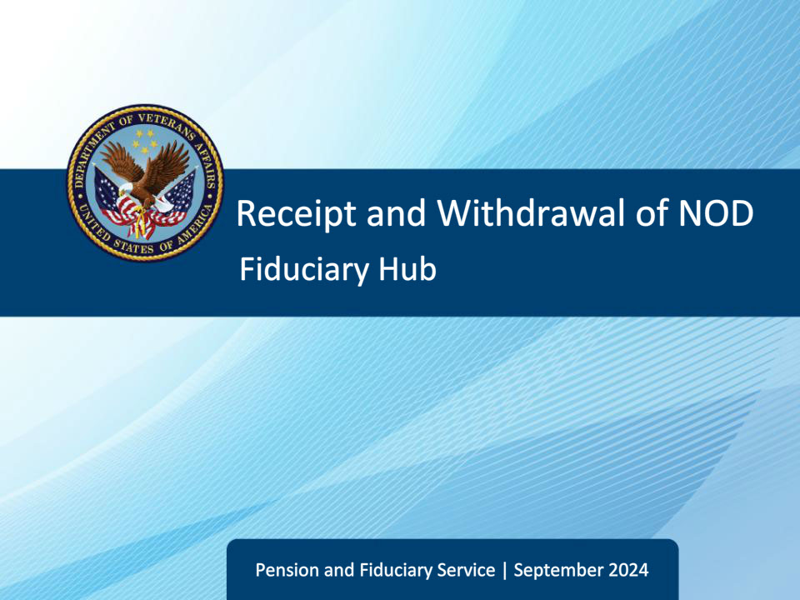
Slide notes

This course teaches learners the procedures for receipt, withdrawal, and reinstatement of legacy NODs.

Slide 2 - Objectives
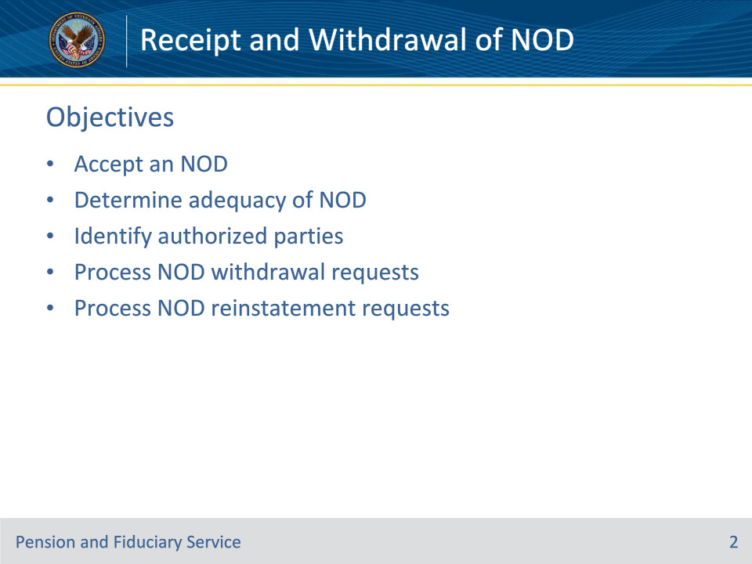
Slide notes

Instructor Notes:

At the end of this lesson, given the training and references, the learner will be able to do the following:

• Accept an NOD

• Determine adequacy of NOD

• Identify authorized parties

• Process NOD withdrawal requests

• Process NOD reinstatement requests

Slide 3 - References
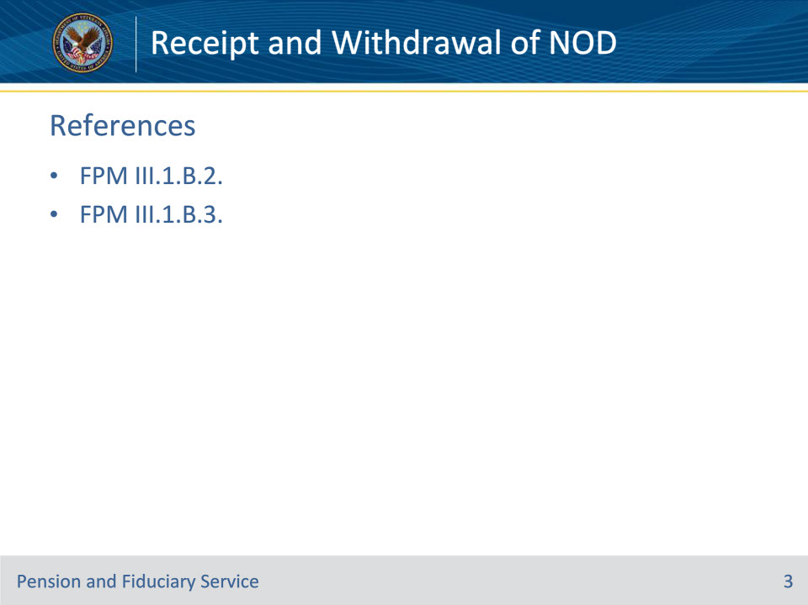
Slide notes

Instructor Notes:

These are the relevant references pertaining to this course:

• FPM III.1.B.2. Receipt of a Legacy NOD

• FPM III.1.B.3. Withdrawing and/or Reinstating a Legacy NOD

Slide 4 - Jurisdiction
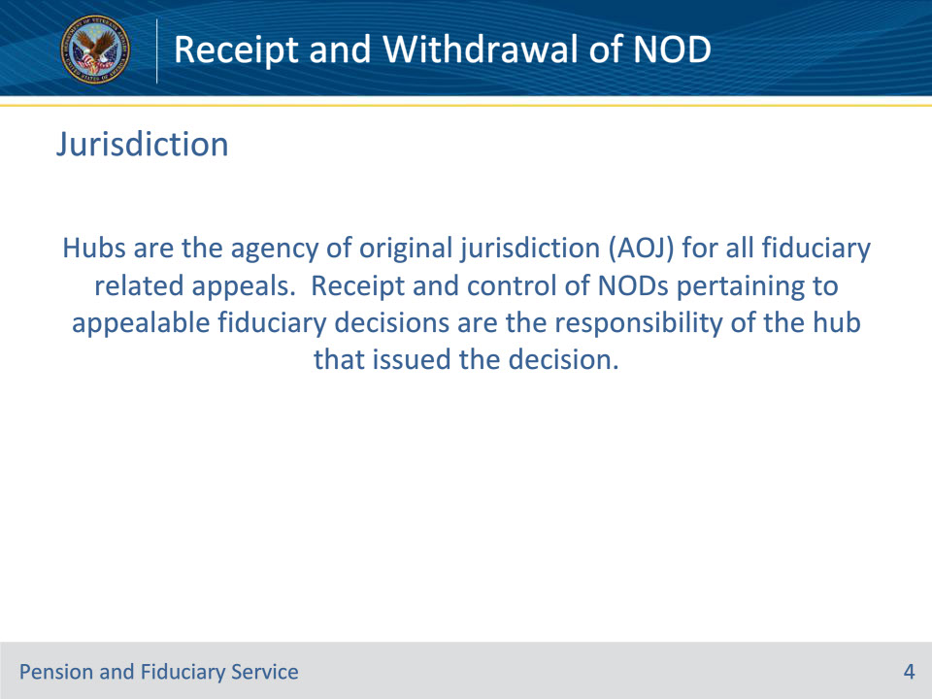
Slide notes

Policy Reference(s): FPM III.1.B.2.a.

Instructor Notes:

Hubs are the agency of original jurisdiction (AOJ) for all fiduciary related appeals. Receipt and control of NODs pertaining to appealable fiduciary decisions are the responsibility of the hub that issued the decision.

Slide 5 - Accepting an NOD
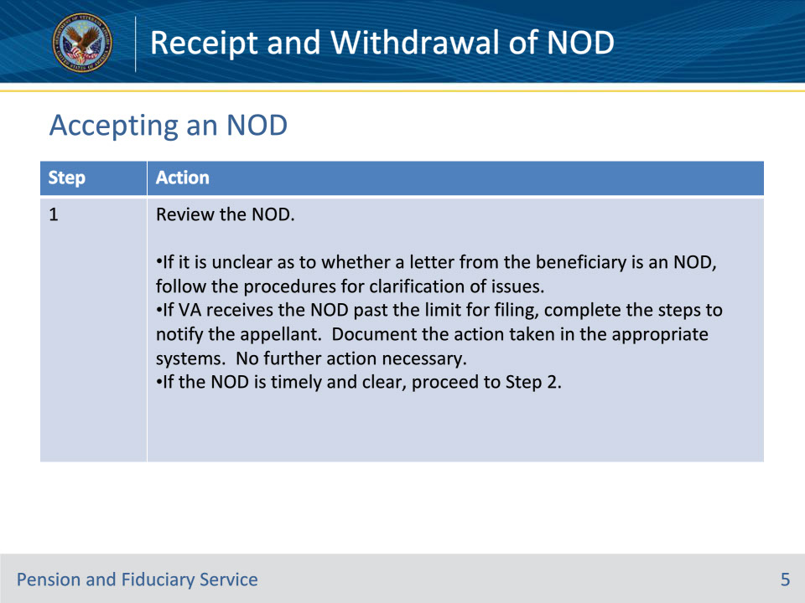
Slide notes

Policy Reference(s): FPM III.1.B.2.b.

Instructor Notes:

Follow the steps on the slides to accept an NOD.

Step 1

Review the NOD.

• If it is unclear as to whether or not a letter from the beneficiary is an NOD, follow the procedures for clarification of issues in FPM, Part III, 1.B.1.d.

• If VA receives the NOD past the limit for filing, complete the steps in FPM, Part III, 1.B.1.d to notify the appellant. Document the action taken in the appropriate systems. No further action necessary.

• If the NOD is timely and clear, proceed to Step 2.

Slide 6 - Accepting an NOD
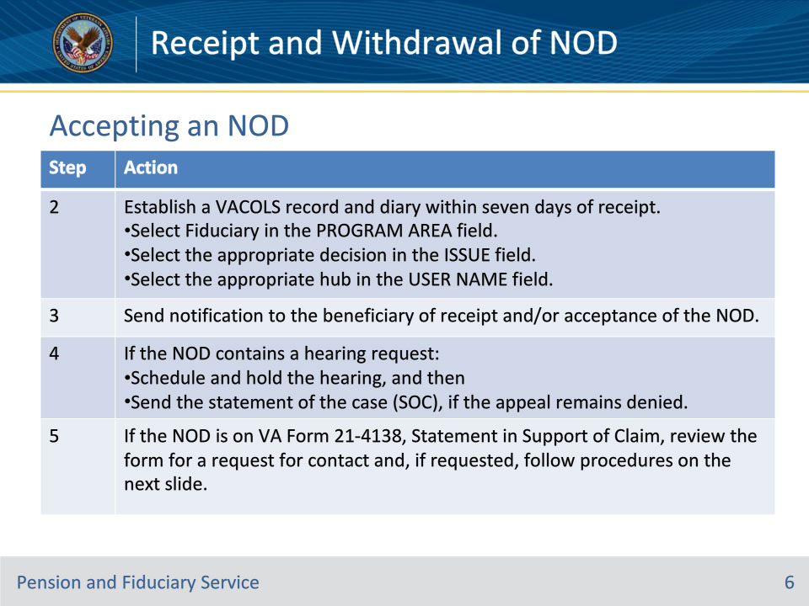
Slide notes

Policy Reference(s): FPM III.1.B.2.b.; M21-5 7.B.2.d.

Instructor Notes:

Step 2

Establish a VACOLS record and diary within seven days of receipt.

• Select Fiduciary in the PROGRAM AREA field.

• Select the appropriate decision in the ISSUE field:

• Fiduciary Appointment

• Hub Manager Removal of a fiduciary under 13.500

• Hub Manager misuse determination under 13.400

• RO Director decision upon recon of misuse determination, or

• Dir PFS of negligence determination for reissuance.

• Select the appropriate hub in the USER NAME field:

• Columbia Fiduciary Hub: RO64

• Indianapolis Fiduciary Hub: RO65

• Lincoln Fiduciary Hub: RO66

• Louisville Fiduciary Hub: RO67

• Milwaukee Fiduciary Hub: RO68, or

• Western Area Fiduciary Hub: RO69.

Step 3

Send notification to the beneficiary of receipt and/or acceptance of the NOD.

Step 4

If the NOD contains a hearing request, follow the guidance in M21-5, Chapter 7, Section B.2.d.

M21-5 7.B.2.d. states the following:

If a hearing request is received with an NOD

• schedule and hold the hearing, and then

• send the statement of the case (SOC), if the appeal remains denied.

Note: This policy applies to both the Decision Review Officer (DRO) and the traditional appellate review processes.

Step 5

If the NOD is on VA Form 21-4138, Statement in Support of Claim, review the form for a request for contact and, if requested, follow procedures in FPM, Part III, 1.B.2.c.

Slide 7 - VA Form 21-4138
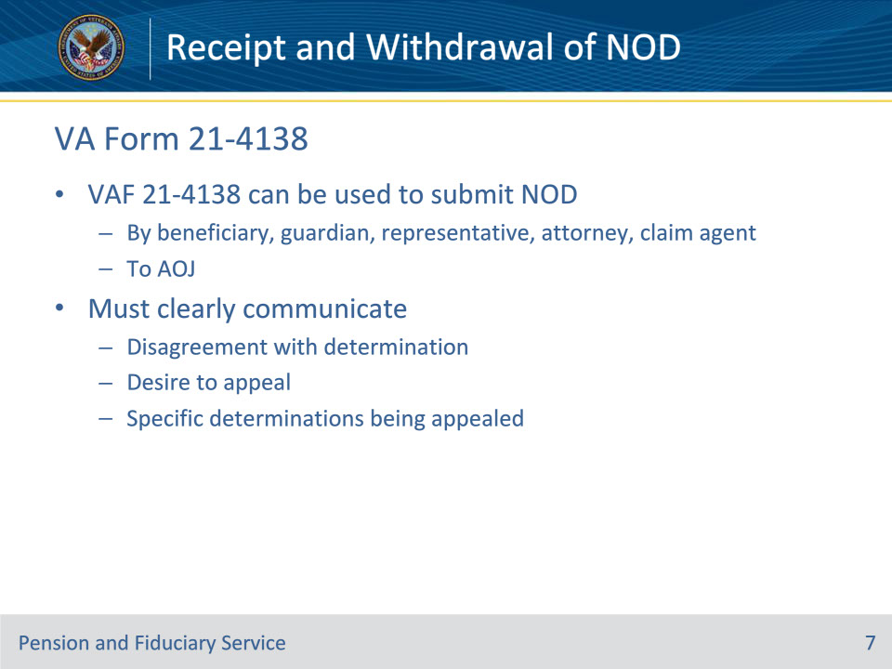
Slide notes

Policy Reference(s): FPM III.1.B.2.c.

Instructor Notes:

A VA Form 21-4138 can be used to submit an NOD by the beneficiary or their legal guardian, accredited representative, attorney, or claim agent to the AOJ. The NOD must be in terms which can be reasonably construed as disagreement with that determination and a desire for appellate review. If the AOJ gave notice that adjudicative determinations were made on several issues at the same time, the specific determinations with which the claimant disagrees must be clearly identified.

Slide 8 - Appealing Inadequate NODs
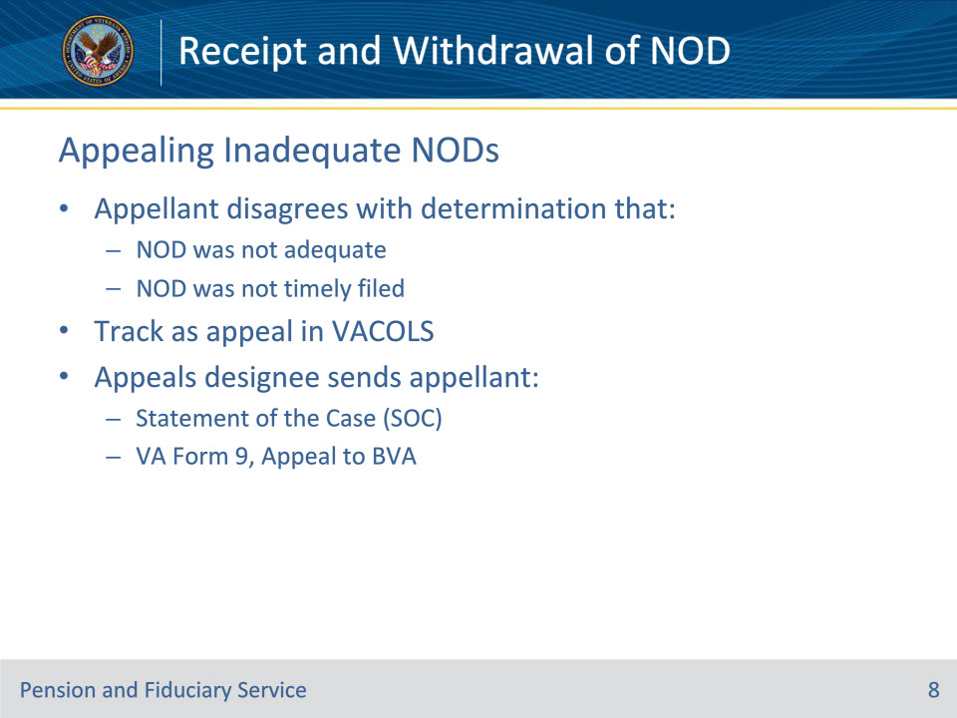
Slide notes

Policy Reference(s): FPM III.1.B.2.d.

Instructor Notes:

If the appellant disagrees with a determination that an NOD was not adequate or timely filed, track the disagreement as an appeal in VACOLS.

The appeals designee sends the appellant

• a statement of the case (SOC) explaining the determination, and

• VA Form 9, Appeal to Board of Veterans’ Appeals.

Slide 9 - New Issues Raised
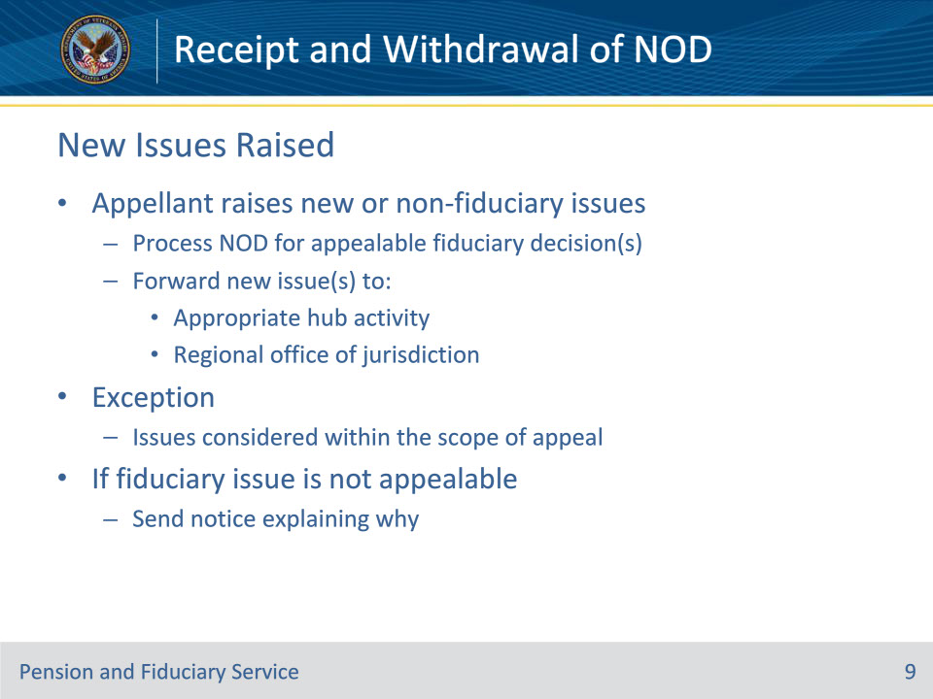
Slide notes

Policy Reference(s): FPM III.1.B.2.e.

Instructor Notes:

If the appellant raises issues on the NOD that are new, or do not fall under the jurisdiction of the hub, continue to process the NOD for the appealable fiduciary decision.

Forward the new issue(s) to the appropriate hub activity or RO of jurisdiction for processing.

If a fiduciary issue is not appealable, send notice to the appellant explaining why the particular issue is not appealable.

For issues outside the jurisdiction of the hub, send e-mail notification to the RO of jurisdiction of any non-fiduciary related appeals issues.

Exception: Issues considered within the scope of the current appeal, must be developed and adjudicated under the current appeal.

Example: Veteran appeals the appointment of their current fiduciary. Veteran then submits a request to have their sister act as fiduciary. The request to appoint the sister is considered within the scope of the current appeal and will be addressed by the appeals designee.

Slide 10 - Authorized Parties
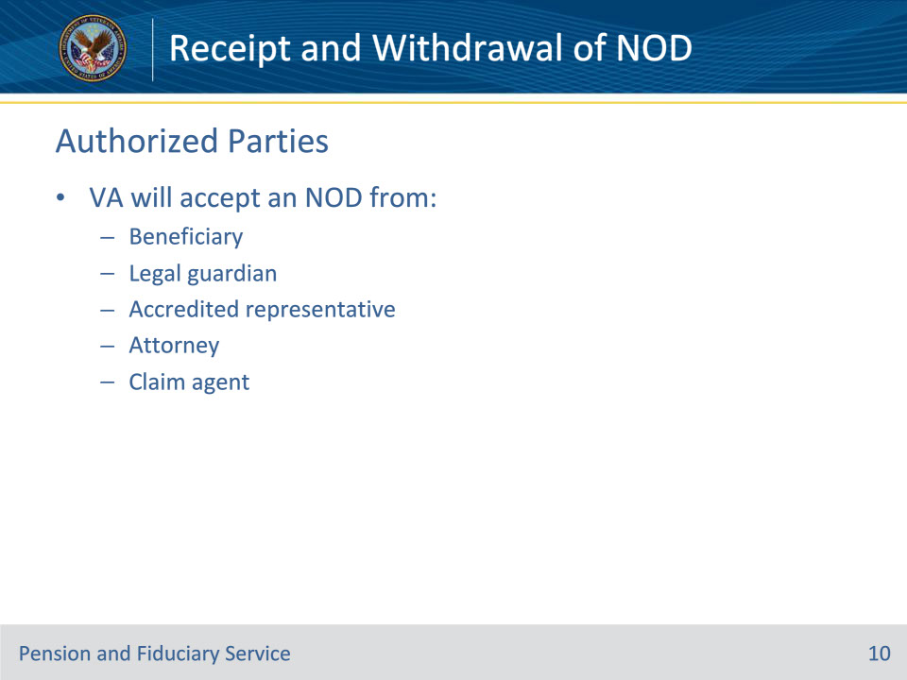
Slide notes

Policy Reference(s): FPM III.1.B.2.f.

Instructor Notes:

VA will not accept an NOD submitted by an individual or entity other than the beneficiary or their legal guardian, accredited representative, attorney or claim agent.

Slide 11 - Authorized Parties
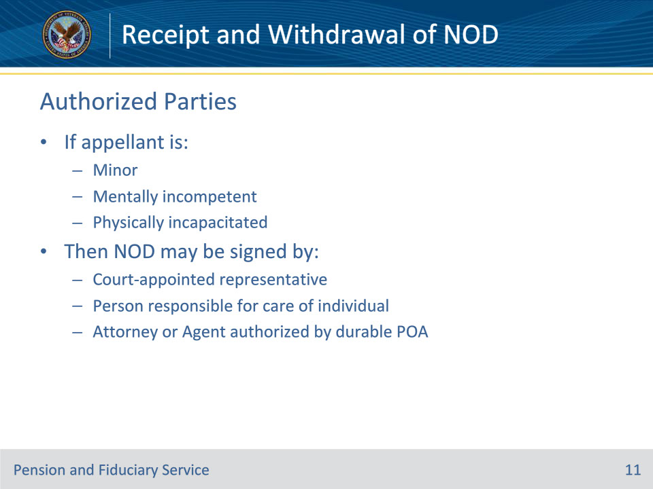
Slide notes

Policy Reference(s): FPM III.1.B.2.f.

Instructor Notes:

If an appellant is a minor, mentally incompetent, or physically incapacitated, the NOD maybe signed by a court-appointed representative, a person who is responsible for the care of the individual, including a spouse or other relative, or an attorney in fact or agent authorized to act on behalf of the individual under a durable power of attorney as provided in 38 U.S.C. 5101(a)(2).

Slide 12 - Authorized Parties
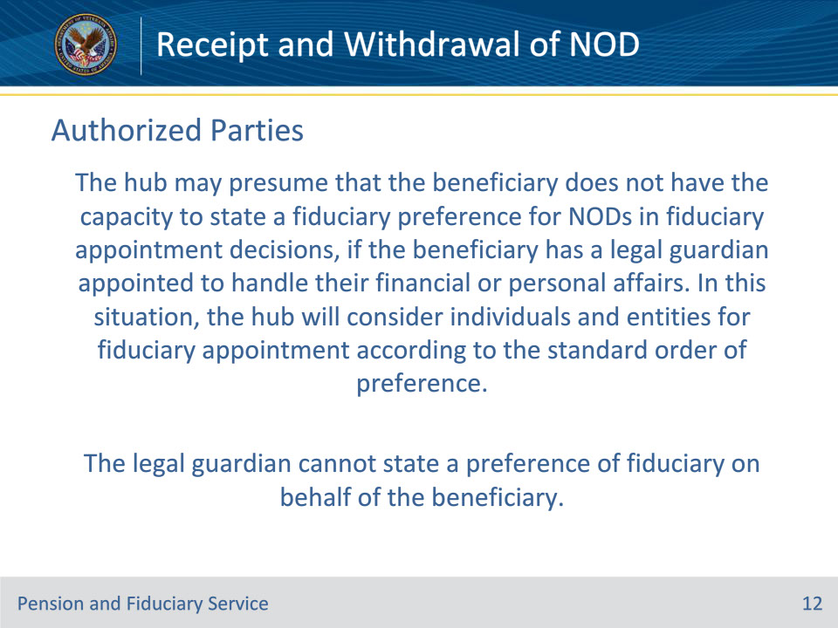
Slide notes

Policy Reference(s): FPM III.1.B.2.f.

Instructor Notes:

The hub may presume that the beneficiary does not have the capacity to state a fiduciary preference for NODs in fiduciary appointment decisions, if the beneficiary has a legal guardian appointed to handle their financial or personal affairs. In this situation, the hub will consider individuals and entities for fiduciary appointment according to the standard order of preference.

The legal guardian cannot state a preference of fiduciary on behalf of the beneficiary. However, the legal guardian can file an NOD with the hub’s selection if they are designated as a legal guardian to act on the beneficiary’s behalf as noted above.

Slide 13 - Notification
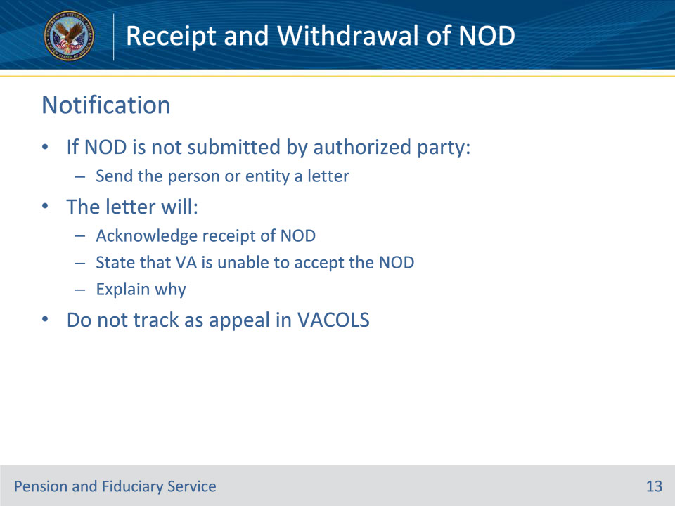
Slide notes

Policy Reference(s): FPM III.1.B.2.f.

Instructor Notes:

If the NOD is not submitted by the authorized person, send the person or entity submitting the correspondence a letter.

This letter will acknowledge receipt of the NOD, but will state that VA is unable to accept the document as an NOD as it did not come from the beneficiary or their legal guardian, accredited representative, attorney, or claim agent.

Do not track this action as an appeal in VACOLS. Ensure completion of the associated task in appropriate work systems.

Slide 14 - Withdrawal
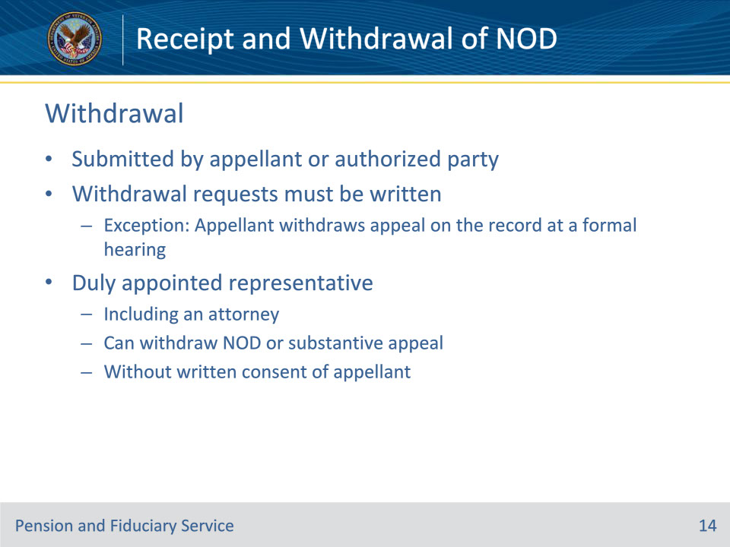
Slide notes

Policy Reference(s): FPM III.1.B.3.a.; b.

Instructor Notes:

An appellant/their legal guardian, accredited representative, attorney or claim agent must submit a request to withdraw an NOD in writing.

Exception: A written submission is not required when the appellant withdraws an appeal on the record at a formal hearing.

A duly appointed representative, including an attorney, can withdraw an NOD or substantive appeal without the written consent of the appellant.

Slide 15 - Reinstatement
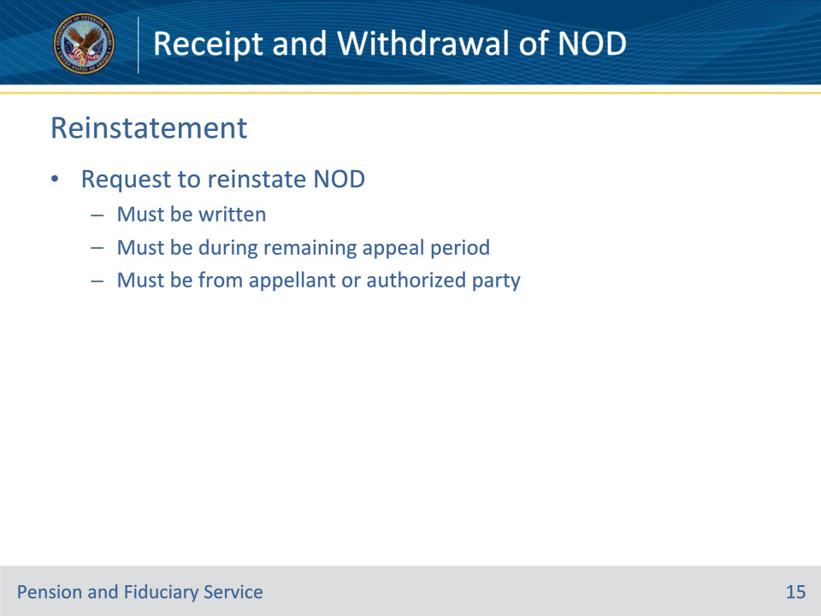
Slide notes

Policy Reference(s): FPM III.1.B.3.c.

Instructor Notes:

The appellant or authorized representative must submit a request for reinstatement of an NOD in writing during the remaining appeal period. If the appellant or authorized representative does not reinstate the NOD, the previously disputed decision(s) is final.

Slide 16 - Questions?
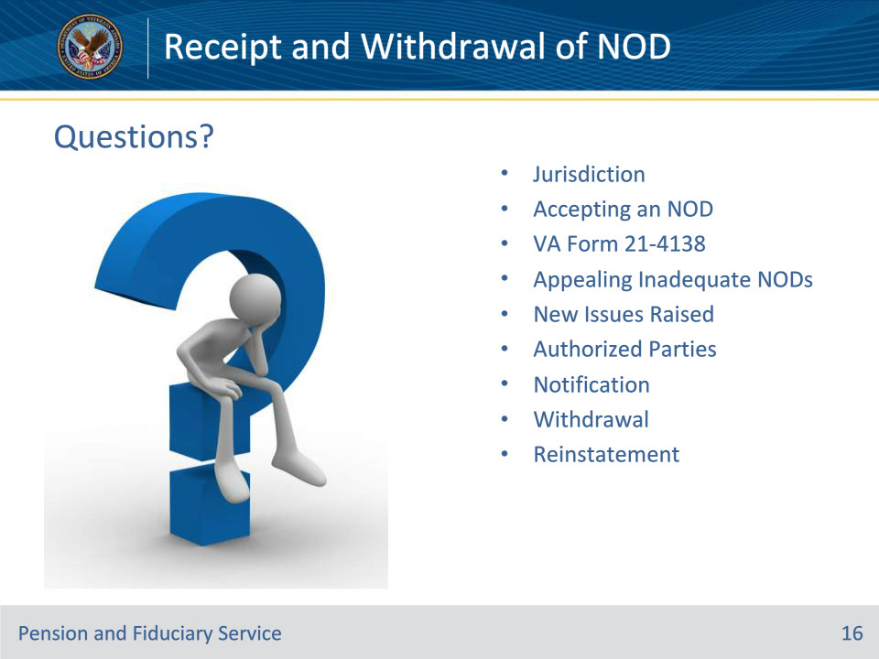
Slide notes

Instructor Notes:

(Recall) These are our learning objectives as stated from the beginning of the training:

• Accept an NOD

• Determine adequacy of NOD

• Identify authorized parties

• Process NOD withdrawal requests

• Process NOD reinstatement requests

(Recap) We discussed each of these learning objectives through the following topics in each slide today:

• Jurisdiction

• Accepting an NOD

• VA Form 21-4138

• Appealing Inadequate NODs

• New Issues Raised

• Authorized Parties

• Notification

• Withdrawal

• Reinstatement

Are there any additional questions?

Questions should be filtered through your QRT team. They will submit your questions to the Field Inquiry Tool (FIT) on your behalf.

Slide 17 - TMS Survey/Assessment
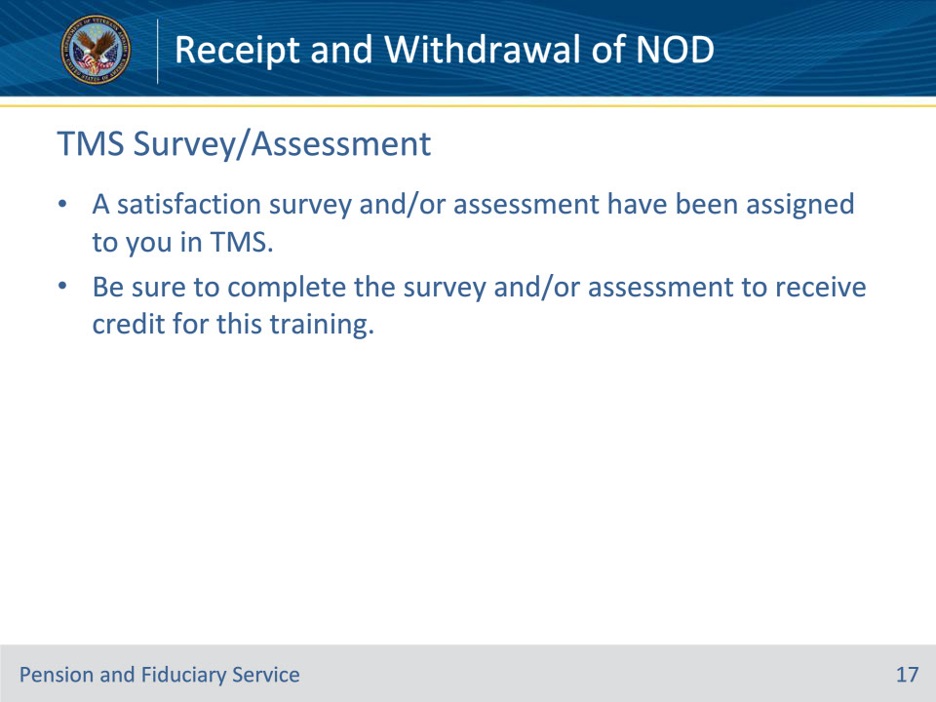
Slide notes

Instructor Notes:

A satisfaction survey and/or assessment have been assigned to you in TMS.

Be sure to complete the survey and/or assessment to receive credit for this training.

