Slide 1 - Supplemental Reviews
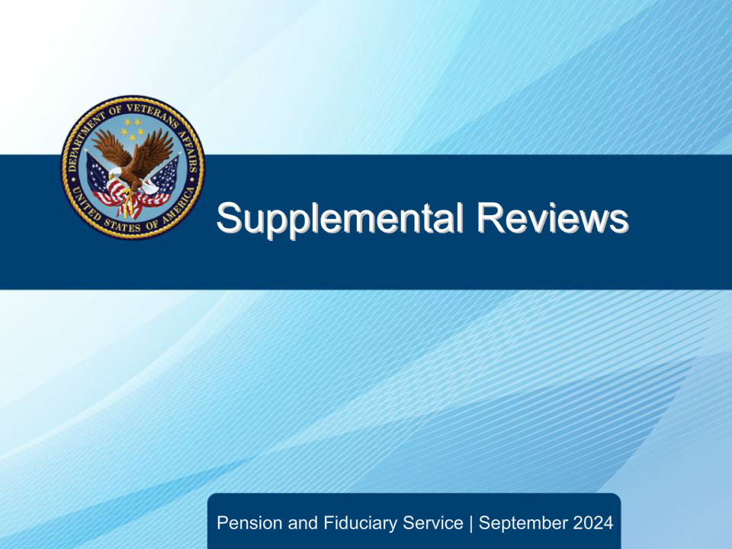
Slide notes

Course Description:

This course teaches learners about supplemental review requests, conducting supplemental reviews, and supplemental review hearings.

Slide 2 - Objectives
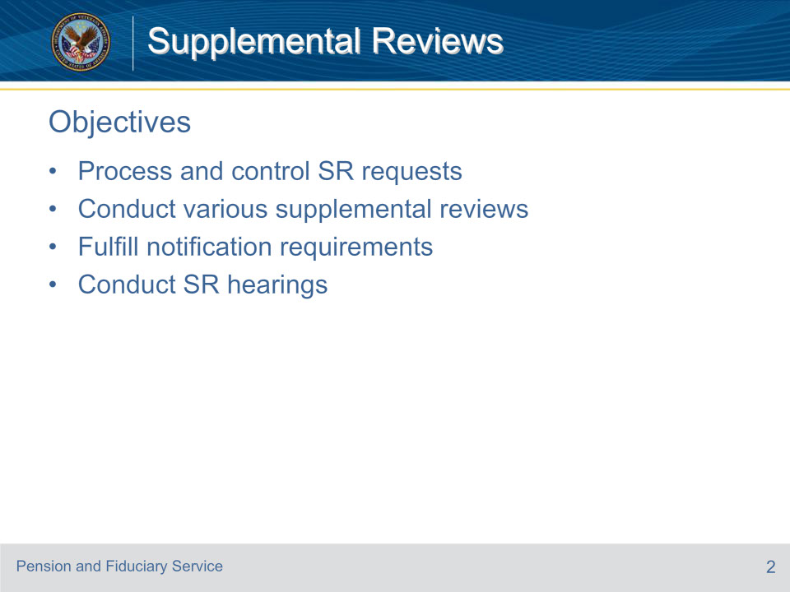
Slide notes

Instructor Notes:

At the end of this lesson, given the training and references, the learner will be able to do the following:

• Process and control SR requests

• Conduct various supplemental reviews

• Fulfill notification requirements

• Conduct SR hearings

Slide 3 - References
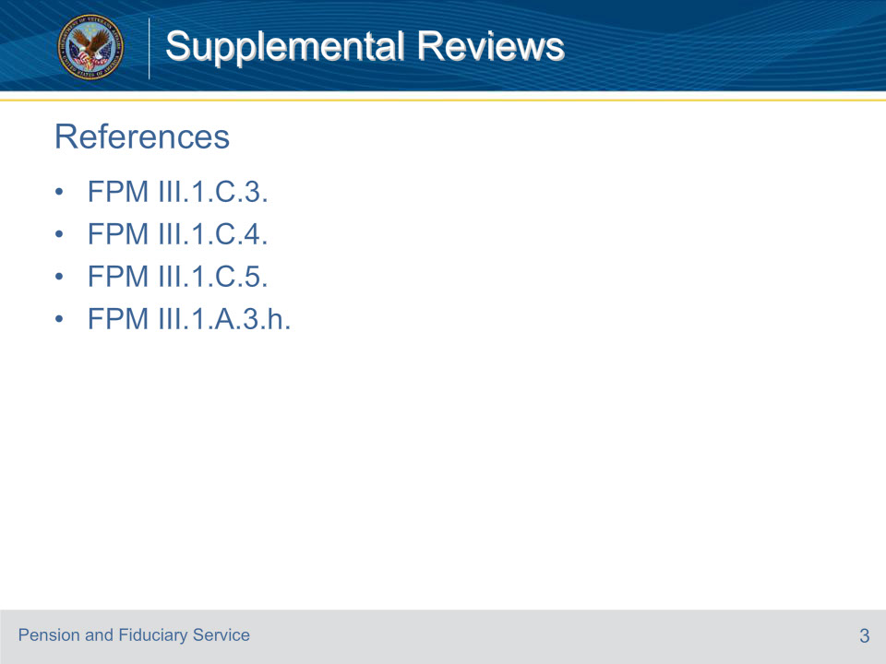
Slide notes

Instructor Notes:

These are the relevant references pertaining to this course:

• FPM III.1.C.3. Supplemental Reviews Requests

• FPM III.1.C.4. Conducting Supplemental Reviews

• FPM III.1.C.5. Supplemental Review Hearings

• FPM III.1.A.3.h. Placing Review Elections Under Control

Slide 4 - SR Request Requirements
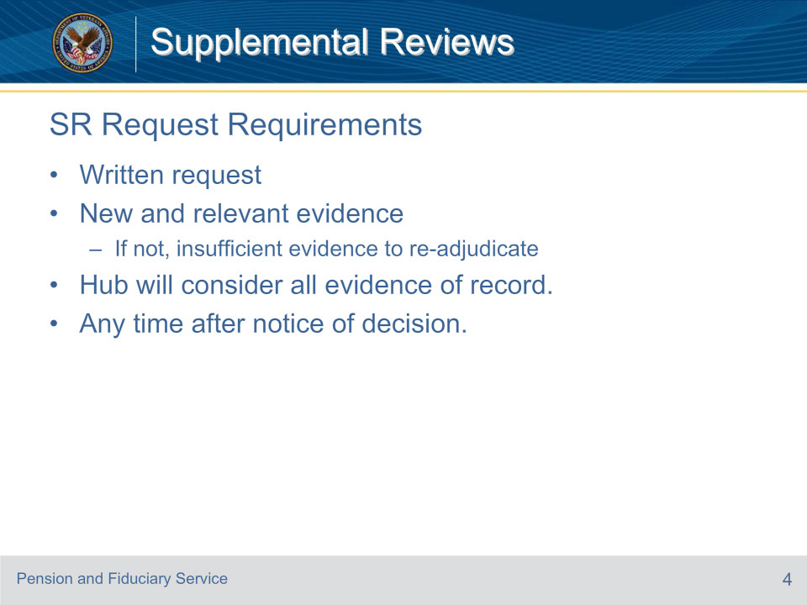
Slide notes

Policy Reference(s): FPM III.1.C.3.a.; b.

Instructor Notes:

A beneficiary or his/her representative who is dissatisfied with a final appealable fiduciary decision, may submit a written request for supplemental review with new and relevant evidence.

The request must be

• submitted in writing, and

• accompanied by new and relevant evidence.

If such evidence is submitted, the hub will reexamine the decision, taking into consideration all the evidence of record.

If the evidence is not new and relevant, the hub will issue a decision finding that there was insufficient evidence to re-adjudicate the decision.

The beneficiary may submit a request for supplemental review with new and relevant evidence at any time after the VA issues the notice of decision.

If the beneficiary submits any evidence in relation to a misuse determination not later than 30 days after the date of notice without a formal request for supplemental review, the hub will process the information as a reconsideration rather than a supplemental review.

Slide 5 - Incomplete SR Requests
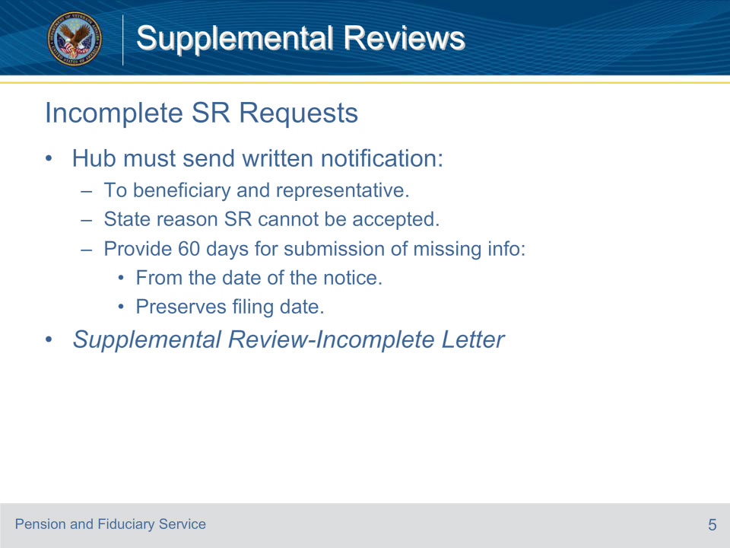
Slide notes

Policy Reference(s): FPM III.1.C.3.b.

Instructor Notes:

Upon receiving a request for supplemental review, the hub must ensure the request is complete. If the beneficiary submits a request that is not complete, the hub must notify the beneficiary and his/her representative, if any, in writing the reason the supplement review cannot be accepted and that the claimant must submit the missing information within 60 days of the date of the notice.

Utilize the Supplemental Review-Incomplete Letter Template to meet the written notification requirement.

A claimant must submit a complete supplemental review request within 60 days of notice by VA that an incomplete request was filed in order to preserve the filing date of the incomplete request.

Slide 6 - Prior Evidence
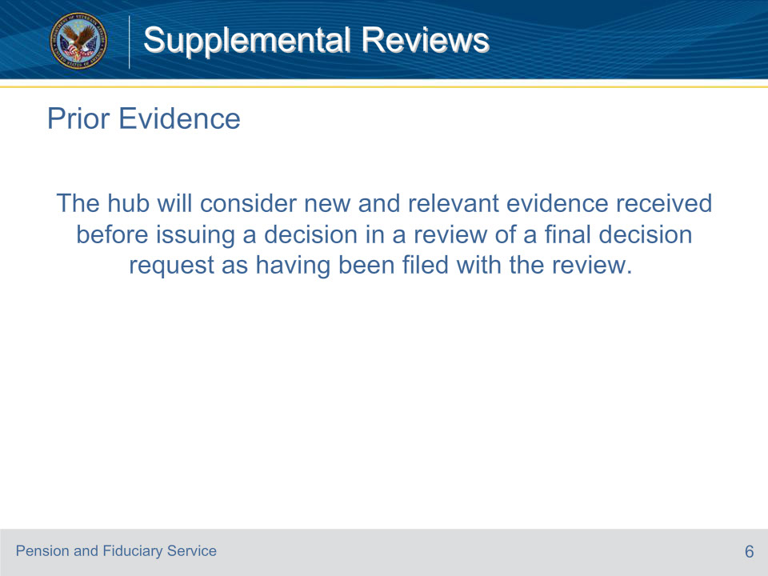
Slide notes

Policy Reference(s): FPM III.1.C.3.c.

Instructor Notes:

The hub will consider new and relevant evidence received before issuing a decision in a review of a final decision request as having been filed with the review.

Slide 7 - Controlling SR Requests
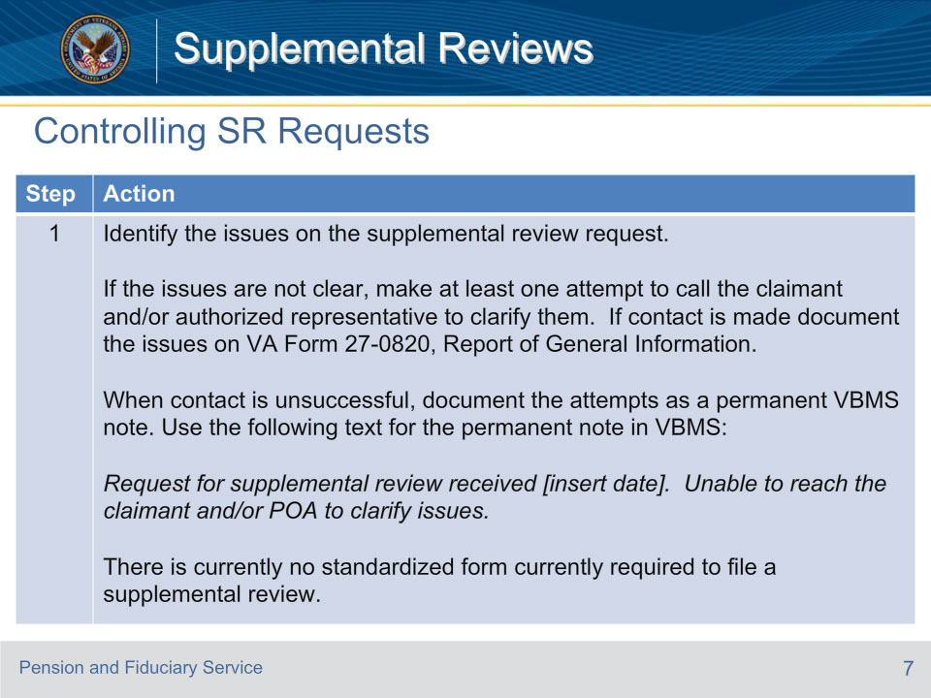
Slide notes

Policy Reference(s): FPM III.1.A.3.h.

Instructor Notes:

Follow the steps in the table above to place the supplemental review election under control.

Slide 8 - Controlling SR Requests (Cont.)
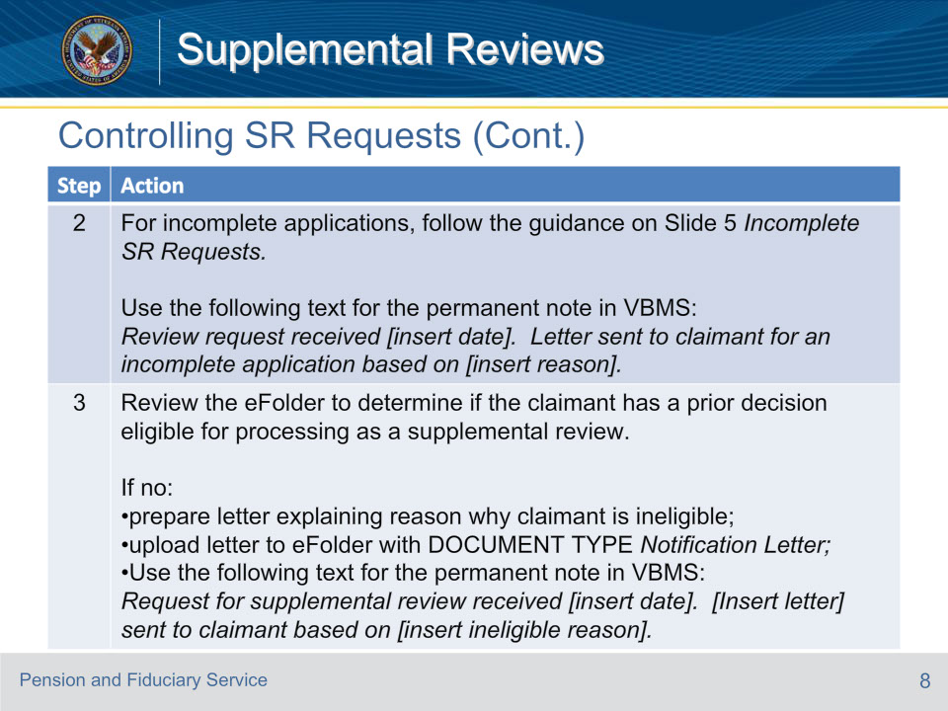
Slide notes

Policy Reference(s): FPM III.1.A.3.h.

Instructor Notes:

Follow the steps in the table above to place the supplemental review election under control.

Slide 9 - Controlling SR Requests (Cont. 2)
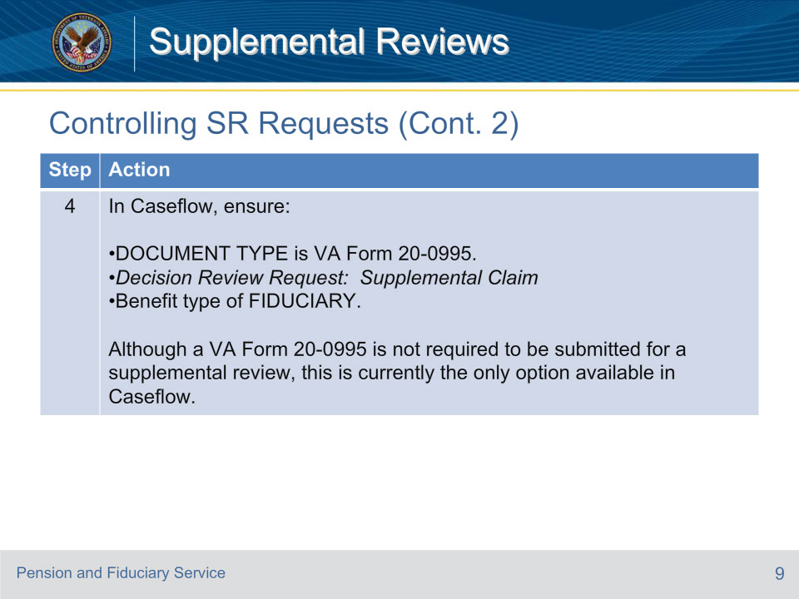
Slide notes

Policy Reference(s): FPM III.1.A.3.h.

Instructor Notes:

Follow the steps in the table above to place the supplemental review election under control.

Slide 10 - Controlling SR Requests (Cont. 3)
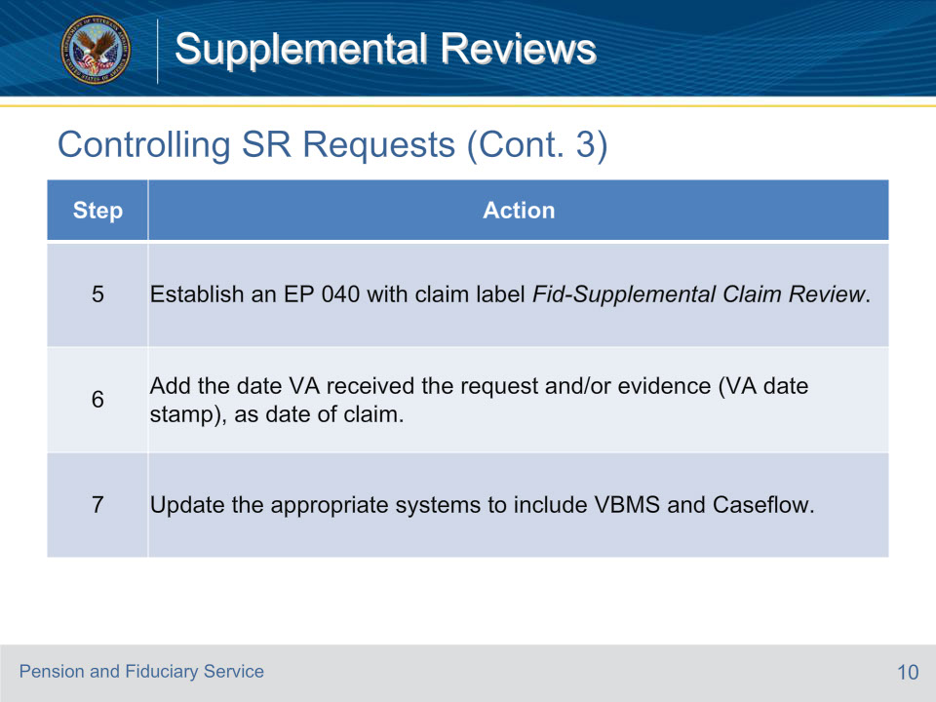
Slide notes

Policy Reference(s): FPM III.1.C.3.d.

Instructor Notes:

Follow the steps in the table above to place the supplemental review election under control.

Slide 11 - Who May Conduct
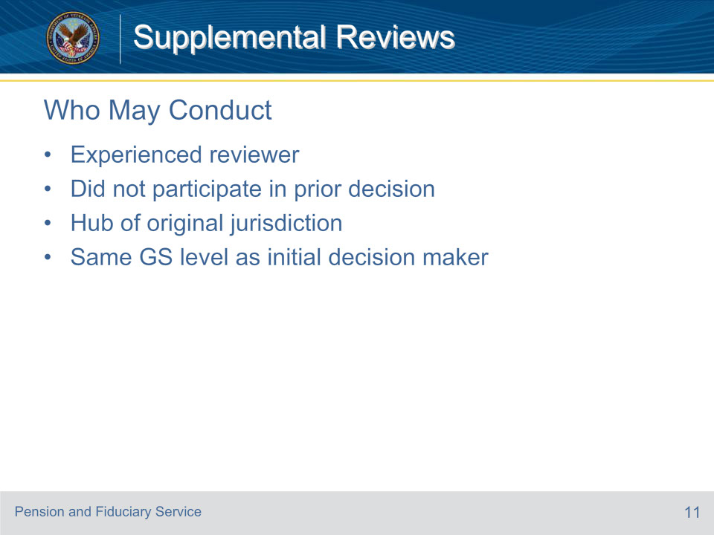
Slide notes

Policy Reference(s): FPM III.1.C.4.a.

Instructor Notes:

A supplemental review of a final decision is conducted by an experienced reviewer at the hub of original jurisdiction who did not participate in the prior decision. Generally, the review is at the same General Schedule level as the individual who made the initial decision.

Slide 12 - Evidentiary Record
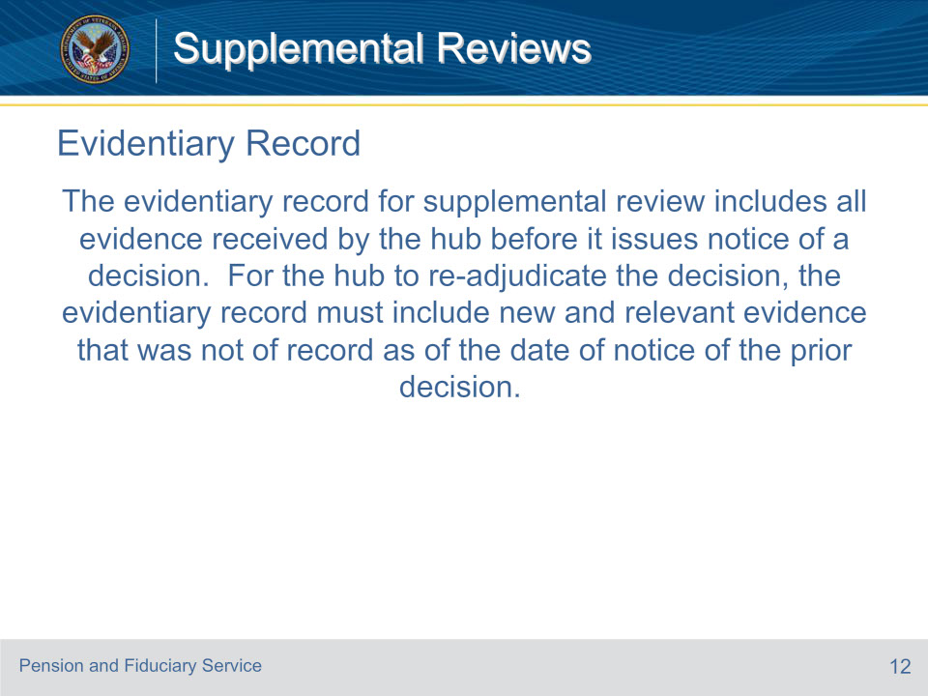
Slide notes

Policy Reference(s): FPM III.1.C.4.b.

Instructor Notes:

The evidentiary record for supplemental review includes all evidence received by the hub before it issues notice of a decision. For the hub to re-adjudicate the decision, the evidentiary record must include new and relevant evidence that was not of record as of the date of notice of the prior decision.

Slide 13 - Fiduciary Appointment SR
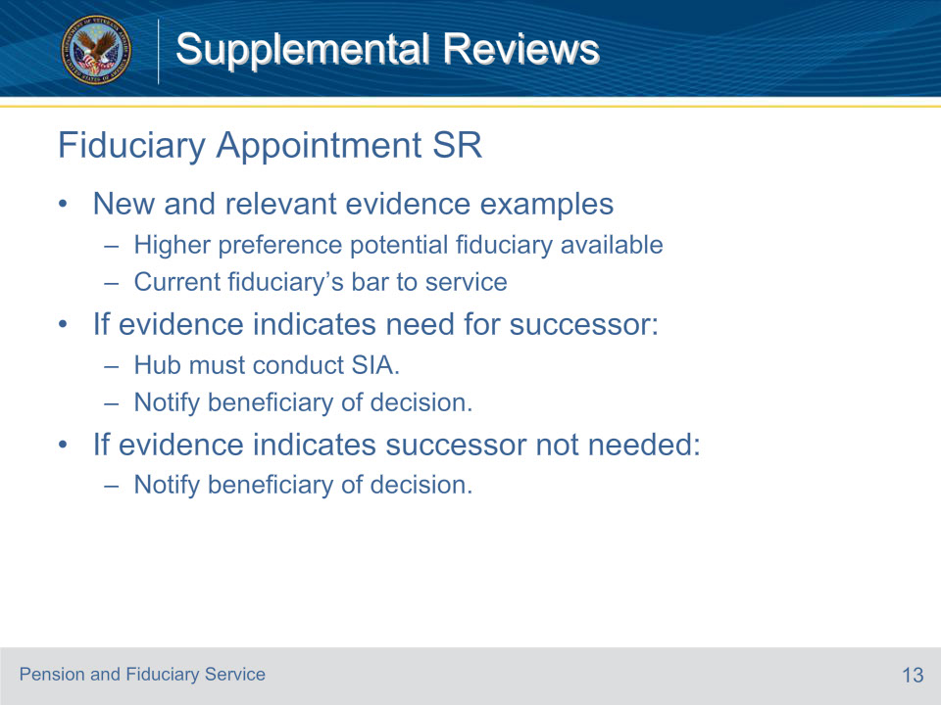
Slide notes

Policy Reference(s): FPM III.1.C.4.c.

Instructor Notes:

If the beneficiary requests a supplemental review of a prior VA decision regarding a fiduciary appointment decision, the hub must review the new and relevant evidence to determine if a successor fiduciary should be appointed. Examples of new and relevant evidence for review of a fiduciary appointment could include documentation

• demonstrating a person of higher preference is available for appointment, or

• of the fiduciary’s bar to service.

The examples provided are not inclusive of all evidence that may be submitted to establish the need for a supplemental review.

If the evidence indicates that a successor fiduciary should be appointed, the hub must establish an SIA. Following the completion of the SIA, the hub will notify the beneficiary of the decision and upload the letter to the eFolder.

If the evidence indicates that a successor fiduciary is not required, the hub will notify the beneficiary of the decision and upload the letter to the eFolder.

Slide 14 - Fiduciary Removal SR
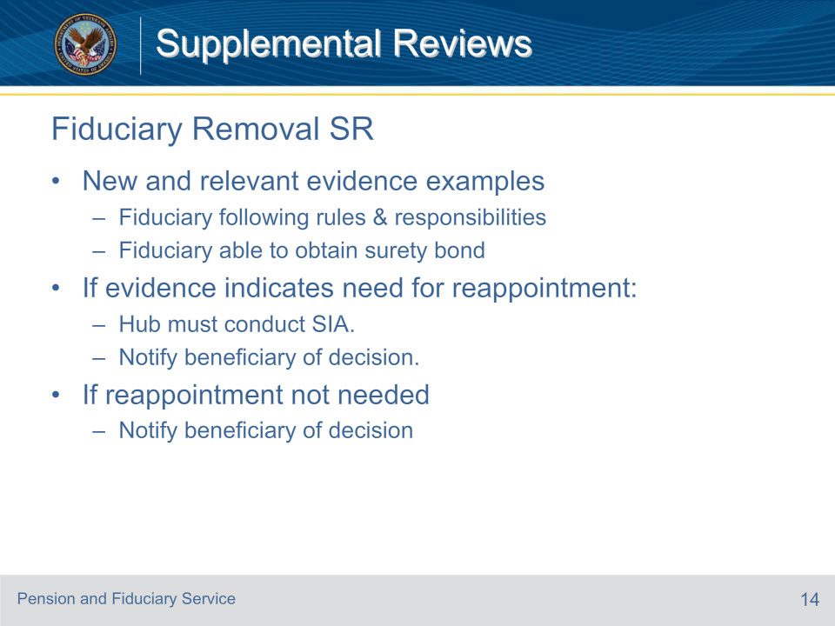
Slide notes

Policy Reference(s): FPM III.1.C.4.d.

Instructor Notes:

If the beneficiary requests supplemental review on a fiduciary removal decision, the hub must review the new and relevant evidence to determine if the former fiduciary should be re-appointed. Examples of new and relevant evidence for a review of a fiduciary removal could include evidence

• showing the fiduciary following the current fiduciary rules and meeting current fiduciary responsibilities, or

• of the fiduciary’s ability to obtain a surety bond.

The examples provided are not inclusive of all evidence that may be submitted to establish the need for supplemental review.

If the evidence indicates that the former fiduciary should be reappointed, the hub must establish the appropriate controls for an SIA. Following the completion of the SIA, the hub will notify the beneficiary of the decision and upload the letter to the eFolder.

If the evidence does not indicate that the fiduciary should be reappointed, the hub will notify the beneficiary of the decision and upload the letter to the eFolder.

Slide 15 - Misuse Determination SR
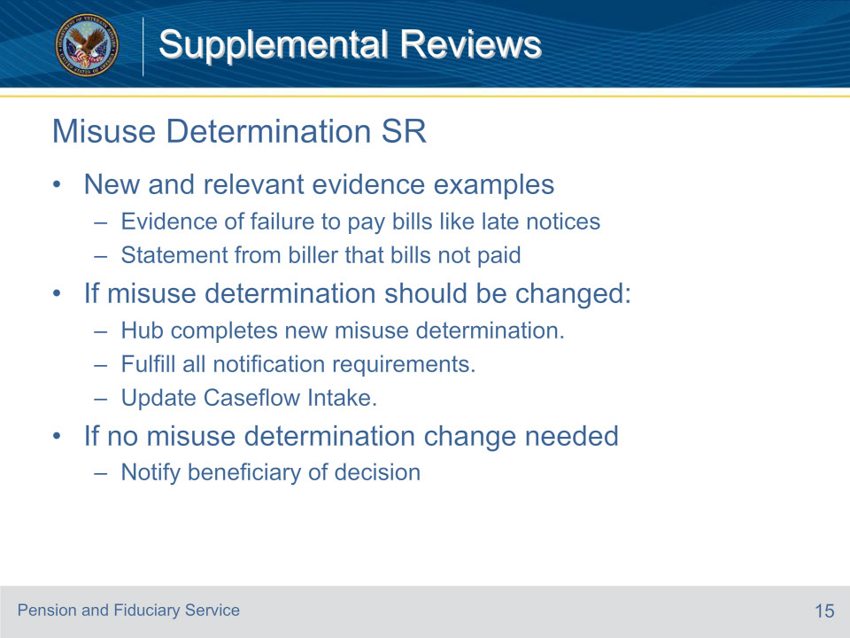
Slide notes

Policy Reference(s): FPM III.1.C.4.e.

Instructor Notes:

If the beneficiary requests a supplemental review on a misuse determination, the hub must review the new and relevant evidence to determine if the misuse determination should be changed. Examples of new and relevant evidence for supplemental review of a misuse determination could include

• evidence of failure to pay bills like late notices for bills, or

• a statement from a biller that the bills were not paid.

The examples provided are not inclusive of all evidence that may be submitted to establish the need for supplemental review.

If the evidence indicates that the misuse determination should be changed, the hub must generate a new misuse determination decision. The hub must upload the new determination into VBMS. The hub must notify the beneficiary and his or her representative of the decision, to include a copy of the updated determination. If appeal was granted, notify additional interested parties of the findings in the new determination.

Following the completion of the misuse determination, the hub will

• notify the beneficiary of the decision

• upload the letter to the eFolder, and

• update Caseflow Intake with the disposition.

If the evidence does not change the misuse determination, the hub will notify the beneficiary of the decision and upload the letter to the eFolder.

Slide 16 - Misuse Reconsideration SR
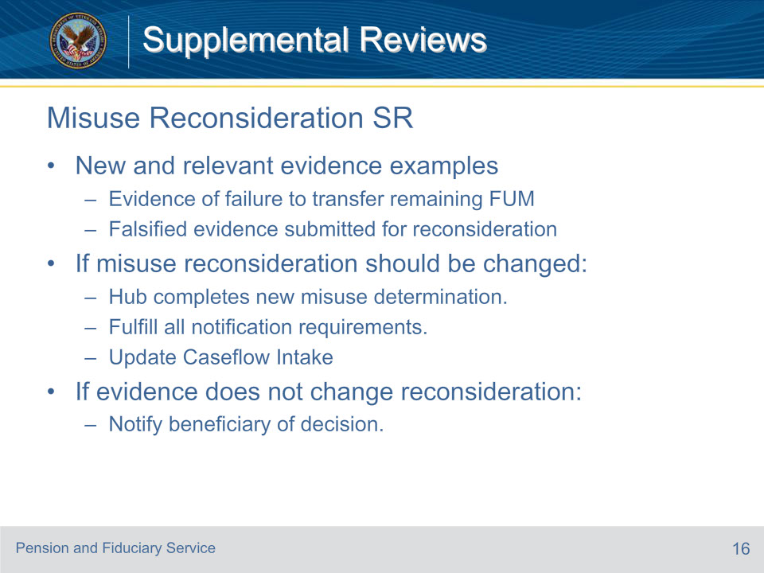
Slide notes

Policy Reference(s): FPM III.1.C.4.f.

Instructor Notes:

If the beneficiary requests a supplemental review on a misuse reconsideration, the hub must review the new and relevant evidence to determine if the misuse reconsideration should be changed. Examples of new and relevant evidence for a supplemental review of a misuse reconsideration include, but are not limited to,

• evidence indicating failure to transfer remaining FUM, or

• falsified evidence submitted for the reconsideration.

If the evidence indicates that the misuse reconsideration should be changed, the hub must

• generate a new misuse determination decision

• upload the new determination into VBMS

• update Caseflow Intake with the disposition, and

• notify the beneficiary, his or her representative, and additional interested parties of the decision, to include a copy of the updated determination.

If the appeal was granted the hub must notify

• additional interested parties of the findings in the new determination

• the beneficiary of the decision, following the completion of the misuse reconsideration, and

• upload the letter to the eFolder.

If the evidence does not change the misuse reconsideration, the hub will notify the beneficiary of the decision and upload the letter to the eFolder.

Slide 17 - Negligence Determination SR
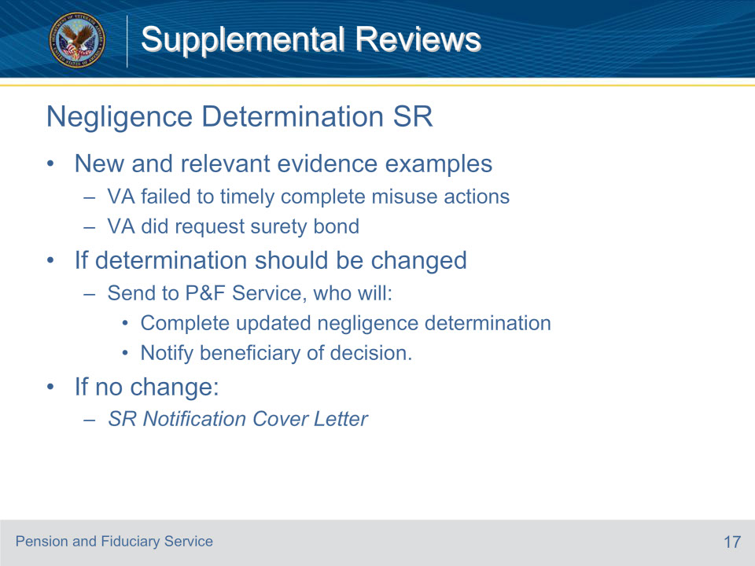
Slide notes

Policy Reference(s): FPM III.1.C.4.g.

Instructor Notes:

If the beneficiary requests a supplemental review on a negligence determination, the hub must review the new and relevant evidence to determine if the negligence determination should be changed. Examples of new and relevant evidence for review of a final negligence determination include, but are not limited to, documentation that VA

• VA failed to timely complete any misuse related actions, or

• did request a surety bond as required.

If the evidence indicates that the negligence determination should be changed, P&F Service will

• review and complete an updated negligence determination

• notify the beneficiary of the decision, and

• upload the letter to the eFolder.

For possible change in the negligence determination, send evidence to VAVBAWAS/CO/P&F TNG QUAL OVRST.

If the evidence does not change the negligence determination, an SR Notification Cover Letter will be completed and uploaded to VBMS.

Slide 18 - Notification
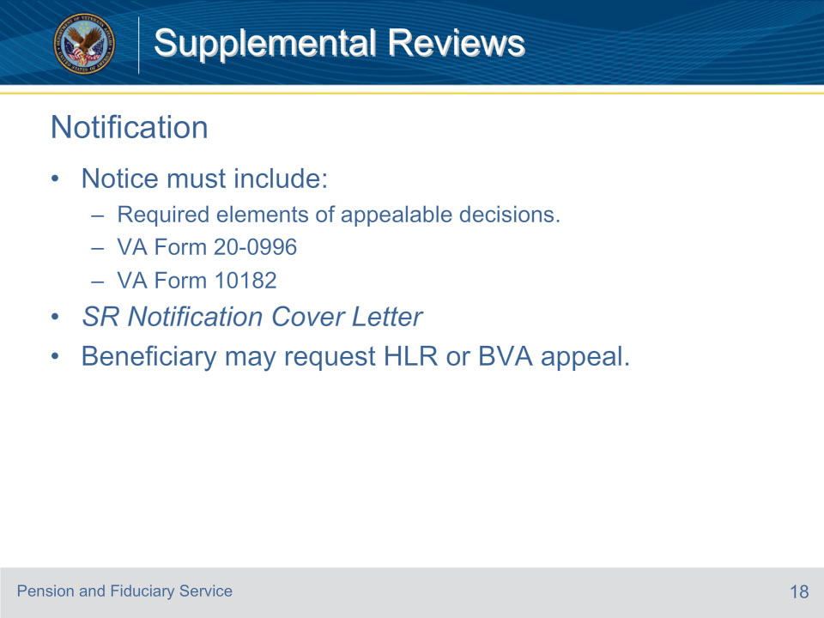
Slide notes

Policy Reference(s): FPM III.1.C.4.h.

Instructor Notes:

A notice of a new decision made under this section must include all required notification elements for appealable fiduciary decisions.

The notice must include the following appeal forms:

• VA Form 20-0996, and

• VA Form 10182, Decision Review Request: Board Appeal (Notice of Disagreement).

Utilize the SR Notification Cover Letter to assist in meeting the written notification requirements.

Following a notice of a decision on a supplemental review, the beneficiary may request an HLR or appeal to the BVA.

Slide 19 - Right to SR Hearing
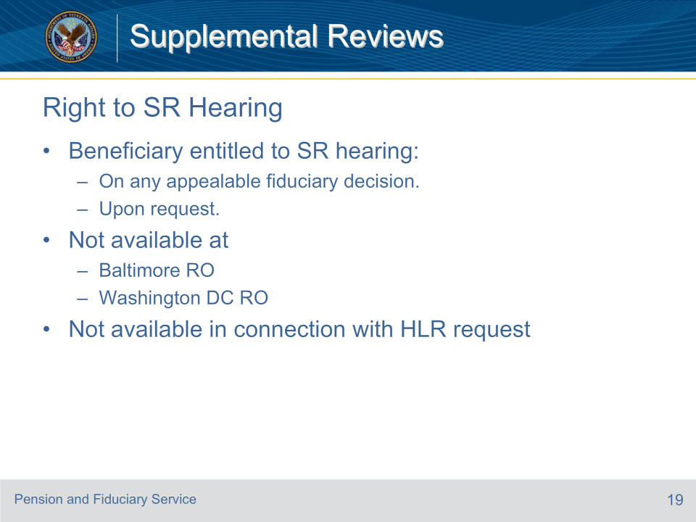
Slide notes

Policy Reference(s): FPM III.1.C.5.a.

Instructor Notes:

Upon request, a beneficiary is entitled to a supplemental review hearing on any appealable fiduciary decision. Such hearing is not available at the Baltimore or Washington, D.C. ROs.

A hearing is not available in connection with a request for an HLR.

Slide 20 - Purpose of SR Hearing
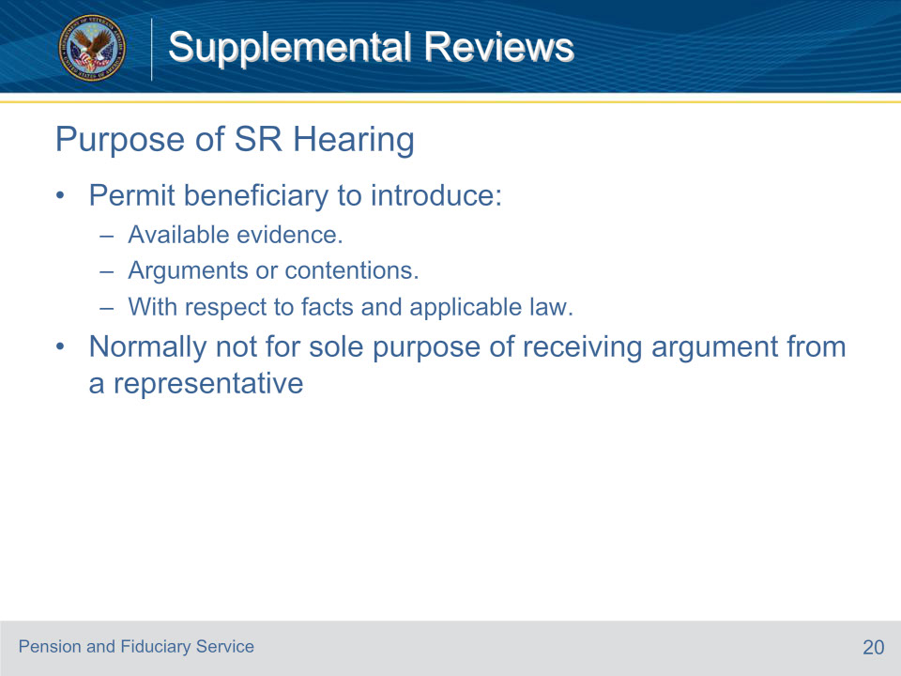
Slide notes

Policy Reference(s): FPM III.1.C.5.b.

Instructor Notes:

The purpose of a hearing is to permit the beneficiary to introduce into the record, in person, any available evidence which he or she considers relevant and any arguments or contentions with respect to the facts and applicable law which he or she may consider pertinent. The AOJ will not normally schedule a hearing for the sole purpose of receiving argument from a representative.

Slide 21 - Conducting SR Hearing
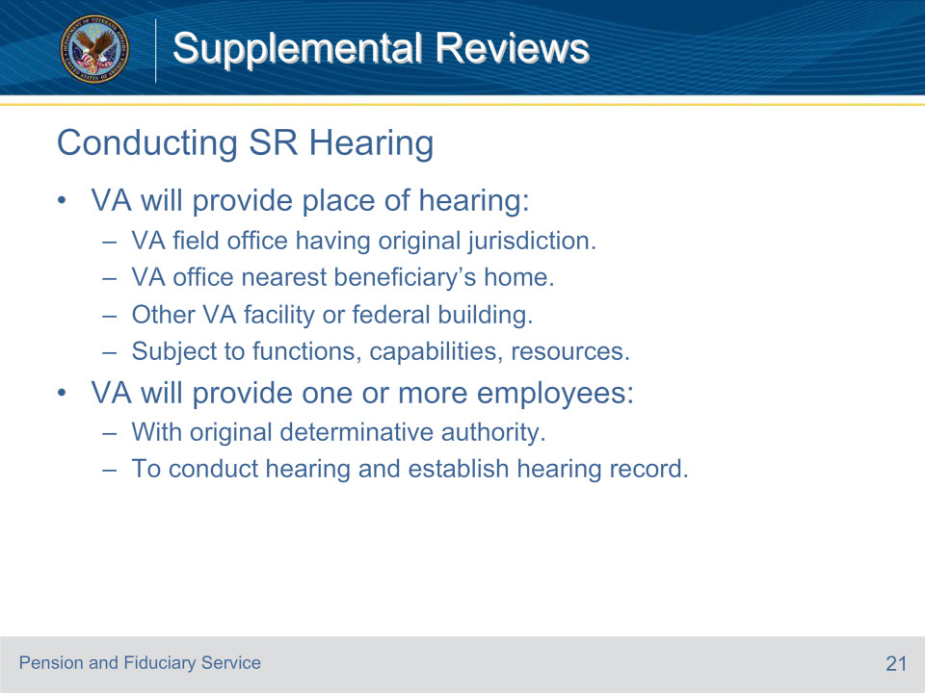
Slide notes

Policy Reference(s): FPM III.1.C.5.c.

Instructor Notes:

VA will provide the place of hearing in the VA field office having original jurisdiction over the claim, or at the VA office nearest the beneficiary’s home having adjudicative functions, or videoconference capabilities, or, subject to available resources and solely at the option of VA, at any other VA facility or federal building at which suitable hearing facilities are available. VA will provide one or more employees who have original determinative authority of such issues to conduct the hearing and be responsible for establishment and preservation of the hearing record.

Slide 22 - Conducting SR Hearing (Cont.)
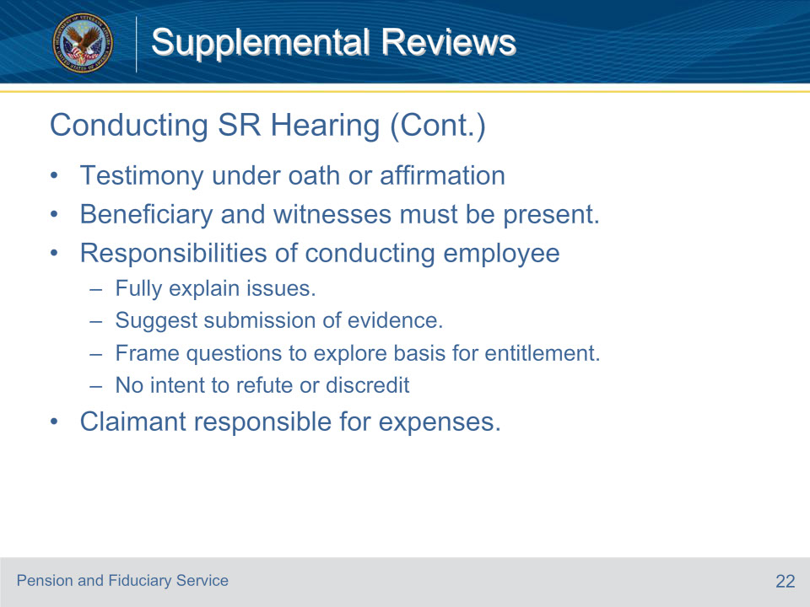
Slide notes

Policy Reference(s): FPM III.1.C.5.c.

Instructor Notes:

All testimony will be under oath or affirmation. The beneficiary is entitled to produce witnesses, but the beneficiary and witnesses must be present. It is the responsibility of the VA employees conducting the hearings to explain fully the issues and suggest the submission of evidence which the beneficiary may have overlooked, and which would be of advantage to the beneficiary’s position. To assure clarity and completeness of the hearing record, questions which are directed to the beneficiary and to witnesses are to be framed to explore fully the basis for claimed entitlement rather than with an intent to refute evidence or to discredit testimony.

All expenses incurred by the beneficiary in connection with the hearing are the responsibility of the claimant.

Slide 23 - 31. Questions?
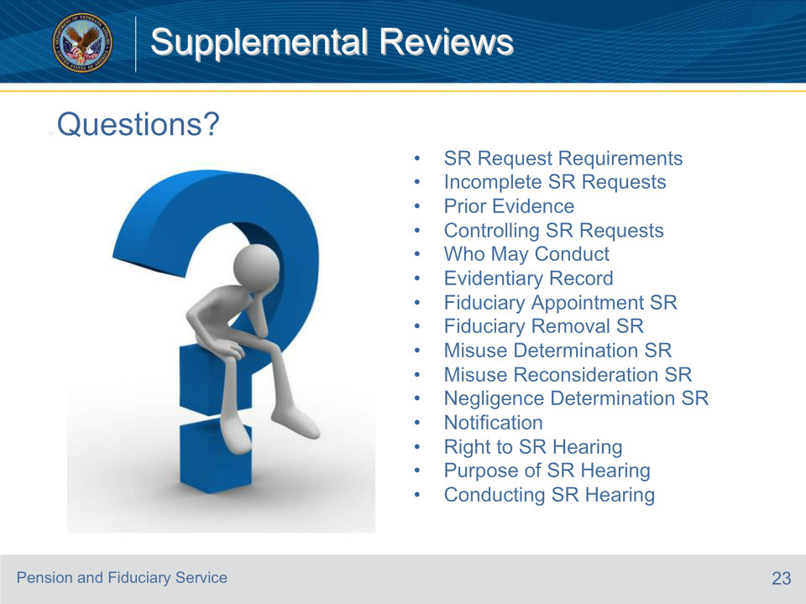
Slide notes

Instructor Notes:

(Recall) These are our learning objectives as stated from the beginning of the training:

• Process and control SR requests

• Conduct various supplemental reviews

• Fulfill notification requirements

• Conduct SR hearings

(Recap) We discussed each of these learning objectives through the following topics in each slide today:

• SR Request Requirements

• Incomplete SR Requests

• Prior Evidence

• Controlling SR Requests

• Who May Conduct

• Evidentiary Record

• Fiduciary Appointment SR

• Fiduciary Removal SR

• Misuse Determination SR

• Misuse Reconsideration SR

• Negligence Determination SR

• Notification

• Right to SR Hearing

• Purpose of SR Hearing

• Conducting SR Hearing

Are there any additional questions?

Questions should be filtered through your QRT team. They will submit your questions to the Field Inquiry Tool (FIT) on your behalf.

Slide 24 - TMS Survey/Assessment
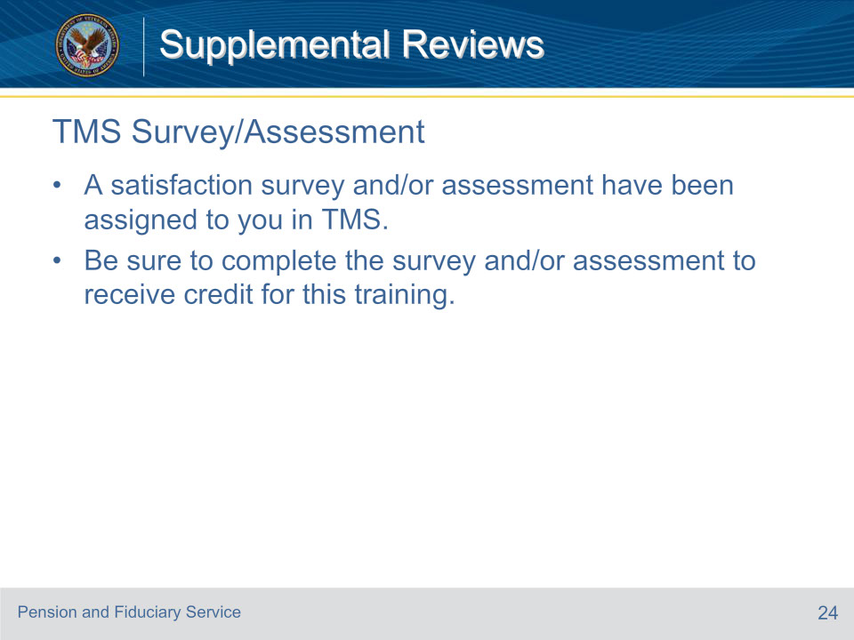
Slide notes

Instructor Notes:

A satisfaction survey and/or assessment have been assigned to you in TMS.

Be sure to complete the survey and/or assessment to receive credit for this training.

