Slide 1 - Conducting Higher-Level Reviews
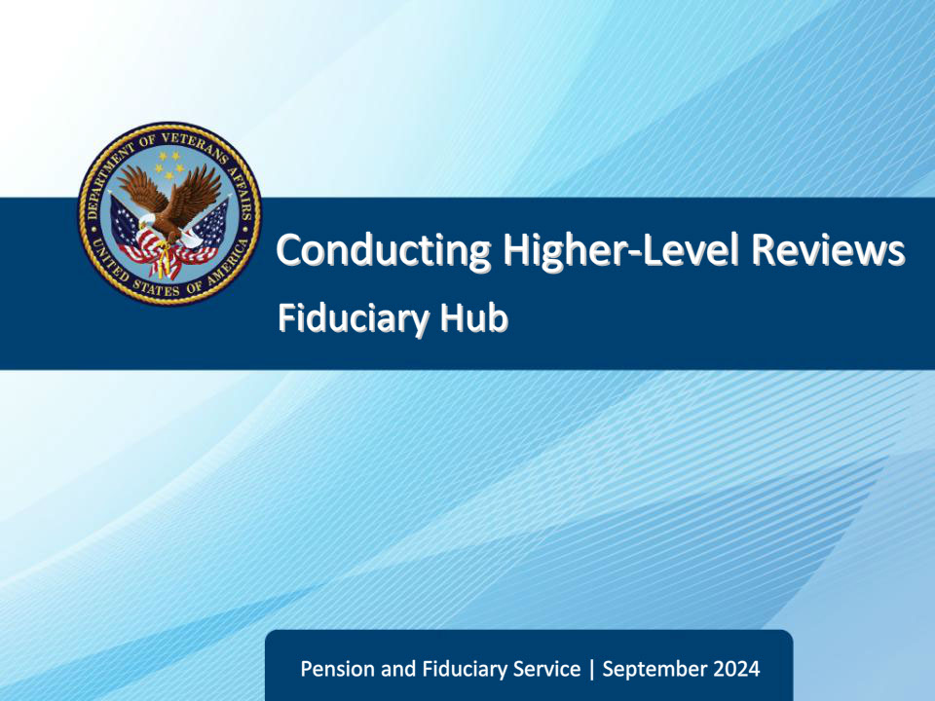
Slide notes

Course Description:

This course teaches learners information about conducting HLRs, including review, documentation, and notification.

Slide 2 - Objectives
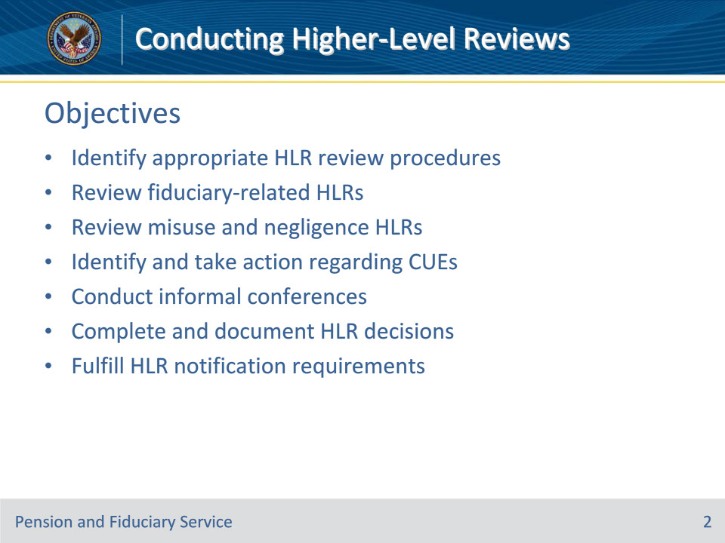
Slide notes

Instructor Notes:

At the end of this lesson, given the training and references, the learner will be able to do the following:

• Identify appropriate HLR review procedures

• Review fiduciary-related HLRs

• Review misuse and negligence HLRs

• Identify and take action regarding CUEs

• Conduct informal conferences

• Complete and document HLR decisions

• Fulfill HLR notification requirements

Slide 3 - References
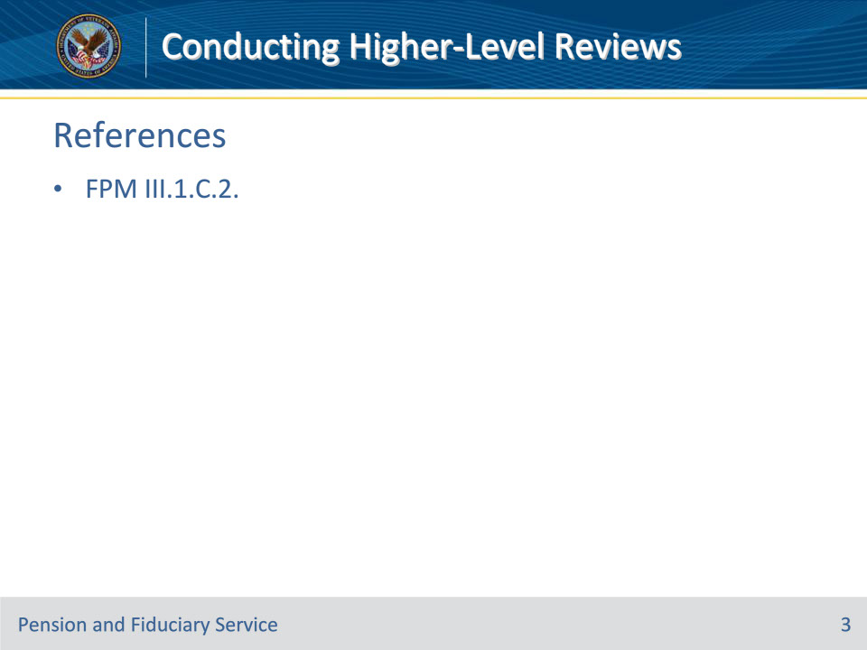
Slide notes

Instructor Notes:

These are the relevant references pertaining to this course:

• FPM III.1.C.2. Conducting HLRs

Slide 4 - Who Conducts HLR
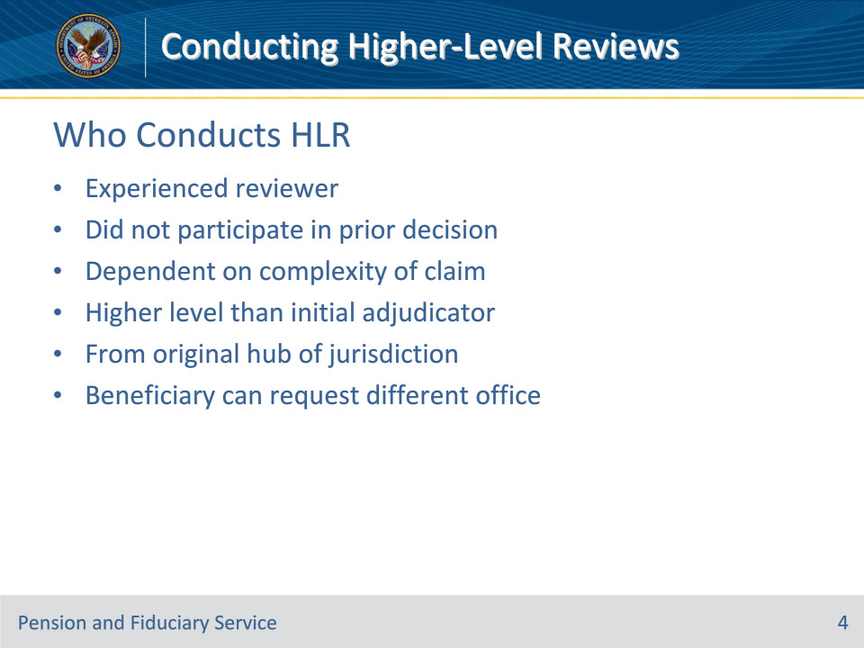
Slide notes

Policy Reference(s): FPM III.1.C.2.a.

Instructor Notes:

An HLR is conducted by an experienced reviewer who did not participate in the prior decision. The level of the higher-level adjudicator is dependent on the complexity of the claim but must be higher than that of the initial adjudicator. The higher-level reviewer should be from the original hub of jurisdiction. However, the beneficiary may request that a different office of jurisdiction conduct the HLR in Block 13 of VA Form 20-0996. The hub should grant the request in the absence of good cause to deny.

Slide 5 - Evidentiary Records
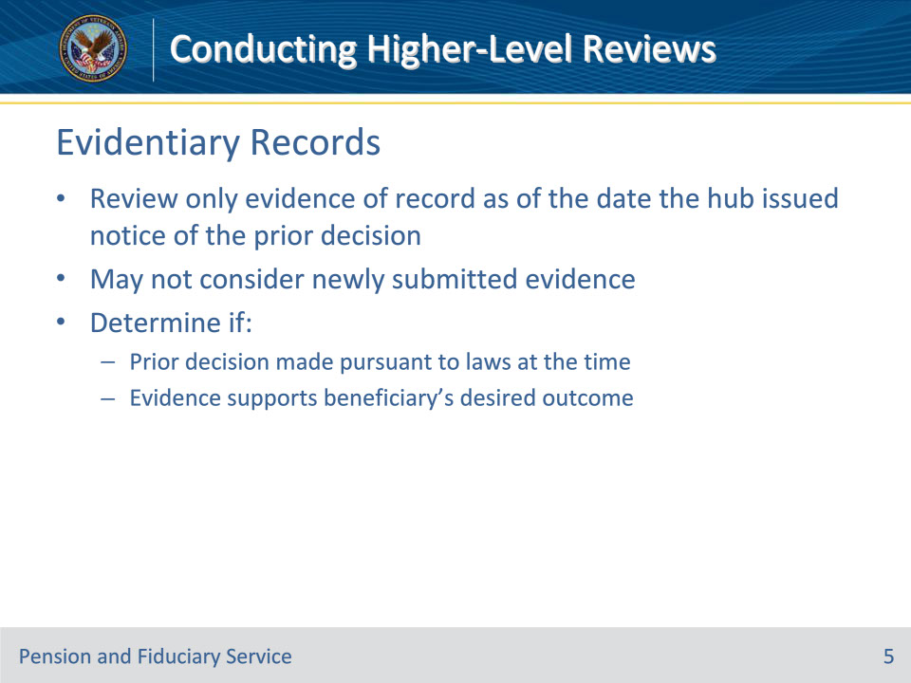
Slide notes

Policy Reference(s): FPM III.1.C.2.b.

Instructor Notes:

The higher-level reviewer must review only the evidence of record as of the date the hub issued notice of the prior decision under review. The higher-level reviewer may not consider additional or newly submitted evidence. The higher-level reviewer must determine if the prior decision was made pursuant to laws and regulations at the time, and whether the evidence of record at the time the decision was made supports the beneficiary’s desired outcome.

Slide 6 - De Novo Review
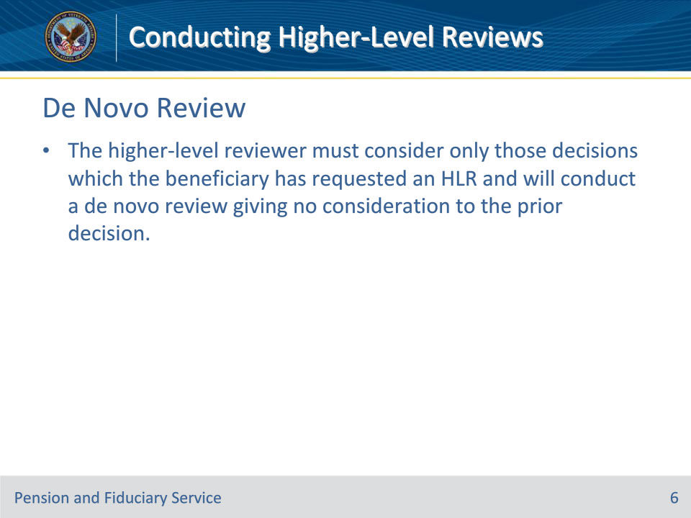
Slide notes

Policy Reference(s): FPM III.1.C.2.c.

Instructor Notes:

The higher-level reviewer must consider only those decisions which the beneficiary has requested an HLR, and will conduct a de novo review giving no consideration to the prior decision.

Slide 7 - Fiduciary Appointment HLR
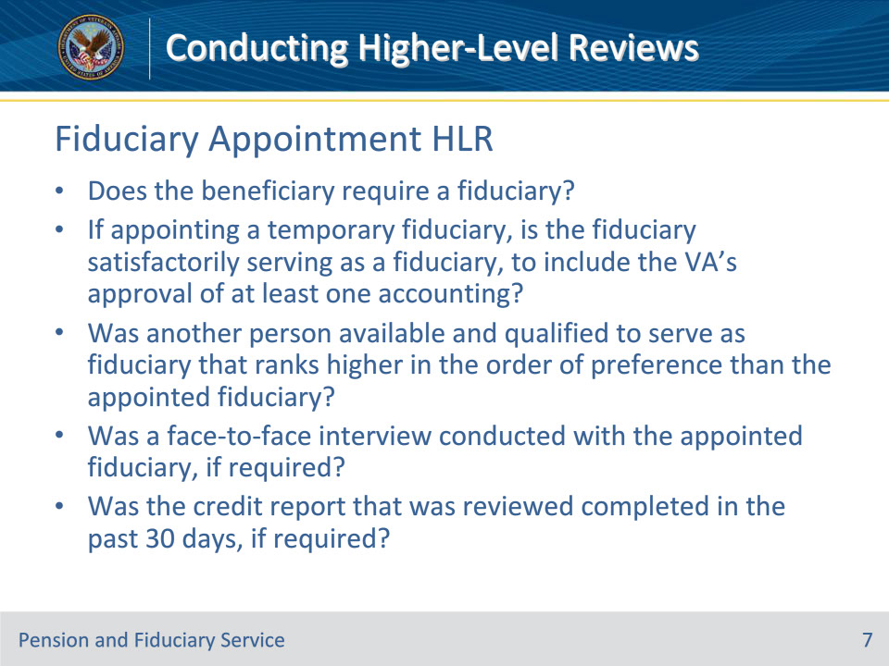
Slide notes

Policy Reference(s): FPM III.1.C.2.d.

Instructor Notes:

When reviewing an appeal of the appointment of a fiduciary, the higher-level reviewer must consider the questions below to ensure they were addressed and fully documented in the field examination report

• Does the beneficiary require a fiduciary?

• If appointing a temporary fiduciary, is the fiduciary satisfactorily serving as a fiduciary, to include the VA’s approval of at least one accounting?

• Was another person available and qualified to serve as fiduciary that ranks higher in the order of preference than the appointed fiduciary?

• Was a face-to-face interview conducted with the appointed fiduciary, if required?

• Was the credit report that was reviewed completed in the past 30 days, if required?

Slide 8 - Fiduciary Appointment HLR (Cont.)
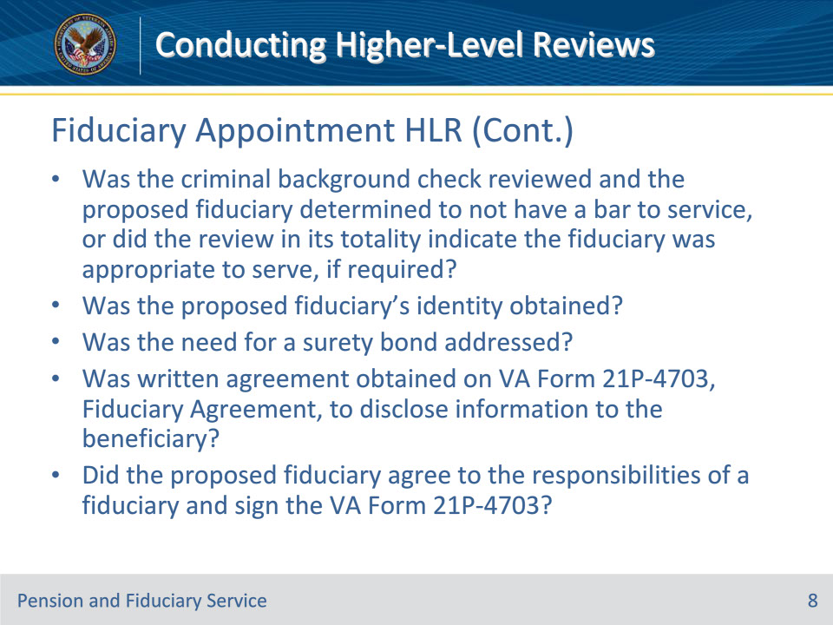
Slide notes

Policy Reference(s): FPM III.1.C.2.d.

Instructor Notes:

• Was the criminal background check reviewed and the proposed fiduciary determined to not have a bar to service, as listed in 38 CFR 13.130, or did the review in its totality indicate the fiduciary was appropriate to serve, if required?

• Was the proposed fiduciary’s identity obtained?

• Was the need for a surety bond addressed?

• Was written agreement obtained on VA Form 21P-4703, Fiduciary Agreement, to disclose information to the beneficiary?

• Did the proposed fiduciary agree to the responsibilities of a fiduciary as listed in 38 CFR 13.140, and sign the VA Form 21P-4703?

Slide 9 - Fiduciary Removal HLR
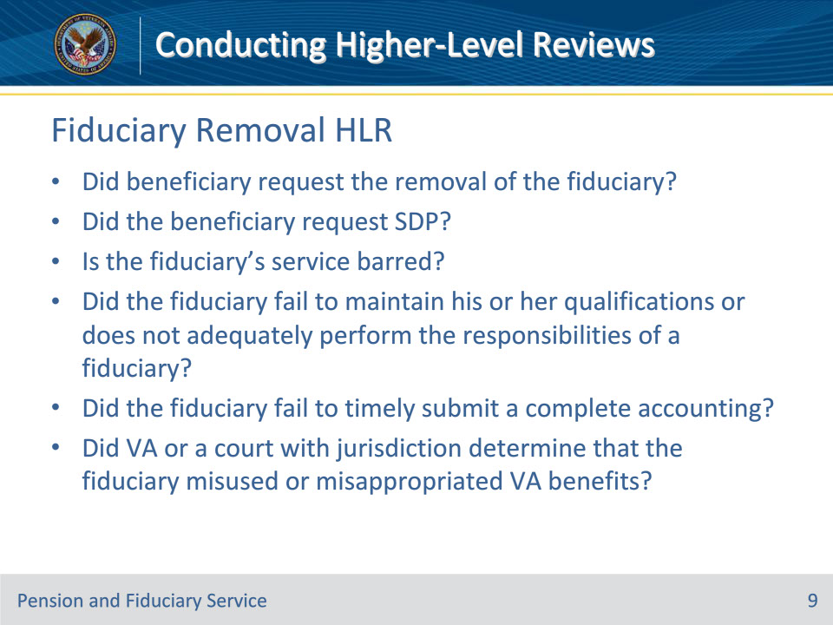
Slide notes

Policy Reference(s): FPM III.1.C.2.e.

Instructor Notes:

When reviewing an appeal of the removal of a fiduciary the higher-level reviewer shall consider the below questions to ensure they were addressed and fully documented in the field examination report.

• Did the beneficiary request the removal of the fiduciary?

• Did the beneficiary request supervised direct pay under 38 CFR 13.110?

• Is the fiduciary’s service barred under 38 CFR 13.130?

• Did the fiduciary fail to maintain his or her qualifications or does not adequately perform the responsibilities of a fiduciary prescribed in 38 CFR 13.140?

• Did the fiduciary fail to timely submit a complete accounting as prescribed in 38 CFR 13.280?

• Did VA or a court with jurisdiction determine that the fiduciary misused or misappropriated VA benefits?

Slide 10 - Fiduciary Removal HLR (Cont.)
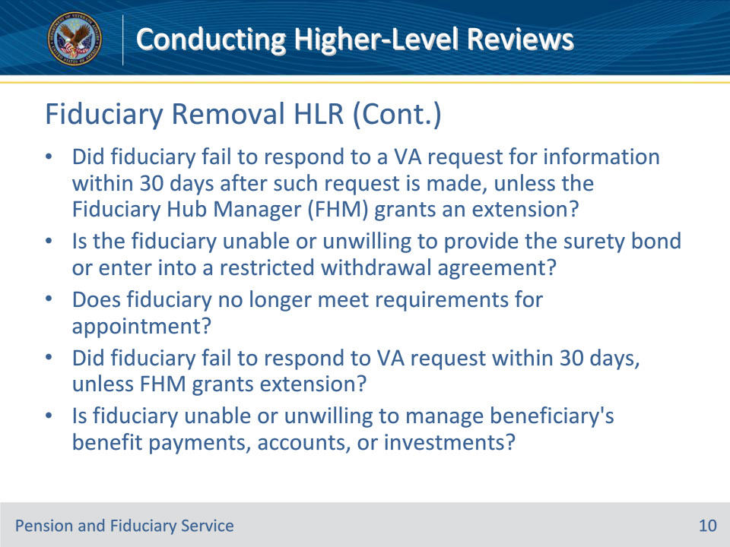
Slide notes

Policy Reference(s): FPM III.1.C.2.e.

Instructor Notes:

• Did the fiduciary fail to respond to a VA request for information within 30 days after such request is made, unless the Fiduciary Hub Manager (FHM) grants an extension based upon good cause shown by the fiduciary?

• Is the fiduciary unable or unwilling to provide the surety bond prescribed by 38 CFR 13.230 or, if applicable, enter into a restricted withdrawal agreement?

• Does the fiduciary no longer meet the requirements for appointment under 38 CFR 13.100?

• Did the fiduciary fail to respond to a VA request for information within 30 days after such request is made, unless the FHM grants an extension based upon good cause shown by the fiduciary?

• Is the fiduciary unable or unwilling to manage the beneficiary’s benefit payments, accounts, or investments?

Slide 11 - Fiduciary HLR Resolution
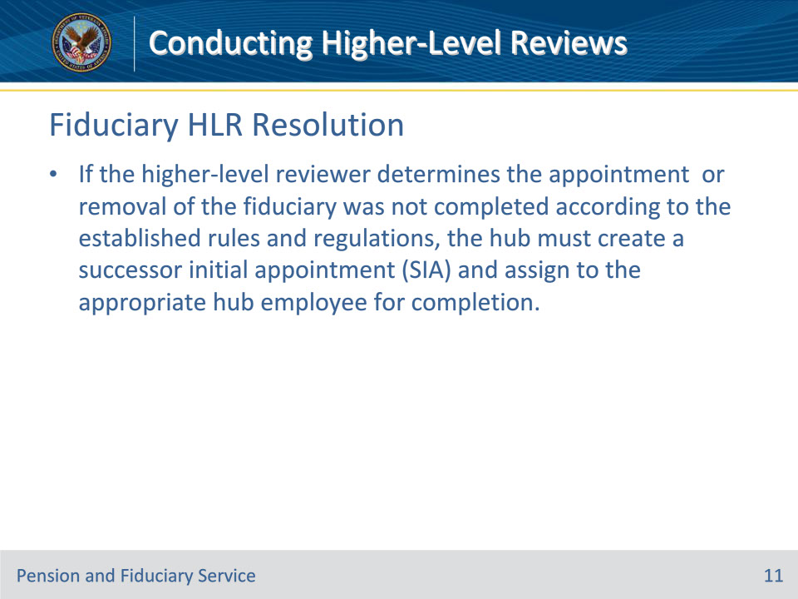
Slide notes

Policy Reference(s): FPM III.1.C.2.d.; e

Instructor Notes:

If the higher-level reviewer determines the appointment of the fiduciary was not completed according to the established rules and regulations, the hub must create a successor initial appointment (SIA) and assign to the appropriate hub employee for completion.

Slide 12 - Misuse Determination HLR
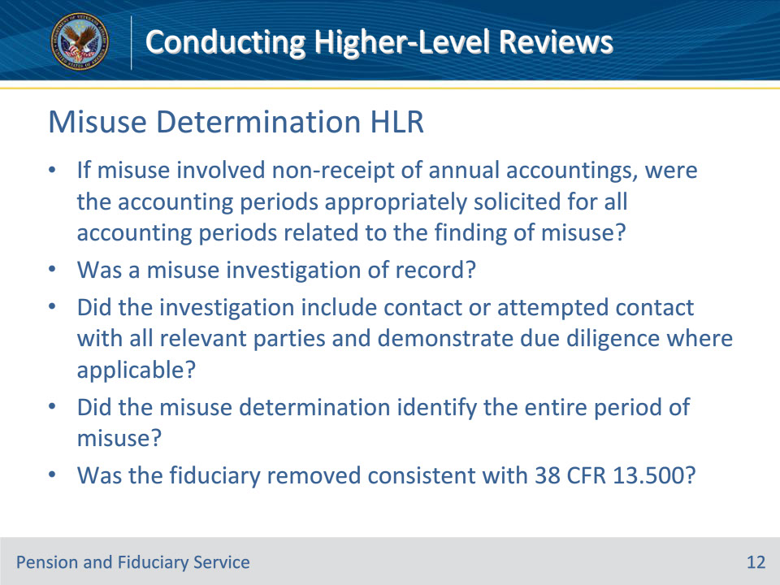
Slide notes

Policy Reference(s): FPM III.1.C.2.f.

Instructor Notes:

When reviewing an appeal of the FHM’s misuse determination, the higher-level reviewer shall consider the below questions to ensure all issues were addressed and fully documented in the misuse determination.

• If the misuse involved non-receipt of an annual accountings, were the accounting periods appropriately solicited for all accounting periods related to the finding of misuse?

• Was a misuse investigation of record?

• Did the investigation include contact or attempted contact with all relevant parties and demonstrate due diligence where applicable?

• Did the misuse determination identify the entire period of misuse?

• Was the fiduciary removed consistent with 38 CFR 13.500?

Slide 13 - Misuse Determination HLR (Cont.)
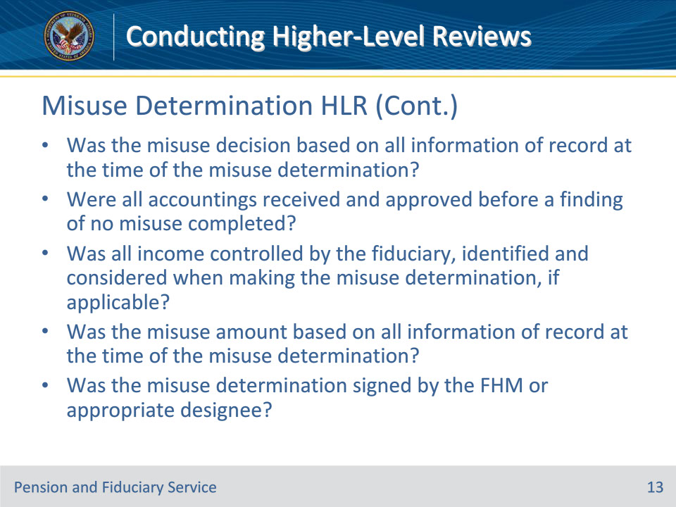
Slide notes

Policy Reference(s): FPM III.1.C.2.f.

Instructor Notes:

• Was the misuse decision based on all information of record at the time of the misuse determination?

• Were all accountings received and approved before a finding of no misuse completed?

• Was all income controlled by the fiduciary, identified and considered when making the misuse determination, if applicable?

• Was the misuse amount based on all information of record at the time of the misuse determination?

• Was the misuse determination signed by the FHM or appropriate designee?

Slide 14 - Misuse Reconsideration HLR
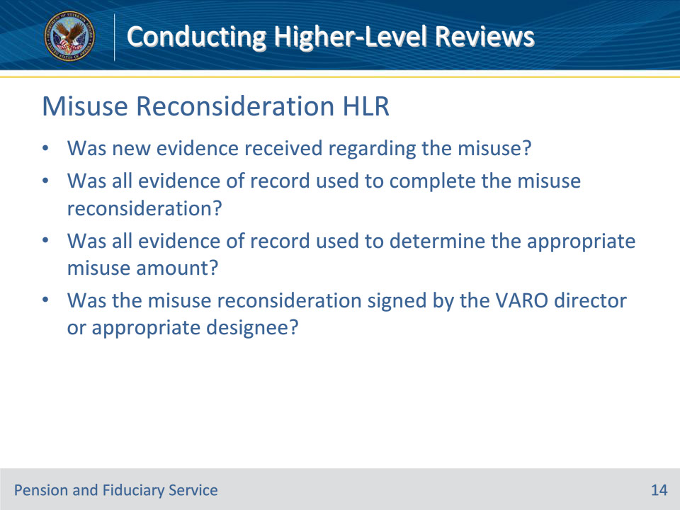
Slide notes

Policy Reference(s): FPM III.1.C.2.g.

Instructor Notes:

When reviewing an appeal of the VA regional office (RO) director’s final reconsideration decision of a misuse determination, the higher-level reviewer shall consider the below questions to ensure all issues were addressed and fully documented in the misuse reconsideration determination.

• Was new evidence received regarding the misuse?

• Was all evidence of record used to complete the misuse reconsideration?

• Was all evidence of record used to determine the appropriate misuse amount

• Was the misuse reconsideration signed by the VARO director or appropriate designee?

Slide 15 - Misuse HLR Resolution
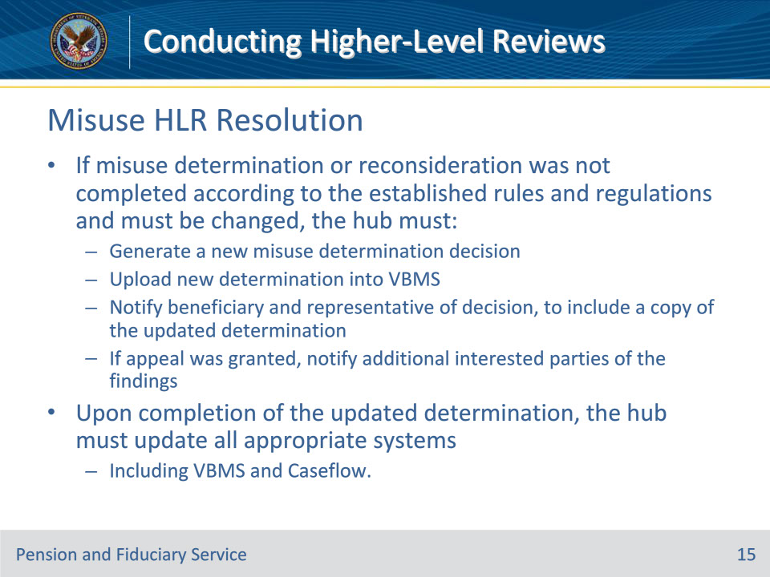
Slide notes

Policy Reference(s): FPM III.1.C.2.f.; g

Instructor Notes:

If the higher-level reviewer determines that the misuse determination or reconsideration was not completed according to the established rules and regulations and must be changed, the hub must

• generate a new misuse determination decision by following the guidance provided in FPM, Part II, 3.A

• upload the new determination into Veterans Benefits Management System (VBMS), and

• notify the beneficiary and his or her representative of the decision, to include a copy of the updated determination. If the appeal was granted, notify additional interested parties as provided in FPM, Part II, 3.A of the findings in the new determination.

Upon completion of the updated determination, the hub must update all appropriate systems to include VBMS and Caseflow.

Slide 16 - Negligence Determination HLR (1 of 3)
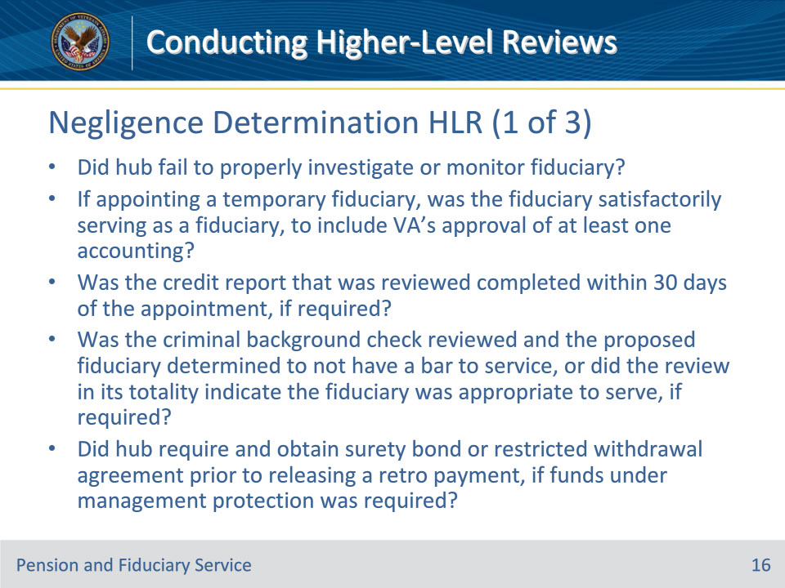
Slide notes

Policy Reference(s): FPM III.1.C.2.h.

Instructor Notes:

When reviewing an appeal of the Director of Pension and Fiduciary (P&F) Service’s negligence determination for purposes of reissuance of benefits, the higher-level reviewer shall consider the below questions to ensure all issues were addressed and fully documented in the negligence determination.

• Did the hub fail to properly investigate or monitor the fiduciary?

• If appointing a temporary fiduciary, was the fiduciary satisfactorily serving as a fiduciary, to include VA’s approval of at least one accounting?

• Was the credit report that was reviewed completed within 30 days of the appointment, if required?

• Was the criminal background check reviewed and the proposed fiduciary determined to not have a bar to service, as listed in, or did the review in its totality indicated the fiduciary was appropriate to serve, if required?

• Did the hub require and obtain a surety bond or restricted withdrawal agreement prior to releasing a retroactive payment, if funds under management (FUM) protection was required?

Slide 17 - Negligence Determination HLR (2 of 3)
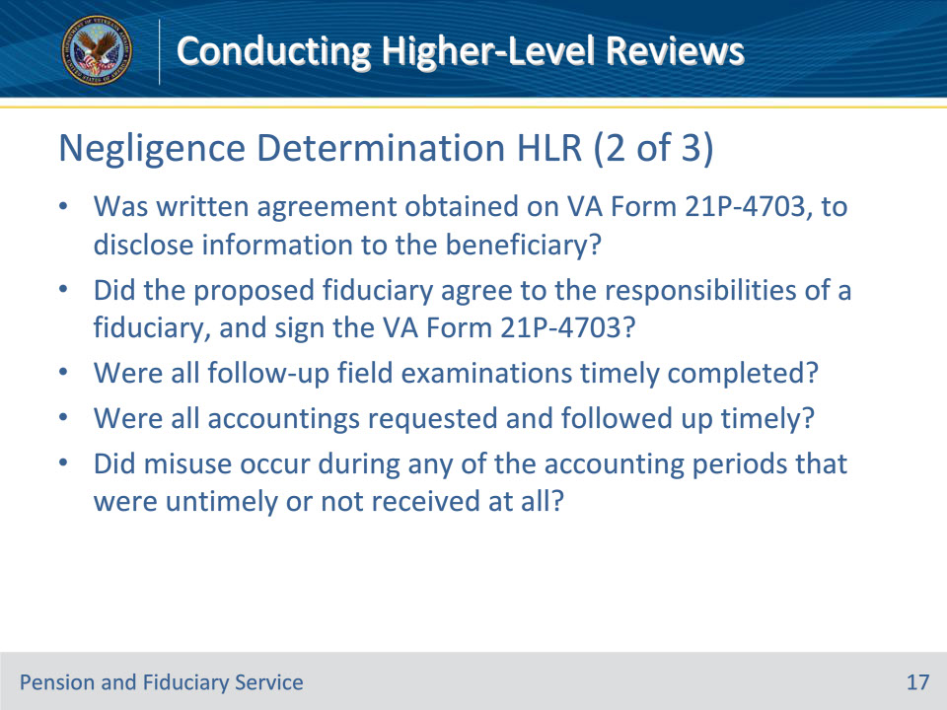
Slide notes

Policy Reference(s): FPM III.1.C.2.h.

Instructor Notes:

• Was written agreement obtained on VA Form 21P-4703, to disclose information to the beneficiary?

• Did the proposed fiduciary agree to the responsibilities of a fiduciary as listed in 38 CFR 13.140, and sign the VA Form 21P-4703?

• Were all follow-up field examinations timely completed (within one year from the initial appointment and within 120 days of the follow-up due date)?

• Were all accountings requested and followed up timely?

• Did misuse occur during any of the accounting periods that were untimely or not received at all?

Slide 18 - Negligence Determination HLR (3 of 3)
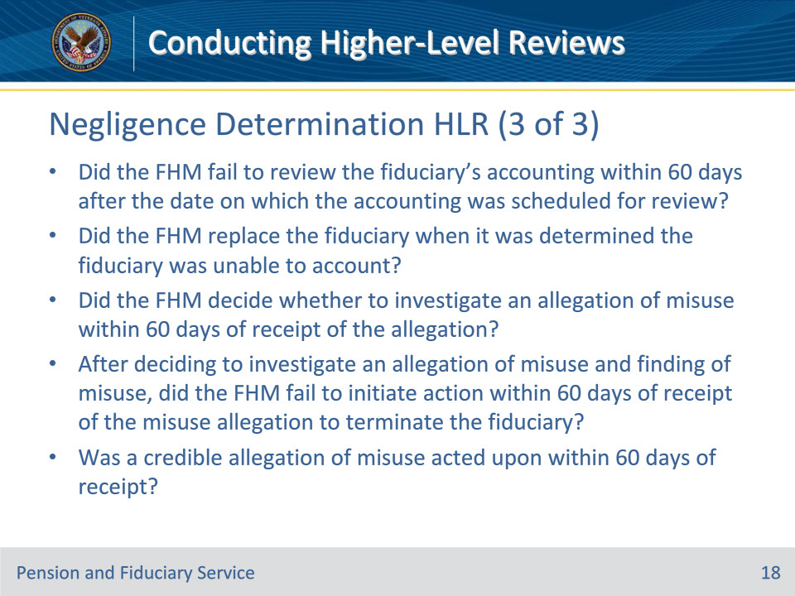
Slide notes

Policy Reference(s): FPM III.1.C.2.h.

Instructor Notes:

• Did the FHM fail to review the fiduciary’s accounting within 60 days after the date on which the accounting was scheduled for review?

• Did the FHM replace the fiduciary when it was determined the fiduciary was unable to account?

• Did the FHM decide whether to investigate an allegation of misuse within 60 days of receipt of the allegation?

• After deciding to investigate an allegation of misuse and finding of misuse, did the FHM fail to initiate action within 60 days of receipt of the misuse allegation to terminate the fiduciary?

• Was a credible allegation of misuse acted upon within 60 days of receipt?

Slide 19 - Negligence HLR Resolution
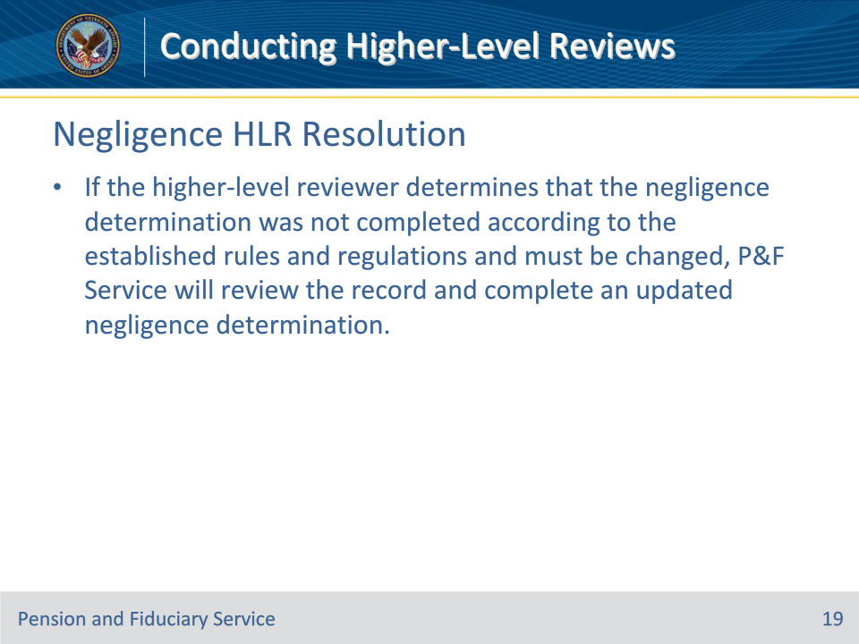
Slide notes

Policy Reference(s): FPM III.1.C.2.h.

Instructor Notes:

If the higher-level reviewer determines that the negligence determination was not completed according to the established rules and regulations and must be changed, P&F Service will review the record and complete an updated negligence determination.

Slide 20 - Difference of Opinion
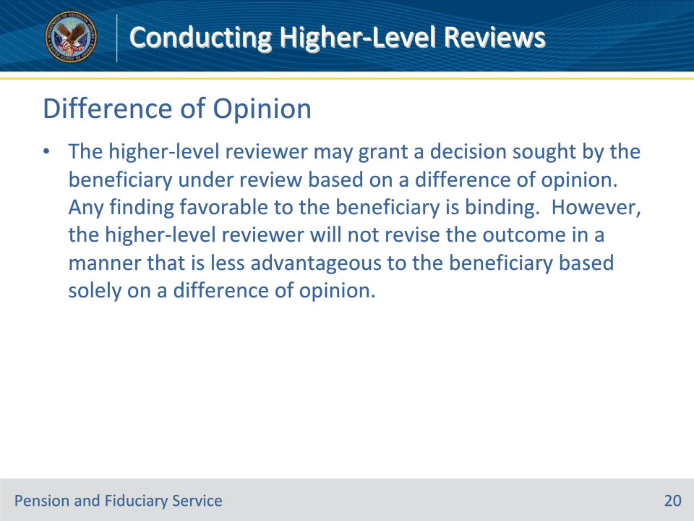
Slide notes

Policy Reference(s): FPM III.1.C.2.i.

Instructor Notes:

The higher-level reviewer may grant a decision sought by the beneficiary under review based on a difference of opinion. Any finding favorable to the beneficiary is binding. However, the higher-level reviewer will not revise the outcome in a manner that is less advantageous to the beneficiary based solely on a difference of opinion.

Slide 21 - Clear and Unmistakable Errors
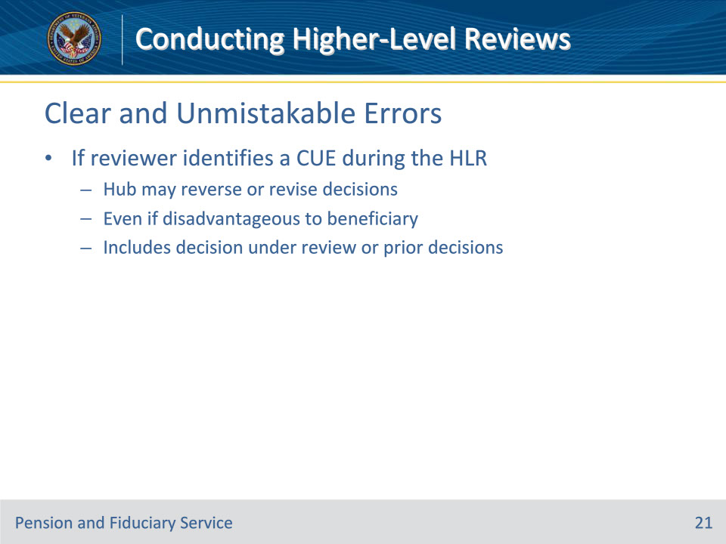
Slide notes

Policy Reference(s): FPM III.1.C.2.j.

Instructor Notes:

If the higher-level reviewer identifies a clear and unmistakable error (CUE) during the HLR, the hub may reverse or revise decisions, even if disadvantageous to the beneficiary. This includes the decision being reviewed or any prior decisions.

Slide 22 - CUE Examples
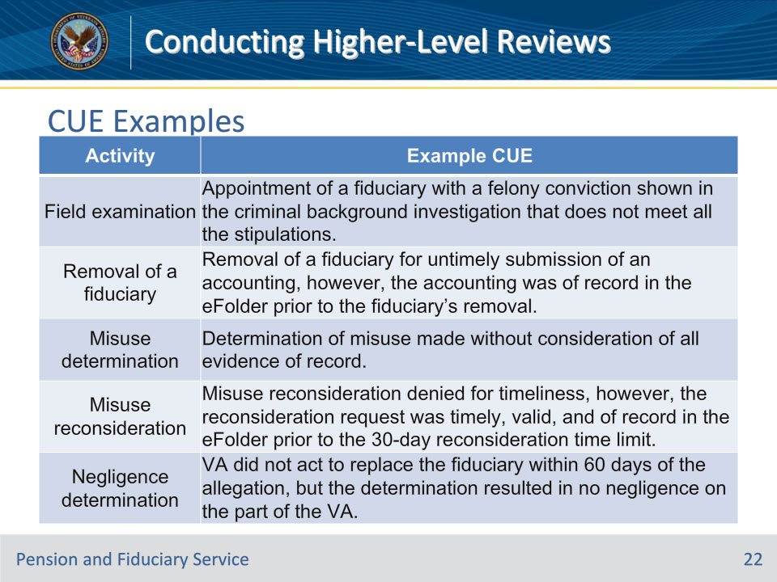
Slide notes

Policy Reference(s): FPM III.1.C.2.j.

Instructor Notes:

See the table above for examples of CUEs during different activities.

Slide 23 - Informal Conferences
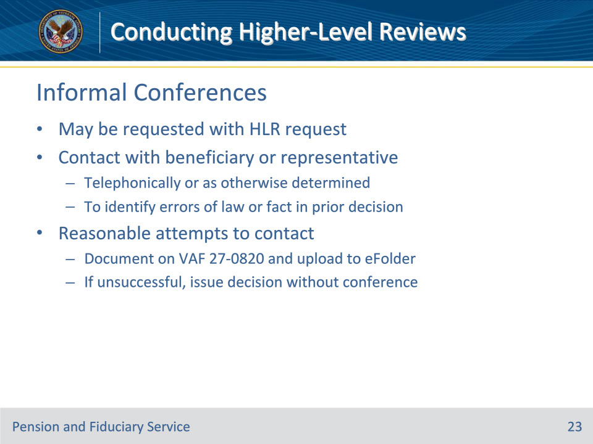
Slide notes

Policy Reference(s): FPM III.1.C.2.k.

Instructor Notes:

A beneficiary or his or her representative, if any, may include a request for an informal conference with a request for HLR. For purposes of this section, informal conference means contact with a beneficiary’s representative or, if not represented, with the beneficiary, telephonically, or as otherwise determined by the hub, for the sole purpose of allowing the beneficiary or representative to identify any errors of law or fact in a prior decision based on the record at the time the prior decision was issued.

If requested, the hub should make reasonable efforts to contact the beneficiary and/or the authorized representative to conduct one informal conference during an HLR. The hub’s attempt to reach the beneficiary or his or her representative must be documented on a VA Form 27-0820, and uploaded to the eFolder. If such reasonable efforts are not successful, a decision may be issued in the absence of an informal conference.

Reasonable efforts generally consist of

• an initial attempt to contact the beneficiary by telephone, using his/her current telephone number, and

• at least one follow-up attempt if the initial attempt is unsuccessful.

Slide 24 - Informal Conferences (Cont.)
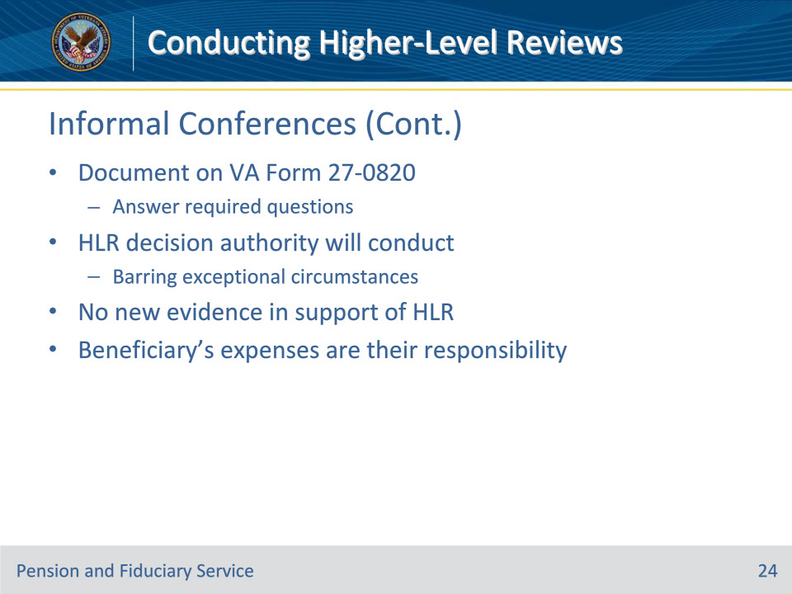
Slide notes

Policy Reference(s): FPM III.1.C.2.k.

Instructor Notes:

A successful informal conference will also be documented on a VA Form 27-0820, and uploaded to the eFolder. At minimum, by the completion of the informal conference, the hub must document the answers to the following questions:

• What is the decision in which you disagree?

• Why do you disagree with the decision?

• Did you submit information to VA that you feel was not considered in the making of the decision? If yes, what was the information?

The higher-level reviewer with decision authority will conduct the informal conference, absent exceptional circumstances. The hub will not receive any new evidence in support of the HLR during the informal conference. Any expenses incurred by the beneficiary in connection with the informal conference are the responsibility of the beneficiary.

Exceptional circumstances are events or problems which you did not expect, and which stop you being able to perform to the best of your abilities in your studies. For example, bereavement, unexpected personal or family problems or illness might be considered as an exceptional circumstance.

Slide 25 - Notification
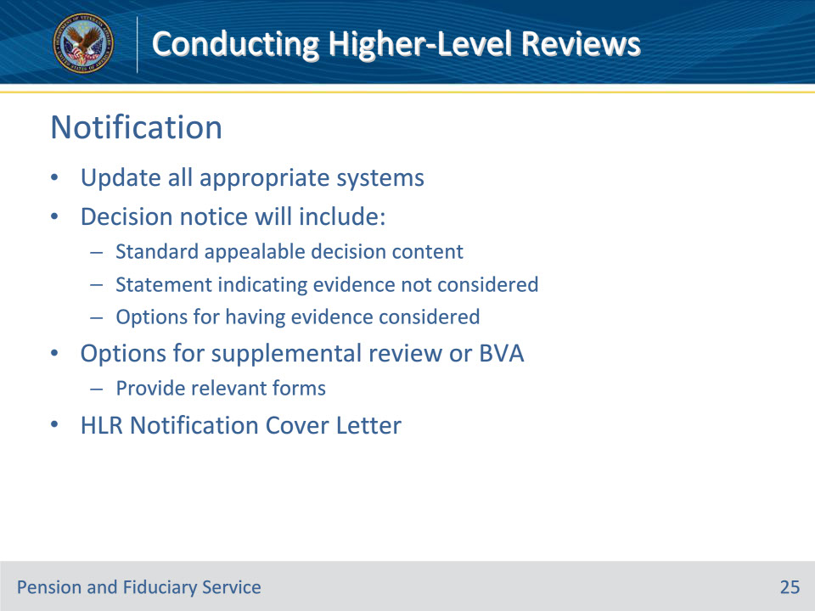
Slide notes

Policy Reference(s): FPM III.1.C.2.m.; III.1.C.2.l.

Instructor Notes:

The higher-level reviewer must document the decision and update all appropriate systems to include VBMS and Caseflow.

Notice of a new decision, whether a grant or denial, made under this section will include

• all the elements described in FPM, Part III, 1.A.3.e

• a general statement indicating that evidence submitted while the record was closed was not considered, and

• notice of the options available to have such evidence considered.

Following notice of a decision on an HLR, the reviewer must notify the beneficiary and his or her representative that the beneficiary may request a supplemental review or appeal to the Board of Veterans’ Appeals (BVA), and provide the beneficiary with the relevant forms. A beneficiary is not allowed another HLR of the new decision.

Utilize the HLR Notification Cover Letter to assist in meeting the written notification requirements.

The hubs cannot move the claim into another lane without the express withdrawal and refiling by the beneficiary.

Slide 26 - Questions?
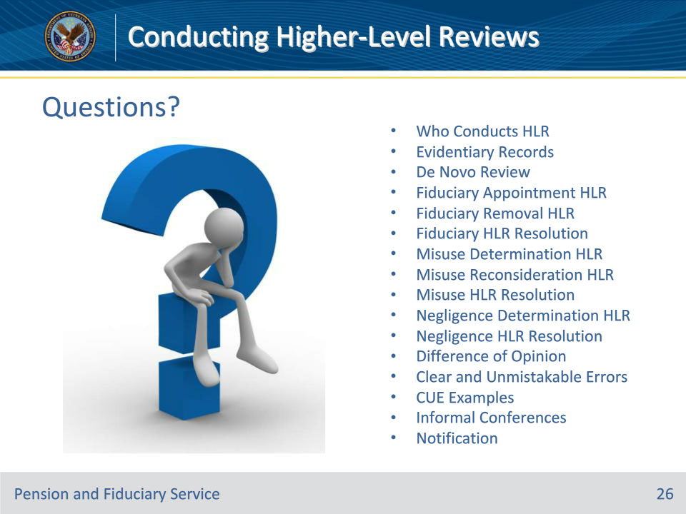
Slide notes

Instructor Notes:

(Recall) These are our learning objectives as stated from the beginning of the training:

• Identify appropriate HLR review procedures

• Review fiduciary-related HLRs

• Review misuse and negligence HLRs

• Identify and take action regarding CUEs

• Conduct informal conferences

• Complete and document HLR decisions

• Fulfill HLR notification requirements

(Recap) We discussed each of these learning objectives through the following topics in each slide today:

• Who Conducts HLR

• Evidentiary Records

• De Novo Review

• Fiduciary Appointment HLR

• Fiduciary Removal HLR

• Fiduciary HLR Resolution

• Misuse Determination HLR

• Misuse Reconsideration HLR

• Misuse HLR Resolution

• Negligence Determination HLR

• Negligence HLR Resolution

• Difference of Opinion

• Clear and Unmistakable Errors

• CUE Examples

• Informal Conferences

• Notification

Are there any additional questions?

Questions should be filtered through your QRT team. They will submit your questions to the Field Inquiry Tool (FIT) on your behalf.

Slide 27 - TMS Survey/Assessment
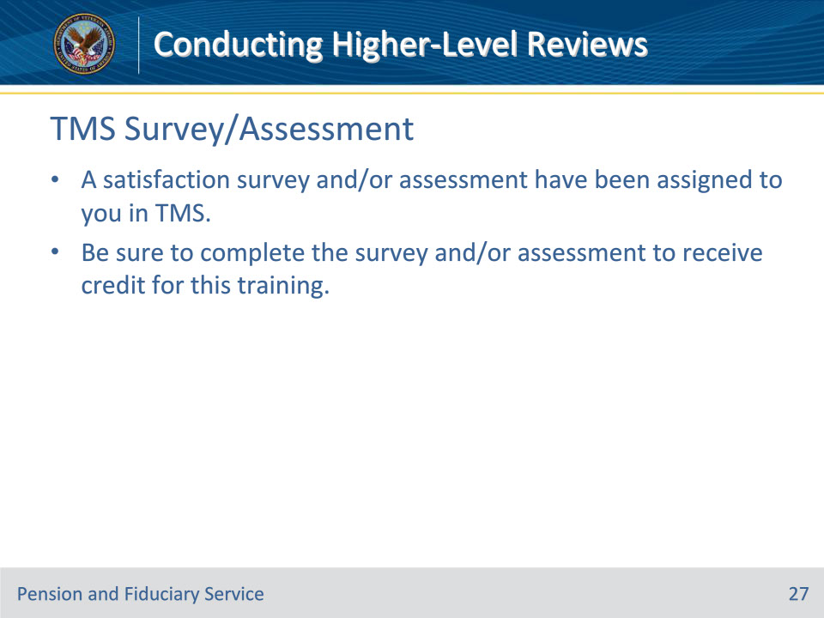
Slide notes

Instructor Notes:

A satisfaction survey and/or assessment have been assigned to you in TMS.

Be sure to complete the survey and/or assessment to receive credit for this training.

