Slide 1 - Appeals to BVA
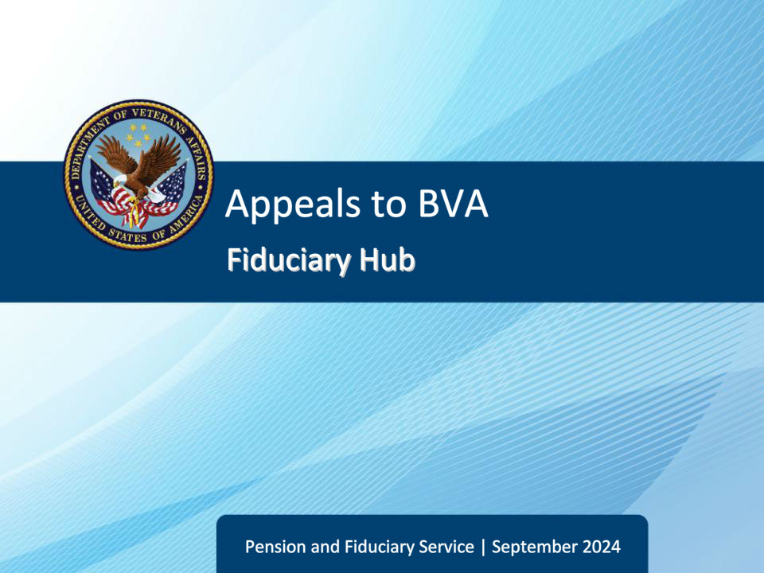
Slide notes

Course Description:

This course teaches learners about notice of disagreements (NODs) filed with Board of Veterans Appeals (BVA).

Slide 2 - Objectives
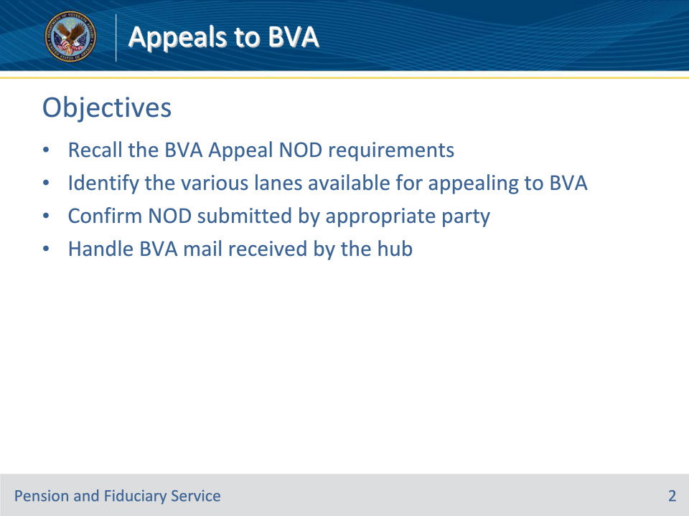
Slide notes

Instructor Notes:

At the end of this lesson, given the training and references, the learner will be able to do the following:

• Understand BVA Appeal NOD requirements

• Identify the various lanes available for appealing to BVA

• Confirm NOD submitted by appropriate party

• Handle BVA mail received by the hub

Slide 3 - References
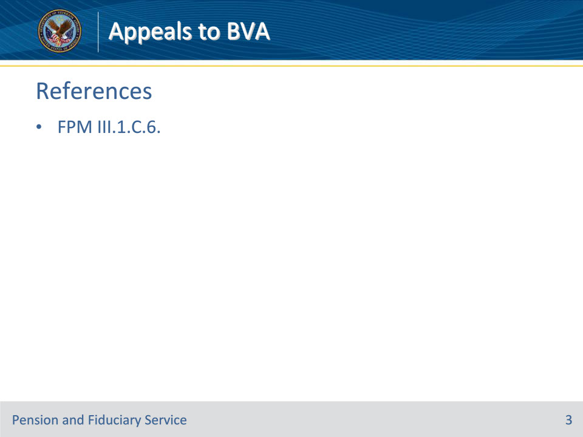
Slide notes

Instructor Notes:

These are the relevant references pertaining to this course:

• FPM III.1.C.6. Appeals to BVA

Slide 4 - Appeals to BVA
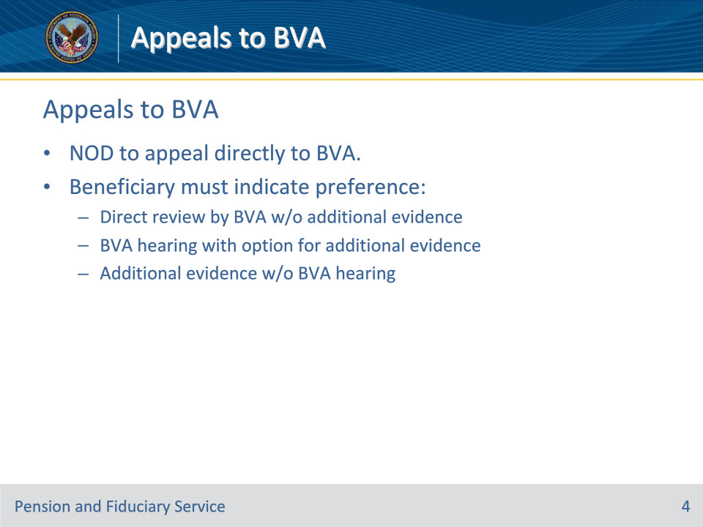
Slide notes

Policy Reference(s): FPM III.1.C.6.a.

Instructor Notes:

A beneficiary may choose to submit a notice of disagreement (NOD) to appeal directly to the BVA. Upon filing the NOD, a beneficiary must indicate whether he or she prefers:

• direct review of the record by BVA before the AOJ at the time of its decision, without submission of additional evidence

• a BVA hearing, to include an opportunity to submit additional evidence at the hearing and within 90 days following the hearing, or

• an opportunity to submit additional evidence without a BVA hearing with an NOD and within 90 days following receipt of the NOD.

These separate dockets will allow BVA to more efficiently and effectively manage distinctly different types of work. The new lane options provide claimants with more choices for resolving disagreements with a VA decision.

Slide 5 - Who May Submit NOD
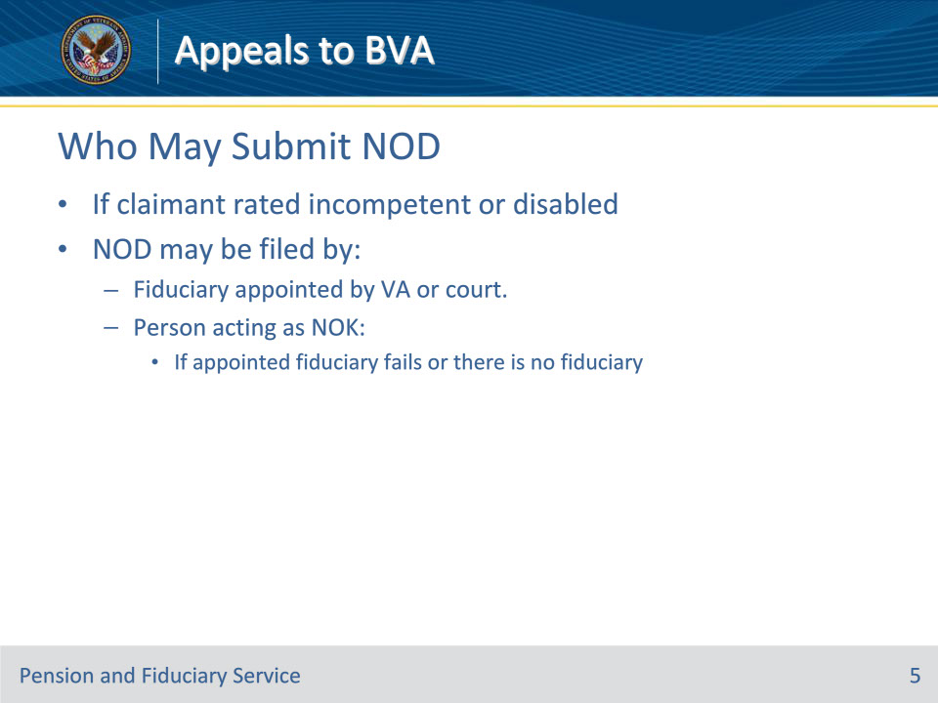
Slide notes

Policy Reference(s): FPM III.1.C.6.b.

Instructor Notes:

If the claimant is rated incompetent by VA or has a physical, mental, or legal disability which prevents the filing of an appeal on his or her own behalf, an NOD may be filed by

• a fiduciary appointed to manage the claimant’s affairs by VA or a court, or

• by a person acting as next of kin, if the appointed fiduciary fails to take needed action or no fiduciary has been appointed.

Slide 6 - NOD Requirements
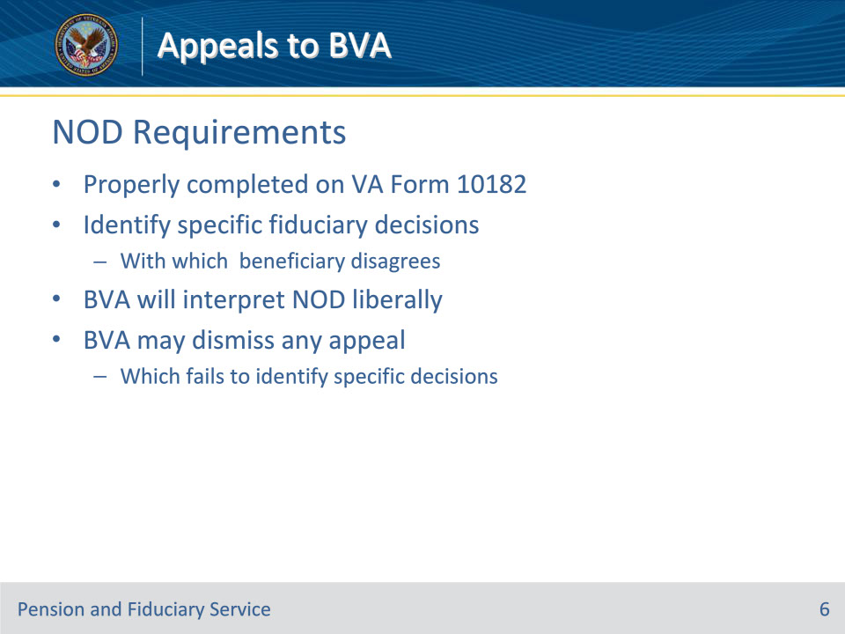
Slide notes

Policy Reference(s): FPM III.1.C.6.c.

Instructor Notes:

An NOD must be properly completed on a VA Form 10182. The NOD must identify the specific fiduciary decision(s) with which the beneficiary disagrees. BVA will interpret the NOD in a liberal manner for purposes of determining whether the beneficiary’s appeal clearly states decisions on appeal. BVA may dismiss any appeal which fails to identify the specific decision(s) with which the beneficiary disagrees.

Slide 7 - BVA Mail
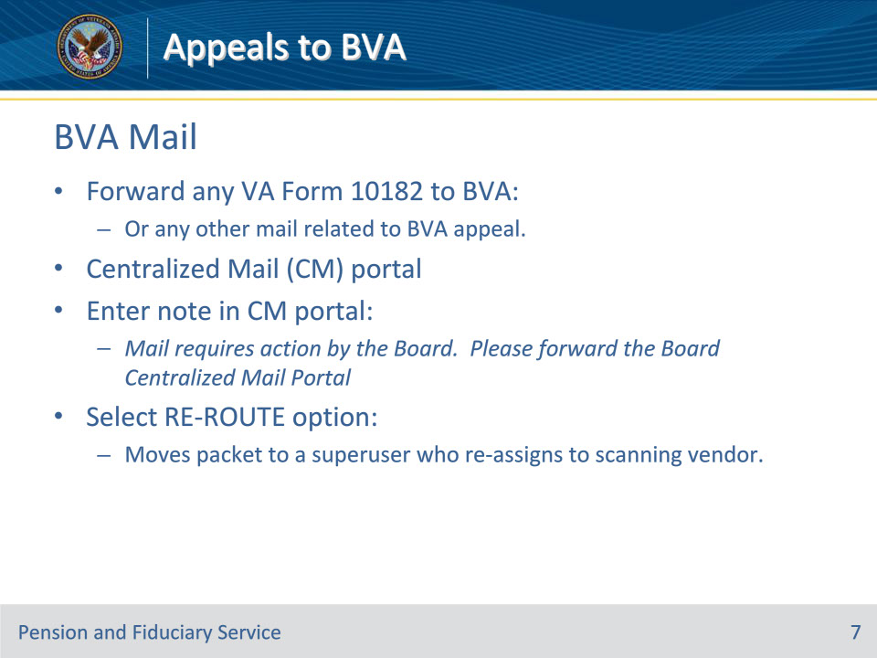
Slide notes

Policy Reference(s): FPM III.1.C.6.d.

Instructor Notes:

Forward any VA Form 10182 to BVA or any other mail related to a BVA appeal through its Centralized Mail (CM) portal by

• entering the following note in the appropriate section of the CM Portal: Mail requires action by the Board. Please forward the Board Centralized Mail Portal, and

• selecting the RE-ROUTE option. This action will move the packet to a superuser who re-assigns it to the scanning vendor.

Slide 8 - 31. Summary
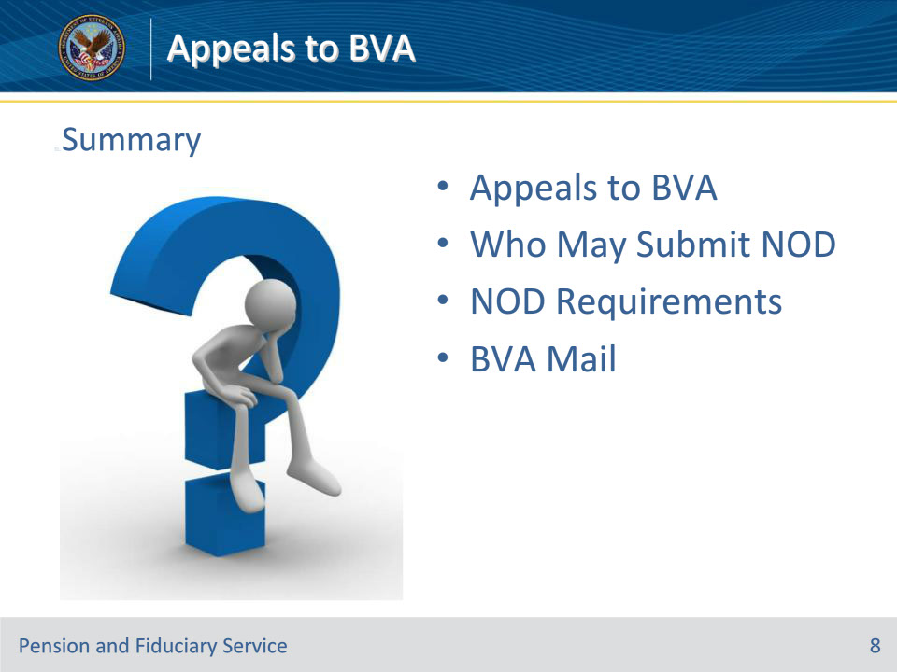
Slide notes

Instructor Notes:

(Recall) These are our learning objectives as stated from the beginning of the training:

• Understand BVA Appeal NOD requirements

• Identify the various lanes available for appealing to BVA

• Confirm NOD submitted by appropriate party

• Handle BVA mail received by the hub

(Recap) We discussed each of these learning objectives through the following topics in each slide today:

• Appeals to BVA

• Who May Submit NOD

• NOD Requirements

• BVA Mail

Are there any additional questions?

Questions should be filtered through your QRT team. They will submit your questions to the Field Inquiry Tool (FIT) on your behalf.

Slide 9 - TMS Survey/Assessment
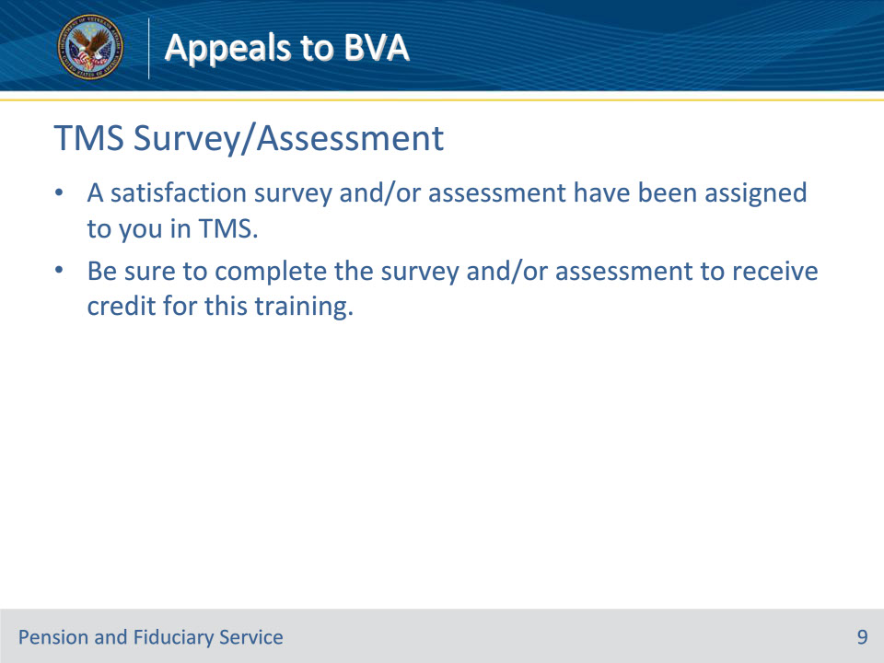
Slide notes

Instructor Notes:

A satisfaction survey and/or assessment have been assigned to you in TMS.

Be sure to complete the survey and/or assessment to receive credit for this training.

