Slide 1 - First Notice of Death for FSRs
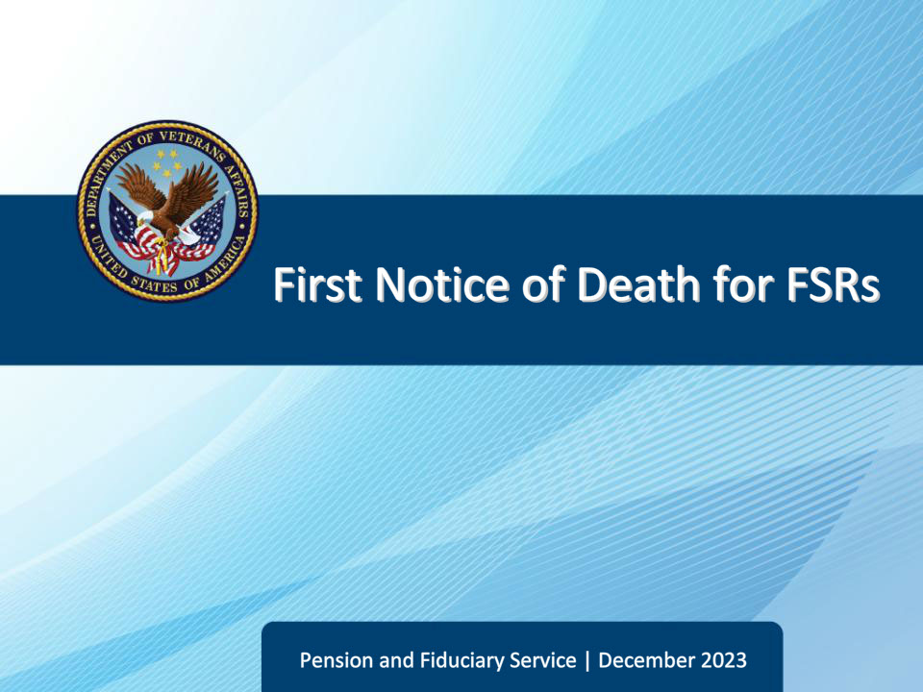
Slide notes

Course Description:

This course teaches learners basic information regarding First Notice of Death (FNODs) and the fiduciary hub procedures for processing them.

Slide 2 - Objectives
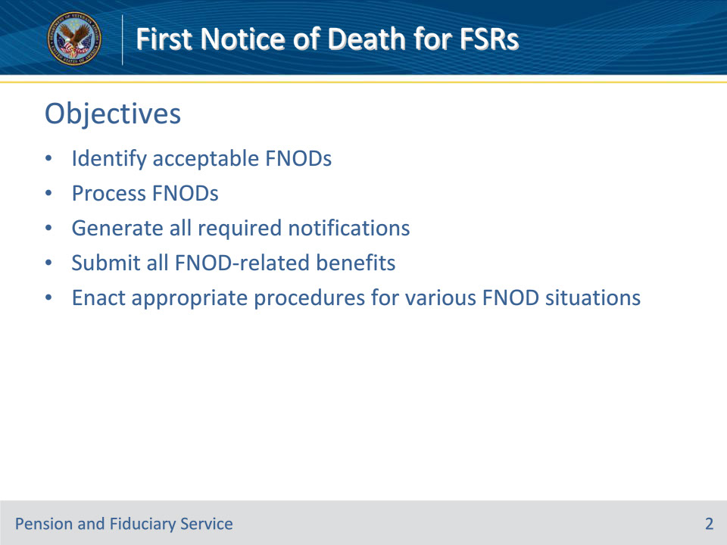
Slide notes

Instructor Notes:

At the end of this lesson, given the training and references, the learner will be able to do the following:

• Identify acceptable FNODs

• Process FNODs

• Generate all required notifications

• Submit all FNOD-related benefits

• Enact appropriate procedures for various FNOD situations

Slide 3 - References
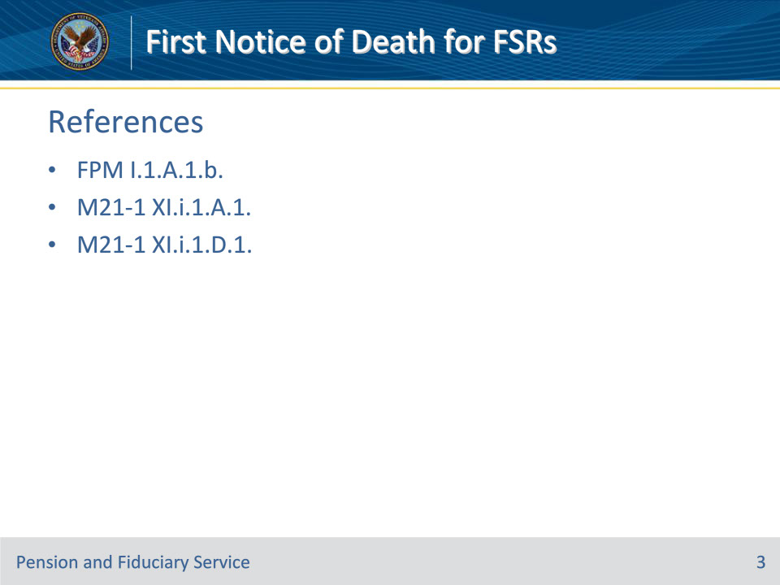
Slide notes

Instructor Notes:

These are the relevant references pertaining to this course:

• FPM I.1.A.1.b. Purpose of Fiduciary Promulgation Activity

• M21-1 XI.i.1.A.1. General Information About Veteran FNOD Processing

• M21-1 XI.i.1.D.1. General Information About Non-Veteran Beneficiary NOD Processing

Slide 4 - First Notice of Death
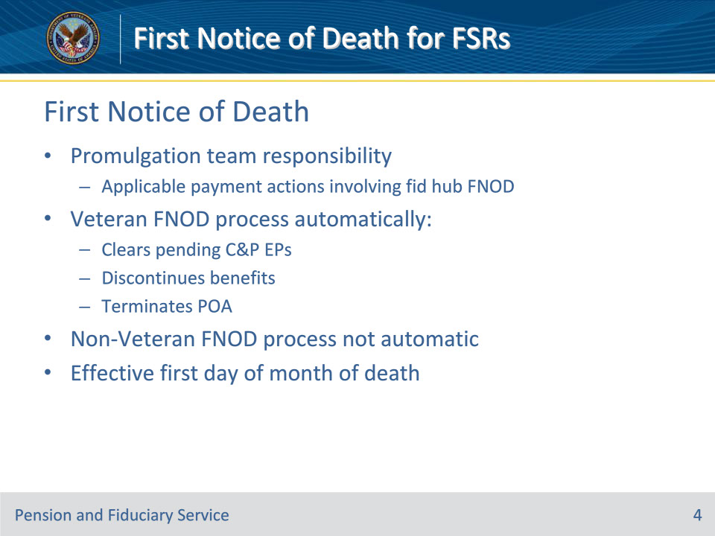
Slide notes

Policy Reference(s): FPM I.1.A.1.b.; M21-1 XI.i.1.A.1.a.

Instructor Notes:

Fiduciary promulgation activity will take applicable payment actions in situations involving first notice of death.

Veteran First Notice of Death (FNOD) processing establishes or updates a Veteran’s Beneficiary Identification and Records Locator Subsystem record with the date of the Veteran’s death. It also automatically

• clears and takes end product (EP) credit on any pending issues for compensation and pension benefits for live Veterans and apportionees that the Department of Veterans Affairs (VA) has not already authorized

• discontinues any benefits being paid, and

• terminates the power of attorney (POA) of record.

Note: The FNOD process will discontinue an award as of the first day of the month of death (MOD).

Slide 5 - Criteria
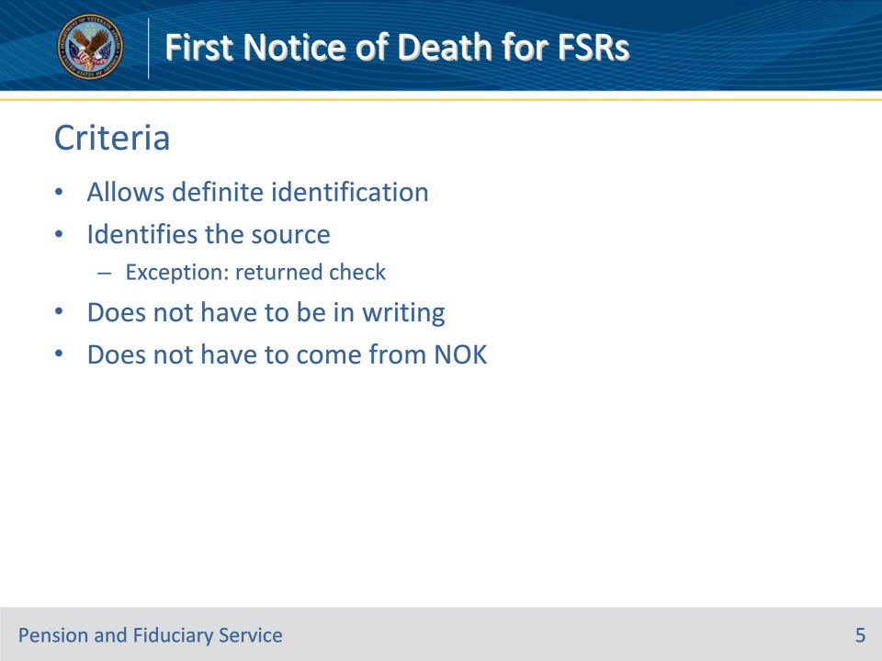
Slide notes

Policy Reference(s): M21-1 XI.i.1.A.1.b.; M21-1 XI.i.1.D.1.a.

Instructor Notes:

A notice of death (NOD) is acceptable if it:

• furnishes sufficient information about the beneficiary to allow a definite identification of the proper record, and

• identifies the source of the report of the death.

Exception: If the NOD is a returned check indicating that the beneficiary is deceased, identification of the source of the report of death is not necessary.

There is no requirement that a NOD be in writing or originate with the next of kin.

Examples:

• Notice of a Veteran’s death from the Compensation and Pension Record Interchange (CAPRI) is considered an acceptable NOD.

• A NOD may originate with a funeral home or other third party.

• A report of contact based on a telephone call is an acceptable NOD if the report clearly identifies the Veteran and the caller.

Slide 6 - Veteran Processing
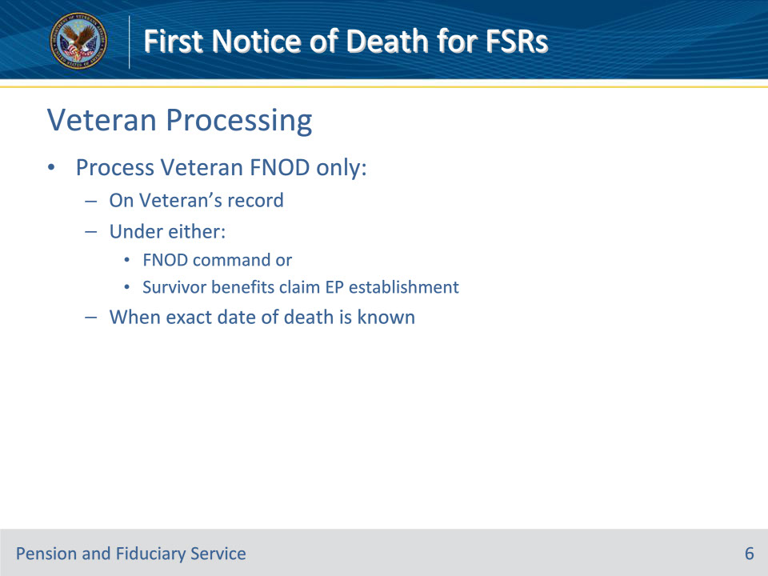
Slide notes

Policy Reference(s): M21-1 XI.i.1.A.1.c.

Instructor Notes:

Upon receipt of an acceptable Veteran NOD, process an FNOD only

• on a Veteran’s record

• under either the

• FNOD command, or

• establishment of an EP for a claim for survivor benefits, and

• when the exact date of death is known.

Slide 7 - Non-Veteran Processing
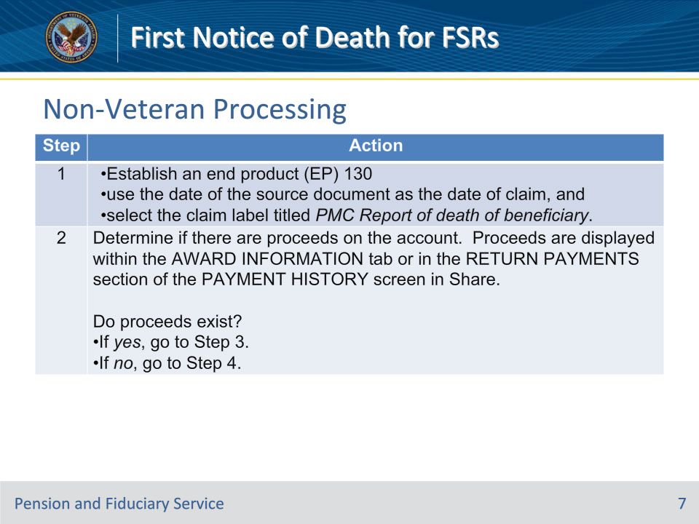
Slide notes

Policy Reference(s): M21-1 XI.i.1.D.1.b.

Instructor Notes:

Upon receipt of an acceptable NOD for a non-Veteran, follow the steps shown in this chart.

Slide 8 - Non-Veteran Processing
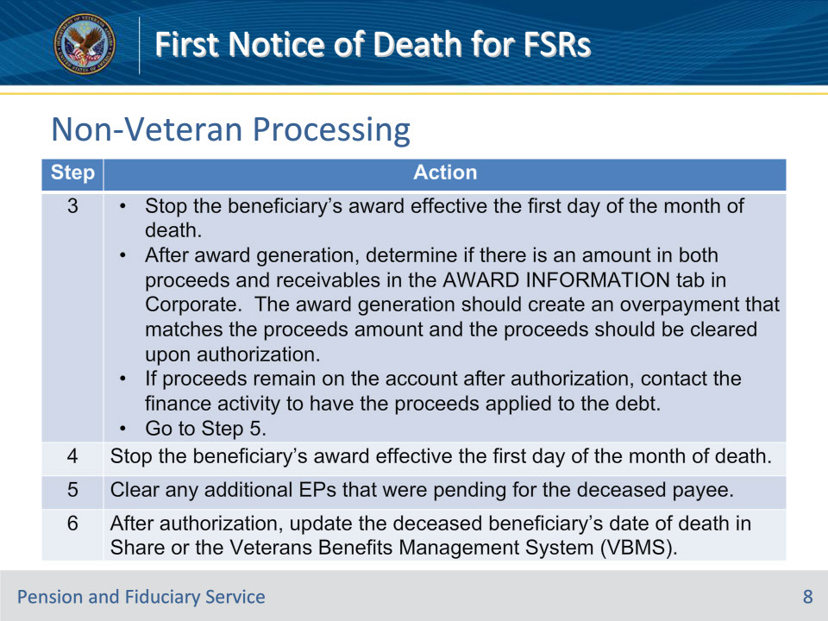
Slide notes

Policy Reference(s): M21-1 XI.i.1.D.1.b.

Instructor Notes:

Upon receipt of an acceptable NOD, follow the steps shown in this chart.

Exception: Do not clear EPs processed by the fiduciary hubs (hubs). Hub EPs are typically identified with the word Fiduciary as the first word in the claim label name. The hub will clear these EPs upon completion of fiduciary oversight actions.

Note: The authorization activity must ensure that any power of attorney (POA) has been removed from the electronic records.

Note: When the exact date of death is unknown, retrieve information through VBMS using the Social Security Administration (SSA) INQUIRY command.

Slide 9 - Notification
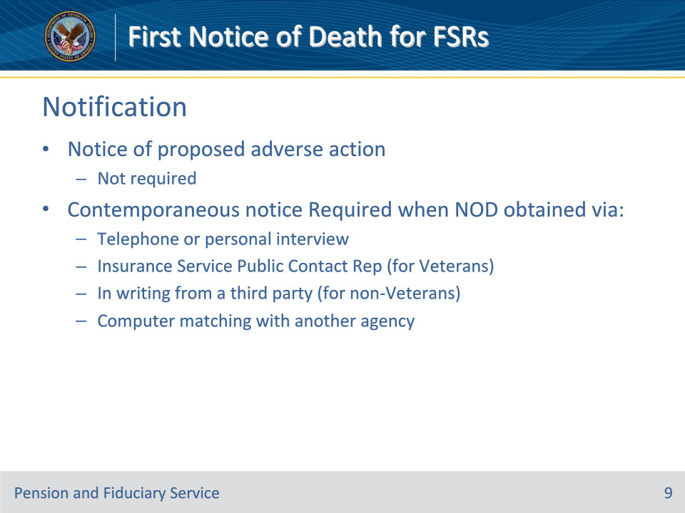
Slide notes

Policy Reference(s): M21-1 XI.i.1.A.1.d.; M21-1 XI.i.1.D.1.c.

Instructor Notes:

In most cases, VA must issue notice of proposed adverse action (due process) to a beneficiary before reducing or discontinuing his/her benefits. The discontinuation of benefits based on receipt of an acceptable NOD is one of the exceptions to this rule.

Although notice of proposed adverse action is not required, contemporaneous notice of the action taken is required if the NOD was obtained

• by way of telephone or personal interview

• from an Insurance Service Public Contact Representative (for Veterans)

• in writing from a third party (for non-Veterans)

• through computer matching with another Federal agency, such as the Social Security Administration (SSA).

Slide 10 - Notification for Veterans
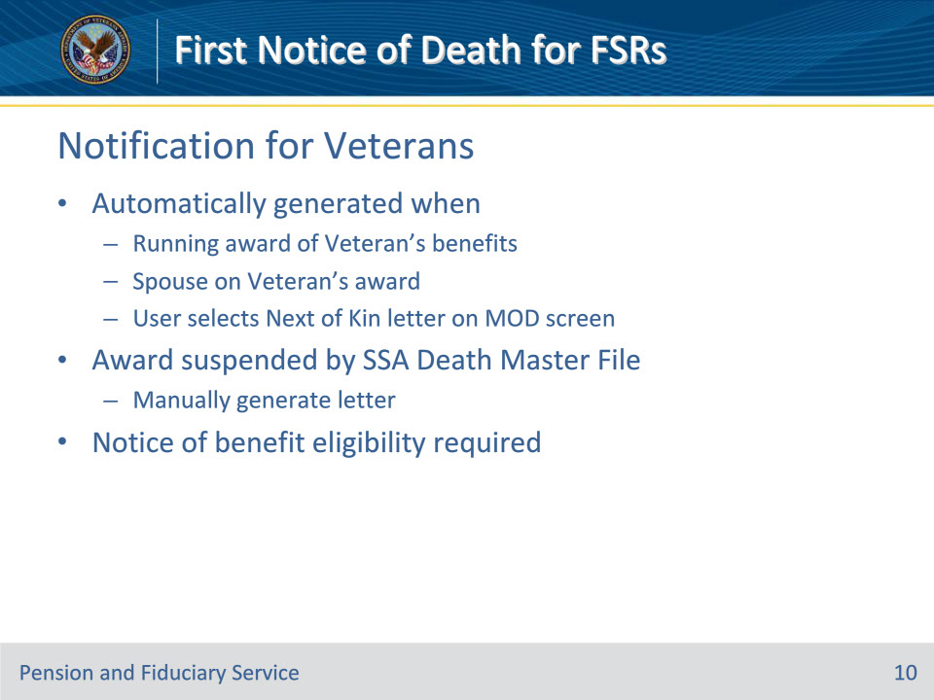
Slide notes

Policy Reference(s): M21-1 XI.i.1.A.1.d.-f.

Instructor Notes:

• An automatic generation and mailing of a contemporaneous notice is sent to the Veteran’s last known address (as it exists in the corporate record), when

• there was a running award of Veteran’s benefits

• a spouse is of record on the Veteran’s award at the time of the FNOD entry, and

• a user selects a Next of Kin letter on the MONTH OF DEATH screen.

• If the award has been suspended by the SSA Death Master File notification, a user-generated letter must be sent by the claims processor.

• Although a contemporaneous notice is not required, VA is required to provide notice of benefit eligibility.

When a VA employee processes the NOD and the Veteran has a running award, the employee is presented with the default option of sending a Next of Kin letter on the MONTH OF DEATH screen. If the employee proceeds with this selection, the Hines Information Technology Center (ITC) generates and mails a letter to the Veteran’s estate containing information about survivor benefits to which the Veteran’s survivors and others may be entitled. These benefits include

• burial benefits

• Survivors Pension

• Dependency and Indemnity Compensation (DIC)

• accrued, and

• educational benefits

When a VA employee processes a NOD and the Veteran has a suspended or terminated award or a pending claim where no award decision has been made, a contemporaneous notice is not required. However, VA is required to provide notice of benefit eligibility.

When processing the NOD, the VA employee is presented with the option of sending a Next of Kin letter. The Next of Kin letter will not be generated or sent if the letter option is selected but the Veteran had did not have a running award.

Slide 11 - Notification for Veterans
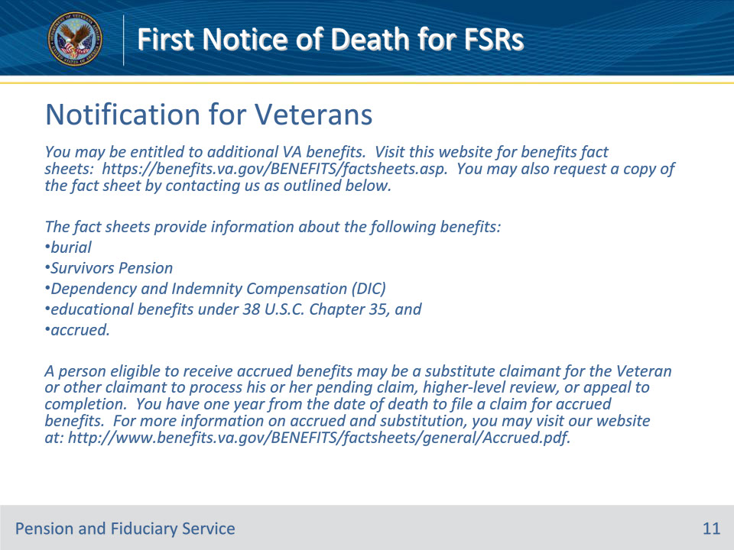
Slide notes

Policy Reference(s): M21-1 XI.i.1.A.1.g.

Instructor Notes:

Include the language below when notifying a deceased Veteran’s estate of benefits to which survivors and others may be entitled.

You may be entitled to additional VA benefits. Visit this website for benefits fact sheets: https://benefits.va.gov/BENEFITS/factsheets.asp. You may also request a copy of the fact sheet by contacting us as outlined below.

The fact sheets provide information about the following benefits:

• burial

• Survivors Pension

• Dependency and Indemnity Compensation (DIC)

• educational benefits under 38 U.S.C. Chapter 35, and

• accrued.

A person eligible to receive accrued benefits may be a substitute claimant for the Veteran or other claimant to process his or her pending claim, higher-level review, or appeal to completion. You have one year from the date of death to file a claim for accrued benefits. For more information on accrued and substitution, you may visit our website at: http://www.benefits.va.gov/BENEFITS/factsheets/general/Accrued.pdf.

Note: When the evidence of record indicates the Veteran was on a Medal of Honor Roll, also include the following language in the notice to the estate.

A surviving spouse of a Veteran whose name has been entered on the Army, Navy, Air Force, or Coast Guard Medal of Honor Roll may be eligible for a Medal of Honor Pension (MOHP) if the spouse was married to the Veteran at the time of the Veteran’s death and either

• they were married for one year or more immediately prior to the Veteran’s death, or

• for any period of time, if a child was born of the marriage or was born to the Veteran and surviving spouse before the marriage.

A surviving spouse of a Veteran who was on a Medal of Honor Roll should provide VA Form 21-4170, Statement of Marital Relationship, to verify marital and parental information which can be used to verify eligibility for MOHP.

Slide 12 - Notification for Non-Veterans
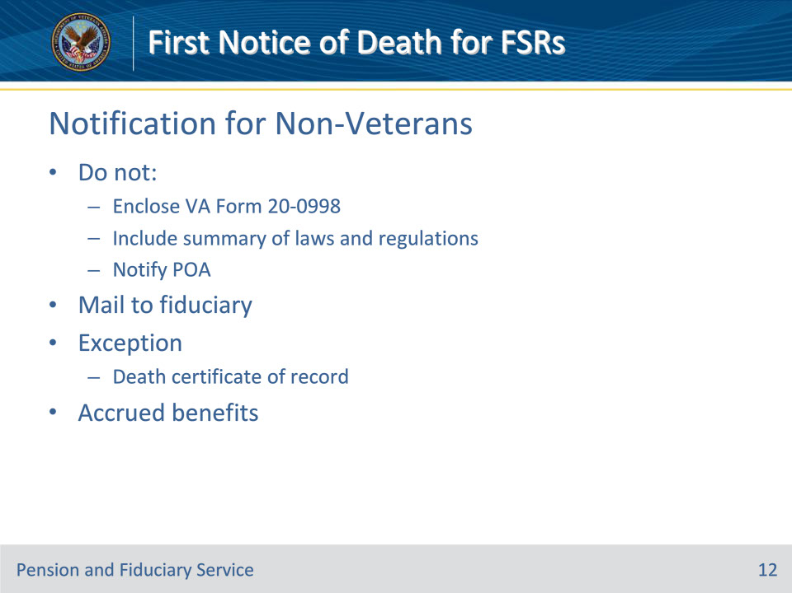
Slide notes

Policy Reference(s): M21-1 XI.i.1.D.1.c., d.

Instructor Notes:

• Do not enclose VA Form 20-0998, Your Right to Seek Review of Our Decision, when sending a contemporaneous notice that benefits have been discontinued based on the reported death of the beneficiary.

• Do not include a summary of laws and regulations.

• If the claimant had a power of attorney (POA), the representation is automatically revoked upon the passing of the beneficiary. Do not notify the former POA.

• If the claimant has a VA-appointed fiduciary at the time of death, issue the contemporaneous notice to the most recent mailing address of record.

Exception: If a death certificate for the deceased non-Veteran beneficiary is of record, no notification letter is required. However, if a probability of accrued benefits exists, VA is required to provide notice. Such a probability could exist, but is not limited to, when there are withholdings for incompetency that were never released or payments returned for months prior to death.

The required notice language can be found at M21-1 XI.i.1.D.1.d. It is the same as language as the Veteran notification except it does not list “burial” as a benefit option in the bulleted list.

Slide 13 - Automated EP 130
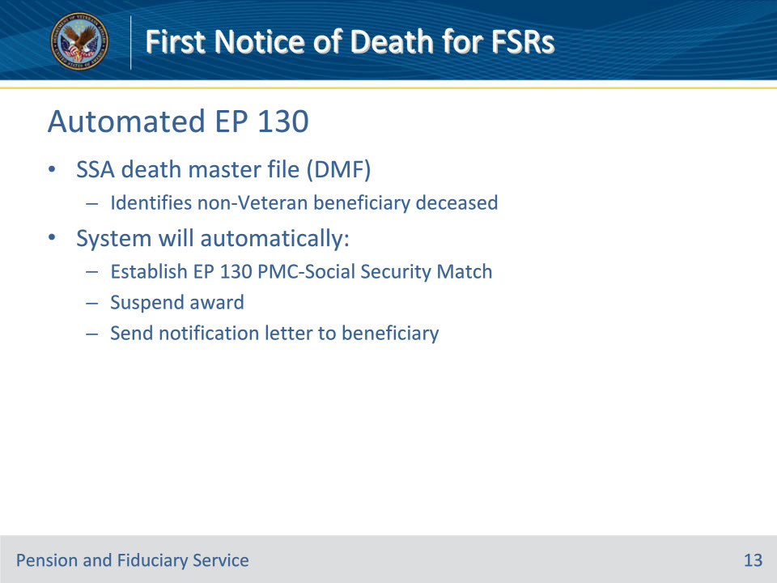
Slide notes

Policy Reference(s): M21-1 XI.i.1.D.1.f.

Instructor Notes:

When a Social Security death master file (DMF) identifies that a non-Veteran beneficiary is deceased, the system will automatically

• establish an EP 130 with the claim label PMC-Social Security Match

• suspend the award, and

• send a notification letter to beneficiary.

Slide 14 - FNOD Benefits
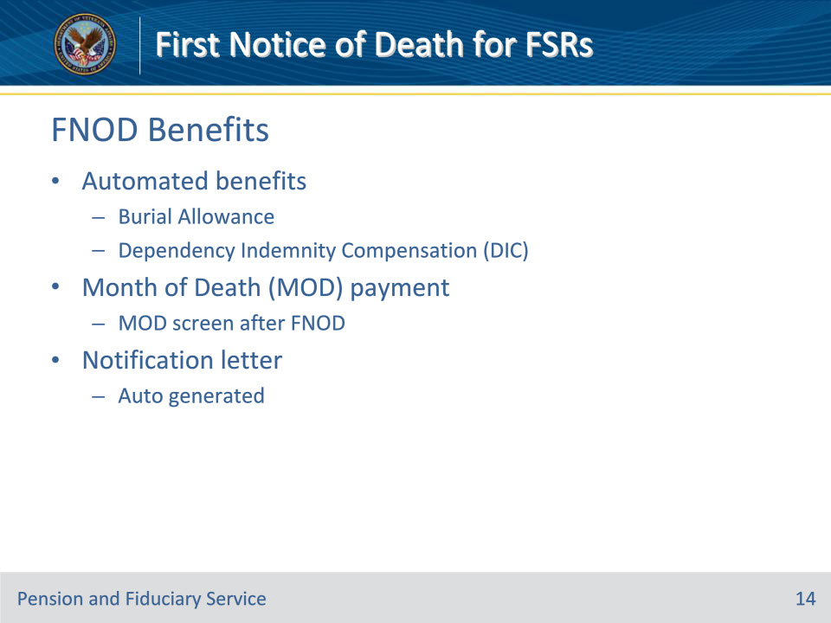
Slide notes

Policy Reference(s): M21-1 XI.i.1.A.1.h.

Instructor Notes:

After FNOD processing, the following automated benefits can be awarded to eligible surviving spouses based on information contained in the corporate record:

• burial allowance, and

• DIC.

The MOD payment is also awarded to eligible surviving spouses after a VA employee completes the MONTH OF DEATH screen that automatically appears after FNOD processing is completed.

An automatically generated letter informs the surviving spouse if the burial allowance, DIC, and/or MOD payment are awarded.

Slide 15 - Date of Death Unknown
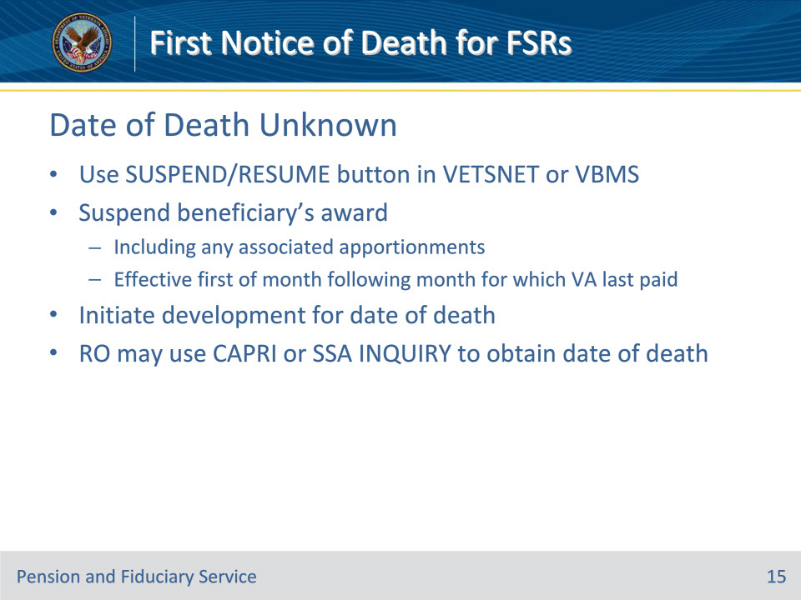
Slide notes

Policy Reference(s): M21-1 XI.i.1.A.1.i.; M21-1 XI.i.1.D.1.e.

Instructor Notes:

If the fact of death is established, but the date of death is unknown

• use the SUSPEND/RESUME button in VETSNET or VBMS

• suspend the beneficiary’s award, to include any associated apportionment(s), effective the first of the month following the month for which VA last paid the beneficiary, and

• initiate development for the date of death.

Note: The regional office (RO) may use CAPRI or the SSA INQUIRY function to obtain a beneficiary’s date of death.

Slide 16 - Specific Situations
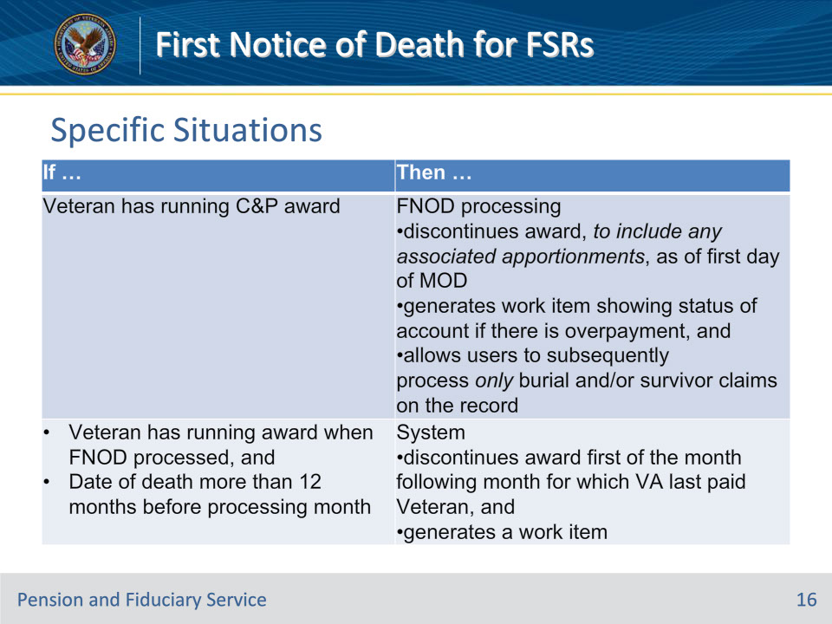
Slide notes

Policy Reference(s): M21-1 XI.i.1.A.1.i.

Instructor Notes:

Use this table to determine the actions to take for handling specific situations that may arise when processing a NOD.

Note: If the apportionee award is in suspense at the time of NOD processing, then the system

• discontinues the apportionee award the first of the month following the month for which VA last paid the beneficiary, and

• generates a work item.

Slide 17 - Specific Situations
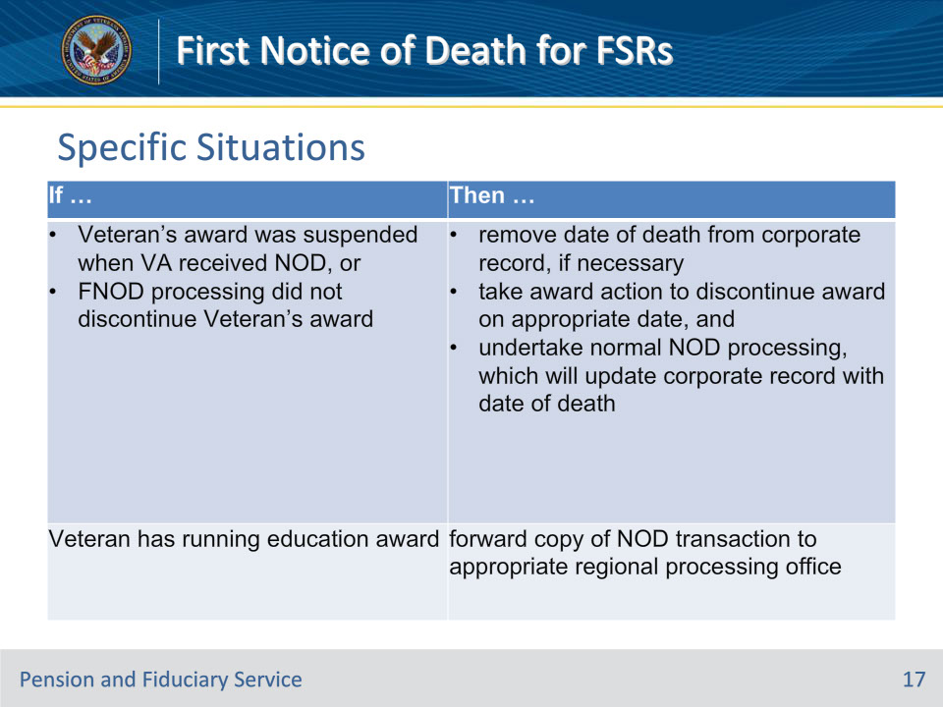
Slide notes

Policy Reference(s): M21-1 XI.i.1.A.1.i.

Instructor Notes:

Use this table to determine the actions to take for handling specific situations that may arise when processing a NOD.

Note: NOD processing suspends a running award of education benefits under 38 U.S.C. Chapters 30 or 31 but does not suspend an award under 38 U.S.C. Chapter 32 or 10 U.S.C. Chapter 1606.

Slide 18 - Specific Situations
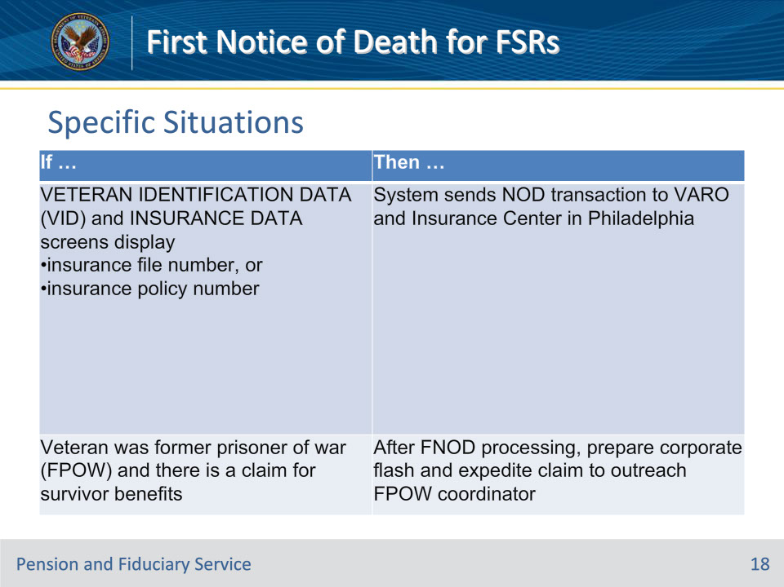
Slide notes

Policy Reference(s): M21-1 XI.i.1.A.1.i.

Instructor Notes:

Use this table to determine the actions to take for handling specific situations that may arise when processing a NOD.

Slide 19 - RLC Notice
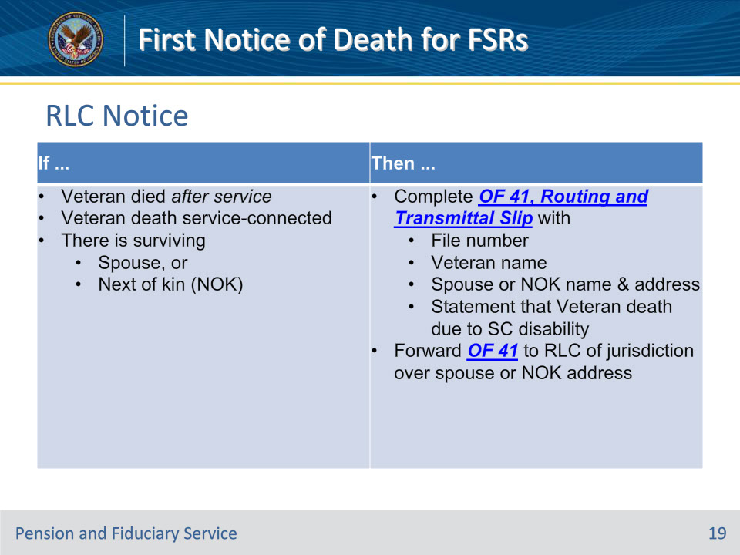
Slide notes

Policy Reference(s): M21-1 XI.i.1.A.1.j.

Instructor Notes:

Loan guaranty benefits may be available to certain surviving dependents of deceased Veterans. Use this table to determine the appropriate means of notifying a regional loan center (RLC).

Slide 20 - 31. Questions?
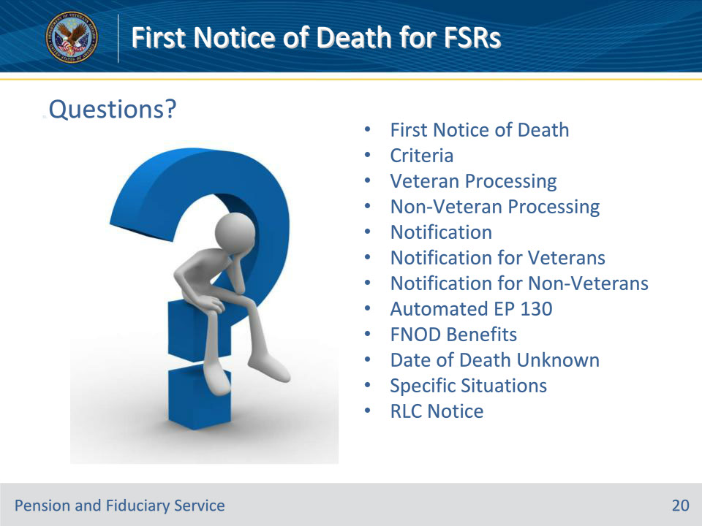
Slide notes

Instructor Notes:

(Recall) These are our learning objectives as stated from the beginning of the training:

• Identify acceptable FNODs

• Process FNODs

• Generate all required notifications

• Submit all FNOD-related benefits

• Enact appropriate procedures for various FNOD situations

(Recap) We discussed each of these learning objectives through the following topics in each slide today:

• First Notice of Death

• Criteria

• Veteran Processing

• Non-Veteran Processing

• Notification

• Notification for Veterans

• Notification for Non-Veterans

• Automated EP 130

• FNOD Benefits

• Date of Death Unknown

• Specific Situations

• RLC Notice

Are there any additional questions?

Slide 21 - TMS Survey
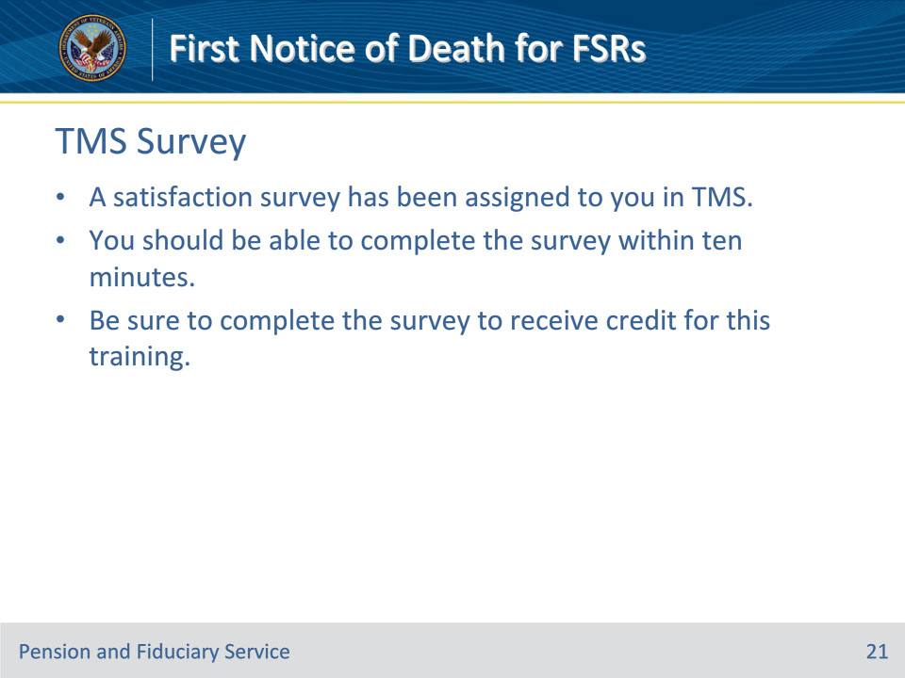
Slide notes

Instructor Notes:

A satisfaction survey has been assigned to you in TMS. You should be able to complete it within ten minutes.

Completing it will allow you to receive credit for this training.

