Slide 1 - Whereabouts Unknown

Slide notes

Course Description:

This course teaches learners the fiduciary hub processes and procedures to follow when a beneficiary or fiduciary’s whereabouts are unknown.

Slide 2 - Objectives
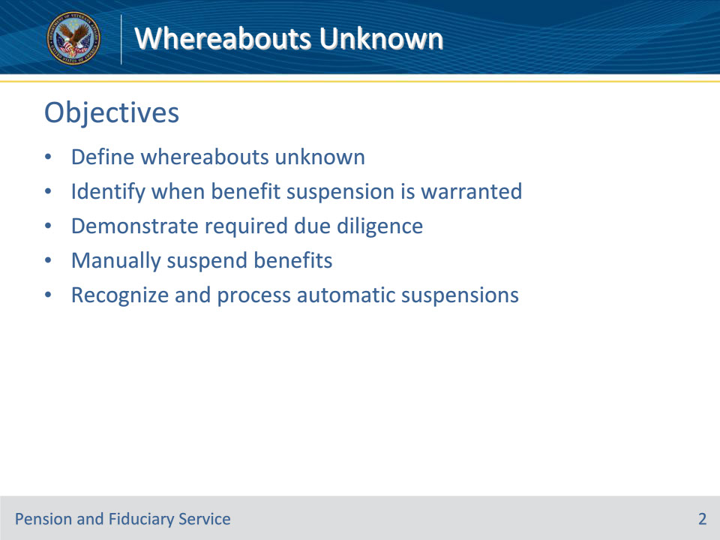
Slide notes

Instructor Notes:

At the end of this lesson, given the training and references, the learner will be able to do the following:

• Define whereabouts unknown

• Identify when benefit suspension is warranted

• Demonstrate required due diligence

• Manually suspend benefits

• Recognize and process automatic suspensions

Slide 3 - References
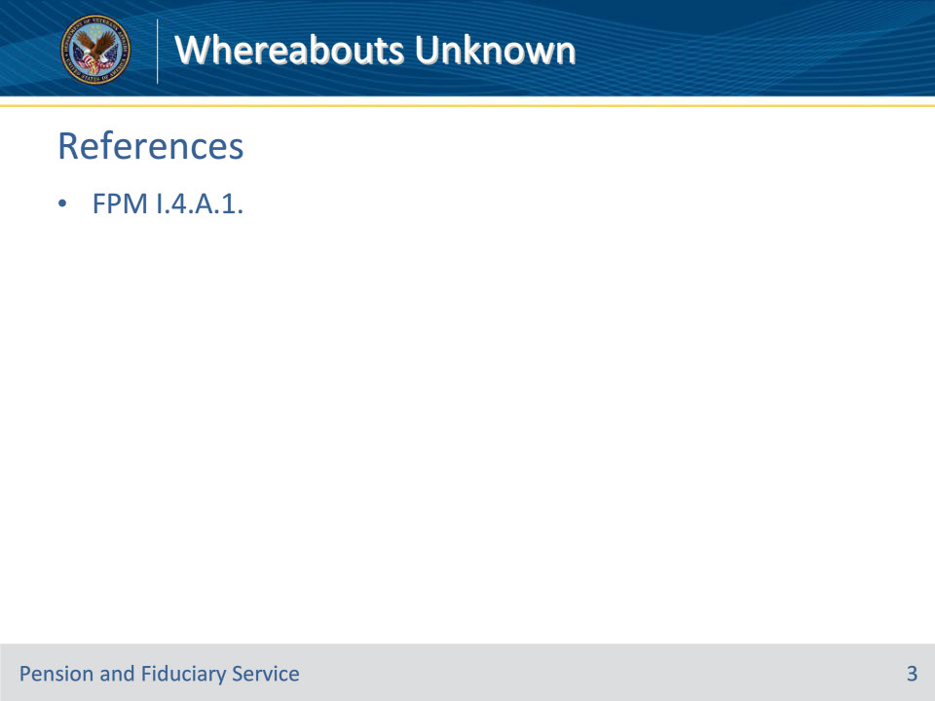
Slide notes

Instructor Notes:

These are the relevant references pertaining to this course:

• FPM I.4.A.1. When Benefits May Be Suspended

Slide 4 - Purpose
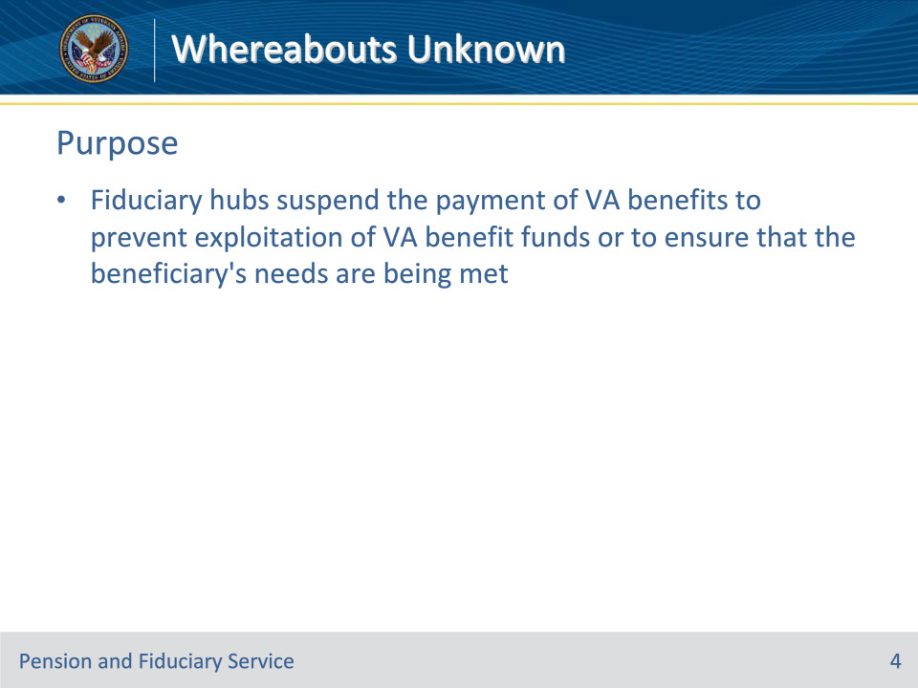
Slide notes

Policy Reference(s): FPM I.4.A.1.a.

Instructor Notes:

Fiduciary hubs (hubs) suspend the payment of Department of Veterans Affairs (VA) benefits to prevent exploitation of VA benefit funds or to ensure that the beneficiary’s needs are being met.

Slide 5 - Suspensions
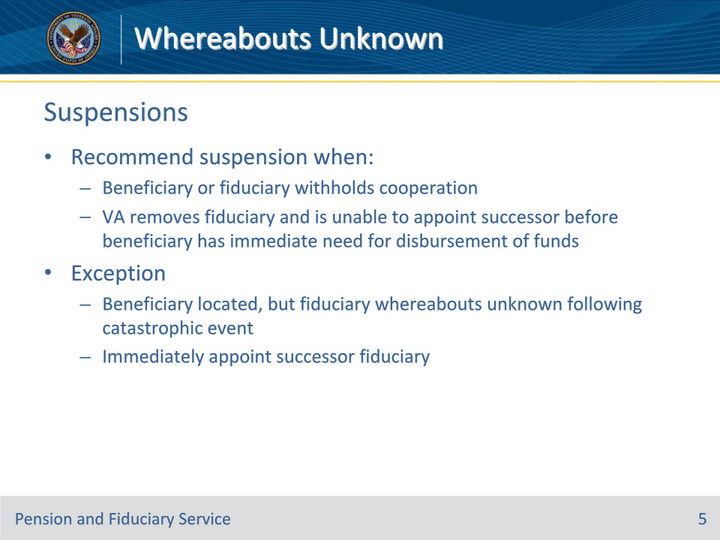
Slide notes

Policy Reference(s): FPM I.4.A.1.b.

Instructor Notes:

To limit the adverse impact that may result from the temporary suspension of VA benefit payments, VA reserves suspension of VA benefit payments for rare cases in which VA has no other option to protect the beneficiary’s VA funds.

The appropriate hub employee will recommend that a beneficiary’s VA benefits be temporarily suspended per 38 CFR 13.50 when

• the beneficiary or fiduciary withholds cooperation in any of the appointment and oversight procedures, specified in 38 CFR 13, or

• VA removes the beneficiary’s fiduciary for any reason prescribed in 38 CFR 13.500(b) and is unable to appoint a successor fiduciary before the beneficiary has an immediate need for disbursement of funds.

Exception: Fiduciary Hub Managers (FHMs) may not approve the suspension of VA benefits when a beneficiary has been located, but the fiduciary’s whereabouts are unknown following a catastrophic event. VA must instead act immediately to appoint a successor fiduciary.

Slide 6 - Withheld Cooperation
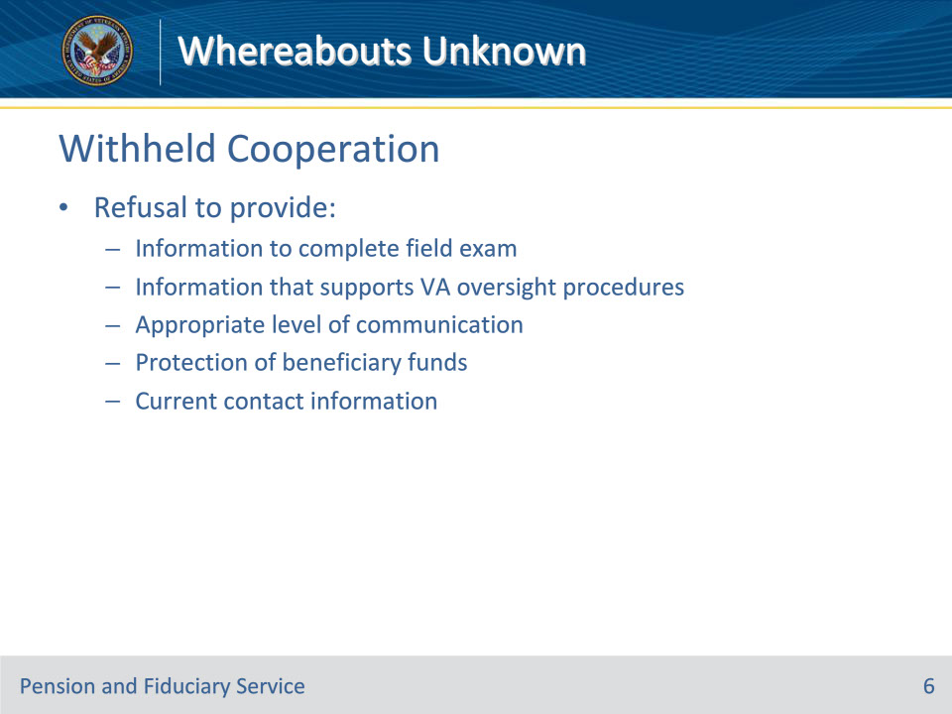
Slide notes

Policy Reference(s): FPM I.4.A.1.c.

Instructor Notes:

Hubs must suspend the payment of VA benefits to the beneficiary when the beneficiary or the beneficiary’s attorney, claims agent, or representative withholds cooperation in any of the appointment and oversight procedures.

Examples of a beneficiary or fiduciary withholding cooperation in appointment and oversight procedures may include, but are not limited to a refusal to provide

• information to complete a field examination

• information that supports VA oversight procedures

• appropriate level of communication

• protection of the beneficiary’s funds, or

• current contact information for the beneficiary and fiduciary to complete oversight activities.

Slide 7 - Due Diligence
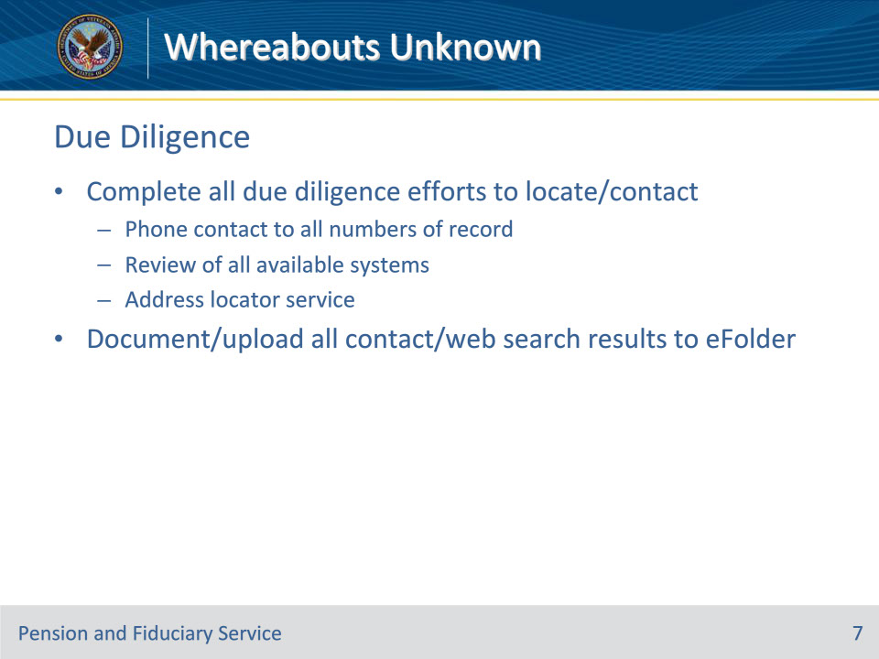
Slide notes

Policy Reference(s): FPM I.4.A.1.d.

Instructor Notes:

Hubs must complete all due diligence efforts to provide notice and communicate with the beneficiary and fiduciary to complete oversight activities.

Due diligence to locate and/or contact the beneficiary and/or fiduciary may include, but is not limited to

• telephone contact to all phone numbers of record for the beneficiary or fiduciary

• a review of all available systems, and

• an internet web address locator service.

Note: VA pays a fee that allows authorized users to access a web-based address locator service to search for a current mailing address for a beneficiary and/or fiduciary. Since VA typically authorizes a limited number of employees per regional office (RO) to utilize this service, employees may need to reach out to their local management to determine the RO’s authorized user(s) to assist in their search efforts.

Important: Document and upload all contact and/or web search results to the electronic claims folder (eFolder).

Slide 8 - Recommending Suspension
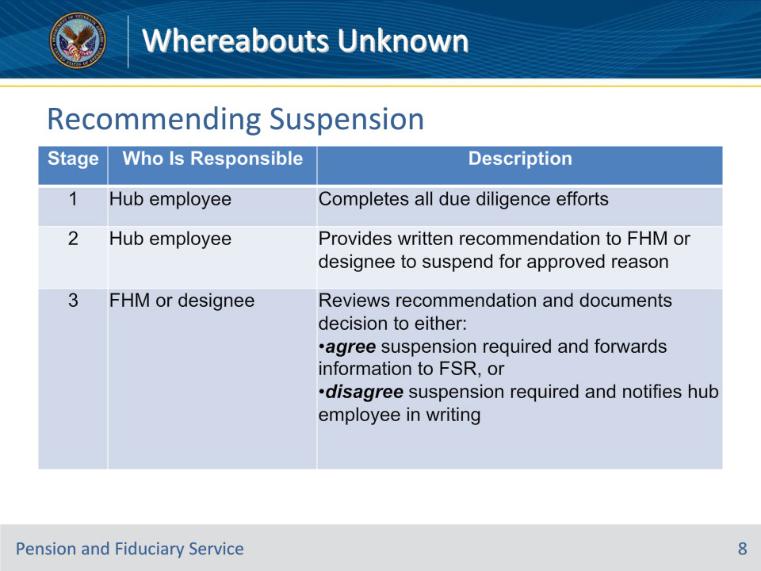
Slide notes

Policy Reference(s): FPM I.4.A.1.e.

Instructor Notes:

This table describes the process that hub personnel must follow to recommend a suspension of benefits.

Important: All correspondence related to the recommendation to suspend must be documented in VBMS and/or uploaded to the eFolder.

Slide 9 - Manual Suspension
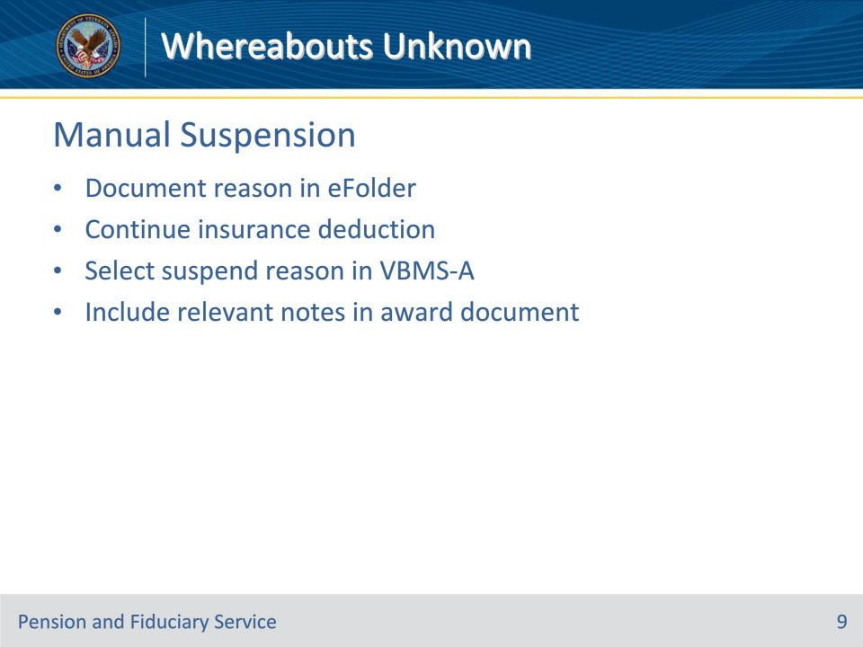
Slide notes

Policy Reference(s): FPM I.4.A.1.f.

Instructor Notes:

Upon completion of due diligence efforts, the hub must clearly document the reason for the suspension in the eFolder.

In compensation cases, take award action to continue the insurance deduction when there is a deduction for payment of

• National Service Life Insurance

• U.S. Government Life Insurance premiums

• Veterans Mortgage Life Insurance premiums, or

• insurance loan payments.

Select the appropriate suspend reason in VBMS-Awards and include any relevant notes in the award document.

Slide 10 - Catastrophic Event- Beneficiary
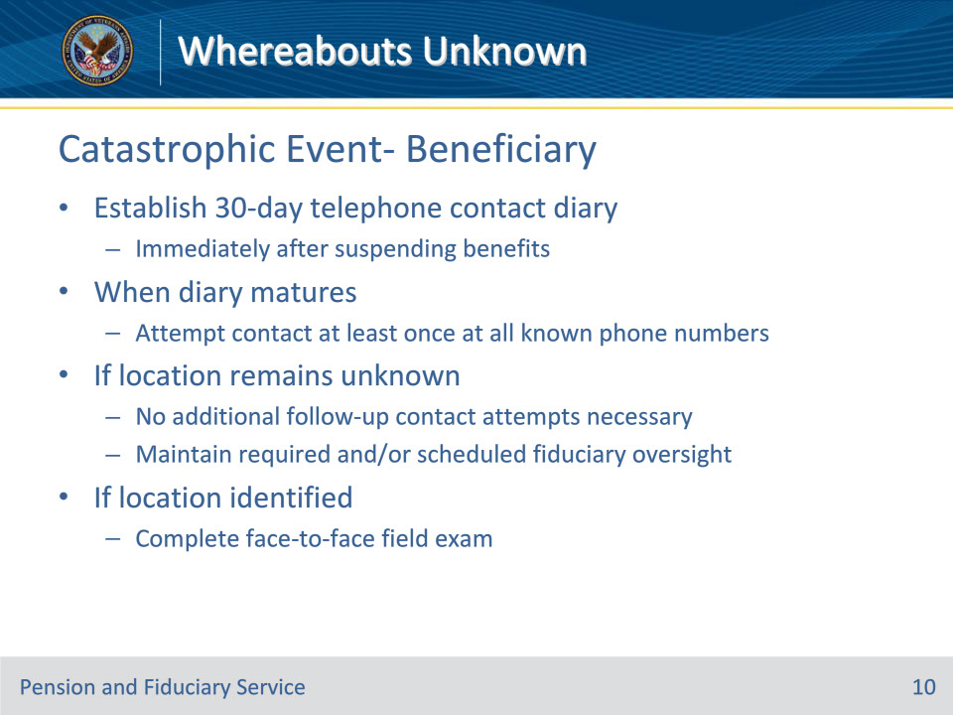
Slide notes

Policy Reference(s): FPM I.4.A.1.f.

Instructor Notes:

When the hub suspends the beneficiary’s benefit payments because the beneficiary cannot be located, and the beneficiary has been impacted by a catastrophic event, establish a 30-day telephone contact diary immediately after suspending benefits.

• When the diary matures, attempt to contact the beneficiary at least once at all known telephone numbers.

• If the beneficiary’s location remains unknown, no additional follow-up attempts to contact the beneficiary are necessary. However, the hub must maintain required and/or scheduled fiduciary oversight during the period in which the beneficiary’s whereabouts are unknown.

• If the beneficiary’s location is identified, complete a face-to-face field examination to assess the beneficiary’s situation.

Slide 11 - Automatic Suspension
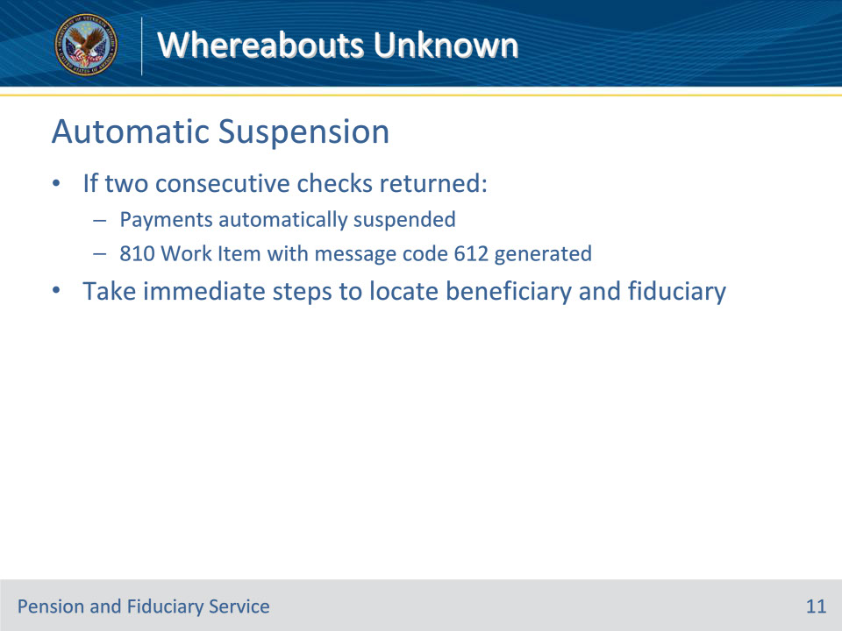
Slide notes

Policy Reference(s): FPM I.4.A.1.g.

Instructor Notes:

If two consecutive checks to a Veteran are returned indicating Whereabouts Unknown or Moved Left No Address, then

• payments are automatically suspended during processing of the returned check, and

• an 810 Work Item, Notice of Benefit Payment Transaction (810WI), is generated with message code 612, Account Suspended - Undeliverable Payment, as notification of the suspended payments.

The hub must take immediate steps to locate a beneficiary and the fiduciary in any situation where the hub discovers that an 810 Work Item, Notice of Benefit Payment Transaction (810WI), is generated with message code 612, Account Suspended - Undeliverable Payment.

Slide 12 - Resuming Award
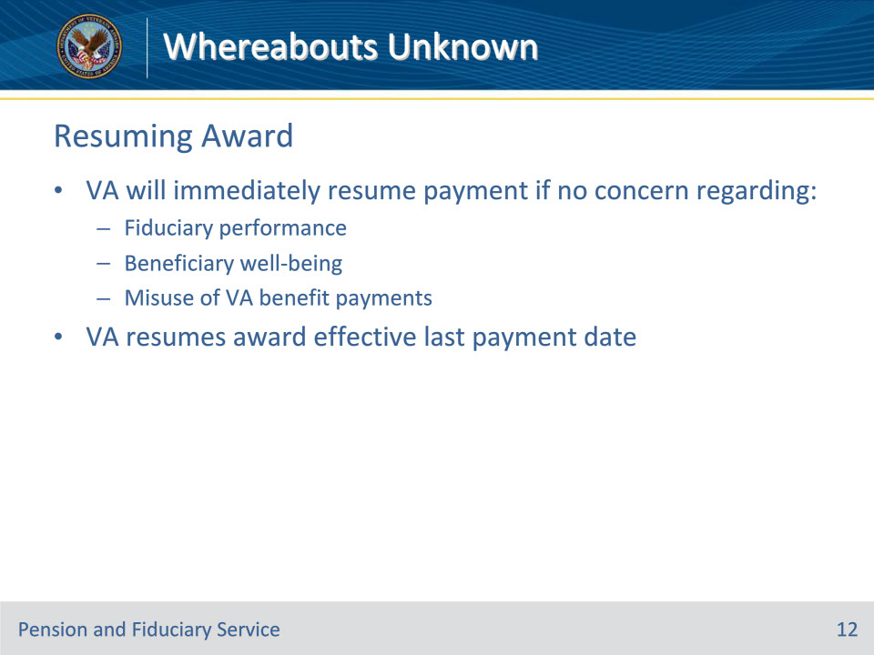
Slide notes

Policy Reference(s): FPM I.4.A.1.h.

Instructor Notes:

Upon appointment of a successor fiduciary or notification of cooperation by the fiduciary and/or beneficiary, VA will immediately resume payment of the award if there is no concern regarding the

• fiduciary’s performance

• beneficiary’s well-being, or

• misuse of VA benefit payments.

VA will resume the award effective the date of the last payment to the beneficiary.

Slide 13 - 31. Questions?
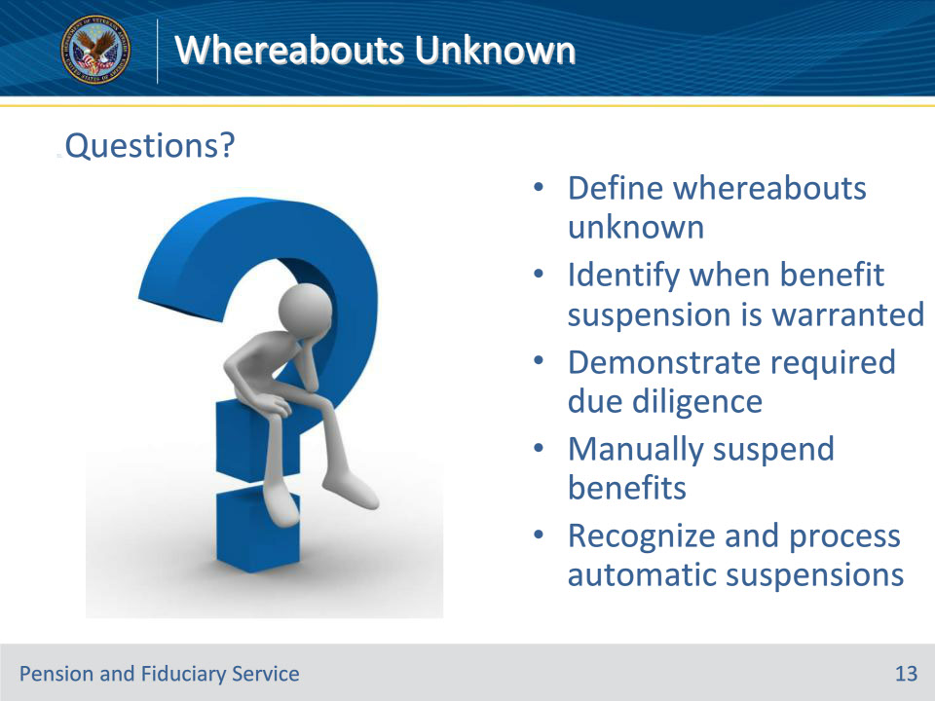
Slide notes

Instructor Notes:

(Recall) These are our learning objectives as stated from the beginning of the training:

• Define whereabouts unknown

• Identify when benefit suspension is warranted

• Demonstrate required due diligence

• Manually suspend benefits

• Recognize and process automatic suspensions

Are there any additional questions?

Questions should be filtered through your QRT team. They will submit your questions to the Field Inquiry Tool (FIT) on your behalf.

Slide 14 - TMS Survey/Assessment
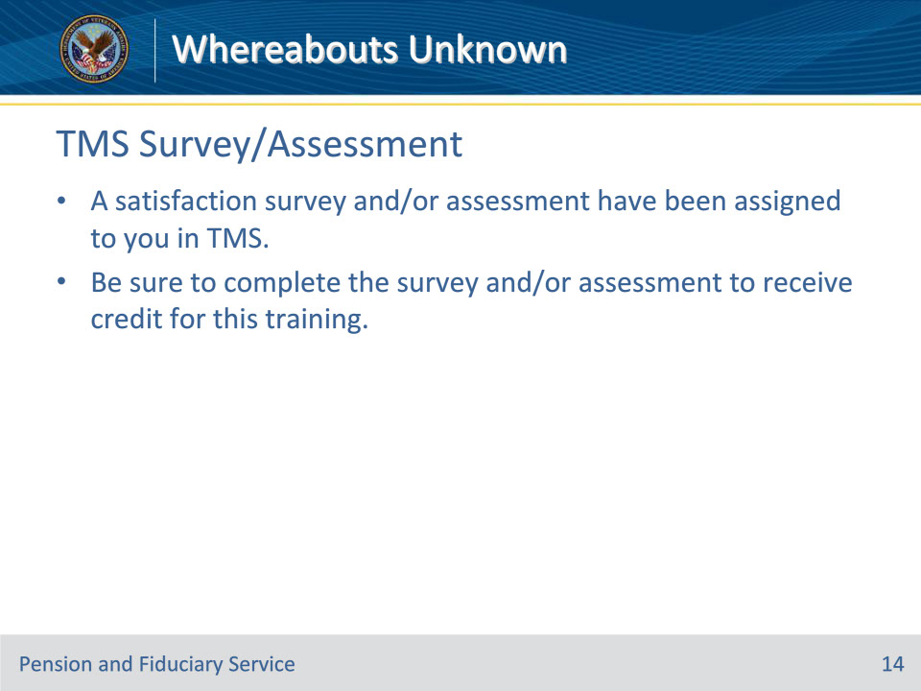
Slide notes

Instructor Notes:

A satisfaction survey and/or assessment have been assigned to you in TMS.

Be sure to complete the survey and/or assessment to receive credit for this training.

