Slide 1 - Overview of Dependency and Indemnity Compensation (DIC) for FSRs
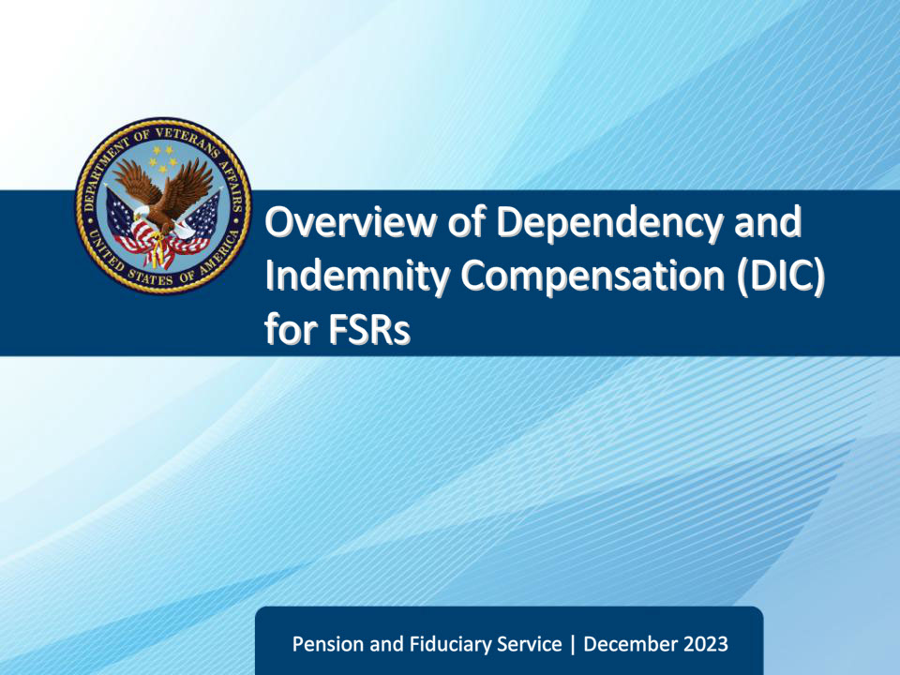
Slide notes

Course Description:

This course teaches FSRs an introduction to Dependency and Indemnity Compensation (DIC) and the related definitions, eligibility, laws, and special allowances.

Slide 2 - Objectives
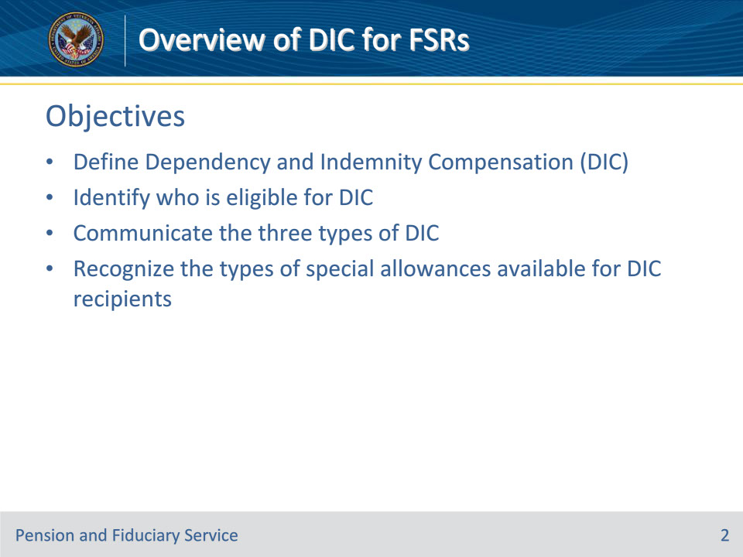
Slide notes

Instructor Notes:

At the end of this lesson, given the training and corresponding references, the learner will be able to do the following:

• Define Dependency and Indemnity Compensation (DIC)

• Identify who is eligible for DIC

• Communicate the three types of DIC

• Recognize the types of special allowances available for DIC recipients

Slide 3 - References
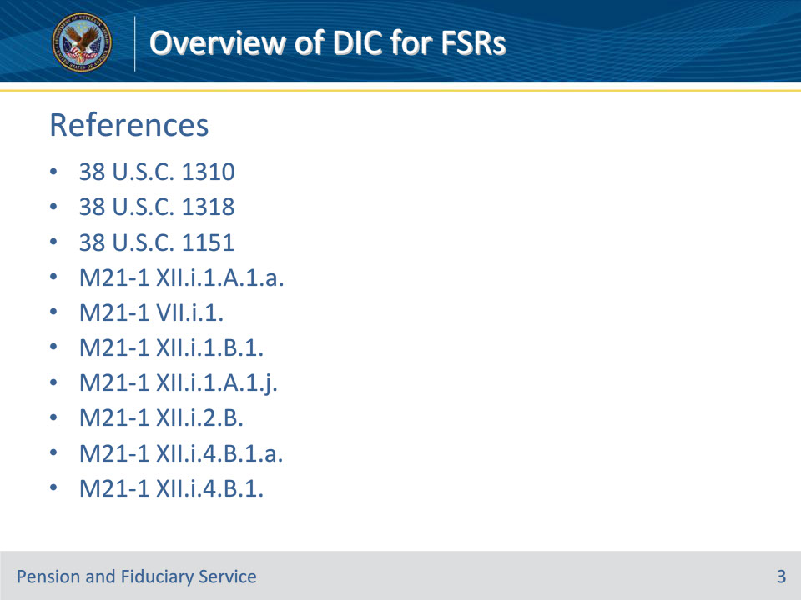
Slide notes

Instructor Notes:

These are the relevant references pertaining to this course:

• 38 U.S.C. 1310

• 38 U.S.C. 1318

• 38 U.S.C. 1151

• M21-1 XII.i.1.A.1.a.

• M21-1 VII.i.1.

• M21-1 XII.i.1.B.1.

• M21-1 XII.i.1.A.1.j.

• M21-1 XII.i.2.B.

• M21-1 XII.i.4.B.1.a.

• M21-1 XII.i.4.B.1.

Slide 4 - Definition
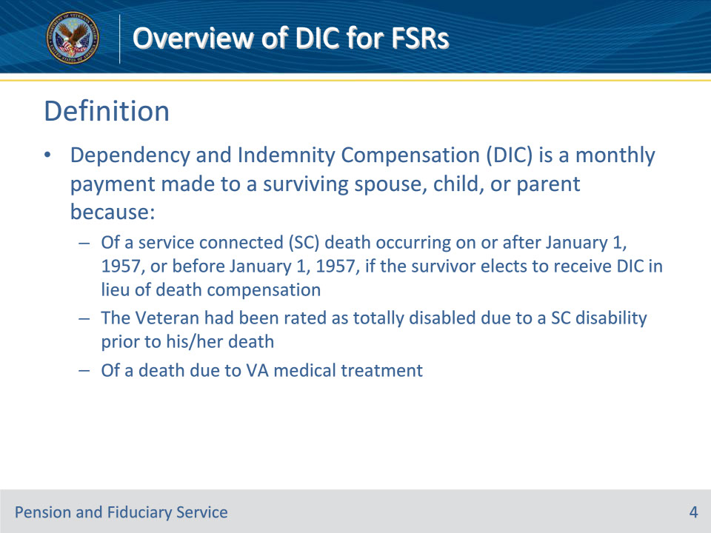
Slide notes

Policy Reference(s): M21-1 XII.i.1.A.1.a.

Instructor Notes:

• Dependency and Indemnity Compensation (DIC) is a monthly payment made to a surviving spouse, child, or parent because:

• Of a service connected (SC) death occurring on or after January 1, 1957 or before January 1, 1957 if the survivor elects to receive DIC in lieu of death compensation

• The Veteran had been rated as totally disabled due to a SC disability prior to his/her death

• Of a death due to VA medical treatment

Slide 5 - Relationship Requirements
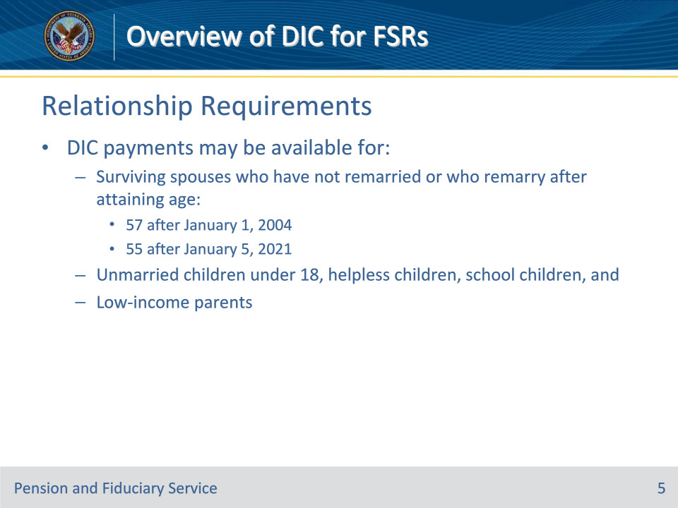
Slide notes

Policy Reference(s): M21-1 VII.i.1.

Instructor Notes:

• DIC payments may be available for:

• Surviving spouses who have not remarried or who remarry after attaining age

• 57 after January 1, 2004

• 55 after January 5, 2021

• Unmarried children under 18, helpless children, school children, and

• Low-income parents

Slide 6 - DIC under 38 U.S.C. 1310
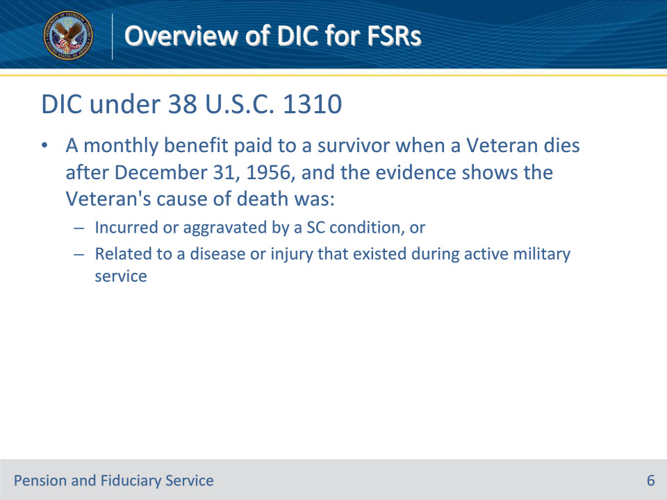
Slide notes

Policy Reference(s): 38 U.S. Code § 1310, M21-1 XII.i.1.B.1.

Instructor Notes:

• DIC under 38 USC 1310 is a monthly benefit paid to a survivor when a Veteran dies after December 31, 1956 and the evidence shows the Veteran’s cause of death was:

• Incurred or aggravated by a SC condition, or

• Related to a disease or injury that existed during active military service

Slide 7 - DIC under 38 U.S.C. 1318
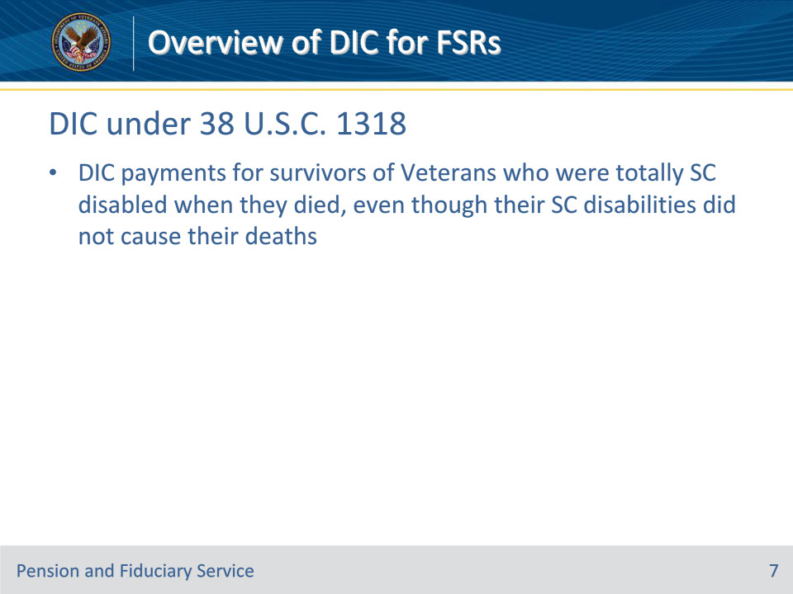
Slide notes

Policy Reference(s): M21-1 XII.i.1.B.1.

Instructor Notes:

DIC under 38 USC 1318 are monthly payments for survivors of Veterans who were totally SC disabled when they died, even though their SC disabilities did not cause their deaths

Slide 8 - DIC under 38 U.S.C. 1318 (Cont.)
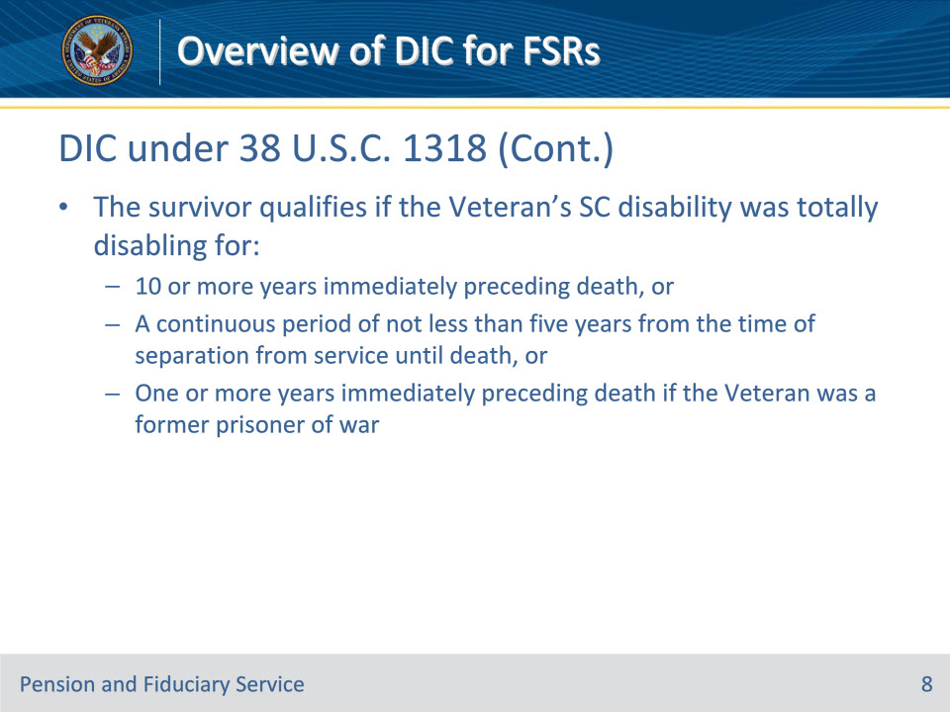
Slide notes

Policy Reference(s): M21-1 XII.i.1.B.1.

Instructor Notes:

• The survivor qualifies for DIC under 38 USC 1318 if the Veteran’s SC disability was totally disabling for:

• 10 or more years immediately preceding death, or

• A continuous period of not less than five years from the time of separation from service until death, or

• One or more years immediately preceding death if the Veteran was a former prisoner of war

Slide 9 - DIC under 38 U.S.C. 1151
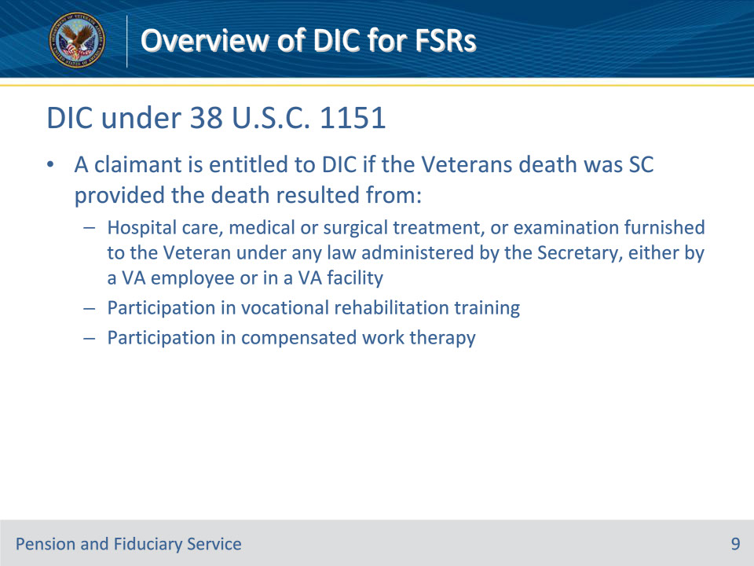
Slide notes

Policy Reference(s): M21-1 XII.i.1.A.1.j.

Instructor Notes:

• A claimant is entitled to DIC under 38 USC 1151 if the Veterans death was SC provided the death resulted from:

• Hospital care, medical or surgical treatment, or examination furnished to the Veteran under any law administered by the Secretary, either by a VA employee or in a VA facility,

• Participation in vocational rehabilitation training, or

• Participation in compensated work therapy

Slide 10 - Special Allowances
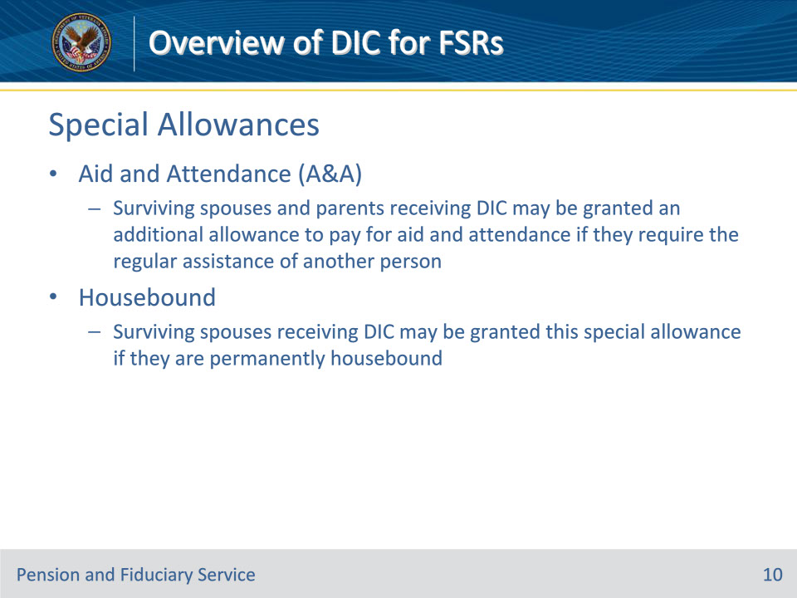
Slide notes

Policy Reference(s): M21-1 XII.i.2.B. M21-1 IX.ii.1.A.1.b. M-21-1 IX.ii.1.A.2.a.

Instructor Notes:

• Aid and Attendance (A&A)

• Surviving spouses and parents receiving DIC may be granted an additional allowance to pay for aid and attendance if they require the regular assistance of another person

• Housebound

• Surviving spouses receiving DIC may be granted this special allowance if they are permanently housebound

Slide 11 - Special Allowances (Cont. 1)
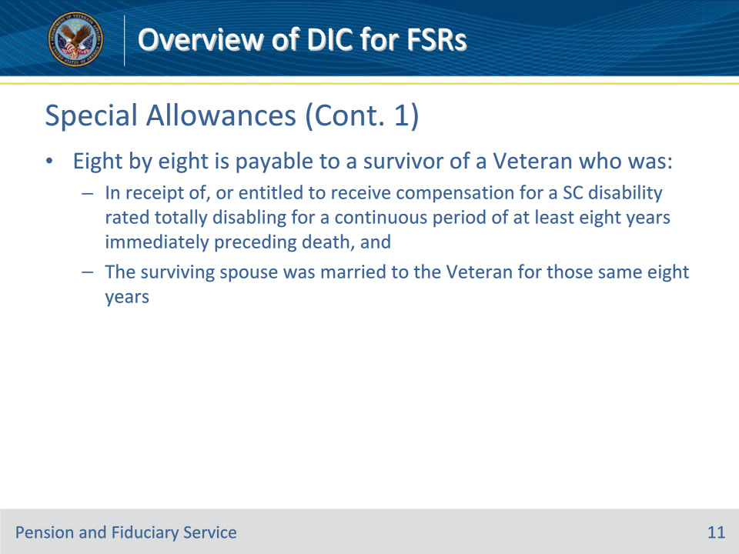
Slide notes

Policy Reference(s): M21-1 XII.i.4.B.1.a.

Instructor Notes:

For a Veteran who died on or after January 1, 1993, an additional monthly allowance is payable under 38 U.S.C. 1311(a)(2) if, at the time of the Veteran’s death,

• the Veteran was in receipt of, or entitled to receive, compensation for a service-connected (SC) disability rated totally disabling (including a rating based on individual unemployability) for a continuous period of at least eight years immediately preceding death, and

• the surviving spouse was married to the Veteran for those same eight years.

Important: Both requirements must be met in order to establish entitlement to this supplemental allowance.

Slide 12 - Special Allowances (Cont. 2)
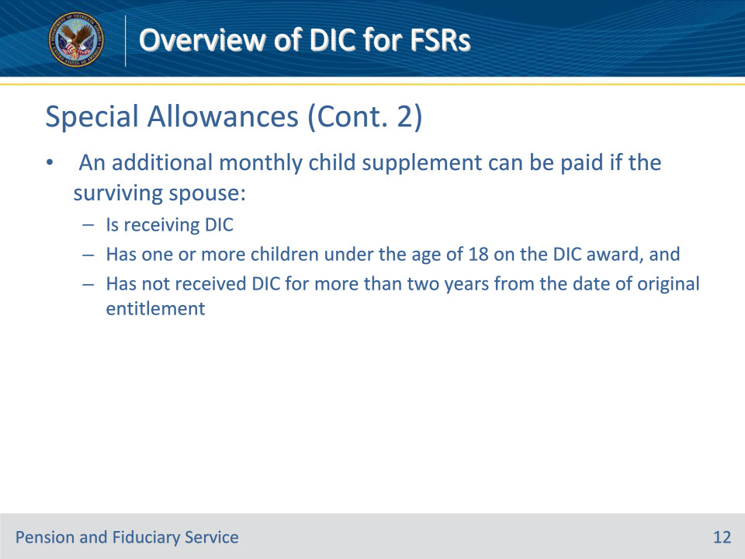
Slide notes

Policy Reference(s): M21-1 XII.i.4.B.1.

Instructor Notes:

A monthly child supplement will be paid in addition to the regular DIC payment if the surviving spouse:

• is receiving DIC

• has one of more children under the age of 18 on the DIC award, and

• has not received DIC for more than two years from the date of original entitlement to DIC

Note- the earliest date the monthly child supplement may be added to a DIC award is January 1, 2005, the first of the month after the date of enactment of PL 108-454

Slide 13 - Questions?
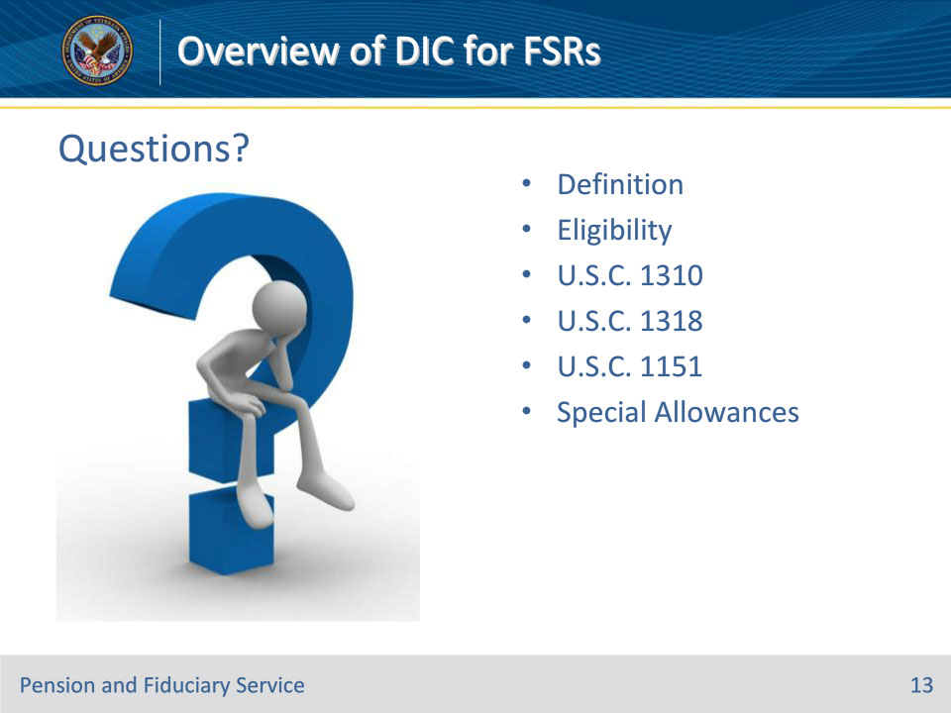
Slide notes

Instructor Notes:

(Recall) These are our learning objectives as stated from the beginning of the training:

• Define Dependency and Indemnity Compensation (DIC)

• Identify who is eligible for DIC

• Communicate the three types of DIC

• Recognize the types of special allowances available for DIC recipients

(Recap) We discussed each of these learning objectives through the following topics in each slide today:

• Definition

• Eligibility

• U.S.C. 1310

• U.S.C. 1318

• U.S.C. 1151

• Special Allowances

Are there any additional questions?

Slide 14 - TMS Survey
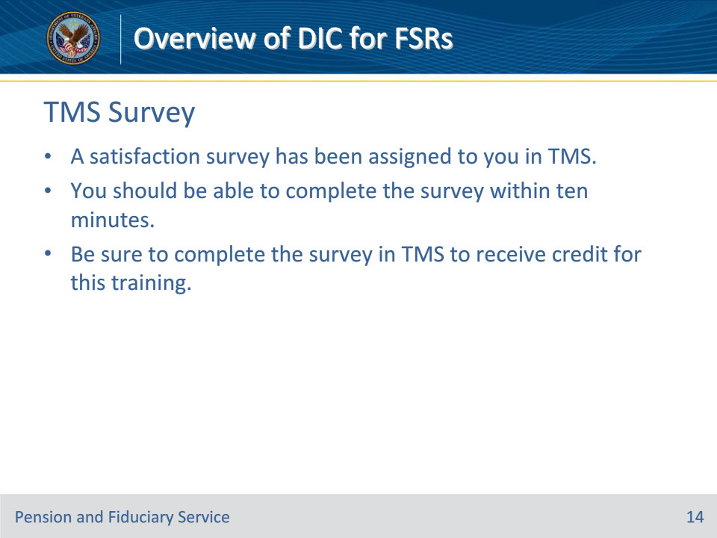
Slide notes

Instructor Notes:

A satisfaction survey has been assigned to you in TMS. You should be able to complete the survey within ten minutes. Completing the survey will allow you to receive credit for this training.

