Slide 1 - Introduction to Awards

Slide notes

Course Description:

This course teaches learners the basic information regarding the various types of awards that are processed by the fiduciary hub promulgation activity.

Slide 2 - Objectives
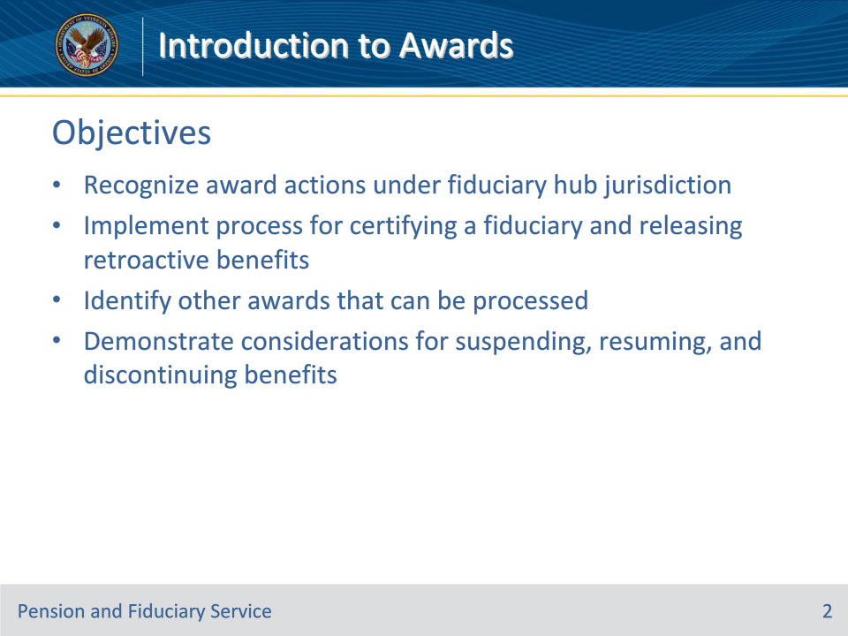
Slide notes

Instructor Notes:

At the end of this lesson, given the training and references, the learner will be able to do the following:

• Recognize award actions under fiduciary hub jurisdiction

• Implement process for certifying a fiduciary and releasing retroactive benefits

• Identify other awards that can be processed

• Demonstrate considerations for suspending, resuming, and discontinuing benefits

Slide 3 - References
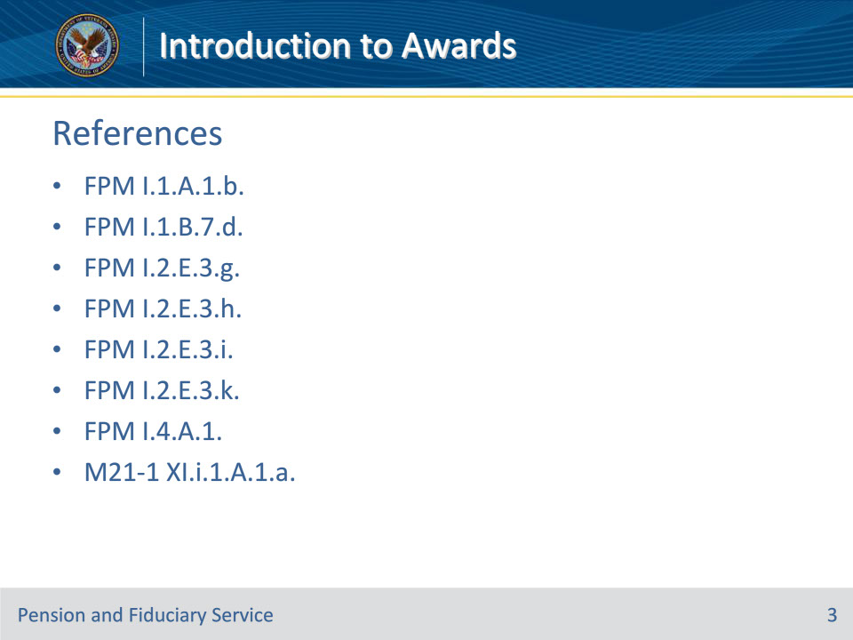
Slide notes

Instructor Notes:

These are the relevant references pertaining to this course:

• FPM I.1.A.1.b.

• FPM I.1.B.7.d.

• FPM I.2.E.3.g.

• FPM I.2.E.3.h.

• FPM I.2.E.3.i.

• FPM I.2.E.3.k.

• FPM I.4.A.1.

• M21-1 XI.i.1.A.1.a.

Slide 4 - Fiduciary Awards
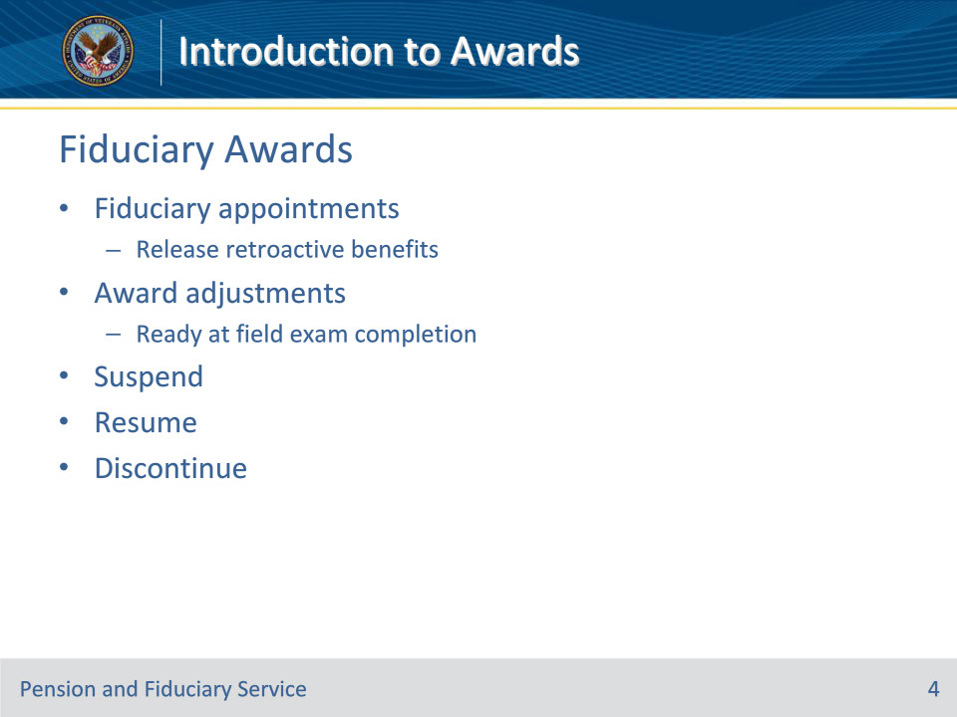
Slide notes

Policy Reference(s): FPM I.1.A.1.b.

Instructor Notes:

Fiduciary promulgation activity is responsible for the following award actions:

• processing fiduciary adjustments for all cases requiring a fiduciary appointment

• completing all award adjustments that are ready for decision at the time the field examination is being completed

Fiduciary promulgation activity has authority to suspend, resume, or discontinue benefit payments when action is identified as a result of a finding by the hub of jurisdiction.

Slide 5 - Releasing Retroactive Benefits
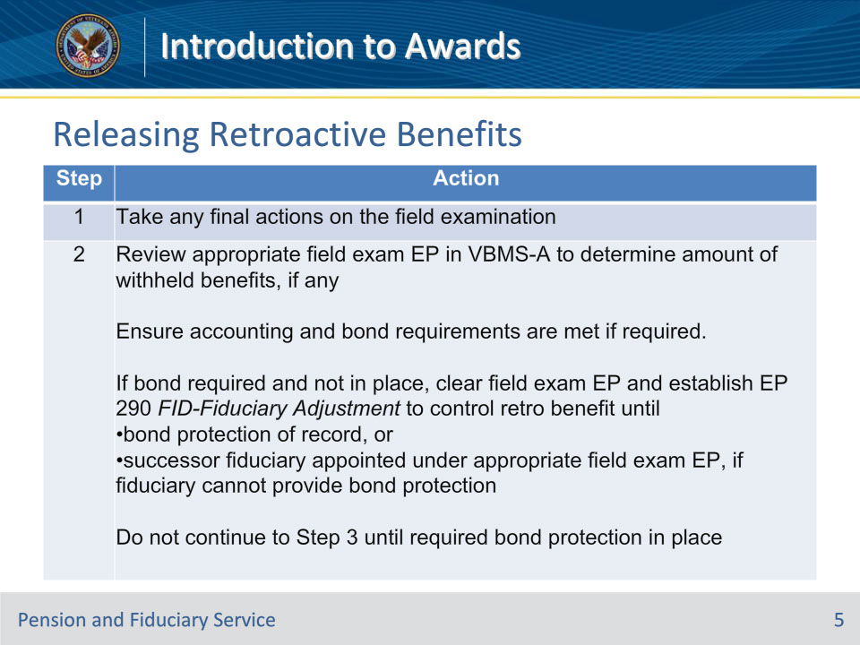
Slide notes

Policy Reference(s): FPM I.2.E.3.g.

Instructor Notes:

Follow the steps in this table when processing fiduciary adjustments following certification of a fiduciary.

Notes for Step 2:

• If the award is excluded from FSR processing, utilize a non-fiduciary program claim label to ensure the claim is routed to the appropriate station.

• The date of claim for the EP 290 with the FID-Fiduciary Adjustment claim label must be the date the field examination EP 590 is cleared, as these actions are completed sequentially on the same day

Slide 6 - Releasing Retroactive Benefits
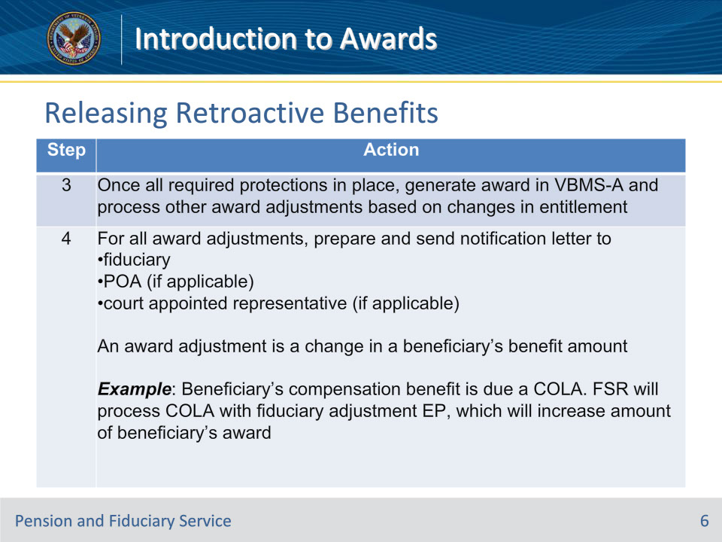
Slide notes

Policy Reference(s): FPM I.2.E.3.g.

Instructor Notes:

Follow the steps in this table when processing fiduciary adjustments following certification of a fiduciary.

Notes for Step 3:

• If development is required, the FSR will ensure the appropriate EP is established and ensure the claim is routed by NWQ.

• Award action is always required, even if no retroactive benefits are due.

• If a surety bond is not required, the award will be generated under the field examination EP. If a surety bond is required, the award will be generated under the EP 290 with the FID-Fiduciary Adjustment claim label once the surety bond is obtained.

• If an accounting is required, establish the necessary accounting EP and notify the fiduciary.

Slide 7 - Releasing Retroactive Benefits
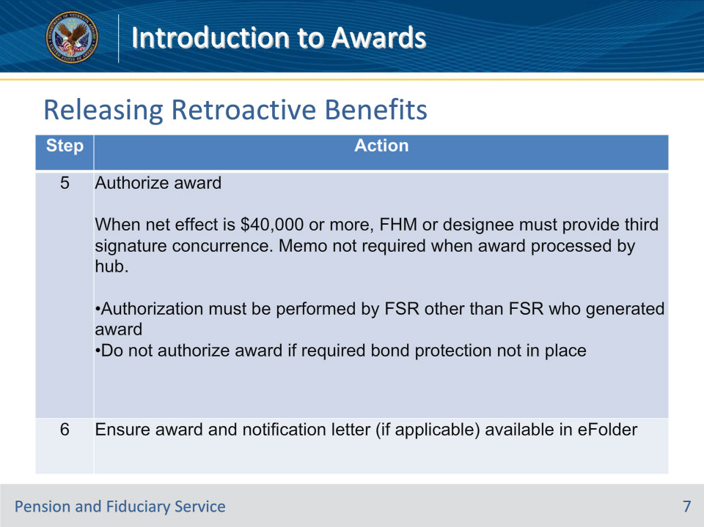
Slide notes

Policy Reference(s): FPM I.2.E.3.g.

Instructor Notes:

Follow the steps in this table when processing fiduciary adjustments following certification of a fiduciary.

Notes for Step 6:

• Following authorization of an award and a fiduciary IA, the promulgation activity must verify that VBMS updated the VA funds under management (FUM) within the beneficiary profile to reflect the amount of any retroactive VA payment released to the fiduciary. The requirement to update the FUM does not apply to SDP, SIAs, or any award adjustment that occurs outside of the initial field examination workflow.

Slide 8 - Accounting Award
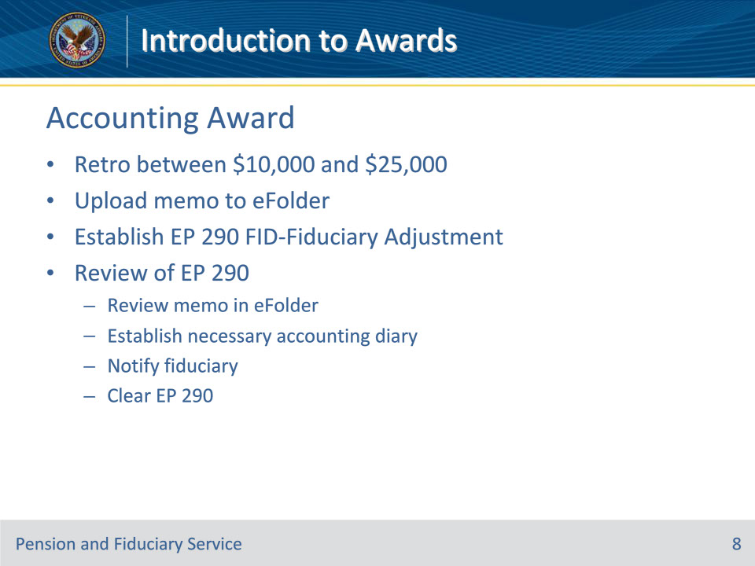
Slide notes

Policy Reference(s): FPM I.2.E.3.i.

Instructor Notes:

The RO authorization activity will complete the following actions on retroactive awards that are between $10,000 and $25,000:

• upload a memorandum into the eFolder, and

• establish an EP 290 with the FID-Fiduciary Adjustment claim label.

Upon establishment of this claim label, NWQ will route the EP to the appropriate hub for action.

Follow the steps below upon review of the EP 290.

1. Review the memo in the eFolder and determine the need for an accounting requirement.

2. If an accounting is required, then establish the necessary accounting diary date and notify the fiduciary.

3. Clear the EP 290.

Slide 9 - Other Award Adjustments
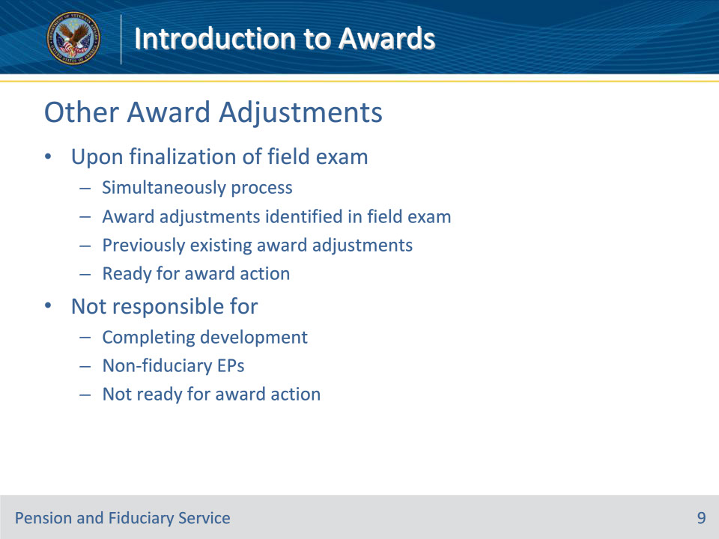
Slide notes

Policy Reference(s): FPM I.2.E.3.k.

Instructor Notes:

The FSR promulgating the retroactive benefit award may simultaneously process any additional award adjustments that are ready for award action upon finalization of the field examination. Award adjustments the FSR may process include:

• the award adjustments that were identified in the field examination, and

• any previously existing award adjustments that are ready for award action.

Hubs are not responsible for completing any development actions on non-fiduciary program EPs that are not ready for award action. In such cases where no further development is required and necessary time limits already afforded to the beneficiary have expired, hubs must ensure the corresponding EP(s) are updated to an Award status. When in an Open status, this should be accomplished by closing any active tracked items, as necessary.

Slide 10 - Competency Restoration
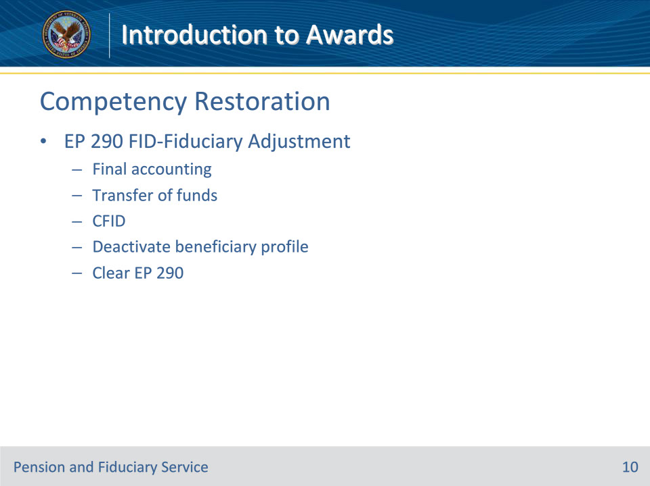
Slide notes

Policy Reference(s): FPM I.2.E.3.h.

Instructor Notes:

The hub has jurisdiction to complete restored competency ratings when the FE submits a Supervised Direct Pay Assessment for restored competency unless an exception applies.

For all other restored competency requests, the RO rating activity completes a final rating determination restoring ability to manage financial affairs and takes award action. The RO will establish an EP 290 with the FID-Fiduciary Adjustment claim label, and the NWQ will route the EP to the appropriate hub for action.

Upon review of the EP 290, the hub must follow the steps below:

1. Determine any needs for a final accounting and/or transfer of funds.

2. Complete a CFID in Share to pay the beneficiary directly.

3. Deactivate the beneficiary profile

4. Clear the EP 290.

• The hub must not deactivate the beneficiary profile until the

• final accounting is received and approved (if required), and

• beneficiary acknowledges receipt of all FUM.

• A new VA Form 21P-555 is not required to be completed for the removal of the beneficiary from the Fiduciary Program.

Slide 11 - Benefit Suspension
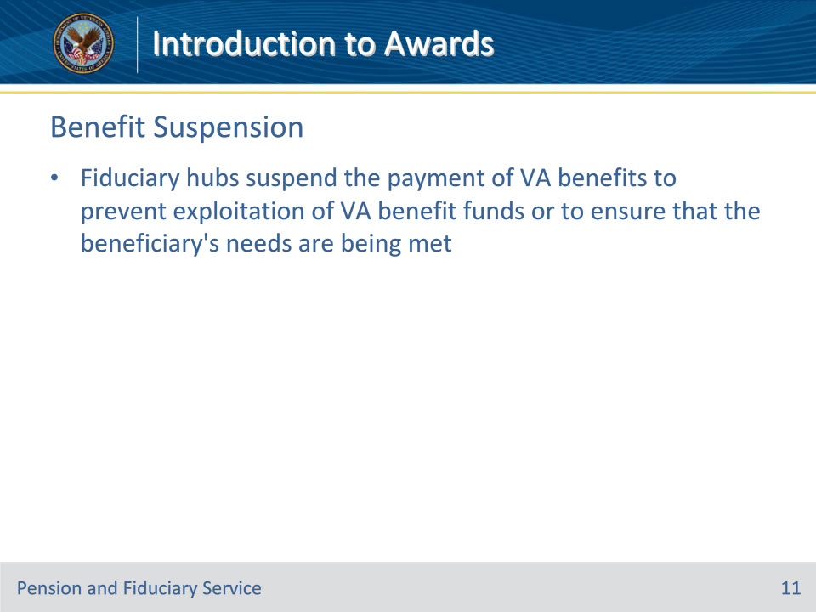
Slide notes

Policy Reference(s): FPM I.1.B.7.d.; FPM I.4.A.1.a.

Instructor Notes:

FSRs are responsible for suspending, resuming, or discontinuing benefit payments when action is identified as a result of a finding by the hub of jurisdiction.

Fiduciary hubs suspend the payment of VA benefits to prevent exploitation of VA benefit funds or to ensure that the beneficiary’s needs are being met.

To limit the adverse impact that may result from the temporary suspension of VA benefit payments, VA reserves suspension of VA benefit payments for rare cases in which VA has no other option to protect the beneficiary’s VA funds.

Slide 12 - Suspensions
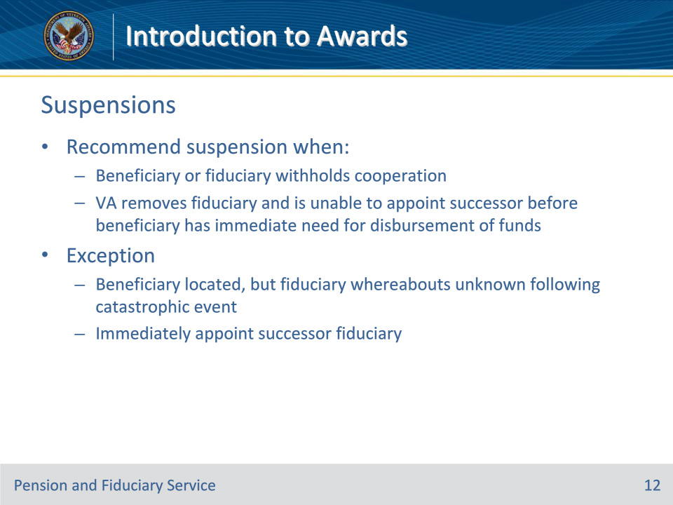
Slide notes

Policy Reference(s): FPM I.4.A.1.b.

Instructor Notes:

To limit the adverse impact that may result from the temporary suspension of VA benefit payments, VA reserves suspension of VA benefit payments for rare cases in which VA has no other option to protect the beneficiary’s VA funds.

The appropriate hub employee will recommend that a beneficiary’s VA benefits be temporarily suspended per 38 CFR 13.50 when

• the beneficiary or fiduciary withholds cooperation in any of the appointment and oversight procedures, specified in 38 CFR 13, or

• VA removes the beneficiary’s fiduciary for any reason prescribed in 38 CFR 13.500(b) and is unable to appoint a successor fiduciary before the beneficiary has an immediate need for disbursement of funds.

Exception: Fiduciary Hub Managers (FHMs) may not approve the suspension of VA benefits when a beneficiary has been located, but the fiduciary’s whereabouts are unknown following a catastrophic event. VA must instead act immediately to appoint a successor fiduciary.

Slide 13 - Withheld Cooperation
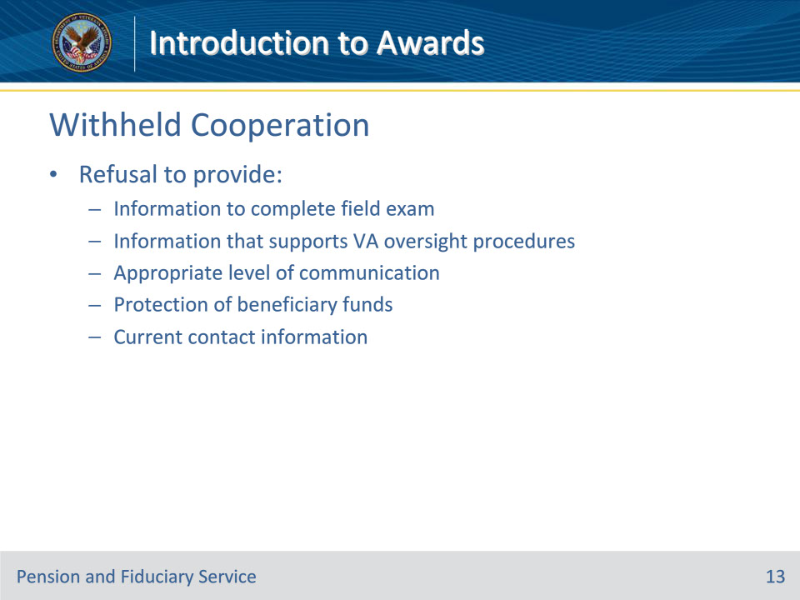
Slide notes

Policy Reference(s): FPM I.4.A.1.c.

Instructor Notes:

Hubs must suspend the payment of VA benefits to the beneficiary when the beneficiary or the beneficiary’s attorney, claims agent, or representative withholds cooperation in any of the appointment and oversight procedures.

Examples of a beneficiary or fiduciary withholding cooperation in appointment and oversight procedures may include, but are not limited to a refusal to provide

• information to complete a field examination

• information that supports VA oversight procedures

• appropriate level of communication

• protection of the beneficiary’s funds, or

• current contact information for the beneficiary and fiduciary to complete oversight activities.

Slide 14 - Due Diligence
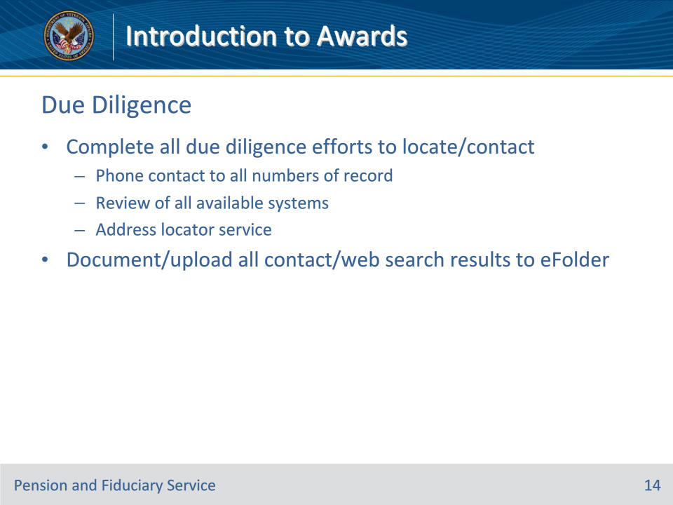
Slide notes

Policy Reference(s): FPM I.4.A.1.d.

Instructor Notes:

Hubs must complete all due diligence efforts to provide notice and communicate with the beneficiary and fiduciary to complete oversight activities.

Due diligence to locate and/or contact the beneficiary and/or fiduciary may include, but is not limited to

• telephone contact to all phone numbers of record for the beneficiary or fiduciary

• a review of all available systems, and

• an internet web address locator service.

Note: VA pays a fee that allows authorized users to access a web-based address locator service to search for a current mailing address for a beneficiary and/or fiduciary. Since VA typically authorizes a limited number of employees per regional office (RO) to utilize this service, employees may need to reach out to their local management to determine the RO’s authorized user(s) to assist in their search efforts.

Important: Document and upload all contact and/or web search results to the electronic claims folder (eFolder).

Slide 15 - Recommending Suspension
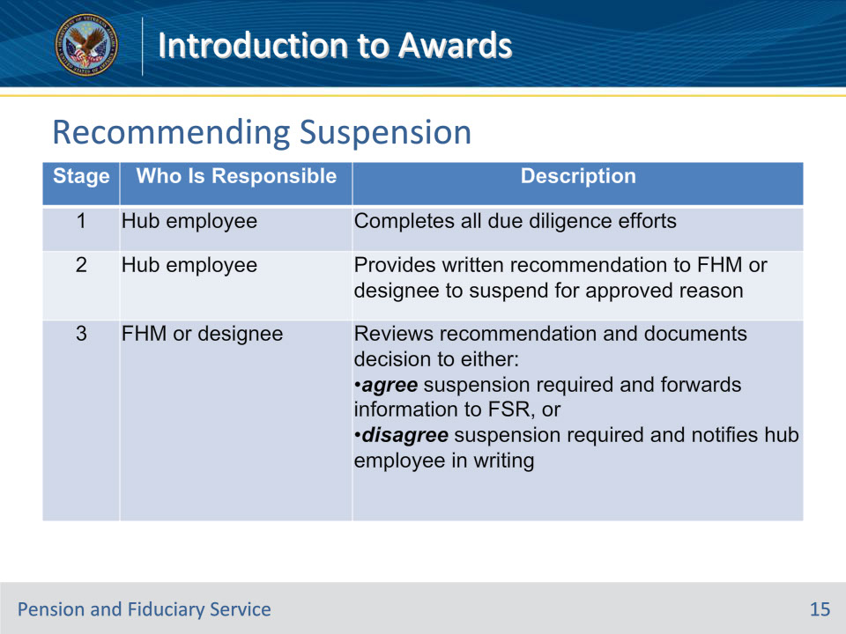
Slide notes

Policy Reference(s): FPM I.4.A.1.e.

Instructor Notes:

This table describes the process that hub personnel must follow to recommend a suspension of benefits.

Important: All correspondence related to the recommendation to suspend must be documented in VBMS and/or uploaded to the eFolder.

Slide 16 - Manual Suspension
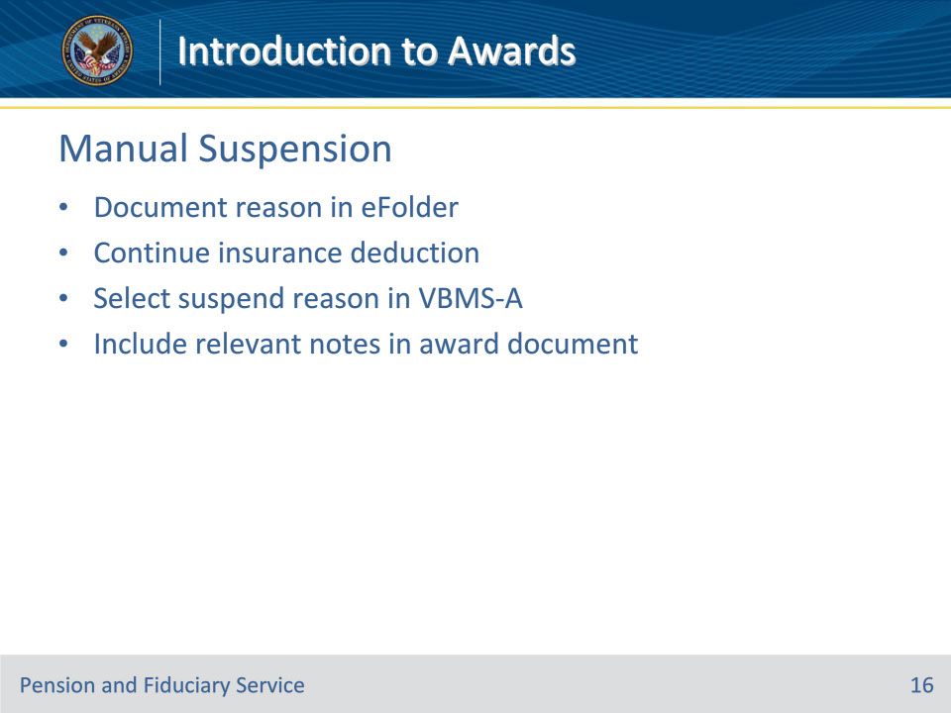
Slide notes

Policy Reference(s): FPM I.4.A.1.f.

Instructor Notes:

Upon completion of due diligence efforts, the hub must clearly document the reason for the suspension in the eFolder.

In compensation cases, take award action to continue the insurance deduction when there is a deduction for payment of

• National Service Life Insurance

• U.S. Government Life Insurance premiums

• Veterans Mortgage Life Insurance premiums, or

• insurance loan payments.

Select the appropriate suspend reason in VBMS-Awards and include any relevant notes in the award document.

Slide 17 - Catastrophic Event- Beneficiary
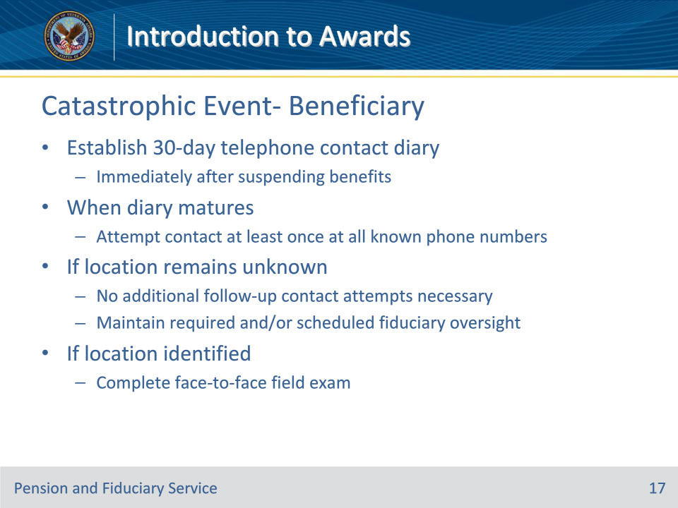
Slide notes

Policy Reference(s): FPM I.4.A.1.f.

Instructor Notes:

When the hub suspends the beneficiary’s benefit payments because the beneficiary cannot be located, and the beneficiary has been impacted by a catastrophic event, establish a 30-day telephone contact diary immediately after suspending benefits.

• When the diary matures, attempt to contact the beneficiary at least once at all known telephone numbers.

• If the beneficiary’s location remains unknown, no additional follow-up attempts to contact the beneficiary are necessary. However, the hub must maintain required and/or scheduled fiduciary oversight during the period in which the beneficiary’s whereabouts are unknown.

• If the beneficiary’s location is identified, complete a face-to-face field examination to assess the beneficiary’s situation.

Slide 18 - Automatic Suspension
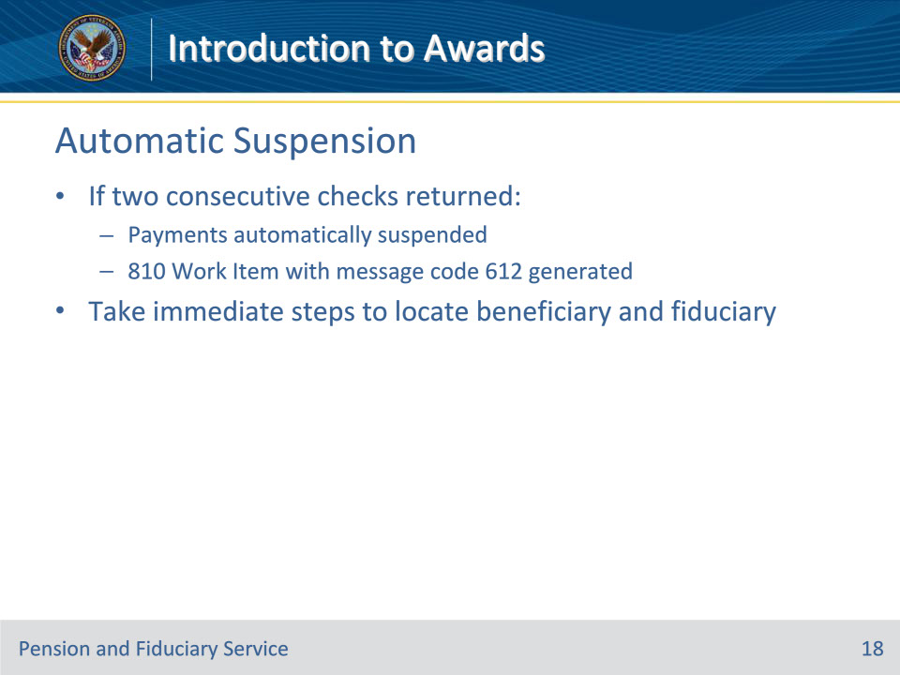
Slide notes

Policy Reference(s): FPM I.4.A.1.g.

Instructor Notes:

If two consecutive checks to a Veteran are returned indicating Whereabouts Unknown or Moved Left No Address, then

• payments are automatically suspended during processing of the returned check, and

• an 810 Work Item, Notice of Benefit Payment Transaction (810WI), is generated with message code 612, Account Suspended - Undeliverable Payment, as notification of the suspended payments.

The hub must take immediate steps to locate a beneficiary and the fiduciary in any situation where the hub discovers that an 810 Work Item, Notice of Benefit Payment Transaction (810WI), is generated with message code 612, Account Suspended - Undeliverable Payment.

Slide 19 - Resuming Award
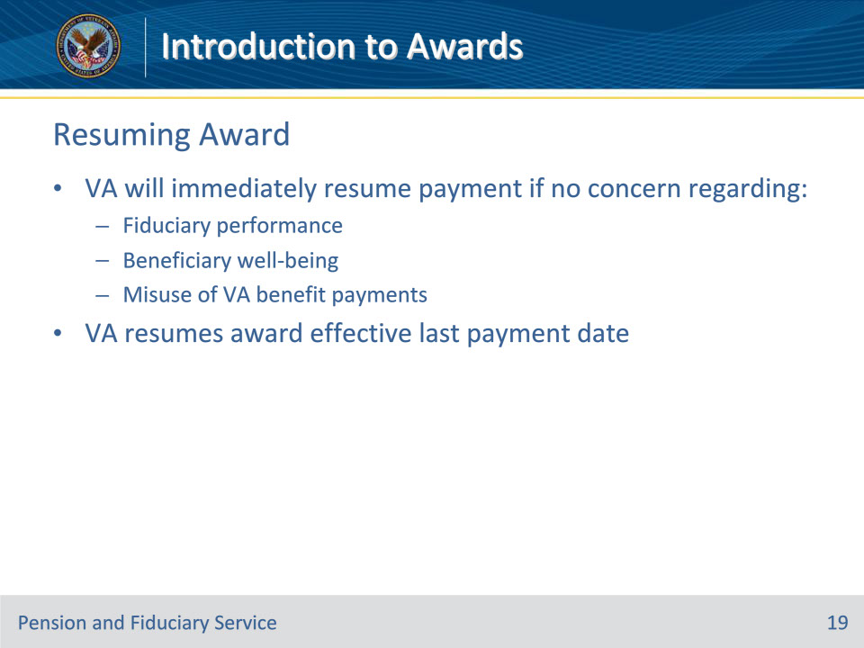
Slide notes

Policy Reference(s): FPM I.4.A.1.h.

Instructor Notes:

Upon appointment of a successor fiduciary or notification of cooperation by the fiduciary and/or beneficiary, VA will immediately resume payment of the award if there is no concern regarding the

• fiduciary’s performance

• beneficiary’s well-being, or

• misuse of VA benefit payments.

VA will resume the award effective the date of the last payment to the beneficiary.

Slide 20 - First Notice of Death
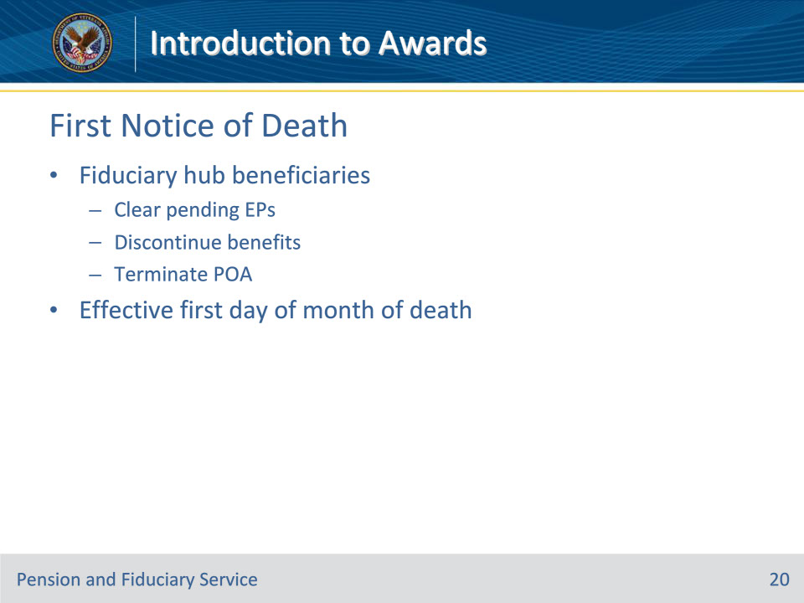
Slide notes

Policy Reference(s): M21-1 XI.i.1.A.1.a.

Instructor Notes:

Fiduciary promulgation activity will take applicable payment actions in situations involving first notice of death.

First Notice of Death (FNOD) processing establishes or updates a Beneficiary’s record with the date of the Beneficiary’s death. It also automatically

• clears and takes end product (EP) credit on any pending issues for compensation and pension benefits for beneficiaries that the Department of Veterans Affairs (VA) has not already authorized

• discontinues any benefits being paid, and

• terminates the power of attorney (POA) of record.

The FNOD process will discontinue an award as of the first day of the month of death (MOD).

More detailed guidance is provided in the FSR FNOD Training.

Slide 21 - 31. Questions?
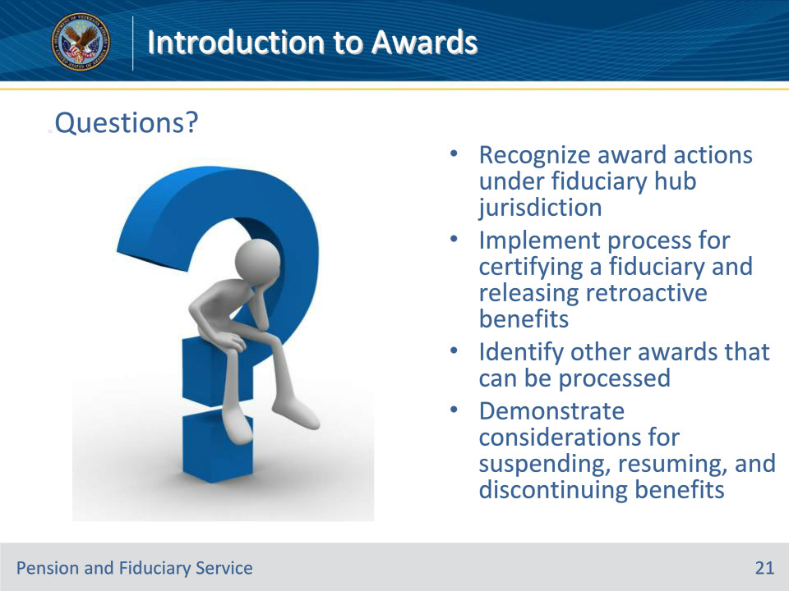
Slide notes

Instructor Notes:

(Recall) These are our learning objectives as stated from the beginning of the training:

• Recognize award actions under fiduciary hub jurisdiction

• Implement process for certifying a fiduciary and releasing retroactive benefits

• Identify other awards that can be processed

• Demonstrate considerations for suspending, resuming, and discontinuing benefits

Are there any additional questions?

Questions should be filtered through your QRT team. They will submit your questions to the Field Inquiry Tool (FIT) on your behalf.

Slide 22 - TMS Survey/Assessment
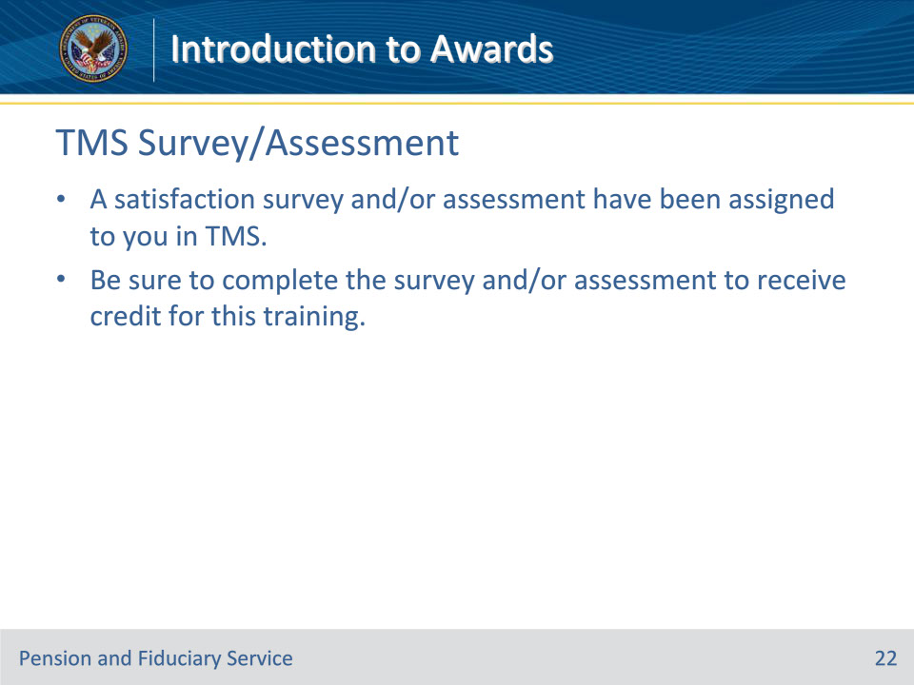
Slide notes

Instructor Notes

A satisfaction survey and/or assessment have been assigned to you in TMS.

Be sure to complete the survey and/or assessment to receive credit for this training.

