Slide 1 - Introduction to Notification Requirements
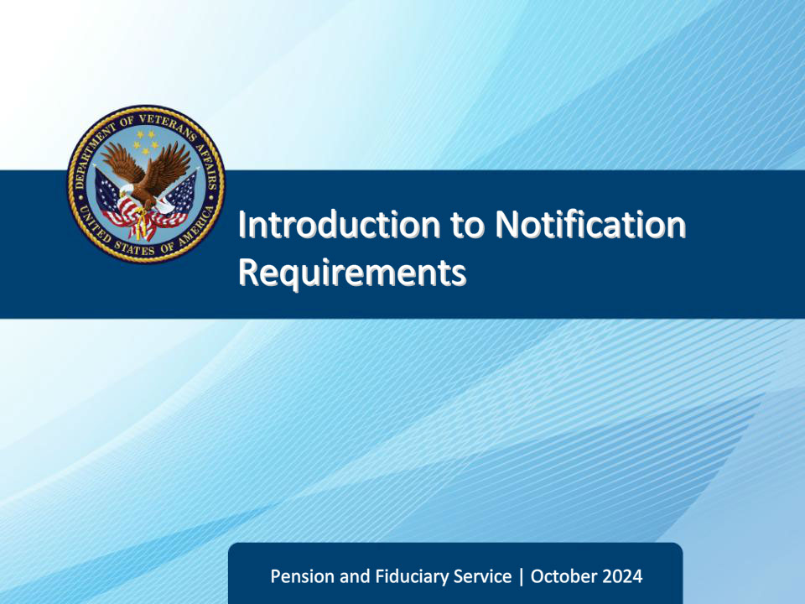
Slide notes

Course Description:

This course teaches learners an overview of the various notification requirements that FSRs are responsible for implementing.

Slide 2 - Objectives
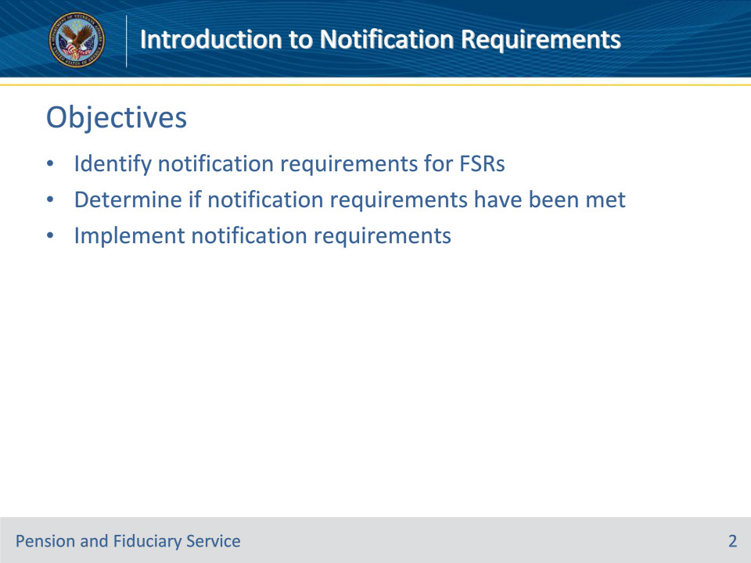
Slide notes

Instructor Notes:

At the end of this lesson, given the training and references, the learner will be able to do the following:

• Identify notification requirements for FSRs

• Determine if notification requirements have been met

• Implement notification requirements

Slide 3 - References
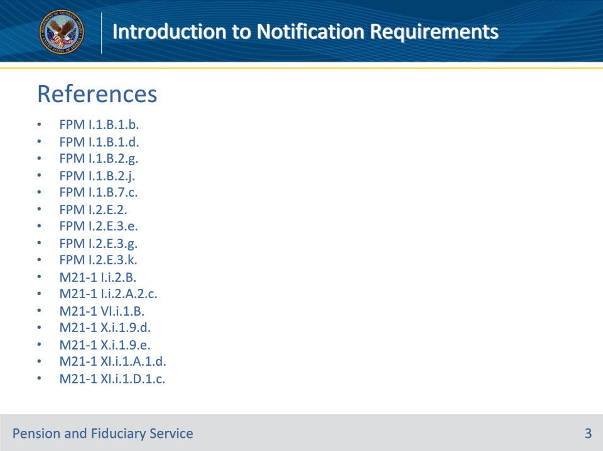
Slide notes

Instructor Notes:

These are the relevant references pertaining to this course:

• FPM I.1.B.1.b.

• FPM I.1.B.1.d.

• FPM I.1.B.2.g.

• FPM I.1.B.2.j.

• FPM I.1.B.7.c.

• FPM I.2.E.2.

• FPM I.2.E.3.e.

• FPM I.2.E.3.g.

• FPM I.2.E.3.k.

• M21-1 I.i.2.B.

• M21-1 I.i.2.A.2.c.

• M21-1 VI.i.1.B.

• M21-1 X.i.1.9.d.

• M21-1 X.i.1.9.e.

• M21-1 XI.i.1.A.1.d.

• M21-1 XI.i.1.D.1.c.

Slide 4 - Notifications
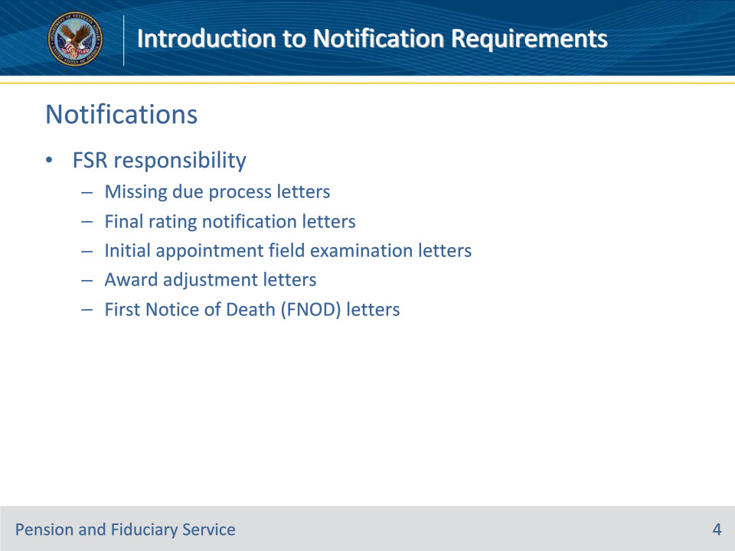
Slide notes

Policy Reference(s):

• FPM I.1.B.7.c.

• FPM I.2.E.2.

• FPM I.2.E.3.e.

• FPM I.2.E.3.g.

• M21-1 XI.i.1.A.1.d.

• M21-1 XI.i.1.D.1.c.

• FPM I.1.B.1.d.

• FPM I.1.B.2.g.

Instructor Notes:

As part of the Promulgation Team, FSRs have additional responsibilities. One of these responsibilities is generating and ensuring the sending of beneficiary and fiduciary notification letters.

Types of letters that FSRs may generate/mail:

• Missing due process letters

• Final rating notification letters

• Initial Appointment field examination letters

• Award adjustment letters

• FNOD letters

Slide 5 - Due Process Letters
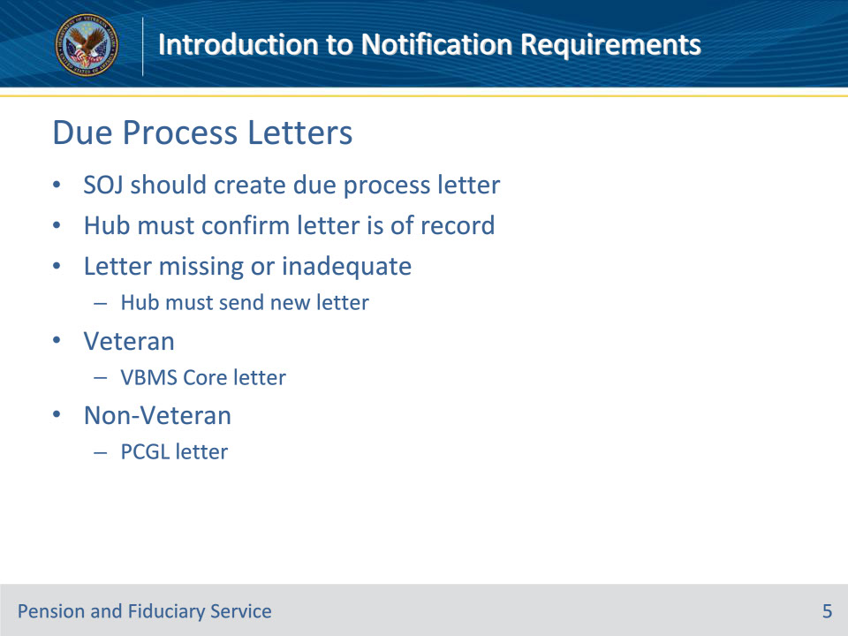
Slide notes

Policy Reference(s): FPM I.1.B.1.b., d.

Instructor Notes:

When the Department of Veterans Affairs (VA) makes a proposed determination of a beneficiary’s inability to manage VA benefits, the station of jurisdiction (SOJ) must notify the beneficiary of the proposed adverse action and its ramifications, and provide the beneficiary with the opportunity to

• submit additional evidence to contest the action, and

• hold a hearing before VA.

Upon completion of all actions associated with the proposal, the SOJ will establish an EP 590 which will be transferred to the fiduciary hub of jurisdiction.

Hubs must confirm that the due process notification letter is of record.

If the letter is not of record or is inadequate, the hub must send a new proposal of incompetency letter. For a:

• Veteran beneficiary, select the appropriate Veterans Benefits Management System (VBMS) Core letter, or

• non-Veteran beneficiary select the Personal Computer-Generate Letters (PCGL) predetermination incompetency template.

Additionally, update the system to ensure that the date of notification letter generation is correct.

Slide 6 - Final Rating Letters
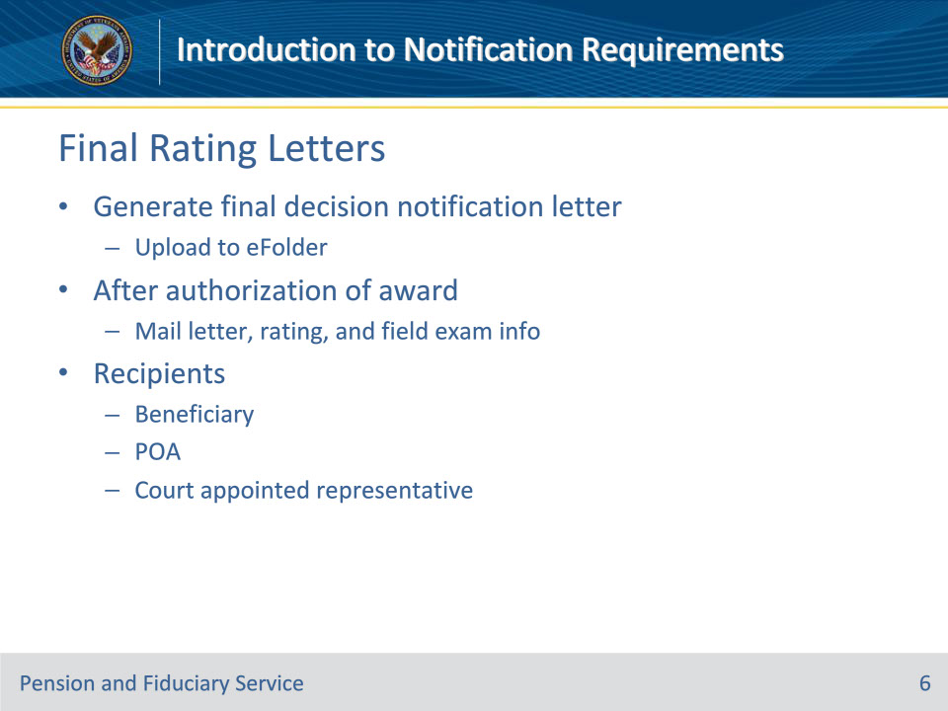
Slide notes

Policy Reference(s): FPM I.1.B.2.g.

Instructor Notes:

The hub finalizes the determination of the beneficiary’s inability to manage VA benefits and sends the final decision notification letter.

Generate the final decision notification letter and upload it to the eFolder.

After authorizing the award, the FSR should ensure the notification letter is uploaded in the eFolder and send the final notification decision, a copy of the rating, and the Fiduciary Program Field Examination information to the

• beneficiary

• power of attorney (POA) (if applicable), and

• court appointed representative (if applicable).

Slide 7 - Final Rating Letters
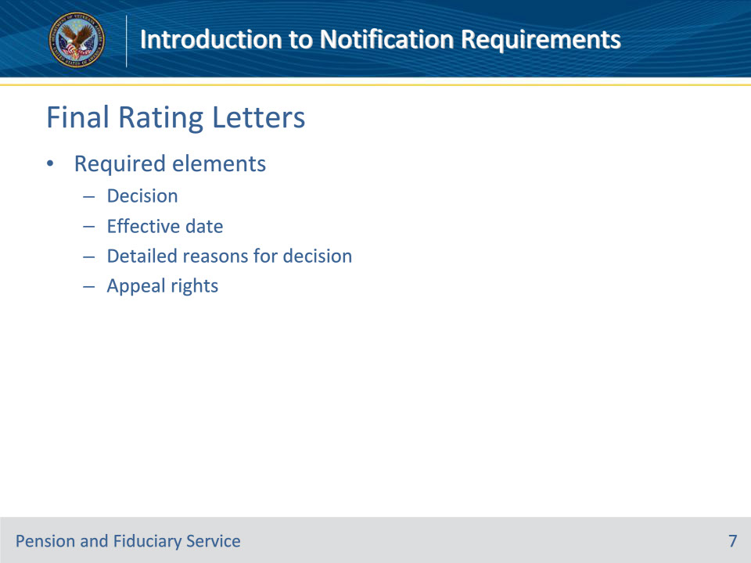
Slide notes

Policy Reference(s): FPM I.1.B.2.j.

Instructor Notes:

The final rating notification letter must advise the beneficiary of the

• decision

• effective date of the decision

• detailed reasons for the decision, and

• appeal rights.

Slide 8 - IA Field Exam Letters
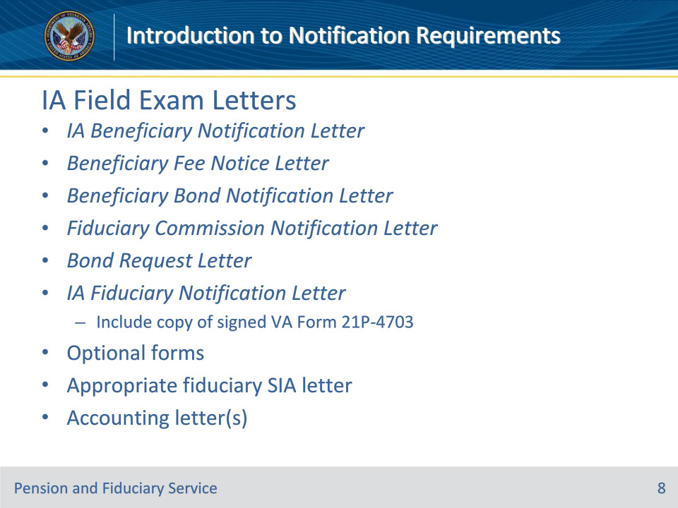
Slide notes

Policy Reference(s): FPM I.2.E.3.e.; FPM I.2.E.2.a., b.

Instructor Notes:

Hub personnel finalizing the field examination will generate and release notification letters with the required forms as confirmation of appointment, expenses and fiduciary policy. Hub personnel are responsible for ensuring letters are provided to the intended recipient with accurate and appropriate information.

Hubs must generate letters associated with field examinations using the templates available in VBMS, unless otherwise specified. The letters available in the system contain sufficient language to fulfill notification requirements. Letters may not be altered except to add information specific to the case.

These are the required notification letters and attachments for IA field exams:

• IA Beneficiary Notification Letter, with a copy to the power of attorney (POA) and/or court-appointed guardian, if applicable.

• Beneficiary Fee Notice Letter, if applicable.

• Beneficiary Bond Notification Letter, if applicable.

• Fiduciary Commission Notification Letter, if applicable.

• Bond Request Letter to the fiduciary, if applicable.

• Certified Court Accounting Due Letter, if applicable.

• IA Fiduciary Notification Letter to the fiduciary, if applicable, including a copy of a signed VA Form 21P-4703.

• Optional forms to attach include a VA Form 21P-4718a and a Standard Form (SF) 1199A, Direct Deposit Sign-Up Form.

For SIA’s, the requirements are the same with the following additional requirements:

• The appropriate fiduciary SIA letter to the previous fiduciary, including accounting forms if a final accounting is required. A copy of the letter is sent to the new fiduciary. Also, send a Beneficiary Bond letter to the new fiduciary, if applicable.

Slide 9 - Award Adjustment Letters
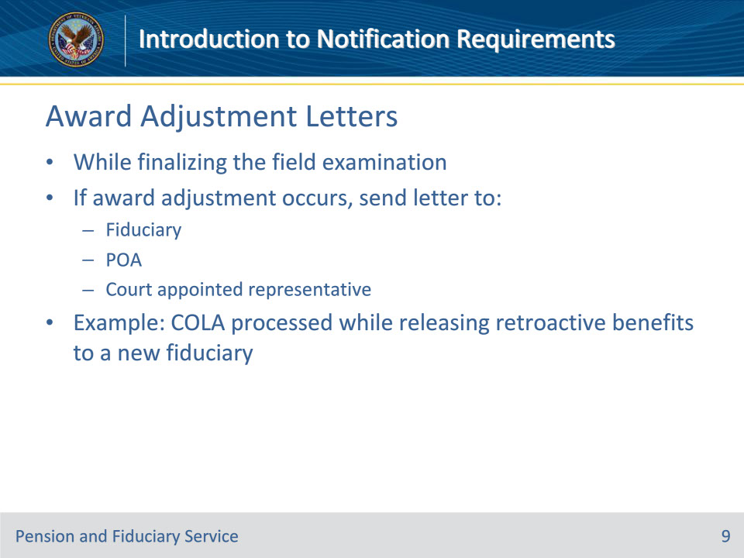
Slide notes

Policy Reference(s): FPM I.2.E.3.k., g.

Instructor Notes:

The FSR promulgating the retroactive benefit award may simultaneously process any additional award adjustments that are ready for award action upon finalization of the field examination.

For all award adjustments, prepare and send a notification letter to the

• fiduciary

• POA (if applicable), and

• court appointed representative (if applicable).

An award adjustment is a change in a beneficiary’s benefit amount.

Example: A beneficiary’s compensation benefit is due a cost-of-living adjustment (COLA). The FSR will process the COLA with the fiduciary adjustment EP, which will increase the amount of the beneficiary’s award.

Slide 10 - FNOD Letters
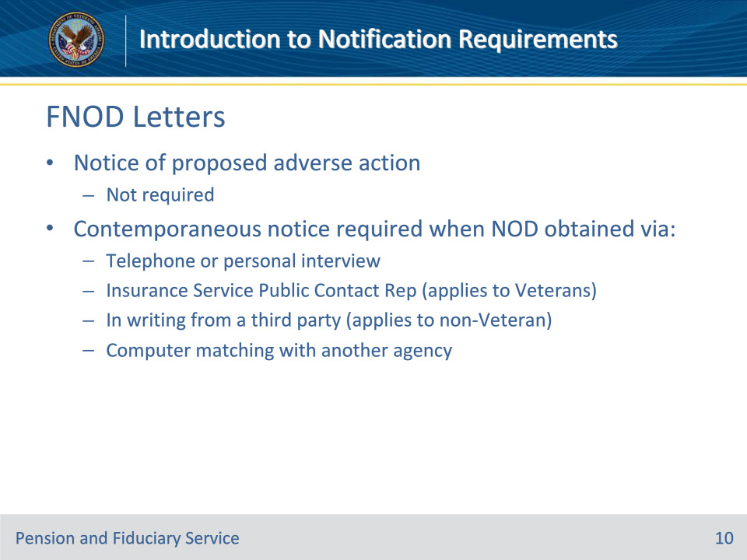
Slide notes

Policy Reference(s): M21-1 XI.i.1.A.1.d.; M21-1 XI.i.1.D.1.c.

Instructor Notes:

In most cases, VA must issue notice of proposed adverse action (due process) to a beneficiary before reducing or discontinuing their benefits. The discontinuation of benefits based on receipt of an acceptable NOD is one of the exceptions to this rule.

Although notice of proposed adverse action is not required, contemporaneous notice of the action taken is required if the NOD was obtained

• by way of telephone or personal interview

• from an Insurance Service Public Contact Representative (applies to Veterans only)

• in writing from a third party (applies to non-Veteran)

• through computer matching with another Federal agency, such as the Social Security Administration (SSA).

The specific procedures for processing FNODs is covered in greater detail in the First Notice of Death FSR Training.

Slide 11 - Power of Attorney
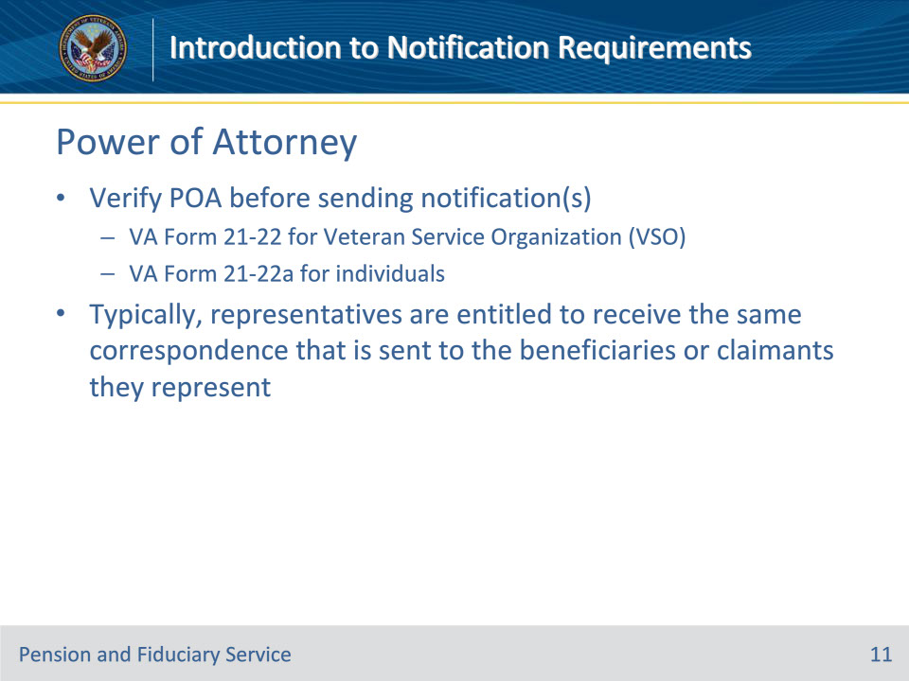
Slide notes

Policy Reference(s): M21-1 VI.i.1.B.; M21-1 I.i.2.B.; M21-1 I.i.2.A.2.c.

Instructor Notes:

• Verify POA before sending notification(s)

• VA Form 21-22 for Veteran Service Organization (VSO)

• VA Form 21-22a for individuals

• Typically, representatives are entitled to receive the same correspondence that is sent to the beneficiaries or claimants they represent

Slide 12 - Visually Impaired
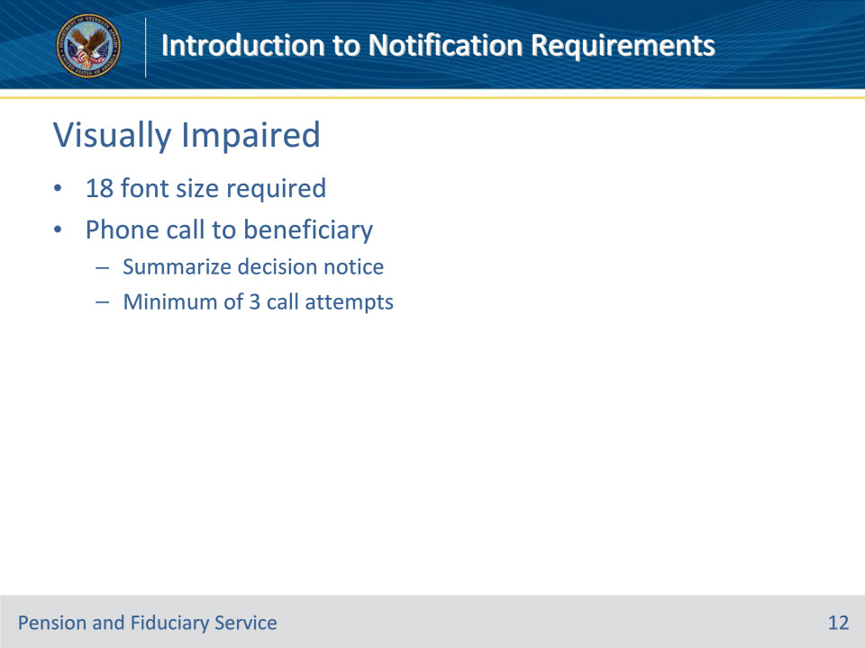
Slide notes

Policy Reference(s): M21-1 X.i.1.9.d.; M21-1 X.i.1.9.e.

Instructor Notes:

18 font size is required when preparing written correspondence for a visually impaired beneficiary.

A minimum of 3 phone call attempts must be made to a visually impaired beneficiary to summarize a decision notice being sent via US Mail.

Slide 13 - 31. Questions?
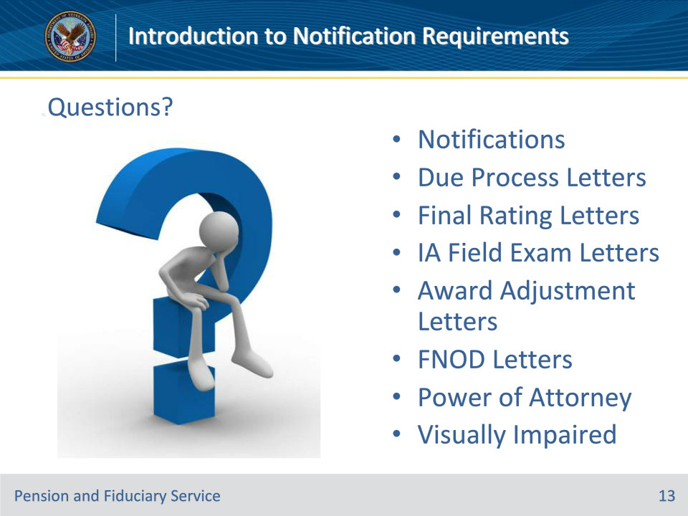
Slide notes

Instructor Notes:

(Recall) These are our learning objectives as stated from the beginning of the training:

• Identify notification requirements for FSRs

• Determine if notification requirements have been met

• Implement notification requirements

(Recap) We discussed each of these learning objectives through the following topics in each slide today:

• Notifications

• Due Process Letters

• Final Rating Letters

• IA Field Exam Letters

• Award Adjustment Letters

• FNOD Letters

• Power of Attorney

• Visually Impaired

Are there any additional questions?

Questions should be filtered through your QRT team. They will submit your questions to the Field Inquiry Tool (FIT) on your behalf.

Slide 14 - TMS Survey/Assessment
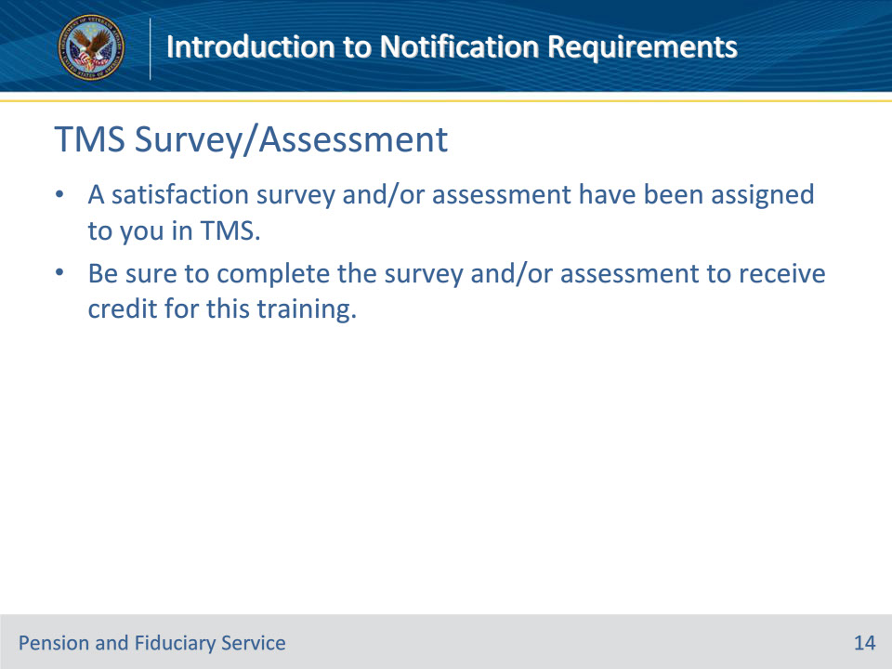
Slide notes

Instructor Notes

A satisfaction survey and/or assessment have been assigned to you in TMS.

Be sure to complete the survey and/or assessment to receive credit for this training.

