Slide 1 - Generating Awards for FSRs
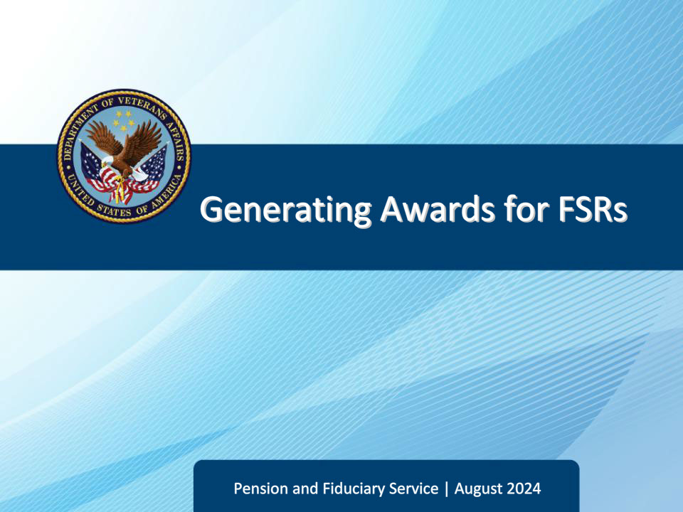
Slide notes

Course Description:

This course teaches learners an overview of how to generate awards using the VBMS-A application.

Slide 2 - Objectives
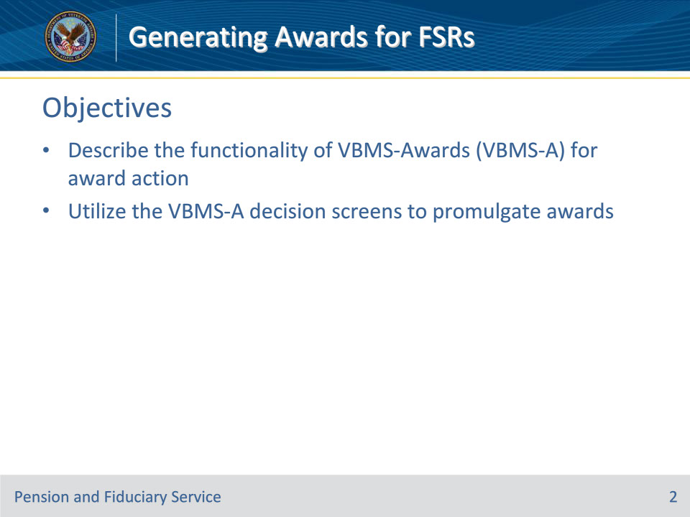
Slide notes

Instructor Notes:

At the end of this lesson, given the training and references, the learner will be able to do the following:

• Describe the functionality of VBMS-Awards (VBMS-A) for award action

• Utilize the VBMS-A decision screens to promulgate awards

Slide 3 - References
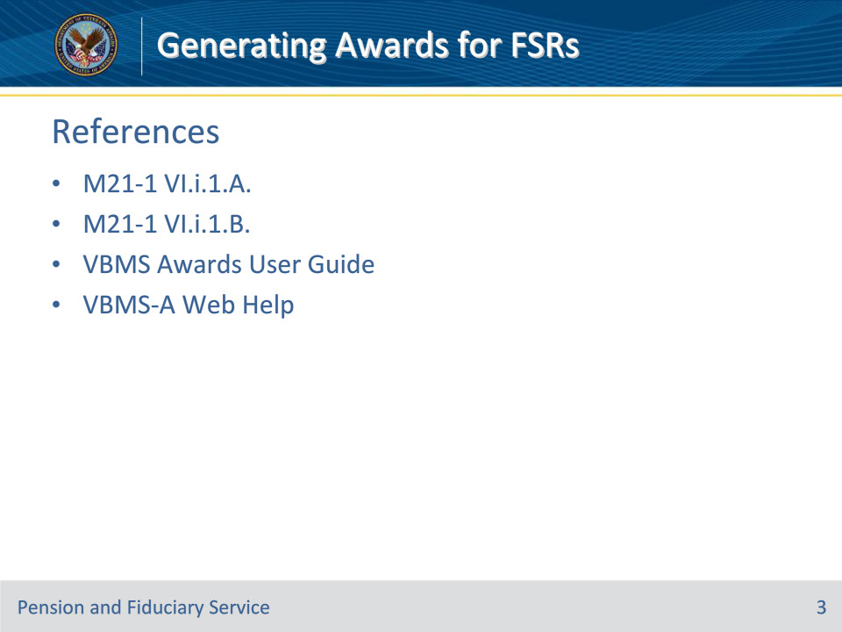
Slide notes

Instructor Notes:

These are the relevant references pertaining to this course:

• M21-1, Part VI.i.1.A. Decision Authorization

• M21-1, Part VI.i.1.B. Decision Notices

• VBMS Awards User Guide

• VBMS-A Web Help

Slide 4 - VBMS-A Functionality
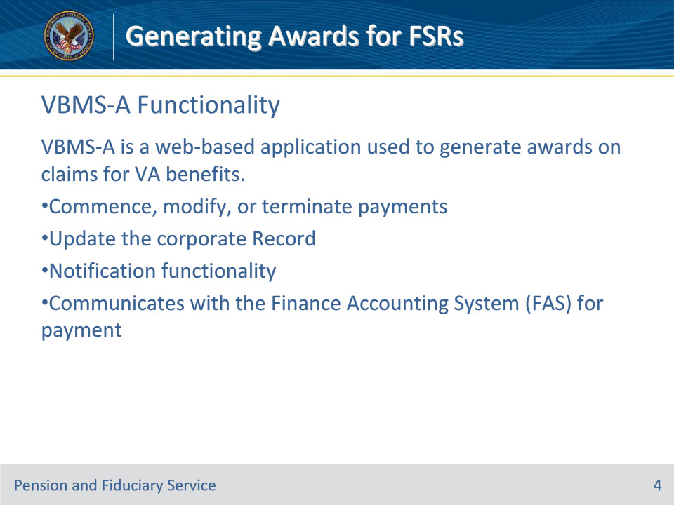
Slide notes

Instructor Notes:

VBMS-A is a web-based application used to generate awards on claims for VA benefits.

Its main uses are:

• Commence, modify, or terminate payments

• Update the corporate Record

• Notification functionality

• Communicates with the Finance Accounting System (FAS) for payment

Note to instructor: The content for the remainder of this training is housed within the slides themselves and the content in each slide should also be demonstrated to the class in VBMS-A to the extent possible.

Slide 5 - Home Page
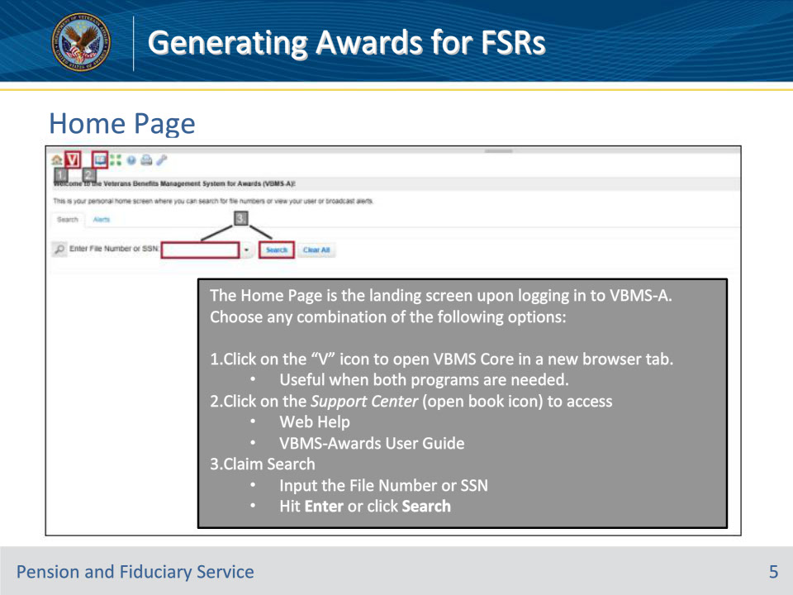
Slide notes

Instructor Actions: Demonstrate the information from the slide in VBMS-A.

Slide 6 - Web Help and User Guide
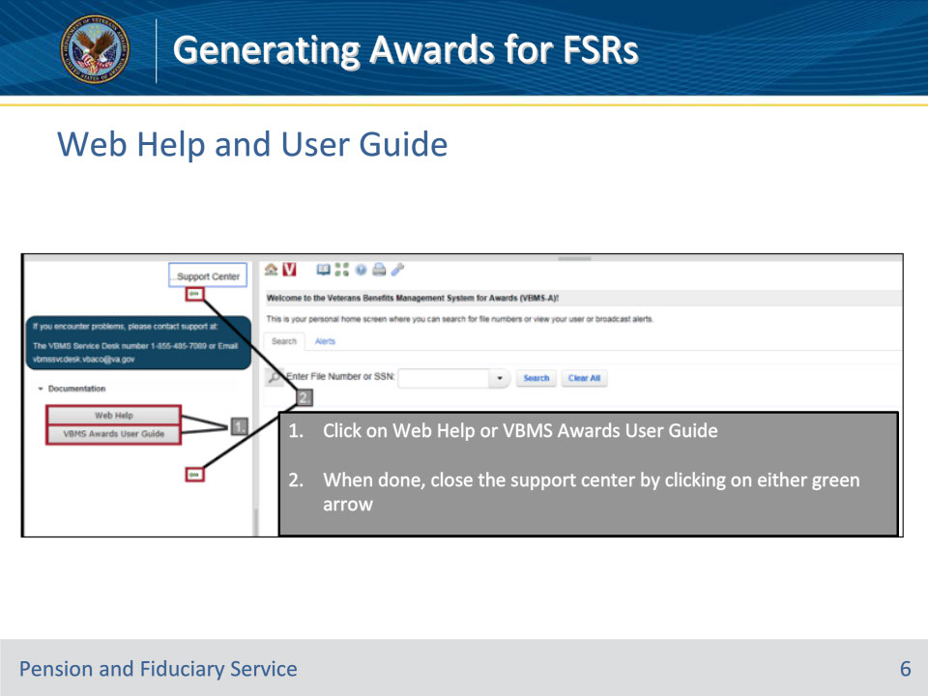
Slide notes

Instructor Actions: Demonstrate the information from the slide in VBMS-A.

Slide 7 - Web Help and User Guide (Cont.)
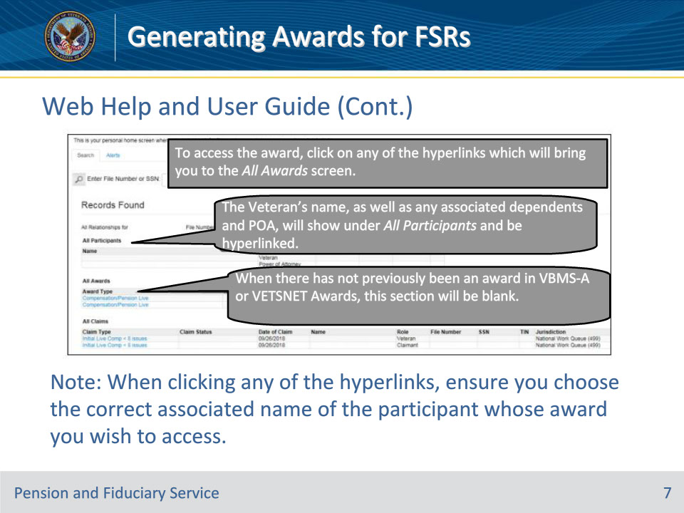
Slide notes

Instructor Actions: Demonstrate the information from the slide in VBMS-A.

Slide 8 - All Awards Screen
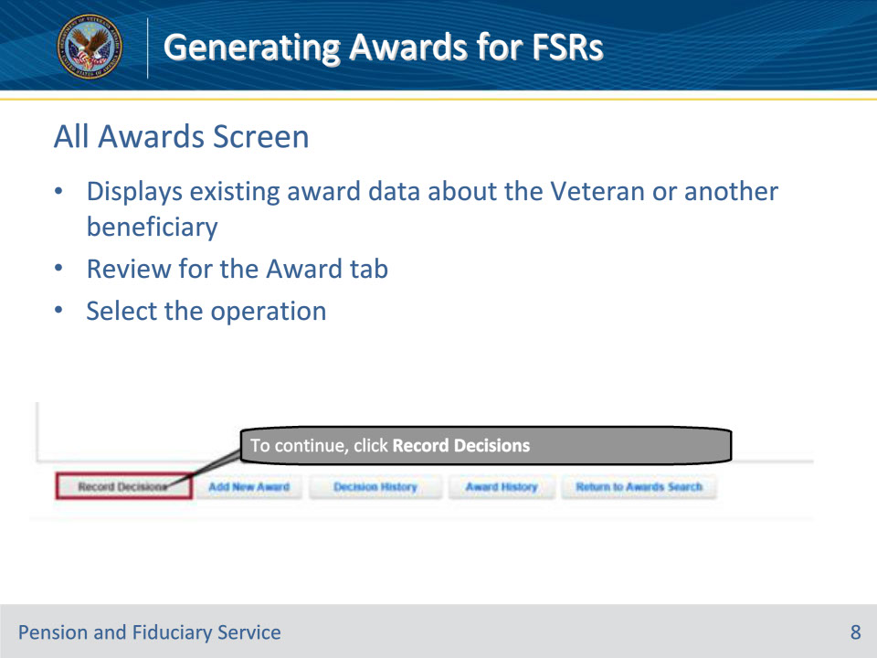
Slide notes

Instructor Actions: Demonstrate the information from the slide in VBMS-A.

Slide 9 - Record Decisions Screen
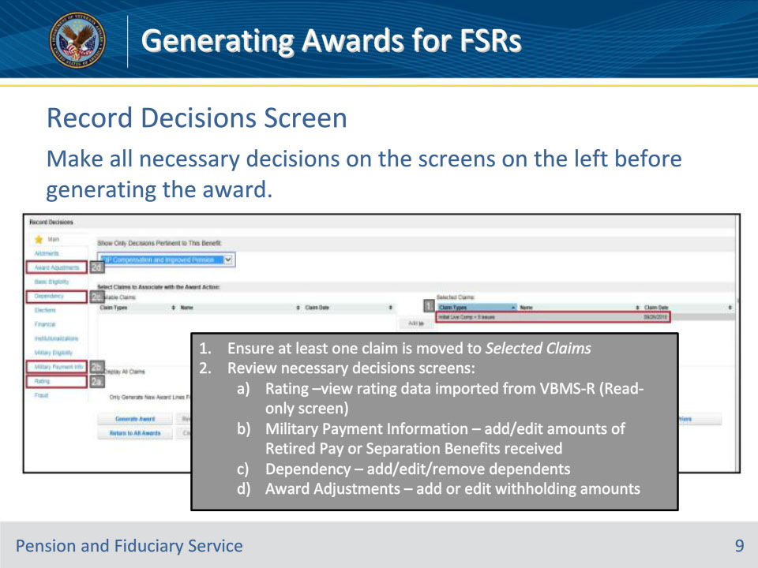
Slide notes

Instructor Actions: Demonstrate the information from the slide in VBMS-A.

Slide 10 - Award Generation
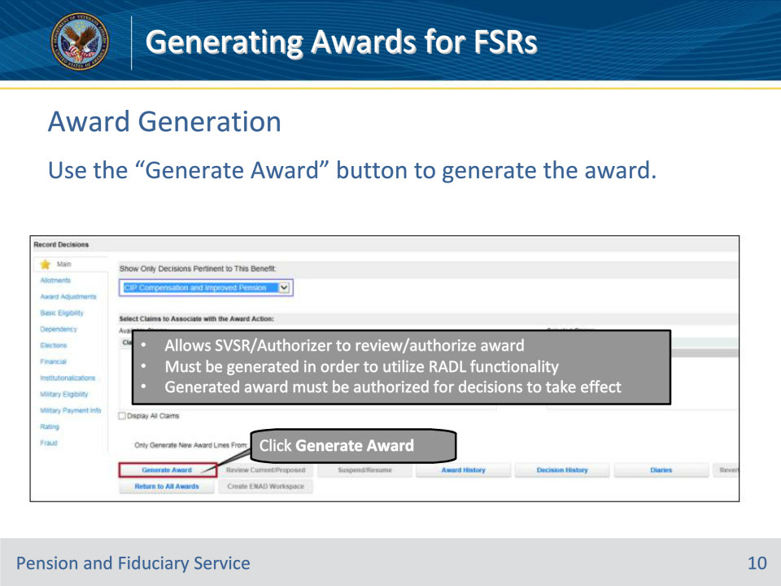
Slide notes

Instructor Actions: Demonstrate the information from the slide in VBMS-A.

RADL stands for Redesigned Automated Decision Letter. RADL automatically generates letters based on Decision inputs in VBMS-R and VBMS-A.

Slide 11 - Payment Address Verification
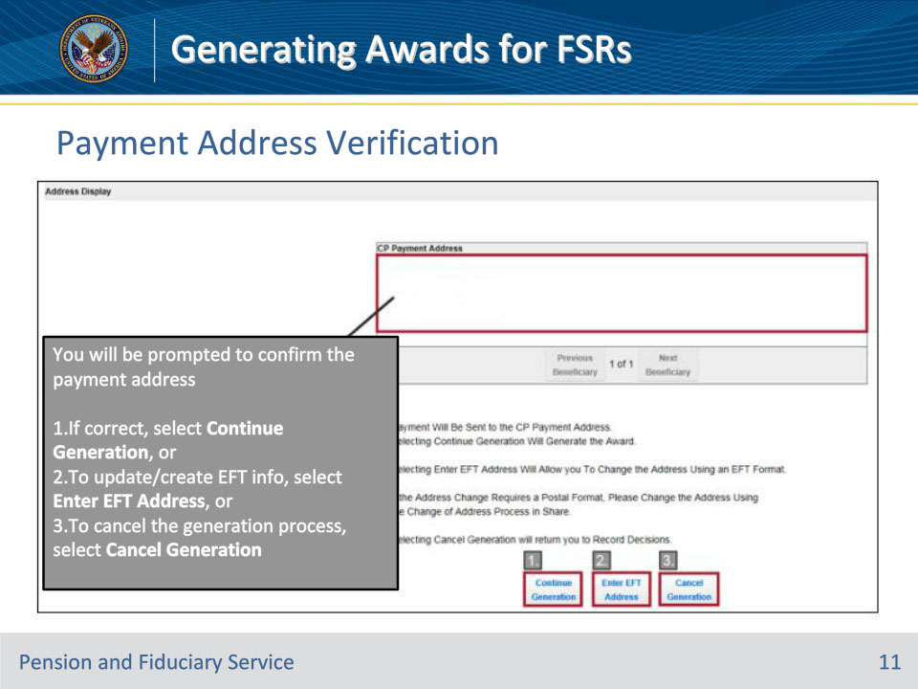
Slide notes

Instructor Actions: Demonstrate the information from the slide in VBMS-A.

Slide 12 - Current/Proposed Screen
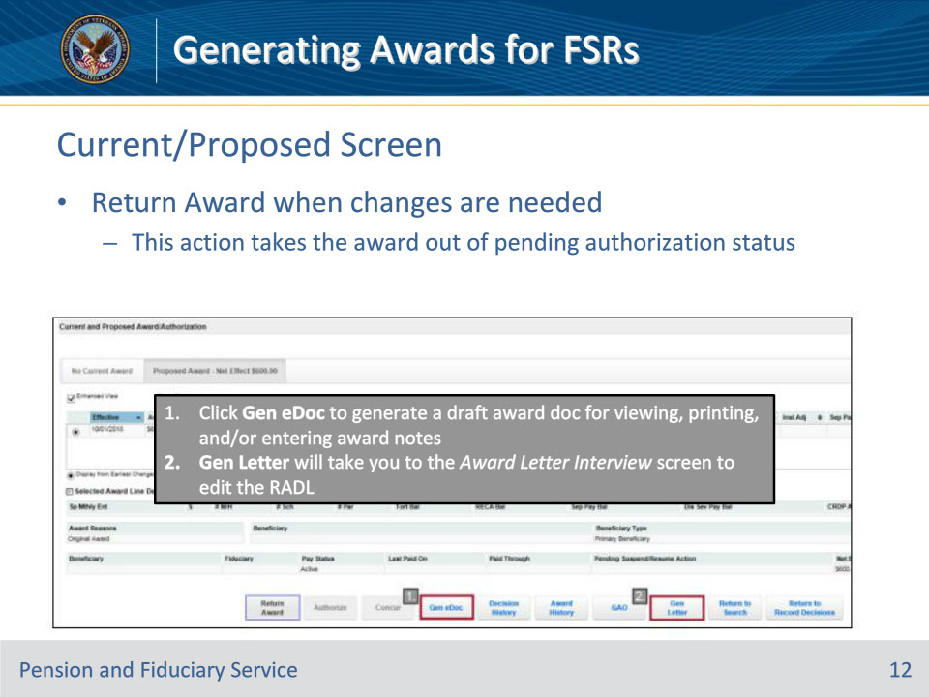
Slide notes

Instructor Actions: Demonstrate the information from the slide in VBMS-A.

Slide 13 - Audit Error Worksheets
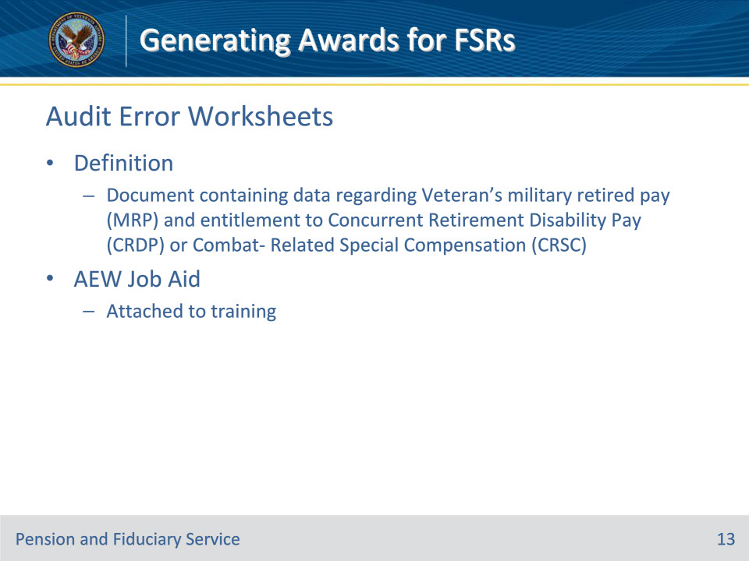
Slide notes

Definition of an Audit Error Worksheet

An audit error worksheet (AEW) is a document containing data regarding a Veteran’s military retired pay (MRP) and entitlement to Concurrent Retirement Disability Pay (CRDP) or Combat- Related Special Compensation (CRSC).

There is a detailed job aid attached to this training module which walks FSRs through AEW processing.

Slide 14 - 31. Questions?
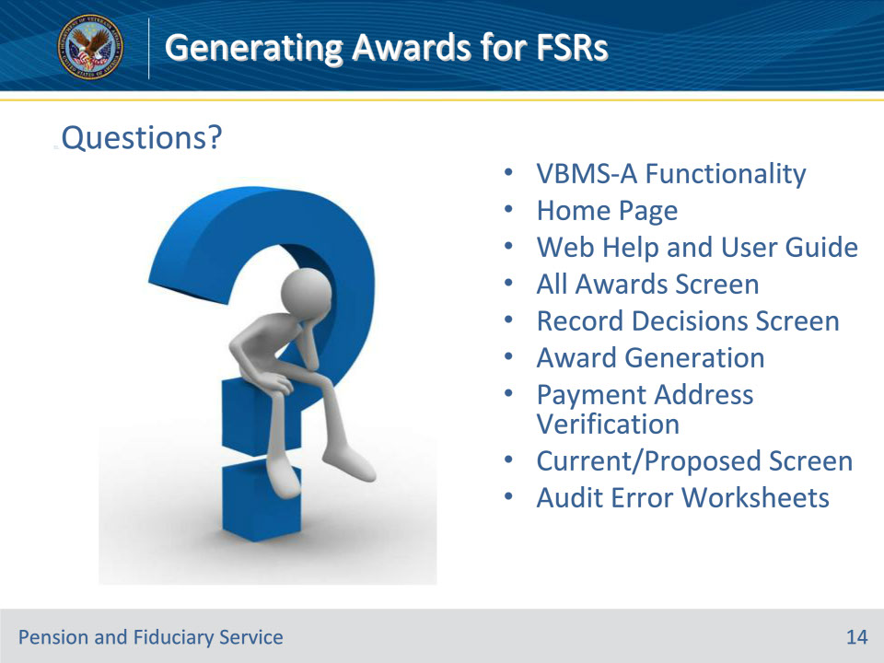
Slide notes

Instructor Notes:

(Recall) These are our learning objectives as stated from the beginning of the training:

• Describe the functionality of VBMS-Awards (VBMS-A) for award action

• Utilize the VBMS-A decision screens to promulgate awards

(Recap) We discussed each of these learning objectives through the following topics in each slide today:

• VBMS-A Functionality

• Home Page

• Web Help and User Guide

• All Awards Screen

• Record Decisions Screen

• Award Generation

• Payment Address Verification

• Current/Proposed Screen

• Audit Error Worksheets

Are there any additional questions?

Questions should be filtered through your QRT team. They will submit your questions to the Field Inquiry Tool (FIT) on your behalf.

Slide 15 - TMS Survey/Assessment
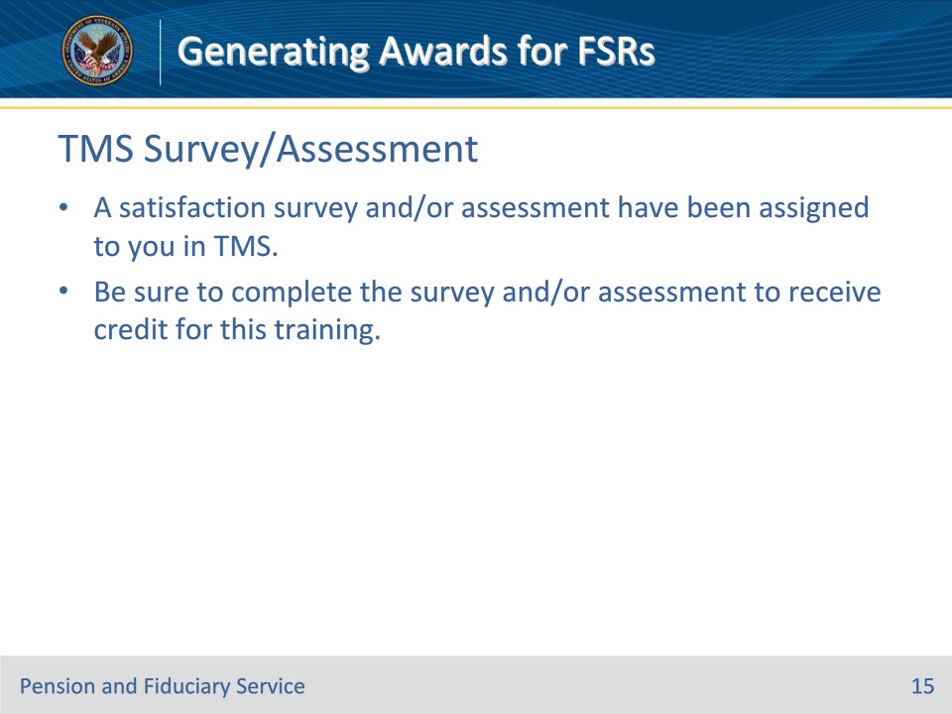
Slide notes

Instructor Notes

A satisfaction survey and/or assessment have been assigned to you in TMS.

Be sure to complete the survey and/or assessment to receive credit for this training.

