Slide 1 - Fiduciary Adjustments
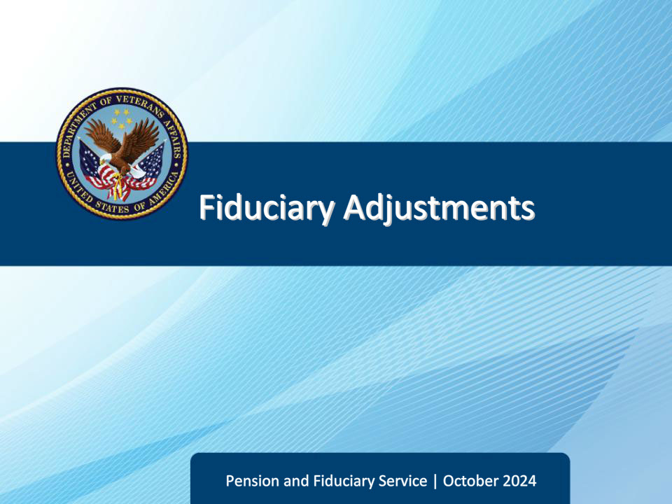
Slide notes

Course Description:

This course teaches learners the various fiduciary adjustment EPs that fall under fiduciary hub promulgation activity jurisdiction and their processing requirements.

Slide 2 - Objectives
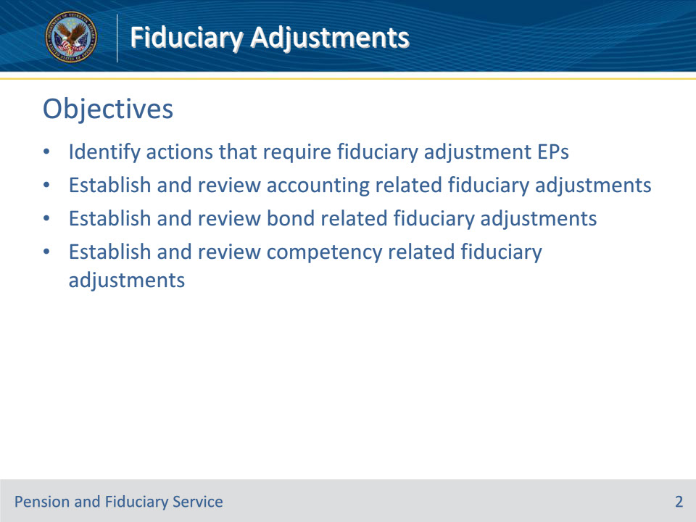
Slide notes

Instructor Notes:

At the end of this lesson, given the training and references, the learner will be able to do the following:

• Identify actions that require fiduciary adjustment EPs

• Establish and review accounting related fiduciary adjustments

• Establish and review bond related fiduciary adjustments

• Establish and review competency related fiduciary adjustments

Slide 3 - References
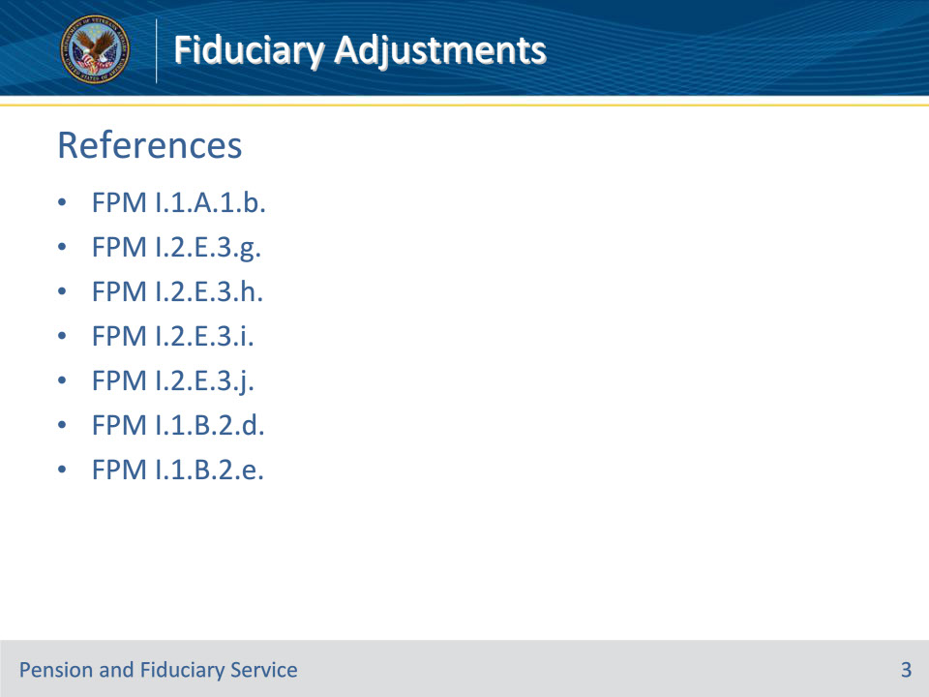
Slide notes

Instructor Notes:

These are the relevant references pertaining to this course:

• FPM I.1.A.1.b.

• FPM I.2.E.3.g.

• FPM I.2.E.3.h.

• FPM I.2.E.3.i.

• FPM I.2.E.3.j.

• FPM I.1.B.2.d.

• FPM I.1.B.2.e.

Slide 4 - Fiduciary Adjustments
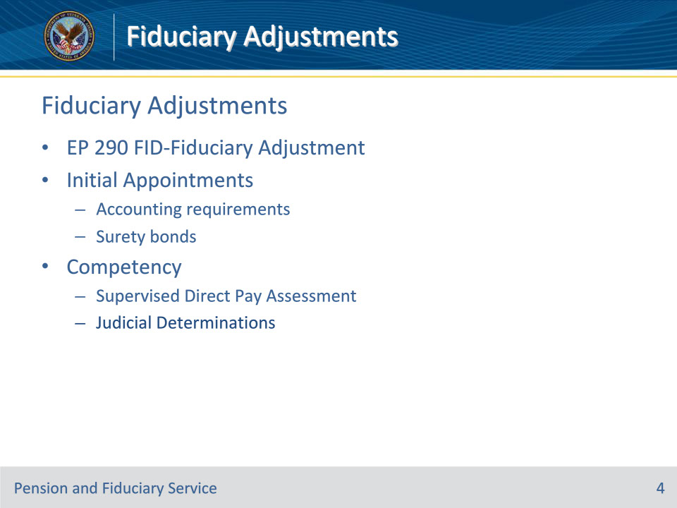
Slide notes

Policy Reference(s): FPM I.1.A.1.b.; FPM I.2.E.3.g.-j.

Instructor Notes:

Fiduciary promulgation activity is responsible for:

• processing fiduciary adjustments for all cases requiring a fiduciary appointment

• ensuring the appropriate end product (EP) is established

• ensuring fiduciary adjustments are completed within the established timeframe.

Fiduciary Adjustments are processed under EP 290 FID-Fiduciary Adjustment.

This EP is utilized for:

• Ensuring an accounting requirement is established following an initial appointment, when required

• Ensuring a surety bond is received before releasing a retroactive payment, when required

• Restoring competency when a Supervised Direct Pay Assessment indicates that a beneficiary can manage their own finances

• Appointing a fiduciary when a judicial determination of incompetency is received

Slide 5 - Establish Accounting EP 290
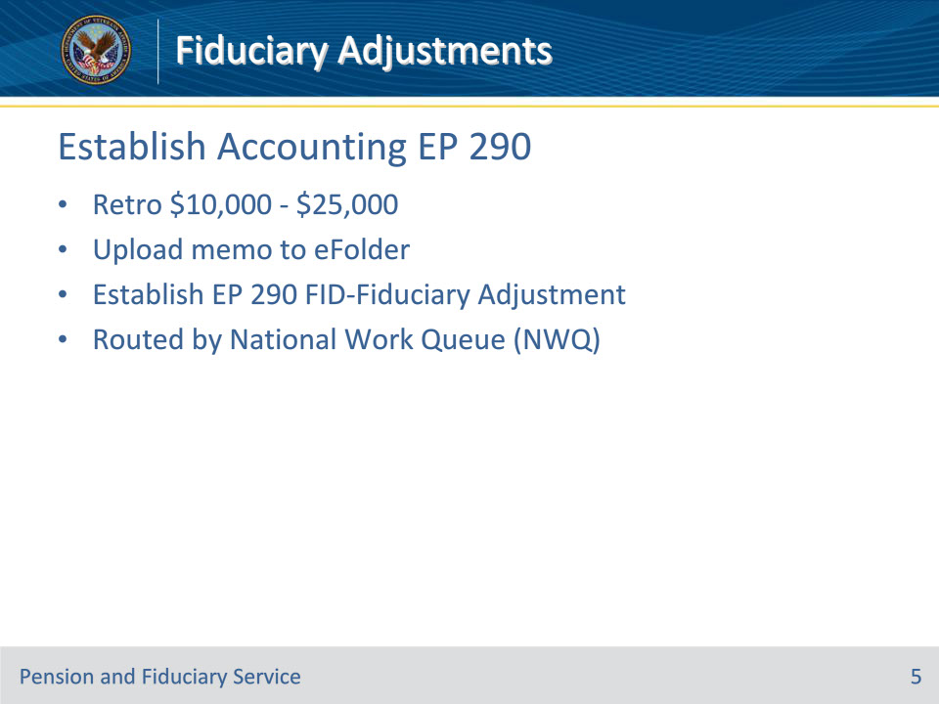
Slide notes

Policy Reference(s): FPM I.2.E.3.i. & j

Instructor Notes:

The RO authorization activity will complete the following actions on retroactive awards that are $10,000 - $25,000:

• upload a memorandum into the eFolder, and

• establish an EP 290 with the FID-Fiduciary Adjustment claim label.

Upon establishment of this claim label, NWQ will route the EP to the appropriate hub for action.

For initial appointments involving retros exceeding $25,000, any necessary accounting requirement will be established during the surety bond EP 290 process. This is covered later in the slides to follow.

Slide 6 - Review Accounting EP 290
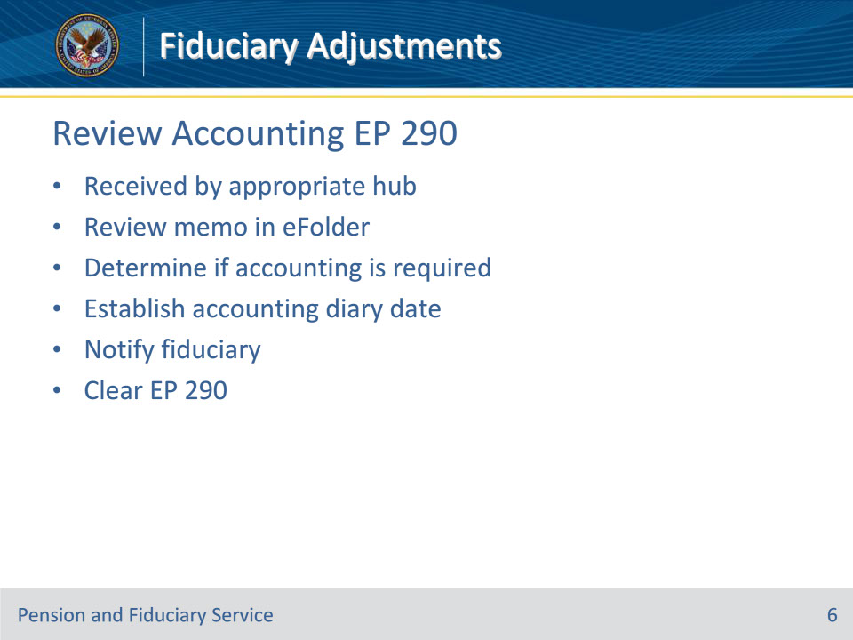
Slide notes

Policy Reference(s): FPM I.2.E.3.i.

Instructor Notes:

Follow the steps below upon review of the EP 290:

• Review the memo in the eFolder and determine the need for an accounting requirement.

• If an accounting is required, then establish the necessary accounting diary date and notify the fiduciary.

• Clear the EP 290.

Slide 7 - Establish Bond EP 290
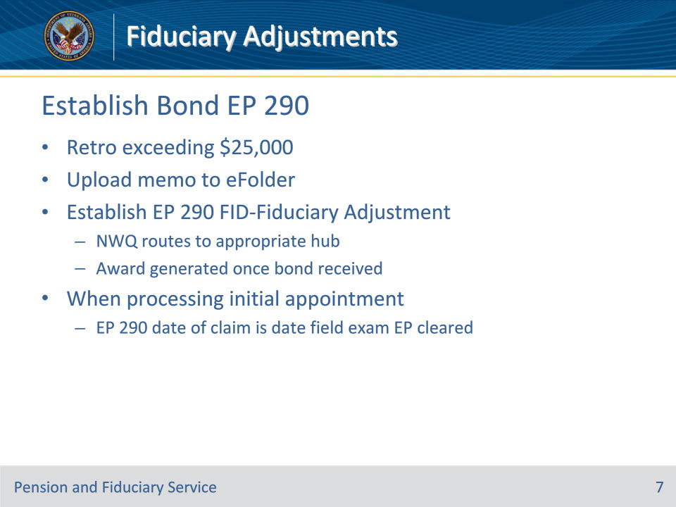
Slide notes

Policy Reference(s): FPM I.2.E.3.j., g.

Instructor Notes:

The RO authorization activity will complete the following on retroactive awards that exceed $25,000:

• upload a memorandum into the eFolder, and

• establish an EP 290 with the FID-Fiduciary Adjustment claim label.

Upon establishment of this claim label, NWQ will route the EP to the appropriate hub for action.

When the surety bond requirement is discovered while processing the certification of a fiduciary, the date of claim for the EP 290-Fiduciary Adjustment must be the date the field examination EP 590 is cleared, as these actions are completed sequentially on the same day.

When a surety bond is required, the award will be generated under the EP 290 Fid-Fiduciary Adjustment once the surety bond is obtained.

Slide 8 - Review Bond EP 290
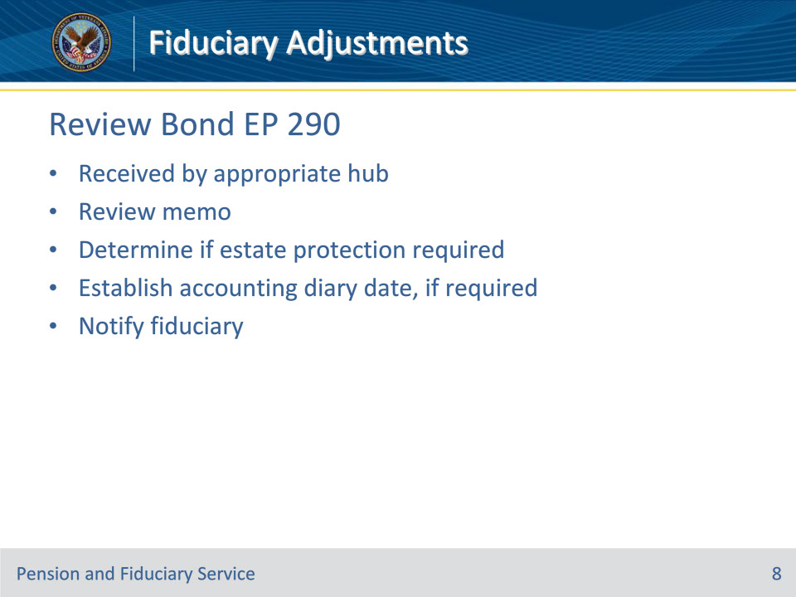
Slide notes

Policy Reference(s): FPM I.2.E.3.j.

Instructor Notes:

The hub will follow the steps below upon review of the EP 290:

Step 1: Review the memo in the eFolder and determine the need for any necessary estate protection and accounting requirements.

Step 2: If an accounting is required, then establish the necessary accounting diary date and notify the fiduciary. If estate protection is needed, develop for the necessary estate protection.

Slide 9 - Complete Bond EP 290
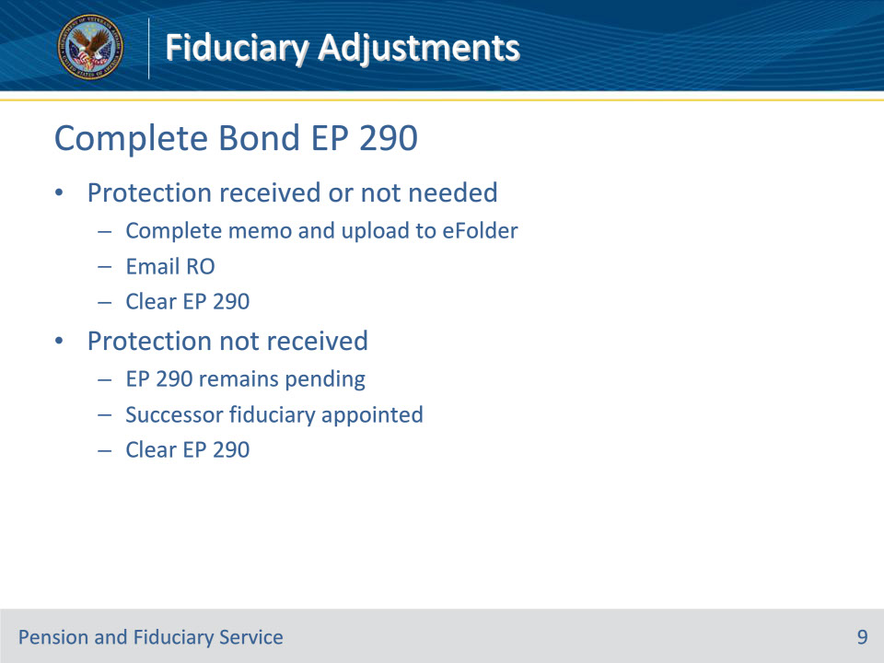
Slide notes

Policy Reference(s): FPM I.2.E.3.j., g.

Instructor Notes:

Step 3: When estate protection is received, or if estate protection is not needed, complete the memorandum provided by the RO and upload it to the eFolder, and e-mail the RO indicating the estate protection is in place.

Step 4: Clear the EP 290.

If the fiduciary cannot provide required estate protection, then the EP 290 will pend until a successor fiduciary is appointed under the appropriate field examination EP.

Slide 10 - Establish Competency EP 290
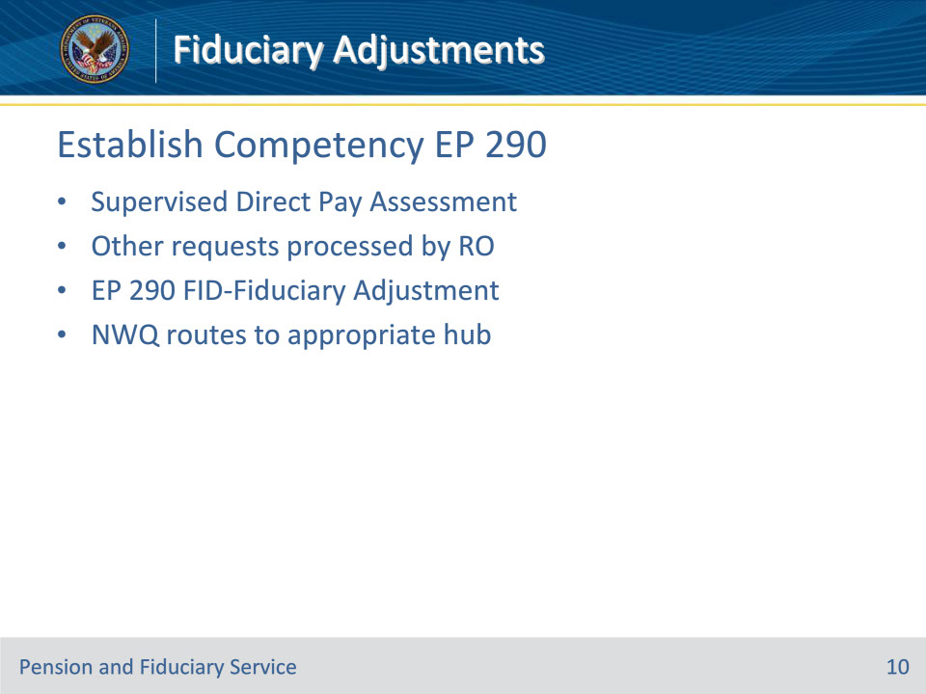
Slide notes

Policy Reference(s): FPM I.2.E.3.h.

Instructor Notes:

The hub has jurisdiction to complete restored competency ratings when the FE submits a Supervised Direct Pay Assessment for restored competency unless one of the exceptions applies.

For all other restored competency requests, the RO rating activity completes a final rating determination restoring ability to manage financial affairs and takes award action. The RO will establish an EP 290 with the FID-Fiduciary Adjustment claim label, and the NWQ will route the EP to the appropriate hub for action.

Slide 11 - Review Competency EP 290
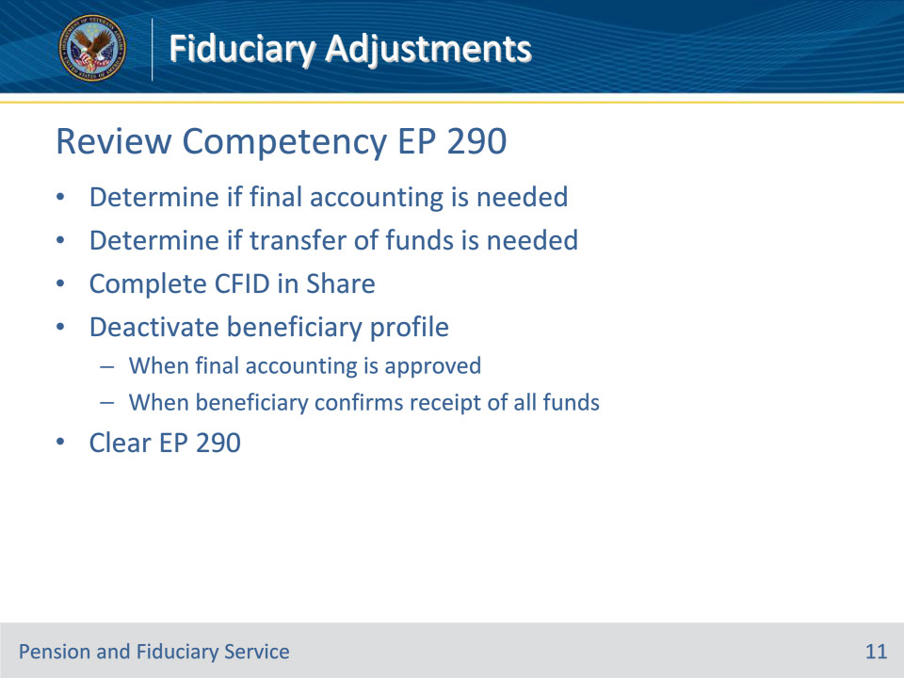
Slide notes

Policy Reference(s): FPM I.2.E.3.h.

Instructor Notes:

The hub will follow the steps below upon review of the EP 290:

1. Determine any needs for a final accounting and/or transfer of funds.

2. Complete a CFID in Share to pay the beneficiary directly.

3. Deactivate the beneficiary profile.

4. Clear the EP 290

• The hub must not deactivate the beneficiary profile until the

• final accounting is received and approved (if required), and

• beneficiary acknowledges receipt of all FUM.

• A new VA Form 21P-555 is not required to be completed for the removal of the beneficiary from the Fiduciary Program.

Slide 12 - Judicial Determination EP 290
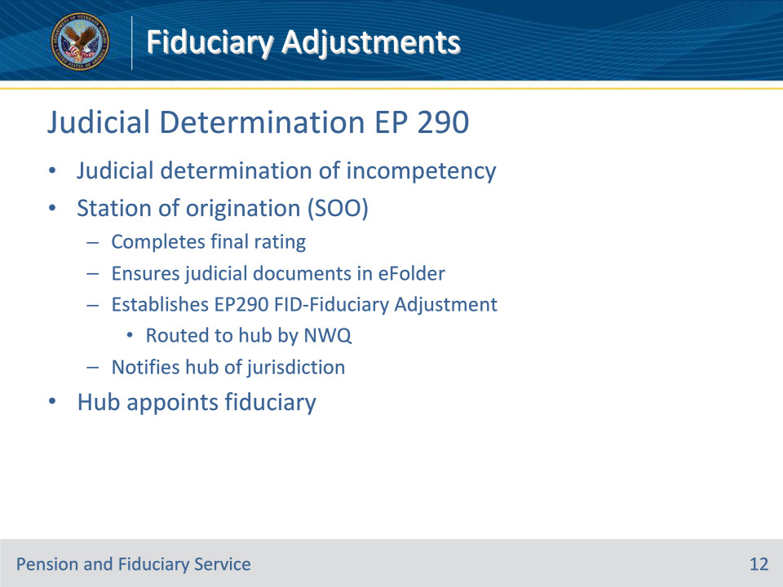
Slide notes

Policy Reference(s): FPM I.1.B.2.d.-e.

Instructor Notes:

Upon receipt of a judicial determination of a beneficiary’s inability to manage affairs, the station of origination (SOO)

• completes a final rating on the beneficiary’s inability to manage VA benefits

• ensures the judicial documents are available in the eFolder

• establishes an EP 290, FID-Fiduciary Adjustment, and

• notifies the hub of jurisdiction using VA Form 21-592.

It is unnecessary for the SOO to

• prepare a proposed rating, or

• provide advance notice of a rating.

Note: Upon establishment of the EP 290, the NWQ will route the EP to the appropriate hub for action.

Upon receipt of notification from the SOO of the judicial determination, the hub will

• confirm receipt of valid court documentation

• review for a judicial finding that the beneficiary is a danger to self or others, in accordance with FPM, Part I, 1.B.2.l

• provide oral notification of Brady Act restrictions

• follow all procedures to appoint a fiduciary, and

• release retroactive benefits to the fiduciary, if appropriate.

Slide 13 - 31. Questions?
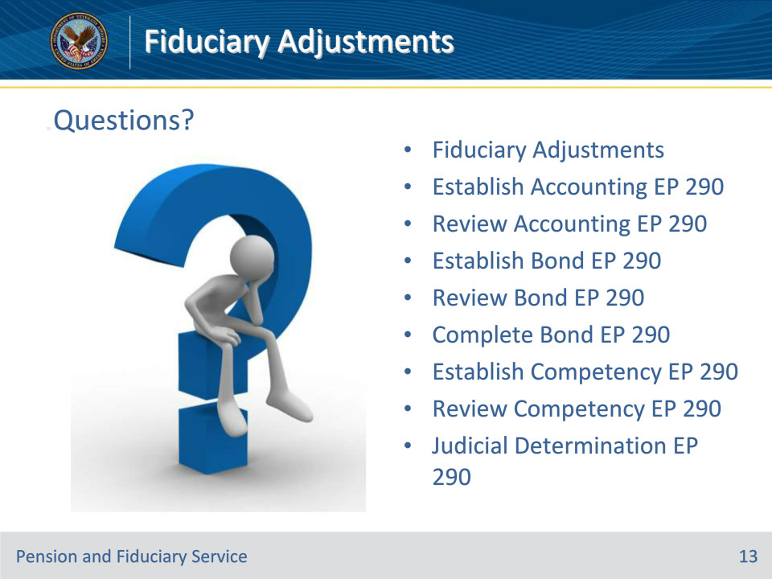
Slide notes

Instructor Notes:

(Recall) These are our learning objectives as stated from the beginning of the training:

• Identify actions that require fiduciary adjustment EPs

• Establish and review accounting related fiduciary adjustments

• Establish and review bond related fiduciary adjustments

• Establish and review competency related fiduciary adjustments

(Recap) We discussed each of these learning objectives through the following topics in each slide today:

• Fiduciary Adjustments

• Establish Accounting EP 290

• Review Accounting EP 290

• Establish Bond EP 290

• Review Bond EP 290

• Complete Bond EP 290

• Establish Competency EP 290

• Review Competency EP 290

• Judicial Determination EP 290

Are there any additional questions?

Questions should be filtered through your QRT team. They will submit your questions to the Field Inquiry Tool (FIT) on your behalf.

Slide 14 - TMS Survey/Assessment
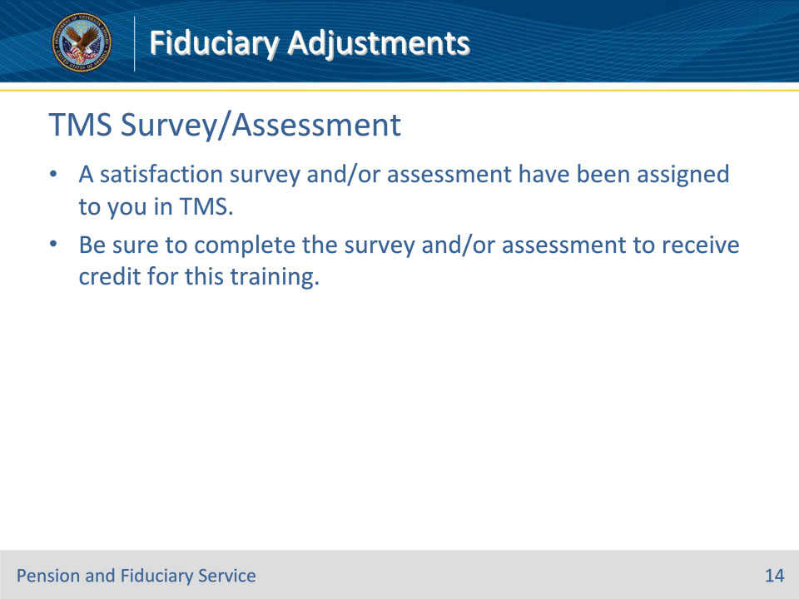
Slide notes

Instructor Notes

A satisfaction survey and/or assessment have been assigned to you in TMS.

Be sure to complete the survey and/or assessment to receive credit for this training.

