Slide 1 - Fiduciary Action Mail and Records Administration
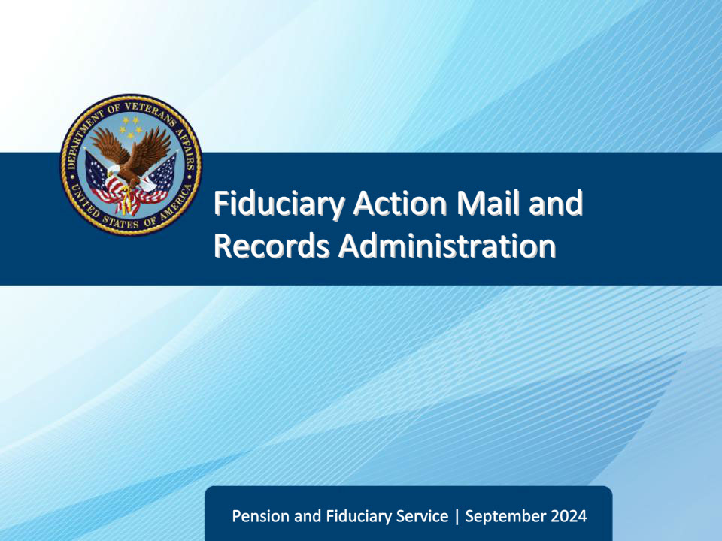
Slide notes

Course Description:

This course teaches learners basic information regarding fiduciary hub mail teams and mail procedures.

Slide 2 - Objectives
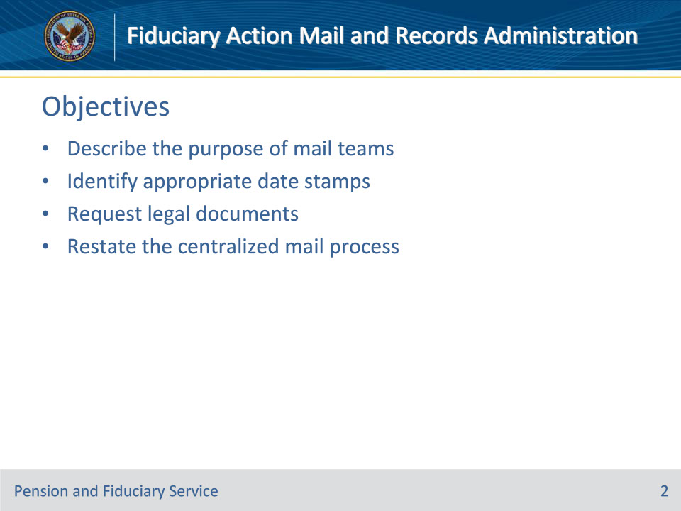
Slide notes

Instructor Notes:

At the end of this lesson, given the training and references, the learner will be able to do the following:

• Describe the purpose of mail teams

• Identify appropriate date stamps

• Request legal documents

• Restate the centralized mail process

Slide 3 - References
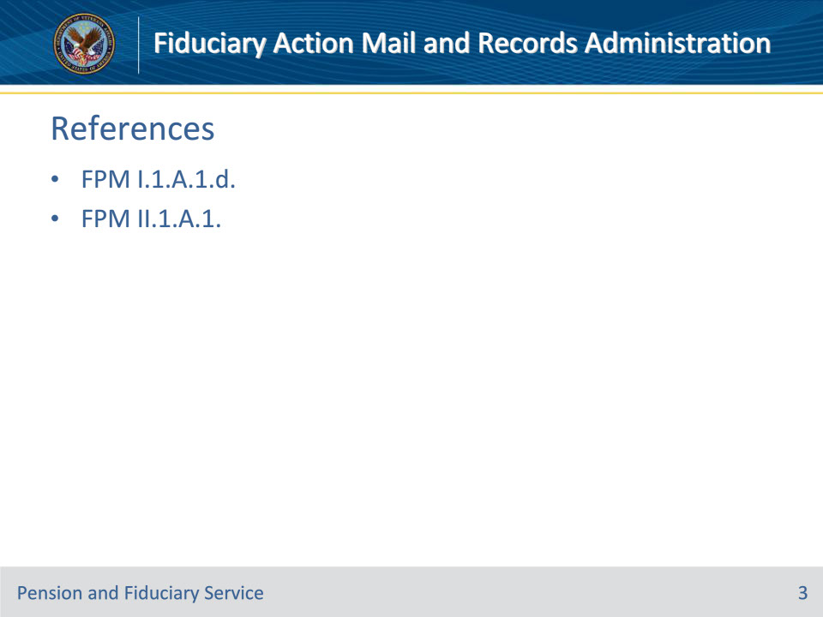
Slide notes

Instructor Notes:

These are the relevant references pertaining to this course:

• FPM I.1.A.1.d. Purpose of Mail Activity

• FPM II.1.A.1. Mail Management

Slide 4 - Purpose
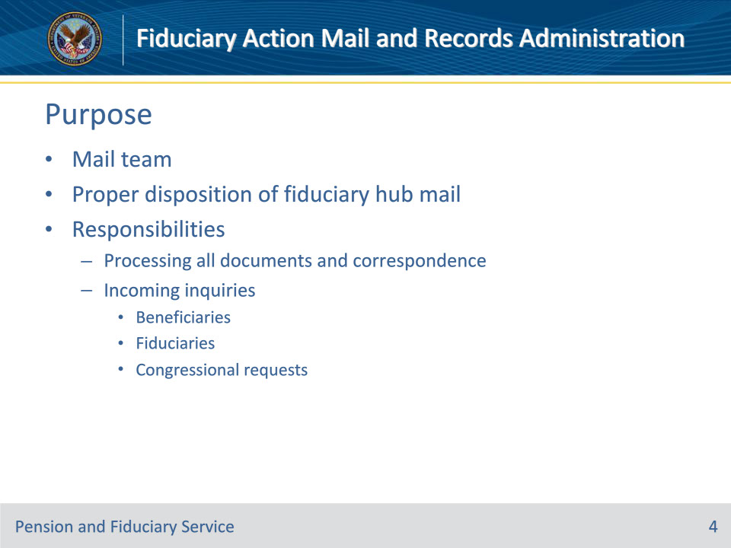
Slide notes

Policy Reference(s): FPM I.1.A.1.d.

Instructor Notes:

The purpose of the mail teams is to ensure proper disposition of all mail received by the hub.

Mail teams are responsible for processing all documents and correspondence coming via acceptable sources. Among these are incoming inquiries from beneficiaries, fiduciaries, and congressional requests.

Slide 5 - Date Stamps
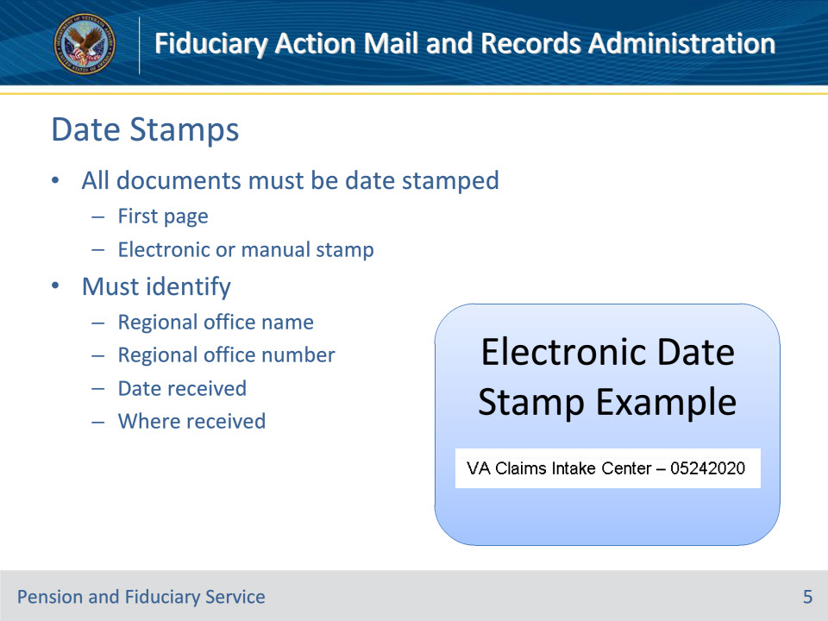
Slide notes

Policy Reference(s): FPM II.1.A.1.a.

Instructor Notes:

Each document submitted to the Department of Veterans Affairs (VA) must receive a stamp with the date of receipt. Documents may be received through the regional office (RO), a field examination, or an out-based facility.

All documents must be date stamped on the first page with an electronic or manual date stamp containing red ink and identifying the

• RO name

• RO number

• date received, and

• where the mail was received, if out-based.

Slide 6 - Documents Without Stamp
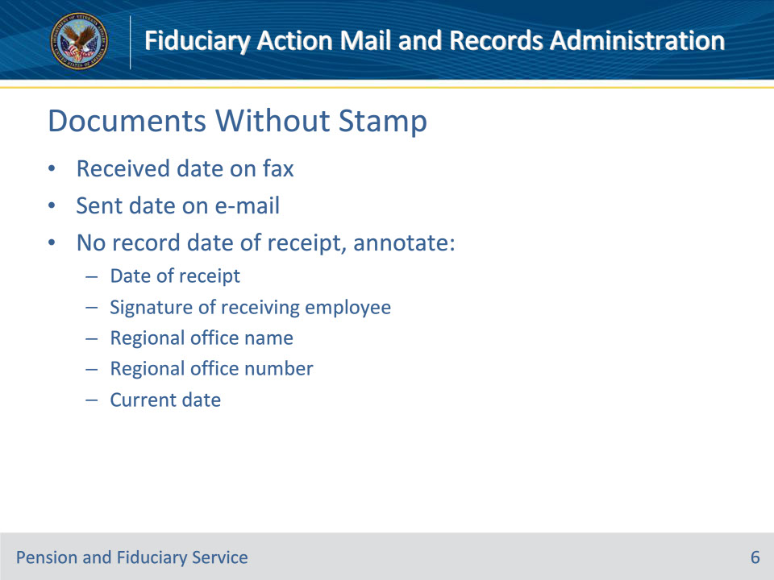
Slide notes

Policy Reference(s): FPM II.1.A.1.b.

Instructor Notes:

Use the guidance below when attempting to determine the date VA received a document without a date stamp.

The received date on a fax is an acceptable date stamp for documents faxed and directly indexed into the electronic claims folder (eFolder).

When documents are received via e-mail through an authorized mailbox, accept the sent date electronically recorded on the e-mail as an acceptable date stamp and upload the e-mail to the claims folder. Do not, however, accept claims or claims-related material via unsolicited e-mails submitted to an individual employee mailbox or other unauthorized mailboxes.

When it is not possible to record date of receipt, via an electronic date stamp, annotate the document with

• date of receipt, recorded either by annotation or manual date stamp

• signature of employee receiving the document

• RO name

• RO number, and

• current date (if different than date of receipt).

For documents uploaded using an approved VA claims submission service such as Direct Upload, the date of receipt is recorded via an electronic date stamp through the Centralized Mail (CM) portal. When documents are received via an approved VA claims submission service or fax do not

• print out the documents in order to affix a manual date stamp, or

• upload back into the eFolder.

Slide 7 - Requesting Legal Documents
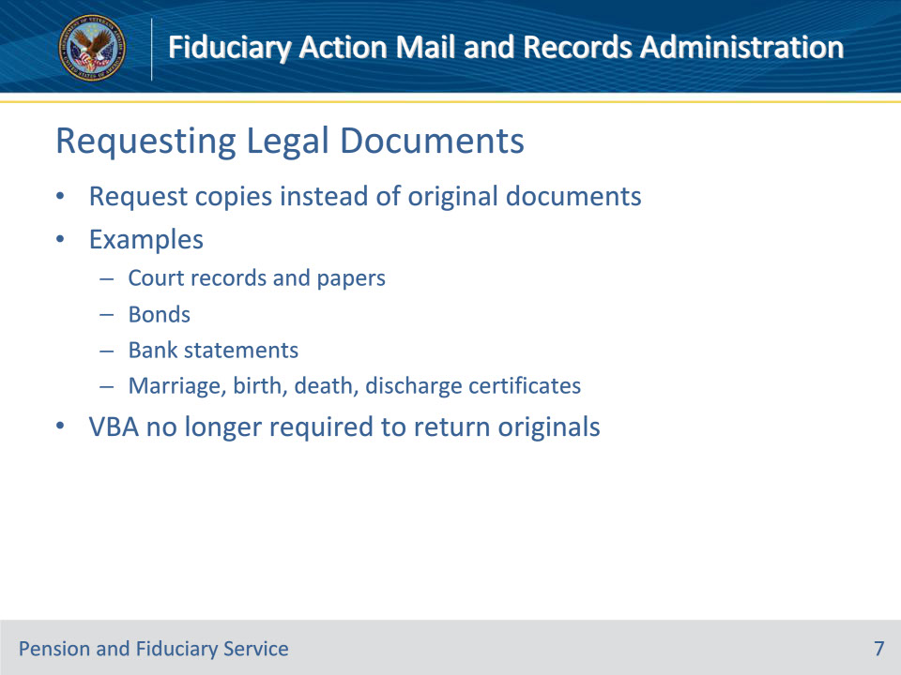
Slide notes

Policy Reference(s): FPM II.1.A.1.c.

Instructor Notes:

Fiduciary hubs should not routinely request the original versions of documents. There is no mechanism in place to retrieve original documents once shipped to the scanning vendor. Instead request only copies of evidentiary documents. Examples of such evidentiary documents include, but are not limited to

• court records and papers

• bonds

• bank statements, and

• marriage, birth, death, and discharge certificates.

The Veterans Benefits Administration (VBA) no longer requires the return of original documents to the fiduciary or beneficiary.

Slide 8 - Intent of Centralized Mail
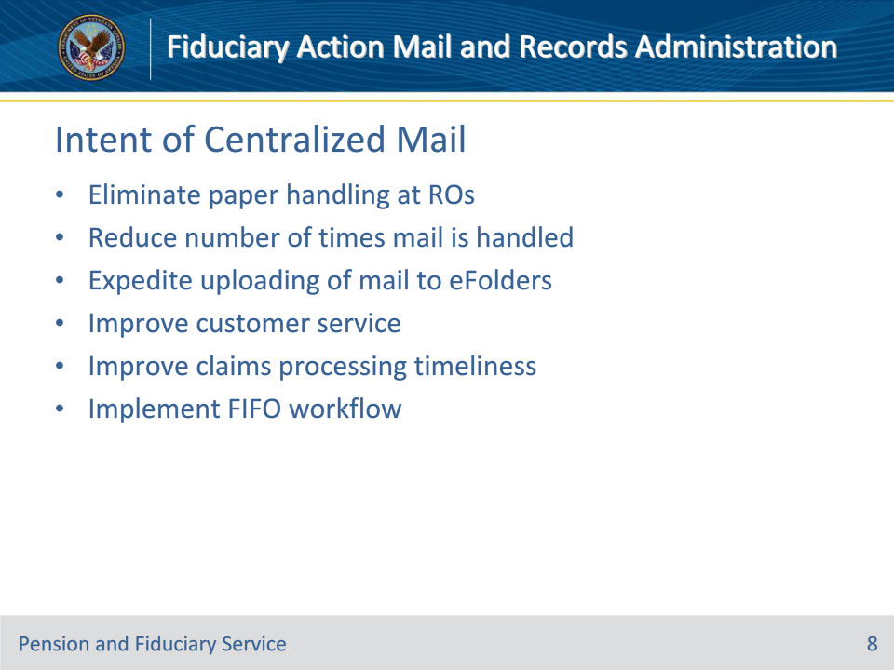
Slide notes

Policy Reference(s): FPM II.1.A.1.d.

Instructor Notes:

Centralizing conversion of incoming paper to an electronic medium in the CM process is intended to

• eliminate paper handling by VA personnel at ROs

• reduce the number of times mail is handled in any medium

• expedite uploading of claims, evidence, and other mail to the eFolders in VBMS

• improve customer service and claims processing timeliness through improved mail control processes, and

• implement first in, first out workflow for all mail received.

Slide 9 - Roles & Responsibilities
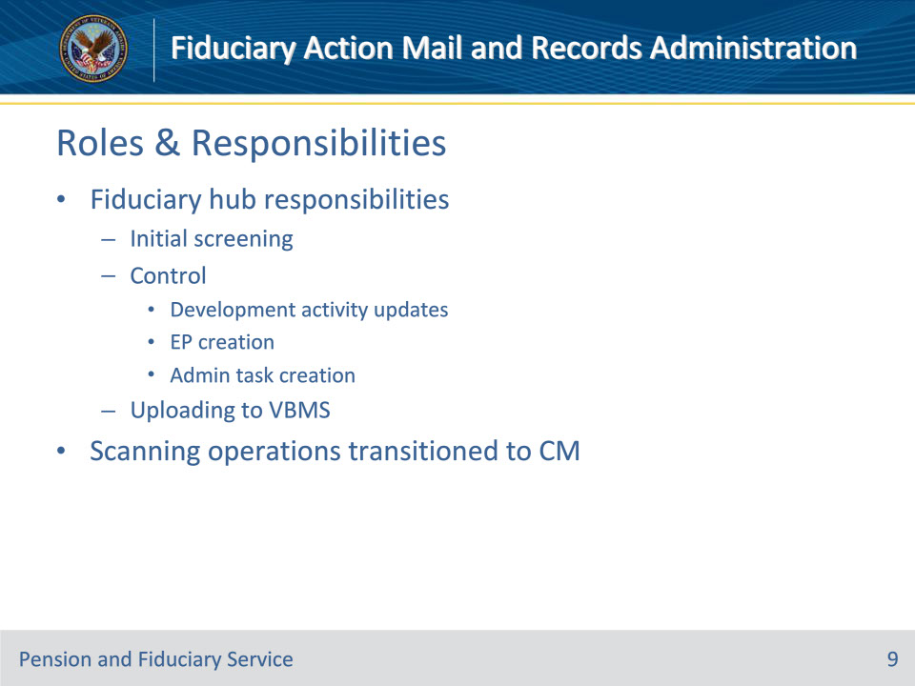
Slide notes

Policy Reference(s): FPM II.1.A.1.e.

Instructor Notes:

Hubs are responsible for initial screening, control, and uploading to VBMS of mail received in the CM portal. This includes updates to development activities, creation of appropriate end products (EPs), and administrative task creation to ensure timely processing of fiduciary activities.

Hubs transitioned all scanning operations to CM on August 12, 2019. The only supported local scanning operation is for Federal tax information (FTI).

Slide 10 - Controlling Mail
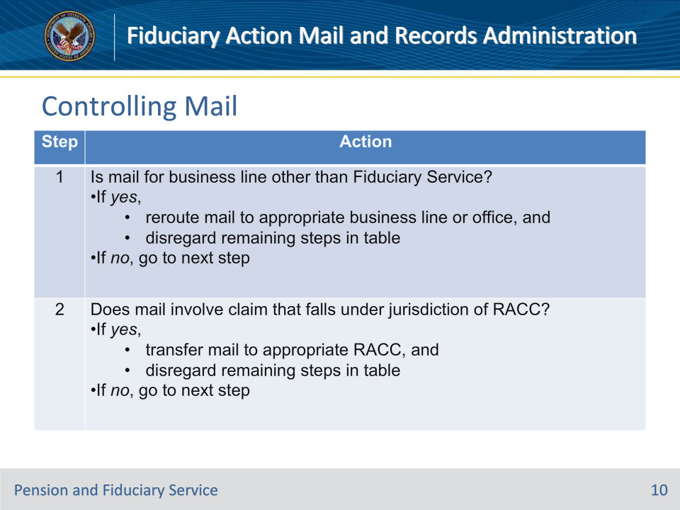
Slide notes

Policy Reference(s): FPM II.1.A.1.f.

Instructor Notes:

Follow the steps in this table when processing mail in the CM portal.

Slide 11 - Controlling Mail
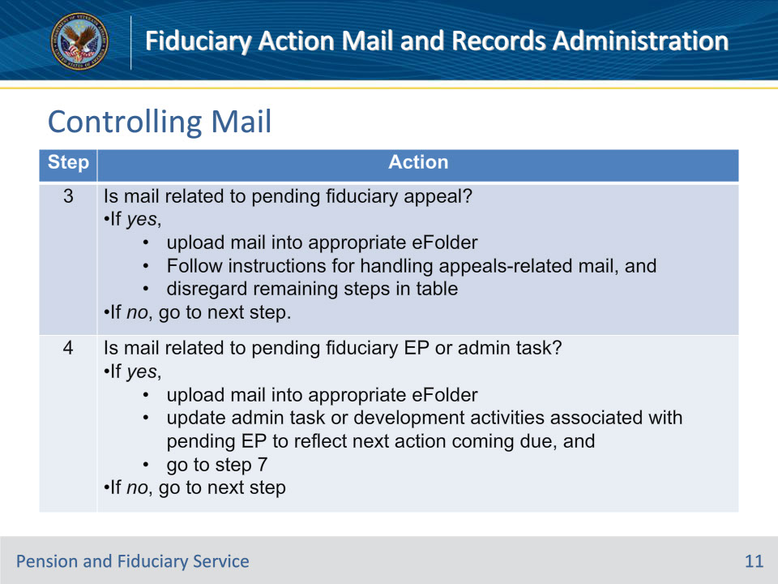
Slide notes

Policy Reference(s): FPM II.1.A.1.f.

Instructor Notes:

Follow the steps in this table when processing mail in the CM portal.

Note for Step 3:

To answer the question in this step, check all applicable claims-processing systems, including:

• VBMS

• Veterans Appeals Control and Locator System, and

• Caseflow

Note for Step 4:

If the user is unable to update the status of the pending administrative task at the time of the action, the user must input a note on the beneficiary profile specifying the action taken and the mail received. The user must also add the task identification to the note.

Slide 12 - Controlling Mail
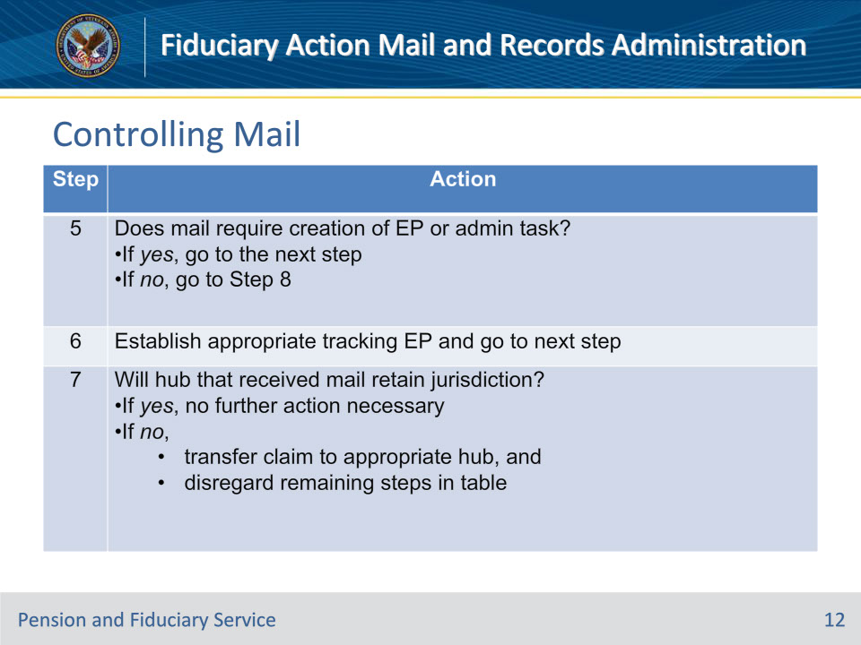
Slide notes

Policy Reference(s): FPM II.1.A.1.f.

Instructor Notes:

Follow the steps in this table when processing mail in the CM portal.

Slide 13 - Controlling Mail
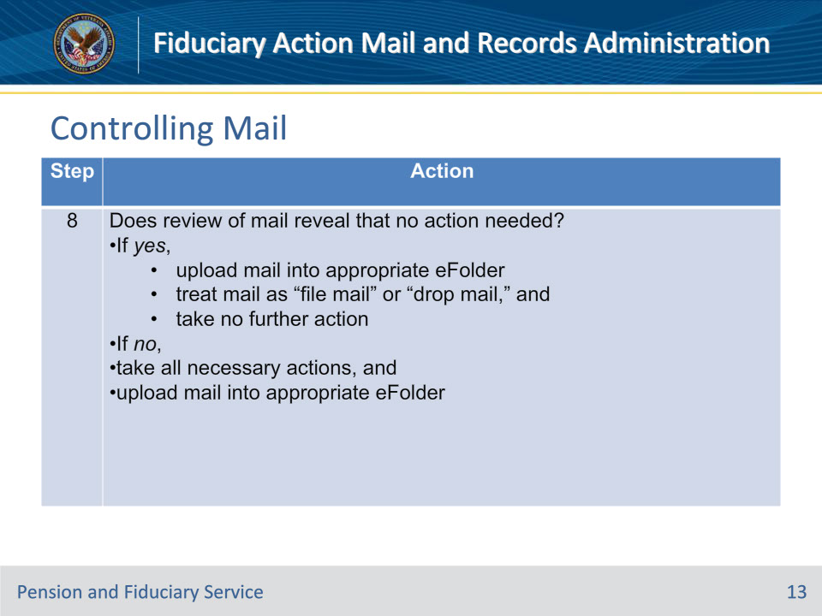
Slide notes

Policy Reference(s): FPM II.1.A.1.f.

Instructor Notes:

Follow the steps in this table when processing mail in the CM portal.

Slide 14 - Controlling Mail
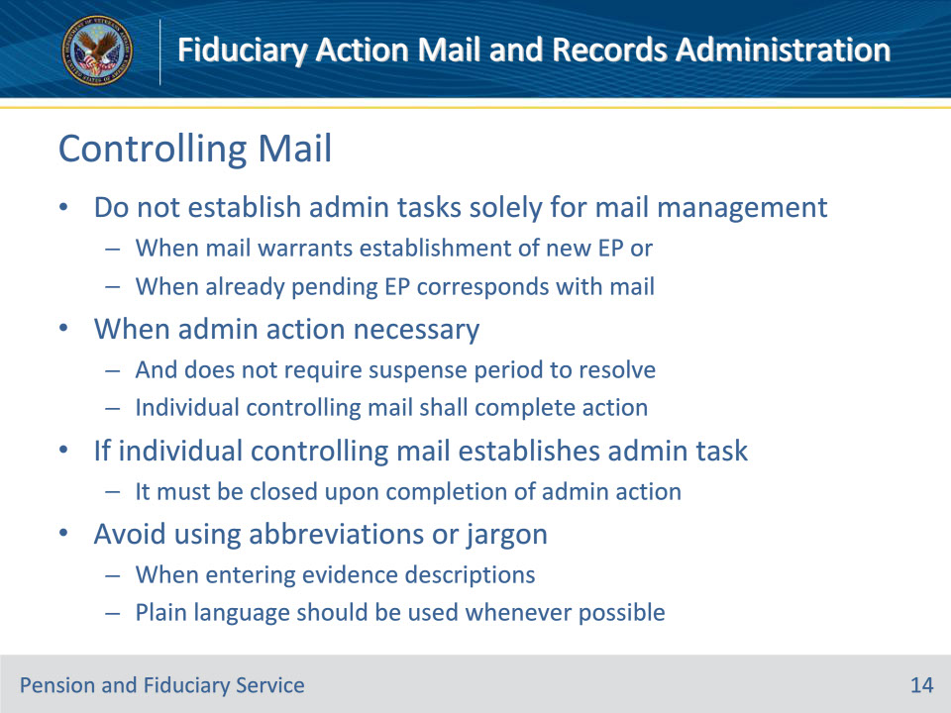
Slide notes

Policy Reference(s): FPM II.1.A.1.f.

Instructor Notes:

• Do not establish administrative tasks for the sole purpose of mail management when the mail warrants establishment of a new EP or when there is already a pending EP that corresponds to the mail that was received.

• When an administrative action (e.g., change of name, mailing address update, direct deposit update, etc.) is necessary and does not require a suspense period to resolve the mail, the individual controlling the mail shall complete that action. If the individual controlling the mail establishes the administrative task, it must be closed upon completion of the administrative action.

• Avoid using abbreviations or jargon when entering evidence descriptions. Plain language should be used whenever possible so that the type of evidence is clearly identifiable to any user with access to VBMS.

Slide 15 - Separating, Routing & Shipping
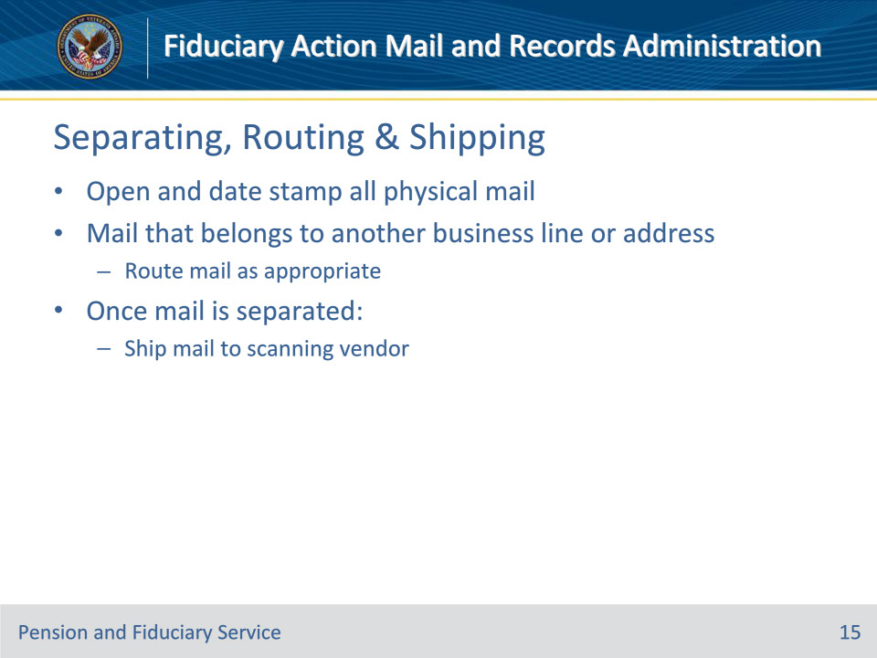
Slide notes

Policy Reference(s): FPM II.1.A.1.g., h.

Instructor Notes:

Hubs must open and date stamp all physical mail. If mail is received that belongs to another VA business line and/or address, route the mail as appropriate.

Once the mail is separated, follow the steps to ship the mail to the scanning vendor.

Slide 16 - Centralized Printing
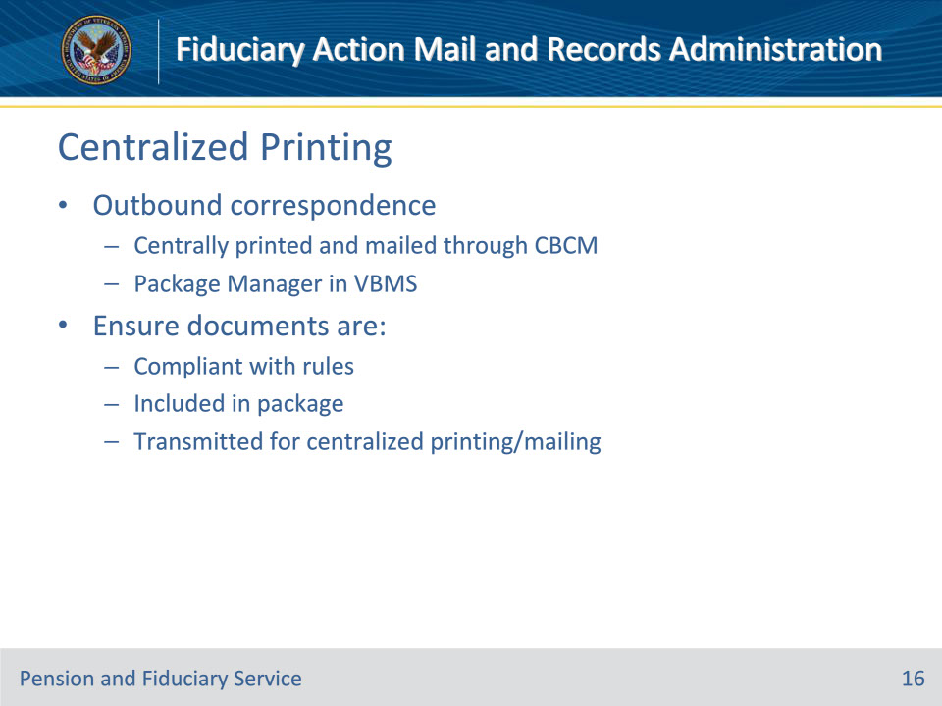
Slide notes

Policy Reference(s): FPM II.1.A.1.i.

Instructor Notes:

With limited exceptions, outbound correspondence addressed to claimants and representatives will be centrally printed and mailed through the Centralized Benefits Communications Management (CBCM) program.

Unless specifically exempted, outbound communications should be sent using the Package Manager in VBMS as provided in the CBCM program. Prior to releasing outbound communication, ensure that any associated documents that must be provided to the beneficiary

• comply with the rules in the document titled Preparing Files for Centralized Printing

• are included in a package, created in VBMS Package Manager, and

• are transmitted for centralized printing and mailing.

Letters should not be locally printed unless an exception exists such as with FTI or express mail.

Slide 17 - Providing Notice
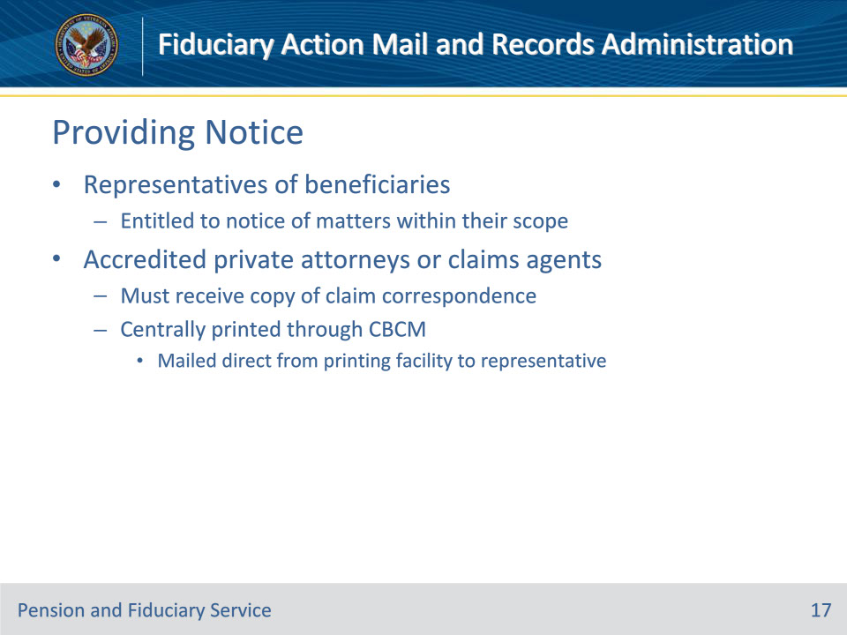
Slide notes

Policy Reference(s): FPM II.1.A.1.j., k.

Instructor Notes:

Representatives of claimants or beneficiaries before VA are entitled to notice of any VA decisions related to matters within the scope of the representation.

Accredited private attorneys or claims agents must receive a paper copy of any correspondence regarding the claim they represent.

Attorney or agent copies of correspondence that are centrally printed through the CBCM program will be mailed from the printing facility directly to the representative.

Slide 18 - Local Printing
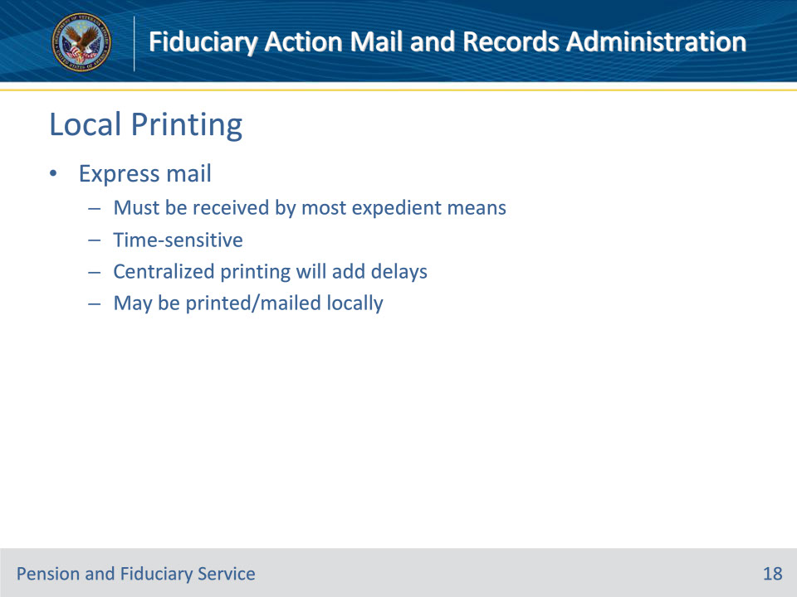
Slide notes

Policy Reference(s): FPM II.1.A.1.l.

Instructor Notes:

Express mail refers to mail that the addressee must receive by the most expedient means. Although CBCM is strongly encouraged in all possible instances, express mail may be printed and mailed locally if the mail is time-sensitive and utilizing centralized printing will add delays.

Slide 19 - Questions?
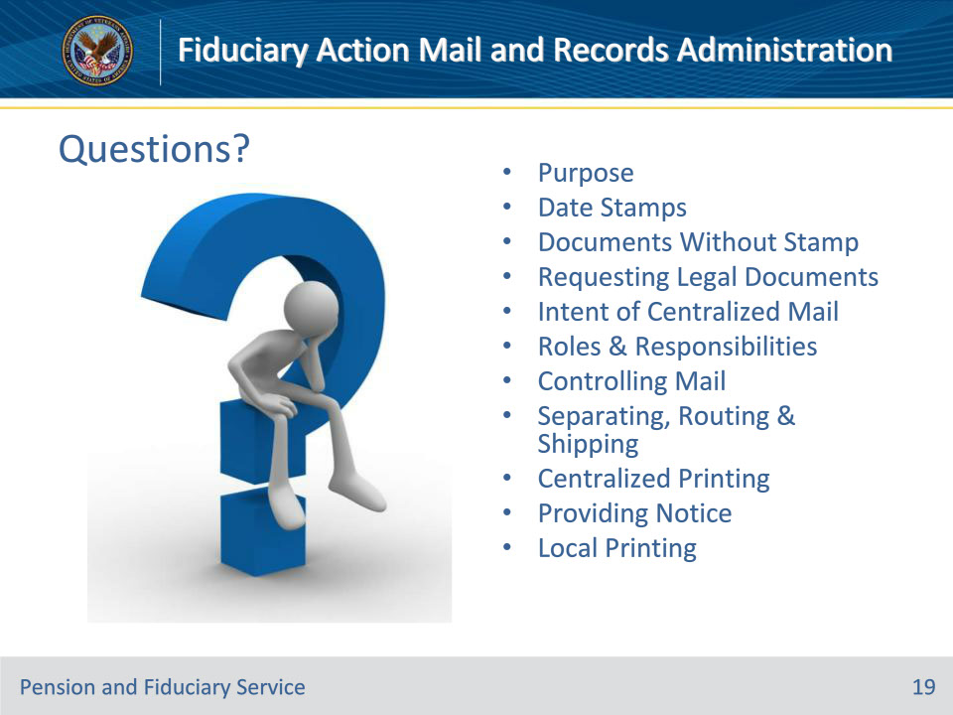
Slide notes

Instructor Notes:

(Recall) These are our learning objectives as stated from the beginning of the training:

• Describe the purpose of mail teams

• Identify appropriate date stamps

• Request legal documents

• Restate the centralized mail process

(Recap) We discussed each of these learning objectives through the following topics in each slide today:

• Purpose

• Date Stamps

• Documents Without Stamp

• Requesting Legal Documents

• Intent of Centralized Mail

• Roles & Responsibilities

• Controlling Mail

• Separating, Routing & Shipping

• Centralized Printing

• Providing Notice

• Local Printing

Are there any additional questions?

Questions should be filtered through your QRT team. They will submit your questions to the Field Inquiry Tool (FIT) on your behalf.

Slide 20 - TMS Survey/Assessment
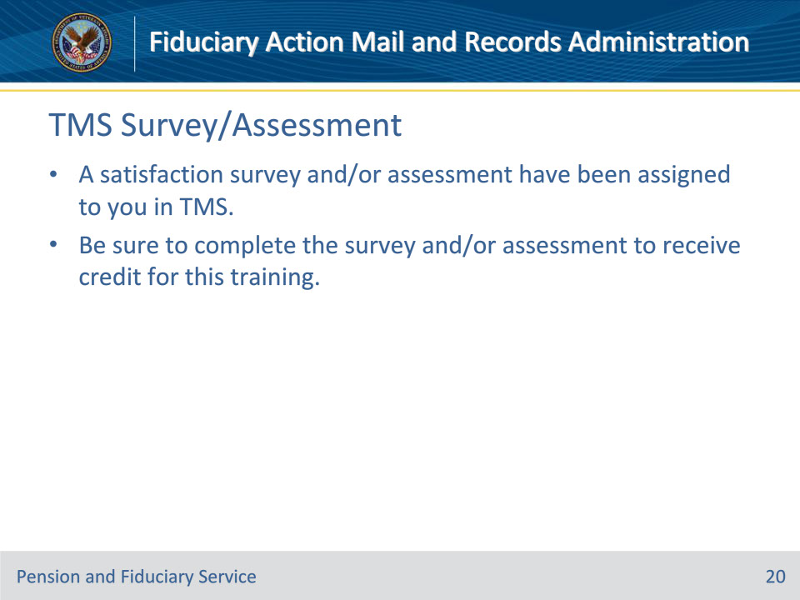
Slide notes

Instructor Notes:

A satisfaction survey and/or assessment have been assigned to you in TMS.

Be sure to complete the survey and/or assessment to receive credit for this training.

