Slide 1 - Overview of Rating Decisions and VBMS-R
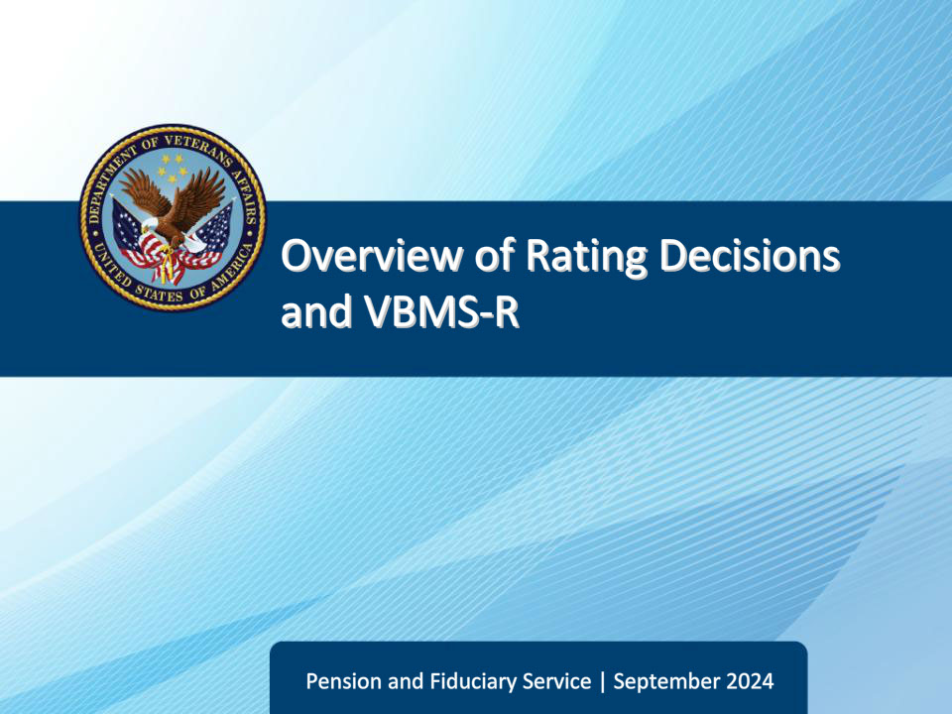
Slide notes

Course Description:

This course teaches learners an overview of the content requirements for rating decisions, how to evaluate evidence, and VBMS-R functionality.

Slide 2 - Objectives
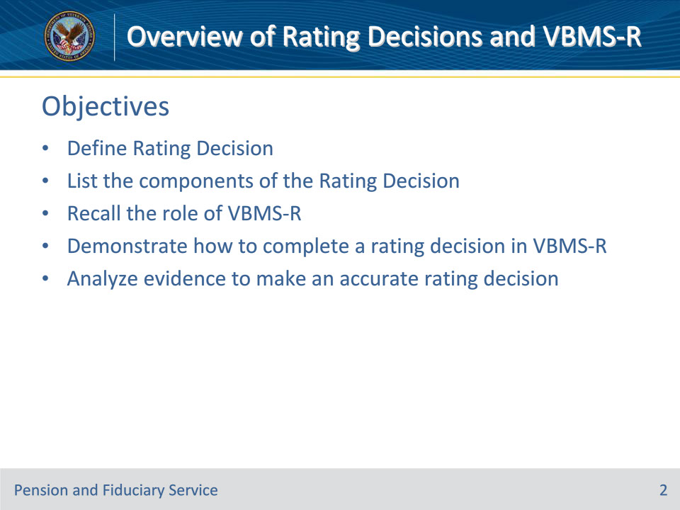
Slide notes

Instructor Notes:

At the end of this lesson, given the training and references, the learner will be able to do the following:

• Define Rating Decision

• List the components of the Rating Decision

• Recall the role of VBMS-R

• Demonstrate how to complete a rating decision in VBMS-R

• Analyze evidence to make an accurate rating decision

Slide 3 - References
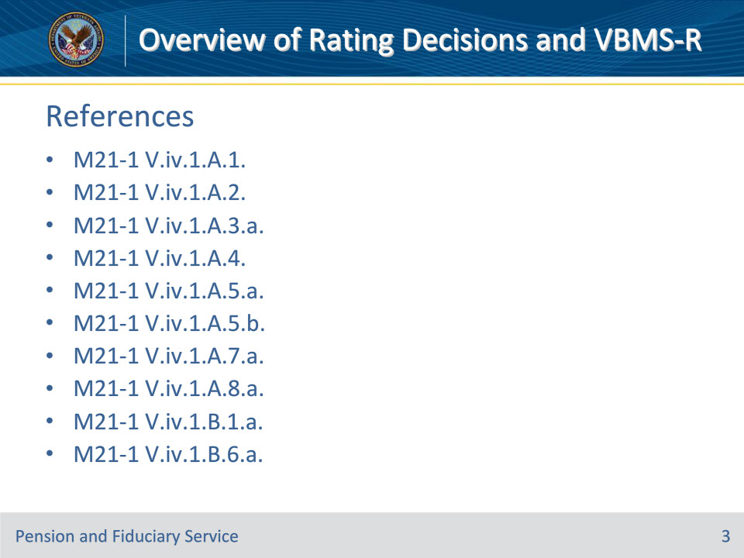
Slide notes

Instructor Notes:

These are the relevant references pertaining to this course:

• M21-1 V.iv.1.A.1. Basic Information on Rating Decisions

• M21-1 V.iv.1.A.2. Introduction

• M21-1 V.iv.1.A.3.a. Purpose of the Decision Section

• M21-1 V.iv.1.A.4. Evidence

• M21-1 V.iv.1.A.5.a. Purpose of the Reasons for Decision

• M21-1 V.iv.1.A.5.b. Reasons for Decision Narrative Formats

• M21-1 V.iv.1.A.7.a. Issues Requiring a Long-Form Rating Narrative

• M21-1 V.iv.1.A.8.a. Purpose of References

• M21-1 V.iv.1.B.1.a. System-Generated Data Table Entries Organized by Field

• M21-1 V.iv.1.B.6.a. Purpose of Special Notations and Notification Templates

Slide 4 - References 2
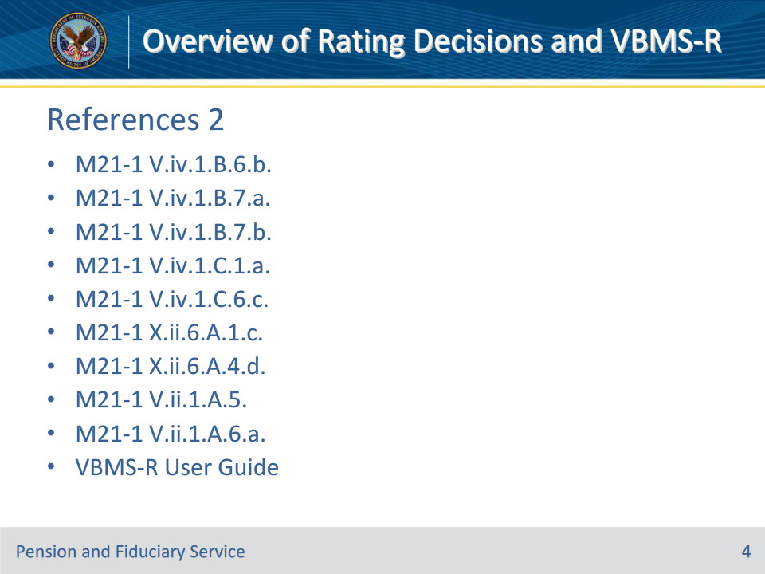
Slide notes

Instructor Notes:

These are the relevant references pertaining to this course:

• M21-1 V.iv.1.B.6.b. Special Notation Field

• M21-1 V.iv.1.B.7.a. Definition: Signatures on Rating Decisions

• M21-1 V.iv.1.B.7.b. Procedure for Completing a Digital Signature on the Rating Decision Codesheet

• M21-1 V.iv.1.C.1.a. Definition: Coded Conclusion

• M21-1 V.iv.1.C.6.c. Coding Competency

• M21-1 X.ii.6.A.1.c. Presuming Competency

• M21-1 X.ii.6.A.4.d. Evidence Required to Restore Competency

• M21-1 V.ii.1.A.5. Weighing the Evidence

• M21-1 V.ii.1.A.6.a. Evaluation of Evidence

• VBMS-R User Guide

Slide 5 - Definition
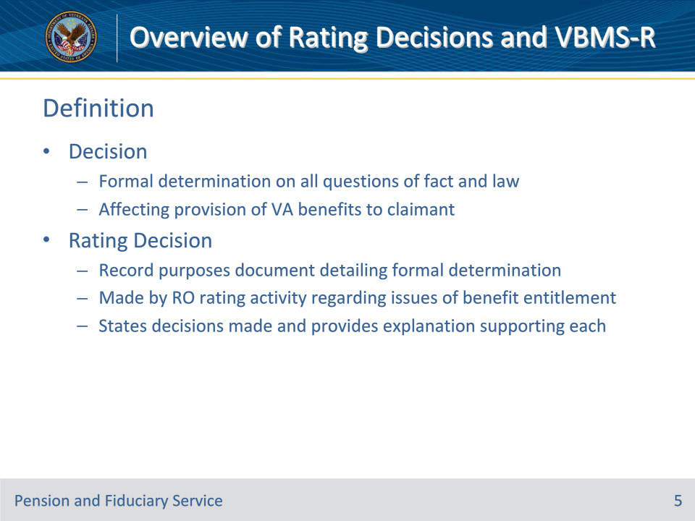
Slide notes

Policy Reference(s): M21-1 V.iv.1.A.1.a., b.

Instructor Notes:

A decision means a formal determination on all questions of fact and law affecting the provision of Department of Veterans Affairs (VA) benefits to a claimant.

A rating decision is a record purposes document detailing the formal determination made by the regional office (RO) rating activity regarding one or more issues of benefit entitlement. The rating decision states the decisions made and provides an explanation supporting each decision.

Slide 6 - Components
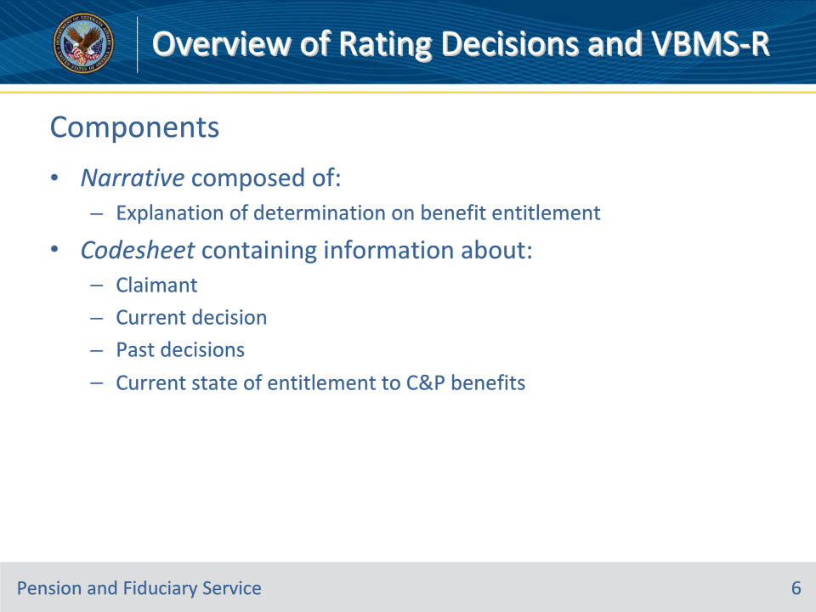
Slide notes

Policy Reference(s): M21-1 V.iv.1.A.1.c.

Instructor Notes:

The rating decision is composed of a Narrative explanation of the determination on benefit entitlement and a Codesheet containing information about the claimant, the current decision, past decisions, and the current state of entitlement to compensation and/or pension benefits.

Slide 7 - Components
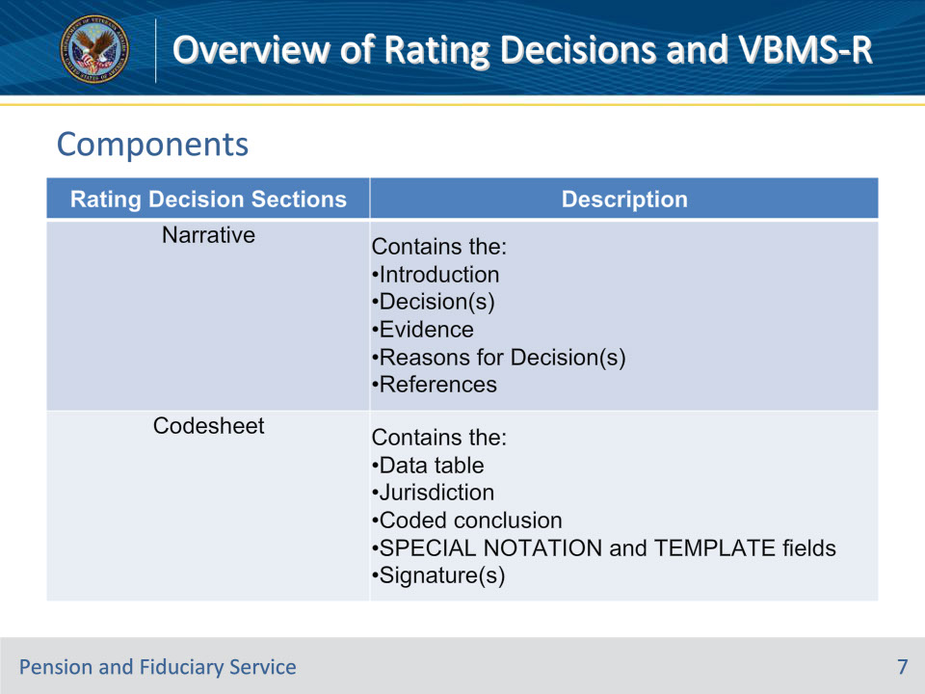
Slide notes

Policy Reference(s): M21-1 V.iv.1.A.1.d.

Instructor Notes:

This table provides information about the sections of a rating decision.

Slide 8 - VBMS-R
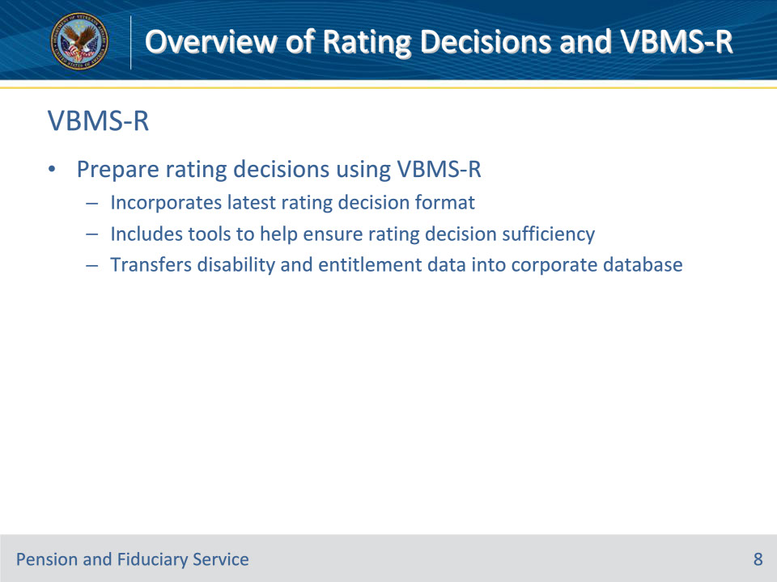
Slide notes

Policy Reference(s): M21-1 V.iv.1.A.1.e.

Instructor Notes:

Rating decisions are prepared using VBMS-R, which

• incorporates the latest rating decision format

• includes tools to help ensure rating decision sufficiency, and

• transfers disability and entitlement data into a corporate database of claimants who have applied for VA benefits.

Slide 9 - Uniformity
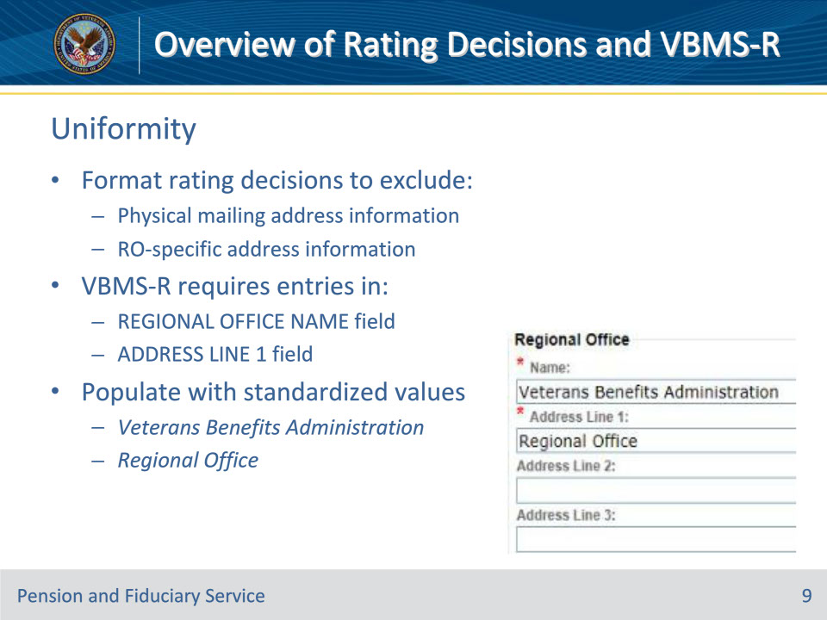
Slide notes

Policy Reference(s): M21-1 V.iv.1.A.1.f.

Instructor Notes:

To the maximum extent possible, rating decisions should be formatted to exclude physical mailing or RO-specific address information.

VBMS-R’s user configuration settings require mandatory entries in the REGIONAL OFFICE NAME and ADDRESS LINE 1 fields, which should be populated with the standardized values Veterans Benefits Administration and Regional Office, respectively, to promote uniformity.

Slide 10 - Introduction
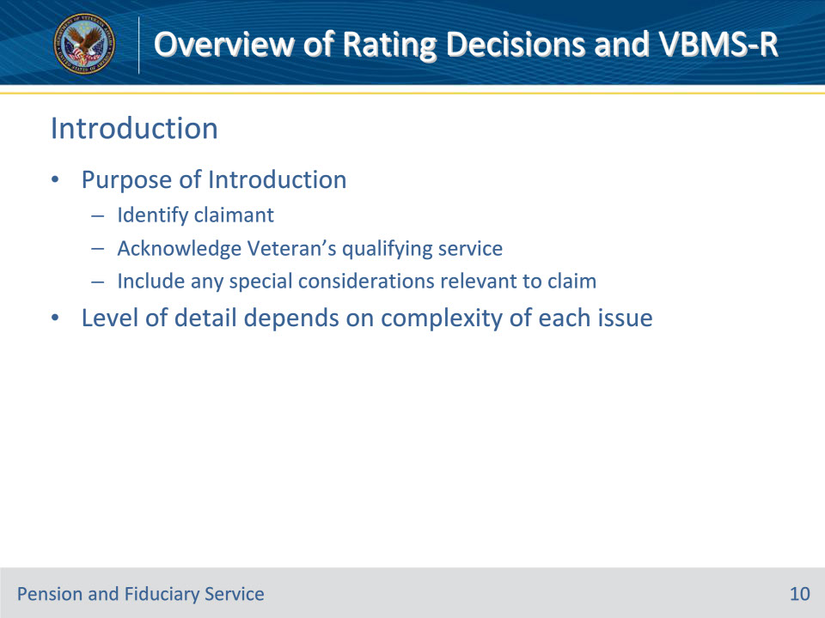
Slide notes

Policy Reference(s): M21-1 V.iv.1.A.2.a.

Instructor Notes:

The purpose of the Introduction is to

• identify the claimant, and

• acknowledge the Veteran’s qualifying service, including any special considerations relevant to the claim, such as former prisoner of war status.

The level of detail in the introduction depends on the complexity of each issue.

Slide 11 - Introduction
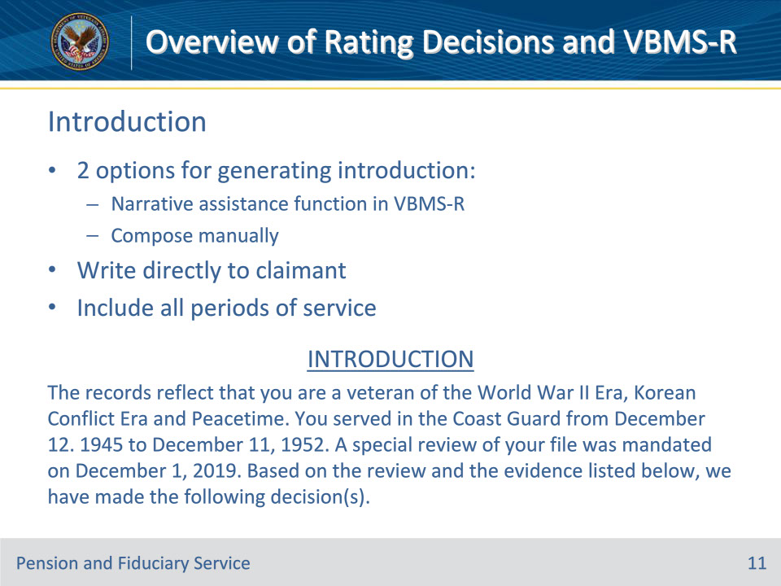
Slide notes

Policy Reference(s): M21-1 V.iv.1.A.2.b.

Instructor Notes:

The Introduction may be generated using the narrative assistance function in VBMS-R or may be composed manually. Use the guidelines listed below when manually composing the Introduction.

• Write directly to the claimant. “You” is acceptable usage.

• Include all periods of service. Use the format “month/day/year to month/day/year.”

Service dates must be checked for accuracy.

Slide 12 - Decision
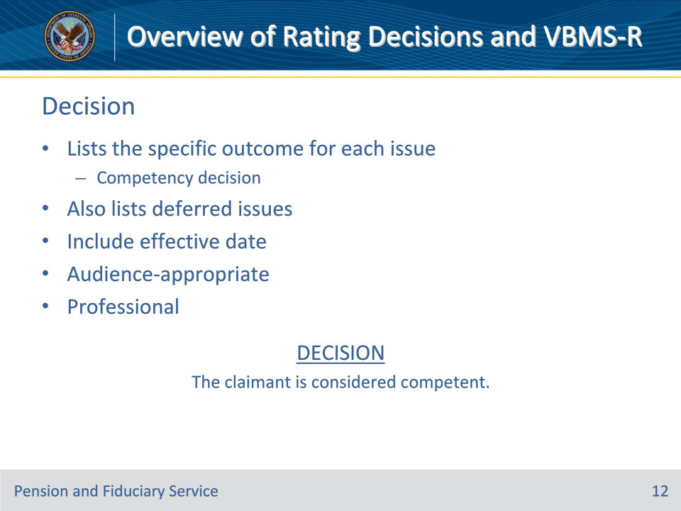
Slide notes

Policy Reference(s): M21-1 V.iv.1.A.3.a.

Instructor Notes:

The Decision section lists the specific outcome for each issue addressed, such as the final competency decision and the award or denial of

• service connection (SC)

• an increased evaluation, or

• an ancillary benefit, such as special monthly compensation (SMC).

Where at least one (but not every) issue must be deferred, the Decision will also list the deferred issue(s).

• For an award of SC, the disposition of the issue will include the evaluation assigned.

• For issues of SC, evaluation, and other award issues, the decision on the issue will include the effective date of the award.

• It is important that formatting of the text entered in VBMS-R’s DECISION field is audience-appropriate and professional with regard to spelling and capitalization because the exact text entered will be restated directly in the resulting Redesigned Automated Decision Letter (RADL).

Slide 13 - Evidence
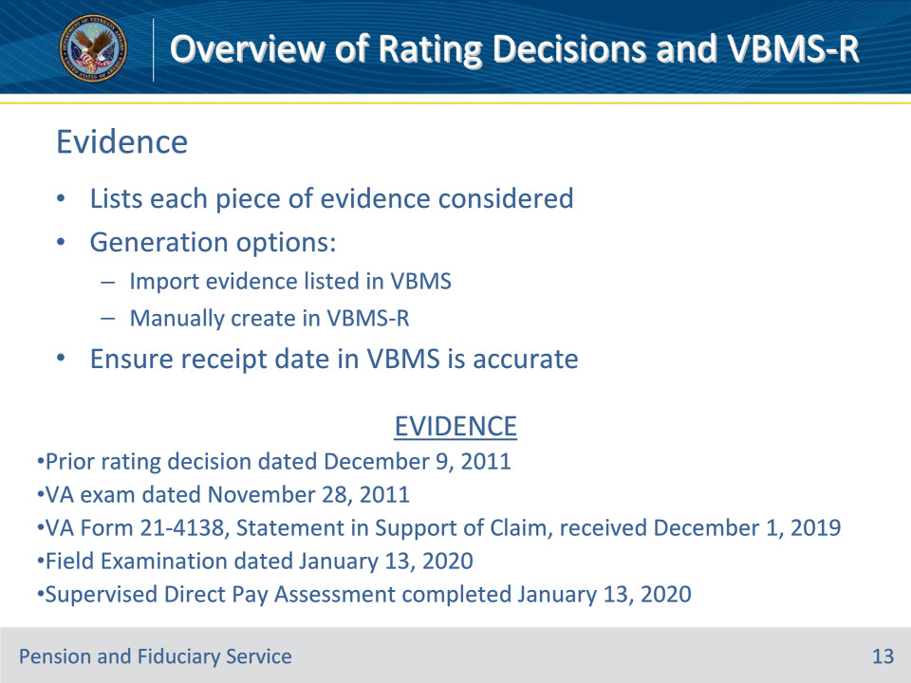
Slide notes

Policy Reference(s): M21-1 V.iv.1.A.4.

Instructor Notes:

The Evidence section is a listing of each piece of evidence considered in arriving at the decision.

The Evidence section can be generated by importing evidence listed in VBMS or can be manually created through user input in VBMS-R.

When importing evidence from VBMS, the Evidence list should always be checked for accuracy and completeness.

The date VA received evidence is often a factor when determining legal entitlement to benefits; consequently, decision makers must ensure the receipt date listed in VBMS is as accurate as possible for any evidence listed in a decision.

If an earlier date of receipt is discovered, edit the document properties in the electronic claims folder to show the correct date.

Slide 14 - Reasons for Decision
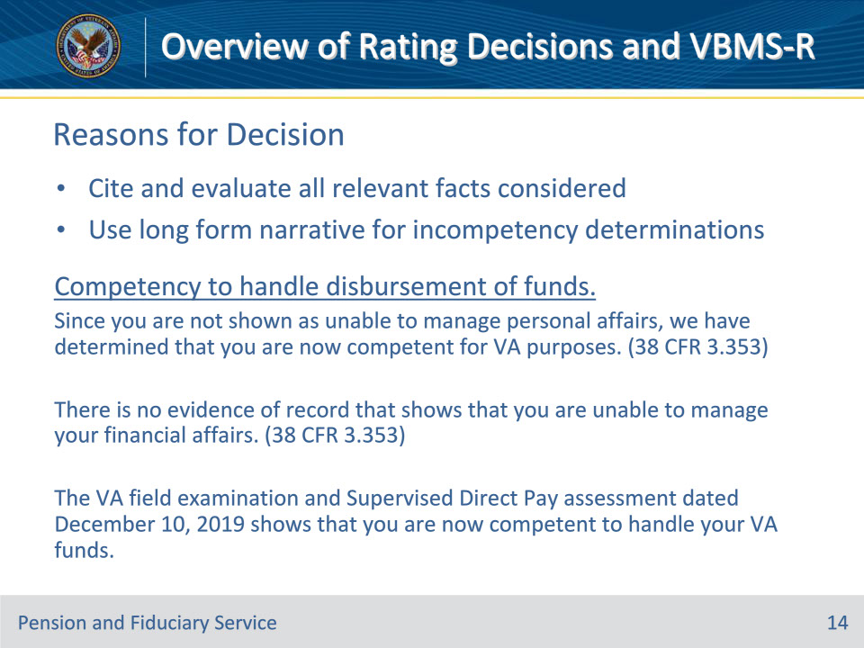
Slide notes

Policy Reference(s): M21-1 V.iv.1.A.5.a., b.; V.iv.1.A.7.a.

Instructor Notes:

The purpose of the Reasons for Decision is to concisely cite and evaluate all relevant facts considered in making the decision.

There are two basic Reasons for Decision formats: a short- and a long-form rating narrative. The distinction between the short- and long-form narrative formats is based on the level of analysis and case-specific detail required in the Reasons for Decision part of the rating decision.

The short-form rating narrative requires minimum explanation of the basic elements of the decision. It is characterized by standardized automated language and limited free text.

The long-form rating narrative requires more detailed analysis and explanation of the facts of a case with reference to specific elements found in the evidence. The Narrative section is generated by automated language from VBMS-R, with the addition of free text.

A rating decision may contain a mix of both the short-form narrative convention and the long-form.

A long-form rating narrative must be used in decisions involving final determinations of incompetency.

Slide 15 - References
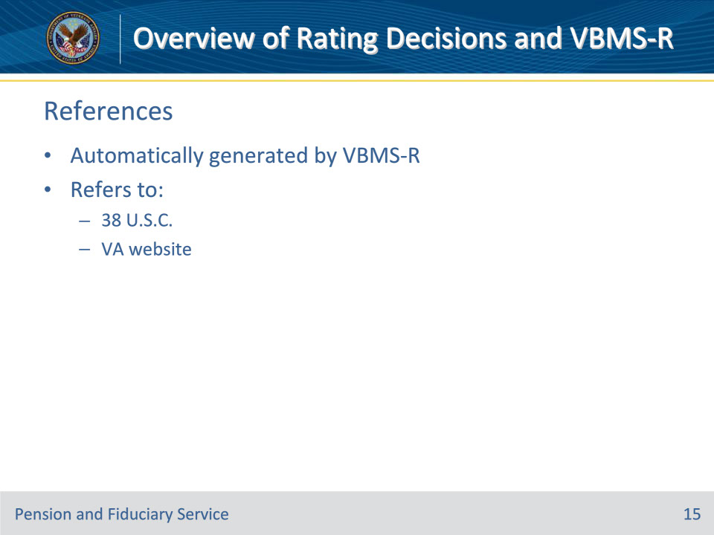
Slide notes

Policy Reference(s): M21-1 V.iv.1.A.8.a.

Instructor Notes:

The References section of the Narrative is automatically generated by VBMS-R. It refers the reader to 38 U.S.C., as well as the VA website, for the laws regarding VA benefits.

Slide 16 - Data Table and Jurisdiction
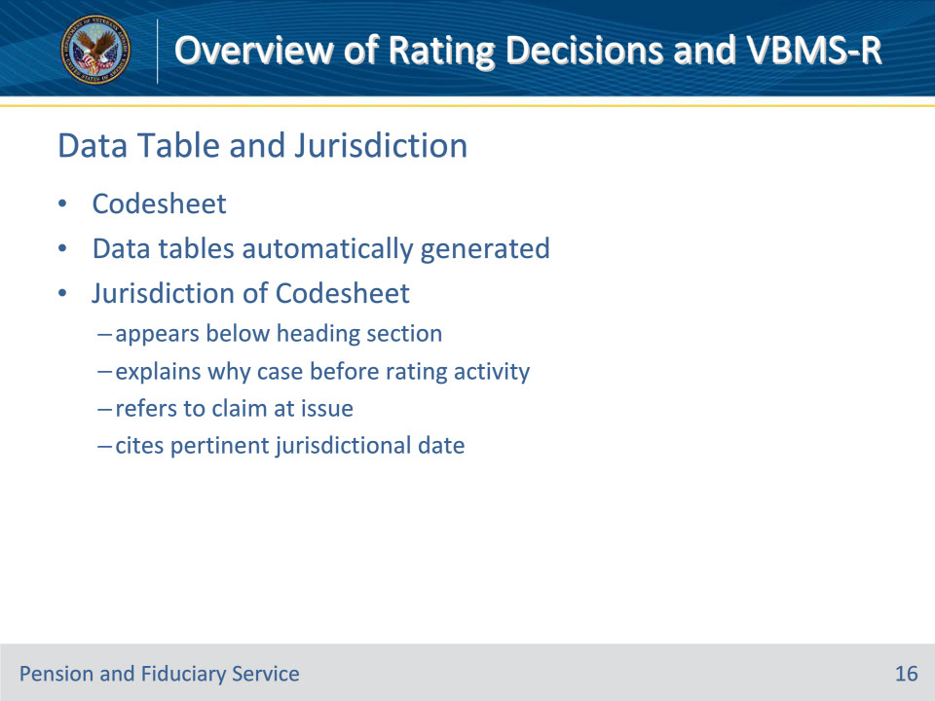
Slide notes

Policy Reference(s): M21-1 V.iv.1.B.1.a., b.

Instructor Notes:

The entries listed below are generated by the system in the fields of the data tables on the Codesheet based on user-entered data on the MASTER RECORD tab and/or DISABILITY DECISION INFORMATION screens.

• Active duty dates, branch, and character of discharge (COD)

• Additional service code

• Combat status code

• Special provision codes

• Future exam date

• Special monthly compensation (SMC) codes

The Jurisdiction of the Codesheet

• appears below the heading section

• explains why the case is before the rating activity

• refers to the claim at issue, and

• cites the pertinent jurisdictional date.

Slide 17 - Special Notations Field
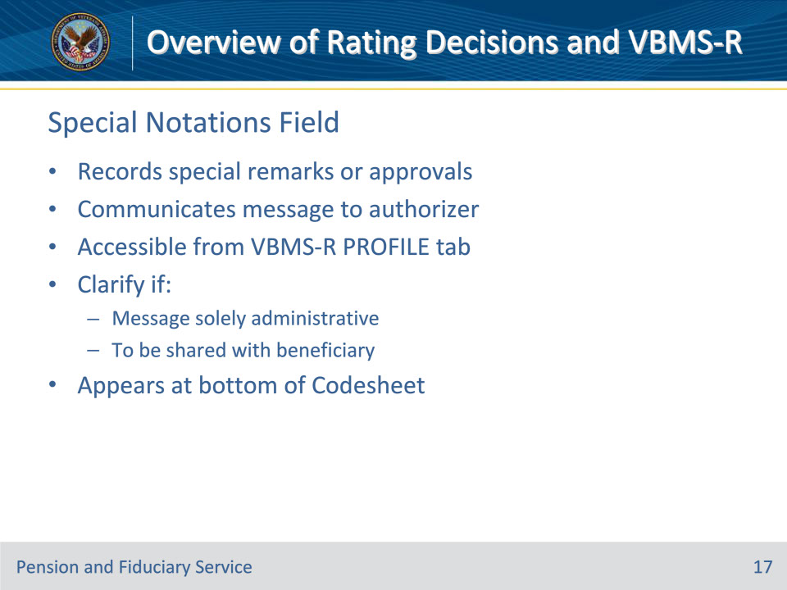
Slide notes

Policy Reference(s): M21-1 V.iv.1.B.6.a., b.

Instructor Notes:The primary purposes of notations made in the SPECIAL NOTATION field and the notification template fields on the Codesheet are to

• record special remarks or approvals applicable to the rating decision, and

• communicate an instruction or administrative message to the authorization activity.

All special notations and templates are generated through input in the PROFILE tab of VBMS-R.

Use the SPECIAL NOTATION field, accessible from VBMS-R’s PROFILE tab, to communicate an instruction or administrative message to the authorization activity. Clarify if the message is solely administrative (for example, Cancel the erroneously established EP 930) or to be shared with the beneficiary (for example, Tell the Veteran that the evaluation of his nephrolithiasis is currently awaiting higher-level review and will be addressed in a future decision).

The special notation text appears at the bottom of the Codesheet above the signature(s).

Slide 18 - Signature
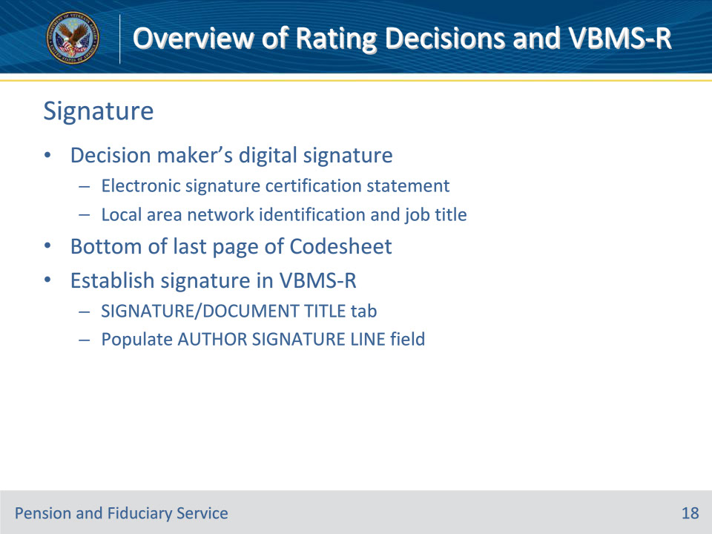
Slide notes

Policy Reference(s): M21-1 V.iv.1.B.7.a., b.

Instructor Notes:Rating decisions must contain the decision maker’s digital signature on the bottom of the last page of the Codesheet.

A rating decision signature is defined as

• an electronic signature certification statement, and

• the user’s

• local area network identification (LAN ID), and

• job title.

• If a rating decision requires more than one signature, the rating decision Codesheet must display the required additional signature fields.

• The signature of the decision maker(s) certifies that the claims folder was reviewed and all phases of the claims process leading to the decision were correctly handled.

The rating decision Codesheet must contain the standardized digital signature of the decision maker. “Wet signatures” are no longer required.

To establish the standardized digital signature, users should navigate to the SIGNATURE/DOCUMENT TITLE tab in VBMS-R’s options configurations, and populate the AUTHOR SIGNATURE LINE field.

Slide 19 - Coded Conclusion
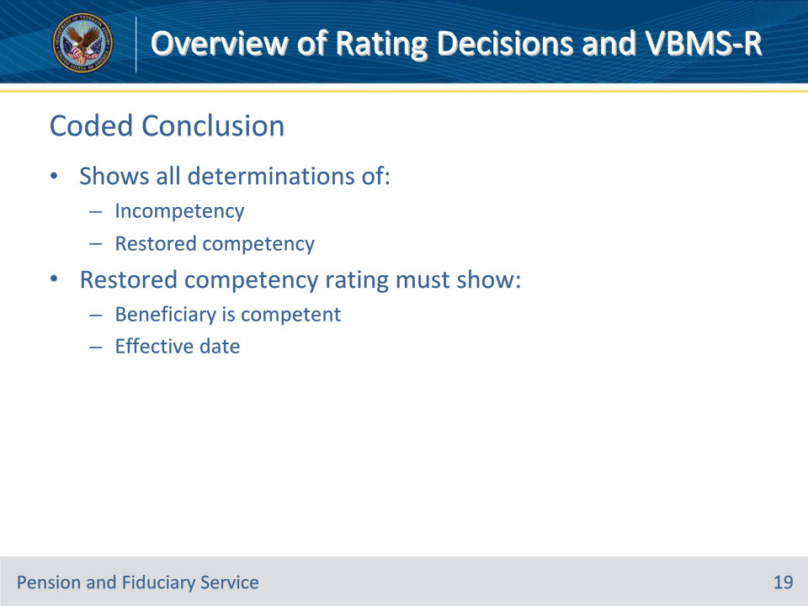
Slide notes

Policy Reference(s): M21-1 V.iv.1.C.1.a.; V.iv.1.C.6.c.

Instructor Notes:

A coded conclusion is the section of the Codesheet of a rating decision which contains:

• a summary of information on the status of benefits, and

• all decided issues.

The coded conclusion should show all determinations of incompetency and restored competency. Include competency determinations in any future ratings that bring forward compensation or pension coding.

If a previously incompetent beneficiary has regained competency

• prepare a rating to show

• that the beneficiary is competent, and

• the effective date of the determination

Slide 20 - Making the Decision
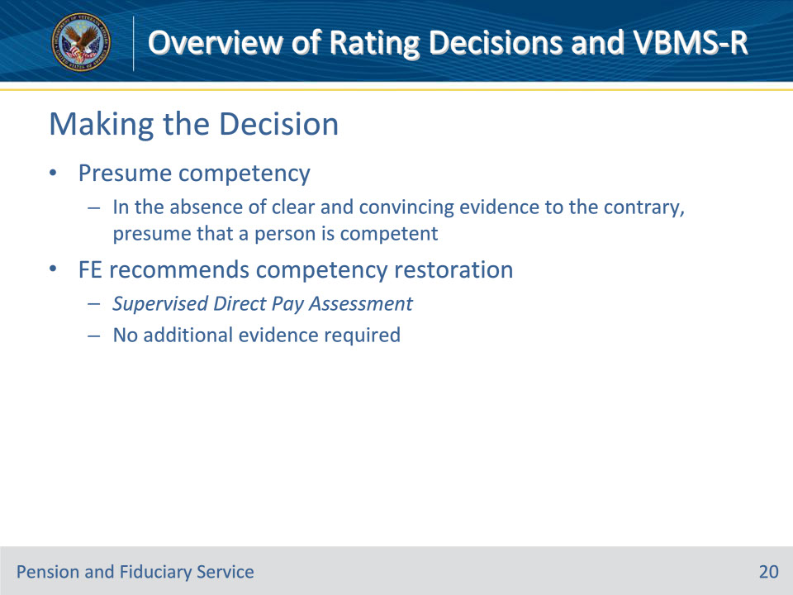
Slide notes

Policy Reference(s): M21-1 X.ii.6.A.1.c.; X.ii.6.A.4.d.

Instructor Notes:

In the absence of clear and convincing evidence to the contrary, presume that a person is competent. If the evidence appears to be in 50/50 balance, the FSR should decide in favor of the beneficiary and rate them competent.

When a field examiner recommends restoration of competency on a Supervised Direct Pay Assessment, and evidence is otherwise consistent with or does not conflict with the recommendation, no additional evidence is required to restore competency.

Slide 21 - Weighing the Evidence
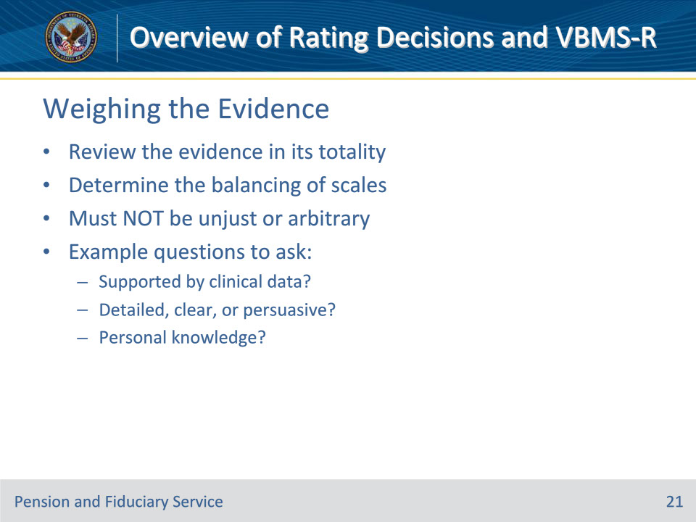
Slide notes

Policy Reference(s): M21-1 V.ii.1.A.5.a., b.

Instructor Notes:

After assigning weight to the evidence

• review the evidence in its totality, and

• determine the balancing of scales.

Do not assign weight unjustly or arbitrarily.

Below are examples of questions that should be asked when weighing evidence.

• Is the medical opinion supported by clinical data and review of medical records?

• How detailed, clear, or persuasive is the opinion?

• Is the opinion based on personal knowledge or on history provided by another person?

Slide 22 - Balance of Evidence
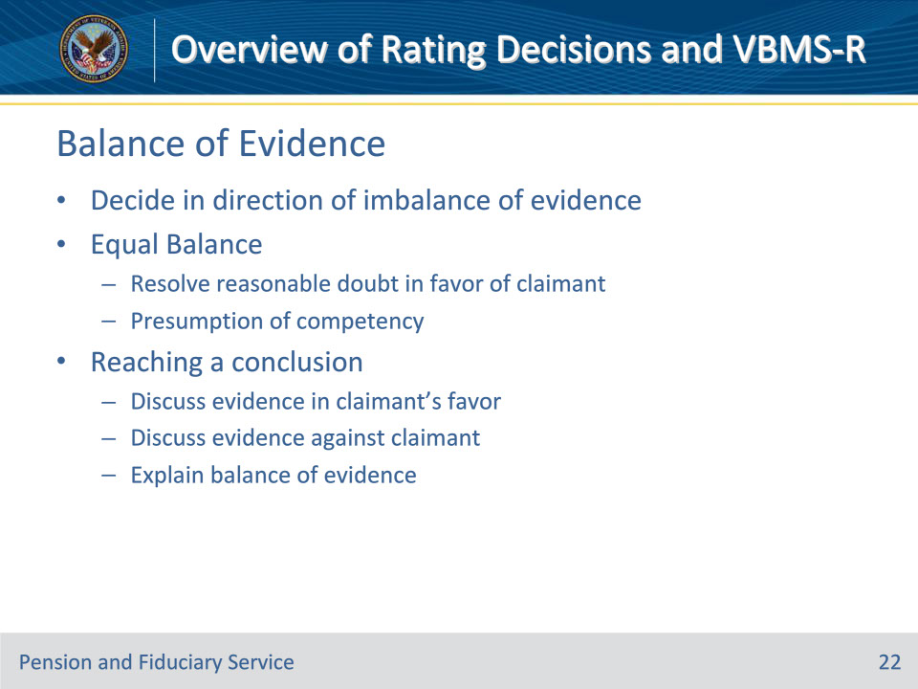
Slide notes

Policy Reference(s): M21-1 V.ii.1.A.5.c.-g.

Instructor Notes:

If the evidence shows an overwhelming imbalance, then the evidence requires a decision in that direction, either for or against awarding the claim. The claim must be awarded if all of the evidence is favorable.

Resolve reasonable doubt in favor of the claimant if all procurable evidence, after being weighed, is found in approximate balance or equipoise. 38 CFR 3.102 dictates that the Veteran prevails when the evidence neither satisfactorily proves nor disproves an issue.

Consider reasonable doubt only when the evidence is in equipoise, not when the evidence weighs either in favor or against the claimant.

After weighing the evidence to reach a conclusion,

• discuss the evidence in favor of the claim

• discuss the evidence against the claim to include any negative evidence, and

• explain that

• one set of evidence outweighs the other set, or

• the evidence is in equal balance for and against the claim.

Slide 23 - Evaluation of Evidence
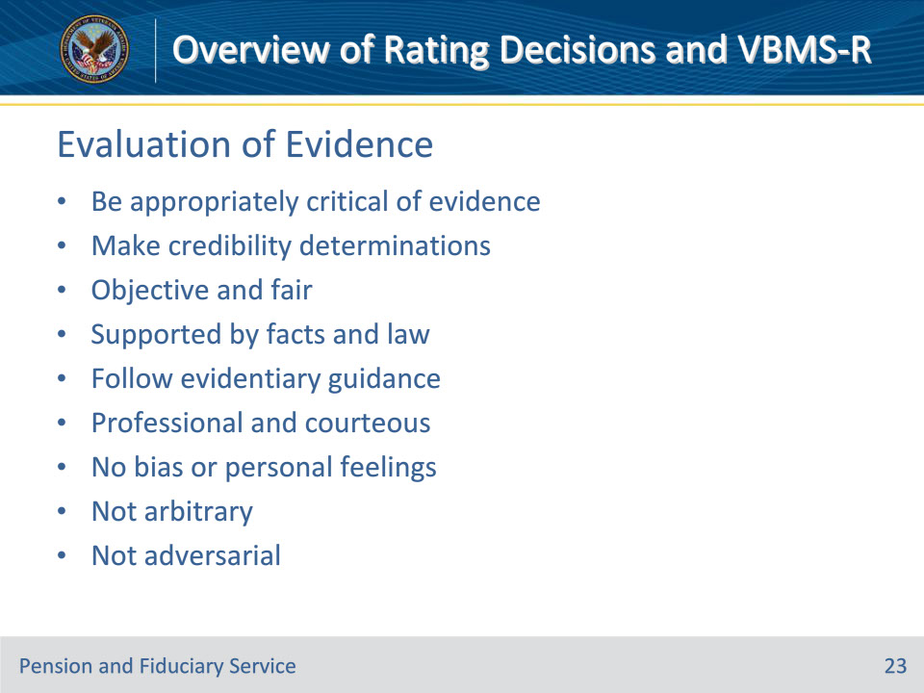
Slide notes

Policy Reference(s): M21-1 V.ii.1.A.6.a.

Instructor Notes:

When discussing the evaluation of evidence in a decision Narrative, VA decision makers are expected to be appropriately critical of the evidence and to make credibility determinations when credibility is raised by the available evidence.

Decision makers must

• be objective and fair in the consideration of evidence

• ensure that any inferences, findings, and conclusions made are supported under the facts and law

• follow evidentiary guidance

• be professional and courteous even when claimants are antagonistic, critical, or abusive

• not allow any bias or personal feelings into the evaluation of evidence or the decision

• not arbitrarily or capriciously refuse to assign weight to a claimant’s evidence, and

• not adopt or express an adversarial position towards a claimant or beneficiary.

Do not refer to the claimant or beneficiary as a liar. Where evidence is not credible, say that and cite facts of record in support.

Do not minimize the weight of a treating physician’s opinion based upon the idea that the physician has become an advocate for the patient since doing so may appear adversarial and biased.

Slide 24 - Veteran Competency Decisions
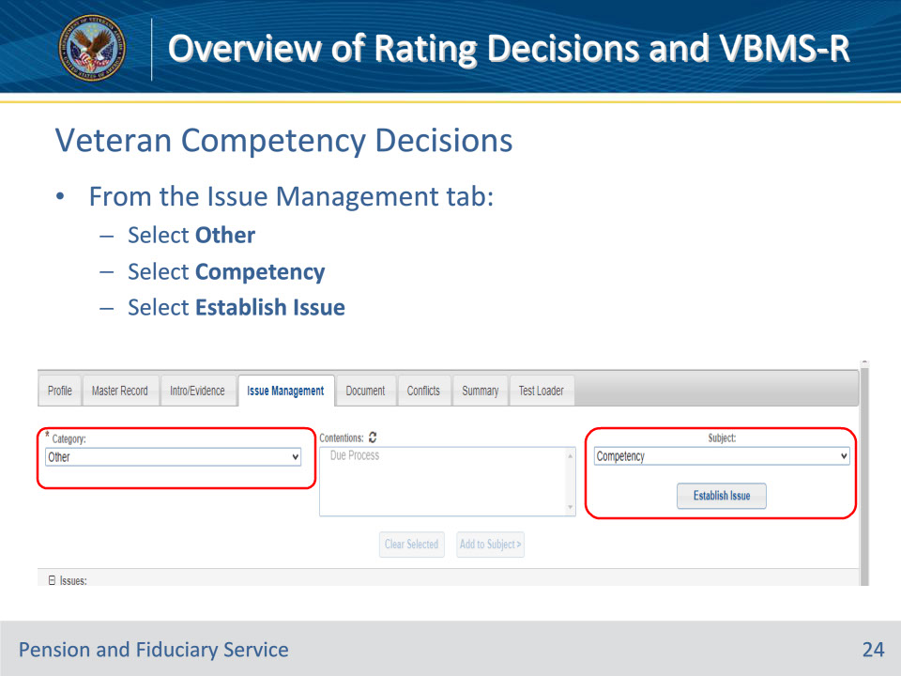
Slide notes

Policy Reference(s): VBMS-R User Guide

Instructor Notes:

The VBMS-R “Other Decisions” tab shows competency determinations. You can add, edit, or delete from this tab.

FSRs will complete the rating decision in VBMS-R. In order to manage a decision regarding competency in VBMS-R, the issue management tab is selected and “other” is selected under the category chevron. Once “Other” is selected as the category, a list of subjects will appear. Select competency as the subject. Competency will now appear on the issue list. Then select “Enter Decision” at the bottom of the screen. From here the adjudicator can make a finding of competent or incompetent.

The beneficiary’s competency information can also be accessed from the “Master Record” tab in VBMS-R. However, a decision will not be generated by editing the master record. In order to generate a competency-related decision, competency must be established as an issue under the “Issue Management Tab.”

Slide 25 - Veteran Competency Decisions (Cont.)
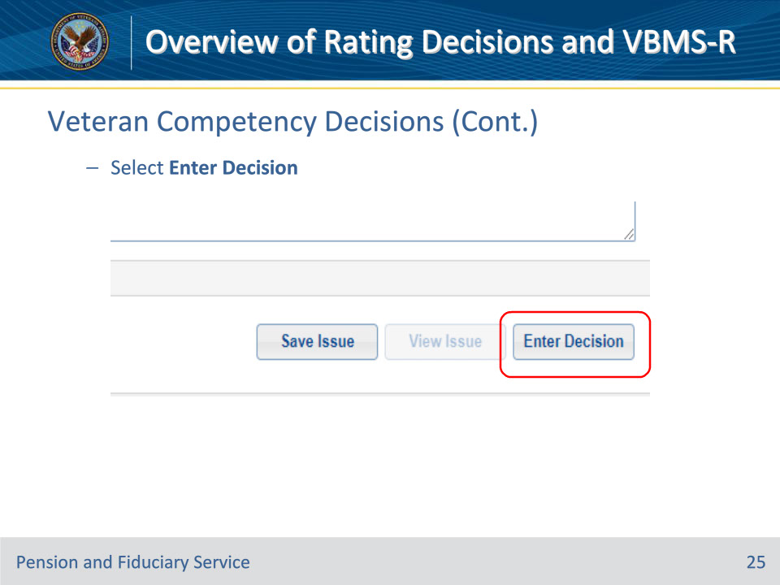
Slide notes

Policy Reference(s): VBMS-R User Guide

Instructor Notes:

The Enter Decision button is at the bottom right of VBMS-R.

Slide 26 - Veteran Competency Decisions (Cont. 2)
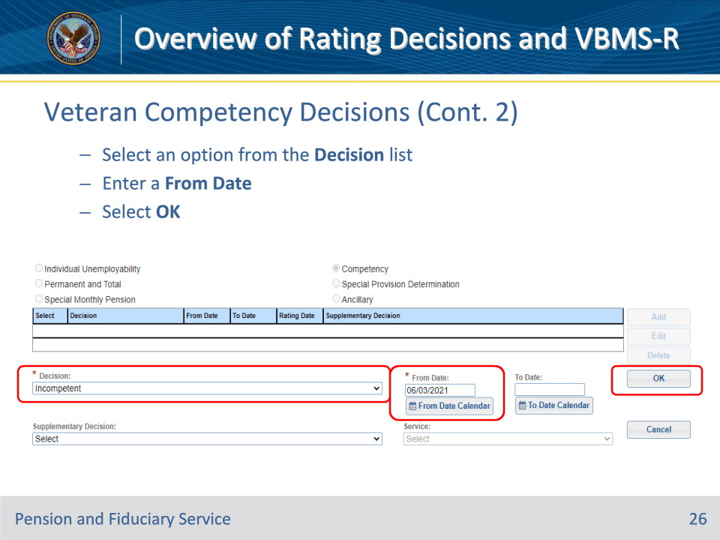
Slide notes

Policy Reference(s): VBMS-R User Guide

Instructor Notes:

Select the appropriate option from the Decision drop down list.

Enter the appropriate From Date.

Select OK when finished

Slide 27 - Veteran Competency Decisions (Cont. 3)
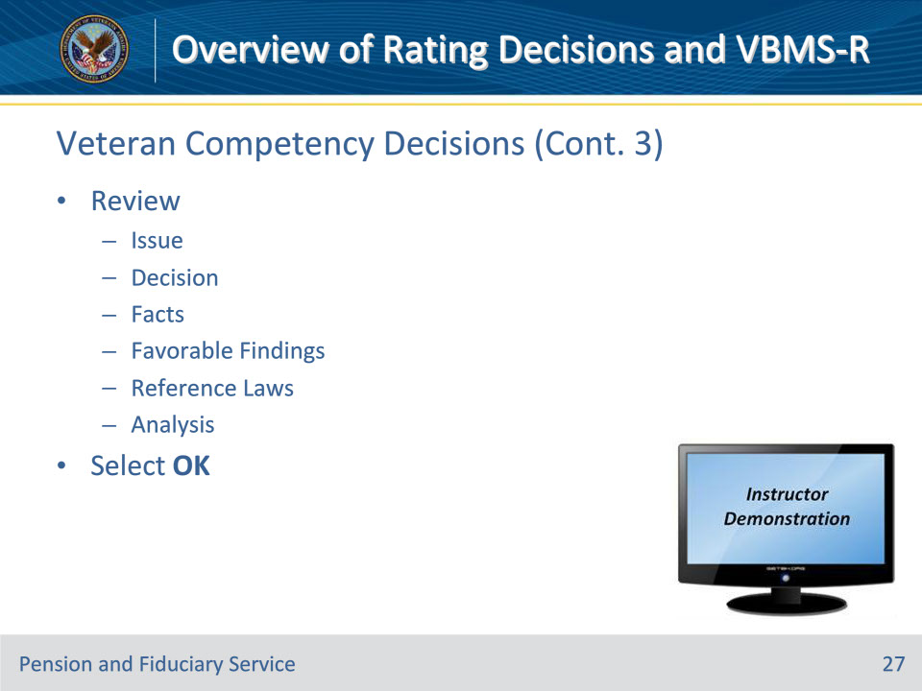
Slide notes

Policy Reference(s): VBMS-R User Guide

Instructor Notes:

On the next screen review the issue, decision, and the facts, favorable findings, Reference law, and Analysis tabs. Once complete, select OK.

Instructor Actions: Demo the information on the slide in VBMS-R

Slide 28 - Non-Veteran Competency Decisions
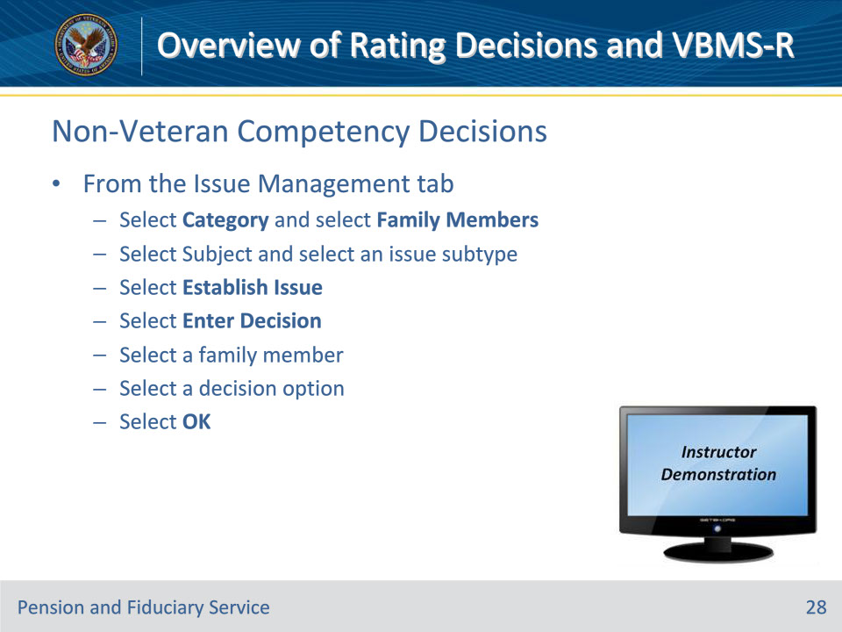
Slide notes

Policy Reference(s): VBMS-R User Guide

Instructor Notes:

From the “Issue Management” tab, you can enter and manage claim issues. For family members, select Competency from the subject list.

Instructor Actions: Demo the information on the slide in VBMS-R

Slide 29 - 31. Questions?
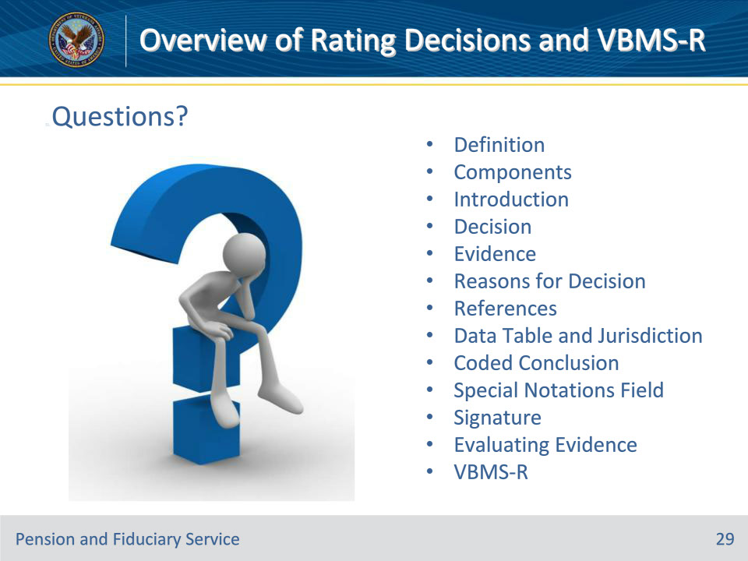
Slide notes

Instructor Notes:

(Recall) These are our learning objectives as stated from the beginning of the training:

• Define Rating Decision

• List the components of the Rating Decision

• Recall the role of VBMS-R

• Demonstrate how to complete a rating decision in VBMS-R

• Analyze evidence to make an accurate rating decision

(Recap) We discussed each of these learning objectives through the following topics in each slide today:

• Definition

• Components

• Introduction

• Decision

• Evidence

• Reasons for Decision

• References

• Data Table and Jurisdiction

• Coded Conclusion

• Special Notations Field

• Signature

• Evaluating Evidence

• VBMS-R

Are there any additional questions?

Questions should be filtered through your QRT team. They will submit your questions to the Field Inquiry Tool (FIT) on your behalf.

Slide 30 - TMS Survey/Assessment
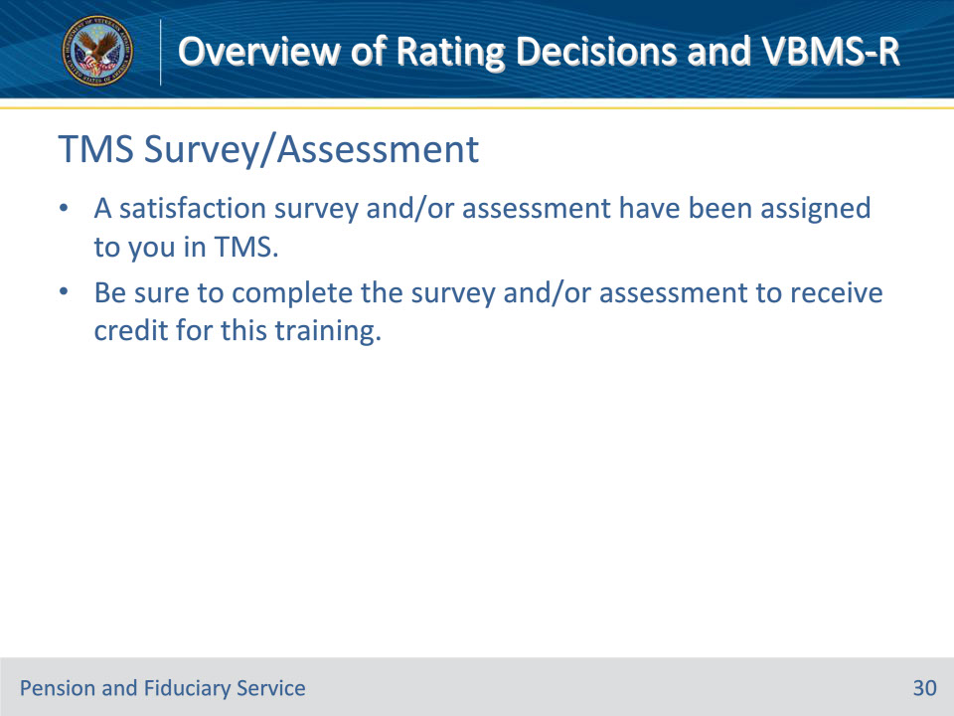
Slide notes

Instructor Notes:

A satisfaction survey and/or assessment have been assigned to you in TMS.

Be sure to complete the survey and/or assessment to receive credit for this training.

