Slide 1 - Final Determinations of Inability to Manage Financial Affairs
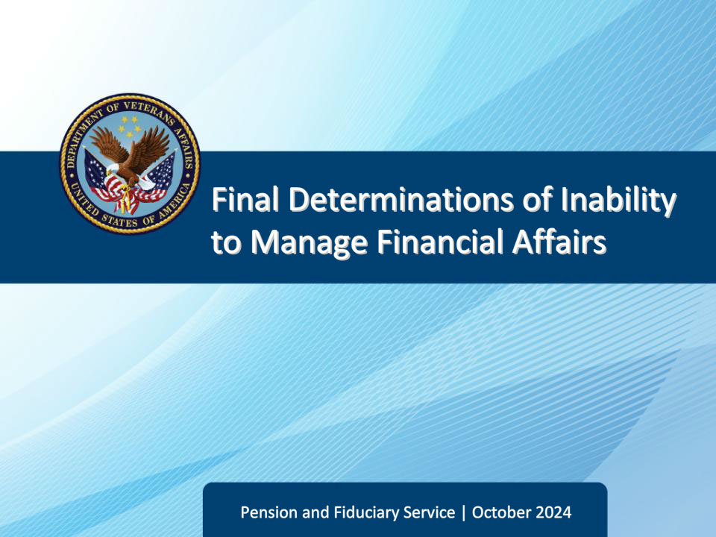
Slide notes

Course Description:

This course teaches learners an overview of the relevant concepts and procedures for processing final determinations of inability to manage financial affairs.

Slide 2 - Objectives
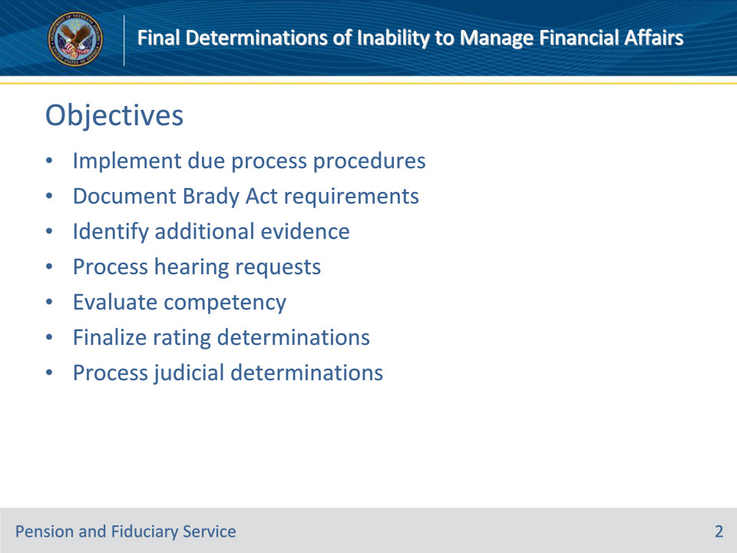
Slide notes

Instructor Notes:

At the end of this lesson, given the training and references, the learner will be able to do the following:

• Implement due process procedures

• Document Brady Act requirements

• Identify additional evidence

• Process hearing requests

• Evaluate competency

• Finalize rating determinations

• Process judicial determinations

Slide 3 - References
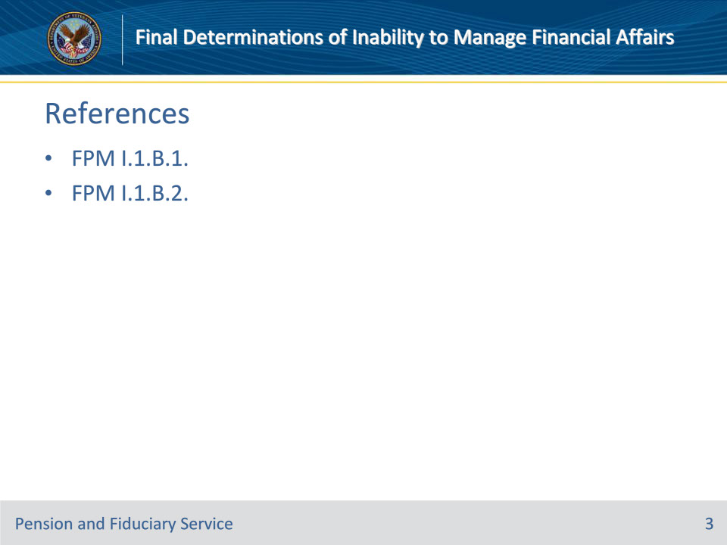
Slide notes

Instructor Notes:

These are the relevant references pertaining to this course:

• FPM I.1.B.1. Due Process and Beneficiary’s Rights

• FPM I.1.B.2. Request for Appointment of a Fiduciary, Custodian, or Guardian

Slide 4 - Proposal
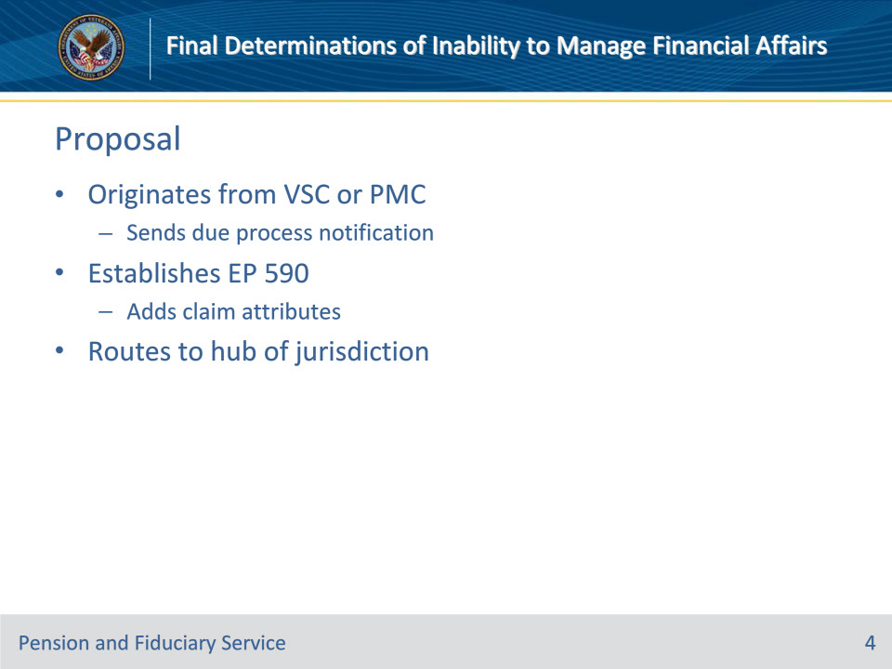
Slide notes

Policy Reference(s): FPM I.1.B.1.b.

Instructor Notes:

When the Department of Veterans Affairs (VA) makes a proposed determination of a beneficiary’s inability to manage VA benefits, the station of jurisdiction (SOJ) must notify the beneficiary of the proposed adverse action and its ramifications, and provide the beneficiary with the opportunity to

• submit additional evidence to contest the action, and

• hold a hearing before VA.

Upon completion of all actions associated with the proposal, the SOJ will

• establish an end product (EP) 590, if not automatically established by the system and

• add any necessary claim attributes (e.g., claim label, corporate flash, or special issue) and

• transfer the EP to the hub of jurisdiction, if National Work Queue (NWQ) routing does not occur

Slide 5 - Due Process
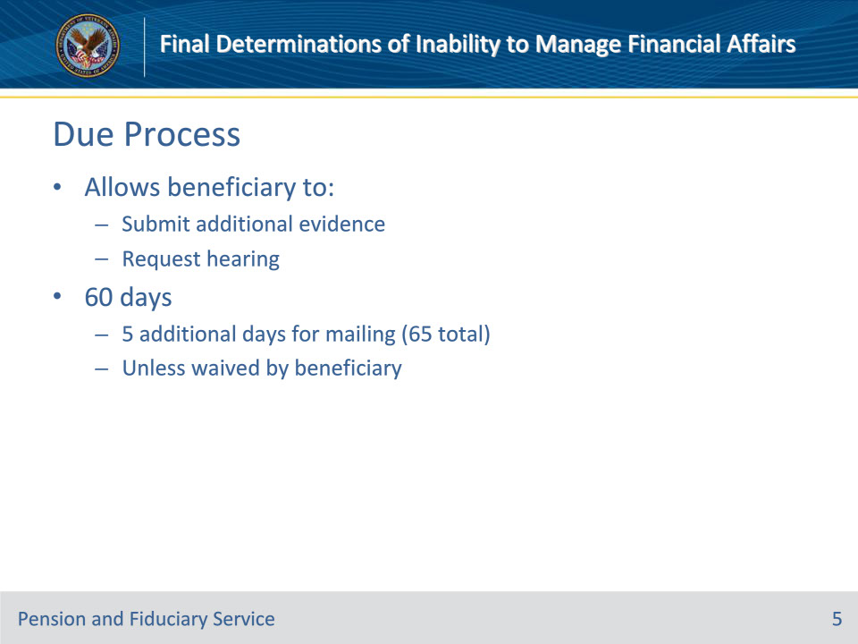
Slide notes

Policy Reference(s): FPM I.1.B.1.a.

Instructor Notes:

The due process period is the control period allotted for the beneficiary to submit additional evidence or request a hearing. The minimum due process period is 60 days, unless waived by the beneficiary. When a waiver is not received, finalization of the determination occurs after the 65th day to allow time for evidence to reach the fiduciary hub (hub).

Slide 6 - Calculating Due Process
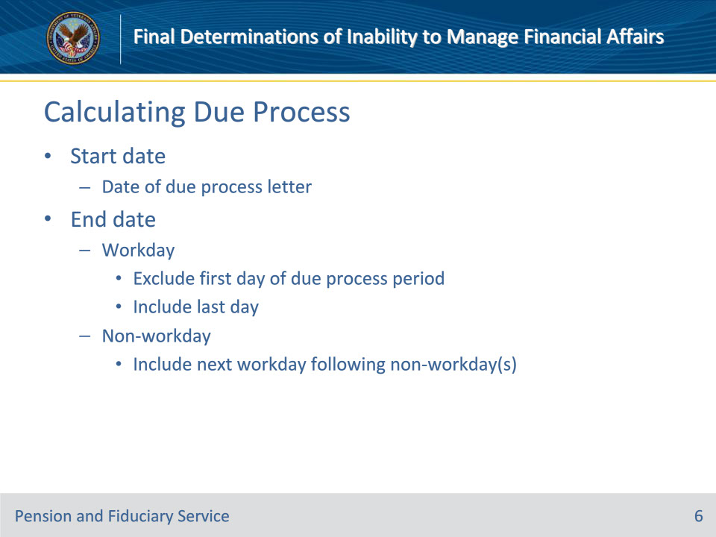
Slide notes

Policy Reference(s): FPM I.1.B.1.c.

Instructor Notes:

The due process period starts on the date of the proposed determination notification letter. Use the information below to compute the due process period:

If the due process period time limit expires on a workday, then exclude the first day of the due process period and include the last day.

If the due process period time limit expires on a Saturday, Sunday, or holiday, then include the next workday following the weekend or holiday.

Slide 7 - Missing Due Process Letter
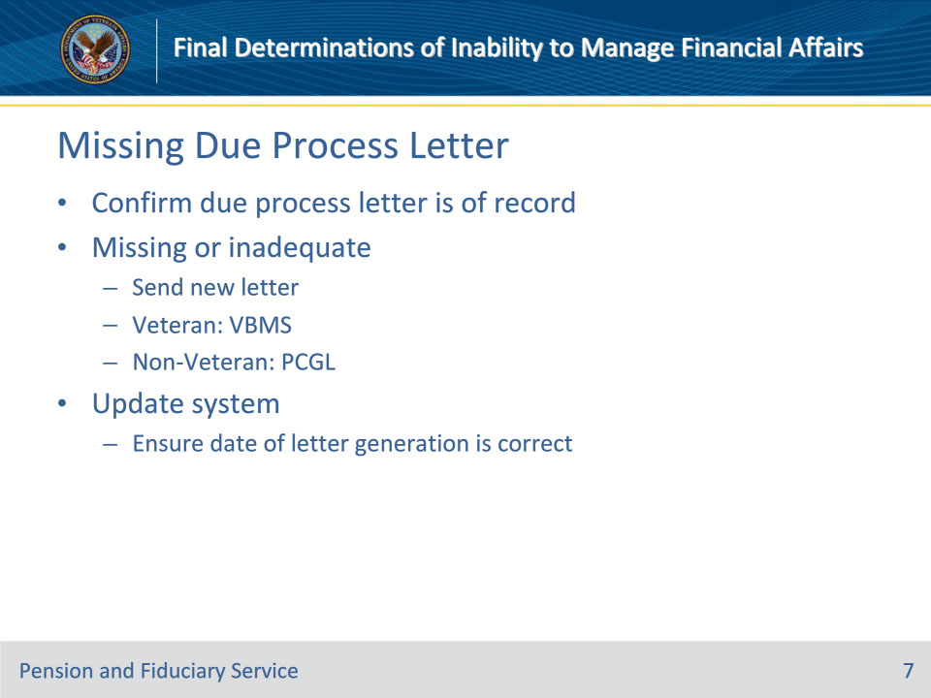
Slide notes

Policy Reference(s): FPM I.1.B.1.d.

Instructor Notes:

Hubs must confirm that the due process notification letter is of record.

If the letter is not of record or is inadequate, the hub must send a new proposal of incompetency letter. For a

• Veteran beneficiary, select the appropriate VBMS Core letter, or

• non-Veteran beneficiary select the PCGL predetermination incompetency template. (CP5 PRE: Incompetency)

Additionally, update the system to ensure that the date of notification letter generation is correct.

Slide 8 - Brady Act
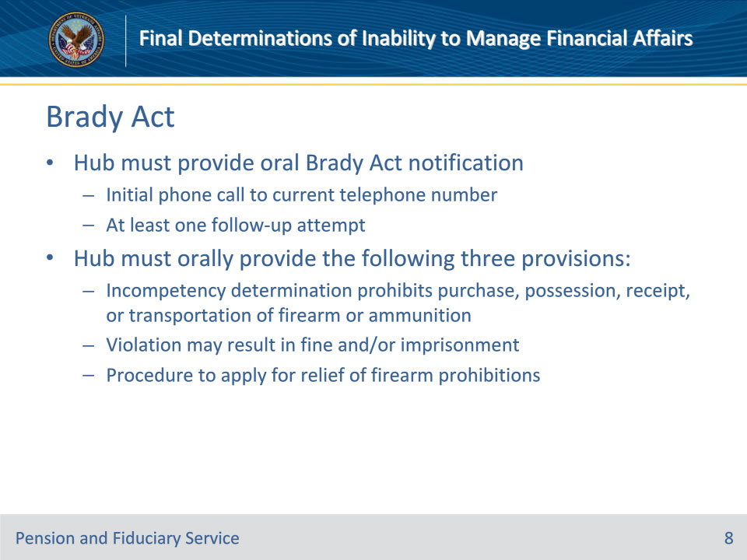
Slide notes

Policy Reference(s): FPM I.1.B.1.e.

Instructor Notes:

After verifying a notice of a proposed rating of incompetency is of record, or after receiving a court decree of incompetency or court appointment of a fiduciary by reason of a beneficiary’s incompetency, the hub must make reasonable efforts to contact the beneficiary by telephone for the purpose of providing the Brady Act oral notification. The hub must orally provide the following three provisions:

• a determination of incompetency will prohibit the purchase, possession, receipt, or transportation of a firearm or ammunition

• violation of the law may result in a fine and/or imprisonment, and

• to apply for relief of any firearm prohibitions resulting from the determination of incompetency, the beneficiary should submit a request to the RO.

Reasonable efforts generally consist of an initial telephone contact to the beneficiary’s current telephone number and at least one follow-up attempt if the initial attempt is unsuccessful.

Slide 9 - Brady Act
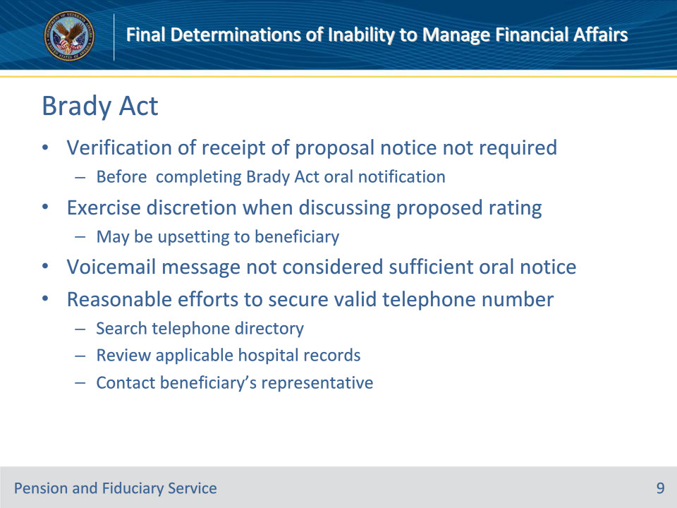
Slide notes

Policy Reference(s): FPM I.1.B.1.e.

Instructor Notes:

• It is not necessary to verify that the beneficiary has received the notice of a proposed rating of incompetency before completing the oral notification requirement.

• Exercise discretion when discussing the proposed rating with the beneficiary, as this type of notice may be upsetting to them.

• A voicemail message is not considered sufficient oral notice.

• If a current valid telephone number is not available for the beneficiary, use reasonable efforts to secure one, which may include

• searching the telephone directory

• reviewing applicable hospital records, and

• contacting the beneficiary’s representative.

Slide 10 - Documenting Brady Call
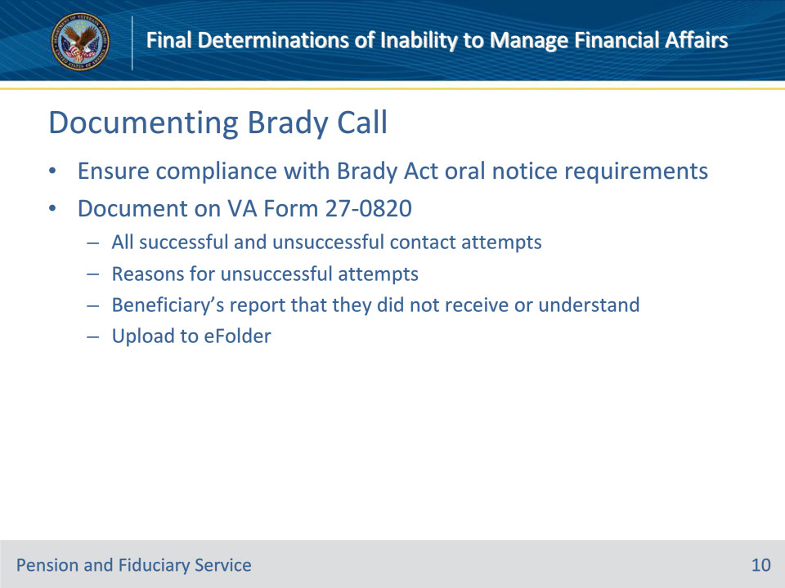
Slide notes

Policy Reference(s): FPM I.1.B.1.f.

Instructor Notes:

Hubs must ensure compliance with the requirement to give oral notice of the three provisions.

All successful and unsuccessful initial and follow-up contacts relating to the Brady Act telephone call with the beneficiary must be documented on a VA Form 27-0820, Report of General Information, and uploaded to the electronic claims folder (eFolder).

Note: The hub must also document on the VA Form 27-0820

• the reason(s) that oral delivery of the notice is unsuccessful, for example, the beneficiary is physically or mentally incapacitated, and/or

• a beneficiary’s report that they did not receive or understand the oral notice and that notice was provided as required.

Slide 11 - Waiver of Due Process
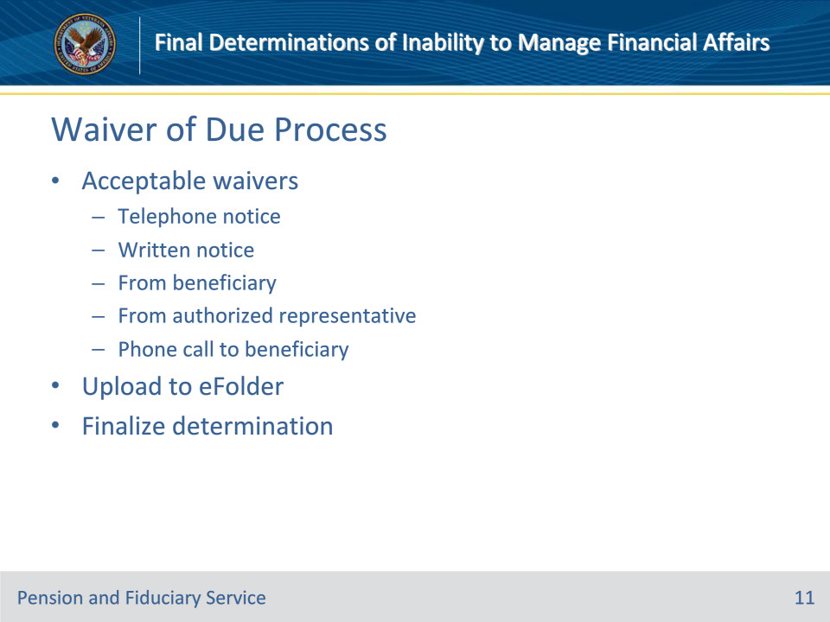
Slide notes

Policy Reference(s): FPM I.1.B.1.g.

Instructor Notes:

VA may accept a beneficiary’s waiver of due process

• by telephone or written notice from the beneficiary or their authorized representative, or

• during a telephone call to the beneficiary initiated by the hub as outlined on the next slide.

If VA receives a waiver of due process

• ensure the waiver is available in the beneficiary’s eFolder, and

• finalize the determination.

Slide 12 - Phone Call to Beneficiary
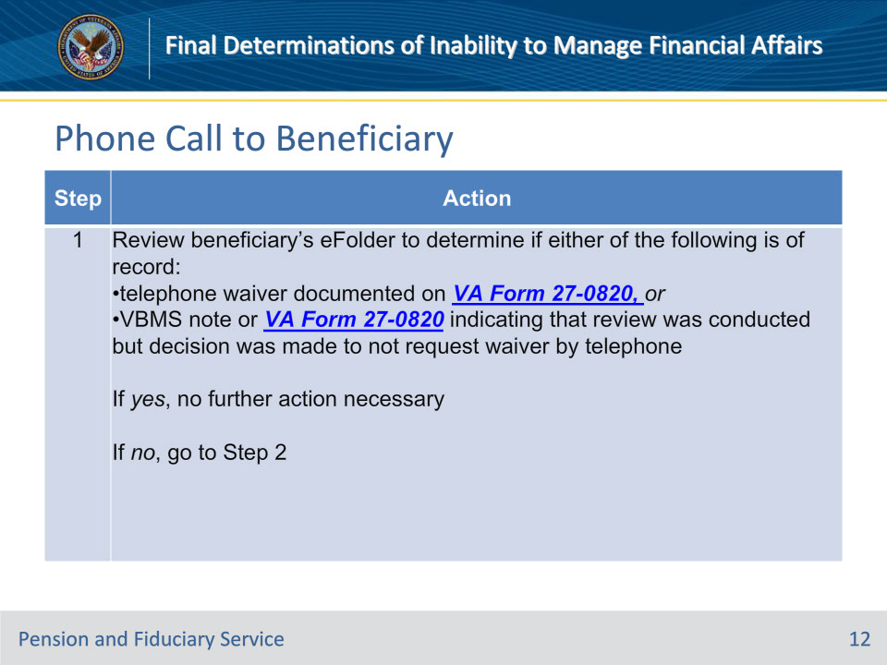
Slide notes

Policy Reference(s): FPM I.1.B.1.g.

Instructor Notes:

Follow the steps in this table if the hub initiates a waiver of due process, by telephone, to the beneficiary.

Slide 13 - Phone Call to Beneficiary
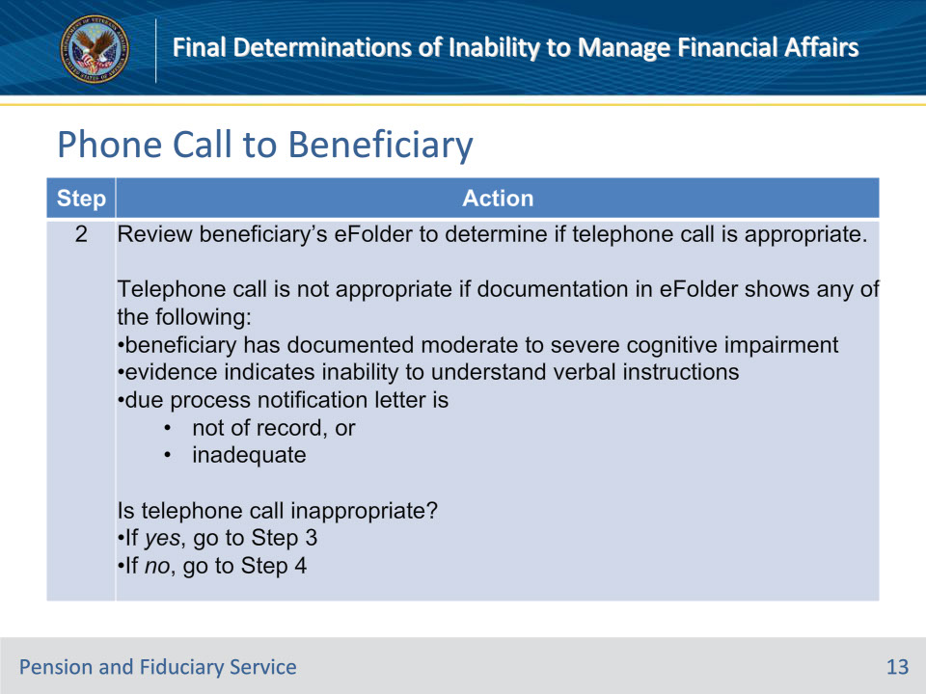
Slide notes

Policy Reference(s): FPM I.1.B.1.g.

Instructor Notes:

Follow the steps in this table if the hub initiates a waiver of due process, by telephone, to the beneficiary.

Slide 14 - Phone Call to Beneficiary
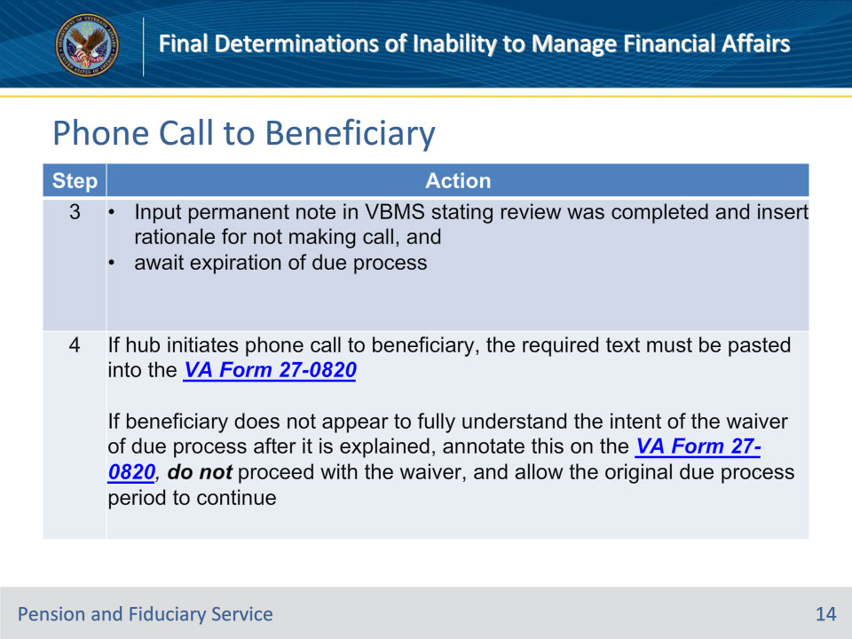
Slide notes

Policy Reference(s): FPM I.1.B.1.g.

Instructor Notes:

Follow the steps in this table if the hub initiates a waiver of due process, by telephone, to the beneficiary.

Required Text for Step 4:

I certify I reviewed the proposal of incompetency letter and have verified it is correct.

I certify I advised the beneficiary of the date of the proposal of incompetency letter.

I certify I advised the beneficiary of the date due process would expire if no waiver was obtained.

I certify the beneficiary acknowledged that their waiver of due process would lead to a final determination of their inability to manage their financial affairs.

The beneficiary communicated their waiver of due process in their own words as follows: [Insert a summary of how the beneficiary expressed their waiver of due process].

Additional call notes:

Notes for Step 4:

• The official statement of a beneficiary’s waiver of due process should be more than a single word. The summary of how the beneficiary expressed their waiver of due process should demonstrate the beneficiary’s understanding of the waiver.

• If the beneficiary instructs the caller to speak with another individual during the call, the call may continue. However, when the call reaches the point of requiring the beneficiary’s official waiver of due process, the beneficiary must be the one providing such waiver.

Slide 15 - Phone Call to Beneficiary
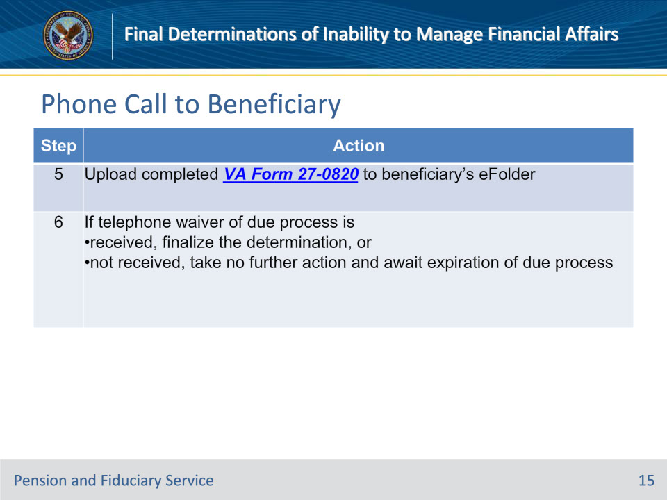
Slide notes

Policy Reference(s): FPM I.1.B.1.g.

Instructor Notes:

Follow the steps in this table if the hub initiates a waiver of due process, by telephone, to the beneficiary.

Slide 16 - Additional Evidence
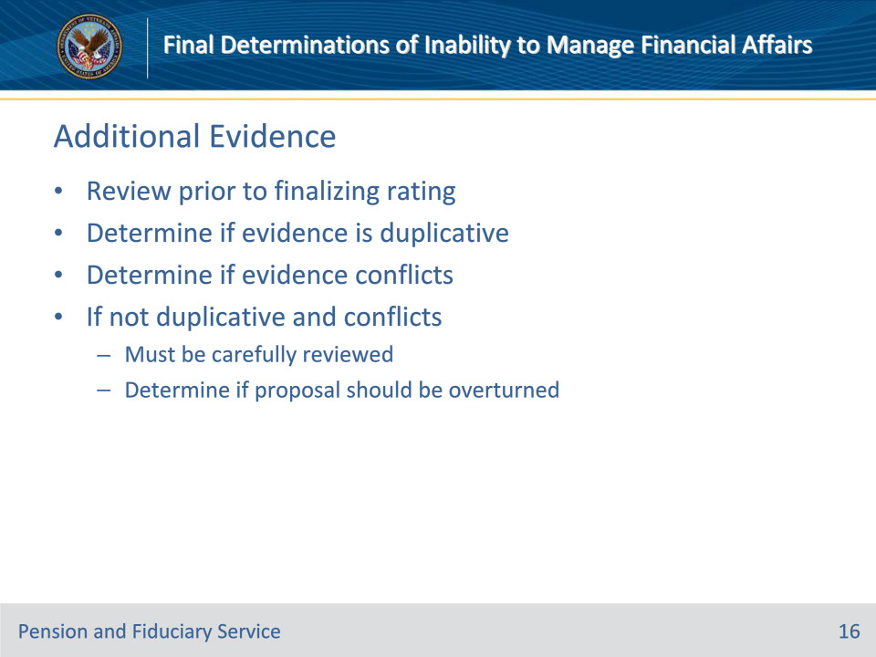
Slide notes

Policy Reference(s): FPM I.1.B.1.h.

Instructor Notes:

If VA receives a request for a hearing or additional evidence during the due process period that relates to the issue of inability to manage affairs, and such evidence may affect the outcome of the rating decision, the hub must review the evidence prior to finalizing the rating.

Upon review of the evidence, the Fiduciary Service Representative (FSR) must determine if the additional evidence is duplicative. Duplicate evidence is any evidence that was reviewed in conjunction with the proposed rating and is described in the proposed rating decision and/or the beneficiary notification letter.

If the evidence is not duplicative, the FSR must then consider whether the evidence conflicts with the proposal of incompetency. New evidence that is not duplicative and also conflicts with the proposed decision of the beneficiary’s inability to manage his/her VA benefit must be carefully reviewed. The FSR will determine if the proposed rating should be overturned, and the beneficiary rated as able to manage their affairs without limitation.

Slide 17 - Hearing Requests
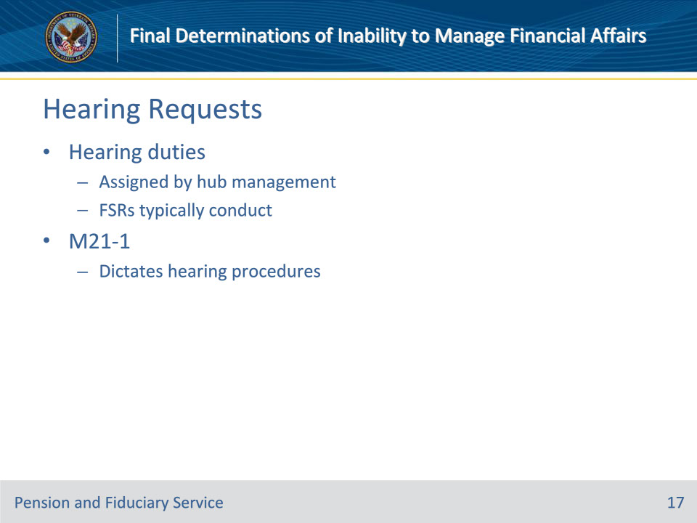
Slide notes

Policy Reference(s): FPM I.1.B.1.i.

Instructor Notes:

Hub management assigns hearing duties for hub hearings. FSRs will typically conduct all hearings requested in connection with the incompetency proposal unless an exceptions applies.

Unless otherwise specified, the hub shall follow the hearing guidance in the M21-1.

Slide 18 - Rights and Representation
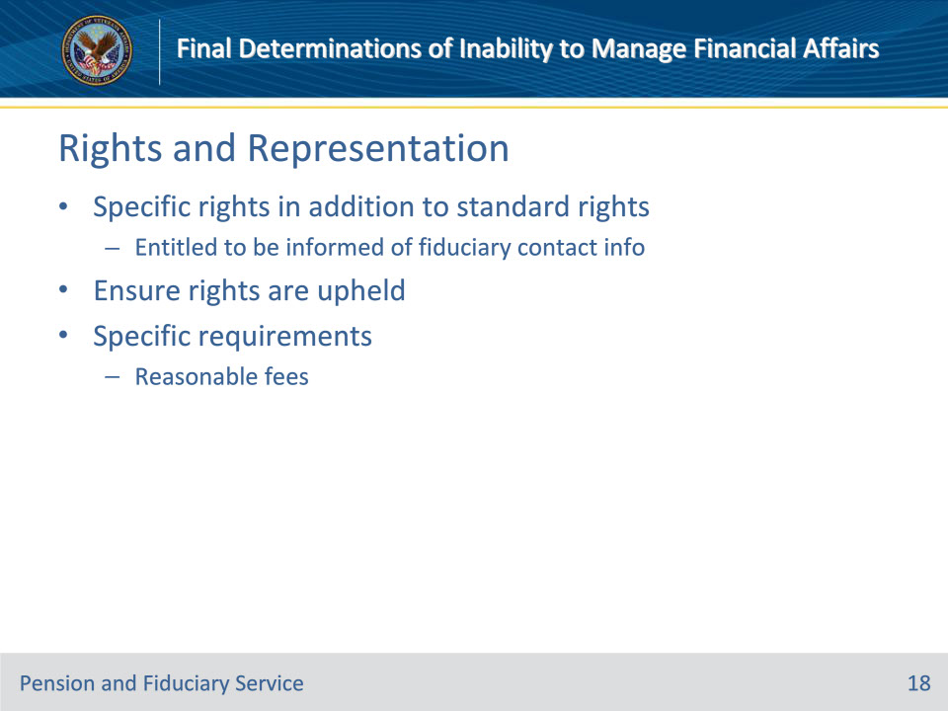
Slide notes

Policy Reference(s): FPM I.1.B.1.j.

Instructor Notes:

Beneficiaries within the Fiduciary Program have specific rights in addition to the standard rights applicable to all VA beneficiaries. For example, the beneficiary is entitled to be informed of the fiduciary’s contact information.

Hub personnel must always ensure these rights are upheld for all beneficiaries within the Fiduciary Program.

Beneficiaries within the Fiduciary Program have specific requirements to be followed by those who represent them before VA. For example, reasonable fees are authorized to the fiduciary when regulatory criteria are met.

Slide 19 - Evaluating Competency
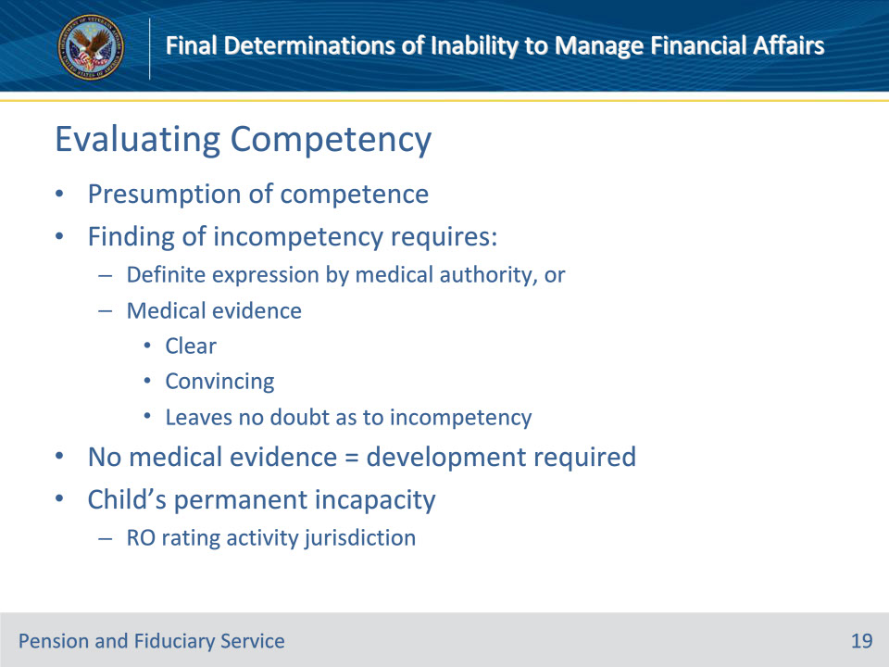
Slide notes

Policy Reference(s): FPM I.1.B.2.f.

Instructor Notes:

In the absence of clear and convincing evidence to the contrary, presume that a person is competent.

A finding of incompetency cannot be made without a definite expression by a responsible medical authority unless the medical evidence of record is

• clear

• convincing, and

• leaves no doubt as to the beneficiary’s incompetency.

If competency of a beneficiary is raised without relevant medical evidence or statement from a responsible medical authority, development must be undertaken for medical evidence before the case can be forwarded for a decision.

The question of a child’s permanent incapacity is one of fact for determination by the rating activity based on competent evidence of record. The RO rating activity is responsible for reviewing the evidence and completing a rating decision to determine whether a child beneficiary is permanently incapable of self-support and competent to manage their financial affairs

Slide 20 - Finalizing Determinations
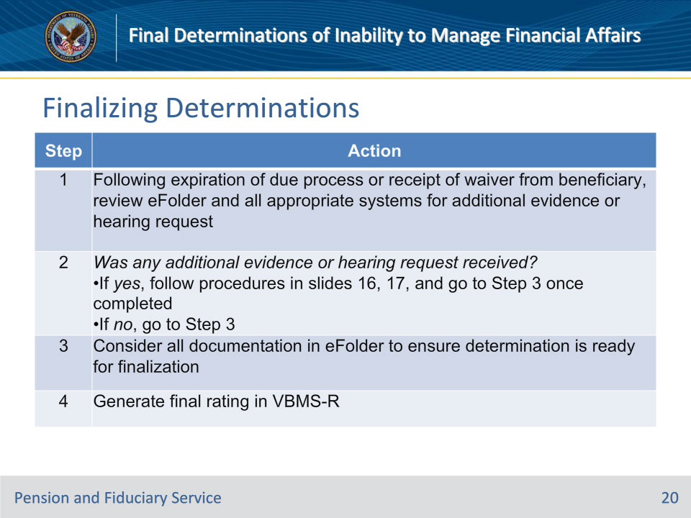
Slide notes

Policy Reference(s): FPM I.1.B.2.g.

Instructor Notes:

The hub finalizes the determination of the beneficiary’s inability to manage VA benefits (unless an exception applies) and sends the final decision notification letter.

Follow the steps in this table to finalize the determination of a beneficiary’s inability to manage VA benefits when the proposal was based on medical evidence.

Slide 21 - Finalizing Determinations
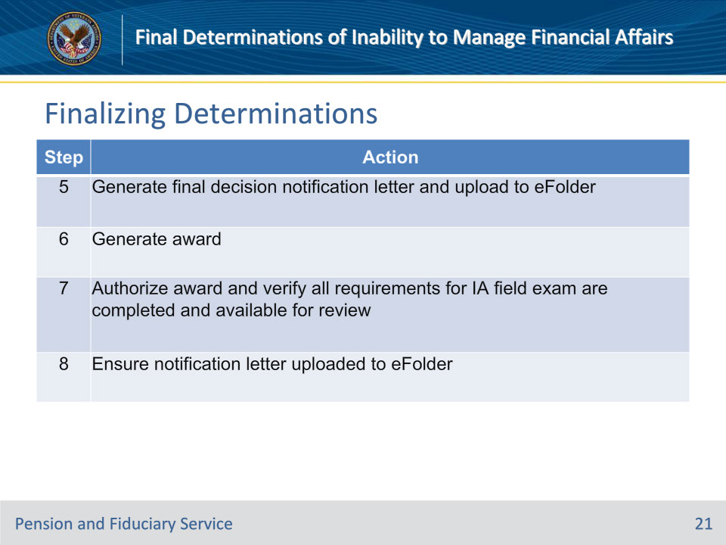
Slide notes

Policy Reference(s): FPM I.1.B.2.g.

Instructor Notes:

Follow the steps in this table to finalize the determination of a beneficiary’s inability to manage VA benefits when the proposal was based on medical evidence.

Notes for Step 7:

• Authorization of the award must be performed by an FSR other than the FSR who generated the award in Step 6.

• At authorization, the system will automatically establish

• the beneficiary profile if one is not already within the system, and

• an EP 590 Initial Appointment Field Examination.

Note for Step 8: Final decisions of a beneficiary’s inability to manage benefits are not subject to review by a Veterans service organization.

Slide 22 - Finalizing Determinations
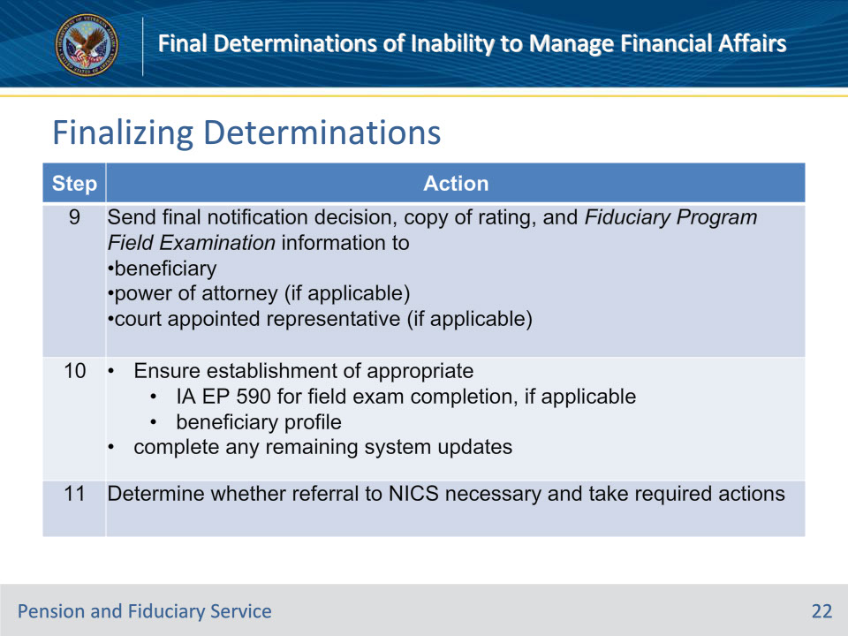
Slide notes

Policy Reference(s): FPM I.1.B.2.g.

Instructor Notes:

Follow the steps in this table to finalize the determination of a beneficiary’s inability to manage VA benefits when the proposal was based on medical evidence.

Slide 23 - Review of eFolder
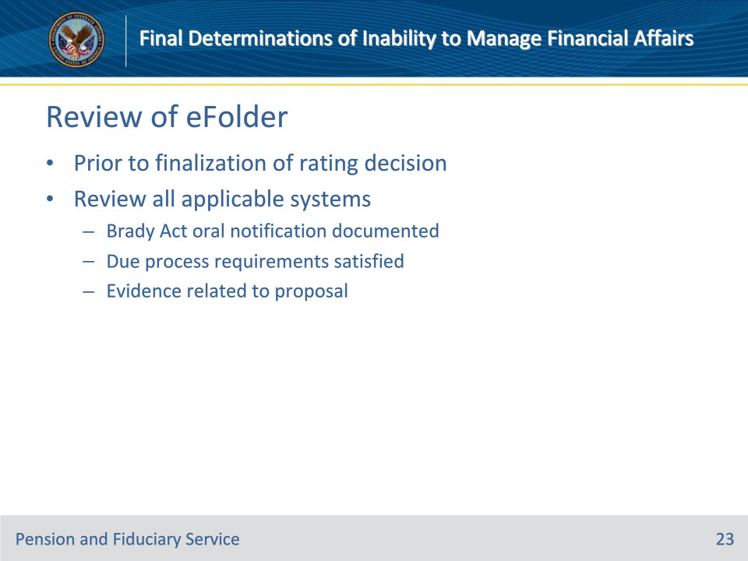
Slide notes

Policy Reference(s): FPM I.1.B.2.h.

Instructor Notes:

Prior to finalization of the rating decision, FSRs must review the eFolder and all applicable electronic systems to ensure:

• oral notification of rights under the Brady Act are documented, and

• due process requirements have been satisfied, as follows:

• due process rights have been waived by the beneficiary, or

• due process period has expired.

Review the evidence related to the proposed rating and any new evidence received.

Slide 24 - Elements of Final Rating
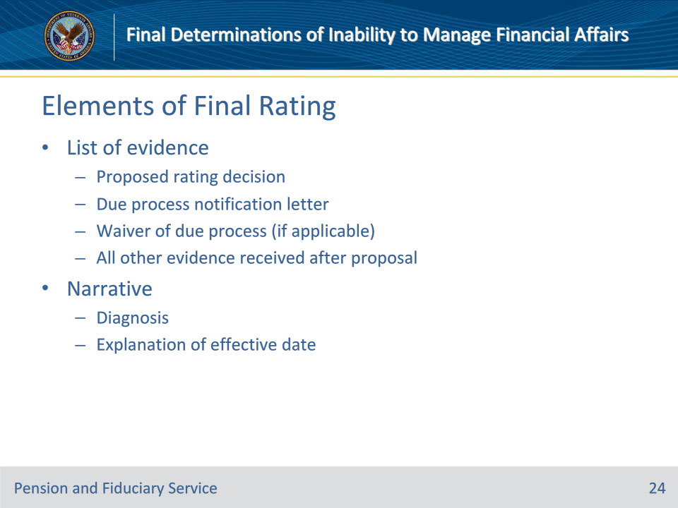
Slide notes

Policy Reference(s): FPM I.1.B.2.i.

Instructor Notes:

The final rating decision includes:

• a list of evidence that contains the

• proposed rating decision

• due process notification letter

• waiver of due process (if received), and

• all other evidence received after the proposed rating decision that does not conflict with the proposal, and

• a narrative that contains the

• diagnosis, and

• explanation of the effective date, which is the date of the final decision.

If the facts contained in the proposed rating decision are complete, do not repeat the facts in the final rating decision.

Slide 25 - Elements of Notification Letter
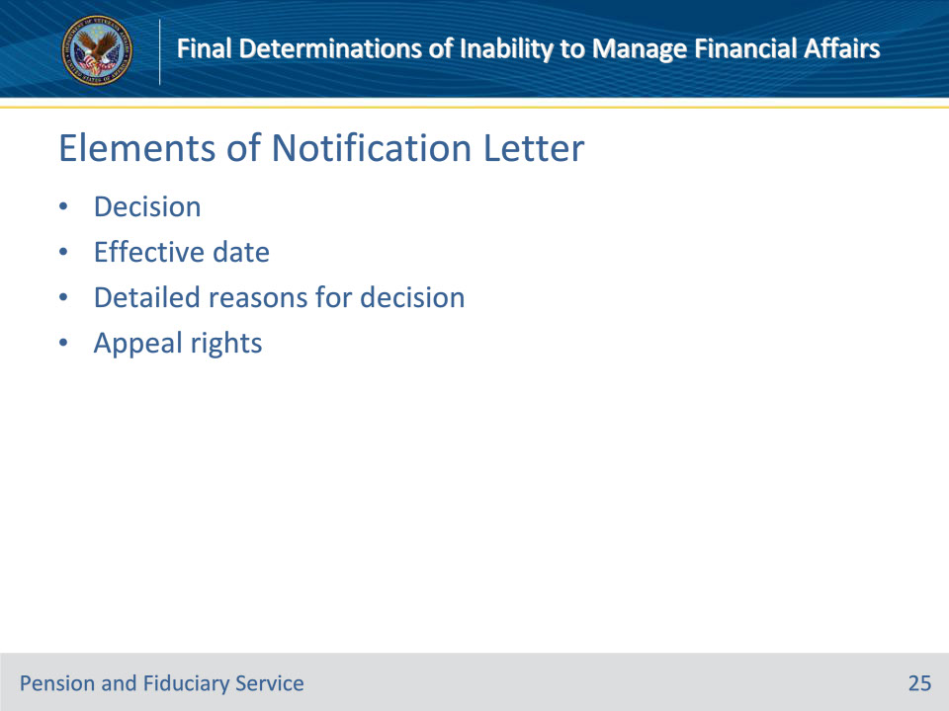
Slide notes

Policy Reference(s): FPM I.1.B.2.j.

Instructor Notes:

The final rating notification letter must advise the beneficiary of the

• decision

• effective date of the decision

• detailed reasons for the decision, and

• appeal rights.

Slide 26 - Restoring Competency
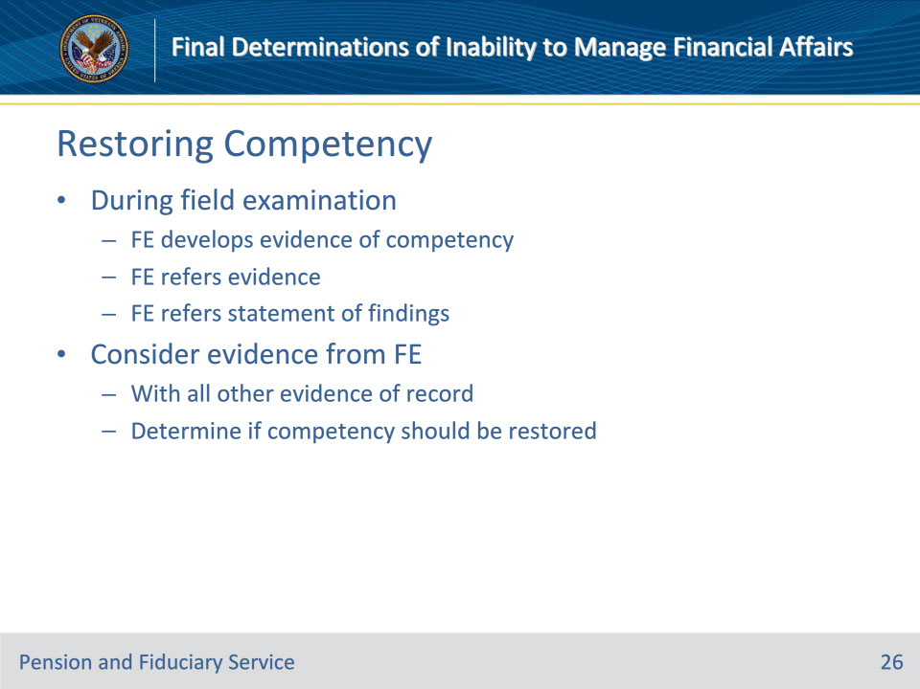
Slide notes

Policy Reference(s): FPM I.1.B.2.k.

Instructor Notes:

If during the course of a field examination, the FE develops evidence indicating that the beneficiary may be capable of administering the funds payable without limitation, the FE will refer that evidence with a statement as to their findings.

This evidence will be considered with all other evidence of record, to determine whether competency should be restored.

Slide 27 - Brady Act Reporting
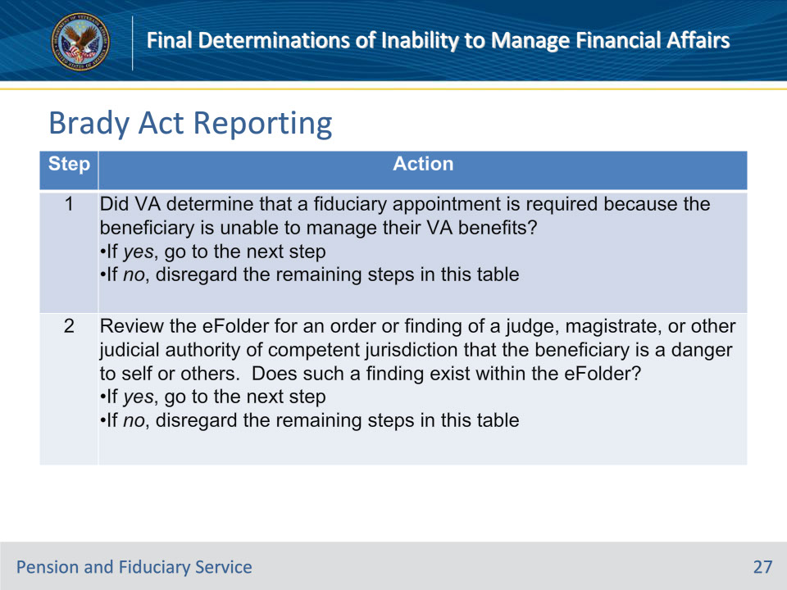
Slide notes

Policy Reference(s): FPM I.1.B.2.l.

Instructor Notes:

The Brady Act prohibits the sale of firearms to incompetent beneficiaries, and VA must report the names of certain individuals to NICS.

Follow the steps in this table to determine whether referral to NICS is necessary and the associated required actions.

Important Note for Step 2: The court documentation must specifically state that the beneficiary is a danger to self or others. The hub must not make their own determination based on other, non-specific language within the court documentation.

Slide 28 - Brady Act Reporting
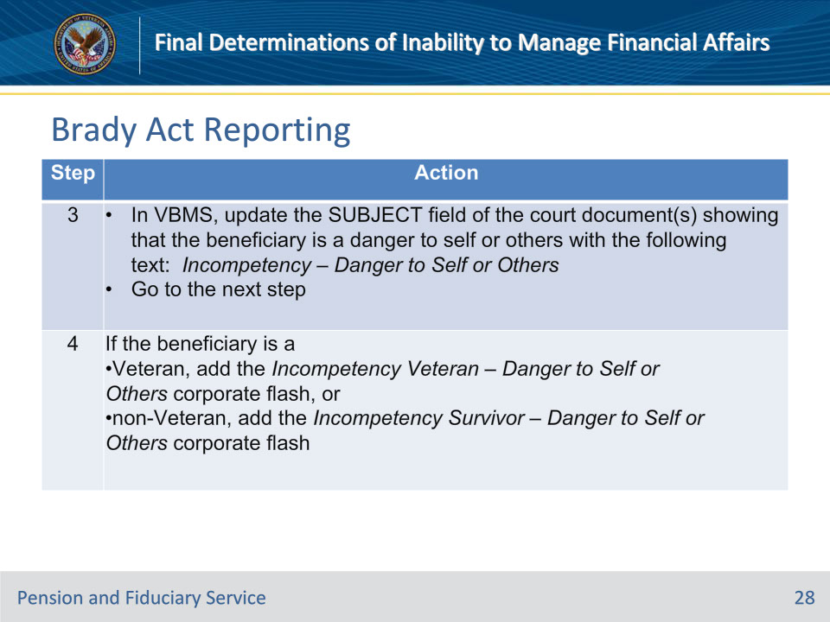
Slide notes

Policy Reference(s): FPM I.1.B.2.l.

Instructor Notes:

Follow the steps in this table to determine whether referral to NICS is necessary and the associated required actions.

Slide 29 - Judicial Determinations
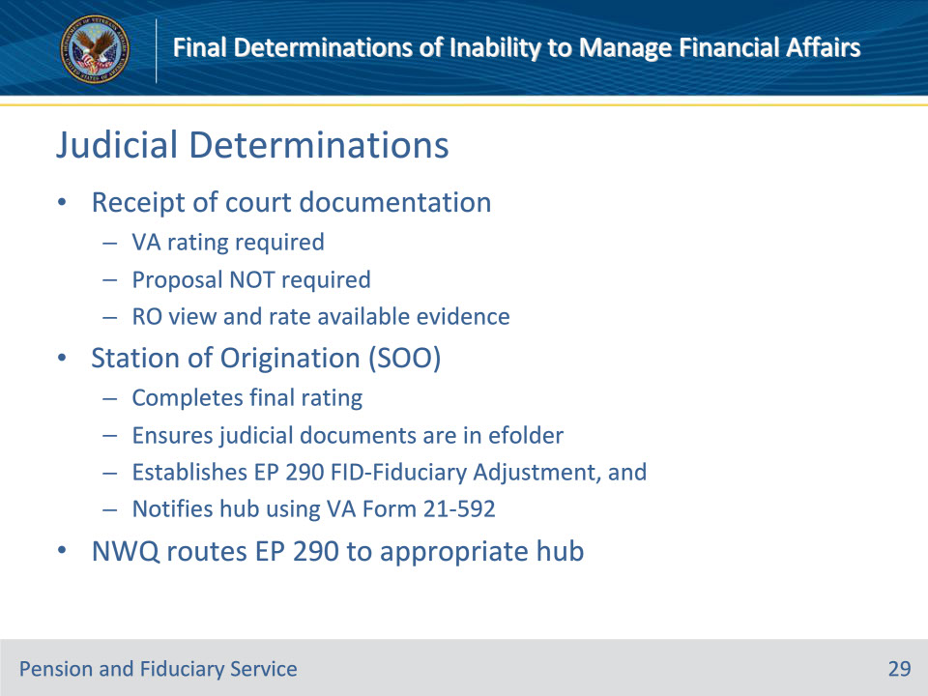
Slide notes

Policy Reference(s): FPM I.1.B.2.c.;d.

Instructor Notes:

Judicial findings regarding a beneficiary’s inability to manage their affairs are not binding on the RO rating activity. If court documentation is received which declares a Veteran unable to manage their financial affairs, rating action is required to determine if VA concurs with the court’s finding. In this circumstance, it is not necessary to propose a rating of an inability to manage VA benefits. Instead, the RO rating activity will review the evidence available and issue a rating based on that evidence.

Upon receipt of a judicial determination of a beneficiary’s inability to manage affairs, the station of origination (SOO)

• completes a final rating on the beneficiary’s inability to manage VA benefits

• ensures the judicial documents are available in the eFolder

• establishes an EP 290, FID-Fiduciary Adjustment, and

• notifies the hub of jurisdiction using VA Form 21-592.

It is unnecessary for the SOO to

• prepare a proposed rating, or

• provide advance notice of a rating.

Note: Upon establishment of the EP 290, the NWQ will route the EP to the appropriate hub for action.

Slide 30 - Hub Process
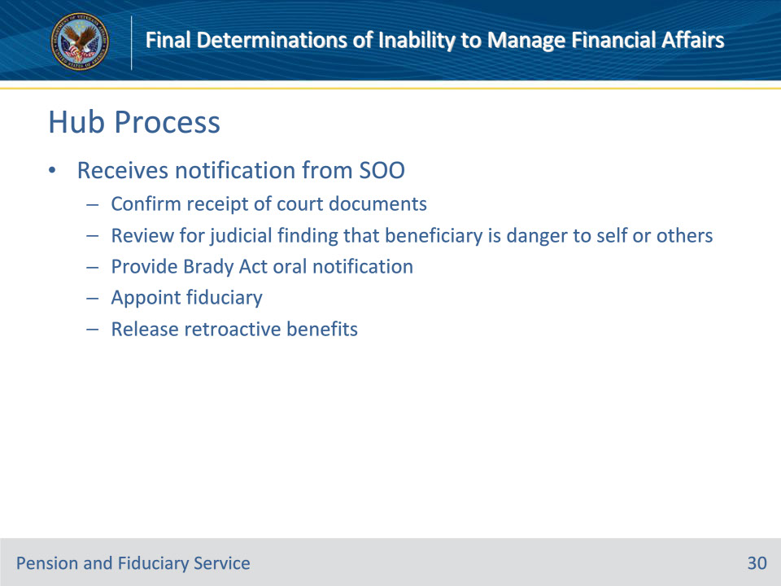
Slide notes

Policy Reference(s): FPM I.1.B.2.e.

Instructor Notes:Upon receipt of notification from the SOO of the judicial determination, the hub will

• confirm receipt of valid court documentation

• review for a judicial finding that the beneficiary is a danger to self or others, in accordance with FPM, Part I, 1.B.2.l

• provide oral notification of Brady Act restrictions

• follow all procedures to appoint a fiduciary, and

• release retroactive benefits to the fiduciary, if appropriate.

Slide 31 - 31. Questions?
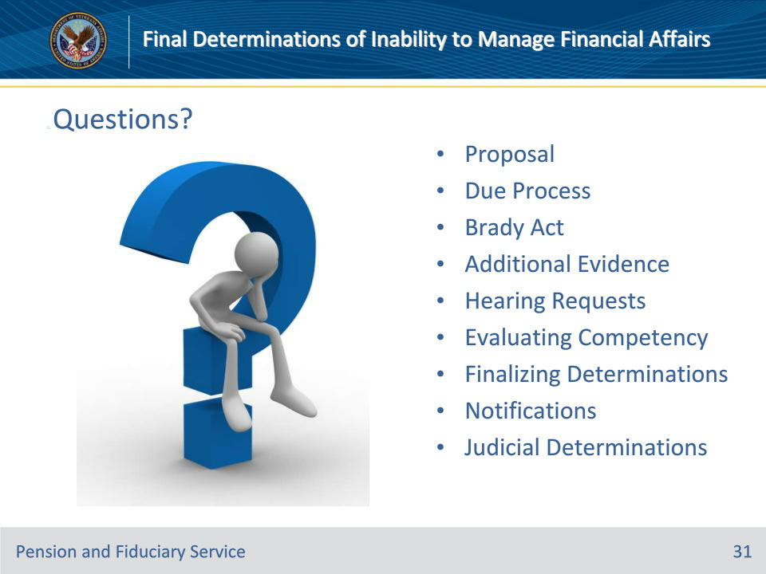
Slide notes

Instructor Notes:

(Recall) These are our learning objectives as stated from the beginning of the training:

• Implement due process procedures

• Document Brady Act requirements

• Identify additional evidence

• Process hearing requests

• Evaluate competency

• Finalize rating determinations

• Process judicial determinations

(Recap) We discussed each of these learning objectives through the following topics in each slide today:

• Proposal

• Due Process

• Brady Act

• Additional Evidence

• Hearing Requests

• Evaluating Competency

• Finalizing Determinations

• Notifications

• Judicial Determinations

Are there any additional questions?

Questions should be filtered through your QRT team. They will submit your questions to the Field Inquiry Tool (FIT) on your behalf.

Slide 32 - TMS Survey/Assessment
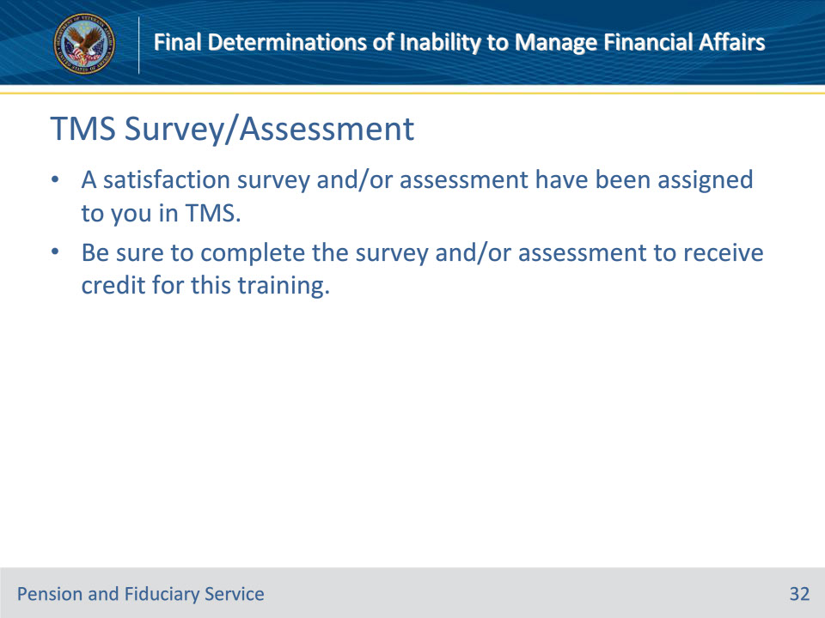
Slide notes

Instructor Notes:

A satisfaction survey and/or assessment have been assigned to you in TMS.

Be sure to complete the survey and/or assessment to receive credit for this training.

