Slide 1 - Introduction to VBMS-Fiduciary
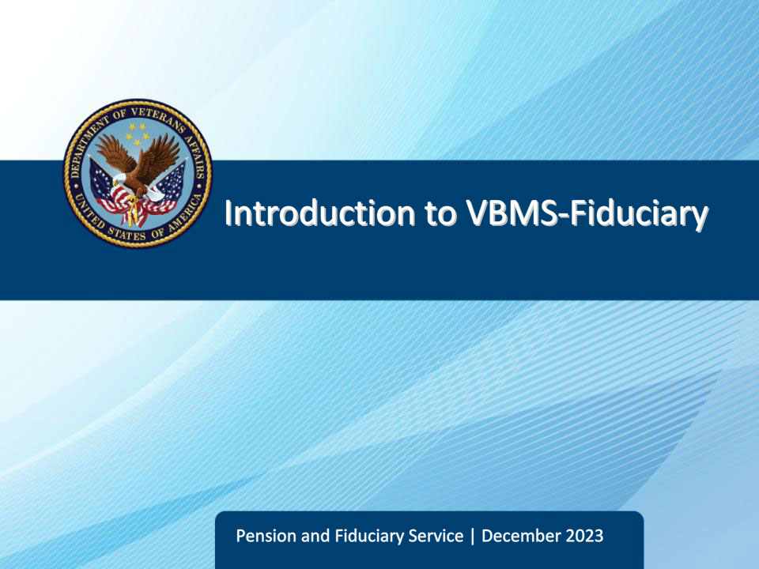
Slide notes

The purpose of this lesson is to provide fiduciary program personnel with the steps necessary to access and navigate the Veterans Benefits Management System for Fiduciary employees (VBMS-Fiduciary)

Slide 2 - Objectives
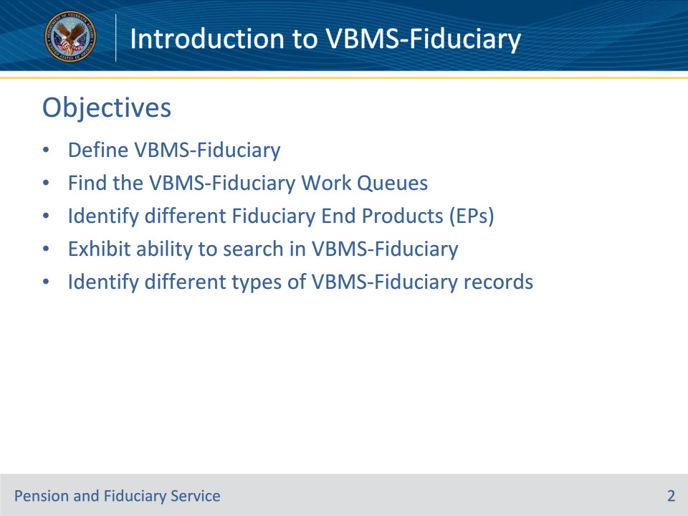
Slide notes

Instructor Notes:

At the end of this lesson, given the training and references, the learner will be able to do the following:

• Define VBMS-Fiduciary

• Find the VBMS-Fiduciary Work Queues

• Identify different Fiduciary End Products (EPs)

• Exhibit ability to search in VBMS-Fiduciary

• Identify different types of VBMS-Fiduciary records

Slide 3 - References
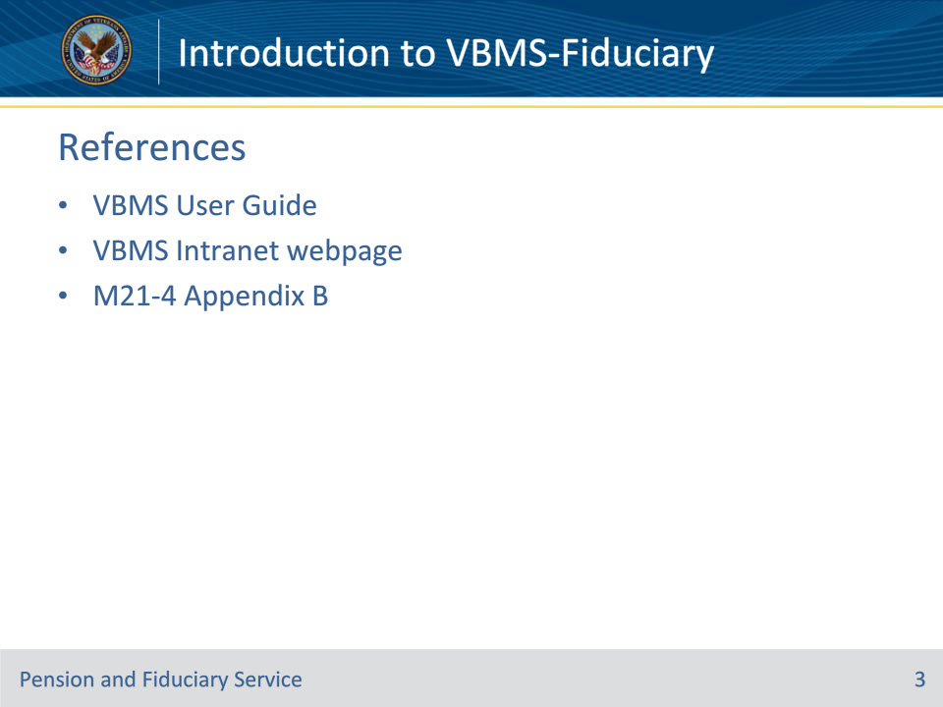
Slide notes

Instructor Notes:

These references are applicable to today’s training:

• VBMS User Guide

• VBMS Intranet webpage

• M21-4 Appendix B, End Product (EP) Codes

Slide 4 - What is VBMS-Fid?
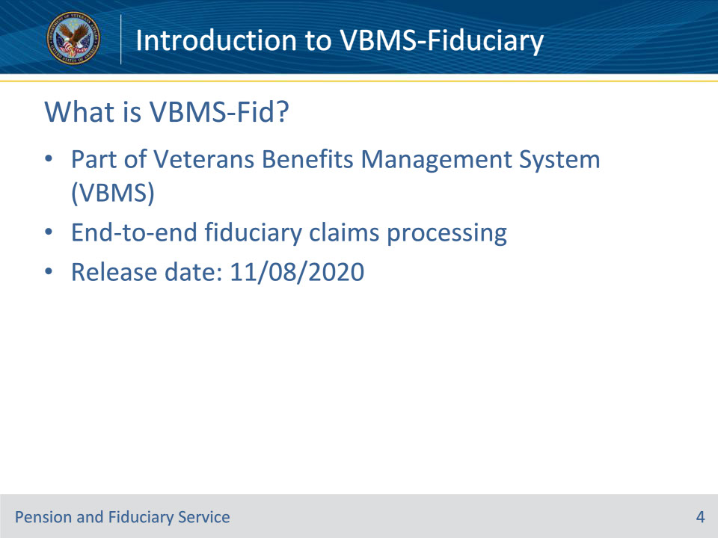
Slide notes

Instructor Notes:

• VBMS-Fid is a computer program that is part of VBMS designated to exclusively handle Fiduciary Program work. This work includes, but is not limited to Field Examination Reports, Account Auditing Tools, Fiduciary and Beneficiary Records, and Misuse Investigation tools).

• VBMS-Fid now allows a fiduciary claim to be worked end-to-end in one system (from the moment the claim of incompetency is received at the VA, to the proposal of incompetency, to the field examination(s), to the accounting(s), all the way until the beneficiary leaves the Fiduciary Program.

• VBMS-Fid went live on November 8, 2020, with data roll-over from the previous Fiduciary Program (BFFS—Beneficiary Fiduciary Field System).

Slide 5 - VBMS-Fid Work Queues
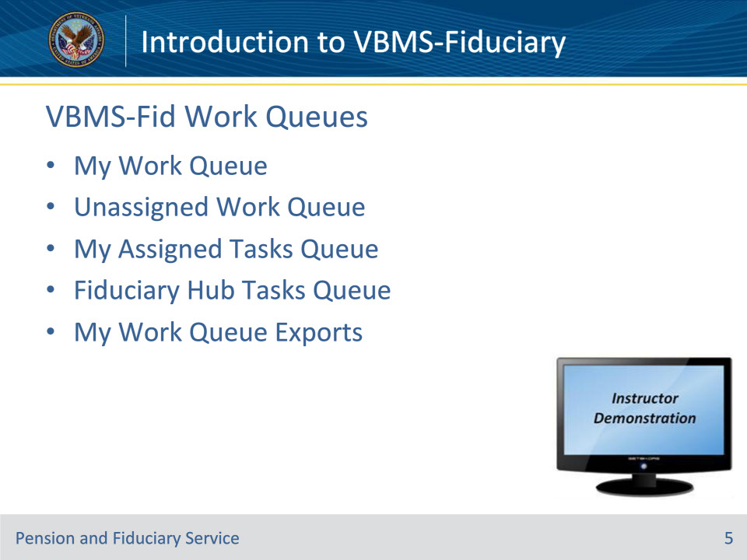
Slide notes

Reference: VBMS User Guide

Instructor Notes:

After logging into VBMS, the program should default to displaying the Work Queue tab

• My Work Queue—This shows the EPs assigned to you.

• Stations Unassigned Work Queue-This shows the unassigned EPs at your station. The tab reflects the user’s station.

When you click on the Fiduciary Tab in VBMS, you will be brought to the Task Queue dashboard. On the left hand side of the screen, you will see:

• My Assigned Tasks Queue: tasks assigned to you

• Fiduciary Hub Tasks Queue: tasks assigned to the fiduciary hub

• My Work Queue Exports: logged history of exports of tasks from the task work queues

Instructor Actions: Demonstrate the various queues listed above. Show their location, how to use them, filter them, etc. as needed.

Slide 6 - Fiduciary End Products
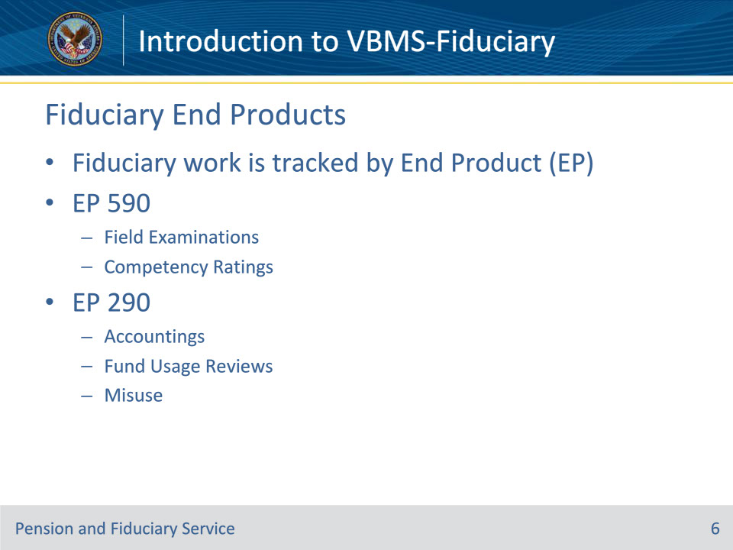
Slide notes

Reference: M21-4, Appendix B

Instructor Notes:

An End Product (EP) is a control number which allows tracking of a claim throughout the lifecycle of the claim.

Fiduciary work is now tracked by End Products (EPs). (NOTE: Many VBA claims are now tracked using EPs, including all Compensation, Pension, DIC, Chapter 35, etc.)

Note: In the Fiduciary workflow, the letters following the EP number give a brief description of the type of specific work associated with the EP.

For example, an EP590IAFE is used to track an Initial Appointment field examination. An EP290AFFID is used to track a Federal Accounting.

Relevant Fiduciary End Products are:

• 590IAFE - Initial Appointment Field Exam

• 590SFUFE - Scheduled Follow-Up Field Exam

• 590UFUFE - Unscheduled Follow-Up Field Exam

• 590FUFE - Fund Usage Field Exam

• 590SIAFE - Successor Initial Appointment Field Exam

• 590NFPFE - Non-Fiduciary Program Field Exam

• 590EIAFE - Expedited Initial Appointment Field Exam

• 590TFUFE - Telephone Follow-Up Field Exam

• 400CFID - FID-Correspondence

• 290MFID - FID-Misuse

• 290FURFID - FID-Fund Usage Review

• 290AFFID - FID-Accounting Federal

• 290ACFID - FID-Accounting Court

Slide 7 - VBMS-Fid Search
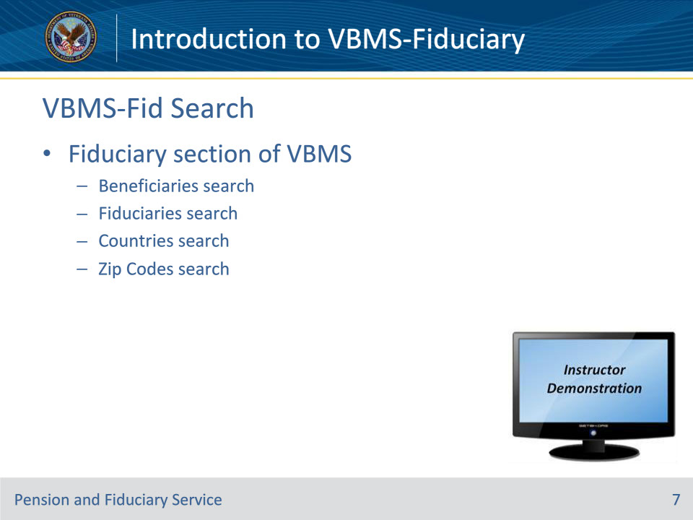
Slide notes

Reference: VBMS User Guide

Instructor Notes:

• Note: Using the “Search” function just below the dark blue toolbar in the upper section of the VBMS page will take the user to the VBMS-Core record; not the VBMS-Fid record.

• Fiduciary section of VBMS—Clicking on the word “Fiduciary” at the top of the screen in the dark blue “toolbar” should take the user to the VBMS-Fid “Search” dashboard.

• Beneficiaries search—User may fill in information to search for a fiduciary beneficiary.

• Fiduciaries search—User can click on “Fiduciaries” under the “Search” tab to search for a fiduciary in the Fiduciary Program.

• Countries and Zip Code searches—User can click on either “Countries” or “Zip Codes” in the “Search” tab when the user is searching for fiduciary information for a specific region. These options are rarely used by most users.

Instructor Actions: Demonstrate the search functionality in VBMS-Fid

Slide 8 - VBMS-Fid Records
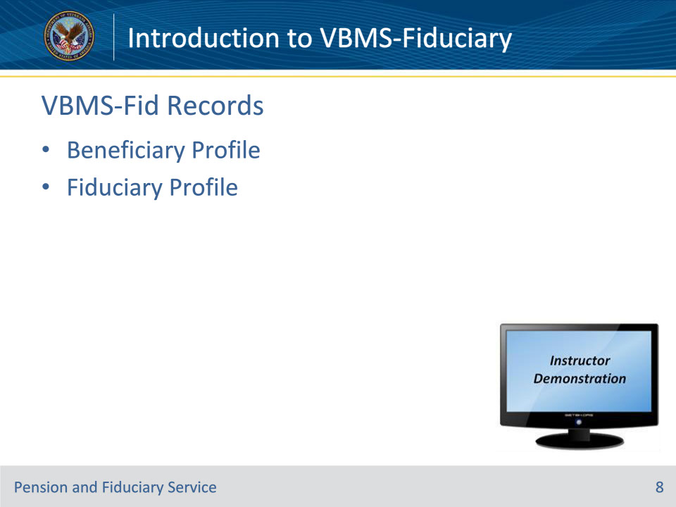
Slide notes

Reference: VBMS User Guide

Instructor Notes:

• Beneficiary Profile—After the user has entered the beneficiary’s search information, the user comes to the Beneficiary Profile page. This page provides an overview of the beneficiary’s status within the Fiduciary Program through various tabs.

• Fiduciary Profile—After the user has entered the fiduciary’s search information, the user comes to the Fiduciary Profile page. This page provides an overview of the fiduciary’s status within the Fiduciary Program.

Instructor Actions: Demonstrate how to access the beneficiary and fiduciary profiles and show the various information contained in each.

Slide 9 - Questions?
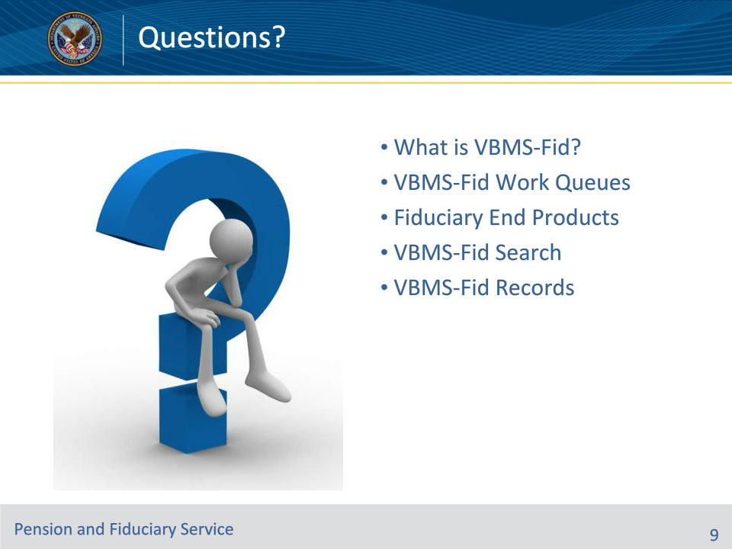
Slide notes

Instructor Notes:

(Recall) These are our learning objectives as stated in the beginning of the training:

• Define VBMS-Fiduciary

• Find the VBMS-Fiduciary Work Queues

• Identify different Fiduciary End Products (EPs)

• Exhibit ability to search in VBMS-Fiduciary

• Identify different types of VBMS-Fiduciary records

(Recap) We discussed each of these learning objectives through the following topics in each slide today:

• What is VBMS-Fid?

• VBMS-Fid Work Queues

• Fiduciary End Products

• VBMS-Fid Search

• VBMS-Fid Records

Are there any additional questions?

Slide 10 - TMS Satisfaction Survey
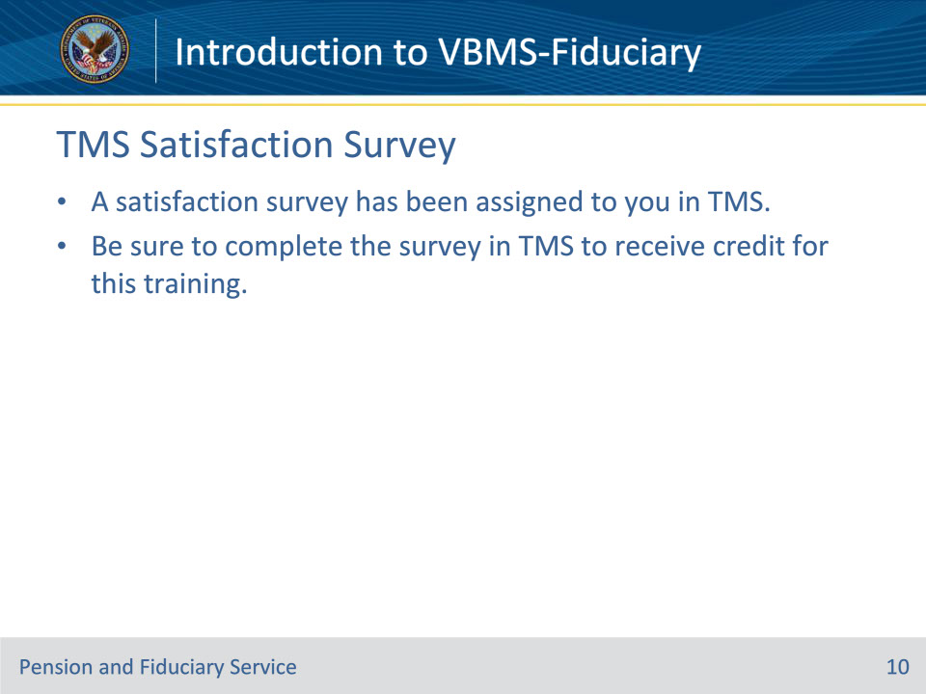
Slide notes

A satisfaction survey has been assigned to you in TMS. You should be able to complete the survey within ten minutes. Completing the survey will allow you to receive credit for this training.

