Slide 1 - Expedited Initial Appointments
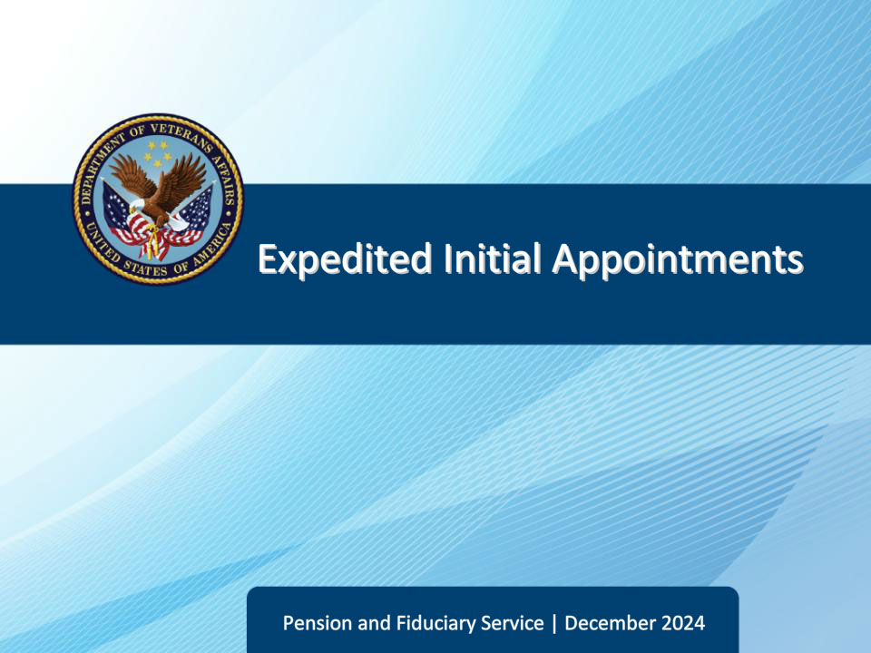
Slide notes

Course Description:

The lesson teaches learners about the purpose, critical elements, and specific requirements of expedited initial appointment field examinations to include how an expedited initial appointment field examination is initiated, documented, and reported.

Slide 2 - Objectives
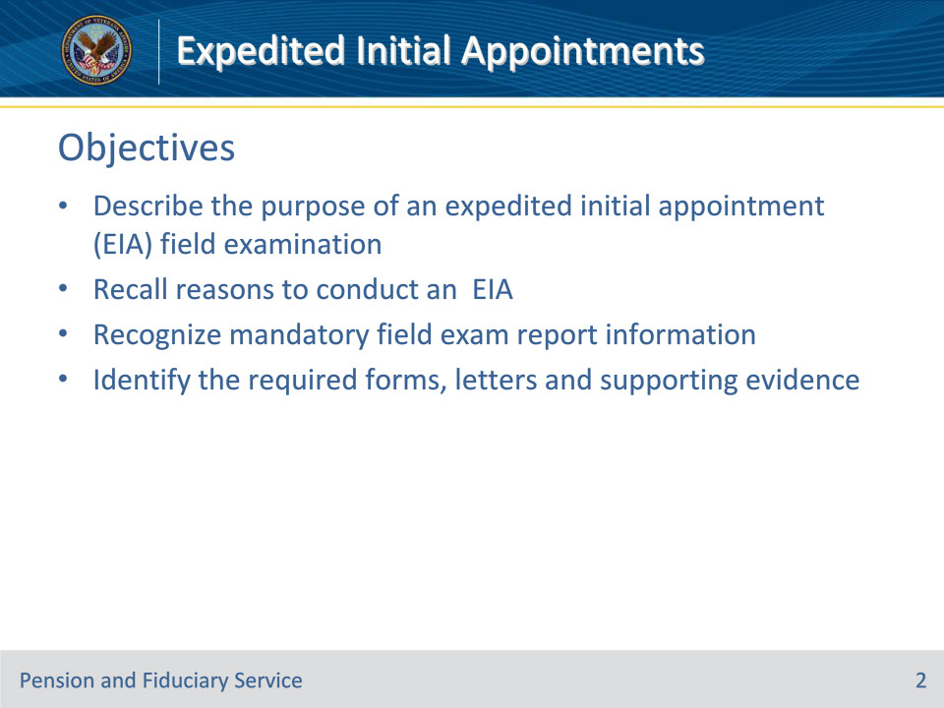
Slide notes

Instructor Notes:

At the end of this lesson, given the training and references, the learner will be able to do the following:

• Describe the purpose of an expedited initial appointment (EIA) field examination

• Recall reasons to conduct an EIA

• Recognize mandatory field exam report information

• Name the required forms, letters and supporting evidence

Slide 3 - References
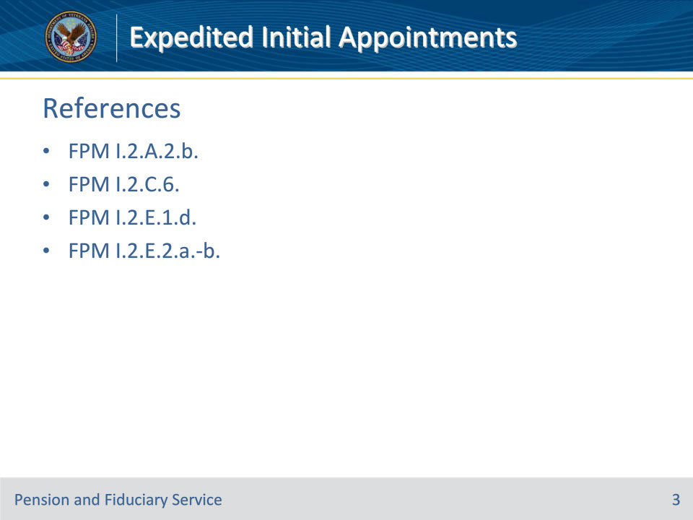
Slide notes

Instructor Notes:

These are the relevant references pertaining to this course:

• FPM I.2.A.2.b. Types of IA Field Examinations

• FPM I.2.C.6. Conducting EIAs

• FPM I.2.E.1.d. How to Prepare Field Examination Documentation

• FPM I.2.E.2.a.-b. Generating Notification Letters and Required Notification Letter

Slide 4 - Overview
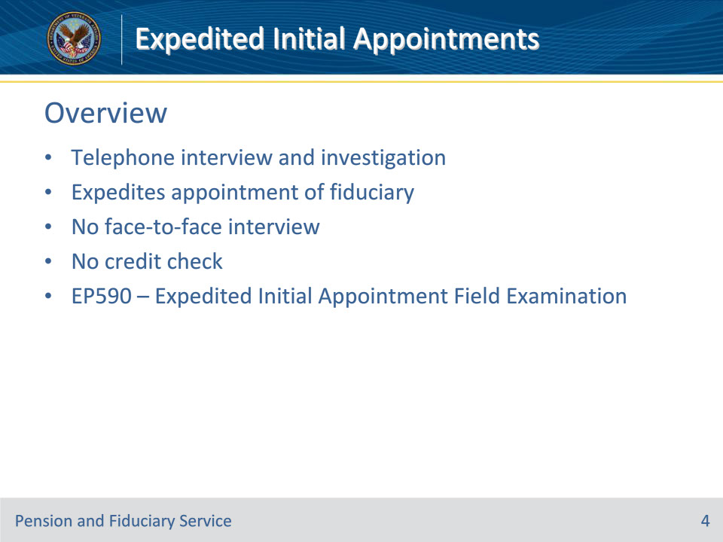
Slide notes

Policy Reference(s): FPM I.2.A.2.b.; FPM I.2.C.6.a.

Instructor Notes:

Expedited Initial Appointment (EIA): A telephone interview and investigation activity conducted by the designated hub or other qualified VA personnel for the purpose of expediting the qualification and appointment of a fiduciary.

The EIA process waives the requirement to obtain a credit report and to conduct a face-to-face interview with the proposed fiduciary.

Hubs will generally use the EP 590 Expedited Initial Appointment Field Examination when the EIA protocol is used. When completing an SIA for a case that qualifies for an EIA, the hubs must utilize the EP 590 Successor Initial Appointment Field Examination.

Requirements outlined in other sections of the FPM do not apply to EIAs unless specifically stated.

Slide 5 - Eligibility
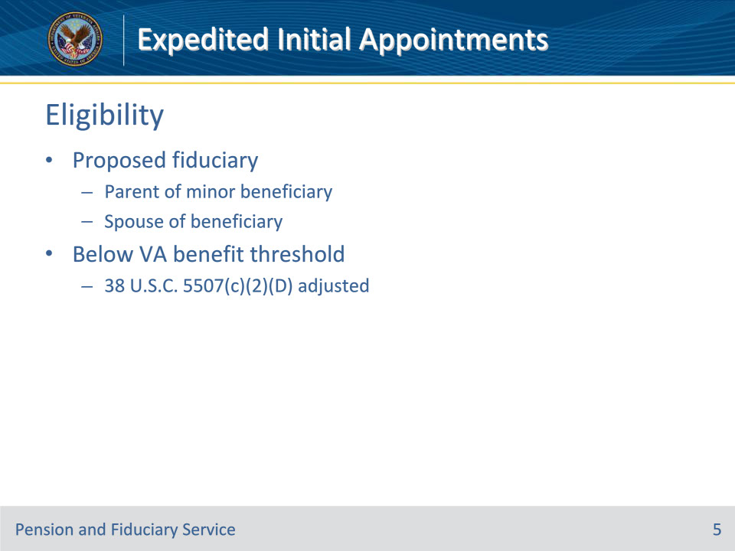
Slide notes

Policy Reference(s): FPM I.2.C.6.a.

Instructor Notes:

The fiduciary hub will not conduct a face-to-face interview or credit check of the proposed fiduciary when:

• the proposed fiduciary is the beneficiary’s

• natural, adopted, or stepparent and the beneficiary is under the age of majority, or

• spouse, or

• the annual amount of VA benefits the proposed fiduciary would manage for the beneficiary does not exceed the amount specified in 38 U.S.C. 5507(c)(2)(D), as adjusted by VA pursuant to 38 U.S.C. 5312. There is a chart with these rates at FPM I.2.A.2.j

For these situations, the EIA protocol will be used unless otherwise excluded.

Slide 6 - Process
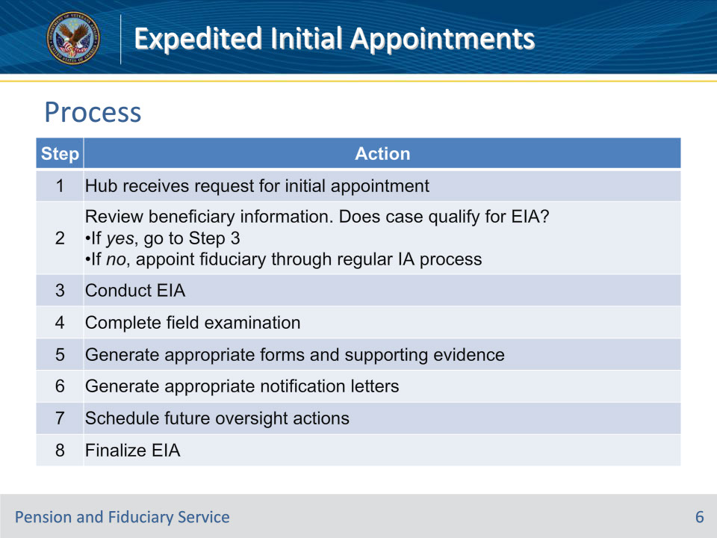
Slide notes

Policy Reference(s): FPM I.2.C.6.a.

Instructor Notes:

In appointing a fiduciary, the fiduciary hub will make every effort to appoint the person, agency, organization, or institution that will best serve the interest of the beneficiary. Follow the steps in this table to expedite the appointment.

Slide 7 - Exclusions
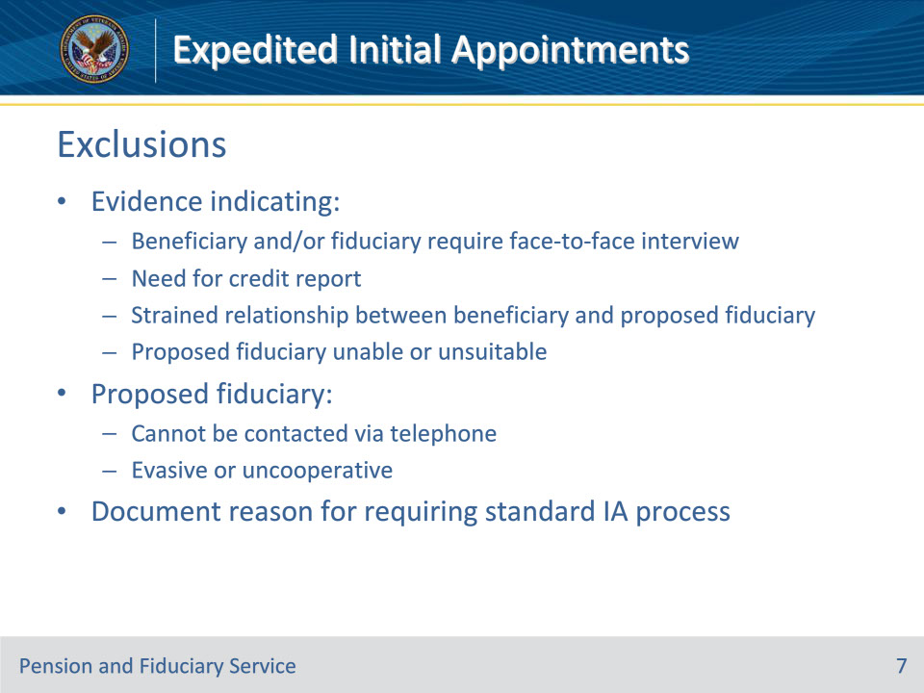
Slide notes

Policy Reference(s): FPM I.2.C.6.b.

Instructor Notes:

An EIA is not appropriate when

• there is evidence indicating

• the beneficiary and/or fiduciary require a face-to-face interview

• the need for a credit report

• a strained relationship between the beneficiary and proposed fiduciary, or

• the proposed fiduciary is unable or unsuitable, or

• the proposed fiduciary

• cannot be contacted via telephone, or

• is being evasive or uncooperative.

If the situation meets the criteria for an EIA but is excluded from the EIA per this block, the FE must document the specific reason for requiring the standard IA process. Include this information with the interview logistics documented.

When an EIA is not appropriate, appoint a fiduciary through face-to-face contact.

Slide 8 - Fiduciary Contact
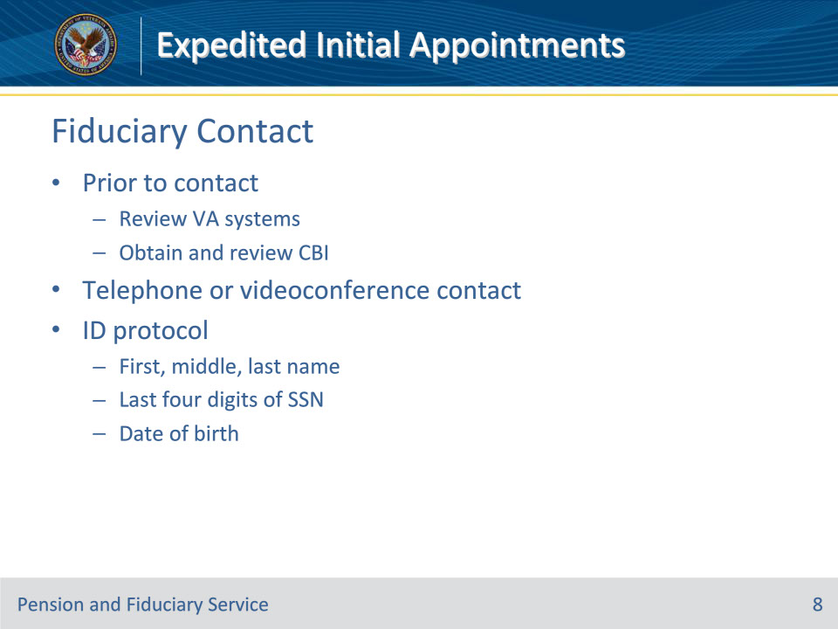
Slide notes

Policy Reference(s): FPM I.2.C.6.c-.d.

Instructor Notes:

Prior to contacting the beneficiary or proposed fiduciary, the FE must review the information in VA systems.

When the case qualifies for an EIA, hub personnel must obtain the CBI of the proposed fiduciary and review the CBI.

The CBI review must be completed prior to contacting the proposed fiduciary to ensure that the person qualifies for fiduciary service.

Face-to-face contact with the proposed fiduciary is not required for EIA. The FE must interview the proposed fiduciary by telephone or secure and approved videoconferencing methods.

FEs will utilize the CBI to conduct identification protocol, verifying the proposed fiduciary’s

• first, middle, and last name

• last four digits of his/her SSN, and

• date of birth.

If the proposed fiduciary’s identity cannot be verified utilizing the CBI, appoint a fiduciary through face-to-face contact.

Slide 9 - Fiduciary Documentation
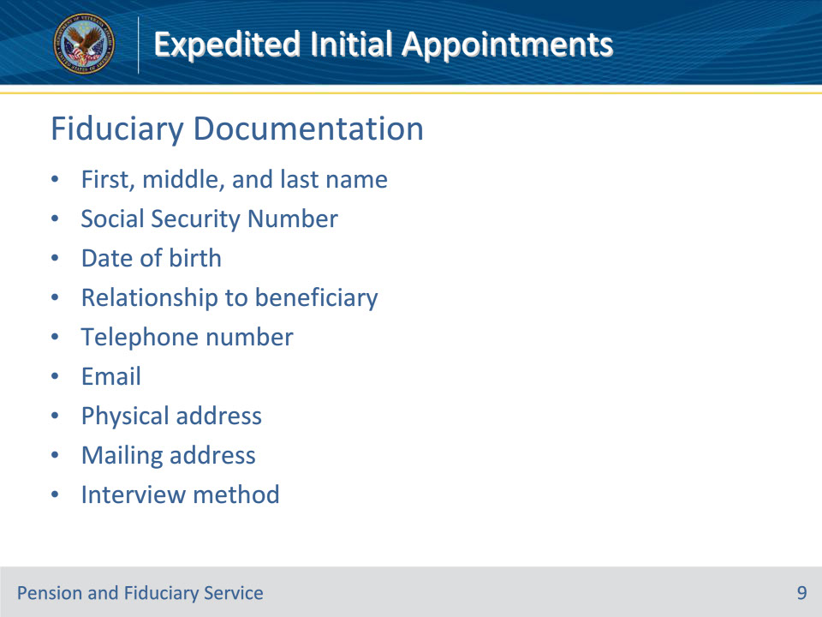
Slide notes

Policy Reference(s): FPM I.2.C.6.d.

Instructor Notes:

As part of the contact with the fiduciary, the FE must document the following fiduciary information in the field examination:

• first, middle, and last name

• SSN

• date of birth

• relationship to the beneficiary

• telephone number

• email, if available

• physical address, and

• mailing address.

The FE must document that the interview was conducted via telephone or videoconferencing in the field examination. The FE must also evaluate and document all other fiduciary unless specifically listed as an exception for EIAs.

Slide 10 - Beneficiary Documentation
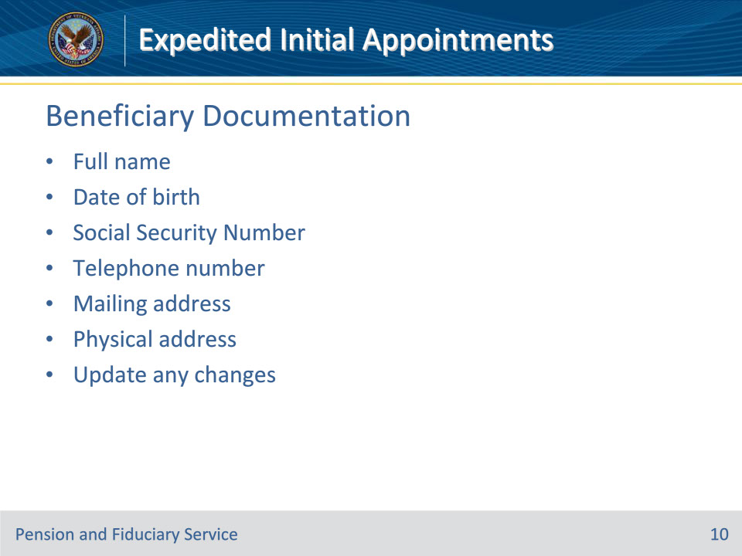
Slide notes

Policy Reference(s): FPM I.2.C.6.e.

Instructor Notes:

The FE must confirm and document the beneficiary’s information, to include the following:

• full name

• date of birth

• SSN

• telephone number

• mailing address, and

• physical address.

This information may have been collected and verified at the time of scheduling; however, if the FE identifies changes in this information during the field examination, the FE must update the beneficiary record with the correct information.

Unless specifically stated as an exception for EIAs, the FEs must also evaluate and document all beneficiary information required for IAs.

Slide 11 - Beneficiary Contact
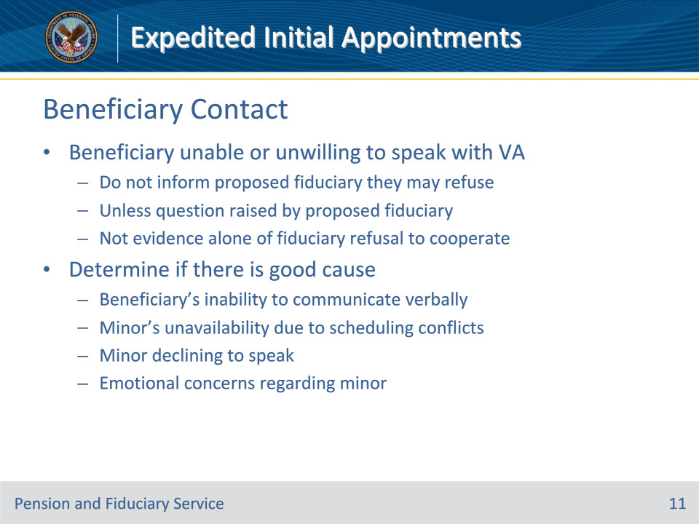
Slide notes

Policy Reference(s): FPM I.2.C.6.f.

Instructor Notes:

The proposed fiduciary may advise the FE that the beneficiary is unable or unwilling to speak with VA during the IA.

The FE should not inform the proposed fiduciary that they may refuse to allow the beneficiary to speak with the FE, unless the question is raised by the proposed fiduciary.

The proposed fiduciary’s unwillingness to allow the FE to speak with the beneficiary alone is not evidence that the fiduciary is attempting to delay or refuse to cooperate in the fiduciary appointment process.

FEs must determine if there is good cause for the proposed fiduciary’s reason for requesting that the FE not speak with the beneficiary.

Good cause for not speaking with the beneficiary may include, but is not limited to the

• beneficiary’s inability to communicate verbally with the FE due to disease or disability

• minor’s unavailability due to conflicting schedules relating to school or other extracurricular activities such as camps, sports or events, travel at the time of the field examination

• minor declining to speak to the FE, or

• proposed fiduciary’s request that the FE not speak with the minor due to the emotional concerns relating to the loss of a parent or other challenges relating to the way in which the child became entitled to benefits.

Slide 12 - Beneficiary Contact
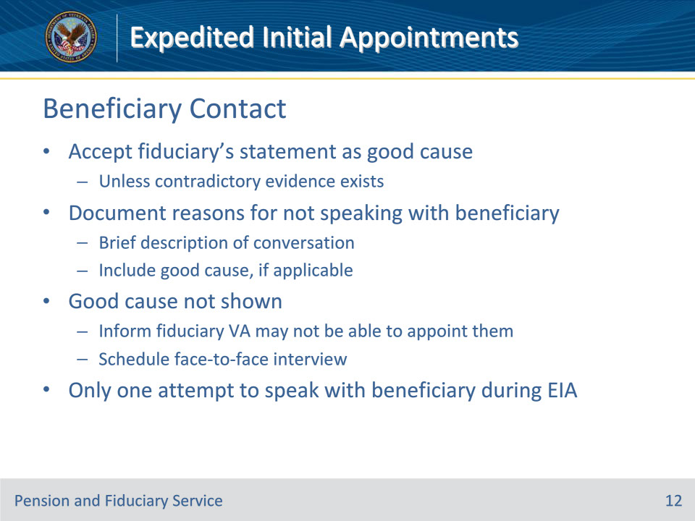
Slide notes

Policy Reference(s): FPM I.2.C.6.f.

Instructor Notes:

Accept the fiduciary’s statement as good cause, unless contradictory evidence exists.

Document the reasons for not speaking with the beneficiary specifically in the field examination and include a brief description of the conversation. Justification must include good cause, if appropriate.

If good cause is not shown for speaking with the beneficiary, the FE must inform the fiduciary VA may not be able to appoint them as the fiduciary if they are unwilling to make the beneficiary available.

If the FE determines speaking with the beneficiary will not occur due to the proposed fiduciary’s unwillingness and good cause is not shown, the FE must schedule a face-to-face interview and refer to the guidance in this section for appointing a fiduciary.

The FE shall make no more than one attempt to speak with the beneficiary during the EIA field examination.

Slide 13 - Fiduciary Responsibilities
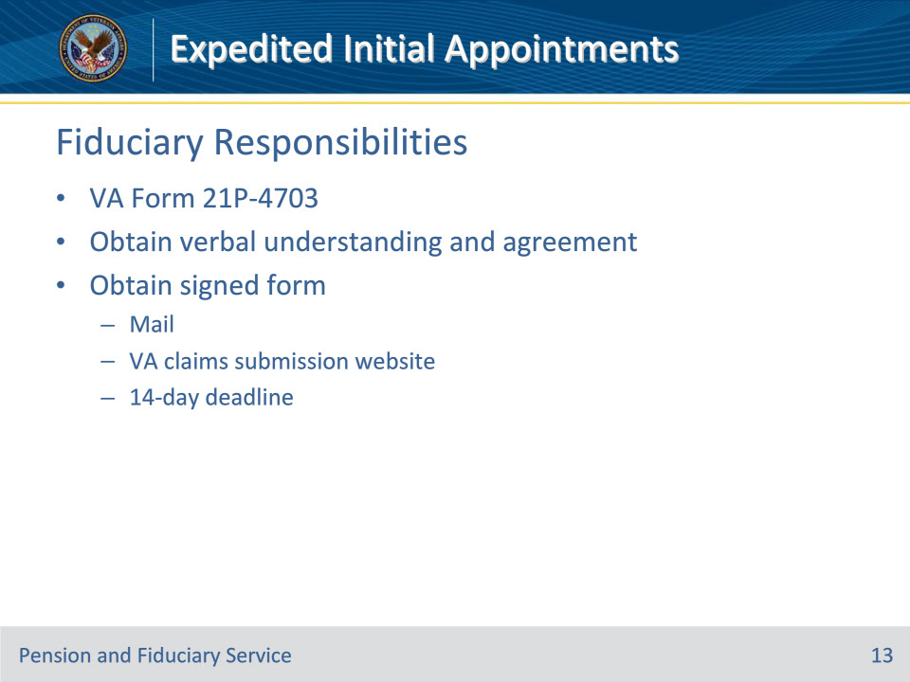
Slide notes

Policy Reference(s): FPM I.2.C.6.g.

Instructor Notes:

During the telephone contact, the FE must explain the fiduciary responsibilities outlined on the VA Form 21P-4703. The FE must obtain verbal verification that the proposed fiduciary understands and agrees to the fiduciary responsibilities.

Prior to submitting the field examination report to the hub for closure, the FE must obtain a signed VA Form 21-4703 to verify that the proposed fiduciary agrees to uphold fiduciary responsibilities. The VA Form 21P-4703 can be obtained via mail or uploaded to the eFolder using an approved VA claims submission service website such as Direct Upload. If the VA Form 21P-4703 is not received within 14 days, appoint a fiduciary through face-to-face contact.

Slide 14 - Required Documents
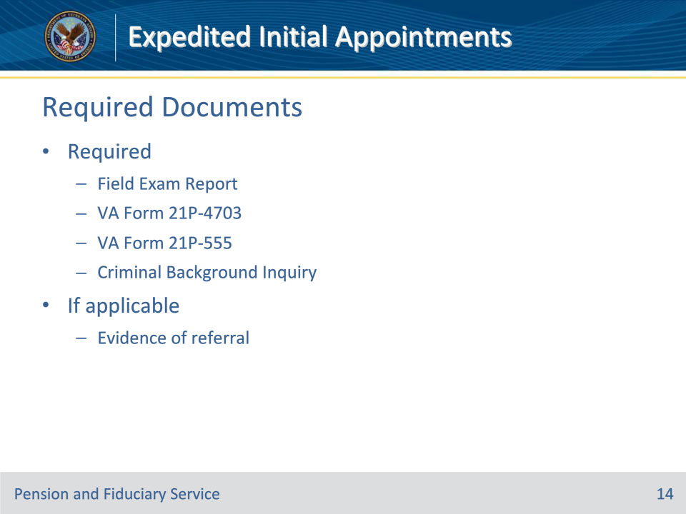
Slide notes

Policy Reference(s): FPM I.2.E.1.d.

Instructor Notes:

This slide covers the basics of required field exam documentation. . Requirements for SDP appointments differ. This topic is covered more in depth in the Field Exam Documentation and Notification training.

Hub personnel must enter the information gathered during the field examination process in the appropriate system or on the appropriate form. Hub personnel must also generate the applicable field examination and upload the report and required form(s) to the eFolder.

The required forms and supporting evidence include, but are not limited to:

• Completed FIELD EXAM REPORT activity within the EP in the VBMS

• VA Form 21P-4703, Fiduciary Agreement

• VA Form 21P-555, Certificate of Legal Capacity to Receive and Disburse Benefits and Fee Authorization

• criminal background inquiry (CBI), if required, and

• evidence of referrals to other agencies, if required.

Slide 15 - Required Notifications
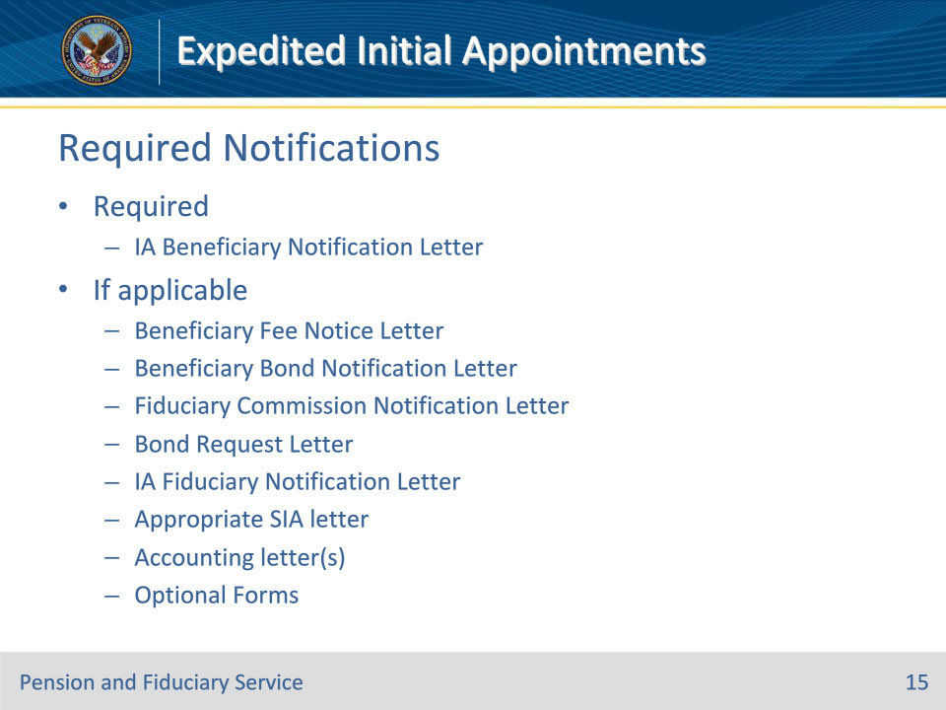
Slide notes

Policy Reference(s): FPM I.2.E.2.a., b.

Instructor Notes:

This slide covers the basics of required field exam notifications. Requirements for SDP appointments differ. This topic is covered more in depth in the Field Exam Documentation and Notification training.

Hubs must generate letters associated with field examinations using the templates available in VBMS, unless otherwise specified. The letters available in the system contain sufficient language to fulfill notification requirements.

For an IA, the required notification letters are:

• IA Beneficiary Notification Letter, with a copy to the power of attorney (POA) and/or court-appointed guardian, if applicable.

• Beneficiary Fee Notice Letter, if applicable.

• Beneficiary Bond Notification Letter, if applicable.

• Fiduciary Commission Notification Letter, if applicable.

• Bond Request Letter to the fiduciary, if applicable.

• Certified Court Accounting Due Letter, if applicable.

• IA Fiduciary Notification Letter to the fiduciary, if applicable, including a copy of a signed VA Form 21P-4703.

• Optional forms to attach include a VA Form 21P-4718a, and a Standard Form (SF) 1199A, Direct Deposit Sign-Up Form.

For an SIA, the required letters are the same with the addition of the appropriate fiduciary SIA letter to the previous fiduciary, including accounting forms if a final accounting is required. A copy of the letter is sent to the new fiduciary. Also, send a Bond Request Letter to the new fiduciary, if applicable.

Slide 16 - Questions?
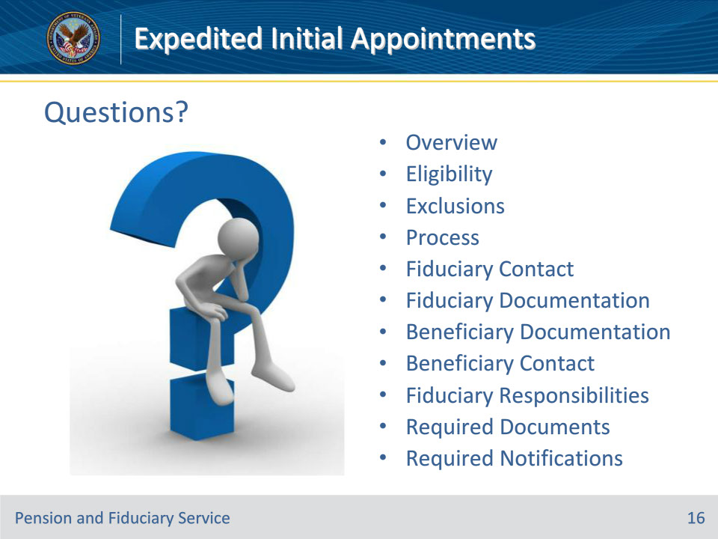
Slide notes

Instructor Notes:

(Recall) These are our learning objectives as stated from the beginning of the training:

• Describe the purpose of an expedited initial appointment (EIA) field examination

• Recall reasons to conduct an EIA

• Recognize mandatory field exam report information

• Name the required forms, letters and supporting evidence

(Recap) We discussed each of these learning objectives through the following topics in each slide today:

• Overview

• Eligibility

• Exclusions

• Process

• Fiduciary Contact

• Fiduciary Documentation

• Beneficiary Documentation

• Beneficiary Contact

• Fiduciary Responsibilities

• Required Documents

• Required Notifications

Are there any additional questions?

Questions should be filtered through your QRT team. They will submit your questions to the Field Inquiry Tool (FIT) on your behalf.

Slide 17 - TMS Survey/Assessment
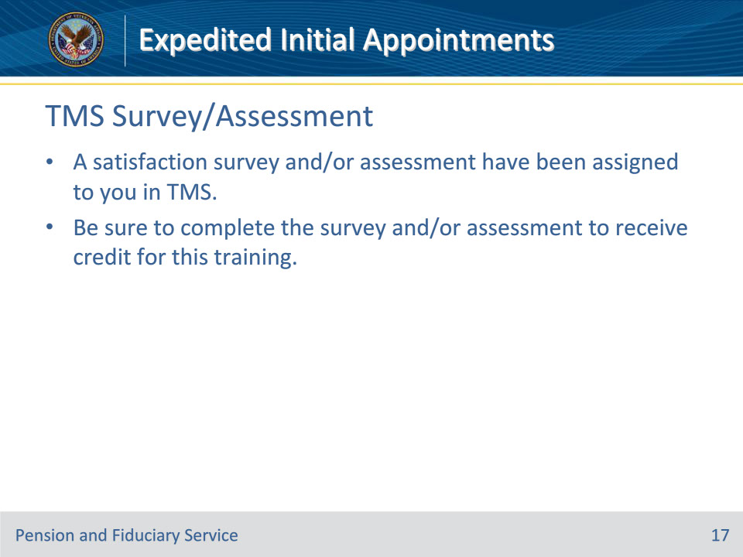
Slide notes

Instructor Notes

A satisfaction survey and/or assessment have been assigned to you in TMS.

Be sure to complete the survey and/or assessment to receive credit for this training.

