Slide 1 - Non-Program Field Examinations
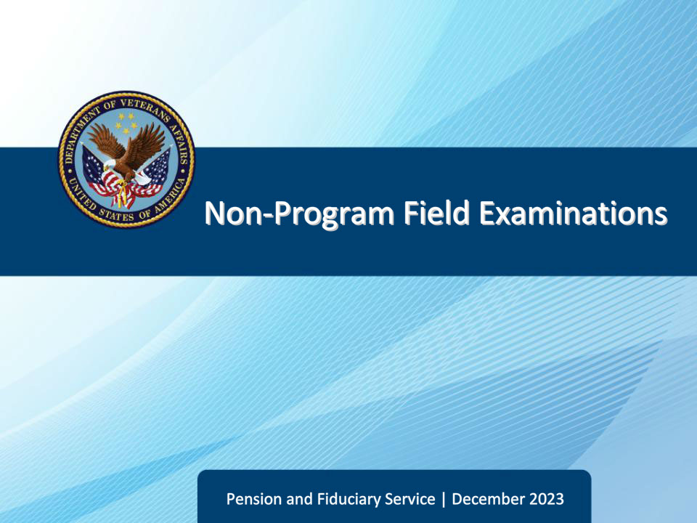
Slide notes

Course Description:

The lesson teaches learners about the purpose, critical elements, and specific requirements of non-program field examinations to include how a non-program field examination is initiated, documented, and reported.

Slide 2 - Objectives
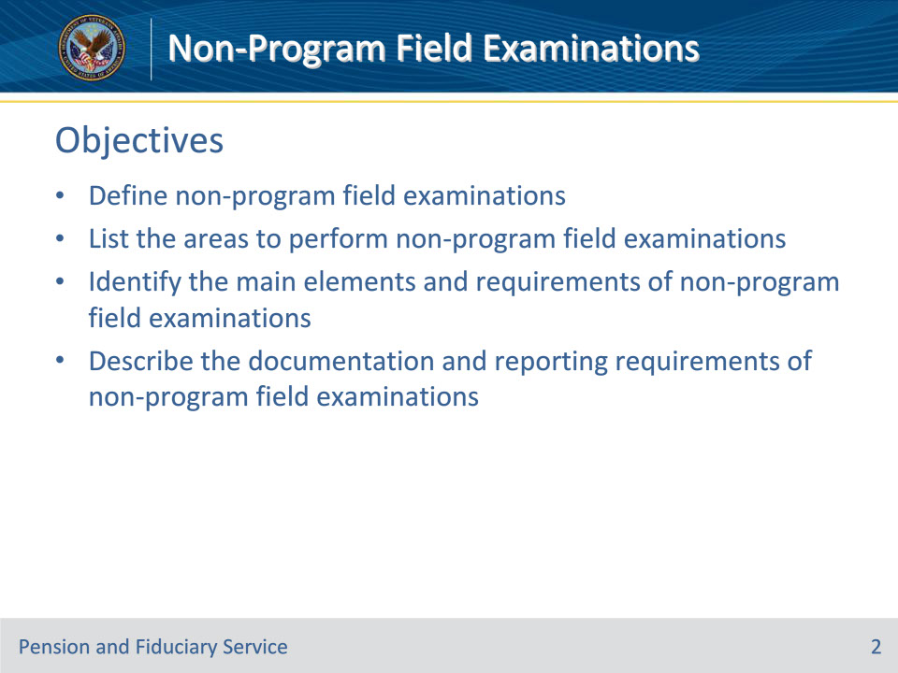
Slide notes

At the end of this lesson, given the training and references, the learner will be able to do the following:

• Define non-program field examinations

• List the areas to perform non-program field examinations

• Identify the main elements and requirements of non-program field examinations

• Describe the documentation and reporting requirements of non-program field examinations

Slide 3 - References
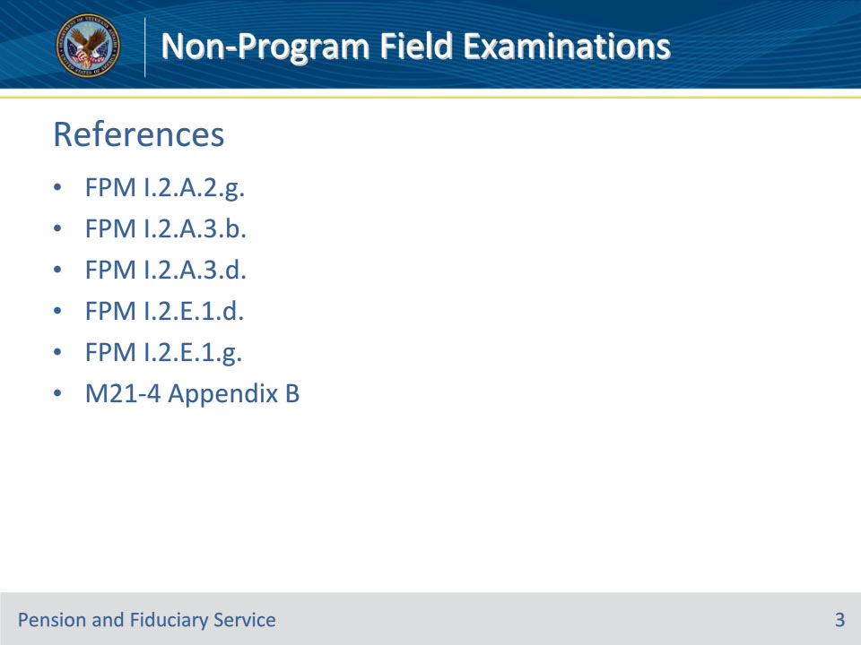
Slide notes

Instructor Notes:

These are the relevant references pertaining to this course:

• FPM I.2.A.2.g. Non-Fiduciary Program Field Examinations

• FPM I.2.A.3.b. Content Requirements for Requests

• FPM I.2.A.3.d. FHM Review of Non-Fiduciary Program Field Examination Requests

• FPM I.2.E.1.d. How to Prepare Field Examination Documentation

• FPM I.2.E.1.g. Processing and Referring the Non-Fiduciary Program Field Examination and Supporting Documentation

• M21-4 Appendix B End Product (EP) Codes

Slide 4 - Definition
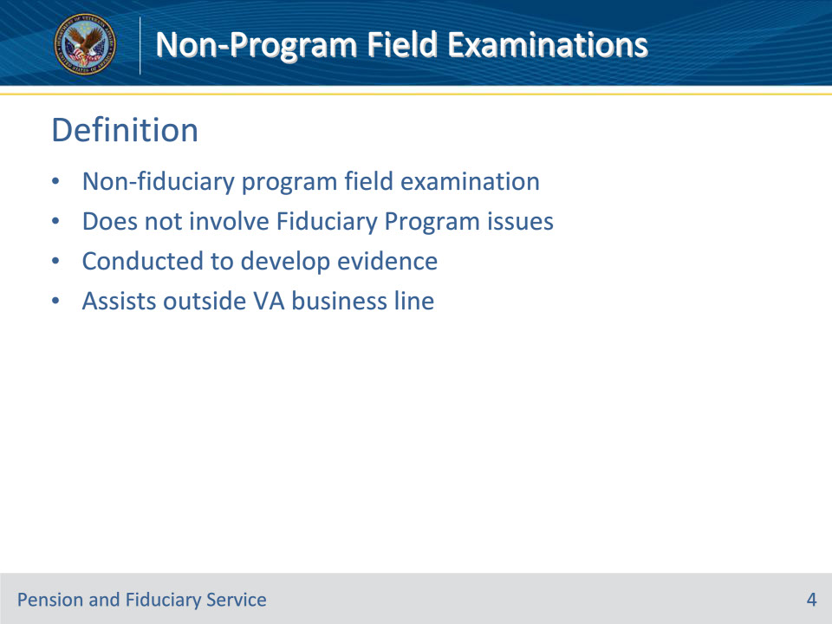
Slide notes

Policy Reference(s): FPM I.2.A.2.g.

Instructor Notes:

A non-fiduciary program field examination, also known as a non-program field examination, is a field examination that does not involve Fiduciary Program issues. This type of exam is conducted to develop evidence to enable the requesting VA business line to resolve outstanding issue(s).

Slide 5 - Areas
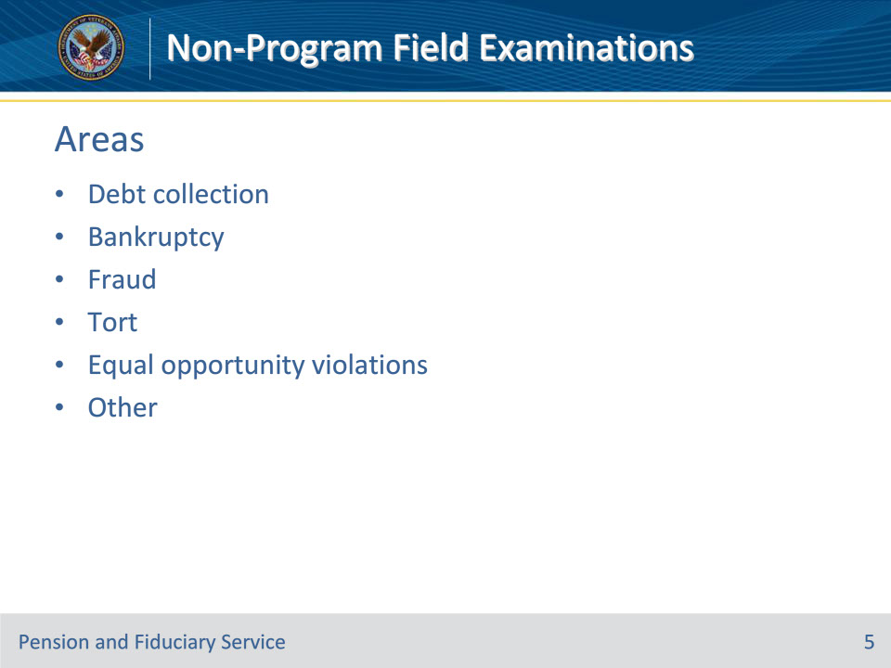
Slide notes

Policy Reference(s): FPM I.2.A.2.g.

Instructor Notes:

Non-fiduciary program field examinations are grouped into the following areas of investigation:

• debt collection

• bankruptcy

• fraud

• tort

• equal opportunity violations, and

• other

The other category includes requests for facts or documentation involving claims for benefits such as compensation or pension.

Slide 6 - Method
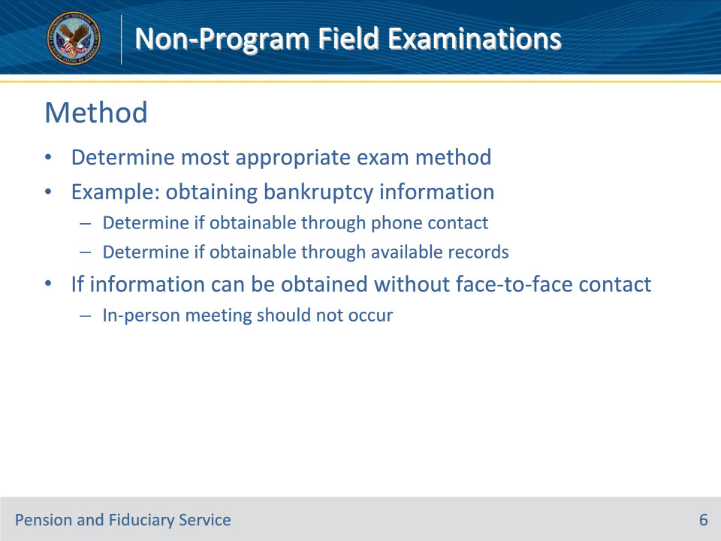
Slide notes

Policy Reference(s): FPM I.2.A.2.g.

Instructor Notes:

Evaluating the information being requested, the hub employee conducting the non-fiduciary program field examination must determine the most appropriate method to conduct the examination. For example, if the hub is being asked to assist with obtaining information relating to a bankruptcy, the hub employee must determine if the information may be obtained through telephone contact and through review of available records. If the hub employee finds the information can be obtained without face-to-face contact, an in-person meeting should not occur.

Slide 7 - Requests
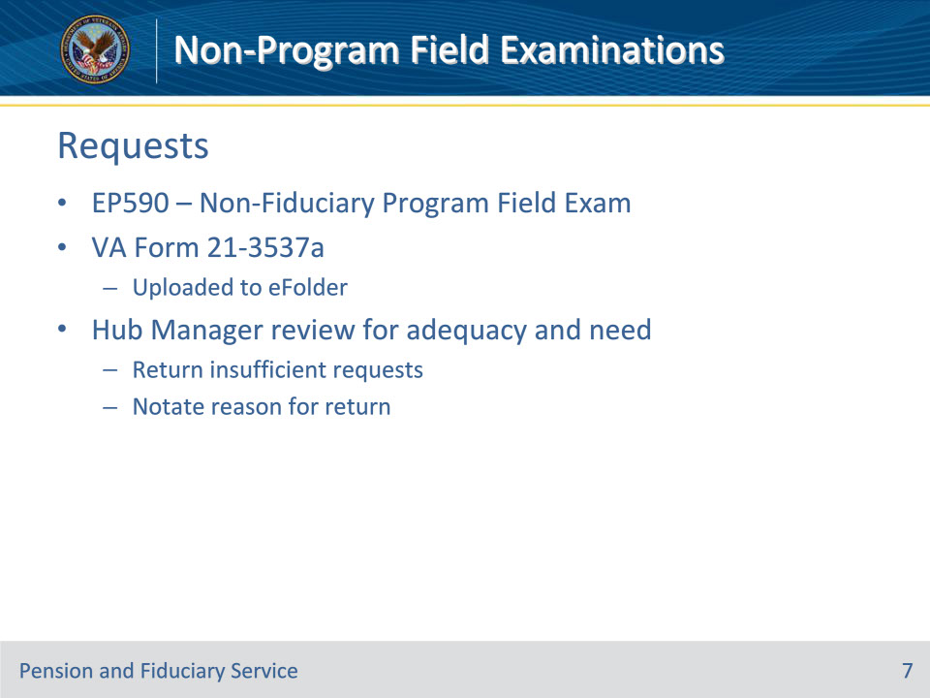
Slide notes

Policy Reference(s): FPM I.2.A.3.b., FPM I.2.A.3.d., M21-4 Appendix B

Instructor Notes:

The EP for a non-program field exam is EP590- Non-Fiduciary Program Field Examination

Non-fiduciary program requests must include a completed VA Form 21-3537a made available for review in the appropriate system of record.

The FHM or designee must review non-fiduciary program requests for adequacy and need. The hub must return requests containing insufficient information or seeking information that can be obtained without a field examination to the originator noting the reason for return.

Slide 8 - Documentation
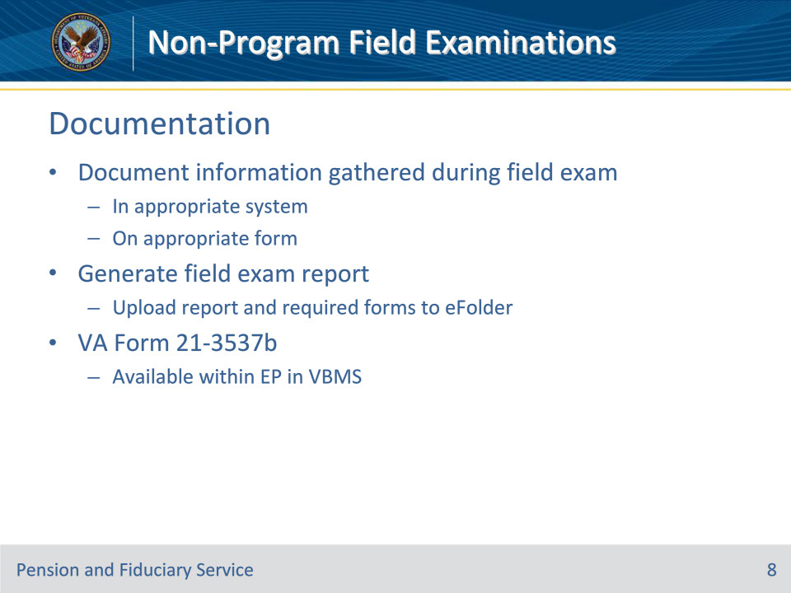
Slide notes

Policy Reference(s): FPM I.2.E.1.d.

Instructor Notes:

Hub personnel must enter the information gathered during the field examination process in the appropriate system or on the appropriate form. Hub personnel must also generate the applicable field examination and upload the report and required form(s) to the eFolder.

The hub must complete VA Form 21-3537b, Report of Field Examination, available within the EP in VBMS.

When generated, the VA Form 21-3537b within VBMS will automatically upload to the beneficiary’s eFolder.

Slide 9 - Referral
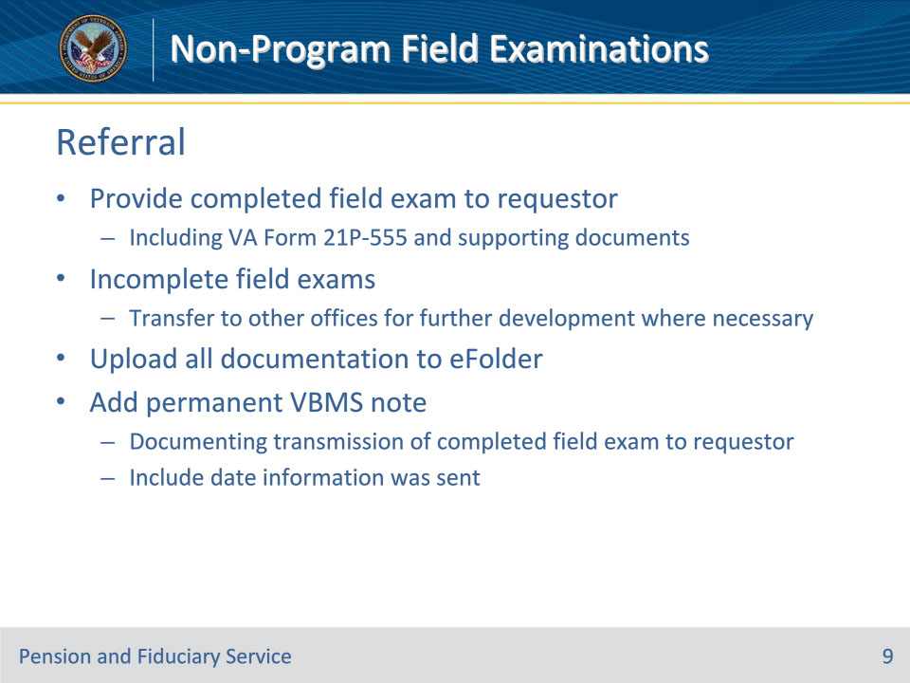
Slide notes

Policy Reference(s): FPM I.2.E.1.g.

Instructor Notes:

Hub personnel must provide completed non-fiduciary program field examinations, to include the VA Form 21P-555 and/or any supporting documentation, to the requestor.

Where necessary, incomplete field examinations are transferred to other appropriate offices for further development and the requestor is advised of the transfer. All documentation prepared or gathered must be uploaded to the beneficiary’s eFolder by the hub personnel completing the field examination.

Add a permanent note in VBMS documenting that the completed field examination was sent to the requesting agency or department, to include the date that the information was sent.

Slide 10 - 31. Questions?
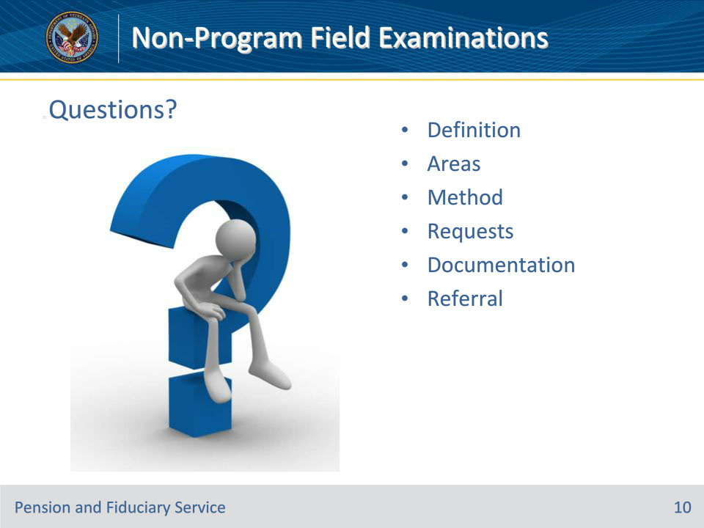
Slide notes

Instructor Notes:

(Recall) These are our learning objectives as stated from the beginning of the training:

• Define non-program field examinations

• List the areas to perform non-program field examinations

• Identify the main elements and requirements of non-program field examinations

• Describe the documentation and reporting requirements of non-program field examinations

(Recap) We discussed each of these learning objectives through the following topics in each slide today:

• Definition

• Areas

• Method

• Requests

• Documentation

• Referral

Are there any additional questions?

Slide 11 - TMS Survey
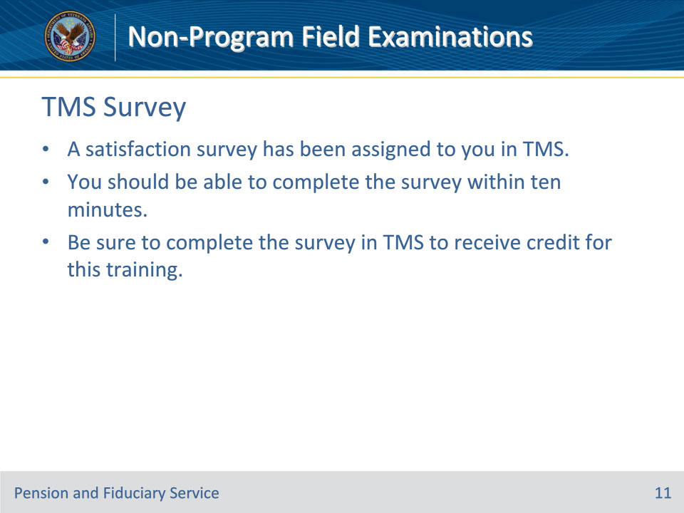
Slide notes

Instructor Notes:

A satisfaction survey has been assigned to you in TMS. You should be able to complete the survey within ten minutes. Completing the survey will allow you to receive credit for this training.

