Slide 1 - Telephone Follow-Up Field Examinations
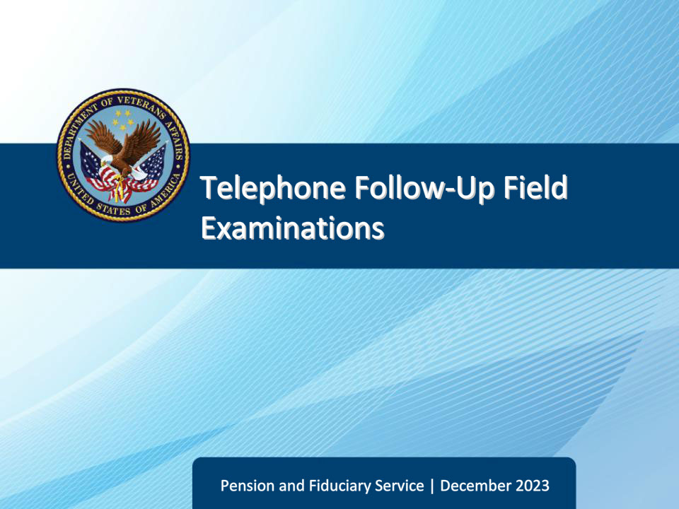
Slide notes

Course Description:

The lesson teaches learners about the purpose, critical elements, and specific requirements of telephone follow-up field examinations to include how a telephone follow-up field examination is initiated, documented, and reported.

Slide 2 - Objectives
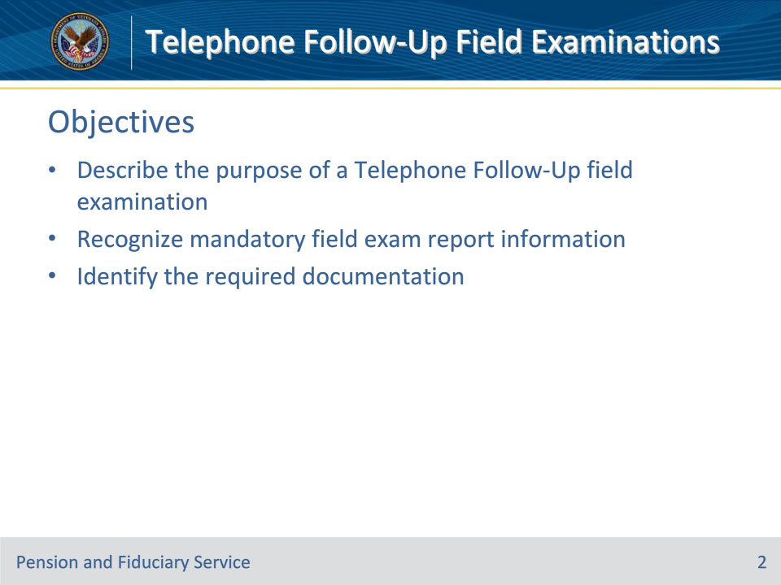
Slide notes

Instructor Notes:

At the end of this lesson, given the training and references, the learner will be able to do the following:

• Describe the purpose of a Telephone Follow-Up field examination

• Recognize mandatory field exam report information

• Name the required documentation

Slide 3 - References
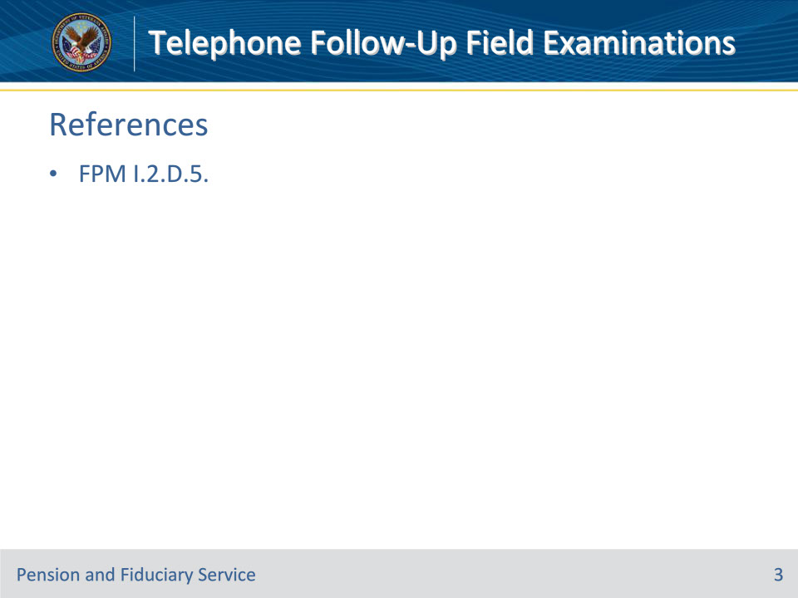
Slide notes

Instructor Notes:

The following are relevant references pertaining to telephone follow-up field examinations:

• FPM I.2.D.5. Beneficiary Telephonic Oversight

Slide 4 - Purpose
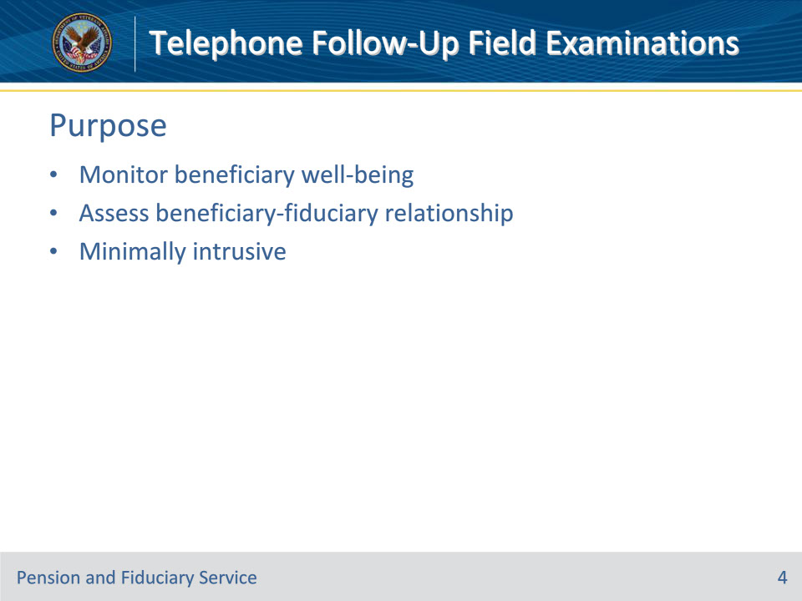
Slide notes

Policy Reference(s): FPM I.2.D.5.a.,b.

Instructor Notes:

VA uses telephonic oversight with qualifying beneficiaries to

• monitor the beneficiary well-being, and

• assess the beneficiary-fiduciary relationship.

Detailed financial information is not gathered during the telephonic contact because the fiduciary will be required to provide VA with three months of bank statements via fund usage reviews.

Fiduciary Program policy requires oversight of beneficiaries using the least intrusive method possible. Telephonic contact allows VA to maintain oversight of beneficiaries in a way that is minimally intrusive when the beneficiary’s ability to correspond with VA is not expected to be limited based on the evidence of record.

Slide 5 - Eligibility
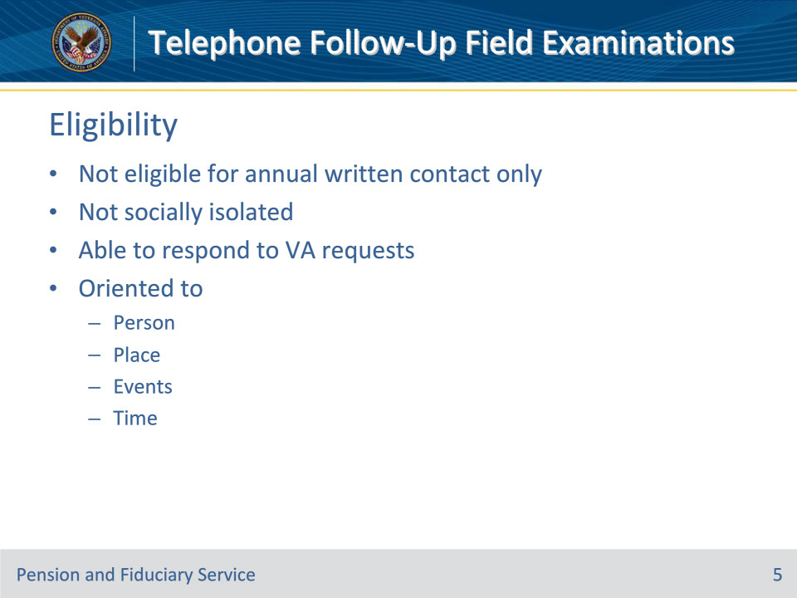
Slide notes

Policy Reference(s): FPM I.2.D.5.c.

Instructor Notes:

If the beneficiary’s situation does not meet the criteria for annual written contact only, the beneficiary may qualify for scheduled telephonic contact.

Beneficiaries who qualify for telephonic oversight are

• not socially isolated

• able to respond to VA requests, and

• oriented to person, place, events and time as of the most recent VA contact.

Social isolation is a state of complete or near-complete lack of contact between an individual and society.

Slide 6 - Disqualifications
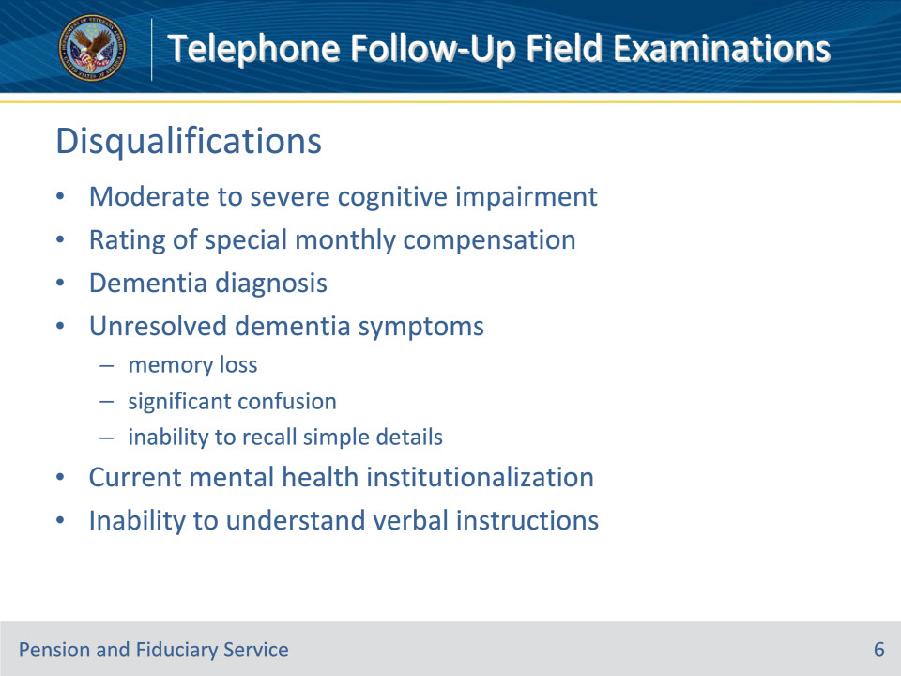
Slide notes

Policy Reference(s): FPM I.2.D.5.c.

Instructor Notes:

Beneficiaries will not qualify for scheduled telephonic contact if documentation in the eFolder shows evidence of

• documented moderate to severe cognitive impairment as evidenced by

• a rating of special monthly compensation

• a diagnosis of dementia

• medical or lay evidence indicating unresolved symptoms of dementia such as

• memory loss of both recent and distant past events

• significant confusion, and/or

• the inability to recall simple details about themselves, or

• current institutionalization of the beneficiary due to mental health, or

• the inability to understand verbal instructions.

Slide 7 - Contact
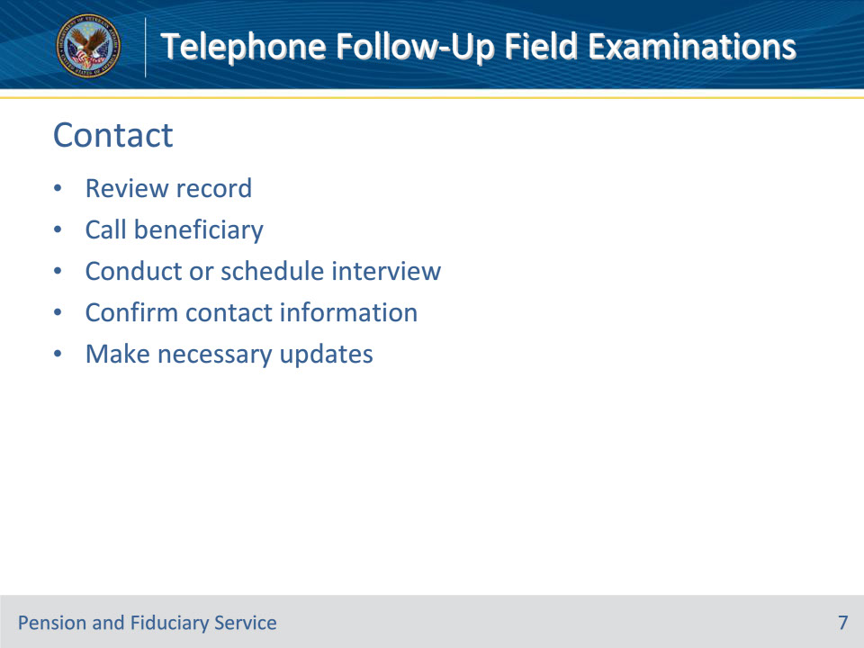
Slide notes

Policy Reference(s): FPM I.2.D.5.d.

Instructor Notes:

Hub personnel must review the beneficiary information and then follow all required steps to contact the beneficiary and complete the telephonic review.

Upon contact with the beneficiary, the interview may be conducted at that time, or scheduled for a future date that is more convenient for the beneficiary. The beneficiary may also elect to conduct the interview via secure videoconferencing.

Confirm contact information (address, telephone numbers, etc.) and make any necessary updates to the beneficiary’s record if there are any changes.

Slide 8 - Dependents
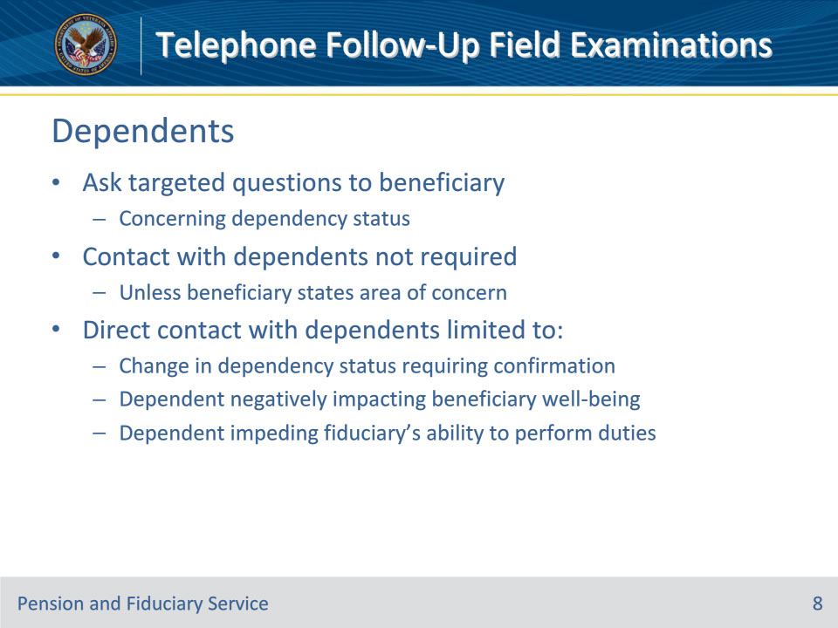
Slide notes

Policy Reference(s): FPM I.2.D.5.d. FPM

Instructor Notes:

Contact with a beneficiary’s dependent(s) is not required during the telephonic field examination unless the beneficiary states an area of concern which requires a dependent to be contacted. Hub personnel conducting the telephonic field examination must ask targeted questions to the beneficiary concerning their dependency status. Direct contact with the dependent(s) will be limited to situations where the beneficiary indicates a:

• change in dependency status which requires confirmation with the dependent, and/or

• dependent is negatively impacting their well-being or is impeding the ability of the fiduciary to perform the required duties.

Slide 9 - Whereabouts Unknown
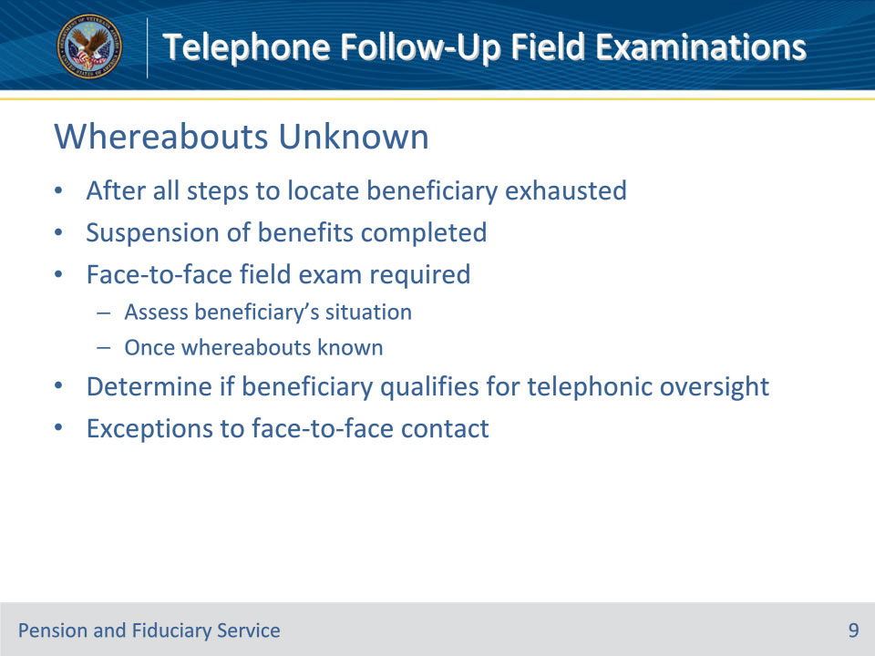
Slide notes

Policy Reference(s): FPM I.2.D.5.e.

Instructor Notes:

After all steps to locate and contact the beneficiary have been exhausted and suspension of benefits completed, a face-to-face field examination will be required to assess the beneficiary’s situation once the whereabouts of the beneficiary are again known.

After the field examination, the FE must determine whether the beneficiary’s situation qualifies for telephonic oversight.

Exception: The FE may conduct the field examination telephonically or via secure videoconferencing when one of the exceptions to unscheduled field examinations exists:

• the beneficiary

• is incarcerated

• is a patient in a hospital with restrictive entry rules, such as a facility for the criminally insane that requires warden approval, or

• would not be contacted directly because of their age, or

• there is a documented safety concern that has not been resolved.

Slide 10 - Interview
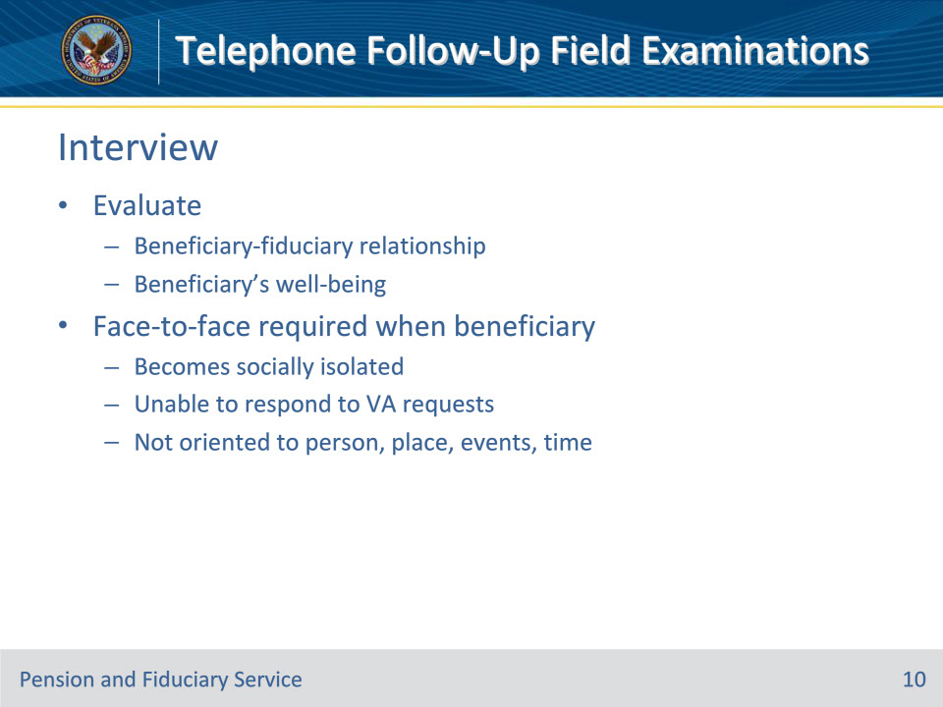
Slide notes

Policy Reference(s): FPM I.2.D.5.f.,g. FPM I.2.D.3.d.

Instructor Notes:

Hub personnel must evaluate and document the beneficiary-fiduciary relationship and evaluate an adult and minor beneficiary’s well-being.

The FE must discontinue the telephone interview and assess the beneficiary’s situation through a face-to-face field examination if it becomes apparent during the telephone interview that the beneficiary

• has become socially isolated

• is unable to respond to VA requests, or

• is not oriented to person, place, events, and time.

Exception: The FE may bypass face-to-face contact if one of the exceptions to unscheduled field examinations exists:

• the beneficiary

• is incarcerated

• is a patient in a hospital with restrictive entry rules, such as a facility for the criminally insane that requires warden approval, or

• would not be contacted directly because of their age, or

• there is a documented safety concern that has not been resolved.

Slide 11 - Documenting
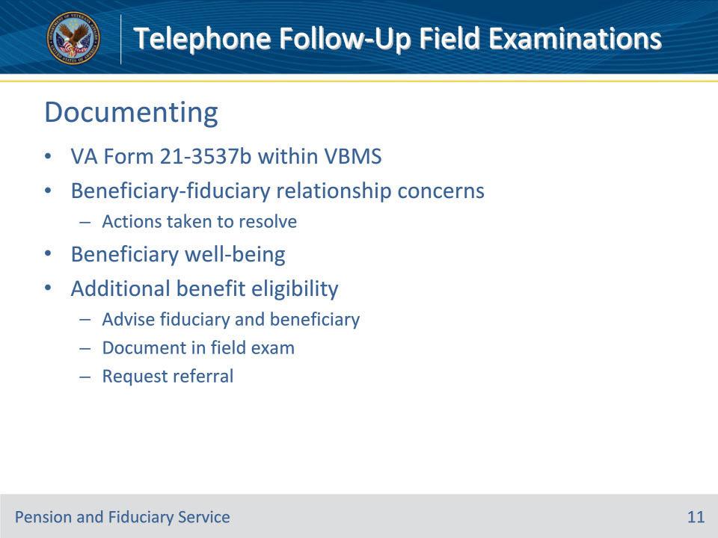
Slide notes

Policy Reference(s): FPM I.2.D.5.h.,i.

Instructor Notes:

The information obtained during the telephonic contact with the beneficiary must be documented on a system-generated VA Form 21-3537b, Report of Field Examination, within VBMS.

At a minimum, the report must contain the following information:

• areas of concern with the beneficiary-fiduciary relationship and the actions taken to resolve those areas of concern, and

• the well-being of the beneficiary to include whether they are responsive to VA requests and oriented to time, place, and events.

When there may be eligibility for additional benefits or services not yet claimed by the beneficiary, hubs must advise fiduciaries and beneficiaries of such benefits and services during the telephonic contact to ensure that the beneficiary receives accurate payment of benefits. The hubs should also explain entitlement to other State and local benefits.

If the hub identifies changes or possible changes in benefit entitlement, the hub must document the information in the field examination and request referral to the appropriate authorization activity.

Slide 12 - Questions?
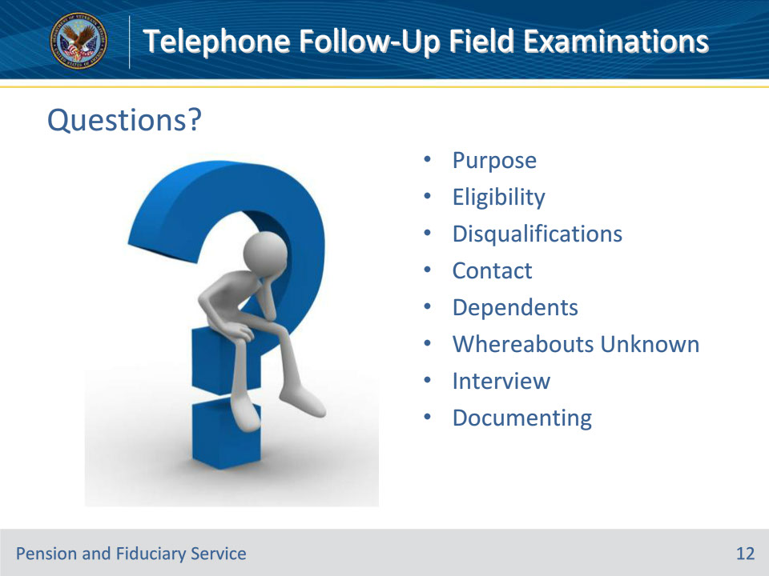
Slide notes

Instructor Notes:

(Recall) These are our learning objectives as stated from the beginning of the training:

• Describe the purpose of a Telephone Follow-Up field examination

• Recognize mandatory field exam report information

• Name the required documentation

(Recap) We discussed each of these learning objectives through the following topics in each slide today:

• Purpose

• Eligibility

• Disqualifications

• Contact

• Dependents

• Whereabouts Unknown

• Interview

• Documenting

Are there any additional questions?

Slide 13 - TMS Survey
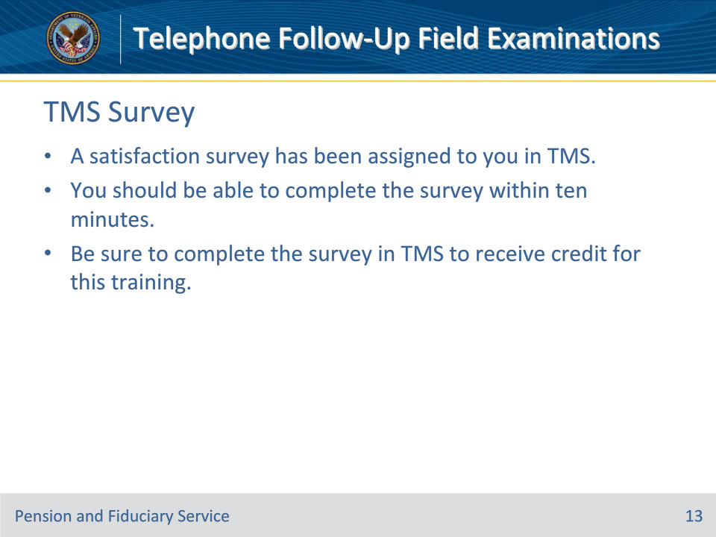
Slide notes

Instructor Notes:

A satisfaction survey has been assigned to you in TMS. You should be able to complete the survey within ten minutes. Completing the survey will allow you to receive credit for this training.

