Slide 1 - Field Examination Safety
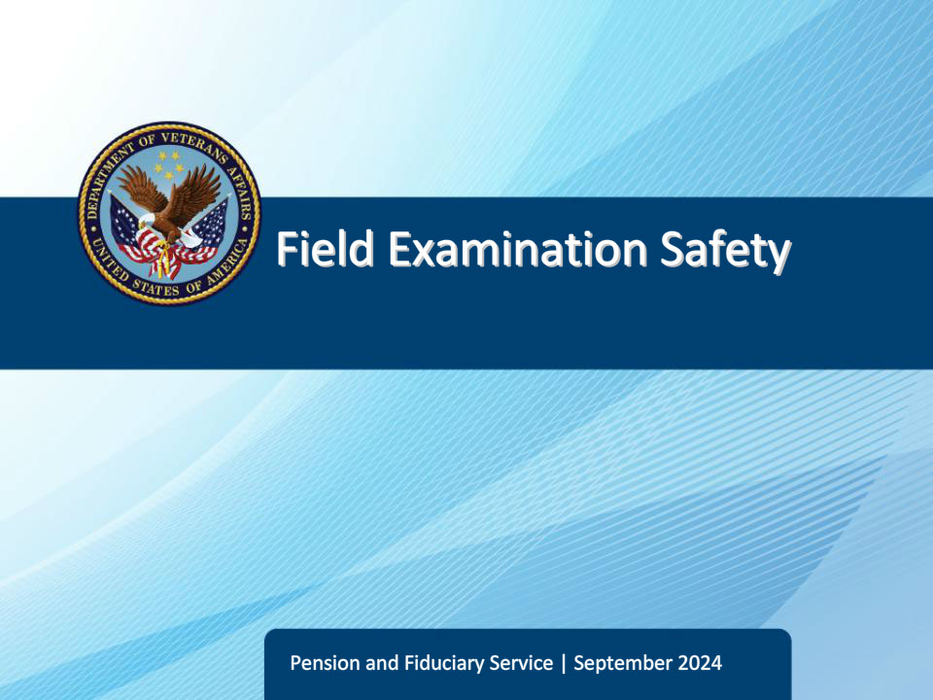
Slide notes

Course Description:

This course teaches learners about field examination safety precautions, considerations, and requirements, as well as the procedures for rescheduling a canceled field examination and reporting assault or threats.

Slide 2 - Objectives
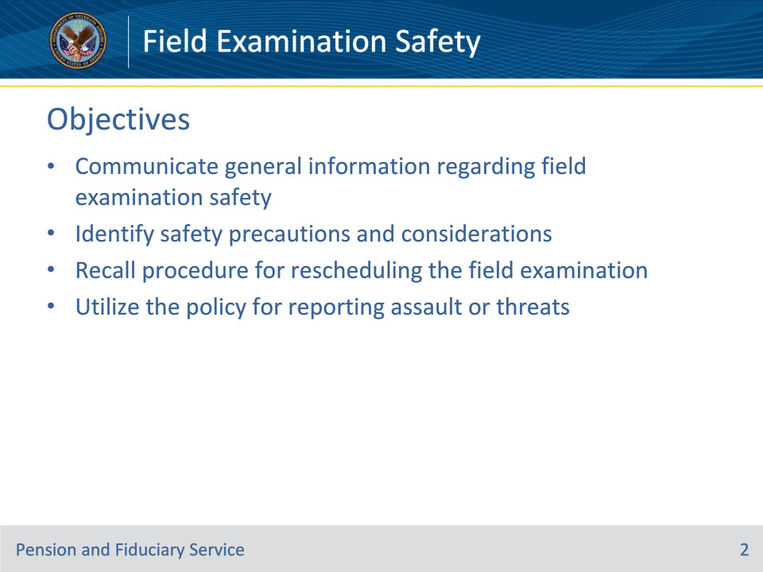
Slide notes

Instructor Notes:

At the end of this lesson, given the training and references, the learner will be able to do the following:

• Communicate general information regarding field examination safety

• Identify safety precautions and considerations

• Recall procedure for rescheduling the field examination

• Utilize the policy for reporting assault or threats

Slide 3 - References
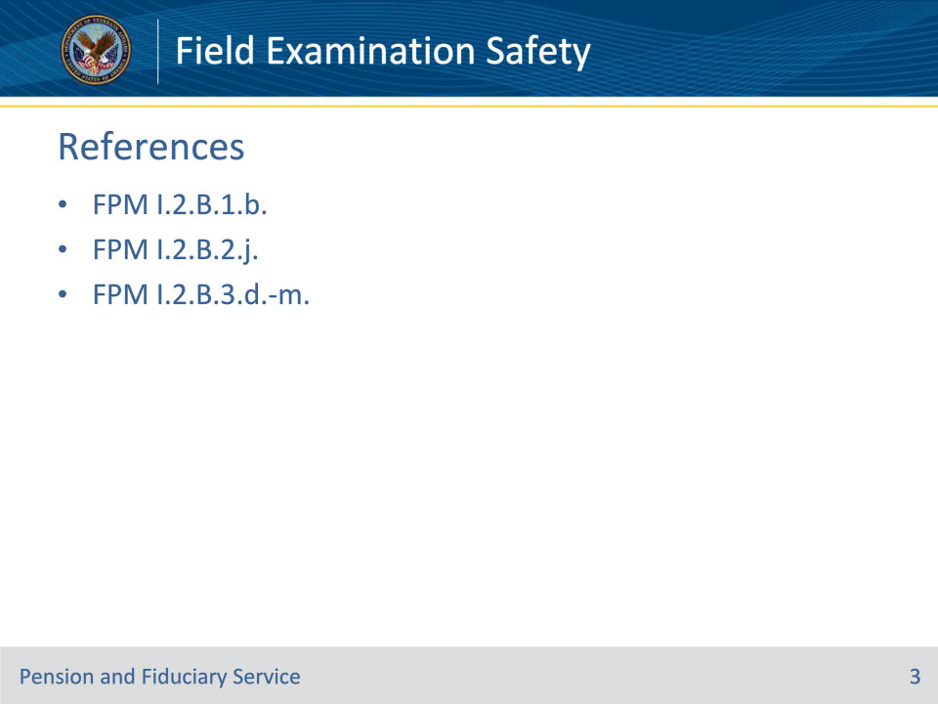
Slide notes

Instructor Notes:

These are the relevant references pertaining to this course:

• FPM I.2.B.1.b. Identifying Safety Concerns

• FPM I.2.B.2.j. Rescheduling Field Examinations Due to Safety Concerns

• FPM I.2.B.3.d. General Information on Safety Concerns During Field Examinations

• FPM I.2.B.3.e. Safety Concerns Related to Traveling to the Interview

• FPM I.2.B.3.f. Safety Concerns Related to Technology and Environmental Awareness

• FPM I.2.B.3.g. Safety Concerns Related to Parking and Leaving the Car

• FPM I.2.B.3.h. Safety Concerns Related to Approaching the Interview Location

• FPM I.2.B.3.i. Safety Concerns Related to the Field Examination Interview

• FPM I.2.B.3.j. Safety Concerns Related to Third-Party Entities Present During Interviews

• FPM I.2.B.3.k. Safety Concerns Related to Weapons and Firearms at the Interview Location

• FPM I.2.B.3.l. Safety Concerns Related to Animals at the Interview Location

• FPM I.2.B.3.m. Reporting Physical Assault or Threats

Slide 4 - General Information
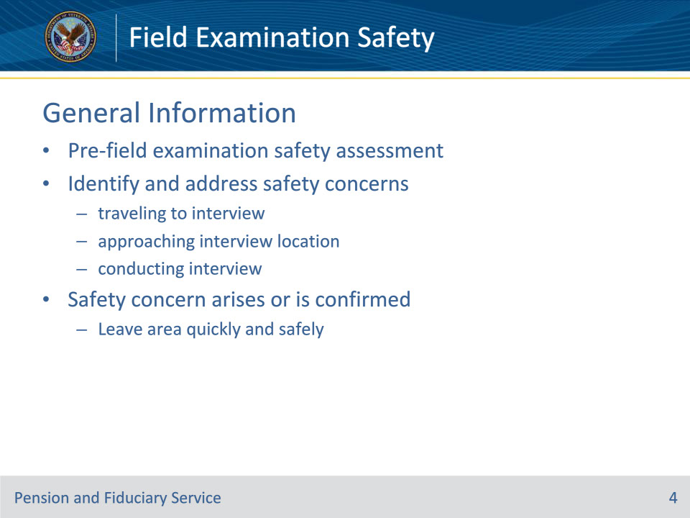
Slide notes

Policy Reference(s): FPM I.2.B.3.d.

Instructor Notes:

Before conducting a face-to-face field examination, the FE must complete a pre-field examination safety assessment.

FEs must take steps to identify and address safety concerns appropriately when

• traveling to the interview

• approaching the interview location, and

• conducting the interview.

At any point during the arrival or interview, if a safety concern arises or is confirmed, the FE must leave the area as quickly and safely as possible.

Slide 5 - Safety Assessment
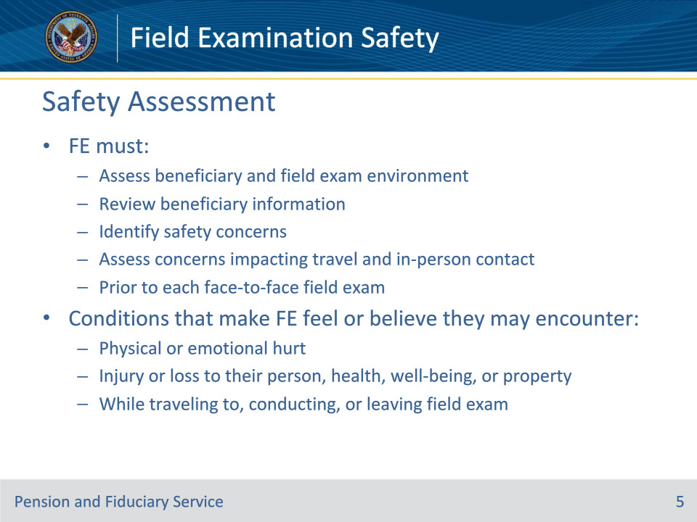
Slide notes

Policy Reference(s): FPM I.2.B.1.b.

Instructor Notes:

Employee safety is a primary concern. Prior to each face-to-face field examination, the FE must assess the beneficiary and field examination environment to identify safety concerns. Safety concerns are conditions that make the FE feel or believe that they may encounter physical or emotional hurt, injury or loss to their person, health, well-being, or property while traveling to, conducting, or leaving a field examination.

The FE must review the beneficiary information to identify safety concerns. The FE must also assess potential safety concerns that may impact travel or the appropriateness of in-person contact.

Slide 6 - Safety Assessment
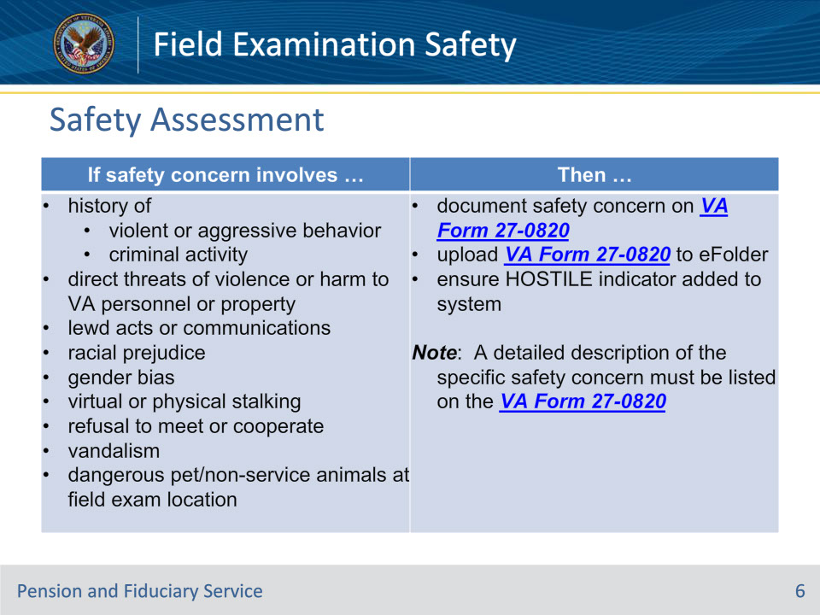
Slide notes

Policy Reference(s): FPM I.2.B.1.b.

Instructor Notes:

Use this table to identify safety concerns and the appropriate actions to complete when a safety concern is identified.

Slide 7 - Safety Assessment
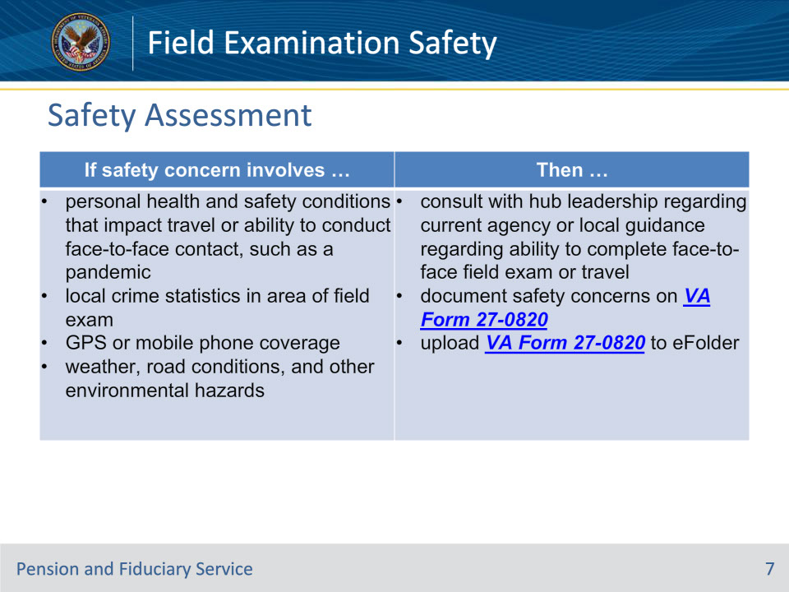
Slide notes

Policy Reference(s): FPM I.2.B.1.b.

Instructor Notes:

Use this table to identify safety concerns and the appropriate actions to complete when a safety concern is identified.

If review of the safety concern results in determination that face-to-face contact is not appropriate, follow the guidance for rescheduling the field examination.

Slide 8 - Travel Precautions
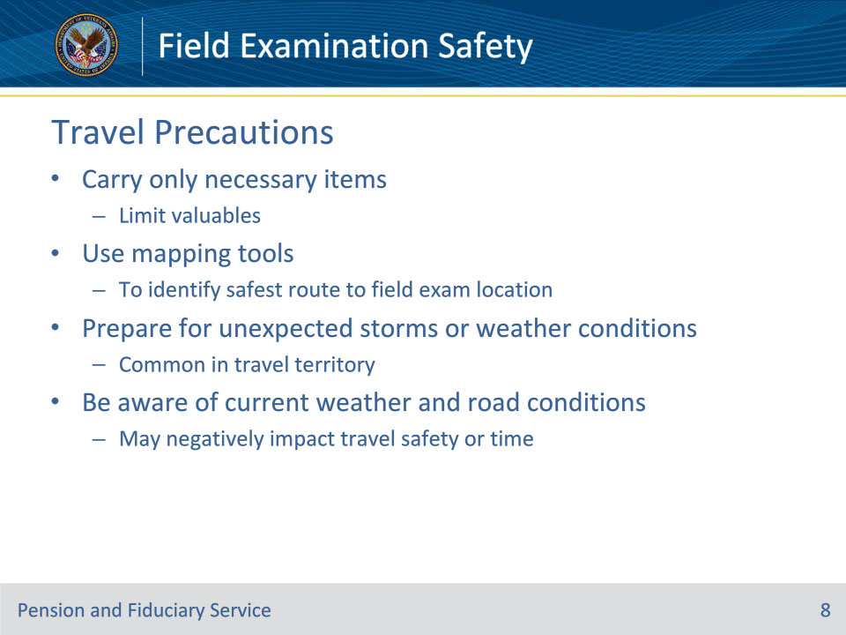
Slide notes

Policy Reference(s): FPM I.2.B.3.e.

Instructor Notes:

Before traveling to a face-to-face field examination, the FE must identify and prepare for safety concerns associated with travel.

To reduce safety concerns FEs should

• only take the items needed for the interview and limit carrying valuable items (cash, jewelry, etc.)

• use mapping tools to identify the safest route to the field examination location

• be prepared for unexpected storms or weather conditions that are common in and around the territory they travel, and

• be aware of current weather and road conditions that may negatively impact travel safety or time

Slide 9 - Travel Precautions
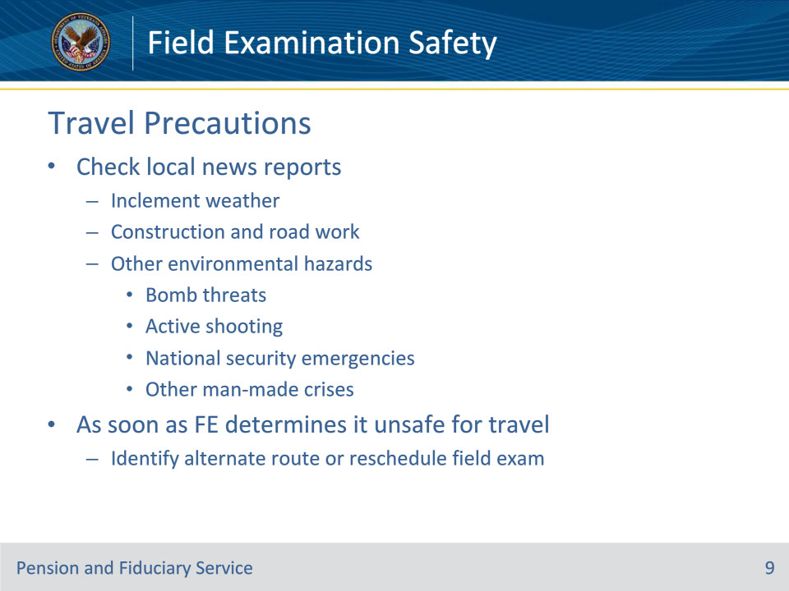
Slide notes

Policy Reference(s): FPM I.2.B.3.e.

Instructor Notes:

• Be aware of current weather and road conditions that may negatively impact travel safety or time by checking local news reports for

• inclement weather

• ongoing construction and road work, or

• other environmental hazards such as

• bomb threats

• active shooting

• national security emergencies (acts of terrorism), or

• other man-made crises.

As soon as the FE determines that weather, road conditions or other environmental hazards make it unsafe for travel, the FE must identify an alternate route or reschedule the field examination.

Slide 10 - Technology
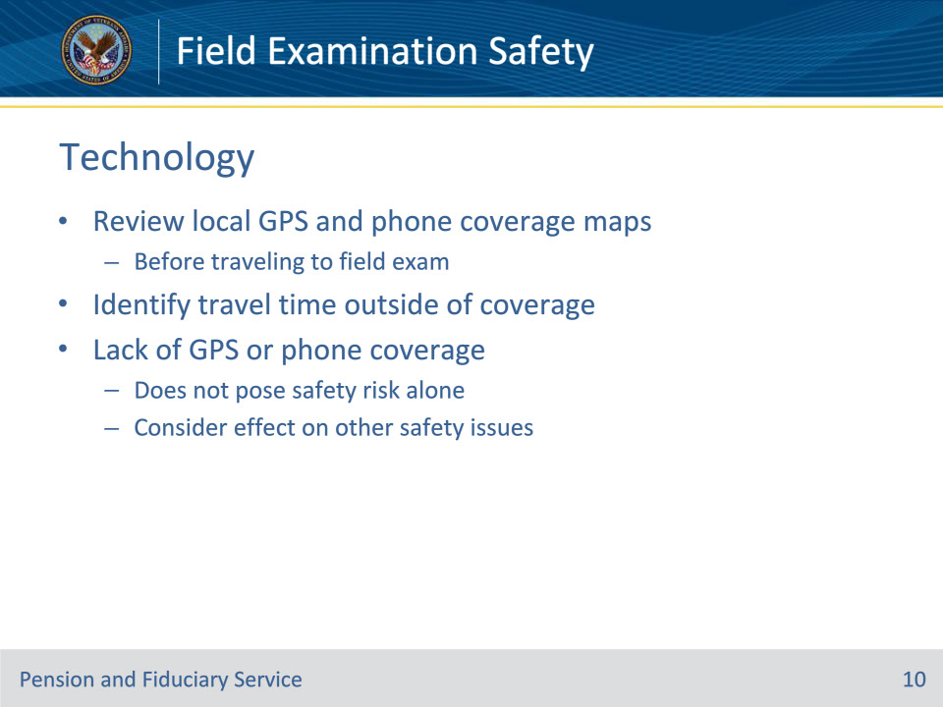
Slide notes

Policy Reference(s): FPM I.2.B.3.f.

Instructor Notes:

Before traveling to a face-to-face field examination, FEs shall review local GPS and mobile phone coverage maps to identify areas in their regular assigned territory with no or poor coverage.

If the interview location falls outside of coverage area, the FE should identify the approximate travel time outside of coverage.

The lack of a GPS satellite signal and/or mobile phone coverage alone does not pose a safety risk. However, the FE must consider how other safety issues could be exacerbated by the lack of GPS and mobile phone coverage.

Slide 11 - Vehicle Precautions
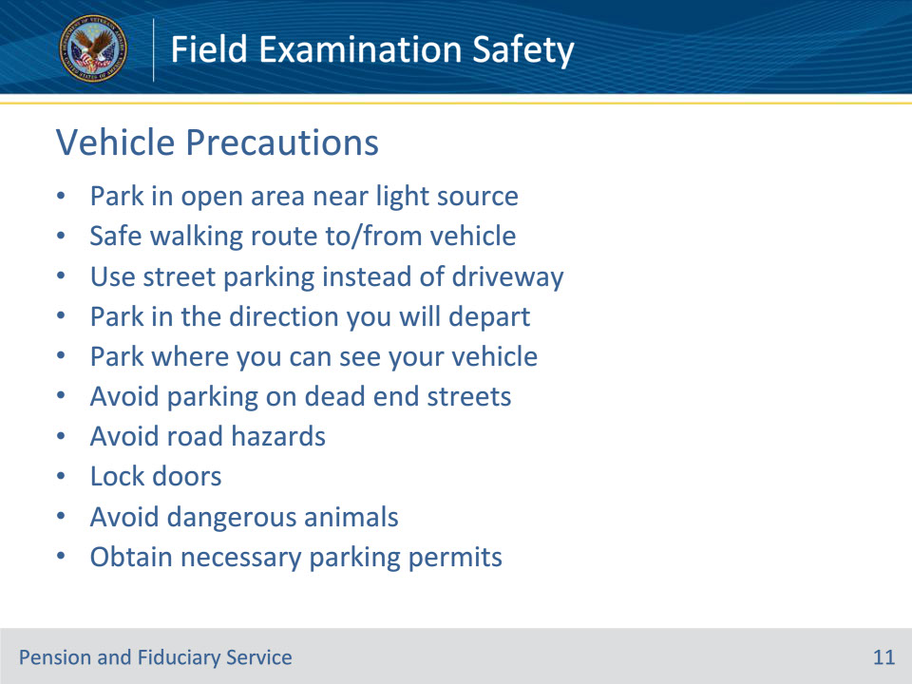
Slide notes

Policy Reference(s): FPM I.2.B.3.g.

Instructor Notes:

Upon arrival at the interview location, FEs must be conscious of where and how vehicles are parked to ensure a safe departure. When possible, FEs should make efforts to

• choose a parking space that is in the open and near a light source, if arriving or departing when daylight is limited, that offers the safest walking route to the interview location

• use street parking, instead of parking in a driveway to avoid potentially blocked exits when visiting a home

• park in the direction that you will depart the interview location and where you can see your car from inside the interview location

• avoid parking on dead end streets

• avoid road hazards (e.g. glass, mud, standing water, ditches) that can flatten a tire or immobilize your car

• lock doors upon entering and exiting the vehicle

• contact the interviewee, if animals are loose and pose a threat to your safety before exiting the vehicle, and

• determine if a visitor parking permit is necessary by contacting the interviewee or building office when planning on utilizing a visitor parking area.

Slide 12 - Approaching Location
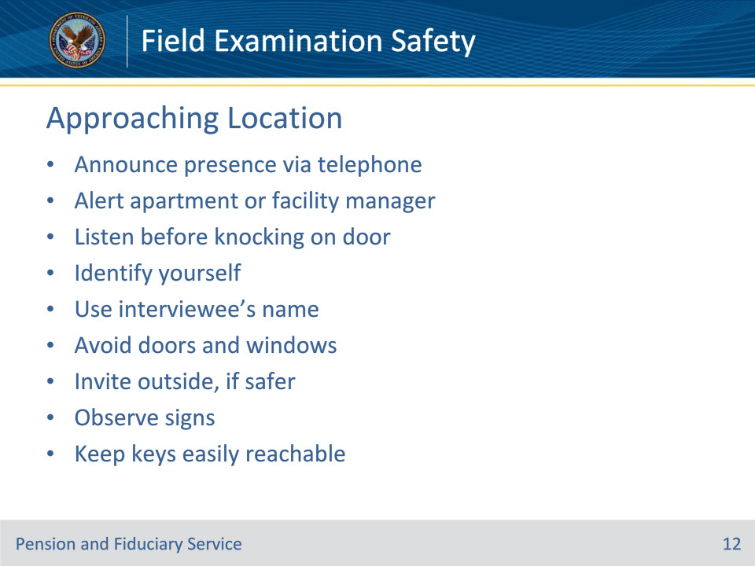
Slide notes

Policy Reference(s): FPM I.2.B.3.h.

Instructor Notes:

When approaching the interview location FEs must

• announce their presence by contacting the individual telephonically when arriving so the individual isn’t surprised

• alert the apartment manager or facility manager of the FEs presence on the premises or in the building, if appropriate

• listen before knocking on a door or ringing the doorbell and leave immediately if arguing, sounds of fighting, or some other signs of hostility are heard

• always reveal their identity and use the interviewee’s name

• avoid standing in front of doors or windows, if possible

• decide if it is safer to enter the site or invite the client outside depending upon what is seen inside

• be mindful of signs like No Trespassing, Beware of the Dog, Beware of the Owner, as they may indicate an attitude towards strangers, and

• keep keys easily reachable.

Slide 13 - Interview Precautions
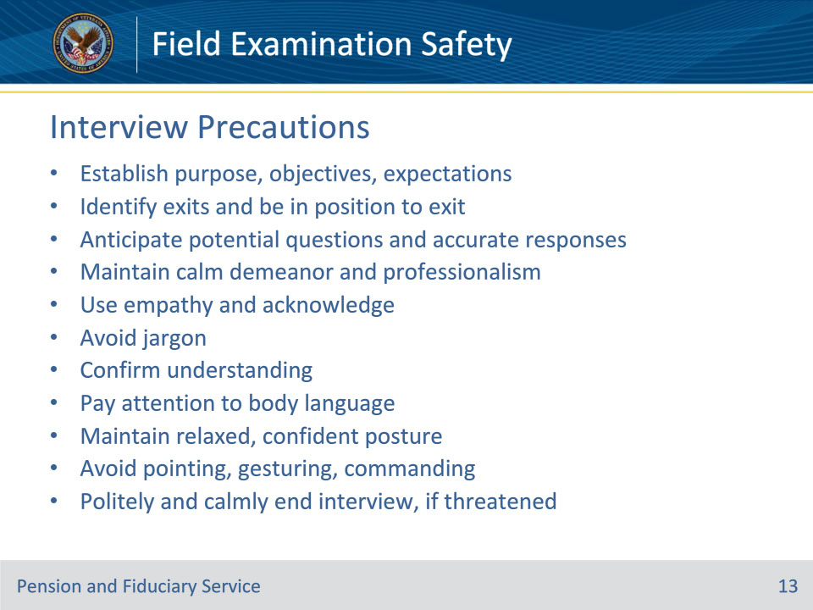
Slide notes

Policy Reference(s): FPM I.2.B.3.i.

Instructor Notes:

The FE should continue to be alert during the interview process.

Before starting an interview, the FE must

• establish purpose, objectives, and expectations for the meeting, and

• identify exits and be in position for a clear exit.

Treat all individuals with dignity and respect; and be courteous, regardless of the other person’s behavior. To do so, the FE must

• prepare for the interview, anticipating potential questions and accurate responses

• maintain a calm and reassuring demeanor, ensuring that another person’s anger does not negatively impact professionalism

• use empathy and acknowledge the other person’s feelings and concerns

• avoid using jargon or technical language

• confirm understanding by repeating issues and concerns

• pay close attention to the other person’s body language

• maintain a relaxed confident, posture and be attentive

• avoid pointing, gesturing, or giving commands, and

• politely and calmly end the interview if threatened in any way.

Slide 14 - Third Parties
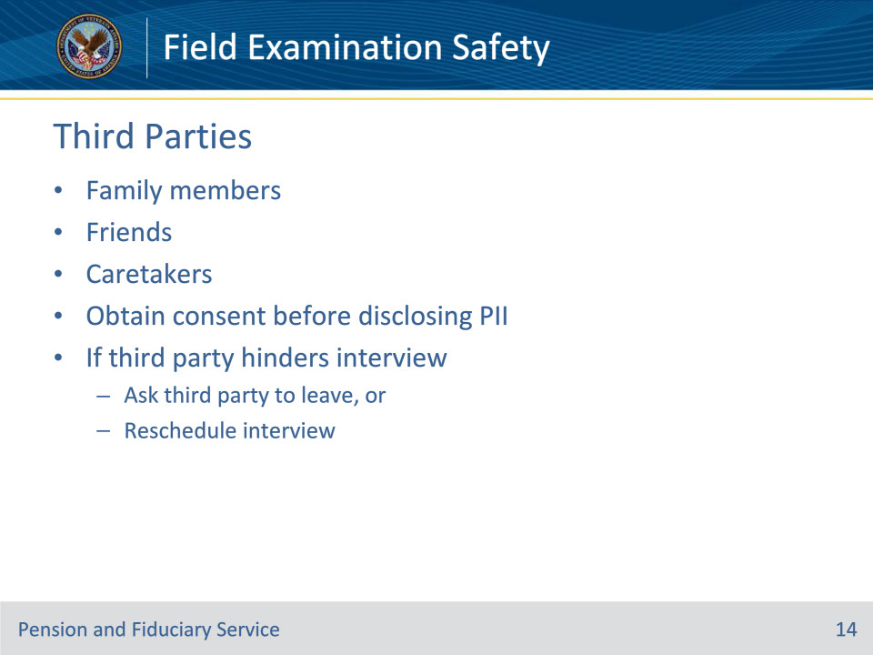
Slide notes

Policy Reference(s): FPM I.2.B.3.j.

Instructor Notes:

The FE may encounter additional third-party individuals, to include

• family members

• friends, or

• caretakers of the VA beneficiary.

The FE must be sensitive to disclosing or sharing personally identifiable information about the VA beneficiary, without obtaining consent.

In addition, third-party entities may try to hinder the interview process.

The FE may find the need to ask the third party to leave to complete the interview or the FE may need to reschedule the interview for another date or time.

Slide 15 - Weapons
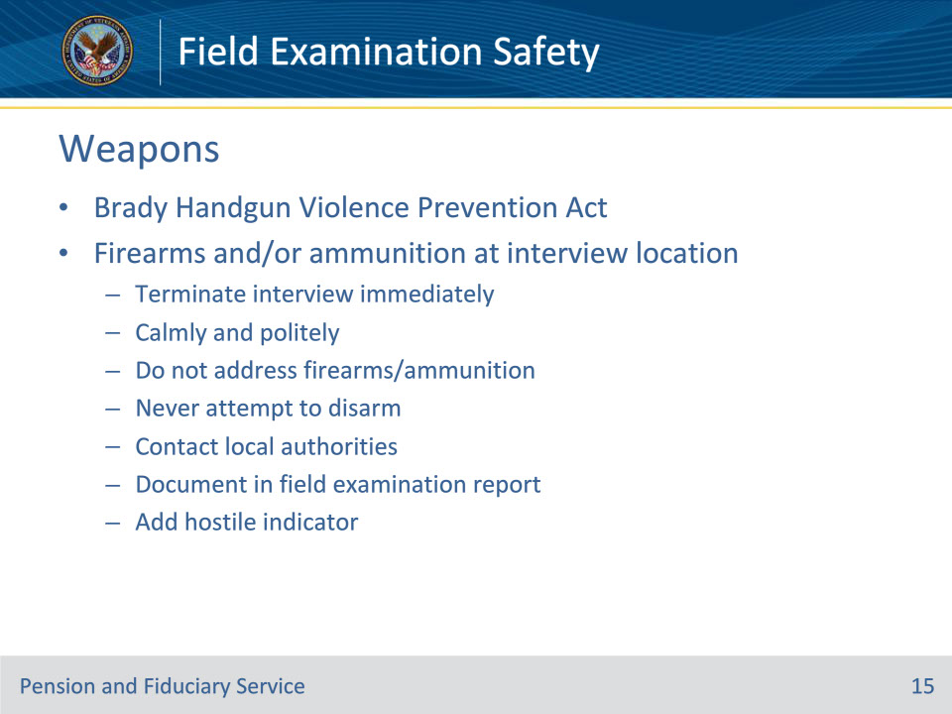
Slide notes

Policy Reference(s): FPM I.2.B.3.k.

Instructor Notes:

The Brady Handgun Violence Prevention Act (Brady Act) prohibits individuals, including beneficiaries the VA determines are incompetent from purchasing, possessing, receiving, shipping or transporting a firearm or ammunition.

When the FE is conducting a beneficiary interview and observes prohibited firearms and/or ammunition in the interview location, the interview must be terminated immediately.

The FE should calmly explain that they must reschedule the interview and apologize for the inconvenience, without addressing the firearm on the premises.

• Do not address that the VA beneficiary is prohibited from possessing the firearm and/or ammunition during the interview.

• Never try to disarm an individual.

• After leaving the interview site, the FE should contact local authorities to report the presence of the firearm and/or ammunition.

• Document that weapons were observed on site in the Field Examination Report.

• Add the HOSTILE indicator in the system before closing the field examination.

Slide 16 - Animals
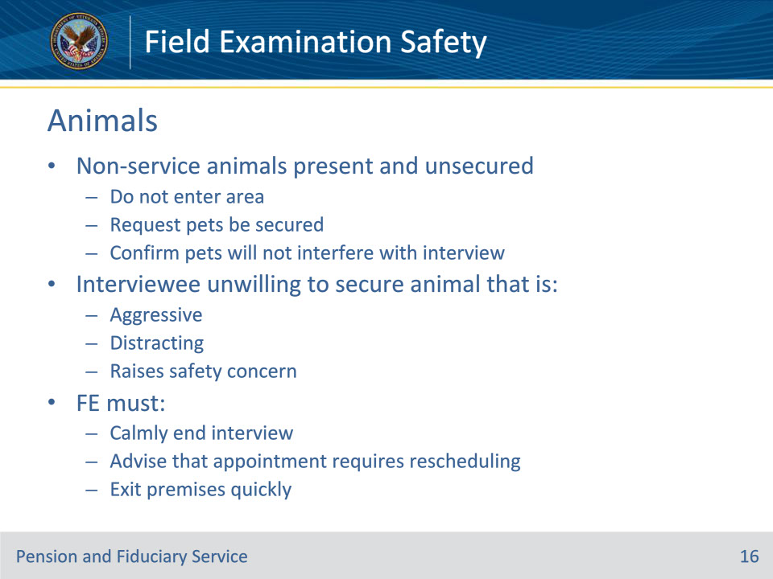
Slide notes

Policy Reference(s): FPM I.2.B.3.l.

Instructor Notes:

When non-service animals are present and unsecured, do not attempt to enter the area. Contact the interviewee and request that the pets are secured and confirm that the pets will not interfere with the interview.

If the interviewee is unwilling to secure animal that is aggressive, distracting or raises a safety concern, the FE must

• calmly and respectfully end the interview

• advise the interviewee that the appointment requires rescheduling, and

• exit the premises as quickly as possible.

Slide 17 - Animals
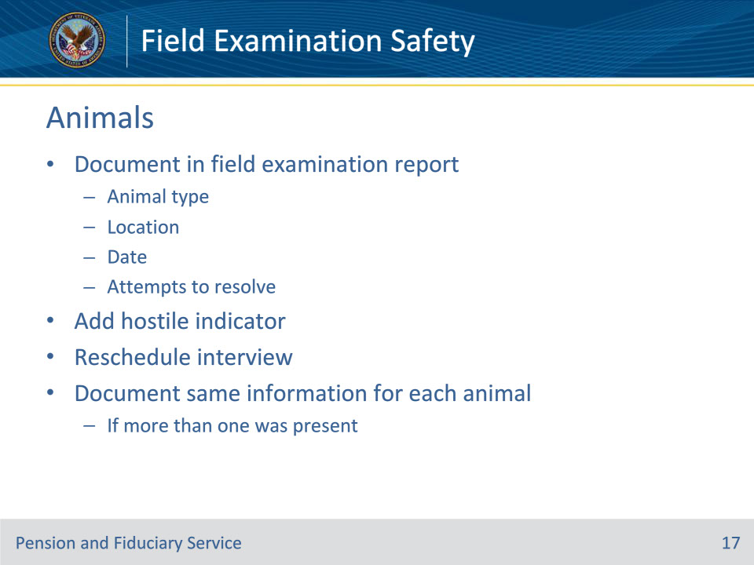
Slide notes

Policy Reference(s): FPM I.2.B.3.l.

Instructor Notes:

When completing the field examination report, the FE must

• document that an unrestrained animal was onsite to include

• animal type

• location

• date, and

• any attempts to resolve the safety concern

• add the HOSTILE indicator in the system, and

• reschedule the interview for a later date when the animal is secured.

Document the same information for each animal if more than one was present.

Slide 18 - Rescheduling
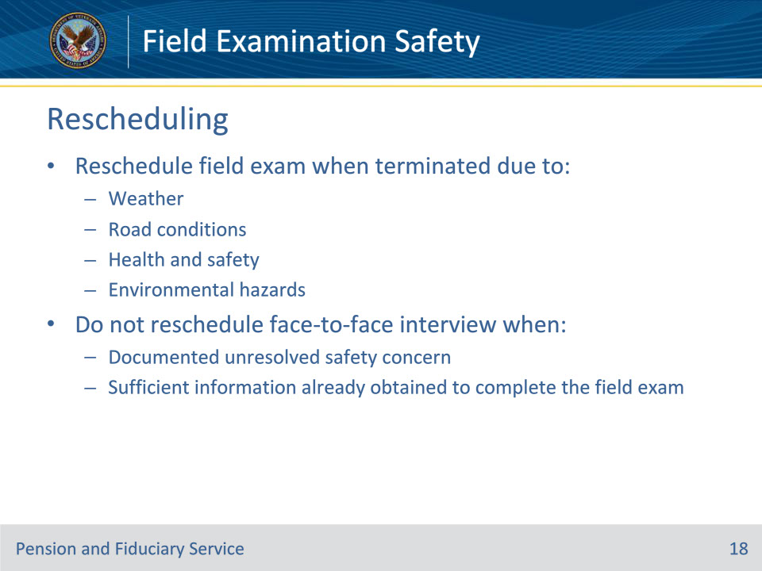
Slide notes

Policy Reference(s): FPM I.2.B.2.j.

Instructor Notes:

Hub personnel must contact the interviewee as soon as possible to reschedule the field examination when it is terminated or does not occur due to a

• safety concern, to include, but not limited to

• weather

• road conditions

• health and safety, or

• environmental hazards.

• Do not reschedule a face-to-face interview when there is a documented safety concern that has not been resolved. In these cases, the interview must be completed telephonically or through other approved teleconference services.

• If the field examination was terminated due to a safety concern, but sufficient information was obtained to complete the field examination, do not attempt to reschedule the interview.

Slide 19 - Rescheduling
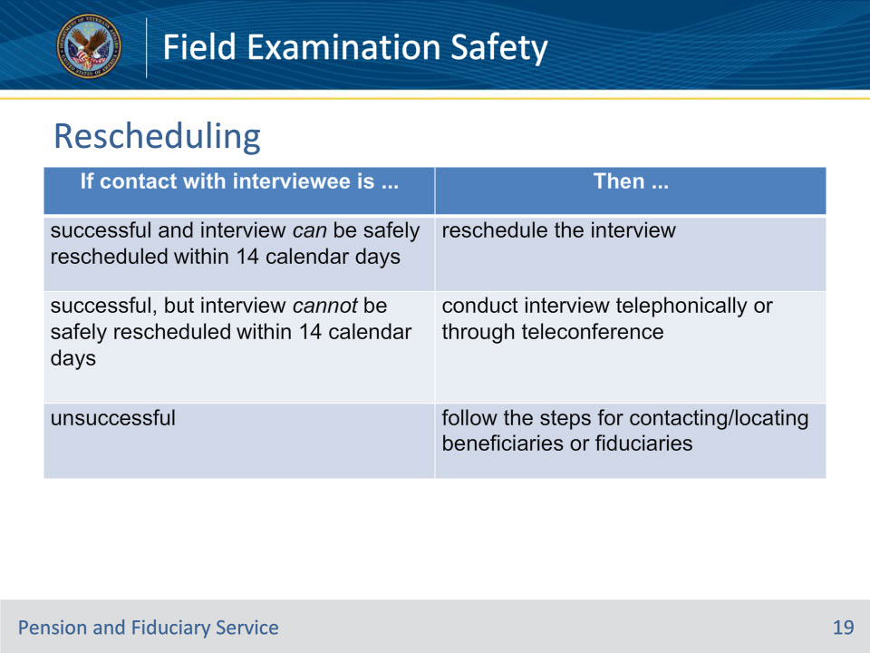
Slide notes

Policy Reference(s): FPM I.2.B.2.j.

Instructor Notes:

When an interview cannot be completed due to weather, road conditions, health and safety, or environmental hazards, call the interviewee at all known telephone numbers and use this table to determine the actions to take to attempt to reschedule the field examination.

Slide 20 - Physical Assaults and Threats
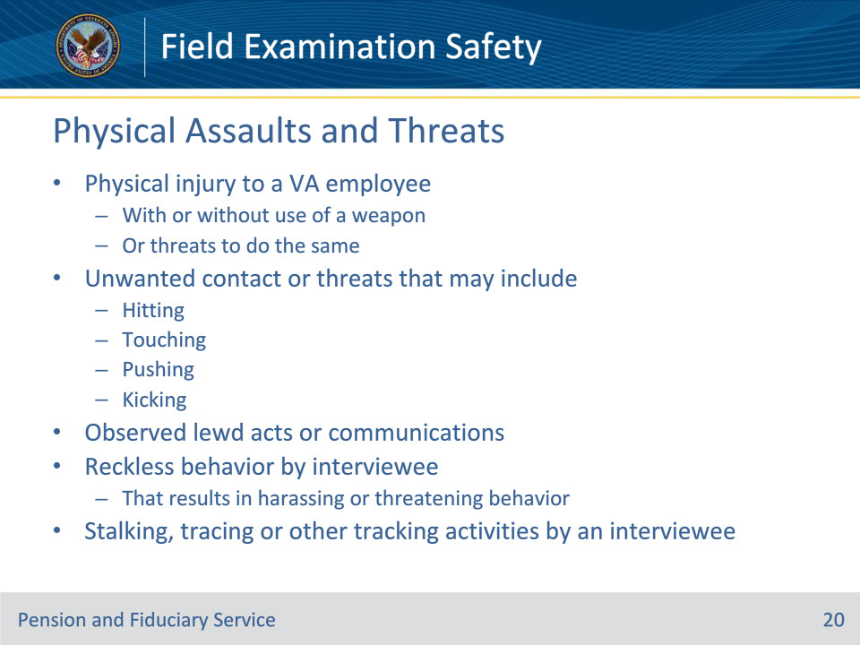
Slide notes

Policy Reference(s): FPM I.2.B.3.m.

Instructor Notes:

Regardless of involvement of weapons, physical assaults and threats may include

• physical injury (impairment of physical condition or substantial pain) to a VA employee with or without the use of a weapon or threats to do the same

• unwanted contact or threats to do the same that may include

• hitting

• touching

• pushing, or

• kicking

• observed lewd acts or communications

• reckless behavior by the interviewee that results in harassing or threatening behavior, or

• stalking, tracing or other tracking activities of the VA employee by an interviewee.

Slide 21 - Reporting Assaults and Threats
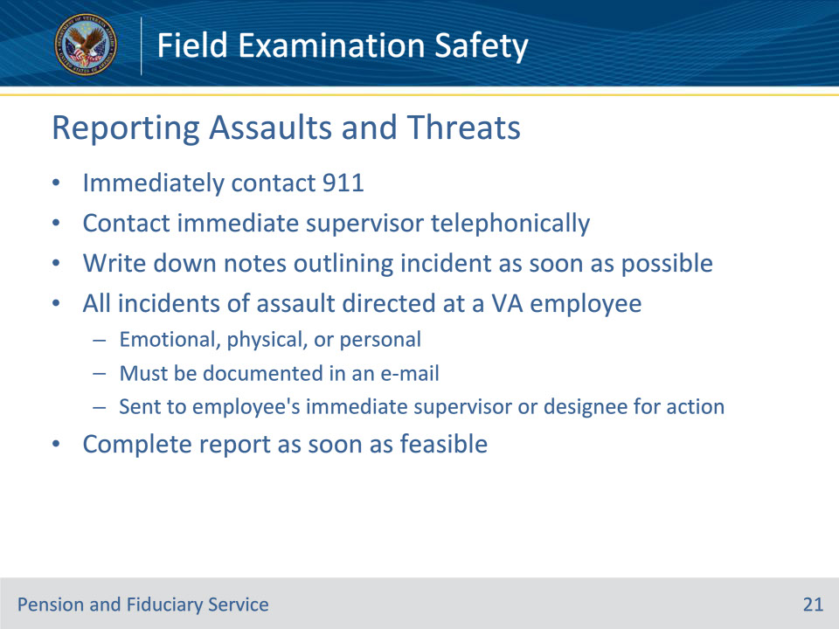
Slide notes

Policy Reference(s): FPM I.2.B.3.m.

Instructor Notes:

Threats and assault against a VA employee will be taken seriously. VA employees who are physically threatened or assaulted while conducting a field examination must

• immediately contact 911

• contact their immediate supervisor telephonically as soon as possible and when it is safe, and

• write down notes outlining the incident as soon as possible.

Following the initial notification, all incidents of emotional, physical, or personal assault directed at a VA employee must be documented in an e-mail and sent to the employee’s immediate supervisor or designee for action. These acts will be taken seriously.

The assaulted individual should complete the report as soon as feasible. If unable to complete the report, the report must be completed by the individual’s immediate supervisor.

Slide 22 - Reporting Assaults and Threats
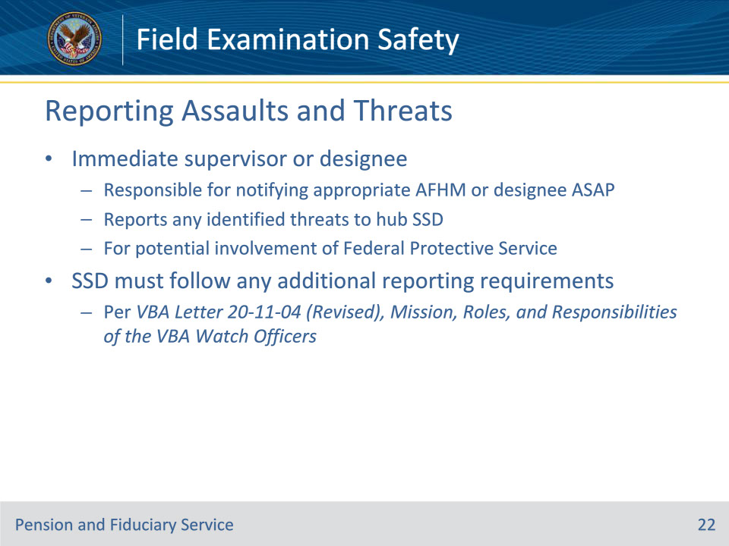
Slide notes

Policy Reference(s): FPM I.2.B.3.m.

Instructor Notes:

• The individual’s immediate supervisor or designee is responsible for notifying the appropriate Assistant FHM or designee of the incident as soon as feasible.

• The supervisor or designee shall report any identified threats made to the FE to the hub Support Services Division (SSD) for potential involvement of the Federal Protective Service.

• SSD must follow any additional reporting requirements per VBA Letter 20-11-04 (Revised), Mission, Roles, and Responsibilities of the VBA Watch Officers.

Slide 23 - Report Content (1/4)
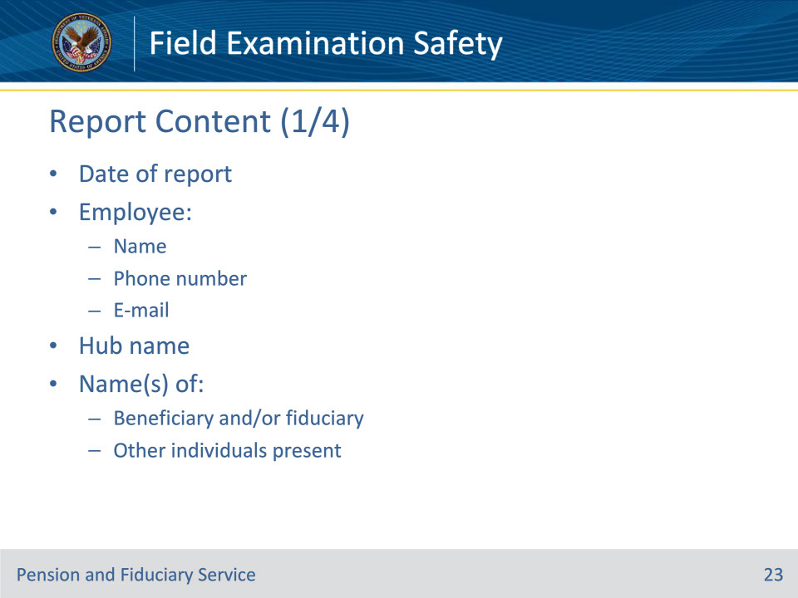
Slide notes

Policy Reference(s): FPM I.2.B.3.m.

Instructor Notes:

The report must include as much information as available about the incident, including but not limited to the

• date of report

• employee’s

• name

• phone number, and

• e-mail

• hub’s name

• name(s) of

• beneficiary and/or fiduciary, and

• other individuals present

Slide 24 - Report Content (2/4)
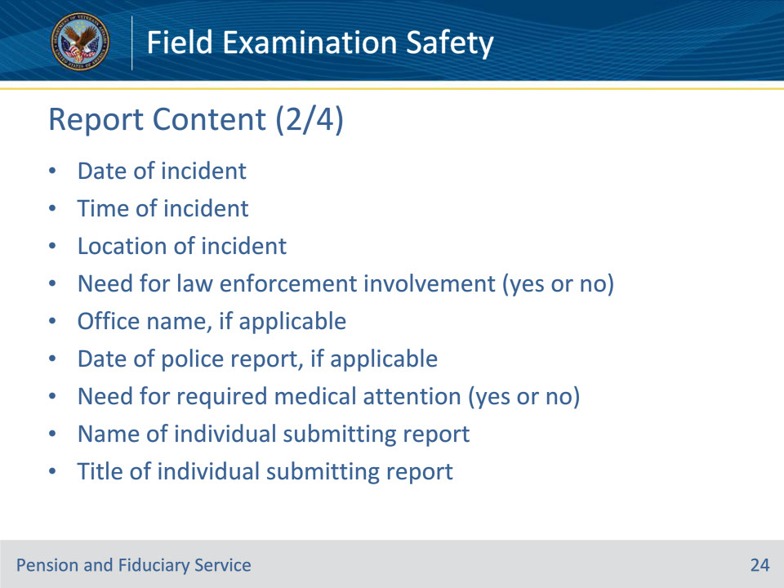
Slide notes

Policy Reference(s): FPM I.2.B.3.m.

Instructor Notes:

• date of incident

• time of incident

• location of incident

• need for law enforcement involvement (yes or no)

• office name, if applicable

• date of police report, if applicable

• need for required medical attention (yes or no)

• name of individual submitting report

• title of individual submitting report

Slide 25 - Report Content (3/4)
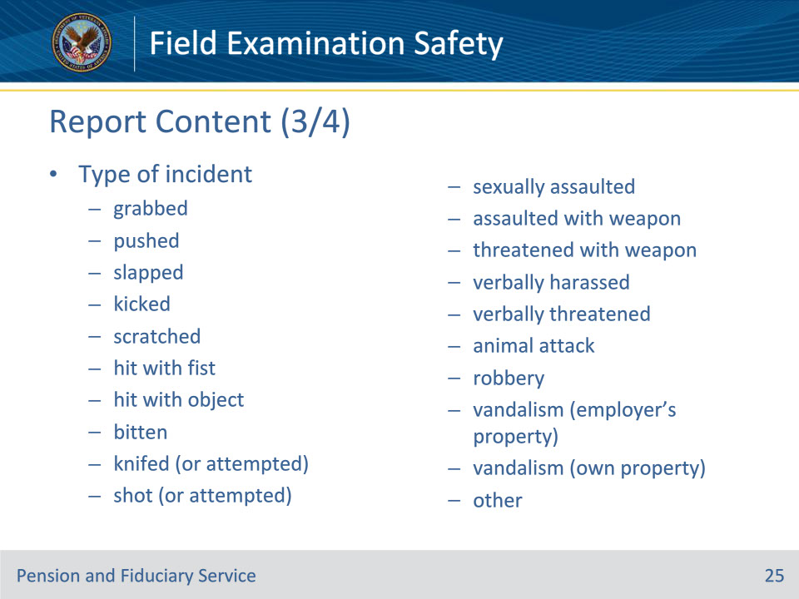
Slide notes

Policy Reference(s): FPM I.2.B.3.m.

Instructor Notes:

• type of incident such as

• grabbed

• pushed

• slapped

• kicked

• scratched

• hit with fist

• hit with object

• bitten

• knifed (or attempted)

• shot (or attempted)

• sexually assaulted

• assaulted with weapon

• threatened with weapon

• verbally harassed

• verbally threatened

• animal attack

• robbery

• vandalism (employer’s property)

• vandalism (own property), and/or

• other, and

Slide 26 - Report Content (4/4)
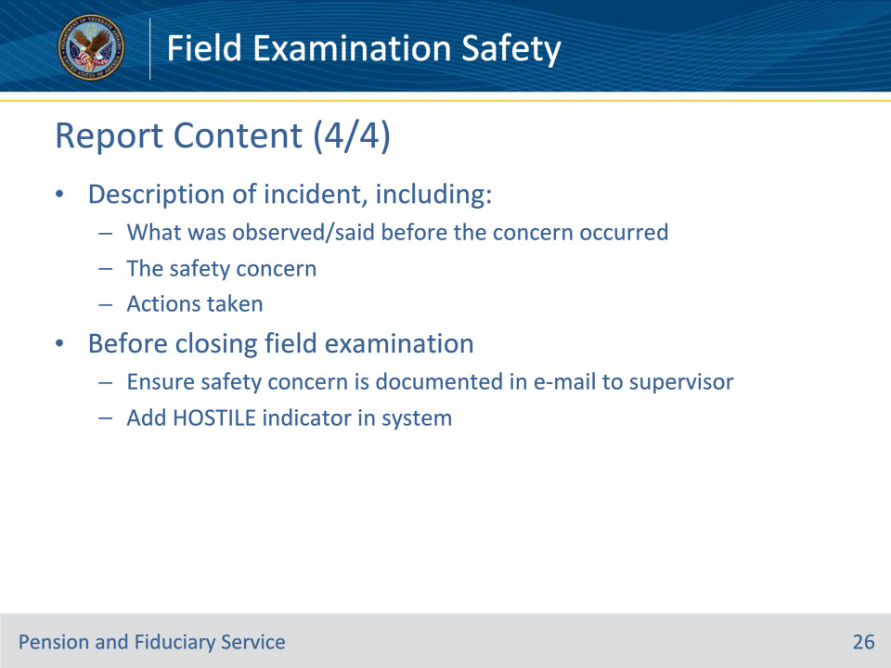
Slide notes

Policy Reference(s): FPM I.2.B.3.m.

Instructor Notes:

• description of the incident, including

• what was observed/said before the concern occurred

• the safety concern, and

• actions taken.

Before closing the field examination, ensure the safety concern is documented in the e-mail to the supervisor and add the HOSTILE indicator in the system.

Slide 27 - Questions?
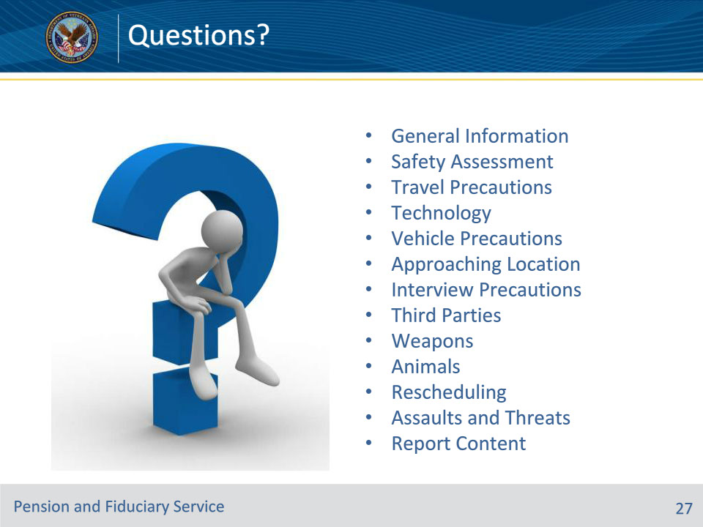
Slide notes

Instructor Notes:

(Recall) These are our learning objectives as stated from the beginning of the training:

• Communicate general information regarding field examination safety

• Identify safety precautions and considerations

• Recall procedure for rescheduling the field examination

• Utilize the policy for reporting assault or threats

(Recap) We discussed each of these learning objectives through the following topics in each slide today:

• General Information

• Safety Assessment

• Travel Precautions

• Technology

• Vehicle Precautions

• Approaching Location

• Interview Precautions

• Third Parties

• Weapons

• Animals

• Rescheduling

• Assaults and Threats

• Report Content

Are there any additional questions?

Questions should be filtered through your QRT team. They will submit your questions to the Field Inquiry Tool (FIT) on your behalf.

Slide 28 - TMS Survey/Assessment
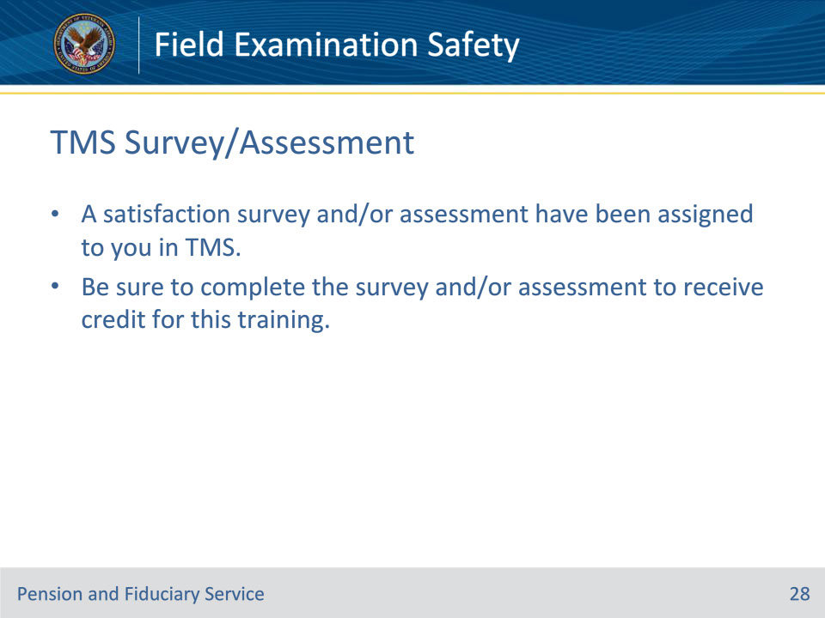
Slide notes

Instructor Notes:

A satisfaction survey and/or assessment have been assigned to you in TMS.

Be sure to complete the survey and/or assessment to receive credit for this training.

