Slide 1 - Oversight Methods
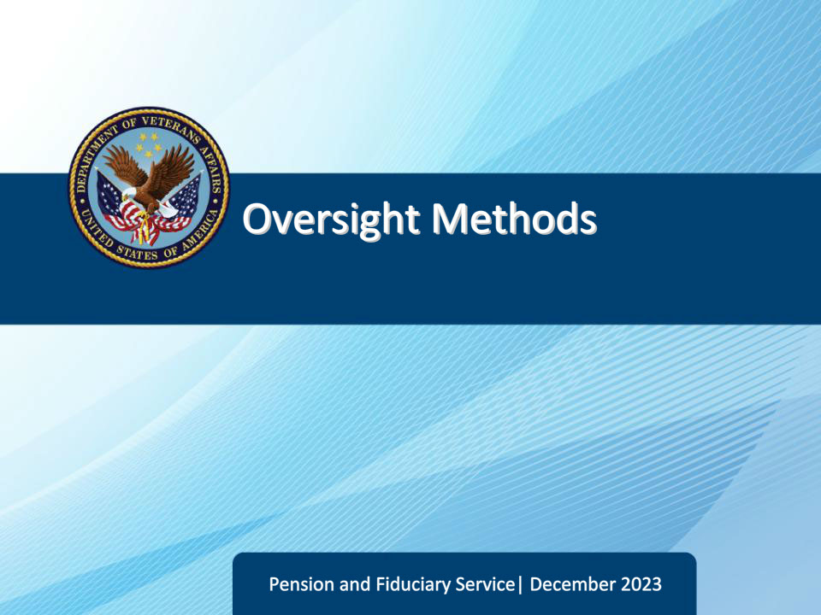
Slide notes

Course Description:

This course gives learners an overview of the current beneficiary and fiduciary oversight methods and procedures.

Slide 2 - Objectives
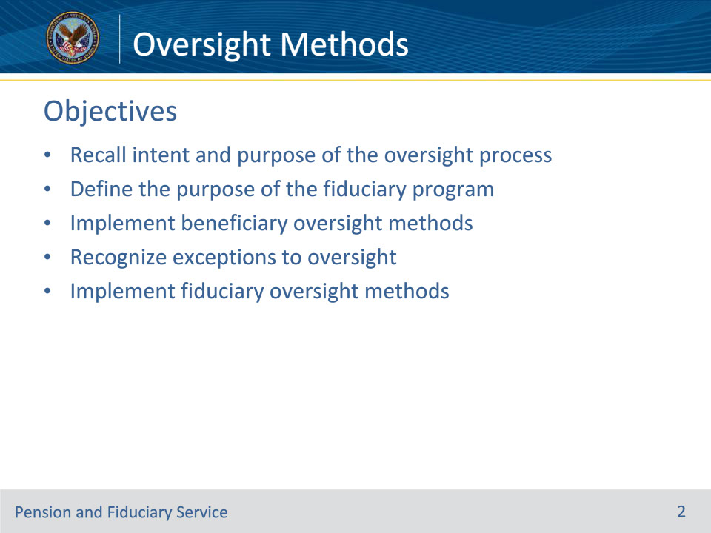
Slide notes

Instructor Notes:

At the end of this lesson, given the training and references, the learner will be able to do the following:

• Recall intent and purpose of the oversight process

• Define the purpose of the fiduciary program

• Implement beneficiary oversight methods

• Recognize exceptions to oversight

• Implement fiduciary oversight methods

Slide 3 - References
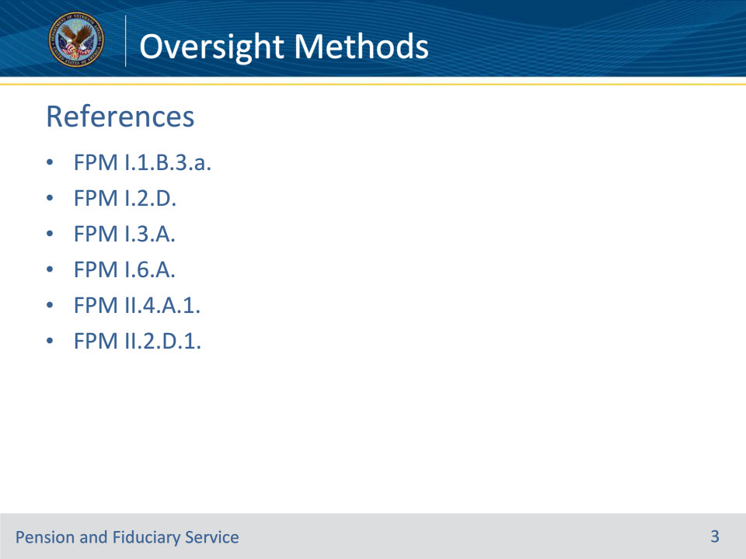
Slide notes

Instructor Notes:

These are the relevant references pertaining to this course.:

• FPM I.1.B.3.a. Purpose of the Fiduciary Program

• FPM I.2.D. Follow-Up Field Examinations

• FPM I.3.A. Accounting Process and Requirements

• FPM I.6.A. Funds Usage Review Oversight

• FPM II.4.A.1. General Information on the Onsite Review Process

• FPM II.2.D.1. Annual Written Contact

Slide 4 - Fiduciary Program
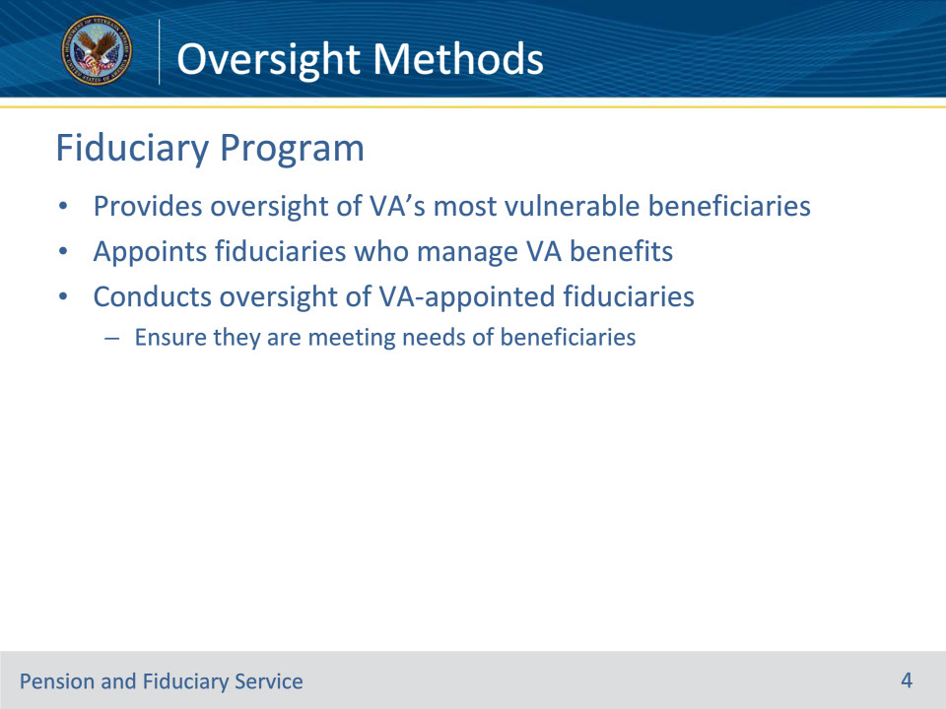
Slide notes

Policy Reference(s): FPM I.1.B.3.a.

Instructor Notes:

The Fiduciary Program provides oversight of VA’s most vulnerable beneficiaries who are unable to manage their VA benefits because of injury, disease, the infirmities of advanced age, or are minor children who have not yet reached the age of majority. VA appoints fiduciaries who manage VA benefits for these beneficiaries and conducts oversight of VA-appointed fiduciaries to ensure that they are meeting the needs of the beneficiaries they serve.

Slide 5 - Oversight
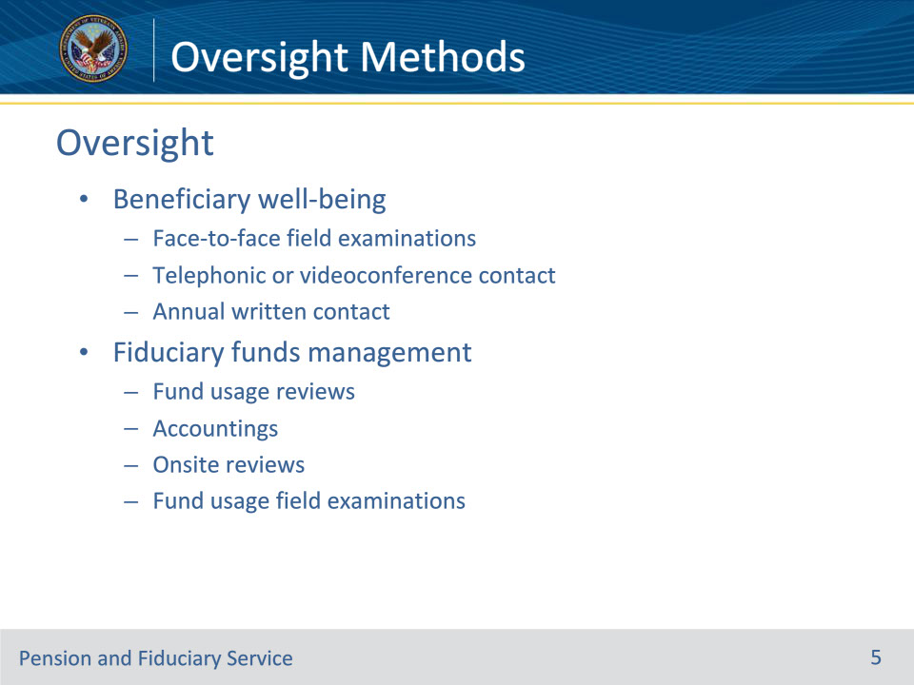
Slide notes

Policy Reference(s): FPM I.2.D.; FPM I.3.A.; FPM I.6.A.; FPM II.4.A.1.

Instructor Notes:

The beneficiary and fiduciary oversight processes consist of various methods of scheduled contact. These activities allow VA to tailor the level of oversight needed based on each beneficiary’s circumstances. It is VA’s policy to utilize the least intrusive method of oversight available based on the circumstances and established criteria.

Beneficiary oversight focuses primarily on monitoring the beneficiary’s well-being while fiduciary oversight focuses primarily on assessing the fiduciary’s management of the beneficiary’s benefits.

Following each field examination, fiduciary hubs must schedule future beneficiary and fiduciary oversight based on the unique circumstances of each case.

Here we have a list of the various levels of oversight for both beneficiaries and fiduciaries, which we will explain in further detail in this training.

• Beneficiary well-being

• Face-to-face field examinations

• Telephonic or videoconference contact

• Annual written contact

• Fiduciary funds management

• Fund usage reviews

• Accountings

• Onsite reviews

• Fund usage field examinations

Slide 6 - Beneficiary Oversight
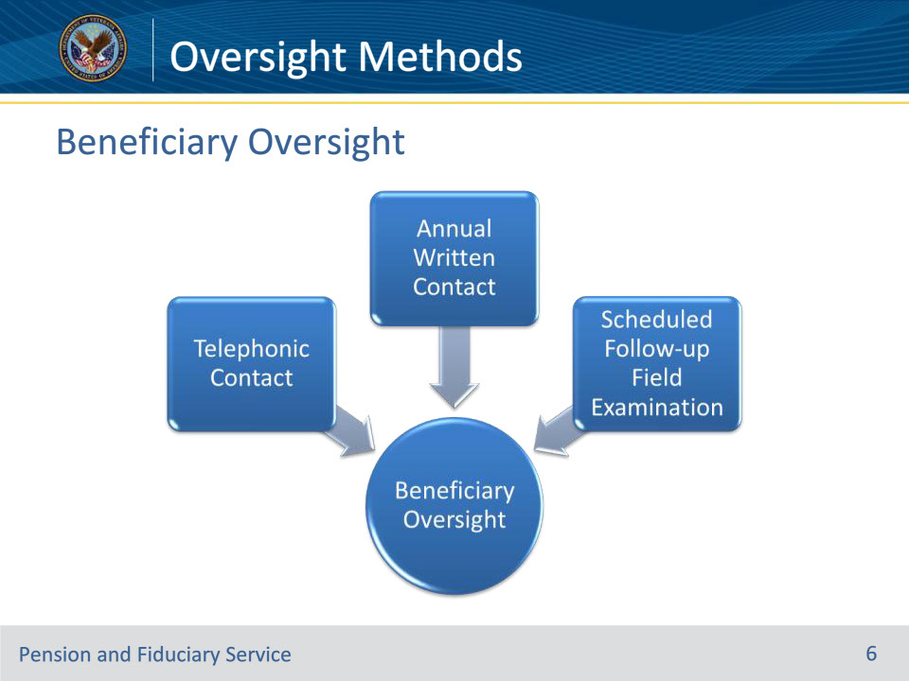
Slide notes

Policy Reference(s): FPM I.2.D.

Instructor Notes:

The beneficiary oversight process will consist of three primary methods of contact that allows VA to tailor the level of oversight needed based on each beneficiary’s circumstances.

VA uses face-to-face field examinations to provide beneficiary well-being oversight for our most vulnerable beneficiaries. For those beneficiaries whose circumstances allow for less intrusive oversight, VA will use telephonic contact and/or annual written contact. VA will also utilize unscheduled field examinations to ensure beneficiary well-being when an area of concern is identified by or reported to the hub.

The beneficiary oversight methods focus on beneficiary well-being but are also used to assess the beneficiary-fiduciary relationship and identify areas of concern with the fiduciary’s performance.

Slide 7 - Fiduciary Oversight
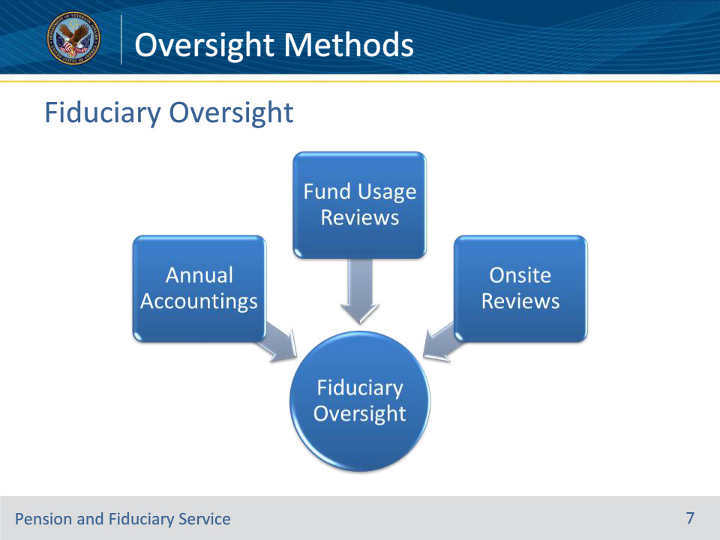
Slide notes

Policy Reference(s): FPM I.2.D.; FPM I.3.A.; FPM I.6.A.; FPM II.4.A.1.

Instructor Notes:

VA’s regular oversight of fiduciaries primarily focuses on the fiduciaries’ management of beneficiaries’ benefits. This is achieved through routine fund usage reviews, accountings, and onsite reviews when applicable. Additionally, if issues are identified with the fiduciary’s funds management, a fund usage field examination can be scheduled for a field examiner to attempt to resolve the issues.

Slide 8 - Annual Written Contact
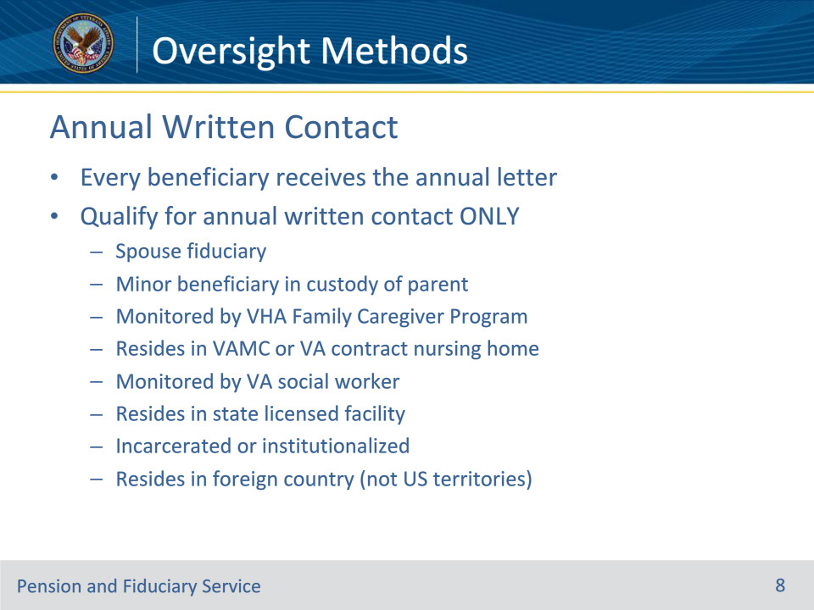
Slide notes

Policy Reference(s): FPM II.2.D.1.

Instructor Notes:

VA contacts every beneficiary in the fiduciary program annually through written correspondence to ensure that beneficiaries are aware of their status in the fiduciary program and who to contact if an issue or concern with their fiduciary is identified.

Some beneficiaries, however, qualify for annual written contact as their only form of beneficiary oversight.

The following beneficiaries are eligible for Annual Written Contact Only:

• Beneficiaries with spouse fiduciaries

• Minor beneficiaries in the custody of a parent

• Beneficiaries actively monitored by the Veterans Health Administration Family Caregiver Program

• Beneficiaries permanently residing in a VA Medical Center or in a nursing home under VA contract

• Beneficiaries who have a VA social worker monitoring their case, including homeless beneficiaries

• Beneficiaries who permanently reside in a state-operated Veterans home or a facility regulated or licensed by state or local government

• Incarcerated or institutionalized beneficiaries, and

• Beneficiaries residing in foreign countries that are not U.S. territories

When the beneficiary qualifies for annual written contact only, no additional method of beneficiary oversight is required beyond the annual letter. Do not schedule the beneficiary for telephonic or face-to-face contact.

Slide 9 - Telephonic Contact
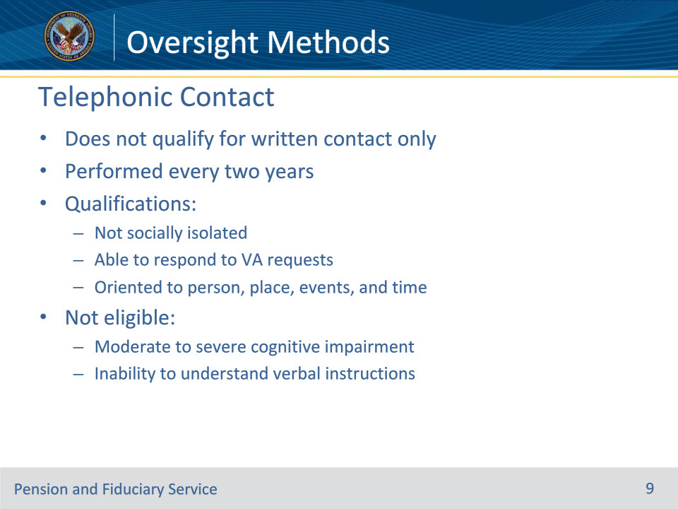
Slide notes

Policy Reference(s): FPM I.2.D.1.d.; FPM I.2.D.5.c.

Instructor Notes:

If the beneficiary does not meet the criteria for annual written contact only, the beneficiary may qualify for scheduled telephonic contact. When the beneficiary qualifies for telephonic contact, the telephonic field examination will be scheduled to occur two years from the date of the beneficiary interview.

Beneficiaries who qualify for telephonic oversight are:

• not socially isolated

• able to respond to VA requests, and

• oriented to person, place, events and time as of the most recent VA contact.

Social isolation is a state of complete or near-complete lack of contact between an individual and society.

Beneficiaries will not qualify for scheduled telephonic contact if documentation in the eFolder shows evidence of:

• documented moderate to severe cognitive impairment as evidenced by

• a rating of special monthly compensation

• A diagnosis of dementia

• medical or lay evidence indicating unresolved symptoms of dementia such as:

• memory loss of both recent and distant past events

• significant confusion, and/or

• the inability to recall simple details about themselves, or

• current institutionalization of the beneficiary due to mental health, or

• the inability to understand verbal instructions.

Slide 10 - Face-to-Face Contact
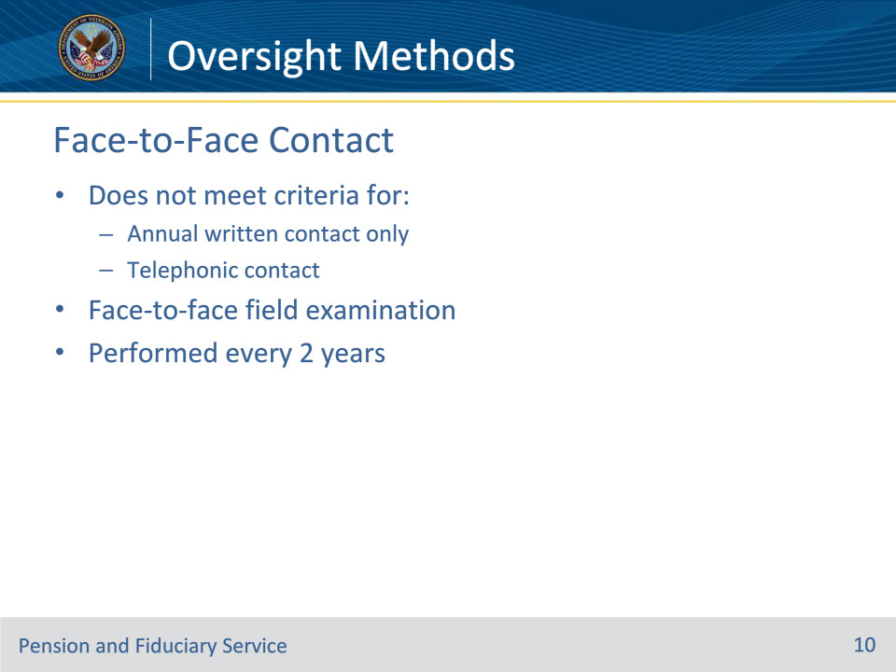
Slide notes

Policy Reference(s): FPM I.2.D.1.e.

Instructor Notes:

VA will schedule a face-to-face follow-up field examination when the beneficiary does not meet the

• criteria to qualify for annual written contact or telephonic contact, and

• exceptions to the requirements for beneficiary oversight.

The scheduled follow-up field examination must be scheduled to occur two years from the date of the beneficiary interview.

Slide 11 - Beneficiary Oversight Exceptions
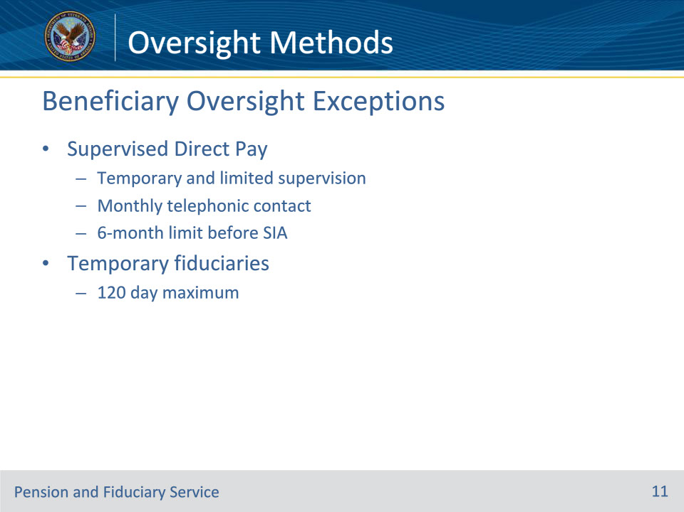
Slide notes

Policy Reference(s): FPM I.2.D.1.f.

Instructor Notes:

There are only two situations that do not fit into the beneficiary oversight methods described previously. The following instances require very specific contacts:

• SDP beneficiaries require temporary and limited supervision through monthly telephonic contact to ensure funds are managed properly. Additionally, if the beneficiary is not rated competent within six months of the SDP appointment, the hub must remove the beneficiary from SDP.

• Temporary fiduciaries are only allowed to serve a maximum of 120 days. SIA field examinations must be completed within 120 days of the initial appointment (IA).

Slide 12 - Fiduciary Oversight
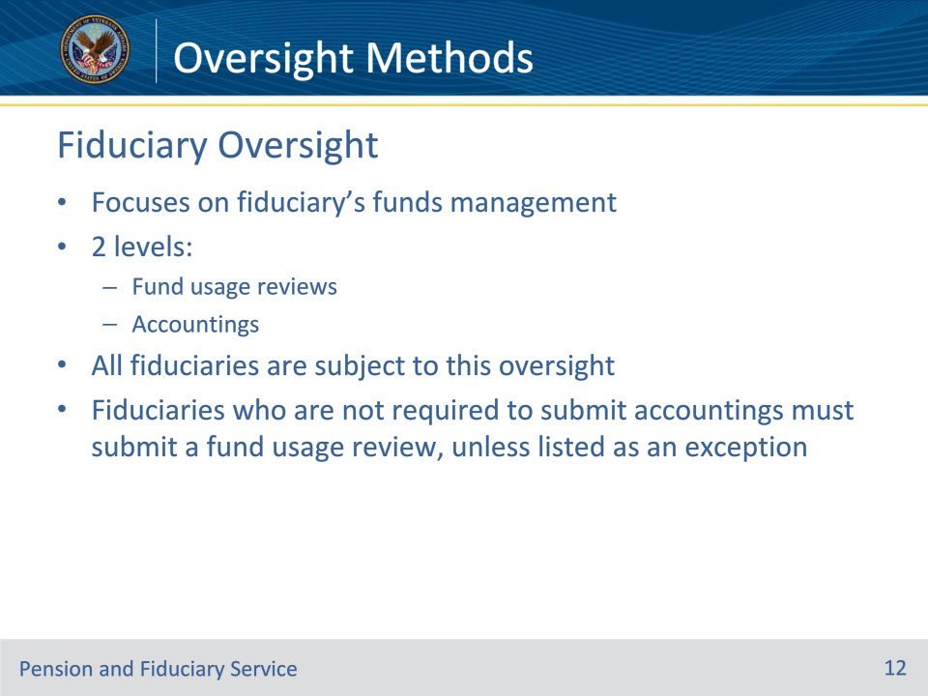
Slide notes

Policy Reference(s): FPM I.2.D.1.h.

Instructor Notes:

The Field Examiner (FE) must evaluate the beneficiary situation and fiduciary appointment to determine the appropriate fiduciary oversight method. Fiduciary oversight focuses on fiduciaries’ management of beneficiaries’ benefits.

Fiduciary oversight is based on criteria that indicates the level of oversight needed. For scheduled oversight, a fiduciary may be required to provide either:

• a fund usage review, or

• an accounting.

All fiduciaries are subject to the requirement of submitting either a fund usage review or accounting unless listed as an exception.

Slide 13 - Exceptions
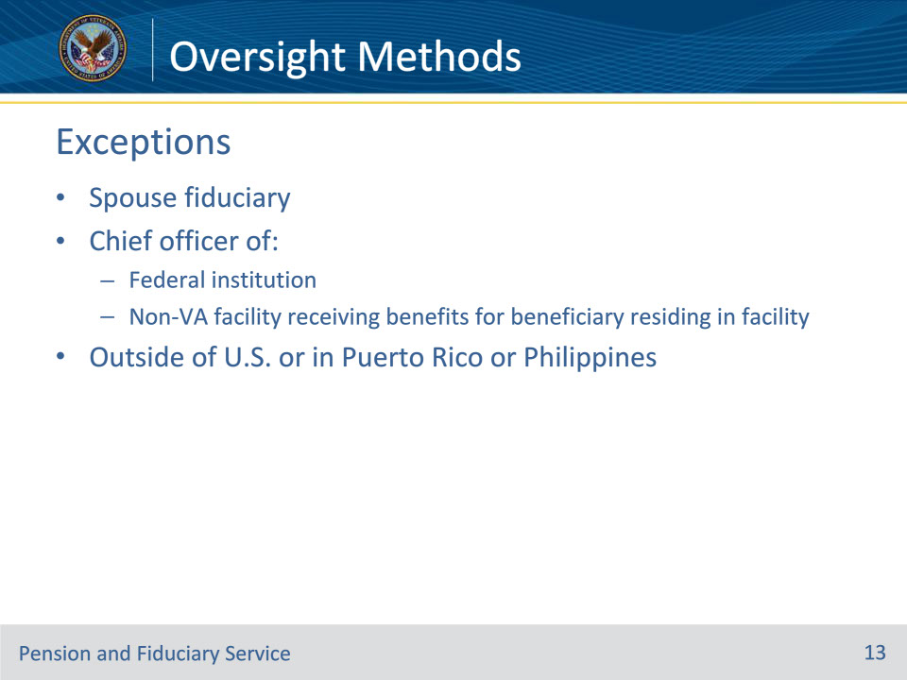
Slide notes

Policy Reference(s): FPM I.3.A.2.c.; FPM I.6.A.1.c.

Instructor Notes:

This is the criteria to be exempted from both fund usage reviews and accountings:

• VA appointed

• spouse fiduciary

• fiduciary who is the chief officer of a Federal institution, or

• fiduciary who is the chief officer of a non-VA facility receiving benefits for a beneficiary residing in the facility, or

• fiduciaries who were appointed outside of the U.S., or in the Commonwealth of Puerto Rico or the Republic of the Philippines, and both the beneficiary and fiduciary permanently resides outside of the U.S., or in the Commonwealth of Puerto Rico or the Republic of the Philippines.

Slide 14 - Onsite Reviews
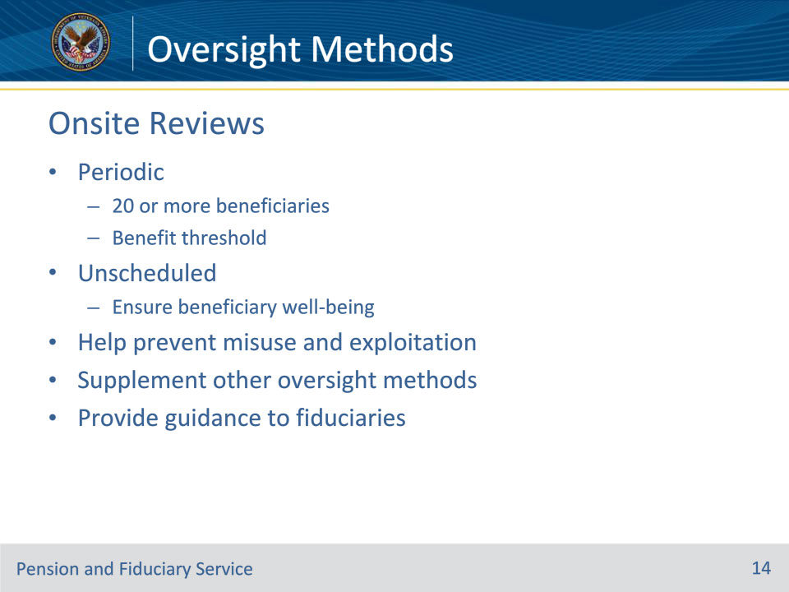
Slide notes

Policy Reference(s): FPM II.4.A.1.

Instructor Notes:

The Department of Veterans Affairs (VA) conducts periodic onsite reviews of any fiduciary in the U.S., whether the fiduciary is an individual or entity when that fiduciary is serving 20 or more beneficiaries and the total annual amount of such benefits exceeds $50,000, as adjusted pursuant to section 38 U.S.C. 5312. In addition, the law grants VA the authority to conduct unscheduled onsite reviews of any fiduciary without regard to the number of beneficiaries served by the fiduciary or the amount of funds under management (FUM) by the fiduciary to ensure the well-being of beneficiaries or prevent exploitation of beneficiary funds.

Onsite reviews are a necessary tool VA uses to determine if VA appointed fiduciaries are performing satisfactorily, and the reviews fulfill VA’s statutory obligation for fiduciary oversight. Moreover, onsite reviews are intended to ensure the well-being of beneficiaries, prevent misuse and exploitation of beneficiary funds, and supplement oversight provided by field examinations and the accounting processes. These reviews also provide VA with an opportunity to provide guidance to fiduciaries.

Slide 15 - Questions?
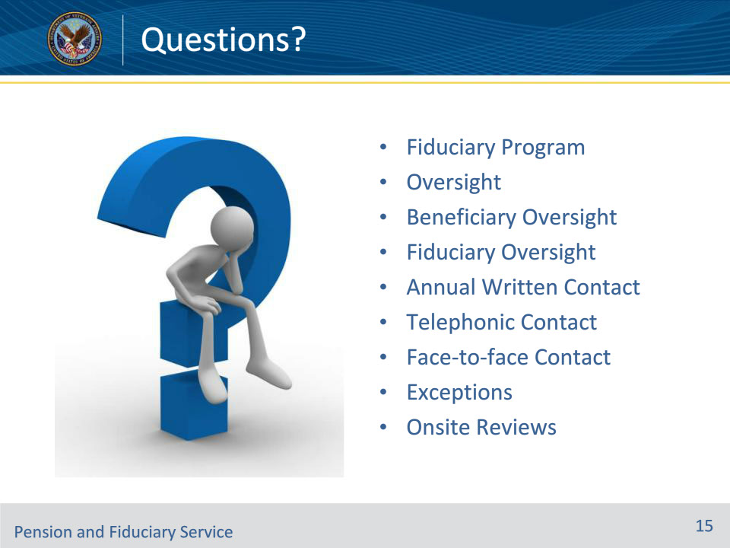
Slide notes

Instructor Notes:

We discussed the following topics today:

• Fiduciary Program

• Oversight

• Beneficiary Oversight

• Fiduciary Oversight

• Annual Written Contact

• Telephonic Contact

• Face-to-face Contact

• Exceptions

• Onsite Reviews

What questions do you have for me today?

Slide 16 - TMS Survey
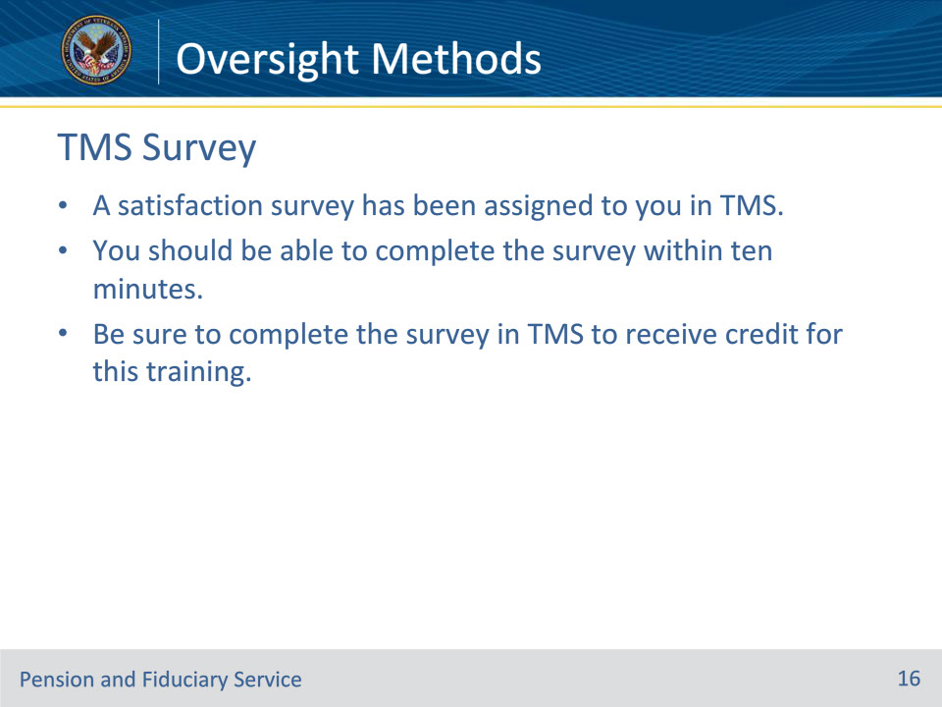
Slide notes

Instructor Notes:

A satisfaction survey has been assigned to you in TMS. You should be able to complete the survey within ten minutes. Completing the survey will allow you to receive credit for this training.

