Slide 1 - Court Appointments and Temporary Fiduciaries
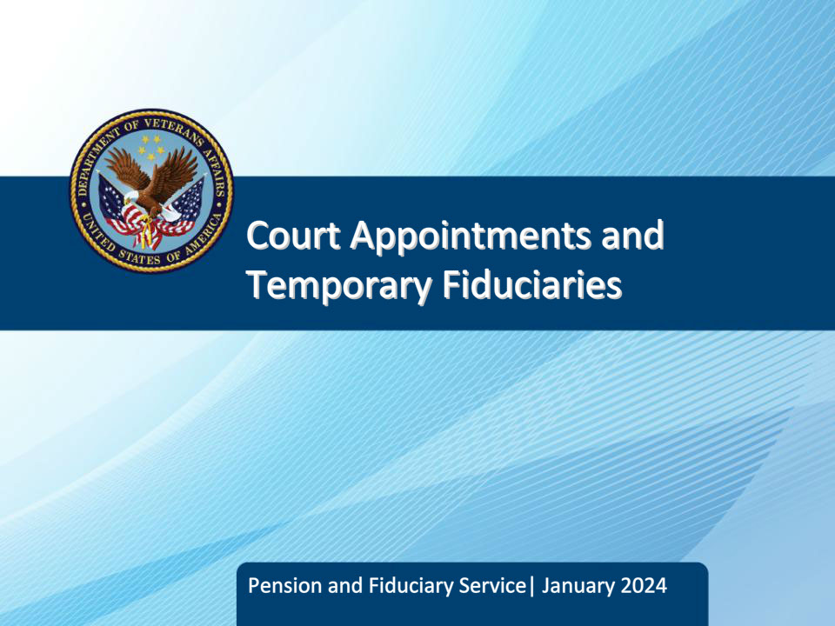
Slide notes

Course Description:

This course teaches learners the various considerations and actions regarding appointing or bypassing an existing court appointed fiduciary as well as basic information regarding temporary fiduciaries.

Slide 2 - Objectives
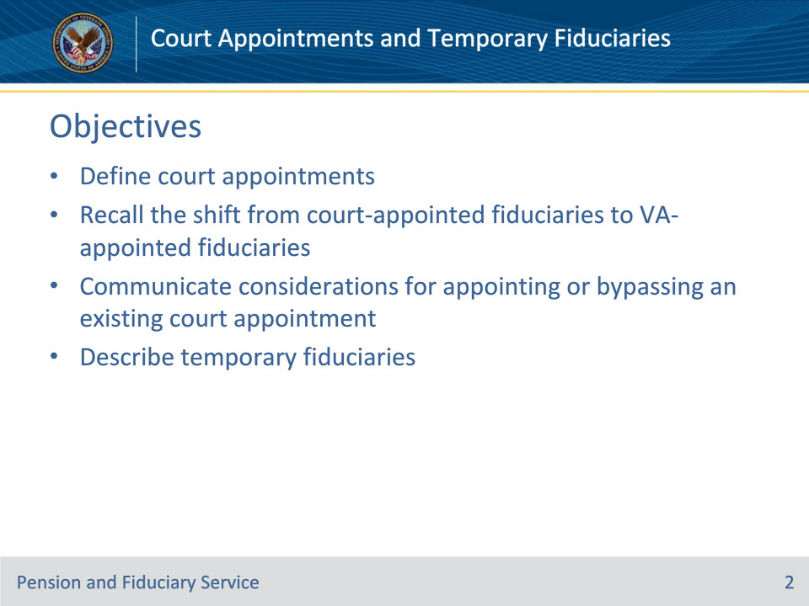
Slide notes

Instructor Notes:

At the end of this lesson, given the training and references, the learner will be able to do the following:

• Define court appointments

• Recall the shift from court-appointed fiduciaries to VA-appointed fiduciaries

• Communicate considerations for appointing or bypassing an existing court appointment

• Describe temporary fiduciaries

Slide 3 - References
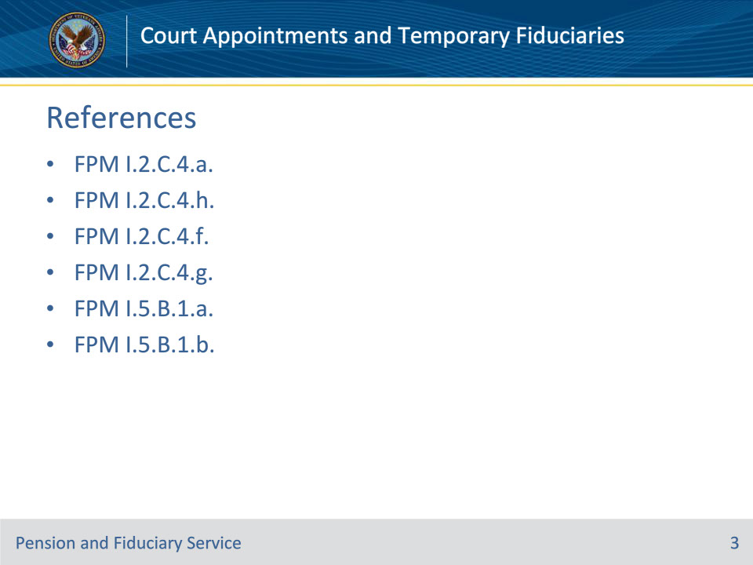
Slide notes

Instructor Notes:

These are the relevant references pertaining to this course:

• FPM I.2.C.4.a. General Policy on Appointment and Fiduciary Types

• FPM I.2.C.4.h. Determining a Fiduciary for a Beneficiary With a Previously Established Court Appointment

• FPM I.2.C.4.f. Bypassing an Existing Court Fiduciary in Favor of a VA-Appointed Fiduciary

• FPM I.2.C.4.g. Determining a Fiduciary for a Beneficiary With a Previously Established Court Appointment

• FPM I.5.B.1.a. Temporary Fiduciaries as Limited Emergency Fiduciaries

• FPM I.5.B.1.b. Limitations and Responsibilities Applicable to Temporary Fiduciary Appointments

Slide 4 - Court Appointments
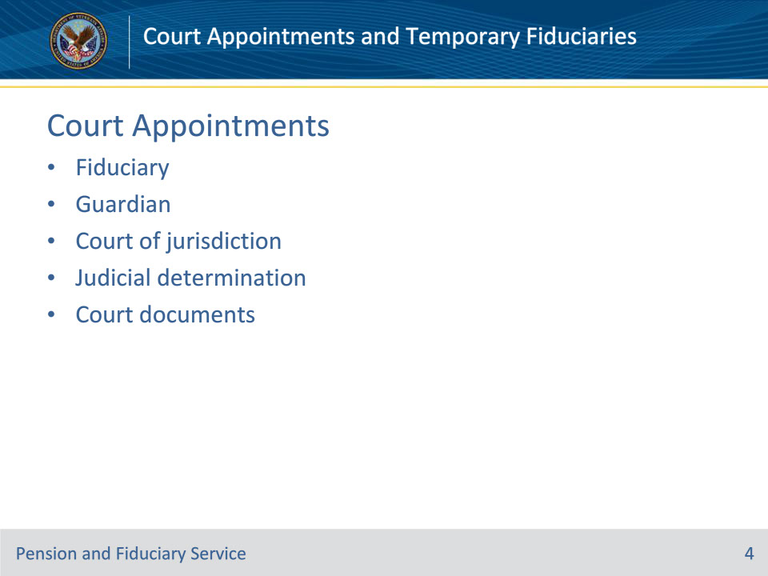
Slide notes

Instructor Notes:

A court appointed fiduciary or guardian is an individual or entity appointed by a court of jurisdiction to serve as fiduciary for a beneficiary. These types of fiduciaries are appointed as part of a judicial determination and provide court document(s) as proof of their appointment.

Slide 5 - Shift to VA-appointed
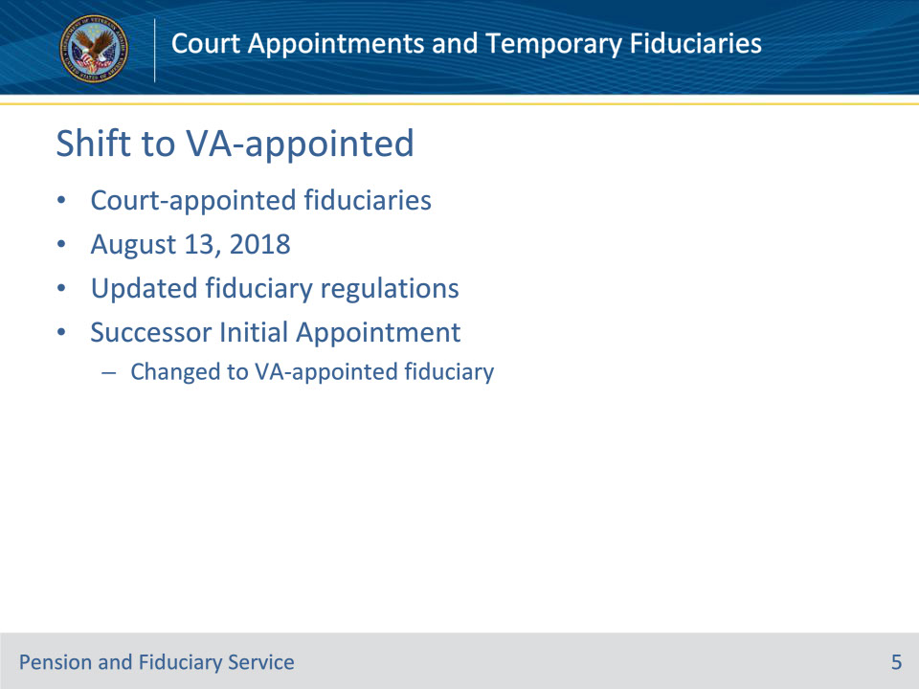
Slide notes

Policy Reference(s): FPM I.2.C.4.a.

Instructor Notes:

• Court-appointed fiduciaries whom VA-appointed before August 13, 2018, the effective date of updated fiduciary regulations, were allowed to maintain their appointment type until the first follow-up field examination on or after August 13, 2018.

• The follow-up field examinations were converted to a SIA to change the fiduciary type and to instruct the court-appointed fiduciary regarding the requirements of a VA-appointed fiduciary.

Slide 6 - Bypassing
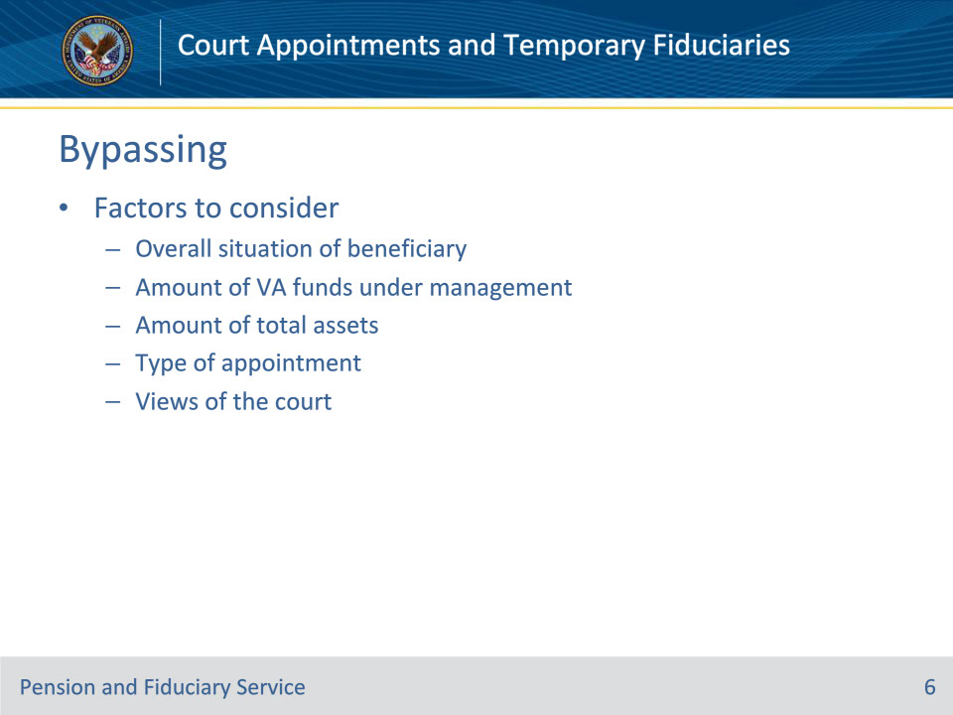
Slide notes

Policy Reference(s): FPM I.2.C.4.f.

Instructor Notes:

When considering appointing a fiduciary other than the existing court appointed fiduciary or court guardian, the FE must consider the following factors:

• the overall situation of the beneficiary

• the amount of VA FUM

• the amount of total assets

• whether the fiduciary is appointed as a general or plenary guardian, or by authority of the State’s Uniform Veterans Guardianship Act, and

• the views of the State court regarding the guardian’s ability to serve.

Slide 7 - Required Actions
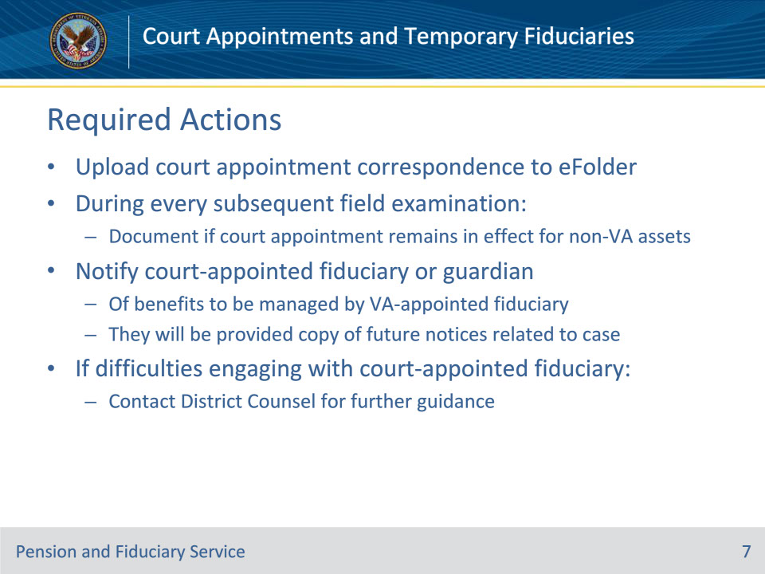
Slide notes

Policy Reference(s): FPM I.2.C.4.f.

Instructor Notes:

If VA decides to appoint an individual or entity that is not the existing court appointed fiduciary or court guardian, VA must

• upload all correspondence associated with the court appointment to the eFolder and document if the court appointment remains in effect for other non-VA assets during every subsequent field examination, and

• notify the court-appointed fiduciary or guardian

• of the benefits payable to be managed by the VA-appointed fiduciary, and

• that they will be provided a copy of all future notices related to the beneficiary’s case.

If there are any difficulties while engaging with a court-appointed fiduciary (for example, obtaining accounting documentation, transfer of funds to the successor fiduciary), contact the District Counsel for further guidance.

Slide 8 - Minors
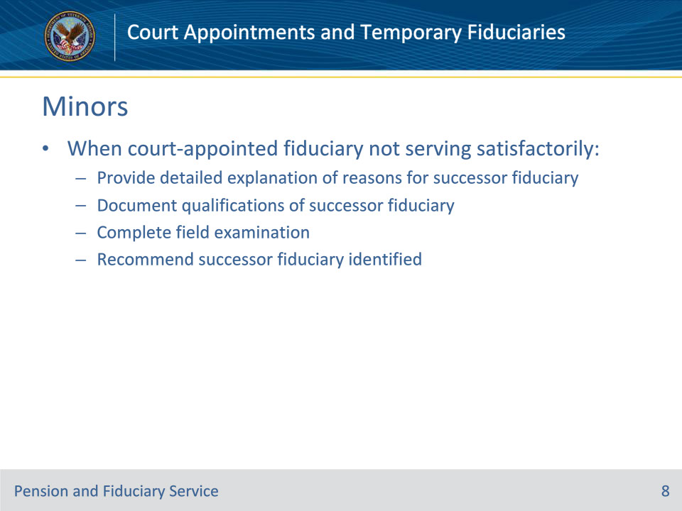
Slide notes

Policy Reference(s): FPM I.2.C.4.f.

Instructor Notes:

In minor beneficiary cases where the FE determines that the VA-appointed fiduciary who is also a court-appointed fiduciary or court guardian is not serving satisfactorily, the FE must

• provide a detailed explanation of the reason(s) for recommendation of a successor fiduciary

• document the qualifications of the recommended successor VA-appointed fiduciary, and

• complete the field examination and recommend the successor fiduciary identified.

Slide 9 - Appointing
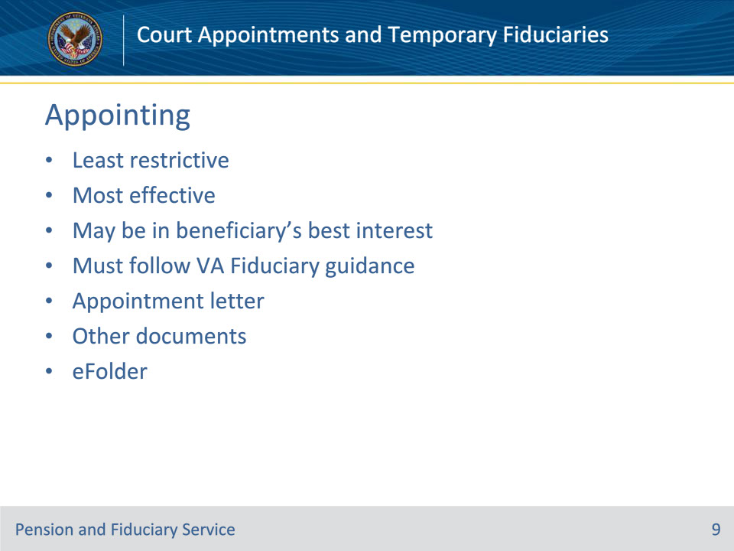
Slide notes

Policy Reference(s): FPM I.2.C.4.g.

Instructor Notes:

VA appoints the least restrictive, most effective fiduciary, regardless of whether a State court has appointed a fiduciary for the beneficiary. Under certain circumstances, appointing the fiduciary appointed by the court to serve as the VA-appointed fiduciary may be in the best interest of the beneficiary since this allows the same fiduciary to manage all funds.

In cases where a fiduciary is appointed by a State court and also appointed by VA as a VA-appointed fiduciary, the fiduciary must follow VA Fiduciary Program guidance regarding certified court accountings.

For all fiduciaries appointed by a State court, the FE must obtain a certified or original court file-stamped copy of the appointment letter for inclusion in the eFolder and facilitate the inclusion of this information into the VBMS record. Additionally, photocopies of any existing bond, the conservator’s inventory, and any orders pertaining to expenditure of funds must be obtained.

When the VA fiduciary is also court-appointed and required to account to the court but not to VA, the FE must follow the guidance to request and control for the certified copy of the court accounting during the IA process.

Slide 10 - Temporary Fiduciaries
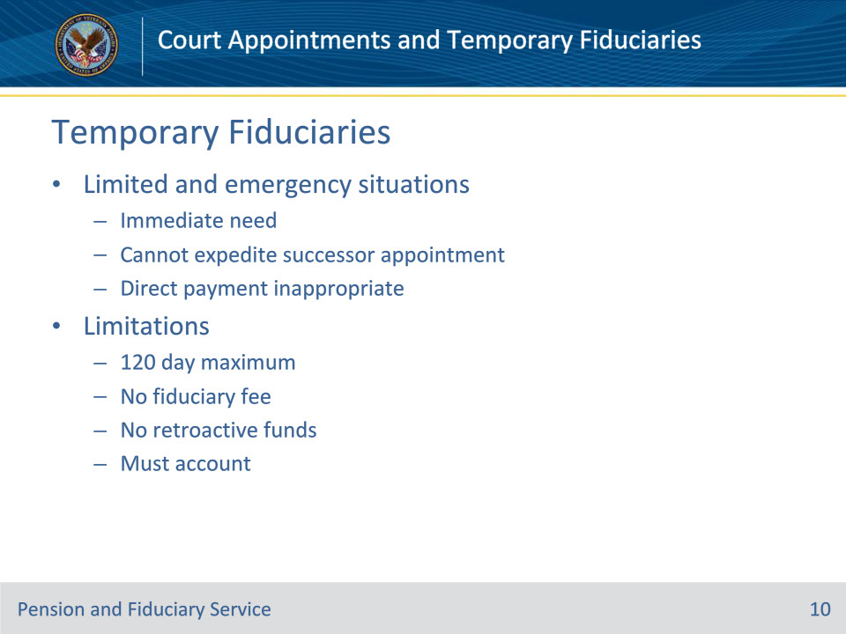
Slide notes

Policy Reference(s): FPM I.5.B.1.a., b.

Instructor Notes:

38 U.S.C. 5507(d) permits VA to appoint a temporary fiduciary in limited and emergent situations.

The appointment of a temporary fiduciary is reserved for situations where VA determines that the beneficiary has an immediate need for fiduciary services and

• VA has removed a fiduciary and cannot expedite the appointment of a successor fiduciary, or

• VA determines that it would not be in the beneficiary’s or the beneficiary’s dependents’ interest to pay benefits to the beneficiary until a fiduciary is appointed.

The following limitations and responsibilities apply to all temporary fiduciary appointments. Temporary fiduciaries:

• may serve no longer than 120 days

• must serve without a fiduciary fee

• may receive only the monthly VA benefits needed for the care of the beneficiary and their recognized dependents, with any retroactive funds withheld, and

• must provide an accounting of funds received during the period of the temporary fiduciary appointment.

Certification of one or more temporary fiduciaries may not exceed a total of 120 days under any circumstance.

Prior to expiration of the 120-day period:

• a fiduciary must be selected based on a VA rating of inability to manage funds or a court-appointed guardianship, or

• the temporary fiduciary arrangement is terminated and the beneficiary is paid directly.

Slide 11 - Questions?
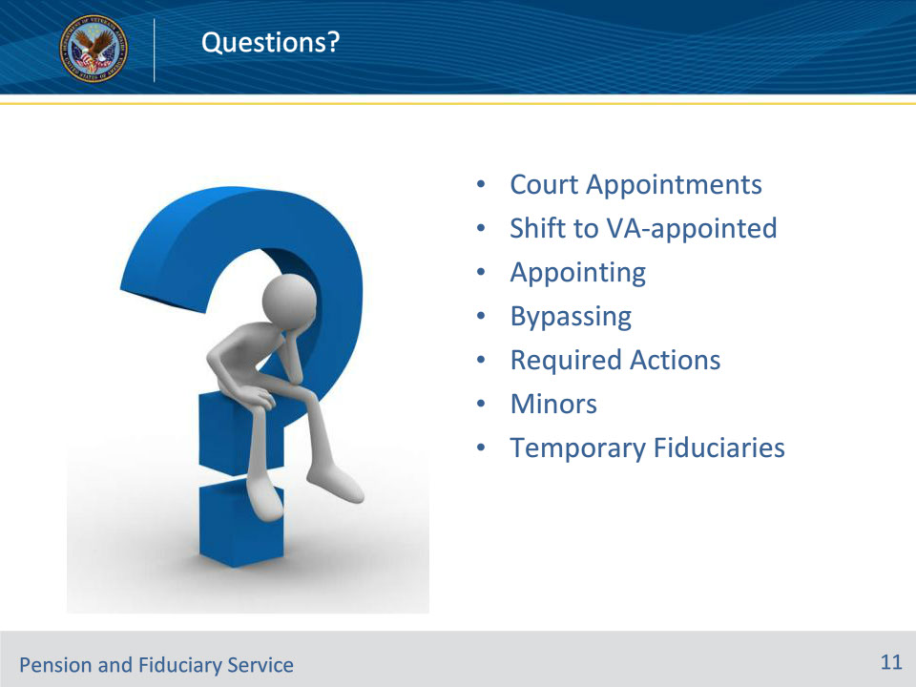
Slide notes

Instructor Notes:

(Recall) These are our learning objectives as stated from the beginning of the training:

• Define court appointments

• Recall the shift from court-appointed fiduciaries to VA-appointed fiduciaries

• Communicate considerations for appointing or bypassing an existing court appointment

• Describe temporary fiduciaries

(Recap) We discussed each of these learning objectives through the following topics in each slide today:

• Court Appointments

• Shift to VA-appointed

• Appointing

• Bypassing

• Required Actions

• Minors

• Temporary Fiduciaries

Are there any additional questions?

Slide 12 - TMS Survey
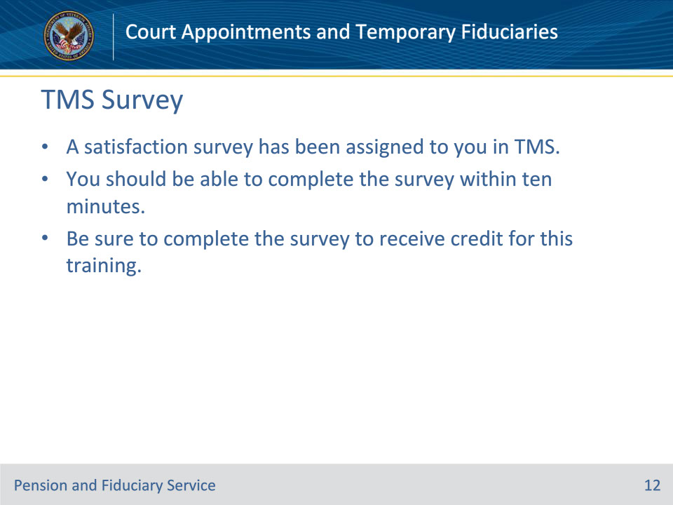
Slide notes

Instructor Notes:

A satisfaction survey has been assigned to you in TMS. You should be able to complete it within ten minutes.

Completing the survey will allow you to receive credit for this training.

