Slide 1 - Credit Reports and Criminal Background Inquiries (LIE-User App)
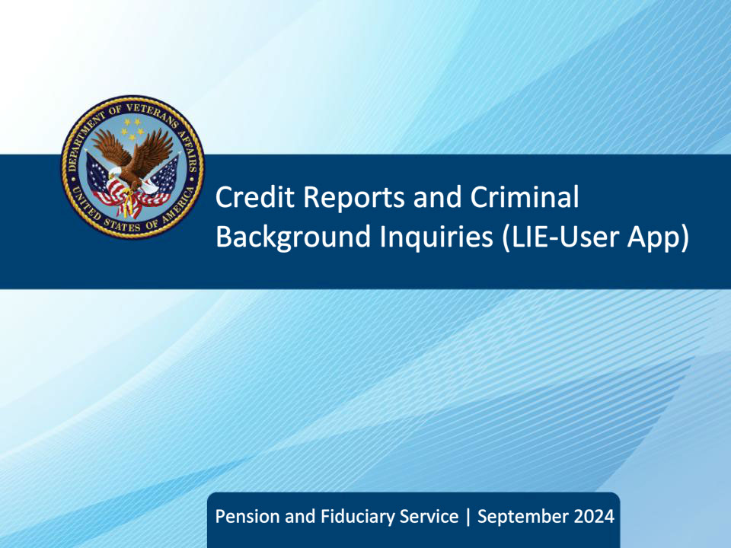
Slide notes

Course Description:

This course explains when to pull a credit report and/or criminal background inquiry (CBI), how to review the documents, and what subsequent actions, if any, to take after reviewing the documents.

Slide 2 - Objectives
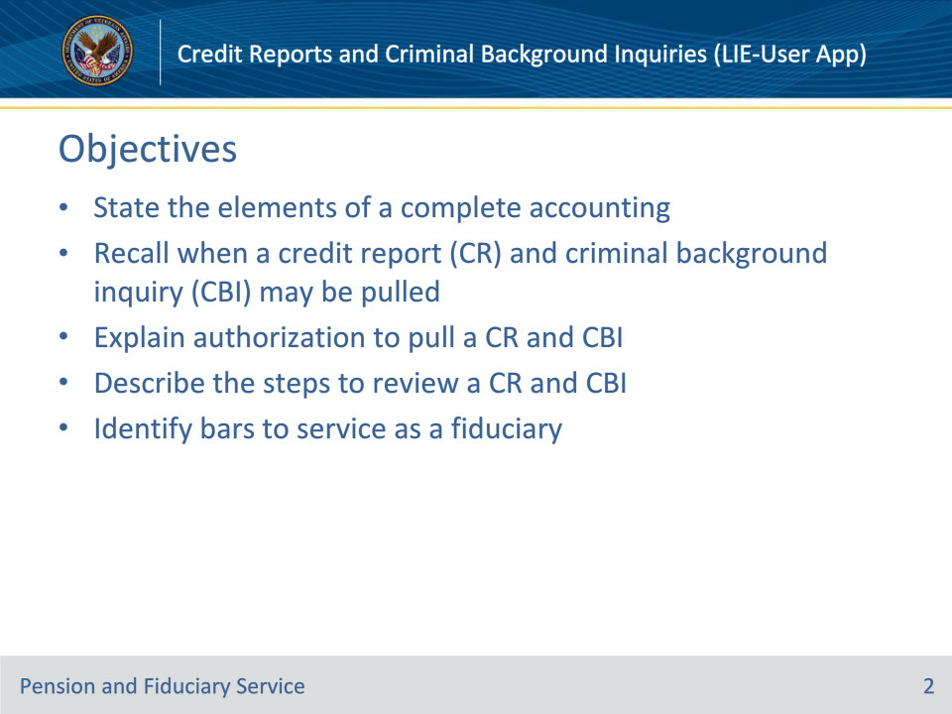
Slide notes

At the end of this lesson, given the training and corresponding references, the learner will be able to do the following:

• State the elements of a complete accounting

• Recall when a credit report (CR) and criminal background inquiry (CBI) must be pulled

• Explain authorization to pull CR and CBI

• Describe the steps to review a CR and CBI

• Identify various bars to service as a fiduciary

Slide 3 - References
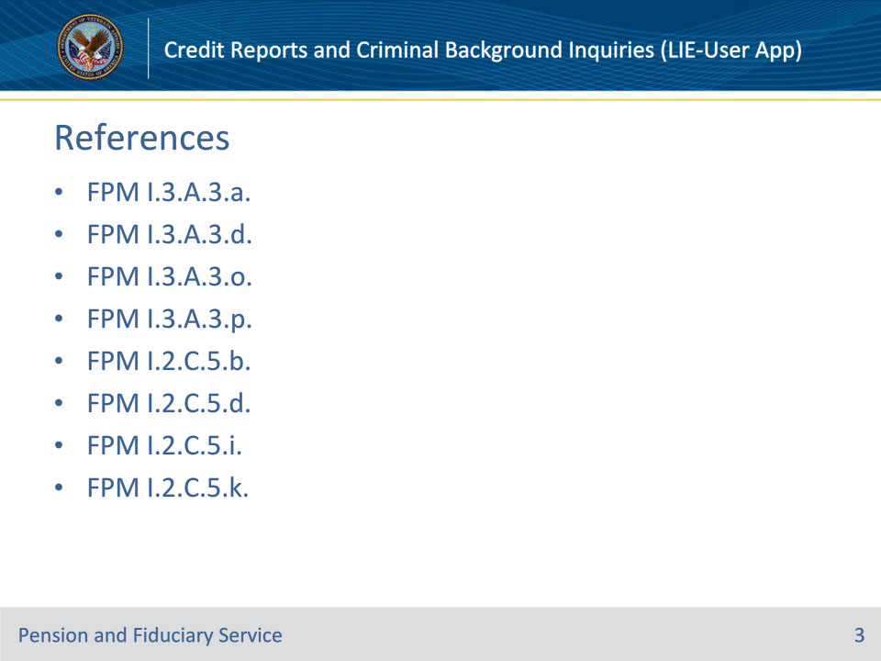
Slide notes

These are the relevant references for this training:

• FPM I.3.A.3.a. Elements of a Complete Accounting

• FPM I.3.A.3.d. Requirements for the Background Information Block on the VA Form 21P-4706b

• FPM I.3.A.3.o. Review of Credit Reports During Accountings

• FPM I.3.A.3.p. Review of CBIs During Accountings

• FPM I.2.C.5.b. Bars to Serving as a Fiduciary

• FPM I.2.C.5.d. Obtaining a Credit Report During an IA

• FPM I.2.C.5.i. Obtaining a CBI During an IA

• FPM I.2.C.5.k. Review of CBI During an IA

Slide 4 - Accounting Requirements
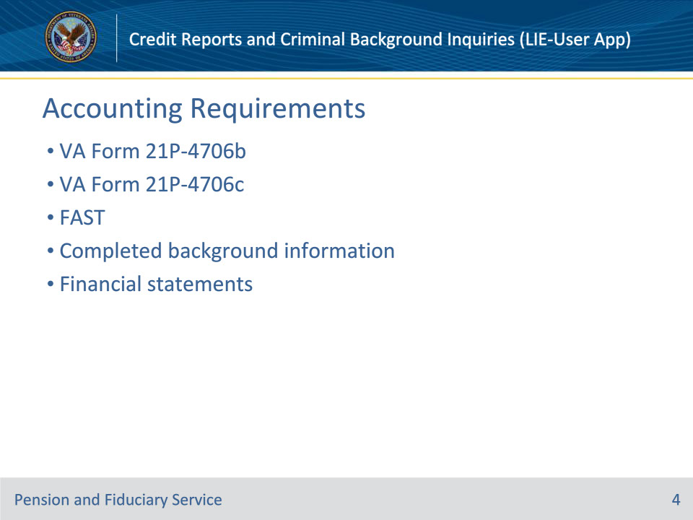
Slide notes

References: FPM I.3.A.3.a., FPM I.3.A.3.d.

Instructor Notes:

Hubs must review all documents the fiduciary submits in response to a VA request for an annual accounting. The hub must determine if the accounting submission is complete before auditing an accounting submission by the fiduciary.

A complete accounting means that the accounting contains enough information for VA to review all income and expenditures during the accounting period.

An accounting report submission by a fiduciary is considered complete and ready for audit if all the conditions below are met:

• the VA Form 21P-4706b, VA Fiduciary’s Account, VA Form 21P-4706c, Court Appointed Fiduciary’s Account, or an accounting submitted via FAST contains the

• name of the beneficiary

• VA file number associated with the beneficiary

• expenses, and

• income, and

• the fiduciary

• completes the background information section, and

• provides financial statements detailing account transactions during the entire accounting period.

• If the fiduciary is submitting the accounting via FAST, submission of an accounting VA Form 21P-4706b or 21P-4706c is not required. A FAST submission takes the place of VA Form 21P-4706b or 21P-4706c.

Slide 5 - Background Information
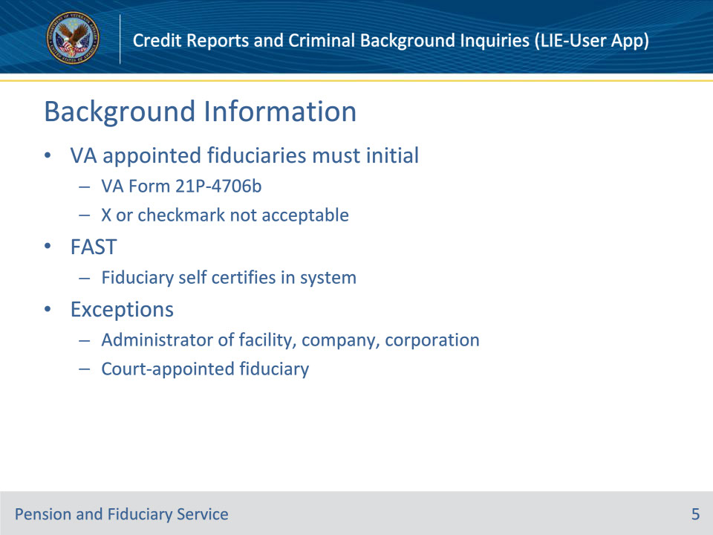
Slide notes

References: FPM I.3.A.3.d.

Instructor Notes:

Generally, individuals serving as VA appointed fiduciaries must initial on the BACKGROUND INFORMATION block on the VA Form 21P-4706b. Do not accept an X or a checkmark as initialing the BACKGROUND INFORMATION block.

All accountings submitted via FAST require the fiduciary to review and confirm the statements pertaining to personal criminal and credit history prior to submitting the accounting. Hub personnel must assume verification of these statements when auditing an accounting in FAST, as the fiduciary is unable to submit the accounting in FAST until these statements are certified.

VA-appointed fiduciaries who are either an administrator of a facility, company, or corporation, or a court-appointed fiduciary, are not required to complete the BACKGROUND INFORMATION block.

Slide 6 - VA Form 21P-4703
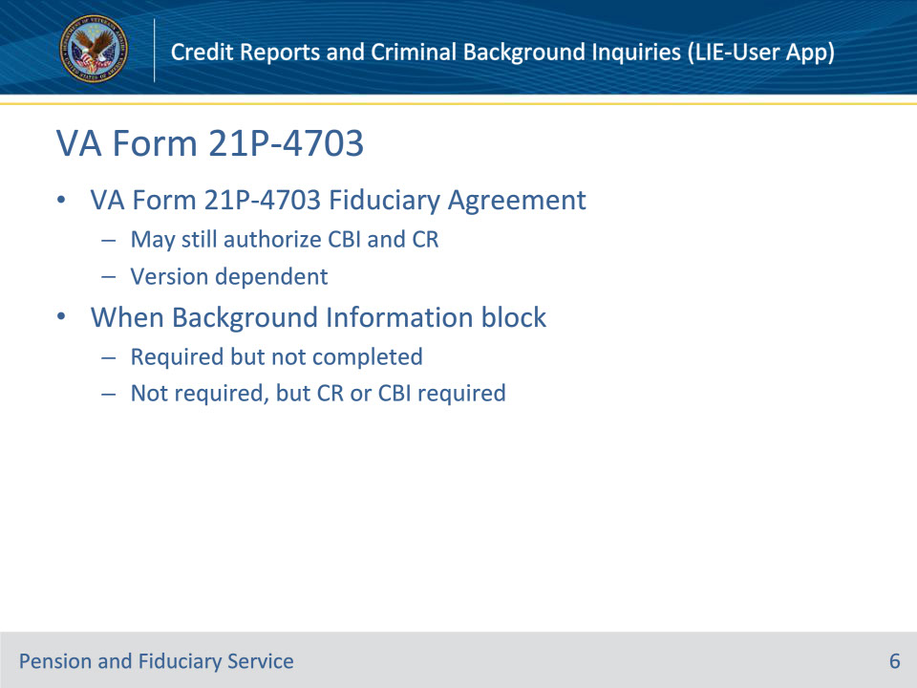
Slide notes

References: FPM I.3.A.3.d.

Instructor Notes:

LIEs may still be able to confirm criminal and credit information by checking to see what version of VA Form 21P-4703, Fiduciary Agreement, is of record when the BACKGROUND INFORMATION block in the VA Form 21P-4706b was

• required but not completed, or

• not required and a credit report and/or criminal background inquiry (CBI) would otherwise be required.

Slide 7 - 2017 Form or Later
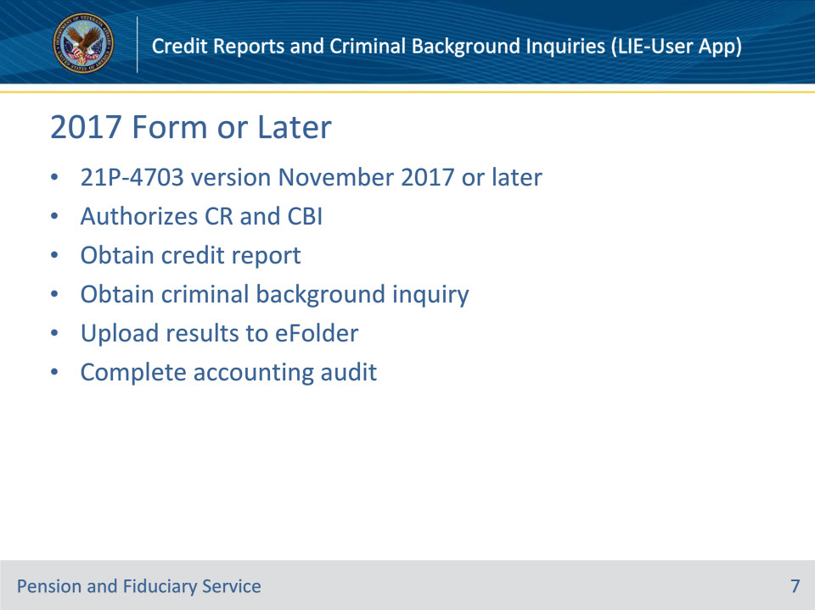
Slide notes

References: FPM I.3.A.3.d.

Instructor Notes:

If the fiduciary signed a VA Form 21P-4703 and the form version date is November 2017 or later, then:

• obtain a

• credit report, if required, to review the fiduciary’s credit history, and

• CBI, if required, to review the fiduciary’s background, and

• upload the results of all required inquiries to the eFolder prior to completing the accounting audit to confirm that all required inquiries were completed.

Slide 8 - Pre 2017 Form (1/3)
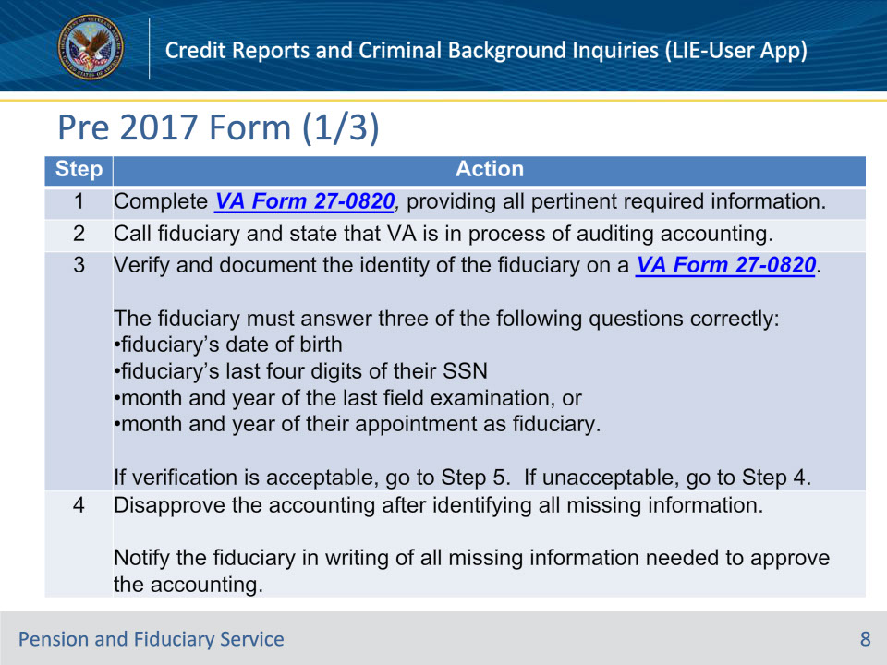
Slide notes

References: FPM I.3.A.3.d.

Instructor Notes:

If the fiduciary signed a VA Form 21P-4703 and the form version date is prior to November 2017 and a phone call attempt to the fiduciary is successful, then follow the steps in this table to determine next step. Continued on next slide.

Slide 9 - Pre 2017 Form (2/3)
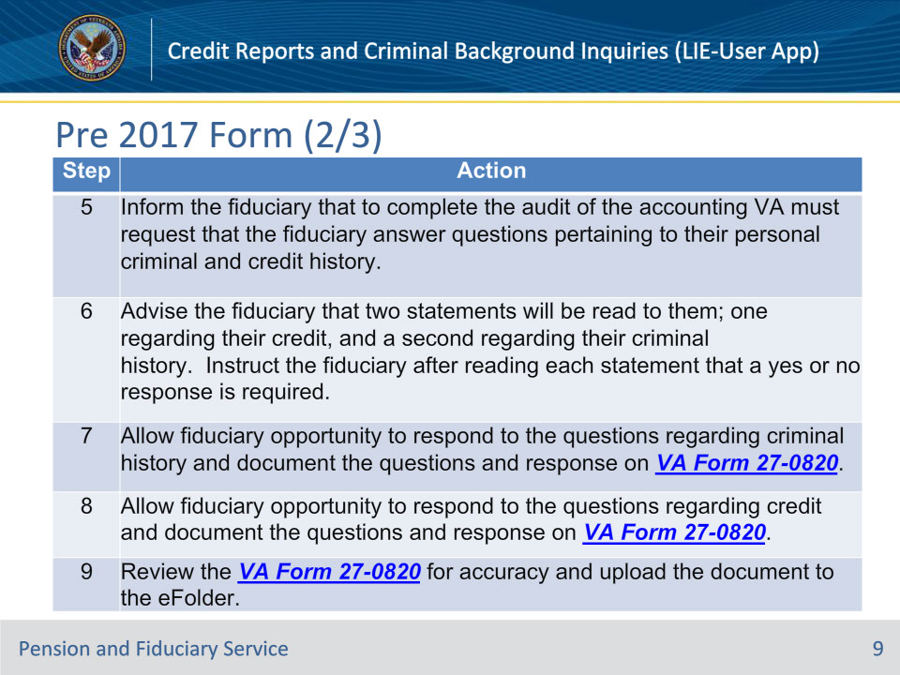
Slide notes

References: FPM I.3.A.3.d.

Instructor Notes:

Remaining steps.

Step 7: Questions regarding criminal history:

Do you certify that during this accounting period, you have not been convicted of any offense under Federal or State law, which resulted in imprisonment for more than one year? You understand the Department of Veterans Affairs may obtain your criminal background history to verify your response and use this information to determine if you meet VA’s requirements for continued fiduciary service.

If negative criminal history information is given, follow the procedures for review of CBI.

Step 8: Questions regarding credit report:

Do you certify that during this accounting period, you did not default on a debt, were not the subject of collection action by a creditor and did not file bankruptcy? To the best of your knowledge, no adverse credit information was reported to a credit bureau because you were unable to meet your personal financial obligations. You understand that the Department of Veterans Affairs may obtain your credit history report to verify your response and use this information to determine if you meet VA’s requirements for continued fiduciary service.

Follow the procedures to review the credit history.

Slide 10 - Pre 2017 Form (3/3)
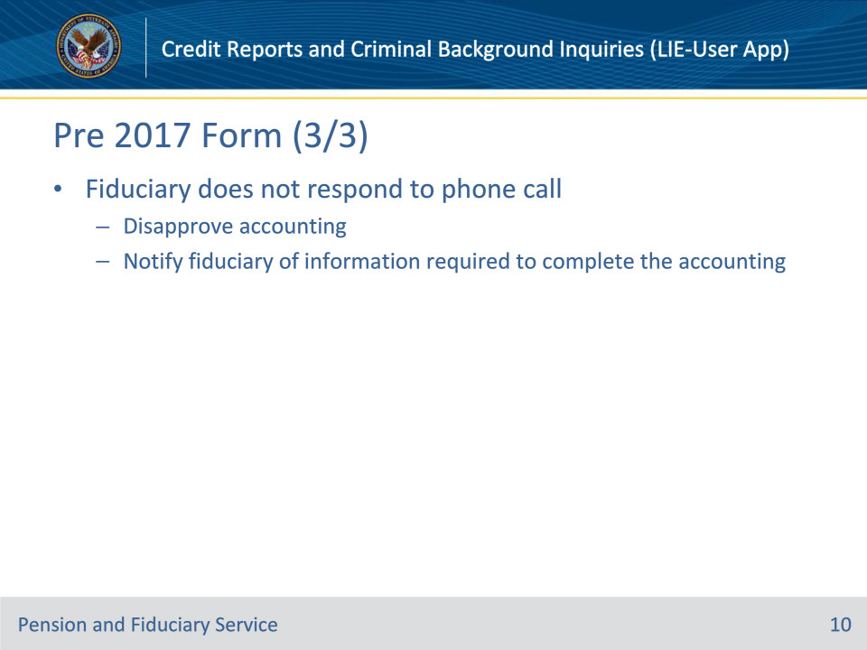
Slide notes

References: FPM I.3.A.3.d.

Instructor Notes:

If the fiduciary signed a VA Form 21P-4703 and the form version date is prior to November 2017 and the fiduciary does not respond to the phone call attempt, then disapprove the accounting and notify the fiduciary of the information required to complete the accounting.

Slide 11 - Accounting Credit Reports
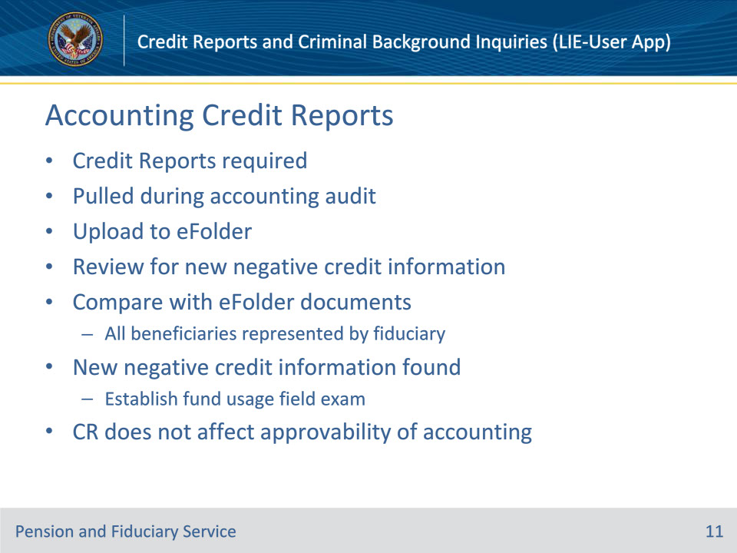
Slide notes

References: FPM I.3.A.3.o.

Instructor Notes:

LIEs must obtain a credit report for all fiduciaries during the accounting audit unless listed as an exception or for a final accounting. LIEs must upload the credit report to the eFolder and review the credit report for any new negative credit information by comparing the report with documents available within the eFolder. When the review of the credit report identifies new negative credit information, a fund usage follow-up field examination must immediately be established to investigate.

• The results of a credit report do not affect whether an accounting is approvable.

• For fiduciaries representing multiple beneficiaries, the eFolder review to compare credit report findings includes the eFolders of all beneficiaries for which the fiduciary is appointed.

Slide 12 - Negative Credit Information
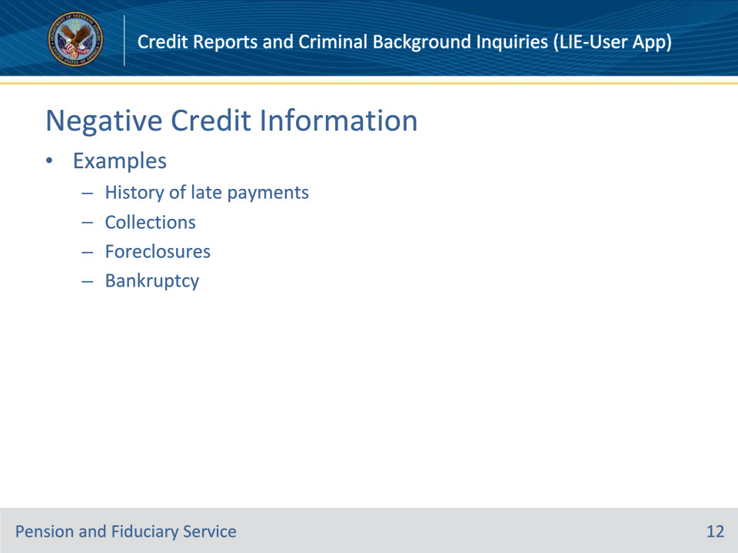
Slide notes

References: FPM I.3.A.3.o.

Instructor Notes:

Examples of negative credit information include, but are not limited to

• a history of late payments

• collections

• foreclosures, and/or

• bankruptcy.

Slide 13 - Fund Usage Field Exam
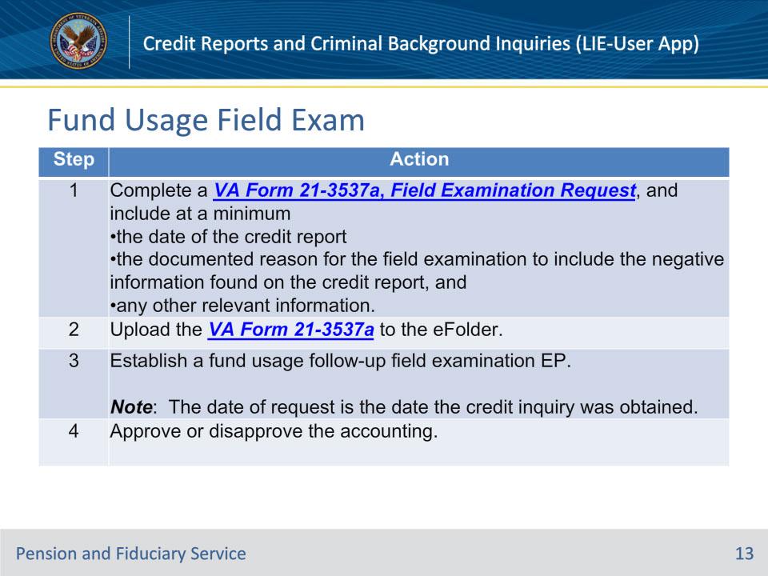
Slide notes

References: FPM I.3.A.3.o.

Instructor Notes:

Follow the steps in this table upon determination that a fund usage follow-up field examination is required.

Slide 14 - No Credit Report Available
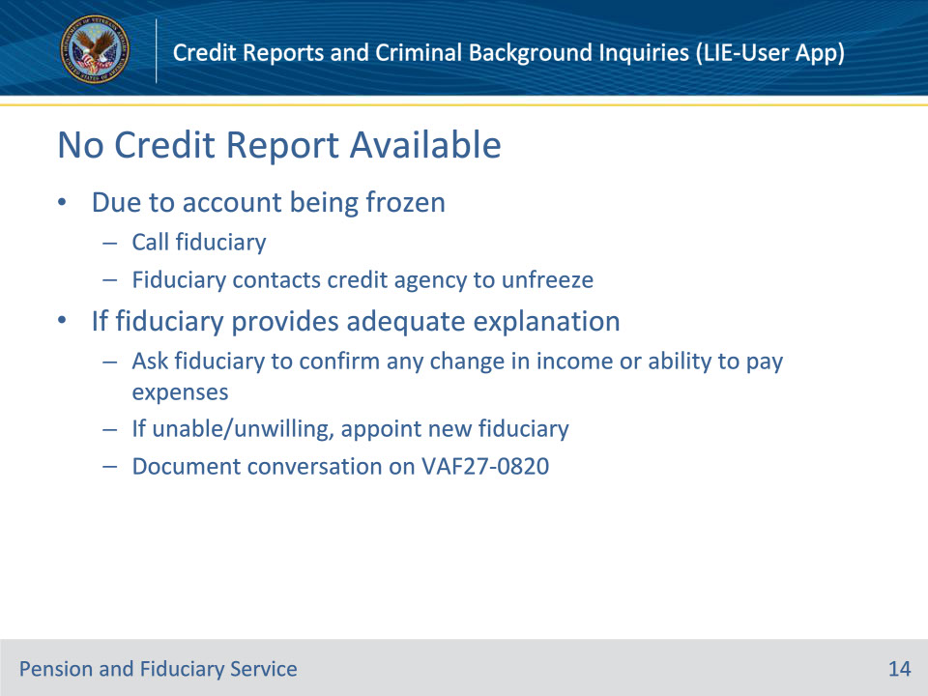
Slide notes

References: FPM I.3.A.3.o.

Instructor Notes:

If the credit review search reveals no credit report is available for review due to the account being frozen, the LIE shall call the fiduciary and request the fiduciary contact a credit agency and unfreeze their account. If the fiduciary provides an adequate explanation about special circumstances for why they cannot unfreeze their account at the present time or if the credit report is not otherwise available, ask the fiduciary to confirm if there is any change in the fiduciary’s income or ability to pay their expenses. The LIE will document the conversation on VA Form 27-0820. If the fiduciary is unable or unwilling to adequately confirm their income and ability to pay expenses, the hub must appoint a new fiduciary.

Slide 15 - Accounting CR Exceptions
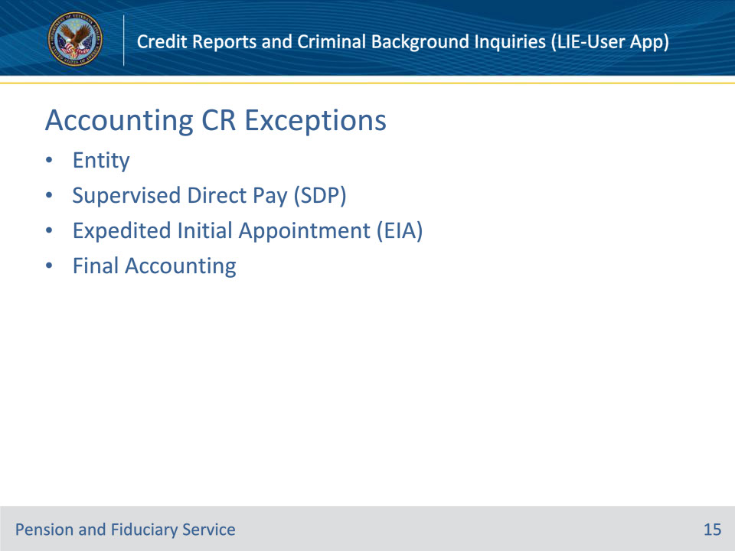
Slide notes

References: FPM I.3.A.3.o.; I.2.C.5.d.

Instructor Notes:

Credit reports are not required for:

• an entity, such as a trust department in a bank that provides trust services

• a beneficiary appointed as SDP

• a fiduciary appointed under the EIA process

• a final accounting

Slide 16 - Accounting CBI
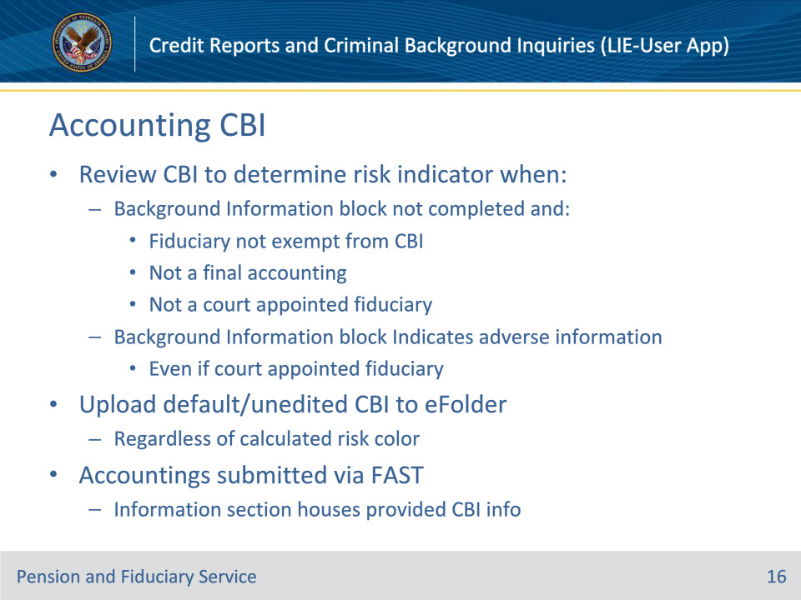
Slide notes

References: FPM I.3.A.3.p.

Instructor Notes:

Review the CBI in CLEAR to determine the risk indicator when the BACKGROUND INFORMATION block on the VA Form 21P-4706b

• is not completed and the fiduciary is not

• exempt from a CBI

• filing a final accounting, or

• a court appointed fiduciary, or

• indicates adverse information even if the fiduciary is classified as a court-appointed fiduciary.

Ensure a copy of the default and unedited CBI is uploaded to the beneficiary’s eFolder regardless of the resulting calculated risk color.

If the fiduciary submitted their accounting via FAST, any negative criminal background information provided by the fiduciary is viewable in the INFORMATION section of the accounting record within FAST.

Slide 17 - CBI Field Exams (1/3)
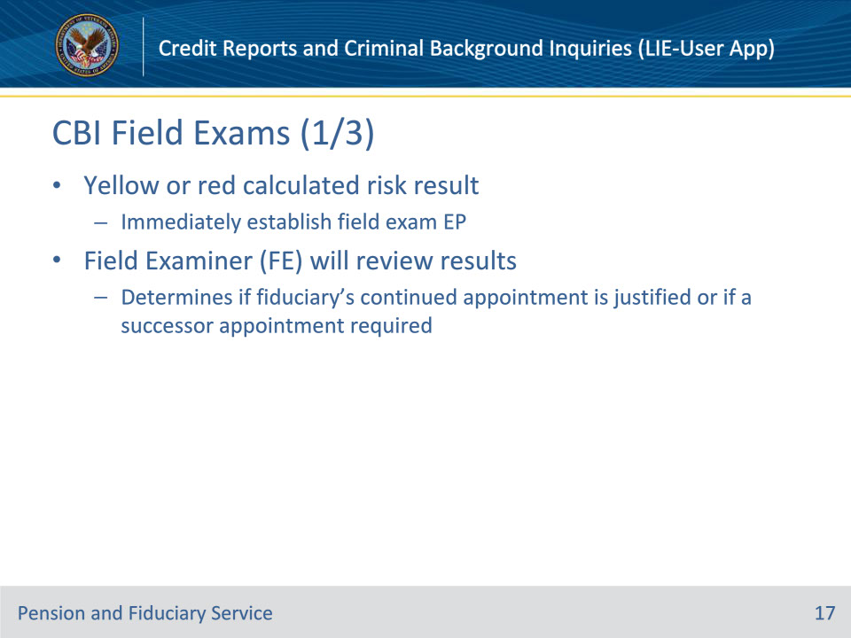
Slide notes

References: FPM I.3.A.3.p.

Instructor Notes:

If during the LIE’s review of the CBI, it is discovered the fiduciary has a yellow or red calculated risk result, immediately establish the appropriate field examination EP. Within that EP, the FE will review the results and determine if the fiduciary’s continued appointment is justified or if a successor fiduciary appointment is required.

Slide 18 - CBI Field Exams (2/3)
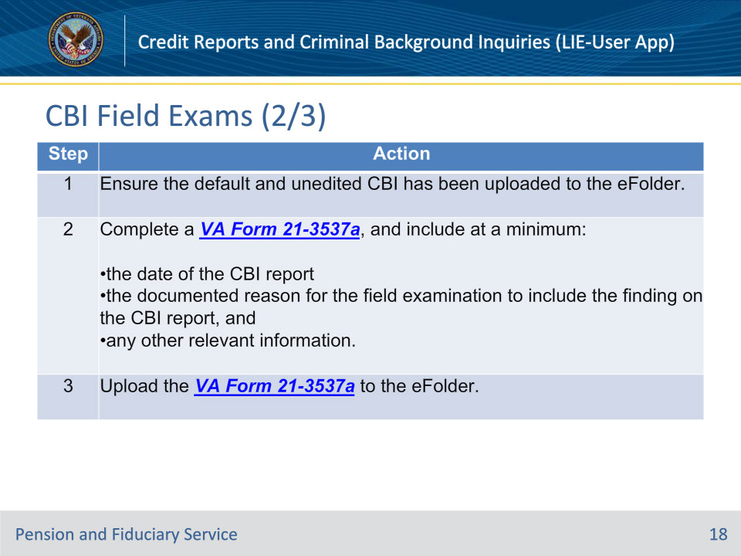
Slide notes

References: FPM I.3.A.3.p.

Instructor Notes:

Follow the steps in this table upon determination that a field examination is required. Steps continued on next slide.

Slide 19 - CBI Field Exams (3/3)
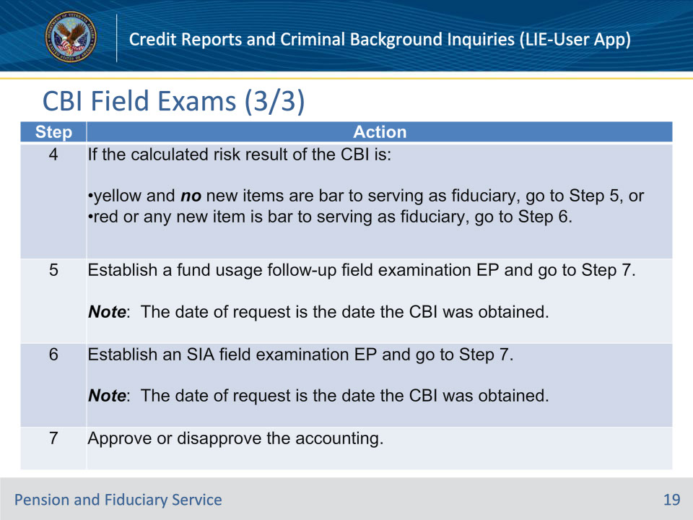
Slide notes

References: FPM I.3.A.3.p.

Instructor Notes:

Continued steps.

Slide 20 - Special Circumstances
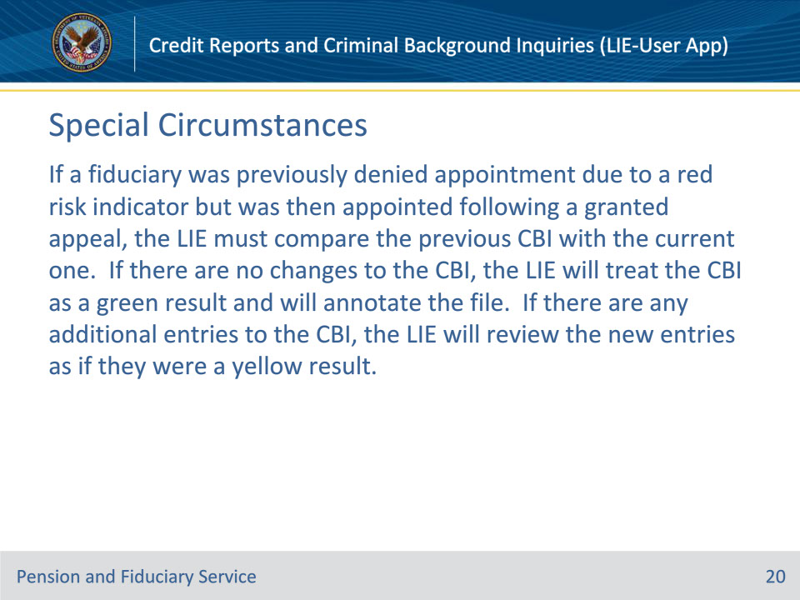
Slide notes

References: FPM I.3.A.3.p.

Instructor Notes:

If a fiduciary was previously denied appointment due to a red risk indicator but was then appointed following a granted appeal, the LIE must compare the previous CBI with the current one. If there are no changes to the CBI, the LIE will treat the CBI as a green result and will annotate the file. If there are any additional entries to the CBI, the LIE will review the new entries as if they were a yellow result.

Slide 21 - Accounting CBI Exceptions
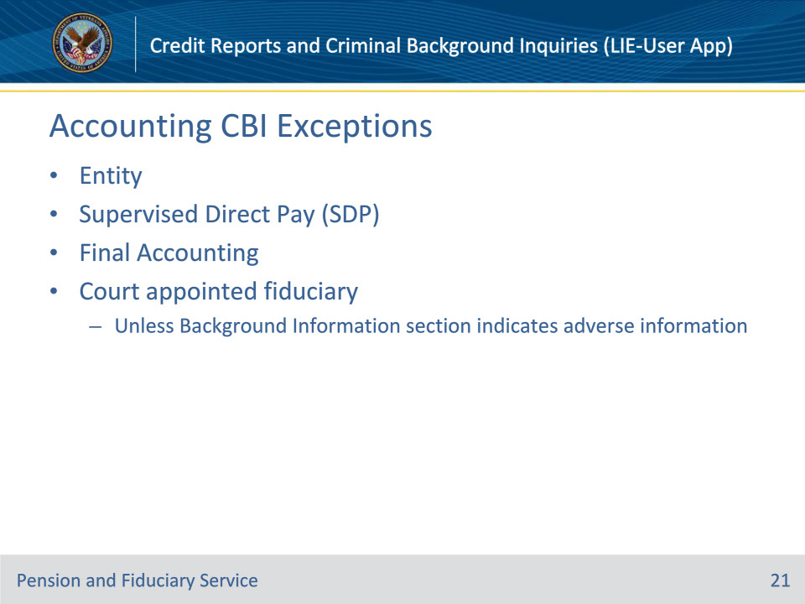
Slide notes

References: FPM I.3.A.3.p.; FPM I.2.C.5.i.

Instructor Notes:

CBIs are not required for:

• an entity, such as a trust department in a bank that provides trust services

• a beneficiary appointed as SDP

• a final accounting

• a court appointed fiduciary, unless background information section indicates adverse information

Slide 22 - Bars to Service
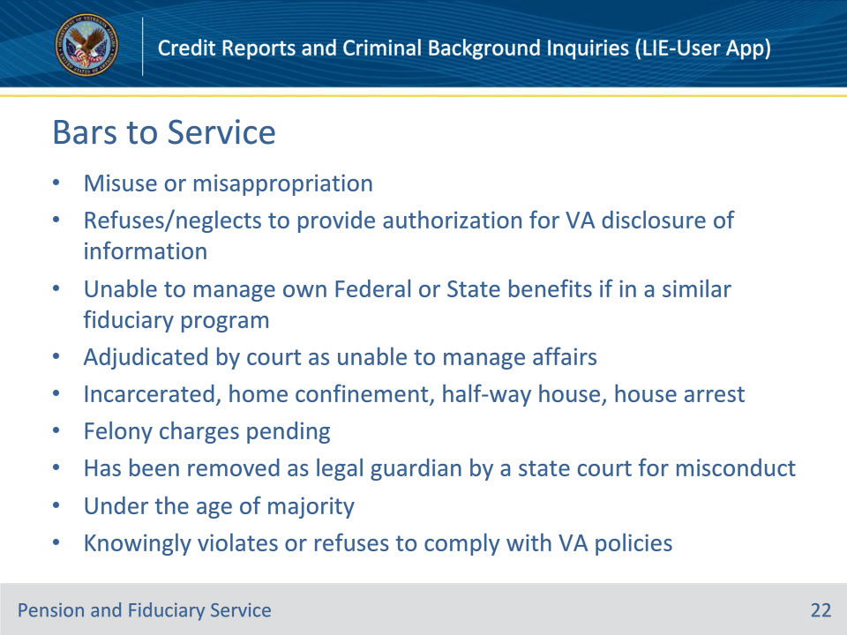
Slide notes

References: FPM I.2.C.5.b.

Instructor Notes:

An individual or entity may not serve as a fiduciary for a VA beneficiary if the individual or entity

• misused or misappropriated a beneficiary’s VA benefits while serving as a fiduciary

• refuses or neglects to provide the authorization for VA disclosure of information

• is unable to manage their own Federal or State benefits and is in a Federal or State agency’s fiduciary, representative payment, or similar program

• has been adjudicated by a court with jurisdiction as being unable to manage his/her own financial affairs

• is incarcerated in a Federal, State, local, or other penal institution or correctional facility, sentenced to home confinement, released from incarceration to a half-way house, or on house arrest or in custody in any facility awaiting trial on pending criminal charges

• has felony charges pending

• has been removed as legal guardian by a state court for misconduct

• is under the age of majority, or

• knowingly violates or refuses to comply with VA policies.

Slide 23 - Felony Exceptions
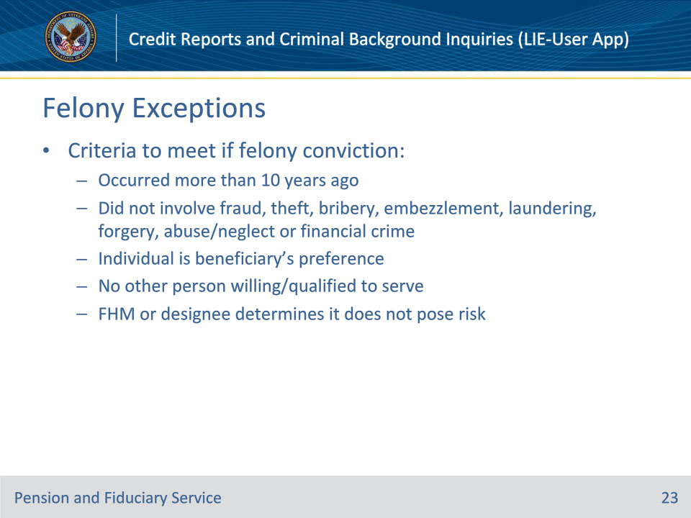
Slide notes

References: FPM I.2.C.5.k.

Instructor Notes:

If the person was convicted of a felony offense, that person can be certified as fiduciary only if it is determined that the person is appropriate based on the circumstances. All the following conditions must be met to appoint the person as fiduciary:

• the conviction occurred more than 10 years ago

• the conviction did not involve fraud, theft, bribery, embezzlement, identity theft, money laundering, forgery, abuse/neglect of another person, or any other financial crime

• the individual is the preference of the beneficiary

• no other person or entity is willing or qualified to serve, and

• the FHM or designee determines the appointment of the individual poses no risk to the beneficiary and is in the beneficiary’s best interest.

Slide 24 - Questions?
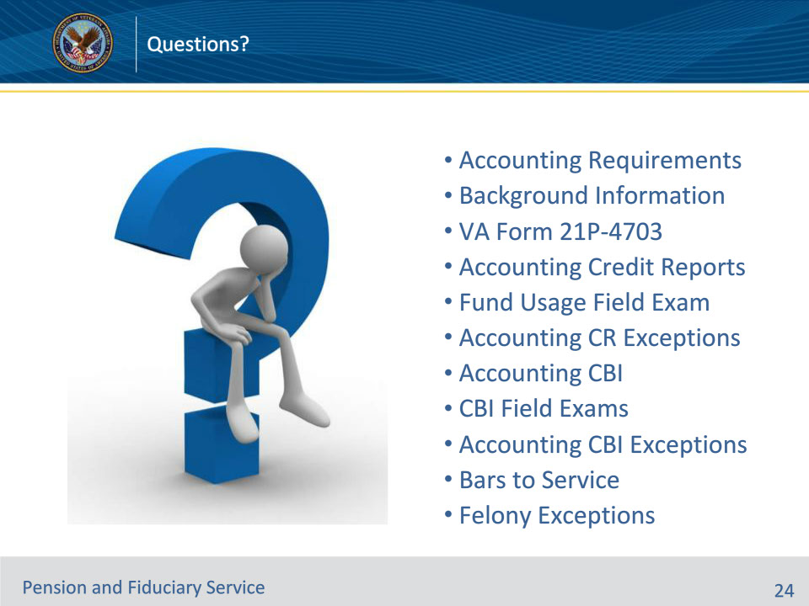
Slide notes

Instructor Notes:

(Recall) These are our learning objectives as stated from the beginning of the training:

• State the elements of a complete accounting

• Recall when a credit report (CR) and criminal background inquiry (CBI) must be pulled

• Explain authorization to pull CR and CBI

• Describe the steps to review a CR and CBI

• Identify various bars to service as a fiduciary

Are there any additional questions?

Questions should be filtered through your QRT team. They will submit your questions to the Field Inquiry Tool (FIT) on your behalf.

Slide 25 - TMS Survey/Assessment
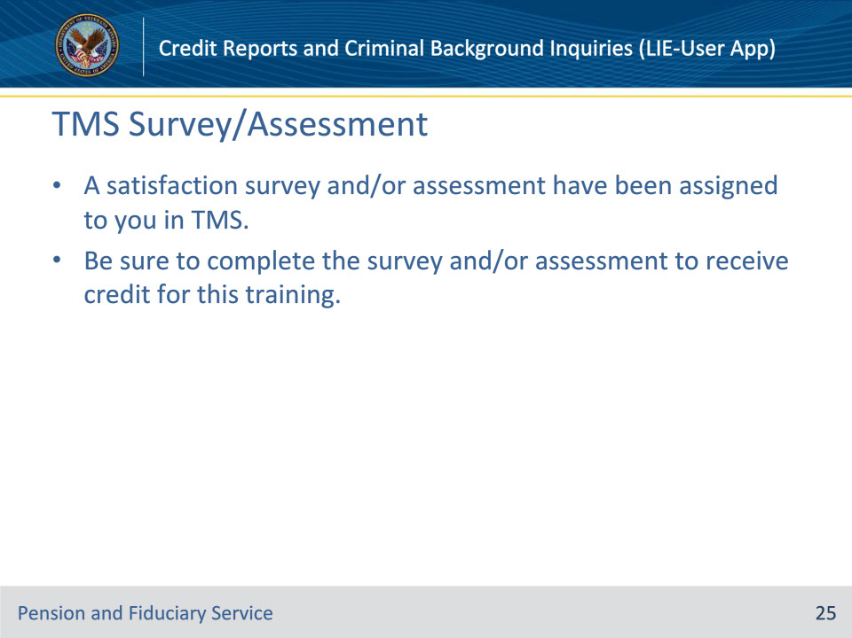
Slide notes

Instructor Notes:

A satisfaction survey and/or assessment have been assigned to you in TMS.

Be sure to complete the survey and/or assessment to receive credit for this training.

