Slide 1 - Cost of Living Adjustment (COLA)
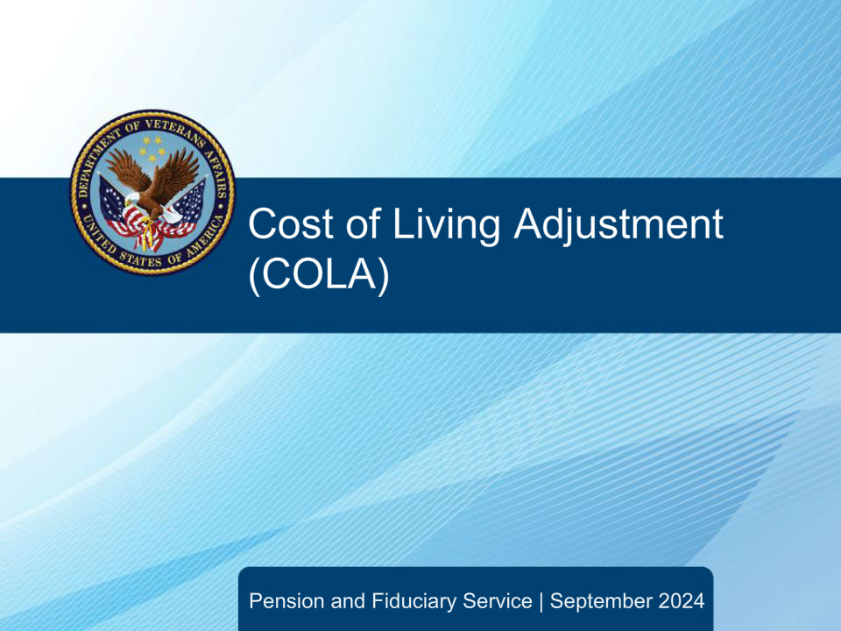
Slide notes

This course is designed to aid Fiduciary Service Representatives in understanding their role in processing COLAs, as well as how to transfer COLA claims.

Slide 2 - Objectives
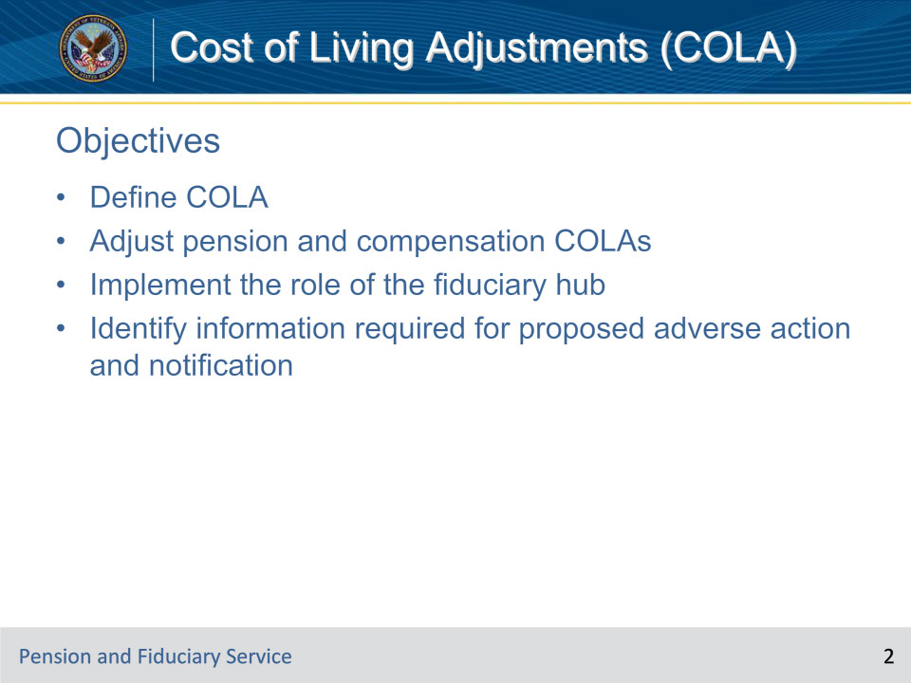
Slide notes

Here are the objectives for this course. At the end of this lesson, given the training and references, the learner will be able to do the following:

• Define COLA

• Adjust pension and compensation COLAs

• Implement the role of the fiduciary hub

• Identify information required for proposed adverse action and notification

Slide 3 - References
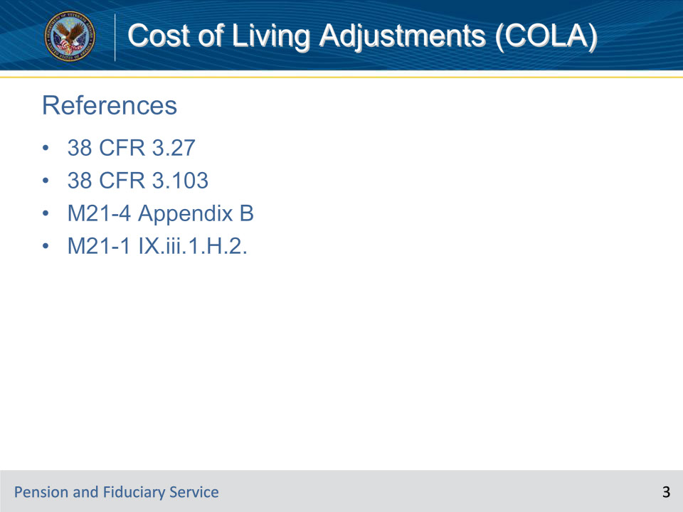
Slide notes

These are the references for today’s training. Please take the time after today’s course to locate and review them.

• 38 CFR 3.27

• 38 CFR 3.103

• M21-4 Appendix B

• M21-1 IX.iii.1.H.2.

Slide 4 - Overview
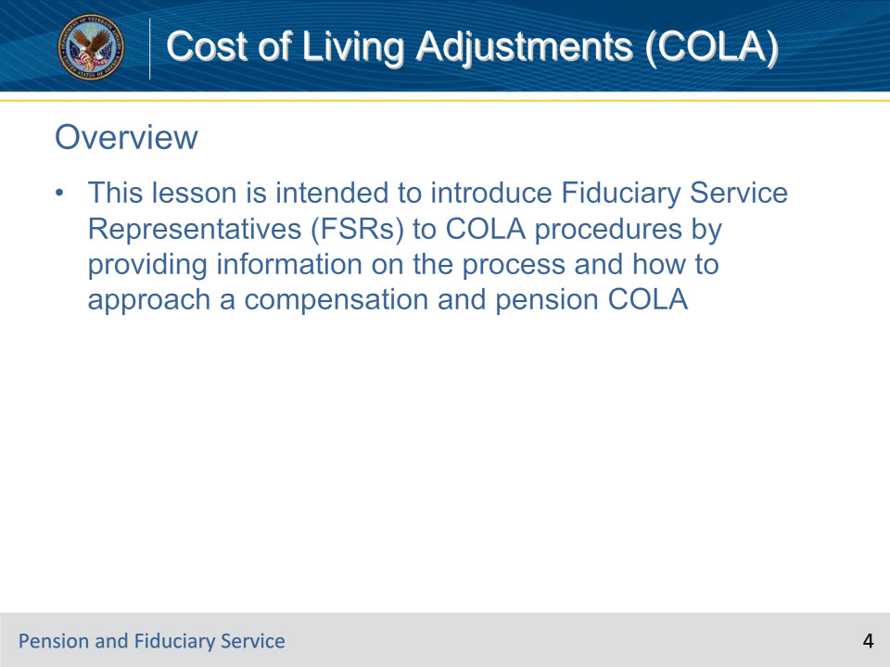
Slide notes

Instructor Notes:

This lesson is intended to introduce Fiduciary Service Representatives (FSRs) to COLA procedures by providing information on the process and how to approach a compensation and pension COLA

Slide 5 - Definition
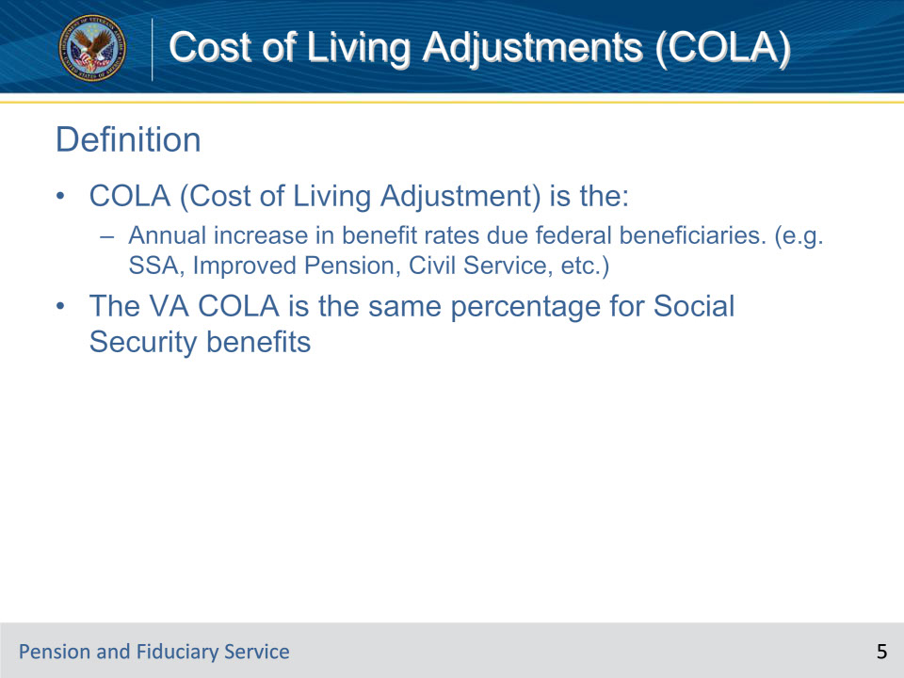
Slide notes

Instructor Notes:

What is COLA (Cost of Living Adjustment)?

COLA is the annual increase in benefit rates due to federal beneficiaries. For example, Social Security, Improved Pension, Civil Service, etc.

Under federal law, the cost-of-living adjustments to VA’s compensation and pension rates are the same percentage as for Social Security benefits

Slide 6 - Example
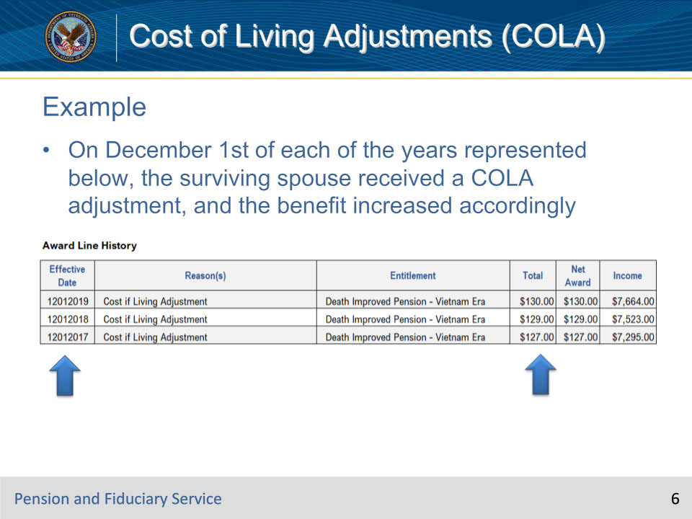
Slide notes

Instructor Notes:

Let’s look at an example. On November 1, 2011, a Veteran’s monthly compensation rate was $2,673.00. You input the COLA rate effective December 01, 2011 and the monthly rate increased to $2,769.00. Awards are generated from the Record Decisions page. Click the Generate Award button to begin the process. The date from which you have decided to generate is not valid as no award lines will be created with that Effective Date. Please revise the date or update your supporting Decision screens (i.e. Rating, Dependency, Financials). Review the current Award line dates for possible acceptable dates. Award Effective Dates for new decisions may also be acceptable. In all cases, the date must be earlier or equal to the date currently shown in the control date field.

Slide 7 - Adjusting Awards
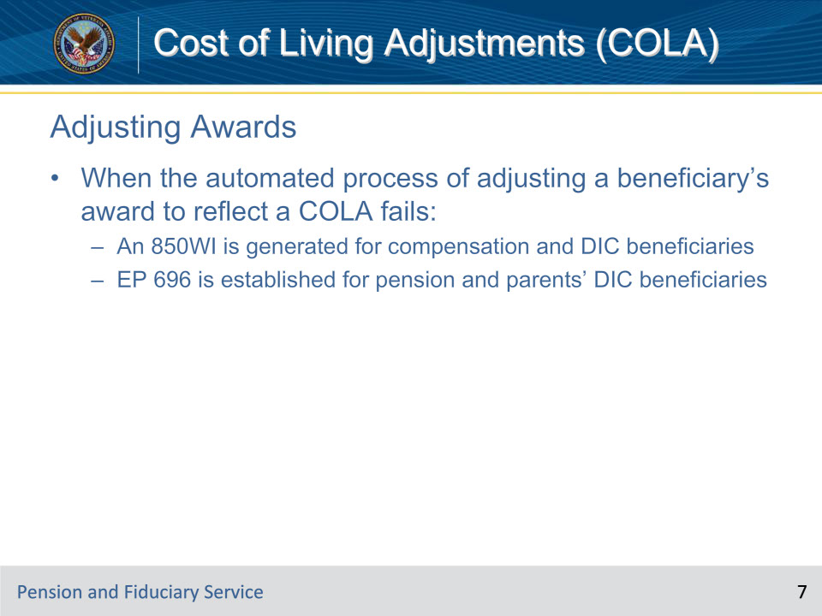
Slide notes

Instructor Notes:

• When the automated process of adjusting a beneficiary’s award to reflect a COLA fails:

• An 850WI is generated for compensation and DIC beneficiaries

• EP 696 is established for pension and parents’ DIC beneficiaries

Slide 8 - Processing 850WI
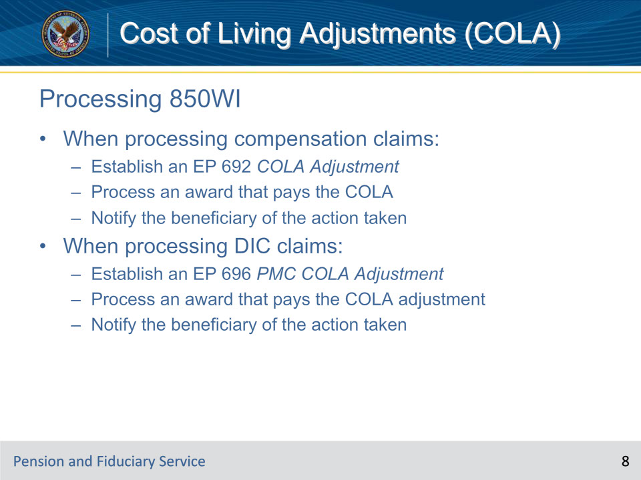
Slide notes

Instructor Notes:

• When processing compensation claims:

• Establish an EP 692 COLA Adjustment

• Process an award that pays the COLA

• Notify the beneficiary of the action taken

• When processing DIC claims:

• Establish an EP 696 PMC COLA Adjustment

• Process an award that pays the COLA adjustment

• Notify the beneficiary of the action taken

Slide 9 - Processing EP 696
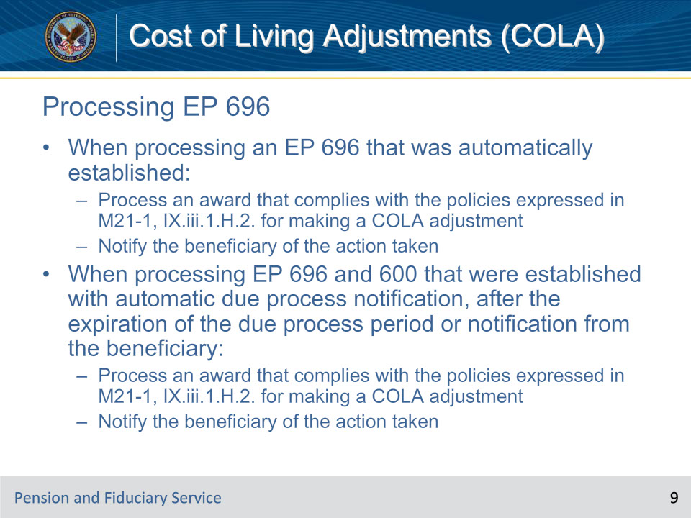
Slide notes

Instructor Notes:

• When processing an EP 696 that was automatically established:

• Process an award that complies with the policies expressed in M21-1, IX.iii.1.H.2. for making a COLA adjustment

• Notify the beneficiary of the action taken

• When processing EP 696 and 600 that were established with automatic due process notification, after the expiration of the due process period or notification from the beneficiary:

• Process an award that complies with the policies expressed in M21-1, IX.iii.1.H.2. for making a COLA adjustment

• Notify the beneficiary of the action taken

Slide 10 - Decrease of Running Award
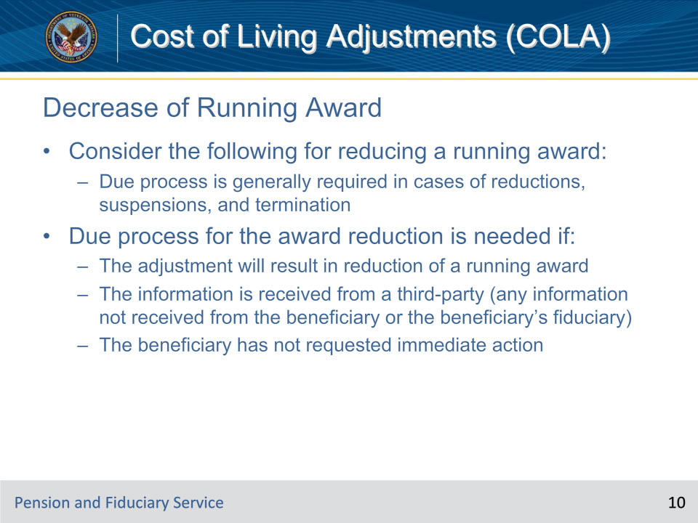
Slide notes

Instructor Notes:

• Consider the following for reducing a running award:

• Due process is generally required in cases of reductions, suspensions, and termination

• Due process for the award reduction is needed if:

• The adjustment will result in reduction of a running award

• The information is received from a third-party (any information not received from the beneficiary or the beneficiary’s fiduciary)

• The beneficiary has not requested immediate action

Slide 11 - Due Process Response Time
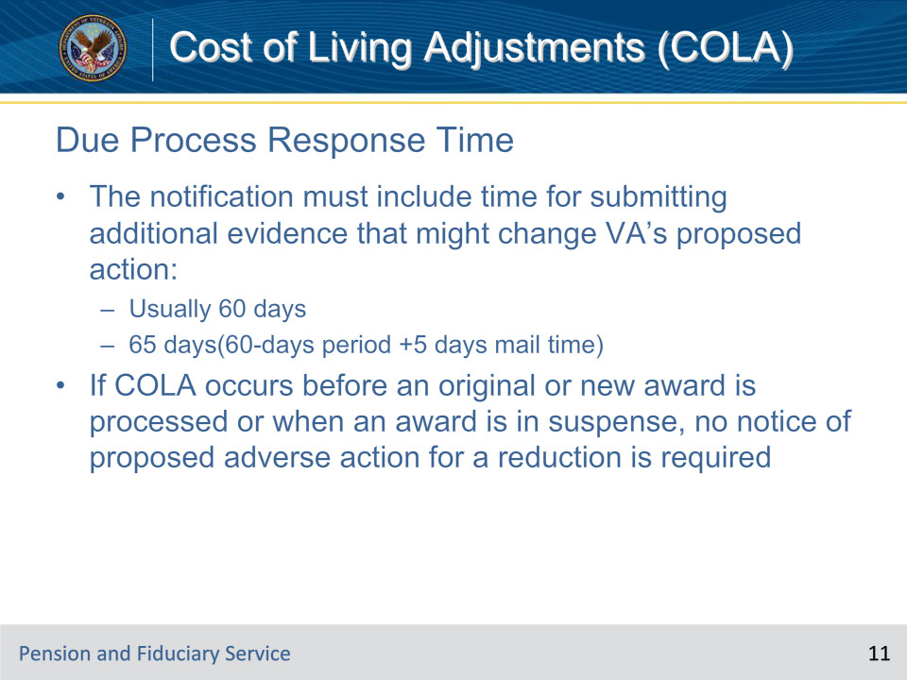
Slide notes

Instructor Notes:

• The notification must include time for submitting additional evidence that might change VA’s proposed action:

• Usually 60 days

• 65 days(60-days period +5 days mail time)

• If COLA occurs before an original or new award is processed or when an award is in suspense, no notice of proposed adverse action for a reduction is required

Slide 12 - Review
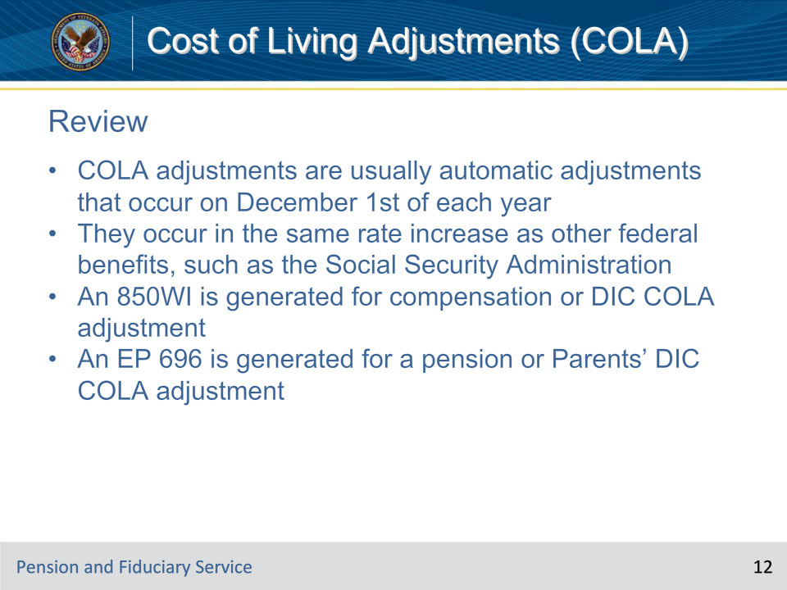
Slide notes

Instructor Notes:

• COLA adjustments are usually automatic adjustments that occur on December 1st of each year

• They occur in the same rate increase as other federal benefits, such as the Social Security Administration

• An 850WI is generated for compensation or DIC COLA adjustment

• An EP 696 is generated for a pension or Parents’ DIC COLA adjustment

Slide 13 - Questions
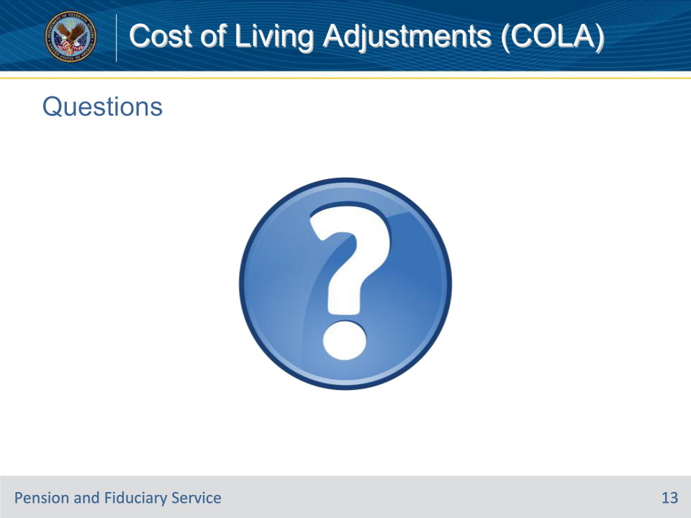
Slide notes

Instructor Notes:

(Recall) These are our learning objectives as stated from the beginning of the training:

• Define COLA

• Adjust pension and compensation COLAs

• Implement the role of the fiduciary hub

• Identify information required for proposed adverse action and notification

Questions should be filtered through your QRT team. They will submit your questions to the Field Inquiry Tool (FIT) on your behalf.

Slide 14 - TMS Survey/Assessment
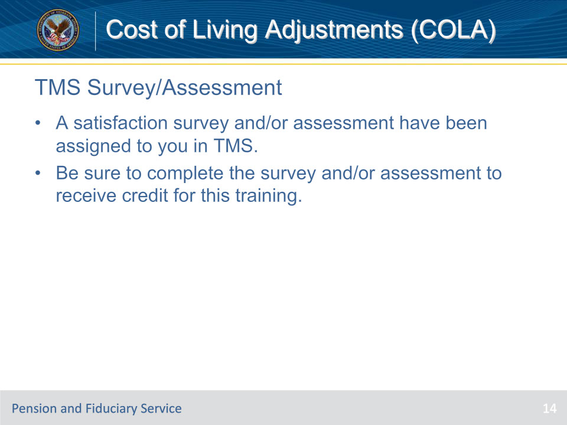
Slide notes

Instructor Notes:

A satisfaction survey and/or assessment have been assigned to you in TMS.

Be sure to complete the survey and/or assessment to receive credit for this training.

