Slide 1 - FSR Apportionment
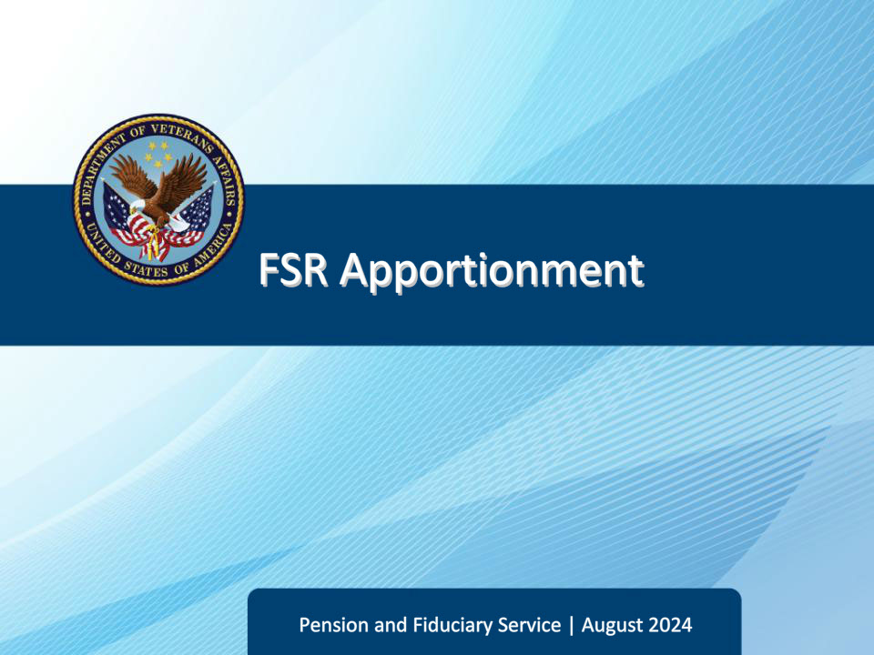
Slide notes

Course Description:

This course is an overview on how to recognize and process apportionment claims.

Slide 2 - Objectives
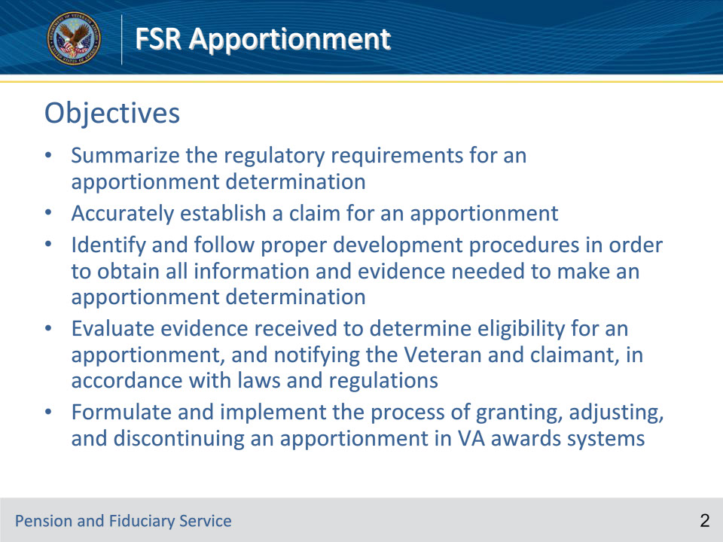
Slide notes

Instructor Notes:

At the end of this lesson, given the training and references, the learner will be able to do the following:

• Summarize the regulatory requirements for an apportionment determination

• Accurately establish a claim for an apportionment

• Identify and follow proper development procedures in order to obtain all information and evidence needed to make an apportionment determination

• Evaluate evidence received to determine eligibility for an apportionment, and notifying the Veteran and claimant, in accordance with laws and regulations

• Formulate and implement the process of granting, adjusting, and discontinuing an apportionment in VA awards systems

Slide 3 - References
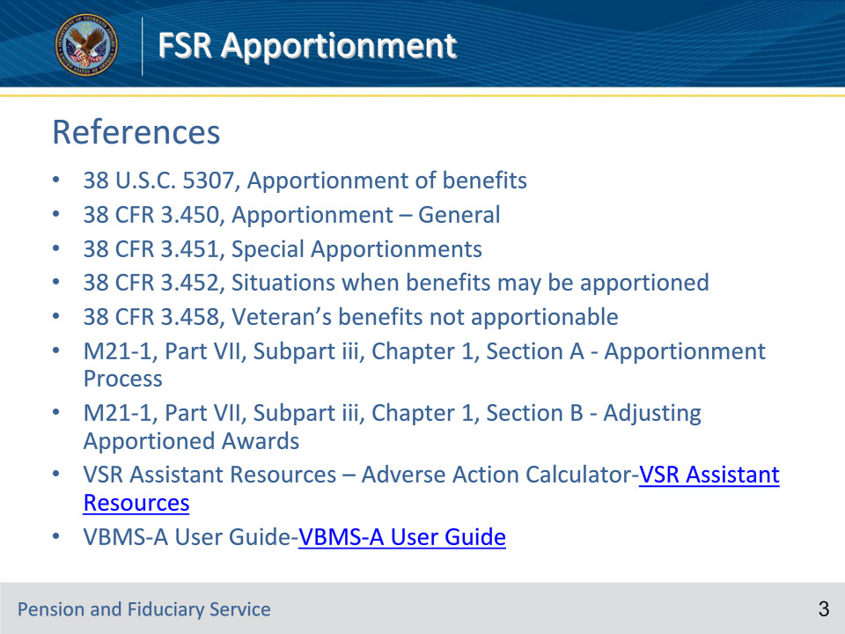
Slide notes

Instructor Notes:

These are the relevant references pertaining to this course:

• 38 U.S.C. 5307, Apportionment of benefits

• 38 CFR 3.450, Apportionment – General

• 38 CFR 3.451, Special Apportionments

• 38 CFR 3.452, Situations when benefits may be apportioned

• 38 CFR 3.458, Veteran’s benefits not apportionable

• M21-1, Part VII, Subpart iii, Chapter 1, Section A - Apportionment Process

• M21-1, Part VII, Subpart iii, Chapter 1, Section B - Adjusting Apportioned Awards

• VSR Assistant Resources – Adverse Action Calculator-VSR Assistant Resources

• VBMS-A User Guide-VBMS-A User Guide

Slide 4 - Apportionment of a Competent Primary Beneficiary’s Benefits under CFR 3.450
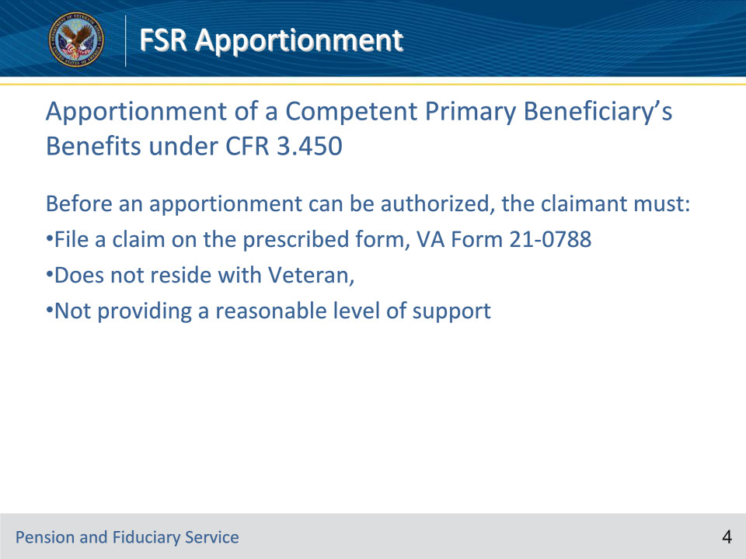
Slide notes

Policy Reference(s): M21-1 VII.iii.1.A.1.d.; M21-1 VII.iii.1.A.1.e.

Instructor Notes:

When processing an apportionment claim, claims processors must first determine whether an apportionment is payable under the provisions of 38 CFR 3.450.

If benefits are not apportionable under 38 CFR 3.450, claims processors must determine whether a special apportionment under the provisions of 38 CFR 3.451 is in order.

The evidence of record must show the following to justify the apportionment of a Veteran’s benefits to an estranged spouse under the provisions 38 CFR 3.450:

•spouse does not reside with the Veteran, and

•Veteran is not providing a reasonable level of support to the spouse.

The evidence of record must show the following to justify the apportionment of a Veteran’s benefits to his/her child (who is in the custody of a former spouse) under the provisions of 38 CFR 3.451:

•child does not reside with the Veteran

•child and former spouse are experiencing financial hardship, and

•apportioning the Veteran’s benefits will not cause undue hardship on the Veteran and his/her other dependent(s).

Slide 5 - Apportionment of a Competent Primary Beneficiary’s Benefits under CFR 3.451
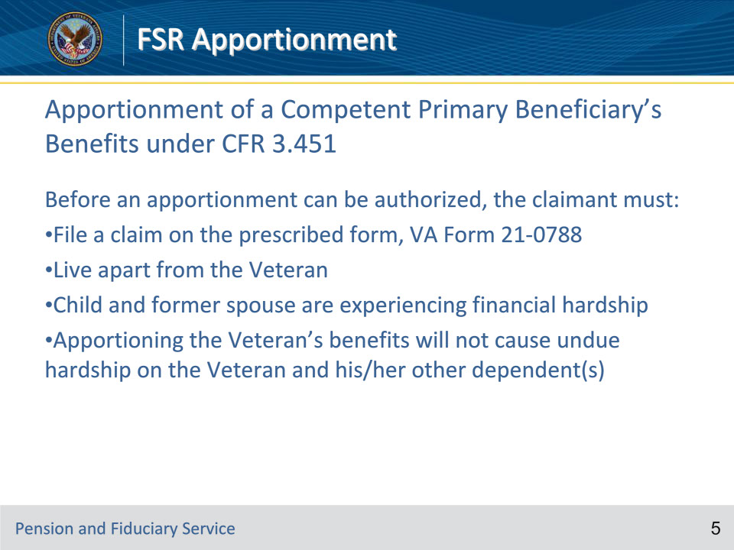
Slide notes

Policy Reference(s): M21-1 VII.iii.1.A.1.e.

Instructor Notes:

• Claimant does not reside with the beneficiary.

• Child and former spouse are experiencing financial hardship,

• Apportionment will not cause undue hardship on the beneficiary and his/her other dependent(s).

Note: When determining entitlement to an apportionment under 38 CFR 3.451, claims processors must consider such factors as

• amount of VA benefits payable

• other resources and income of the beneficiary and claimant, and

• special needs of the

• beneficiary

• beneficiary’s other dependent(s), and

• claimant.

Slide 6 - Who May Receive an Apportionment
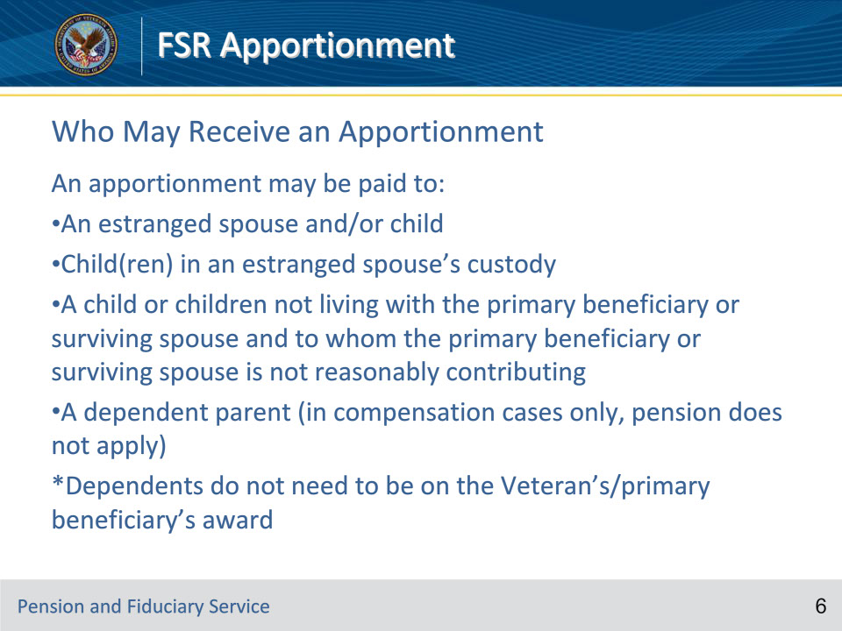
Slide notes

Policy Reference(s): M21-1 VII.iii.1.A.1.b.

Instructor Notes:

An apportionment may be paid to or for a Veteran’s

• estranged spouse

• child that is in an estranged or former spouse’s custody

• child that is not living with the Veteran or the Veteran’s surviving spouse, or

• dependent parent.

Important:

• VA may not apportion a surviving spouse’s current-law Survivors Pension to a child that is not in the surviving spouse’s custody. (The child, in this case, might be entitled to Survivors Pension in his/her own right.)

• The policy described in the previous bullet does not apply if the surviving spouse is receiving Section 306 or Old Law survivors pension.

Slide 7 - Veterans Benefits Not Apportionable
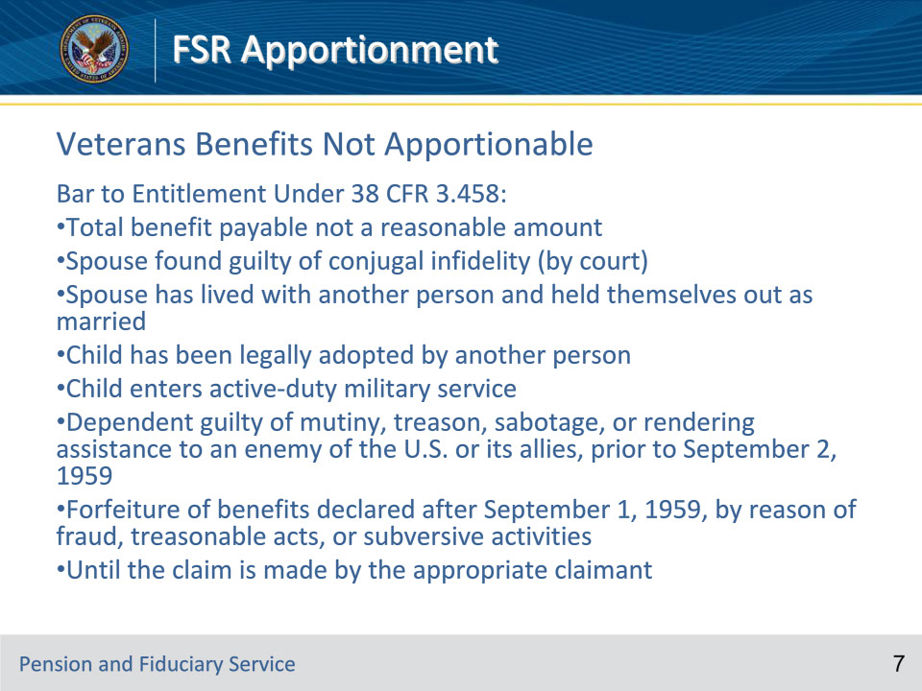
Slide notes

Instructor Notes:

Where a child enters the active military, air, or naval service, any additional amount will be paid to the veteran unless such child is included in an existing apportionment to an estranged spouse. No adjustment in the apportioned award will be made based on the child’s entry into service.

Slide 8 - Upon Receipt of an Apportionment Claim
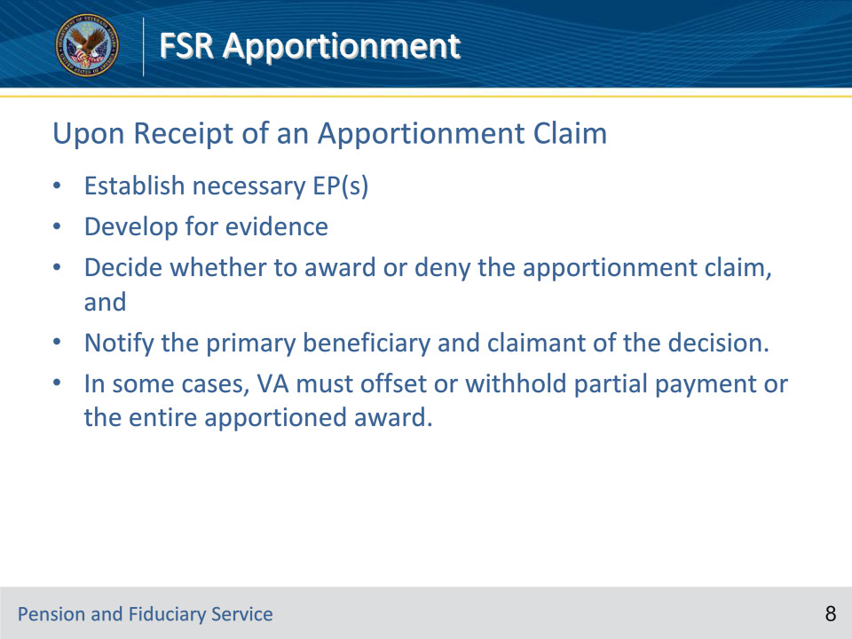
Slide notes

Instructor Notes:

Upon Receipt of an Apportionment Claim:

• Establish necessary EP(s)

• Develop for evidence

• Decide whether to award or deny the apportionment claim, and

• Notify the primary beneficiary and claimant of the decision.

• In some cases, VA must offset or withhold partial payment or the entire apportioned award.

Slide 9 - Apportionment Development
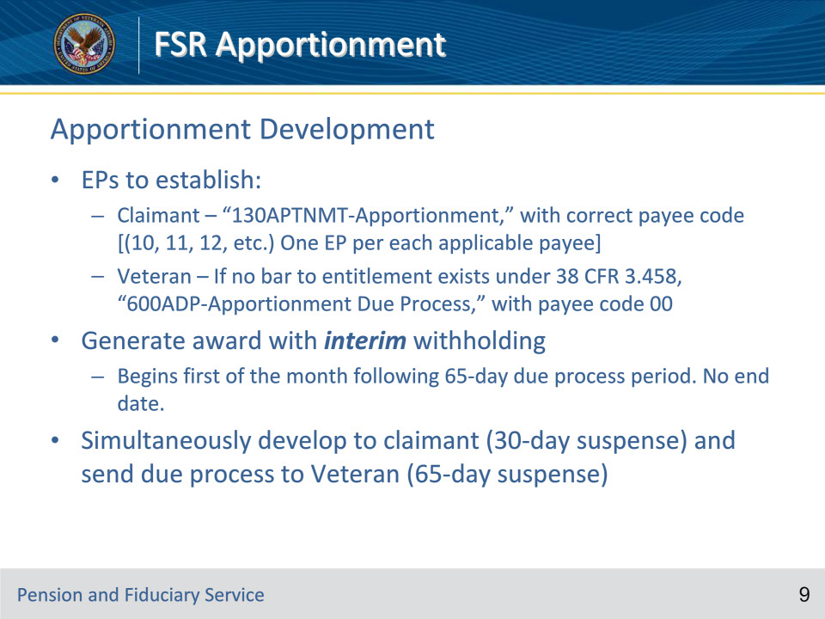
Slide notes

Instructor Notes:

Payee code 10-Spouse

11- 1st child

12-2nd child

60-mom

50-dad

Slide 10 - Interim Withholding Award
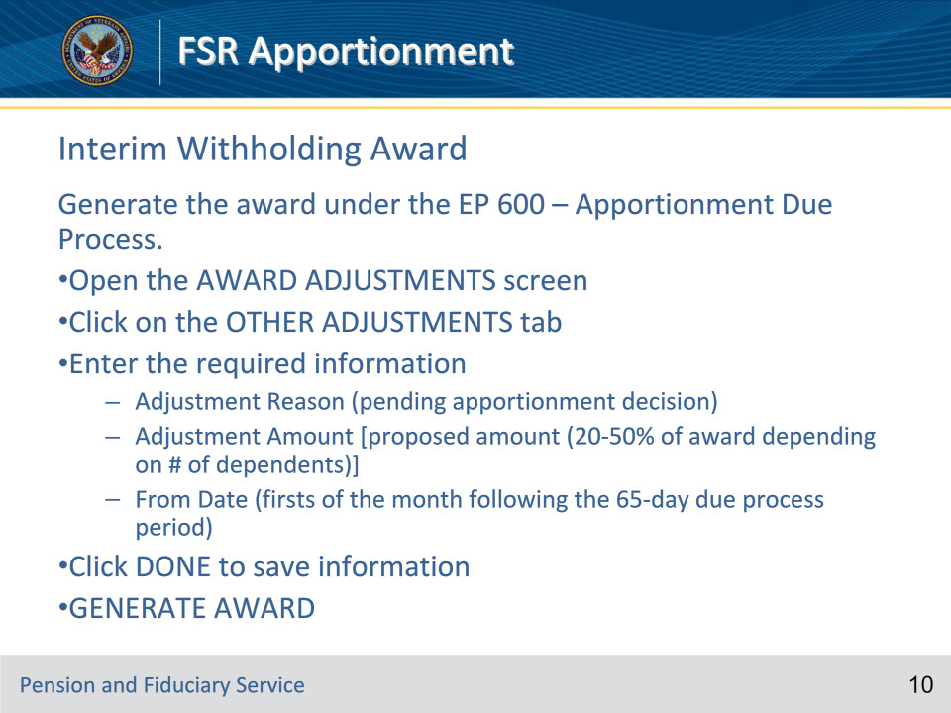
Slide notes

Instructor Notes:

The statutory authority for granting an apportionment is 38 U.S.C. 5307.

*Steps are correct

Slide 11 - Decision & Notification (1 of 4)
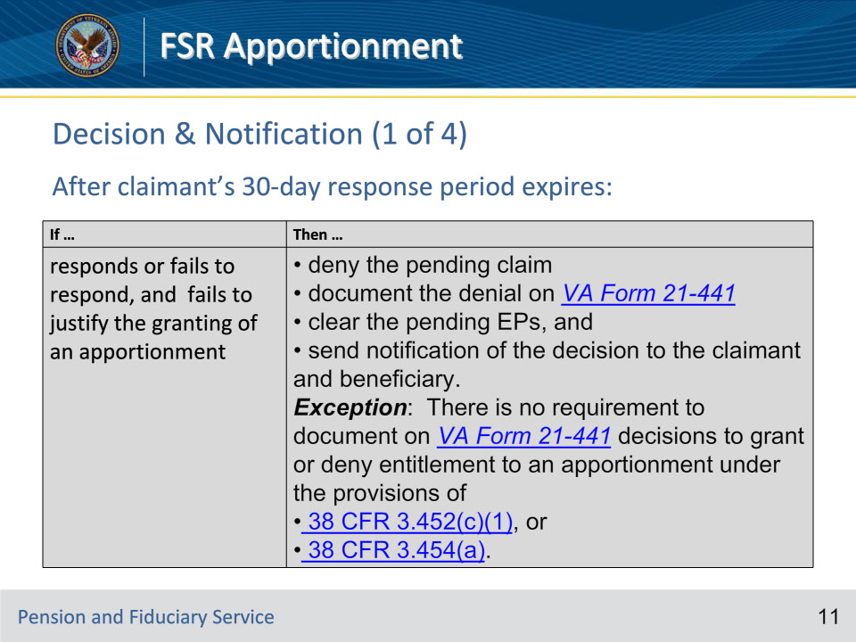
Slide notes

Policy Reference(s): M21-1 VII.iii.1.A.3.b.

Instructor Notes:

If VA sent a development letter to a claimant that requested completion of VA Form 21-0788 (because the claimant filed his/her claim prior to March 24, 2015) or requested additional evidence or information, follow the instructions in the table below after the claimant’s 30-day response period expires.

If the claimant responded, but the evidence of record fails to justify the granting of an apportionment, then

• deny the pending claim

• document the denial on VA Form 21-441

• clear the pending EPs, and

• send notification of the decision to the claimant and beneficiary.

If the claimant did not respond and the evidence of record fails to justify the granting of an apportionment, then

• deny the pending claim

• document the denial on VA Form 21-441

• clear the pending EPs, and

• send notification of the decision to the claimant and beneficiary.

Exception: There is no requirement to document on VA Form 21-441 decisions to grant or deny entitlement to an apportionment under the provisions of

• 38 CFR 3.452(c)(1), or

• 38 CFR 3.454(a).

If evidence of record justifies the granting of an apportionment, but the suspense date of the EP 600 has not passed, and the beneficiary has not yet responded to the corresponding notice of proposed adverse action, then

• adjust the suspense date of the EP 130 so it matches the suspense date of the EP 600, and

• take no further action until the earlier of the following events:

• the beneficiary responds to the notice of proposed adverse action, or

• the suspense date of the EP 600 passes.

Slide 12 - Decision & Notification (2 of 4)
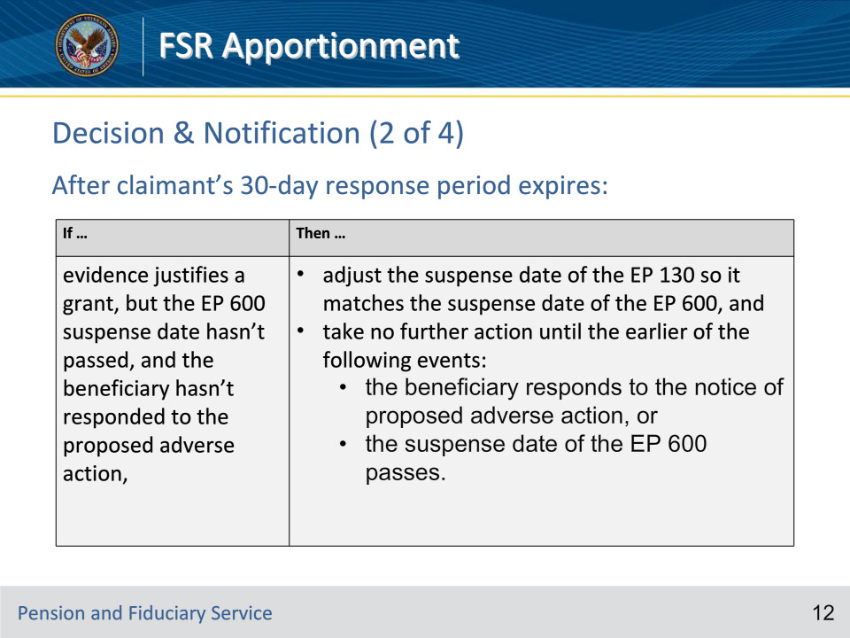
Slide notes

Policy Reference(s): M21-1 VII.iii.1.A.3.b.

Instructor Notes:

If VA sent a development letter to a claimant that requested completion of VA Form 21-0788 (because the claimant filed his/her claim prior to March 24, 2015) or requested additional evidence or information, follow the instructions in the table below after the claimant’s 30-day response period expires.

If the claimant responded, but the evidence of record fails to justify the granting of an apportionment, then

• deny the pending claim

• document the denial on VA Form 21-441

• clear the pending EPs, and

• send notification of the decision to the claimant and beneficiary.

If the claimant did not respond and the evidence of record fails to justify the granting of an apportionment, then

• deny the pending claim

• document the denial on VA Form 21-441

• clear the pending EPs, and

• send notification of the decision to the claimant and beneficiary.

Exception: There is no requirement to document on VA Form 21-441 decisions to grant or deny entitlement to an apportionment under the provisions of

• 38 CFR 3.452(c)(1), or

• 38 CFR 3.454(a).

If evidence of record justifies the granting of an apportionment, but the suspense date of the EP 600 has not passed, and the beneficiary has not yet responded to the corresponding notice of proposed adverse action, then

• adjust the suspense date of the EP 130 so it matches the suspense date of the EP 600, and

• take no further action until the earlier of the following events:

• the beneficiary responds to the notice of proposed adverse action, or

• the suspense date of the EP 600 passes.

Slide 13 - Decision & Notification (3 of 4)
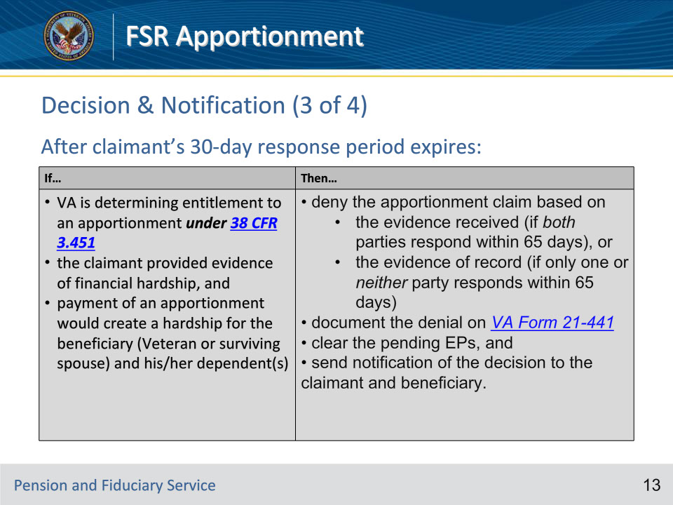
Slide notes

Policy Reference(s): M21-1 VII.iii.1.A.3.b.

Instructor Notes:

If

• VA is determining entitlement to an apportionment under 38 CFR 3.451

• the claimant provided evidence of financial hardship, and

• payment of an apportionment would create a hardship for the beneficiary (Veteran or surviving spouse) and his/her dependent(s)

Then

• deny the apportionment claim based on

• the evidence received (if both parties respond within 65 days), or

• the evidence of record (if only one or neither party responds within 65 days)

• document the denial on VA Form 21-441

• clear the pending EPs, and

• send notification of the decision to the claimant and beneficiary.

Important: Do not deny an apportionment claim on the basis that granting the claim would create a hardship for the primary beneficiary unless the primary beneficiary completed and returned VA Form 21-0788.

If

• VA is determining entitlement to an apportionment under 38 CFR 3.451

• the claimant provided evidence of financial hardship, and

• payment of an apportionment would not create a hardship on the part of the beneficiary (Veteran or surviving spouse) and his/her dependent(s)

Then

• grant the apportionment claim based on

• the evidence received (if both parties respond within 65 days), or

• the evidence of record (if only one or neither party responds within 65 days)

• document the decision on VA Form 21-441

• clear the pending EPs, and

• send notification of the decision to the claimant and beneficiary.

Slide 14 - Decision & Notification (4 of 4)
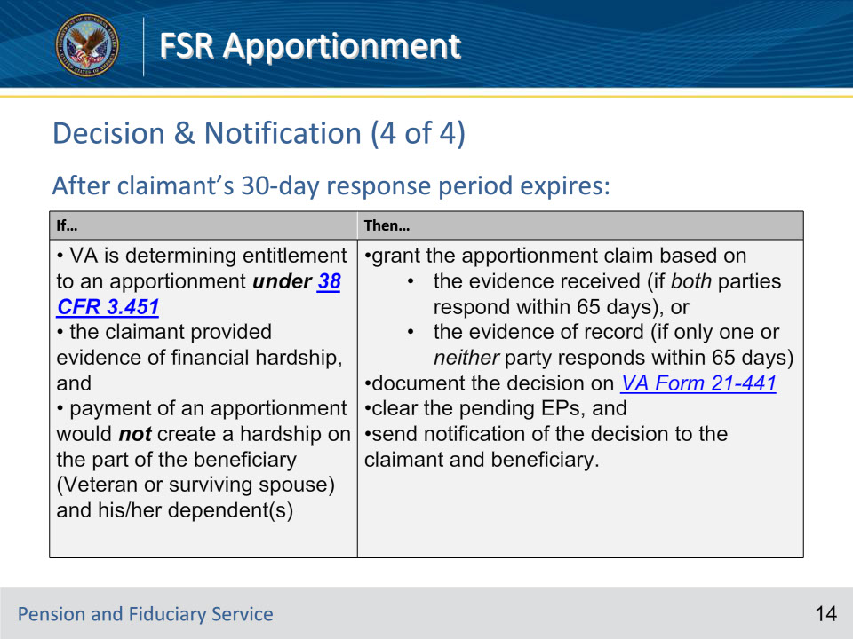
Slide notes

Policy Reference(s): M21-1 VII.iii.1.A.3.b.

Instructor Notes:

If

• VA is determining entitlement to an apportionment under 38 CFR 3.451

• the claimant provided evidence of financial hardship, and

• payment of an apportionment would create a hardship for the beneficiary (Veteran or surviving spouse) and his/her dependent(s)

Then

• deny the apportionment claim based on

• the evidence received (if both parties respond within 65 days), or

• the evidence of record (if only one or neither party responds within 65 days)

• document the denial on VA Form 21-441

• clear the pending EPs, and

• send notification of the decision to the claimant and beneficiary.

Important: Do not deny an apportionment claim on the basis that granting the claim would create a hardship for the primary beneficiary unless the primary beneficiary completed and returned VA Form 21-0788.

If

• VA is determining entitlement to an apportionment under 38 CFR 3.451

• the claimant provided evidence of financial hardship, and

• payment of an apportionment would not create a hardship on the part of the beneficiary (Veteran or surviving spouse) and his/her dependent(s)

Then

• grant the apportionment claim based on

• the evidence received (if both parties respond within 65 days), or

• the evidence of record (if only one or neither party responds within 65 days)

• document the decision on VA Form 21-441

• clear the pending EPs, and

• send notification of the decision to the claimant and beneficiary.

Slide 15 - Granting – How much?
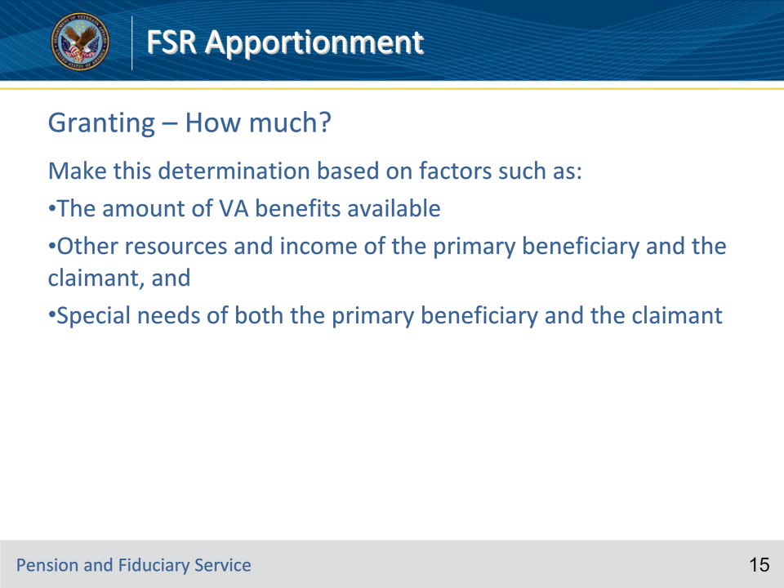
Slide notes

Instructor Notes:

Granting – How much?

Make this determination based on factors such as:

• The amount of VA benefits available

• Other resources and income of the primary beneficiary and the claimant, and

• Special needs of both the primary beneficiary and the claimant

Slide 16 - VA Form 21-441, Special Apportionment Decision
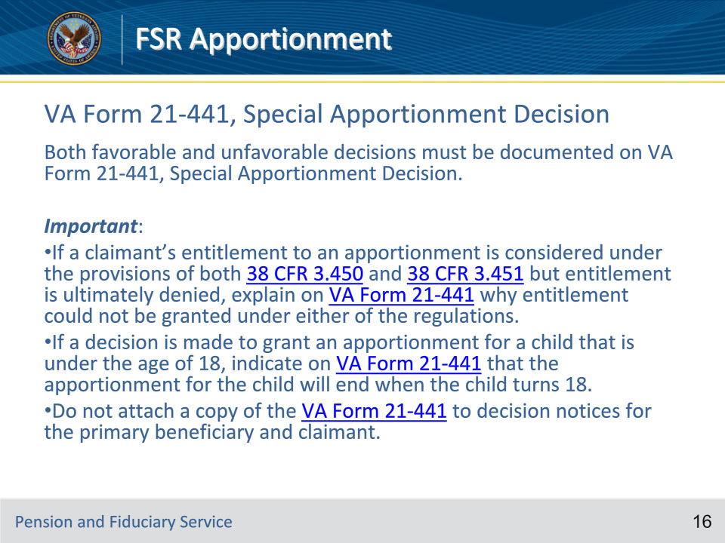
Slide notes

Instructor Notes:

Document both favorable and unfavorable decisions on claims for apportionment using VA Form 21-441.

Exceptions: For exceptions to the requirement described in the preceding paragraph, see M21-1

Important:

• If a claimant’s entitlement to an apportionment is considered under the provisions of both 38 CFR 3.450 and 38 CFR 3.451 but entitlement is ultimately denied, explain on VA Form 21-441 why entitlement could not be granted under either of the regulations.

• If a decision is made to grant an apportionment for a child that is under the age of 18, indicate on VA Form 21-441 that the apportionment for the child will end when the child turns 18.

• Do not attach a copy of the VA Form 21-441 to decision notices for the primary beneficiary and claimant.

Slide 17 - Effective Dates for Grants
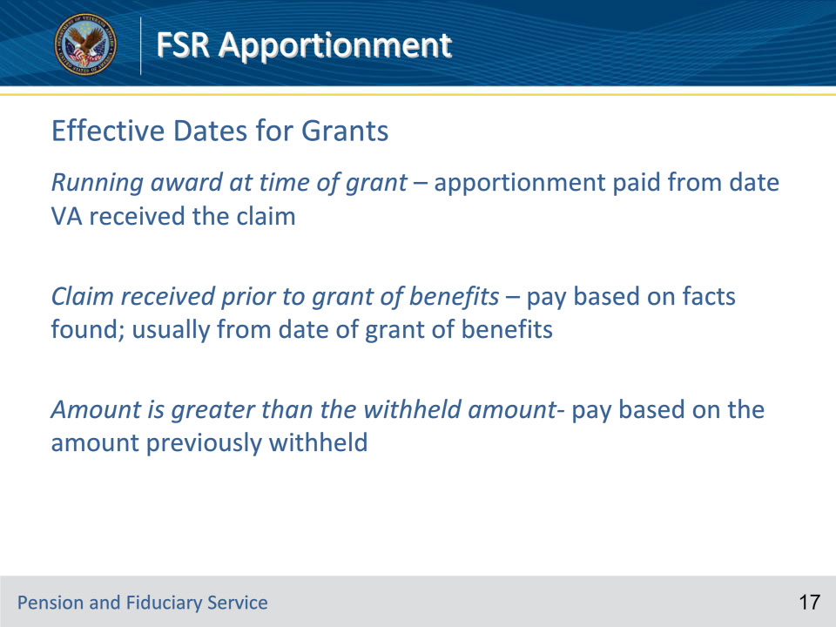
Slide notes

Instructor Notes:

Effective Dates for Grants

Running award at time of grant – apportionment paid from date VA received the claim

Claim received prior to grant of benefits – pay based on facts found; usually from date of grant of benefits

Amount is greater than the withheld amount- pay based on the amount previously withheld

Slide 18 - Reasons to Deny
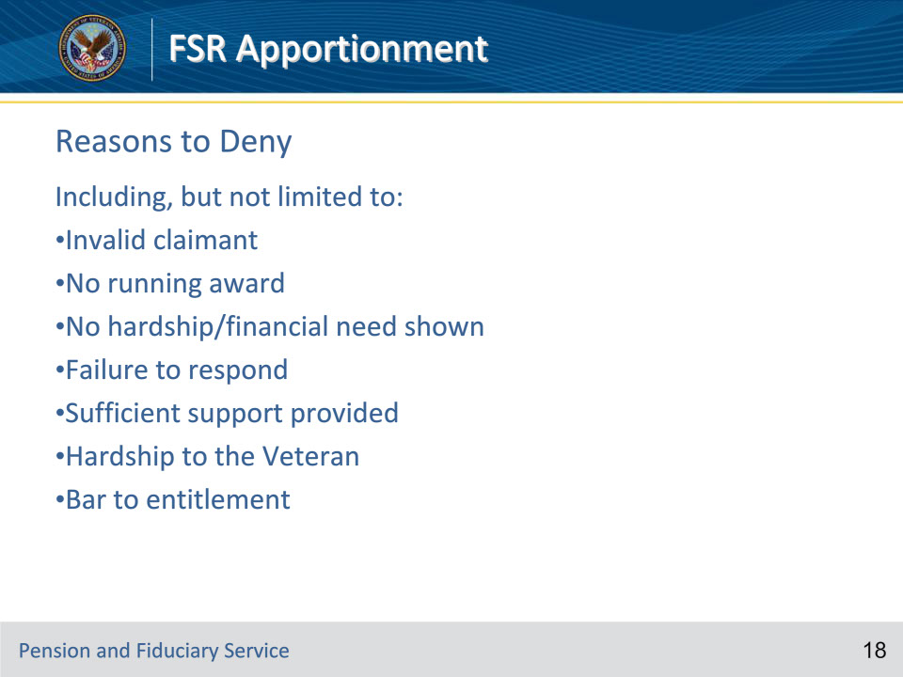
Slide notes

Instructor Notes:

Reasons to Deny

Including, but not limited to:

• Invalid claimant

• No running award

• No hardship/financial need shown

• Failure to respond

• Sufficient support provided

• Hardship to the Veteran

• Bar to entitlement

Slide 19 - Notification (grants or denials)
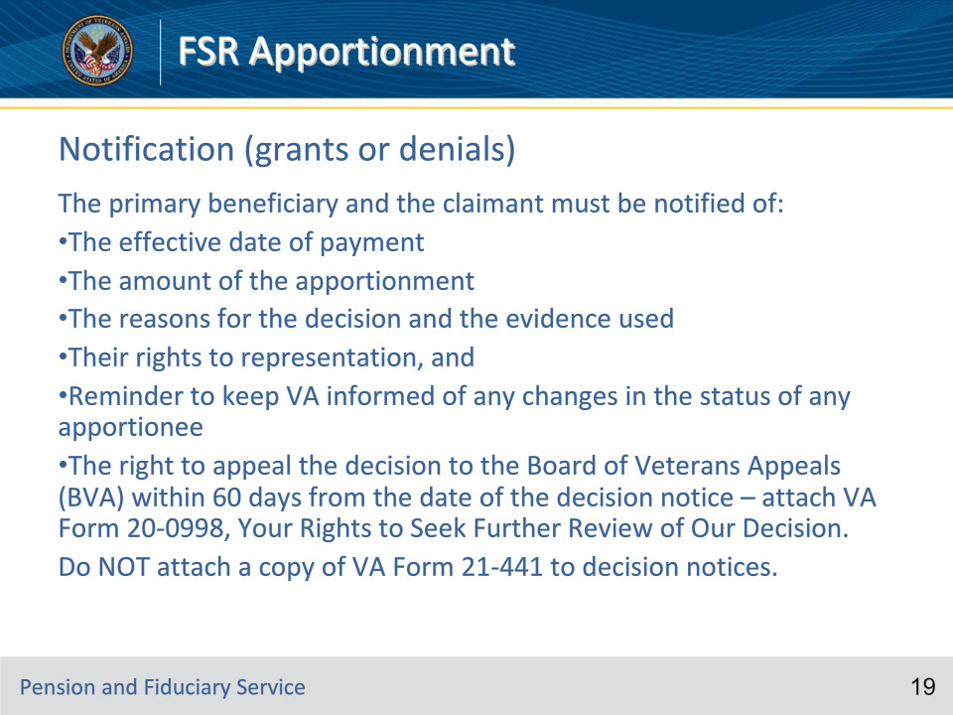
Slide notes

Instructor Notes:

Notification (grants or denials)

The primary beneficiary and the claimant must be notified of:

• The effective date of payment

• The amount of the apportionment

• The reasons for the decision and the evidence used

• Their rights to representation, and

• Reminder to keep VA informed of any changes in the status of any apportionee

• The right to appeal the decision to the Board of Veterans Appeals (BVA) within 60 days from the date of the decision notice – attach VA Form 20-0998, Your Rights to Seek Further Review of Our Decision.

Do NOT attach a copy of VA Form 21-441 to decision notices.

Slide 20 - Disclosing Information
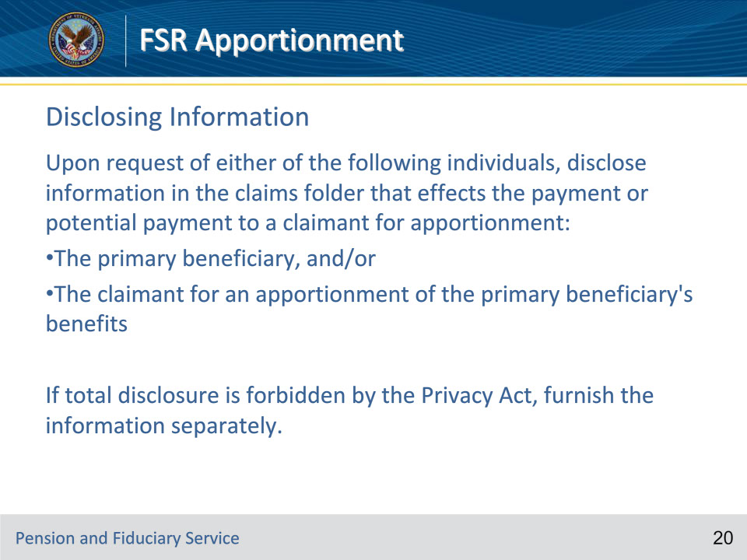
Slide notes

Policy Reference(s): M21-1 VII.iii.1.A.1.l.

Instructor Notes:

Following receipt of a request from either of the following individuals, disclose to him/her information in the claims folder that affects the payment or potential payment of an apportionment:

• individual that is claiming an apportionment, and/or

• beneficiary that is the subject of the apportionment claim.

When the Privacy Act forbids a total disclosure of correspondence or other submissions from either party to the other, separately furnish the information that is vital to the decision to be made.

Slide 21 - Effects of Offsets and Withholdings
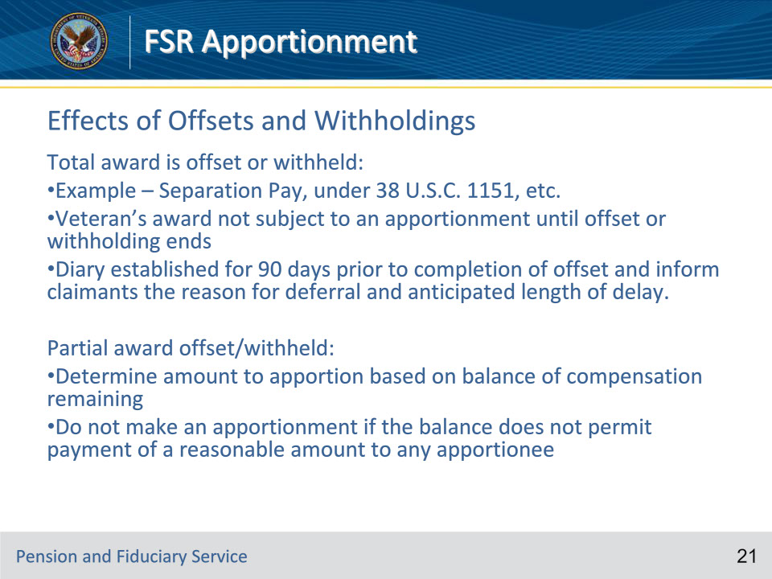
Slide notes

Policy Reference(s): M21-1 VII.iii.1.A.4.c.; M21-1 VII.iii.1.A.4.b.

Instructor Notes:

Follow the steps in the table below following receipt of an apportionment claim if a Veteran’s entire award is being

• offset under 38 U.S.C. 1151, or

• withheld to recoup separation benefits.

Step 1- Establish a future diary control for 90 days prior to the approximate date the offset or withholding will end to ascertain at that time whether an apportionment is still in order.

Important: Do not establish an EP.

Step 2- Inform any persons claiming an apportionment of the

• reason for the deferral, and

• anticipated length of delay.

Step 3- When the diary matures, follow the instructions in M21-1

Notes:

• If a VA Form 21-0788 (from either the beneficiary or the claimant) is of record but is more than one year old, ask the claimant and/or beneficiary to complete and return a new one. This will ensure claims processors have current financial information when they decide the apportionment claim.

• When establishing the withholding, do not withhold benefits for any period prior to the first day of the month in which the recoupment or offset ended.

In some cases,

• a Veteran is entitled to benefits for two or more disabilities, and

• the amount to be recouped is only the amount payable for the disability(ies) which resulted in

• an award under 38 U.S.C. 1151, or

• the payment of disability severance pay.

In such cases,

• determine the amount to be apportioned or withheld on the basis of the balance of compensation payable to the Veteran, not on the basis of the total award, and

• do not make an apportionment if the balance of compensation does not permit payment of a reasonable amount to any apportionee.

• Severance pay is an example of partial withholding.

Slide 22 - Granting the Apportionment
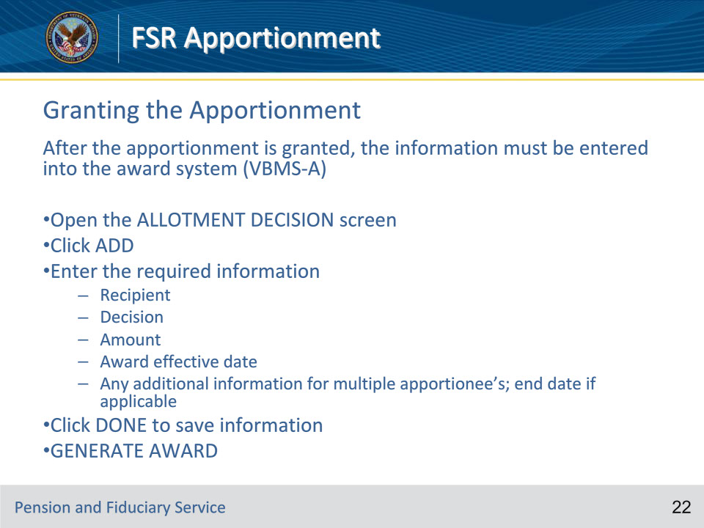
Slide notes

Policy Reference(s): Pg 293 in VBMS-A user guide

Slide 23 - Discontinuing the Apportionment
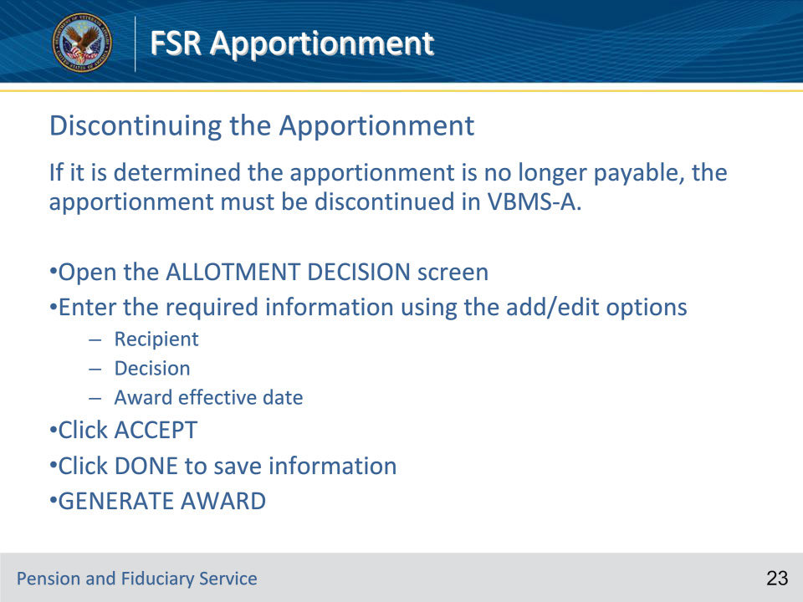
Slide notes

Policy Reference(s): M21-1 VII.iii.1.B.1.b.

Slide 24 - Questions?
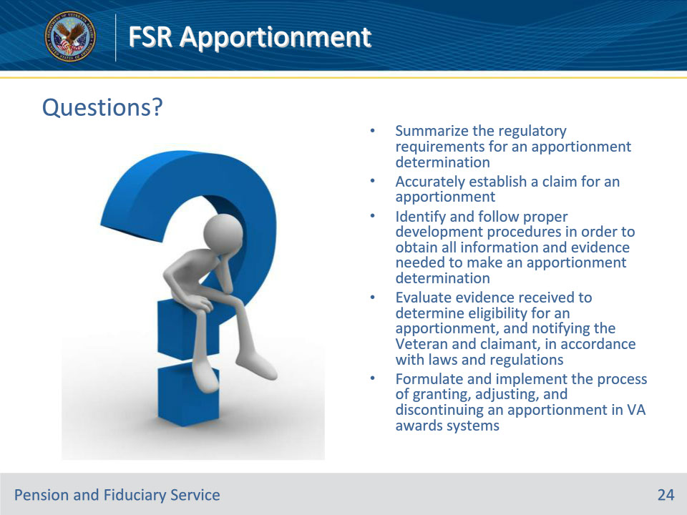
Slide notes

Instructor Notes:

(Recall) These are our learning objectives as stated from the beginning of the training:

• Summarize the regulatory requirements for an apportionment determination

• Accurately establish a claim for an apportionment

• Identify and follow proper development procedures in order to obtain all information and evidence needed to make an apportionment determination

• Evaluate evidence received to determine eligibility for an apportionment, and notifying the Veteran and claimant, in accordance with laws and regulations

• Formulate and implement the process of granting, adjusting, and discontinuing an apportionment in VA awards systems

Are there any additional questions?

Questions should be filtered through your QRT team. They will submit your questions to the Field Inquiry Tool (FIT) on your behalf.

Slide 25 - TMS Survey/Assessment
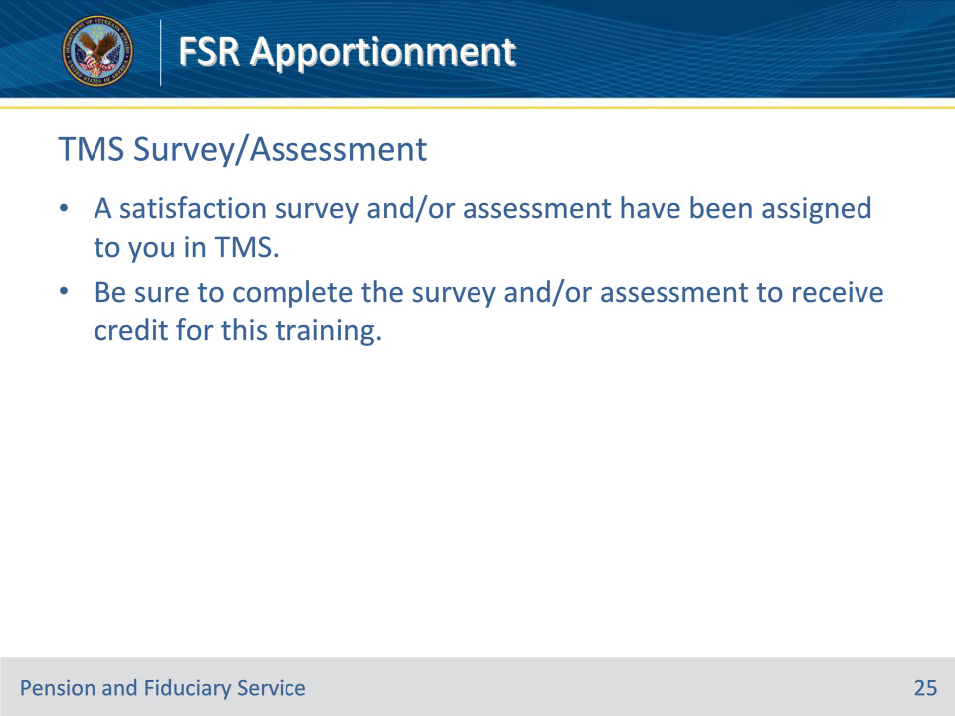
Slide notes

Instructor Notes

A satisfaction survey and/or assessment have been assigned to you in TMS.

Be sure to complete the survey and/or assessment to receive credit for this training.

